

National Disability Insurance Scheme: Service Agreement Variation Process
FAQs for service providers – August 2018
Contents
Key messages 3
NDIS funding changes and calculations 4
1. What are the key differences between the old and new approaches to service provider funding? 4
2. How will state funding be withdrawn? 4
3. When will state funding be withdrawn? 4
4. How will funding be withdrawn from HACC-PYP service providers? 4
5. When is state funding withdrawn for clients that have their NDIS approved plan reviewed and consequently receive an updated plan and plan start date?) 5
6. What happens if a client transitions ahead of their area or activity transition schedule? 5
7. How will state funding for each participant and service be determined? 5
8. Are block-funded averages recalculated from time to time? 6
9. Will a client’s funding be transferred to the NDIA as that client transitions to the NDIS? 7
10. How will we know which clients have become NDIS participants or have been deemed ineligible? 7
11. Will service providers be impacted if a planned area transition schedule period has ended and individual plans are still not approved? 7
12. How and when will service delivery targets for disability services be adjusted during the NDIS transition? 7
Funding withdrawal process 7
13. What will happen to funding withdrawals during the annual process for end of financial year, roll-over and indexation? 7
14. What action should service providers take with unspent funding received from the Department of Health and Human Services which is associated with their clients entering the NDIS? 8
15. What happens if there are insufficient funds left to adjust future payments? 8
16. What if clients decide to move to a new service provider upon transition? 8
17. How has information relating to clients who have been supported by a service provider been collated? 9
Clients not eligible for the NDIS 9
18. What if clients are not eligible to enter the NDIS? 9
19. When will service providers be notified of clients transferring to the Commonwealth Continuity of Support arrangements? 9
20. How will the Commonwealth Continuity of Support arrangements impact service provider state funding, and how will this be calculated? 9
21. How can we ensure that as many clients as possible enter the NDIS before their 65th birthday? 9
Updating client data 10
22. How can service providers update the list of clients they support? 10
23. Why is client data being updated periodically? 10
24. Are service providers that are solely funded for Home and Community Care Program for Younger People (HACC-PYP) required to update their client data? 10
25. Should service providers alert the department when a client passes away? 10
26. Are there any other documents that service providers can review to assist with updating their client data? 10
27. Who should service providers contact with questions and/ or any issues? 10
Provider reports available through the Online Provider Report and SigBox 11
28. What is the Online Provider Report? 11
29. How often is the Online Provider Report updated? 11
30. How will service providers access the Online Provider Report? 11
31. Who will have access to the Online Provider Report? 11
32. Can a service provider allow additional access to the Online Provider Report? 11
33. What should service providers do when using the Online Provider Report? 11
34. Are the previous Provider Reports still available through SigBix? 12
35. How will service providers know the Online Provider Report has been updated? 12
Appendix A - examples of funding withdrawal across service agreements 13
Appendix B - examples of state funding withdrawal timing 16
Appendix C - examples of reports available for providers 18
Appendix D - more information 25
Where can I obtain more information on the NDIS? 25
Resources 25

Version 5 - What has changed in this version?
Key messages updated.
Updates to questions 2,8,12-13, 20 and 30.

Key messages
- State funding will be withdrawn progressively as clients’ transition to the NDIS, except for Home and Community Care Program for Younger People (HACC-PYP) service providers who choose to continue with existing state funding for the extended transition period.
- Clients found to be ineligible for the NDIS who are 65 and over (50 years and over for Aboriginal and Torres Strait Islander people) and receiving existing state disability services may be eligible to transition to the Commonwealth Continuity of Support Programme. Victorian clients eligible for these arrangements started transitioning from 1 April 2018.
- Funding withdrawals will be backdated to the client’s earliest NDIS plan approval date, through adjustments to future payments.
- Provision of accurate and up-to-date client data from service providers has a direct impact on funding withdrawals. Service providers will have a final opportunity to update their client data in September 2018.
- Service providers can access updated information on their clients’ transition via the Online Provider Report.
- Disability block funding will be withdrawn on a state-wide average per activity, per provider basis (and pro-rated), or as a proportion of the cost of a house for Shared Supported Accommodation (and pro-rated).
- Mental Health Community Support Services funding will be withdrawn using an average calculated by catchment area, by provider, by activity.
- Client averages for block-funded activity withdrawals will be recalculated effective from 1 July and 1 December each year and will use the most up to date client data.
- Funding for 2018-19 has been confirmed for the Information Services (17033) and Building Inclusive Communities (17061) programs.
- Some clients may transition to the NDIS ahead of their area transition. Service providers should register as a NDIS provider early so that they can claim payments promptly.
- From 1 January 2018, service delivery targets for in-scope disability services have been reduced to reflect the proportion of state funding withdrawn from disability services for clients that have transitioned to the NDIS.

NDIS funding changes and calculations

What are the key differences between the old and new approaches to service provider funding?
The state funds services through a mixture of individualised and block funding. Funding is provided in advance on an annualised payment schedule.
The National Disability Insurance Agency (NDIA) will fund all services on an individual basis. Funding will be paid to registered service providers in arrears, that is, after a service has been provided.
Service providers will be able to submit payment claims immediately after a service is provided (service providers should refer to the NDIA website for more details on its portal payment process and timing).

How will state funding be withdrawn?
State funding for in-scope services will be withdrawn as clients transition to the NDIS. This will include all clients who have received the service within the 12 months preceding the most recent client data refresh.
Individualised funding will be withdrawn on a pro-rata basis. Disability block funding will be withdrawn on a state-wide average per activity, per provider basis (and pro-rated), or a proportion of the cost of a house for Shared Supported Accommodation (and pro-rated). For Mental Health Community Support Services a client funding average is calculated by catchment area, by provider, by activity.
Funding for 2018-19 has been confirmed for the Information Services (17033) and Building Inclusive Communities (17061) activities.

When will state funding be withdrawn?
State funding will, in effect, be withdrawn from the date a state client has a NDIS approved plan (see Question 5 for further information for clients with revised plan start dates), except where Home and Community Care Program for Younger People (HACC-PYP) service providers have chosen to continue with the in-kind funding arrangement during the NDIS transition period (see Question 4 for more information).
Generally, all transactions to reduce state funding will occur between one and three months after plan approval.
The NDIA assumes funding responsibility for the client's supports from the date of plan approval. Funding reductions will be backdated to plan approval date and will result in a reduction to future payments.
The retrospective funding withdrawal will give service providers some cash flow relief and allow sufficient time to claim payments from the NDIA.
Refer to Appendix B for examples of state funding withdrawal timing.

How will funding be withdrawn from HACC-PYP service providers?
HACC-PYP service providers can chose between two funding withdrawal options during the NDIS transition.
Option 1
Most service providers will continue to deliver services under the current funding arrangements with the department during the in-kind period (extended transition period).
At the end of the extended transition period, funding will be adjusted for each service provider based on the proportion of services previously delivered to clients who have transitioned to the NDIS.
Option 2
Service providers can choose to have their funding progressively withdrawn each month based on the number of clients that have transitioned to the NDIS.
To identify which clients have transitioned to the NDIS, service providers can access the Online Provider Report to view clients that have attained plan approved status. Refer to Question 10 and Appendix C for further information on the Online Provider Report.
Organisations that have registered as a NDIS provider can continue to deliver services to participants and claim payment from the NDIA.
Clients of organisations that are not delivering services under the NDIS will need to find an alternative service provider. The NDIA’s Local Area Co-ordinators are able to assist with identifying and engaging alternative service providers.

When is state funding withdrawn for clients that have their original approved NDIS plan reviewed and consequently receive an updated plan and plan start date?
State funding is withdrawn based on a client’s original NDIS plan approval date. This is the date from which the NDIA assumes funding responsibility for the client's supports.
If the plan is reviewed, even if soon after the first plan approval, any subsequent letter or plan will have a new plan approval date indicating when that revised plan commenced.

Providers should ensure that service bookings are created back to the original plan approval date. The original plan approval date is shown on the Online Provider Report.

Further details on claiming back to the plan approval date can be found in the ‘step-by-step guides’ on the NDIS Provider Toolkit <https://providertoolkit.ndis.gov.au>

What happens if a client transitions ahead of their area schedule?
Some clients may transition early and ahead of their residential area rollout if they are on the Disability Support Register or Early Childhood Intervention Services Waitlist. In these cases, funding withdrawals will occur sooner than service providers may have expected.
It is important that service providers register as an NDIS provider early in order to claim payments from the NDIA, minimising any potential cash-flow issues. See the NDIS website for further details contained within its Provider FAQs: https://providertoolkit.ndis.gov.au/frequently-asked-questions.
Under the NDIS, participants are free to choose their own service provider.

How will state funding for each participant and service be determined?
The following methods are used to withdraw state funding for each activity listed below:
Activities | Methods
Shared Supported Accommodation (SSA) | - Each SSA house has its own service agreement commitment.  - The cost per person is calculated as the total cost of the house divided by the number of clients identified as living in that dwelling in the last 12 months.
Individual Support Packages (ISPs) and Futures for Young Adults (FFYA) | - The individualised funding allocated to clients is used to determine the state funding withdrawal.  - ISP funding is evenly distributed throughout the year and has been pro-rated based on the timing of transition (i.e. monthly payment is equal to the total state funding divided by 12 months).  - When a client becomes a NDIS participant, the plan approval date is the end date of the state funding.  - The process is the same for ISPs funded via a service agreement with a lead agency, financial intermediary or direct payments to the client.
Disability Block-Funded Activities | - The total state-wide funding allocated to a service provider for a certain activity has been divided by the total number of its clients for that activity to arrive at an average cost per provider, per activity, per client.  See Q.7 – Are block funded averages recalculated from time to time?  - An area-based average cannot be used as state funding for each activity is not allocated solely within the department’s 17 geographical areas.
Mental Health Community Support Services (MHCSS) | - MHCSS funds geographical catchment areas which are different to “DHHS” areas.  - A client funding average applies to each catchment, by provider, by sub activity (there are three MHCSS main activities in-scope for the NDIS – Individualised Client Support Packages, Supported Accommodation Services and Adult Residential Rehabilitation Services).
Home and Community Care Program for Younger People (HACC-PYP) | - HACC service providers can choose to continue with the existing funding arrangements from the department during the in-kind period. The in-kind period continues for six months after the area transition period for all areas commencing transition after July 2017.  - Alternatively, service providers may opt to progressively withdraw funding as clients transition to the NDIS.  - Funding withdrawals are based on the proportion of services delivered to clients transitioning to the NDIS.  - See the NDIS transition information for HACC-PYP providers on the Victorian Government NDIS website <https://www.vic.gov.au/ndis/service-providers.html>
State-wide Contracts | - There are two approaches to withdraw the funding for state-wide contracts:  - Where client information is available, the disability block-funded approach is used; or  - Where client information is not available (e.g. Aids and Equipment), specific funding withdrawals have been calculated for each service provider by area. The timing of state funding withdrawals will be agreed with each service provider in advance for both direct and administrative funding.

Are block-funded averages recalculated from time to time?
Yes – Block-funded averages are recalculated on 1 July and 1 December each year to account for the Equal Remuneration Order and indexation.
The number of clients (denominator) is derived by filtering the 'Date of Last Service column' in the Client Data Collection Template for those clients who received a service in the 12 months prior to the data collection submission (see section – Updating client data). A service provider's latest client data submission will be used to inform block-funded averages on 1 July and 1 December each year through transition.
Following the application of indexation in July 2018, updated block funded averages are based on the client data collected in March 2018. The new averages take account of withdrawals for clients who transitioned prior to 1July 2018 and will be used for funding withdrawals for clients who transition from 1 July 2018. These adjustments will be transacted from September 2018.
Block-funded averages will also be recalculated in December 2018 and will be based on the client data refresh in September 2018.

Will a client’s funding be transferred to the NDIA as that client transitions to the NDIS?
Not directly.
State funding that is withdrawn from service providers will form part of Victoria’s financial contribution to the NDIS. Individual NDIS packages costs will be determined by the NDIA on a case-by-case basis.

How will we know which clients have become NDIS participants or have been deemed ineligible?
NDIA provides Victoria with reports on clients’ NDIS transition progress twice each month. The department, in turn, updates the Online Provider Report which outlines the status of clients at a point in time (e.g. plan approved or access met) and the funding withdrawals that will result as a consequence of clients becoming NDIS participants (based on the phasing schedule).
The Online Provider Report (see Appendix C) allows service providers to monitor the progress of their clients’ NDIS transition. The Online Provider Report is a restricted and secure website that allows users to access the most recent data available. User access is restricted with a unique login issued for each user. The Online Provider Report is available using the link: <https://tableau.deloitte.com.au/#/site/NDISclientrollout/views/ProviderReportsProvider_0/Cover>.
To support the transition to the Online Provider Report, provider reports will continue to be distributed to service providers through SigBox, a secure online data room.
Service providers are encouraged to use these tools to identify those clients who have become NDIS participants (plan approved status) and those clients likely to become participants in the near future (access met status). This information can assist in conversations between organisations and clients on their progress into the scheme and future intentions on provider choice.
Further, the Online Provider Report includes clients assessed by the NDIA as not meeting the NDIS eligibility criteria under the status ‘Access not met’.
See the Online Provider Report section below for more information.

Will service providers be impacted if a scheduled area transition period has ended and individual plans are still not approved?
Support to enter the NDIS scheme and to have a plan approved will continue even if the scheduled area transition period has ended. As the service provider, you will continue to receive state funding until an individual’s plan is approved, or all reasonable efforts to assist the client to transition have been exhausted.

How and when will service delivery targets for disability services be adjusted during the NDIS transition?
From 1 January 2018, service delivery targets for in-scope disability activities have been reduced to reflect the proportion of state funding withdrawn for clients who transitioned to the NDIS. The adjustments ensure that service delivery targets and measures remain accurate and relevant during the NDIS transition.
A Target Reduction Report detailing service delivery target adjustments is provided through My Agency.
Target adjustments are carried out on a quarterly basis.

Funding withdrawal process

What will happen to funding withdrawals during the annual process for end of financial year, roll-over and indexation?
The department’s ability to withdraw funding relating to the NDIS transition is restricted during the annual process to roll-over service agreements and apply indexation increases on the Service Agreement Management System (SAMS).

Individual Support Packages and Futures for Young Adults
The withdrawal of individualised funding as clients become NDIS participants will continue each month leading up to and following the end of financial year.
Where a client receives an approved NDIS plan prior to 30 June but the termination is not processed until the following financial year, the funding withdrawal will be processed as a prior year adjustment and recouped from the next available payment.
Block funded disability and Mental Health Support Services – transition prior to 30 June 2018
Withdrawals of block funding relating to clients who become NDIS participants prior to 30 June 2018, and where related funding was not withdrawn during the financial year, were transacted in SAMS in August 2018 as prior year adjustments and recouped from the next available payment.
These variations will use the block funding average for each provider and activity (and catchment area for MHCSS) from the end of the previous financial year.
Block funded disability and Mental Health Support Services – transition post 1 July 2018
Withdrawals of block funding related to clients who become NDIS participants from 1 July will commence on SAMS in September 2018 and impact on provider payments and cash flow from October 2018.
These variations will be based on an updated block funding average calculated for each provider and activity (and catchment area for MHCSS services).

What action should service providers take with unspent funding received from the Department of Health and Human Services which is associated with their clients entering the NDIS?
Service providers should hold any funds received for services delivered post plan approval, as the department will be making retrospective service agreement variations back to a client's NDIS plan approval date.
This will impact on future payments or, where the service provider has insufficient departmental funding remaining, require the provider to return funds via an invoice.
Unspent funds should be kept available in an account from which the organisation can withdraw funds rather than a trust account.

What happens if there are insufficient funds left to adjust future payments?
Future monthly payments to service providers will be reduced to account for clients who have transitioned to the NDIS.
For disability services activities, if there is insufficient funding left in the disability services funding but sufficient departmental funding within non-disability services agreement, a negative payment will be applied to an NDIS Disability Services funding recoupment activity within an NDIS Transition Recoupment service plan in the non-disability services agreement. This withdrawal will effectively reduce other payments in this agreement.
Where the service agreement between the department and a service provider does not have sufficient funding to offset the adjustment, an invoice will be issued to the service provider. Invoices will have standard payment terms as per existing service agreements.
A decision tree indicating the scenarios and the resultant withdrawal method is shown at Appendix A.

What if clients decide to move to a new service provider upon transition?
The Online Provider Report is a useful planning tool which enables service providers to understand which clients have been earmarked for plan approval – ‘Access met’ status means that they have been deemed eligible and will likely transition soon.
Service providers are strongly encouraged to use the information in the Online Provider Report to facilitate conversations with clients about their intentions regarding their choice of service provider post transition.

How has information relating to clients who have been supported by a service provider been collated?
Client data (including service details) from all service providers was collected through the client data refresh in March 2018 (and previous client data refreshes) and uploaded to the department’s database. See the updating client data section for further details.
Client information is provided to the NDIA so that it can contact potential NDIS participants. This information also enables the department to accurately determine the quantum of state funding to be withdrawn from service providers, by client and by activity.

Clients not eligible for the NDIS

What if clients are not eligible to enter the NDIS?
Clients who are aged over 65, or 50 to 64 years old for Aboriginal and Torres Strait Islander clients, and are ineligible for the NDIS will continue to receive services under the Commonwealth’s Continuity of Support arrangements. The majority of clients eligible for the Commonwealth Continuity of Support arrangements started to transition from 1 April 2018, with the small number of remaining clients transferring by 30 June 2019.
Further information on the Commonwealth’s Continuity of Support arrangements is available on the Victorian Government NDIS website <https://www.vic.gov.au/ndis/service-providers.html>.
Clients who are not eligible for the NDIS or the Commonwealth’s Continuity of Support arrangements will continue to receive Victorian Government funded services.

When will service providers be notified of clients transferring to the Commonwealth Continuity of Support arrangements?
Once a client has transitioned to the Commonwealth Continuity of Support arrangements, disability service providers will be funded under new agreements with the Commonwealth Department of Health.
Service providers were advised of the date of transition to the Continuity of Support arrangements in June 2017. Since this time, the Commonwealth Department of Health has been working with service providers to finalise the list of clients transitioning.

How will the Commonwealth Continuity of Support arrangements impact service provider state funding, and how will this be calculated?
Funding and Service Agreements began to be varied effective from 1 April 2018 as the first stage of clients transitioned to the Commonwealth.
Funding adjustments are based on the clients in-scope for the funding agreements prepared by the Commonwealth Department of Health. Withdrawals will be calculated using the same funding withdrawal methodology in place for clients transitioning to the NDIS.
The funding agreements with the Commonwealth include a provision for funding to be backdated to the transition date. If there is a delay in the execution of a service provider’s funding agreement, the Commonwealth’s payments will be backdated to the clients’ transition date.

How can we ensure that as many clients as possible enter the NDIS before their 65th birthday?
Clients over the age of 65 are not eligible to enter the NDIS (although clients who turn 65 after joining the NDIS can remain in the NDIS).
Victoria and the Commonwealth have agreed that clients who are aged 64 at the time of their area’s transition will be prioritised for access.
The NDIA will perform assessments and provide the necessary access for clients who are aged 64 up to six months prior to their area rollout. Although access requests will be made earlier, the clients will transition to the NDIS in line with their transition period. Once access is met, these clients will transition to the NDIS even if they are 65 on the actual transition date.

Updating client data

How can service providers update the list of clients they support?
Service providers will be asked to update their client data in September 2018.
Service providers will be supplied with a tailored spreadsheet (the client data collection template) that will be pre-populated with client data previously supplied by the service provider. Each service provider will be asked to add new department-funded clients and to update client details, as appropriate, in the ‘Your Latest Client Data’ worksheet.
The transfer of client data to and from service providers will continue to be made through the SigBox online data room facility.
Further details are available in the Client Data Refresh FAQs document available at https://www.vic.gov.au/ndis/service-providers.html .

Why is client data being updated?
There are three main reasons why client data is updated:
- to ensure that eligible clients do not miss out on streamlined access to the NDIS
- so service providers can identify when clients have become NDIS participants, and therefore can commence invoicing the NDIA for services provided to those clients
- accurate and up-to-date client data ensures that block funding withdrawals are calculated correctly.

Are service providers that are solely funded for Home and Community Care Program for Younger People (HACC-PYP) required to update their client data?
Yes. These service providers will be asked to identify their clients who are likely to be eligible for the NDIS.

Should service providers alert the department when a client passes away?
Yes. Service providers should communicate a client’s death to their departmental Adviser and to NDIS.data@dhhs.vic.gov.au without delay so that client records are updated and attempts to contact the client or their family ceased.

Are there any other documents that service providers can review to assist with updating their client data?
Yes. Along with detailed instructions in the client data collection template, there is an Information Summary for service providers and a Frequently Asked Questions (FAQs) document on the client data refresh.
Further details are available at https://www.vic.gov.au/ndis/service-providers.html
Please contact your departmental Adviser if you require any additional assistance.

Who should service providers contact with questions and/ or any issues?
All issues and questions should be directed to the service provider’s departmental Adviser.

Provider reports available through the Online Provider Report and SigBox

What is the Online Provider Report?
Financial reports are produced by the department and made available to service providers using the Online Provider Report.
These reports show a full client list including when clients are expected to transition to the NDIS (by month), their related services, the amount of state funding estimated to be withdrawn and their NDIA status (such as plan approved). These reports cover all areas for the full period of the transition, to June 2019.

How often is the Online Provider Report updated?
The Online Provider Report allows service providers to access their latest client transition information at any point in time and removes the need for service providers to periodically access SigBox to download the latest provider reports.
The Online Provider Report is updated twice per month following the receipt of updated information from the NDIA.

How will service providers access the Online Provider Report?
The Online Provider Report can be accessed through this link: https://tableau.deloitte.com.au/#/site/NDISclientrollout/views/ProviderReportsProvider_0/Cover
Service providers should select the ‘Client or business partner’ link and proceed to login. New users will need to set up Multi-Factor Authentication to login.
Any questions on accessing the Online Provider Report should be directed to the service provider’s departmental Adviser.

Who will have access to the Online Provider Report?
The Online Provider Report is a secure site with restricted access based on unique logins. Each service provider should have at least one person with access to the Online Provider Report.

Can a service provider allow additional access to the Online Provider Report?
Yes, a service provider can allow additional access, for example if the service provider would like another member of the organisation to be responsible for accessing the Online Provider Report.
Only the financial signatory to the service agreement can request access for another member of the organisation. Requests must be in writing; an email is sufficient.
Any requests for additional access or updates to existing access should be directed to NDIS.data@dhhs.vic.gov.au and copied to the service provider’s departmental Adviser.

What should service providers do when using the Online Provider Report?
Service providers should use their unique logins to access the Online Provider Report which is systematically refreshed based on the latest available data.
It is important that service providers take the opportunity to review the Online Provider Report in a timely manner as it contains important information about the NDIS transition status of clients. State funding will be withdrawn as clients transition to the NDIS.
Any questions on the content of the provider reports should be directed to the service provider’s departmental Adviser.

Are the previous Provider Reports still available through SigBox?
To help transition service providers to the Online Provider Report, Provider Reports will continue to be available through SigBox.
Note that there are currently two file paths used by the department on SigBox for data exchange with service providers: one for the client data refresh and one for provider reports (with a prefix of “PR”). Access is set up for each path independently so an individual may have access to one path but not the other. To view Provider Reports, the user must have access to the Provider Reports file path.

How will service providers know the Online Provider Report has been updated?
The Online Provider Report will be systematically updated using the latest data available. Service providers should regularly review the Online Provider Report.
The cover page shows:
- the date of the last NDIA update – to indicate when the status was last provided by the NDIA
- the client data refresh cycle – which client data return has been used.
Service providers will continue to receive an automated generic email from SigBox when new provider reports have been updated – these updates will automatically be reflected on the Online Provider Report. The prefix ‘PR’ in the File/Folder Name indicates that a provider report is available to download.
The email will come from sigbox@dhhs.vic.gov.au. Service providers should ensure that this is an email address in their safe list and doesn’t go into the Spam folder.
Further information is available in the Guidance to using SigBox document.

Appendix A - examples of funding withdrawal across service agreements
Disability Services: funding withdrawal scenarios

The following tables provide examples of the method of funding withdrawal as clients’ transition and funding is reduced.
Table 1: Sufficient funding remaining in FY against activity
Required variation: Withdraw $30,000 from Community Respite
Service Agreement | Service Plan | Activity | FY funding remaining before variation ($) |  |  | FY funding remaining after variation ($)
Service Agreement | Service Plan | Activity | Activity | Service Agreement | Provider | Activity | Service Agreement | Provider
Disability Services | Disability Services | Community Respite | 50,000 | 110,000 | 210,000 | 20,000 | 80,000 | 180,000
Disability Services | Disability Services | Therapy | 60,000 | 110,000 | 210,000 | 60,000 | 80,000 | 180,000
DHHS NGO | Homelessness Accommodation | Transitional Support | 100,000 | 100,000 | 210,000 | 100,000 | 100,000 | 180,000
Table 2: Insufficient funding remaining in FY against activity, sufficient funding remaining in FY against disability service agreement
Required variation: Withdraw $30,000 from Community Respite
Service Agreement | Service Plan | Activity | FY funding remaining before variation ($) |  |  | FY funding remaining after variation ($)
Service Agreement | Service Plan | Activity | Activity | Service Agreement | Provider | Activity | Service Agreement | Provider
Disability Services | Disability Services | Community Respite | 20,000 | 80,000 | 180,000 | -10,000 | 50,000 | 150,000
Disability Services | Disability Services | Therapy | 60,000 | 80,000 | 180,000 | 60,000 | 50,000 | 150,000
DHHS NGO | Homelessness Accommodation | Transitional Support | 100,000 | 100,000 | 180,000 | 100,000 | 100,000 | 150,000
Table 3: Insufficient funding remaining in FY against activity, insufficient funding remaining in FY against disability service agreement, sufficient funding remaining in FY against non-disability service agreement
Required variation: Withdraw $30,000 from Community Respite
Service Agreement | Service Plan | Activity | FY funding remaining before variation ($) |  |  | FY funding remaining after variation ($)
Service Agreement | Service Plan | Activity | Activity | Service Agreement | Provider | Activity | Service Agreement | Provider
Disability Services | Disability Services | Community Respite | 5,000 | 10,000 | 110,000 | -5,000 | 0 | 80,000
Disability Services | Disability Services | Therapy | 5,000 | 10,000 | 110,000 | 5,000 | 0 | 80,000
DHHS NGO | Homelessness Accommodation | Transitional Support | 100,000 | 100,000 | 110,000 | 100,000 |  | 80,000
DHHS NGO | NDIS Transition Recoupment | NDIS Disability Services funding recoupment (17159) |  |  | 110,000 | -20,000 | 80,000 | 80,000

Table 4: Insufficient funding remaining in FY against activity, insufficient funding remaining in FY against disability service agreement, in sufficient funding remaining in FY against non-disability service agreement, invoice required
Required variation: Withdraw $30,000 from Community Respite
Service Agreement | Service Plan | Activity | FY funding remaining before variation ($) |  |  | FY funding remaining after variation ($)
Service Agreement | Service Plan | Activity | Activity | Service Agreement | Provider | Activity | Service Agreement | Provider
Disability Services | Disability Services | Community Respite | 5,000 | 10,000 | 20,000 | -5,000 | 0 | 0
Disability Services | Disability Services | Therapy | 5,000 | 10,000 | 20,000 | 5,000 | 0 | 0
DHHS NGO | Homelessness Accommodation | Transitional Support | 10,000 | 10,000 | 20,000 | 10,000 |  | 0
DHHS NGO | NDIS Transition Recoupment* | NDIS Disability Services funding recoupment (17159)* |  |  | 20,000 | -10,000 | 0 | 0
Invoice raised for recoupment of $10,000 from service provider
* The NDIS service plan and activity have been created to ensure a negative adjustment to a non-disability service agreement is clearly shown as being the result of a withdrawal of disability funding

Appendix B - examples of state funding withdrawal timing
Below are some illustrative examples of clients transitioning and the associated funding withdrawal implications.
Note: The following examples assume that there are RIS update and SAMS2 variation windows within the period and that the provider’s service agreement has sufficient funds to backdate any state funding reduction to the client’s plan approval date.
1 – ISP via providers and financial intermediary through RIS/SAMS2
Information received by the department from the NDIA mid-month

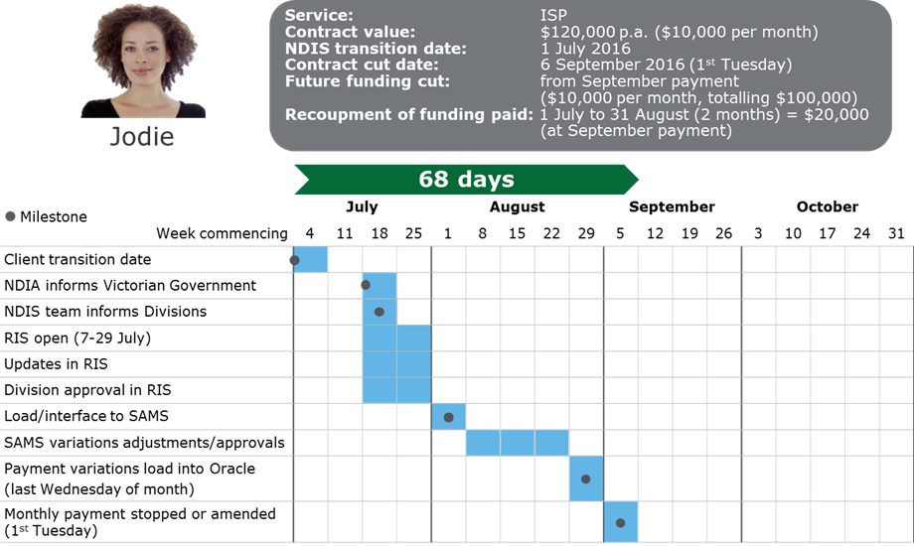
2 – ISP via providers and financial intermediary through RIS/SAMS2
Information received by the department from the NDIA at the end of the month
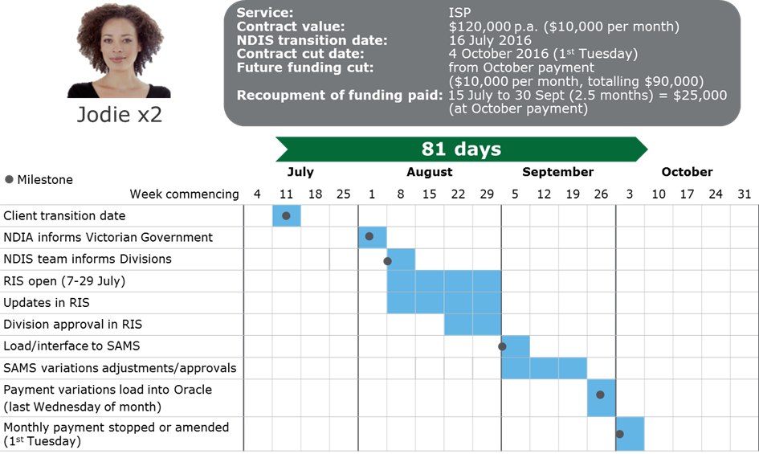
3 – Block funded disability services and mental health
Information received by the department from the NDIA mid-month

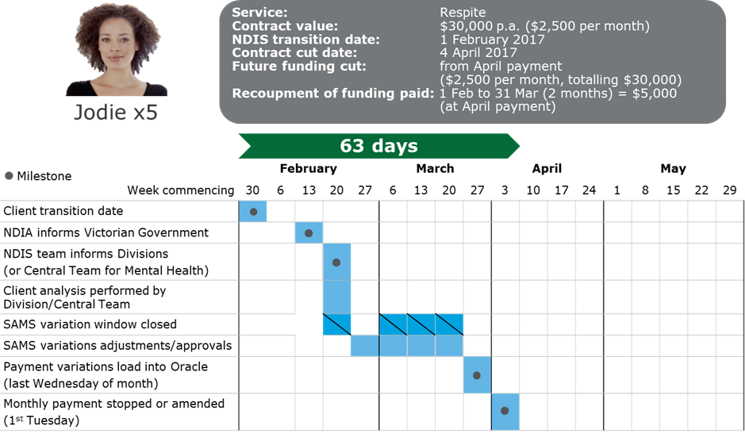
4 – Block funded disability services and mental health
Information received by the department from the NDIA at the end of the month

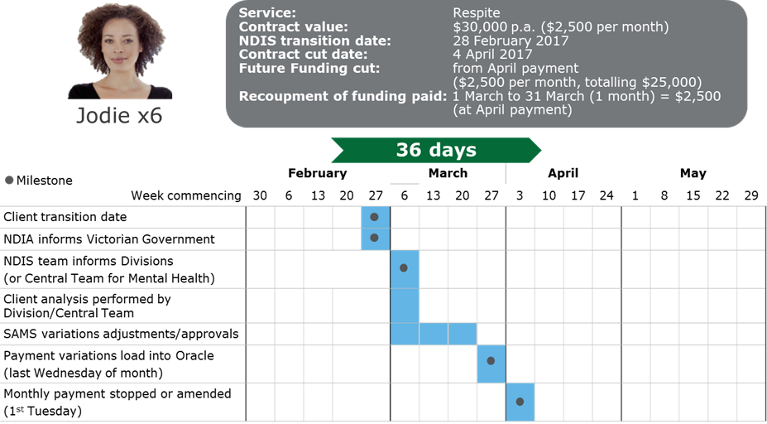

Appendix C - examples of reports available for service providers
What information will service providers receive?
The Online Provider Report allows services providers to access reports about their clients’ NDIS transition progress, including forward looking forecasts by month for the full period of the NDIS transition to June 2019. It also allows service providers ability to sort, filter and generate information most relevant to their needs.
The information available on the Online Provider Report is consistent with the provider reports distributed through SigBox.
Guidance on how to use the Online Provider Report is included under the ‘User Guide 1/2’ and ‘User Guide 2/2’ working tabs. The Online Provider Report includes a range of client transition reports, see below.
Table 1 – ‘Combined Overview’ provides a summary forecast by month. This includes:
- the number of state clients who have transitioned to the NDIS
- the forecast number of existing state clients who will transition to the NDIS by the end of the transition
- the services that have been provided to each client (note that when multiple services are received by the same client, each service will be shown separately)
- the state funding that will be released for each service
- a funding withdrawal chart detailing the monthly and cumulating funding withdrawal phasing.
The above will be provided at both a monthly and cumulative level for clients, services and state funding.

Table 2 – ‘Detailed Client List’ provides client transition information. This includes:
- a list of all of the service providers’ state funded clients with a separate line for each service that each of the service provider’s clients receive (e.g. if a client receives an ISP and Therapy, these will be shown on two separate lines)
- clients’ first name, surname and date of birth (the name fields are excluded from the examples used)
- the current NDIA status
- the forecast transition date
- the actual transition date (plan approval date), when status is ‘Plan Approved’
- the annual state funding that is attributed to each service
- the actual amount of state funding that will be withdrawn each year based on the actual plan approval date (pro-rated for the financial year based on actual plan approval date) or the forecast amount of state funding that is expected to be withdrawn in the financial year based on the forecast transition date.

Table 3 – Calculations – Supported Accommodation (SSA):
- This table provides a summary of the service provider’s funded Shared Supported Accommodation houses (if applicable), along with a breakdown of the total number of clients matched to these houses (both under and over 65) and the estimated funding release for each client in a Supported Accommodation service that is determined by:
  - the amount of annualised funding for that Supported Accommodation house divided by the total number of clients matched to that house based on the residential addresses provided through the state-wide data collection.
- The table includes the averages applying for each period between recalculations.

Table 4 – Calculations – Block Funded disability activities:
- This table provides a summary of the service provider’s block-funded Disability activities, along with a breakdown of the total number of clients reported for each of these activities within the state-wide data collection process and the estimated funding release for the provider’s block-funded activity clients that is determined by:
  - the amount of annualised funding to the service provider for a particular activity divided by the total number of client services that the service provider has reported for that particular activity through the state-wide data collection.
- The table includes the averages applying for each period between recalculations.

NDIA status definitions
NDIA Status | Definition
Access Met | Person is now an eligible participant of the Scheme.
Access Not Met | Person has been found ineligible for the Scheme.
Withdrawn | Person is required to provide additional evidence for the access decision to be met.
Cancelled - Unable to Contact | After 4 attempted phone calls, have not yet made contact with this person. Letter and Access Request Form have been sent.
Revoked / Ceased (Access) | This person has been made eligible, but is no longer eligible or deceased.
Access Decision in Progress | An access request for this person is underway, but a decision is yet to be made
Draft | This is the default status until an access request is commenced.
Cancelled – Evidence not provided | Insufficient evidence has been provided.
Plan Submitted for Approval | Person’s plan has been submitted for approval to the NDIS.
Plan Approved | Person has become an NDIS participant.
No NDIA Status | There is no known NDIA status for the person; their data may not have been loaded into the NDIA’s customer database.

Table 1 – Summary forecast by month for the provider (clients)
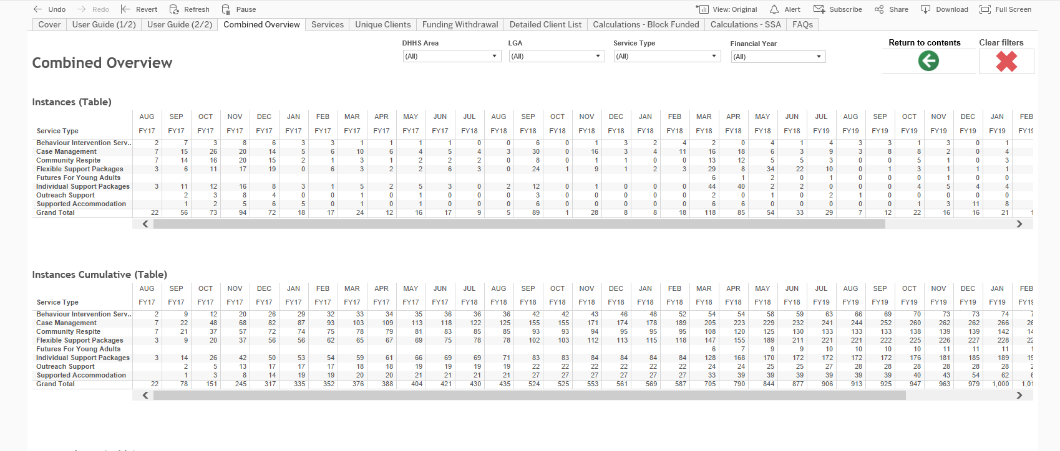
Note: All data used is for illustrative purposes only and is not real data.
Table 1 – Summary forecast by month for the provider (funding) (continued)
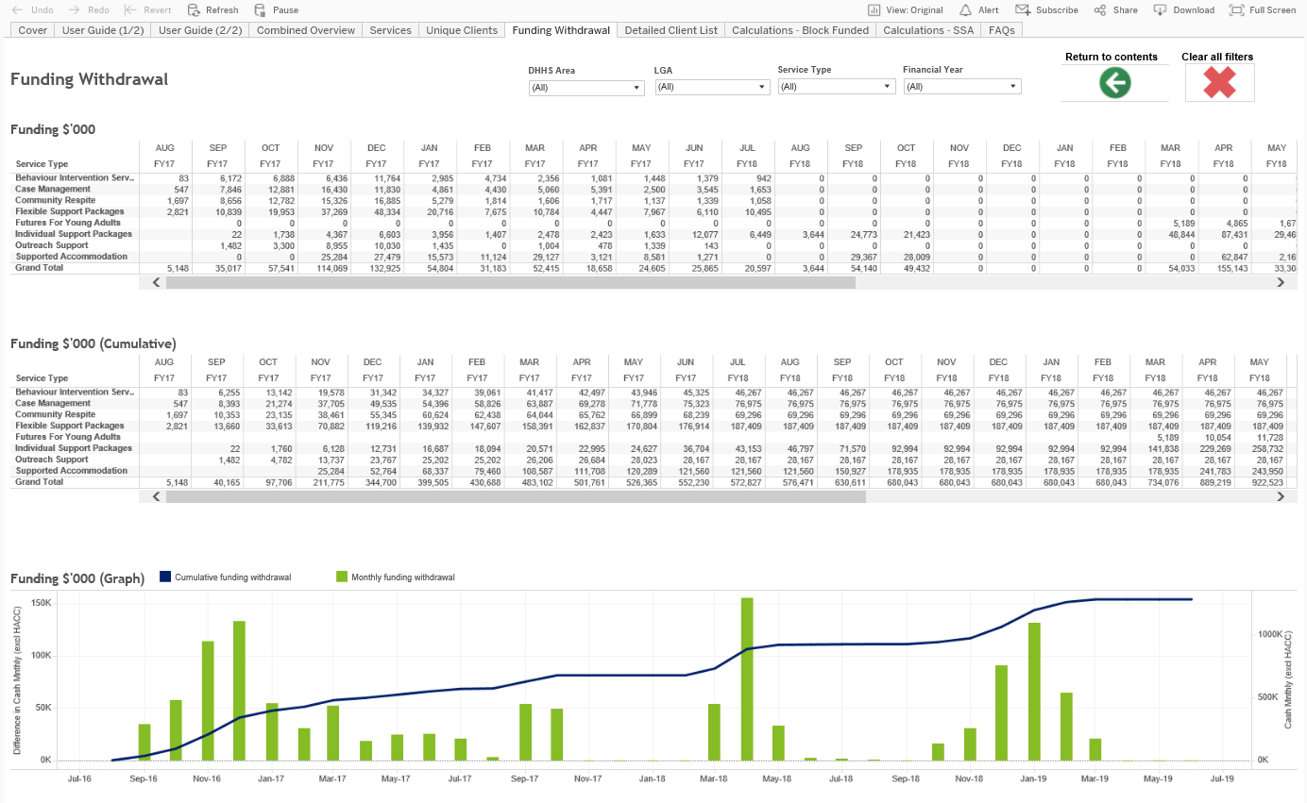
Note: All data used is for illustrative purposes only and is not real data.
Table 2 – Detailed client listing for provider
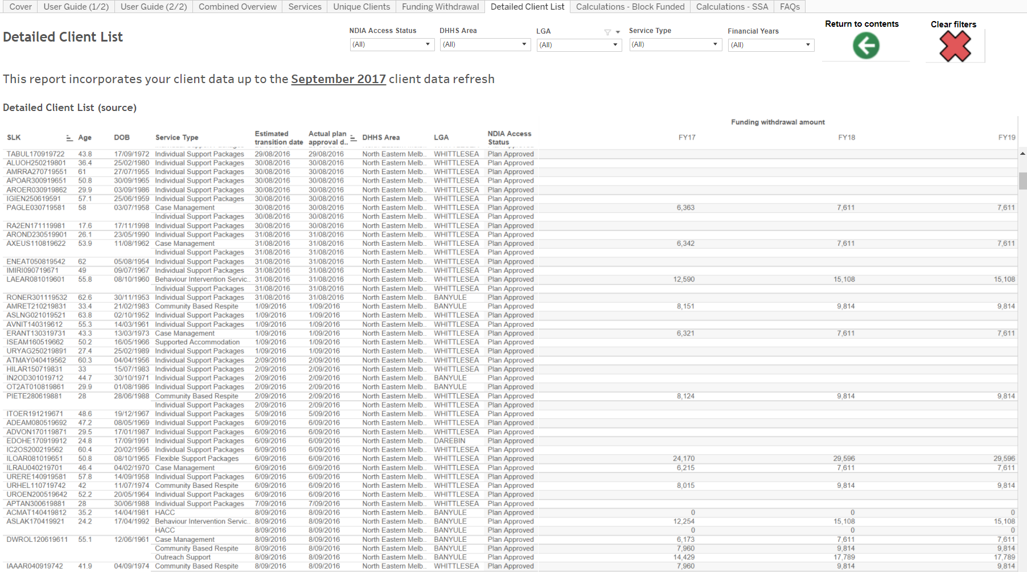
Note: All data used is for illustrative purposes only and is not real data.
Table 3 - Estimated funding withdrawal calculation methodology – supported accommodation

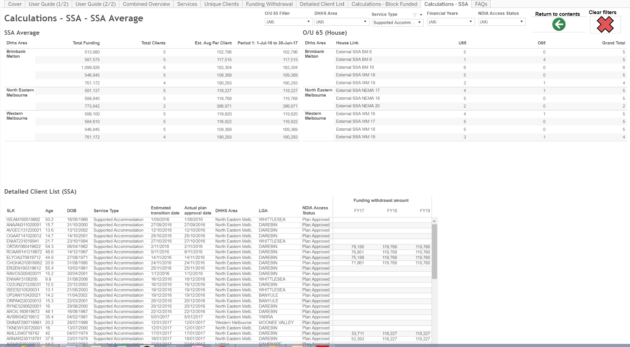
Note: All data used is for illustrative purposes only and is not real data.
Table 4 - Estimated funding withdrawal calculation methodology - block funded disability activities

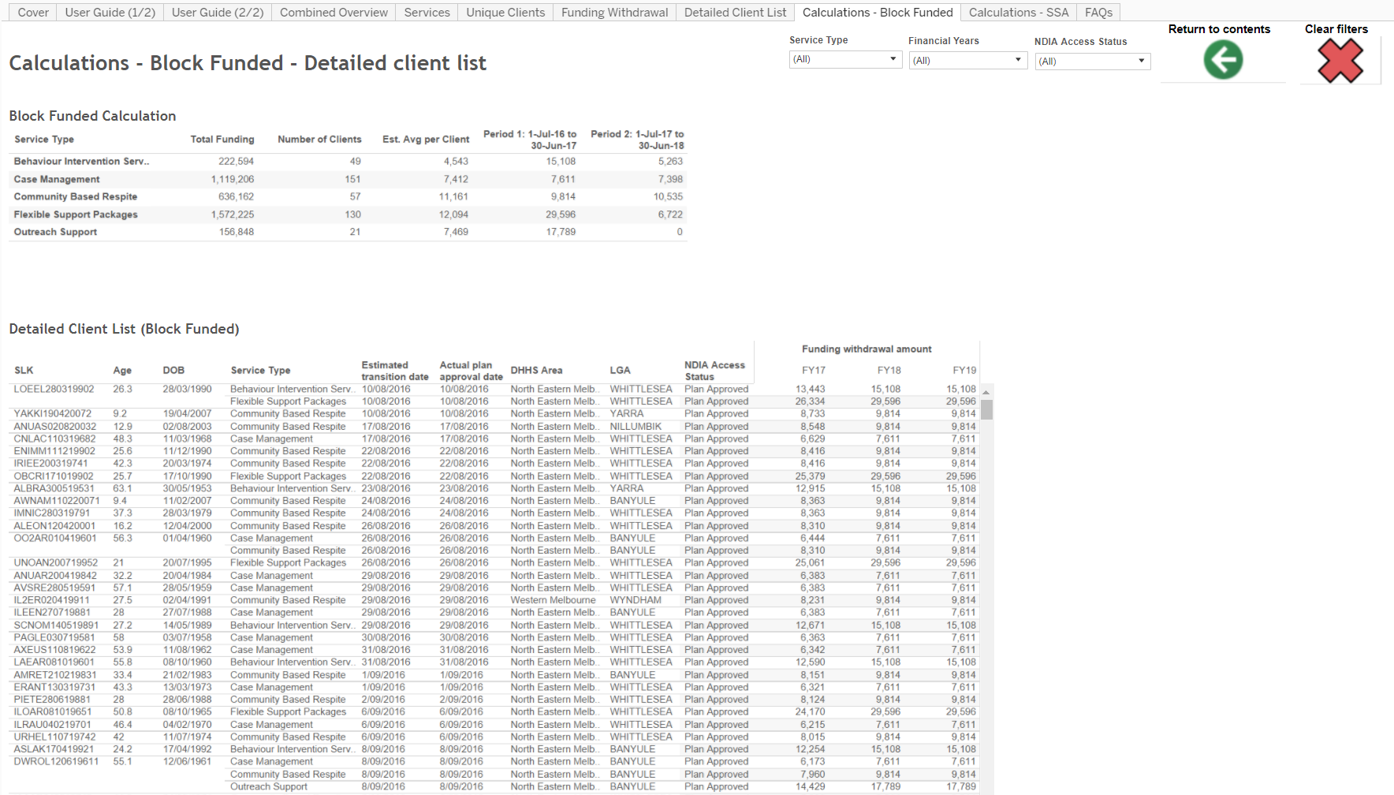
Note: All data used is for illustrative purposes only and is not real data.

Appendix D - more information

Where can I obtain more information on the NDIS?
More information about the NDIS is available through the NDIS website at www.ndis.gov.au or by telephone at 1800 800 110.

The Department of Health and Human Services will be engaging with providers’ peak associations. Questions about registration for the Scheme should be directed to the NDIA at www.ndis.gov.au/providers.

Resources
Victorian NDIS Site
(http://www.vic.gov.au/ndis.html)

Victorian NDIS Site: Phasing Fact Sheets (for North East Melbourne, Central Highlands, Loddon, Inner Gippsland, Ovens Murray, Wimmera South West, Outer Eastern Melbourne, Inner Eastern Melbourne, Hume Moreland and Bayside Peninsula as at January 2018, with others to follow as rollout progresses)
(https://www.vic.gov.au/ndis/rollout-in-victoria.html)

NDIS Provider Toolkit
(https://providertoolkit.ndis.gov.au/)

NDIS Victoria Information and Operational Plan
(https://www.ndis.gov.au/about-us/our-sites/VIC.html)

To receive this publication in an accessible format, please email publishing.services@dhhs.vic.gov.au,, using the National Relay Service 13 36 77 if required.
Authorised and published by the Victorian Government, 1 Treasury Place, Melbourne.
© State of Victoria, Department of Health and Human Services August, 2018.
Available at https://www.vic.gov.au/ndis/service-providers.html

