Appendix 4: Response options following identification and screening of family violence risk and Basic Safety Plan

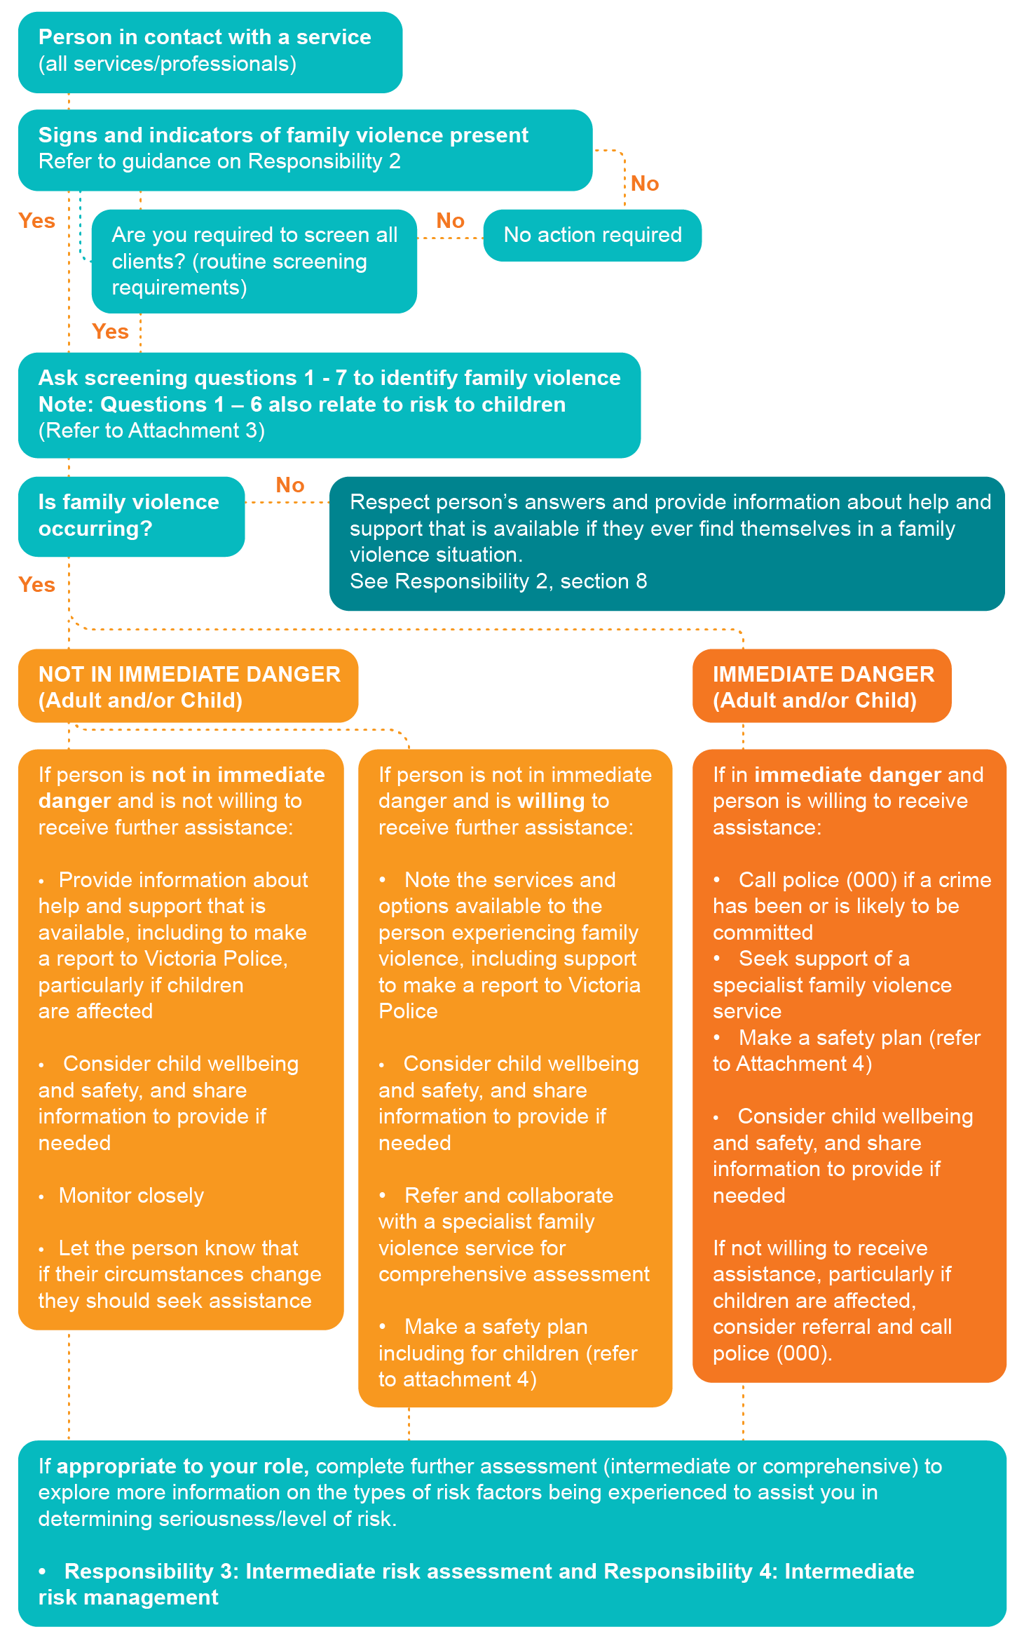

Making a Safety Plan

Safety Planning guide for adults (or older children and young people, if appropriate)
The following are elements of a safety plan and questions you can ask to help the person experiencing family violence make a plan.
Every safety plan will be unique and based on the needs of the adult or young person – you should be guided by the victim survivor on what is important and safe for them in their safety plan.
This guide aims to assist you to discuss what planning and actions can be undertaken safely.

Plan detail and questions to support planning |  | Checklist and detail
Safe place to go
Where are you right now – are you safe?  If you need to leave your home in a hurry, where could you go? |  | Address or name of place:  Address of safe place (if different to above):
Emergency contacts
Would you feel comfortable calling the police (000) in an emergency? (if not - How can we support you to do so?)
☐ Yes ☐ No ☐ N/A
Call 000 in an emergency or Safe Steps on 1800 015 188 or local family violence service on ____________ [insert]
Who are your personal emergency contacts? |  | Name, relationship, contact details
System intervention
Where is the perpetrator right now? |  | (provide details)
Is an intervention order in place (and children named)? |  | ☐ Yes ☐ No ☐ N/A  (provide details)
Support of someone close by
Is there someone close by you can tell about the violence who can call the police? |  | ☐ Yes ☐ No ☐ N/A
Planning for children, older people or people in your care [if applicable]
What would you need to arrange for people in your care? |  | (provide details)
If you have children in your care
 | How many children do you have in your care?  Where are they right now? | (provide details)  (provide details)
Safe Communication
Do you have access to a phone or internet? |  | ☐ Yes ☐ No ☐ N/A  (provide details)
Transport
Do you have access to a vehicle or other public transport options? |  | ☐ Yes ☐ No ☐ N/A  (provide details)
Items to take with you – escape bag
What documents, keys, money, clothes, or other things should you take with you when you leave? What is essential? |  | (provide details)
Financial Access
Do you have access to money if you need to leave? Where is it kept? |  | ☐ Yes ☐ No ☐ N/A  (provide details)

Consent to information sharing
Consent for information sharing and referral:
I ………………………………………………...(name) consent to the collection, use and sharing of my personal information under Part 5A of the Family Violence Protection Act 2008. I understand that my information may be shared without consent if there is a serious threat to myself or another individual’s life, health, safety or welfare.
I also understand that my information may be shared without consent if it is relevant for assessing or managing risks to a child victim survivor of family violence, or to promote the safety or wellbeing of a child or young person. (Note where your information may be shared without your consent, we will endeavour to consult with you on your views and inform you if this occurs).
Signature ……………………………………..…… Date……………………………….
Name (print)………………………………………..
Worker Signature……………………………..….. Date……………………………….
Worker (print)………………………………………
Verbal Consent obtained ……………………… Date……………………………….
Please indicate your preferred contact method:
Mail: ………………………………………………… Email: …………………………….
Phone  Text : ………….. Would you prefer to be called from a private number? ☐ Yes ☐ No
What is the best day and time for us to call?……………………… ……………………………
A message left with an authorised/safe person for you to return the call:……………………
Authorised person contact details: (full name, relationship, telephone:)……………….…………………….……………………………………………………………………………………………………………………………..
………………………………………………………………………………………………………..

Referrals made
Type of organisation | Organisation Name | Contact person | Date of referral | Information sought/shared with
Aboriginal specific service
Child FIRST
Child Protection
Police
Court (Magistrates’ and Children’s Court)
Sexual assault service
Specialist family violence service for adult victim survivors**
Specialist family violence service for perpetrators**
Specialist family violence service for child victim survivors**
The Orange Door
Other
Other
** Specialist family violence services includes services that provide tailored services for Aboriginal people and people from diverse communities and at-risk age groups.

