Survey Standards: Large Brown Tree Frog, Litoria littlejohni

- Purpose
This document outlines the standards required for surveying fauna species listed under the Flora and Fauna Guarantee Act 1988 (FFG Act). These standards detail acceptable survey methods and the minimum survey effort to determine the likelihood of the species’ presence or absence at a site. They also detail appropriate record keeping and reporting standards.

There are two main purposes of these standards.
- To document the information required to determine if a record is valid – i.e. determining presence only. The standards provide the information that is required to enable an assessment to be made as to whether a record can be accepted as a valid record. All records, irrespective of how they are obtained, need to adhere to these standards.
- To document the information required for surveys that aim to determine both presence and absence – i.e. outlining the acceptable level of survey effort required to provisionally infer absence if a species is not detected during a survey. These minimum standards are required to be met by any organisation/group undertaking a presence/absence survey.

Executing and reporting a survey to these standards will support the Department of Sustainability and Environment (DSE) to make an assessment of the validity of a claim to species presence or absence at a site. Subject to DSE approval, alternative survey methods may be applied where the proponent provides an evidence-based rationale for the approach and a detailed description of the survey technique(s) and where the standards are considered to exceed those set out below. Alternatively, rather than undertaking surveys where optimal detection methods and certainty levels are unknown, a habitat-based approach could be taken, whereby the species is assumed to be present if the area provides suitable habitat.

In the context of timber harvesting operations they should be read in conjunction with the Code of Practice for Timber Harvesting and Forest Management Plans. As further information about the species and survey techniques becomes available, these standards will be reviewed and updated.

- Introduction
The Large Brown Tree Frog Litoria littlejohni is a little-known forest-dwelling frog. It is listed as Vulnerable under the Environment Protection and Biodiversity Conservation Act. To date, no federal recovery plan has been prepared. The species is also listed as a threatened taxon under the Victorian FFG Act. An FFG Action Statement has not yet been prepared for this species. There are very few recent, verified records of this species in Victoria. Most records date from the 1960s to the early 1990s, with the most recent record from 1996. It is not known whether the species has undergone a decline in abundance or distribution since that time.

Within Victoria the Large Brown Tree Frog is confined to the portion of East Gippsland between the NSW border and Bruthen. Relatively little is known about the biology of this species, or the likely impact of timber harvesting operations on populations. They are

known to breed in a variety of forest water bodies, including fire dams, slow-moving streams and ponds. Outside of the breeding season, it is unknown how far away from breeding water bodies the frogs move. In the absence of detailed knowledge regarding the non-breeding habitat use of the species, it would be prudent to treat areas up to at least 1 km from water bodies known to be occupied, as potential habitat for the species.

- Requirements to demonstrate presence
Large Brown Tree Frogs have been detected using the following survey methods:
  - Advertisement call surveys: listening for calling males during the breeding season.
  - Spotlight searches: searching around suitable water bodies at night for adult frogs.
  - Tadpoles searches: searching and dipnetting for tadpoles in suitable water bodies during times of year when tadpoles would be expected to be present.

  - Acceptable records
The following types of records are considered acceptable as evidence of the occurrence of the Large Brown Tree Frog at a site:
    - Voucher specimens of adult frogs.
    - Identifiable photographs of adult specimens. Photographs should show morphological features of the frogs adequate for positive identification.
    - Digital or analogue recordings of male advertisement calls confirmed by an agreed expert, or identifiable as Large Brown Tree Frog by comparison to available reference recordings of the species.
    - Voucher specimens of identifiable eggs, tadpoles or metamorphic frogs.

All records require independent verification (by examination of specimens, photographs or recordings) by an experienced amphibian biologist.

  - Expertise required and reporting standards to show presence
The Large Brown Tree Frog is a distinctive species that should be readily identifiable by frog biologists experienced in the identification of Victorian frogs, and with access to up-to- date field guides, and the original paper describing the species (White et al. 1994). There is a small possibility that adults could be confused with the related Jervis Bay Tree Frog L. jervisiensis which, although not known to occur in Victoria, is known from adjacent areas of NSW, and could possibly occur within Victoria. Photographs should be taken of any adults detected during surveys, to provide evidence to back up any tentative field identifications. Consideration should also be given to taking voucher specimens of adult Large Brown Tree Frogs, subject to conservation and ethical considerations, and permit requirements.

The advertisement call of the Large Brown Tree Frog has been described by Martin and Littlejohn (1966) and White et al. (1994). A recording of the call is available from http://frogs.org.au/frogs/species/Litoria/littlejohni/ for reference purposes. Audio recordings of any suspected Large Brown Tree Frog should be collected during surveys, and efforts made to capture calling males in order to confirm identifications made on the basis of calls.

Eggs and larvae could potentially be confused with those of other Litoria species, particularly with several species of the L. ewingii complex that occur within the known Victorian range of the Large Brown Tree Frog. Anstis (2002) provides a description of the tadpole of the Large Brown Tree Frog, which can assist in distinguishing its tadpoles from

those of other sympatic Litoria species. Retention of voucher specimens of tadpoles of the Large Brown Tree Frog collected during any targeted surveys for the species may be necessary to allow independent confirmation of preliminary identifications made in the field, particularly where other corroborating evidence from the site is not available.

The following data are required to support a record of a Large Brown Tree Frog:
- name and contact details of the observer (including indicating that they will make themselves available to escort an independent validator to the site if required);
- permit details of the surveyors (i.e. a research permit under the Wildlife Act, a research permit under the National Parks Act if working within a Park and consent from DSE Land and Fire Division if working in State Forest);
- details of the species present and number of individuals detected;
- date and time of record;
- precise geographic location of record (written location and GPS coordinates);
- photographic evidence of the location with a fixed relocatable feature in the frame to enable validation if required;
- details of the method of obtaining the record, including the sampling effort and equipment used;
- description of the area of water bodies searched;
- prevailing meteorological conditions (rainfall and air and water temperature in particular); and
- documentation of supporting evidence: photograph, call recording or voucher specimen.

This is the core information required for records to be entered onto the Atlas of Victorian Wildlife. Records of all other frog species observed at the site should also be submitted to the Atlas of Victorian Wildlife.

- Requirements to demonstrate presence/absence
While it is relatively straightforward to document the presence of a species, it is more difficult to determine if a species is truly absent if it was not recorded during a survey, or alternatively if the survey was not adequate to reliably record the species if it was present.

Given the paucity of records and survey work that have been undertaken in Victoria for the Large Brown Tree Frog, there is no adequate data available to provide a basis for formally assessing the adequacy of any given level of survey effort, or the relative merits of alternative survey techniques for detecting populations of the species at sites where they occur. Accordingly, surveys which fail to detect the Large Brown Tree Frog need to be interpreted with caution.

Geographic coverage is also an important consideration when assessing the likelihood of detection of the Large Brown Tree Frog. The species’ presence and detectability at any given water body may be dynamic over time. Thus, failure to detect the species at a single water body at a point in time may not reflect the species’ actual status in the general area. All else being equal, surveys that cover more area over more time will incrementally increase the confidence in the survey results.

  - Survey effort
DEWHA (2010) recommended ‘a minimum of four nights under ideal conditions, covering a range of stream structure’, as providing a sufficient level of survey effort for detecting adult Large Brown Tree Frogs, although the basis for this recommendation is not clear. Similarly, dipnet surveys of waterbodies are recommended, including ‘multiple sweeps in pools’, without a more exact specification of required effort, or a justification for these recommendations (DEWHA 2010). Survey guidelines have also been recommended for the Large Brown Tree Frog by Gillespie (2010). These recommendations include surveying potential breeding by listening for calling males, using call playback and spotlighting. Tadpole surveys should be undertaken during the day by sweeping with a fine mesh net.

At present, the probability of detecting the Large Brown Tree Frog using any survey method is not known. Until more information is available, the DEWHA (2010) and Gillespie (2010) recommendations should be followed, as outlined below.

Surveys for adults and tadpoles
- Potential breeding sites (i.e. stationary waterbodies such as forest fire dams, swamps, streamside pools, roadside ditches, quarry sites, tree stump depressions and ephemeral streams) should be located during the day and to facilitate nocturnal sampling.
- Search each waterbody for tadpoles by dragging a dip net though each pool for a set time period, usually 1-2 minutes.
- All potential breeding sites should be investigated after dark for calling individuals.
On reaching the site there should be a 5 minute listening period, followed by call playback. The area should then be thoroughly searched using a headlamp for non- calling individuals.
- Undertake driving transects at night throughout the area, stopping every 500 m to 1 km to listen for frogs calling in the distance. These breeding sites can then be located via triangulation.

The surveys should sample all potential breeding sites within the study area, and should be conducted over multiple days (see below for details) to maximise the probability of detection. Surveys should also extend outside of the immediate proposed area of impact, as occurrences of the species in areas adjacent to the area of consideration may make the presence of an undetected population within the target area more likely. Various elements of timber harvesting operations beyond just the removal of timber, such as elevated sediment input to streams, may also have impacts on populations of Large Brown Tree Frog.

  - Timing considerations
Nocturnal spotlight and calling male surveys
Lemckert and Mahony (2008) provide data on the seasonality of calling activity for the Large Brown Tree Frog, based on data from NSW. However, similar data from the Atlas of Victorian Wildlife provides only five records of calling frogs in Victoria, limiting the conclusions that can be drawn concerning the seasonality of calling activity in Victoria. Both of these data sets are reproduced in Figure 1. Based on the NSW data, it is apparent that, while calling by male Large Brown Tree Frogs has been recorded in all months, there are distinct peaks in calling activity occurring in late summer / early autumn, and late winter

/ early spring. Gillespie (2010) considers June to August is optimal for undertaking call surveys. Because the species probably occurs at low densities, in order to provide a greater level of certainty, Gillespie (2010) recommends that potential breeding sites should be sampled at least once in each month of June, July and August, and after significant rain events in spring and summer.

It is likely that calling and other breeding activities of the species is triggered by heavy rainfall. Accordingly, surveys for adults will probably be more successful if conducted during or soon after periods of heavy rain.

Tadpole surveys
The Atlas of Victoria Wildlife contains only nine records of tadpoles of the Large Brown Tree Frog, recorded during the months of January (three records), February (five records) and October (ten records). Anstis (2002) reports that metamorphosis in NSW populations occurs mainly in December and January, and that the larval period in captivity was 124 days. These observations are consistent with larvae potentially being present in water bodies during much of spring and early summer, although any differences in seasonality of tadpole development between NSW and Victoria populations are unknown. Accordingly, tadpole surveys should be carried out during spring and early summer in order to maximise the chances of successfully detecting tadpoles of the Large Brown Tree Frog. For optimal results Gillespie (2010) recommends that tadpole sampling should be undertaken a minimum of twice; in August and October.

  - Reporting standards for presence/absence surveys
Surveys conducted for the Large Brown Tree Frog should be properly and thoroughly documented to allow assessment of their adequacy. Should data subsequently become available that allows a more rigorous assessment of survey adequacy, any previous survey results can be re-assessed in light of such data.

The core data required for the “presence only” reporting also needs to be provided for the presence/absence surveys (refer section 3.2). Additional data required to document presence/absence surveys is outlined below. This information needs to be provided for all surveys, including those that did not detect the species.
- date and times of all surveys;
- survey methods and equipment used (i.e. type of nets);
- duration of survey and search effort for each method; and
- extent of the area searched for frogs.

References

Anstis, M. (2002) Tadpoles of South-eastern Australia: A Guide with Keys. Reed New Holland, Frenchs Forest NSW.
DEWHA (2010) Survey Guidelines for Australia’s Threatened Frogs. Guidelines for detecting frogs listed as threatened under the Environment Protection and Biodiversity Conservation Act 1999. Department of Environment, Water, Heritage and the Arts, Canberra.
Gillespie, G.R. (2010) Survey methods for the Large Brown Tree Frog Litoria littlejohni and Giant Burrowing Frog Heleioporus australiacus. Unpublished report commissioned by Biosis Research.
Lemckert, F. (2004) The biology and conservation status of the heath frog Litoria littlejohni.
Herpetofauna 34: 99-104.
Lemckert, F. (2010) Habitat relationships and presence of the threatened heath frog Litoria littlejohni (Anura: Hylidae) in central New South Wales, Australia. Endangered Species Research 11: 271-278.
Lemckert, F. & Mahony, M. (2008) Core calling periods of the frogs of temperature New South Wales, Australia. Herpetological Conservation and Biology 3: 71-76.
Martin, A.A. & Littlejohn, M.J. (1966) The breeding biology and larval development of Hyla jervisiensis (Anura: Hylidae). Proceedings of the Linnean Society of New South Wales 91: 47-57.
White, A.M., Whitford, R.W. & Mahony M.J. (1994) A new species of Litoria (Anura: Hylidae) from Eastern Australia. Proceedings of the Linnean Society of New South Wales 114: 3-10.

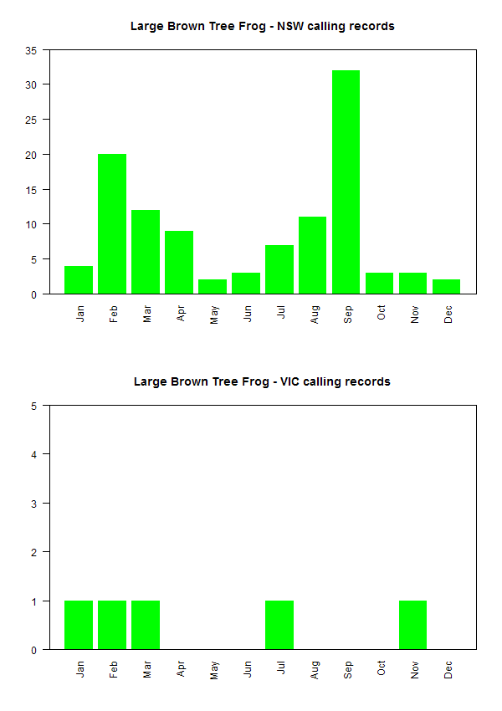
Figure 1. Seasonality of calling activity for the Large Brown Tree Frog from NSW (data obtained from Lemckert and Mahony, 2008), and from Victoria (data obtained from the Atlas of Victorian Wildlife.

