Survey Standard: Long-footed Potoroo, Potorous longipes

- Purpose
This document outlines the standards required for surveying fauna species listed under the Flora and Fauna Guarantee Act 1988 (FFG Act). These standards detail acceptable survey methods and the minimum survey effort to determine the likelihood of the species’ presence or absence at a site. They also detail appropriate record keeping and reporting standards.

There are two main purposes of these standards.
- To document the information required to determine if a record is valid – i.e. determining presence only. The standards provide the information that is required to enable an assessment to be made as to whether a record can be accepted as a valid record. All records, irrespective of how they are obtained, need to adhere to these standards.
- To document the information required for surveys that aim to determine both presence and absence – i.e. outlining the acceptable level of survey effort required to provisionally infer absence if a species is not detected during a survey. These minimum standards are required to be met by any organisation/group undertaking a presence/absence survey.

Executing and reporting a survey to these standards will support the Department of Sustainability and Environment (DSE) to make an assessment of the validity of a claim to species presence or absence at a site. Subject to DSE approval, alternative survey methods may be applied where the proponent provides an evidence-based rationale for the approach and a detailed description of the survey technique(s) and where the standards are considered to exceed those set out below.

These standards should be read in conjunction with the Action Statement for this species. In the context of timber harvesting operations they should be read in conjunction with the Code of Practice for Timber Harvesting and Forest Management Plans. As further information about the species and survey techniques becomes available, these standards will be reviewed and updated.

- Introduction
The Long-footed Potoroo is listed under the Flora and Fauna Guarantee Act, and categorised as Endangered in Victoria (DSE 2007). An Action Statement has been prepared (DSE 2009). Nationally, the species is listed as Endangered under the Environmental Protection and Biodiversity Conservation Act 1999. There is a national recovery plan (Nunan et al. 2000). There are forest management prescriptions for this species under the East Gippsland, North East and Central Gippsland Forest Management Plans.

The Long-footed Potoroo is known from three apparently disjunct populations, with the main two populations restricted to Victoria: 1) in East Gippsland where they occur across about 200,000 ha between the Snowy and Bemm Rivers; and 2) straddling the Great Dividing Range, occurring in the upper Ovens and Mitchell River catchments in the north-east and Gippsland, respectively.

Long-footed Potoroos occupy home ranges of between 20 and 90 ha. Preferred habitat includes Damp Forest, Wet Forest and Lowland Forest, while drier forest types are less

preferred. They utilise a range of forest age classes and the common element appears to be a well developed understorey providing plenty of cover.

- Requirements to demonstrate presence
Long-footed Potoroos have been detected by using a range of mammal survey techniques. The most commonly used techniques are camera trapping, hair-tube surveys and live capture in cage traps. Of these techniques, camera trapping is the most efficient and cost-effective method of detecting Long-footed Potoroos.

  - Acceptable records
- Camera trapping – clearly identifiable images of Long-footed Potoroos obtained from remote cameras deployed at survey sites, with the identification confirmed by an independent expert.

- Hair tubing – identification of Long-footed Potoroo hair samples by an experienced mammal hair analyst. Where doubt exists as to the identity of the species from which the hair was obtained, hair records should not be accepted as evidence of occurrence of the species at a site. Hair samples should be archived, to enable independent confirmation of identifications.

- Cage trapping – observation of captured Long-footed Potoroos in cage traps by experienced individuals able to confidently identify the species. Such records should be evidenced by photographs to ensure reliability of identification and allow independent confirmation.

  - Non-acceptable records
The following are not considered acceptable records:
- Sightings of individuals, without supporting evidence.
- Observations of suspected Long-footed Potoroo diggings, scats and footprints as diggings, scats and footprints made by this species cannot be reliably distinguished from those of Long-nosed Potoroos P. tridactylus and bandicoots.
- Long-footed Potoroo remains obtained from predator (dog or fox) scats as the location where the Long-footed Potoroo was consumed may be some distance from the site where the remains were found.

  - Reporting standards to show presence
The following data are required to support a record of a Long-footed Potoroo:
- name and contact details of the observer (including indicating that they will make themselves available to escort an independent validator to the site if required);
- permit details of the surveyors where required (i.e. if undertaking trapping or hair- tubing, a research permit under the Wildlife Act is required, as well as a research permit under the National Parks Act if working within a Park and consent from DSE Land and Fire Division if working in State Forest);
- details of the species present, number of individuals detected or number of photographs;
- date and time of record;
- precise geographic location of record (written location and GPS coordinates);

- photographic evidence of the location with a fixed relocatable feature in the frame to enable validation if required;
- method of obtaining the record, including the sampling effort (e.g. number of camera trap-nights, number of hair-tube nights);
- supporting evidence: remote camera surveys and cage trapping rely on correctly identifying Long-footed Potoroos, either by direct observation (cage trapping) or from digital images (remote cameras). Long-footed Potoroos need to be distinguished from similar species such as Long-nosed Potoroos and bandicoots. Clear photographs are to be submitted to allow independent confirmation of the identification.
- for hair-tube records, the name and expertise of the person identifying the hair is required, along with a written description of how the identification was made. The identification of Long-footed Potoroo hairs by microscopic examination of hair morphology is a highly specialised skill, that requires expert knowledge of hair morphology and the ability to reliably distinguish hair from similar species. Hair samples should be archived for further examination if required.
This is the core information required for records to be entered onto the Atlas of Victorian Wildlife. Records of all other species observed at the site should also be submitted to the Atlas of Victorian Wildlife.

- Requirements to demonstrate presence/absence
While it is relatively straightforward to document if a species is present, it is more difficult to determine that a species is truly absent if it was not recorded during a survey, or if the survey was not adequate to reliably record the species if it was present. The following section outlines the survey requirements needed for there to be confidence that if a species is not recorded it is absent. While there can never be complete certainty that a species is absent, DSE will accept, for planning purposes, that the species is effectively absent if surveys are undertaken to the following specifications.

  - Survey effort and resulting level of certainty
Camera trapping
Camera-trap data can be readily analysed using statistical methods developed by MacKenzie et al. (2002) to estimate the probability of detecting potoroos on occupied sites (i.e., sites where potoroos actually occur) during a single survey. This estimate provides a basis for assessing the likelihood that potoroos may have been present at some survey sites but were not detected during the survey.

The performance of remote camera surveys in detecting Long-footed Potoroos has been assessed for the Great Dividing Range population (Lumsden et al. 2010, in prep.). Using two remote cameras, set 100 m apart, at survey sites for approximately 3 weeks, the probability of detection was assessed using an occupancy modelling approach. Two different types of remote cameras were used in these studies, and some minor differences in detection probability were noted between the two camera types. The inferred relationships between the duration of the remote camera surveys and the overall probability of detection is depicted in Figure 1.

To determine the required duration of remote camera surveys for establishing presence/absence with 95% certainty, a conservative approach has been taken by basing these inferences on the lowest of the available estimates of detection probability shown in Figure 1. The lowest estimate was for surveys conducted using two Trailmac cameras during December, where the required number of consecutive days of camera trapping to achieve a 95% chance of detecting Long-footed Potoroos if they are present was 30 days (with 95% confidence intervals of 20, 45).

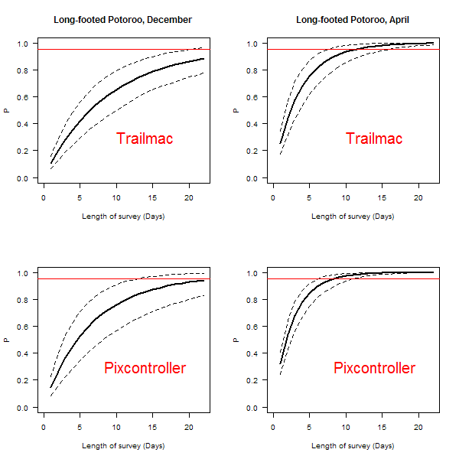

Figure 1. Relationships between number of days that a pair of remote cameras were deployed at a site, and the probability of detecting Long-footed Potoroos in the Great Dividing Range population. Results are given for two times of year (December and April) and for two remote camera models (Pixcontroller and Trailmac).

Camera trap surveys to obtain a 95% certainty of detection can be carried out at significantly less cost that other types of surveys for Long-footed Potoroos. Accordingly, camera trap surveys are the most cost-effective and reliable survey technique which have been identified thus far for Long-footed Potoroos, and are the recommended survey technique. Camera

surveys can be conducted throughout the year, however, due to seasonal variability in detection probability, if sampling is being undertaken during late spring - early summer the cameras need to be left in place for 30 days. During autumn, a 21 day period is adequate. Detection probability at other times of the year is unknown, however, in general cameras should be left in place for between 21 and 30 days. The recommended bait is a mixture of peanut butter, rolled oats and golden syrup, with pistachio essence added to simulate the odour of underground fungi.

Information concerning the home range sizes of individual Long-footed Potoroos are used to determine the geographic area this sampling design covers. The average home range size (95% kernel) of 12 radiotracked individuals in the East Gippsland and Great Dividing Range populations was 22 ha (Green et al. 1998). Individuals are likely move throughout most of their home range within a 3 week period. Therefore it is considered that one site, consisting of two cameras set approximately 100 m apart, will adequately sample an area of 22 ha.

Detection probability using cameras for Long-footed Potoroos in East Gippsland has not yet been calculated. Until such studies are undertaken, it will need to be assumed that detection probabilities are similar to those of the Great Dividing Range population. Survey methods evaluated in one part of a species’ range may not work as well as expected in another part of the species range, due to differences in animal densities or behaviour. Accordingly, the quantitative assessments provided here may overestimate or underestimate the ability of these survey techniques to detect Long-footed Potoroos in other parts of their geographic range.

Hair-tubes
Hair-tubes (baited devices containing adhesive tape which captures hair from fauna investigating baits) have been widely used in the past for surveying Long-footed Potoroo populations. Various designs of tube have been employed (e.g. handiglaze, Faunatech), with bait the same as for the camera surveys.

An assessment of the probability of detecting Long-footed Potoroos using hair-tubes has been undertaken in the Great Dividing Range population of the species (Lumsden et al. 2007). There was considerable variation in the detection probabilities associated with this survey methodology between years, and also large uncertainties in the estimates of detection probability. Under the lowest detection probability scenario, the most likely number of repeat two-week hair-tube surveys required to achieve an overall 95% probability of detection is 13 surveys (refer to Appendix 1 for details). Meeting such a requirement would require an extraordinarily high level of survey effort, and is likely to be prohibitively costly, both in time and resource requirements. As a result, hair-tubing is not recommended for surveys aimed at reliably detecting Long-footed Potoroos, or when trying to establish that the species is absent from a site.

Cage traps
Large treadle operated cage traps can be used to detect Long-footed Potoroos. No systematic assessment has been made of the trapping effort required to be confident of detection. However, the effort required is likely to be large. At Bellbird in East Gippsland, where the species is known to be present, a grid of 100 traps set in 10 lines at approximately 50 m intervals and checked daily for 5 days (i.e. 500 trap nights) routinely yields only one or two individuals and sometimes none for the whole session. Establishing a trapping grid is also

very labour intensive. Thus, trapping is not recommended as a general survey technique, although it remains the best method for intensive ecological studies.

  - Reporting standards for presence/absence surveys
In order to assess the adequacy of surveys conducted for Long-footed Potoroos, proper documentation of survey effort is essential. This is particularly the case for survey methods where reliable quantitative assessments of survey effort can be made (i.e. camera trap and hair-tube surveys), where data concerning survey effort (number of survey devices and survey duration) is essential for assessing survey adequacy.

The core data required for the “presence only” reporting also needs to be provided for the presence/absence surveys (refer section 3.3). Additional data required to document presence/absence surveys is outlined below. This information needs to be provided for all surveys, including those that did not detect the species.

Camera surveying:
- details of the number and type of cameras deployed;
- positioning of camera;
- camera settings;
- GPS coordinates of each camera location and distance between cameras;
- type of bait used; and
- evidence of the length of time the cameras remained operational (which may be less than the full duration of the deployment in cases of camera malfunction, battery exhaustion or camera storage media exhaustion)

Hair-tubing:
- number and location of hair-tubes;
- type of hair-tube;
- type of bait used; and
- duration for which hair-tubes were deployed;

Cage trapping:
- number, type and location of traps deployed;
- duration of the deployment; and
- frequency of checking of traps.

Appendix 1. Assessing detection probability from hair-tube surveys

Lumsden et al. (2007) assessed the efficacy of arrays of hair-tubes for detecting Long-footed Potoroos from the North-eastern Victorian/Great Divide population of the species. They conducted two successive hair-tube surveys at a total of 50 sites, including 25 sites located in existing Special Management Areas (SMAs) with records of Long-footed Potoroos, and 25 sites close to the SMAs, in adjacent areas of presumed suitable habitat. Surveys involved deployment of 50 handiglaze hair-tubes at each site, for approximately 14 days. Tubes were arranged in a grid pattern, with lines of tubes placed approximately 20 m apart, and at intervals of 50 m along the lines. Each site was subjected to two consecutive rounds of sampling, so that detection probabilities could be inferred using the method of MacKenzie et al. (2002).

There was considerable variation in the detection probabilities associated with this survey methodology between years, and also large uncertainties in the estimates of detection probability, possibly as a consequence of the relatively small sample sizes on which their inferences were based (Lumsden et al. 2007). Based on these results, it is possible to infer the probability of detecting Long-footed Potoroos after a given number of hair-tube surveys, based on the single-survey estimates of detection probability provided by Lumsden et al. (2007), using the following equation (Kéry, 2002):

P=1-(1-p)n

Where, p is the single survey probability of detection and P is the overall probability of making at least one detection after n surveys have been conducted. For each of the four estimates of single-survey detection probability provided by Lumsden et al. (2007), the corresponding inferred relationships between number of surveys and overall probabilities of detection are depicted in Figure 2. Essentially, these results show that the required number of repeat hair-tube surveys to establish presence-absence with a high degree of certainty is itself rather uncertain, as the estimates varied between years, and between surveys within years.

In the face of this uncertainty, a prudent and conservative approach would be to assess required survey effort on the basis of the lowest available estimate of single-survey detection probability. The lowest estimate was that associated with the second round of hair-tube surveying in 2005, where a single survey detection probability of 0.210 was inferred, with 95% confidence intervals (0.037, 0.570).

Under this worst case detection probability scenario, the most likely number of repeat two- week hair-tube surveys required to achieve an overall 95% probability of detection is 13, with 95% confidence intervals (4-79), calculated from the single-survey detection probability using the equations provided by McArdle (1990). Meeting such a requirement would require an extraordinarily high level of survey effort, as each repeat-survey takes two weeks, with site visits between each repeat survey in order to collect hair samples from the hair-tubes and renew baits. Such a level of survey effort is likely to be prohibitively costly, both in time and resource requirements.

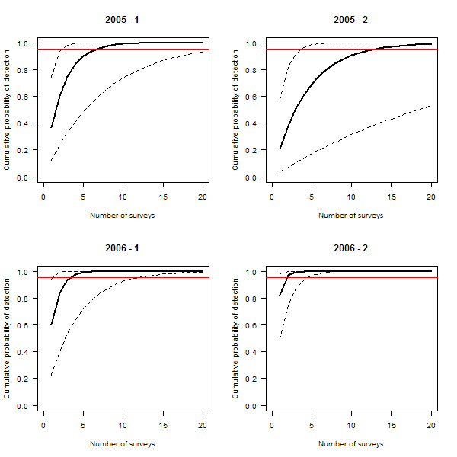

Figure 2. Relationships between number of hair-tube surveys (i.e. 50 hair-tubes set for 2 weeks) and probabilities of detection, under four different estimates of detection probability. Horizontal red lines denote a detection probability of 0.95.

References

DSE (2007). Advisory List of Threatened Vertebrate Fauna in Victoria – 2007. Department of Sustainability and Environment, East Melbourne, Victoria.
DSE (2009). Flora and Fauna Guarantee Act 1988 Action Statement No. 58 – Long-footed Potoroo. Department of Sustainability and Environment, East Melbourne.
Green, K., Mitchell, A.T. and Tennant, P. (1998). Home range and microhabitat use by long- footed potoroos, Potorous longipes. Wildlife Research 24: 357-372.
Kéry, M. (2002). Inferring the absence of a species – a case study of snakes. Journal of Wildlife Management 66: 330–338,
Lumsden, L., Scroggie, M., Chick, R., Grgat, L., Woodford, L., Bush, A., Alexander, J. and Robley, A. (2007). Assessing Management Strategies and Wildfire Impact on Long-footed Potoroos in north-eastern Victoria. 2nd Progress Report. Results from 2004/05 and 2005/06. Arthur Rylah Institute for Environmental Research, Department of Sustainability and Environment, Heidelberg, Victoria.
Lumsden, L., Chick, R., Scroggie, M., Howard, K., Woodford, L., Douglas, A., Alexander, J.
& Pascoe, C. (2010). Assessing management strategies and wildfire impacts on Long- footed Potoroos in the Great Dividing Range area. 4th Progress Report. Draft report, Arthur Rylah Institute for Environmental Research, Department of Sustainability and Environment, Heidelberg, Victoria.
Lumsden, L., Chick, R., Scroggie, M., Howard, K., Woodford, L., Douglas, A., Alexander, J.
& Pascoe, C. (in prep.). Assessing management strategies and wildfire impacts on Long- footed Potoroos in the Great Dividing Range area. Final report. Draft report, Arthur Rylah Institute for Environmental Research, Department of Sustainability and Environment, Heidelberg, Victoria.
McArdle, B.H. (1990). When are rare species not there? Oikos 57: 276-277.
MacKenzie, D.I., Nichols, J.D., Lachman, G.B., Droege, S., Royle, J.A. and Langtimm, C.A. (2002). Estimating site occupancy rates when detection probabilities are less than one. Ecology 83: 2248-2255.
Nunan, D., Henry, S. & Tennant, P. (2000). Long-footed Potoroo Recovery Plan.

