The Victorian Government has a new symbol to help Victorian families find a kindergarten. It’s called the Kinder Tick.

You will see this symbol when you come into a building that has a kindergarten or early childhood service. You might also see this symbol on their website.

These kindergarten services are really important for children’s education.

The Kinder Tick looks like this.

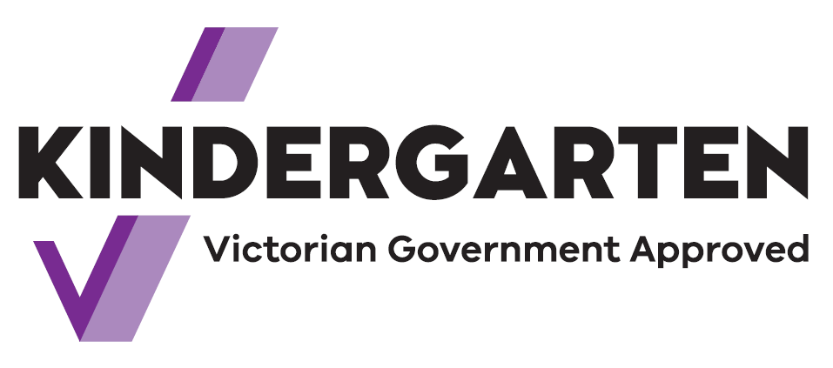

The tick means that the services are funded by the Victorian Government.

Your children will learn from qualified teachers through play.

For example, they will learn about language, numbers and patterns. They will learn how to make friends, share and listen. They will also gain other skills to help them get ready for school.

From 2022, Victorian children can attend two years of kindergarten before school.

A kindergarten program can be a part of childcare. It can also be a separate program.

Look for the Kinder Tick sign in your community. Speak to the teachers at the kindergarten if you need more information.