**House rules**

**This section includes:**

**1. House Rules**

**2. Pet Request Form**

**Specialist Disability  
Accommodation House Rules**

# House Rules

The following House Rules that relate to your SDA dwelling, have been developed by the Specialist Disability Accommodation (SDA) provider and are intended to be supplementary to any House Rules that the residents and Supported Independent Living (SIL) provider develop. The following relate to general operating of the SDA dwelling and requirements under the Residential Tenancies Act 1997 (RTA).

## Accessing the house and other resident’s bedrooms

Before entering other people’s bedrooms, you must ask their permission. Where applicable (such as in a duplex arrangement) you can only enter if you have been invited and via the front door, even if your SIL provider can freely access the other dwelling internally.

The RTA gives the SDA provider authority to enter bedrooms without permission when there are urgent repairs required.

## Changing bedroom protocol

All tenantable bedrooms are numbered and align with the relevant property evacuation plan. As the bedroom numbers are described in your SDA residential agreement, switching bedrooms requires you to enter into a new SDA residential agreement with the SDA provider.

You are only able to switch bedrooms where the SDA provider has provided written approval, and this can be requested by emailing [myhome@homes.vic.gov.au](mailto:myhome@homes.vic.gov.au) with the following information:

1. Name of resident
2. Current room number
3. Proposed new room number
4. Reason for the move

Once received, the SDA provider will consider the request and advise of the outcome. If agreed, the SDA provider will forward a termination of your current SDA Residency Agreement and a new SDA Residency Agreement for your new bedroom.

## Modifying the property

You must not modify the SDA dwelling, unless permission from the SDA Provider is received. This includes where funding may come from the NDIS and/or where a recommendation is provided by a subject matter expert, such as an occupational therapist. Examples of modifications requiring consent include the installation of locks and grab rails and changing of flooring or the toilet. If you would like to self-fund or request the department to fund a modification to the SDA dwelling, you can make a request by emailing [SDA.coordinator@homes.vic.gov.au](mailto:SDA.coordinator@homes.vic.gov.au). An SDA Coordinator will contact you to discuss the request.

## Other charges

You are responsible for ordinary usage of utilities (gas, electricity and water). There may be additional costs, such as Pay TV, internet and cost related to pets that may or may not be applicable. Your SIL provider will assist you with understanding and organising for payment where required.

## Pets and assistance animals

If you want to keep a pet, you must have consent from the SDA provider and all other residents of the SDA dwelling. To request consent from the SDA provider, send a completed Pet Request Form to [SDA.coordinator@homes.vic.gov.au](mailto:SDA.coordinator@homes.vic.gov.au), refer Attachment 8.

A separate Pet Request Form must be completed for each pet you want to keep. Please note, for an assistance pet (a dog that is trained to perform tasks that help a person with a disability to reduce the effects of their disability) you are not required to complete a Pet Request Form.

If you already have a pet living with you must complete and return a Pet Request Form for each pet to [SDA.coordinator@homes.vic.gov.au](mailto:SDA.coordinator@homes.vic.gov.au)

All charges, including any modifications required to the SDA dwelling to accommodate your pet, cleaning charges, essentials (food, council registration and equipment), and compliance with local council laws are your responsibility and not the responsibility of the SDA provider. An exception to this rule would be where reasonable capital modifications are required to accommodate a certified assistance animal (most commonly dog guides). Any request for such modifications must be forwarded to [SDA.coordinator@homes.vic.gov.au](mailto:SDA.coordinator@homes.vic.gov.au). The Pet Request Form and more information can be found at <https://www.consumer.vic.gov.au/housing/renting/applying-for-a-rental-property-or-room/pets-and-renting>

## Pool / Spas

Fixed and portable pools / spas that have a capacity to hold water in excess of 300mm in depth and which require council registration **must not** be installed.

## Portable heater

Portable heating appliances must not be used or stored in the SDA dwelling, except where alternatives are not practicable and the SDA provider has consented in writing to the use of the appliance. The SDA provider may consent to the use of oil filled column heaters or electric panel heaters which have an over heat cut out device fitted. Individual portable heating appliances that have been approved for installation by the SDA provider, must be permanently fixed in position, and installed in accordance with the manufacturer’s specifications and, if applicable, the relevant Australian Standards. Your SIL provider must check each approved heating appliance on a weekly basis to ensure compliance and maintain records of these checks.

All approved heating appliances must be inspected and tested in accordance with the AS/NZS3760.

Electric blankets must not be used or stored in department owned SDA.

Solid fuel burning appliances and open fireplaces must not be used in department owned SDA.

|  |
| --- |
| To receive this document in another format, phone 1300 161 485, using the National Relay Service 13 36 77 if required, or email [myhome@homes.vic.gov.au](mailto:myhome@homes.vic.gov.au)  Authorised and published by the Victorian Government, 1 Treasury Place, Melbourne.  © State of Victoria, Australia, Department of Families, Fairness and Housing, February 2021. |

**Pet request form**

***Residential Tenancies Act 1997*, section 71B**

**Information for tenants and landlords**

Tenants must use this form to ask their landlord for consent to keep a pet at the rented premises. Landlords can only refuse a pet request if the Victorian Civil and Administrative Tribunal (VCAT) orders it is reasonable to do so.

A pet means any animal except an assistance dog (a dog that is trained to perform tasks that help a person with a disability to reduce the effects of their disability).

**Information for the tenant**

Complete a separate form for each pet you want to keep and give the completed form/s (including this information page) to your landlord. Keep a copy of the form and the details of how you gave the request, for your own records.

Your landlord cannot unreasonably refuse to give you consent. If they want to object to you keeping the pet, your landlord will need to apply to VCAT within 14 days (starting the day after they receive the form) for an order that they may refuse on reasonable grounds. It will be up to VCAT to decide if this type of order should be made. See ‘What can VCAT order?’ below.

If your landlord does not apply to VCAT within this 14-day period, the landlord’s consent is taken to be granted. It may take several days for you to receive a copy of any VCAT application.

**Information for the landlord**

If you consent to this pet request, it is recommended that you notify the tenant in writing. Tick the relevant box in section 6 and send the form back to the tenant, keeping a copy for your records.

Under the law, you must not unreasonably refuse consent for a tenant to keep a pet on the rented premises. If you want to refuse, you **must** apply to VCAT within 14 days (of the day after you receive this form). VCAT will hold a hearing and consider your application. See ‘What can VCAT order?’ below.

To apply, visit the [VCAT Residential Tenancies Hub](https://www.vcat.vic.gov.au/RTHub) (vcat.vic.gov.au/RTHub) or call 1300 01 8228.

Complete section 6 of this form, to tell your tenant whether you consent or whether you have applied to VCAT to refuse consent. Send the form back to the tenant, and keep a copy for your records.

If you do not apply to VCAT within the 14-day period, this will mean you have consented to the pet request, even if you have not given consent in writing.

**What can VCAT order?**

VCAT can order that:

the tenant may keep the pet on the premises, **or**

it is reasonable for the landlord to refuse consent to the pet request, and/or the pet is excluded from the premises.

When making its decision, VCAT may consider:

the type of pet the tenant wants to keep, or is keeping

the character and nature of the premises the tenant is renting

the character and nature of the appliances, fixtures and fittings in the premises

other relevant laws (for example, if the pet is prohibited by a local council law)

anything else VCAT considers relevant.

If VCAT makes an order excluding the pet from the premises, the order will include a date for the tenant to comply with the order. If the tenant has not complied with the order within 14 days of that date, the landlord may serve them with a notice to vacate, giving a minimum of 28 days’ notice.

**If a tenant keeps a pet without consent**

If a landlord reasonably believes a tenant is keeping a pet on the premises without consent, they can apply to VCAT for an order to exclude the pet from the premises. See ‘What can VCAT order?’ above.

**Does this form apply to me?**

New laws on pets in rental properties commenced on 2 March 2020. Tenants do not need to request consent for pets that were already present in the rented premises before this date.

After 2 March 2020, tenants who want to bring a new pet into the property must use this form to request consent. It does not matter what date the tenancy agreement started.

**Help or further information**

For more information, visit [Pets and renting – Consumer Affairs Victoria website](https://www.consumer.vic.gov.au/petsrenting) (consumer.vic.gov.au/petsrenting) or call Consumer Affairs Victoria on 1300 55 81 81.

If you want legal advice you can contact one of the community legal organisations listed at [Who to go to for help – Consumer Affairs Victoria website](https://www.consumer.vic.gov.au/whotogoto) (consumer.vic.gov.au/whotogoto).

Information about renting is available in other languages at [Other languages – Consumer Affairs Victoria website](https://www.consumer.vic.gov.au/languages) (consumer.vic.gov.au/languages).

**Telephone Interpreter Service**

If you have difficulty understanding English, contact the Translating and Interpreting Service (TIS) on 131 450 (for the cost of a local call) and ask to be put through to an Information Officer at Consumer Affairs Victoria on 1300 55 81 81.

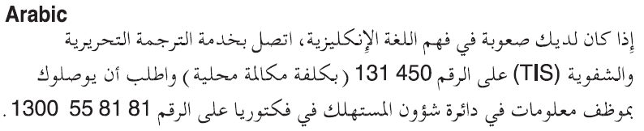

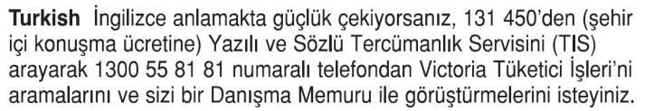

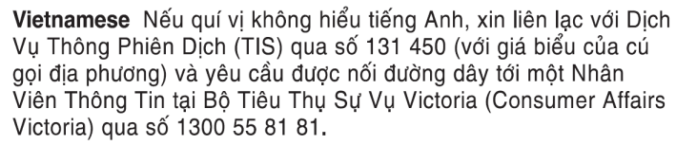



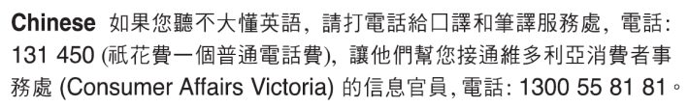

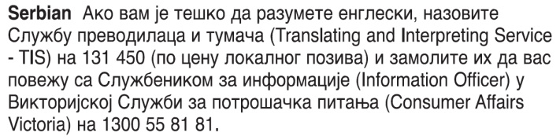







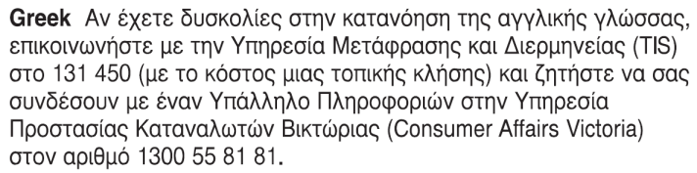

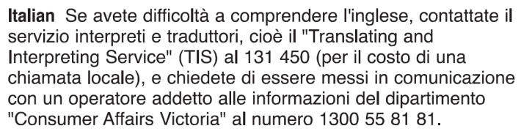

**Pet request form**

**1 Tenant details**

Tenant/s name/s:

|  |
| --- |
|  |

Address of rented premises:

|  |
| --- |
|  |

Tenant/s address for serving documents *(can be email address if tenant has consented to electronic service)*:

|  |
| --- |
|  |

**2 Landlord details**

Landlord/s name/s:

|  |
| --- |
|  |

Landlord/s address for serving documents *(can be email address if landlord has consented to electronic service, and can be agent’s address)*:

|  |
| --- |
|  |

**3 Pet details**

I am asking to keep the following pet at the rented premises.

*Complete a separate form for each pet. If you do not yet have a specific pet, complete as much information as you can about the kind of pet you intend to keep at the rented premises.*

Animal type *(including breed and species if known)*:

|  |
| --- |
|  |

Pet name *(if known)*:

|  |
| --- |
|  |

Identifying details *(if known – e.g. registration number, microchip number, sex, fur colour/length, other features)*:

|  |
| --- |
|  |

Other information you would like to share about the suitability of the pet being kept on the premises:

*You do not have to provide other information, but it may help the landlord to make an informed decision. This could include, for example:*

* *information about the pet’s age, size, temperament, training or other characteristics*
* *whether the premises is suitable for keeping this type of pet (e.g. size of property, outdoor areas)*
* *whether the pet is permitted under the local council   
  by-laws*
* *whether you intend to keep the pet inside and/or outside, or in an appropriate enclosure.*

|  |
| --- |
|  |

Further details are attached to this form *(e.g. photo of pet, photo of enclosure, other information)*:

|  |  |
| --- | --- |
| Yes: |  |
| No: |  |

Description of attachment/s:

|  |
| --- |
|  |

**4 Service details**

This form will be given on *(date)*:

|  |
| --- |
|  |

The form will be given *(method of delivery)*:

|  |  |
| --- | --- |
| personally *(for example by hand)* |  |
| by post |  |

Post method *(e.g. regular, priority, express, registered)*

|  |
| --- |
|  |

Delivery time *(in days)*

|  |
| --- |
|  |

|  |  |
| --- | --- |
| email *(if the landlord has consented to receive notices this way)* |  |

Landlord’s email address *(can be an agent’s)*:

|  |
| --- |
|  |

The 14-day period for the landlord to apply to VCAT if they want to refuse consent to the pet request begins the day after the landlord receives the form.

If you send this form by post, you must take into account the extra days it takes for the form to be delivered. Keep a clear record of the date you posted the form, and any evidence such as a registered post receipt. For information on Australia Post mail delivery options and times, visit the [Australia Post website](https://auspost.com.au) (auspost.com.au).

If you send this form by email, the provisions of the Electronic Transactions (Victoria) Act 2000 apply. For legal purposes, the time when a document is received is when it can be retrieved from the email address the recipient nominated.

**5 Signature of tenant**

Signature/s of tenant/s

|  |
| --- |
|  |

Name/s of tenant/s

|  |
| --- |
|  |

Date of signature/s

|  |
| --- |
|  |

**6 Landlord’s consent**

*(To be completed by landlord – check the appropriate box)*

|  |  |
| --- | --- |
| I consent to the pet being kept at the rented premises |  |

**OR**

|  |  |
| --- | --- |
| I have applied to VCAT to refuse consent to this request |  |

VCAT proceeding no.

|  |
| --- |
|  |

Signature/s of landlord/s

|  |
| --- |
|  |

Name/s of landlord/s

|  |
| --- |
|  |

Date of signature/s

|  |
| --- |
|  |