Cladding Safety Victoria

Strategic Plan

2021-25

### Aboriginal acknowledgement

Cladding Safety Victoria respectfully acknowledges the Traditional Owners and custodians of the land and water upon which we rely. We pay our respects to their Elders past, present and emerging. We recognise and value the ongoing contribution of Aboriginal people and communities to Victorian life. We embrace the spirit of reconciliation, working towards equality of outcomes and an equal voice.

© State of Victoria

The Cladding Safety Victoria Strategic Plan 2021-25 is licensed under a Creative Commons Attribution 4.0 licence. You are free to re-use the work under that licence on the condition that you credit the State of Victoria as author. The licence does not apply to any images, photographs or branding, including the Victorian Coat of Arms, the Victorian Government logo and the Cladding Safety Victoria logo.

Copyright queries may be directed to IPpolicy@dtf.vic.gov.au.

Available online at www.vic.gov.au/cladding-safety.

# List of contents

Aboriginal acknowledgement 2

Message from the Board Chair 5

Message from the Chief Executive Officer 6

About Us 6

Strategic Context 7

The Challenge 7

Funding 7

Risk 8

Values 8

Planning Framework 9

Strategic Plan Structure 10

Strategic Plan Overview 10

Outcome 1: CSV actions improve the safety of buildings within the scope of the program 11

How will we measure our success? 11

What will we deliver? 12

Residential rectification program 12

Government rectification program 12

Measuring our progress 12

How will we enhance performance and create additional value? 13

Outcome 2: Owners corporations participating in the rectification program, as well as the wider Victorian community, are well-informed about cladding risk 13

How will we measure our success? 13

What will we deliver? 14

Measuring our progress 14

How will we enhance performance and create additional value? 14

Outcome 3: Robust financial and resource management optimises the value of CSV’s delivery outcomes 15

How will we measure our success? 15

What will we deliver? 15

Measuring our progress 16

How will we enhance performance and create additional value? 16

Reporting and Review 17

Progress Reporting 17

Review 17

# Message from the Board Chair

**Victoria’s cladding rectification program is ambitious. Its purpose is to improve the safety of the built environment by directly addressing fire risks associated with non-compliant cladding on public and defined types of private residential buildings.**

Cladding Safety Victoria (CSV) has been established as a statutory authority, effective from 1 December 2020, to deliver the Cladding Rectification Program (CRP). In so doing, the government appointed a Board to oversee the CRP and the performance of CSV in executing the program.

The role and responsibilities of the Board are defined as part of the Cladding Safety Victoria Act 2020.

Board members have been selected to form a team that has broad experience and knowledge across the building and development industry and its regulation, public engagement and communications, risk management, public administration and governance, financial management, strategic planning and legal practice.

The central role of the Board is to ensure rigorous governance processes are employed, including stringent performance reporting, compliance with legislative obligations and government requirements, such as the Victorian Government Risk Management Framework, and conflict of interest disclosures.

To assist the Board with its governance responsibilities, a Finance and Audit Committee and a Risk Committee have been established, to provide focussed attention to the complex and intertwined commercial, regulatory and stakeholder management issues entailed in the conduct of the rectification program.

On behalf of the Board, I am pleased to endorse this Strategic Plan, which has been designed to cover the expected lifespan of CSV.

This endorsement is subject to annual work programs and budgeting to be completed and reviewed by the Board as required throughout the life of the program.

All elements of the plan and the related annual work program will be delivered within agreed funding parameters.

If issues emerge that have the potential to go beyond the purview and tenure of CSV, collaborative arrangements with the Department of Environment, Land, Water and Planning (DELWP), the Victorian Building Authority (VBA) and other stakeholders will provide a framework for such matters to be assessed in the longer term and as determined by the government.

The Board acknowledges the excellent work already undertaken by CSV in designing and refining the processes necessary to successfully carry out rectification works and scale up activity to ensure 200 buildings are admitted to the CRP and underway by mid-2021.

The Board has embraced a fast-learning curve and while it is still early days from the Board’s perspective, the quality of the leadership provided by the CSV team and the engagement and goodwill being demonstrated by DELWP, VBA and other stakeholders augers well for the achievement of the government’s objective of reducing the risks associated with flammable cladding in Victoria.

Rod Fehring  
Board Chairperson  
Cladding Safety Victoria

# Message from the Chief Executive Officer

**CSV is a five-year program designed to keep people safe by reducing combustible cladding risks.**

This strategic plan, to be implemented from the beginning of our second year and our first as a fully formed statutory authority, underpins our commitment to working at pace to make people safer, sooner.

The initiatives and benchmarks outlined in this plan are both ambitious and achievable. More detail about our projects and performance targets can be found in our annual work program, which provides an in-depth view of our deliverables.

An important part of our progress to date and going forward lies in our ability to refine and adopt our processes as we learn more about the best way to retrospectively fix the buildings in our program.

Recognising the many complexities associated with reducing cladding risks on privately-owned buildings, we are committed to continuously improving our methods and processes based on experience and lessons learned throughout the life of the program.

Our teams strive to build strong relationships with owners corporations, building industry practitioners, and working with key government agencies.

Supporting owners corporations is a priority and we will also endeavour to give advice and guidance to help owners corporations that may not be eligible for funding to remove cladding.

We will continue to inform our industry stakeholders regarding the program’s progress, recognising the need to keep those with a vested interest in our program abreast of how it is evolving.

We will deliver our governance and compliance obligations through robust reporting mechanisms, prudent financial management practices and a comprehensive customer management relationship database as part of discharging our obligations to the public on behalf of government.

In building our team, we have fostered a positive and enthusiastic culture and strong sense of purpose in our people. As shown in our 2020 staff survey, our team are proud to work for CSV and feel encouraged and well supported in their work.

Maintaining this enthusiasm and valuing the contribution our team makes to the rectification program means we will continue to retain staff and move from strength to strength.

CSV exists to make people safer and to give people certainty.

The organisation prides itself on direct and clear engagement with owners corporations, stakeholders and our Board, working together to deliver our landmark program.

Dan O’Brien  
Chief Executive Officer  
Cladding Safety Victoria

# About Us

**CSV was announced as the first organisation solely charged with rectifying combustible cladding anywhere in the world.**

In July 2019, the Victorian Government announced its intention to set up an agency dedicated to cladding rectification in response to key recommendations of the final report from the Victorian Cladding Taskforce.

As a business unit of the VBA, CSV recruited staff and built the policies and procedures needed to deliver cladding rectification.

In late 2020, CSV was established as its own statutory entity with its own Act of Parliament.

CSV’s primary objective is to make the Victorian community safer by reducing combustible cladding risk. CSV is committed to delivering this goal by prioritising government and residential buildings that have combustible cladding on a risk basis and undertaking rectification works on the buildings deemed to be within the scope of the program.

As part of CSV’s focus on safety, the rectification program is governed by delivery models that prioritise the safety and wellbeing of the community, building occupants, contractors and our staff.

Under CSV’s legislation, the organisation has a clear remit to administer the residential rectification program through prioritising buildings, determining eligibility for assistance, supporting owners corporations throughout the process and monitoring works.

Some owners corporations do not to have the resources to oversee complex rectification projects. CSV provides the support, expertise and connection between owners corporations and the right practitioners to carry out works.

The organisation works closely with owners corporations and their management to deliver clear advice and guidance throughout the process. In addition, CSV provides information to the wider Victorian community with a focus on those who have an interest in cladding rectification, whether or not they are participants in the rectification program.

CSV also facilitates rectification of government-owned buildings, working with the DELWP to administer the government program.

The organisation continues to work closely with the VBA, which refers buildings found to have higher-risk combustible cladding from its cladding audit team to CSV to determine funding eligibility.

The organisation reports to the Minister for Planning. The six-member board is appointed by the Minister for a three-year term.

# Strategic Context

## The Challenge

CSV has a responsibility to rectify those buildings where the VBA advises that combustible cladding poses the most significant risk. Our challenge is to both prioritise buildings according to risk and to utilise the funding that has been made available to maximise the amount of flammable cladding risk removed over time.

## Funding

The Victorian Government announced in July 2019 its commitment to fund the removal of non-compliant flammable cladding up to $600 million. Should fire safety risk not be reduced to an acceptable level on exhaustion of the available funding envelope, additional funding may be sought.

CSV was established in 2019 and became a statutory authority on 1 December 2020.

CSV is co-funded through government appropriation and money raised through the cladding rectification levy, which has been established under the Building Act 1993. Comprehensive forecasting is undertaken to support efficient delivery of the rectification program, including strategic procurement, for example, and this forecasting is based on robust assumptions. However, yield from the levy is uncertain, particularly in the current environment. In addition, each building and the issues associated with them are different and the cost of construction labour remains in a state of flux. Through delivery of the first stages of the rectification program, CSV is building a sound evidence base that will support further refinement of its forecasting models to enable the prioritisation of highest risk buildings within the existing funding envelope.

CSV is working towards the delivery of cladding rectification works for more than 110 government buildings and 400 residential buildings in the next two years. If the funding available is insufficient to meet this target, CSV will ensure that buildings with the highest level of cladding risk are prioritised for rectification and will work closely with government on the development of options to help address any remaining gaps.

## Risk

CSV examines its risk profile as part of the planning process and has integrated a consideration of risks relating to the external and internal environment in its strategic plan. CSV is delivering a high-profile world-first program and there are risks inherent in developing the new systems and processes required to support the program, navigating the complex stakeholder context and ensuring that value-for-money outcomes are delivered for the community.

As part of its ongoing commitment to effective risk management, CSV regularly reviews its strategic, operational and program risks to support the delivery of agreed objectives. CSV also works in collaboration with DELWP and other relevant departments and agencies to identify and mitigate shared and state significant risks across the broader cladding rectification portfolio.

## Values

CSV’s values and organisational culture underpin the successful delivery of the strategic plan. Our values are embedded into the way we operate and the way in which we assess our overall performance.

CSV has adopted the Victorian Public Sector values, which are:

* responsiveness
* integrity
* impartiality
* accountability
* respect
* leadership
* human rights.

As a delivery agency, CSV’s culture will evolve as the scale and scope of the rectification program progresses.

Ensuring the performance of CSV’s purpose with an overarching commitment to safe work practices forms the foundation upon which CSV will discharge its duty of care to the Victorian public on behalf of the Victorian Government.

A responsive and respectful culture will underpin successful working relationships with stakeholders exposed to cladding fire risk and cladding removal works, and the broader community.

In order to achieve CSV’s purpose, a high degree of integrity and accountability will be necessary to manage complex processes, involving the deployment of public funds in a safe, timely and efficient manner and in accordance with government procurement rules and policies.

CSV is undertaking a world-first program that will require leadership to define pathways to ensure fire risks of the type posed by misapplication of flammable cladding are not repeated and ensure a body of knowledge is developed that can be readily deployed elsewhere.

# Planning Framework

**CSV planning occurs within the broader framework of Victorian Government policy and relevant requirements that arise from Commonwealth and Victorian legislation and regulations. Specific obligations, functions and delivery outcomes for CSV are outlined in its establishing Act, the *Cladding Safety Victoria Act 2020*, and Statements of Expectations issued by the Minister for Planning from time-to-time. These key documents establish the planning environment that informs the development of CSV’s strategic plan and its companion plan, the annual work program.**

The diagram below illustrates the relationship between CSV’s plans and the context in which they operate.

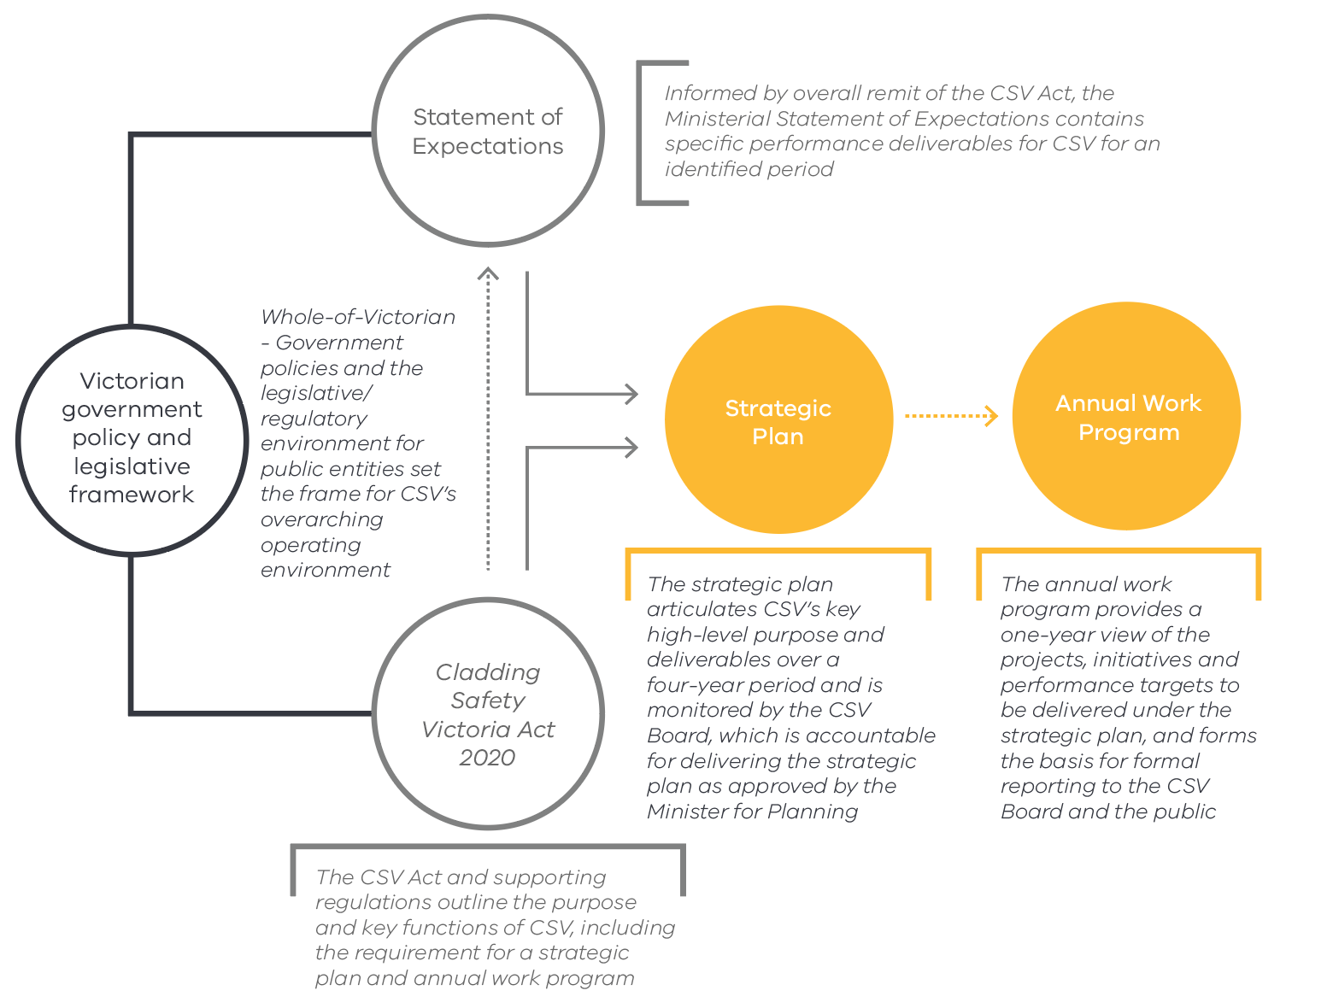

# Strategic Plan Structure

**The structure of the strategic plan reflects the Victorian Government Outcomes Framework. Details of the projects and performance targets to be delivered under the strategic plan are outlined in CSV’s annual work program, which is a companion document to the strategic plan.**

The diagram below outlines the elements of the strategic plan and their purpose.

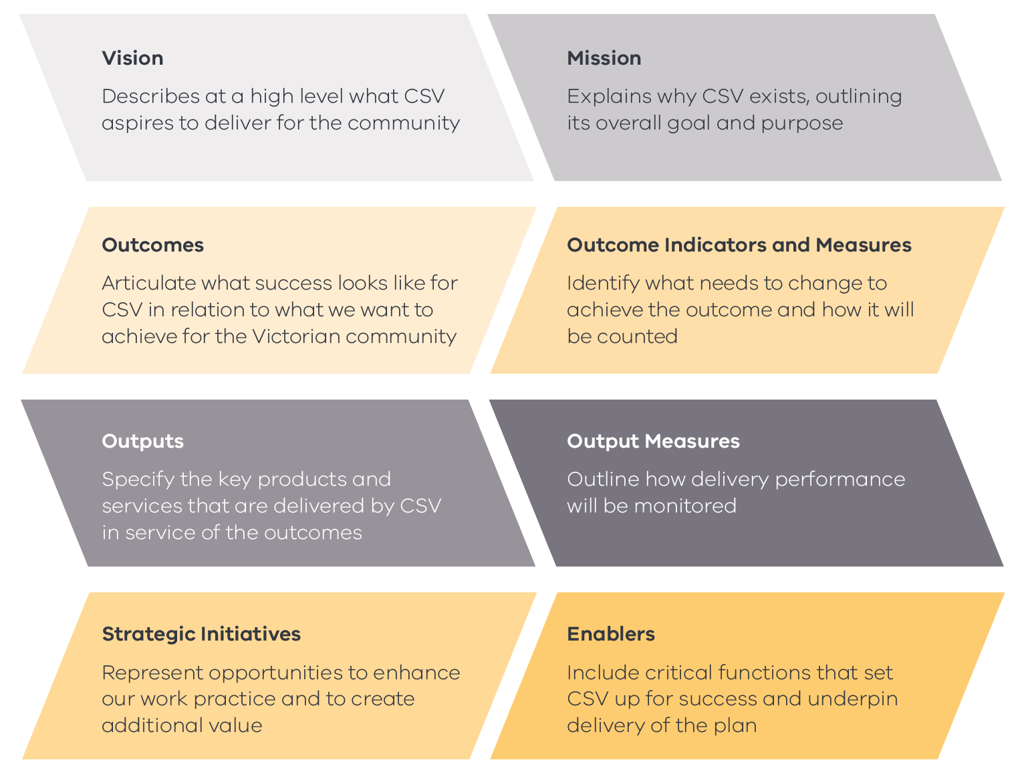

# Strategic Plan Overview

**A high-level overview of the strategic plan is provided below. Details of the indicators, measures, outputs and strategic initiatives that sit beneath each outcome are presented in the following sections.**

|  |  |  |  |
| --- | --- | --- | --- |
| Vision | Making the community safer by reducing combustible cladding risk | | |
| Mission | We will improve the safety of buildings impacted by cladding issues by working in partnership with industry and the community | | |
| Outcomes | CSV actions improve the safety of buildings within the scope of the program | Owners corporations participating in the rectification program, as well as the wider Victorian community, are well-informed about cladding risk | Robust financial and resource management optimises the value of CSV’s delivery outcomes |
| Enablers | CSV’s key supporting functions, including risk management, systems and record keeping, assurance, compliance and contract management, underpin successful delivery of the vision, mission and outcomes | | |

# Outcome 1: CSV actions improve the safety of buildings within the scope of the program

**The focus of CSV’s rectification program is to efficiently reduce the risks associated with combustible cladding on government and residential properties, thereby protecting occupants and building assets from the serious impacts of fire that can spread through building cladding. CSV works intensively with government departments and owners corporations to develop high-quality and cost-effective solutions that effectively address cladding risk and to ensure these are implemented to the highest safety standards.**

## How will we measure our success?

|  |  |
| --- | --- |
| Outcome Indicator | Timely rectifications of buildings prioritised on risk basis* |
| Outcome Measure | % buildings within the program that reach practical completion within agreed timeframes* |

*Interim indicator and measure to be used until risk coefficient is developed and baseline established

## What will we deliver?

### Residential rectification program

CSV works closely with owners corporations to deliver cladding rectification works for residential buildings, which are prioritised through a risk framework for inclusion in this program. CSV is working to commence rectification on 400 prioritised buildings by 30 June 2022, with additional buildings to be prioritised subject to the availability of funding.

CSV’s oversight of the program ensures that:

* project management processes protect the safety of staff, residents, contractors and the community
* rectification is achieved within agreed timeframes with minimal disruption to residents
* each project is delivered within the forecast budget
* prioritisation is dynamic based on up-to-date knowledge of risks, construction costs, funding and the overall building portfolio
* projects are delivered to high quality standards that ensure the mitigation of cladding risk to an acceptable level
* value-for-money outcomes maximise the impact of the state’s investment.

CSV also works collaboratively with the Victorian Building Authority and other practitioners to develop joint processes and appropriate information sharing that support efficient delivery of the program and a seamless experience for participating owners corporations.

### Government rectification program

Under this program, CSV works with departments that own and manage properties with combustible cladding to support them in delivering rectification works. The cladding rectification program for government buildings will largely be completed in 2021–22, with the exception of a few larger hospitals. The program is expected to be delivered 12 months ahead of schedule, despite the inclusion of an additional 16 buildings into the program. The rectification of 112 buildings in total will meet the government’s objective to reduce the fire safety risk for community users of these buildings and is expected to be delivered within budget.

## Measuring our progress

The effectiveness of our delivery will be monitored through the following measures.

|  |  |
| --- | --- |
| Output Measures | * No. of buildings within the government and residential programs that reach practical completion * Identified residential rectification program milestones met * Lost-time injury frequency rate * % same-day at-site incident reports * No. of new jobs supported through the rectification program * Variance between actual and forecast cost, excluding contingency, for the rectification programs * Variance between actual cost and Cost Plan C estimate for all buildings, including for original builders |

## How will we enhance performance and create additional value?

#### Development of an evidence base to demonstrate the reduction in risk to the built environment as a result of addressing cladding issues

CSV is continually collecting data to support the development of robust and objective methodologies to enhance the efficiency of the delivery of the rectification program and to evaluate the effectiveness of program outcomes. This evidence base ensures that CSV is achieving its stated objectives of reducing combustible cladding risk and improving the safety of buildings, and can also be used to inform the community of the success of the government’s risk reduction interventions. Beyond the lifespan of CSV’s program, it may further be used by government in the broader consideration of built environment risk and the design of future programs. This process will be an integral part of CSV’s approach to continuous improvement as the database grows and feedback from owners corporations and other stakeholders will help refine and improve CSV’s processes and rectification strategies/methodologies.

#### Contribution to the development of new legislation, regulations and standards relating to cladding

Through the delivery of its programs and extensive engagement with industry and community stakeholders, CSV has developed a deep understanding of cladding-related issues and significant expertise in establishing practical solutions to the risks posed by combustible cladding. In working collaboratively with the bodies who are responsible for reviewing Victoria’s building regulatory framework by sharing information and contributing to government submissions and reports, CSV can act as an agent of change and a positive contributor to the long-term reform strategy for the construction industry.

# Outcome 2: Owners corporations participating in the rectification program, as well as the wider Victorian community, are well-informed about cladding risk

**The community has a critical role to play in preserving the safety of buildings that contain combustible cladding. CSV produces resources and undertakes engagement activities to ensure that the community has access to information about cladding risk and its implications for households exposed to fire risk in domestic and public settings. CSV also works closely with owners corporations participating in the rectification program to ensure that they are fully informed about the rectification process and the steps they can take to protect their buildings. In addition, CSV regularly distributes information about the importance of fire safety and practical advice and safety tips for circulation to residents.**

## How will we measure our success?

|  |  |
| --- | --- |
| Outcome Indicator | Enhanced awareness of the Victorian community and participating owners corporations about cladding fire safety risk and the rectification program |
| Outcome Measure | Satisfaction rating for participating owners corporations  Engagement rates for community information campaigns |

## What will we deliver?

#### Residential program engagement model

Effective engagement with owners corporations, owners and residents is essential for the successful delivery of the residential rectification program, as it creates the foundation on which CSV can establish collaborative working relationships between all of the program participants. CSV puts these stakeholders at the heart of its program, consulting in a transparent and empathetic way throughout the rectification process. To this end, CSV ensures that each owners corporation involved in the program has a dedicated Customer Liaison Officer and access to the CSV executive to support them across the full lifecycle of their rectification project.

#### Communication programs and campaigns

CSV employs a multifaceted approach to communications that is guided by its communications and stakeholder engagementstrategy. CSV recognises there are interested stakeholders from the wider Victorian community, and provides information to ensure awareness about cladding safety risks, as well as the progress of the rectification program. This includes face-to-face engagement such as presentations at industry seminars and hosted information sessions, the provision of written information and resources for industry groups, and digital strategies to connect with the broader community. CSV maintains a website and social media platforms that contain comprehensive information about cladding risk for the Victorian community, as well as owners corporations, building practitioners and residents involved in rectification program. CSV also works with Fire Rescue Victoria and the Victorian Building Authority to determine safety messaging, with CSV’s focus being on cladding risk awareness and how residents can act to reduce fire risk.

## Measuring our progress

The effectiveness of our delivery will be monitored through the following measures.

|  |  |
| --- | --- |
| Output Measures | * % of queries about cladding and the rectification program responded to within 72 hours * % of participating owners corporations inducted by a dedicated CLO within two weeks of referral * Resolution of issues from participating owners corporations within agreed timeframes * No. of hits for the CSV website * Satisfaction rate for CSV-hosted information sessions |

## How will we enhance performance and create additional value?

#### Expansion of our approaches to engagement, such as exploring new forms of visual communications

In order to reach as many members of the community as possible, CSV is constantly considering new ways to engage our stakeholder groups. As a way of providing a broader range of information about the rectification program, CSV continually builds its YouTube channel with short information videos, evidence of project completions and testimonials from project managers and owners corporations. As the library of video footage, photos and testimonials is expanded, CSV will be able to consistently generate new digital content.

#### Continuous improvement of our engagement approach with owners corporations

CSV’s deep engagement with its stakeholders, and owners corporations in particular, aims to create an optimal environment to facilitate effective delivery of the rectification program and the mitigation of cladding risks. CSV’s approach to engagement has been developed based on better practice principles. However, to ensure the ongoing effectiveness of this approach, CSV is committed to gathering regular feedback from owners corporations so that it can further improve its practice and the owners corporation experience.

# Outcome 3: Robust financial and resource management optimises the value of CSV’s delivery outcomes

**CSV’s success is underpinned by the processes and controls that work to build and sustain a high level of organisational performance through effective resource management, comprehensive risk and safety systems, and strong financial governance. CSV is continually striving to improve the operational practices that provide a strong foundation for the achievement of its objectives. This is realised through benchmarking against better-practice organisations, sound oversight and the external review of our processes by independent bodies.**

## How will we measure our success?

|  |  |
| --- | --- |
| Outcome Indicator | Enhance the effectiveness of CSV’s financial, risk and resource planning and systems |
| Outcome Measures | Actual vs budgeted cost (CSV overall)  Internal CSV operating costs as a percentage of overall costs  % of extreme and high risks managed within tolerance levels |

## What will we deliver?

#### Financial control systems

A robust financial control system ensures that public resources are being used efficiently and that financial risks, including fraud, are being appropriately managed. It also ensures that CSV is meeting its compliance obligations relating to financial management. CSV is committed to the maintenance of a strong financial control environment and to this end, will document its control systems through the development of a financial control plan.

#### Annual program forecasting plan

Comprehensive forward financial forecasting enables CSV to accurately identify in advance any funding issues that may impact on the timely delivery of the rectification program. This planning informs effective decision-making with respect to funding requirements and enables CSV to manage any risks relating to the availability of funding. To ensure that this forecasting is undertaken in a consistent and thorough manner, CSV will develop an annual forecasting plan for the full rectification program.

#### People and culture plan

A robust positive workplace culture that attracts talent, drives engagement, enhances staff satisfaction and improves performance is a critical enabler for the delivery of CSV’s strategic objectives. CSV is committed to developing and implementing a comprehensive People and Culture Plan that will build on CSV’s existing strong culture. The plan will include organisational culture, talent acquisition, onboarding, staff development, leadership development, staff performance, staff retention, occupational health, safety and wellbeing and exit strategies.

#### Risk management framework

Robust risk management practice is critical to ensuring that CSV is well-placed to achieve its objectives. CSV’s risk management framework provides a systematic approach to the identification and mitigation of risks to support effective decision-making. Under the framework, CSV undertakes regular reviews of its risk profile and provides the executive and Board with tactical and strategic risk information that facilitates program and business planning, the monitoring of performance and the escalation of critical issues.

#### Future planning and collaboration

In order to clarify CSV’s ability to fund the Cladding Rectification Program and meet government commitments, CSV will work in collaboration with DELWP to develop options for future delivery models to support government’s aim of reducing the risk posed by combustible cladding and the submission of additional funding requests.

## Measuring our progress

The effectiveness of our delivery will be monitored through the following measures.

|  |  |
| --- | --- |
| Output Measures | * Organisational culture and staff engagement rating * % safety corrective actions completed within agreed timeframes * % completion of mandatory compliance training modules * % program reporting delivered within agreed timeframes * % compliance with mandatory financial management requirements * % of risk treatment actions completed within agreed timeframes |

## How will we enhance performance and create additional value?

#### Continuous improvement to program governance and quality assurance processes

Successful delivery of the rectification program is underpinned by governance and assurance processes that ensure the consistent and effective implementation, and ongoing improvement, of CSV’s delivery framework. These processes provide key points of review, crucial business intelligence and methods to identify opportunities to streamline systems of work, create new efficiencies and enhance the processes that deliver strong financial outcomes.

#### Improvement of commercial capabilities to enhance the effectiveness of contract management processes

Critical to the achievement of quality and value-for-money outcomes through the rectification program is the application of effective commercial principles to CSV’s delivery approach. CSV is committed to further developing its internal commercial capability by incorporating construction industry expertise and methodologies into its contracting, risk management and issue resolution processes.

# Reporting and Review

## Progress Reporting

CSV regularly reviews its progress towards the delivery of agreed objectives to ensure that projects and initiatives are on track, key risks to outcomes are assessed and any critical issues are addressed in a timely manner.

Formal reporting against the strategic plan is undertaken in relation to the projects, initiatives and targets outlined in the annual work program, which are aligned with the strategic plan outcomes. Quarterly progress reports are provided to the CSV Board and public reporting of achievements and challenges occurs annually through CSV’s annual report.

CSV also provides regular program and operational reports to DELWP, as well as progress reports against the Ministerial Statement of Expectations to the Minister for Planning.

## Review

CSV operates within a dynamic environment and needs to ensure that its planning reflects any key changes in its broader policy, stakeholder or industry context. To this end, CSV will review the plan on an annual basis and undertake a formal mid-cycle evaluation that includes an assessment of the effectiveness and efficiency of its delivery against the outcomes and measures in the plan.

Website www.vic.gov.au/cladding-safety

Email support@claddingsafety.vic.gov.au

**Postal address** PO Box 23392, Docklands VIC 8012

**Telephone** 1300 456 542

For enquiries in languages other than English, contact the Translating and Interpreting Service on 131 450.

If you are deaf, or have a hearing or speech impairment, contact us through the National Relay Service.

For more information:

Voice Relay number 1300 555 727

TTY number 133 677

SMS relay number 0423 677 767