

|  |
| --- |
| Keep in Touch (KIT): Youth mental health promotion initiative |
| North Division – Loddon Area |
|  |

Contents

This case study shows 1

About this case study 1

Youth participation in the project 2

Benefits 3

For young people 3

For the department and organisations 3

During the pandemic 3

Success factors 3

What young people say 4

Learn more 5

# This case study shows

At least two of the principles for meaningful participation:

* Children and young people have experience and expertise to share
* The voices of children and young people lead to positive action and outcomes.

# About this case study

The culmination of an in-depth youth consultation involving over 160 young people from the Loddon area, 2018’s *When Life Sucks* report, contained 20 project ideas put forward by young people.

In early 2019, DHHS created a project steering committee to decide which of the 20 ideas to fund. The steering committee included:

* An unlimited number of young people from the Loddon area (ensuring youth participation throughout the project)
* A broad range of sectors working with young people, including local government Local Learning and Employment Networks.

The young people narrowed down the original 20 ideas to 3 proposals for the steering committee. Following further consultation, a youth services caravan (KIT van) and directory app were selected to be the foundations of the project. A Youth Champions network was formed for the project to continue to engage young people.

# A photograph of five people standing and smiling by the side of the Keep in Touch Van at the official launch.

On 8 October 2019, the Area Director, Loddon and KIT Crew officially launched the KIT van and app at an event in the Macedon Ranges Shire.

# Youth participation in the project

The steering committee’s youth representatives took the lead on short-listing and interviewing candidates for a project worker and a youth-focused human-centred design (HCD) agency to facilitate the KIT van and app codesign. The youth representatives recommended a local agency, based in Kyneton.

The codesign process involved multiple rounds of prototyping and consulting with young people to ensure the KIT van and app addressed their needs and wants.

The young people’s key message was that the purpose of the KIT van would be to:

* de-stigmatise mental health
* provide an inclusive, culturally safe, youth-friendly space for young people to connect with their peers
* connect young people to a broad range of mental health and wellbeing resources and information about services that cover their local area
* deliver mental health prevention and promotion activities.

The KIT app and Facebook page should be an online place for information, connection and support.

The codesign process resulted in conceptual designs for the outreach van and mobile app and the name Keep in Touch (KIT). DHHS contracted Anglicare Victoria – North Central Region to engage a KIT coordinator to work with the KIT Crew youth champions from across the Loddon area. Steering committee members also provided significant in-kind support.

# Benefits

## For young people

A flexible and mobile service, co-designed by young people, that can go to them. In November 2019, KIT began engaging young people about mental health and wellbeing. Young people, community groups, schools and event organisers made bookings through the KIT app, emails and by phone.

The KIT van, coordinator and KIT Crew youth champions visited locations and youth events across the Loddon area, including the Woodend Football and Netball Club and a Kyabram Blue Light Pool Party.

The youth representatives on the steering committee gained:

* leadership skills
* experience of participation that they could add to their CVs
* connections with other young people
* the confidence to disclose personal or sensitive information such as sexual orientation or experiences with anxiety and depression.

## For the department and organisations

The KIT project was a significant learning experience for steering committee members. The young people shared their knowledge about the possibilities created by using digital technology and social media.

The HCD agency, gained significant learnings from young participants about working with young people in a different way, with young people as the design clients.

The department’s initial investment has leveraged a further three years of non-government funding.

## During the pandemic

KIT pivoted its rural and regional mental health promotion activities when COVID-19 began because it had been designed to be mobile and flexible.

When COVID-19 restrictions began and bookings were cancelled, KIT provided young people with online resources to build a toolkit consisting of:

* self-care
* ‘iso’ activities
* stories and other way to express thoughts and emotions
* new ways to keep in touch with friends
* trusted sources for COVID facts
* new online COVID-19 mental health and wellbeing services.

During 2021, the KIT van visited skate parks in Heathcote, Axedale, Eaglehawk and Newham, and an outdoor screening of *Shrek* in Gisborne.

# Success factors

* **Sharing power with young people**: DFFH Loddon Community Partnerships and steering committee representatives of other organisations shared power more than in any previous work. The steering committee put out an Expression of Interest for youth representatives, rather than seeking nominations from local governments, schools or universities. The committee also followed through on its commitment to engage the agency selected by the youth representatives.
* **Young Voices approach**: valuing the voice and life experiences of young people and providing young people with opportunities to draw on their own experiences to design key elements of the project. All decisions were always made in the context of the young people’s lived experience and needs as advised by them.
* **Place-based approach**: focusing on the local needs, resources and priorities of each community and engages community members as active partners in developing solutions.
* **Human-centred design (HCD)**: Working with a values-based human centred design agency and using human centred design methodology. Gained and maintained executive leadership’s confidence by referencing the evidence base for HCD, demonstrating that HCD is a rigorous methodology which includes client voice as a vital element.
* **Accountability to young people**:the steering committee was accountable for authentically acting on the recommendations of young people. This fostered genuine codesign, using Facebook and consultation events to go back to young people with a series of prototypes to check, ‘Is this what you wanted and need KIT to be?’
* **Respecting and supporting youth representatives**: Committee members committed to holding meetings at afterhours venues and times, around youth representatives’ study and work commitments. On occasion and with permission, the chair also transported a youth representative from school to an evening meeting and to their hometown for a steering committee meeting – more than 2 hours round trip.

# What young people say

*The best people to connect with young people is other young people.*

*One of the best parts of helping out and consulting was knowing that my passions for mental health were shared not only by other young people but… everyone involved in the kit project as well. I never felt like I wasn’t listened to. All my opinions were taken on board and it was really just a good experience to feel like I was really doing something to reduce the stigma of mental health.*

*The co-design element of KIT is a huge success, that the project has been able to effectively work with young people throughout the whole project.*

*KIT has supported me to be more confident in myself, more confident in my community and more confident in voicing my community’s views.*

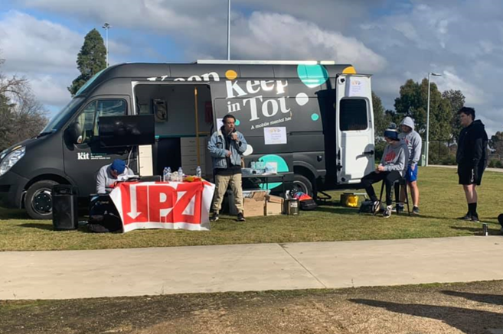

KIT Crew at an event engaging young people about mental health and wellbeing

# Learn more

* [KIT Crew youth champions: YACVic Rural Youth Awards 2020 Facebook video](https://www.facebook.com/KeepinTouchVan/videos/1063601787426565) <https://www.facebook.com/watch/?v=1063601787426565>

|  |
| --- |
| To receive this document in another format, email [Community Services Quality and Safety Office](mailto:Community%20Services%20Quality%20and%20Safety%20Office) <CSQSO@dhhs.vic.gov.au>.  Authorised and published by the Victorian Government, 1 Treasury Place, Melbourne.  © State of Victoria, Australia, Department of Families, Fairness and Housing, March 2022.  Available at [Young voices](https://providers.dffh.vic.gov.au/young-voices) <https://providers.dffh.vic.gov.au/young-voices> |