Learn Local Jobs Board User Guide

**September 2022**

Contents

Purpose 2

Scope and Audience 2

Help and Support 2

Use of the Jobs board– General rules for posting 3

Jobs Board Navigation 3

Example Posts 4

Purpose

This purpose of this User Information Guide (the ‘Guide’) is to provide guidance related to the use of the ‘Jobs Board’ course in the Learn Local Secure Portal (LLSP).

What is the LLSP?

The LLSP is part of the VET Shared Learning Resources Department of Education and Training application. DET has funded a variety of projects and programs that involve the development of professional development and teaching and learning resources. These resources are shared with Learn Local providers through the LLSP site.

In the LLSP trainers are able to collaborate and exchange teaching materials. The LLSP is hosted on the Canvas Learning Management System (LMS). Whilst not every Learn Local provider uses Canvas, sharing resources using this platform means that users can easily preview eLearning content, including Moodle exports and SCORM packages, before deciding if the resources are suitable for their needs.

Scope and Audience

The guide will assist Learn Local staff to navigate and use the LLSP ‘Jobs Board’, the guide includes instructions for:

* Finding the Jobs Board on the LLSP
* How to post effectively on the Jobs Board to offer additional hours to staff from other Learn Locals to fill gaps in staffing, or find additional hours for staff at your Learn Local.

Help and support

* The Department has issued User Guides for all users of the Secure Portal to assist new users to access and navigate the portal.
* Any additional queries regarding the Jobs Board should be directed to [ACFEB.Secretariat@education.vic.gov.au](mailto:ACFEB.Secretariat@education.vic.gov.au)

Use of the Jobs Board– General rules for posting

To ensure that the Jobs Board is an effective platform for staff across the Learn Local sector to help fill short-term gaps in organisational staffing profiles and ensure that those seeking additional hours delivering Learn Local courses can be matched to opportunities, we recommend the following approach to posting on the Jobs Board.

As each Learn Local provider is allocated two licences to access the LLSP, staff with access should identify the following key information in their posts:

* The nature of the opportunity (identify the hours requested/offered, what period of dates)
* The names and contact details of staff requesting hours, including their preferred mode of delivery (online, face-to-face or both) and area/s of expertise (SfWS, LEAP etc.)
* LGA delivery location (where applicable)

Jobs Board Navigation

**STEP 1**

Navigate to <https://vetsharedresources.instructure.com/>

**STEP - 2 Find and click on the** [**Jobs Board**](https://vetsharedresources.instructure.com/courses/3386)

**STEP –Click on subscibe to receive notifications of new posts (can be set to weekly or instant in notifications settings)**

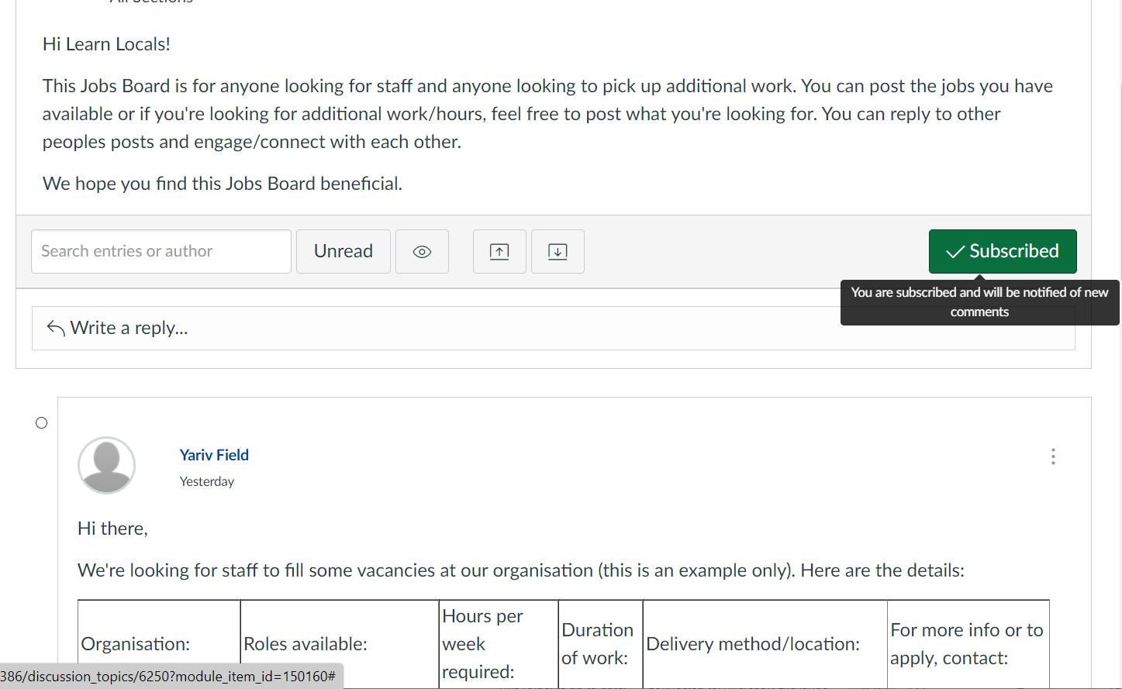

Example Posts

**Example 1: Finding staff to fill a vacancy at your organisation:**

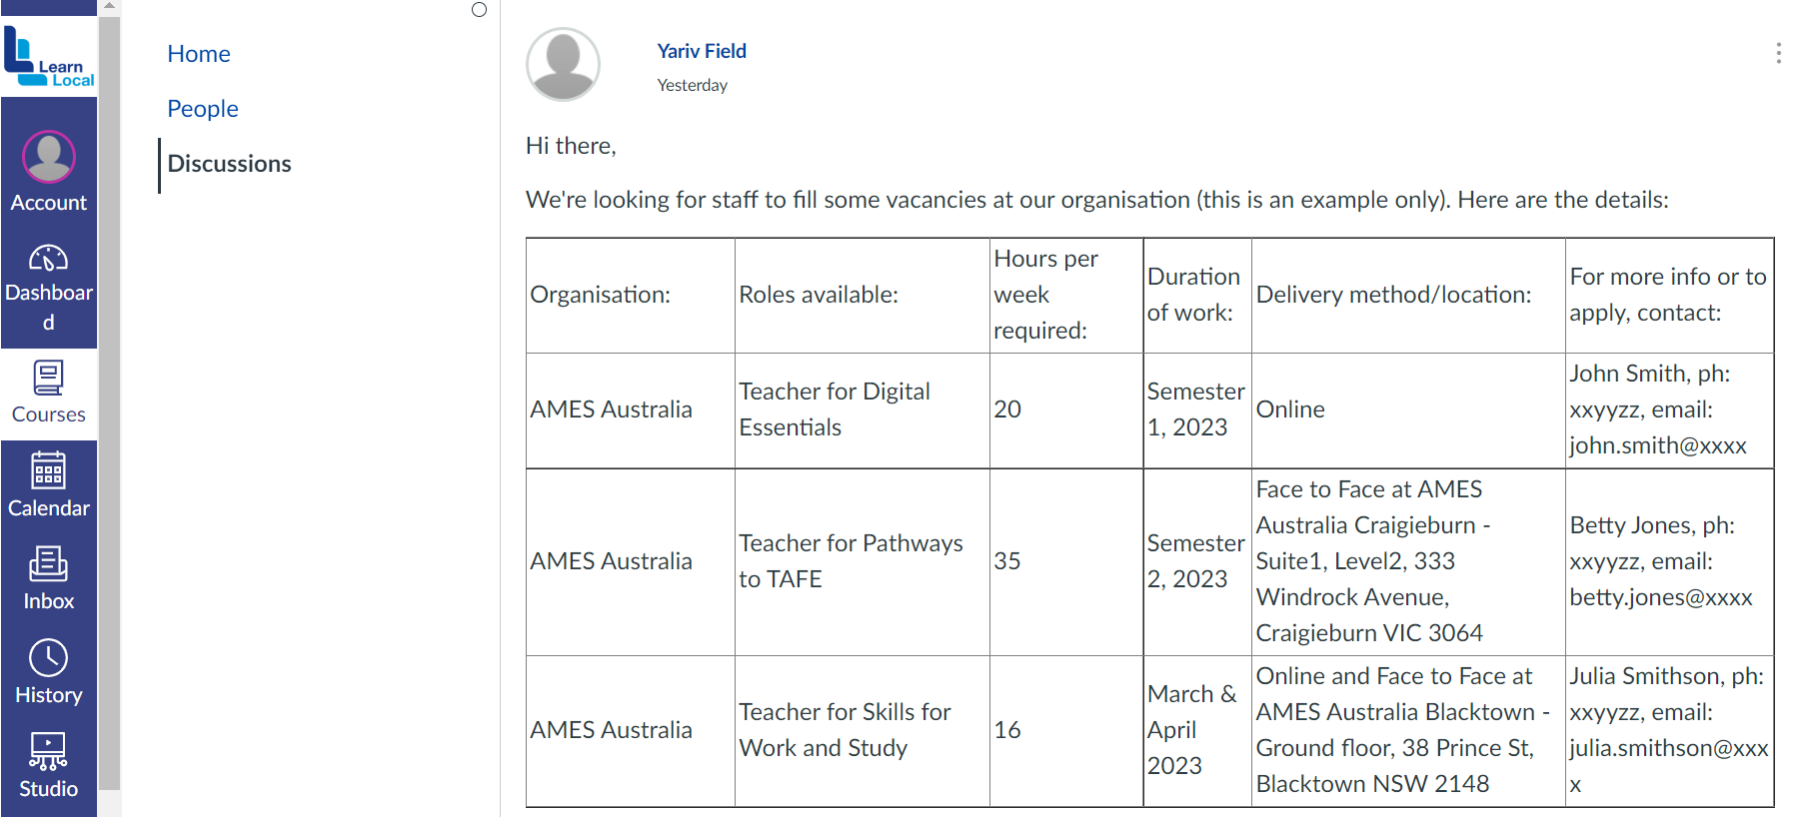

**Example 2: Offering additional hours for staff at your organisation:**

