# Instructions to apply for an outdoor temporary limited licence

The VCGLR has introduced a simplified approach towards granting new licences for outdoor areas in circumstances where the licensee currently holds an outdoor area TLL for the area which expires on 15 March 2022.

All applications made under this process must be made by licensees who hold an outdoor area TLL for the outdoor area that expires on 15 March 2022.

This is a step-by-step instruction guide to assist you in applying for a new outdoor area TLL to allow you to continue using the outdoor area until 15 December 2022.

This application is free of charge, however due to system limitations an application fee of $116.30 will be charged, however the VGCCC will refund this within two weeks.

You are not required to submit any documentation or information other than the temporary licence number of your outdoor area TLL which expires on 15 March 2022. This will begin with a 901.

**Note:** The content on the applications system states limitations that do not apply in this situation, for example limiting to a small number of events. This would normally apply, however due to present circumstances they do not when applying for outdoor trading in this circumstance. Due the difficulty in making changes to this system, changes that recognise this have not been made.

Step one: Open the online temporary [limited licence application portal](https://liquor.vcglr.vic.gov.au/templicence/)

Step two: Click the “Apply now” button at the bottom of the screen as highlighted in the image below:

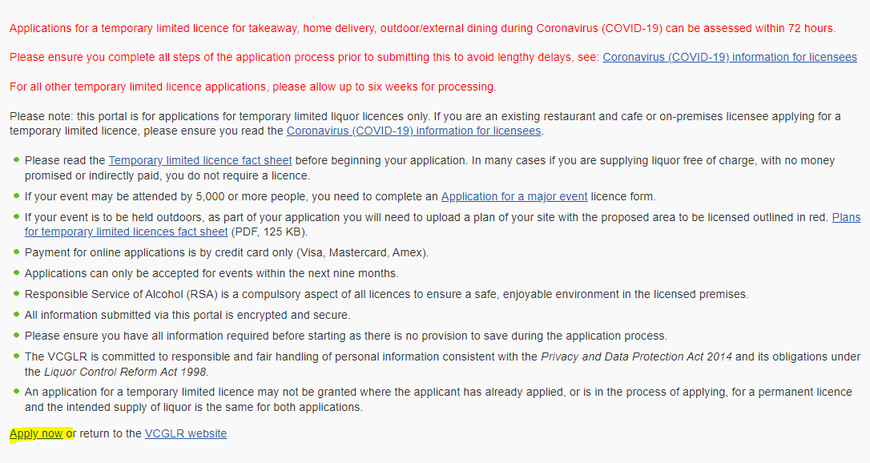

The below screen will appear.

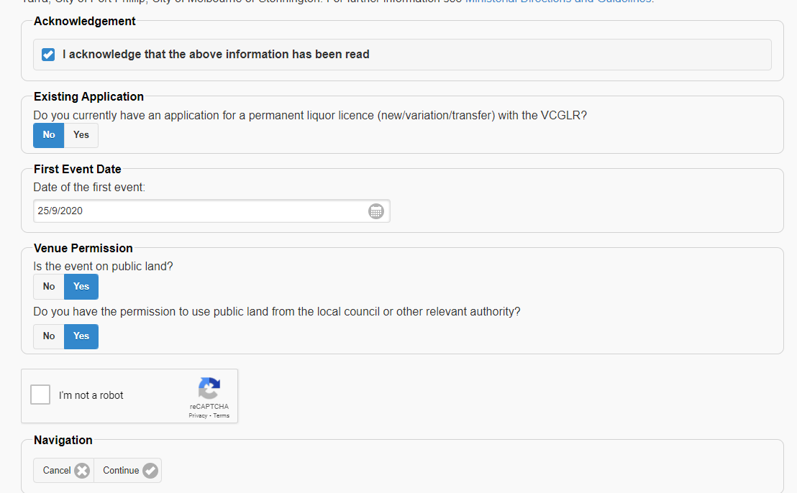

Step three: Complete the following steps:

* read the content at the beginning of the page and then click the “Acknowledgement”
* click “No” on the box regarding existing applications
* enter the date of 16 March 2022
* Under “Venue permission”, click “Yes” if the land being used is public (owned by the local council) or “No” if the land being used is privately-owned, and then click “Yes” “Yes”. You must have permission to use the land.
* Click the “I’m not a robot” button and, if required, solve the captcha.
* Click Continue

Step four: Click “Yes” and then enter your permanent licence number. If you do not do so assessment of your application will be delayed. After this, click continue.

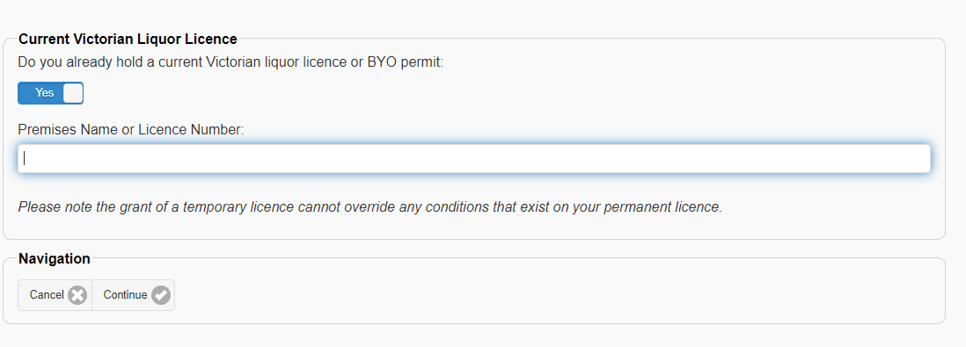

Step five: Select the licensee of the permanent licence that is most relevant, and then confirm that you are either a director or the individual.

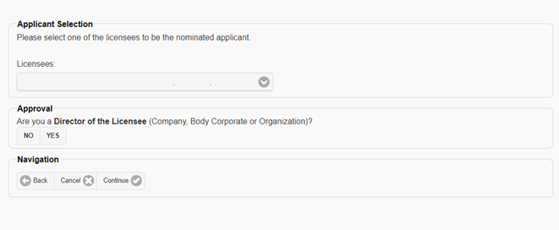

Step six: As shown below, this page will auto-fill with details we have on record. Please fill in any gaps and check all information is correct. If you find incorrect information, please update this.

Select the relationship you have to the applicant and then click continue.

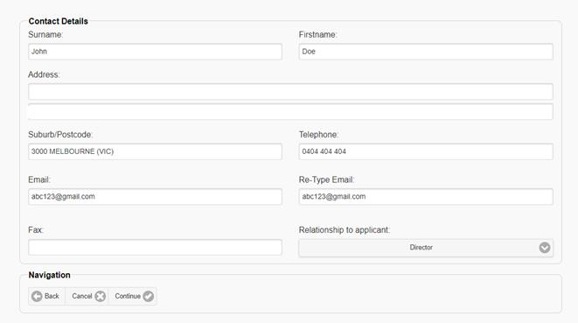

Step seven: Enter the details regarding the outdoor area. Please be as specific as possible when describing the location and ensure the address is correct. Click continue.

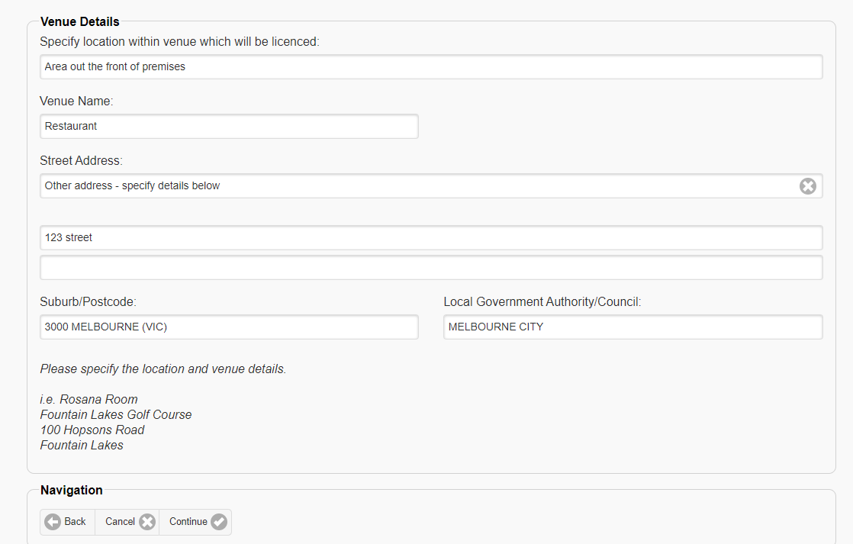

Step eight: Select “Temporary extension of permanent licence”, and then click continue. This will allow you to provide the required information later in the application process. If you select another event type this may delay the assessment of your application.

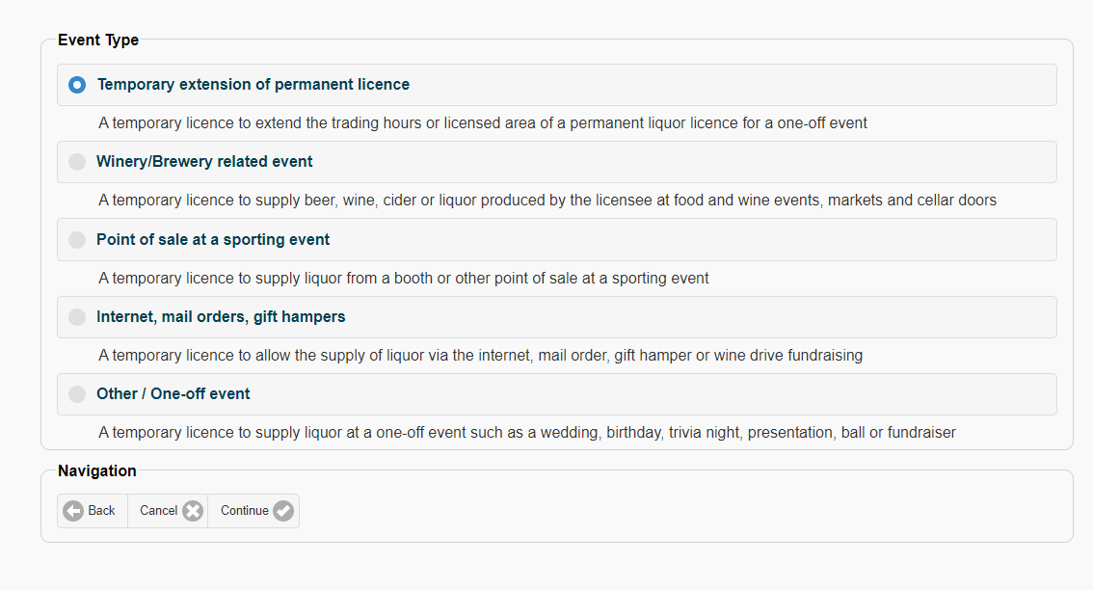

Step nine: As shown below, select No, No and then No. Please note that the trading hours in this policy are the lesser of what appears on your local council permit (if applicable) or your permanent licence, and extensions beyond this will not be granted under this policy.

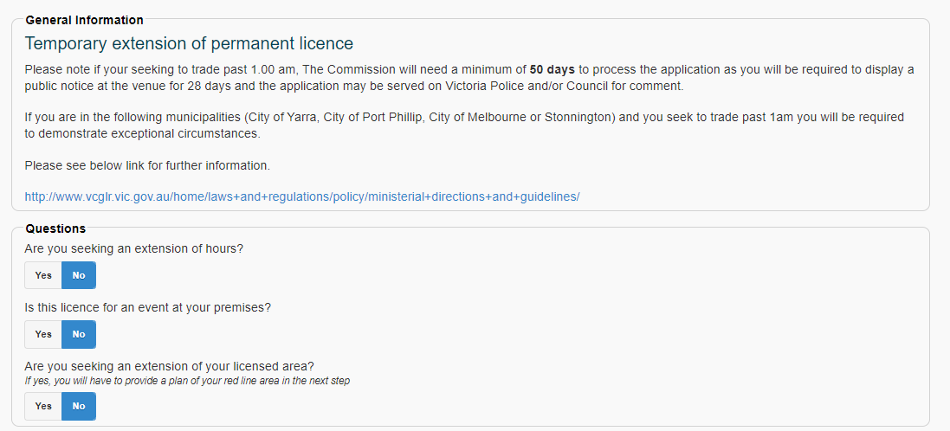

Scroll further down the page to the section titled “Event Occurrences”.

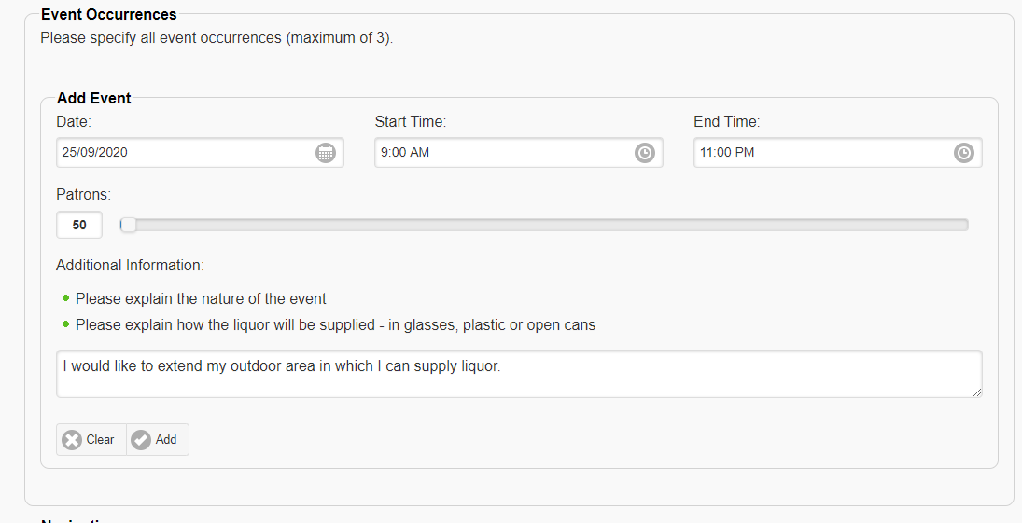

In this section, please add the date of 16 March 2022. This event must be on the same day as the event date supplied earlier. You must include trading hours (these will appear on your council permit and permanent licence, please enter the lesser of these two). You must enter a patron capacity (this should appear on your council permit), and if this is below 50 it should be set to 50. Please be aware that any patron capacity endorsed on a licence does not override, or ensure compliance with, government regulations in regards to social distancing If you do not include trading hours or a patron capacity, you will not be able to proceed in your application.

Step ten: In the “additional information” section please include the licence number of your existing outdoor area TLL, and then click the “Add” button.

After an event has been added press continue. The screen will ask you to confirm that the event is only for one (or however many you entered) events – please ignore this and click continue.

Step eleven: You do not need to attach any documents at this stage, instead just click continue

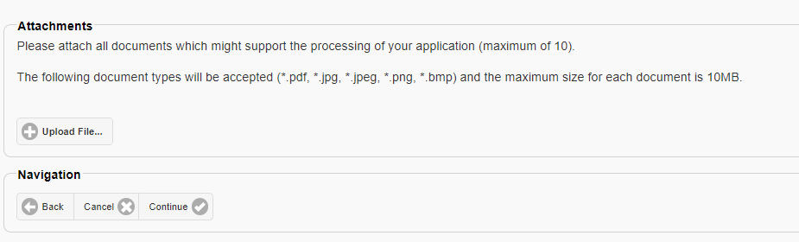

Step twelve: Once you have clicked continue you will be asked to complete a declaration. Please ensure you everything you have provided is accurate then submit your application.

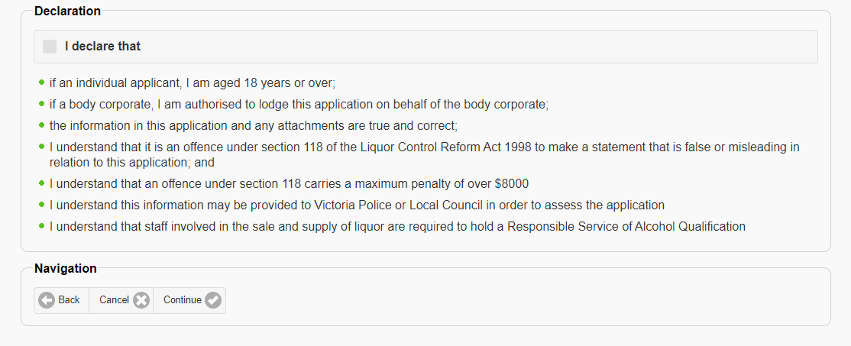

Once your application is submitted, we will endeavour to process your application within three business days. This period of time may be longer if you do not provide your current outdoor area TLL number, or any details are not correct.