Quick Reference Guide:

Supplier and User Registration Process  
for the DE Oracle Supplier Portal

# Audience

* Suppliers of goods and services who have not previously been engaged by the Department of Education (DE) – formerly the Department of Education and Training (DET) – or certain other Education portfolio agencies.
* Suppliers of goods and services who have previously been engaged by DE or certain other Education portfolio agencies.

# Introduction

From May 2022, DE will be issuing many of its procurement approaches to market, both open and select, through the DE Oracle Supplier Portal (the Portal). Portfolio agencies using DE’s procurement processes will also adopt this approach.

This Quick Reference Guide (QRG) explains how organisations can be set up in the Portal as suppliers and then add staff members as users to access the Portal.

Please note: DE and partner agencies will continue to use the [**VendorPanel**](https://www.vendorpanel.com.au/) platform for market approaches linked to relevant State Purchase Contracts and DE standing offers. However, suppliers must also be separately registered with the Portal to allow us to maintain appropriate records of procurement activities and outcomes. Open market approaches will also continue to be advertised on the [**Buying for Victoria Supplier Portal**](https://www.tenders.vic.gov.au/), however full documentation and submissions for those will be managed through this Portal.

# Important Information

* Suppliers who **have not** previously been formally engaged by DE or its partner agencies do not have supplier records in our financial systems. You will need to register your organisation as a prospective supplier in order to create a supplier record and at least one user account linked to that record.

Jump to: **Registering as a Prospective Supplier**

* Suppliers who **have** previously been formally engaged by DE or its partner agencies will have existing supplier records in our financial systems. In this case, DE will need to manually create and link one user account again that existing record.

Jump to: **Registering as the First User of an Existing Supplier**

* Once a company has been registered and a first user established, that user will then be able to register other colleagues as other users from the same company. **The supplier registration process is only undertaken once per organisation.**

Jump to: **Registering More Users for a Supplier**

# Registering as a Prospective Supplier

1. Click the registration link: <https://enyw.fa.ap1.oraclecloud.com/fscmUI/faces/PrcPosRegisterSupplier?prcBuId=300000004771220>

The registration form has 4 steps, numbered 1-4 near the top of the screen. You will need to fill information in for each of the steps. To move between the steps, you can either click the name of the step or use the **Back** and **Next** buttons on the page.

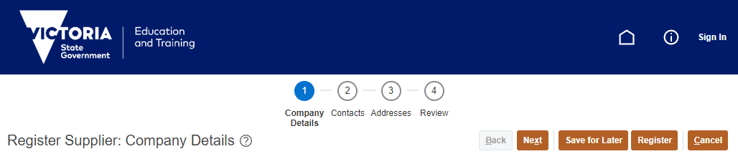

1. For Step 1, complete the following fields for Company Details:

* **Company:** insert your organisation’s formal name
* **Tax Organization Type:** select from the drop-down list
* **Supplier Type:** please select ‘Supplier’, regardless of whether any other option may be relevant
* **Tax Country:** select the appropriate country for your organisation
* Graphical user interface, text, application

  Description automatically generatedAustralian organisations should provide their ABN in the **Tax Registration Number** field. Please do not provide a TFN or any other alternative. Overseas organisations not holding an ABN should provide an alternative local identifier.

No other details fields need to be completed. You can add attachments or notes if you wish.

In the Your Contact Information section, add in your:

* **First Name**
* **Last Name**
* **Email** address
* **Confirm Email** address

Click on **2 – Contacts** or the **Next** button to move forward.

1. For Step 2, the Contacts page is open. Note that your own details from Step 1 are used to pre-fill the first user account for your organisation.

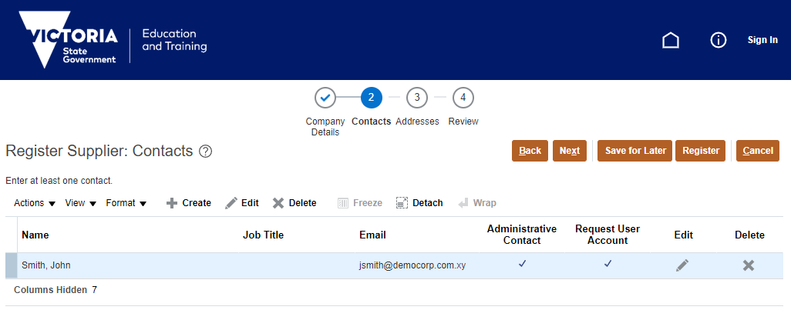

To create other user accounts for colleagues, click the **Create** button

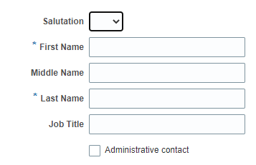The **Create Contact** dialog box opens. Fill in the details of the new contact.

You must provide at least a:

* **First Name**
* **Last Name**
* **Job Title**
* **Email** address

You must check **Request user account**.

At least one contact from every supplier should be designated as an **Administrative Contact**. This will be the person(s) we contact with any queries about your organisation or its suppliers.

Click the **Create Another** button to create further contacts or click **OK**.

Click on **3 – Addresses** or the **Next** button to move forward.

1. For Step 3, the **Addresses** page opens. We require at least one address to be registered for a supplier.

To create an address, click the **Create** button.

The **Create Address** dialog box opens. Fill in the details of your primary business address.

You must provide at least a:

* **Address Name** (e.g. ‘Main office’, ‘Melbourne’)
* **Country**
* **Address Line 1**
* **City**

For Australian addresses, please provide a full address including state and postcode.

At a minimum, tick the **Address Purpose** of *RFQ or Bidding*. Other options may be selected but are not immediately relevant.

You should now link your contacts to this address. Click the **Select** button in the Address Contacts section to do this.

Select the users who should be linked to this address (*use the Ctrl key to select multiple names*) and then click **OK**.

Click the **Create Another** button to create further addresses or click **OK**.

Click on **4 – Review** or the **Next** button to move forward.

1. For Step 4, review the information you have provided. You can either return to Steps 1-3 to make changes or click the **Register** button to submit this request.

Click **OK** on the confirmation dialog box. Your details are submitted for approval.

The submitter will receive email notification confirming if this request has been approved or rejected by DE.

Upon approval, all contacts for whom a user account was requested will receive a separate welcome email that includes their User ID and password.

# Registering as the First User of an Existing Supplier

Organisations that have previously been engaged to supply goods or services to DE will likely have an existing supplier record in our system, so the above registration process would create a duplicate record and cannot be used. Any attempts to register an already-registered supplier will be rejected.

DE will instead manually add a user record to the existing supplier record and link that record to existing address data.

Where a user from such an organisation wishes to create a user account for themselves and no existing users are known to exist in the organisation (*see the next section if one is known*), they should email the DE Supplier Portal team at [Oracle.Procurement.Cloud@education.vic.gov.au](mailto:Oracle.Procurement.Cloud@education.vic.gov.au).

Please provide the following details in that email:

* Organisation name and ABN (to validate that we have an existing record)
* Your name
* Your job title
* Your email address

DE will undertake any steps it deems necessary to validate your association with the organisation before creating a user account.

# Registering More Users for a Supplier

Users that have been created in the Supplier Portal have the power to create further accounts for colleagues or edit existing details.

1. A picture containing icon

   Description automatically generatedLog in to the [Supplier Portal](https://enyw.fa.ap1.oraclecloud.com/).
2. Click the Supplier Portal tile on the home page.

Click **Manage Profile** in the left-hand Tasks menu.



On the Company Profile screen, click the **Edit** button to begin a profile change request. Click **Yes** to confirm this request.

1. The Edit Profile Change Request screen appears. Type in a **Change Description** for this request and then use the **Contacts** or **Addresses** tabs to add in information for new users as required.

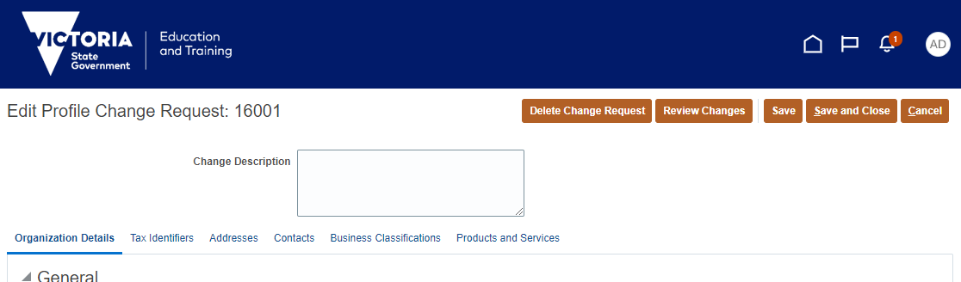

The rules for inputting new contacts or addresses are as per pages 3 and 4 above.

To save your draft change request without formally submitting it, click **Save** or **Save and Close**.

To submit and activate your change request, click **Review Changes** and then **Submit**.

*Note: each supplier can only have one change request underway at a time. If a request is not either submitted or cancelled, it will block your colleagues from making any other change request. Requests are linked to your supplier, so colleagues can edit or delete your draft request if necessary.*

**For support with this process, contact the Oracle Procurement Cloud team at DE:**

[**oracle.procurement.cloud@education.vic.gov.au**](mailto:oracle.procurement.cloud@education.vic.gov.au)