Foundation (Prep) Enrolment Information Pack for Early Childhood Sector

Guidance and resources for the early childhood   
sector regarding 2024 government school Foundation enrolments

Contents

Introduction 3

Steps to enrol in Foundation for 2024 school year 3

How you can support families 3

For more information 4

Helpful resources 5

Downloadable resources 5

Useful links 5

Suggested social media content 6

Posts 6

Social media tiles 6

Suggested newsletter content 7

Enrolling in primary school for 2024 7

Poster 8

Factsheet 9

# Introduction

Early childhood education and care service providers and services are invited to share information about the new statewide Foundation (Prep) enrolment timeline with staff and families.

The Department of Education has released a new statewide timeline for enrolling in Foundation (Prep) for the 2024 school year.

The timeline advises parents and carers when and how to enrol their child in Foundation at a government school. It seeks to make the enrolment process simpler, clearer and fairer for families.

The timeline will apply for children starting Foundation in 2024 at a Victorian government primary school. All Victorian government primary schools will follow the new timeline in 2023 to support enrolments for the 2024 school year.

Please note that the timeline will not apply to non-government schools (Independent or Catholic schools).

## Steps to enrol in Foundation for 2024 school year

**Parents and carers can apply to enrol their child in a Victorian government primary school from the start of Term 2, 2023 (Monday 24 April 2023). Parents and carers are asked to apply to enrol by Friday 28 July 2023.**

**What parents and carers need to do:**

1. **Read about when and how to enrol their child in Foundation** at [vic.gov.au/enrolling-foundation-prep](https://www.vic.gov.au/enrolling-foundation-prep)**.**
2. **Locate their child’s designated neighbourhood school and other nearby government schools on** [findmyschool.vic.gov.au](https://www.findmyschool.vic.gov.au/)**.**
3. **Contact a government primary school to book a school tour and learn more about the school and the enrolment application process.**
4. **Submit an enrolment application to a government primary school by Friday 28 July 2023.**
5. **Parents and carers will be notified of the outcome of their application by Friday 11 August 2023. If they receive an enrolment offer, parents and carers should accept the offer by Friday 25 August 2023.**

**While parents and carers are asked to submit an enrolment application by Friday 28 July 2023, applications after this date will still be accepted. Enrolment applications submitted after 28 July 2023 will be processed by the school as they are received, in accordance with the department’s Placement Policy.**

**In Victoria, children have the right to attend their designated neighbourhood school under the *Education and Training Reform Act 2006*. Parents and carers may apply to a school that is not their designated neighbourhood school.** The school will consider the application in line with the department’s Placement Policy: [www2.education.vic.gov.au/pal/enrolment/guidance/placement-policy](https://www2.education.vic.gov.au/pal/enrolment/guidance/placement-policy).

## How you can support families

We have put together this pack to help early childhood education and care services understand the timeline and, if they wish to, share information about the timeline with families.

This pack provides a range of optional materials, including a poster, factsheet, social media content and newsletter template. It also includes links to Victorian Government webpages.

We encourage you to share and distribute these materials with your staff and families through your own communications channels, however it is optional for you to do so.

## There are no changes to the Transition Learning and Development Statement or transition to school processes.

## 

## For more information

More information and resources about the enrolment timeline are available on the Enrolling in Foundation (Prep) webpage at: [vic.gov.au/enrolling-foundation-prep](https://www.vic.gov.au/enrolling-foundation-prep). You may direct families to this webpage and advise families to contact the primary school they want to apply to regarding any questions they have about the enrolment process.

More information and resources about transitions to school, including the [Transition: a positive start to school resource kit](https://www.vic.gov.au/transition-school-resource-kit) and [Transition Learning and Development Statements](https://www.vic.gov.au/transition-learning-and-development-statements) are available at: [vic.gov.au/moving-primary-school](https://www.vic.gov.au/moving-primary-school).

If your organisation has any questions, you can contact your relevant regional office. Contact information can be found here: [vic.gov.au/contact-early-childhood-improvement-branch](https://www.vic.gov.au/contact-early-childhood-improvement-branch).

# Helpful resources

These resources will help you to understand more about the new statewide enrolment timeline. We encourage you to reference and use these resources in your communications with families.

## Downloadable resources

**Poster**

You can print the poster on page 8 of this pack for display in settings where staff, parents and carers will see it. The poster provides a step-by-step guide of the enrolment process. The poster does not include any specific dates for 2024 enrolments so can be displayed all year round and in future years. The QR code on the poster links parents and carers to the Enrolling in Foundation (Prep) webpage for more information and key dates.

**Factsheet**

You can read and distribute the factsheet on pages 9-11 of this pack to staff, parents and carers.

The 3-page factsheet provides a summary of the Foundation enrolment process and includes key dates in the timeline for children commencing Foundation in the 2024 school year. The factsheet also includes Frequently Asked Questions (FAQs) and references to relevant policies.

Please note, in addition to this plain English factsheet, translated factsheets are also available in more than 40 languages. You can download all the factsheets from [vic.gov.au/enrolling-foundation-prep](https://www.vic.gov.au/enrolling-foundation-prep).

**Parent/carer enrolment information pack**

The parent/carer pack includes more comprehensive information and detailed FAQs for parents and carers compared to the factsheet. The pack can be downloaded from [vic.gov.au/enrolling-foundation-prep](https://www.vic.gov.au/enrolling-foundation-prep).

## Useful links

Online resources will always include the most accurate and up-to-date information about the statewide Foundation enrolment timeline and process for enrolling in school. We ask that you reference and refer parents and carers to these websites for more information.

**Enrolling in Foundation (Prep)** – [vic.gov.au/enrolling-foundation-prep](https://www.vic.gov.au/enrolling-foundation-prep)

**Enrolling in school** – [vic.gov.au/how-choose-school-and-enrol](https://www.vic.gov.au/how-choose-school-and-enrol)

**Find my School** – [findmyschool.vic.gov.au](https://www.findmyschool.vic.gov.au/)

**Information on school zones** – [vic.gov.au/school-zones](https://www.vic.gov.au/school-zones)

**Disability and inclusive education** – [vic.gov.au/disability-and-inclusive-education](https://www.vic.gov.au/disability-and-inclusive-education)

**Regional office contacts** – [vic.gov.au/office-locations-department-education-and-training](https://www.vic.gov.au/office-locations-department-education)

# Suggested social media content

We have developed sample social media posts and tiles that you may use across your own social channels to help raise awareness of the enrolment timeline. It is optional for you to do so. If you wish to post content to social media, please use the template wording prior to the application due date of Friday 28 July 2023. You can mix and match the post and social media tile options based on your preference.

## Posts

**Option A**

Is your child starting primary school in 2024? Apply by Friday 28 July 2023 to enrol in a government school. For more information, visit [vic.gov.au/enrolling-foundation-prep](https://www.vic.gov.au/enrolling-foundation-prep)

**Option B**

The first year of primary school is called Foundation or Prep. If your child is starting school in 2024, it’s time to enrol. Apply by Friday 28 July 2023 to enrol in a government school. For more information, visit [vic.gov.au/enrolling-foundation-prep](https://www.vic.gov.au/enrolling-foundation-prep)

**Option C**

If your child will be 5 years old by 30 April 2024, they can start school next year. Apply by Friday 28 July 2023 to enrol in a government school. For more information, visit [vic.gov.au/enrolling-foundation-prep](https://www.vic.gov.au/enrolling-foundation-prep)

## Download social media tiles

Please click on the images below to download the social media tiles.

**Option 1 Option 2**

**[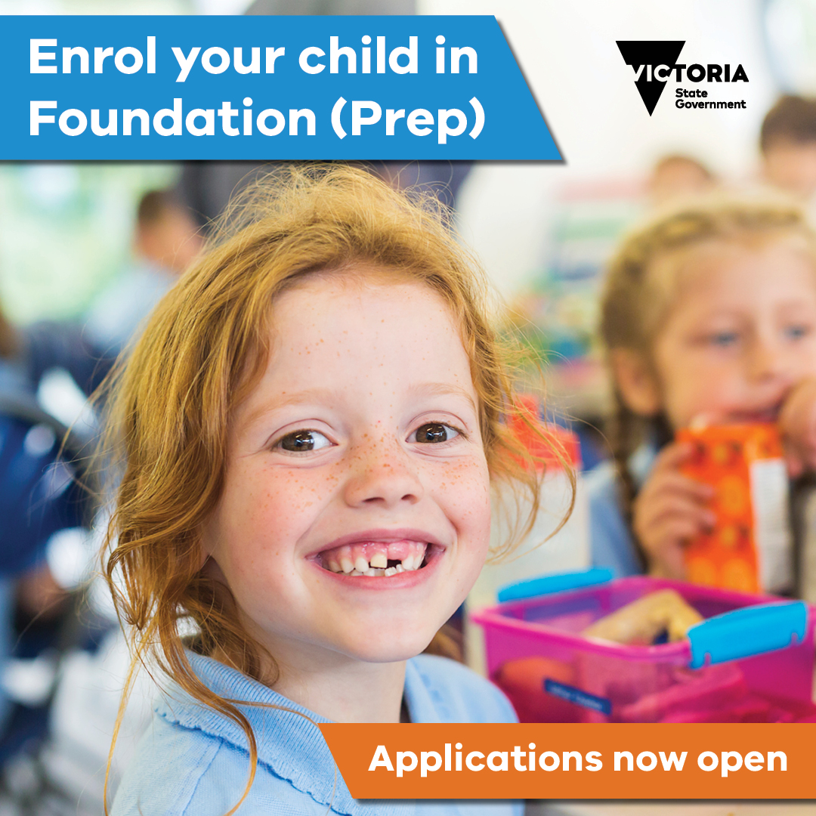](https://www.education.vic.gov.au/Documents/school/parents/Foundation-Prep-enrolment-social-media-tile-option-two.jpg)**[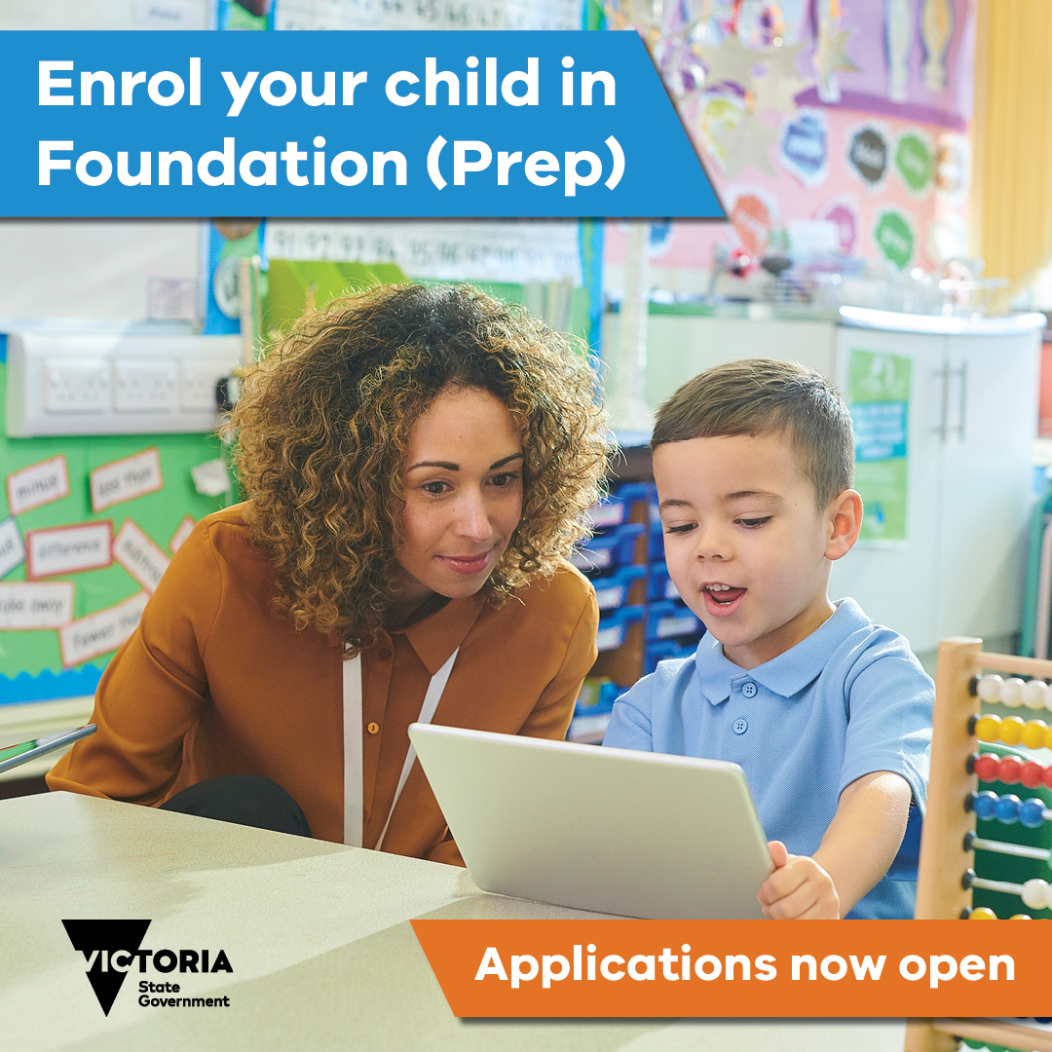](https://www.education.vic.gov.au/Documents/school/parents/Foundation-Prep-enrolment-social-media-tile-option-one.jpg)

# Suggested newsletter content

Please consider using the template content below in your newsletter or preferred communication channel to families. It is optional for you to do so.

## Starting primary school in 2024?

If your child is turning 5 years old by 30 April 2024 and is eligible to start school next year, it is time to decide where they will go to school.

The first year of primary school is called Foundation or Prep. The Department of Education has released a statewide Foundation enrolment timeline for all Victorian government primary schools to follow. The timeline helps you to understand when and how to enrol your child in Foundation at a Victorian government school.

The Foundation enrolment timeline will only apply to government primary school enrolment. If you wish for your child to attend a non-government school (Catholic or Independent school), please contact individual non-government schools for their enrolment processes. **Applications to government schools for the 2024 school year open from the start of Term 2, 2023 (Monday 24 April 2023). You should apply to the school by Friday 28 July 2023.**

What you need to do:

1. **Read about when and how to enrol your child in Foundation** at [vic.gov.au/enrolling-foundation-prep](https://www.vic.gov.au/enrolling-foundation-prep)**.**
2. **Use** [findmyschool.vic.gov.au](https://www.findmyschool.vic.gov.au/) **to locate your child’s designated neighbourhood school and other nearby government schools.**
3. **Contact a school to book a tour and to learn more about the school and the enrolment application process.**
4. **Submit an enrolment application to a government primary school by Friday 28 July 2023.**
5. **You will be notified of the outcome of your application by Friday 11 August 2023. If you receive an enrolment offer, you should accept the offer by Friday 25 August 2023.**
6. Take part in enrolment information and transition sessions during Term 4, 2023.
7. Your child will start Foundation from Tuesday 30 January 2024.

In Victoria, your child has a right to enrol in their designated neighbourhood government school. Your designated neighbourhood school is determined on the basis of your child’s permanent residential address.

You can also apply for a place at a school that is not your designated neighbourhood school. The school will consider your application in line with the Department of Education’s Placement Policy.

You can contact a government primary school if you have any questions about enrolling in school. Information and resources are also available on the Victorian Government website at [vic.gov.au/enrolling-foundation-prep.](https://www.vic.gov.au/enrolling-foundation-prep)

This is one important part of the transition to school process. Further information on transition to primary school, including Transition Learning and Development Statements, will be provided to parents and carers later this year.

# Enrolling in primary school for 2024

Starting school is an exciting time for children, parents and carers. We want to help make the enrolment process as easy as possible for you.

In Victoria, your child has the right to attend their designated neighbourhood school (your ‘local school’) under the *Education and Training Reform Act 2006*.

You can also apply for a place at a school that is not your local school. The school will consider your application in line with the Placement Policy. For more information on the Placement Policy, visit the [Enrolling in school](https://www.vic.gov.au/how-choose-school-and-enrol) page.



### New statewide timeline for Foundation (Prep)

The first year of primary school is called Foundation or Prep. We have released a new Foundation enrolment timeline for all Victorian government primary schools to follow (see page 3). The timeline aims to help you understand when and how to enrol your child into Foundation for the 2024 school year.

**When should I enrol my child in their first year of primary school?**

Your child must be 5 years old by 30 April in the year that they start school.

Schooling is compulsory for children who have turned 6 years old.

To enrol your child in a Victorian government primary school for the 2024 school year, submit an enrolment application to the school by 28 July 2023.

### How do I enrol my child in their first year of primary school?

Take these steps to enrol your child in their first year of primary school:

1. Find your local school on the Find my School website (see below).
2. Contact a government primary school to book a school tour or to learn more about the school and the enrolment application process.
3. Download the Foundation (Prep) enrolment information pack from [Enrolling in Foundation (Prep)](https://www.vic.gov.au/enrolling-foundation-prep)  (available from 24 April 2023).
4. Submit an enrolment application for Foundation **by Friday 28 July 2023**.
5. You will be notified of the outcome of your application **by Friday 11 August 2023**. If you receive an offer of placement, you should accept the offer by **Friday 25 August 2023**.
6. Take part in enrolment information and transition sessions **during Term 4 2023**.
7. Your child will start Foundation from **Tuesday 30 January 2024**.

### How do I find my local school?

Find your local school on the Find my School website by following the steps below:

1. Enter [findmyschool.vic.gov.au](http://www.findmyschool.vic.gov.au/) into your browser.
2. Enter your permanent residential address under ‘Enter your address to get started’.
3. Select 2024 under ‘Enrolment year’. **Note:** 2024 school zones will be available late Term 1, 2023.
4. Select Primary under ‘School type’.

The map will then show your address, your local school, and on the left the contact details for the school. If you scroll down, it will also show you the five closest schools to your address.

You can also search by school name under ‘Search for school’.

### Can my child apply to a government primary school that is not our local school?

Yes, you can apply to schools other than your local school. The school will consider your application in line with the Placement Policy and available space. You can find information on how applications are prioritised on the [Enrolling in school](https://www.vic.gov.au/how-choose-school-and-enrol) page.

**What happens if I receive a letter saying my enrolment application was unsuccessful?**

You should apply to enrol your child in another school. Your child is guaranteed a place at their local school. Your child’s local school is determined on the basis of their permanent residential address. Visit [Find my School](https://www.findmyschool.vic.gov.au/) to locate your child’s local school. The [Enrolling in school](https://www.vic.gov.au/how-choose-school-and-enrol) page can also help you to confirm your child’s address for enrolment.

You can also appeal the decision. The [Enrolling in Foundation (Prep)](https://www.vic.gov.au/enrolling-foundation-prep) page has information on the process to appeal an enrolment application outcome.

### What happens if I miss the enrolment timeframes?

You can apply to enrol your child into Foundation for the 2024 school year at any time from Term 2, 2023.

While you are asked to submit an enrolment application by Friday 28 July 2023, applications after this date will still be accepted from those families who miss enrolment timelines, move permanent residence or newly arrive to Victoria.

Enrolment applications submitted after 28 July 2023 will be processed by the school as they are received, in accordance with the department’s Placement Policy.

### Where can I find further information on enrolling in primary school?

You can ask your local primary school for further information on the Foundation enrolment process.

At the start of Term 2, 2023 you can also find an information pack on the Foundation enrolment process on the [Enrolling in Foundation (Prep)](https://www.vic.gov.au/enrolling-foundation-prep) page of the Starting School webpage.

If you require help translating the information pack, please talk to your local primary school for assistance.

### Who do I contact for help?

The Transition Coordinator, Enrolment Officer or Principal of the primary school you want to apply to can help you with any questions you may have about the enrolment process.

### Useful links

Please find some useful links below that may be helpful for you as your child starts primary school in 2024:

Find my School – [findmyschool.vic.gov.au](http://www.findmyschool.vic.gov.au/)

Information on school zones – [vic.gov.au/school-zones](http://www.vic.gov.au/school-zones)

Enrolling in Foundation (Prep) – [vic.gov.au/enrolling-foundation-prep](https://www.vic.gov.au/enrolling-foundation-prep)

Enrolling in school – [vic.gov.au/how-choose-school-and-enrol](https://www.vic.gov.au/how-choose-school-and-enrol)

Disability and inclusive education – [vic.gov.au/disability-and-inclusive-education](https://www.vic.gov.au/disability-and-inclusive-education)

Regional office contacts – [vic.gov.au/office-locations-department-education-and-training](https://www.vic.gov.au/office-locations-department-education-and-training)

# Timeline for 2023-24

|  |  |
| --- | --- |
| **2023 Dates** | **Activity** |
|
| Term 2: Monday 24 April 2023 – Friday 23 June 2023 | |
| Terms 1 and 2, 2023 | Primary schools conduct tours, information sessions and other activities for families seeking Foundation (Prep) enrolment for their child for 2024. |
| By the start of Term 2, 2023 | School zones for the 2024 school year go live on [findmyschool.vic.gov.au](http://www.findmyschool.vic.gov.au/)  Parents/carers should go to [findmyschool.vic.gov.au](http://www.findmyschool.vic.gov.au/) to locate their designated neighbourhood school for 2024.  The Enrolment Information Pack for Parents/Carers is available to download from [Enrolling in Foundation (Prep)](https://www.vic.gov.au/enrolling-foundation-prep). |
| From Week 1, Term 2 2023 | Primary schools may distribute the Enrolment Information Packs to prospective families and their school community. |
| From Week 1, Term 2, 2023 | **Enrolment applications open** – parents/carers may submit their completed enrolment application to a government primary school from this date. |
| Term 3: Monday 10 July 2023 – Friday 15 September 2023 | |
| By Friday 28 July 2023 | **Enrolment applications due** – parents/carers submit their completed enrolment application to a government primary school by this date. |
| By Friday 11 August 2023 | Primary schools notify parents/carers in writing of Foundation (Prep) enrolment outcomes, as per the ‘Priority Order of Placement’ under the department’s Placement Policy. This may include a letter confirming enrolment, a letter of offer, or an unsuccessful application letter.  Parents/carers sent an unsuccessful application letter may start submitting written non-placement appeals to their preferred primary school. |
| By Friday 25 August 2023 | Parents/carers sent a letter of offer indicate acceptance of their child’s place by this date. |
| By Friday 25 August 2023 | **Closing date** for parents/carers to submit a written non-placement appeal with their preferred primary school. |
| By Friday 15 September 2023 | Primary schools notify all parents/carers, in writing, of the outcome of their non-placement appeal by this date. |
| Term 4: Monday 2 October 2023 – Wednesday 20 December 2023 | |
| During Term 4, 2023 | Primary schools host transition sessions. |
| By Friday 20 October 2023 | **Closing date** for parents/carers to submit a written non-placement appeal with the relevant Regional Director, where they have been unsuccessful with their appeal to their preferred primary school. |
| By Friday 17 November 2023 | Regions notify all parents/carers in writing of the outcome of Regional Director non-placement appeals by this date. This only applies to appeals received by the closing date of Friday 20 October 2023. |