CLEARING THE AIR IN MELBOURNE’S INNER WEST
ACTION PLAN
MAY 2023
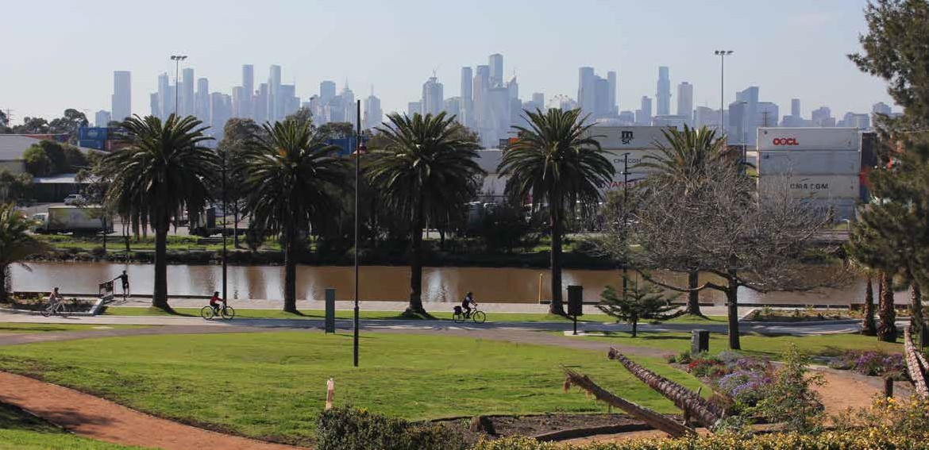


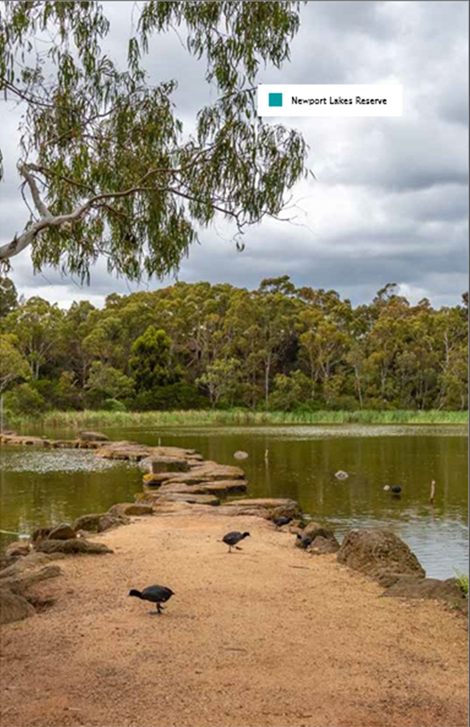
Accessible version
of the document

Please email Department of Transport and Planning
to obtain an accessible version of this document
community@transport.vic.gov.au

Authorised by the Victorian Government, Melbourne.
1 Spring Street Melbourne Victoria 3000
Telephone (03) 9655 6666.

Designed and published by the
Department of Transport and Planning.

Contact us if you need this information in an
accessible format such as large print or audio,
please telephone (03) 9655 6666 or email
community@transport.vic.gov.au

© Copyright State of Victoria
Department of Transport and Planning

Except for any logos, emblems, trademarks,
artwork and photography this document is made
available under the terms of the Creative Commons
Attribution 3.0 Australia licence.
Acknowledgement
of Country

The Department of Transport and Planning
proudly acknowledges Victoria’s Aboriginal
communities and their ongoing strength
in practicing the world’s oldest living
culture. We acknowledge the Traditional
Owners of the lands and waters on which
we live and work, and pay our respect
to their Elders past and present.

Taking action to improve
air quality in the inner west

The Victorian
Government is
investing $20 billion
in infrastructure
and development
in Melbourne’s west
to create a better place
to live, work and raise
our families.

The transport challenges in this
growing and changing area are
complex and need a coordinated
response across government.
Our vision for the inner west is to
improve air quality and liveability
by reducing heavy vehicle
movements through local streets
and supporting low and
zero-emissions vehicles and
active transport options.

As a government, we know we can
achieve much more when we work
in partnership – with industry, with
our communities and with our peers
at all levels of government.
We want to acknowledge the
constructive and collaborative way
in which it’s come about – from
the Victorian Government, local
community groups and residents,
to the Victorian Transport
Association, the National Heavy
Vehicle Regulator and local
Councils – there’s been great
cooperation and commitment
to get things done.

We’re creating freight connections
for cleaner trucks, shifting more
freight to rail, and improving access
to the port to meet our growing
freight task.

The actions we’re delivering – from
planning and strategies, to trials to
reduce emissions and projects to
enhance communities and improve
health and wellbeing– will make a
difference now, but also stand us in
good stead for when the West Gate
Tunnel opens in 2025.

The inner west of Melbourne’s
proximity to the Port of
Melbourne and the high number
of warehousing and logistics
businesses in the area generate a
large volume of heavy truck traffic.
We recognise the need to balance
the priorities of residents, local road
users and heavy vehicles on the
transport network.

Since 2001, the Department
of Transport and Planning has
implemented a number of time
and mass-based curfews across
the inner west to reduce the
impacts of these vehicles on the
local community.

The Victorian Government will
introduce 24-hour truck bans
on six local roads when the
West Gate Tunnel project
is completed in 2025.

Timeline
July 2018
The Inner West Air Quality
Community Reference Group
(CRG) established
March 2020
The CRG submitted its final
report to Government
April 2020 – January 2021
A Government Committee was
convened to review and respond
to the report
September 2020
CRG Report was publicly released on
Department of Energy, Environment
and Climate Action’s website
May 2021
The Victorian Government
presented to the CRG on the work
underway to improve air quality
in the inner west
July 2021
Government formal written response
was circulated to the CRG
August 2022
Government presented a progress
update to the newly formed Inner
West Air Quality Network
October 2022
Victoria’s Air Quality
Strategy released

Actions we’re taking to improve air quality in the inner west

- Modernising our truck fleet
We’ve allocated $15 million for upgrading the truck fleet travelling through the inner west to the port. And $5 million has been set aside for councils to seal roads that carry traffic in or near industry, which will reduce dust pollution.
- Best Practice guidelines for green vegetation projects
We’re developing best practice guidelines for the roll out of green vegetation projects across the west. These guidelines will help the rollout of local projects that include planting trees and vegetation along busy roads. The goal is to enhance air quality for local residents.
- Targeting childhood asthma
We’re investing $1.788 million to support local childhood asthma projects. This is part of our strategy to improve the management of childhood asthma in the inner west.
- Truck curfews
To reduce the impacts trucks on the people living in Footscray, Yarraville, Seddon, and Kingsville, we’ve introduced restrictions on when and where heavy trucks can operate.
- A truck curfew guide for drivers
A new guide to educate truck drivers about where and when they can travel through the inner west, and to help industry better plan their journey. Now available in six community languages.
- More trees for a greener, cooler west
In Melbourne’s West, we have already planted 192,000 trees as part of our ambitious plan to plant more 500,000 trees. This includes the establishment of an urban forest in Brooklyn, featuring 3,000 trees. This will help create shaded and cooler neighbourhoods for residents in the west.
- Greening Brooklyn
Revitalising the Federation Trail route through Pipeline Reserve with landscaping, tree planting, and footpaths under a $500,000 fund from the West Gate Tunnel Neighbourhood Fund. The project also gives young people employment opportunities.
- Zero-emission bus trials
Victoria’s Bus Plan trial includes two hydrogen and 50 electric buses on 15 school services and 26 routes in Melbourne’s inner west, including Footscray, Sunshine, Yarraville, Newport, and Williamstown. The trial is a partnership between bus services, manufacturers, and energy companies to shift to a green fleet.
- Support ports to drive supply chains to lower emissions
Victoria’s Commercial Ports Strategy will help the sector support the state’s renewable energy targets and transition to net zero emissions. The Port of Melbourne’s green methanol fuel plans and decarbonization efforts are gaining momentum.
- Air quality improvement precincts
Two Air Quality Improvement Precincts will be established in the inner and outer west with $2.84 million funding. These precincts aim to reduce air pollution and tackle environmental challenges in collaboration with the community and business.
- New air monitoring
Six air quality monitoring stations near to the West Gate Tunnel project have been set up to record local air quality. Air quality is being monitored now and up to five years after the tunnel opens. The results are helping find the best solutions for managing air quality and emissions.
- Heavy Better heavy vehicle signage
New heavy vehicle signs have been installed in Yarraville, West Footscray, Kingsville, and Footscray to inform truck drivers about the existing truck curfews and restrictions. This effort is aimed at improving safety for pedestrians, cyclists, and drivers.
- Heavy vehicle monitoring camera trial
An innovative heavy vehicle monitoring camera trial is underway, with cameras set up on Somerville Road, Hudsons Road, and Moore Street. These cameras use video analytics technology to capture truck compliance data and help ensure the ongoing safety and well-being of the community.
- Direct rail link to the port
The $58 million Port Rail Shuttle Network includes a direct link from the SCT Logistics hub at Altona to the port. This will benefit local residents by reducing emissions and decreasing the number of trucks on the roads.

- New uses for old Melbourne Market site
Re-purpose a site near the port for more freight and transport uses such as truck marshalling and empty container storage, container handling, a truck rest and refuelling stop and an urban freight consolidation, to reduce reliance on the inner west for these services.
- New pedestrian fences have been installed near schools
New fences have been installed on Wembley Avenue and Hyde Street in Yarraville to improve safety for children and their parents traveling to school. Other measures have been taken to reduce truck noise and a 50km/h speed limit has been implemented on Williamstown Road, Francis Street, Moore Street, and Buckley Street.
- New and improved pop-up bike routes across inner west
$5.6 million has been allocated to develop cycling and shared use paths in the west. We’re testing new pop-up bike routes in Footscray, Seddon, and Yarraville, making it easier and safer to travel by bike.
- Improving busy intersections
We’re investing $3.14 million to improve safety for pedestrians accessing Footscray Station and Footscray Market. Moore Street and Hopkins Street intersection will be realigned with new crossings, lights, and safety features. A new 40km/h speed limit has been announced for Moore Street.
- West Gate Tunnel
The West Gate Tunnel project will help reduce congestion, give a dedicated heavy vehicle link to the port, and connect people to jobs, education, and services.
- Truck bans
The West Gate Tunnel Project aims to offer a vital alternative to the West Gate Bridge, providing faster and safer journeys. As part of this project, there will be 24-hour truck bans on six local streets, and more than 9,000 trucks will be removed from the inner west.

Next steps to lift air quality across Victoria
- Net-zero transport emissions
We have committed to bringing forward the target for achieving net-zero emissions from 2050 to 2045 to reduce emissions, enhance communities, and improve health.
- Victoria’s Air Quality Strategy
The Air Quality Strategy of Victoria outlines our approach to reduce air pollution and address major sources of pollution while also supporting the community, the economy, and the environment.
Download report here: Victorian Air Quality Strategy (environment.vic.gov.au)
- New interstate rail freight terminal in Truganina
We’ve allocated $6.1 million for planning a new interstate rail freight terminal in Truganina. This will allow rail freight services to be moved away from South Dynon, reducing the need for goods to be transported through inner west in the future.
- More freight on rail
We’ve invested $181 million in rail freight maintenance, in addition to $83 million in COVID-19 stimulus funding to improve rail freight lines. This investment aims to shift more freight from trucks to rail.

- Port transformation rail project
The $125 million project aims to make freight rail transport more competitive and reduce truck congestion at the port. It will serve as a key connection for moving freight on rail from regional Victoria to the port, helping reduce truck traffic on local roads.
- Better sites for empty container parks
To improve the liveability in inner west, the plan is to place industry closer to transport connections and key freight hubs. This approach will significantly reduce the freight industry’s reliance on Brooklyn and Tottenham for port access.
- Cleaner vehicles
We’ve pledged $100 million to the transport sector to support zero emissions vehicles, which includes an innovation fund, government fleet cars, and fast charging networks. The innovation fund includes an electric cement truck trial, electric vehicles for share ride services and postal delivery vehicles. This will not only benefit the environment but also improve residents’ health.
- Hume Hydrogen Highway trial
Victoria and NSW have committed $10 million to deliver the Australia’s first renewable hydrogen refuelling station. This will help to reduce emissions and meet our new target of net zero by 2045.
transport.vic.gov.au

