

How to register for the Grants Gateway
OFFICIAL
Contents
Step 1. Register 1
Step 2. Enter Details 2
Step 3. Confirm Email Address 2
Step 4. Choose Password 2

Step 1. Register
Select New? Register here
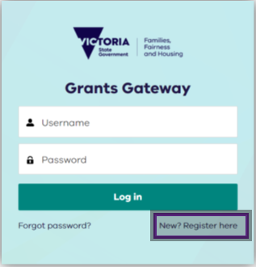

Step 2. Enter details
Enter account details (salutation, first name, last name, email, phone number) and select Sign Up.
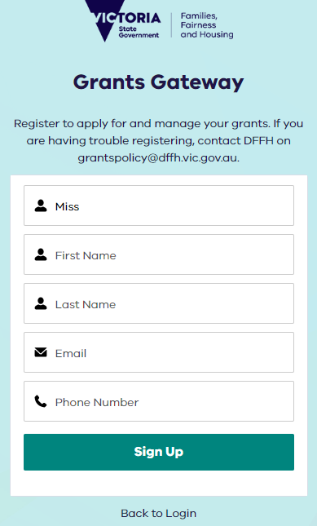

Step 3. Confirm email address
Check for a confirmation email for the registered account. Open your email inbox and search for subject line ‘Welcome to Grants Gateway’ email from No Reply Salesforce <noreply@salesforce.com> on behalf of Grants Gateway.
Select the link in the email to confirm your account.

Step 4. Choose password
Create a password for your account. The password must be:
- 13 characters
- 1 letter
- 1 number
- 1 special character
Confirm your password by retyping it and then select Change Password.
You now have access to Grants Gateway

To receive this document in another format, email Grants Policy grantspolicy@dffh.vic.gov.au
Authorised and published by the Victorian Government, 1 Treasury Place, Melbourne.
© State of Victoria, Australia, Department of Families, Fairness and Housing, August 2023.
Available at Grants Gateway https://grantsgateway.dffh.vic.gov.au/
(2308554)

