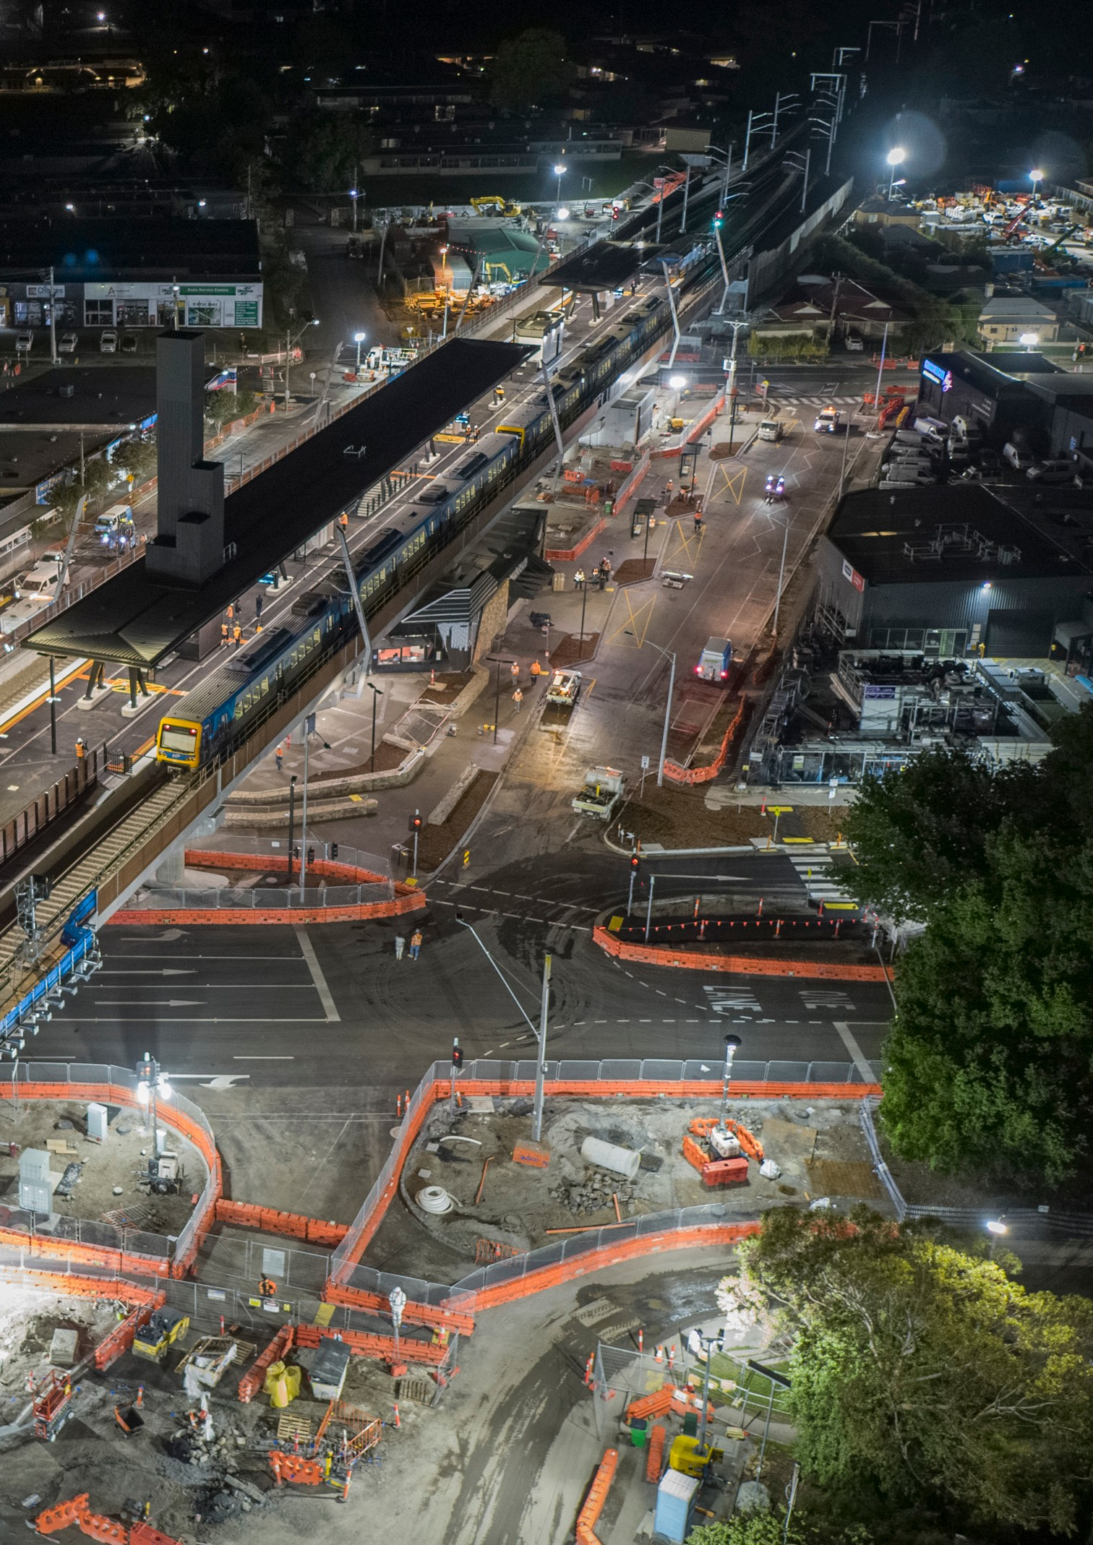
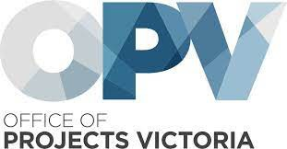


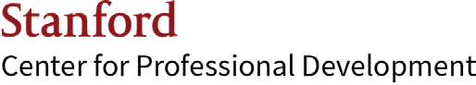
Australian Major Projects Leadership Academy

2024 Prospectus

Level crossing removal, Lilydale, Victoria

2 AMPLA Prospectus



Foreword
It is my great pleasure to introduce the 2024 Australian Major Projects Leadership Academy (AMPLA) Prospectus.
Established in 2018 to build Australia’s public sector project capability, AMPLA graduates represent an elite group who will be critical in helping Australia meet its infrastructure commitments.
There has never been a more demanding time in Australia’s construction and infrastructure industries. Just 13 years ago, Australia had only one major project valued at over $5 billion. Today the number of those mega-projects is in the double digits. States are investing historic sums in long-term infrastructure commitments.
The unprecedented size and complexity of investment requires leaders who can increase productivity, deliver sustainable projects and prioritise the mental health and wellbeing of workers. It also requires a forward-thinking program that supports and develops highly resilient and adaptable future project leaders.
Delivered in collaboration with Stanford Center for Professional Development and McKinsey & Company, the AMPLA program combines world-leading expertise
on strategy and innovation with global perspectives, practical experience and development opportunities. We’re unlocking the full potential of our public sector project leaders.
AMPLA has now produced over 200 graduates, with many working on major projects around the country. These participants have already demonstrated their ability to transform learnings into real-world results, empowered by adaptive ways of thinking and the tools needed to navigate and deliver complex major projects.
The valuable experiences and bonds forged on this course transcend state lines. They are enabling project leaders who can build the best outcomes for Australia’s future. Leaders who can drive the transformation needed to deliver the trainlines, roads, hospitals and schools for generations to come.
AMPLA participants will be at the forefront of this historic era of growth.


Tim Pallas
Victorian Treasurer

About OPV
The Office of Projects Victoria (OPV) leads and influences excellence in project delivery, to ensure that projects are completed on time and on budget, and the full benefits of the investment are realised for Victorians. OPV does this by providing trusted independent advice to the Victorian Government.
The organisation provides major project learning and development, project portfolio oversight and assurance, independent advice, and targeted support for project leaders.
OPV founded AMPLA to provide a unique development offering that enables major project leaders to reach their full potential and form a network of highly sought-after leaders in the sector.


3 AMPLA Prospectus

Designed for
government by government in collaboration with global leaders in innovation

OPV and McKinsey Design Team Members

4 AMPLA Prospectus

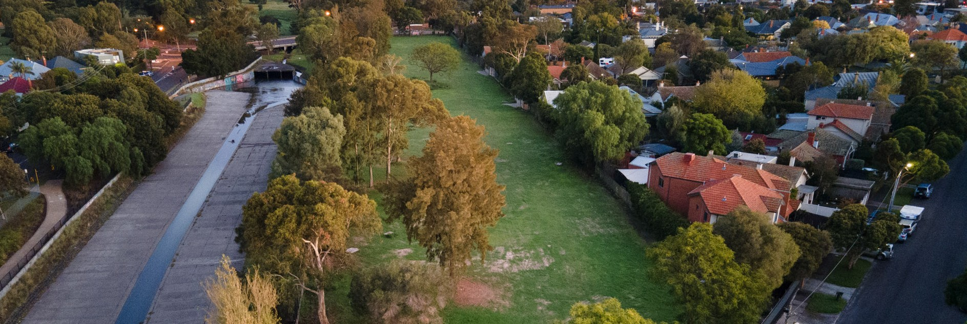
About AMPLA
AMPLA aspires to help major project leaders
reach their full potential and transform the culture, productivity, and sustainability of the major projects sector in Australia.

The Australian Major Projects Leadership Academy (AMPLA) is a year-long immersive program
for experienced public sector major projects leaders. It will be delivered by Professors from Stanford University together with McKinsey & Company. These two world-class organisations have collaborated to create a unique program for Australian public sector major project leaders, drawing together academic excellence and practical experience to create a customised learning experience.
In an increasingly complex environment with greater community interest about major projects and how they are delivered, the role of a project leader is evolving. With an unprecedented pipeline of investment in Australia of $120 billion over the next ten years, project leaders face international supply chain challenges, changing demographics, ongoing digital disruption and the global imperative to achieve net zero by 2050.
AMPLA has been designed to equip major project leaders with the skills, capabilities and mindsets required to successfully navigate this era of growth and transformation.
Today’s major project leaders need to recognise the historic opportunity for innovation. They need to build on their strong foundations to better leverage strategic and critical thinking, lead through disruption and make decisions in the face of uncertainty, while ensuring they embed public sector values and build a positive culture that supports the wellbeing of their people. They must become leaders who:
Have adaptive leadership skills and are self-aware and resilient, to manage the
more complex stakeholder, governance and regulatory environments.
Can leverage technical skills and innovations to unlock productivity, which is needed to ensure projects and the construction industry deliver better public value and achieve the best outcomes for the community.
Can drive the environmental sustainability and social responsibility agenda within their
organisation and beyond to meet Australia’s net zero commitments and create meaningful social outcomes as part of major project delivery.

5 AMPLA Prospectus

A glimpse into our 2023 cohort
AMPLA brings together the best of McKinsey and Stanford’s thought leadership to help our 2023 cohort get ahead of their current challenges. The conference- style delivery of our residentials supported participants to develop real connections and access to our faculty for coaching opportunities. Throughout the residentials , faculty from Stanford University and senior leaders from
McKinsey & Company supported learning by co-facilitating presentations, ensuring direct access to international and domestic experts in every session.

59 participants from a broad range of organisations and projects across the country

Participant evaluation of Residential 2
Quotes from our participants

98%
Reported likely to recommend AMPLA to their peers

90%
Reported positively to the overall program experience
A valuable experience and investment in helping me
become a better person and leader.
“”

It has renewed my passion for projects and my excitement about the people I’ll be working with for future decades.
“”

A great opportunity for networking with peers and finding shared challenges while learning new techniques and approaches that will help in my day-to-day work and reflect on my long-term career path and goals.
“”
More executives in Government need this kind of leadership training and development.
“”

It is providing so many opportunities to self develop and explore in comparison to other leadership courses.
“”

Insightful with practical application and leveraging the value of an experienced peer group of major project leaders.
“”

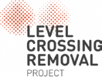



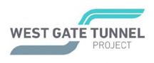




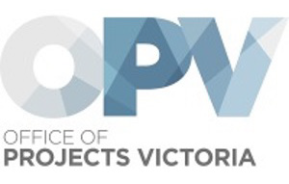





AMPLA will continue to be evaluated to assess the program’s impact on individuals, organisations and the infrastructure sector.

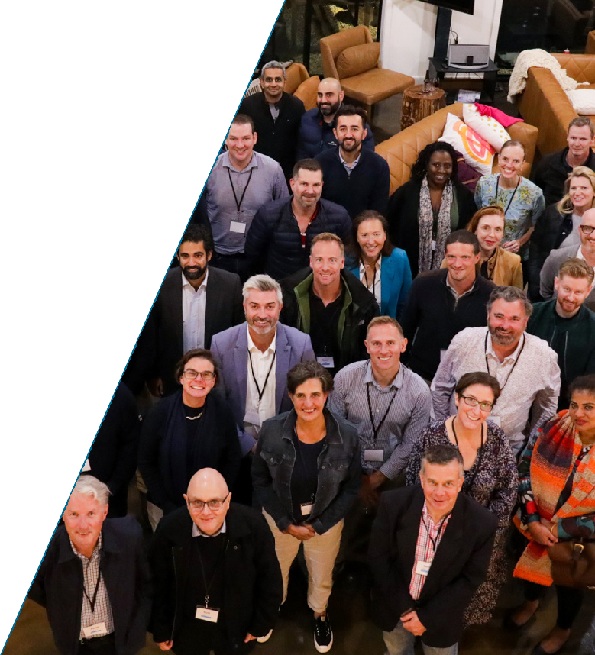



6 AMPLA Prospectus

AMPLA 2023

Feedback from the 2023 cohort

Jason Gordon
Acting in the role of CEO of Water Infrastructure NSW
“What I’ve learned is leadership is a craft that you practice your whole life. I’ve enjoyed learning about the different types of leadership. Technical versus adaptive leadership and strategic thinking. I realise we’re all dealing with wicked or enterprise problems and we have access to 60 peers to test ideas and help. This network of people going through similar things I am, has been a helpful support and provided me with solutions to some of my more challenging issues.”

Virginia Bax
Director, Office of the Chief Executive Officer -
Suburban Rail Loop Authority
“What’s resonated with me since starting the program is the four stages of project leadership. Normally when you do a strategic leadership program, it’s very self-focused - about how can I improve myself as a leader. This program is quite different. It talks about the self, the team and then about strategic leadership in your project as a whole. But something that’s really different, is we are learning about strategic leadership in a system. What really excites me
is how we can leverage future opportunities with other Victorian projects and gain efficiencies and innovations across the entire infrastructure sector from this system- wide approach to leadership.”


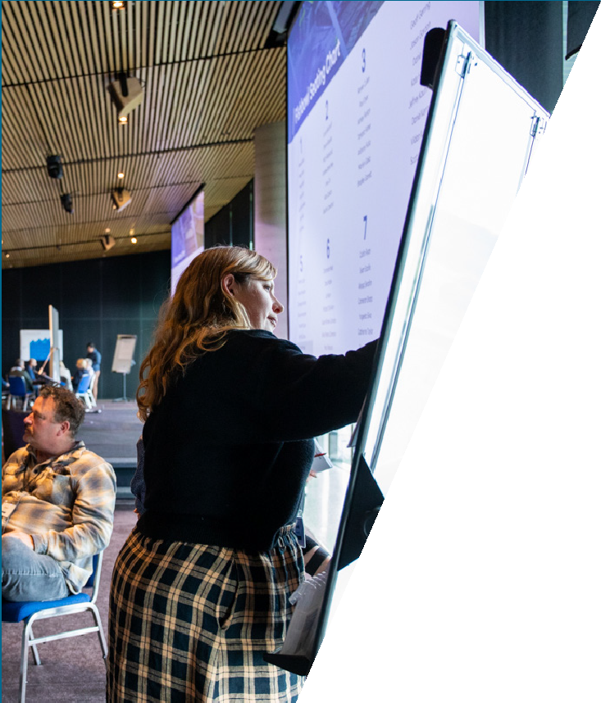
7 AMPLA Prospectus

Building on AMPLA’s solid base

The 2024 program builds on strong foundations, leveraging lessons from the first five years and feedback from key stakeholders (participants and their managers) to further enhance the program’s outcomes.
Since its inception, the program has had participants from Victoria, New South Wales, Queensland, South Australia, Western Australia and the Australian Capital Territory.
Past evaluations of the program show significant impact on participants as shown below.

Impact for participants

93%
reported a greater ability to adapt their leadership style

91%
reported an improvement in their approach to managing major risks and uncertainty

87%
saw a change in the stakeholder engagement approach

AMPLA will continue to be evaluated to assess the program’s impact on individuals, organisations and the infrastructure sector.

8 AMPLA Prospectus

For managers and sponsors
Being a major projects leader in the public sector has arguably never been as challenging as it is today. The scale of infrastructure projects, complexity of the stakeholder environment and unprecedented investment create immense expectations for public sector leaders to deliver for the communities they serve. Equally, today’s major projects leaders have a unique opportunity to achieve transformational impact. Innovations, both technological and commercial, can be harnessed to create a step change in project outcomes and industry productivity.
AMPLA brings together the best of McKinsey and Stanford’s thought leadership to help your colleagues get ahead of these challenges and unlock the opportunities. By sending a participant to AMPLA, you are investing in the opportunity for them to grow their skillsets and their network to help solve these challenges. We are seeking a diverse cohort of experienced major project leaders in the public sector to join our 2024 program.

Participant profile Benefits as a manager

AMPLA is designed for experienced major project leaders in the public sector.

A typical AMPLA participant:
Is a leader who is passionate about transformational change in
1
infrastructure, major project delivery and public service
Is an executive or senior manager with 10 years or more work experience in government, infrastructure or major project delivery
2

Has had exemplary performance as a leader or team member
3

Is open to innovation and diversity of thought
4
More effective project delivery leadership through access to major project coaching from McKinsey & Company and Stanford University global team of experts


Your project can benefit from the experience of other
government professionals with relevant expertise through
the participants’ network and community amongst fellow leaders across Australia



Deliver more efficiently with your leader having access to the latest research and
innovations through hands on exercises and workshops

For managers who sponsored participants:

87%
saw an improvement in stakeholder engagement
75%
saw an improvement in leadership abilities
75%
saw an improvement in resilience





9 AMPLA Prospectus

Program objectives and capabilities

To enable immediate and long-term impact, AMPLA’s learning objectives have been designed in response to industry needs and participant feedback. Major project leader in today’s environment, will need to lead themselves, their teams, their projects, and be a leader across systems. The learning experiences will apply to each participant individually as well as to their organisations; offering insights that are useful in the short term and new tools that will sustain the participants for the foreseeable future.

Use adaptive leadership skills to optimise major program and project outcomes

Define and deliver a high- performance culture in a combined public/private sector project team

Unlock productivity growth and embed innovation in public infrastructure

Deliver environmental sustainability and social responsibility required for an inclusive net zero future

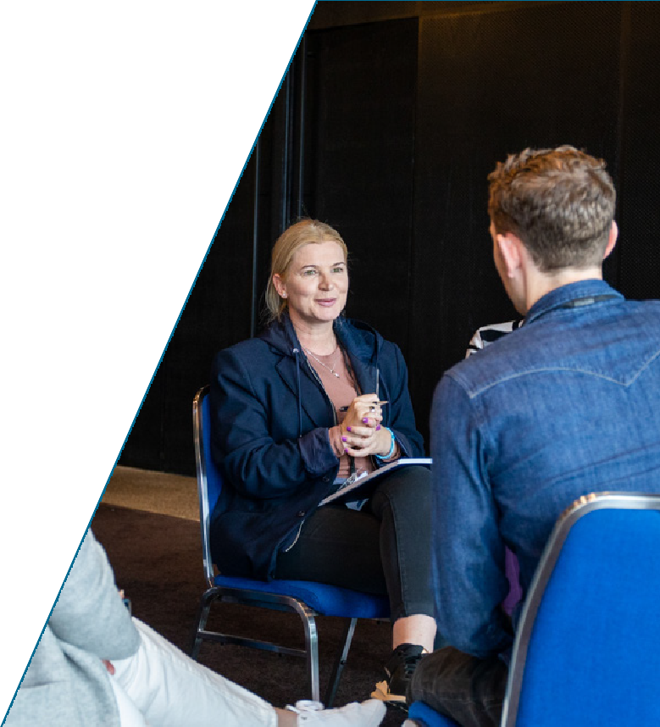

10 AMPLA Prospectus

Use adaptive leadership skills to optimise major program and project outcomes

Capabilities
Leverage strategic and critical thinking to connect actions with results
Use adaptive leadership to lead through disruption and make decisions in uncertainty
Embed public sector values and positive mental health and wellbeing practices

Expected outcomes
Achieve more in the increasingly complex environment of the public sector, balancing multiple and competing priorities to achieve the greatest value for the public
Better pre-empt and manage issues that affect projects’ critical paths
Create individual and team experiences to sustain positive individual, team, project and system outcomes

Define and deliver a
high-performance culture
in a combined public/private sector project team

Capabilities
Create a diverse and inclusive culture Build adaptive and resilient teams
Create a peer network to improve inter-governmental collaboration

Expected outcomes
Better understand and prioritise psychological safety
Empower teams to achieve their best - giving latitude while providing guidance in managing projects and in the broader context

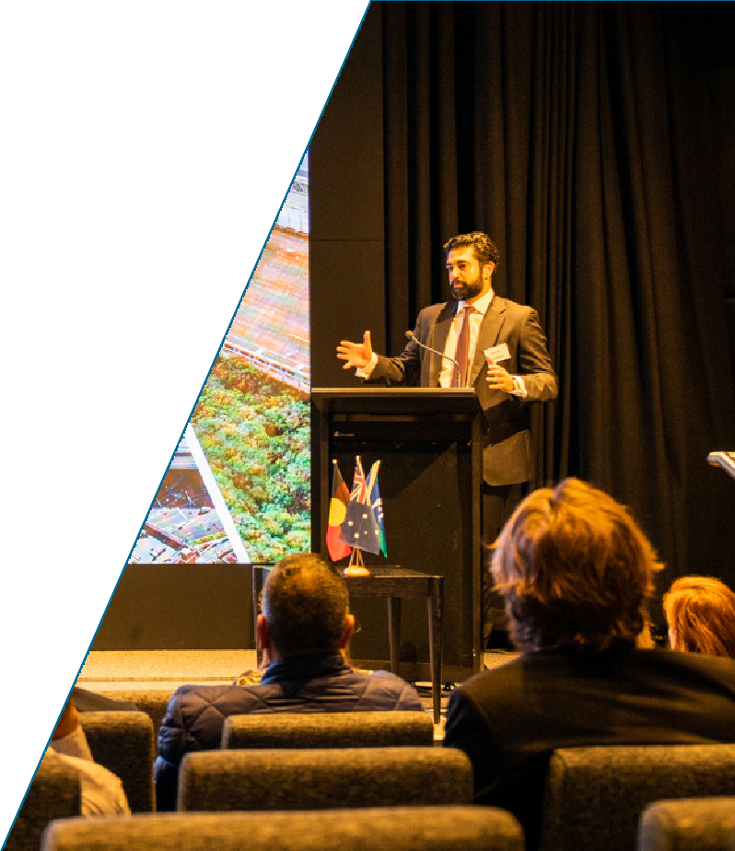

11 AMPLA Prospectus

Unlock productivity growth and embed innovation in public infrastructure

Capabilities
Adopt value-creating, digital and data-led practices to improve project outcomes for the community
Design fit-for-purpose contracting and negotiation practices
Enhance public-sector governance practices when delivering major projects

Expected outcomes
Complement their existing project delivery toolkit to identify and deploy tools that will make a step change on projects e.g.
Use digital innovations to support more efficient design approaches and use data and analytics to drive process improvements across the project lifecycle
Negotiate to achieve the optimal value for the community through contracting practices and management of the contract throughout the project or program lifecycle
Develop governance arrangements that
are embedded into the project and support the team

Deliver environmental sustainability and social responsibility required for an inclusive net zero future

Capabilities
Design, procure and deliver new projects that are climate resilient and support a net-zero future
Deliver existing projects that are climate resilient and support a net-zero future
Influence and drive social responsibility and ESG across government

Expected outcomes
Identify where and how to cost effectively decarbonise major project delivery
Maintain the project vision and desired decarbonisation objectives over the course of a project as priorities change and budget and schedule pressures increase
Support a holistic approach to social procurement and practices focusing on the outcome for the community in conjunction with the delivery aims of the project or program of works

12 AMPLA Prospectus

Program Overview

Program Format
AMPLA will be delivered as a blended model of immersive in-person experiences, small group sessions, project work and self-paced online modules. There are six key elements:

Skills baseline
At the beginning of the program, each participant will complete a personal skills baseline and identify individual learning priorities. The baseline will be used to tailor the learning journey and measure personal growth at the end of
the program.

Residential program
Participants will attend three, four-day immersive in-person learning experiences, where they will explore topics with a diverse Stanford and McKinsey faculty, and experience breakthrough learning moments, while building deep connection with peers.



Individual transformation project
Throughout the year, participants will apply practices and techniques from the course to their own projects/ workplaces and will work with coaches and peer groups to share progress, achievements and challenges. In the final residential participants will submit a reflection paper and personal transformation plan.

Small group
peer-based learning
Participants will be matched with a small and diverse group of peers from the program. Groups will work together on cases and meet regularly over the year to progress their individual transformation projects ahead of residentials.

Stanford/ McKinsey online modules
Self-paced, online learning modules will be available from Stanford and McKinsey educational libraries, tailored to individual development needs, to supplement learning in between residentials.

Capstone presentation
In the final residential, participants will present recommendations for a real- world project example to a Board of senior public executives with a small group
of peers, demonstrating application of concepts learned in the program.

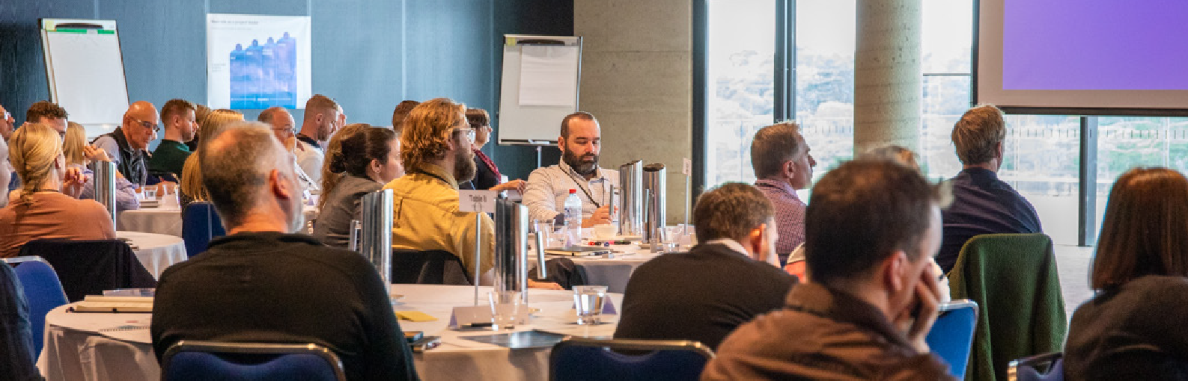
Learning Journey
13 AMPLA Prospectus
The Participant Experience

TBD-March
Program launch
8 April
Residential 1
22 July
Residential 2
14 October
Residential 3

Dec
Jan | Feb | Mar |  |  | Apr | May | Jun | Jul |  | Aug | Sep | Oct |  | Nov Dec

Jan


2023

Pre-Program
Set baseline and aspirations

Phase 2
Develop innovation toolkit and agile mindset

Post-Program
Continue learning and connecting
2024
2025



Phase 1
Build ambition and global perspective

Phase 3
Translate learnings into personal
transformation plan

Key Activities

- Complete skills baseline
- Set personal aspirations
- Meet cohort and faculty at program launch
- Attend Residential 1
- Establish peer groups
- Set personal leadership and project improvement objectives for the year
- Practice learnings and meet with peer group and coaches regularly to share progress, achievements and challenges
- Commence self-paced online learning
- Attend Residential 2
- Meet with peer group and coaches to work on project and leadership objectives
- Progress self-paced online learning
- Attend Residential 3
- Deliver Capstone presentations
- Prepare and share personal
transformation plan with manager and coaches
- Celebrate learning journey with peers and managers and receive certificate of completion
- Access unique alumni benefits, including
online research databases, AMPLA faculty and events
- Continue peer group connection through alumni events

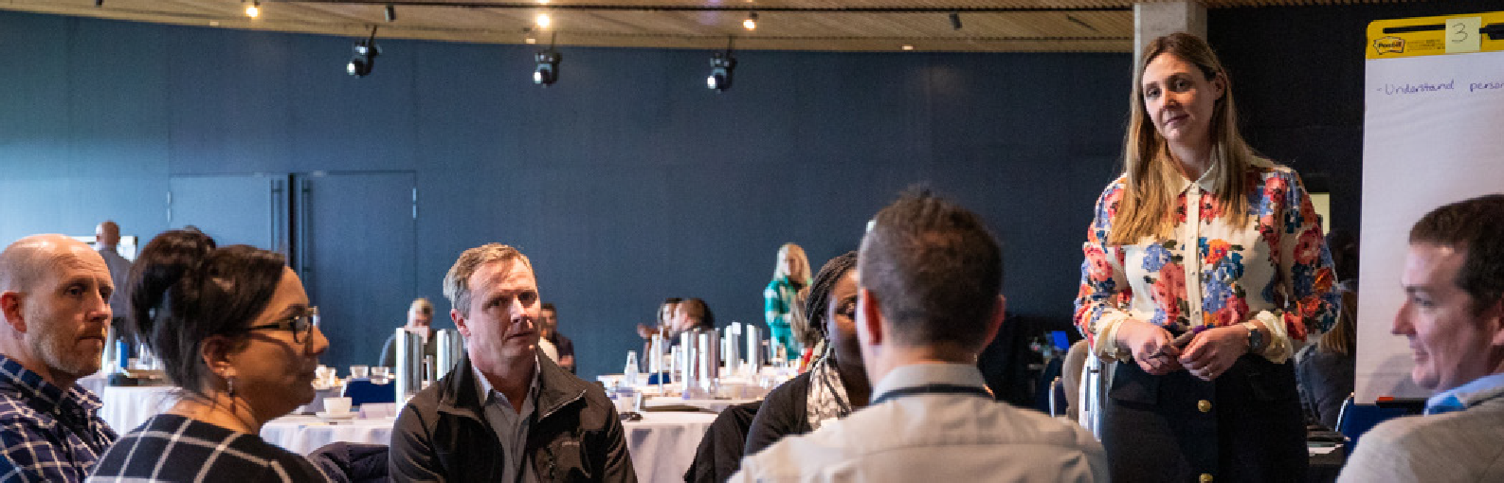
Residential Experience
14 AMPLA Prospectus
Residentials are four-day, in-person, immersive learning experiences

Residential 1 Residential 2 Residential 3
8-11 April
22-25 July
14-17 October

Key focus:
Build ambition and global perspective

Key topics:
Case for change and your role as a major projects leader
Value creation in capital projects
Strategic leadership Health and performance

Experiences:

Develop innovation toolkit and agile mindset

Data-driven decision making
Navigating disruption
Fostering inclusive and diverse teams
Culture transformation
Sustainable design and delivery

Translate learnings into personal transformation plan

Public sector governance and influence
Systems transformation Authentic leadership


Explore real-world cases, root causes of systemic challenges and how they can be most effectively worked through in a public sector context
Learn best-in-class practice from Stanford and McKinsey faculty through bespoke offerings
Engage with experienced senior executives who have successfully navigated and delivered under public scrutiny in Australia in fireside chats
Visit major project sites and hear from leaders who have deployed innovative practices to deliver significant scope, cost and time efficiencies on their major projects
Work with a complementary group of peers to solve problems and be coached to become a high performing peer network
Experience breakthrough learning moments while building deep connections with peers

Note: The exact format and structure of the program may change depending on number of participants enrolled

15 AMPLA Prospectus

About the Stanford & McKinsey collaboration
The AMPLA 2024 program is developed in collaboration with the Stanford Center
for Professional Development (SCPD) and McKinsey & Company from across Australia and the United States. This collaboration brings a holistic value proposition that covers major capital projects, leadership, public sector, academic learning and behavioural change science.
SCPD is a longstanding leader in global, online and extended education, increasing access to Stanford University’s teaching and research and creating a global community of learners, industry leaders, and educators. SCPD works closely with Stanford faculty across the university, as well as industry experts, to design and deliver engaging, immersive educational programs in Europe, South America, Asia, North America and now Australia.
Stanford educational programs impart the mindset, knowledge, and skills essential to drive innovation, manage the impact of disruption in technology and business, and transform industry, government, and other organisations. SCPD is housed within the Stanford School of Engineering, long at the forefront of innovation, ground-breaking interdisciplinary research, and the creation of pivotal technologies that have transformed the worlds of information technology, communications, health care, energy, business and beyond.
McKinsey & Company is the trusted advisor and counsellor to many of the world’s most influential businesses and institutions. As a truly global management consulting firm, its scale, scope and knowledge allows it to address problems in unique ways; bringing deep functional and industry expertise as well as a breadth of geographical reach.
As the partner of choice for organisations seeking to maximise the impact of their leadership, McKinsey is one of the largest providers of leadership development in Australia and globally, with 300+ client specific learning journeys delivered each year. Additionally, over the past five years, McKinsey has delivered impact across 1,450+ capital projects globally and infrastructure engagements worth $1.5tn USD.
This combined horsepower of both SCPD and McKinsey & Company fuels the blended learning approach used in the design of AMPLA 2024. It ensures that the real-world skills of leaders are enhanced from their very first engagement with the program.
This collaboration also brings together the global reach and network of both organisations collectively to an Australian audience for the first time. Participants will have unparalleled access to faculty and industry experts from both SCPD and McKinsey, from whom they can receive additional insight above and beyond the course content.

16 AMPLA Prospectus

Faculty

A mix of Stanford and McKinsey & Company faculty from across Australia and the United States will deliver the program to bring the best of both organisations to the learning journey.


Ishaan Nangia
Senior Partner, McKinsey & Company
Ishaan brings extensive experience in leading client services in capital excellence across infrastructure, real estate,
telecommunications and mining in Australia, New Zealand and the United Kingdom. He co-authored “Australia’s Infrastructure Innovation Imperative” – McKinsey’s perspective on six
levers to transform productivity in the delivery of transport infrastructure projects, and is currently the Chair of the Committee for Melbourne’s “Transport Taskforce”. Ishaan is a member of the Business Council of Australia’s “Infrastructure & Regional Development Committee”.



Emily Kiernan
Partner, McKinsey & Company
Emily brings a unique perspective having served clients across transport, logistics and infrastructure both in Australia and North America, specialising in large, capital- intensive and typically regulated network businesses.
She has worked with clients across all capability areas including strategy, transformation, organisational design, and change management. Her recent focus is on leading diagnostics and large scale transformations in the
public and private sector. Emily is also part of McKinsey’s CEO Excellence service line with a particular focus on supporting executives transition to new roles.



Martin Fischer
Professor of Civil and Environmental Engineering and Director of the Center for Integrated Facility Engineering, Stanford University
Martin’s research goals are to improve the productivity of project teams involved in designing, building, and operating facilities and to enhance the sustainability of the built environment. He is known globally for his work and leadership in developing digital methods and in integrating project delivery to increase the productivity
of construction project teams, enhance building performance, and create new strategic opportunities for organisations in the construction industry.


Fiona Prowse
Dean of AMPLA program, McKinsey & Company
Having joined McKinsey in 2021 following over a decade in the Victorian Government, Fiona has a strong track-record in leading complex strategic reforms. This has included justice and social service system reform, NDIS and disability service transformation, modernisation of occupational health and safety laws, and major infrastructure and transport projects. Additionally, Fiona led Victoria’s COVID-19 workplace policy response and service model design for supporting complex clients. Fiona leverages distinctive public sector experience and expertise to drive enduring societal change with our clients, supporting them to transform their workforces and organisations (particularly at points of crisis/ transition), reform complex service systems, and build their own leadership capabilities.


Kimberley Swords
Associate Partner, McKinsey & Company
Kimberley brings extensive public sector leadership, including leading the land use planning and acquisitions for Victoria’s Regional Rail Link, five years as Deputy Secretary regulating major projects for the Commonwealth Government, two years as the Chief Advisor Queensland Government Procurement, and the design and delivery of significant leadership programs. She studied organisational design and leadership at RMIT University
and has guided leadership development through the first cohort of Victorian Leadership Development Centre (VLDC) participants, the Williamson Community Leadership Program, IPAA (VIC and ACT) Young Professionals, NSW Leadership Academy, and a selection of public sector leadership and executive programs.

17 AMPLA Prospectus




Ben Fletcher
Senior Partner, McKinsey & Company
Ben brings 15 years of experience as a global leader in McKinsey’s People & Organisational Performance (POP) practice where he leads leadership capability building programs including McKinsey Implementation and McKinsey Academy. Ben specialises in building individual, team and institutional capabilities to power performance transformations, and has extensive experience leading transformations at large organisations that are transitioning to new ways of working.

Pamela Hinds
Professor and Chair of the Department of Management Science and Engineering, Stanford University
Pamela brings extensive knowledge on the impact of technology on teams, collaboration, and innovation. Her published works explore cross-boundary dynamics, cultural factors in teams and the role of site visits in knowledge sharing. Her current research interests involve looking
at the changing nature of work in the face of emerging technologies, including the nature of coordination in open innovation, and the changing role of data analysis.



Robert Burgelman
Professor of Management, Stanford Graduate School of Business, Stanford University
Robert’s research has focused on the role of strategy- making in organisation evolution. He has taught executive programs and led senior and top management seminars for major companies worldwide. He has also served on boards of directors and boards of advisors of several private companies.

Brian Sedar
Adjunct Professor, Civil and Environmental Engineering, Stanford University
Brian brings over 35 years of experience in EPC work spanning project controls, procurement, project development, construction, project management and operations.



Ram Rajagopal
Associate Professor of Civil and Environmental Engineering, Stanford University
Ram directs the Stanford Sustainable Systems Lab (S3L), focused on large-scale monitoring, data analytics and stochastic control for infrastructure networks. His current research interests in power systems are in the integration of renewables, smart distribution systems, and demand-side data analytics.

Jill Charker
Associate Partner, McKinsey & Company
Jill supports clients across a broad range of people and organisational topics, with a focus on operating models, capability building and leadership team effectiveness. She works across McKinsey’s public and social sector, people and organisational performance and global basic materials and mining practices. Jill is a qualified executive coach and partners closely with clients to solve complex workforce, culture and leadership issues, tailoring bespoke solutions to drive their success.

18 AMPLA Prospectus




Victor Finkel
Partner, McKinsey & Company
Victor is a Partner at McKinsey, based in Melbourne, Australia. He is a leader in McKinsey’s Australian public sector practice, focused on the energy transition and defence acquisition & sustainment. He works on issues at the intersection of engineering and economics, where public sector and private sector solutions are needed to complex systems challenges.

Shannon Peloquin
Partner, McKinsey & Company
Shannon brings 15 years of experience as a leader in McKinsey’s Capital Projects & Infrastructure and Sustainability practice supporting transportation, infrastructure and major utilities organisations in North America and globally to enhance long-term strategy and investments, operations, safety, and reliability.



Roland Dillon
Partner, McKinsey & Company
Roland brings over 10 years of experience serving Governments in Australia, Asia and the U.S. as part of McKinsey’s Public Sector practice and is an experienced public sector transformation leader. He is on the board of the McKinsey Centre for Government and leads
our global research into what makes public sector transformations successful, including our research, “Delivering for Citizens” which is the largest global data set on public sector transformation.

Michael Lepech
Professor of Civil and Environmental Engineering and Senior Fellow at the Woods Institute for the Environment, Stanford University
Mike directs the Stanford Center for Sustainable Development and Global Competitiveness and the Stanford Center at
the Incheon Global Campus. His work combines multi- physics engineering, infrastructure sensing, innovation and entrepreneurship to make our cities progressively smarter and to design and operate built environments that
are increasingly decarbonised.



David Dyer
Partner, McKinsey & Company
David brings more than 17 years of client service experience across Australia, the UK and Asia, with extensive experience advising State, Federal and international governments on delivering better outcomes for citizens and society.

Emma Loxton
Partner, McKinsey & Company
Emma brings a decade of experience in helping clients in the UK and Europe to build strategies, improve commercial functions, and manage mergers across the transportation industry.

19 AMPLA Prospectus




Roberto Charron
Capital Projects Academy, McKinsey & Company
Roberto brings over 25 years of experience in the design and construction industry, he is one of the leaders of the McKinsey’s Capital Excellence Academy and the Project Delivery and Construction service
line. He has worked with clients on operational transformation topics in a variety of industries, including Transportation, Healthcare, Oil and Gas, Power Generation, Renewables, Telecommunications and Manufacturing amongst others. He has deep expertise in Lean Construction, Production Planning, Project Controls and Operations Transformation.



Howard Ashcraft
Partner, Hanson Bridgett
Adjunct Lecturer, Civil and Environmental Engineering, Stanford University
Howard Ashcraft is a practicing construction lawyer with extensive experience in major infrastructure projects, especially those using advanced
and innovative project delivery methods. He is particularly well-known for developing the theory and recommended practices for collaborative project delivery approaches, such as Integrated Project Delivery, and in integrating technology with project delivery. He, with his Hanson Bridgett team, has structured hundreds of collaborative projects and has used these experiences to evolve the advanced
project delivery. Many of the key publications and texts for IPD were authored, or co-authored, by Howard.
In addition to his transactional practice, Howard has significant experience with complex construction litigation. These projects have also provided important lessons regarding the limitations of traditional design and construction delivery.

Alistair Carmichael
Expert Associate Partner, McKinsey & Company
Alistair is an Expert Associate Partner at McKinsey & Company and a leader of the People and Organizational Performance Practice and McKinsey Health Institute.
He is a founder and global leader of McKinsey’s thinking and work on mentally healthy and safe workplaces. From his base in Sydney, he advises and works with clients on workplace mental health, to transform culture and growth, better manage change, develop leadership and talent, and reimagine operating models. Outside of McKinsey, Alistair is a passionate advocate for mental health and a volunteer at Lifeline (Australia’s suicide prevention and crisis line).
Prior to joining McKinsey, Alistair practiced employment and industrial relations law at law firms in London and Sydney.


Marc Walker
Senior Expert & Associate Partner, McKinsey & Company
Marc brings 10 years of experience as a leader in McKinsey’s People & Organisational Performance (POP) practice where he focuses on the complex people challenges faced by organisations, with a particular focus on leadership development, facilitating deep shifts in individual and organisational capability building.
As a facilitator, he leads a network of learning and development professional advisors and executive coaches. Marc is also the Dean of the Australia & New Zealand Executive Leadership Program and Young Leaders Forum – the largest annual multi- organisation leadership development programs in the region.

20 AMPLA Prospectus

How to apply

Participant profile
AMPLA is designed for experienced major project leaders in the public sector. We are seeking a diverse cohort of leaders for our 2024 program.

A typical AMPLA participant:
Is a leader who is passionate about transformational change in infrastructure, major project delivery and public service
1

Is an executive or senior manager with 10 years or more work experience in government, infrastructure or major project delivery
2

Has had exemplary performance as a leader or team member
3

Is open to innovation and diversity of thought
4

Application process
To apply to the program, please submit an application on our program website before 17 November 2023, 11:59pm AEST

Link to program website

Dates
Application period 18 September – 17 November 2023
Selection & notification 17 November – 1 December 2023

Enrolment & skills baselining
1 December 2023 – 9 February 2024

Please note that participants must have sponsorship approval from their managers to be considered for the program.

21 AMPLA Prospectus

The total program fee including GST, payable upon enrolment, is A$38,390.
Program fees
This fee includes all classes and learning materials, as well as accommodation and meals for all three residential programs (3 nights, 4 days each).
Please note the total price excludes travel to and from residentials and any additional accommodation required.

Information sessions
We will be hosting virtual information sessions throughout the application period.
Details are as below:



Contact Us
Further information about the AMPLA application process is on the program website. Any queries can be directed to the Office of Projects Victoria at opvlearning@opv.vic.gov.au.
If you require further assistance, please contact the OPV-AMPLA coordination team:
Sharni White
Acting Senior Manager, Office of Projects Victoria
sharni.white@opv.vic.gov.au
Caitlin Phillips
Director, Strategic Improvement, Office of Projects Victoria
Caitlin.phillips@opv.vic.gov.au
Link to program website
Time and Date
10 – 11 am AEDT
3 October
1 – 2 pm AEDT
24 October
12 – 12:45 pm AEST
12 October
1:30 – 2:30 pm AEST
2 November

Sessions will be recorded and available on the program website. To sign up for one of our information sessions, please register here.
For the latest updates on information sessions, please refer to the program website.

22 AMPLA Prospectus

FAQs

Over what time period will the program take place?
The AMPLA program will take place from January to October 2024, including onboarding and post- program activities. The core program components will be delivered between March and October.
Participants will start the journey with a skills baseline and faculty 1:1, followed by several in-person and virtual events which include the three, four-day residentials.

What is the average time commitment needed to complete the program? Do I need to commit to the full program?
Participants are expected to attend all scheduled learning events across the learning journey. Course organisers understand the ongoing professional commitments of participants and do their best to schedule learning activities and events with this in mind. The full program of activities is estimated to be approximately 20 working days (including residentials) of participant time during the program.

Are participants required to submit assessments?
Participants will be expected to actively engage with the material provided, including the Capstone presentation including the Capstone presentation and an Individual Transformation Project. Pre-reading will be required, as well as preparation for presentations throughout the program.

Where are the residentials going to be held?
Residentials will be held in various locations in Australia to create an immersive experience for learning and connection across the cohort.

What is the program fee?
The 2024 program fee for AMPLA is A$38,390 (including GST). This includes accommodation at the residentials, meals, classes and learning materials. It does not include travel costs. When considering participation, please discuss all the costs with your manager.

Do I receive a certification upon completion?
Upon completion, participants will receive a certificate of achievement from the Stanford Center for Professional Development (SCPD).

What if I have other questions about AMPLA?
If you or your organisation requires any further information about AMPLA please contact OPV at opvlearning@opv.vic.gov.au.


Engineering and Capital Excellence
23 AMPLA Prospectus
Insights from the faculty
Participants and sponsors can learn more about our faculty and organisational areas of expertise by clicking on the below list of selected publications.

Integrating Project Delivery
Fischer, M., et al., Wiley, 2017

Measuring the impact of blockchain and smart
contracts on construction supply chain visibility
Advanced Engineering Informatics, Hamledari, H. and Fischer, M., 2021

Digital Twin: From Concept to Practice
Journal of Management in Engineering, Agrawal, A., Fischer,
M. and Singh, V.2022; 38

Measuring Progress and Productivity in Model-Driven Engineering for Capital Project Delivery
Journal of Construction Engineering and Management, Garcia, G., et al., M.2021; 147

Virtual design and construction
Construction Management and Economics, Kunz, J. and Fischer, M, 2020

Human-Robot Collaboration in Construction: Opportunities and Challenges
Brosque, C., et al., IEEE, 2020: 338-345

24 AMPLA Prospectus

Engineering and Capital Excellence

Making Each Workhour Count: Improving the Prediction of Construction Durations and Resource Allocations
Fischer, M. et al., Springer International Publishing, 2018:
273–95

PaToPaEM: A Data-Driven Parameter and Topology Joint Estimation Framework for Time-Varying System in Distribution Grids
IEEE Transactions on Power Systems, Yu, J., Weng, Y. and Rajagopal, R, 2019; 34 (3): 1682–92

Australia’s infrastructure innovation imperative
McKinsey & Company, Nangia, I., et al. September 2019

Bridging the labor mismatch in US construction
McKinsey & Company, Hovnanian, G., Luby,R., and Peloquin, S., March 2022

How capital expenditure management can drive performance
McKinsey & Company, Brinded, T., et al., June 2022

The next normal in construction
McKinsey & Company, João Ribeirinho, M, et al., June 2020

Reinventing construction through a productivity revolution,
McKinsey & Company, Barbosa,
F. et al., February 2017

25 AMPLA Prospectus

Strategy and Business

Becoming Hewlett Packard: Why Strategic Leadership Matters
Burgelman, R.A., McKinney, W. and Meza, P.E., 2016

Built to Become: Corporate Longevity and Strategic Leadership
Burgelman, R.A., 2014

Cutting the Strategy Diamond in High-Technology Ventures
Burgelman, R.A. and Siegel, R 2008

Public Sector Leadership

The Power of Strategic Integration,
Burgelman, R. and Doz, Y.L., 2001

The wisdom of transformations: How successful CEOs think about change
McKinsey & Company, Huizenga, T., et al., July 2019

Putting people at the heart of public-sector transformations
McKinsey & Company, Dillon, R., et al., March 2019

Sustainability

Transforming capital projects to deliver net-zero emissions
McKinsey & Company, Cutler, Z. et al., February 2022

Action needed: Help us measure project sustainability
McKinsey & Company, Heuss, R., et al., September 2021

Climate change impacts on international seaports:
knowledge, perceptions, and planning efforts among port administrators
Climatic Change, Becker, A. et al., 2012; 110 (1-2): 5-29

Further information about AMPLA 2024 application process is on the program website.
Any queries can be directed to OPV at opvlearning@opv.vic.gov.au.


Hoddle Street, Melbourne
Link to program website

