

<Regulator Name>
<Permission Name>
Better Practice Permissions Process Manual

When adapting this document for your organisation’s context and requirements, please replace BRV’s branding with your own.
The Better Practice Process Manual can support you to implement ‘better practice’ permissions.
This Better Practice Permissions Process Manual (the Manual) accompanies the Implementing ‘Better Practice’ Permissions Playbook (the Playbook). It provides you with a template to document your processes, business rules and requirements, and apply lessons learnt to your specific context. It is organised to follow the six stages of the Playbook.
Text in purple is provided as guidance for the completion of the Manual and should be deleted before publishing.
You are encouraged to adapt the materials in this document to your organisation’s templates and requirements. The content in this Manual provides a starting point as you work through the Playbook. It can be modified and deleted as required to match your needs and context. You should consider the prompts provided in the Playbook when completing this Manual, and how the process, business rules and requirements relate to your particular permissions.
When working through the Playbook and Manual, you should:
- Use each stage and component of the Better Practice Permission Journey as they align with your permissions.
- Modify the process map in the accompanying Better Practice Permission Journey Template to align with your own permissions and processes and add to this Manual.
- Add annotations and numbering references to the tables in this Manual as required to support commentary and linkages to the process map.
- Use the generic tables throughout the Manual to document processes, business rules and requirements.
Each section has a table for common business rules to be documented. As you review your processes you may find that you need to develop further content and instructions. You can use the table and prompts provided at the end of the document.

Contents
Contents 2
Document revision history 2
Purpose 3
Context 3
Process maps and activity steps 5
Inform 6
Apply 7
Review & Stream 10
Assess 14
Decide 17
Notify & Issue 20
Generic Templates 22
Risk assessment framework 23
Identified risks 23
Adopted assumptions 23
System and process requirements 24

Document revision history
Mandatory section
Record minor and major version of this better practice process. There is no need to keep a record of drafts. Limit to relevant versions. Previous versions will be available in archived copies.
Version | Revision date | Author | Summary of changes | Reviewer | Approver
0.1 | 01/07/2023 | Original Draft | Original document | Manager/Lead  Subject Matter Experts | Senior Manager/ Lead

Purpose and context
Modify and/or delete content as required.
This Better Practice Permissions Process Manual (the Manual) defines the service design, processes, business rules and requirements for the group of processes that constitute ‘better practice’ permissions. It accompanies and aligns to the Implementing ‘Better Practice’ Permissions Playbook (the Playbook).
This Manual covers information provided to prospective applicants during the ‘Inform’ stage, the information requested from applicants during the ‘Apply’ stage, and the internal regulator processes relating to the approval of a permission application across the ‘Review & Stream, Assess, Decide, and Notify & Issue’ stages. It will be used by Regulator name to inform the processes, business rules and requirements to implement ‘better practice’ permissions and prepare for future digitisation.

‘Better Practice’ Permission Journey
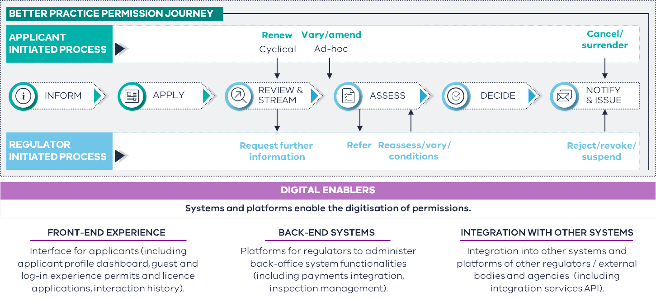

Business process overview
Process name | Process description | Version number | Process owner | Upstream processes | Downstream processes
Inform | Information provided by a regulator about a permission | Template | Role | NA | Apply
Apply | Application for a permission | Template | Role | Inform | Review & Stream
Review & Stream | Regulator processes for the approval of a permission. | Template | Role | Apply | Assess
Assess | Assessment of a permission application. | Template | Role | Review & Stream | Decide
Decide | Outcome of a permission application. | Template | Role | Assess | Notify & Issue
Notify & Issue | Notifying the application of the outcome of a permission outcome. | Template | Role | Decide | NA

Process maps and activity steps

Process map – Inform & Apply
Modify and/or delete content as required. An editable version of the Better Practice Permission Journey map accompanies this Manual. Components and details can be modified and deleted to match your processes.
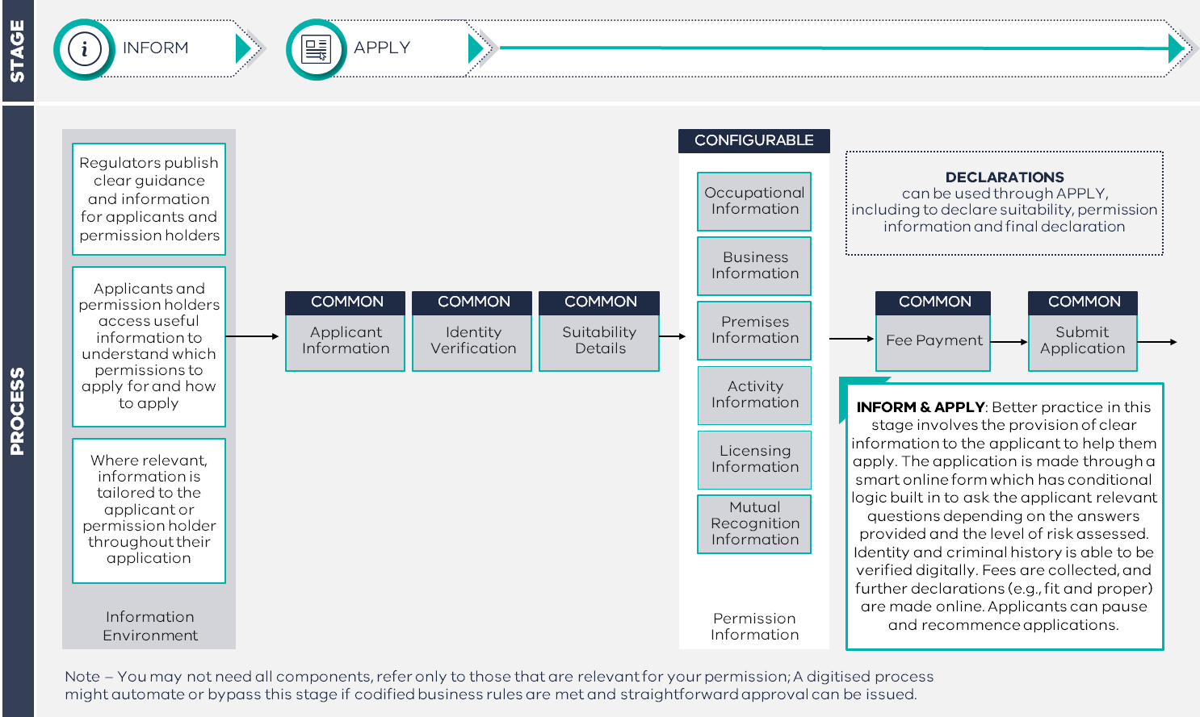

Inform

Content guidance – Inform
This table outlines the content in the ‘Inform’ stage, covering information provided to applicants and regulated entities before, throughout, and after the application and approvals process. Each line reflects a component of information that is provided to applicants and regulated entities.
Modify and/or delete content as required. This table should be used to inform and guide more detailed content development. Each line should reflect a component of information (e.g., a specific webpage or document) and this information should be classified as common (applying to all applicants and regulated entities), contextual or audience specific (applying to a subset of applicants and regulated entities), or external (from a third-party source). Some examples have been provided in the table below.
Information/web page name | Description | Information type | Location/link
Name of information or webpage | What is the information provided | Is it Common, contextual or audience specific, or external information?  If contextual or audience specific, what simple business rules outline when it is relevant? | Link to the relevant webpage or document
When do you require a licence? | Webpage that provides information on the circumstances in which an entity requires a permission. | Common | Link to relevant webpage or document
Information requirements for a specific licence | Webpage providing information on specific application requirements. | Contextual or audience specific  Displayed when applicant chooses a specific licence type | Link to relevant webpage or document

Applicant types – Inform
This table outlines the business rules in the ‘Inform’ stage, covering the conditional provision of information to particular groups or types of applicants. Each line should reflect an application or entity type, and the specific type of information they require.
Modify and/or delete content as required. This table should be used to inform and guide the identification of different groups or types of applicants and regulated entities. These groups should be classifiable by responses to particular questions or traits/features that mean they require different information about the permission. Business rules should outline the link between the group an applicant is in, and the specific information that they should be provided with. An example have been provided in the table below.
Applicant group/type | Determining questions/information | Stage this information is provided | Business rule
Applicant group or type, or classifying feature | What questions or information can be used to determine an applicant matches a particular group? | What stage in the process is this information primarily provided by the applicant? | What business rules guide what information is presented?
Individuals with an unrecognised tertiary qualification | Select the country in which you completed your tertiary qualification. | Qualification information | IF applicant is from a country with unrecognised qualifications  THEN provide information on processes for validation of qualifications

Apply

Information request guidance – Apply
This table covers the processes in the ‘Apply’ stage, covering the submission of information by applicants. It captures each data field that is requested from the applicant, primarily through the application form, including whether the information is required universally or conditionally.
Modify and/or delete content as required. This table should outline all information requested as part of the application. The table structure will assist the mapping of information requests against the categories in the Better Practice Permission Journey Map, and the classifying of each field as universally required (should be asked of all applicants) or conditionally requested (asked from a subset of applications). Some examples are provided in the table below.
Information component | Field name | Description | Information request type
Which component does the information sit in? | Which information is requested? | What is the detailed information? | Is this information universally required or conditionally requested?
Applicant details | Name | First and last name of the applicant | Universally required
Applicant details | Phone number | Australian landline or mobile number | Universally required
Business information | Corporate structure | Corporate structure of the applying business | Conditionally requested

Business rules for conditionally requested information – Apply
This table covers the business rules for conditionally requested information in the ‘Apply’ stage. It captures each conditionally requested data field, the business rule governing its request, and what information is used to inform this business rule.
Modify and/or delete content as required. This table should be used to develop the business rules and dependent information for conditionally requested information. Each business rule should be dependent on the response to another question in the application form. An example has been provided in the table below.
Information component | Field Name | Business rule | What information informs this business rule
Which component does the information sit in? | Which information is requested? | What business rules guide this conditionally requested information? | What other information can be used to trigger the request for this information?
Business information | Corporate structure | IF entity type is business  THEN request corporate structure | What entity type is applying for this permission?

Information not to be requested – Apply
This table covers information that should not be requested, considered or analysed in the context of an application for a permission. This includes information that is currently requested but will not be in a better practice state, or information that may be provided incidentally through the submission of other information.
Modify and/or delete content as required. This table should be used to develop a view of information that should not be considered as part of an application. A rationale should be developed and provided for each excluded data field, alongside any exceptions in which it may be appropriate to request, consider or analyse this information. An example has been provided in the table below.
Information name | Description | Rationale for exclusion | Exceptions
What information should not be requested? | Is this universal or only in certain circumstances? | Why is this excluded? | Are there any exceptions when this information should be requested or used?
Date of birth | The specific date of birth (DD/MM/YYYY) of an applicant. | For the purposes of regulatory outcomes, a year of birth or age is sufficient. | N/A

Review & Stream
Modify and/or delete content as required. An editable version of the Better Practice Permission Journey map accompanies this Manual. Components and details can be modified and deleted to match your processes.

Process map – Review & Stream
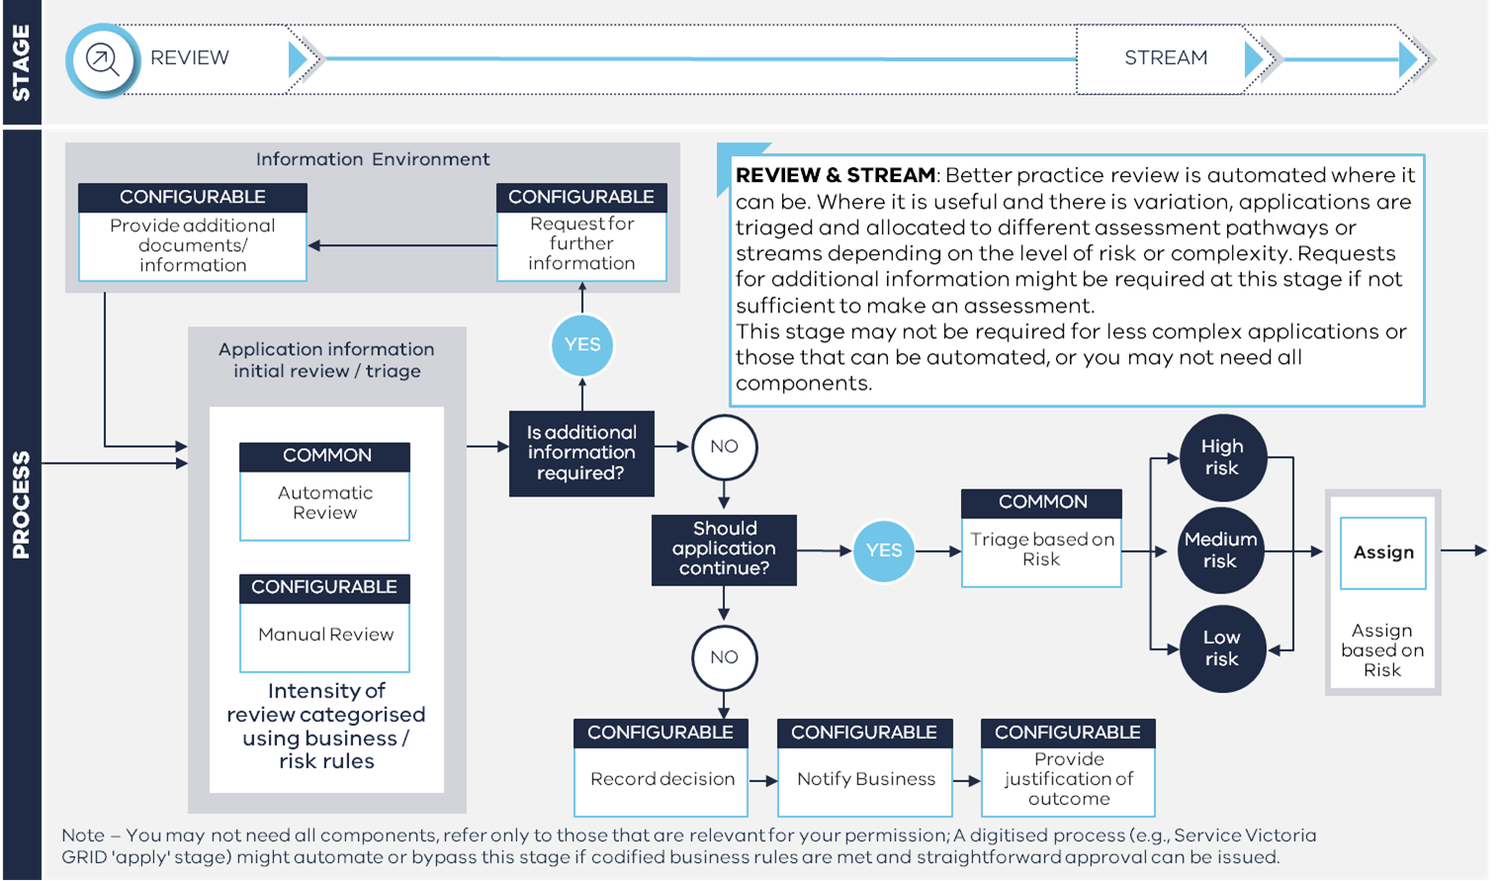

Information to inform risk – Review & Stream
This table outlines the sources of information that are used in the review and streaming of an application. This includes information captured through the application process, and any other external sources of information that might be used in building the risk profile of an application. Guidance should be provided to the information that can be obtained from each source.
Modify and/or delete content as required. Each line should align with a specific source of information used by the regulator in forming a view of the risk of an application. Some examples have been provided in the table below.
Source of information | Information Component | Guidance
Where is this information captured, including from external sources? | What components are captured here? | What information is captured, and how can it be used?
Application form | Personal Information  Identity Verification  Permission Information  Declarations  Suitability | Primary source of information used in the permission approvals process.
Intelligence from other regulators | Suitability | Used to flag any history of non-compliance, or other indicators of unsuitability to hold a permission

Risk indicators – Review & Stream
This table outlines the risk indicators that are used by regulators in assessing the risk profile of an application. It captures each risk indicator, a description of the indicator, a rationale for its use as a risk indicator, and business rules that govern the risk posed by an indicator.
Modify and/or delete content as required. Each line should capture an individual risk indicator. Risk indicators can relate to information requested in the application process, or through external sources. This table can be replaced by a risk rubric or similar document if it already exists. There should be a clear rationale for the use of each risk indicator. What constitutes a high, medium, or low risk indicator should be clearly articulated, and linked to a source of information to ensure consistency. An example has been provided in the table below.
Risk indicator | Description | Guidance and business rules
What is the indicator of risk? | How does it relate to risk? | What constitutes a high, medium, or low risk indicator?
Tertiary institution | The institution at which the applicant obtained their tertiary qualification. Qualifications from unrecognised institutions must be validated, whereas domestic qualifications can be automatically verified via MyeQuals | IF tertiary institution is unrecognised  THEN medium risk is posed, requirement for further validation and assessment  IF tertiary institution is recognised,  THEN no additional risk is posed, qualification can be automatically reviewed and assessed

Risk streams – Review & Stream
This table summarises the risk streams that applications will be sorted into through the review and streaming process. It provides a description of each stream, and KPIs or targets related to the applications that sit within each category.
Modify and/or delete content as required. Each line should capture a separate risk stream. The criteria for each stream should be clearly articulated, and linked to the above risk indicator framework. KPIs should reflect the complexity and distribution of applications received, and the capacity for automated review and assessment. Some examples have been provided in the table below.
Risk stream | Description and criteria | KPIs
What is the risk stream? | What criteria should be met for each stream? | What % of applications should be in this stream? How much regulator time and effort should be allocated here?
Low | Applicant with no or few risk indicators. Review and assessment can be largely automated. | 85% of applicants should be in the low risk stream, given their risk profile.  The assessment of these applications should be largely automated, with minimal manual intervention required.
Medium | Applicants with some risk indicators, and a moderate relative risk level.
High | Applicants with several risk indicators, with a relative risk level above most other applicants.

Assess
Modify and/or delete content as required. An editable version of the Better Practice Permission Journey map accompanies this Manual. Components and details can be modified and deleted to match your processes.

Process map – Assess
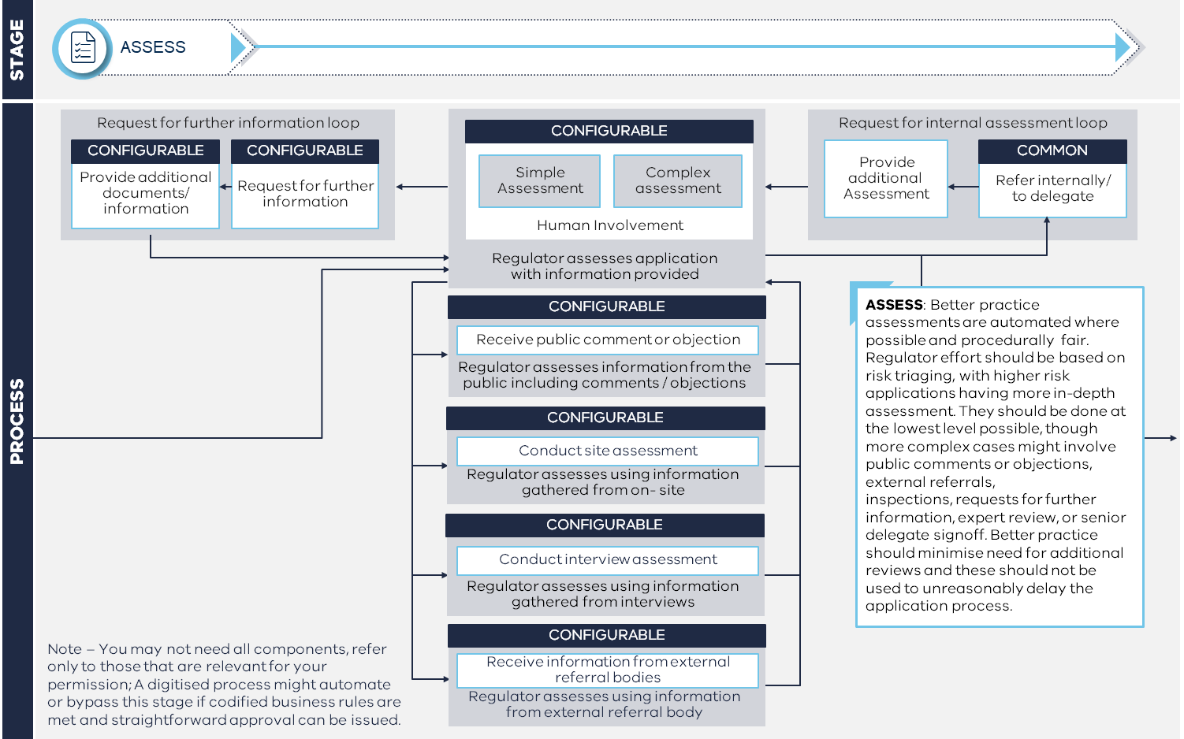

Assessed information – Assess
This table outlines information that will be assessed as part of the approval of an application. It captures all pieces of information, the types of assessment that will be applied, the business rules that govern how this information is assessed.
Modify and/or delete content as required. This template should be used to develop a holistic view of all the information to be assessed. Each line should capture a separate piece of information to be assessed. Business rules should be clearly articulated, and linked to indicators that can be obtained through the application process. An example has been provided in the table below.
Information to be assessed | Information component | Type of assessment | Business rule
What is the information? | Which component does the information sit in? | What type of assessment is required? Manual vs Automatic, Simple vs Complex | What business rules guide assessment?
Tertiary qualification | Permission Information | Automated, Simple  Manual, Simple  Manual, Complex | IF domestic degree from recognised institution with MyeQuals  THEN Automated, Simple  IF domestic degree from recognised institution without MyeQuals  THEN Manual, Simple  IF qualification from unrecognised institution  THEN Manual, Complex

Assessment guidelines – Assess
This table outlines the criteria and guidelines that should be used in the assessment of specific pieces of information provided by the applicant. It captures all information assessed, assessment guidelines for regulator officers, and any additional guidance that is provided.
Modify and/or delete content as required. This template should be used to document and establish assessment guidelines. Each line should capture a separate piece of information to be assessed. Guidelines should be clear and easily followed, and where applicable linked to other resources provided to officers to support assessment. An example has been provided in the table below.
Information to be assessed | Information component | Assessment guidelines | Additional guidance
What is the information? | Which component does the information sit in? | What are the guidelines that explain what information should be examined and what constitutes acceptable information? | Is there any additional guidance provided? (e.g., checklists)
Tertiary qualification | Permission information | Name: Does the applicant’s personal information match the name on the qualification  Units: Has the applicant completed all the required units?  Misconduct: Has any misconduct been reported as part of the qualification? | NA

Decide
Modify and/or delete content as required. An editable version of the Better Practice Permission Journey map accompanies this Manual. Components and details can be modified and deleted to match your processes.

Process map – Decide
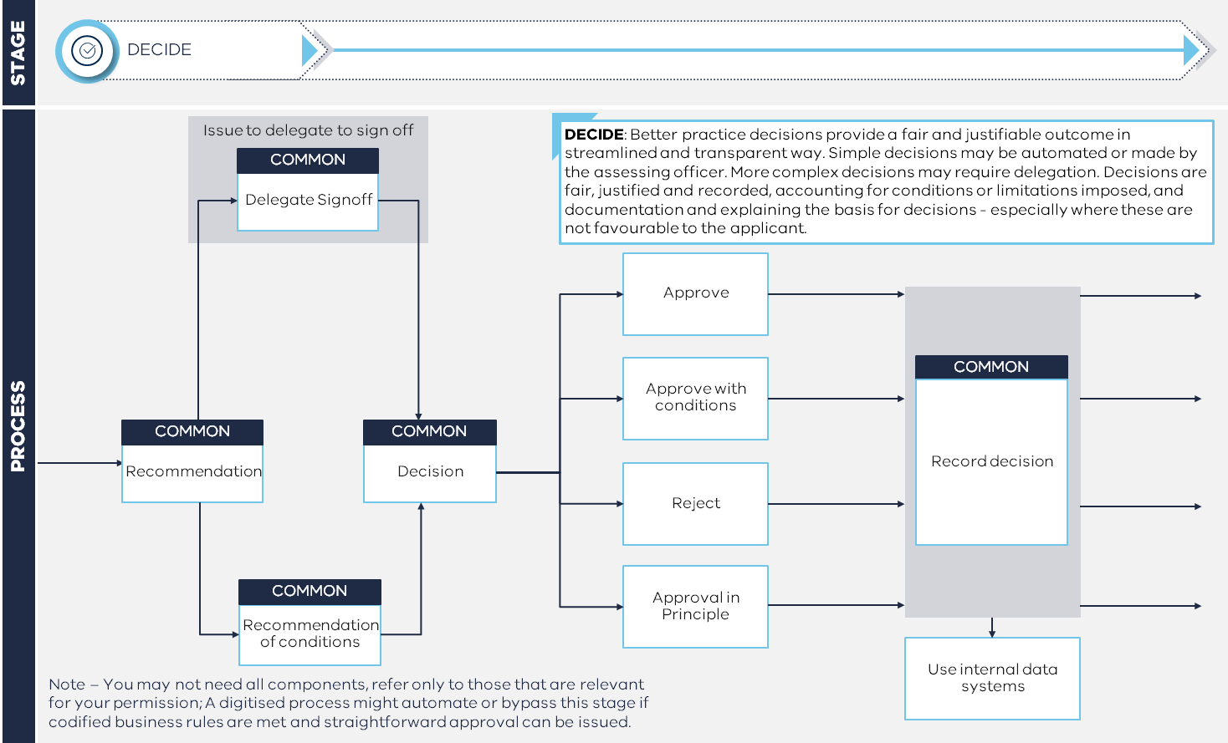

Recommendation and decision guidelines – Decide
This table outlines the recommendations and decisions that can be made by a regulator at the end of the approval of an application. It captures each decision or recommendation outcome, and provides guidelines for when each outcome should be applied.
Modify and/or delete content as required. This template should be used to document when each outcome should be applied. This table should be linked to other resources used to evaluate applications, for example application checklists. Each line should reflect a particular outcome that can occur after the assess stage of the permission journey. Some examples have been provided in the table below.
Decision/recommendation | Description | Guidance and business rules
What is the decision or recommendation type? | What does the type look like? | When should this decision or recommendation be applied?
Approve | Approval for a permission without conditions. | IF all information is provided and meets low risk criteria  THEN recommend a permission is approved
Approval with standard conditions
Approval with bespoke conditions
Reject
Approval in principle

Standard conditions and guidelines – Decide
This table collates the standard conditions that can be applied to a permission. It captures each standard condition, the requirements this imposes on permission holders, and the criteria for placing conditions on a permission holder.
Modify and/or delete content as required. This table should be used to document and standardise the use of conditions. This table should be linked to any existing conditions library is available. This table should also inform the application of bespoke conditions. Each line should capture a specific standard conditions, and the requirements that this places on permission holders. The criteria for applying a condition should be clearly articulated to enable consistent use. An example has been provided in the table below.
Condition | Description | Requirements | Criteria
What is the condition? | What does it mean for permission holders? | What does this permission impose on a permission holder? | When should this be applied? When should it not be applied?
Requirement for supervision | Graduate practitioners require supervision. | Requirement to be supervised by a registered practitioner for 12 months. | IF applicant is a graduate applicant  THEN apply requirement for supervision condition

Notify & Issue
Modify and/or delete content as required. An editable version of the Better Practice Permission Journey map accompanies this Manual. Components and details can be modified and deleted to match your processes.

Process map – Notify & Issue
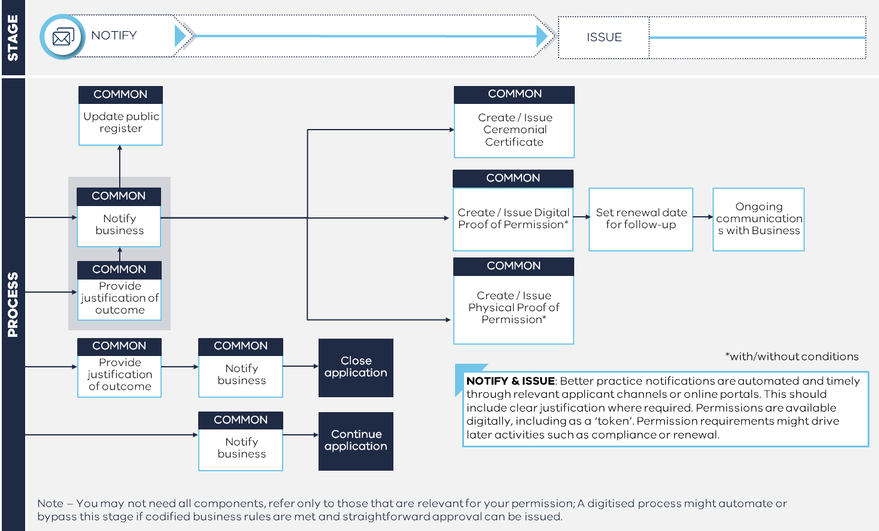

Notification guidance – Notify & Issue
This table outlines the notifications the regulator will send to an applicant after the approval process on an application. This table captures the specific message, and any guidance on when this particular message should be used.
Modify and/or delete content as required. This table should be used to standardise the communications that are provided to applicants after the approvals process. Each line should capture a separate outcome and/or message. An example has been provided in the table below.
Notification name | Notification template | Guidance and business rules
What is the notification? | What is the information to be included? | When should the notification be sent? How will it be sent? What information is required?
Notification of approval | Link to message template | IF application has been approved  THEN trigger notification of approval and send by email, populating permission holder information and issue date

Generic templates and prompts for completing this Manual
These generic templates can be copied into the main body of the Manual as needed, with instructions on how they might be used.

Documenting the Better Practice Permission Journey
Think about the level of further explanation you need to include in this Manual or any more detailed processes and procedures sitting under it, accounting for the process map. You might use additional process maps and flow charts (building on the Better Practice Permission Journey map), or text or tables with additional explanation aligned to the map.
It is important to think through and document the general flow of activities and who does them, before moving specific work instructions for given tasks.
Modify and/or delete content as required. The following table shows an example of information linked to the Better Practice Permission Journey, describing the overall process.
Reference | What happens
1 | Lead officer raises a request for further information
2 | Applicant receives the request and acknowledges the deadline
3 | Applicant provides the further information
4 | Lead officer reviews the further information and allocates technical review to the SME  [Reference to relevant work instruction]
5 | SME completes technical review and provides advice
6 | Lead officer confirms the advice and forms a recommendation

Giving work instructions
When you need to instruct a person on what to do within the process, you can use detailed flow charts, or work instruction tables. Consider:
- First capturing any general rules, policy statements or guiding messages – if these are clear, there may be less need for detailed work instructions
- Listing the general tasks, and the specific actions, using the following format (hypothetical example provided):
Modify and/or delete content as required. The following table shows an example of business rules linked to the Better Practice Permission Journey.
Tasks | Work instruction
Stocktake | - Check the submission material against the checklist  - Verify the full requirements are met and included in submitted materials  - Confirm complete materials following the form
Organise | - Save the files into the review folder  - Open the review task in the system
Allocate | - Assign the review of technical material to your SME, as required  - Record the due date for the review

Explaining business rules
Within a work instruction, you may need to describe business rules (e.g., what happens within a specific scenario or event). To do this, you might include a table within the process map, or as a standalone table to support a key message or rule.
Modify and/or delete content as required. The following table shows an example of business rules linked to the Better Practice Permission Journey.
Scenario | What to do…
The applicant has a ‘red flag’ around past conduct | - Further review the character reference
The applicant has no ‘red flags’ and has completed the declarations | - Process the application
It is difficult to judge the character of the applicant due to conflicting information | - Seek the advice of a senior delegate
You can break this advice down further by setting conductional rules against a scenario.

Roles and responsibilities
Modify and/or delete content as required. You can provide overall guidance on who does what through a table as follows. This can be useful at the beginning of a stage or the overall document. An example has been provided in the table below.
Role | Responsibilities
What is the role? | What are the activities they are responsible for?
Assessment office | Assessing information in line with the guidance and business rules.

Document Register
Modify and/or delete content as required. A table as follows can be used to capture relevant resources. An example has been provided in the table below.
Document name | Document purpose
What is the document? | What is its purpose?
System user guide | Outlines the operating procedure and user guide for the core system.

Risk assessment framework
This table outlines the factors that are considered when assessing the risk profile of an application. These factors should be applied consistently to all applications to ensure standardised risk triaging of applications. The risk factors should be, where possible, aligned to information provided by the applicant in the application form.
Modify and/or delete content as required. This risk assessment framework should be linked with the risk indicators referenced above.
Decision point | Options | Risk factors | Risk level
What is the decision point relevant to the risk? | What are the potential options relating to the decision point? | What factors add or lessen the risk level? | What level of risk is posed by the option?
Qualification | Recognised Australian degree | Qualification verification through MyeQuals | Low
Qualification | Unrecognised degree | Manual qualification verification  Meets knowledge requirements | Medium

Identified risks
This table outline risks that have been identified in relation to the above permissions processes.
Modify and/or delete content as required. The identified risk should be clearly stated, the potential implications of this risk outlined including who likely to be impacted.
Identified risk | Description
What is the identified risk? | What impact could the risk have?
Low regulator capacity limits the capacity to implement digital-ready reforms | Regulator time constraints may limit their ability to implement digital-ready reforms. These would delay the realisation of benefits, and the push out timeframes of digitisation initiatives.

System and process requirements
This table outlines system and process requirements that must be met in order to actualise the above permissions processes. These system and process requirements relate to legislative and digital obligations held by regulators, and the design of any future digital enhancements should align with these features.
Modify and/or delete content as required. The requirement should be clearly stated, including what will need to occur in order for this requirement to be met.
Requirement | Description
What is the requirement? | What detail is useful?
The system must support delegation to a defined user for decision. | Delegations should be integrated within standard workflows

Adopted assumptions
This table outlines assumptions that have been adopted in relation to the above permissions processes. These assumptions relating to processes and system capability have been made so that the processes can be defined and articulated. This includes assumptions on the capabilities of regulator systems and platforms, which have been assessed to be feasible and practical for implementation.
Modify and/or delete content as required. The adopted assumption should be clearly stated, including what the implications of this assumption are on the permissions process. Any assumptions relating to the capability of regulator systems or Service Victoria products should be listed here.
Assumption | Description
What is the assumption? | What detailed assumption has been made?
Service Victoria’s Identity Verification service can be integrated into systems | This Manual assumes that Service Victoria’s Identity Verification Service can be integrated into systems as a white-label product. This allows automated verify an applicant’s identity, reducing time spent on manual checks.

