Frequently Asked Questions
  - Call for applications for Dolphin Swim Tour Permits in the Port Phillip Bay Limited Permit Area

- What is the Port Phillip Bay Limited Permit Area?
Under the Victorian Wildlife Act 1975 (Wildlife Act), an area can be determined where the number of whale watching tour or whale swim tour permits are limited in order to ensure those activities are ecologically sustainable. The definition of a whale includes dolphins, as well as species such as southern right whales and orcas. Note that the current Port Phillip Bay Limited Permit Area determinations are only applicable to dolphins.
Port Phillip Bay is home to the threatened Burrunan Dolphin and also a unique inshore resident population of the Common Dolphin. To protect these significant populations, two Limited Permit Area determinations were declared on 17 September 2020 for Port Phillip Bay which limits the number of dolphin swim tour permits (for dolphins only) to four and prevents any whale watching permits for dolphins from being issued. No changes have been made to these determinations.

A call for applications for dolphin swim permits in Port Phillip Bay has been made in the Victorian Government Gazette, the Herald Sun newspaper and on the Department of Energy, Environment and Climate Action website
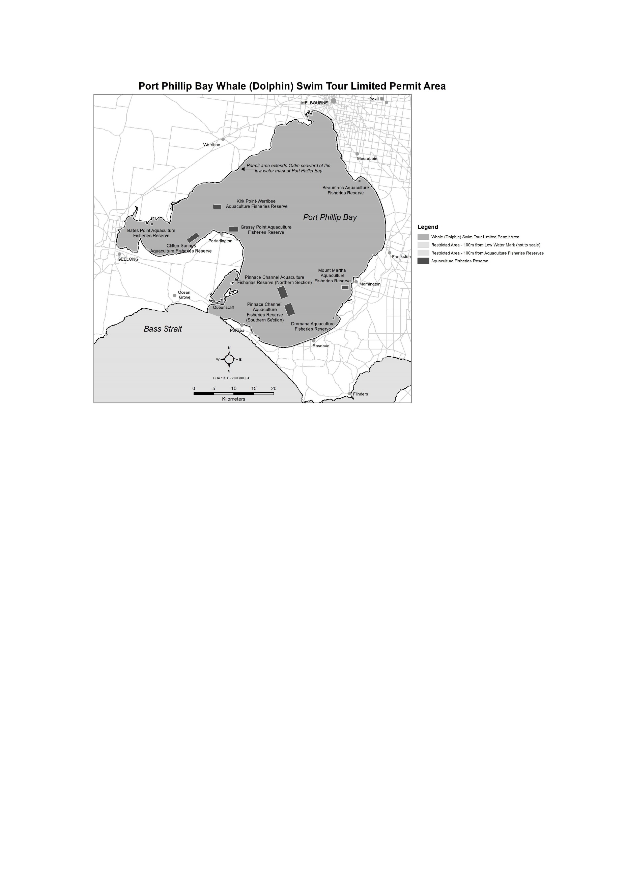
- How was it determined that four swim tour permits is sustainable and why are no dolphin watching tour permits allowed for Port Phillip Bay?
The decision was made to limit the number of dolphin swim tour permits to four and to not allow any dolphin watching tour permits to be issued in Port Phillip Bay based on the best available information, which suggests that:
- it is the close approach of vessels that is the key disturbing activity in vessel-based dolphin tourism; given that approach conditions for whale swim and whale watching tours are largely equivalent under Victoria’s Wildlife (Marine Mammals) Regulations 2019, the number of permits considered sustainable should be applied across both categories;
- a maximum of four permits is considered sustainable for Port Phillip Bay dolphins; the potential impacts of increasing this number are unknown; and
- assigning the maximum number entirely to the dolphin swim category will maximise the economic opportunities available to tour operators within the limits that have been applied.
- What activities does a Dolphin Swim Tour Permit authorise?
These permits allow for commercial tour operators to undertake tours to swim with dolphins within the Port Phillip Bay Limited Permit Area. Swimming with any other whale species is not allowed.
The rules for how swim activities can be conducted are specified in the Wildlife (Marine Mammals) Regulations 2019 and the conditions of the permit.
- Where can dolphin swim tours be conducted?
Dolphin swim tours are restricted to the Port Phillip Bay Dolphin Swim Tour Limited Permit Area. Dolphin swim tours must not be conducted outside of this area.
- How many permits are available?
A total of four Dolphin Swim Tour Permits are available. There are no boat-based whale watching permits available. The Conservation Regulator is under no obligation to issue all four permits.
- How long are permits valid for?
Permits will be valid for approximately five years (1 July 2025 to 30 June 2030).
- Who can apply for a permit?
Permits are open to all interested commercial operators.
Under the Wildlife Act 1975 permits can only be issued in the name of a natural person – they cannot be issued to a business or a corporation.
If you have been found guilty of an offence under the Wildlife Act 1975 or the Wildlife (Marine Mammal) Regulations 2019, or a similar offence in another jurisdiction, or have failed to comply with the Act, regulations or conditions of past permits, your application may not be assessed.
- How do I apply?
Application forms can be downloaded from https://www.vic.gov.au/marine-mammal-tour-permits. Applicants must complete the application form and address the assessment criteria specified in the application. Applications must be submitted electronically to: wildlifelicensing@deeca.vic.gov.au by no later than 2:00 pm on Thursday 5 June 2025; and marked CONFIDENTIAL – Dolphin Swim Tour Permit Application.
- When are applications due?
Applications must be received by no later than 2.00pm on 5 June 2025. Late and/or incomplete applications may not be considered.
- Can I apply for more than one permit?
Only one permit can be issued per person. As permits are issued to individuals rather than businesses, there is no legal impediment for two individuals in the same business each having a permit.
However, in deciding whether to grant multiple permits to people operating the one business, the Conservation Regulator will consider the potential impact on competition and entry to the market for new operators, in addition to each applicant’s response to the assessment criteria.
- Are there any other requirements?
If your application is successful, you will need to provide the Conservation Regulator with additional documentation, including:
- Vessel details, including registration and certificate of survey;
- Proof of public liability insurance;
- Certificate/s of competency for the vessel master and any crew; and
- The licence number and expiry date of your Tour Operator Licence.
. These documents do not need to be provided with your application however successful applicants who are unable to provide these documents at least five (5) business days prior to the proposed licence start date of 1 July 2025 will not be issued a licence. Applications that include this information will not be assessed any differently from those applications that do not.
- What is the cost of the permit?
The required fee for a dolphin swim tour permit is 121 Fee Units per year. If you are successful you will be required to pay for full term of the permit (1 July 2025 to 30 June 2030).
- Do I need to provide payment with my application?
No. You will only be required to pay if your application is successful. Please do not include payment with your application.
- Does the permit holder need to be on the vessel during a dolphin swim?
Applicants may nominate other natural persons as 'tour supervisors'. Tour supervisors will be permitted to conduct tours in the absence of the permit holder, but the permit holder retains overall accountability for all activities conducted under the permit. Applicants must ensure that any crew are aware of and understand the relevant regulations and permit conditions.

- How will applications be assessed?
Applications will be assessed by a panel against a set of assessment criteria. Successful applicants will be those that can best demonstrate compliance with and capability to meet these criteria. The assessment criteria are specified on the Application Form. An external Probity Adviser will oversee the deliberations of the evaluation panel to ensure an equitable and fair process.
- Can I conduct swim tours with other whale species if I’m successful?
No. Swims tours are only permitted for bottle-nose dolphins and common dolphins within Port Phillip Bay. It is illegal to conduct swim tours involving any other whale species in Victoria.
- Will I need Tour Operator Licence if I’m successful?
Yes. All Dolphin Swim Tour Permit holders require a separate Licensed Tour Operator Permit to operate in Port Phillip Bay (and other State waters) and are required to meet all conditions of their tour operator licence. For more information on these permits, visit the Parks Victoria website at www.parks.vic.gov.au.
- What if I already have a whale watching permit in the Port Phillip Bay Area?
All Whale Watching Permits issued for Port Phillip Bay have now expired. Operators can apply for a whale watching permit in Port Phillip Bay for whales other than dolphins.
- How will I know if my application is successful or not?
All applicants will be advised in writing of the outcome of their application.
- What happens if I am successful?
Successful applicants will be required to provide proof of insurance, a Certificate of Survey for the tour vessel, and Certificates of Competency as required by the Marine Act 1988 for all nominated master(s) and crew of the vessel.
Once these documents have been accepted and your payment has been received, a Dolphin Swim Tour Permit will be issued. The Conservation Regulator will write to successful applicants advising of the required documentation and payment process once the competitive allocation process has been completed.
- Are Dolphin Swim Tour Permit holders monitored?
Yes. The Conservation Regulator undertakes regular monitoring and compliance checks on all dolphin swim tour permit holders. All permit holders are also required to submit monthly returns on the form provided to all permit holders.
- What conditions are attached to the permit?
Activities authorised by the permit are subject to a range of conditions by which operators must abide by. The purpose of these conditions is to help minimise the possible negative impact of activities on dolphins. Conditions of permits for dolphin swim tours are listed in Regulations 28 and 29 of the Wildlife (Marine Mammals) Regulations 2019. Penalties will apply if these conditions are not met. In addition, there are a number of penalties under these same regulations which everyone must abide by. The Secretary also has the authority to impose other conditions to help reduce impact on the dolphins and ensure passenger safety. Conditions prescribed by the regulations are outlined in Attachment 2 of the Application Form.
- Are Dolphin Swim Tour Permit transferable?
No. Permits are not transferable by the Permit Holder.
- What happens if I can no longer operate under my permit?
Permits can be surrendered back to the Conservation Regulator. It is a condition of the permit that the permit holder demonstrate continuous use of the permit (excluding seasonal closures). Failure to conduct dolphin swims over an extended period may form the basis for cancellation of the permit.
- Where can I get a copy of the regulations governing dolphin swim permits?
A copy of the Wildlife (Marine Mammal) Regulations 2019, are available from www.legislation.vic.gov.au.
- What are the impacts of tourism on the dolphins?
Interactions with humans can have a range of impacts on dolphins, particularly with regards to how they spend their time (for example, feeding and resting). Dolphins may also become conditioned to avoid humans. The implications of these changes to the overall health of dolphin populations are the subject of on-going research, both in Victoria and overseas.
- Can my permit be suspended or cancelled?
Yes. A permit may be suspended or cancelled if:
- An operator is found guilty of an offence under the Wildlife Act 1975;
- An operator has a breached a condition of their permit;
- The activity authorised by the permit is adversely affecting dolphins or whales;
- An operator has been convicted of an offence relating to animals in another area of Australia; or
- An operator fails to comply with other statutory requirements or legal obligations they may have (including adequate insurance);
- An operator fails to comply with any other legal obligations held under any other Act of Parliament.
- If I’m not a commercial operator can I swim with dolphins anyway?
No. Swimmers must not approach within 30 metres of a dolphin. Recreational boaters must remain 100 metres away from dolphins, except if approached. Within the Ticonderoga Bay Whale Sanctuary (between Police Point and Nepean Rock) recreational boaters cannot approach within 200 metres of a dolphin.
- Who can I speak to about the permit or my application?
If you have any queries regarding this application process contact the Conservation Regulator via writing at wildlifelicensing@deeca.vic.gov.au.
- Where can I get more information on other marine mammal tour permits?
For more information on other Marine Mammal Tour Permits, please visit www.wildlife.vic.gov.au/wildlife-research-tourism-and-cinema/marine-mammal-tour-permits

