# **Application for an Authority to Control Wildlife**

All native animals (birds, mammals, reptiles and frogs) are protected in Victoria under the *Wildlife Act 1975*. It is illegal to wilfully disturb, trap or kill wildlife without a permit and may result in a fine and/or imprisonment.

You may apply for an Authority to Control Wildlife (ATCW) permit to disturb (scare) disperse, trap or kill wildlife if it is:

* damaging buildings, pasture, crops or other property;
* posing a risk to human health and safety; or
* impacting on biodiversity

and you are either the:

* owner;
* occupier; or
* administrator of the affected property

Guidance to help you understand the ATCW application process and how to fill in this application form is available on our website - [ATCW form guidance](https://delwpvicgovau.sharepoint.com/:w:/s/ecm_435/EaoZpc9zmdhCvhcNwbby7AwBoxe3S2TExOfIavLgu7BW3A?e=xkRMRa).

**Before you apply for an ATCW**

There are a number of ways to manage wildlife damage that do not require an ATCW, for example fencing or compliant netting to exclude animals. An application for the lethal control of wildlife will only be considered when all practical non-lethal options have been considered. More information about non-lethal and lethal control methods can be found in the [ATCW form guidance](https://delwpvicgovau.sharepoint.com/:w:/s/ecm_435/EaoZpc9zmdhCvhcNwbby7AwBoxe3S2TExOfIavLgu7BW3A?e=xkRMRa).

An ATCW is not required to control Eastern or Western Grey Kangaroos if you use a Kangaroo Harvest Program (KHP) authorised harvester. Landholders are required to register with Services Victoria who will provide a list of authorised harvesters working in your area. It is then up to you to contact a harvester. The KHP ensures the harvesting is ecologically sustainable, humane, only undertaken by people who have been authorised to do so and enables the use of carcasses pet food production. Further information is available at <https://djpr.vic.gov.au/game-hunting/kangaroo-harvesting> .

Applicants are encouraged to complete an ATCW application online. The online form includes links to assist you with completing your property details and will ensure that all required information has been included which will help reduce processing times. You can find the online form at <https://www.vic.gov.au/wildlife-management-and-control-authorisations>.

**Processing time and causes for delay**

Allow up to 6 weeks for your ATCW to be processed. Your application will be assessed by a DEECA officer who may inspect your property to confirm the wildlife issues. To ensure your application is processed as quickly as possible:

* make sure your application is complete and legible;
* provide as much detail as possible to support your application, including photos if they are relevant;
* send your application via email.

Please ensure that you provide all required information as part of your application. Missing information will result in a delay in processing your application, and delays in responding to requests for additional information may result in your application being lapsed. If this occurs you will need to reapply.

**Review of the decision**

If you are not satisfied with the decision made by DEECA, you can apply to the Victorian Civil Administrative Tribunal (VCAT) for a review within 28 days. See <https://www.vcat.vic.gov.au/>.

**ATCW expiry and renewal**

Authorities to Control Wildlife have an expiry date and are not able to be renewed. Each application is individually assessed against many factors, including the local and broader environmental context. If you have been issued an ATCW in the past, keep in mind that your application for a similar activity will not be automatically approved.

**Additional obligations**

There are other requirements you might need to meet before controlling wildlife, even if you have been issued an ATCW. These include following local municipal bylaws and other legislation relating to the use of firearms or the disposal of carcasses. More information can be found in the [ATCW form guidance](https://delwpvicgovau.sharepoint.com/:w:/s/ecm_435/EaoZpc9zmdhCvhcNwbby7AwBoxe3S2TExOfIavLgu7BW3A?e=xkRMRa).

**For more information**

Should you have any question, please consult our [website](https://www.wildlife.vic.gov.au/managing-wildlife/wildlife-management-and-control-authorisations) or call the Customer Service Centre on 136 186.

**Authority to Control Wildlife Application Form**

Please ensure all fields have been completed, are legible and submit your application via email.  
Standard assessment timeframes for applications submitted by email is six to eight weeks.

|  |  |  |  |  |
| --- | --- | --- | --- | --- |
| 1. **Applicant’s personal details** | | | | |
| Title | First name | Other given names | Family name | Date of birth |
|  |  |  |  |  |

|  |  |  |  |
| --- | --- | --- | --- |
| 1. **Applicant’s residential address** | | | |
| Flat/Floor/Unit No | House/Lot No | Street name | |
|  |  |  | |
| City/Suburb/Town | | | Postcode |
|  | | |  |

|  |  |  |  |  |  |  |  |
| --- | --- | --- | --- | --- | --- | --- | --- |
| 1. **Applicant’s postal address** | | | | | | | |
| *Tick if ‘As above’ (or give details below)* | | | | |
| Flat/Floor/Unit No | | House/Lot No or PO Box No | Street name | | | | |
|  | |  |  | | | | |
| City/Suburb/Town | | | | State | Postcode | |
|  | | | |  |  | |

|  |  |
| --- | --- |
| 1. **Applicant’s contact details** | |
| Preferred phone number | Email address |
|  |  |

|  |  |  |  |  |  |  |  |  |  |  |  |  |  |
| --- | --- | --- | --- | --- | --- | --- | --- | --- | --- | --- | --- | --- | --- |
| 1. **Applicant’s relationship to the land the application applies to:** | | | | | | | | | | | | | |
| Landowner |  | Occupier |  | Administrator | | |  | Other |  | |  | |
|  | | | | | | | | | | | | | |
| Is the land where wildlife is to be controlled: | | | | | Private land |  | | Crown land |  |
|  | | | | | | | | | | | | | |
| If Crown Land, what is the name of the park or reserve? | | | | | | |  | | | | |

|  |
| --- |
| 1. **Business name (ONLY complete if the land is owned under the name of a business)** |
|  |

|  |  |  |  |  |
| --- | --- | --- | --- | --- |
| 1. **Description and location of land where you plan to control wildlife** | | | | |
| *Crown Allotment Number(s)**must be supplied. See your Local Government Rates Notice or look for your Crown Allotment number at* <https://www.propertyandlandtitles.vic.gov.au/property-information/property-information> or <https://www.landata.vic.gov.au/tpc_specify_property.aspx> | | | | |
| Crown allotment number/s | | | | |
|  | | | | |
| Property address (*e.g.42 Upper Smith Road, Smithsville*) | | | | Postcode | |
|  | | | |  | |
| Municipality (eg. Glenelg Shire) | Approximate area (hectares) | Land use zone | Current land use | |
|  |  |  |  | |

|  |  |  |  |  |  |  |  |  |  |  |  |
| --- | --- | --- | --- | --- | --- | --- | --- | --- | --- | --- | --- |
| 1. **Understanding the wildlife problem - species, wildlife impact, and control methods** | | | | | | | | | | | |
| For each individual species of wildlife that you are seeking an ATCW for, please provide a completed Part 8 addressing each species separately (eg. if applying to control three species, please complete Part 8 for each of them). | | | | | | | | | | | |
| 1. **Species** | | | | | | | | | | | |
| *It is your responsibility to provide us with the species and number of problem wildlife. For example, if your issue is with ducks, please do not simply list “ducks” but identify what type of duck (eg. Hardhead or White-eyed Duck).* | | | | | | | | | | | |
|  | | | | | | | | | | | |
| If applying for Eastern Grey Kangaroo or Western Grey Kangaroos, have you registered for the Kangaroo Harvest Program or had an authorised harvester shoot kangaroos on your property? | | | | | | | | Yes  No | | |
| 1. **Wildlife impact/ reason for application for this species?** | | | | | Health and safety risks  Wildlife causing damage  To support a wildlife management plan | | | | | | |
| 1. **Description of impact** | | | | | | | | | | | |
| *Please describe the damage or safety risks being caused by this species; or otherwise why control of this species is required.* | | | | | | | | | | | |
|  | | | | | | | | | | | |
| 1. **Estimated number of animals on the property causing problems** | | | | | |  | | | | | |
| The number causing problems  *This is not the number of animals that you wish to control. It should be a reasonable and accurate estimate of the number of animals that you have observed causing problems.* | | | | | | | | |  | | |
| How was that number was estimated? *(ie. actual count, or estimation based on tracks/scats, or on impacts)* | | | | | | | | | | | |
|  | | | | | | | | | | | |
| 1. **Description of attempts to reduce wildlife impacts** | | | | | | | | | | | |
| *Please describe which control methods you are currently using, if any, or steps you have already taken to stop the wildlife i.e. installing netting, wire or fences to stop wildlife gaining access; what the intended effect of the control method was and if it was successful i.e., to stop wildlife having access to; and if you have not been able to take any further steps, why i.e. financial reasons, in the process of installing a long-term control method but need an immediate solution.* | | | | | | | | | | | |
|  | | | | | | | | | | | |
| 1. **Requested wildlife control** | | | | | | | | | | | |
| *Please describe which methods you are proposing to undertake to manage the wildlife issues, both lethal/non-lethal. It is important that your methods favour an overall approach to living with and managing wildlife. Please note that lethal control is a last resort method which will only be approved if all practicable non-lethal controls are exhausted.*  *State the quantity of animals (below) that you wish to control via your preferred Control Method.* | | | | | | | | | | | |
|  |  | *Quantity* |  |  | | | *Quantity* | | |
|  | Shoot only |  |  | Egg and nest destruction | | |  | | |
|  | Trap and shoot |  |  | Scare/disturb | | |  | | |

|  |
| --- |
|  |
| 1. **Understanding the wildlife problem - species, wildlife impact, and control methods** | |
| I, (name of applicant) …………………………………………………………………….………………… being the applicant for this Authority to Control Wildlife, acknowledge that it is an offence under Section 58B of the Wildlife Act 1975 to provide false or misleading information in, or in connection with, the application for an Authority to Control Wildlife and I state that the information that I have provided is true, correct and complete.  SIGNATURE of Applicant …………………………………………………… DATE signed ……………… | |
| **Collection, use and disclosure of personal information - *Privacy and Data Protection Act 2014*** | |
| The Department of Energy, Environment and Climate Action (DEECA) is committed to protecting personal information provided by you in accordance with the principles set out in the Victorian privacy laws. This privacy statement applies to the collection and use of personal information, voluntarily provided by you, in relation to administration of licences and authorisations administered under the *Wildlife Act 1975*. The information you provide will be used to assess your application, administer any relevant licences or authorisations and carry out compliance relating to those licences or authorisations. DEECA or its contracted service providers under confidentiality agreements may survey you about your experience with DEECA. You may apply for access to your personal information at any time to confirm that it is accurate and up to date, upon payment of a prescribed fee (if any).  Enquires should be directed to the DEECA Customer Service Centre on 136 186. | |

**Submitting your application**

Once your application has been completed and signed, please lodge at your local DEECA Office (listed below).  
**You are encouraged to submit your application via email.**Application forms returned via post may be subject to delays greater than 6 weeks.

|  |  |  |
| --- | --- | --- |
| **Port Phillip region** |  | **Gippsland region** |
| [**atcw.portphillipregion@delwp.vic.gov.au**](mailto:atcw.portphillipregion@delwp.vic.gov.au)  or  Permissions Lead  DEECA  Private Bag 15  Ferntree Gully Delivery Centre VIC 3156 |  | [**Gippsland.cr@delwp.vic.gov.au**](mailto:Gippsland.cr@delwp.vic.gov.au)  or  Permissions Lead  DEECA  71 Hotham Street  Traralgon VIC 3844 |
| **Hume region** |  | **Grampians region** |
| [**atcw.hume@delwp.vic.gov.au**](mailto:atcw.hume@delwp.vic.gov.au)  or  Permissions Lead  DEECA  1683 Healesville – Kinglake Road  Toolangi VIC 3777 |  | [**atcw.grampians@delwp.vic.gov.au**](mailto:atcw.grampians@delwp.vic.gov.au)  or  Permissions Lead  DEECA  110 Natimuk Road  Horsham 3400 |
| **Barwon South West region** |  | **Loddon Mallee region** |
| [**barwonsouthwest.cr@delwp.vic.gov.au**](mailto:barwonsouthwest.cr@delwp.vic.gov.au)  or  Permissions Lead  DEECA  PO Box 115  Colac VIC 3250 |  | [**permissions.lm@delwp.vic.gov.au**](mailto:permissions.lm@delwp.vic.gov.au)  or  Permissions Lead  DEECA  PO Box 3100  Bendigo Delivery Centre  Bendigo VIC 3551 |

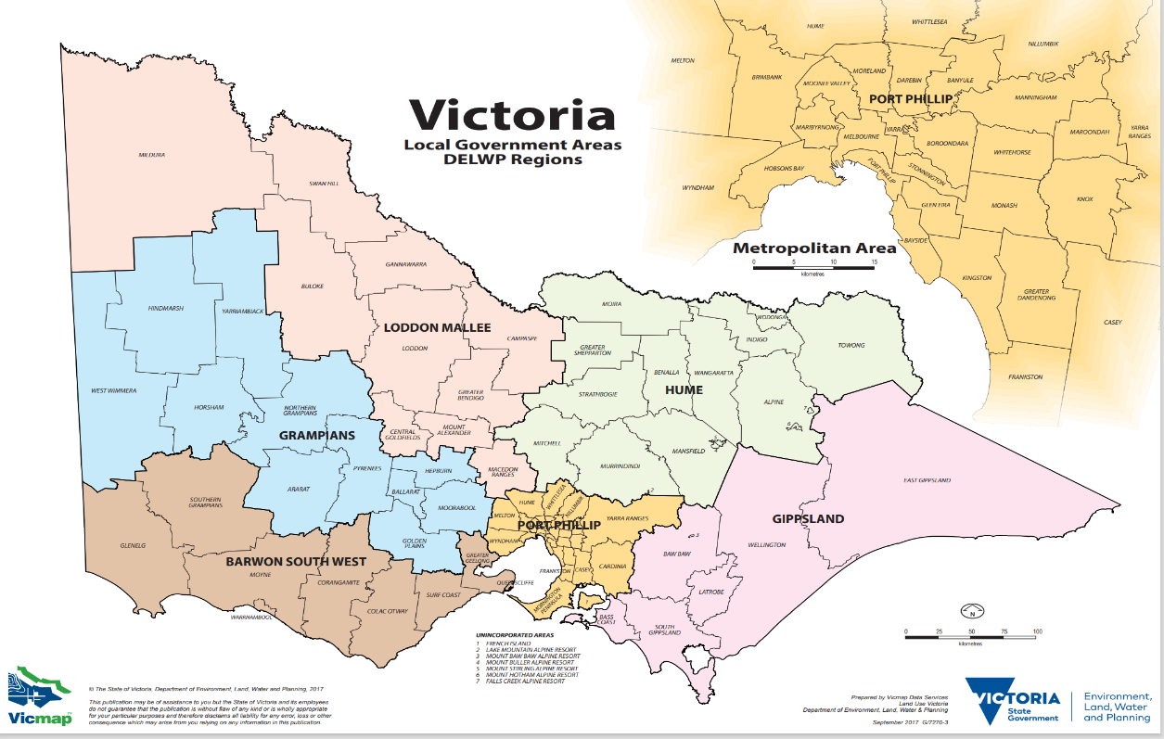

Version 23.1 (September 2023)