Circular Economy Risk,   
Consequence and   
Contingency Plan 2025

Table of Contents

Executive summary 3

Acronyms 5

Introduction 7

Purpose of the Circular Economy Risk, Consequence and Contingency Plan 7

What is system resilience in the waste, recycling and resource recovery sector? 8

What is a circular economy? 9

Legislative environment 10

Recycling Victoria 13

United Nations Sustainable Development Goals 13

About this plan 14

Context 15

Sector risk context in 2024 15

Global macro risks and trends affecting the sector 16

National trends and emerging issues in the circular economy 19

Victorian trends and emerging issues in the circular economy 25

Issues of performance and supply 26

Government action towards risk mitigation 30

Responsible entity progress towards sector risk mitigation 35

Victorian waste, recycling and resource recovery sector risks 36

Risk assessment process 36

Serious sector risks 39

Risk treatments 58

Actions proposed to be taken by responsible entities 58

Responsible entity measures 60

Engagement and support 63

Engagement 63

Support 63

Consultation on a draft CERCC Plan 2025 64

Appendices 66

Appendix 1 – Essential service providers for the Victorian waste, recycling and resource recovery sector 66

Appendix 2 – Definition of responsible entity 75

Appendix 3 – Total amount of waste managed in Victoria for the specified period 77

Appendix 4 – Victorian waste, recycling and resource recovery sector risk assessment process 81

Publication information 101

# Executive summary

Recycling Victoria has prepared the second annual Circular Economy Risk, Consequence and Contingency (CERCC) Plan 2025. The CERCC Plan is part of an overarching Risk, Consequence and Contingency Planning Framework (RCC Framework) enabling Victoria’s transition to a strong and resilient circular economy that is better positioned to withstand future shocks and stressors.

CERCC Plan 2025 on publication, becomes the CERCC Plan in force and supersedes the inaugural CERCC Plan 2024.

The sector faced significant challenges in 2024, including the proliferation of lithium-ion battery (LIB) sourced fires, significant incidents and fires involving large scale impacts to facilities and the presence of asbestos contamination in mulch, identified in public spaces along the eastern seaboard.

Existing stressors and new challenges facing the sector were also experienced, driven by rising inflation and costs felt in Victoria, nationally and globally. Each of these challenges has faced the sector with a need to be more resilient.

CERCC Plan 2025 has been prepared in accordance with statutory requirements and includes a review of CERCC Plan 2024, including revisions of serious sector risks identified and the identification of a new risk – Commercial viability in the market – in response to these challenges. Preliminary analysis of content from inaugural Responsible Entity, Risk, Consequence and Contingency Plans (RERCC Plans) submitted to Recycling Victoria in September 2024 has informed and improved sector understanding of risks and their management. Issues of performance and supply, particularly impacting the sector in 2024 have also been highlighted. The total amount of waste managed in Victoria, for the specified period (refer Appendix 3) has been included, to enable self-assessment by operators to determine their responsible entity status. Case studies representing examples of sector resilience are further identified in the second CERCC Plan.

New in CERCC Plan 2025 is the inclusion of existing responsible entity controls, proposed responsible entity actions and measures directed by Recycling Victoria to further mitigate serious sector risks. Responsible entities will be required to address and report on these in their RERCC Plans, to be submitted to Recycling Victoria in September 2025.

Recycling Victoria consulted on a draft of the CERCC Plan 2025 with responsible entities, public sector bodies that may be affected by the CERCC Plan and others deemed appropriate. Feedback from this consultation has been considered and addressed.

Recycling Victoria will continue to support industry in adopting these requirements in 2025. This includes engagement on CERCC Plan 2025, supporting responsible entities to implement their RERCC Plans and progressively improve their risk management practices as they prepare their RERCC Plans for 2025.

# Acronyms

Table 1: List of Acronyms

| Abbreviation | Full name |
| --- | --- |
| ACCC | Australian Competition and Consumer Commission |
| CDS Vic | Victoria’s Container Deposit Scheme |
| CE Act | *Circular Economy (Waste Reduction and Recycling) Act* 2021 |
| CE Regulations | Circular Economy (Waste Reduction and Recycling) (Risk, Consequence and Contingency Plans and Other Matters) Regulations 2023 |
| CERCC Plan | Circular Economy Risk, Consequence and Contingency Plan |
| CO2-e | Carbon dioxide equivalent |
| CSIRO | Commonwealth Scientific and Industrial Research Organisation |
| DCCEEW | (Australian) Department of Climate Change, Energy, the Environment and Water |
| DEECA | Department of Energy, Environment and Climate Action |
| DELWP | Department of Environment, Land, Water and Planning (the former) |
| EMM | Environment Minister’s Meeting |
| EPA | Environment Protection Authority Victoria |
| FY | Financial year |
| the Guidelines | Guidelines for a Responsible Entity Risk, Consequence and Contingency Plan |
| HAZMAT | Hazardous materials |
| HEPA | Heads of Environment Protection Authority Australia and New Zealand |
| ISO | International Organization for Standardization |
| IT | Information technology |
| LIB | Lithium-ion battery |
| NSW | New South Wales |
| PFAS | Per- and polyfluoroalkyl substances |
| RCC Framework | Risk, Consequence and Contingency Planning Framework |
| RERCC Plan | Responsible Entity Risk, Consequence and Contingency Plan |
| SCADA | Supervisory control and data acquisition |
| VIDA | Victoria Infrastructure Delivery Authority |
| VRIP | Victorian Recycling Infrastructure Plan |

# Introduction

## Purpose of the Circular Economy Risk, Consequence and Contingency Plan

The Circular Economy Risk, Consequence and Contingency (CERCC) Plan aims to mitigate harms associated with waste, recycling and resource recovery sector risks, including financial harms for government and to the sector. The CERCC plan is developed and given effect with the relevant requirements of the *Circular Economy (Waste Reduction and Recycling) Act 2021* (CE Act) and Circular Economy (Waste Reduction and Recycling) (Risk, Consequence and Contingency Plans and Other Matters) Regulations 2023 (CE Regulations).

The CERCC Plan is an annual plan that the Head, Recycling Victoria must submit for approval to the Minister by 31 December each year.

As the CERCC Plan captures risk across all services in the waste, recycling and resource recovery sector and is a statewide report, it has relevance to everyone involved in the waste, recycling and resource recovery sector, including consumers, producers and state and local government.

Recycling Victoria submitted the inaugural CERCC Plan to the Minister before 31 December 2023, which was subsequently approved and published in early 2024.

The inaugural CERCC Plan identified the serious sector risks to widespread service continuity and progressing a more circular economy.

CERCC Plan 2024 detailed the risks that responsible entities had to address in the preparation of their inaugural Responsible Entity Risk, Consequence and Contingency Plans (RERCC Plans), due by end September 2024.

CERCC Plan 2025 outlines the current challenges of the sector and issues relating to performance and supply and provides an updated assessment of sector risks, factoring in the existing controls in place, as informed by RERCC plans received.

To showcase industry action, CERCC Plan 2025 builds on the examples in the inaugural plan and features further sector driven resilience initiatives to minimise sector risk or maximise the transition to a circular economy.

CERCC Plan 2025 includes information from the inaugural submissions by responsible entities to Recycling Victoria in the form of RERCC Plans and Statements of Assurance. This includes actions that responsible entities propose to take to prevent or minimise the serious sector risks.

Measures that responsible entities must take have been included in CERCC Plan 2025. Identification of measures was based on Recycling Victoria’s assessment of sector preparedness and resilience following the sector risk review, sector discussions and responses from responsible entities.

A CERCC Plan remains in force until revoked or updated through publishing of a subsequent plan. RERCC Plans remain in force until updated through the submission of a subsequent plan. Responsible entities must prepare and submit an annual RERCC Plan, on the basis of the information and requirements included in the CERCC Plan in force at the time.

Recycling Victoria acknowledges there are significant regulatory controls in place in Victoria to manage environmental risks associated with waste, recycling and resource recovery. The CERCC Plan has been designed not to duplicate existing instruments, but to complement them by providing an assessment of the risks of serious failure, disruption or hindrance to the provision of waste, recycling and resource recovery services and risks of a financial nature to Victoria’s transition to a circular economy.

## What is system resilience in the waste, recycling and resource recovery sector?

System resilience in the waste, recycling and resource recovery sector includes:

* a minimum level of industry strategic coordination
* sector-wide risk planning
* increased government visibility over sector-wide risks, operations and data

improving sector-level risk, consequence and contingency management practices by service providers.

Increasing the level of sector resilience aims to result in greater reliability and fewer significant disruptions to the provision of services.

## What is a circular economy?

A circular economy aims to reduce the environmental impact of production and consumption while promoting economic growth through the efficient use of natural resources[1]. It achieves this goal by designing products that eliminate waste and improve the recovery of materials that can be reused.

It encourages businesses to adopt more efficient models, such as product sharing and service-based models that include maintenance, repair, and disposal. By doing so, it increases the value people derive from the resources used to create goods and services. This approach replaces the traditional linear economy mindset of take, use and throw away, with a more innovative and productive approach. It fosters creativity and productivity, invigorating existing businesses and creating new ones, which in turn creates more jobs and economic growth at the local, regional, state, national and global levels (Figure 1).

Figure 1 Resource flows in a circular economy

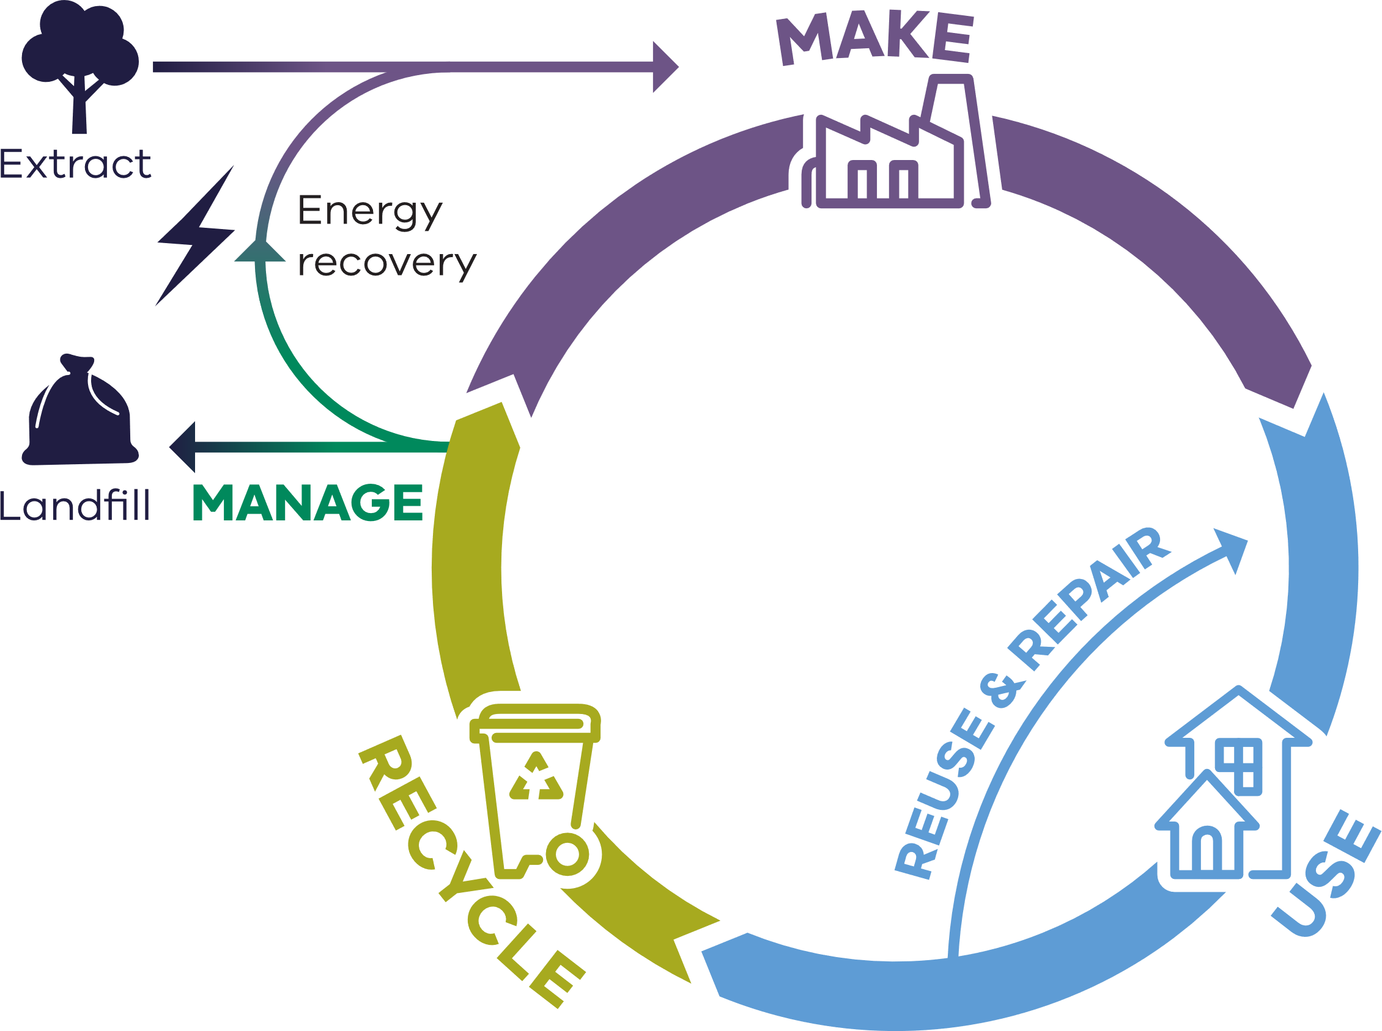

Victoria’s circular economy policy, *Recycling Victoria: a new economy[2]* outlines that it is the responsibility of all levels of government, along with industry, businesses, communities and individuals in Victoria to support the growth of a circular economy.

## Legislative environment

The CE Act confers functions and powers on the Head, Recycling Victoria and places high-level obligations or requirements on various waste, recycling and resource recovery service providers and other entities to manage risks.

Section 74 of the CE Act, relating to service standards, imposes a duty on providers of essential waste, recycling and resource recovery services to minimise risk of failure, disruption or hindrance of service.

Division 4 of Part 5 of the CE Act establishes a Risk, Consequence and Contingency Planning Framework (RCC Framework) to manage significant risks to the waste, recycling and resource recovery sector. The RCC Framework is designed to proportionately apply controls for providers of services in the waste, recycling or resource recovery sector that present the greatest risks if disrupted. For this reason, greater legislative obligations are placed on providers (referred to under the CE Act as responsible entities) of services that are identified as essential services and where the risks of impact of failures or disruptions to services are deemed high and unacceptably managed.

Under section 183 of the CE Act, the CE Regulations have been made to further specify the details of the RCC Framework.

It is important that all entities operating in the waste, recycling and resource recovery sector are familiar with the requirements of the CE Act and CE Regulations. A copy of these can be found on the Victorian Legislation website at[www.legislation.vic.gov.au](http://www.legislation.vic.gov.au/)

Together, the CE Regulations and CERCC Plan publication connect through an annual cycle with risk assessment, planning, reporting, implementation and monitoring of the sector, year on year (Figure 2).

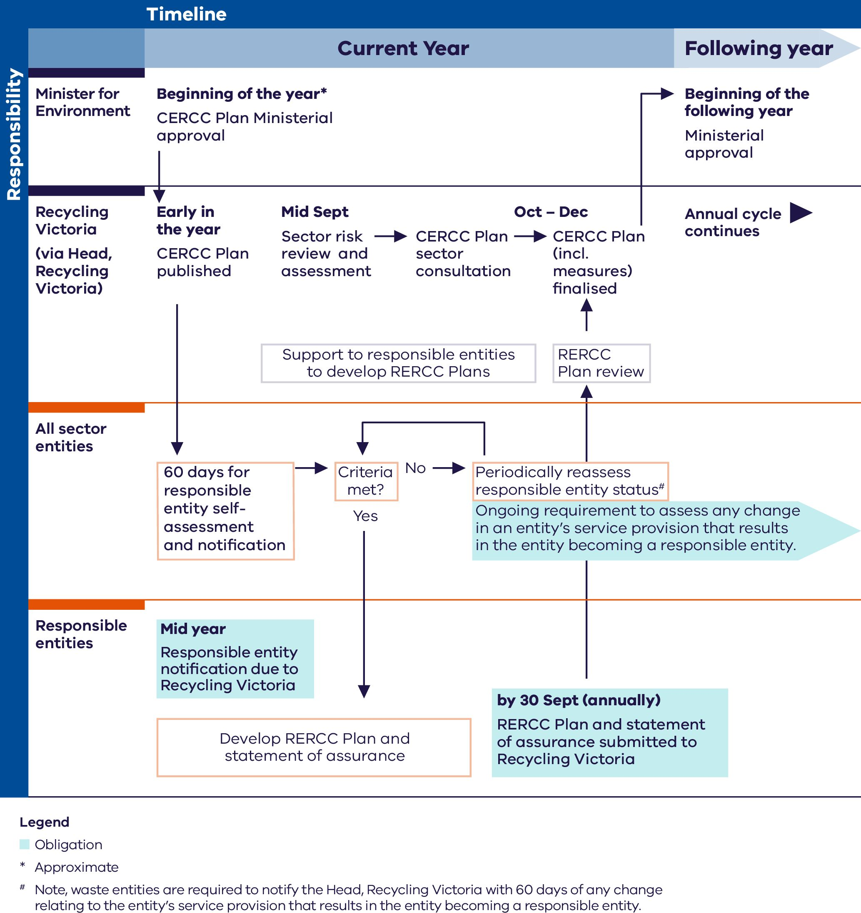Figure 2: CERCC Plan and RERCC Plan annual development cycle

## Recycling Victoria

Recycling Victoria’s vision is for a world-class circular economy system that helps build a more sustainable future for all Victorians.

Recycling Victoria was established in July 2022 to provide leadership, stewardship and oversight of Victoria’s waste and resource recovery services to support a strong and resilient circular economy with robust market investment and growth. This includes providing regulatory oversight for the resilience in the provision of services in sector, as guided by Recycling Victoria’s inaugural Regulatory Strategy. Recycling Victoria’s strategic priorities for 2023 to 2026[3] include identifying, monitoring and mitigating serious system risks associated with waste, recycling, and resource recovery services.

Our focus is on pursuing statewide market growth and investment, building capacity, resilience and reliability in the sector, while maximising the ongoing use and value of products and materials. Everyone has a part to play – collaboration between industry, community, and local, state and Australian governments is needed to help the sector respond to current and future challenges. Recycling Victoria will support the recycling sector to transition to a more resilient circular economy model, which delivers reliable waste, recycling and resource recovery services and the benefits that Victorians expect.

## United Nations Sustainable Development Goals

Recycling Victoria’s Strategic Plan3 identifies contributions towards 12 of the 17 the United Nations 17 Sustainable Development Goals and Targets (Figure 3) specifically sets out to address 4ofthe 17 goals:

* **Goal 8:** Decent work and economic growth.
* **Goal 11:** Sustainable cities and communities.
* **Goal 12:** Responsible consumption and production.
* **Goal 17:** Partnerships for the goals.

Figure 3: United Nations Sustainable Development Goals

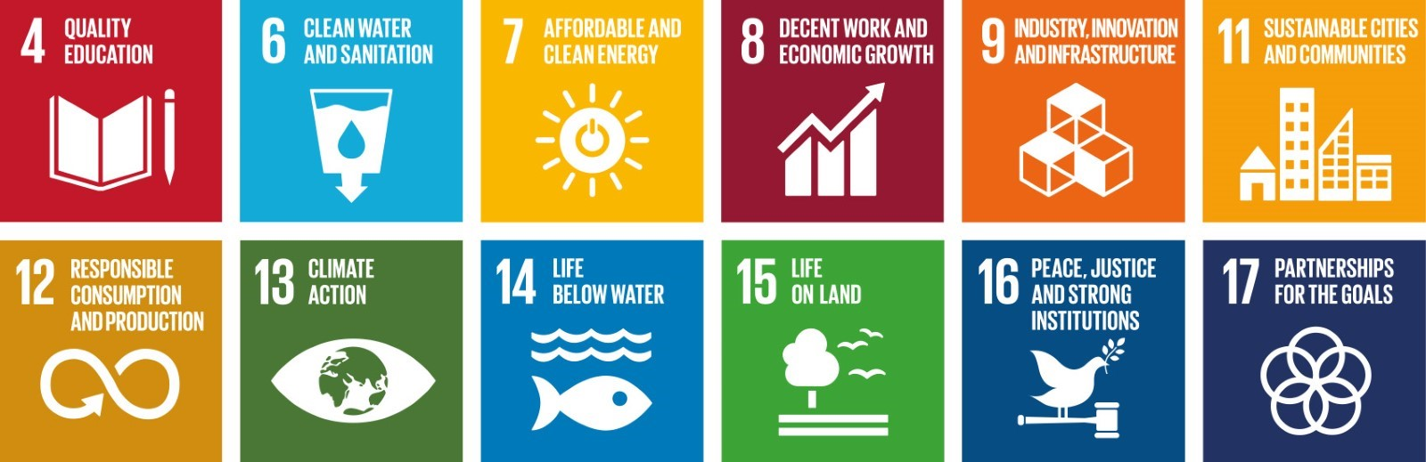

## About this plan

The CERCC Plan 2025 is prepared in accordance with section 74B(1) of the CE Act and is the annual plan in force.

In accordance with section 74B of the CE Act, the annual CERCC Plan remains in force until it is revoked or varied by the Minister or replaced by the following annual plan on approval of the Minister. Recycling Victoria, in accordance with Regulation 10 of the CE Regulations, is required to provide a draft of a CERCC Plan for a consultation period of at least 14 calendar days to:

* responsible entities
* any public sector body that may be affected by the CERCC Plan
* any other person or entity considered appropriate by the Head, Recycling Victoria.

Feedback received on the consultation draft of the CERCC Plan is to be considered and addressed in preparing this plan.

Responsible entities are required under section 74D(1) of the CE Act, to comply with the CERCC Plan that is in force. Responsible entities are required in their RERCC Plans to demonstrate that their RERCC Plan complies with, and is prepared having regard to, the CERCC Plan.

Publication of a new CERCC Plan does not alter the requirements for responsible entities to comply with their RERCC Plan, submitted the previous September. Responsible entities must comply with an existing RERCC Plan, until a new RERCC Plan is prepared which has regard to the CERCC Plan in force.

# Context

## Sector risk context in 2024

The introduction of the inaugural CERCC Plan in 2024 commenced requirements for reporting on risk, consequences and contingencies impacting the waste, recycling and resource recovery sector in Victoria.

On publication of the CERCC Plan, responsible entities, the cohort of operators providing essential services at a volume, value or scale of significance, were required to self-assess against criteria and determine their status, before notifying Recycling Victoria when the criteria were met. Responsible entities shared their risk, consequence and contingency planning with Recycling Victoria on submitting their inaugural RERCC Plans by 30 September 2024.

Some important sector gains in relation to the management of risks has occurred in 2024. The introduction of Victoria’s Container Deposit Scheme (CDS Vic) on 1 November 2023, saw a new partnership through an industry driven stewardship scheme, supported by network operators to receive and process material collected, with administration and oversight by Recycling Victoria. CDS Vic has been successful in adding infrastructure across the state, with over 330 new purpose built collection points established during the year. Positive perception and trust have been achieved through CDS Vic, which Victorians have embraced enthusiastically in its first year. Over 1 billion containers have been returned in that time through the public refund collection point network.

In 2024, the sector experienced a continuation and in some cases the amplification of challenges in relation to the risk of failure, disruption or hindrance of service, or the transition to a circular economy.

The risks associated with contamination in the sector continue. The proliferation of lithium-ion sourced battery fires has led to load dumping from collection vehicles, impacted facilities, caused service disruptions and gained significant community interest. An industry commissioned and funded report in December 2023 by the Australian Council of Recycling[4] articulated the prevalence of risks facing the sector from battery sourced fires, with battery usage growing exponentially each year. A follow up industry survey[5] in June 2024 found the proliferation of fires in the sector increasing.

Asbestos contamination in mulch gained national media attention in early 2024, with the detection of asbestos in public parks and gardens across New South Wales, the Australian Capital Territory, Queensland and Victoria[6].

The costs of delivering and affording sector services have also escalated as a risk throughout 2024, as many nations globally are experiencing the increase in inflationary pressures and other additional costs which have been imposed on businesses.

Cybersecurity breaches generally and with some specific cases for the sector remain a threat to business continuity. With a significant reliance on information technology (IT), service continuity in the sector is vulnerable to attack. Cybersecurity remains a prominent cause of the external threat risk of the sector.

In response to these challenges the sector is being asked to more comprehensively consider and plan for how it may deal with these risks.

## Global macro risks and trends affecting the sector

The risks faced by the world today are more interdependent than ever before. Environmental and societal crises are being driven by underlying geopolitical and economic trends, which will continue to shape the next decade. Compounding shocks, interconnected risks and diminishing resilience are making society more susceptible to crises. The 2024 Global Risks Report[7] serves as a call to action, urging us to prepare ourselves for the next crisis and work together to create a more stable and resilient world. The 2024 Global Risks Report ranks risks over the short and long term (Figure 4).

The continuing global rise in economic uncertainty, as shown in Figure 4, and the ongoing economic challenges faced by Australia, could impact Australia's progress towards circularity and service continuity. Economic risks, including a lack of economic opportunity, inflation and economic downturn are notable new entrants to the top 10 risk rankings over the 2 year period.

Environmental risks continue to dominate the risks landscape across all time frames. Extreme weather is the top risk most likely to present a material crisis on a global scale in 2024. Nearly all environmental risks feature among the top 10 over the longer term. Natural resource shortages over the next 10 years have grown in ranking from last year’s report[8][9].

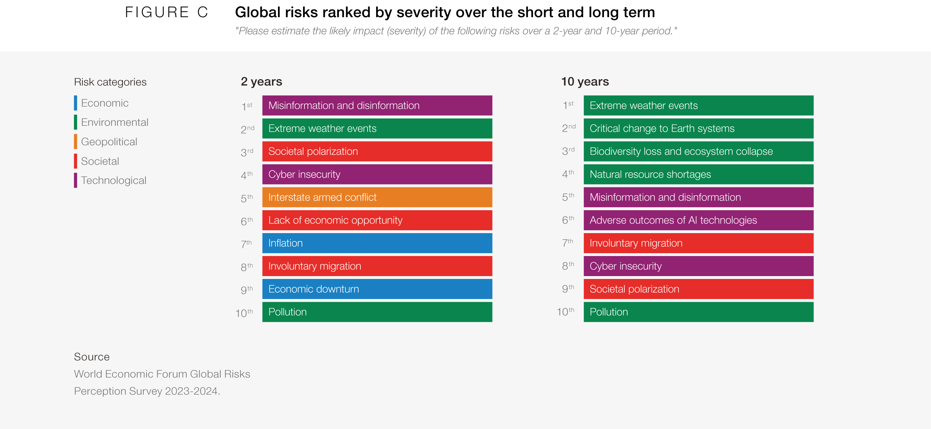Figure 4: Global risks ranked by severity over the short and long term

Reflecting on business resilience, survey data released in 2024[10] found disruptions are inevitable in the current risk environment. That is, it’s not a case of ‘if’ disruption might happen, but ‘when’.

The report quotes from PwC’s recent 2023 Global Crisis and Resilience Survey which “found that an incredible 91% of organisations experienced at least one disruption over the last 2 years (excluding the pandemic), with 76% saying that their most serious disruption had a medium-to-high impact on operations, ‘disrupting critical business processes and services and causing downstream financial and reputational issues.”

The report also advises “organisations are contending with external macro forces and internal business transformations, and it is against this backdrop that resilience has become one of the most vital strategic priorities in the corporate world.”

The report notes building and implementing operational resilience is achieved through a strategic and holistic governance by boards and senior leadership teams to systemically address risks, particularly those high risk areas that are managed across organisational silos and are interconnected, including:

the use of technology, including Artificial Intelligence – from procurement to implementation and ongoing management of technology systems

data and information lifecycle management – from collection/generation, use/re-use, to disposal

regulatory compliance – ensuring data security and data minimisation requirements are met – including collecting only necessary personal data and disposal of data that is no longer needed by the organisation

measuring carbon footprint of data and information being stored by the organisation and all the various cloud storage and physical archives.

*Sector challenge: Inflationary pressures*

Inflation pressures are leading to increased costs and expenses nationally and internationally and challenging affordability. For the sector, this may result in increased costs to consumers, or a challenge for businesses operating under fixed contracts, without options to accommodate fiscal variability.

Infrastructure cost increases present direct costs and indirect costs in the waste, recycling and resource recovery sector. The cost of infrastructure has increased over 20% in recent years, affecting materials and labour. Demand has outstripped supply in many cases, further compounding cost pressures.

Waste, recycling and resource recovery services are ordinarily high capital investments, requiring significant financing and long lead times, to commence operations. Once established, they require sustained investment in technology and maintenance to remain cost competitive. These start-up costs and longer lead times before achieving profitability are challenged by fiscal variability. In most circumstances, the cost of recycled materials remains higher than that of raw or virgin materials.

As a smaller scale industry, the sector is potentially less resilient to cost pressures than larger scale industries. Costs in the waste, recycling and resource recovery sector have also increased, including in fuel, transportation and insurance. At the same time, community cost avoidance, such as illegal dumping or fraud and corruption, are potentially undercutting legitimate operations.

## National trends and emerging issues in the circular economy

Export markets are raising requirements to remove low-quality, mixed materials. Export restrictions and bans on some materials and contaminants are driving us to build our capacity to turn these waste materials into high-value, recycled commodities in Australia.

By ensuring we only export waste material that have been properly processed, we are reducing the prospect of harm to the environment and human health that arises when mixed, poor quality materials are used overseas.

National packaging targets are not being [met](http://www.packagingcovenant.org.au) and recycling of flexible plastics remains a notable challenge, though in Victoria new facilities, including the Polymer Processors facility (Dandenong) and the new Close the Loop facility (Reservoir), has added much needed new capacity. Technology improvements such as advanced chemical recycling, which creates plastic crude oil for manufacturing equivalent to virgin plastic, holds significant promise to diversify processing options for a broad range of plastic types. The market environment for these investments to be possible and/or sustainable are still considered limited and uncertain.

Changes have occurred such as removal of PVC from rigid and soft plastic packaging by many brand owners, and the progression of efforts to phase-out chemicals of concern from food packaging.

There has been increasing demand from manufacturers to integrate recycled contents in their packaging, both locally and internationally. Bottle to bottle plastic processing is replacing virgin material with recycled resources in an environment where market price for virgin-equivalent recycled plastics can command higher prices than virgin plastics.

Australia's national, state and local governments have united to adopt an ambitious collaborative plan to enhance waste recovery and recycling rates. The National Waste Policy and Action Plan (2022),[11] prepared by the Department of Climate Change, Energy, the Environment and Water (DCCEEW), has been developed by Australia’s 3 levels of government. The plan aims to transition Australia's material use into a circular economy. There is now a national commitment to several goals, including gradually halting the export of critical waste streams.

Waste paper and cardboard regulation commenced on 1 July 2024, with licences required for export from 1 October 2024. Together with waste tyres, plastic and glass, which commenced regulation in 2021, this means that more waste must now be processed domestically.

Australia also aims to increase its resource recovery rate to 80% by2030, reduce food waste sent to landfills by half by2030 and set national packaging targets for the industry. These targets include:

* 100% of packaging should be reusable, recyclable or compostable by 2025
* 70% of plastic packaging should be recycled or composted by 2025
* 50% of packaging should be made up of recycled materials by 2025
* 100% of single-use plastic packaging should be phased out by 2025.

To fulfil these goals, Australia must increase its local processing and recycling capacity substantially, creating opportunities and certainty for investors. The Australian Government has developed key guidance for implementation by the waste, recycling and resource recovery sector during 2024:

* Revised National standard for waste and resource recovery data and reporting were released in March 2024 to assist organisations to provide data in a consistent and reliable manner[12].
* Consultation by the Australian Government via online tutorials to build industry capability in recycled content traceability and to develop content that best meets the needs of businesses[13].

*Sector challenge: Proliferation of battery driven fires*

The enabling technologies for batteries, together with the rising demand for consumer electronics, have increased demands of existing waste, recycling and resource recovery services, resulting in contaminated waste streams and frequent fires.

This is placing growing pressure on industry and government to undertake priority interventions, to preserve life and property, avoid service disruption and achieve greater material circularity.

Lithium-ion batteries (LIB) are the most at risk of causing significant fires. Degradation of LIBs is termed thermal runaway, which occurs when a battery generates heat faster than it can be dissipated, leading to a rapid increase in temperature and potentially resulting in fire or explosion. The challenges vary, depending on the specific battery chemistry, for example Lithium iron phosphate and nickel manganese cobalt batteries (both types of LIBs), have different risk profiles. Further, the knowledge base for best management practices is still developing.

The LIB waste stream will continue to grow significantly in coming years across Australia (estimated at 19-22% growth rate each year).

*Government action*

Safe battery disposal is a national issue of significance being considered by the Environment Ministers Meeting (EMM). At its meetings in June and December 2024, EMM noted:

* that battery fires are escalating as an issue and require intervention through the battery life cycle (design, storage and disposal)
* the need for urgent reforms to product stewardship arrangements for batteries to address the escalating risks of battery fires and create a safe, circular economy for batteries.

The EMM also discussed the findings of a draft Regulatory Impact Statement, prepared by Victoria and New South Wales (NSW), examining options for these reforms. Recognising the need to act quickly to reduce the risks of battery fires, Ministers agreed to consider how they might progress aligned state-led reforms for mandatory battery product stewardship.

Safe management of batteries throughout their lifecycle requires a multi-faceted approach, therefore, multiple complementary workstreams are underway. Governments will work to ensure these workstreams are addressing aligned objectives.

For example, the Environment Protection Authority (EPA) Victoria is leading national work on behalf of the Heads of EPA Australia and New Zealand (HEPA) to develop a national guideline for the safe storage, handling and transport of LIBs.

|  |
| --- |
| **CASE STUDY: *Resilience and adaption through innovation* – Commonwealth Scientific and Industrial Research Organisation (CSIRO) Australia**  Australia’s national science agency, CSIRO, is conducting research to support LIB recycling efforts, through processes for the safe recovery of metals and materials, development of new battery materials and battery reuse and recycling to support a circular economy, including the following:   * A pilot facility trialling safer and more environmentally friendly recycling of LIB’s has begun operating in Clayton, Victoria. The pilot plant, to be operated by CSIRO, will provide valuable insights into battery fire risks during collection, transportation and storage. * The adoption of new methods to safely process batteries, moving away from the traditional practice of wet shredding in liquid mediums (usually water), to opting for dry shredding under an inert nitrogen gas atmosphere blanket, to exclude oxygen from the air. In the dry shredding process, the electrolyte, a valuable component, can be safely separated and recovered. It also often yields a cleaner black mass, leading to a higher purity of recovered metals with increased safety. The dry shredding unit is equipped with several technical features, such as optical and thermal (infrared) cameras and the ability to measure and clean the exhaust gases emitted from the process. * Working with industry to develop an electrical discharge unit that allows for the safe and controlled discharging of batteries.   **CASE STUDY: *Safer and more convenient battery collection* – Ecobatt**  Ecocycle, through its subsidiary Ecobatt, operates a range of battery transport bins and household battery collection kiosks across Victoria and Australia, designed to safely and conveniently collect batteries.  Ecobatt provide collection bins, equipped with smart sensor technology, to reduces the risks of loose battery and embedded lithium-ion battery product collections. Through ongoing development with patented technology, the sensors enable temperature monitoring and collection scheduling of batteries. The kiosks are located in supermarkets, hardware stores, other retail outlets, council buildings and libraries.  There are also designated (dangerous goods registered) battery collection trucks and service equipped with the latest technology, including fire containment systems, hand-held lithium extinguishers for adverse battery events, and in-built automated aerosol suppression systems. |

*Sector challenge: The threat of serious IT disruptions and the benefit of cybersecurity*

As technology continues to weave itself into the fabric of daily life, every Australian becomes increasingly vulnerable to cybersecurity threats and IT disruptions. From the average individual to the nation's largest corporations, the digital landscape presents a minefield of potential hazards. Significant IT incidents received public attention in recent times, including incidents concerning Optus, Medibank and Fire Rescue Victoria. Hardware failures, human errors, software bugs, and malicious attacks like viruses and ransomware, can compromise personal data, business operations and critical infrastructure.

The waste, recycling and resource recovery sector faces a similar cyber-security threat, coupled with unique consequences. A significant IT disruption, such as a server failure, could cripple scheduling and routing systems for waste collection trucks. This disruption would result in uncollected waste and recyclables and could create severe environmental hazards. Automated systems reliant on real-time data, such as those for supervisory control and data acquisition (SCADA), would face operational paralysis, impacting efficiency and effectiveness.

The impact isn't confined to operational disruptions. The reputational damage for companies can be immense. With increased media exposure following significant breaches, businesses may face a loss of trust from customers and stakeholders. The aftermath of such attacks often involves costly recovery efforts.

According to the Australian Cyber Security Centre, publicly reported incidents of vulnerabilities and exposure has increased by 20% since 2021-22 and costs associated with recovering from cyber incidents has increased by 14%.

In 2024, a notable IT disruption incident impacted the waste, recycling and resource recovery sector in Victoria, disrupting their operations. This incident halted waste collection and recycling processes and compromised customer service, highlighting the critical need for robust IT disruption systems and processes in the industry.

The Australian Government is introducing a Cyber Security Act that will carry new legislative requirements for all government and industries to comply with. Information is available through Australian Signals Directorate on how to keep your business safe from cyber threats.

Only through a well-rounded approach to cybersecurity can the waste, recycling and resource recovery sector maintain resilience in the face of ever-evolving digital threats.

## Victorian trends and emerging issues in the circular economy

In Victoria in 2023, an estimated 18.4 million tonnes of hazardous and non-hazardous waste was generated, with an estimated 71% of state-wide non-hazardous waste recovered. Waste generation is estimated to rise from around 2.7 tonnes per capita currently to 3 tonnes per capita over the next 30 years[14].

The largest contributor to Victorian waste generation (by weight) is the construction and demolition sector with 51% of state-wide generation, and is estimated to grow over the next 30 years. The commercial and industrial sector contribute 29% and the municipal solid waste sector contribute 20% though are estimated to decrease their contributions to total waste generation over the next 30 years14.

Most waste generated in Victoria is managed in the state, with some materials exported interstate, or overseas. In 2023, an estimated 7% of state-wide generated waste (by weight) was exported. Notably, 33% of Victorian-generated metal and 24% state-wide paper and cardboard waste was exported internationally. Exports are expected to remain an important market for Victoria’s recycling and resource recovery sector, particularly for certain material streams[15].

In Victoria in 2021, the waste sector was responsible for 3.4% of Victoria’s total net greenhouse gas emissions – emissions from the sector in 2021 were 2.7megatons of carbon dioxide equivalent (CO2-e), significantly below the 6.4megatons of CO2-e emitted in 1990[16]. The main source of waste sector emissions in 2021 was from the disposal of solid waste to landfill (65.8% of total waste sector emissions).

## Issues of performance and supply

Section 74B(2)(f) of the CE Act requires Recycling Victoria to identify issues relating to the performance or supply (including issues relating to the generation, collection, sorting, reprocessing, or re-manufacturing of waste) within the circular economy market or a part of the market of waste management services. Examples that have been evident during 2024 include the following:

* The prevalence of battery fires and near misses in the sector experienced in 2024 across the whole supply chain (refer to *Sector challenge: Proliferation of battery driven fires*).
* Industry has noted challenges obtaining materials to manufacture kerbside bins in Victoria and have had to seek alternate markets and other strategies to service the demand for orders placed by Victorian councils.
* There has been activity in the market for the securing of supply of feedstock, particularly for proponents seeking to establish waste to energy facilities. Nine councils have grouped together to enter a Waste Supply Agreement with Maryvale EfW Project Co Pty Ltd (a consortium between Veolia Australia and New Zealand, Opal Australian Paper, and Masdar Tribe Australia) to send waste to a waste to energy facility in Maryvale in Victoria’s Latrobe Valley.
* Six notable fires in the waste, recycling or resource recovery sector, or allied industries, occurred in built up areas in 2024. A significant fire at the Welvic Pty Ltd facility in July 2024 reduced sector capacity to process PVC materials. For such incidents, businesses are required to enact their emergency response and human resource and business continuity procedures to respond to and manage the consequences of the incident. Based on incidents observed, health and environmental monitoring and recovery activities may also be required for extended periods of time.
* Analysis found that possible consequences of fires related to waste, recycling and resource recovery services are generally highest in facilities near major urban areas, where most combustible recyclable and waste material is stored[17]. Facilities are sometimes located adjacent or near to built up areas, such as residential dwellings and waterways. Population growth and increasing density in Melbourne and regional cities can complicate or increase the human and environmental interactions with such facilities and consequences of industrial fires involving waste, recycling and resource recovery facilities.
* An increase in administrative costs and missed opportunities for recycling and resource recovery from a lack of harmonisation between jurisdictions and / or insufficient or inconsistent applications of Standards, within or between jurisdictions, in the management of materials, particularly evident in CDS Vic services.
* Reports from sector operators of a continuing contamination of services, particularly in food and garden organics (FOGO), with industry citing the absence of cohesive and connected community education for consumer behaviour improvements (in accessing and utilising services) as a key contributor.
* A growing demand for recycling and resource recovery not supported or cost effective for all material streams to transition to a circular economy, particularly for textiles. Victoria is reliant on exports and sends most of its textile waste overseas for reprocessing. There is a growing industry circularity movement seeking to increase resource recovery of textiles. Industry product stewardship scheme, Seamless, funded by the Australian Government, has developed a roadmap to establish multiple recycling facilities for clothing to increase diversion of end-of-life garments to address the existing gap in infrastructure for sorting and reprocessing materials.
* Improving sector planning for sufficient infrastructure for all services - the Victorian Recycling Infrastructure Plan (VRIP)[18] was published in November 2024 and aims to address the current infrastructure capacity and capability issues within the sector, address future infrastructure challenges before they become issues and support more reliable waste and recycling systems.
* An emerging issue identified through consultation on the draft CERCC Plan 2025 is a risk of future contamination of services from hazardous materials. These have been supported by Victorian Government initiatives such as Detox your Home and the Asbestos Disposal Points Grants programs.

|  |
| --- |
| *CASE STUDY: Risk reduction through community education – local government partnering with industry for mutual benefit*  Mornington Peninsula Shire and Solo Resource Recovery  Mornington Peninsula Shire and Solo Resource Recovery have partnered for an education and awareness campaign, informing residents that hazardous/highly flammable items cannot go in any kerbside bin through messages on the sides of the Shire’s collection trucks.  Solo Resource Recovery continues to support accredited and voluntary industry-led battery stewardship programs, B-cycle and MobileMuster, in a new national campaign that shares fire prevention messages on the sides of their collection trucks.  “Your batteries need extra care, and by taping the terminals of used batteries with clear sticky tape, recycling these resources becomes safer”.  Hobsons Bay City Council and Cleanaway / Pact Group  Hobsons Bay City Council is adopting community education strategies to assist households in making smart choices for waste, recycling and resource recovery. Council is using a multi-factorial approach to risk control and have targeted e-waste and batteries as an improvement opportunity. Hobsons Bay City Council, through partnership with Cleanaway and Pact Group as their collections contractor and bin supplier, provide new and replacement bin lids for residents with messaging not to put e-waste, including batteries, with this simple image hot stamped into bin lids.  This is designed to avoid unwanted materials risking combusting during collection and transport and to avoiding depositing material in landfill that may otherwise be recycled. Council is also recommending the use of appropriate facilities to collect batteries through promoting the Ecobatt battery bins located in 8 council facilities as an alternative to kerbside collection.  Maribyrnong City Council and Bin Thinking  Maribyrnong households are being urged to show more care when disposing of batteries and e-waste. As part of the “Bin it Better” recycling education program launched by Maribyrnong City Council in 2024, residents are being warned to keep used batteries and e-waste out of kerbside bins to avoid contamination.  To avoid this, Council is recommending that used batteries and e-waste be disposed of at one of the electrical drop off hubs or B-cycle drop offs, located throughout the municipality. Through funding by Sustainability Victoria, the “Bin it Better” campaign seeks to empower residents to place the correct items in the right bins for collection to reduce the amount of contamination in kerbside recycling (yellow lid bins) and FOGO (green lid bins).  To achieve this, the campaign is running education workshops across the municipality, including at local schools. Workshops focusing on organics will take place across the municipality in 2025 and more schools are encouraged to sign up and take part in the free education sessions. These sessions are delivered by Bin Thinking, a specialist waste and recycling education business, to further reinforce sustainable waste management practices among students. |

*Sector challenge: Organics contamination by asbestos*

The risks of asbestos are well known. All use, import or manufacture of asbestos was banned completely in Australia by 2003. However, after 100 years of its use in building products and materials, Victoria, like many other jurisdictions worldwide, is dealing with legacy asbestos in the built environment.

In early 2024, reports of asbestos contamination in mulch at public places in NSW, the Australian Capital Territory and Queensland, led to concerns for public safety and posed market impacts for recycled organic material.

EPA undertook compliance assessments of mulch producers during April 2024 to determine prevalence of asbestos contamination of mulch in Victoria. Investigations found no evidence of asbestos contamination in mulch products at processing facilities; however, small levels of asbestos contamination were detected at some sites, attributed to legacy contamination, or from illegal dumping. All contaminated sites were immediately remediated[19].

Other Victorian Government initiatives to reduce risks of asbestos contamination include:

* expansion of an asbestos disposal point pilot program to additional sites in 2024-25, as part of the delivery of the Asbestos Disposal Management Plan. The Asbestos Disposal Points Grants program has provided funding for local government or industry to establish asbestos disposal points that will increase access to waste facilities that support the safe disposal of small quantities (under 10 square meters) of non-friable, packaged asbestos waste
* EPA’s 'Reducing Illegal Asbestos Disposal - Compliance Strategy' which is an area of focus in EPA’s 2024-25 Annual Delivery Plan
* action highlighted in Recycling Victoria’s VRIP, published in 2024, which is to establish a cross-agency working group to address specific residual and hazardous waste challenges, including asbestos disposal locations across Victoria.

## Government action towards risk mitigation

### Australian Government

In 2024, EMM met in June and December and discussed the Australian Government’s new National Circular Economy Framework, delivered in December 2024. The National Circular Economy Framework will drive a faster transition to a circular economy and ensure efficient use of key resources and materials in Australia. Opportunities exist in the manufacturing, food and agriculture, resources and critical minerals sectors and the built environment.

At their meetings in June 2024, EMM discussed the following:

* Encouraging the development of stronger end markets for recycled products.
* Implementing the new national packaging regulatory scheme, part of a commitment to harmonisation between jurisdictions.
* Committing to seeing a circular economy for plastics established in Australia, noting the growing challenge of soft plastics, and industry’s slow progress to re-establish in-store collection since the collapse of the REDcycle scheme.
* Further progress on per- and polyfluoroalkyl substances (PFAS) contamination, including its removal in packaging as an urgent priority for all jurisdictions. HEPA are reviewing design standards.

Prioritising their focus on battery management and safe disposal, given the risk from fires to life and property.

At their meeting in December 2024, EMM discussed the following:

* The National Circular Economy Framework to accelerate Australia’s transition to a circular economy, ensuring more efficient and productive use of our resources.
* Agreed to a strengthened National Waste Policy Action Plan that will direct efforts to where it is most needed to achieve the 2030 waste and resource recovery targets.
* Consultation with governments and industry in early 2025 on packaging design guidance from the National Design Standards Working Group, which is based on best practice and independent expert views.
* Agreed in principle for a roadmap to harmonise kerbside collection systems, to a minimum set of items that can be collected and recycled across the country, to make recycling easier for households, reduce confusion, increase recycling rates and reduce likelihood of people putting things in the wrong bin and a pathway for soft plastics collection and recycling.
* Agreed to release a summary of the National Roadmap: Harmonising action on problematic and unnecessary plastics identifying 24 items that jurisdictions have agreed to work together to reduce variations on, without reversing any measures that have been taken.

Noted the need for urgent reforms to product stewardship arrangements for batteries - as detailed in Sector challenge: Proliferation of battery driven fires of this plan.

National progress towards a circular economy has informed development of this CERCC Plan and will continue to inform future risk, consequences and contingencies for the sector in Victoria through implementation of the CERCC Plan and RERCC Plans.

### Victorian Government

During 2024, the Victorian Government provided assistance to the sector in response to significant emergency management events across Victoria.

In February, a number of local government regions experienced a major storm event and there was a major bushfire near Beaufort. Both of these events created significant volumes of disaster waste to be managed. In response, the Department of Energy, Environment and Climate Action (DEECA) coordinated gate fee rebates and waste levy waivers for eligible entities, including local governments and other facility operators.

Support provided through a gate fee rebate and waste levy waiver allowed the communities in affected areas to dispose of disaster waste for free at designated waste facilities. This support allowed eligible organisations such as local governments, transfer stations operators and landfills to provide management for over 6,500 tonnes of material.

Further support was provided to Agriculture Victoria in response to the avian influenza outbreak at poultry farms. Victorian Government action led to the diversion of over 13,000 tonnes of waste from the response to control disease spread, that would have otherwise been disposed of in landfill.

|  |
| --- |
| *CASE STUDY: Victoria’s Big Build partner - ecologiQ*  ecologiQ is a Victorian Government initiative, whose goal is to leverage unprecedented investment in infrastructure to be recognised as the world leader in the sustainable use of recycled and reused materials by 2025. This is one step in supporting Victoria’s transition to a circular economy.  ecologiQ is optimising the use of Victorian recycled and reused materials on Victorian major transport projects, as part of the $100 billion Big Build, overseen by the Victorian Infrastructure Delivery Authority (VIDA) and the Suburban Rail Loop Authority.  To achieve its goal, ecologiQ is:   * encouraging innovation in transport infrastructure construction to improve quality and accelerate the implementation of new Victorian recycled products * supporting a vibrant and sustainable Victorian market for reused and recycled materials in transport infrastructure construction * adopting reduce, re-use and recycling of materials without compromising the delivery of safe, high-quality and sustainable infrastructure.   Further, ecologiQ are changing the approach to technical standards and specifications and pursuing market development opportunities for emerging materials. Recycled material used in major transport projects include waste plastic, tyres, glass, concrete, brick, fly ash and slag.  A key driver of change in recycled material adoption is the Recycled First Policy, which, for the first time in Australian history, requires contractors delivering Victorian transport projects to optimise their use of recycled and reused materials. This includes:   * optimisation of recycled and reused material use in accordance with current standards and specifications * trialling new or innovative products * opportunities to boost recycled and reused material quantities within existing standards and specifications.   To date, the Recycled First policy has delivered 4.6 million tonnes of recycled materials into Victoria’s Big Build, effectively leveraging the government’s substantial purchasing power to promote alternative waste uses and reduce landfill.  A key achievement for ecologiQ has been updating existing standards and developing new standards and specifications, including for recycled plastic noise walls along roadways. The first implementation of the noise walls on the Mordialloc Freeway:   * were constructed from 75% recycled plastic - half of which was plastic disposed in kerbside recycling such as milk and soft drink bottles, with the other half made up of soft plastics such as bread bags, food wrappers and bubble wrap * diverted more than 570 tonnes of plastic waste from landfill - the equivalent of plastic waste products collected from 25,000 homes across Victoria in one year - through the installation of 32,000 square metres of noise wall along the Mordialloc Freeway (a world first) * created and retained local jobs - with noise walls manufactured in Carrum Downs by PACT Group * generated construction efficiencies - at less than half the weight of steel or concrete panels, the recycled plastic panels are quicker and safer to install, while still meeting or exceeding traffic noise reduction requirements   are designed with reprocessing in mind - the recycled plastic panels are non-porous, meaning they won’t absorb paint and graffiti.  Recycled plastic noise walls and investment in a circular economy sends a clear signal to the market of a growing demand for recycled products. By growing the market for recycled products the viability of the recycling sector is maintained. This is critical to the ongoing continuity of recycling services and Victoria’s transition to a circular economy. |

## Responsible entity progress towards sector risk mitigation

Following consultation with Recycling Victoria during 2024, 24 entities notified as responsible entities and provided RERCC Plans and ‘Statements of Assurance’ to Recycling Victoria. Recycling Victoria, through preparation of Guidelines for a Responsible Entity Risk, Consequence and Contingency Plan (the Guidelines), which were specifically designed to address the self-assessment process, assisted essential service providers in making their own assessments. The Guidelines proved useful in seeking to clarify any uncertainty in the self-assessment process. The self-assessment process remains an ongoing requirement.

For the inaugural RERCC Plans, responsible entities were able to identify their relevance to the serious sector risks identified by Recycling Victoria in CERCC Plan 2024. Responsible entities were all able to specify actions they propose to take to prevent or minimise the risks identified.

RERCC Plan content reconfirmed the continued relevance of the 6 serious sector risks published in CERCC Plan 2024 as key challenges to achieving the sector objectives of minimising serious failure disruption or hindrance to the provision of waste, recycling and resource recovery services, and risks of a financial nature to Victoria's transition to a circular economy. The plans also outlined additional uncertainties impacting the sector and service delivery.

Through preparation of the RERCC Plans, responsible entities have evidenced the importance of planning for and anticipating emerging or heightening challenges to service continuity and the transition to a circular economy, in partnership with other operators, or with the Victorian Government. Preparation of RERCC Plans is affording a better understanding of where resilience in the system is strong and where further strengthening opportunities exist.

While still in its first year, the breadth of services covered by responsible entities is significant, with 14 of the 15 essential services listed in the CE Regulations managed by the 24 responsible entities. There is a significant focus and spread across landfill, hazardous waste, construction and demolition and the container deposit scheme. There are no providers of long term waste containment services as this type of service is not currently operational in Victoria.

Responsible entities have demonstrated focus on risks related to work, health and safety and environmental risks. A level of partnership between entities and regulators, local government and aligned agencies is evident of the controls for some risks. Examples of controls in place include:

* engineering controls – weighbridges, fire suppression systems, 24/7 surveillance, excavators, fire suppression water trucks, perimeter fencing, physical barriers, spill containment equipment, stormwater infrastructure, generators, fleet, hot spot or odour detection
* administrative controls – fire management plans, inspection protocols, preventative maintenance programs, safe operating procedures, visitor management procedures, training regimes on environmental management systems and site-specific protocols and equipment, business continuity plans, third party agreements, financial practices such as reconciliation and financial reporting, conflict of interest policies and registers.
* technological controls – multi-factor authentication, firewalls, system audit trails, back to base duress alarms, key or fob security access system, barcode system, automated data collection systems
* people related controls – training on site-specific protocols, incident management training and exercising, biosecurity training, succession planning, driver training and competency assessments, delegation of authority, labour hire arrangements, fraud and integrity training, segregation of duties.

Recycling Victoria experienced a strong willingness by industry to engage in this new process, receiving RERCC Plans that provided information beyond minimum mandatory requirements, which gave extra context and demonstrated openness and transparency.

# Victorian waste, recycling and resource recovery sector risks

## Risk assessment process

Recycling Victoria followed a standard risk methodology to develop the CERCC Plan 2024 and 2025. Refer to methodology details in Appendix 4.

There are elements of each CERCC Plan that will remain consistent between plans, as the content of the plan is prescribed by the CE Act and the CE Regulations.

### Risk identification

Through this plan, Recycling Victoria is required to identify risks of serious failure, disruption or hindrance to the provision of waste, recycling, and resource recovery services and identify financial risks to Victoria's transition to a circular economy and to responsible entities.

In order to understand sector vulnerability and resilience, including to financial hardship, Recycling Victoria has reviewed and identified serious sector risks, particularly financial risks in 2024.

CERCC Plan 2025 provides an updated sector risk profile in response to the changing circumstance impacting the sector over the previous 12 months and reflective of insights and opportunities detailed within RERCC Plans. Recycling Victoria has built a sector knowledge base, with input from previous industry consultation and existing knowledge, such as reports and events. This knowledge was accessed to further assess the sector risks relevant for the CERCC Plan 2025.

The interconnected nature of the sector means that disruptions to one business can have cascading effects on other businesses. This makes risk mitigation at an individual business level alone insufficient to strengthen the sector. If a business in the sector is not able to operate, there can be flow-on consequences to others in the upstream and downstream supply chain that can have significant consequences across the state.

In accordance with regulation 10(a) of the CE Regulations, Recycling Victoria undertook a review of the previous CERCC Plan to inform the preparation of this document.

CERCC Plan 2024 identified 6 serious risks to widespread service continuity and progressing a more circular economy:

* contamination
* external threats
* planning
* social acceptance
* internal threats
* economic stressors

Reflecting on the context and incidents in the sector, these 6 risks were assessed and remain relevant.

The economic stressors risk has expanded to include shocks. This is reflective of the significance of the economic stressors facing Victorians, and the sector, and the acknowledgment that significant economic shock(s) should also be detailed when considering an increase in overall economic vulnerability.

A new risk event has been identified during 2024 – ‘commercial viability in the market’ - which has been included as a serious sector risk in response to challenges directly and indirectly affecting affordability in the sector and a reflection of material streams that may not currently be commercially viable. This risk was introduced to articulate the intrinsic considerations that exist for sector participants such as immature markets, low margins or high operating costs. These factors are further explored in the Sector challenge: Inflationary pressures part of this document.

### Risk analysis

Through this plan, Recycling Victoria is required to outline the likelihood and consequence of each risk that has been identified including the severity of the harm that may result. To analyse risk, Recycling Victoria assessed existing controls, informed by those listed in the RERCC Plans and subsequently revised ratings for the likelihood of the risk occurring and the consequences of the risk to the sector.

The risk ratings for 5 risks identified in the CERCC Plan 2024 remained steady, with one risk (Internal threats) increasing. Adjustments were made to the likelihood of 2 risks (Internal threats and Economic stressors) and to the severity of one risk (Economic stressors), in response to current sector challenges.

The Internal threats risk rating increased from Significant to High in response to significant sector challenges experienced in 2024. Increased rates of contamination impacting facilities and in particular battery sourced fires has seen the likelihood of the risks of Internal threats increase from ‘possible’ to ‘likely’.

Resilience of the sector can be lowered by stressors and eroded by an unforeseen shock. Inclusion of shock(s) decreased the likelihood, though increased the consequence of this risk.

It is important to note that actions in RERCC plans that are intended to be implemented but are not currently in place, were not considered existing controls and therefore did not influence likelihood or consequence ratings.

The sector risk assessment used likelihood rating and consequence ratings as outlined in Appendix 4.

### Risk evaluation

Once the likelihood and consequence ratings were determined for each risk, they were assessed using the qualitative risk matrix as outlined in Appendix 4. Risks scored in accordance with the risk matrix (Figure 7 in Appendix 4) as having a Significant or High rating were considered serious risks which are required to be listed in a CERCC Plan.

## Serious sector risks

The 7 risks for 2025 are outlined below.

Seven serious risks that may impact waste, recycling and resource recovery service continuity or progress towards a circular economy.

Table 2: Risk 1 – Contamination

Risk description: Unacceptable levels of contamination of a waste material or stream

| Causal factors | Likelihood rating | Consequence rating | Evaluation |
| --- | --- | --- | --- |
| * consumer behaviour, such as kerbside contamination or changes in behaviours or consumer/commercial ignorance after changes to sorting rules * separation, recycling or repurposing not built into manufacturer packaging design * materials entering or within the market that are complex to process or emerging contaminants, such as per-and polyfluoroalkyl substances (PFAS) * degradation of unprocessed material over time leading to contamination, particularly for asbestos * inadequate detection or increased requirements for testing * lack of accessible disposal options for certain products, such as batteries, leading tocontamination of other waste streams * insufficient contract management or lack of specificity in contract specifications * inadequate technical ability in system to sort highly contaminated material * poorly maintained plant and equipment * inconsistent material management requirements between jurisdictions * inaccurate or unavailable data or inability or unwillingness to share data to inform decision making | **Almost  certain** | **Major  harm** | **High** |

Consequences of contamination risk events

| Consequences |
| --- |
| Consequences that may arise from unacceptable levels of contamination of a waste, recycling or resource recovery material or stream include:   * increase in fires or chemical pollution incidents at waste, recycling or resource recovery facilities resulting in protracted service disruptions * oversupply or overproduction of unusable products, resulting in stockpiling non-compliance or affecting end markets * significant environmental pollution including where contaminants cannot be identified, controlled or contained * withdrawal of services * an increase in costs for additional sorting, handling, and disposal of contaminated waste * operational inefficiencies causing lower system wide capacity * harm to human health, including directly to operators and potentially to community from contaminated products * lower recovery rates cause an inability to achieve circular economy goals * loss of consumer confidence * equipment damage and increased maintenance needs. |

Table 3: Risk 2 – External threats

Risk description: Severe or sustained external disruption event affecting services

| Causal factors | Likelihood rating | Consequence rating | Evaluation |
| --- | --- | --- | --- |
| * emergencies, as defined in the *Emergency Management Act* *2013*, including: * earthquake, flood, wind-storm or other natural event * a fire, an explosion, a road accident or any other accident * a plague or an epidemic or contamination * a warlike act or act of terrorism, whether directed at Victoria or a part of Victoria or at any other State or Territory of the Commonwealth or a hi-jack, siege or riot * a disruption to an essential service or * cyber-security emergency including malware, ransomware, denial of service attacks etc. * supply chain limitation or failure * changing feedstock volumes * critical utility outage such as power, telecommunications, water, gas or loss of or delayed access to key transport or transport routes * inaccurate or unavailable data or inability or unwillingness to share data to inform decision making | **Likely** | **Major**  **harm** | **High** |

Consequences of external threats

| Consequences |
| --- |
| Consequences that may arise from a severe or sustained external disruption event affecting services include:   * disruption to the collection and transportation of material * increased waste generation and rates of material contamination * damage to assets, infrastructure or energy supply essential to service provision * an inability to communicate, navigate effectively * loss of process control, such as SCADA systems * stockpiling of waste material awaiting processing, when services cannot be delivered * air, land or water pollution or harm to human health * a loss of public trust in waste, recycling and resource recovery services due to lack of resilience. |

Table 4: Risk 3 – Planning

Risk description: Inadequate planning of capacity and capability in or across services, to maintain service continuity

| Causal factors | Likelihood rating | Consequence rating | Evaluation |
| --- | --- | --- | --- |
| * variable capability and capacity for business planning in the waste, recycling and resource recovery sector * insufficient consideration of land use planning conflicts restricting expansion of existing facilities or building new facilities * insufficient consideration of and planning for regulatory approval requirements * cost and time of achieving enhanced buffer protection and planning scheme amendments * variability in material supply and demand, including unseasonal demands from surge in waste material from emergency events or large-scale government projects * rapid changes in consumer behaviour that increases generation of certain materials * insufficient or unavailable collection points to receive material restricting material supply * insufficient infrastructure, through poor planning, to manage demand * workforce constraints, such as staff unavailability due to fatigue/illness, skills shortages or widespread industrial action * updated legislation, regulation, standards or guidance not yet appropriately considered * supply chain limitations, including consumables, feedstock or equipment * inability to spread demand across facilities through reluctance to collaborate * unavailable end markets to establish capacity to recycle some material streams, such as textiles * the tyranny of distance for regional communities * inaccurate or unavailable data or inability or unwillingness to share data to inform decision making | **Likely** | **Major harm** | **High** |

Consequences of planning risk events

| Consequences |
| --- |
| Consequences that may arise from inadequate capacity or capability in or across services, to maintain service continuity include:   * inability to expand and increase capacity of existing waste management facilities * reduction in processing capacity or inability to perform functions and continue services * requirement to operate in less optimal locations or areas such as temporary transfer facilities * competition for available land and increase in capital costs to acquire land suitable for functioning * community opposition to facility location and expansion * human impacts associated with poor planning, such as, fatigue, stress and illness * reduction in quality of process materials, increase in volumes of material being sent to landfill * increased costs to manage material such as transport to alternative possessing facilities * loss of investment in the innovation of more sustainable waste management technologies * increase in prevalence of non-compliant operations such as stockpiling of material * lack of public confidence and trust in the waste, recycling and resource recovery system * increased rates of contamination, where insufficient planning limits appropriate decision making. |

Table 5: Risk 4 – Social acceptance

Risk description: A loss of, or a significant reduction in, or an inability to gain a social licence to operate

| Causal factors | Likelihood rating | Consequence rating | Evaluation |
| --- | --- | --- | --- |
| * high profile service disruptions * lack of industry participation in, or failures of recycling programs and voluntary product stewardship schemes * poor compliance record of entities offering services * lack of investment or participation in education and behaviour change campaigns * socio-economic variability in Victoria * real or perceived impact on property prices and lifestyle * change in planned facility operating life or site use, post operation phase * increased expectations across the community and globally in response to climate action * variable access to certain services inregional and remote areas * recyclable materials ending in landfill, without reasonable excuse, eroding public confidence in recycling and resource recovery * inaccurate or unavailable data to inform decision making | **Likely** | **Major harm** | **High** |

Consequences of social acceptance risk events

| Consequences |
| --- |
| Consequences that may arise from a loss of, significant reduction in, or an inability to gain the social licence to operate may include:   * reputational damage to industry and government * inability to recover true costs of service provision * persistently higher contamination rates * recycling and resource recovery targets not met, due to delay or inability to establish key facilities * greater requirement for investment in decontamination processes and equipment * loss of revenue due to inability to produce premium product grades * slower processing resulting impacts on system-wide capacity * reduced participation in recycling or resource recovery services * increased incidence of illegal dumping * underutilisation of council services, such as resource recovery facilities * greater prevalence of infiltration of the waste, recycling and resource recovery sector by organised or opportunistic criminal operations * loss of market/less demand for contaminated product * inappropriate disposal of material through charitable organisations * negative publicity about poor industry practice or non-compliant operations * potential for enhanced sector regulation, to reduce sector impacts. |

Table 6: Risk 5 – Internal threats

Risk description: Severe or sustained internal disruption event affecting services

| Causal factors | Likelihood rating | Consequence rating | Evaluation |
| --- | --- | --- | --- |
| * mishandling of hazardous material * industrial workplace accident * inadequate or insufficient maintenance of plant and equipment, particularly critical equipment * vehicle accidents * poor site hygiene protocols * spontaneous combustion * sabotage/disgruntled insiders * police operation * poor risk culture/control regime * inadequate standard operating procedures * inability to attract and retain the right workforce * illegal activities, including breaching standards, stockpiling and dumping * stop work notices * inaccurate or unavailable data to inform decision making | **Likely** | **Major harm** | **High** |

Consequences of internal threats

| Consequences |
| --- |
| Consequences that may arise from a severe or sustained internal disruption event affecting services include:   * an increase in health and safety risks to employees and the community * air, land or water pollution * higher Workcover premiums, or an inability to secure insurance coverage * possible hazardous materials (HAZMAT) contamination of processed material, limiting market access or leading to breaches of standards * significant disruption in the resource recovery process leading to impact of resource recovery and targets * an increased prevalence of waste stockpiling * enactment of contingency arrangements and plans - material diversion to alternative facilities * a loss of workforce capability or capacity * damage to infrastructure, assets or storage due to hazards/fire * shutdown, de-rating, replacement or retirement of hazard-affected assets and infrastructure, site remediation * legal proceedings in relation to hazards and work health and safety issues * reputational impacts and poor public perception of the industry * increase of government regulations * an increase in potentially recyclable material entering landfill * an increase in rates of material contamination * a loss of public trust in waste, recycling and resource recovery services the Victorian Government’s regulatory capability. |

Table 7: Risk 6 – Economic shocks and stressors

Risk description: Extrinsic factors influencing the system meaning it is not cost effective for the consumer to engage in and/or operators to provide services, due to changes in market conditions

| Causal factors | Likelihood rating | Consequence rating | Evaluation |
| --- | --- | --- | --- |
| * inflation impacts * increasing costs of business operations, such as insurance, labour, energy or transport * rapid or unexpected changes in commodity prices * loss of market, for instance as an adjustment to export bans * adjustment to increased regulation * unintended negative consequences arising from policy decisions * insufficient data, or inability to access relevant data to required quality standards, when needed * scale of required investment to keep pace with a changing characterisation of material streams * waste crime and/or operators that undercut legitimate businesses * Australian Government exemptions to export bans reducing profitability of onshore recycling * narrowing of margins from increasing feedstock costs and decreasing affordability * gate fees for recycling, resource recovery or waste to energy are not competitive with landfill * inaccurate or unavailable data to inform decision making * inability or unwillingness to share data | **Possible** | **Major harm** | **Significant** |

Consequences of economic shocks and stressors

| Consequences |
| --- |
| Consequences that may arise from extrinsic factors influencing the system meaning it is not cost effective for the consumer to engage in and/or operators to provide services, due to changes in market conditions may include:   * reduced investment in new waste, recycling and resource recovery infrastructure, technologies, expansion and diversification * limited access to capital, which in turn will impact the expansion of recycling and resource recovery operations * difficulties in predicting revenue and undertaking longer-term investment planning * barriers to new market entrants * market consolidation - lack of healthy market tension through competition * an increase in disruptions in the supply chain, impacting the availability of materials and machinery * renegotiation or variations of waste management contracts * loss of business revenue resulting in less maintenance and renewal * less investment in workforce training and development * potential for work health and safety standards deterioration * increased rates of non-insurance and under-insurance * voluntary and involuntary exit of market players. |

Table 8: Risk 7 – Commercial viability in the market

Risk description: Intrinsic factors within the system, services or market are not commercially viable

| Causal factors | Likelihood rating | Consequence rating | Evaluation |
| --- | --- | --- | --- |
| * insufficient, immature or cost prohibitive circular economy end markets, particularly within Victoria * products are not cost competitive against raw or virgin materials, for most streams * raw or virgin materials are not subject to the same testing requirements as recycled material * costs of processing material across its lifespan are not included * scale of investment required by operators to keep pace with a changing characterisation of material streams * loss of markets, for example, as an adjustment to export bans * loss of major contracts (supply) * inability to resume operations if non-insured/under-insured/self-insured * scale of required investment to keep pace with a changing characterisation of material streams * inconsistent costs in managing material between streams * landfill as a less expensive alternative to recycling and resource recovery * inadequate volume of material within services or across the system * low margin - high operational costs favours larger scale operators over smaller scale operators * logistical challenges - availability of product to match demand * waste crime and/or operators that undercut legitimate businesses * cost prohibitive research and development to find new products/new markets * inaccurate or unavailable data to inform decision-making | **Possible** | **Major harm** | **Significant** |

Consequences of commercial viability in the market risk events

| Consequences |
| --- |
| Consequences that may arise from intrinsic factors within the system, or services or market that are not commercially viable include:   * voluntary and involuntary exit of market operators * increased market consolidation, leading to monopolies if not regulated and a lack of healthy market tension, through competition * reduced business profitability * increased rates of non-insurance and under-insurance * inability to achieve cost parity to similar products made with unrecycled content * reduced investment in new waste, recycling and resource recovery infrastructure, technologies, expansion, and diversification or maintenance of existing plant and equipment * limited access to capital, which in turn delays the expansion of recycling and resource recovery operations * difficulties in predicting revenue and undertaking longer-term investment planning * less investment in workforce training and development * potential for work health and safety standards deterioration * stockpiling of material * loss of community confidence in recycling * delay in transition to a circular economy in Victoria. |

## Risk treatments

Recycling Victoria acknowledges a level of shared responsibility between industry and government for the management of risks to waste, recycling and resource recovery services. In accordance with section 74F(2) of the CE Act, responsible entities must respond to the serious sector risks outlined in the CERCC Plan in the preparation of their RERCC Plan.

## Actions proposed to be taken by responsible entities

Recycling Victoria has summarised actions proposed to be taken, by responsible entities from their RERCC Plans, to prevent or minimise the risks identified, in accordance with 74B(2)(e) of the CE Act in Table 9. These actions are in response only to the risks identified in CERCC Plan 2024.

Table 9: Summary of actions proposed to be taken by responsible entities to prevent or minimise serious sector risks

|  |  |
| --- | --- |
| **Contamination**   * implementing or improving incident/emergency/crisis management planning, detection and response plans * implementing or improving contamination detection and management training for staff and contractors * introducing supplier assurance statements for feedstock hygiene * enhancing waste collection vehicle fire training | **External threats**   * further establishing back up or alternative suppliers in the event of failure * implementing site buffer monitoring and tracking * improving cyber-security resilience such as redundancy failover, backups, penetration testing, cyber security training * developing site-specific business continuity plans |
| **Planning**   * implementing improved regulator liaison on infrastructure design and construction * strengthening relationships with local and state government planning * strengthening management oversight of infrastructure expansion * improved data collection | **Social acceptance**   * additional engagement with emergency service organisations * improving odour management |
| **Internal threats**   * expanding waste collection vehicle fire training * improving plant and equipment maintenance and management procedures * improving environmental management plans related to processes and equipment * implementing fraud and corruption risk assessment processes * undertaking fraud and corruption training * developing site-specific business continuity plans | **Economic stressors**   * identifying alternative recruitment pools to fill local capacity gaps * improving construction and project management to maximise resource utilisation * adapting commercial strategies |

## Responsible entity measures

A gap analysis was conducted to determine the need for additional measures. This was achieved by considering existing controls and subsequent risk evaluations and noting the actions that are proposed to be implemented by responsible entities as outlined in RERCC Plans.

The following measures are required to be considered and undertaken by responsible entities, where relevant to their operations, to prevent or minimise the risks identified. Measures are included for 5 of the 7 serious sector risks. Responsible entities will need to document actions to undertake each measure in their RERCC Plan and Statement of Assurance and submit to Recycling Victoria by 30 September 2025:

1. **Planning**

* Assess risks or implications of the revised EPA Buffer and Separation guidelines on the operation of facilities that support essential waste, recycling and resource recovery services. If the updated guidelines introduce or change any relevant risks in the responsible entity risk profile, update the risk register accordingly.

1. **Planning**

* Identify relevant risk events that may arise from an inability to secure relevant approvals as and when required, for continued service provision.

This includes:

* approvals to enable continuous supply of landfill airspace (landfill service providers)
* permissions, exemptions, authorisations, and designations associated with sector activities (all service providers).

1. **External and Internal threats**

* Assess IT risks (including cybersecurity) and implement appropriate cybersecurity preparedness controls and planning arrangements for disaster recovery and backup.

1. **Commercial viability in the market**

* Identify relevant risk events that may arise from fluctuations in the supply and demand of material and implement appropriate planning arrangements for service and business continuity.

1. **Contamination**

* Identify relevant risk events that may arise from contamination (including from LIB) and implement arrangements to minimise business impacts.

|  |
| --- |
| *CASE STUDY: A circular economy for paint* - Paintback  Paintback was established by the paint industry in 2016 as an independent not-for-profit organisation to operate a product stewardship scheme to divert unwanted paint and its packaging from ending up in landfill and waterways.  Paintback is funded by an Australian Competition and Consumer Commission (ACCC) approved levy of 15 cents plus GST per litre on the wholesale price of 90% of all architectural and decorative paint sold in Australia, in packaging of between 1 and 20 litres. The ACCC approval is valid until 2031.  Paintback provides over 165 free drop off and collection sites in Australia that service approximately 85% of the population. Trade operators and community members can drop off up to 100 litres of paint at a time, free of charge. Paintback supports collection sites by developing collection and storage compliance guidelines and undertaking audits of collection sites to monitor site compliance and to target support where needed. This engagement ensures close action with sites, building strong relationships, which may be leveraged if compliance issues or disruptions occur. Limitations enable safe and short-term temporary storage, facilitating efficient collection and consolidation, in accordance with compliance requirements, demonstrating good planning and minimising internal threats.  Paintback is currently building the Paint Circular Economy Headquarters in Melbourne to process collected paint and packaging with the aim of repurposing over 90% of what they collect. Paintback wants to create a true circular economy for paint and its packaging. By entering the supply chain with a purpose designed and built facility it will create a world first scheme in terms of circularity of paint and its packaging.  Part of its commitment to the circular economy is investment by Paintback in research and development, creating new and innovative products for processed materials and seeking to expand their services to create a truly vertically integrated system.  Through combination of Paint Circular Economy Headquarters and its research and development, Paintback’s activities allow a focus on maximising a circular economy position for paint, minimising reliance on other processors and reducing environmental impacts of the paint industry are designed with reprocessing in mind - the recycled plastic panels are non-porous, meaning they won’t absorb paint and graffiti.  Recycled plastic noise walls and investment in a circular economy sends a clear signal to the market of a growing demand for recycled products. By growing the market for recycled products the viability of the recycling sector is maintained. This is critical to the ongoing continuity of recycling services and Victoria’s transition to a circular economy. |

# Engagement and support

The Victoria Government remains committed to supporting Victorians accessing waste, recycling and resource recovery services and continuing the transition to a circular economy.

## Engagement

On publication of the CERCC Plan in May 2024, Recycling Victoria conducted a series of sector focused information sessions in May and June 2024 to introduce entities to the RCC Framework. This included legislative considerations, understanding the criteria of becoming a responsible entity and assisting essential service providers to complete the responsible entity self-assessment process. This enabled responsible entities to successfully complete their notification submissions by the initial notification deadline on 8 July 2024.

Recycling Victoria conducted a series of follow up voluntary workshops with responsible entities during July and August 2024 to support and provide guidance to responsible entities with their inaugural RERCC Plan preparation, Statement of Assurance and necessary requirements enabling submission by the 30 September 2024 deadline. Recycling Victoria hosted voluntary information sessions on the draft CERCC Plan 2025 during the consultation period with responsible entities, public sector bodies and entities who may be affected by the plan.

## Support

This CERCC Plan supports Recycling Victoria’s Regulatory Strategy[20], by guiding service providers to understand and appropriately respond to the risk context in which they operate.

Recycling Victoria published Guidelines in conjunction with the release of CERCC Plan 2024. The Guidelines are part of Recycling Victoria’s regulatory approach to first support regulated entities to improve their understanding of the law, as well as their abilities to address risks and non-compliance areas.

The Guidelines provide comprehensive information to support responsible entities to determine their responsible entity status, notify this to Recycling Victoria and prepare their RERCC Plan. Recycling Victoria provided optional templates for a RERCC Plan, risk register and Statement of Assurance to comply with the minimum mandatory requirements set out in the CE Act and CE Regulations.

Recycling Victoria has established a dedicated email address to respond to enquiries, correspond with responsible entities and receive submissions.

To maintain confidence in industry to share confidential and commercially sensitive information, Recycling Victoria has adopted stringent privacy and data security arrangements to safeguard responsible entities information. This has been undertaken in accordance with Victorian Government guidelines for information and assets security, which adheres to protecting information under the provisions of the *Privacy and Data Protection Act 2014*. Details of this are included in the Guidelines.

Responsible entities have welcomed support from Recycling Victoria in adopting these new regulatory requirements. Where possible and appropriate, Recycling Victoria will continue to support responsible entities in complying with their RERCC Plans and work across the Victorian Government to support industry and the community in response to emergencies or major risks of the sector that cannot be fully mitigated.

## Consultation on a draft CERCC Plan 2025

Recycling Victoria, in accordance with Section 74B(2)(h) of the CE Act and Regulation 10 of the CE Regulations provided a draft CERCC Plan 2025 for feedback to:

* responsible entities
* public sector bodies that may be affected by the CERCC Plan
* any other person or entity considered appropriate by the Head, Recycling Victoria, which included organisations involved in waste, recycling or resource recovery, a peak body or association, local government or Municipal Association of Victoria and the Recycling Victoria Advisory Committee.

Recycling Victoria consulted with these stakeholders from 6-19 November 2024, sharing a draft CERCC Plan 2025 via the Engage Victoria platform and utilising a survey to guide stakeholders on the scope of available feedback. Information sessions to inform consultation were also offered to stakeholders. Further opportunity was offered directly to responsible entities, to ensure feedback of this most affected stakeholder was captured.

Sixteen survey responses were provided from responsible entities, public sector bodies, industry and local government. A further 4 written submissions were also received. These were supplemented with verbal feedback received in consultation information sessions.

Stakeholder feedback on the risks strongly supported the scale and significance of the risks identified. Additional risk causes and consequences were identified and where relevant, these have been included in the risk tables.

Feedback on actions proposed reflected that, when implemented, actions would represent good risk practices by responsible entities.

Stakeholders broadly supported the inclusion of the measures and considered that these were reasonable to further prevent or minimise the risks identified. The CERCC Plan 2025 has further clarified that measures only apply to responsible entities where relevant to their operations or services.

Recycling Victoria welcomed feedback in relation to additional issues of performance and supply experienced in 2024, which have been further clarified.

Recycling Victoria has considered comments and submissions received during the consultation period and revised the CERCC Plan 2025 as appropriate, in accordance with Regulation 10(c) of the CE Regulations. The measures above reflect the issues identified in the CERCC Plan submitted to the Minister for Environment for approval, in accordance with 74B(2)(h) of the CE Act.

Other feedback, not directly related to the CERCC Plan 2025, was also provided, such as requests for changes to regulations or due dates for RERCC Plan submissions. These will also be considered by Recycling Victoria.

# Appendices

## Appendix 1 – Essential service providers for the Victorian waste, recycling and resource recovery sector

Table 10: Essential service providers for the Victorian waste, recycling and resource recovery sector.

| Item | Essential waste, recycling, & resource recovery service | Description of the service | Exclusions |
| --- | --- | --- | --- |
| 1 | Landfill services | Services relating to the operation of a landfill facility that receives, discharges or deposits solid waste to land, including waste containment and all associated services including but not limited to landfill gas management and leachate disposal. This includes landfill services related to the disposal of any of the following:  (a) hazardous waste;  (b) putrescible waste;  (c) solid inert waste. | Services relating to:   1. the operation of a municipal landfill facility occupied by a council servicing fewer than 5000 people; or 2. a landfill used only for the discharge or deposit of mining or extractive industry wastes in accordance with the *Mineral Resources (Sustainable Development) Act (1990)* that discharges or deposits waste solely to land; or 3. the care and maintenance of a closed landfill facility. |
| 2 | Hazardous waste services | Services relating to any of the following:   1. the management of reportable priority waste; 2. the management of the disposal of radioactive materials; 3. services relating to the disposal of dangerous goods. | Services relating to the temporary storage of:   1. 40 m3 or less of any biomedical waste not generated at the site by a council, a health service or an ambulance service; or 2. less than 10 m3 of double wrapped, non-friable asbestos not generated at the site for a period of no more than 60 days on land: 3. permitted under a planning scheme made under the *Planning and Environment Act (1987)* for use as a transfer station and which is allowed to accept asbestos; or 4. used as a depot by a public utility or a contractor of the public utility that stores only asbestos generated by the public utility or a contractor of the public utility and that is 100 metres or more from sensitive land uses, including residential premises, health services, childcare centres and education centres; or 5. 1000 litres or less of designated waste not generated at the site if the storage is for a period of no more than 60 days. |
| 3 | Residual waste services | Services relating to residual waste arising from any of the following:  (a) municipal activities;  (b) commercial activities;  (c) industrial activities;  (d) public waste services. |  |
| 4 | Thermal waste to  energy services | Services relating to the operation of a thermal waste to energy facility. |  |
| 5 | E-waste services | Services relating to the management or disposal of e-waste. |  |
| 6 | Long term waste containment  services | Services relating to the long-term on-site retention of any waste type in a structure (other than a landfill) specifically designed to contain waste. |  |
| 7 | Construction and demolition waste services | Services relating to wastes generated by construction and demolition activities. | Services related to skip bin services for private domestic construction and demolition works. |
| 8 | Metal recycling services | Services related to waste metals. |  |
| 9 | Municipal resource recovery centre and transfer station services | Services provided by or on behalf of a council or Alpine Resorts Victoria relating to the operation of a:  (a) resource recovery centre; or  (b) transfer station. |  |
| 10 | Recycling services  (commingled) | Services relating to any of the following:   1. recyclable materials  (commingled) collected from: 2. municipal activities; or 3. commercial activities; or 4. industrial activities; or 5. public waste services; 6. recycling from waste arising from municipal, commercial or industrial activities. |  |
| 11 | Organics services | Services related to organic wastes including any of the following:   1. municipal food organics and garden organics services; 2. commercial and industrial food organics and garden organics services; 3. municipal green waste services; 4. commercial and industrial green waste services; 5. services processing organic waste by aerobic or anaerobic biological conversion; 6. rendering, in which substances derived from animals are manufactured or extracted. | Services related to operations processing organic waste generated on-site where the processed organic waste is retained on-site. |
| 12 | Public waste  services | Waste services provided by or on behalf of a government agency on public land including any of the following:   1. waste services; 2. litter services; 3. waste-related maintenance of public assets including roadways (street sweeping and removal of roadkill); 4. collection, transportation and disposal of illegally dumped waste. |  |
| 13 | Secure waste destruction  services | Services providing secure destruction of waste including any of the following:   1. documents; 2. records; 3. products; 4. e-waste; 5. hazardous waste; 6. other waste of a secure or confidential nature. |  |
| 14 | Recycling services(glass) | Services relating to:   1. recyclable glass materials collected from any of the following:   (i) municipal activities;  (ii) commercial activities;  (iii) industrial activities;  (iv) public waste services;  (v) container deposit scheme;   1. the recycling of glass arising from municipal, commercial or industrial activities. |  |
| 15 | Container deposit scheme services | Services relating to the operation of the container deposit scheme. |  |

(sourced from Table 1 in Schedule 1 to the CE Regulations).

## Appendix 2 – Definition of responsible entity

The following excerpt is from regulation 6 of the CE Regulations(Circular Economy (Waste Reduction and Recycling) (Risk, Consequence and Contingency Plans and Other Matters) Regulations 2023) and defines a responsible entity, as well as their role in the CERCC Plan and RERCC Plans.

**Regulation 6 - Responsible entity**

1. For the purposes of the definition of ***responsible entity*** in section 74A of the CE Act, an entity is prescribed as a responsible entity if:
2. the entity provides an essential waste, recycling or resource recovery service that isnot an essential service within the meaning of section 74C of the *Emergency Management Act 2013*; and
3. the entity
4. holds 20% or more of the Victorian market share for that service or that service for a type of waste; or  
   **Example**   
   Clinical waste is a type of waste dealt with by an essential waste, recycling or resource recovery service that provides hazardous waste services.
5. holds one or more government contracts under which it delivers that service, with a total combined value of over $50 million over the life of the contracts; or
6. provides services under ongoing arrangements or at regular intervals in5ormore declared regions.
7. A public sector body is not a responsible entity unless it provides an essential waste, recycling or resource recovery service as specified in sub-regulation (1):
8. as one of its statutory functions; or
9. for reward or profit.
10. Sub-regulation (1)(b)(i) does not apply to a service if:
11. a CERCC Plan is not in force; or
12. the total annual amount of waste managed in Victoria by all providers of that service is not published in the CERCC Plan that is in force.
13. Sub-regulation (1)(b)(i) does not apply to a service for a type of waste if:
14. a CERCC Plan is not in force; or
15. the total annual amount of waste of that type managed in Victoria by all providers of that service is not published in the CERCC Plan that is in force.
16. For the purposes of sub-regulation (1)(b)(ii), the value of a contract does not include the value of any option to extend that contract.
17. For the purposes of sub-regulation (1)(b)(iii), a person does not provide a service in a declared region solely by transporting waste and materials for resource recovery:
18. through that region; or
19. to that region for the purpose of being aggregated, stored, treated or disposed of at a facility operated by another party.

## Appendix 3 – Total amount of waste managed in Victoria for the specified period

The following information satisfies the data provision requirements of the CERCC Plan as outlined in regulation 11 of the CE Regulations (**Table 11**).

As per regulation 7 of the CE Regulations:

The Victorian market share held by an entity providing an essential waste, resource recovery and recycling service during a specified period is the amount of waste managed in Victoria by the entity in that period:

1. in the course of providing that service, expressed as a percentage of the total amount of waste managed in Victoria by all providers of the service in that period; or
2. in the course of providing that service for a type of waste, expressed as a percentage of the total amount of waste managed in Victoria by all providers of that service for that type of waste in that period- as the case requires.

The amount of waste included in the relevant section of Table 11 applies for the purposes of determining an entity’s Victorian market share in the financial year (FY) commencing 1 July 2023 and ending on 30 June 2024. All data is rounded to the nearest thousand tonnes.

The sources of data include:

1. EPA - Landfill levy returns 2023-24
2. EPA – Hazardous Waste Tracker 2023-24
3. Recycling Victoria- Victorian Local Government Annual Survey 2023-24
4. Recycling Victoria Data Hub – <https://www.vic.gov.au/recycling-victoria-data-hub.>

**Table 11: Total amount of waste managed in Victoria for each essential waste, recycling or resource recovery service for the specified period**

|  |  |  |
| --- | --- | --- |
|  | **Essential waste, recycling and resource recovery service** | **Tonnes per annum during the specified period**  **(2023–24 FY)** |
| **1** | **Landfill services, including the following types of waste:** | 549,800 |
| 1. Hazardous |
| 1. Putrescible and solid inert ^ | 4,542,400 |
| **2** | **Hazardous waste services** | 2,103,200 |
| **3** | **Residual waste services, including the following types of waste:** | 1,436,900 |
| 1. Municipal |
| 1. Commercial and Industrial * | 2,945,200 |
| **4** | **Thermal waste to energy services** | - |
| **5** | **E-waste services** | - |
| **6** | **Long term waste containment services** | - |
| **7** | **Construction and demolition waste services** | 5,096,800 |
| **8** | **Metal recycling services** | 1,549,600 |
| **9** | **Municipal resource recovery and transfer  station services #** | 459,600 |
| **10** | **Recycling services (commingled), including the following types of waste:**   1. Municipal | 502,600 |
| **11** | **Organics services, including the following types of waste:** | 718,300 |
| a) Municipal |
| b) Processing organic waste by aerobic or anaerobic biological conversion | 1,542,100 |
| **12** | **Public waste services** | - |
| **13** | **Secure waste destruction services** | - |
| **14** | **Recycling services (glass), including the following types of waste:** | 16,500 |
| 1. Municipal |
| 1. Recycling glass arising from municipal, commercial or industrial activities | 222,700 |
| **15** | **Container deposit scheme services +** | 30,700 |

**Notes**

1. ^ Type of waste includes material disposed at any licenced landfill for all non-hazardous waste (putrescible and solid inert waste from both municipal and industrial sources, including fill material).
2. * Type of waste includes commercial and industrial and construction and demolition material (excludes fill material).
3. **#** Service is defined as those provided by or on behalf of a council or Alpine Resorts Victoria.
4. **+** Service is defined as those provided through the container deposit scheme refund collection point network.
5. Further information about data sets relating to services 7, 8, 9, 10, 11 and 14 are available here <https://www.vic.gov.au/recycling-victoria-data-hub>.
6. Where volumes have not been reported, this is due to a lack of data availability at the time of reporting.

## Appendix 4 – Victorian waste, recycling and resource recovery sector risk assessment process

**Risk management process**

The CERCC Plan risk management process is aligned with *International Organization for Standardization* (*ISO) 31000: 2018 – Risk Management Guidelines[21]* (Figure 5) to maintain common language and a recognisable approach, while allowing the process to remain flexible and adaptable to the complexity of circular economy sector risks.

The *ISO 31000 – Risk Management Guidelines* is a widely accepted, generic workflow for risk assessment that has been largely included in a range of international, national and state emergency risk guidelines, management plans and reports.

Figure 5: Risk process as detailed in the ISO 31000 – Risk Management Guidelines

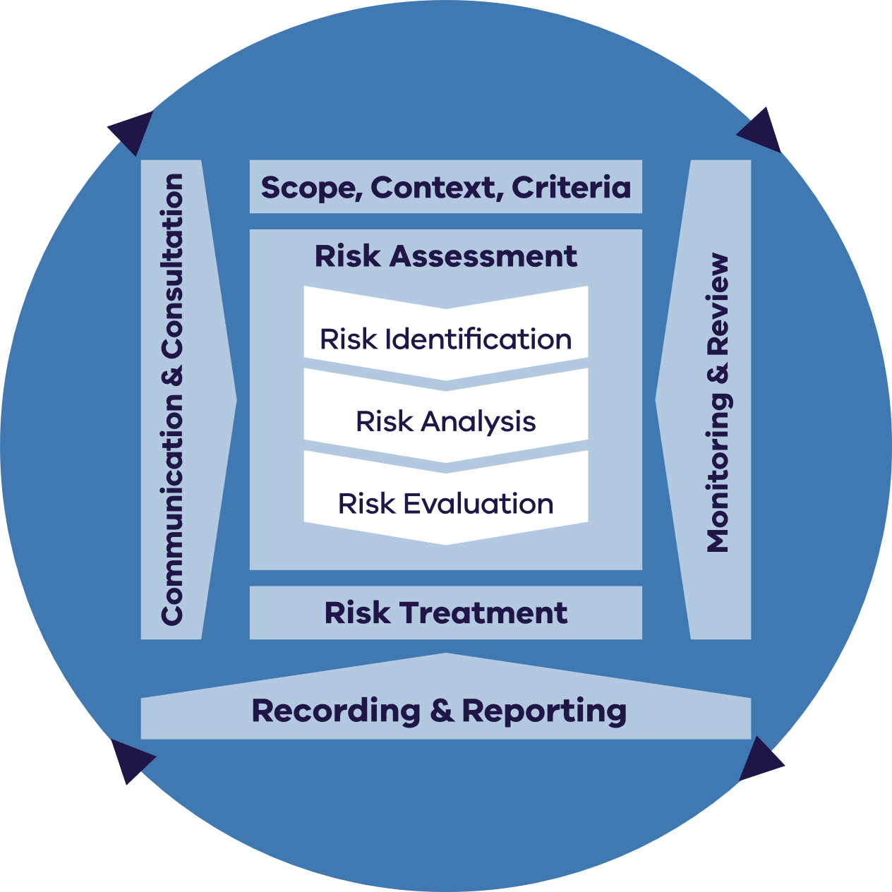

Figure 5 is Reproduced by Department of Energy, Environment and Climate Action (DEECA) in Victoria with the permission of Standards Australia Limited under licence CFL0424DEECAVIC.

Copyright in AS ISO 31000:2018 vests in Standards Australia and ISO. Users must not copy or reuse this work without the permission of Standards Australia or the copyright owner.

**Scope, context, criteria**

Defining the scope, context and risk criteria is a fundamental step in tailoring the risk assessment to meet the unique requirements of the sector. This involves gaining insight into internal and external factors and undertaking consultation with the sector.

**Scope**

The CERCC Plan encompasses significant market-level (macro) risks across all services in the waste, recycling, and resource recovery sector.

**Context**

The circular economy has several objectives, however, achieving them poses multiple competing risk factors. These risk factors fall under various categories:

* Societal risks – natural or man-made hazards and the support of communities and individuals towards the objectives.
* Operational risks – technical and logistical challenges of implementing circular economy solutions, such as a lack of infrastructure, skills and/or standards and/or standards.
* Financial risks – costs and benefits of circular economy investments, such as return on investment, cash flow and/or market demand.
* Reputational risks – perception and expectations of stakeholders, such as customers, suppliers, investor and/or regulators.

Strategic risks – alignment and adaptation of business models and value propositions to the circular economy paradigm, such as innovation, differentiation and/or competitiveness.

**Criteria**

Recycling Victoria's Strategic Plan has set strategic objectives that emphasise the importance of transitioning Victoria to a circular economy and reforming our waste and resource recovery system over the next decade. The 4 strategic objectives focus on:

1. opportunities to ensure a robust circular economy
2. increasing the resilience of the waste and resource recovery system
3. enabling sector investment and growth
4. building system capacity and capability (Figure 6).

Identifying, analysing, and evaluating risks within the context of Recycling Victoria's strategic objectives will help frame the risks, considering the sector's current capabilities, capacity and opportunities for strengthening measures aligned with the transition to greater circularity. Considerations for these 4 strategic objectives were integral to the risk assessment process, as well as the development of measures.

The aim is to assess the risks to Victoria's circular economy stemming from various hazards and exposures. This includes identifying sector vulnerabilities and critical dependencies that can result in significant failures, hindrances or disruptions in waste, recycling or resource recovery services.

Figure 6: Recycling Victoria’s strategic objectives

Recycling Victoria’s 4 strategic objectives are: 
Recovery, Reliability, Economy and Management.

**Risk assessment process**

**Risk identification**

Through this plan, Recycling Victoria is required to identify risks of serious failure, disruption or hindrance to the provision of waste, recycling and resource recovery services and identify financial risks to Victoria's transition to a circular economy and to responsible entities.

Risk identification begins with an initial identification of relevant risks through industry consultation and existing knowledge, such as reports and past events. Building this knowledge base assists in selecting hazards, impacts and risks for consideration in the risk analysis phase.

Identifying the sector's risks requires consideration of natural and manmade hazards, direct and indirect exposures, sector vulnerabilities and system dependencies. Additionally, it involves understanding the sector's capacity to protect itself from significant disruptions in the provision of waste, recycling and resource recovery services and its long-term strategy to transition to a circular economy.

**Risk analysis**

Through this plan, Recycling Victoria is required to outline the likelihood and consequence of each risk that has been identified including the severity of the harm that may result. Risk analysis is a critical step of the risk assessment process and helps develop an understanding of the identified risks. To analyse risk, an understanding of existing controls is necessary, as well as the risk criteria in which the risk will be analysed and evaluated including the likelihood of the risk occurring and the consequences of the risk to the sector.

When analysing risk, it is important to consider the following:

* Likelihood – that is how likely is the event to occur?

Consequence - what impact would it have on people, places and systems?

Likelihood refers to the probability of a risk occurring or the consequences of a risk resulting from an event. Consequence can be defined as the outcome of an event affecting objectives.

When determining the likelihood, a range of factors will need to be considered, including:

* timeframes
* causes that may lead to a risk materialising
* controls that are in place to reduce likelihood

the compounding and cascading events that might play out.

The sector risk assessment uses a likelihood rating and description to determine the probability of a risk, using Table 12 in Appendix 4 and consequence ratings (Table 14 – Table 21 in Appendix 4).

**Risk evaluation**

Once the likelihood and consequence ratings were determined for each risk, they are assessed using a qualitative risk matrix that combines the likelihood and consequence levels to determine the risk level, which ranges from low to high. The purpose of the risk evaluation process determines which risks need to be treated, as well as the priority for treatment based on the outcomes of the risk analysis performed. The risks are categorised as high, significant, medium or low, depending on the likelihood and consequence ratings.

Risks scored in accordance with a risk matrix (**Figure 7**in**Appendix 4**) identified as having a significant or high rating were considered serious risks. These risks are tested through consultation to confirm the risks.

**Risk treatment process**

Risk treatments aim to determine and implement the most effective actions that will prevent or minimise risks.

CERCC Plans will specify suitable measures for responsible entities to take to prevent or minimise risks.

Future measures are developed in recognition of the causes and consequences within the control of the responsible entities and with the serious sector risks, form part of a consultation process. Responsible entities are required to use these measures to develop specific actions in their RERCC Plans.

Treatment takes into consideration the identified institutional and infrastructure risks. The risk treatments focus on bolstering the coping capacity of the Victorian Government and responsible entities to better manage hazards, exposures and vulnerabilities.

Risk treatment options aim to achieve:

* avoiding risk
* removing a risk source
* changing the likelihood of the source of risk or consequence occurring
* sharing the risk

retaining the risk by informed decisions.

**Recording and reporting**

Recycling Victoria will record and report on the risks identified in the CERCC Plan, including their effectiveness at identifying serious risks to sector service continuity and material circularity.

The Minister can direct the Head, Recycling Victoria to prepare a written report on the CERCC Plan under section 74E of the CE Act. The report may include:

* the CERCC Plan’s ongoing suitability
* the effectiveness of measures to prevent or minimise any risks identified
* the compliance of a responsible entity or class of responsible entity with the CERCC Plan
* any actions the Head, Recycling Victoria has carried out or proposes to carry out in response to the report

recommendations that the Head, Recycling Victoria considers appropriate.

**Monitoring and review**

Recycling Victoria has monitored and reviewed CERCC Plan risks as part of risk recording and reporting processes.

The first RERCC Plans, prepared by responsible entities were received by the Head, Recycling Victoria by 30 September 2024. An initial review of RERCC Plans have informed the update to risks, actions proposed to be undertaken and measures required of responsible entities, informed by assessing existing controls.

**Communication and consultation**

Recycling Victoria will continue to communicate and consult on risks identified in the CERCC Plan, through consideration of the inaugural RERCC Plans and their associated statements of assurance, and in review of consultation responses to this draft CERCC Plan.

**Risk assessment and rating references**

**Identifying and assessing existing controls**

The sector risk assessment uses Table 12 to assess the effectiveness of existing controls.

Table 12: Control effectiveness

| Control effectiveness rating | Description |
| --- | --- |
| (1) Good | * Controls are well designed, address the risk and are effective and reliable at all times * Require ongoing maintenance and monitoring * There are multiple controls in place to reduce risk |
| (2) Satisfactory | * Most controls are designed correctly and are in place and effective * Controls address risk at least partially however may require further improvement * Some work needs to be done to improve operating effectiveness or management has doubts about operational effectiveness and reliability of some controls * Consideration should be given to implementing further controls for risks outside of appetite |
| (3) Poor | * There are controls, but they do not effectively address the risk or require significant improvement * Most of the controls do not seem correctly designed and do not operate effectively * Significant control gaps * Additional controls must be developed for all risks outside of appetite |
| (4) Uncontrollable | * There are virtually no credible controls that exist to address the risk * Management has no confidence that any degree of control is being achieved due to poor control design and/or very limited operational effectiveness * Controls must be implemented to address risks outside of appetite |

Assessing likelihood

The sector risk assessment uses Table 13 likelihood rating and description to determine the probability of a risk:

Table 13: Likelihood rating

| Likelihood rating | Description |
| --- | --- |
| 1. Rare | Conceivable but only under extreme circumstances / once in 100 years |
| 1. Unlikely | Hasn’t happened yet but could / once in every 10 years |
| 1. Possible | Could happen or known to happen / once a year |
| 1. Likely | Could easily happen / once a month |
| 1. Almost certain | Occurs often / once a week |

Assessing consequences

The consequences tables (Table 14 to Table 21) provide detailed lists of potential consequences impacting Victoria’s transition to a circular economy. The highest potential impact from each table has been used when assessing the consequence rating. The rating is determined by judgement on the consequence and possible impact of the risk.

Consequences tables

Table 14: Financial consequences

| Level of harm | Financial impact |
| --- | --- |
| (1) Negligible harm | Victorian Government: increased cost / loss up to $0.1M  Responsible entities: increased cost / loss <0.5% of operations |
| (2) Minor harm | Victorian Government: increased cost / loss $0.5M  Responsible entities: increased cost / loss 0.5 – 2 % of operations |
| (3) Moderate harm | Victorian Government: increased cost / loss $5M  Responsible entities: increased cost / loss 2-10% of operations |
| (4) Major harm | Victorian Government: increased cost / loss $10M  Responsible entities: increased cost / loss 10-20% of operations |
| (5) Extreme harm | Victorian Government: increased cost / loss $100M or greater  Responsible entities: increased cost / loss >20% of operations |

Table 15: Environment consequences

| Level of harm | Environment impact |
| --- | --- |
| (1) Negligible harm | * Negligible effect on the natural and/or built environment * Environmental recovery is negligible and/or under 1 year * Contained locally within a single site/area * Negligible effect on the sector's capacity to process recyclable and non-recyclable materials |
| (2) Minor harm | * Limited effect on the natural and/or built environment and/or the environment suffers harm for 1–5 years * Environmental recovery on minor scale up to 5 years * Restricted to single township or locality * Limited effect on the sector's capacity to process recyclable and non- recyclable materials |
| (3) Moderate harm | * Moderate effect on the natural and/or built environment and/or environment suffers harm for 5–10 years * Environmental recovery on a small scale and/or over a period  5-10 years * Impacts on a municipality or several responsible entities * Moderate effect on the sector's capacity to process recyclable and non-recyclable materials |
| (4) Major harm | * Major effect on natural and/or built environment and/or environment suffers harm for 10–20 years * Impacts on a region or multiple responsible entities * Significant increase of recyclable and non-recyclable material in landfill causing major effect on sector capacity |
| (5) Extreme harm | * Very serious effect on natural and/or built environment and/or environment suffers long-term harm (20+ years) * Environmental recovery on a very large scale and/or over 20+ years * Impacts on multiple regions and responsible entities * Very serious effect on the sector's capacity to process recyclable and non-recyclable materials |

Table 16: Cultural heritage consequences

| Level of harm | Cultural heritage impact |
| --- | --- |
| (1) Negligible harm | * Negligible effect on significant heritage or Aboriginal sites/artefacts * Protection of cultural heritage is negligible and/or under 1 year * Contained locally within a single site/area |
| (2) Minor harm | * Limited impact on significant heritage sites/artefacts * Protection on a minor scale up to 5 years * Restricted to single Traditional Owner or site |
| (3) Moderate harm | * Moderate impact on significant heritage or Aboriginal sites/artefacts/ sacred objects * Aboriginal culture/site suffers harm for 5-10 years * Recovery on a small scale and/or over a period of 5-10 years * Impacts on an Aboriginal group or multiple Aboriginal groups |
| (4) Major harm | * Major impact on significant Aboriginal heritage sites/artefacts * Major impact on Aboriginal highly sensitive cultural heritage such as sacred sites, environment and/or traditional food source * Major impact on Aboriginal spiritual, social and cultural connection and cultural values (tangible and/or intangible) with Country * Recovery on a large scale and/or over 10-20 years * Impacts on a region or multiple areas under custodian of many Traditional Owners |
| (5) Extreme harm | * Very serious impact on significant Aboriginal heritage sites/ artefacts/environment, suffers long-term harm (20+ years) * Impacts likely or almost certainly result in highly significant Aboriginal cultural values to be lost, degraded or damaged and notably altered, modified, obscured, or diminished * Recovery on very large scale and /or over a long period (20+ years) * Impacts on state or multiple Traditional Owners custodians of land and water |

Table 17: Workforce consequences

| Level of harm | Workforce impact |
| --- | --- |
| (1) Negligible harm | * On-site first aid treatment required by responsible entity staff, visitor, contractor or member of the public * No staff downtime or turnover * Staff disgruntlement * Lack of consistency in some practices by staff across enterprise |
| (2) Minor harm | * Minor injuries or illness (physical/ mental) requiring medical attention by responsible entity staff, visitor, contractor or member of the public * Responsible entity staff complaints, passively upset, uncooperative * Industrial action that impacts the operations of a non-critical essential waste service * Some responsible entity staff turnover with minor loss of skills, knowledge and expertise |
| (3) Moderate harm | * Significant injury or illness (physical/ mental) requiring in-patient hospitalisation of responsible entity staff, visitor, contractor or member of the public * Low morale, disengagement, increased absenteeism and workplace conflict * Industrial action that impacts the operations of a business unit or critical team * Some responsible entity staff have limited understanding of circular economy * Some turnover of key staff and loss of key skills, knowledge and expertise |
| (4) Major harm | * Significant injury or illness (physical/ mental) requiring in-patient hospitalisation of responsible entity staff, visitor, contractor or member of the public * Low morale, disengagement, increased absenteeism and workplace conflict * Industrial action that impacts the operations of an enterprise disrupting circularity * Many responsible entity staff have limited understanding of circular economy * Considerable turnover of key staff and loss of key skills, knowledge and expertise |
| (5) Extreme harm | * Single or multiple deaths or severe permanent disability or illness (physical/ mental) of staff, visitor, contractor or member of the public * Enterprise-wide morale issues and mass absenteeism * Widespread industrial action impacting responsible entity operations * Most staff are not engaged or have limited understanding of circular economy * Resignations of large numbers of key management staff with a significant loss of skills, knowledge and expertise * Staff are not upskilled to meet responsible entity enterprise goals and targets |

Table 18: Social license to operate consequences

| Level of harm | Social license to operate impact |
| --- | --- |
| (1) Negligible harm | * Very limited public and political interest * Minimal adverse local attention * Complaint from one stakeholder regarding new facilities to support circularity |
| (2) Minor harm | * Adverse localised public and political interest regarding new facilities to support circularity or changes to waste, recycling or resource recovery practices * Limited attention on a single issue in local media regarding circular economy or changes to waste, recycling, or resource recovery practices |
| (3) Moderate harm | * Adverse localised negative public and political attention regarding new facilities to support circularity or changes to waste, recycling or resource recovery practices * Short-term negative local media attention regarding new facilities to support circularity or changes to waste, recycling or resource recovery practices * Local community concern on a single issue over a sustained period regarding new facilities to support circularity or changes to waste, recycling or resource recovery practices |
| (4) Major harm | * Serious adverse public attention at state/national level * Negative state/national media on one or more issues over a prolonged period * Repeated displeasure by the Minister regarding public discourse on circular economy and waste, recycling, or resource recovery * Medium-term negative public interest (correspondence and phone calls) and political interest (in parliament) regarding new facilities to support circularity or changes to waste, recycling or resource recovery practices |
| (5) Extreme harm | * Very serious public outcry at state/national level * Negative state/national media over a prolonged period regarding Victoria's progress to a circular economy * Breakdown of public confidence in the government/department/ Minister regarding Victoria's progress towards a circular economy * Ongoing or prolonged negative public interest (correspondence and phone calls) and political interest (in parliament) |

Table 19: Regulatory consequences

| Level of harm | Regulatory impact |
| --- | --- |
| (1) Negligible harm | * Non-compliance with legislation identified, resulting in government acknowledgement and process review |
| (2) Minor harm | Non-compliance with legislation or breach of duty and obligations as described in section 74ofthe CE Act and either:   * resolved by departmental staff with no further escalation * resulting in prosecution or civil action involving exposure to minor compensation and/or minor negative precedent |
| (3) Moderate harm | Non-compliance with legislation or breach of duty and obligations as described in section 74ofthe CE Act resulting in:   * investigation or report to responsible authority * prosecution or civil action, with one of moderate level of compensation or moderate level of negative precedent |
| (4) Major harm | Non-compliance with legislation or breach of duty and obligations as described in section 74ofthe CE Act resulting in:   * investigation or report to responsible authority public inquiry, such as a royal commission or parliamentary committee * prosecution or civil action with high level compensation and high-level negative precedent * sanctions imposed by external regulator |
| (5) Extreme harm | Non-compliance with legislation or breach of duty and obligations as described in section 74ofthe CE Act resulting in:   * prosecution or civil action leading to imprisonment of an officer * public inquiry such as a royal commission or parliamentary committee * uninsured compensation payments * negative precedent requiring very serious impact and major reform to the department * severe sanctions imposed by external regulator |

Table 20: Service delivery consequences

| Level of harm | Service delivery impact |
| --- | --- |
| (1) Negligible harm | * Insignificant impact on the sector’s delivery of services/ function * No inconvenience to customers/stakeholders/communities * Negligible impact on the sector’s critical activities * Insignificant impact (<5% delays) on transport and logistics |
| (2) Minor harm | * Minor, short-term impact on the sector’s delivery of services/functions * Customers/stakeholders/communities slightly inconvenienced * Less than 1 day’s impact on sector’s critical activities * Minor impact (5-10% delay) on transport and logistics |
| (3) Moderate harm | * Moderate impact on the sector’s delivery of services/ functions * Customers/stakeholders/ communities inconvenienced * Up to 3 days impact on the sector’s critical activities * Significant impact (10-20% delay) on transport and logistics |
| (4) Major harm | * Ongoing difficulties in delivering the sector’s services/functions * May impact on multiple responsible entities and/or regions * Major impact on customers/stakeholders/communities * Up to 10 days’ impact on the sector’s critical activities * Major impact (20-50% delay) on transport and logistics |
| (5) Extreme harm | * Long-term and severe impact on delivery of services/functions * Impacts on multiple responsible entities and/or regions * Severe impact on customers/stakeholders/communities * More than 10 days’ impact on business unit’s critical activities * Vital or very serious delays (>50% delay) to transport and logistics or operation’s objective is not met |

Table 21: Consequences to Recycling Victoria’s strategic objectives

| Level of harm | Recycling Victoria impact |
| --- | --- |
| (1) Negligible harm | * Delivery of core function is unaffected, or impacts are immaterial * Insignificant impact on the sector's ability to grow and innovate |
| (2) Minor harm | * Limited reduction in delivery of core functions * Limited impact on the sector's ability to grow and innovate |
| (3) Moderate harm | * Significant reduction in the delivery of core functions * Divert some available Recycling Victoria’s resources to deliver core functions or seek external assistance to deliver some of its functions * Moderate impact on the sector's ability to grow and innovate |
| (4) Major harm | * Severe reduction in the delivery of core functions * Divert a significant amount of Recycling Victoria’s available resources to deliver core functions or seek external assistance to deliver the majority of its core functions * Significant impact on the sector's ability to grow and innovate. * Limited or inadequate redundancies in place to maintain circularity |
| (5) Extreme harm | * Unable to deliver core functions * Severe impacts on the sector's ability to grow and innovate * No redundancies in place to maintain circularity |

**Risk evaluation**

Once the likelihood and consequence ratings are determined for each risk, the risk is given an overall rating using the following risk matrix (**Figure 7**). The qualitative risk matrix combines the likelihood and consequence levels to determine the risk level, which ranges from low to high.

Figure 7: Risk matrix table

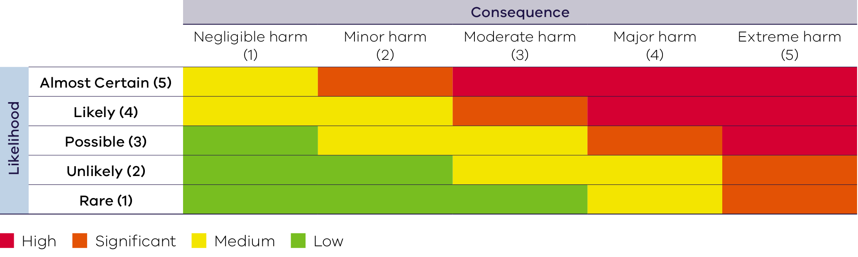

**Risk treatment**

Table 22 provides detail on the appropriate management response and activities for each level of risk.

Table 22: Risk treatments

| Level of Risk | Treatment and level of reporting requirement |
| --- | --- |
| **HIGH** | * Falls outside risk appetite * Accountability and responsibility to be managed by Recycling Victoria and/or the responsible entity * A risk treatment plan must be established and implemented by Recycling Victoria and/or the responsible entity * To be managed to a level that is as low as reasonably practicable based on resource, cost and practicality * Active monitoring of risk and risk treatments * Risk must be integrated with corporate and/or business planning * Reporting must be provided from responsible entities to Recycling Victoria |
| **SIGNIFICANT** | * May fall outside risk appetite * Accountability and responsibility to be managed by Recycling Victoria and/or the responsibly entity * A risk treatment plan must be established and implemented * Should be managed to a level that is as low as reasonably practicable based on resource, cost and practicality * Regular monitoring of risk and risk treatments * Risk must be integrated with corporate and/or business planning * Responsible entities to report risks to Recycling Victoria |
| **MEDIUM** | * Falls within risk appetite * Accountability and responsibility to be managed by Recycling Victoria and/or the responsible entity * May be managed or accepted without further treatment, provided the risk is appropriately monitored at least every 6 months, with re-evaluation undertaken based on factors that may increase consequence or likelihood * Risk should be integrated with corporate and/or business planning * Risk owner to monitor the risk at least every 6 months |
| **LOW** | * Falls well within risk appetite * Accountability to be managed by the appropriate risk owner * May be reviewed to assess whether the risk is being over controlled, and whether some reduction inactive controls may be considered * Risk owner to monitor the risk at an appropriate frequency |

# Publication information

## Acknowledgements

We acknowledge and respect Victorian Traditional Owners as the original custodians of Victoria’s land and waters, their unique ability to care for Country and deep spiritual connection to it.

We honour Elders past and present whose knowledge and wisdom has ensured the continuation of culture and traditional practices.

DEECA is committed to genuinely partnering with Victorian Traditional Owners and Victoria’s Aboriginal community to progress their aspirations.

## Copyright

© The State of Victoria Department of Energy, Environment and Climate Action, May 2025.

## Creative Commons

This work is licensed under a Creative Commons Attribution 4.0 International licence, visit the [Creative Commons website](http://creativecommons.org/licenses/by/4.0/) (<http://creativecommons.org/licenses/by/4.0/>).

You are free to re-use the work under that licence, on the condition that you credit the State of Victoria as author. The licence does not apply to any images, photographs or branding, including the Victorian Coat of Arms, and the Victorian Government and Department logos.

ISBN 978-1-76136-678-9 (pdf)

## Disclaimer

This publication may be of assistance to you but the State of Victoria and its employees do not guarantee that the publication is without flaw of any kind or is wholly appropriate for your particular purposes and therefore disclaims all liability for any error, loss or other consequence which may arise from you relying on any information in this publication.

## Accessibility

To receive this document in an alternative format, phone the Customer Service Centre on 136 186, email [customer.service@delwp.vic.gov.au](mailto:customer.service@delwp.vic.gov.au), or contact National Relay Service on 133 677. Available at DEECA website ([www.deeca.vic.gov.au](http://www.deeca.vic.gov.au/)).

**End of document.**

1. DELWP (2020), Recycling Victoria [A new economy](https://www.vic.gov.au/sites/default/files/2020-03/02032020%20Circular%20Economy%20Policy%20-%20Final%20policy%20-%20Word%20Accessible%20version%20.pdf) February 2020
2. DELWP (2020), Recycling Victoria A new economy February 2020
3. Recycling Victoria (2023), [Strategic Plan 2023 – 2026](https://www.vic.gov.au/strategic-plan-2023-2026)
4. Australian Council of Recycling (2023), [A Burning Issue: Navigating the battery crisis in Australia's recycling sector](https://acor.org.au/wp-content/uploads/2024/02/231219-ACOR-Battery-Crisis-Issues-Paper-final.pdf)
5. Australian Council of Recycling (2024), [Industry survey: Battery fires in waste & recycling June 2024](https://acor.org.au/wp-content/uploads/2024/06/240603-ACOR-battery-fire-survey-summary.pdf)
6. Asbestos and Silica Safety and Eradication Agency (2024), Asbestos in mulch
7. The World Economic Forum (2024), [Global Risks Report 2024 19th Edition Insight Report](https://www.weforum.org/publications/global-risks-report-2024/)
8. The World Economic Forum (2023), [The Global Risks Report 2023 18th Edition Insight Report](https://www.weforum.org/publications/global-risks-report-2023/)
9. The World Economic Forum (2024), [The Global Risks Report 2024 19th Edition Insight Report](https://www.weforum.org/publications/global-risks-report-2024/)
10. Drova (2024), [Operational Resilience Outlook](https://www.drova.com/operational-resilience-outlook)
11. DCCEEW (2022), National Waste Policy Action Plan
12. DCCEEW (2024), [National standard for waste and resource recovery data and reporting – second edition](https://www.dcceew.gov.au/environment/protection/waste/publications/national-standard-waste-resource-recovery-data-reporting-second-edition)
13. DCCEEW (2024), [Capability needs survey for industry on recycled content traceability](https://www.dcceew.gov.au/environment/protection/waste/recycled-content-traceability)
14. Recycling Victoria (2024), [Victorian Recycling Infrastructure Plan](https://www.vic.gov.au/victorian-recycling-infrastructure-plan) p.24
15. Recycling Victoria (2024), [Victorian Recycling Infrastructure Plan](https://www.vic.gov.au/victorian-recycling-infrastructure-plan) p.25
16. DEECA (2023), [Victorian Greenhouse gas emissions](https://www.climatechange.vic.gov.au/victorias-greenhouse-gas-emissions-and-targets)
17. DELWP (2018), [Management and storage of combustible recyclable and waste material (CRWM): Policy impact assessment](https://www.vic.gov.au/sites/default/files/2019-10/Combustible-Recyclable-and-Waste-Material-PIA-PDF.pdf)
18. Recycling Victoria (2024), [Victorian Recycling Infrastructure Plan](https://www.vic.gov.au/victorian-recycling-infrastructure-plan)
19. EPA (2024), [EPA response to potential asbestos in mulch in parks](https://www.epa.vic.gov.au/for-community/incidents/response-to-potential-asbestos)
20. Recycling Victoria (2023), [Regulatory Strategy 2023 – 2026](https://www.vic.gov.au/regulatory-strategy-july-2023-june-2026)
21. International Organization for Standardization (2018), ISO 31000:2018 Risk Management Guidelines