Focus species

Murray-Darling carpet python​

Figure 1: An illustration of a Murray-Darling carpet python

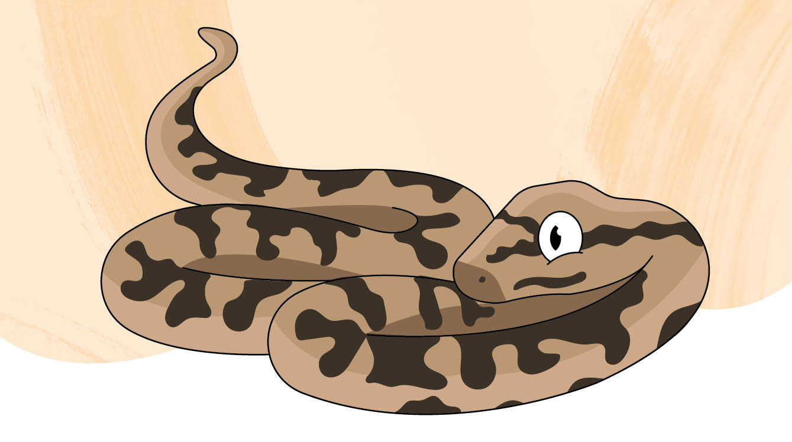

**Scientific name:** *Morelia spilota metcalfei*

**Conservation status:** Endangered

**Average life span:** 15 to 20 years

**Range/distribution:** Northern Victoria

**Habitat:** Tree hollows and rock crevices along rivers and streams

**Classification:** Semi-arboreal reptile

# Who am I?

am one of Victoria’s two python species. I’m mostly silver with solid black blotches and stripes, but the colour of my scales can vary a lot. I can grow up to three-metres-long, or about as long as a car! I’m non-venomous but my bite can still be painful if I’m startled.

I live in rock crevices on the ground and up high in tree hollows, waiting for my meals to come to me. I like to eat rodents, frogs, lizards, and birds. Over winter, I can sleep for up to five months until the weather warms up again.

We breed every 3-4 years, and females will lay 20-50 eggs. I’m the only Victorian snake that guards its eggs, coiling around them to keep them warm until they hatch after 50-60 days. I’m endangered in Victoria, so every new hatchling counts!

Carpet pythons are also bred for people to keep as pets with a wildlife licence, but they are different to the ones you might see in the wild.

# How can you help me?

If I happen to slither past you in the wild, you can look but don’t touch me! It’s safer for both of us when you leave me alone.

It’s not okay to take me or any other wildlife home from the wild. So, if you’re thinking of getting a pet python, you’ll need to get it from a licenced source, and have the right licence. And remember, you can never release your pet python into the wild as they could spread diseases to wild snakes!

**Keep wildlife wild, observe don’t disturb.**

# Complete the crossword puzzle

Can you solve the clues and fill in the grid?

Figure 2: A crossword puzzle grid

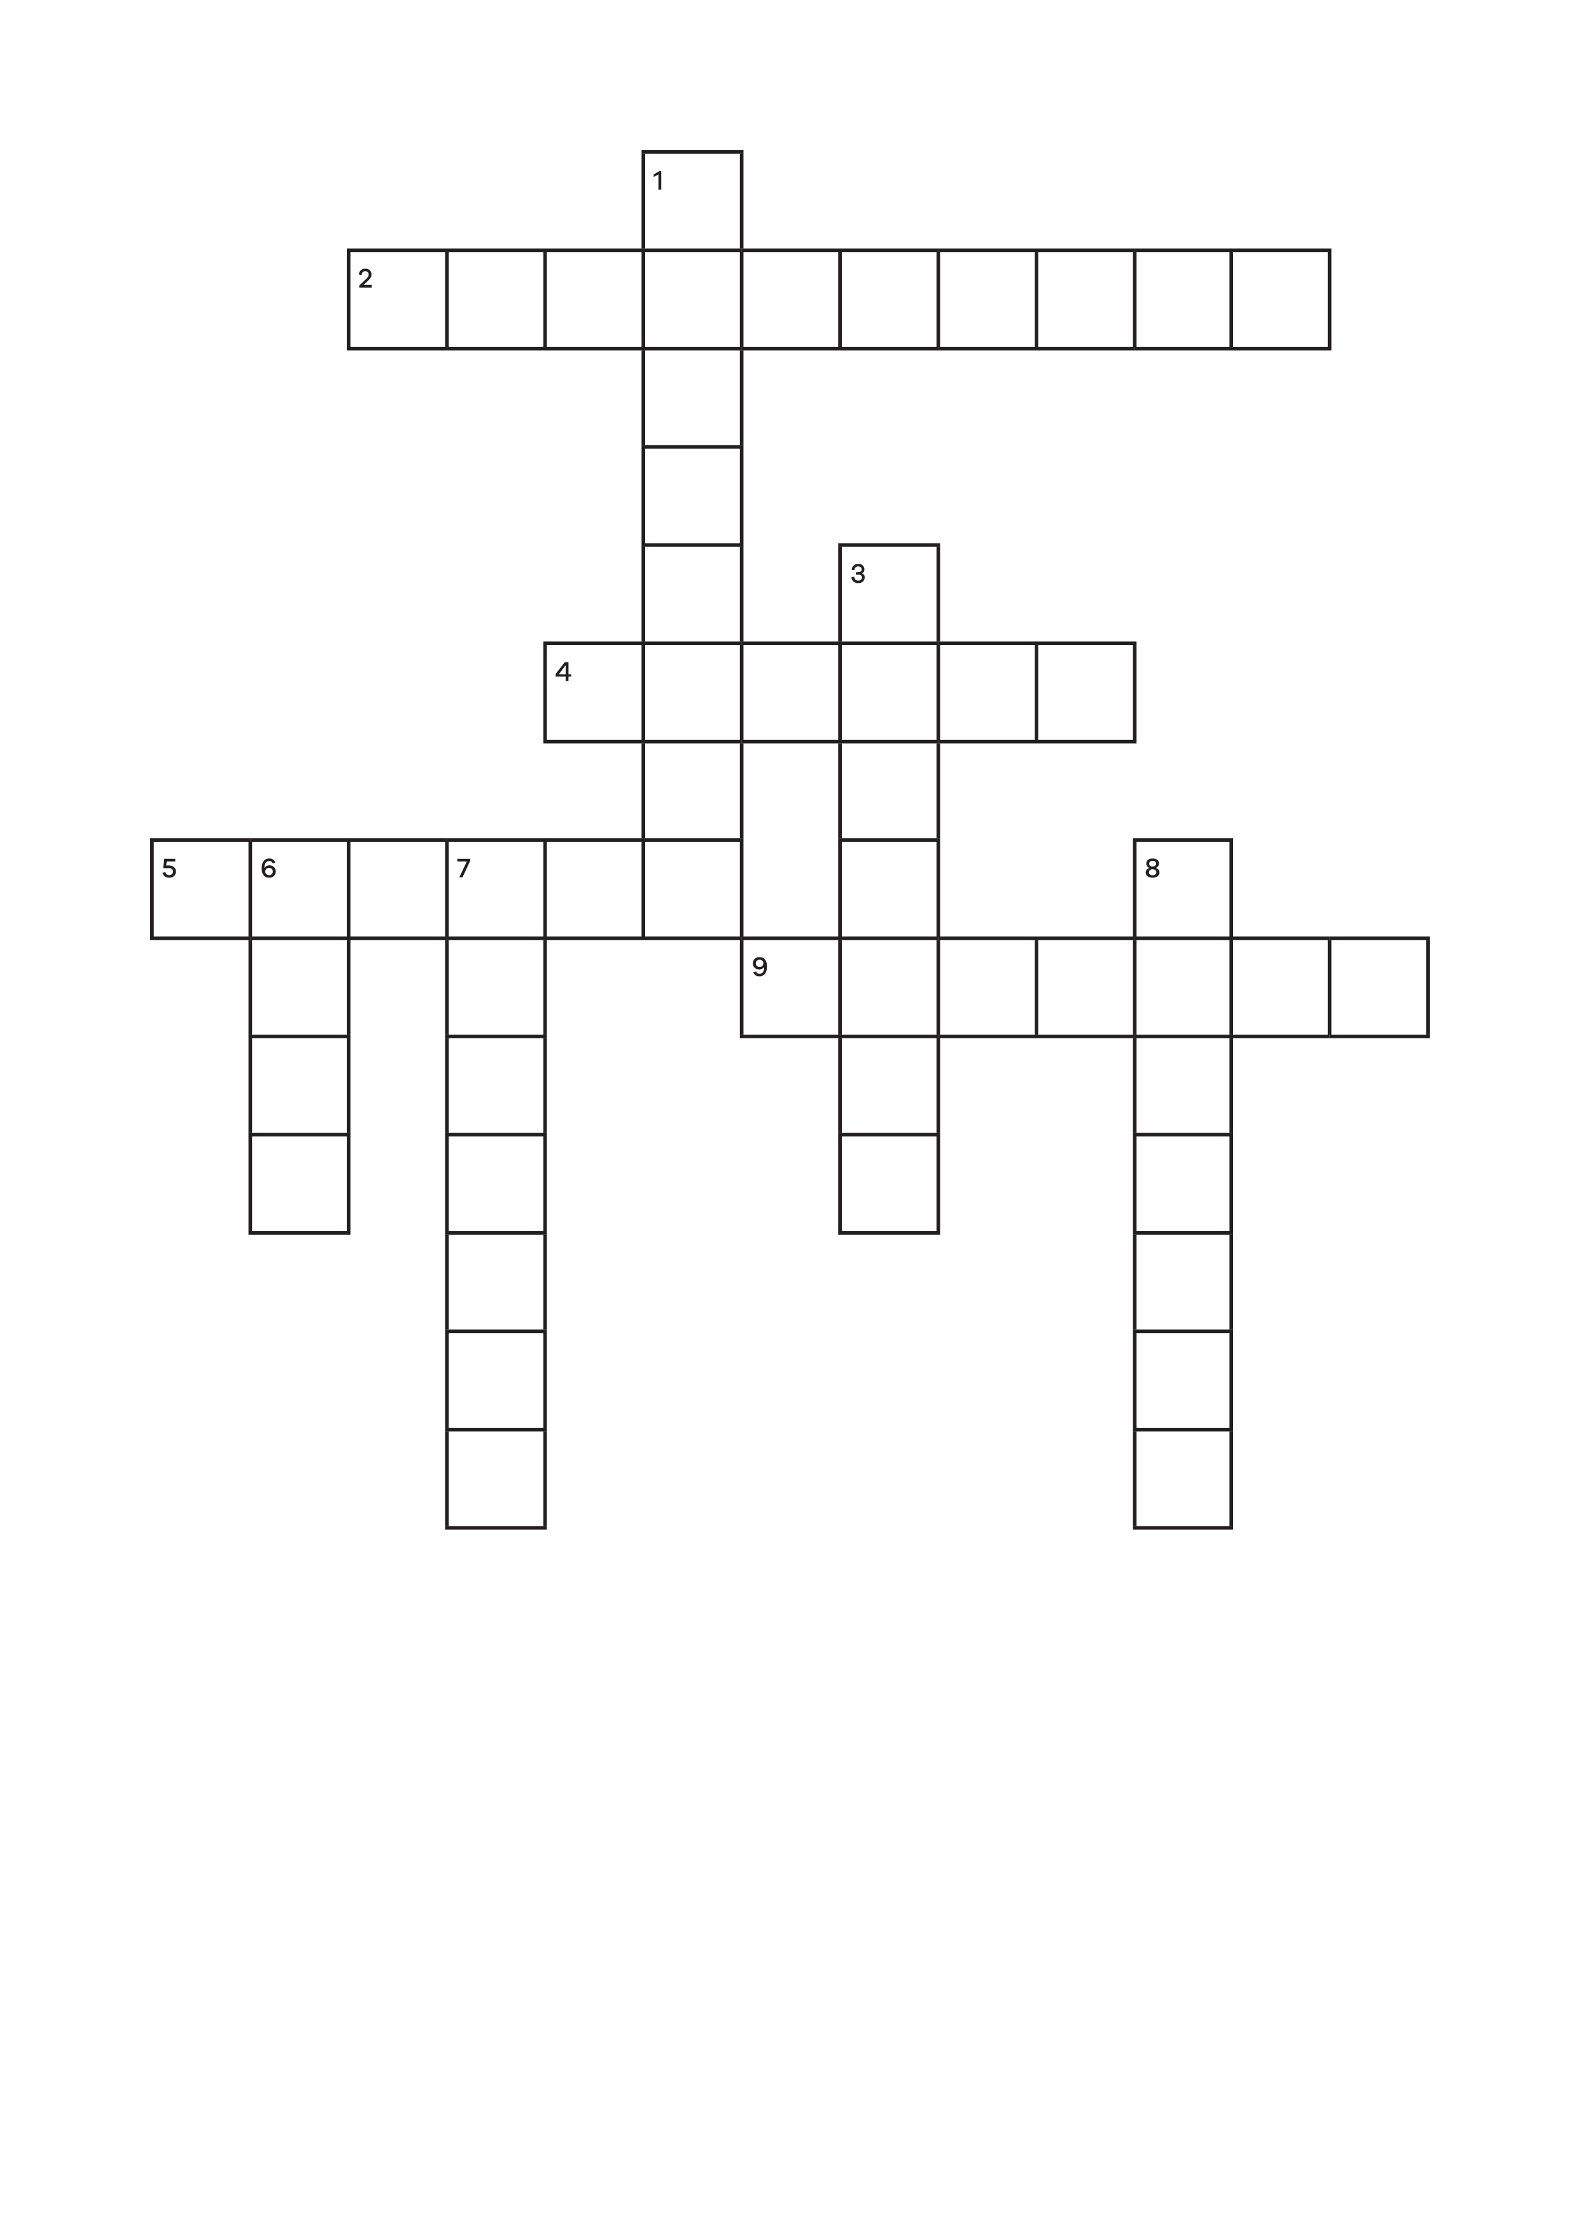

## Down:

**1.** While it can be painful, the python’s bite is non- _________?

**3.** Murray-Darling carpet pythons belong to what class of animals?

**6.** Female pythons_________around their eggs to keep them warm.

**7.** Something needed to keep a python as a pet.

**8.** The natural home of the python, like tree hollows along rivers.

## Across:

**2.** Morelia spiolta metcalfei is what type of name for the Murray-Darling carpet python?

**4.** A type of small mammal pythons eat.

**5.** The colour of these can vary a lot on the Murray-Darling carpet python.

**9.** Pet snakes can spread __________ to wild snakes if released.

# Is this true or false? Circle your answer.

Murray-Darling carpet pythons should never be taken from the wild, and you need a license to keep a python as a pet.

**True** or **False**

Hint! The answer to true or false is on the first page and crossword answers are below.

**Crossword answers:**

**DOWN**

1. venomous

3. reptile

6. coil

7. licence

8. habitat **ACROSS**

2. scientific

4. rodent

5. scales

9. disease

Conservation Regulator Focus Species have been selected to raise awareness about the small changes people can make to protect wildlife in the wild and in captivity.

Find out more at [conservationregulator.vic.gov.au](http://conservationregulator.vic.gov.au/)

**End of document.**