Network Development Plan – Metropolitan Rail
Overview
December 2012

Table of Contents
Overview 6
Giving Melburnians the train services they want and need 12
1. Context 13
2. Developing a metro-style system for Melbourne 17
3. Stage 1 – Overcoming constraints: now until 2016 24
4. Stage 2 – Commencing the introduction of a metro-style system: within 10 years 25
5. Stage 3 – Extending the network: within 15 years 28
6. Stage 4 – Preparing for further growth 31
8. Funding 34

This report is a summary of a more detailed rail plan which is available on Public Transport Victoria’s website. The report draws on a detailed patronage modelling report, which is also available online. A number of independent rail feasibility studies and supporting technical reports investigating rail links to Rowville, Melbourne Airport and Doncaster have also been released and are available online.

Network Development Plan – Metropolitan Rail
Public Transport Victoria letter of presentation to the Minister for Public Transport

The Hon Terry Mulder
Minister for Public Transport
Minister for Roads

Dear Minister,
I am pleased to present the attached Network Development Plan – Metropolitan Rail.
Consistent with the objectives of its formation in April this year, Public Transport Victoria (PTV) has completed a detailed examination of how Melbourne’s train system needs to evolve to meet the needs of the city and of train passengers in the short, medium and long-term.
PTV has examined how travel needs are likely to change as Melbourne grows and how the demand for train travel will evolve. We have examined alternative ways of expanding the network to meet these needs and identified the most cost-effective way forward.
This plan is intended to inform government in its process of policy formulation and PTV recognises that government will set its priorities accordingly.
We have been mindful of government policy priorities and cognisant of the fact that delivery of this plan is dependent on the ability of the Victorian and Australian governments to fund a program of rail projects. All projects in this plan will be subject to rigorous and detailed testing according to normal government requirements including an analysis of the costs and benefits of each project.
The plan is designed to:
- expand the capacity of the existing network to meet the growing needs of the city;
- re-design train services to maximise opportunities for seamless coordination with buses and trams; and
- extend the network to areas currently not served by metropolitan rail.
I believe that this plan represents the most comprehensive strategy for Melbourne’s rail system in 40 years and is intended to maintain and enhance Melbourne’s reputation as one of the world’s most liveable cities. PTV will continually update the plan as market conditions change.

Ian Dobbs
Chief Executive Officer
Public Transport Victoria
18 December 2012

Overview
Patronage on Melbourne’s trains has grown at unprecedented rates over the last decade and continuing strong growth is forecast in the years ahead. Major investments have already been made in response to these growth pressures and further projects are being delivered. However, significant challenges remain if the rail network is to meet the current and future travel needs of a rapidly growing city.
Population growth, road congestion, petrol price rises and greater environmental awareness have all contributed to more Melburnians using public transport. There has been an unprecedented 70 per cent growth in train patronage in the last decade and 40 per cent in the last five years alone, which has stretched the capacity of the current network.
Detailed transport modelling undertaken by PTV underlines the challenge ahead: annual patronage across train, tram and bus services is forecast to hit one billion trips by 2031. On trains alone, average weekday boardings will more than double to 1.7 million passengers per day by 2031.
This plan is built upon the aforesaid transport demand modelling and is a ‘bottom-up’, suburb-bysuburb, line-by-line, demand-led strategy for planning Melbourne’s rail system over the next two to three decades. Concept timetables have been built for each stage of this plan.
The Network Development Plan – Metropolitan Rail establishes a firm basis for expanding the capacity of Melbourne’s rail network over the next 20 years and beyond. The key strategic objectives of the plan are:
- To expand the capacity of the existing network to meet the growing needs of the city
- To redesign train services to maximise opportunities for seamless coordination with buses and trains
- To extend the network to serve new growth areas.
The plan unfolds in four stages over 20 years and beyond:
1. Overcome existing network constraints and provide a strong foundation for further expansion of capacity in the future. Addressing current constraints will give passengers more frequent, reliable and convenient services, as well as maximising the use of existing infrastructure and providing the basis for future growth.
2. Introduce a metro-style train system for Melbourne. Moving to a metro-style operation will provide more high capacity, high frequency services, allowing passengers to ‘turn up and go’.
3. Extend the network into growth areas and existing areas without good access to rail services. New lines and the electrification of existing lines will support Melbourne’s high growth areas and places currently not served by the rail network.
4. Prepare for further growth and protect future options. As the city continues to grow and travel needs change, future options for the metropolitan rail network will be investigated, planned and protected.
The approach and initiatives in this plan will increase peak-hour capacity by 50 per cent within 10 years, and by more than 100 per cent within 20 years.
A central focus of the plan is to regularly overhaul and simplify timetables and train operations, getting every extra service possible out of the existing system at zero or low cost, before turning to more costly infrastructure solutions.
The rail network’s 100-year-old signalling system will be gradually replaced with new high capacity signalling to allow more trains to run on the network, and Melbourne will shift to new, high capacity trains that can carry up to 1100 passengers, with the capability to be further lengthened to carry up to 1600 passengers.
Major city shaping rail projects such as Regional Rail Link (fully funded, to be completed in 2016) and the Melbourne Metro rail tunnel form the cornerstone of major capacity upgrades within the next decade.
The plan also proposes a program of track duplications and electrification projects, major rail extensions, and important supporting works such as new stabling and maintenance facilities.
A new approach to modal coordination will improve the consistency and frequency of those services with high demand, better match the timing of services to the travel needs of passengers and make changing between travel modes easier and more convenient.
Just as importantly, the plan is built around a fundamental shift in timetabling and train operations as Melbourne moves to a modern metro-style network common in major cities around the world – essentially a ‘turn up and go’ service across the network every day of the week.
The plan sets out a staged approach to strengthening and securing Melbourne’s rail network:

Stage 1 – Overcoming constraints

Now to completion of Regional Rail Link in 2016
The first stage, to be in place by 2016, focuses on overcoming immediate critical network constraints and providing the foundation for the future expansion of capacity. Stage 1 includes the following major changes:

Key projects
- Regional Rail Link (RRL), including Tarneit and Wyndham Vale stations, Southern Cross platforms 15/16
- Seven new trains and associated stabling and power upgrades
- Hurstbridge line upgrade and Eltham stabling
- An initial order for up to 33 new high capacity trains, each capable of initially carrying up to 1100 passengers and capable of being extended up to 220 metres in length
- 40 new V/Locity carriages
- Williams Landing Station
- Grovedale Station
- Southland Station
- High capacity signalling trial on Sandringham line.

Supporting works and operational changes
- Further timetable changes to maximise use of existing infrastructure
- Calder Park stabling
- Geelong stabling upgrade
- Ballarat maintenance upgrade
- Network operational changes (loop access)
- Restrict train stabling moves at peak times
- Changes to crew changeover arrangements
- Train interior modifications.
At the completion of this stage, V/Line operations will have been largely separated from metropolitan train operations, which is a major step toward segregated operations. This will allow a substantial uplift in capacity and reliability across most of the suburban and regional train services running through Melbourne’s west and north.

Stage 2 – Commencing the introduction of a metro-style system: within 10 years
The second stage will commence the introduction of a metro-style system to Melbourne’s rail network.
This stage includes:

Key projects
- The Melbourne Metro rail tunnel project, a nine-kilometre rail tunnel between South Kensington and South Yarra via the CBD and five new inner-city stations
- Duplication of the rail line to Melton
- Dandenong Rail Corridor Upgrade
- Deliver initial order of up to 33 high capacity trains, order and deliver a further 70 trains
- Installation of high capacity signalling on the Sandringham, South Morang and Hurstbridge lines and between Sunbury and South Yarra.

Supporting works and operational changes
- Carry out associated maintenance, stabling and power upgrades for high capacity trains, including at Pakenham East
- Major changes to timetables to adopt metro-style operations
- Werribee signalling upgrade
- Essendon turnback
- Brighton Beach turnback
- Upfield second platform
- Clifton Hill junction changes
- Heidelberg to Rosanna duplication
- North Melbourne stabling
- Lilydale stabling
- Toolern station
- Burnley junction changes
- Black Forest Road Station.
At this stage, the Melbourne Metro rail tunnel project will have allowed all rail corridors to be segregated from one another, except in locations where there is the need to move trains to and from maintenance facilities. There will be a further major uplift in capacity on all key growth area lines, including the South Morang corridor, and improved reliability across the network.

Stage 3 – Extending the network: within 15 years
The third stage will focus on extending the metropolitan rail network to growth areas and existing areas not serviced by metropolitan rail, utilising the core capacity created in Stages 1 and 2.
This stage includes:

Key projects
- A new line to Melbourne Airport
- A new line to Rowville
- South Morang services diverted into a new tunnel between Clifton Hill and Southern Cross, allowing construction of a new line to Doncaster
- Electrification to Melton
- Order and deliver extra high capacity trains
- High capacity signalling (Northern and Cross-City groups)
- Continuation of Dandenong Rail Corridor Upgrade.

Supporting works and operational changes
- Reinstatement of the Somerton to Upfield link
- Duplication from Dandenong to Cranbourne
- Baxter electification and maintenance facility
- Duplication from Greensborough to Eltham
- Truganina Station
- Sayers Road Station
- Davis Road Station
- Retirement of all remaining Comeng trains.

Stage 4 – Preparing for future growth: within 20 years
The fourth stage will capitalise on the benefits already delivered and prepare for more growth.
This stage includes:
- Order and deliver extra high capacity trains
- Reconfiguration of the City Loop to provide seven separate, independently operated lines through the Melbourne CBD
- Quadruplication of the line between Burnley and Camberwell
- Duplication from Altona Junction to Seaholme and grade separation of Altona Junction
- Electrification projects to Geelong and Wallan
- Extension to Mernda and new stabling facilities
- Duplication from Mooroolbark to Lilydale and new stabling
- Extension from Werribee to Wyndham Vale
- Extension of South Morang – Southern Cross Line to Fishermans Bend.

Long Term
The plan also anticipates the need for capacity expansion in subsequent decades, based on the current best understanding of growth needs. The focus of further planning is to protect potential options that could form part of the long term vision for Melbourne’s rail network.

Funding
Critical to the delivery of this plan is the availability of funding for the identified initiatives. The plan also contains a range of low-cost operational improvements that can generate capacity while business case and development work continues for major projects that will require significant investment.
Major projects such as RRL and Melbourne Metro are either fully funded or have significant planning money allocated to them to enable early construction.
Detailed planning work will continue to allow major rail projects such as Rowville, Doncaster and Melbourne Airport to begin as soon as necessary key infrastructure and supporting works are in place and as funding becomes available. While a rail link to Avalon Airport is not part of the metropolitan network at this time, and not considered as part of this plan, the Victorian Government is committed to protecting a reservation and is currently undertaking planning and design for construction of a rail link to commence within the next five years.
The ability to deliver these projects will depend on funding from Commonwealth and State governments, which may include new funding models currently being examined by Infrastructure Australia and the Council of Australian Governments (COAG).
PTV will continue to work with both State and Commonwealth governments to provide sound business cases for the implementation of these projects.

Giving Melburnians the train services they want and need
For many Melburnians, the city’s train network is an important part of their daily lives, using it to commute to and from work in the central city and beyond. An increasing number of Melburnians use the network on the weekends, travelling to sporting and other events or visiting family and friends.
The changes and projects being delivered through the plan are strongly passenger-focused and aim to deliver positive and lasting benefits to Melburnians as they move around the city for education, work, business and leisure. Over the course of the plan, passengers will see significant improvements in the rail network, including:
- A high quality rail network across the city that provides more frequent, more comfortable, highly punctual and reliable services
- More peak hour services
- Easier and more convenient changing between trains and other modes of transport
- More travel choices that meet people’s transport requirements
- Better access to jobs, education, services and other activities for residents in the city’s fastest growing areas.
More broadly, the implementation of the plan will help to relieve congestion on Melbourne’s roads by encouraging more people to use public transport.
More efficient trains services will contribute to improved business productivity and help to boost Melbourne’s reputation as a growing centre for knowledge-based businesses and as an attractive city in which to invest.
The plan will also benefit Victorians travelling to Melbourne from regional areas by train, improving service reliability and travel times from regional centres such as Geelong, Ballarat and Bendigo.
Figure 1 – Planned Service Levels on the Metropolitan Network
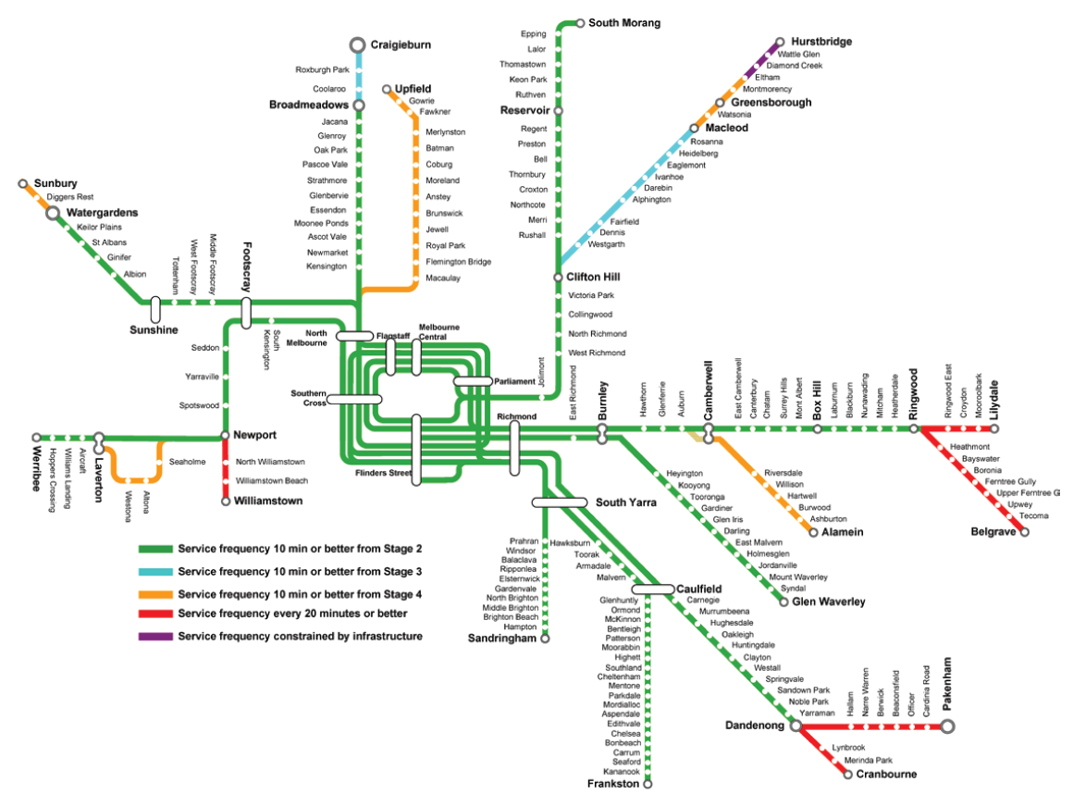

1. Context
Our growing city Patronage on Melbourne’s trains has grown at unprecedented rates over the last decade and strong growth is anticipated in the years ahead. Population growth, road congestion, petrol price rises and greater environmental awareness are all factors that have contributed to more Melburnians making the shift to public transport.
Major investments have already been made in response to these growth pressures and further projects are being delivered. However, significant challenges still lie ahead if Melbourne’s rail network is to meet the future travel needs of a rapidly growing city.
Most of Melbourne’s population growth is projected to occur in the north, west and south-east of the city, with population in Melbourne’s west expected to nearly double by 2030. At the same time, employment is expected to grow significantly in the CBD and inner south-east areas, increasing the need for travel to and through inner Melbourne.
Employment in the City of Melbourne has risen from an estimated 210,000 in the early 1990s to a current 475,000, providing the base for rapidly growing knowledge-based industries that have underpinned Victoria’s economic growth in recent years. Employment in the City of Melbourne is projected to reach between 800,000 and 1.2 million in the next 40 years.
The rate of growth in patronage on the rail network has been unprecedented in Melbourne and among the highest in the world. Growth of 70 per cent in train patronage in the last decade has resulted in rail demand rapidly approaching the capacity of the current network.
After a steady decline in punctuality through most of the past decade, new timetables and operational changes in the past 12 months have led to a sustained improvement. Train operator Metro’s recent punctuality is the best in many years.

Future growth in rail patronage
Detailed modelling undertaken by PTV shows that overall public transport boardings are expected to increase strongly in the years ahead. The modelling for metropolitan public transport for the 20 years from 2010-11 to 2031 demonstrates that:
- Weekday patronage across all trains, trams and buses will more than double from 1.8 million to 3.8 million boardings
- Annual patronage across all trains, trams and buses is forecast to grow from 517 million to more than one billion boardings
- On metropolitan rail, average weekday boardings are expected to more than double to 1.7 million
- The annual average growth rate in weekday rail boardings is forecast to be around four per cent per annum – an increase of more than 850,000 boardings per day between 2011 and 2031.
Patronage growth is likely to be strongest along those corridors that serve Melbourne’s key growth areas, which include the Werribee, Watergardens/Sunbury, Craigieburn, Upfield, South Morang and Dandenong lines. There is a pressing need to plan for significant improvements to capacity in these corridors, while strengthening the network as a whole to meet the overall growth in demand.

Investment in Melbourne’s rail network over the past 30 years
The first line in Melbourne’s rail network was built in 1854 and much of the existing network was developed over the following 80 years. Melbourne’s metropolitan rail network is large by world standards with 830 kilometres of track and 217 stations.
The last piece of major rail infrastructure constructed in the inner core of the rail network was the City Loop, which opened in the early 1980s and was built to relieve excessive crowding at Flinders Street by providing additional access points to the Central Business District (CBD). The City Loop comprises four tunnels known as the Caulfield, Burnley, Northern and Clifton Hill Underground Loops.
Other projects in the last decade have extended the metropolitan rail network from St Albans to Sydenham, Broadmeadows to Craigieburn and Epping to South Morang. Metropolitan services were extended from Watergardens to Sunbury in November 2012.
Regional Rail Link (RRL) is under construction and will be operational by 2016. RRL will provide double tracks and supporting infrastructure between West Werribee and Southern Cross. This will allow for the separation of Geelong, Ballarat and Bendigo regional services (except Sunshine to Sunbury) from metropolitan services on the Werribee, Williamstown, Sunbury, Craigieburn and Upfield lines.
New stations at Lynbrook and Cardinia Road in Melbourne’s growth areas opened in April 2012 and the new Williams Landing Station will be opened in April 2013.
New track infrastructure has been progressively introduced to untangle bottlenecks at the Clifton Hill junction, Westall and Laverton.
Additional stabling has been added to the network at Newport, Upfield and Craigieburn to support the delivery of Melbourne’s 45 new trains, which started coming into service in 2010. Further stabling at Calder Park is planned for construction in 2013.
May 2011 marked the first major overhaul of timetables in Melbourne for more than 20 years, improving capacity and reliability on a number of lines. This is the first stage in a planned roll-out of ‘back to basics’ timetable upgrades from 2012 to 2015 that will simplify the operations of the network and ensure as many services can be added ahead of the completion of major construction projects.

Our current network
Melbourne’s rail system is a relatively complex legacy network that caters for many different types of services. Metropolitan trains run on 16 lines via the City Loop or direct to Flinders Street – some express, some semi-express, some stopping all stations. Regional trains terminate at Southern Cross and run largely express through the metropolitan area. In addition, broad gauge freight trains share tracks with passenger trains on some occasions and standard gauge freight and passenger trains share rail reserves at times.
While most lines comprise double tracks for the majority of their length, which allows two-way operations, sections of single track exist on the Werribee (via Altona), Upfield, Hurstbridge, Lilydale, Belgrave, Alamein and Cranbourne lines, limiting capacity and affecting reliability.
Melbourne’s rail network was designed as a ‘hub and spoke’ commuter-style network, carrying people to and from the central city with connecting branches and junctions.
The 16 lines are managed in ‘groups’, which comprise two to four lines that merge at particular junctions and share sections of track and platforms at inner-city stations.
The metropolitan lines are grouped as follows:
- Clifton Hill Group – South Morang and Hurstbridge lines
- Dandenong Group – Pakenham and Cranbourne lines
- Northern Group – Craigieburn, Sunbury and Upfield lines
- Cross-City Group – Werribee, Williamstown, Frankston and Sandringham lines
- Burnley Group – Alamein, Belgrave, Lilydale and Glen Waverley lines.
Management of the different rail lines in their respective groups is complex, especially during the peak periods. Services follow a number of different stopping and express patterns, which reduces the network’s capacity to run more trains.
This is a particular challenge when tracks are shared by metropolitan and regional services, as regional trains generally run express through the metropolitan area and can be delayed by late-running metropolitan stopping trains. This also creates gaps in the metropolitan timetable as express paths must be allowed for regional services, leading to greater overcrowding and unreliability.
Ultimately, the current network configuration and style of operations will severely constrain the ability to add more services and extend the network to growth areas.

Constraints
The capacity of Melbourne’s metropolitan rail network is currently limited by a number of operational and infrastructure constraints, as demonstrated in Figure 1. This diagram highlights sections of the network where extra capacity cannot be added due to:
- Signalling constraints
- At-grade junction constraints where two or more lines merge or intersect with each other
- Interaction between regional and metropolitan trains on shared tracks
- Sections of single track
- Capacity constraints at end-of-line termini
- Other operational / timetable constraints.
This diagram shows that creating more capacity requires a whole-of-network approach, with constraints needing to be addressed before new ways of operating, new technology or a new generation of high capacity trains can be introduced.
Figure 2 - Key network constraints
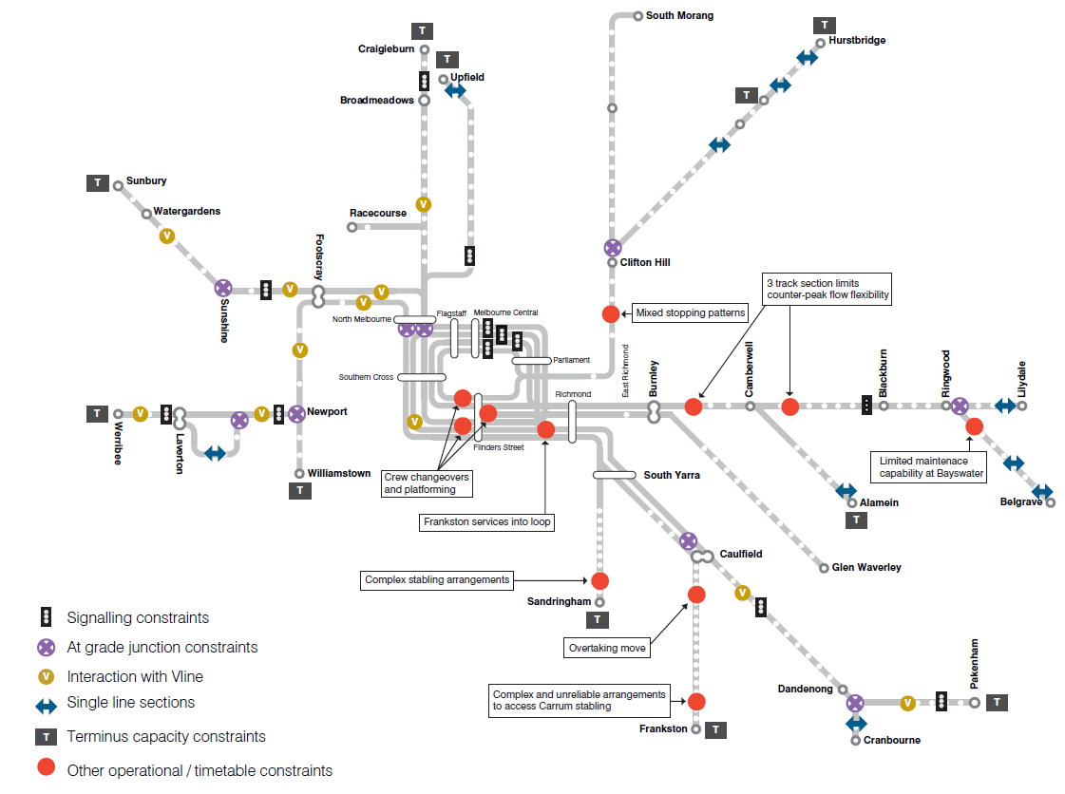

2. Developing a metro-style system for Melbourne
The purpose of the plan is to establish a basis for planning for the development of Melbourne’s metropolitan rail network over the next 20 years and beyond.
The plan aims to expand the capacity of the existing network to meet growing demands through operational changes and cost-effective new investments. This will provide the basis for much needed extensions to areas of Melbourne not serviced by heavy rail, as well as enabling improved coordination with buses and trains.
Ultimately, the plan charts the way for transforming Melbourne’s rail network into a metro-style system, similar to those in London and Paris. This is the central solution to strengthening and securing Melbourne’s rail network into the future.

What is a metro-style system?
Expanding the capacity of Melbourne’s metropolitan rail network to meet growth pressures will require that it increasingly adopt metro-style operations. Metro systems have strong passenger-focused characteristics, including:
- Simple timetables with ‘turn up and go’ frequency and consistent stopping patterns
- Stand-alone, end-to-end lines that do not intersect or merge with other lines to prevent any service disruptions or delays cascading across other lines
- Separate train fleets, maintenance and stabling facilities for each line
- Modern high capacity signalling technology to maximise the number of trains that can operate on each line and enhance relability
- Modern high capacity trains designed to minimise boarding and alighting times by use of wide doors and clear areas around doors
- Frequent services designed to match with connecting buses and trams
- Grade separations of level crossings where increasing train numbers are causing unacceptable traffic delays.
For Melbourne, this will require:
- The capacity to run more frequent peak and off-peak services
- Ongoing changes to timetables, including simple, consistent stopping patterns and changes to how the existing City Loop is used
- Modifications to existing trains to increase their capacity and their ability to load and unload efficiently
- A new tunnel through the heart of the CBD to remove bottlenecks and provide critical capacity to the inner core of the rail network – the Melbourne Metro rail tunnel project
- The purchase of new high capacity trains
- Moving to high capacity signalling, replacing aging signalling systems, designed for slower trains, that limit the number of trains that can be run
- Low-cost infrastructure upgrades, including fixing single-line sections of track, eliminating at-grade junctions and providing new maintenance and stabling facilities.
A metro-style system for Melbourne’s rail network will shift operations to independent, end-to-end lines capable of carrying significantly more passengers. It will also contribute to a better integrated public transport system across the city, making changing between trains, trams and buses easier and more convenient and supporting the changing travel patterns of Melburnians.

Features of a metro-style system for Melbourne
The three major features required to achieve a metro-style system for Melbourne’s rail network are the Melbourne Metro rail tunnel project, high capacity signalling and high capacity trains. These projects will be supported by a number of other critical operational and infrastructure improvements.

Melbourne Metro rail tunnel project
Following the delivery of RRL, which will untangle regional and metropolitan lines in Melbourne’s west and north, the next critical requirement is enhancing and unlocking the capacity of the inner core of the network.
With capacity limitations of the City Loop fast approaching, the ability to introduce more services and extend the metropolitan network is constrained.
To achieve a true metro-style system with high frequency, independent end-to-end lines, major new infrastructure will be required at the centre of the network.
The Melbourne Metro rail tunnel project (discussed in more detail in Chapter 4: Stage 2) will involve the construction of a nine-kilometre rail tunnel between South Kensington and South Yarra via the CBD and five new inner-city stations.
The Melbourne Metro rail tunnel project will lead to the biggest overhaul of the metropolitan rail network since the opening of the City Loop in the early 1980s, resulting in a fundamental change to the rail network and major improvements in capacity, reliability and travel times.
From its first day of operation, the Melbourne Metro rail tunnel project will:
- Strengthen the inner core of the network
- Create four independent metro lines that will cater to Melbourne’s key growth areas
- Increase service frequencies across the bulk of the network
- Provide the capacity needed to extend the rail network to areas not currently serviced by metropolitan heavy rail.
Along with other supporting upgrades, the Melbourne Metro rail tunnel project will allow longer trains to operate and will enable service plans and timetables to be further simplified and start to operate with genuine metro-style characteristics. The project will significantly improve the reliability, frequency and convenience of train services for passengers.
At the same time, the project will relieve pressure on the heavily loaded Swanston Street / St Kilda Road tram services and will stimulate urban renewal in the Arden area.

High capacity signalling
A railway signalling system is required to control the safe movement of trains. The type of signalling system is a major factor in determining the number of trains that can be safely operated on a network.
Most of Melbourne’s existing signalling system, known as an Automatic Fixed Block system, currently uses coloured lights next to train tracks to advise the driver of what speed it is safe to travel – essentially the same technology introduced a century ago. Safe distance between trains is ensured by providing a signal sighting / driver reaction time, a minimum braking distance and a safety margin.
The existing system typically operates at around 15 trains per hour and could operate at up to 24 trains per hour in an ideal operating environment, albeit at a lower level of reliability.
High capacity signalling will move signals from the trackside to the train driver’s cabin and use computers to control acceleration and braking. As high capacity signalling is computer driven it allows the gap between trains to be optimised by adopting a dynamic separation method. With high capacity signalling systems in place, it is possible to operate beyond 30 trains per hour.
High capacity signalling can also improve safety by automatically applying brakes to avoid a dangerous situation.

High capacity trains
A considerable increase in trains will be needed over the next 20 years in order to retire the oldest trains currently operating on the network and to provide for the significant number of new services that will run across many lines following the completion of the Melbourne Metro rail tunnel project and other new rail extensions.
Funding of $210 million was allocated in the 2011-12 State Budget to buy seven new X’Trapolis trains to meet immediate demand. However, to help move more people on Melbourne’s trains, a progressive move to high capacity trains will be required over the next 20 years. The trains will be metro-style, single deck trains with a planned capacity on our existing infrastructure of up to 1100, compared to the existing 798 standard, with the ability to be lengthened further to carry more than 1600 passengers if needed.
The new trains will carry more people as they have no intermediate driver cabins, are longer and have wider doors and more internal room around the doors, enabling more efficient loading and unloading. Their length will also make full use of the platform length available at City Loop stations.
It is expected that Melbourne’s train fleet size will need to be increased by around 100 trains to cater for short-medium term patronage growth including the Melbourne Metro rail tunnel project. Further trains will be needed to allow for planned rail extensions to Melbourne Airport, Rowville and Doncaster, to cater for further demand growth and the retirement of the Hitachi and Comeng fleets.

What the plan will achieve
The plan will result in significant improvements across the metropolitan rail network, providing Melbourne with a 21st century train service that will deliver benefits in travel time, reliability, convenience and comfort for passengers.
Over the next 20 years, 200 kilometres of new track will be added to the existing 837 kilometres of metropolitan network. Nearly 130 kilometres of new track will be built to extend the network to bring rail service to some 300,000 people in areas like Doncaster and Rowville that do not currently have a rail service. Additionally, up to 300 kilometres of existing non-metropolitan track will be electrified to bring metropolitan services to growth areas at and beyond Melbourne’s fringe such as Melton, Geelong and Wallan.

Increased capacity
The plan seeks to expand the capacity of the existing network as and where needed to meet growing demands through operational changes and cost-effective new investments. This will be done in stages by dealing first with current constraints before introducing a metro-style system and extending the network.
The new timetables and operational changes, combined with the projects included in the plan, will provide a 50 per cent increase in peak hour capacity within 10 years and a 130 per cent increase within 20 years. This will allow 130,000 additional passengers to be carried into the city in the morning peak hour and reverse in the afternoon peak. This is equivalent to the capacity that would be provided by more than 100 freeway lanes.
Table - Capacity increases within 20 years
Metric | Capacity increase within 10 Years | Capacity increase within 20 Years
Number of peak hour train services into the city | 34% | 76%
Peak hour capacity into the city | 51% | 131%
Extra passengers that can be carried in peak hour | 50,000 | 130,000

In addition to extra peak services, the plan will deliver frequent services at all times of the week on most sections of the network, encouraging passengers to use the train network out of peak times and improving coordination with tram and bus services. Shoulder-peak periods will also benefit from close to peak-hour service levels on most lines, providing commuters with more flexibility and encouraging peak spreading.

Network extensions
With a metro-style system in place and significantly increased capacity generated, the plan provides for nine potential extensions to the rail network. These extensions will extend the reach of the rail network to Melbourne’s growth areas and existing areas that are currently not serviced by metropolitan rail. However, this plan has to be delivered sequentially and network extensions in stages three and four are only possible once stages one and two are delivered, as additional capacity has to be created through the CBD before new lines can be opened. The timing for each proposed extension will be determined by the expected rate of development of new suburbs, the capacity of the network and the availability of funding. The network will be expanded as follows:
- A new line to Melbourne Airport
- A new line to Rowville
- A new line to Doncaster
- Electrification and duplication to Melton
- Electrification of the Upfield line to Wallan
- Extension of the South Morang line to Mernda
- Extension of the Cranbourne line to Clyde
- Electrification of the Frankston line to Baxter
- Electrification to Wyndham Vale and ultimately Geelong
- Extension of South Morang – Southern Cross Line to Fishermans Bend.
More information about the scope and staging of each extension is contained in Sections 4 to 7.

Improved modal coordination
A significant number of Melbourne’s public transport trips involve transfer between train, tram and bus.
It will be critical to improve upon intermodal coordination going forward as:
- A large number of Melburnians rely on more than one mode of public transport to complete their trips
- Nearly 40 per cent of Melbourne’s rail passengers currently access the rail network by private car
- There are currently major inconsistencies in off-peak service frequencies across modes.
This will encourage passengers to shift to bus travel instead of using private cars to access the train. This will also encourage people whose origin or destination is beyond walking distance from the rail network to use public transport rather than default to travelling by car.
To provide seamless transfer between modes of public transport, coordination is required between the individual modes in relation to service design, scheduling and operations.
As Melbourne’s rail network is transformed into a metro-style system, the plan also sets out progressive improvements to modal coordination through:
- Consistent connection types for all intersecting services: for example, services are timed exactly or passengers can ‘turn up and go’
- Use of standard frequencies across all modes: for example, set to multiples of 10 and 20 minutes
- Definition of consistent service periods (for example ‘day’, ‘peak’ and ‘night’) applied throughout the week and weekends across all modes.

3. Stage 1 – Overcoming constraints: now until 2016

Network planning 2012 to 2016
This plan focuses in the first instance on overcoming existing constraints and expanding the capacity of Melbourne’s rail network. Along with key projects already underway, there will be major timetabling and operational changes to get the most out of the network.
By 2016, every timetable on every metropolitan and regional rail line will have been completely re-built, with new peak services on all lines, a longer peak period on some lines, better late night services and better weekday off-peak services.
New trains purchased for Melbourne’s network have the capacity to carry an average of 900 passengers due to an improved internal layout. A project to retrofit existing trains to replicate this layout and boost capacity is now underway.
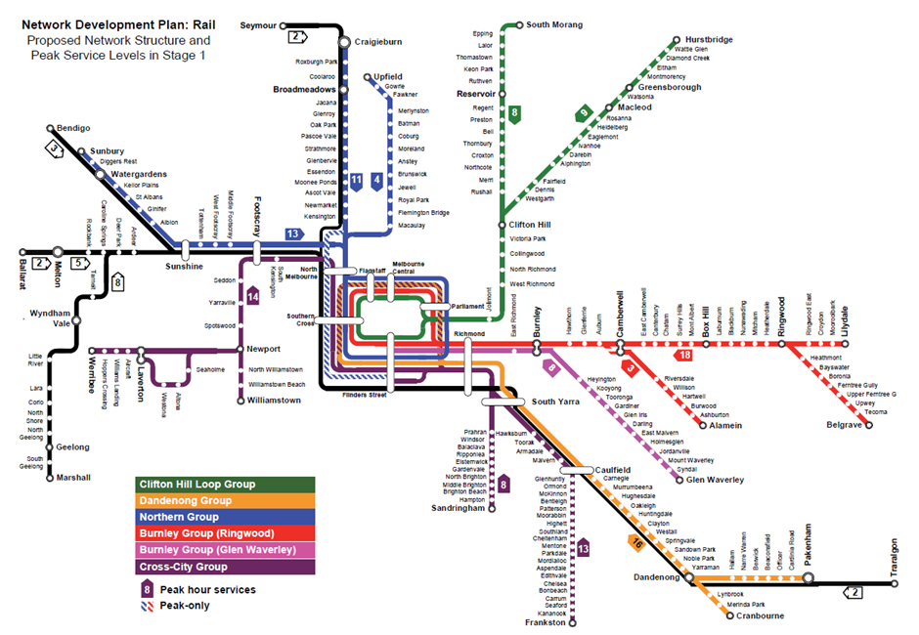

Projects 2012 to 2016
Upon completion of RRL in 2016, the metropolitan network will enter a new era with far greater separation from regional services and new stations in Melbourne’s western suburbs.
The removal of regional trains from the Sunshine and Werribee metropolitan corridors will provide critically needed capacity for additional services to be added immediately to these high growth corridors.
The Werribee, Sunbury, Craigieburn and Upfield lines will benefit most from the project, but there will also be improved peak hour capacity and reliability on the Geelong, Ballarat and Bendigo lines.
In other areas, the completion of the Sunbury Electrification Project in 2012 and Hurstbridge Line Upgrade in 2013 will result in a step-change in capacity and service delivery on these lines, supported by associated stabling projects.
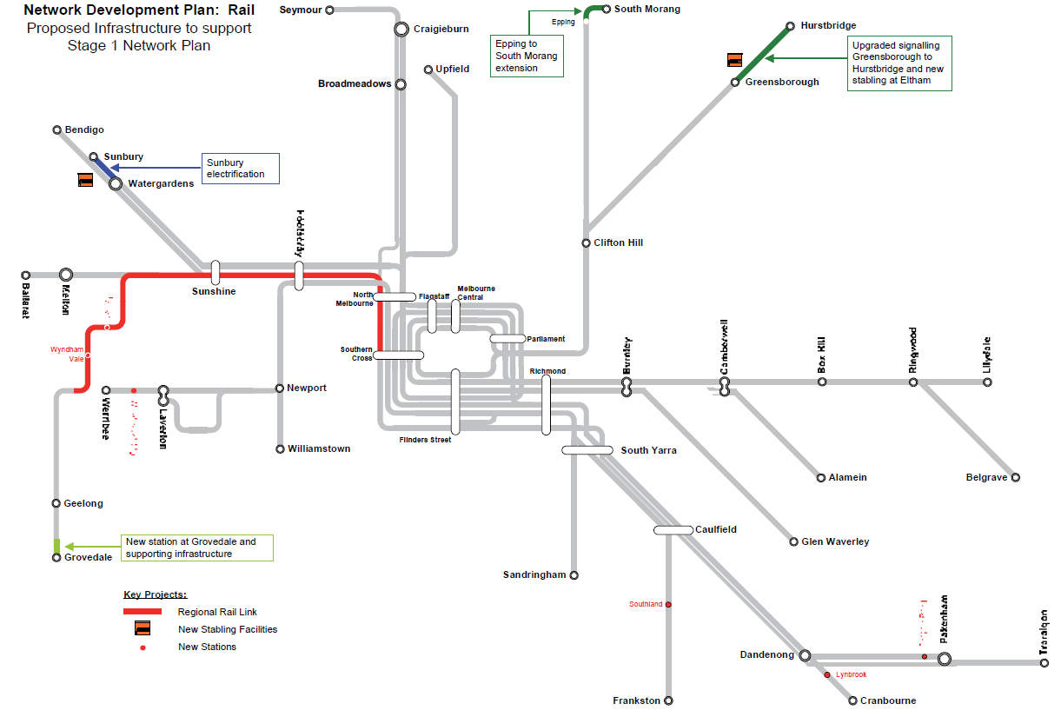

4. Stage 2 – Commencing the introduction of a metro-style system: within 10 years

Network planning
Following the implementation of the post-RRL timetable, all existing metro trains will be used at peak times. About 100 high capacity trains will be required to cater for growth beyond that time, carrying more passengers and providing a higher level of comfort, security, reliability and performance.
High capacity trains will allow extra services to be operated on all lines.
Associated works will include construction of a new maintenance facility at Pakenham East, new stabling facilities at Pakenham East, Calder Park, Lilydale, Eltham and North Melbourne, upgraded power systems on the Dandenong corridor and reallocation of other trains around the network.
Melbourne’s conventional trackside coloured-light signalling system has served the network for more than 100 years. However, rapidly growing patronage and services mean the system has outgrown its design capacity and is now restricting growth on the network. These limitations can be overcome through the introduction of high capacity signalling.
The plan proposes a gradual transition to high capacity signalling starting with a pilot on the Sandringham line. The pilot project will lead to the introduction of high capacity signalling on future rail projects and upgrades and ultimately across the entire network, improving capacity, punctuality and reliability.
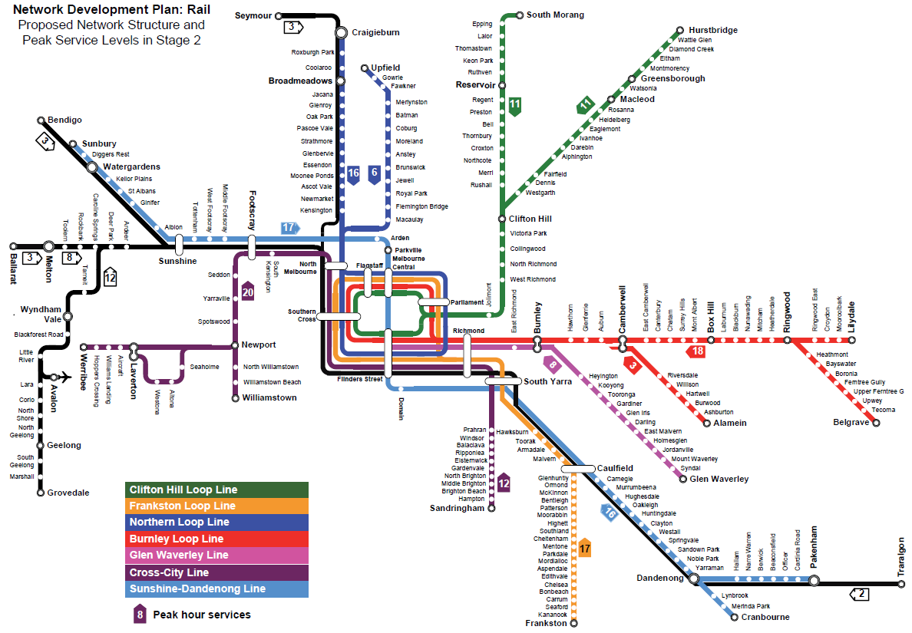

Projects
To support the Stage 2 network and service plans, a series of major projects and complementary network changes will be required.
The Melbourne Metro rail tunnel project will lead to the biggest overhaul of the metropolitan rail network since the opening of the City Loop in the early 1980s, resulting in a fundamental change to the rail network and major improvements in capacity, reliability and travel times.
Consisting of a new nine-kilometre rail tunnel through the centre of Melbourne and associated works, the Melbourne Metro rail tunnel project will create capacity for new peak services on the Werribee, Craigieburn, Sunbury, Upfield, Sandringham and Frankston lines, allowing 19 additional peak hour services to run.
The project will create the opportunity to operate longer trains on the Sunbury and Dandenong corridors and provide the inner-city capacity to enable future metropolitan services to operate to Melton, Melbourne Airport and Rowville.
The Melbourne Metro rail tunnel project will be designed to deliver a major network reconfiguration, with more through-running lines, five new stations within inner Melbourne and punctual and reliable services.
The delivery of the Melbourne Metro rail tunnel project will create four independent train lines:
- Northern Loop Line: Craigieburn and Upfield services running exclusively via the Northern Loop
- Sunshine – Dandenong Line: Sunbury, Cranbourne and Pakenham services via the Melbourne Metro rail tunnel
- Cross-City Line: Reconfigured from the previous Cross-City Group to provide exclusive use for Werribee and Williamstown services to operate direct to Flinders Street via Southern Cross and through to Sandringham and vice versa
- Frankston Loop Line: Frankston corridor services operating as a stand-alone group via the released Caulfield Underground Rail Loop.
The Dandenong Rail Corridor Upgrade will focus on grade separations and road alterations at multiple level crossings between Caulfield and Dandenong and the introduction of high capacity trains.
The Clifton Hill Group Upgrade will follow on from the Hurstbridge line upgrade, introducing high capacity signalling and duplicating the line from Heidelberg to Rosanna, permitting a high frequency service and a simpler and more consistent timetable pattern. Following the duplication and new signalling, Clifton Hill junction will become the key bottleneck on the group, requiring the existing junction to be upgraded.
Melton duplication will require duplication from Deer Park to Melton as well as the construction of passing loops on the Ballarat corridor and new stabling at Melton Station. These upgrades will improve peak capacity from Melton and Ballarat, improve off-peak services on the Ballarat and Bendigo corridors and improve capacity, reliability and travel times on the Geelong line. The upgrades will also support future electrification to Melton.
New stations will be constructed at Toolern on the Ballarat line and Black Forest Road on the Geelong line.
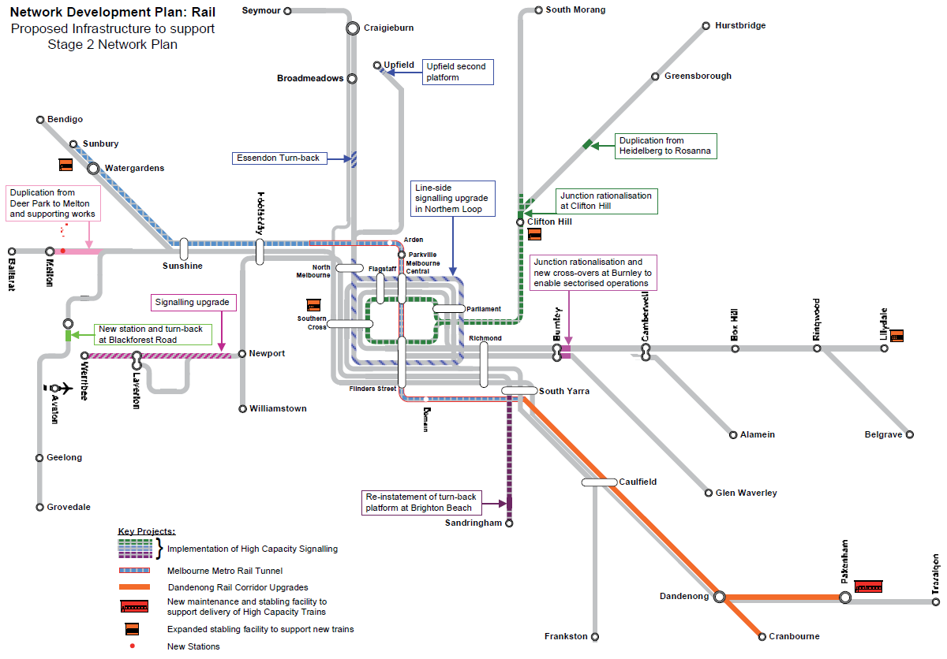

5. Stage 3 – Extending the network: within 15 years

Network planning
Having created the capacity and infrastructure on which to expand the network, this period will improve network reach through a series of line extensions and electrification works, while continuing to roll-out high capacity signalling.
High capacity signalling will be implemented on the Cross-City Line between Flinders Street and Werribee / Williamstown and on the Northern Loop Line, covering the City Loop and to Craigieburn and Upfield.
The continuation of the Dandenong Rail Corridor Upgrade will allow more and longer trains to operate while still accommodating V/Line services in this major growth area. The project will also prepare the corridor for the Rowville line extension. Key works will include further grade separations and road alterations at multiple level crossings between Caulfield and Dandenong, platform extensions at all stations to enable trains of up to 220 metres to operate through the corridor, and high capacity signalling.
Melbourne Airport can at that point be connected to the metropolitan network by a new rail line, and the extension to Rowville can open.
Electrification from Frankston to Baxter will enable high capacity trains to be operated, stabled and maintained on the line, providing improved capacity, reliability and travel times.
A new tunnel between Clifton Hill and Southern Cross at about this point would allow for major changes to the South Morang and Hurstbridge lines, with the diversion of South Morang services into a new tunnel to increase frequency and allow Doncaster line services to begin running via the Clifton Hill Loop Line.
Capacity and reliability on the Northern Loop Line will be further enhanced with the use of new signalling on the line and the diversion of Seymour V/Line services via the Upfield corridor where greater capacity will exist to accommodate those services.
A further order of high capacity trains will be delivered to provide for services on the rail extensions constructed in this period.
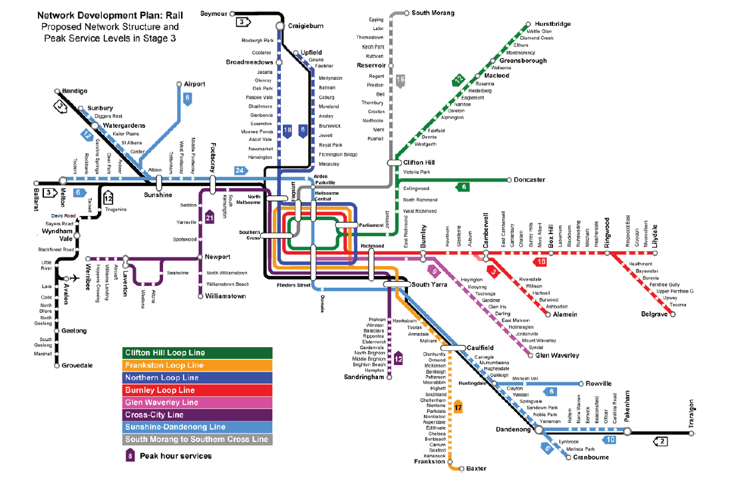

Projects
The draft finding of the Melbourne Airport Rail Link Study is that the best route for a rail line to Melbourne Airport is via the existing Albion East reservation and Melbourne Metro rail tunnel to link into the Sunshine-Dandenong rail corridor. This option will allow airport services to operate through the Melbourne Metro rail tunnel providing direct access to the airport from the Cranbourne and Pakenham lines and from Flinders Street, Melbourne Central and Parkville in the city.
An independent study commissioned by the Victorian Government has found that a 12 kilometre rail line between Huntingdale Station and the Stud Park area is the most appropriate option for the Rowville Rail Link. Four new stations will also be provided at Monash University, Mulgrave, Waverley Park and Rowville.
Phase one of the Doncaster Rail Link study has been completed, recommending an alignment generally following the Eastern Freeway and connecting to the existing rail network near Clifton Hill.
Capacity growth on the South Morang and Hurstbridge Lines presents a significant challenge for the introduction of the Doncaster rail line. Even with the provision of high capacity signalling, capacity will be insufficient to meet patronage demands on the South Morang and Hurstbridge lines and to enable a minimum 10 minute service on the Doncaster line.
The proposed solution is to separate the South Morang and Hurstbridge lines, creating two new corridors. The Clifton Hill Loop line will accommodate the Hurstbridge and new Doncaster lines via the existing Clifton Hill underground rail loop. The South Morang line will operate in a new tunnel from Clifton Hill via Parkville to Southern Cross Station.
To support the upgrading of train frequencies and protect reliability on the Sunshine – Dandenong Line, the existing single track to Cranbourne will be duplicated and an additional platform will be provided at Dandenong Station. The overall project will result in the entire Sunshine – Dandenong Line, including branch lines to Rowville, Melbourne Airport and Melton, being a two-track railway on all sections with metro-style services operating at a high level of reliability.
Electrification to Melton will enable use of high capacity trains to cater for patronage growth, providing direct access to new Melbourne Metro rail tunnel stations and south eastern suburbs.
Electrification to Baxter, combined with new stabling and maintenance facilities, will be required for the Frankston Loop line. Baxter will be developed as a park-and-ride facility. Stony Point services will then terminate at Baxter and interchange with the Frankston Loop Line.
The diversion of Seymour regional services via the Upfield line will become possible through the reinstatement of the Somerton to Upfield link, reducing pressure on the Craigieburn line, improving travel times for Seymour services and – most importantly – enabling additional short-starter regional services to be introduced from Wallan as a precursor for the electrification of the line.
As the Melbourne Metro rail tunnel project nears completion in Stage 2, consideration will need to be given to the staged delivery of the major projects listed above. In the coming years, more detailed work will be undertaken to more fully understand the costs and benefits of each project.
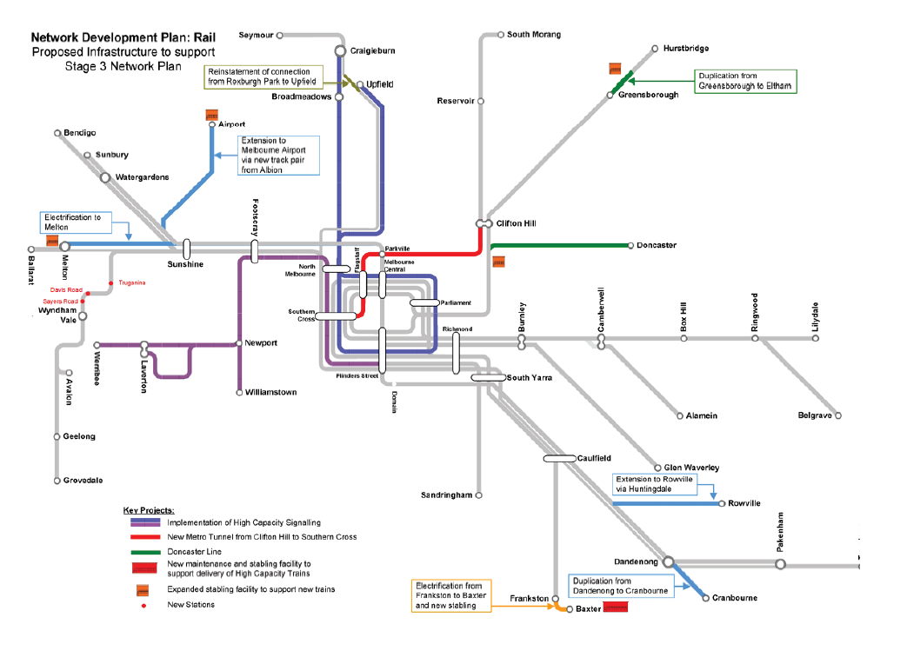

6. Stage 4 – Preparing for further growth

Network planning
Looking further ahead, a major network reconfiguration is planned to occur in Stage 4. Central to the delivery of the Stage 4 plan is the reconfiguration of the City Loop, which will provide the opportunity to rationalise the Burnley group into two fully independent lines.
The works will also enable the separation of the Craigieburn and Upfield lines creating an opportunity to successfully serve the northern growth corridor.
The reconfiguration will result in seven separate, independently operated metro-style lines through the CBD and will provide capacity for an extra 32 trains per hour. This stage provides the footprint to allow some important future line extensions to be added to the system without any adverse capacity or reliability outcomes.
The works identified in this period will be the final stage in delivering the metro-style network. They will result in a profound change in the way the metropolitan rail system is operated and are likely to provide the basis on which the network can be developed for the following half-century or more.
A further order of high capacity trains will be delivered in this period.
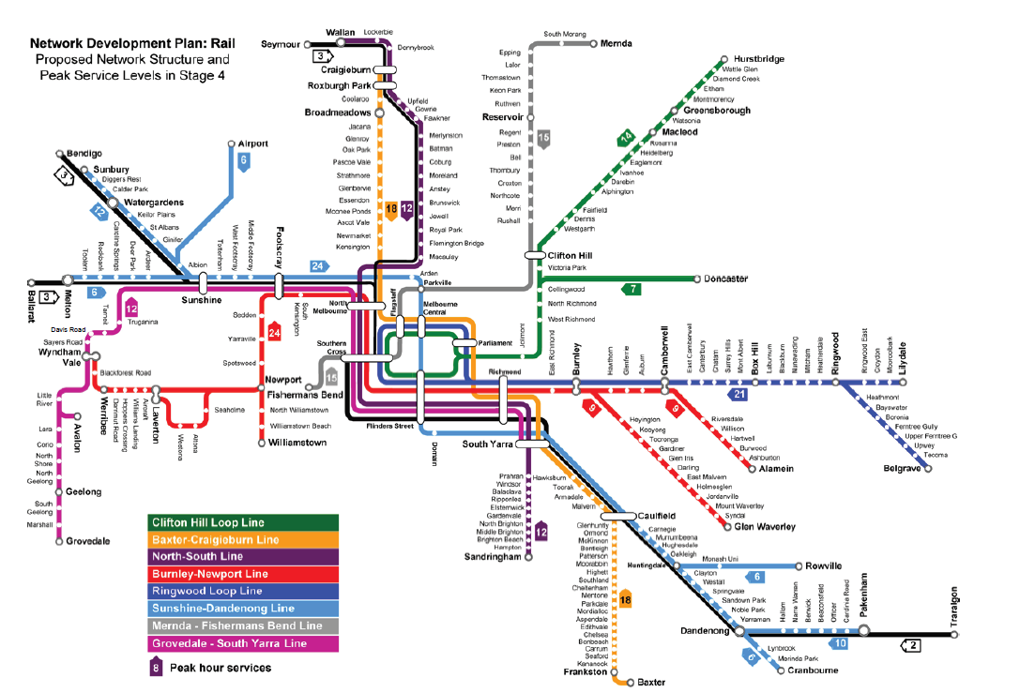

Projects
The reconfiguration of the Northern and Caulfield loops will be a key project late in Stage 4. The project will deliver two new through-running lines through the city, one via the underground stations and one via Flinders Street and Southern Cross stations. There will also be upgrades of City Loop stations.
Other key projects implemented in this period include quadruplication of the line between Burnley and Camberwell, duplication from Altona Junction to Seaholme and grade separation of Altona Junction.
Further expansion of the metro network will be enabled through electrification projects to Geelong and Wallan. There will be an extension from Werribee to Wyndham Vale, an extension from South Morang to Mernda and duplication from Mooroolbark to Lilydale, with all projects including new stabling facilities.
The South Morang – Southern Cross Line will be extended across the city to serve the proposed development of Fishermans Bend.
Many of the works identified here will set up the network to accommodate significant patronage growth on all lines, as well as enable further line extensions to be considered.
By 2050, it is expected that Melbourne will be a city of at least 6.5 million people. To support this growth, the public transport network will need even more capacity and improved connections. Detailed development has not yet been undertaken on this even longer-term vision of the rail network (beyond Stage 4), but the network would potentially include many more extensions and enhancements.
Further work will be undertaken to develop the longer-term vision. Detailed planning for shorter-term projects will take the long-term vision into account.
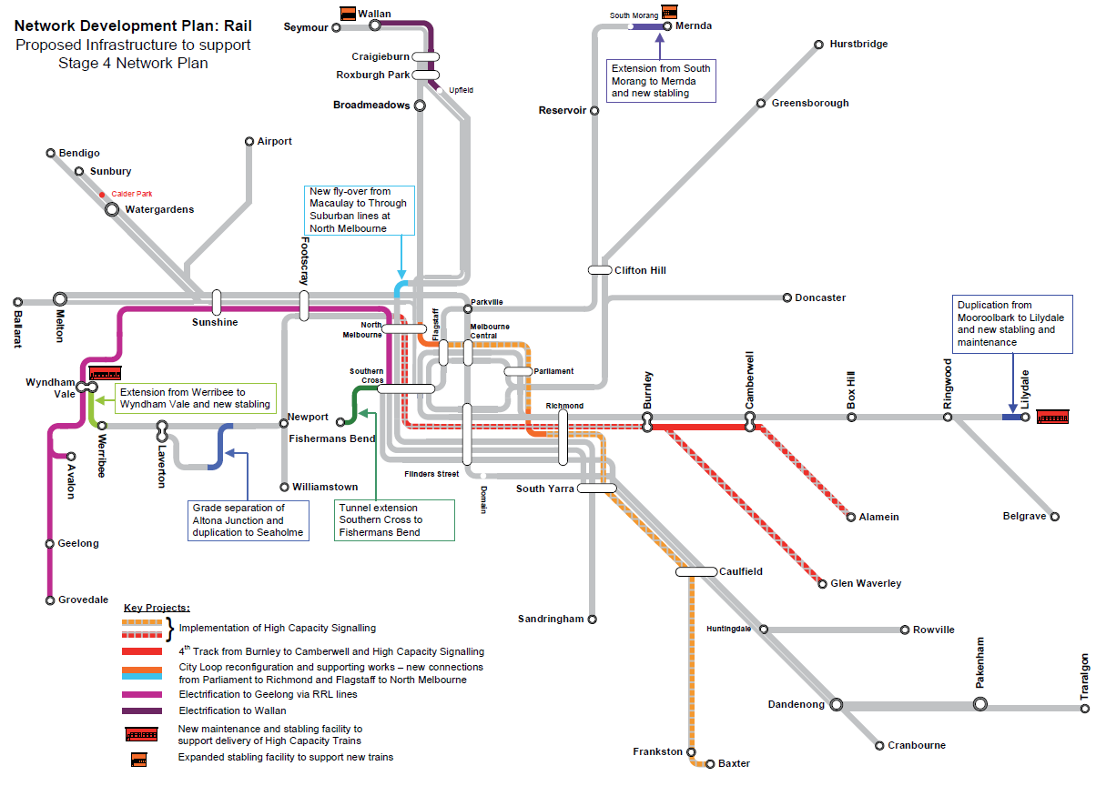

8. Funding
A central focus of the plan through each stage is to regularly overhaul and simplify timetables and train operations, getting every extra service possible out of the existing system at zero or low-cost, before turning to more costly infrastructure solutions.
Nearly all projects needing to be delivered by 2016 to meet expected demand are already funded and in various stages of delivery and all projects needing to be delivered in Stage 2 are at various stages of project development.
Detailed planning work will continue to allow major rail projects such as Rowville, Doncaster and Melbourne Airport to begin as soon as necessary key infrastructure and supporting works are in place and as funding becomes available.
The ability to deliver these projects will depend on funding from Commonwealth and State governments, which may include new funding models currently being examined by Infrastructure Australia and the Council of Australian Governments (COAG).
It should be noted that a program of further grade separations will be delivered through this period under a separate program to be delivered by other government agencies including VicRoads and VicTrack.

For more information
This report is a summary of a more detailed rail plan which is available on Public Transport Victoria’s website. The report draws on a detailed patronage modelling report, also available online. A number of independent rail feasibility studies and supporting technical reports into links to Rowville, Melbourne Airport and Doncaster have also been released and are available online.
Please visit ptv.vic.gov.au to access copies of these reports.

Public Transport Victoria
For more information visit ptv.vic.gov.au or call 1800 800 007 (6am – midnight daily)
Public Transport Victoria is your central stop for information on public transport services, fares, tickets and initiatives. Up-to-date information is available via our website, call centre and mobile applications.
© State of Victoria 2012

PTV7425/12

