TRACK RECORD
Victorian transport services quarterly performance bulletin
ISSUE 66 – SERVICES JANUARY TO MARCH 2016

Established in April 2012, Public Transport Victoria (PTV) manages Victoria’s train, tram and bus services. PTV also provides a single contact point for customers wanting information on public transport timetables, services, tickets and improvement projects.

Public transport performance declined in the first quarter of 2016, with punctuality and reliability results falling across regional services as a result of regional train disruptions from mid-January.
Overall satisfaction with metropolitan services decreased compared with last quarter, from 69.6 per cent to 69.0 per cent. There was no significant change compared to the March 2015 quarter (68.1 per cent).

Contents
TRACK RECORD 1
Contents 4
Punctuality and reliability 5
Punctuality 5
Reliability 8
Quarterly City and Westona Loop Bypasses 9
Unplanned express services 9
Customer compensation 10
Metropolitan train and tram 11
V/Line 12
Bus 12
Customer satisfaction 13
Customer satisfaction 13
About customer satisfaction ratings 13
Overall satisfaction 14
Metropolitan trains 17
Metropolitan trams 18
Metropolitan buses 19
V/Line modes 20
V/Line trains 21
V/Line coaches 22
Travel behaviour and ticketing 23
Travel behaviour 23
myki device availability 24
Fare evasion 25
Attitudes toward Authorised Officers 25
Customer service 26
Website 26
Call Centre 28
Industry-wide feedback 30
About industry feedback 30
Stakeholder share 30
Types of feedback 31
Industry feedback 32
PTV feedback 33

Punctuality and reliability

Punctuality
Metropolitan trains are considered on time if they arrive no more than four minutes and 59 seconds after their scheduled time in the timetable.
Metropolitan trams are considered on time if they arrive no more than 59 seconds before or four minutes and 59 seconds after the scheduled time in the timetable.
Metropolitan buses are considered on time if they arrive no more than 59 seconds before or five minutes and 59 seconds after their scheduled time in the timetable.
Long distance regional trains are considered on time if they arrive no more than 10 minutes and 59 seconds after their scheduled time in the timetable.
Short distance regional trains are considered on time if they arrive no more than five minutes and 59 seconds after their scheduled time in the timetable.
Punctuality measures do not include replacement services (i.e. replacement buses and coaches) which operated during the V/Line restoration period (January – June 2016).
Note: Effective from 1 July 2015, performance reporting for punctuality for metropolitan bus services has changed.
Some punctuality measures included in Track Record 66 use data provided from the Bus Tracking System (BTS). BTS technology uses on-board global positioning system (GPS) and communications equipment to provide real-time updates on bus locations.
Prior to the introduction of BTS, data was collected manually and self-reported by operators.
Future editions of Track Record are expected to solely use BTS data for punctuality reporting.
Table 1: Train, tram and bus punctuality – percentage of services on-time
Mode | Threshold | Jan – Mar 2015 | Apr – Jun 2015 | Jul – Sep 2015 | Oct – Dec 2015 | Jan – Mar 2016
Metropolitan trains | 4 minutes, 59 seconds late | 92.7 | 91.5 | 92.8 | 93.0 | 91.6
Metropolitan trams –  average over route | 4 minutes, 59 seconds late | 80.2 | 82.7 | 85.0 | 82.3 | 83.7
Metropolitan trams – at destination | 4 minutes, 59 seconds late | 68.3 | 72.7 | 76.3 | 72.3 | 74.6
Metropolitan buses | punctuality | 93.2 | 93.1 | 89.8 | 90.8 | 89.6
V/Line trains | punctuality | 90.7 | 88.5 | 87.7 | 87.8 | 81.9
Figure 1: Train, tram and bus punctuality – percentage of services on-time
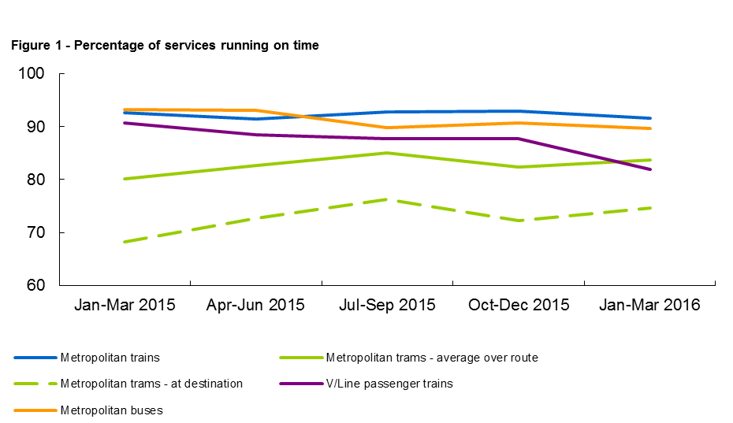
Table 2: Metropolitan train punctuality – percentage of peak services on-time at destination
Line | Jan – Mar 2015 | Apr – Jun 2015 | Jul – Sep 2015 | Oct – Dec 2015 | Jan – Mar 2016
Alamein | 93.4% | 90.1% | 93.4% | 91.5% | 91.2%
Belgrave | 86.5% | 83.2% | 87.2% | 89.0% | 87.9%
Craigieburn | 91.2% | 89.2% | 91.5% | 90.8% | 90.3%
Cranbourne | 89.6% | 85.5% | 89.4% | 88.5% | 84.8%
Frankston | 90.0% | 87.3% | 89.4% | 88.3% | 86.5%
Glen Waverley | 94.4% | 93.1% | 94.7% | 95.1% | 94.6%
Hurstbridge | 92.0% | 90.8% | 92.2% | 93.1% | 92.1%
Lilydale | 89.2% | 86.6% | 89.0% | 91.3% | 88.5%
Pakenham | 90.9% | 86.7% | 91.0% | 89.8% | 85.9%
Sandringham | 95.3% | 93.5% | 96.8% | 96.8% | 93.6%
South Morang | 94.5% | 93.5% | 95.2% | 95.8% | 96.0%
Stony Point | 96.4% | 87.5% | 96.9% | 96.1% | 92.7%
Sunbury | 91.7% | 91.3% | 92.3% | 92.4% | 88.8%
Upfield | 94.1% | 93.1% | 95.0% | 93.5% | 92.7%
Werribee | 87.6% | 85.4% | 93.0% | 93.2% | 89.4%
Williamstown | 91.3% | 89.9% | 94.9% | 94.6% | 92.0%
Network Total | 91.4% | 89.2% | 92.3% | 92.3% | 90.2%
Table 3: Metropolitan train punctuality – percentage of off-peak services on-time at destination
Line | Jan – Mar 2015 | Apr – Jun 2015 | Jul – Sep 2015 | Oct – Dec 2015 | Jan – Mar 2016
Alamein | 95.7% | 94.2% | 95.2% | 95.6% | 94.0%
Belgrave | 91.1% | 90.5% | 91.7% | 93.1% | 92.4%
Craigieburn | 93.3% | 92.3% | 92.3% | 92.2% | 92.7%
Cranbourne | 91.5% | 88.3% | 89.7% | 88.7% | 87.8%
Frankston | 90.4% | 89.5% | 89.0% | 89.1% | 89.7%
Glen Waverley | 96.8% | 96.4% | 96.1% | 96.4% | 97.2%
Hurstbridge | 95.1% | 95.1% | 95.0% | 95.7% | 93.4%
Lilydale | 92.5% | 91.7% | 93.2% | 94.0% | 91.7%
Pakenham | 89.9% | 89.0% | 88.8% | 88.6% | 86.5%
Sandringham | 96.2% | 95.2% | 95.2% | 95.5% | 94.1%
South Morang | 95.1% | 95.0% | 94.5% | 96.2% | 94.5%
Stony Point | 97.1% | 100.0% | 97.4% | 95.1% | 94.4%
Sunbury | 92.7% | 93.0% | 93.5% | 93.7% | 88.7%
Upfield | 94.2% | 93.8% | 94.5% | 93.5% | 93.4%
Werribee | 91.3% | 92.0% | 93.6% | 94.1% | 92.7%
Williamstown | 95.2% | 95.7% | 96.0% | 95.3% | 94.8%
Network Total | 93.3% | 92.7% | 93.1% | 93.4% | 92.2%

Reliability
Metropolitan train reliability is measured as the percentage of the timetable that is delivered. Non-delivery of services includes cancellations, trains that run short and trains that bypass the City or Altona Loops.
Metropolitan tram reliability is based on the percentage of the timetable delivered. Non-delivery of services includes cancellations and trams that run short.
Metropolitan bus reliability is the percentage of services that operate and are completed.
Regional train reliability is measured as the percentage of scheduled services that are delivered.
Reliability measures do not include replacement services (i.e. replacement buses and coaches) which operated during the V/Line restoration period (January – June 2016).
Table 4: Train and tram reliability – percentage of timetable delivered
Mode | Measure | Jan – Mar 2015 | Apr – Jun 2015 | Jul – Sep 2015 | Oct – Dec 2015 | Jan – Mar 2016
Metropolitan trains | % timetable delivered | 98.8 | 98.6 | 98.9 | 98.8 | 98.3
Metropolitan trams | % timetable delivered | 98.9 | 99.1 | 99.0 | 98.7 | 98.6
V/Line trains | % services delivered | 98.5 | 98.5 | 98.0 | 97.4 | 92.5
Metropolitan buses | % services delivered | >99.9 | >99.9 | >99.9 | >99.9 | >99.9
Figure 2: Train, tram and bus reliability – percentage of timetable delivered
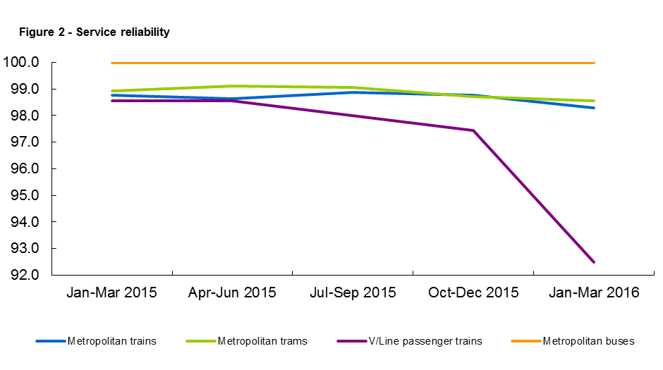

Quarterly City and Westona Loop Bypasses
Table 5: Quarterly City and Westona Loop Bypasses
Line | Q1 2015 | Q2 2015 | Q3 2015 | Q4 2015 | Q1 2016 | Services scheduled to run through the loop Q1 2016
Alamein | 41 | 68 | 53 | 49 | 54 | 1,260
Belgrave | 124 | 128 | 129 | 96 | 140 | 4,186
Craigieburn | 51 | 21 | 24 | 36 | 26 | 6,222
Cranbourne | 127 | 171 | 176 | 165 | 246 | 3,452
Frankston | 150 | 148 | 146 | 153 | 157 | 3,651
Glen Waverley | 68 | 51 | 27 | 51 | 55 | 3,753
Hurstbridge | 16 | 10 | 15 | 17 | 35 | 6,071
Lilydale | 192 | 220 | 162 | 151 | 195 | 6,524
Pakenham | 192 | 226 | 234 | 215 | 247 | 6,357
Sandringham | 14 | 17 | 27 | 34 | 33 | 1,478
South Morang | 22 | 12 | 25 | 14 | 34 | 5,654
Sunbury | 52 | 13 | 18 | 40 | 20 | 6,233
Upfield | 46 | 11 | 15 | 22 | 20 | 4,621
Werribee (Delivered Bypassing City Loop) | 48 | 10 | 1 | 14 | 6 | 0
Werribee (Delivered Bypassing Westona Loop) | 103 | 122 | 74 | 110 | 79 | 8,426
Werribee (Delivered Bypassing Both Loops) | 1 | 1 | – | – | 1 | 1,349
Grand Total | 1,247 | 1,229 | 1,126 | 1,167 | 1,348 | 69,237

There were 1,269 bypasses of the City Loop this quarter, which is 2.1 per cent of the 60,811 services scheduled to run through the loop during this time.
There were 79 bypasses of the Westona Loop, which is 0.9 per cent of the 8,426 services scheduled to run through the loop during this time.

Unplanned express services
Table 6: Quarterly unplanned express services
Measure | Jan – Mar 2015 | Apr – Jun 2015 | Jul – Sep 2015 | Oct – Dec 2015 | Jan – Mar 2016
Total number of timetabled services | 185,886 | 185,846 | 192,101 | 188,832 | 190,166
Number of express run services | 270 | 190 | 82 | 75 | 107
Percentage of total services run as unplanned express | 0.1 | 0.1 | 0.0 | 0.0 | 0.1
The percentage of services run as unplanned express over the March 2016 quarter was 0.1 per cent.

Customer compensation
Train and tram operators are expected to deliver a punctual and reliable service for customers.
PTV insists that operators do everything they can to deliver services in line with the agreed timetable.
Where operators fall short, they are required to pay compensation to customers, in the form of complimentary travel. Only customers who travel with a periodical ticket of four weeks or more are eligible to receive compensation.
Table 7: Service level thresholds for compensation (per cent)
Measure | Threshold | Trains | Trams | V/Line
Punctuality | Arrival by 4 minutes, 59 seconds | 88 | 77 | -
 | Arrival by 5 minutes, 59 seconds | - | - | 92*
Reliability | Percentage of timetable delivered | 98 | 98 | -
 | Percentage of services delivered | - | - | 96
* For long distance V/Line services, on-time arrival is defined as arriving no later than 10 minutes and 59 seconds after the timetabled arrival time
Metropolitan trains
Customer compensation was not paid for metropolitan trains this quarter.
Metropolitan trams
Customer compensation was not paid for metropolitan trams this quarter.
V/Line
In January, passenger compensation was payable on all lines as punctuality was below the applicable threshold (92.0 per cent). Compensation was also payable for reliability on the Ballarat, Bendigo, Geelong and Gippsland corridor as performance was below the applicable threshold (96.0 per cent).
In February, passenger compensation was payable on all lines except Ararat & Maryborough as punctuality was below the applicable threshold (92.0 per cent). Compensation was also payable for reliability on the Ballarat, Geelong, Gippsland and Seymour corridors as performance was below the applicable threshold (96.0 per cent).
In March, passenger compensation was payable on all lines except Ararat & Maryborough as punctuality was below the applicable threshold (92.0 per cent). Compensation was not payable for reliability on all lines as performance was above the applicable threshold (96.0 per cent).
Note: Despite V/Line meeting reliability targets on all lines in March, customer compensation has been made available to all customers travelling on replacement coaches from 8 February to 26 June.
Payments

Metropolitan train and tram
Metro Trains and Yarra Trams receive regular payments from Public Transport Victoria to cover the delivery of services and the operation and development of the networks. The terms of these payments are outlined in operator franchise agreements.
PTV requires that operators meet agreed performance targets. Penalties or incentives are paid depending on how operators perform against these targets.
Incentive payments are based on a detailed measure of the passenger impact of service disruptions. These include delays, cancellations, short services and a number of other disruption types (including trains that bypass the City and/or Westona loops).
Each disruption is multiplied by an agreed 'passenger weighting' for that service which depends on the route, the time of day, and the direction of the service. Longer delays result in higher penalties. Operators can receive bonus payments or incur penalties depending on whether the level of disruption is above or below agreed levels in the contracts.
Table 8: Metropolitan train payments ($'000s)
Payment type | Jan – Mar 2015 | Apr – Jun 2015 | Jul – Sep 2015 | Oct – Dec 2015 | Jan – Mar 2016
Base contract | 57,500 | 63,799 | 50,989 | 62,078 | 49,384
Incentive or penalty | 1,887 | 3,405 | 3,295 | 3,457 | -13
Customer Experience Performance Regime | 0 | 0 | 0 | 200 | 0
Revenue Reset Adjustment Payment | 24,685 | 24,593 | 19,492 | 17,864 | 28,954
Maintenance and projects¹ | 58,637 | 80,059 | 102,425 | 76,490 | 68,278
Rolling stock² | 25,589 | 23,899 | 27,852 | 24,315 | 23,220
Operations and systems³ | 8,614 | 15,543 | 18,775 | 11,408 | 13,049
TOTAL | 176,912 | 211,298 | 222,828 | 195,612 | 182,871
¹ Maintenance and projects combines maintenance and capital projects payments
² Rolling stock payments include rolling stock adjustments and exams
³ Operations and systems include payments for business system upgrades, driver establishment, electricity, and employee entitlements

Table 9: Metropolitan tram payments ($'000s)
Payment type | Jan – Mar 2015 | Apr – Jun 2015 | Jul – Sep 2015 | Oct – Dec 2015 | Jan – Mar 2016
Base contract | 4,776 | 7,313 | 3,494 | 5,903 | 2,986
Incentive and penalty | -1,124 | -788 | -89 | -1,619 | -1,226
Customer Experience Performance Regime | 0 | 0 | 0 | 439 | 0
Revenue Reset Adjustment Payment | 13,589 | 12,814 | 19,619 | 19,619 | 16,377
Maintenance and projects¹ | 5,900 | 15,065 | 16,349 | 17,522 | 15,065
Rolling stock | 8,767 | 8,767 | 8,767 | 8,767 | 8,767
Operations and systems² | 2,929 | 3,206 | 3,596 | 4,692 | 3,772
TOTAL | 34,837 | 46,377 | 51,736 | 55,324 | 45,741
¹ Maintenance and projects combines maintenance and capital projects payments
² Operations and systems payments include business system upgrades, electricity and employee entitlements

V/Line
Regional coach payments are made to V/Line, which is a state-owned enterprise, however regional train payments and penalties have ceased following the signing of the V/Line services agreement.
Table 10: Regional train and coach payments ($'000s)
Payment type | Jan – Mar 2015 | Apr – Jun 2015 | Jul – Sep 2015 | Oct – Dec 2015 | Jan – Mar 2016
Base contract | 79,839 | 81,936 | 78,570 | 87,057 | 82,866
Regional Coaches | 8,212 | 8,212 | 8,573 | 8,573 | 8,573
Farebox | 23,987 | 22,442 | 22,698 | 20,919 | 21,671
Rolling stock | 8,953 | 8,953 | 8,953 | 8,953 | 8,953
Total | 120,991 | 121,543 | 118,794 | 125,502 | 122,063

Bus
PTV has individual contracts with bus operators to run services in Melbourne and regional areas. Payments are made to these operators to help deliver route and school bus services.
Table 11: Metropolitan, regional and school bus payments ($'000s)
Payment type | Jan – Mar 2015 | Apr – Jun 2015 | Jul – Sep 2015 | Oct – Dec 2015 | Jan – Mar 2016
Metropolitan | 143,972 | 144,650 | 144,852 | 146,536 | 144,751
Regional | 27,151 | 27,256 | 27,534 | 27,332 | 28,951
School | 36,492 | 55,357 | 56,144 | 56,214 | 37,287
Total | 207,615 | 227,263 | 228,530 | 230,081 | 210,989

Customer satisfaction

Customer satisfaction
Overall satisfaction with metropolitan services decreased compared with last quarter, from 69.6 per cent to 69.0 per cent. There was no significant change compared to the March 2015 quarter (68.1 per cent).
Overall satisfaction with metropolitan trains remained unchanged compared with last quarter, at 73.5 per cent. This result was nevertheless a significant increase compared to the March 2015 quarter (71.9 per cent). Compared to last quarter, there were significant increases in customer satisfaction with value for money and myki ticketing, and a significant increase in the likelihood to recommend.
Overall satisfaction with metropolitan trams decreased compared with last quarter, from 77.1 per cent to 76.3 per cent. The result was an increase compared to the March 2015 quarter (75.9 per cent). Compared with last quarter, there was a significant decrease in customer satisfaction with comfort. Compared to the March 2015 quarter, there was a significant increase in the likelihood to recommend.
Overall satisfaction with metropolitan buses increased slightly compared with last quarter, from 76.1 per cent to 77.7 per cent. The result was also an increase compared to the March 2015 quarter (76.5 per cent). Compared with last quarter, there were significant increases in customer satisfaction with information, service delivery, bus stops and myki ticketing. Compared to the March 2015 quarter, there was a significant increase in the likelihood to recommend.

Overall customer satisfaction with regional trains decreased significantly compared with last quarter, from 78.8 per cent to 73.8 per cent. This was also a decrease compared to the March 2015 quarter (75.7 per cent). Compared with last quarter, there were significant decreases in customer satisfaction with information, service delivery, and a significant decrease in the likelihood to recommend. Compared with the March 2015 quarter, there was a significant increase in satisfaction with stations/stops, and a significant decrease in the likelihood to recommend.
Overall customer satisfaction with regional coaches decreased slightly compared with last quarter, from 86.1 per cent to 81.6 per cent. The result was also a decrease compared to the March 2015 quarter (84.6 per cent).

About customer satisfaction ratings
All results except overall metropolitan satisfaction (six-point scale) are reported in a 0-10 scale. Results prior to April 2009 were reported on a six-point scale.

Overall satisfaction
Table 12: Metropolitan public transport modes overall satisfaction
Jan – Mar 2014 | Apr – Jun 2014 | Jul – Sep 2014 | Oct – Dec 2014 | Jan – Mar 2015 | Apr – Jun 2015 | Jul – Sep 2015 | Oct – Dec 2015 | Jan – Mar 2016
65.5 | 66.1 | 66.4 | 66.7 | 68.1 | 67.3 | 67.8 | 69.6 | 69.0
Note: These results are still presented in the six-point scale.
Figure 3: Metropolitan public transport modes overall satisfaction
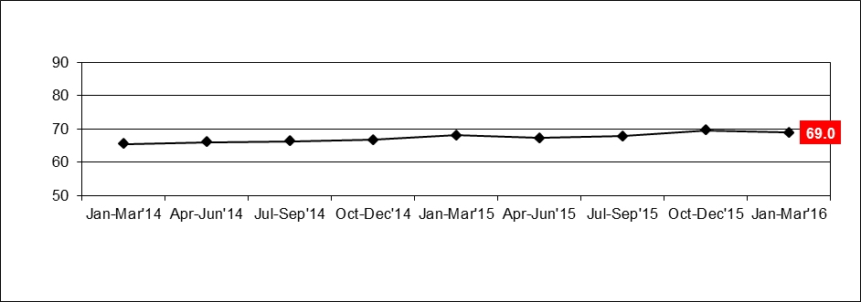
Table 13a: Metropolitan trains individual overall satisfaction
Mode | Jan – Mar 2014 | Apr – Jun 2014 | Jul – Sep 2014 | Oct – Dec 2014 | Jan – Mar 2015 | Apr – Jun 2015 | Jul – Sep 2015 | Oct – Dec 2015 | Jan – Mar 2016
Metropolitan Trains | 69.5 | 70.4 | 71.4 | 71.5 | 71.9 | 71.2 | 71.4 | 73.5 | 73.5

Figure 4a: Metropolitan trains individual overall satisfaction
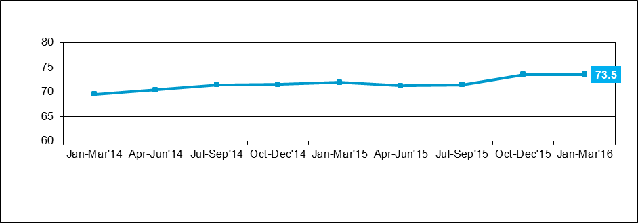
Table 13b: Metropolitan trams individual overall satisfaction
Mode | Jan – Mar 2014 | Apr – Jun 2014 | Jul – Sep 2014 | Oct – Dec 2014 | Jan – Mar 2015 | Apr – Jun 2015 | Jul – Sep 2015 | Oct – Dec 2015 | Jan – Mar 2016
Metropolitan Trams | 74.4 | 74.4 | 73.7 | 74.7 | 75.9 | 75.2 | 75.6 | 77.1 | 76.3

Figure 4b: Metropolitan trams individual overall satisfaction
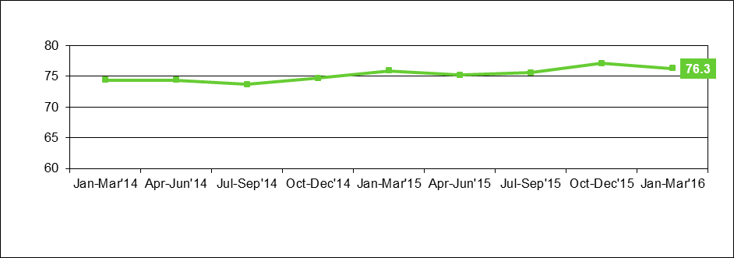
Table 13c: Metropolitan buses individual overall satisfaction
Mode | Jan – Mar 2014 | Apr – Jun 2014 | Jul – Sep 2014 | Oct – Dec 2014 | Jan – Mar 2015 | Apr – Jun 2015 | Jul – Sep 2015 | Oct – Dec 2015 | Jan – Mar 2016
Metropolitan Buses | 76.3 | 76.2 | 76.2 | 75.2 | 76.5 | 76.6 | 76.9 | 76.1 | 77.7

Figure 4c: Metropolitan buses individual overall satisfaction
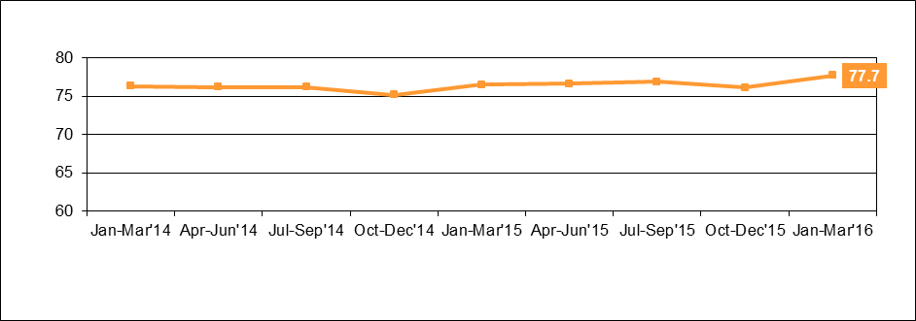

Metropolitan trains
Figure 5a: Satisfaction with key service aspects for metropolitan trains
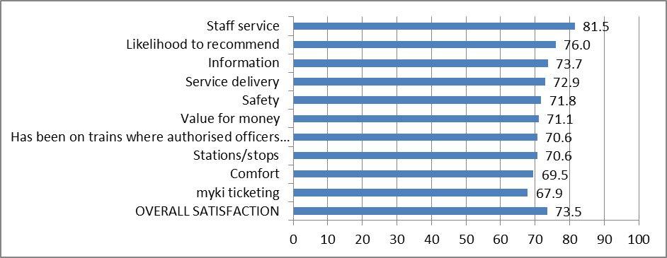
Table 14a: Satisfaction with key service aspects for metropolitan trains
Satisfaction indicator | Score | Significant change from previous quarter
Staff service | 81.5
Likelihood to recommend | 76.0
Information | 73.7
Service delivery | 72.9
Safety | 71.8
Value for money | 71.1
Has been on trains where authorised officers check tickets | 70.6
Stations/stops | 70.6
Comfort | 69.5
myki ticketing | 67.9
OVERALL SATISFACTION | 73.5

Metropolitan trams
Figure 5b: Satisfaction with key service aspects for metropolitan trams
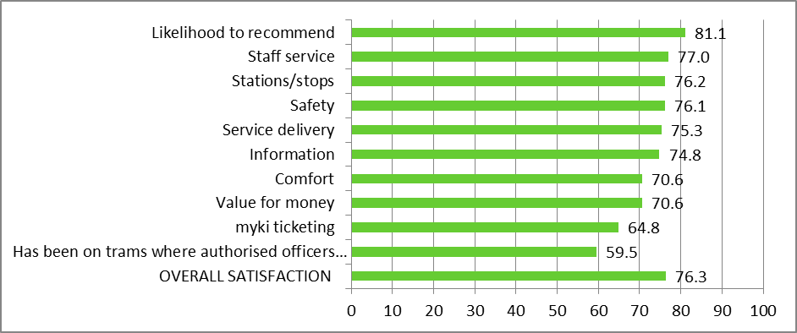
Table 14b: Satisfaction with key service aspects for metropolitan trams
Satisfaction indicator | Score | Significant change from previous quarter
Likelihood to recommend | 81.1
Staff service | 77.0
Stations/stops | 76.2
Safety | 76.1
Service delivery | 75.3
Information | 74.8
Comfort | 70.6 | decrease
Value for money | 70.6
myki ticketing | 64.8
Has been on trams where authorised officers check tickets | 59.5
OVERALL SATISFACTION | 76.3

Metropolitan buses
Figure 5c: Satisfaction with key service aspects for metropolitan buses
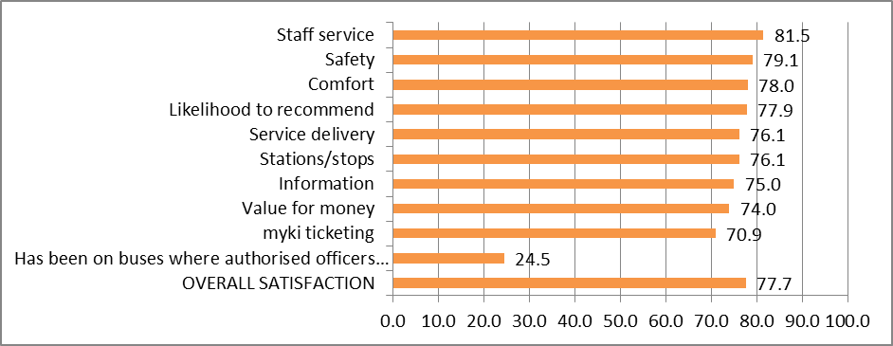
Table 14c: Satisfaction with key service aspects for metropolitan buses
Satisfaction indicator | Score | Significant change from previous quarter
Staff service | 81.5
Safety | 79.1
Comfort | 78.0
Likelihood to recommend | 77.9
Service delivery | 76.1 | increase
Stations/stops | 76.1 | increase
Information | 75.0 | increase
Value for money | 74.0
myki ticketing | 70.9 | increase
Has been on buses where authorised officers check tickets | 24.5
OVERALL SATISFACTION | 77.7

V/Line modes
Table 15a: V/Line trains individual overall satisfaction
Mode | Jan – Mar 2014 | Apr – Jun 2014 | Jul – Sep 2014 | Oct – Dec 2014 | Jan – Mar 2015 | Apr – Jun 2015 | Jul – Sep 2015 | Oct – Dec 2015 | Jan – Mar 2016
V/Line trains | 75.7 | 75.8 | 77.3 | 75.4 | 75.7 | 76.9 | 76.2 | 78.8 | 73.8

Table 15b: V/Line coaches individual overall satisfaction
Mode | Jan – Mar 2014 | Apr – Jun 2014 | Jul – Sep 2014 | Oct – Dec 2014 | Jan – Mar 2015 | Apr – Jun 2015 | Jul – Sep 2015 | Oct – Dec 2015 | Jan – Mar 2016
V/Line coaches | 82.8 | 81.4 | 80.3 | 80.8 | 84.6 | 85.7 | 83.9 | 86.1 | 81.6

Figure 6: V/Line individual overall satisfaction – trains and coaches
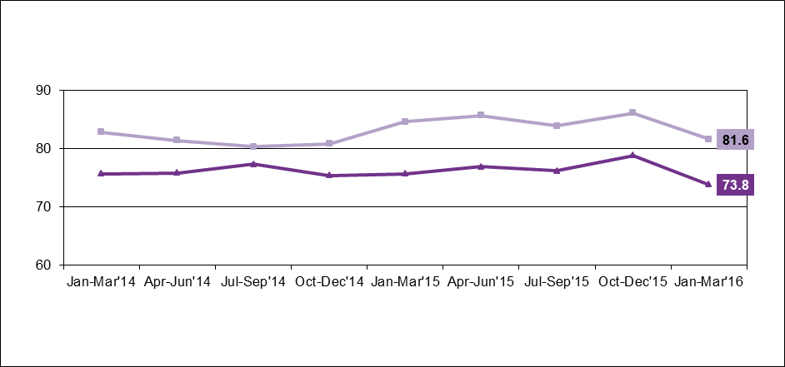

V/Line trains
Figure 7a: Satisfaction with key service aspects for V/Line trains
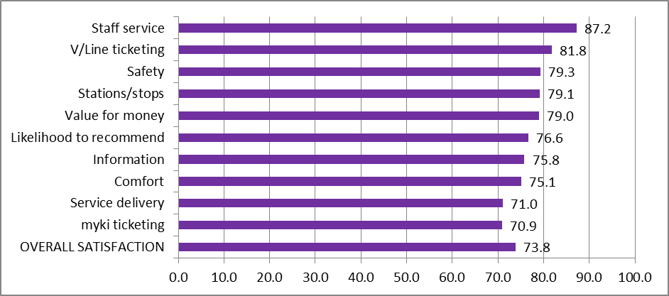
Table 16a: Satisfaction with key service aspects for V/Line trains
Satisfaction indicator | Score | Significant change from previous quarter
Staff service | 87.2
V/Line ticketing | 81.8
Safety | 79.3
Stations/stops | 79.1
Value for money | 79.0
Likelihood to recommend | 76.6 | decrease
Information | 75.8 | decrease
Comfort | 75.1
Service delivery | 71.0 | decrease
myki ticketing | 70.9
OVERALL SATISFACTION | 73.8 | decrease

V/Line coaches
Figure 7b: Satisfaction with key service aspects for V/Line coaches
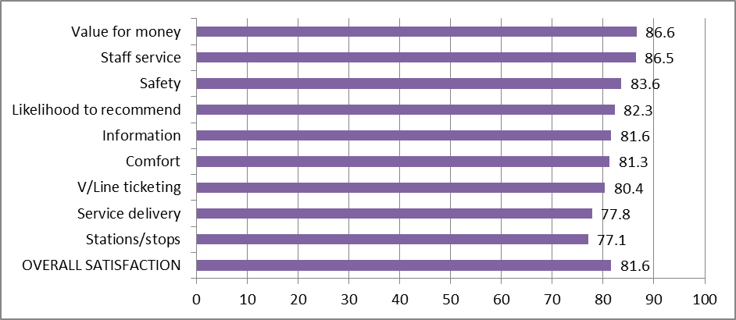
Table 16b: Satisfaction with key service aspects for V/Line coaches
Satisfaction indicator | Score | Significant change from previous quarter
Value for Money | 86.6
Staff service | 86.5
Safety | 83.6
Likelihood to recommend | 82.3
Information | 81.6
Comfort | 81.3
V/Line ticketing | 80.4
Service delivery | 77.8
Stations/stops | 77.1
OVERALL SATISFACTION | 81.6

Travel behaviour and ticketing

Travel behaviour
The proportion of non-users of public transport continues to remain stable in the March 2016 quarter with 7 per cent stating they hardly ever or never use public transport.
Figure 8: Main purpose of trip on weekday and weekend
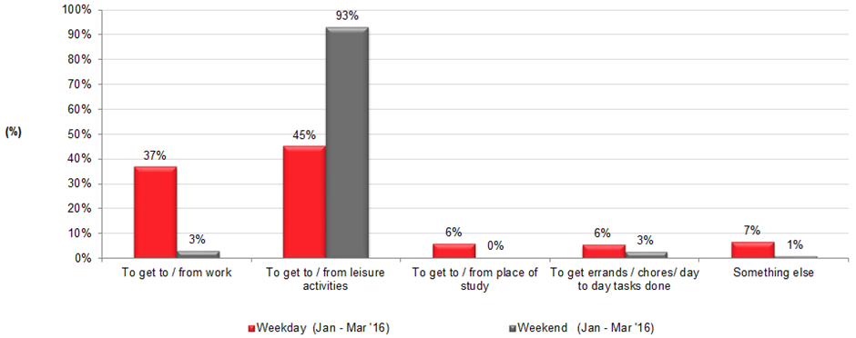
Table 17: Main purpose of trip on weekday and weekend
Reason for travelling | Weekday  (Jan – Mar 2016) | Weekend (Jan – Mar 2016)
To get to/from work | 37% | 1%
To get to/from leisure activities | 45% | 90%
To get to/from place of study | 6% | 0%
To get errands/chores/day to day tasks done | 6% | 8%
Something else | 7% | 1%
The most popular reason for using public transport on weekdays is for leisure purposes (45 per cent), which continues to lead commuting to work (37 per cent).
Weekend travel continues to be dominated by leisure purposes (90 per cent).

myki device availability
A private company, NTT Data Victorian Public Ticketing System Pty Ltd, is under contract to the Victorian Government to operate and maintain the myki ticketing system for Victoria’s public transport network.

Measurements included in the contract include targets to represent minimum levels of acceptable availability and performance, and specified levels of non-availability due to maintenance, servicing and breakdowns.

Table 18: Month-by-month NTT Data Key Performance Indicator calculated availability (per cent)

Equipment | Jan 2016 | Feb 2016 | Mar 2016
myki gate | 99.9494% | 99.9191% | 99.9442%
myki reader (mobile) | 99.9992% | 99.9962% | 99.9991%
myki reader (stationary) | 99.9995% | 99.9993% | 99.9927%
*Tracking data only – Subject to variation
Figure 9: Month-by-month NTT Data Performance Indicator calculated availability (per cent)

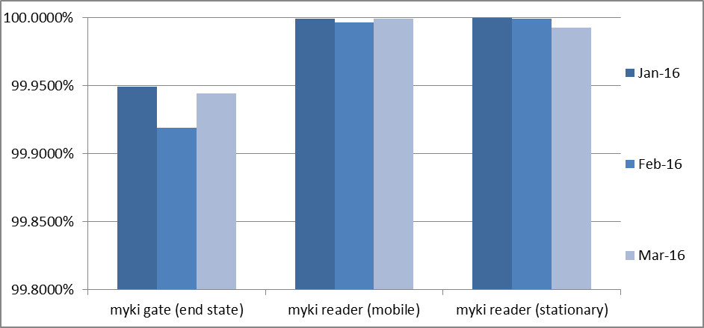
Monitoring of ticketing equipment

The status of ticketing equipment at railway stations is monitored via fixed communication. NTT Data therefore, has accurate and up-to-date information on the availability of ticketing machines at railway stations and can promptly schedule repairs or servicing.

Mobile equipment on board trams and buses utilises wireless communications. Tram and bus operators are required to make vehicles with faulty equipment available to NTT Data for repairs and services. Measures and performance targets vary between modes.

Fare evasion
Attitudes toward Authorised Officers
Figure 10: Attitudes toward Authorised Officers (per cent)
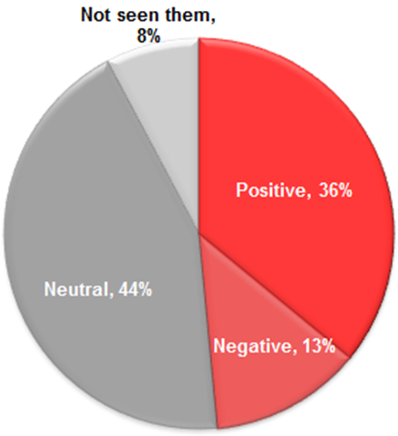
Table 19: Detailed attitudes toward Authorised Officers
Attitudes towards authorised officers | Jan – Mar 2015 | Apr – Jun 2015 | Jul – Sep 2015 | Oct – Dec 2015 | Jan – Mar 2016
Neutral | 44% | 56% | 49% | 30% | 44%
Pleased | 15% | 15% | 16% | 27% | 18%
More secure | 17% | 18% | 19% | 22% | 18%
Annoyed | 5% | 2% | 4% | 6% | 5%
Nervous | 8% | 5% | 3% | 5% | 4%
Harassed | 2% | 1% | 3% | 3% | 4%
Have not seen them | 8% | 2% | 4% | 8% | 8%
Sample size | 401 | 400 | 503 | 400 | 400
Over a third (36 per cent) of public transport users reported feeling positive towards Authorised Officers in the March 2016 quarter, down from last quarter (49 per cent).

The decrease in overall positive feelings is driven due to an increase in those feeling ‘neutral’ (from 30 per cent last quarter to 44 per cent this quarter).

Customer service

Website
PTV’s website provides journey planning, timetable, ticketing and marketing information for metropolitan Melbourne and regional Victoria. The PTV mobile phone apps for iPhones and Android handsets feature timetable and journey planning information.
Table 20: Website performance
 | Jan 2016 | Feb 2016 | Mar 2016 | Quarter total | Quarter on quarter change* | Year on year change*
Visits | 4.3m | 4.4m | 4.7m | 13.5m | +13% | +8%
Visitors | 2.0m | 1.9m | 2.0m | 4.9m* | +12% | +11%
Pageviews | 12.5m | 12.6m | 12.7m | 37.8m | +16% | +10%
*The quarter total for unique visitors may be higher than the aggregate of the three months as a visitor may visit the website more than once during a month, but is only counted once in the quarter total.
The PTV website received a record 13.5 million visits from customers in the March quarter. This is up 8% year-on-year on the previous record of the same quarter last year.

Activity built across the quarter, peaking in early to mid-March. This period is the usual annual peak for usage, driven by the start of the university year.

Journey planner

Customers planned a record 39.5 million journeys using PTV’s journey planner on our website, mobile phone apps or at the call centre during the quarter. This is a 6% increase on the record total of the previous quarter, and up 50% on the same period last year. Much of this growth is attributable to the increasing usage of PTV’s mobile apps.

News and service alterations

Improvements works on the Frankston line, including bus replacements over several weeks was the quarter’s most-viewed news article, with V/Line cancellations and coach replacements also driving a lot of activity.

Mobile apps

PTV mobile apps were installed by 184,000 new customers during the quarter, and updates to both our iOS and Android apps were released in February.

Figure 11: Website visits
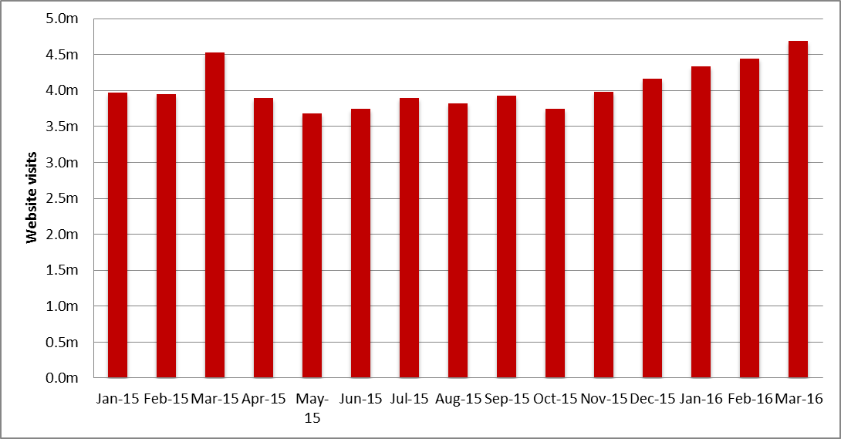
Source: Google analytics
Table 21: Website visits
Month | Jan 2015 | Feb 2015 | Mar 2015 | Apr 2015 | May 2015 | Jun 2015 | Jul 2015 | Aug 2015 | Sep 2015
Pageviews | 11,153,446 | 11,052,454 | 12,267,552 | 10,656,664 | 9,931,612 | 10,733,268 | 10,891,310 | 10,398,847 | 10,723,050
Visitors | 1,786,858 | 1731404 | 1,846,251 | 1,695,067 | 1,609,900 | 1,667,018 | 1,686,169 | 1,628,928 | 1,720,521
Visits | 3,965,426 | 3,943,325 | 4,525,912 | 3,891,184 | 3,681,972 | 3,743,489 | 3,895,115 | 3,819,592 | 3,928,755

Month | Oct 2015 | Nov 2015 | Dec 2015 | Jan 2016 | Feb 2016 | Mar 2016
Pageviews | 10,053,883 | 11,047,132 | 11,422,931 | 12,520,822 | 12,570,239 | 12,715,156
Visitors | 1,655,989 | 1,755,162 | 1,845,806 | 1,964,263 | 1,938,322 | 1,997,612
Visits | 3,746,178 | 3,978,079 | 4,162,017 | 4,334,701 | 4,446,234 | 4,686,265

Call Centre
PTV’s Call Centre provides journey and ticket information for metropolitan and regional services, as well as taking reservations and payment for V/Line tickets. It also collects feedback on behalf of all operators.
Table 22: Call Centre calls received
Measure | Jan 2016 | Feb 2016 | Mar 2016 | Quarter Total | Quarter on quarter change | Year on year change
Calls received | 130,356 | 128,492 | 126,178 | 385,026 | 17.8% | 13.3%
Call volumes increased 17.8 per cent this quarter and increased 13.3 per cent against the same period last year.
Figure 12: Call Volumes and Grade of Service (per cent)

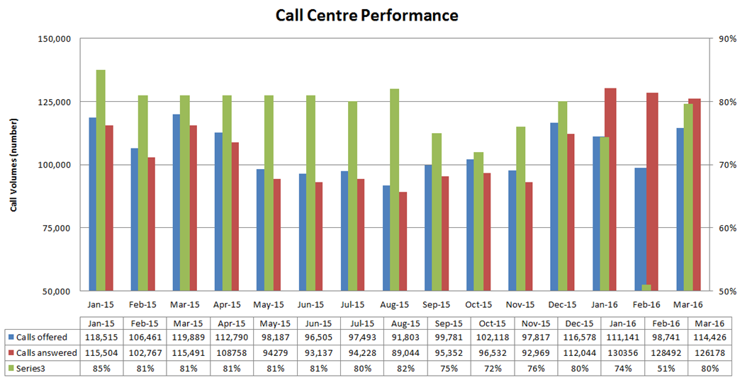
Table 23: Call Volumes and Grade of Service (per cent)
Calls | Jan 2015 | Feb 2015 | Mar 2015 | Apr 2015 | May 2015 | Jun 2015 | Jul 2015 | Aug 2015 | Sep 2015 | Oct 2015 | Nov 2015 | Dec 2015 | Jan 2016 | Feb 2016 | Mar 2016
offered | 118,515 | 106,461 | 119,889 | 112,790 | 98,187 | 96,505 | 97,493 | 91,803 | 99,781 | 102,118 | 97,817 | 116,578 | 111,141 | 98,741 | 114,426
answered | 115,504 | 102,767 | 115,491 | 108,758 | 94,279 | 93,137 | 94,228 | 89,044 | 95,352 | 96,532 | 92,969 | 112,044 | 130356 | 128492 | 126178
GOS% | 85% | 81% | 81% | 81% | 81% | 81% | 80% | 82% | 75% | 72% | 76% | 80% | 74% | 51% | 80%
The Grade of Service target of 80 per cent of calls answered within 30 seconds was not met in January (74 per cent) and February (51 per cent), but was met in March (80 per cent).

Industry-wide feedback

About industry feedback
Feedback data from all operators who have Resolve (Metro, Yarra, V/Line and PTV), is collected in a central database to aid industry-wide reporting and analysis. Bus data is provided to PTV by BusVic on behalf of its members.

Stakeholder share
During the March quarter, stakeholders reported receiving 23,764 cases (excluding special needs booking requests); this was an 11 per cent increase on the previous quarter, and up by 28 per cent year-on-year.
PTV received 4,546 primary cases during the quarter; a 14 per cent increase on the previous quarter, and up by 5 per cent year-on-year.
Figure 13: Resolve – Stakeholder share
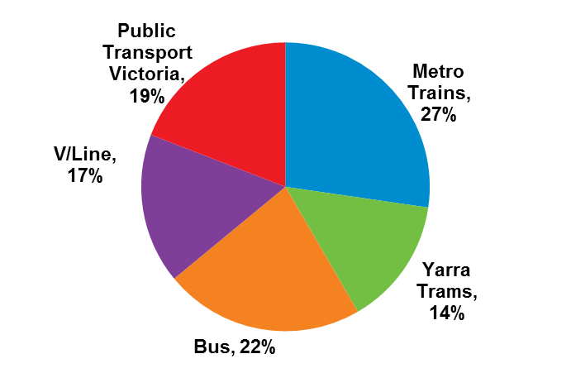
Table 24: Resolve – Stakeholder share
Operator | Total number of cases | Share of all cases | Quarter-on-quarter change | Year-on-year change
Metro | 6,486 | 27% | 19% | 14%
Yarra Trams | 3,406 | 14% | -9% | 12%
Bus | 5,324 | 22% | -2% | 55%
V/Line | 4,002 | 17% | 45% | 86%
PTV | 4,546 | 19% | 14% | 5%
Total | 23,764 | 100% | 11% | 28%
* Special needs booking requests have been removed

Types of feedback
Figure 14: Types of feedback
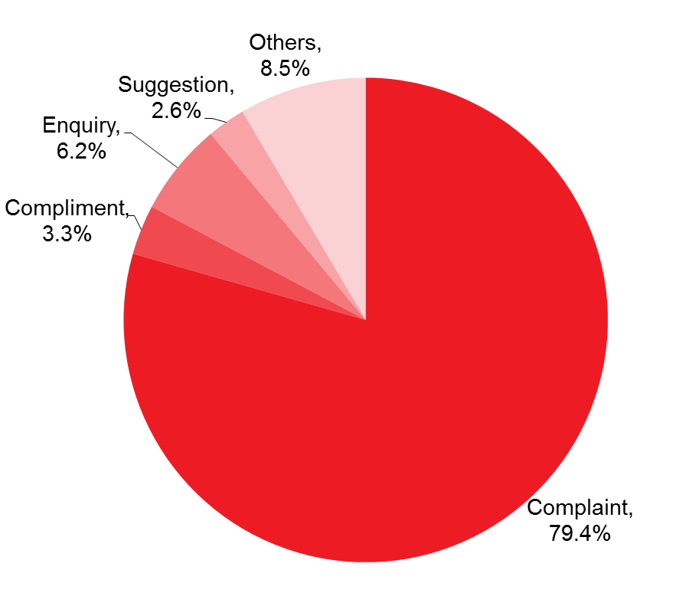
Table 25: Types of feedback
Feedback type | Percentage
Complaint | 79.4%
Compliment | 3.3%
Enquiry | 6.2%
Others | 8.5%
Suggestion | 2.6%

Industry feedback
Figure 15: Top five feedback issues across the industry
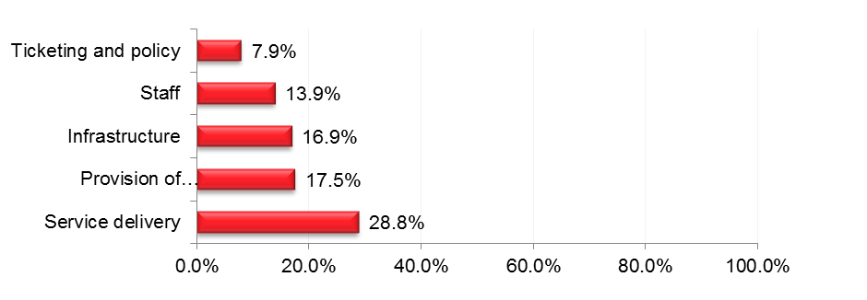Note: Top issues for cases entered into the Resolve database (excluding performance-based compensation claims and compliments).
Table 26: Top five feedback issues across the industry
Issue | Percentage
Service delivery | 28.8%
Provision of information | 17.5%
Infrastructure | 16.9%
Staff | 13.9%
Ticketing and policy | 7.9%
Note: Top issues for cases entered into the Resolve database (excluding performance-based compensation claims and compliments).
Table 27: Breakdown of top industry issue*
Issue | Percentage
Service Disruption | 20.1%
Delayed | 16.3%
Cancellation | 8.8%
Service Change Needed | 7.6%
Bus replacements | 7.0%
*Top issue: Service delivery: 28.8 per cent of cases
Note: Bus industry feedback categorisation does not currently allow for analysis beyond the top PTV issues feedback.

PTV feedback
Provision of information was the top feedback issue of the quarter, accounting for 32 per cent of PTV cases.
Mobile Products accounted for 43 per cent of the feedback received under Provision of Information.
59 per cent of the feedback came from the iPhone – PTV App 3.0. Issues consisted of:
- Technical issues
- Future enhancement
- Ease of use.
Service delivery accounted for 21 per cent of all PTV cases. Requests included:
- Service change needed
- System improvement
- Compensation request.
Some 3.3 per cent of cases received during the quarter were compliments.
The top compliments were Staff and Service delivery (accounting for 62 per cent of compliments).
- 79 per cent of the compliments from Staff related to Call Centre.
- 35 per cent of the compliments from Service delivery related to Night Network.
Figure 16: PTV top five feedback issues
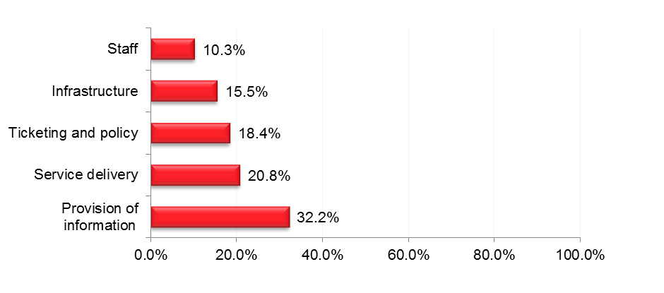
Note: Bus industry feedback categorisation does not currently allow for analysis beyond the top PTV issues feedback.
Table 28: PTV top five feedback issues
Issue | Percentage
Provision of Information | 32.2%
Service delivery | 20.8%
Ticketing and policy | 18.4%
Infrastructure | 15.5%
Staff | 10.3%
Note: Top issues for cases entered into the Resolve database (excluding performance-based compensation claims and compliments).
Table 29: Breakdown of top PTV issue*
Issue | Percentage
iPhone - PTV App 3.0 | 58.6%
Android | 21.4%
PTV Apps | 13.1%
iPhone - PTV App 3.1.0 | 2.8%
Android - PTV - App 1.1.1 | 1.4%
*Top PTV issue: Provision of Information: 32.2 per cent of cases
Note: Bus industry feedback categorisation does not currently allow for analysis beyond the top PTV issues feedback.

