Can I? Can’t I? Domestic firewood collection from Victoria’s public land

Photo : Firewood that has been collected from a Victorian State Forest.

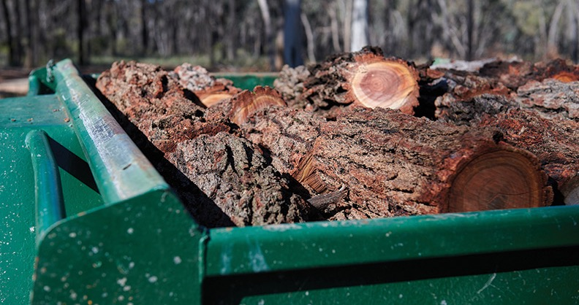

# Introduction

You can collect firewood from public land at designated collection areas during the Autumn and Spring collection seasons. You can collect trees and branches that are already on the ground but not cut down standing trees. You can use the wood you find for domestic use (at home or for camping), but you can’t sell it.

The rules are in place to:

* make sure there’s enough for everyone (especially local community members who rely on it for heating)
* ensure the forests stay healthy enough to keep producing firewood into the future
* protect trees that may take hundreds of years to reach maturity and that provide homes for our native wildlife.
* Firewood supplies at collection areas are limited and may be exhausted early in the collection season. Collectors should plan accordingly and seek legal firewood suppliers as an alternative when public land supply runs out.

# Common questions and answers

## Where can I collect firewood?

### Firewood collection areas

You can only collect firewood from designated firewood collection areas during certain times of year. These areas can be found online at [ffm.vic.gov.au/firewood](http://ffm.vic.gov.au/firewood) or on the domestic firewood collection area map available from your nearest DEECA or Parks Victoria office.

When you arrive in the forest, you will see the areas marked with signs.

### Why?

Firewood collection areas are chosen to best balance making firewood available to the community with keeping the forest healthy and productive.

## When can I collect firewood?

### Spring and autumn

Victoria has two statewide firewood collection seasons:

* Autumn – 1 March to 30 June
* Spring – 1 September to 30 November

The collection season is subject to local conditions and areas may be closed at short notice. Check [ffm.vic.gov.au/firewood](http://ffm.vic.gov.au/firewood) for updates.

### Why?

Collection seasons are during safest times of year and tracks are stable. Summer months present too high a fire danger, and heavy use of forest areas in winter seasons damages roads and tracks.

## How much firewood can I collect?

You can collect two cubic meters of firewood per person per day. That’s about two small to medium trailer-loads. You can collect a total of 16 cubic meters of firewood for your household per financial year.

### Why?

Firewood is in short supply in many areas, and these limits prevent households stockpiling large volumes of firewood from public land and denying others. Please consider others when deciding how much firewood to collect.

## Is there any priority access to firewood?

### Yes

In areas where firewood supplies are very limited, we can give priority access. This includes:

* Those more dependent on firewood as a household energy source.
* Local community members.
* Concession card holders.
* Traditional Owners.

Signs indicate restricted access areas. Information is also available online or from your nearest DEECA office.

## Can I collect firewood for another person?

### Yes

You need to fill out a nominated firewood collection form available at your nearest DEECA or Parks Victoria office, or get one online at [ffm.vic.gov.au/firewood](http://ffm.vic.gov.au/firewood)

You need to keep the form with you when you collecting. Authorised Officers may ask you to show your form on request.

## Can a person be fined for not following the rules?

### Yes

Infringements can be issued for a range of offences. For more serious offending linked to tree felling for personal commercial gain, individuals risk having items such as chainsaws, trailers and even vehicles seized and forfeited to the Crown.

People who take more than their fair share of firewood, or take it outside the nominated seasons and collection areas can also face significant fines or even imprisonment.

## What type of wood can I take?

You can take wood from trees or branches that:

* are already on the ground;
* are further than 20m (approx. 20 big steps) from a waterway
* are not visibly hollow; and
* do not have moss or fungi growing on them.

### Why?

These rules help keep our native wildlife habitat intact, and our forests rich and healthy.

## What equipment can I bring?

### Domestic vehicles & equipment

You can bring an ordinary vehicle, like a car, ute or 4WD, and a trailer. You can only drive on formed roads and established tracks. You can put logs into your vehicle or trailer, but not tow or winch them along the ground.

You can also bring items such as a chainsaw, axe and/or handsaw. If you need to refill your chainsaw oil or fuel, this must be on an impermeable surface such as a rubber mat or the ute tray, (not an absorbent surface like soil).

Heavy vehicles and equipment such as bulldozers, cranes, excavators, forwarders, hydraulic log splitters, saw benches, skidders, skid steer loaders or tractors are not allowed.

## Can I cut down standing trees or take branches from them?

### No

Felling or cutting down trees (whether they are dead or alive) on public land is illegal.

### Why?

Cutting down trees on public land is a safety risk and standing trees (both dead and alive) are critical to forest and wildlife health.

## Can I sell firewood that I’ve collected from public land?

### No

It is illegal to sell firewood collected from public land, unless you have a special authorisation to do so.

### Why?

People who illegally sell firewood are taking more than their fair share and making a profit from something that belongs to us all. This affects wood supply and impacts the people who really need it.

People who sell firewood illegally also often take very large, old trees from protected areas. Once age old dead trees have been cut down, they will not be replaced in our lifetimes, particularly with slow growing durable species such as River Red Gum and Grey Box. These trees are also important for the native animals that rely on them for shelter. Don’t destroy their homes to heat yours.

# If you see something, say something.

**Please call 136 186 to report suspected illegal activity.**

[ffm.vic.gov.au/firewood](http://ffm.vic.gov.au/firewood)

# Publication information

## Acknowledgements

We acknowledge and respect Victorian Traditional Owners as the original custodians of Victoria’s land and waters, their unique ability to care for Country and deep spiritual connection to it.

We honour Elders past and present whose knowledge and wisdom has ensured the continuation of culture and traditional practices.

DEECA is committed to genuinely partnering with Victorian Traditional Owners and Victoria’s Aboriginal community to progress their aspirations.

## Copyright

© The State of Victoria Department of Energy, Environment and Climate Action, 2021.

## Creative Commons

This work is licensed under a Creative Commons Attribution 4.0 International licence, visit the [Creative Commons website](http://creativecommons.org/licenses/by/4.0/) (<http://creativecommons.org/licenses/by/4.0/>).

You are free to re-use the work under that licence, on the condition that you credit the State of Victoria as author. The licence does not apply to any images, photographs or branding, including the Victorian Coat of Arms, and the Victorian Government and Department logos.

**ISBN** 978-1-76136-133-3 **(Print)**

**ISBN** 978-1-76136-132-6 **(pdf/online/MS word)**

## Disclaimer

This publication may be of assistance to you but the State of Victoria and its employees do not guarantee that the publication is without flaw of any kind or is wholly appropriate for your particular purposes and therefore disclaims all liability for any error, loss or other consequence which may arise from you relying on any information in this publication.

## Accessibility

To receive this document in an alternative format, phone the Customer Service Centre on 136 186, email [customer.service@delwp.vic.gov.au](mailto:customer.service@delwp.vic.gov.au), or contact National Relay Service on 133 677. Available at DEECA website ([www.deeca.vic.gov.au](http://www.deeca.vic.gov.au/)).

**End of document.**