# Performance by material

## Aggregates, masonry and soil

Aggregate is a granular material used in construction. The most common natural aggregates include sand, gravel and crushed rock. Aggregates are used in a wide variety of applications including the construction of roads, pavements, building foundations and agricultural applications. When combined with other materials, aggregates enable the construction of essential infrastructure such as houses, roads, bridges, schools and hospitals – all critical components in maintaining living standards. Recycled concrete aggregate is highly effective for use in road bases and hardstand areas due to its compaction properties, which result in stronger and more durable surfaces compared to virgin aggregate.

Masonry materials include heavy waste types such as concrete, bricks, asphalt and rubble (O’Sullivan 2021). These are the primary materials generated by the construction industry, which is one of the highest contributors to Australia’s total waste generation.

Soil, as discussed in this material stream, focuses exclusively on non-contaminated soil. Soil with contaminants above specified thresholds or containing asbestos is classified as contaminated soil (a reportable priority waste). Soil discussed here predominantly originates from industrial processes but is classified as non-priority waste as it does not pose significant environmental or health risks. This material is commonly reused as fill material and utilised for leveling land or filling pits (EPA 2024). It is noted that most fill material does not enter the formal waste management system as it is reused onsite or transported directly to fill sites.

Waste generation is positively correlated with the amount of C&D activity each year due to the weight of the material.

Asphalt, bricks and concrete have a very high recovery rate reflective of valuable application in built environment. Soils, natural materials and plaster have a much lower recovery rate and they are more challenging to recycle (Recycling Victoria 2024c).

With the construction industry being one of the largest employers in Victoria, there are strong and viable local end markets for recycled materials across the state (Recycling Victoria, 2024c). Because of factors such as transport costs and carbon emissions, the uptake of recycled / reused materials in these projects is higher in Metropolitan Melbourne than in regional areas.

The recovery and reuse of materials like aggregates and masonry in the construction sector have become well-established practices. The processing of these materials locally has proven to be highly efficient, with substantial potential for regional investment. Due to the high transport costs associated with moving materials over long distances and the relatively low technological requirements for reprocessing, local reprocessing capacity is well-positioned to meet growing demand across the state (Recycling Victoria 2024c).

### Market performance

The overall recovery rate for aggregates, masonry and soil in Victoria in 2022–23 was 83%, which is similar to the recovery rate of 85% observed in both 2020–21 and 2021–22.

Figure 8: Aggregates, masonry and soil generated, recovered for processing, and disposed of in Victoria in 2022–23 (tonnes) (Recycling Victoria 2024b)

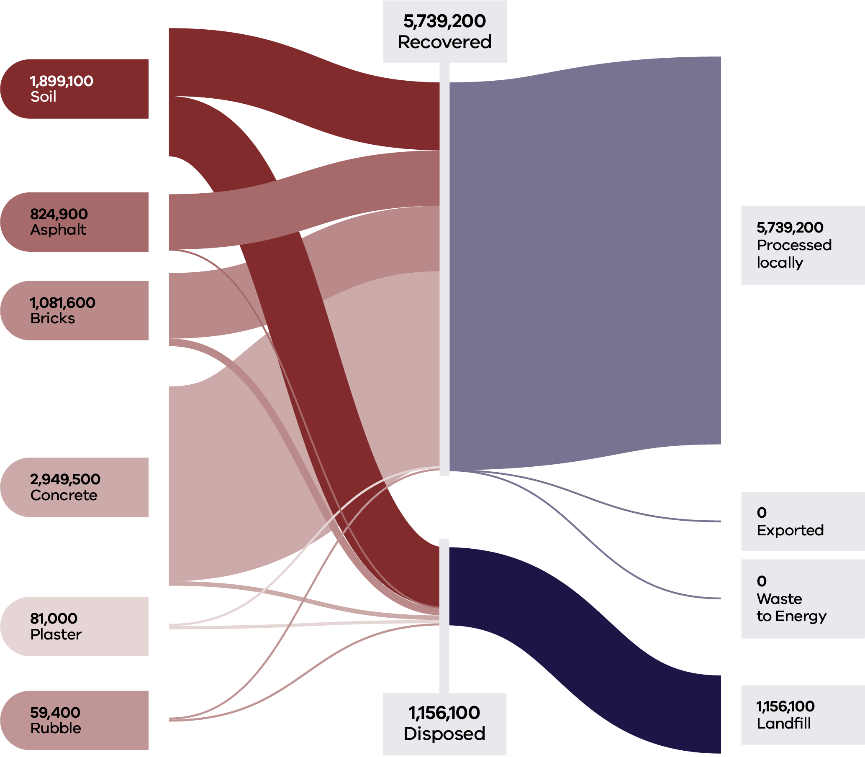

This was largely driven by the C&D sector, with the MSW and C&I sectors generating a low volume of material and lower recovery rates (21% and 41% respectively).

As in 2020–21, there was no export of aggregates, masonry and soil from Victoria in 2022–23. All processing is carried out in Victoria, ensuring that the investment and full value of resource recovery activity is captured locally.

Aggregates, masonry and soil combined, are Victoria’s largest waste stream by mass (6.9M tonnes in 2022–23), representing 47% of all state-wide waste generation. Most (93%) of this material was generated and managed by the C&D sector (Table 6).

Table 6: Source streams and recovery rates for aggregates, masonry and soils in Victoria in 2022–23 (Recycling Victoria 2024b)

| Stream | Generated | | Recovered for reprocessing | | | Disposed | Recovery rate |
| --- | --- | --- | --- | --- | --- | --- | --- |
|  |  |  | **Processed locally** | **Exported** | **Total** |  |  |
|  | **Tonnes** | **Proportion** | **Tonnes** | **Tonnes** | **Tonnes** | **Tonnes** | **%** |
| MSW | 91,100 | 1% | 18,800 | 0 | 18,800 | 72,200 | 21% |
| C&I | 438,400 | 6% | 180,600 | 0 | 180,600 | 257,800 | 41% |
| C&D | 6,365,800 | 93% | 5,539,800 | 0 | 5,539,800 | 826,100 | 87% |
| **Total** | **6,895,300** |  | **5,739,200** | **0** | **5,739,200** | **1,156,100** | **83%** |

| Stream | Generated | | Recovered for reprocessing | | | Disposed | Recovery rate |
| --- | --- | --- | --- | --- | --- | --- | --- |
|  |  |  | Processed locally | Exported | Total |  |  |
|  | Tonnes | Proportion | Tonnes | Tonnes | Tonnes | Tonnes | % |
| Asphalt | 824,900 | 12% | 819,100 | 0 | 819,100 | 5,700 | 99% |
| Bricks | 1,081,600 | 16% | 970,300 | 0 | 970,300 | 111,300 | 90% |
| Concrete | 2,949,500 | 43% | 2,882,700 | 0 | 2,882,700 | 66,800 | 98% |
| Plaster | 81,000 | 1% | 33,000 | 0 | 33,000 | 48,000 | 41% |
| Rubble | 59,400 | 1% | 28,800 | 0 | 28,800 | 30,600 | 48% |
| Soil | 1,899,100 | 28% | 1,005,300 | 0 | 1,005,300 | 893,700 | 53% |
| **Total** | **6,895,300** |  | **5,739,200** | **0** | **5,739,200** | **1,156,100** | **83%** |

### Developments and changes

Victoria’s rapid growth and investment in major infrastructure projects continue to increase demand for quarry products such as soil, sand and rock consistent with projections of demand doubling between 2015 and 2050 (Resources Victoria 2023).

The Victorian Government’s ecologiQ initiative, supported by the Recycled First policy, has continued to provide end market pull-through of aggregates and masonry into large government infrastructure projects (ecologIQ 2024).

The Recycled First Summary Report on progress from 2020 to 2023 (ecologIQ 2024) shows some of the benefits realised through the policy. There are 16 Recycled First road and rail projects that have been completed, with a further 36 in procurement and delivery. There is 3.4M tonnes of recycled or reused material committed for future projects, with 90% of that amount being road projects.

### Market issues and challenges

The waste stream from C&D activities is projected to grow to over 16 million tonnes annually over the next 30 years.

The reuse of materials, particularly soil, can sometimes be hindered by lack of space to sort and temporarily store material.

In smaller construction projects, mixed material loads are frequently sent directly to landfill, perpetuating reliance on virgin materials. These projects often face higher costs per unit for using recycled materials, in addition to navigating regulatory challenges and market resistance. Compared to large-scale projects, smaller projects are more likely to encounter barriers to adopting recycled materials due to these economic and regulatory constraints.

Another major logistical challenge for the soil reuse market is the need to ensure that contamination is not present in recycled quarry products including soil. Australian soil has been contaminated with conventional and emerging contaminants for decades, including heavy metals, hydrocarbons, organic matter and man-made chemicals (Quarry 2020).

Contaminated soil wastes are a major component of hazardous waste in Australia, but little national data is available on these wastes (Plant et al. 2014). This is due, in part, to the diverse ways in which jurisdictions define, classify and regulate waste. Historically this has led to hazardous waste tracking that has been irreconcilable at the national level, making systematic and coherent national assessment and tracking challenging.

### Focus areas for greater circularity – aggregates, masonry and soils

The analysis highlights the following opportunities for improvements to this material stream:

* Identification and promotion of best practice management techniques to recover, treat and store soil to increase reuse options and recovery rate.
* Investigation and promotion of end markets for recycled plaster and rubble.
* Improved site design and planning to make space for the sorting and storage of recovered materials.

## Glass

Glass is a key material used in a wide range of applications including windows, food and beverage packaging, solar panels, electronics (such as device screens), medical technologies and in fibre optic cables that enable faster internet connections. One of the unique qualities of glass is its ability to be endlessly recycled – melted down and reshaped without losing its structural integrity.

The market demand for glass based construction materials remains high. The glass recovery sector is serviced by beneficiation plants, glass crushing processors and a packaging manufacturing plant.

Recovered glass packaging markets in Victoria are stable and improving but current glass generation exceeds the demand for recycled into new glass packaging. This is expected to improve over the next few years as the recycled content in glass manufacturing increases. All recovered glass is processed in Victoria into glass cullet, then back into glass packaging, or otherwise crushed glass/glass fines into construction materials. Recovering used glass for production of glass sand is growing in Victoria, supported by changes to construction specifications that have increased how much recycled glass sand can be used in road and rail construction (Recycling Victoria 2024c).

### Market performance

The overall recovery rate for glass in Victoria in 2022–23 was 64%. This is consistent with the recovery rate of 63% observed in 2021–22, but less than the recovery rate of 71% observed in 2020–21.

Glass continues to have a high circularity opportunity, with the ability to remanufacture glass packaging into new glass packaging, using around 20–30% less energy compared to glass from virgin silica sand (Recycling Victoria 2024a).

Figure 9: Glass generated, recovered for processing, and disposed of in 2022–23 (tonnes) (Recycling Victoria 2024b)

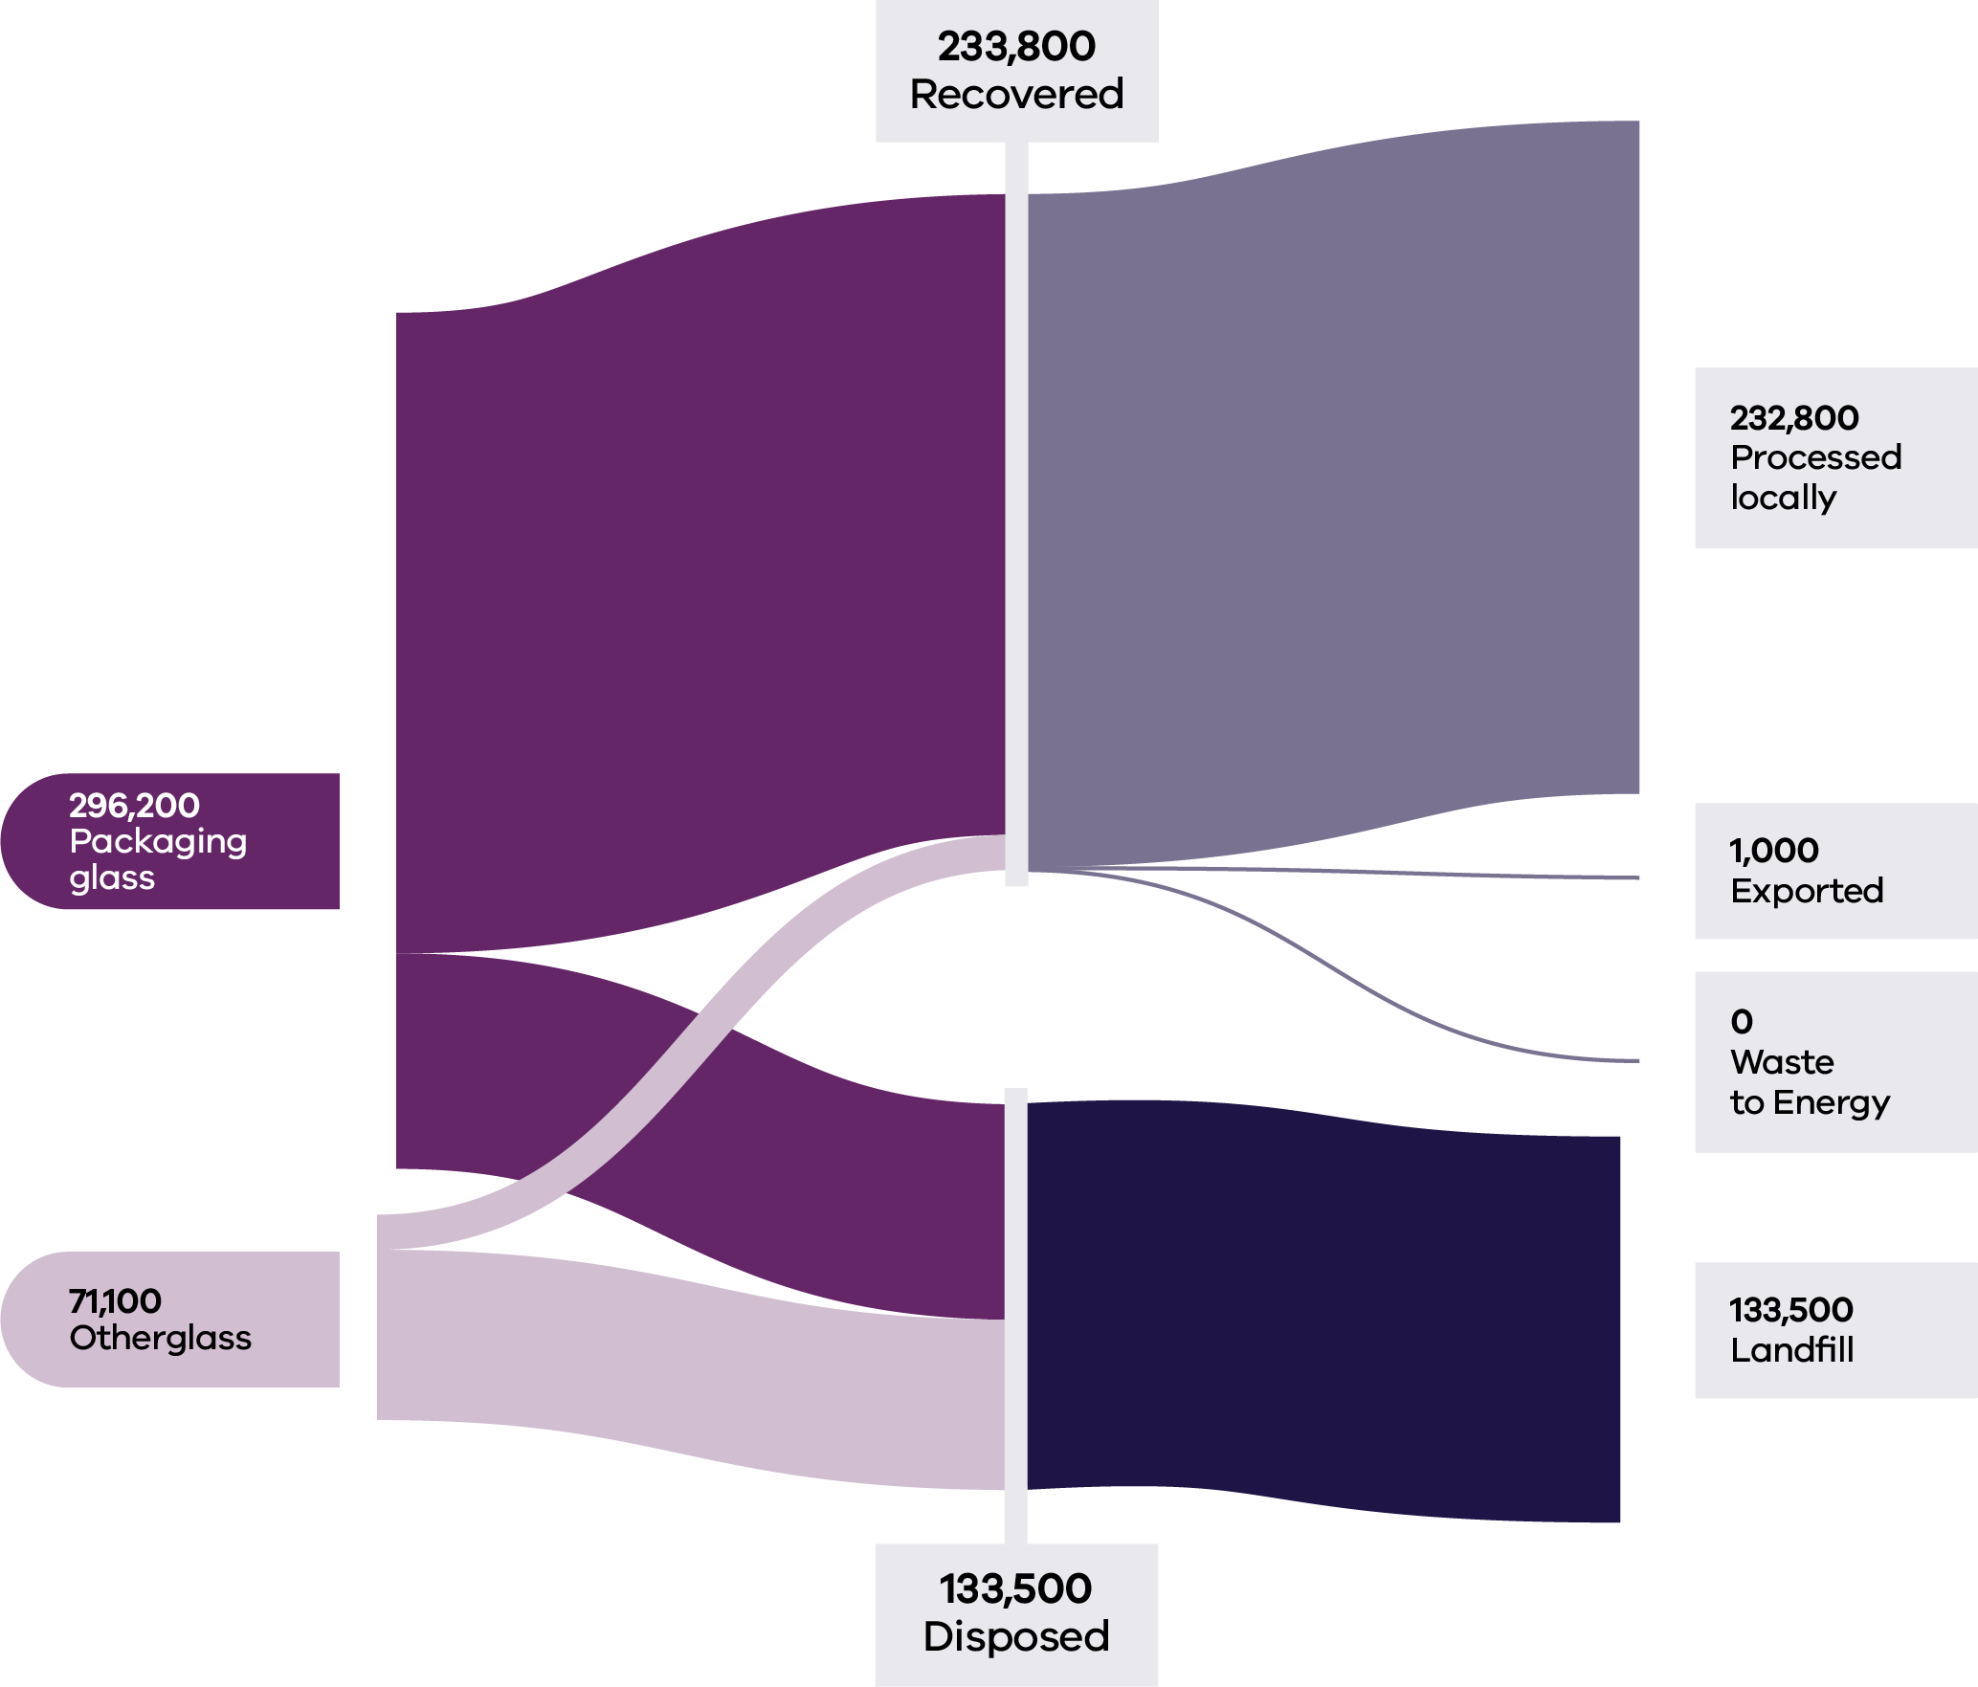

Households (MSW) were the largest contributors to the generation of glass waste (62%) and maintained a similar recovery rate to 2020–21 (66%) and 2021–22 (66%). The recovery rate for ‘Packaging glass’ (75%) is significantly higher than that observed for ‘Other glass’ (17%).

Based on 2021–22 commodity values, it is estimated that almost $17M was lost in landfill from the glass sector in 2022–23, as compared to approximately $25M of lost value for this material type in Victoria in 2021–22.

There was some very limited export of glass materials out of Victoria in 2022–23. Export tonnages are a very minor component (<0.1%) of all recovered glass with almost all material reprocessed locally.

Table 7: Source streams and recovery rates for glass in Victoria in 2022–23 (Recycling Victoria 2024b)

| Stream | Generated | | Recovered for reprocessing | | | Disposed | Recovery rate |
| --- | --- | --- | --- | --- | --- | --- | --- |
|  |  |  | **Processed locally** | **Exported** | **Total** |  |  |
|  | **Tonnes** | **Proportion** | **Tonnes** | **Tonnes** | **Tonnes** | **Tonnes** | **%** |
| MSW | 227,800 | 62% | 150,200 | 700 | 150,900 | 76,900 | 66% |
| C&I | 127,400 | 35% | 74,600 | 300 | 74,900 | 52,600 | 59% |
| C&D | 12,100 | 3% | 8,100 | 0 | 8,100 | 4,100 | 67% |
| **Total** | **367,400** |  | **232,800** | **1,000** | **233,800** | **133,500** | **64%** |

| Stream | Generated | | Recovered for reprocessing | | | Disposed | Recovery rate |
| --- | --- | --- | --- | --- | --- | --- | --- |
|  |  |  | **Processed locally** | **Exported** | **Total** |  |  |
|  | **Tonnes** | **Proportion** | **Tonnes** | **Tonnes** | **Tonnes** | **Tonnes** | **%** |
| Packag-ing Glass | 296,200 | 81% | 220,600 | 1,000 | 221,600 | 74,600 | 75% |
| Other  Glass | 71,100 | 19% | 12,200 | 0 | 12,200 | 58,900 | 17% |
| **Total** | **367,400** |  | **232,800** | **1,000** | **233,800** | **133,500** | **64%** |

### Developments and changes

There is a current strong market emphasis on increasing the recycled glass content in glass packaging manufacture, from the current average of 30–35% to a target range of 60–70%, increasing circularity benefits.

This market trend appears to be driven by consumer expectations. National Government policy is also proposing increases in a minimum post-consumer recycled content threshold for glass of 50% by 2025. This minimum threshold is proposed to increase to 75% by 2040 (DCCEEW 2024d).

In its first year of operation, CDS Vic has collected more than 1 billion eligible containers, which continues to secure a cleaner stream of glass material.

Twenty local government authorities have now introduced a glass-only kerbside bin service (representing 25% of all councils), with a further 16 introducing a new separated glass drop-off service (DEECA 2024).

Both above developments have resulted in an increase in the supply of clean glass to the sector, suitable for glass-to-glass remanufacture

### Market issues and challenges

The glass waste stream is expected to grow by over 50% over the next 30 years, with Victoria projected to generate over 500,000 tonnes by 2053.

Contamination from materials like food residues, bottle caps or ceramics makes it difficult to separate and recycle glass effectively.

Broken glass is also challenging to handle and often not recycled if it’s in small shards or heavily damaged. Limited recycling infrastructure in some areas, along with improper disposal and the economic cost of processing heavily contaminated or broken glass contributes to this issue. Addressing these challenges requires improved recycling facilities, better public awareness and better contamination control.

Many countries are nearing 100% glass recycling rates. In Australia, more than 80% of glass usage is attributed to food and beverage packaging (Dalla Costa and De Meillon, 2022) and more than a quarter of the glass used ends up in landfill. Even when disposed of correctly, broken glass and contamination can render the material unrecyclable.

### Focus areas for greater circularity – glass

The analysis highlights the following opportunities for improvements to this material stream:

Ongoing investigation into opportunities to maximise bottle-to-bottle recycling from opportunities presented by CDS Vic and glass-only kerbside collection.

Support opportunities to increase Victorian glass beneficiation capacity, including regionally.

Investigate opportunities to increase the use of lower grade recovered glass in construction materials, supporting the market for lower grade glass that is not suitable for glass-to-glass recycling.

## Metals

Sources of waste metals in Victoria include:

* packaging from households
* commercial businesses and the hospitality industry
* components from discarded furniture, household appliances and e-waste
* scrap generated by industrial manufacturing processes

materials from end-of-life vehicles.

Additionally, construction and demolition activities contribute significantly to waste metal, with metals like steel, copper and aluminium being recovered from building materials, infrastructure and machinery.

Recovered metals in Victoria are predominantly non-packaging types such as structural steel and aluminium (Recycling Victoria 2024d). Packaging metals, particularly those from food and beverage containers, make up a small portion of the total recovery, typically making up 3–4% of household recycling bin contents.

The waste metals recovery and reprocessing system is well established, and the industry is mature. There is strong dependence on exporting processed metals to fill that need. Increasing the local metal processing market is an opportunity to protect against export bans or other changes, increase the circularity and reduce embodied emissions, particularly if renewable energy is used.

The domestic metal recycling market is based on many small scrap metal collectors who collect material so that it can be aggregated into sufficient volumes to be managed. Waste generation and management levels have been relatively stable for several years. Generally, steel and aluminium packaging is recycled back into post-consumer metal pools to manufacture durable applications such as vehicles, building materials and many other products.

Exported steel and aluminium packaging are sold into large markets with most metal coming from non-packaging sources. The material flows from all countries are destined for wherever the demand requires material for production. Unlike some other materials, the origin of the steel or aluminium in new product is often unknown. Demand and pricing can increase or decrease based on worldwide supply and demand conditions.

### Market performance

The overall recovery rate for metals in Victoria in 2022–23 was 88% which is consistent with the recovery rate of 89% observed in 2020–21 and 2021–22.

More than 35% of all scrap metal generated was exported in 2022–23, making it the biggest export component of recyclable materials. Over 70% of all recovered aluminium was exported for processing in 2022–23. Victoria does not have local aluminium reprocessing capacity, so relies on the export market for managing this material stream. A total of 606,849 tonnes of metals were exported internationally in 2021–22 compared to 512,200 tonnes in 2022–23.

Figure 10: Source streams and recovery rates for glass in Victoria in 2022–23 (Recycling Victoria 2024b)

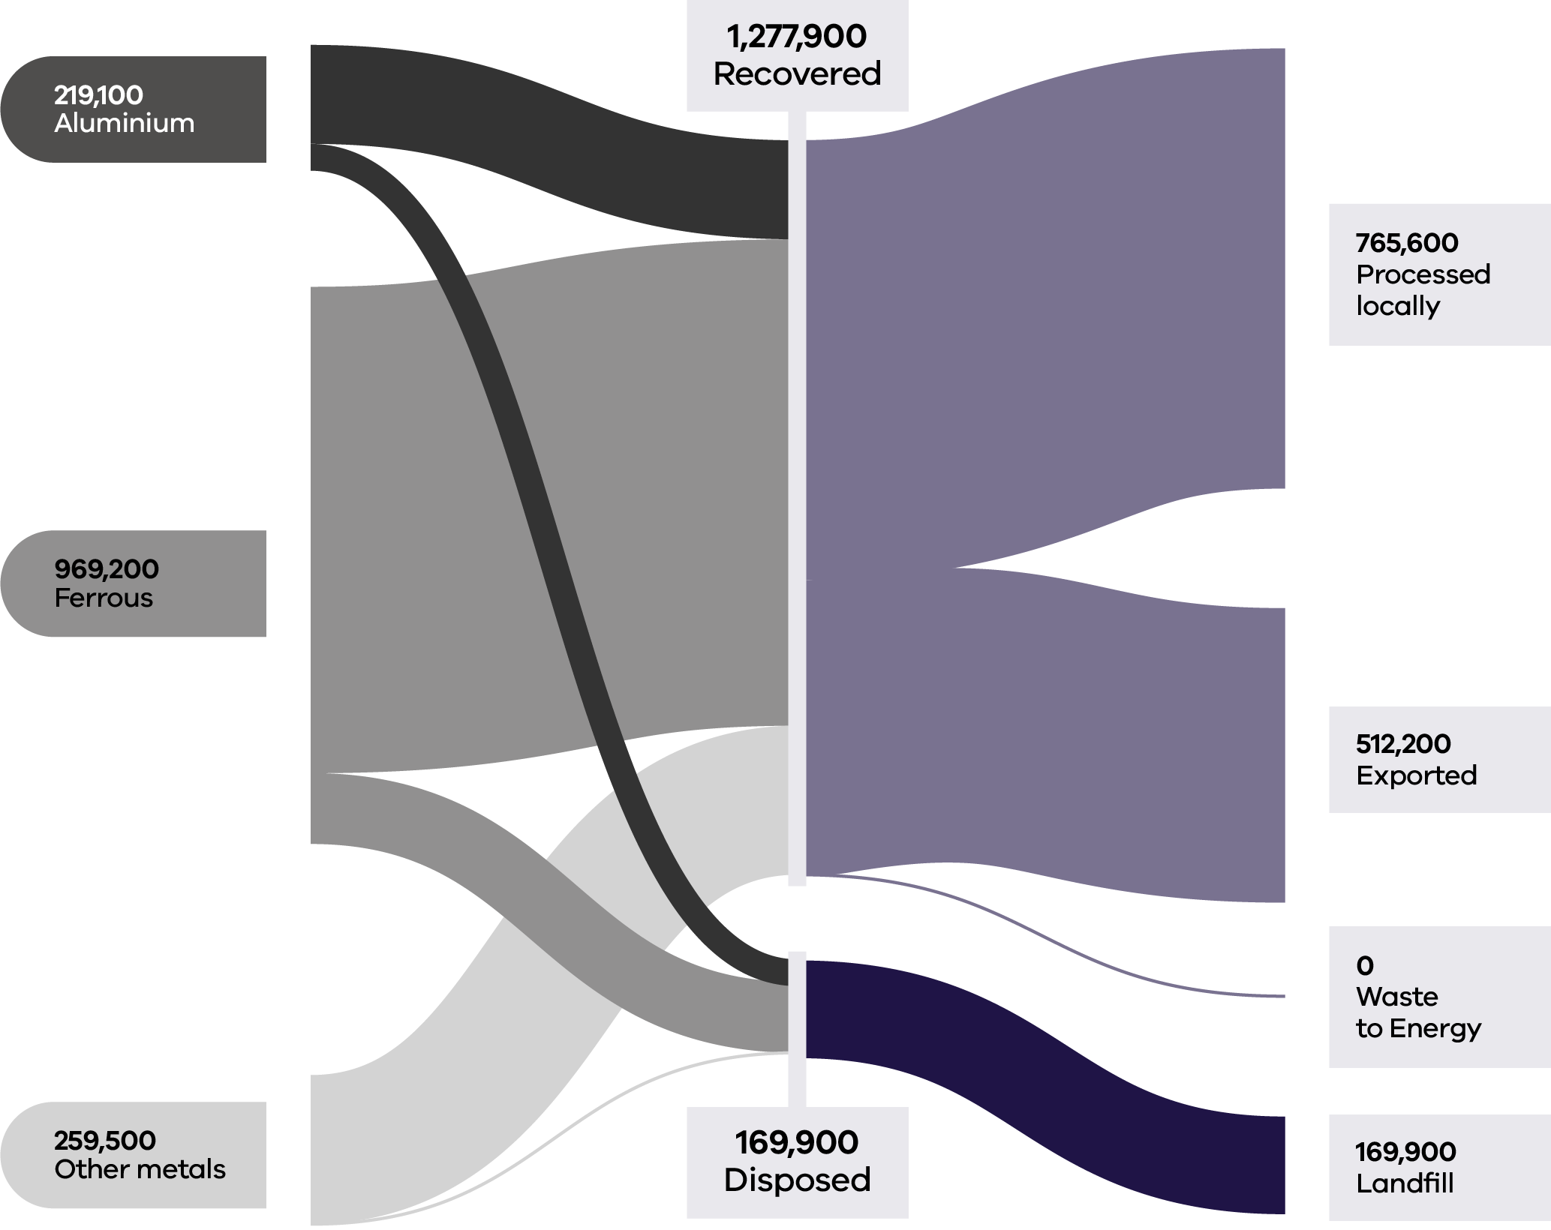

C&I was the largest contributor to the generation of metal (68%) and maintained a similar recovery rate (91%) to 2020–21 (92%) and 2021–22 (91%). A key driver of the high recovery rate for metal waste is the high commodity prices that can be achieved (Recycling Victoria 2024c). The rate of recovery exceeded 75% across all sectors in 2022–23. Similarly high rates were observed in 2020–21.

Around 60% of recovered metal waste was processed locally in 2022–23, with the remainder being processed outside of Victoria (Table 8)

The majority (~90%) of ‘other metals’ were processed locally in 2022–23, with similarly high processing rates reported in 2021–22.

Table 8: Metal flows by stream and material sub-groups for 2022–23 (Recycling Victoria 2024b)

| Stream | Generated | | Recovered for reprocessing | | | Disposed | Recovery rate |
| --- | --- | --- | --- | --- | --- | --- | --- |
|  |  |  | **Processed locally** | **Exported** | **Total** |  |  |
|  | **Tonnes** | **Proportion** | **Tonnes** | **Tonnes** | **Tonnes** | **Tonnes** | **%** |
| MSW | 374,800 | 26% | 182,200 | 136,600 | 318,900 | 55,900 | 85% |
| C&I | 985,400 | 68% | 551,100 | 341,300 | 892,400 | 93,000 | 91% |
| C&D | 87,600 | 6% | 32,400 | 34,300 | 66,600 | 21,000 | 76% |
| **Total** | **1,447,800** |  | **765,600** | **512,200** | **1,277,900** | **169,900** | **88%** |

| Stream | Generated | | Recovered for reprocessing | | | Disposed | Recovery rate |
| --- | --- | --- | --- | --- | --- | --- | --- |
|  |  |  | **Processed locally** | **Exported** | **Total** |  |  |
|  | **Tonnes** | **Proportion** | **Tonnes** | **Tonnes** | **Tonnes** | **Tonnes** | **%** |
| Aluminium | 219,100 | 15% | 50,500 | 121,900 | 172,400 | 46,700 | 79% |
| Ferrous | 969,200 | 67% | 483,500 | 362,500 | 846,000 | 123,200 | 87% |
| Other metals | 259,500 | 18% | 231,700 | 27,800 | 259,500 | 0 | 100% |
| **Total** | **1,447,800** |  | **765,600** | **512,200** | **1,277,900** | **169,900** | **88%** |

It is estimated that material with a potential value of $208M was lost to landfill in 2022–23 in Victoria indicating an opportunity for improved recovery.

The pricing for recycled steel and aluminium reflect that these feedstocks are highly integrated into global markets for virgin commodities. Hence these prices tend to reflect global influences on demand and supply, including perceptions of future global growth.

### Developments and changes

The metal waste stream is projected to grow by around 50% in the next 30 years, generating over 2.6 million tonnes of waste annually in 2053. Metal markets are well established with high value materials. There have been commercial developments in Australia with Sims Resource Renewal in Queensland testing plasma gasification of automotive floc to convert the waste into a synthetic gas, but this is still several years from reaching its potential (Recycling Victoria 2024c).

Operating for over one year now, CDS Vic has created a new collection pathway for metal beverage containers, presenting opportunities for reprocessing to capitalise on this new high value material stream.

### Market issues and challenges

Shredder floc continues to represent a challenge. Floc consists of glass, rubber, plastics, fibres, dirt and fines that remain after ferrous and nonferrous metals have been removed. Floc is highly combustible and poses a fire risk when inappropriately stored in stockpiles.

Ongoing action is required to increase capacity to meet future demand and, where economically viable, to replace exports with local reprocessing. Ongoing actions are also needed to increase capability relating to shredder floc and metals from e-waste (Recycling Victoria 2024c).

### Focus areas for greater circularity – metals

The analysis highlights the following opportunities for improvements to this material stream:

* Explore options to increase local reprocessing capacity to meet future demand and, where economically viable, to replace exports with local reprocessing.
* Investigate improved methods for managing and processing shredder floc to limit stockpiling.
* Investigate options to increase local end markets for steel and aluminium packaging.
* Investigate opportunities to recover precious and rare earth metals in e-waste.

## Organics

Organic waste includes biodegradable material such as:

* food scraps
* garden waste and other plant-based materials
* biodegradable packaging materials
* by-products from food processing and manufacturing

biosolids from water treatment processes.

These materials can be recovered, composted or used for bioenergy production to reduce disposal to landfill.

Organics are the most potent source of greenhouse gas emissions in landfill (DCCEEW 2024c). Recovering organics into compost and fertiliser products reduces greenhouse gas emissions, regenerates landscapes and builds healthier soils.

### Market performance

Victoria recovered just under half (48%) of all organic material generated in 2022–23. Of the 3 contributing sectors, households (MSW) contributed the most to the total tonnes generated (56%) and had the highest recovery rate (59%). This is an improvement from the recovery rate observed for households in 2020–21 (52%) and reflects the benefits realised from the ongoing roll out of FOGO collection services across this state. C&I is the next largest contributor to total tonnes generated (38%) although has a less optimal recovery rate than that for households (37%) (Table 9).

Food organics and garden organics each contribute approximately a third to the total material generation by weight. The recovery rate is markedly better for garden organics (82%) than for food organics (23%). It is estimated that the average Australian household loses $890 every year to food waste and the cost to the Australian economy is $20 billion (KPMG 2020).

Figure 11: Organics generated, recovered for processing, and disposed of in 2022–23 (tonnes) (Recycling Victoria 2024b)

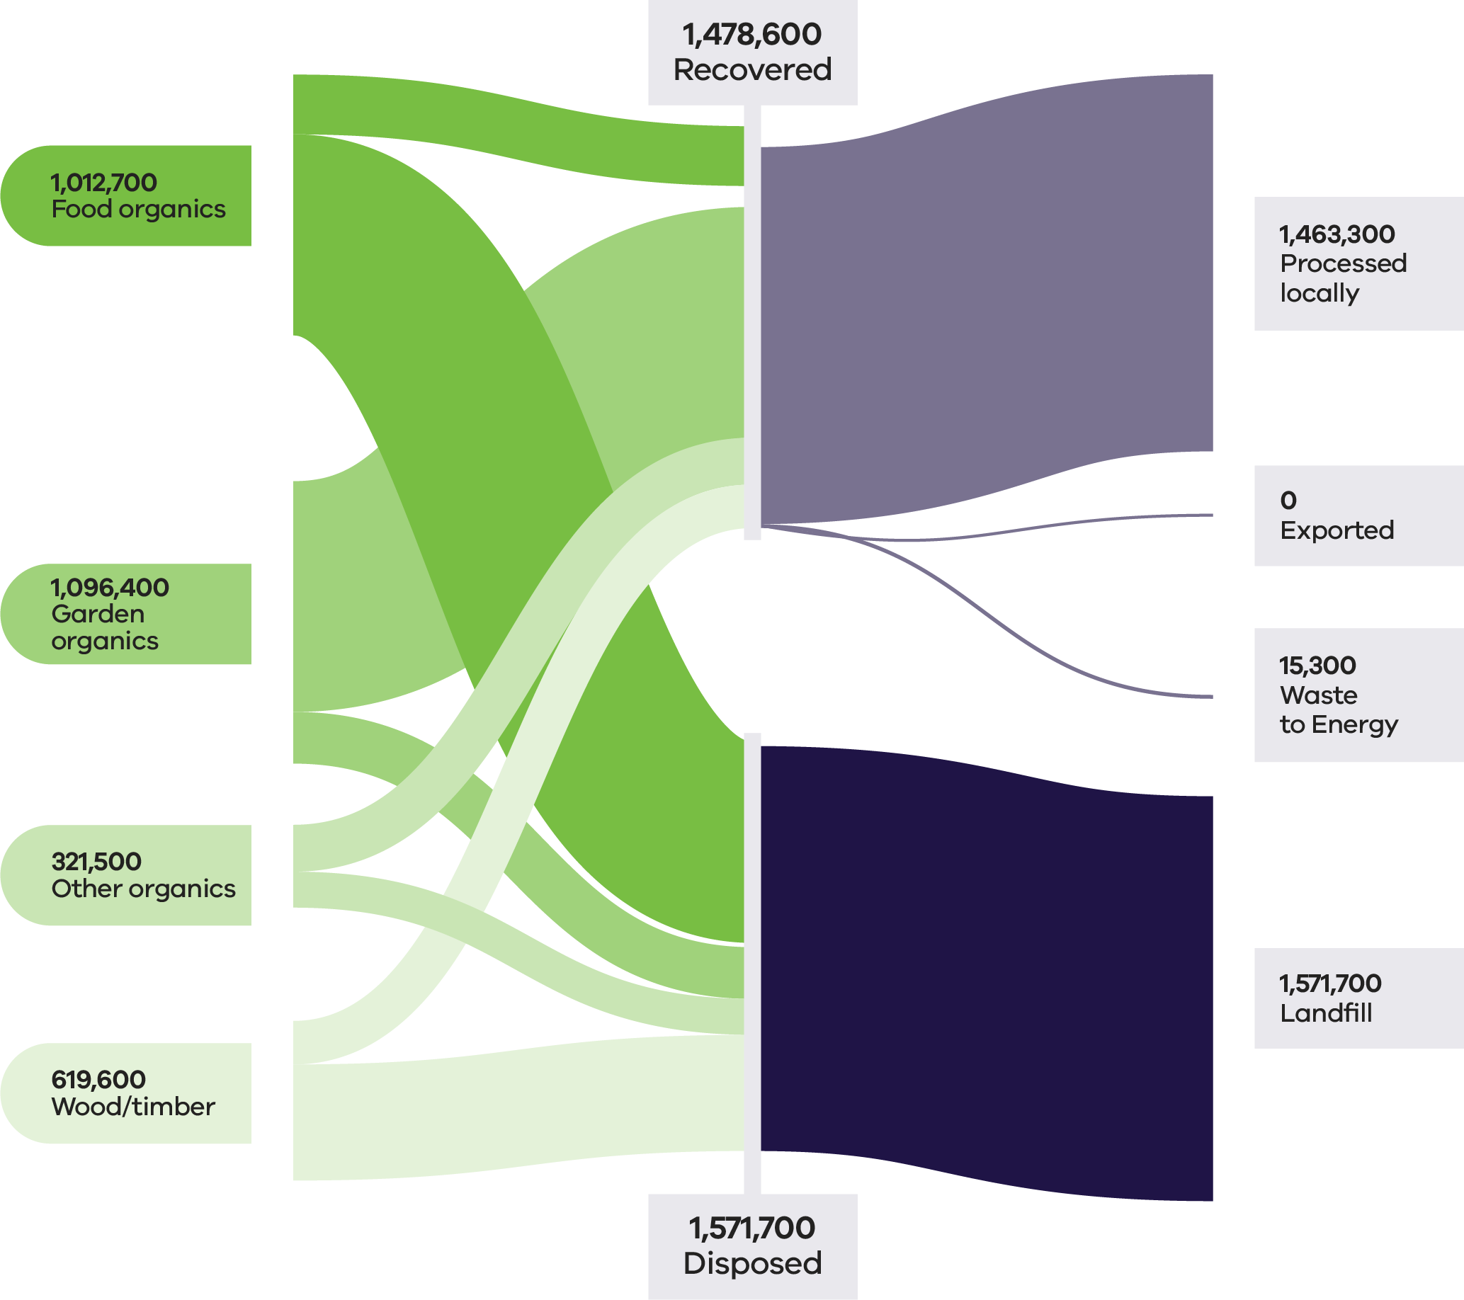

Table 9: Organics flows by stream and material sub-groups for 2022–23 (Recycling Victoria 2024b)

| Stream | Generated | | Recovered for reprocessing | | | Disposed | Recovery rate |
| --- | --- | --- | --- | --- | --- | --- | --- |
|  |  |  | **Processed locally** | **Exported** | **Total** |  |  |
|  | **Tonnes** | **Proportion** | **Tonnes** | **Tonnes** | **Tonnes** | **Tonnes** | **%** |
| MSW | 1,712,800 | 56% | 1,017,100 | 0 | 1,017,100 | 695,700 | 59% |
| C&I | 1,153,900 | 38% | 409,100 | 15,300 | 424,400 | 729,500 | 37% |
| C&D | 183,600 | 6% | 37,100 | 0 | 37,100 | 146,500 | 20% |
| **Total** | **3,050,300** |  | **1, 463,300** | **15,300** | **1,478,600** | **1,571,700** | **48%** |

| Stream | Generated | | Recovered for reprocessing | | | Disposed | Recovery rate |
| --- | --- | --- | --- | --- | --- | --- | --- |
|  |  |  | **Processed locally** | **Exported** | **Total** |  |  |
|  | **Tonnes** | **Proportion** | **Tonnes** | **Tonnes** | **Tonnes** | **Tonnes** | **%** |
| Food Organics | 1,012,700 | 33% | 216,700 | 15,300 | 232,700 | 780,700 | 23% |
| Garden Organics | 1,096,400 | 36% | 895,600 | 0 | 895,600 | 200,900 | 82% |
| Other Organics | 321,500 | 11% | 182,200 | 0 | 182,200 | 139,400 | 57% |
| Wood/ Timber | 619,600 | 20% | 168,900 | 0 | 168,900 | 450,700 | 27% |
| **Total** | **3,050,300** |  | **1,463,300** | **15,300** | **1,478,600** | **1,571,700** | **48%** |

Over the last 5 years, the amount of garden organics collected has increased by approximately 80% while retaining a recovery rate of over 80%. The volume of food organics collected is also expected to steadily increase as councils across the state expand green bin services to include food organics (Recycling Victoria 2024b).

Figure 12 shows the amount of food and garden organics generated and recovered from households (MSW). (Recycling Victoria 2024b)

Figure 12: Changes in MSW food and garden organics recovery over 5 years (Recycling Victoria 2024b)

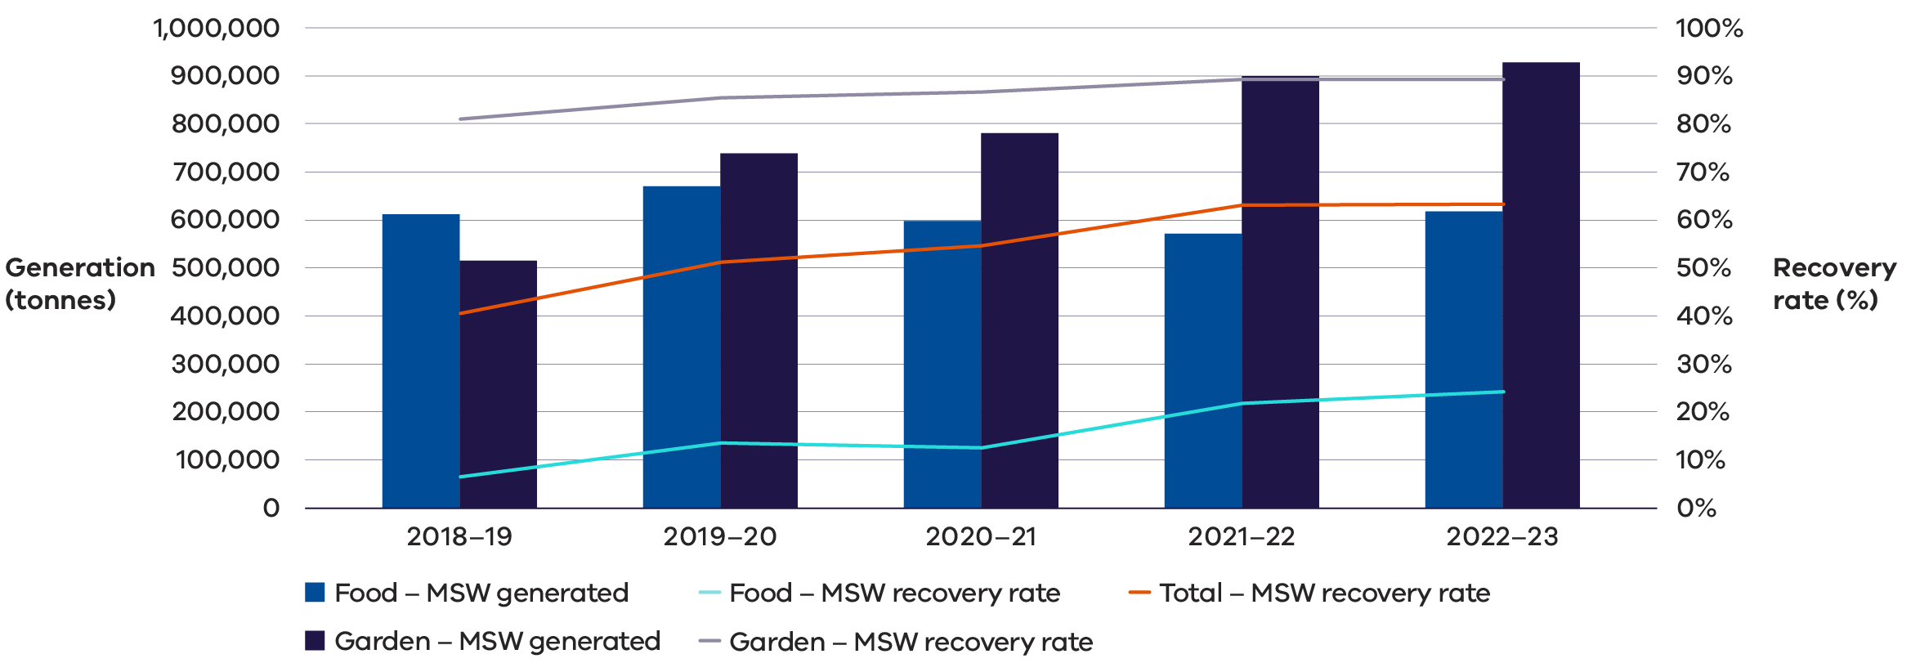

### Commercial and Industrial food waste

Victoria produces 25% of all fresh food in Australia, processes over 50% of all Australian made foods and is responsible for around 25% of Australia’s total food waste (Sustainability Victoria, 2024).

Food waste is a global issue. Each year around the world 1.3 billion tonnes of food is wasted. About one third of all the food produced for human consumption becomes waste. This is a financial concern as well as a major contributor to global warming (Reset 2024). Trends in Australian C&I food organics management as reported in the National Waste Report 2024 (DCCEEW 2024d) show that across all jurisdictions and time periods of available data, the disposal of C&I food organics to landfill is the most common fate.

Organics have high potential for circularity but currently have a low to medium recovery rate nationally. The C&I sector has a poor recovery rate for organics relative to MSW. The national target is to halve food waste by 2030, with the baseline set in 2016–17, and most jurisdictions have adopted targets consistent with the national targets. Victoria has an additional interim target of a 20% reduction in food waste to landfill by 2025.

Opportunities exist at each stage of the lifecycle to reduce C&I food waste and increase recovery including generation, collection, processing and end uses. Opportunities include the following:

* **Avoidance** – Awareness for businesses on the importance of food waste avoidance and education/support for hospitality and food service operators on ways to reduce food waste.
* **Re-use** – Promotion of food reuse via food rescue organisations or business connection platforms.
* **Sorting and collecting** – Collection services through local networks and promote/education on incentivise onsite commercial food recovery systems.
* **Contamination / Recycling** – Decontamination technology (such as depackaging) and ways to improve contamination tolerance in organics recycling facilities.
* **Alternative technology** – Viability assessments of business onsite maceration equipment designed to work with anaerobic digestion and in-sink macerators in collaboration with water industry, as well as the exploration of insect processing as an alternative treatment process and viability for residual C&I timber to be used for refuse derived fuel.

### Development and changes

Household recovery of garden organics continues to develop with the rollout of kerbside FOGO. This is in line with the Victorian Government target to ensure 100% of households have access to food and organic waste services or composting by 2030 (Recycling Victoria 2024f).

The development of small-scale composting infrastructure for regional councils is a relatively recent advancement.

There is increasing uptake from industry and regional communities in advanced recycling methods beyond composting. Water authorities and regional municipalities are also exploring anaerobic digestion and pyrolysis, which present emerging pathways for organic waste into energy, biogas digestate and biochar.

### Market issues and challenges

It is estimated that the average Australian household loses $890 every year to food waste and the cost to the Australian economy is $20 billion (KPMG 2020).

Opportunities remain to reduce food waste generation across the entire value chain, from cultivation and harvesting to retail, households, and the hospitality sector.

Compost and fertiliser products typically attract a modest per-tonne market value and are traded in bulk. These factors, along with transport costs and the perishable nature of organics, impose geographical limitations on supply chains and market reach. As a result, organics markets operate locally, with materials recovered, processed and sold entirely within Victoria.

There is an ongoing opportunity for further development of recycled organics markets in Victoria. Opportunities exist to enable investment and policy reform to improve the recovery rates for the C&I sector noting that this sector contributes 40% of the total organic materials generated but only has a recovery rate of 36% (Table 9). Opportunity also exists for the improved recovery of food organics which comprises a third of total organic materials generated but only has a recovery rate of 23% (Table 9).

### Key focus areas for greater circularity – organics

The analysis highlights the following opportunities for improvements to this material stream:

* Investigate opportunities to reduce contamination across all organic material types.
* Investigate opportunities to enable investment and reduce barriers to food waste collection in the C&I sector.

## Case study: Tackling barriers to food waste reduction

Too Good To Go, a certified B Corp social impact company and the world’s largest business to consumer marketplace for surplus food was founded in Copenhagen in 2015. Too Good To Go connects food businesses to consumers as a way to help them unlock value from surplus food and reduce food waste through its free to use mobile app. The business has accumulated over 100 million registered users and 170,000 active partners, in 19 countries across Europe, North America and Australia.

### Problem

Forty percent of all the food produced around the world is wasted, this is as much as 2.5 billion tonnes each year (WWF 2021), with this wastage accounting for 10% of all greenhouse gas emissions worldwide (WWF 2024). Economically, the cost of global food waste amounts to about $1.1 trillion annually (WWF 2024). In Australia, food waste is a multi-billion-dollar problem, with over 7.6 million tonnes of food wasted annually, despite 70% of this food still being edible. Reducing food waste tackles climate change by limiting the temperature rise to 2˚C by 2100 (Project Drawdown 2020).

### Approach

Too Good To Go aims to help households and businesses halve Australia’s annual food waste by 2030 in line with the National Food Waste Strategy. In order to help combat the food wastage problem at a retail level, the Too Good To Go marketplace partners with food businesses, giving them the opportunity to use “Surprise Bags” as a simple solution to unlock value from surplus food and reduce food waste. As surplus varies on a day-to-day basis, retailers have the flexibility to include genuine surplus in Surprise Bags that are advertised on the Too Good To Go app for purchase, direct to consumers.

Too Good To Go officially launched in Melbourne on the 29th of August 2024 with over 80 innovative and pioneering businesses who understand the importance and benefits of moving to a circular economy to reduce waste from both a cost perspective and environmental perspective. Since August, Too Good To Go has scaled to expand into Sydney as of mid-November 2024, and amassed over 400 businesses and 250,000 registered users in 4 months. Since the launch, consumers have saved over 70,000 meals from going to waste, the equivalent of 189,000 Kg CO2e, 196,000 m2 of land use and 56.7 million litres of unnecessary water use.

Too Good To Go quantifies the environmental impact of the food that users help to save in ‘Surprise Bags’ from going to waste. It is estimated that saving a meal from being wasted (1 ‘Surprise Bag’ = 1 kg) through the app is equivalent to avoiding 2.7 kg of CO2e emissions, 810 litres of water use and 2.8 m2 of unnecessary land use per year. (The quantities of each measure are based on independent research conducted in 2023 by Mérieux Nutrisciences | Blonk and validated by researchers from Oxford University and WRAP. The research is concluded in a bespoke measurement framework based on Life Cycle Index data of the food from going to waste.)

### Lessons

While the positive environmental impact is the primary focus of Too Good To Go, there is also a positive economic impact for its partners, aiding them in the recovery of costs on food items that would otherwise go to landfill by selling them through the app. These costs not only involve the cost of ingredients, production and labour, it also includes council and landfill fees associated with the disposal of this surplus food.

Selling surplus food on Too Good To Go also attracts new customers to these businesses. Across all segments, over one in 3 (Sources: Too Good To Go Internal Data; Too Good To Go 2024 Survey across 20 million users in 19 markets who bought a Surprise Bag in 2024.) customers collecting their Too Good To Go Surprise Bag had never purchased from these businesses before. The new traffic allows partners to showcase their products and foster brand loyalty to a new audience.

There is a link to improved brand perception, with 83% of Too Good To Go customers saying they will favour a brand over competition because they are on the app. Too Good To Go’s model shows that tackling food waste can be an environmental imperative and a viable economic opportunity with measurable societal benefits.

## Case Study: Tackling barriers to food re-use

Hospitality businesses in Melbourne’s CBD overcoming barriers to improved food waste collection

### Problem

In Australia 5 million tonnes of food waste ends up in landfill each year. (ABC 2022). To address food waste volumes generated by Melbourne’s dining precincts, the City of Melbourne partnered with hospitality businesses to trial a ‘butler’ style food waste collection service in 2022. The goal was to divert a large proportion of the city’s hospitality food waste from ending up in landfill.

### Approach

Businesses were provided with 22 litre tubs for food waste, which were collected directly from the business using e-bikes with a trailer. The e-bike and trailer were a practical option to avoid the congestion caused by larger vans or trucks in narrow city laneways.

The tubs were taken to Degraves Street Recycling Facility to be inspected, sorted for contamination and weighed prior to processing in food waste digesters. Tubs were then cleaned by the facility and returned to businesses for ongoing service collection. The service diverted tonnes of biodegradable waste from ending up in landfill and instead the food waste was processed into compost.

### Lessons

The trial of the ‘butler’ style service led to the collection of valuable data on how food waste services can operate.

The key constraints to effective participation were resistance to changing practices, lack of space within the kitchen for tubs, poor communication between managers and kitchen staff, confusion that businesses could request more tubs/collection times and misunderstanding that all organics can be collected (businesses were often only collecting kitchen organic waste and not including plate scrapings).

Recurring engagement by council staff was necessary to maintain high diversion rates. Additionally, in-person interaction with collection staff had assisted with managing contamination and ongoing recycling education. Multi-lingual printed material such as letter, flyers and signage were required to support in-person engagement, but distribution of printed material alone did not prove effective.

There were varied diversion rates between businesses, but higher diversion rates were often found in businesses with previous experience in source separation as normal practice.

City of Melbourne derived 3 conditions that need to be met to drive behaviour change with the introduction of a new waste service:

1. It must be cost effective for the business or be proven to reduce costs.
2. The service must be easy and convenient.
3. The business must legally be required to participate.

By collecting organics directly from businesses, staff did not need to wash containers/bins themselves, and businesses did not need to buy new waste bins. Initial diversion rates were 10% for drop off facilities compared to 30% for the ‘butler’ service. Both collection systems had increased diversion rates with ongoing education and engagement.

The trial also included economic benefits for the City of Melbourne, allowing for expansion of the existing organics service without installing new infrastructure (such as bin-based drop-offs). Reducing the number of bins in public spaces and the associated truck movements for waste collection helped to maintain amenity in the CBD.

## Paper and cardboard

Paper and cardboard waste includes:

* cardboard
* liquid paperboard
* newsprint & magazines
* printing and writing paper

other mixed paper materials.

Paper and cardboard can be recycled into:

* newsprint
* printing and communication products
* tissue products
* packaging and industrial products

other products like kitty litter, compost insulation, egg cartons and building products.

Recycling paper and cardboard is especially important from an environmental perspective. When paper is disposed of in landfill rather than recycled, it creates methane as it breaks down.

By world standards, Australia has a small pulp, paper and paperboard industry. There may be opportunities to grow the domestic market and replace virgin products with recycled material. However, the limited size of the domestic market compared to the overall supply of paper and cardboard means exports is likely to continue to play a key role in the sector (Recycling Victoria 2024b).

### Market performance

The overall recovery rate for paper and cardboard in Victoria in 2022–23 was 59% (Table 10). This is consistent with the recovery rate of 57% observed in 2020–21 and 60% observed in 2021–22. C&I was the largest contributor to the generation of paper and cardboard (62%) and maintained a similar recovery rate 2020–21 (64%) and 2021–22 (63%). Recovery in the MSW sector was 52%. This has increased from 45% observed in 2020–21.

Cardboard and other paper (mixed) had the highest rates of export and recovery among all paper and cardboard material types in 2022–23, except for newspapers and magazines, which generated very little waste relative to other types.

The packaging (typically corrugated boxes) used to transport imported goods is not accounted for as part of the packaging material imports data. This means that the Australia-wide volume of paper and paperboard available for recovery is significantly greater than total consumption.

Figure 13: Paper and cardboard generated, recovered for processing, and disposed of in 2022–23 (tonnes) (Recycling Victoria 2024b)

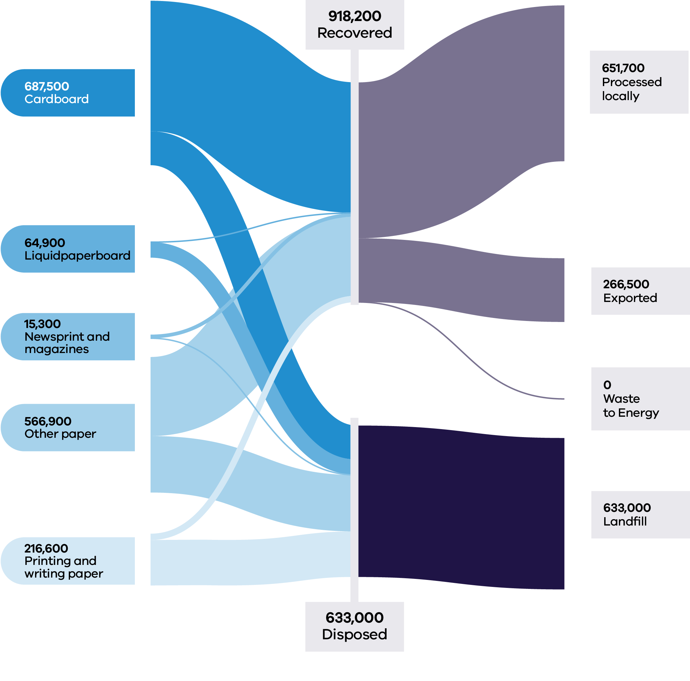

It is estimated that over $80M was lost in value to landfill in 2022–23, as compared to $66M lost in value from the sector in Victoria in 2021–22 (based on 2021–22 commodity values).

The price of kraft pulp stayed steady in 2024 after reaching historic high levels of nearly AUD$1,800 per tonne in September 2022, and the price falling significantly in early 2023 (Trading Economics 2024).

Approximately 29% of all paper and cardboard recovered in 2022–23 was exported out of Victoria (266,500 tonnes), with more material exported from the MSW sector than the C&I sector (Table 10). Similar tonnages were exported to international markets in 2021–22 (Recycling Victoria 2024a).

Table 10: Paper and cardboard flows by stream and material sub-groups for 2022–23 (Recycling Victoria 2024b)

| Stream | Generated | | Recovered for reprocessing | | | Disposed | Recovery rate |
| --- | --- | --- | --- | --- | --- | --- | --- |
|  |  |  | **Processed locally** | **Exported** | **Total** |  |  |
|  | **Tonnes** | **Proportion** | **Tonnes** | **Tonnes** | **Tonnes** | **Tonnes** | **%** |
| MSW | 574,200 | 37% | 176,600 | 123,000 | 299,600 | 274,600 | 52% |
| C&I | 968,700 | 62% | 475,100 | 143,500 | 618,600 | 350,100 | 64% |
| C&D | 8,400 | 1% | 0 | 0 | 0 | 8,400 | 0% |
| **Total** | **1,551,200** |  | **651,700** | **266,500** | **918,200** | **633,000** | **59%** |

| Stream | Generated | | Recovered for reprocessing | | | Disposed | Recovery rate |
| --- | --- | --- | --- | --- | --- | --- | --- |
|  |  |  | Processed locally | Exported | Total |  |  |
|  | Tonnes | Proportion | Tonnes | Tonnes | Tonnes | Tonnes | % |
| Card-board | 687,500 | 44% | 420,800 | 124,700 | 545,500 | 141,900 | 79% |
| Liquid Paper board | 64,900 | 4% | 0 | 0 | 0 | 64,900 | 0% |
| News-print & maga-zines | 15,300 | 1% | 10,400 | 4,900 | 15,300 | 0 | 100% |
| Other paper (mixed) | 566,900 | 37% | 194,000 | 136,900 | 330,800 | 236,100 | 58% |
| Printing/writing paper | 216,600 | 14% | 26,500 | 0 | 26,500 | 190,100 | 12% |
| **Total** | **1,551,200** |  | **651,700** | **266,500** | **918,200** | **633,000** | **59%** |

### Developments and changes

CDS Vic, in operation over the last year, has removed glass and beverage packaging from the commingled kerbside bin stream, leaving less contaminated and cleaner material.

An increase in Victoria’s capacity and capability to recover paper and cardboard occurred over the past year, with Visy commissioning a new drum pulper at the Coolaroo site in August 2023. The pulper has potentially added an extra 95,000 tonnes of processing infrastructure annually, thus doubling the Victorian capacity (Recycling Victoria 2024b).

Recent closures of paper manufacturing machines have taken place at Sorbent (closure of several machines from October 2023 to March 2024) and Opal Australian Paper Maryvale Mill (closure of white paper machine in 2023), thereby reducing the local processing capacity (Recycling Victoria 2024b).

The Australian Government sought feedback in August 2023 on proposals to regulate mixed paper and cardboard exports from 1 July 2024 by imposing a maximum contamination rate of 5%, tightening to 3% in 2026. This means that higher value, cleaner materials can continue to be exported, but lower grade materials will require domestic processing.

RMIT University recently partnered with Intrax Consulting Engineers and Citywide Service Solutions Pty Ltd to research the application of recycled cardboard in residential and commercial construction. This project is investigating the use of treated cardboard mixture to replace aggregates in production of concrete panels and timber trusses in both commercial and residential buildings. The reprocessing system will crush and shred cardboard waste materials and combine it with recycled plastic resin to form a product that replaces the traditional building materials (Venkatesan et al. 2023).

### Market issues and challenges

Over the next 30 years, the paper and cardboard waste stream is projected to grow by 47%, with Victorians expected to generate over 2.6 million tonnes by 2053. Cardboard and other paper together make up 81% of the waste stream and this is projected to increase to approximately 91% in 2053.

There remain challenges in the separation of paper grades, particularly in the MSW sector. This may impact the ability for domestic manufacturers of paper and cardboard to drive recovery.

Another recycling challenge is that the cellulose fibres that form the base for the manufacture of paper and cardboard. These fibres undergo structural changes during the process, particularly during drying or water removal. Paper with long fibres, like white office paper, offer the most flexibility for recycling, while paper with short fibres, like newsprint grade, offers lower quality recycling options.

### Focus areas for greater circularity – paper and cardboard

The analysis highlights the following opportunities for improvements to this material stream:

* Investigate options to improve sorting to reduce contamination and allow different material grades to be collected and recycled to maximise higher order end markets and meet export regulations.
* Investigate opportunities to use materials with a lower recovery rate where appropriate as a substitute for higher quality material streams.
* Support the market to utilise opportunities to collect and recover high quality cardboard streams from C&I sector.

## Plastics

Plastics are used to make many modern products including:

* packaging
* household goods
* synthetic textiles
* furniture
* pipes, hoses and cabling

plastic film

Existing end markets for plastics include:

* the built environment
* electrical and electronic applications
* industrial applications
* transport and logistics
* packaging

energy recovery.

### Market performance

The overall recovery rate for plastics in Victoria in 2022–23 was 23%. This was the lowest performing recovery rate across the key material streams but was consistent with the recovery rate for 2021–22 (23%), and slightly better than the recovery rate for 2020–21 (18%).

Figure 14: Plastic generated, recovered for processing and disposed of in 2022–23 (tonnes) (Recycling Victoria 2024b)

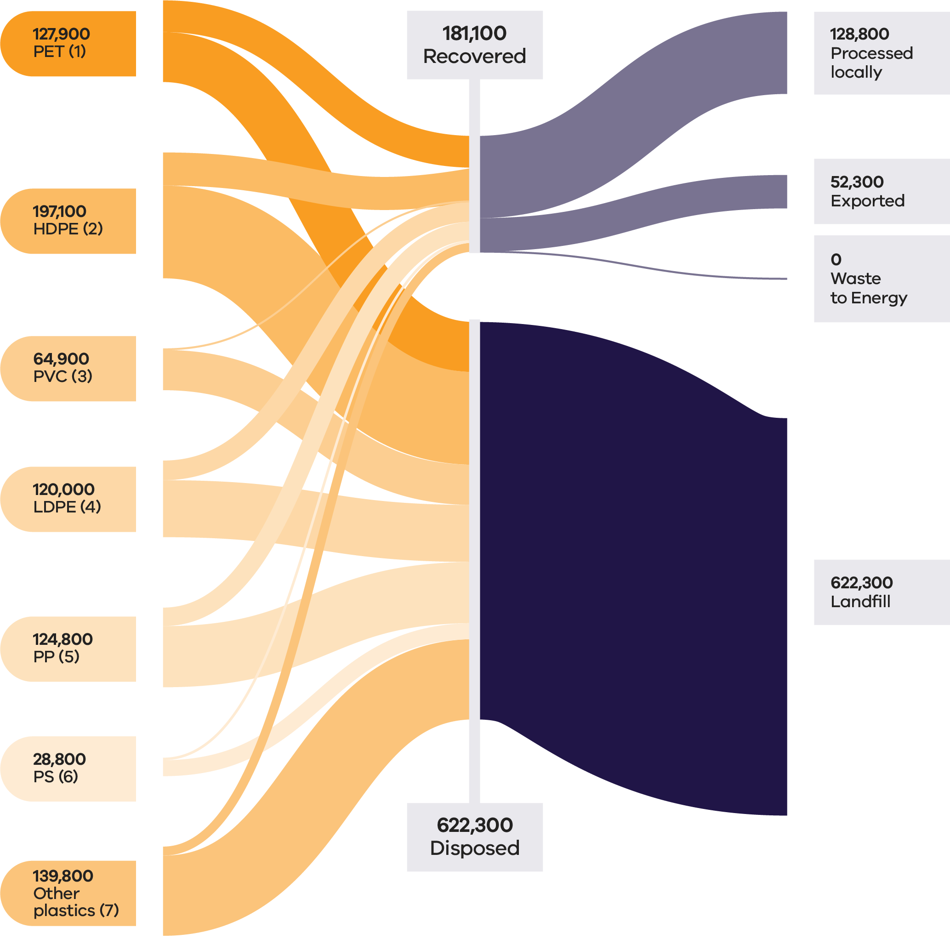

In 2022–23, plastics accounted for approximately 5% of all waste generated by weight in Victoria. The unrealised market value of plastics lost to landfill was ~$536 million based on 2022–23 commodity values, the highest value lost to landfill out of all material types.

Fluctuations in the price of fossil fuels directly impact the cost of new plastic and the economics of recycling plastics. When oil prices rise, recycled plastics become more commercially attractive; when oil prices fall recycled plastics become less commercially attractive as a feedstock.

Market prices for recycled plastic were above long-term historical averages throughout 2023–23 (Recycling Victoria 2024d). Prices for recycled PET ranged from a high of around AUD$1,200 per tonne and fell to around AUD$420-$500 per tonne by end of the financial year. Prices for recovered HDPE followed a similar pattern, averaging AUD$900–$1,100 for the financial year.

While Victoria does export plastics for reprocessing, export bans and licensing requirements currently limit international end market opportunities for processors, in favour of local solutions. Approximately 24% of all recovered plastics (42,300 tonnes) was exported interstate or internationally for processing in 2022–23.

Table 11: Plastic flows by stream and material sub-groups for 2022–23 (Recycling Victoria 2024b)

| Stream | Generated | | Recovered for reprocessing | | | Disposed | Recovery rate |
| --- | --- | --- | --- | --- | --- | --- | --- |
|  |  |  | **Processed locally** | **Exported** | **Total** |  |  |
|  | **Tonnes** | **Proportion** | **Tonnes** | **Tonnes** | **Tonnes** | **Tonnes** | **%** |
| MSW | 443,300 | 55% | 101,900 | 33,300 | 135,200 | 308,100 | 31% |
| C&I | 337,400 | 42% | 23,700 | 18,400 | 42,200 | 295,200 | 12% |
| C&D | 22,700 | 3% | 3,200 | 600 | 3,700 | 19,000 | 16% |
| **Total** | **803,400** |  | **128,800** | **52,300** | **181,100** | **622,300** | **23%** |

| Stream | Generated | | Recovered for reprocessing | | | Disposed | Recovery rate |
| --- | --- | --- | --- | --- | --- | --- | --- |
|  |  |  | Processed locally | Exported | Total |  |  |
|  | Tonnes | Proportion | Tonnes | Tonnes | Tonnes | Tonnes | % |
| PET (1) | 127,900 | 16% | 32,800 | 16,700 | 49,600 | 78,300 | 39% |
| HDPE (2) | 197,100 | 25% | 36,900 | 14,900 | 51,800 | 145,300 | 26% |
| PVC (3) | 64,900 | 8% | 2,000 | 0 | 2,000 | 62,900 | 3% |
| LDPE (4) | 120,000 | 15% | 16,200 | 14,500 | 30,700 | 89,300 | 26% |
| PP (5) | 124,800 | 16% | 25,000 | 4,000 | 29,000 | 95,800 | 23% |
| PS (6) | 28,800 | 4% | 3,200 | 700 | 3,900 | 25,000 | 13% |
| Other  plastics (7) | 139,800 | 17% | 12,600 | 1,500 | 14,100 | 125,700 | 10% |

While low, Victoria’s recovery rates are higher than all jurisdictions other than South Australia (based on 2021–22 national data). The overall recovery rate obscures the fact that some plastics, such as PET and HDPE are more easily recycled and have higher recovery rates than other types.

Table 12: All plastics material types - recovery rate and recycling characteristics

| Plastics type | Recovery rate 2022−23 and recycling characteristics |
| --- | --- |
| PET (1) Polyethylene Terephthalate | (39%)  PET is the easiest plastic to recycle. It’s a clear, tough, solvent resistant plastic. It’s used for water, soft drink and detergent bottles. It’s recycled into bottles and polyester fibres. |
| HDPE (2) High Density Polyethylene | (26%)  HDPE is a common plastic, and in the rigid form is usually white or coloured, and is used for milk bottles, shampoo bottles and cleaning products. HDPE bottles are recycled into more bottles or bags. |
| PVC (3) Polyvinyl chloride | (3%)  PVC is mainly used in pipes, toys, furniture and packaging. In Australia, PVC pipes are fully recyclable. Other PVC products remain difficult to recycle and contain harmful chemicals. |
| LDPE (4) Low Density Polyethylene | (26%)  LDPE is usually a soft, flexible plastic that’s used for different kinds of wrapping, bread bags, produce bags and bin bags. LDPE is recyclable. However, rigid LDPE products are much easier to recycle than flexible and soft versions of plastic. |
| PP (5) Polypropylene | (23%)  PP is a hard but still flexible plastic. It’s used for ice cream containers and lids and plastic take away containers. Polypropylene is recyclable. It can be separated from other plastic types, melted into a liquid, cooled, and turned into pellets, then used to form new plastics. However, polypropylene loses its strength and flexibility as it goes through the recycling process. |
| PS (6) Polystyrene | (13%)  PS is used to make cups, foam food trays and packing materials. It’s also known as Styrofoam and presents challenges due to its bulky yet very light nature, making it difficult to recycle. |
| Other Plastics | (10%) |

### Developments and changes

From 1 July 2022, the federal export restrictions increased the amount of material that must be reprocessed domestically, leading to significant investment in mechanical plastic reprocessing in Victoria. These investments and technologies are now operating at scale and are anticipated to play a critical role now and into future years.

Polyvinyl chloride (PVC) and polystyrene (PS) continue to be proactively phased out by many brand-owners, and the quantities of these polymers in kerbside collections are low and continue to fall. This is likely to improve the overall recovery rate for plastic in the future.

There is growing focus on improving plastic recovery due to increased environmental awareness, stricter regulations and consumer preference for sustainable products. Governments are enforcing policies to reduce plastic waste, while companies and consumers are shifting towards recycled materials for environmental benefits. Economic incentives also make recycled plastics an attractive alternative, contributing to a robust and expanding future market for recycled plastics.

Major advances are being made through a focus on innovation and significant investments in research and development, process technology and environmental protection. These advances span the use of sustainable bio-based and plastics waste feedstocks for polymer production, innovative materials and designing for recyclability to significant progress in cutting-edge chemical recycling technologies.

Victorian based company APR Plastics is progressing technology to meet the demand from food manufacturers packaging made from fully recycled material. Following the success of a pilot project that turns soft plastics into oils for plastic remanufacture, through a process known as pyrolysis, APR is scaling up the process. The company aims to commission a demonstration plant in Bacchus Marsh in early 2025 and a sorting facility in Dandenong by mid-2025 (Korycki 2024).

### Market issues and challenges

Plastic waste in Victoria is projected to grow by around 50% over the next 30 years, generating over 1.2 million tonnes by 2053.

Multiple factors limit the recovery of plastics. Contamination in feedstock streams increase processing costs. Virgin plastics remain comparatively inexpensive, undercutting the competitiveness of recycled products. Furthermore, manufacturers require clean, monomer feedstock while the abundance and diversity of different polymers in collections streams present sorting and processing challenges.

Soft plastics remain particularly challenging to recycle as a complex, low value, high volume material. Recycled polymers degrade with each use, necessitating the need for virgin polymers for some applications. Recovered PVC, for example, has a low market value due to not being fit for reuse in plumbing applications.

Plastic packaging is also problematic due to inconsistent products that are not designed for circularity. The Australian Government is seeking to mandate obligations for packaging to be designed for circularity and make industry responsible for the packaging, including soft plastics, they place on the market.

### Focus areas for greater circularity – plastics

The analysis highlights the following opportunities:

* Continue to seek efforts for national and/or state-based product stewardship for packaging to ensure market development is incentivised and financially viable.
* Support and promote improved product design for better recycling and reuse outcomes, including the minimisation of difficult to recycle plastics including business to consumer PVC, composite flexible and PS packaging.
* Continue to support the ban of avoidable and problematic plastic items, especially single use items.
* Increase processing capability and capacity where needed to aim for the highest order beneficial recycling outcomes.
* Support the continued deployment of mechanical reprocessing, chemical processing proven at scale and emerging technologies to provide increased capability for challenging plastic types and increased system capability to support kerbside collection of soft plastics.

## Tyres

Tyres are a composite product made from natural and synthetic rubber, steel wire, textile fibres, carbon black and other additives. At end-of-life, tyres are generally managed in 2 streams involving mechanical size reduction, granulating and crumbing for local manufacturing (predominantly tyres without textile fibres), and shredding for export as tyre derived fuel (predominantly tyres with textile fibres).

Whole baled tyres have been banned from landfill in Victoria since 1 July 1993 and export of all whole tyres, including baled tyres was banned from 1 December 2021 under the Council of Australian Government national waste export regulations.

Victoria is the largest producer of granules and crumb in Australia, receiving tyres from surrounding states to meet demand for these materials, and is the third largest producer of tyre shred.

Victoria has been a leader in the use of crumb rubber in road construction with the use of rubber in spray seals since the 1960s and it was the first state to introduce specifications for recycled crumb rubber in asphalt.

### Market performance

The overall recovery rate for tyres in Victoria in 2022–23 was 74% which is consistent with the recovery rate of 76% observed in 2021–22, but less than the recovery rate of 86% observed in 2020–21. C&I was the largest contributor to the generation of tyres (90%) and maintained a similar recovery rate (77%) to that observed in 2021–22 (79%) but lower than that observed in 2020–21 (88%).

Some truck and bus tyres are sent for retreading, although the local retreading industry has declined over the past couple of decades with the introduction of cheaper truck and bus tyres entering Australia.

Almost 42,000 tonnes of tyres were recovered in Victoria in 2022–23 with a recovery rate of 74%. The greatest recovery rate was reported in the C&I waste stream (77%).

It is estimated that $2.8M of value was lost to landfill for this material in Victoria in 2022–23 (based on 2021–22 commodity values) compared to $5.6M in 2021–22.

Approximately 43% (18,200 tonnes) of all recovered tyres were exported from Victoria in 2022–23 (Table 13). A total of 32,918 tonnes of tyres were exported internationally in 2021–22. Victoria continues to be reliant on overseas markets, with tyre derived fuels as the primary export market. Most of this is sent to Asia to be used as a coal replacement in high heat applications such as in cement kilns.

Figure 15: Tyres generated, recovered for processing, and disposed of in 2022–23 (tonnes) (Recycling Victoria 2024b)

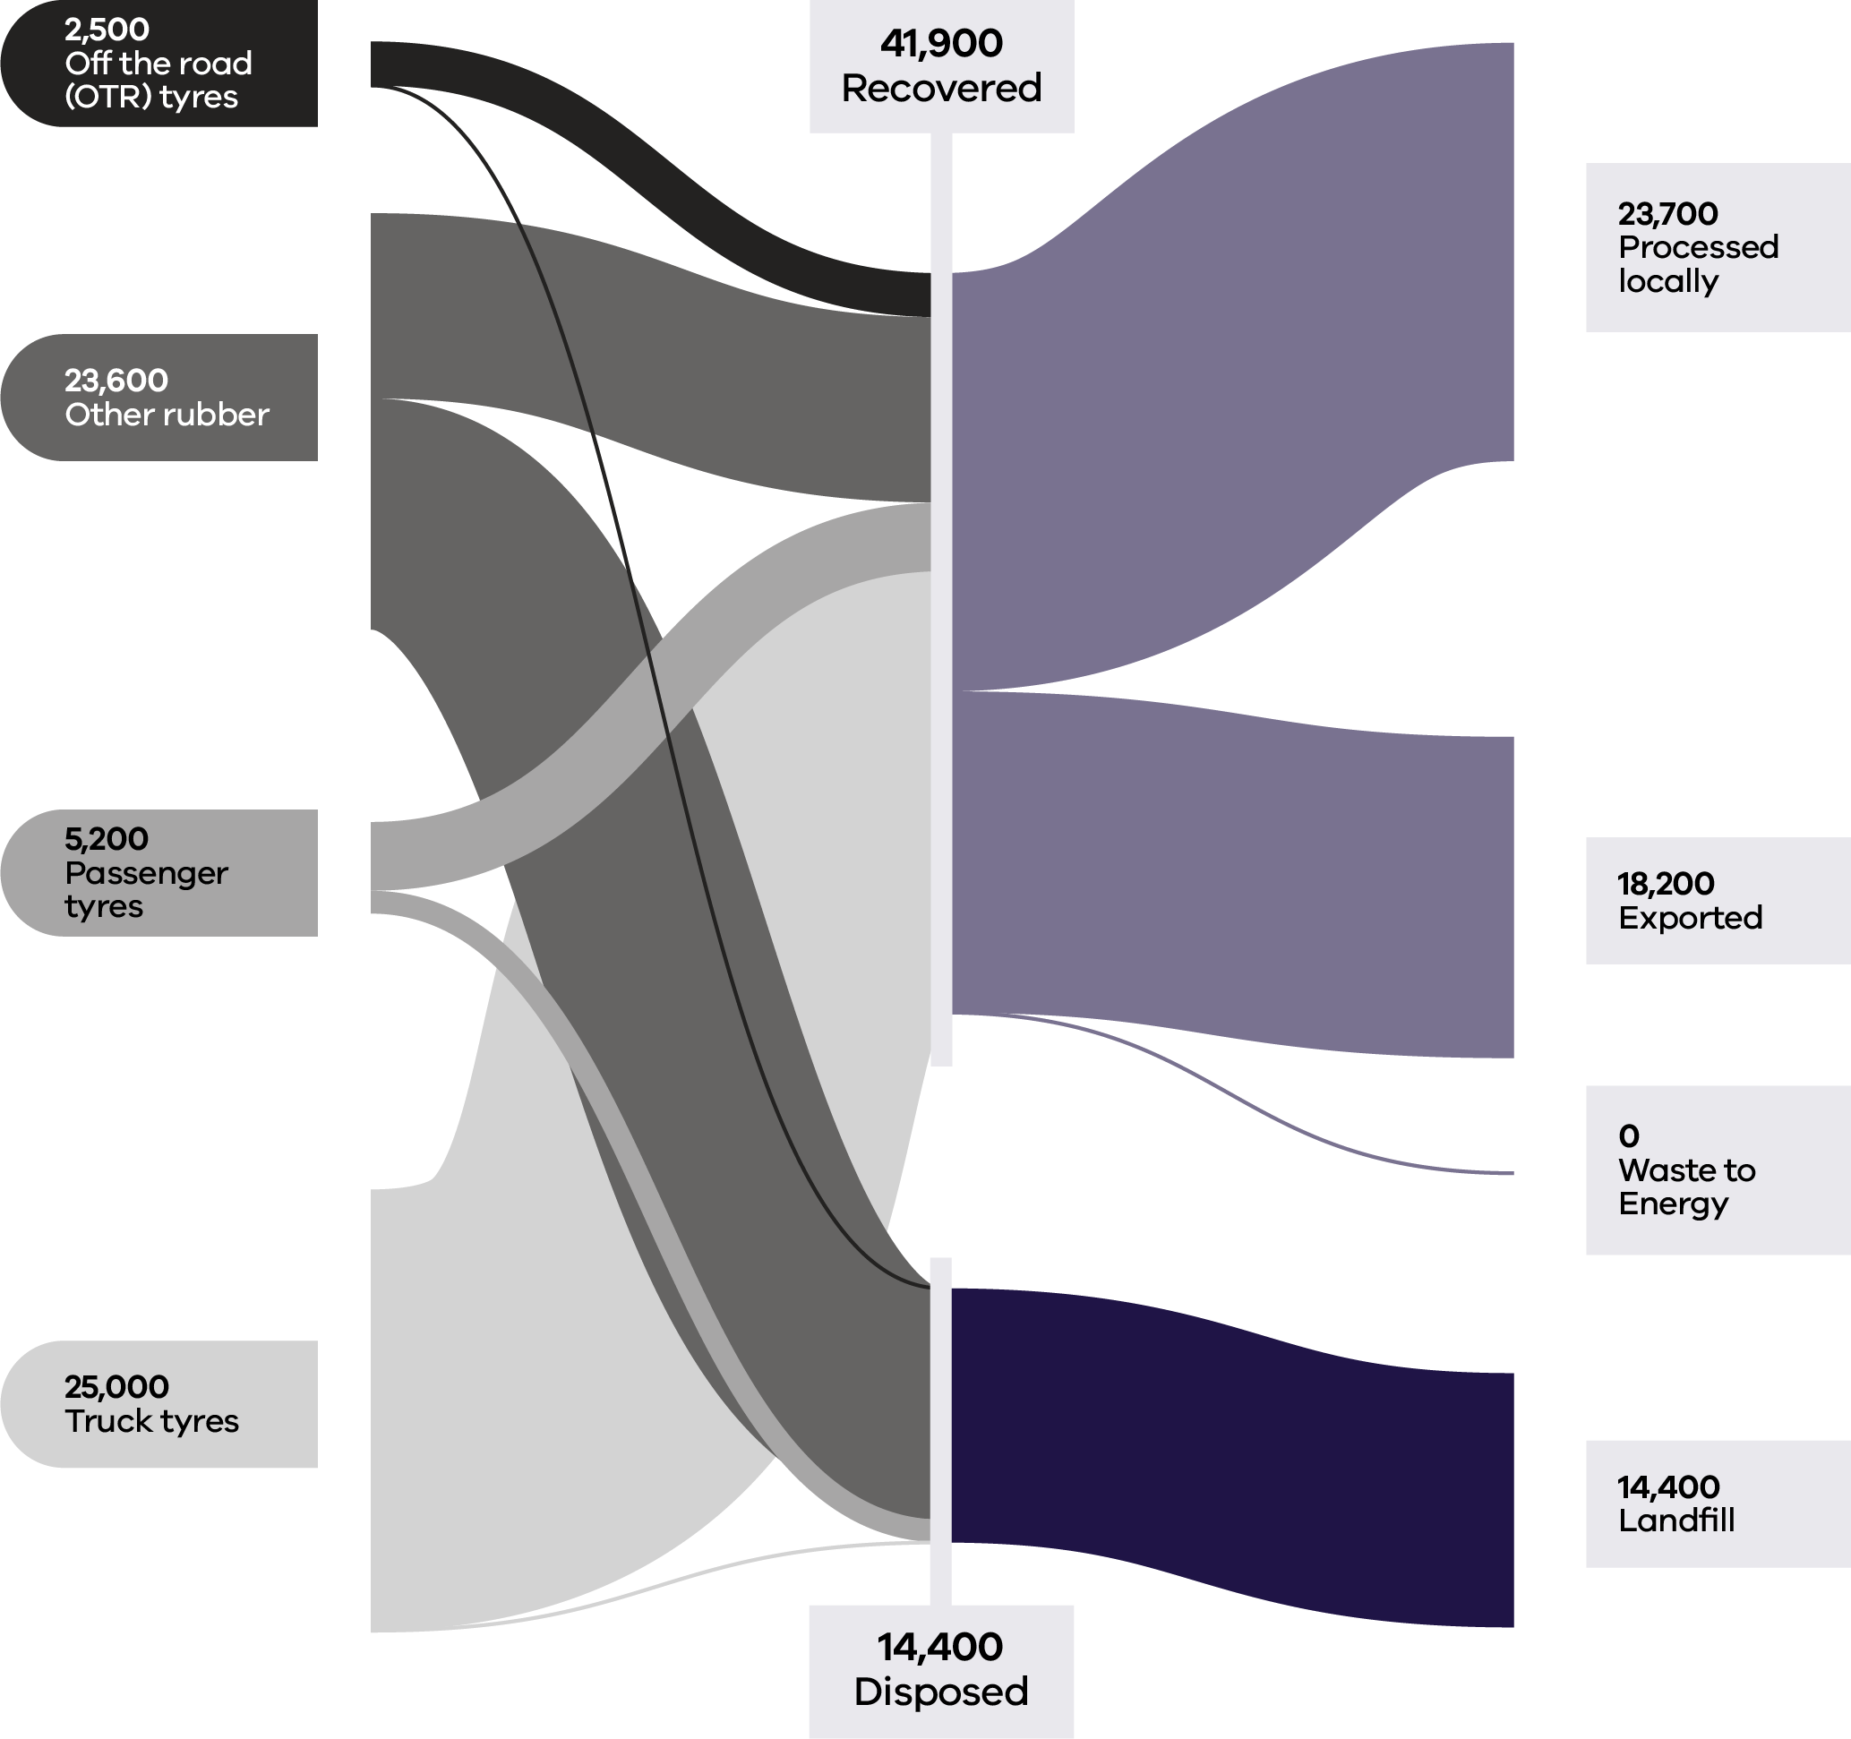

Table 13: Tyres flows by stream and material sub-groups for 2022–23 (Recycling Victoria 2024b)

| Stream | Generated | | Recovered for reprocessing | | | Disposed | Recovery rate |
| --- | --- | --- | --- | --- | --- | --- | --- |
|  |  |  | Processed locally | Exported | Total |  |  |
|  | Tonnes | Proportion | Tonnes | Tonnes | Tonnes | Tonnes | % |
| MSW | 5,200 | 9% | 1,200 | 1,600 | 2,800 | 2,500 | 53% |
| C&I | 50,700 | 90% | 22,500 | 16,600 | 39,100 | 11,600 | 77% |
| C&D | 300 | 1% | 0 | 0 | 0 | 300 | 0% |
| **Total** | **56,300** |  | **23,700** | **18,200** | **41,900** | **14,400** | **74%** |

### Developments and changes

Recent product development successes include the development by Saferoads, a new generation of road safety barriers that uses tyre derived material to increase public safety and reduce waste. The City of Greater Geelong is using more than 50 tonnes of recycled crumbed rubber to upgrade local sporting precincts (City of Greater Geelong 2024). The recycled rubber has been sourced from used truck tyres and will see the athletics track at Landy Field in South Geelong installed with a base rubber and sealer coat.

Recycled rubber is also being used to upgrade asphalt paths in golf courses in regional Victoria.

### Market issues and challenges

Tyres and rubber waste is expected to grow to 130,000 tonnes by 2053, representing a 44% increase on 2023 tonnages.

Western Australia presented a discussion paper to the Environment Ministers’ meeting in June 2023, identifying 3 broad challenges the tyre sector faces:

* Risks and costs to the environment and communities.
* Missed opportunities for recovery and the loss of resources.

Limitations and inequities of the current industry-led framework where efficacy and success are constrained by industry participants currently avoiding or not fully meeting responsibilities under the scheme (Government of Western Australia Department of Water and Environmental Regulation 2024).

A lack of cost-efficient solutions can lead to stockpiling or dumping, even if there is enough infrastructure capacity to meet the demand. In Australia approximately 11.3 million tyres were illegally dumped, stockpiled, hidden in warehouses or put into landfill in 2022–23 (Scott, 2023). Tyre dumping is a challenge across Victoria, particularly in rural areas. EPA works to prevent illegal tyre dumping by inspecting mechanics and tyre stores to ensure they are legally disposing of used tyres (Hermant and Kent, 2024).

### Focus areas for greater circularity

The analysis highlights the following opportunities for this material stream:

* Support Australian product stewardship (in development).
* Build market resilience through supporting increased uptake of tyre-derived products such as in government procurement.
* Support data sharing across Australian jurisdictions, to improve quality and measurements of end market products.
* Investigate business models to minimise waste and keep materials at highest use for longer.
* Support increased infrastructure capability to achieve higher order use and more circular outcomes, such as expanded use of crumb rubber, including reprocessing passenger tyres for crumb rubber.
* Investigate re-treading of truck and bus tyres to help higher order outcomes in the circular economy; support for new products, including the use of reclaimed rubber.

## Textiles

Textile waste is composed of discarded:

* clothing
* sheets
* curtains
* carpets
* bedding

other items made from natural or artificial fibres.

Clothing makes up the largest component of the waste stream. Other textiles make up the rest which includes bedding carpet soft furnishings and mattresses.

Textile waste is a concern because a large portion of discarded textiles end up in landfill.

In addition to taking up space in landfills, the production of new textiles to replace those discarded consumes 98 million tonnes of non-renewable resources like oil to produce synthetic fibres, fertilisers to grow cotton, and chemicals to produce dye, globally each year (Sustainability Victoria 2023).

Textile waste can be repurposed through various end markets to support sustainability and reduce landfill impact. Key markets include recycling waste into new textiles or fibres, upcycling into accessories or home décor, and using waste as insulation, building materials, or stuffing for products. Agricultural applications like composting and crop protection, along with energy recovery through waste to energy plants, are additional options. Textile waste can also serve as raw materials for industries like paper production and automotive manufacturing or be transformed into bioplastics for eco-friendly goods.

Mechanical and chemical recycling of textiles produces commercial textile fibres for use by textile and apparel companies in new clothing products. Strong international export markets exist for second-hand clothing.

### Market performance

Victoria recovers just under a quarter (24%) of all textile material generated (Table 14). The recovery rate is almost wholly dependent on exports (excluding the proportion of textiles that are reused). Of the 3 contributing sectors, households (MSW) contribute the most to the total tonnes generated and have the highest recovery rate (44%). C&I is the next largest contributor to total tonnes generated (44%) and has a less optimal recovery rate than that for households (1%).

It is estimated that almost $200M value was lost to landfill through disposal in 2022–23 (based on 2021–22 commodity values), as compared to ~$155M in 2021–22.

Of the 66,800 tonnes of textiles recovered in 2022–23, over 97% was exported. Almost all recovered clothing (99%) is exported for reprocessing as this waste material is relatively lightweight and has relatively low transport costs (Recycling Victoria 2024b).

Figure 16: Textiles generated, recovered for processing, and disposed of in 2022–23 (tonnes) (Recycling Victoria 2024b)

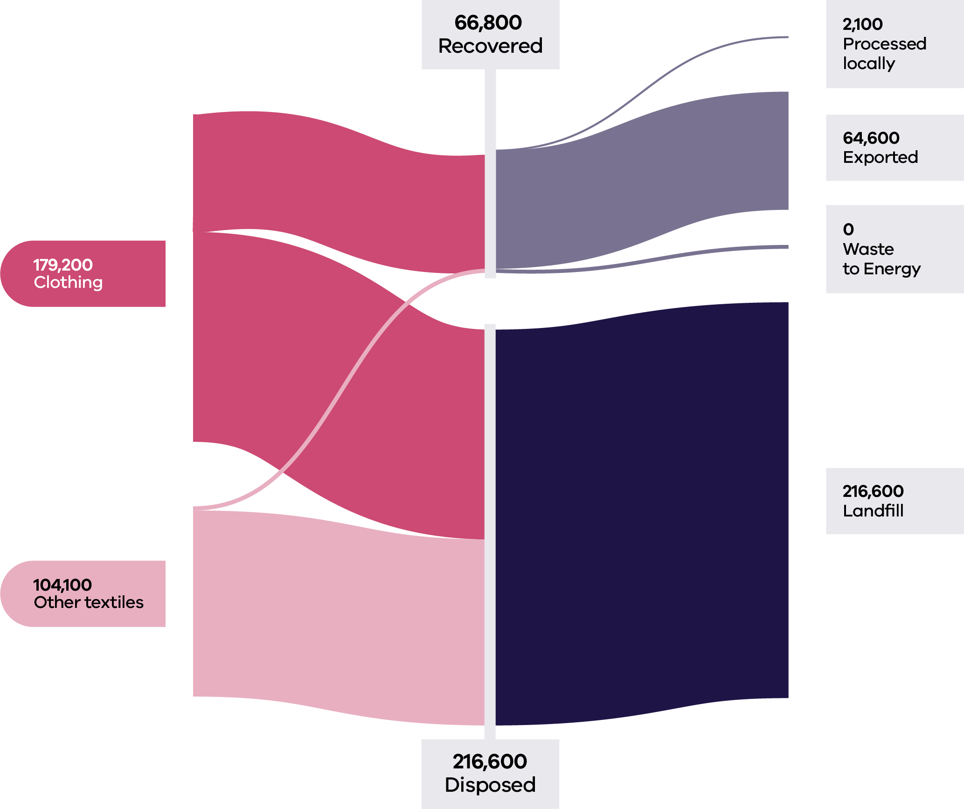

Table 14: Textile flows by stream and material sub-groups for 2022–23 (Recycling Victoria 2024b)

| Stream | Generated | | Recovered for reprocessing | | | Disposed | Recovery rate |
| --- | --- | --- | --- | --- | --- | --- | --- |
|  |  |  | Processed locally | Exported | Total |  |  |
|  | Tonnes | Proportion | Tonnes | Tonnes | Tonnes | Tonnes | % |
| MSW | 148,600 | 52% | 1,700 | 64,100 | 65,800 | 82,800 | 44% |
| C&I | 124,200 | 44% | 400 | 600 | 1,000 | 123,200 | 1% |
| C&D | 10,500 | 4% | 0 | 0 | 0 | 10,500 | 0% |
| **Total** | **283,300** |  | **2,100** | **64,600** | **66,800** | **216,600** | **24%** |

| Stream | Generated | | Recovered for reprocessing | | | Disposed | Recovery rate |
| --- | --- | --- | --- | --- | --- | --- | --- |
|  |  |  | Processed locally | Exported | Total |  |  |
|  | Tonnes | Proportion | Tonnes | Tonnes | Tonnes | Tonnes | % |
| Clothing | 179,200 | 63% | 400 | 64,100 | 64,500 | 114,800 | 36% |
| Other  textiles | 104,100 | 37% | 1,700 | 600 | 2,300 | 101,800 | 2% |
| **Total** | **283,300** |  | **2,100** | **64,600** | **66,800** | **216,600** | **24%** |

### Developments and changes

The textile waste stream is projected to grow to over 400,000 tonnes annually by 2053, which reflects growth of over 53% over the period.

Seamless, Australia’s clothing product stewardship scheme, became operational on 1 July 2024, with the mission to make Australian clothing circular by 2030. The funding for this program will be a financial contribution made by member organisations of 4 cents for every new piece of their clothing placed in the market. This funding will be directed towards 4 priority areas:

* Incentivising businesses to design more durable, repairable, sustainable and recyclable clothes.
* Growing the market for new business models based on repair, reuse, remanufacturing and rental.
* Establishing sorting and collection systems for effective reuse of wearable items and recycling of non-wearables.

Empowering citizens to make the right choices in acquiring, reusing, caring and disposal of clothes.

The Victorian Government has invested over $630,000 to reduce textile waste generation by 600 tonnes per year via a range of initiatives:

* Australian fashion label A.BCH is connecting the oversupply of textile materials with demand through an online marketplace (Circular Sourcing n.d.).
* Global outdoor brand Kathmandu is leading a project to intercept used, damaged or faulty products destined for landfills and repair them for resale under the Kathman-REDU label (Circular Economy Business Innovation Centre 2023).
* Neighbourhood Collective Australia is developing op-shops and slow fashion hubs (Sustainability Victoria 2023).
* Phillip Island Community and Learning Centre is creating a repair centre for heavy materials like tents, caravan annexes, utility tonneaus and surfboard covers.

### Market issues and challenges

The textile waste stream is projected to grow to over 400,00 tonnes annually by 2053. This presents an opportunity for an improved recovery solution.

Victoria has 2 facilities that process textile waste into recycled fibre and 2 mattress preprocessors. There is currently a limited market in Australia for recovered textiles, with 127 Australian textile production businesses in Australia (Recycling Victoria 2023).

Addressing the state’s lack of recycling capability is challenging due to the limited opportunities for local reuse and the relatively low product value (Recycling Victoria 2024b). Domestic textile reprocessing is generally limited to mechanical fibre recycling. Although mechanical fibre recycling technologies are well established, there remains a challenge in commercially scaling up the recycling of the huge quantity and diversity of plastic fibre-based materials contained in textiles such as carpets and mattresses (Recycling Victoria 2024b).

For many articles of clothing, elements present on a textile product, such as fasteners, buttons, zippers or similar items may be a disruptor to the recycling process and often need to be removed before the product is suitable as feedstock for recycling. This results in high costs to sort and deconstruct textiles prior to recycling.

‘Fast fashion’ lines are made from poor quality fabric with low durability but are attractive to the consumer due to low cost.

Synthetic chemicals classed as per- and polyfluoroalkyl substances (PFAS) are often used in clothing and other textiles to repel water, oil and dirt, and provide thermal stability and durability. The presence of PFAS in textiles can be a barrier to longer use, reuse and recyclability, negatively influencing the sector’s shift to a more circular economy.

Given the economic challenges for a local market, there is continued reliance on international exports for textile waste.

### Focus areas for greater circularity – textiles

The analysis has highlighted the following opportunities for this material stream:

* National product stewardship building off Seamless.
* Support improved collections services and consumer access to donation bins.
* Promote the design of textiles for longer life, reuse and repair to drive towards an overall reduction in consumption.
* Investigate onshore processing of clothing that reaches end-of-life and cannot be reused/repaired.
* Support the continued development of markets for recycled textiles.

## Emerging materials

Several materials were identified in the inaugural Circular Economy Market Report as emerging materials in Victoria, including photovoltaics (solar panels), batteries and wind turbines.

The Victorian Government has legislated renewable generation targets of 65% by 2030 and 95% by 2035, as well as storage targets of at least 2.6GW by 2030 and at least 6.3GW by 2035. These targets translate to approximately 25GW additional large and small-scale generation capacity from 2024 to 2035, requiring installation of an additional 27 million new solar panels and 900 new wind turbines (DEECA 2024a).

Recycling the eventual waste streams from these energy sources will require significant infrastructure capacity and capability advancement. The ecological and climate benefits of using recycled materials are not yet fully accounted for in the costs of the materials used in renewable energy, which means suitable secondary materials regularly compete on price with primary materials that are often cheaper (European Environment Agency 2021). In addition, the technical processes to recycle much of this waste is currently still evolving.

### Photovoltaic systems e-waste

End-of-life PV systems are a form of electronic waste (or e-waste), which is defined as waste in the form of electrical or electronic equipment, devices or machines that are driven by an electric current or electromagnetic field (Solar Victoria 2024). In simple terms, this means any device that has a plug, battery or power cord that is no longer working or wanted is e-waste, including solar PV panels and associated PV waste including inverters, attached cabling and racking. PV could also potentially cover household energy storage batteries.

These systems comprise Australia’s fastest growing electronic waste stream, reflecting Australia’s status as an early developer of solar technology and, more recently, as a world leader in adopting rooftop solar.

As of the end of October 2024, over 780,000 Victorian households and commercial establishments had installed rooftop solar panels (Clean Energy Regulator 2024). The size of solar systems installed has grown alongside the number of installations, with the average system capacity having increased from 3.3 kW in 2012 to 8.62 kW in Q1 2024 (Australian Energy Council 2024).

Currently, Victoria’s solar capacity is 6GW, comprising 5GW of rooftop solar and 1GW of utility-scale solar. By July 2035, this capacity will need to expand to 15.6GW, including 12.6GW of distributed rooftop solar and 3GW of utility-scale solar (Australian Energy Council, 2024).

Modelling undertaken for the Victorian Government forecasts that tonnages of PV system e-waste (including inverters, batteries and solar panels) will increase significantly by 2035 with growth rates of around 20% per annum. This equates to PV system e-waste tonnages approximately doubling every five years to 2035 (Sustainability Victoria 2021).

### Barriers to circularity

Inevitably, solar panels reach an end-of-life. While the designed life for solar panels is typically 25–30 years, solar PV systems can have a shorter life due to weather damage, installation errors, or manufacturing serial defects, as well as cell defects (which include degradation of the cell anti-reflective coating, and discoloration or delamination of the cell). In addition, some panels are removed from rooftops and solar farms prior to end-of-life, for example if an inverter fails or a new battery gets installed, triggering a wholesale replacement with new panels (Stock, 2024). The falling PV system cost also possibly encourages households and industry to upgrade working solar panels earlier than end-of- life thereby creating additional waste.

Victoria currently lacks an established and proven capacity to process PV panels beyond basic processing of recyclable components, such as aluminium frames (Recycling Victoria, 2024a). In Victoria Elecsome has recently entered the market as the first Australian solar panel upcycling plant that operates by transforming end-of-life solar panels into higher value products. Elecsome’s total capacity is one million panels per annum.

To be reused, solar panels need to be broken down so each component, including glass, aluminium, copper, plastic and silicon, can be separated. This requires extensive heavy machinery.

Key challenges in PV recycling, in economic and technological terms, are the delamination, separation and purification of the silicon from the glass and the semiconductor thin film. The PV panel can be described as a “sandwich” of laminates comprising glass, adhesive, solar cells and a backing sheet. The strong adhesion needed to ensure durability of the panels across a range of weather conditions provides challenges in disassembly of the same panels at end-of-life.

The current cost of recycling each solar panel in Australia is $28, roughly 6 times the cost of sending it to landfill ($4.50) (Hill 2023).

By weight, a solar panel is more than 70% glass, with the remainder being aluminium, silica, plastic, and small amounts of precious metals. On average, $22.60 worth of materials could be potentially recovered from a typical 20 kg solar panel, resulting in a material value of over $1000 per tonne of solar panels (Deng 2024).

Various research groups are taking up the challenge of extracting valuable materials from PV panels. In 2024 the Victorian Government announced that the inaugural Breakthrough Victoria Challenge will focus attention on reducing solar waste in landfills.

### Support for circularity

The Australian Government aims to increase local manufacturing to capture a bigger market share through the Future Made in Australia policy which will support renewables development locally (Australian Government 2024).

Another funding initiative, the Sunshot program, is aimed at supporting the domestic production of solar panels and innovative manufacturing facilities in Australia across the solar PV supply chain. The solar PV supply chain includes polysilicon production, production of ingots, wafers, solar PV cells, and solar module assembly. Detailed work on the Sunshot program is currently underway through the Australian Renewable Energy Agency (ARENA 2024). Round one funding decisions are due before the end of December 2024.

The Basel Convention was established to control international movements of hazardous waste, though an amendment adopted in 2022 also controls transboundary movement of non-hazardous e-waste commencing 1 January 2025. This impacts the management of non-hazardous e-waste plastics, which have historically been sold to overseas processing facilities.

Based on the extended-producer responsibility principle, the EU Waste Electrical and Electronic Equipment directive requires all producers supplying PV panels to the EU market (wherever they may be based) to finance the costs of collecting and recycling end-of-life PV panels put on the market in Europe.

Photovoltaics have been listed by the Australian Government on the Minister for the Environment and Water’s priority list for product stewardship since 2016–17. The Australian Government has committed to develop a mandatory product stewardship scheme to reduce waste from small electrical products and solar photovoltaic systems. A discussion paper was released on the proposed regulations for consultation in June 2023 (DCCEEW 2023b). The definition of a small-scale solar PV system in the discussion paper are those with up to 100 kW of capacity. The regulations pertaining to small-scale PV systems would have requirements in relation to the amount of material recovery, a collection network mechanism and awareness raising about sustainability. Unlike large-scale systems, legacy waste (sourced from systems that were installed prior to the commencement of the scheme) would be covered under the regulations.

The key outcomes sought under an e-waste regulatory product stewardship scheme (DCCEEW 2024e) including solar photovoltaic (PV) systems are to:

* reduce waste going to landfill, especially harmful materials found in e-waste
* increase recovery and re-use of valuable materials in a safe, scientific and environmentally sound manner
* provide convenient access to recycling services for e-products and solar panels across Australia
* help Australia take responsibility for its own waste and re-use the materials to make other products, and support Australia’s transition to a circular economy
* encourage all those involved in the creation, sale, use and disposal of e-products to act in a way that is consistent with reducing waste to landfill.

### Wind turbines

Victoria’s wind power infrastructure became operational in the last decade and has a typical 20-year lifespan (Clean Energy Council 2023). With wind farms continuing to become a more prominent component in Australia’s energy transformation, local communities hosting wind farms are interested in understanding life cycle aspects of energy infrastructure assets.

The Australian Energy Council reports that currently, Victoria has approximately 715 onshore wind turbines across the state in operation and will require around 130% increase in onshore wind capacity to meet the 2035 target. Additionally, 222 offshore wind turbines will need to be developed and in operation by 2035 for the 4GW target to be met, with 111 of them needing to be online by 2032 to meet a 2GW interim target (Monaghan 2024).

Recycling wind turbines has several challenges. Internationally, processing is still under development for turbine blades made of lightweight materials like carbon fibre, glass fibre and composite materials, with further research and implementation needed. The large scale of blades can make transportation costs prohibitive for long-distance hauls where recycling facilities may be located far away (European Environment Agency 2021).

There is currently no clear large scale recycling option for carbon-fibre in Australia (Clean Energy Council 2023). To improve circularity of wind turbines, repair options are under development. Barriers to realising this option include design intellectual property barriers, and economic viability (Clean Energy Council 2020).

### Batteries

Batteries are used in consumer products from mobile devices to laptop computers and in toys, appliances and tools. The use of batteries is growing rapidly worldwide, driven by growth in renewable energy storage systems from domestic scale household batteries through to large storage systems. Demand for renewable energy production and storage is also driven upwards by the increased electrification of the transport sector, as the number of electric vehicles (EVs), e-bikes and scooters continue to grow at an exponential rate.

The global battery market consists of primary batteries (which are non-rechargeable) and secondary batteries (which are rechargeable). Just under 75% of batteries in the global market are secondary batteries, typically lead acid batteries and lithium-ion batteries.

The market direction is strongly moving to lithium-ion batteries becoming the most common battery type (Battery Stewardship Council, 2020). Compared to lead acid batteries, lithium-ion batteries are lighter, less bulky and have longer cycle lives.

By 2035, Australia could be generating 137,000 tonnes of lithium battery waste annually (McKell Institute 2022). As a result, a domestic recycling industry for lithium batteries could be worth $603 million to $3.1 billion in just over a decade (Zhao et al 2021).

Lithium-ion batteries can be highly flammable. Fire services in Victoria and Queensland respond to lithium-ion battery fires almost every day (Lu 2024). More than half of Australians still dispose of used batteries in kerbside collection in recycling or landfill bins. Education and awareness are key to behavioural change, as 95% of Australians surveyed said they would be willing to take used batteries to a collection point once they were made aware of drop-off locations.

Almost all discarded lithium-ion batteries will still hold some charge. Currently, lithium-ion batteries are considered end-of-life when they are unable to continue to sufficiently power an application or a device. EV batteries need replacing when they reach 70–80% of original capacity and no longer meet performance standards. This presents an opportunity to repurpose these batteries for other applications, most notably in stationary storage or as secondary batteries that are still operational and effective – meaning that the approach lends itself to the circular economy principles of “use longer” and “use again.”

### Barriers to circularity

In 2021, Australia recycled 99% of lead acid batteries, compared to just 10% of lithium-ion batteries (CSIRO 2020).

The Association for the Battery Recycling Industry (ABRI) identified numerous issues and barriers to lithium battery recycling including the lack of consumer awareness around battery types, the limited access to collection systems and the challenge of logistics since lithium batteries are classified as dangerous goods.

In a recent submission to the Productivity Commission’s review of circular economy opportunities (Productivity Commission 2024), ABRI identified the following unique opportunities and comparative advantages to become a world leader in lithium battery recycling technology and supporting services:

Strong research and resources sector capability in hydrometallurgy underpinning the development of exportable technology to recover materials from lithium black mass.

Development of containers to support safe transport and storage.

Development of solutions for safe collection and, possibly partial processing to reduce transport costs, in regional and remote areas.

### Support for circularity

In April 2024 the Victorian Government announced funding for 2 companies (Ecobatt and Enviropacific) to establish lithium-ion processing and recycling facilities in Campbellfield and Stawell respectively. Following a change in ownership, the Enviropacific project has been discontinued. Ecobatt has requested a change of capacity that represents more than a 50% reduction from the original proposal but will come online earlier than originally planned.

The Battery Stewardship Council (BSC) launched B-cycle, which has been in operation since 2022 as a cooperative network of businesses that collect, sort and recycle used batteries in a safe and sustainable way. It has received support of all state and the Australian governments and has the authorisation of the Australian Competition and Consumer Commission (ACCC). B-cycle has 285 organisations that provide over 5,300 drop off points nationwide. Nearly 800 tonnes of batteries were collected in Victoria in 2023 as part of the B-cycle scheme, a 33% increase from 2022. The focus for B-cycle has been consumer batteries, while the mandate of the BSC included electric vehicle batteries and battery energy storage systems (B-cycle 2023).

The Commonwealth Department of Industry, Science and Resources published the National Battery Strategy in May 2024 to provide a pathway for Australia to move up the battery value chain and capitalise on key opportunities. The main actions of the strategy are:

$523.2 million Battery Breakthrough to provide a targeted production incentive to support local manufacturers to build capabilities and focus on producing high-value battery products.

$20.3 million Building Future Battery Capabilities measure to build future battery capabilities and strengthen national collaboration. This includes funding to deliver a supply chain navigator tool, battery innovation and scale-up program, best practice guidelines and standards, and provide battery industry skills and training.

$1.7 billion for the Future Made in Australia Innovation Fund (including batteries in addition to other priorities) to support innovation, commercialisation, pilot and demonstration projects and early-stage development in priority sectors – including manufacturing clean energy technologies such as batteries.

$5.6 million for the Australian Made Battery Precinct to conduct foundational work to support the establishment of the Australian Made Battery Precinct, in partnership with the Queensland Government (DISER 2024).

At the June 2024 Environment Ministers Meeting all ministers agreed that battery related fires require greater interventions across the entire life cycle. They decided that Victoria, New South Wales, and Queensland governments would jointly accelerate work towards product stewardship for all batteries, including through the development of a draft Regulatory Impact Statement (RIS), informed through informal consultation with industry and government. At the December 2024 Environment Ministers Meeting, ministers discussed the findings of the draft RIS, prepared by New South Wales and Victoria, examining options for these reforms. Recognising the need to act quickly to reduce the risks of battery fires, ministers discussed progression of aligned state-led reforms for mandatory battery product stewardship, with NSW intending to introduce legislation in 2025.