**Membership Types**

Multiple users can now be associated with an organisation’s Portal profile, to manage the organisation’s account and licence processes.

|  |  |  |  |  |  |
| --- | --- | --- | --- | --- | --- |
| Access Type | Manage User Access Requests | Change User Access Permissions | Apply for a Licence | Submit Notifications | Request a Licence Variation |
| Group Administrator | Checkmark with solid fill | Checkmark with solid fill | Checkmark with solid fill | Checkmark with solid fill | Checkmark with solid fill |
| Group Editor |  |  | Checkmark with solid fill | Checkmark with solid fill | Checkmark with solid fill |
| Group Viewer | VIEW ONLY |  | VIEW ONLY | VIEW ONLY | VIEW ONLY |

**Adding New Users or Changing Membership Type (For Group Administrators)**

If you are a Group Administrator, you can add New Members to your organisation profile and update user Membership Types by:

**Step 1)** From the **‘HOME’** tab in‘My Submissions’ dashboard, click on your Registered Organisation – this should start with ‘OPROF’.

Note: If you do not have a Registered Organisation, please see **User Guide: Creating an Organisation Profile.**

**Step 2)** 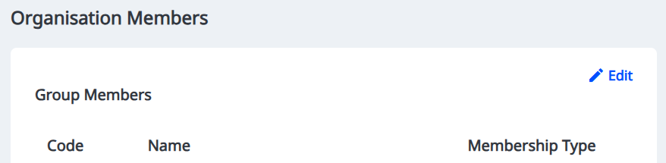Click on ‘Edit’ to update the Membership Type for existing Group Members or add new Group Members for your organisation

**Step 4)** By clicking the three dots ‘…’ next to the relevant user, you can either:

**Modify member:** Choose a different membership type for this member

**Remove member:** Remove the member from your organisation profile

**Step 5)** Select **‘+ New Member’** to add a new Group Member

Make sure the person you are adding already has a Portal log in account

**Step 6)** Search for the Group Member using their Portal log-in email address and select the membership type you would like to grant to them.

**Requesting Access to an Organisation**

**Step 1)** Create an account and log in to the Portal account

**Step 2)** Select ‘Organisation Access Request’ from the Portal homepage

**Step 3)** Fill in your details and the details of the organisation you would like to access.

The organisation **must be** registered before you can request access. See **User Guide: Creating an Organisation Profile** for more information.

**Step 4)** Click ‘Send Access Request’ once you have reviewed the details of your access request.

**Step 5)** The Group Administrator will be notified to of your request to join the organisation’s Portal profile.

**Step 6)** When your access

**Approving Access Requests (For Group Administrators)**

If you are a Group Administrator, you will be notified of requests from New Members wanting to access your organisation profile. You can review these requests by:

**Step 1)** From the **‘HOME’** tab in‘My Submissions’ dashboard, click on your Registered Organisation – this should start with ‘OPROF’.

If you do not have a Registered Organisation, please see **User Guide: Creating an Organisation Profile.**

**Step 2)** Under ‘Membership Update Requests’, click on the relevant request you want to review. This should start with ‘MU’

**Step 3)** You can review the details of the request and select either approve or deny

**Step 4)** The user will automatically be provided with the Group Editor Membership Type.