- Introduction
Since 2014, a series of programs aimed at improving road infrastructure have been initiated or completed in Victoria, including the former Safe System Road Infrastructure (TAC funded, DTP delivered) investment program across the Top 20 and Next 16 rural highway networks. Pre- and post-treatment analysis of the Top 20 and Next 16 roads, using AusRAP star ratings demonstrates significant improvements along these key road corridors.

- Safe Roads Top 20
The Top 20 roads were developed and delivered through the Safe System Road Infrastructure Program between 2017 and 2022. This program aimed to implement transformative safe system treatments along our highest-function roads.
  - Program Overview
Road Safety Victoria (RSV) partnered with the Transport Accident Commission (TAC) to improve safety features on 20 high-risk roads, covering over 1,700 km. Key treatments included over 2,300 km of flexible safety barriers (including motorcycle-friendly barriers), rumble strips, and roundabouts.
Figures 1 to 3 show examples of these treatments as applied in the Top 20 Program. These treatments are designed to prevent crashes or, where avoidance is not possible, reduce their severity.

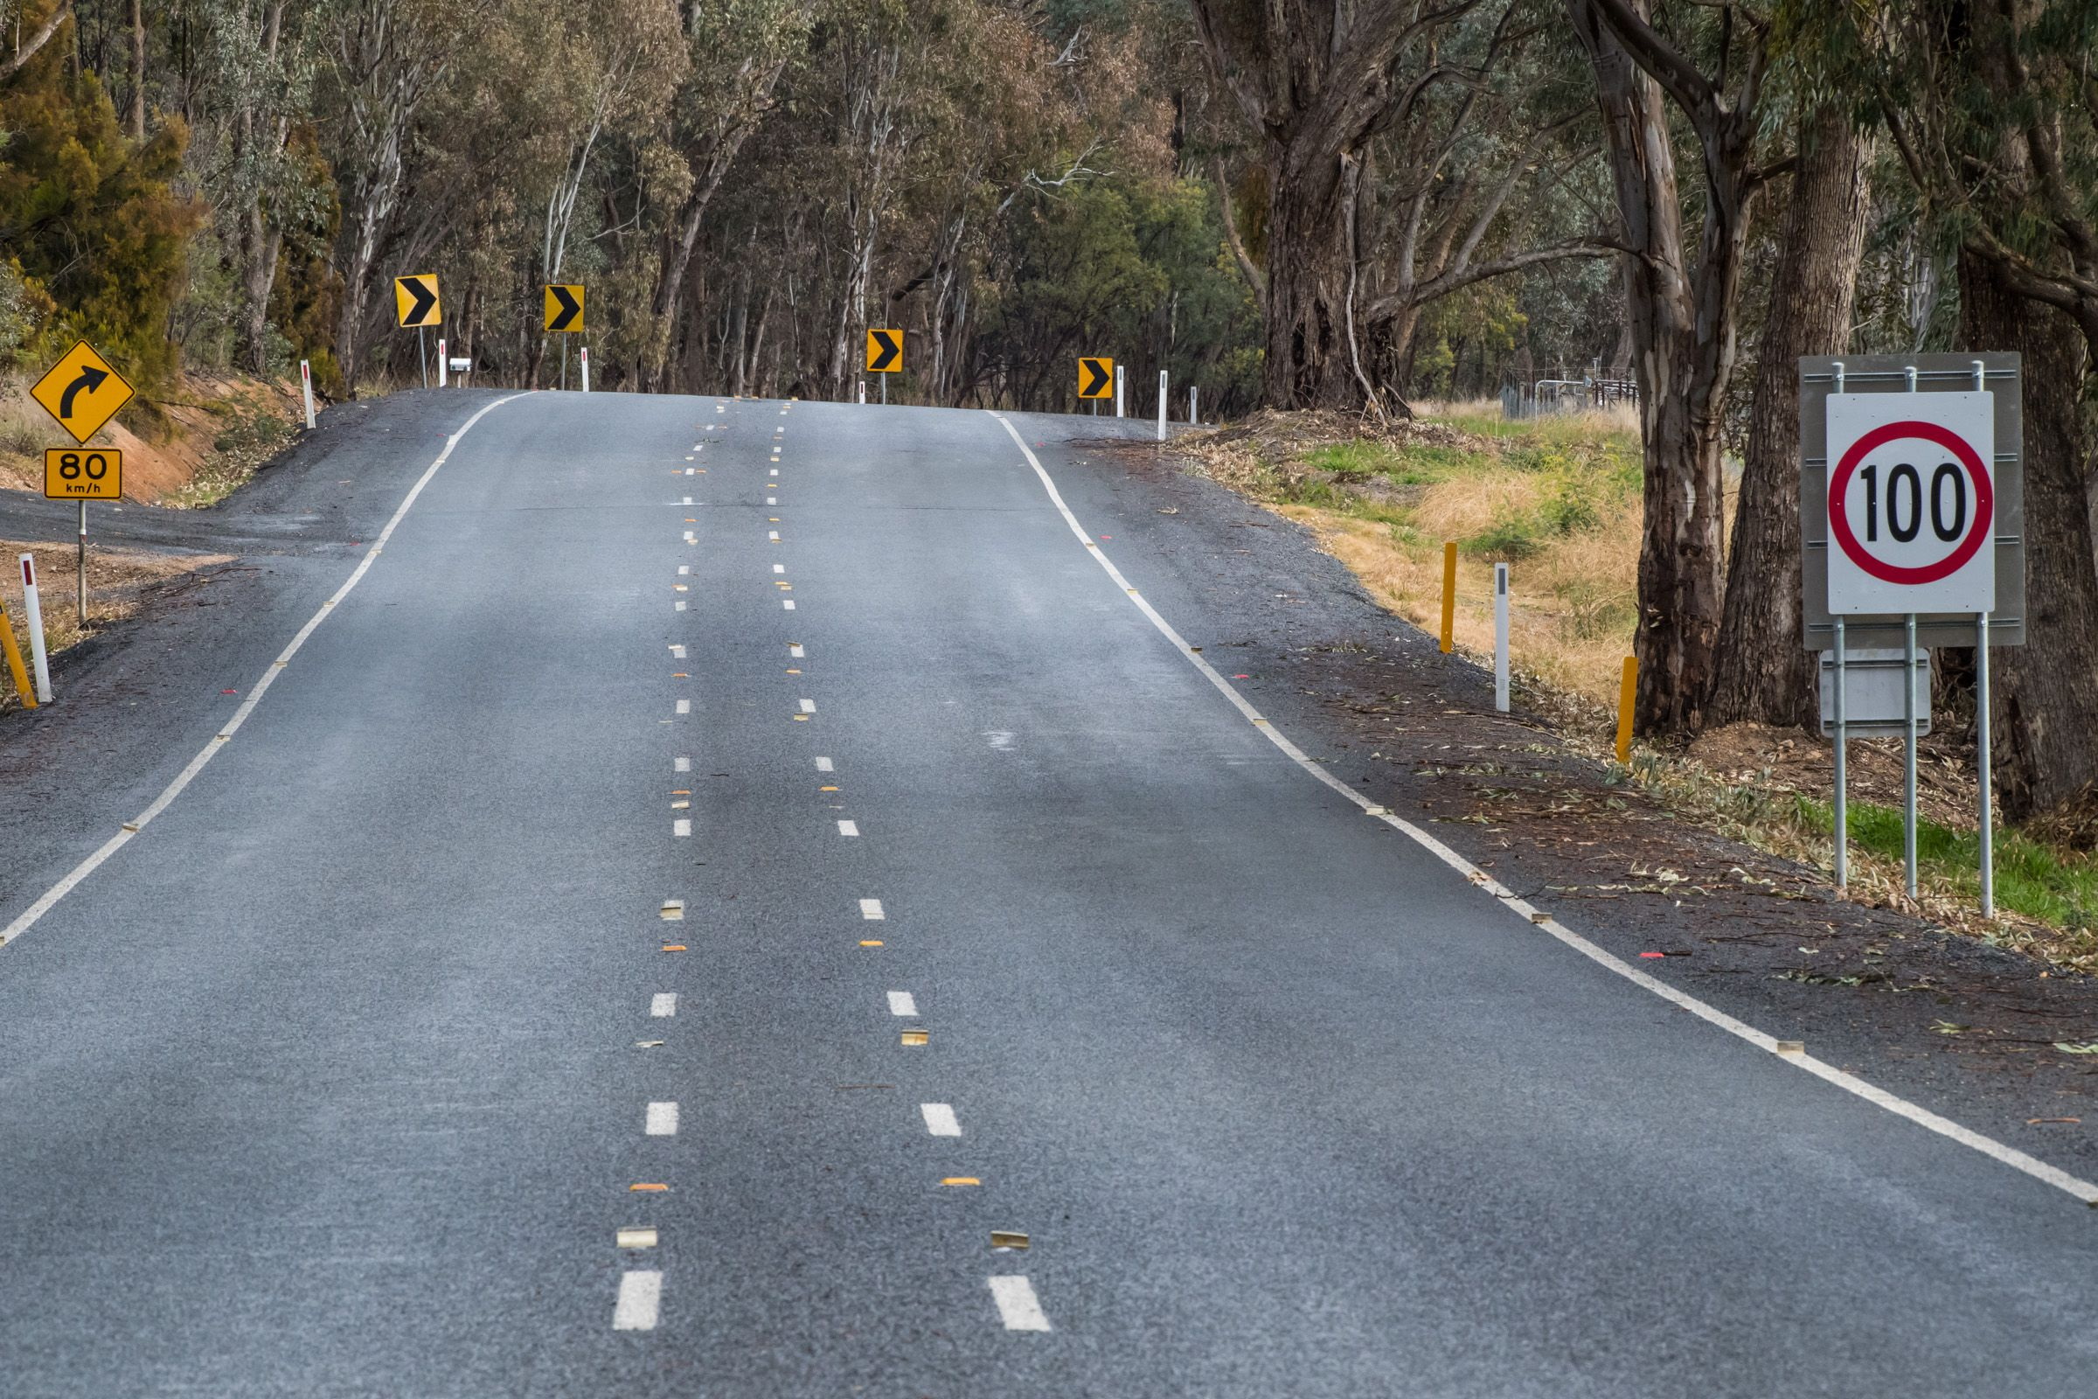  Figure 1: Beechworth-Wodonga Road, wide centreline treatment | 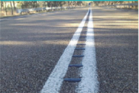  Figure 2: Audio tactile line marking (ATLM)

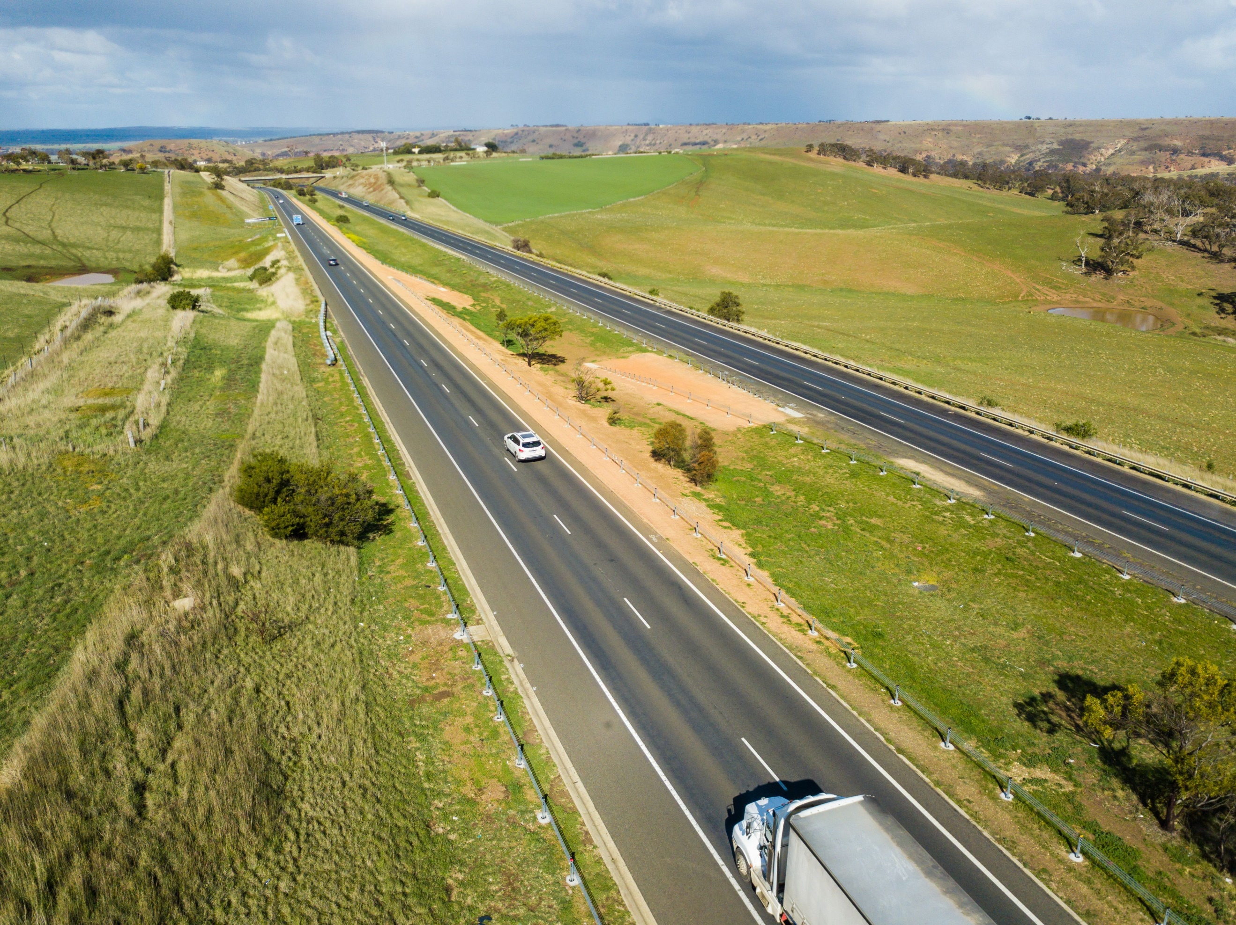
Figure 3: Western Highway, continuous median and roadside flexible barriers

  - Roads selected for the program
The Top 20 roads and their extents are shown in Table 1 below.
Table 1: Top 20 roads list and extents
Road | Extent
Anglesea / Great Ocean Road | Bellbrae to Anglesea
Bass Highway | Lang Lang to San Remo
Beechworth-Wodonga Road | Beeachworth to Yackandandah Rd
Calder Freeway | M80 Ring Road/Keilor Park to Bendigo
Geelong Ring Road | Corio to Waurn Ponds
Goulburn Valley Highway | Yea to Molesworth
Hume Freeway / Highway | M80 Ring Road / Thomastown to Wodonga
Maffra-Sale Road | Sale to Maffra
Midland Highway | Ballarat to Creswick
Mornington Peninsula Freeway / Highway | Mount Martha to Rosebud
Princes Freeway East | Longwarry to Traralgon
Princes Freeway East | Traralgon to Sale
Princes Highway West | Little River to Corio
South Gippsland Highway | Leongatha to Meeniyan
Western Freeway | M80 Ring Road / Sunshine West to Ballarat
Geelong Bacchus Marsh Road | Heales Road to Woolpack Road
Melbourne-Lancefield Road | Sunbury Road to Chauncey Street
Paynesville Road | Main Road to Princes Highway
Midland Shepparton to Stanhope | Girgarre-Rushworth Road to Goulburn Valley Highway
Princes Highway East - Sale to Bairnsdale | Forster Street to Forge Creek Road

  - Top 20 Star Rating Map
The following figures compare the star rating results of the Top 20 road corridors, before and after treatments were installed.
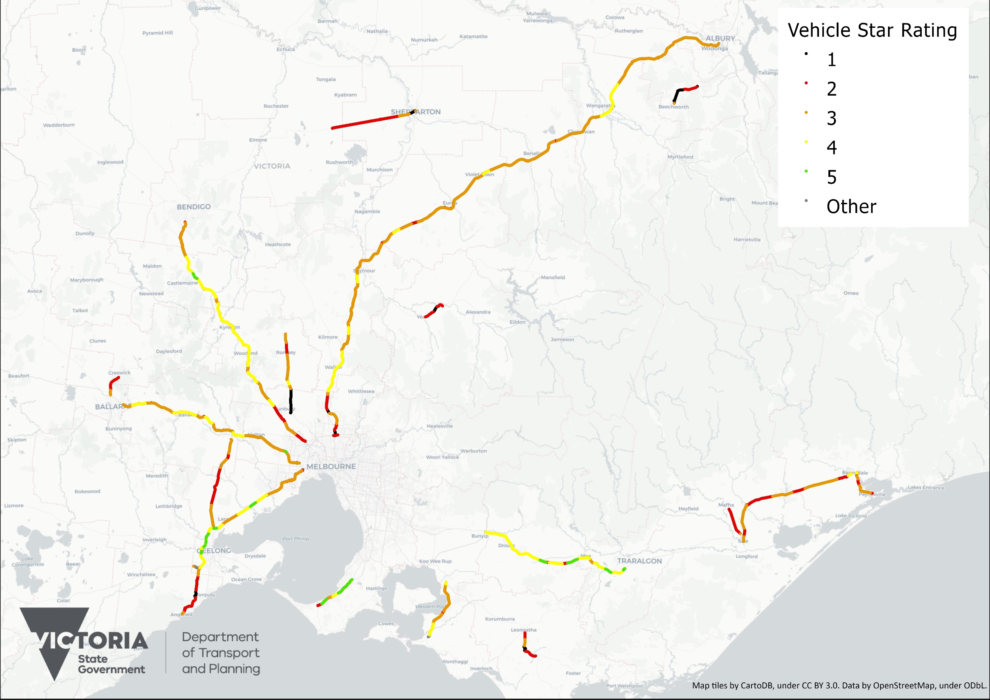
Figure 4: AusRAP star ratings map of Top 20 road corridors – before treatments
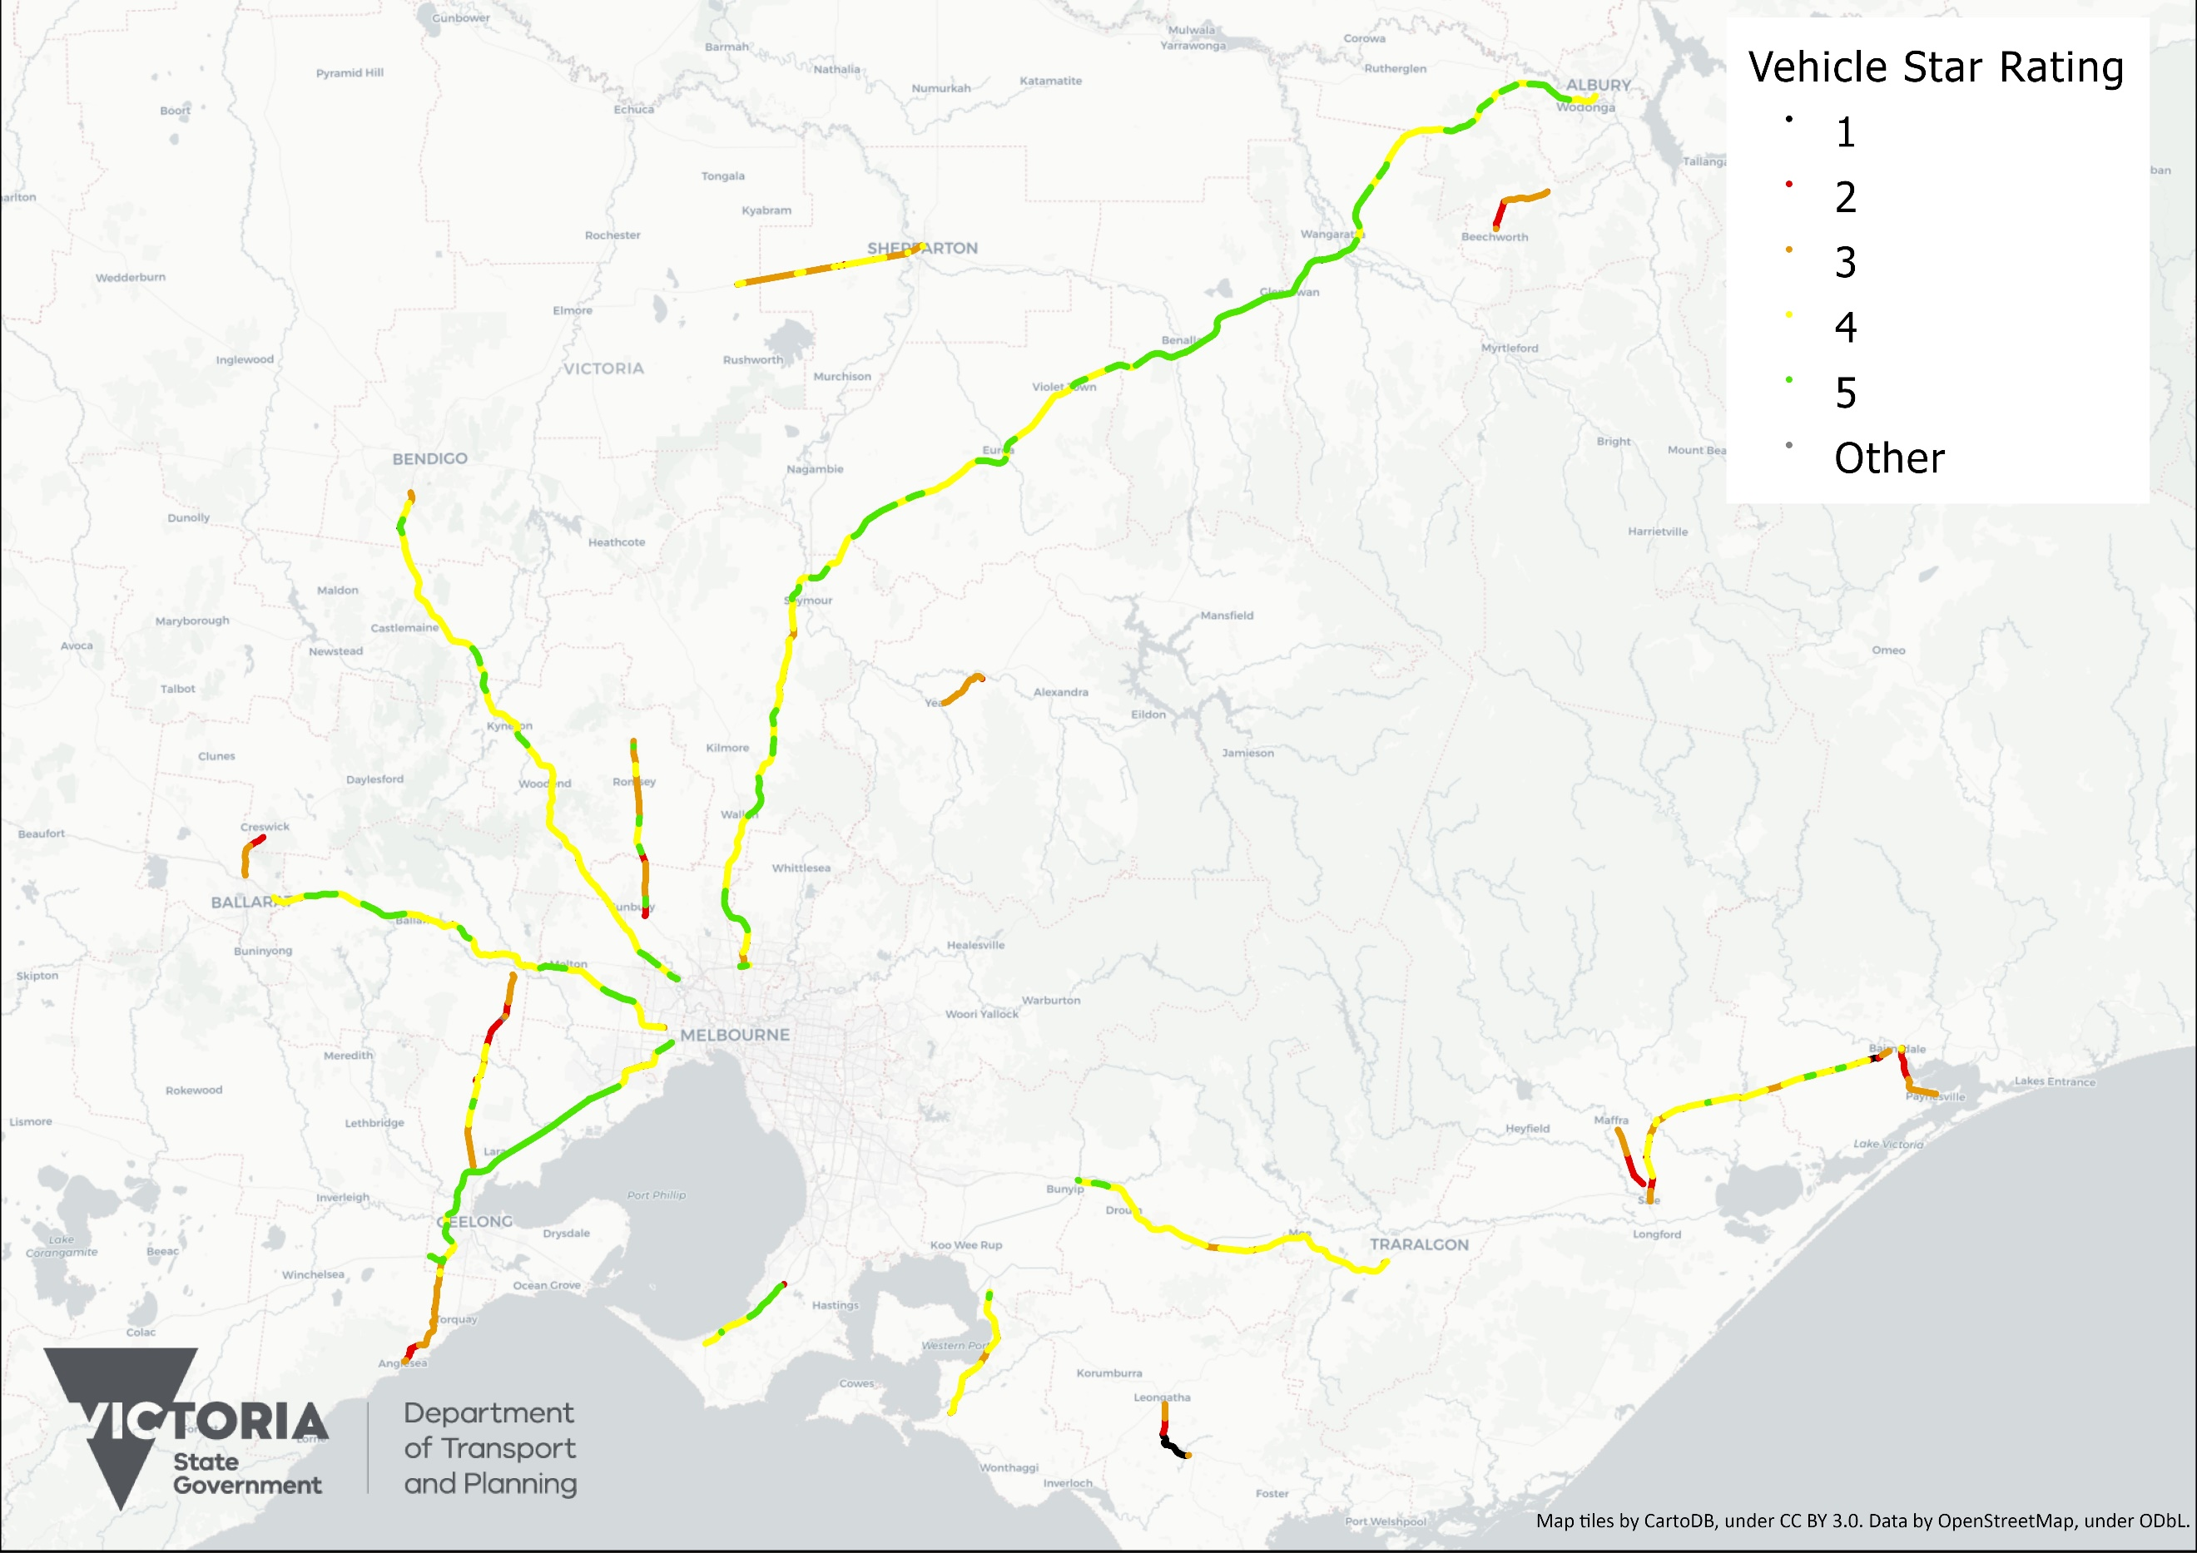
Figure 5: AusRAP star ratings map of Top 20 road corridors – after treatments
  - Top 20 Results
    - Road safety star ratings
Key statistics from the Top 20 before and after assessments are summarised in the following tables and figures. Table 2 summarises star ratings by percentage of road length, while Table 3 summarises them by percentage of travel.
Table 2: AusRAP star ratings by length, Top 20 roads – before and after
Star Ratings | Top 20 Roads – By Length
 | Before |  | After
 | Length (km) | Percent | Length (km) | Percent | % Change
5-star | 37.1 | 2.1% | 363.4 | 21% | +18.9%
4-star | 366.5 | 21% | 1,027.3 | 61% | +40%
3-star | 932.4 | 53% | 230.2 | 14% | -39%
2-star | 320.9 | 18% | 51.9 | 3.1% | -14.9%
1-star | 72.2 | 4.1% | 15.8 | 0.9% | -3.2%
Total | 1,759.2 | 100% | 1,691.1 | 100%
3-star or better | 1,336.0 | 76% | 1,620.9 | 96% | +20%
4-star or better | 403.6 | 23% | 1,390.7 | 82% | +59%

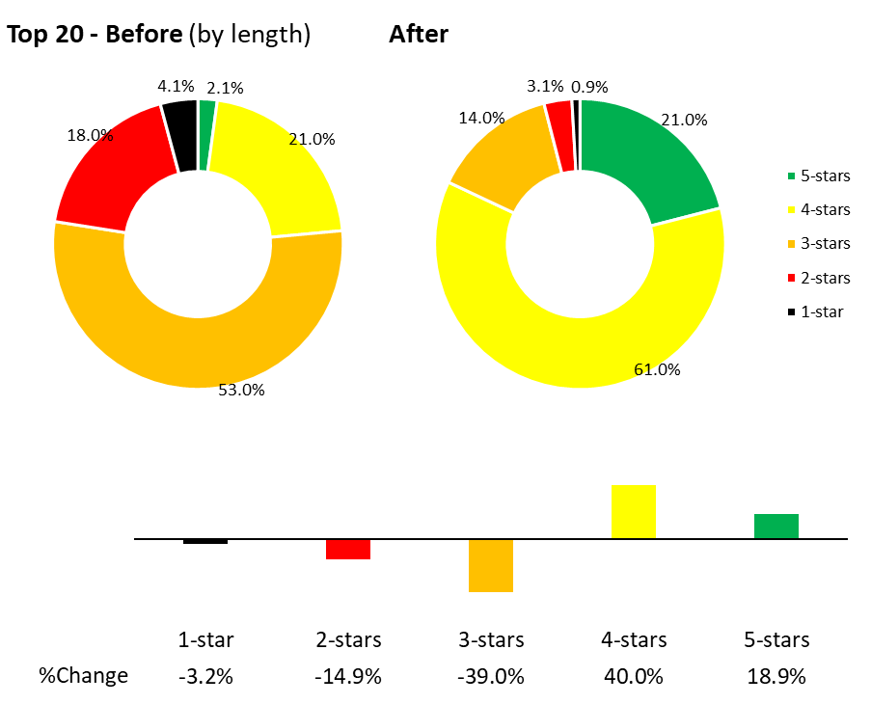
Figure 6: AusRAP star ratings by length, Top 20 roads – before and after
Table 3: AusRAP star ratings by travel, Top 20 roads – before and after
Star Ratings | Top 20 Roads – By Travel
 | Before |  | After
 | Million VKT (km) | Percent | Million VKT (km) | Percent | % Change
5-star | 150.9 | 2.5% | 2,193.1 | 28% | +25.5%
4-star | 1,383.7 | 22% | 4,587.2 | 58% | +36%
3-star | 3,079.5 | 50% | 869.1 | 11% | -39%
2-star | 1,137 | 18% | 137.5 | 1.8% | -16.2%
1-star | 321.7 | 5.2% | 56.7 | 0.7% | -4.5%
Total | 6,153.8 | 100% | 7,855.2 | 100%
3-star or better | 4,614.1 | 75% | 7,649.5 | 97% | +22%
4-star or better | 1,534.6 | 25% | 6,780.4 | 86% | +61%

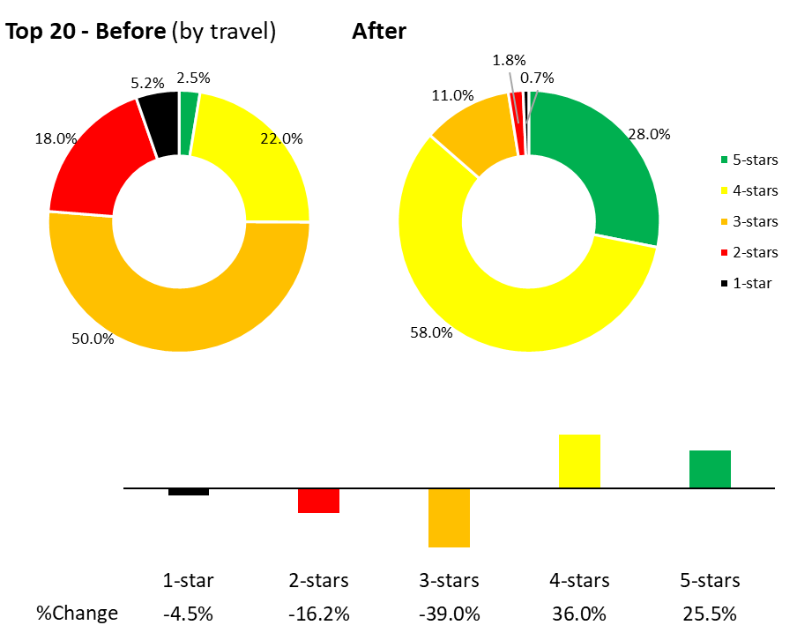
Figure 7: AusRAP star ratings by travel, Top 20 roads – before and after
These results show significant improvements in star ratings for the Top 20 roads. In summary:
- The percentage of road length rated 3-star or better increased from 76% (before treatments) to 96% (after treatments) for vehicle occupants.
- The percentage of travel rated 3-star or better has risen from 75% (before treatments) to 97% (after treatments).
- The percentage of travel rated 4-star or better has significantly increased from 25% (before treatments) to 86% (after treatments).
    - Road safety trauma evaluation
Victoria’s rollout of continuous barriers has delivered significant safety benefits.
The Transport Accident Commission (TAC) conducted an analysis linking police reports and insurance claims to annual injury and hospitalisation data. The analysis found that, based on police-reported cases, the Top 20 Program improvements resulted in:
- 77% fewer fatalities
- 50% fewer serious injuries
- 45% fewer minor injuries
Additionally, TAC found that the Top 20 Program led to significant reductions in TAC claims, injury severity, and hospital stays per year for lane departure crashes, specifically:
- 94% fewer MAIS 3+ claims
- 39% fewer MAIS 2 claims
- 30% fewer MAIS 0–1 claims
- 74% fewer hospital bed days

- Safe Roads Next 16
The Next 16 roads were developed and delivered through the Investment Plan (IP) 21 and IP 22. These initiatives were introduced to enhance safety on high-risk corridors using proven infrastructure treatments.
  - Program Overview
The IP 21 – Full Barrier on Divided High-Speed Roads program implemented approximately 436 km of linear flexible barrier on both the left-hand side and the median, covering over 176 km of the road length on ten high-risk road corridors.
The IP 22 - Full Barrier and Intersection Treatments on Undivided 100km/h Roads program treated intersections and installed at least 80 km of centreline flexible barriers, as well as flexible safety barriers on the left-hand side and overtaking lanes on six high-risk road corridors.
Figure 8 and Figure 9 show typical treatments on the selected road segments. These treatments aim to prevent crashes or mitigate their severity where avoidance is not possible.
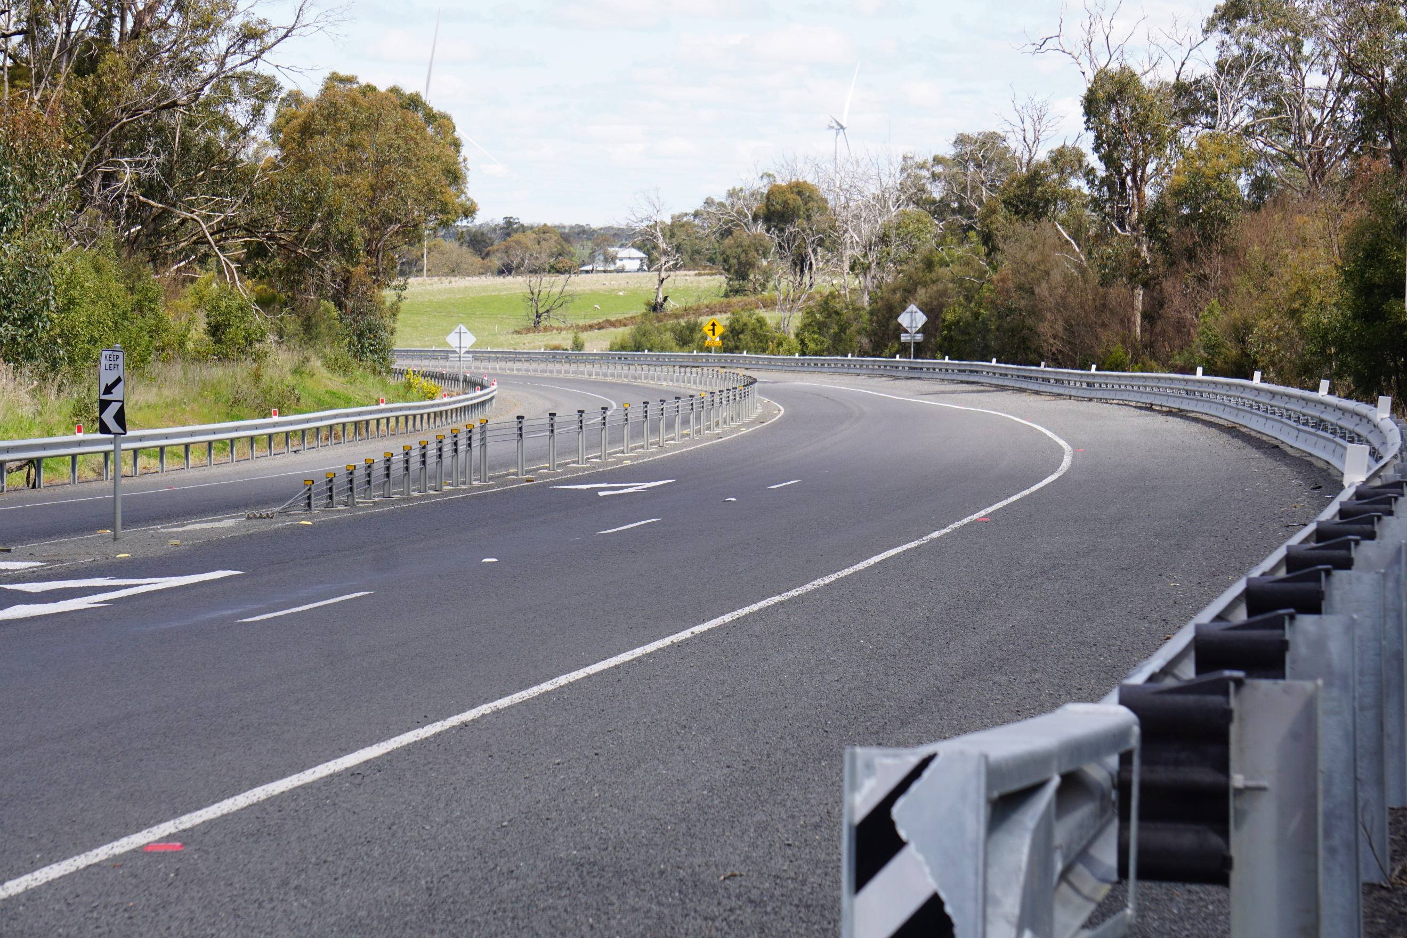
Figure 8: Midland Highway, continuous median and roadside flexible barriers
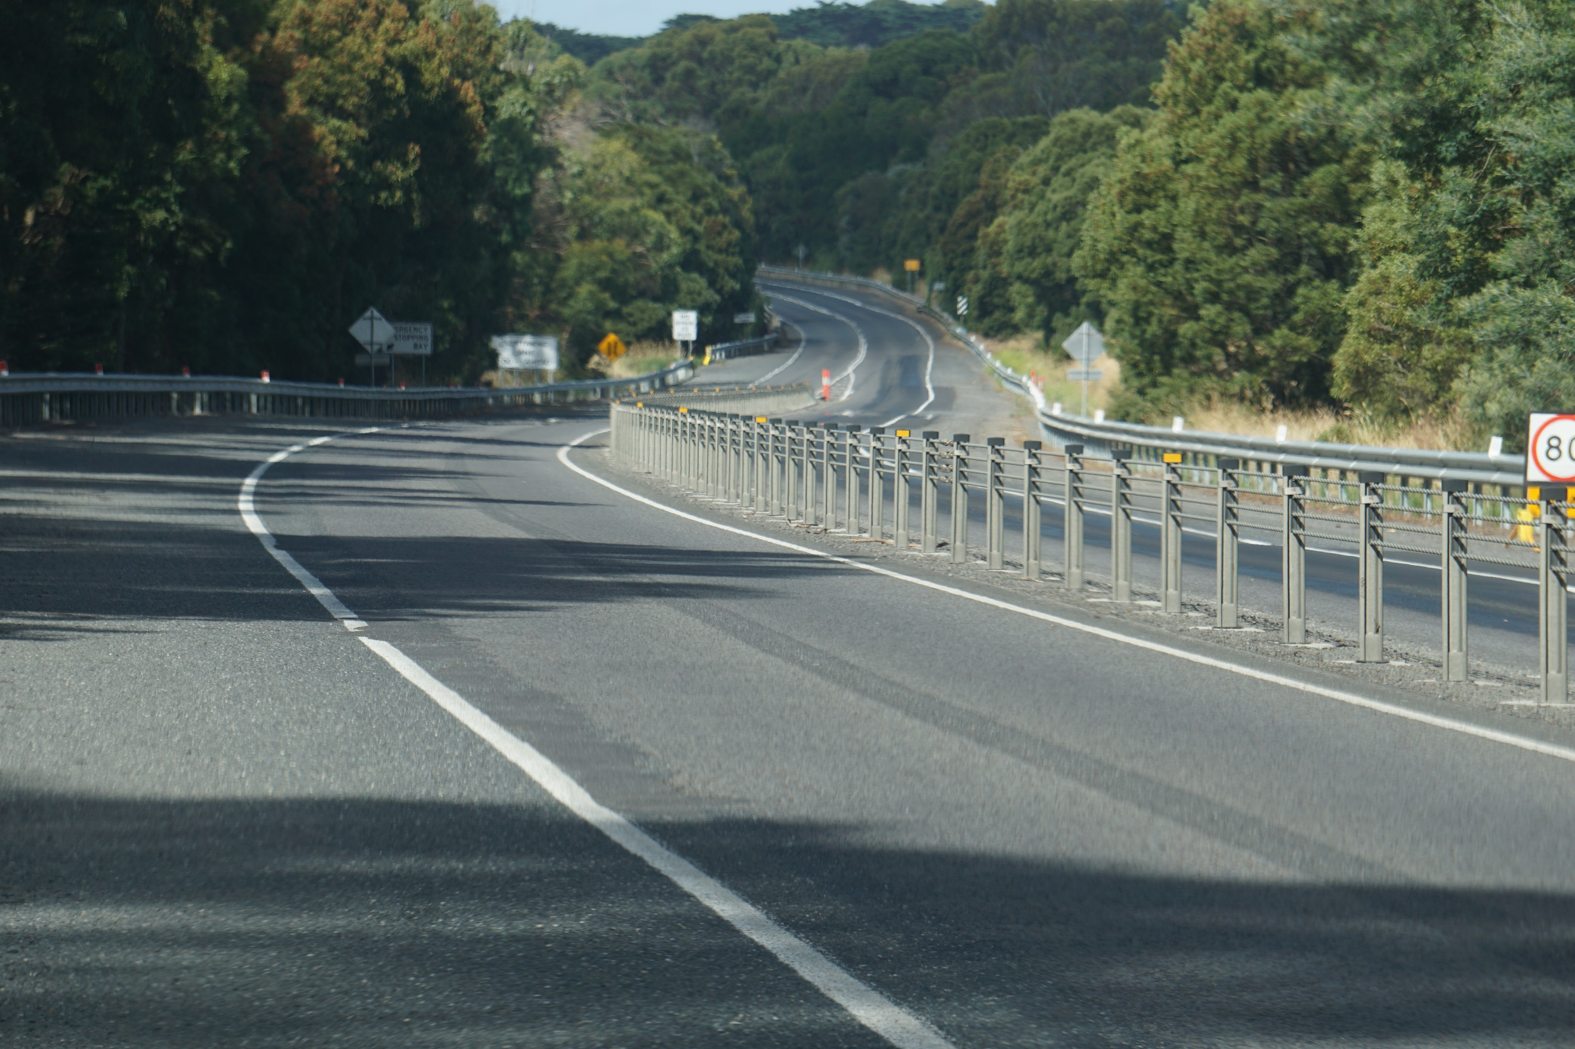
Figure 9: Princes Highway West, continuous median and roadside flexible barriers

  - Roads selected for the program
The Next 16 roads and their extents are shown in Table 4 below.
Table 4: Next 16 roads list and extents
Road | Extent
Goulburn Valley Freeway | Seymour to end duplication (Ross Road)
Princes Highway West | Ziegler Parade to Mahoneys Road
Princes Highway West | Panmure to Allansford
South Gippsland Highway | Craig Road to Bass Highway
Bellarine Highway | Christies Road to Grubb Road
Frankston Freeway | Mornington Peninsular Freeway to Beach Street
Moorooduc Highway | Sumner Road to Balnarring Road
Mornington Peninsular Freeway | Springvale Road to Frankston Freeway
Princes Freeway East | Cardinia Road to Bunyip River
Surf Coast Highway | Feehans Road / Coastside Drive to Merrijig Drive
Westernport Highway | South Gippsland Hwy to North Road
Midland Highway | Clarendon to Buninyong
Midland Highway | Shepparton to Nalinga
Maroondah Highway | Coldstream
Fyansford-Gheringhap Road | Dog Rocks Road to Midland Hwy
Murray Valley Highway | Mystic Park to Lake Boga

  - Next 16 Star Rating Map
The following figures compare the star rating results of the Next 16 road corridors, before and after treatments were installed.
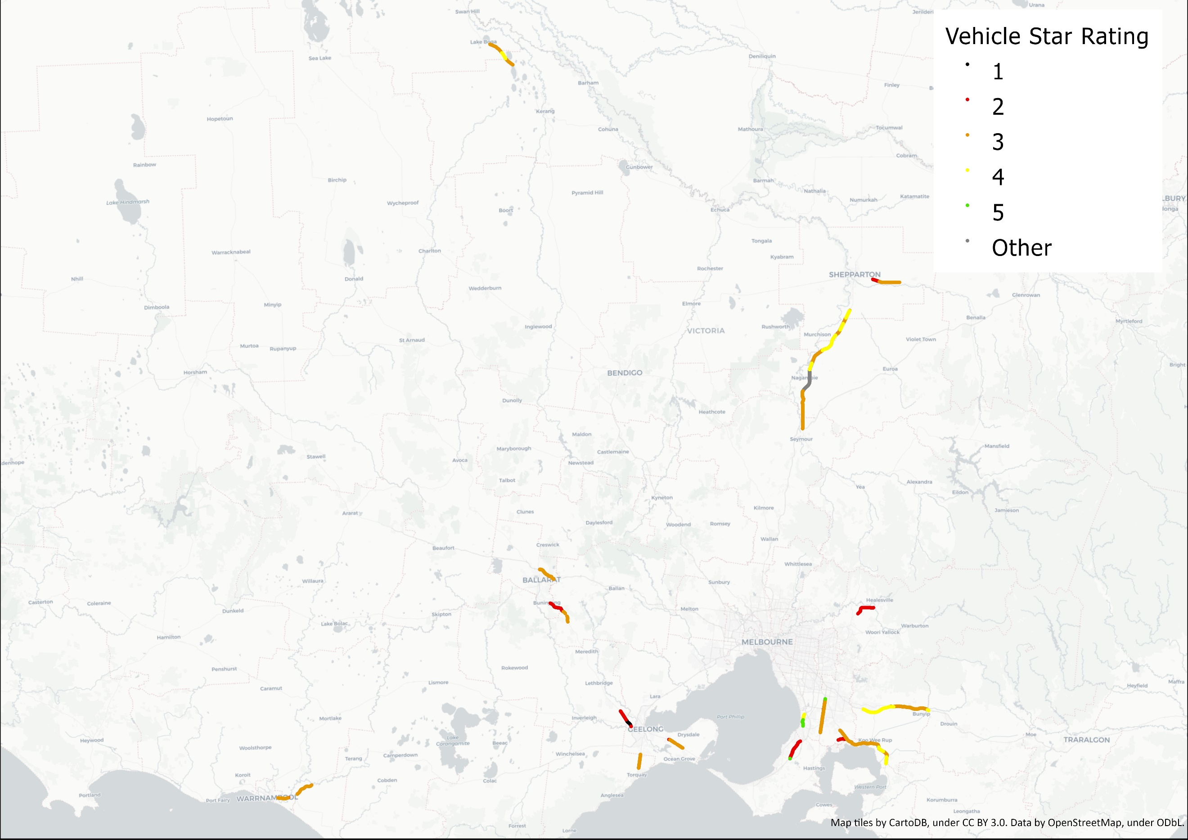
Figure 10: AusRAP star ratings map of Next 16 road corridors – before treatments

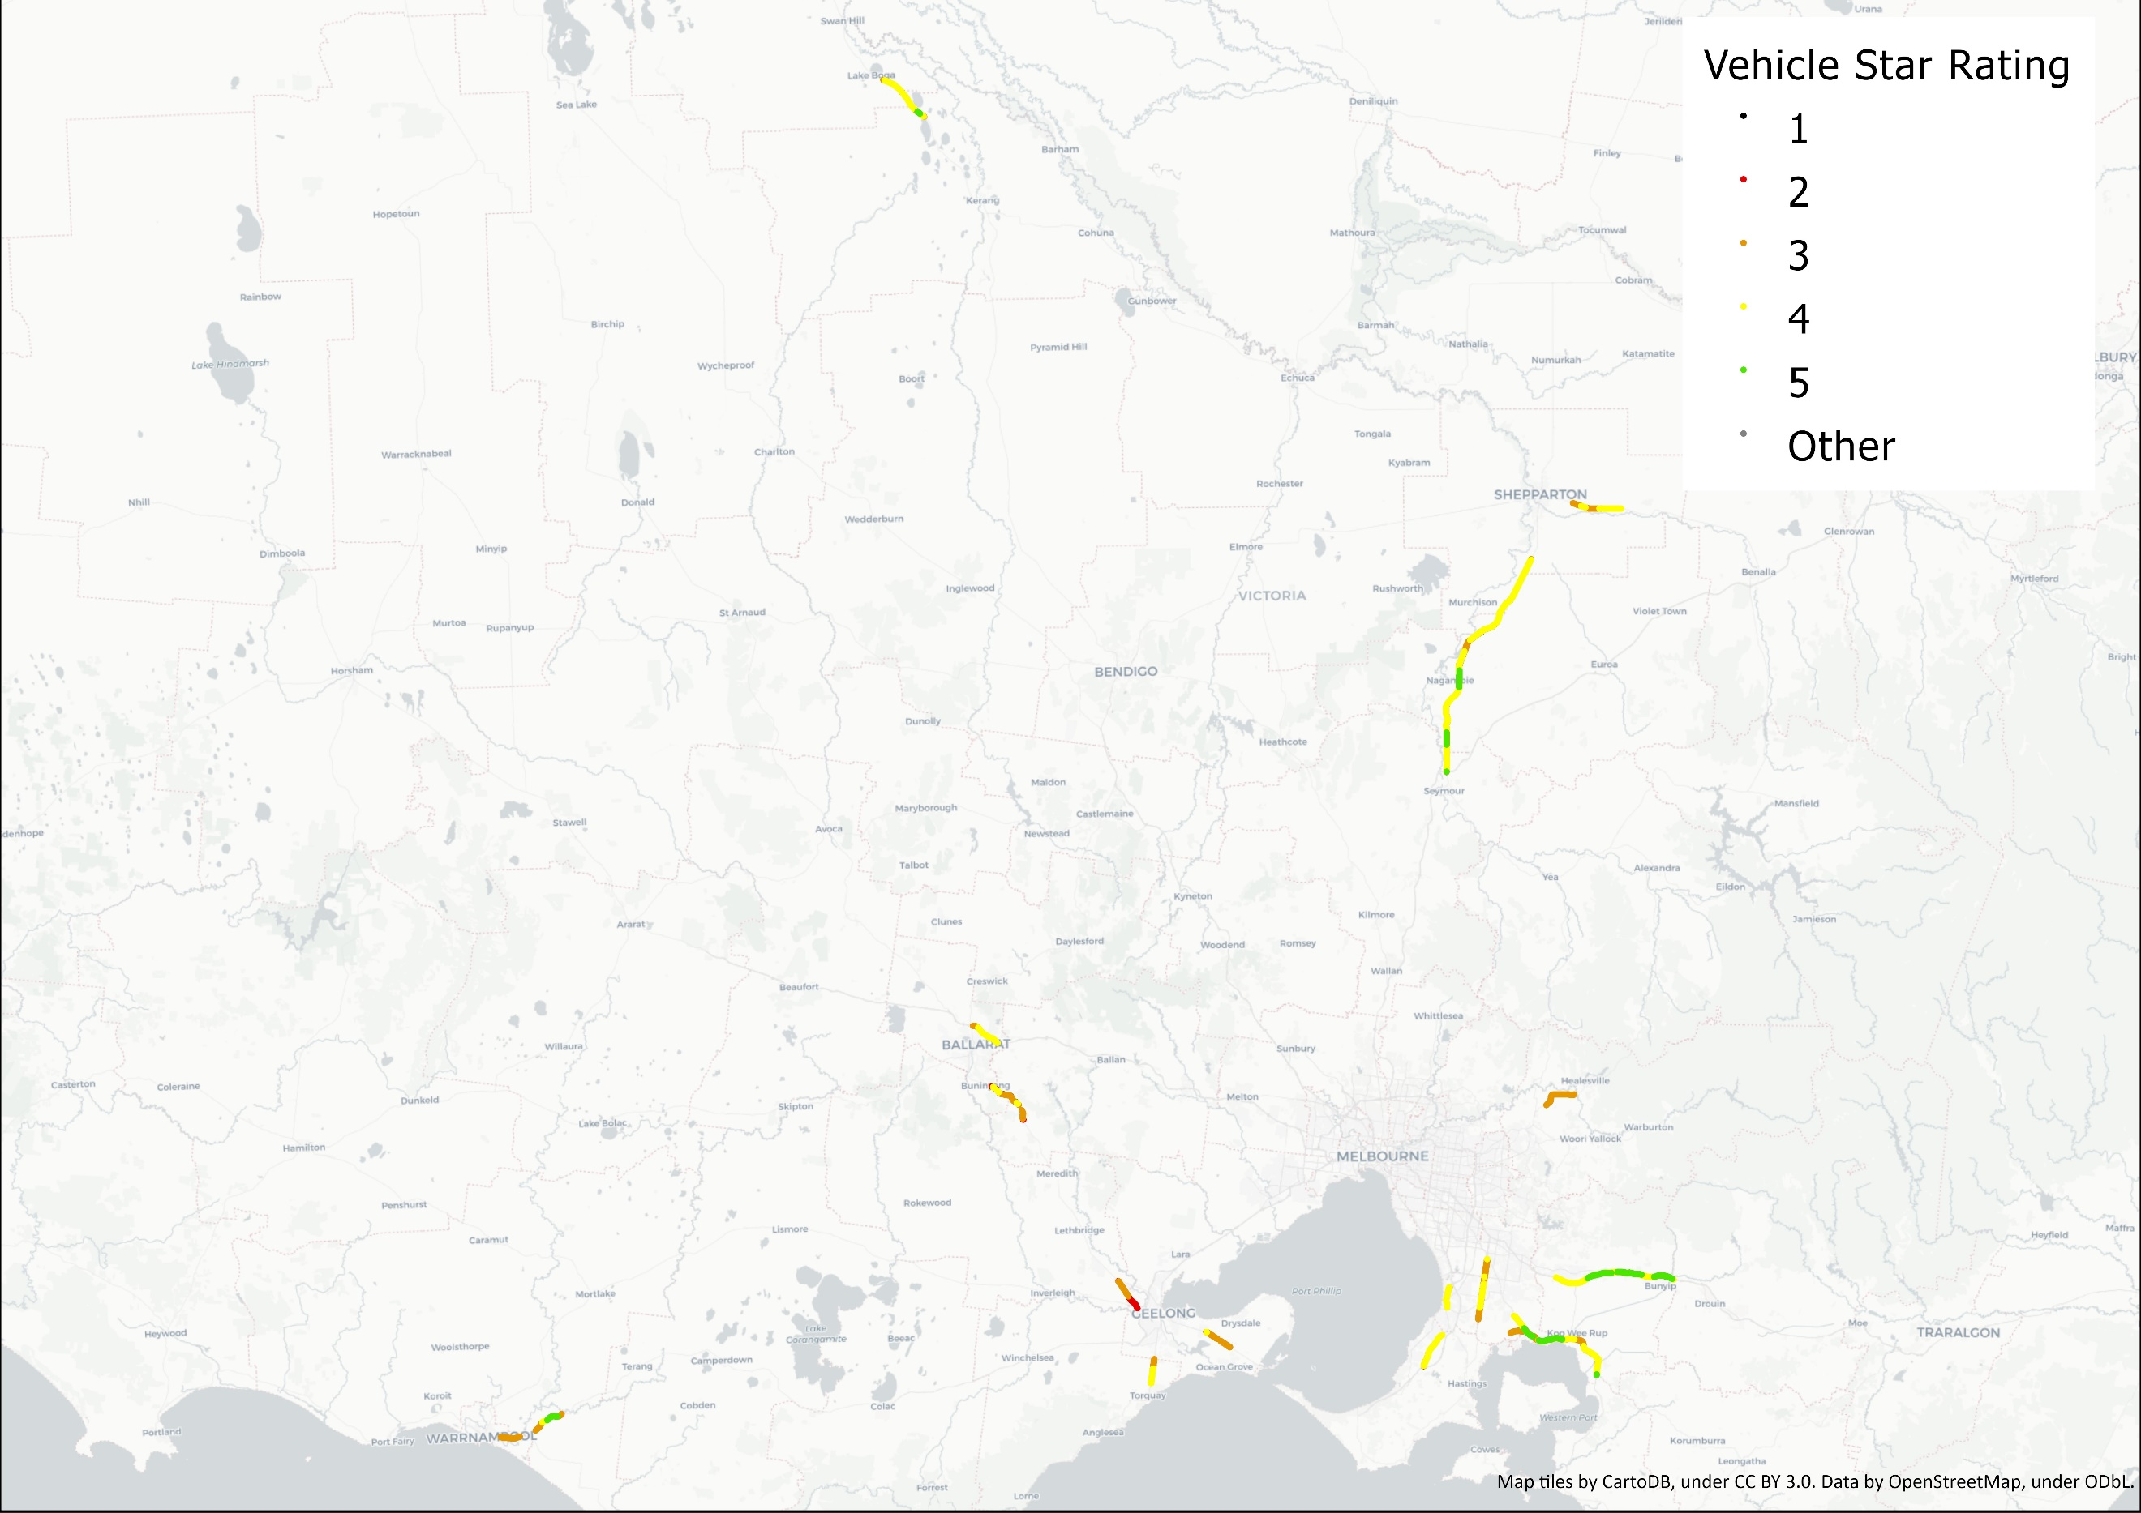
Figure 11: AusRAP star ratings map of Next 16 road corridors – after treatments

  - Next 16 Results
    - Road safety star ratings
Key statistics from the Next 16 before and after assessments are summarised in the following tables and figures. Table 5 summarises star ratings by percentage of road length, while Table 6 summarises them by percentage of travel.
Table 5: AusRAP star ratings by length, Next 16 roads – before and after
Star Ratings | Next 16 Roads – By Length
 | Before |  | After
 | Million VKT (km) | Percent | Million VKT (km) | Percent | %Change
5-star | 5.6 | 1.3% | 42.6 | 11% | +9.7%
4-star | 64.2 | 15% | 208.1 | 51% | +36%
3-star | 220.5 | 53% | 143.5 | 36% | -17%
2-star | 82.4 | 20% | 7.6 | 1.9% | -18.1%
1-star | 10.4 | 2.5% | 2.3 | 0.6% | -1.9%
Total | 416.1 | 100% | 404.1 | 100%
3-star or better | 290.3 | 70% | 394.2 | 98% | +28%
4-star or better | 69.8 | 17% | 250.7 | 62% | +45%

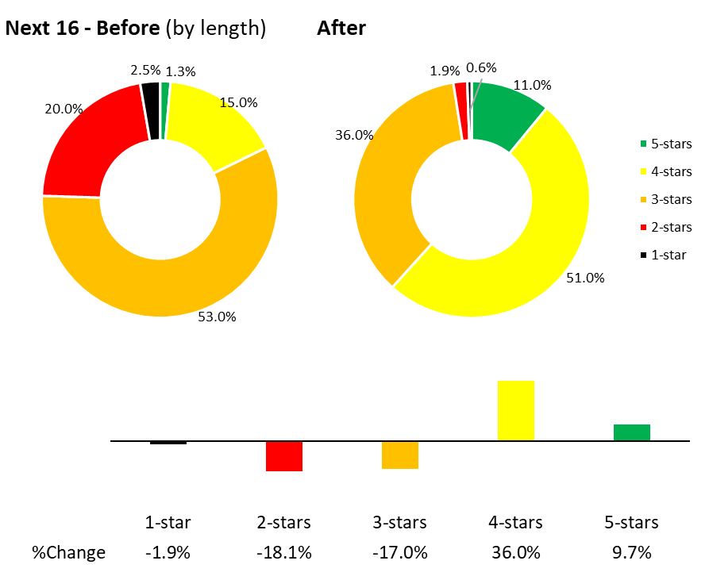
Figure 12: AusRAP star ratings by length, Next 16 roads – before and after

Table 6: AusRAP star ratings by travel, Next 16 roads – before and after
Star Ratings | Next 16 Roads – By Travel
 | Before |  | After
 | Million VKT (km) | Percent | Million VKT (km) | Percent | %Change
5-star | 51.8 | 4.3% | 151.1 | 12% | +7.7%
4-star | 265.7 | 22% | 701.6 | 56% | +34%
3-star | 530 | 44% | 384.1 | 31% | -13%
2-star | 266.3 | 22% | 17.4 | 1.4% | -20.6%
1-star | 32.6 | 2.7% | 5.2 | 0.4% | -2.3%
Total | 1,192.2 | 100% | 1,259.0 | 100%
3-star or better | 847.4 | 71% | 1,236.9 | 98% | +27%
4-star or better | 317.5 | 27% | 852.7 | 68% | +41%

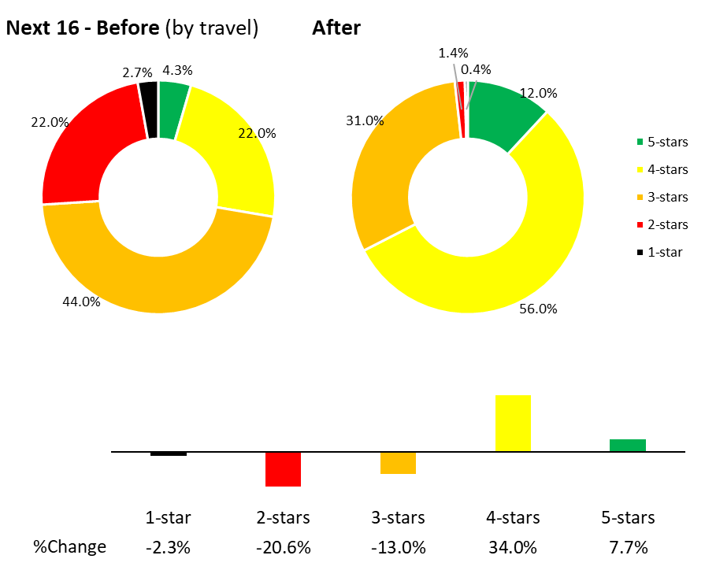
Figure 13: AusRAP star ratings by travel, Next 16 roads – before and after
These results show significant improvements in star ratings for the Next 16 roads. In summary:
- The percentage of road length rated 3-star or better has increased from 70% (before treatments) to 98% (after treatments) for vehicle occupants.
- The percentage of travel rated 3-star or better has risen from 71% (before treatments) to 98% (after treatments).
- The percentage of travel rated 4-star or better has significantly increased from 27% (before treatments) to 68% (after treatments).
    - Road safety trauma evaluation
This program will be assessed as part of the Safer Roads Program Evaluation. Based on the TAC study’s findings, similar positive results are expected.

