- Introduction
The Department of Transport and Planning has conducted a comprehensive assessment of the safety performance of the Victorian road network using the AusRAP methodology, covering more 24,500 km carriageway kilometres of state-controlled roads. This includes 4,650 km of urban roads and 19,850 km of rural roads. Local council-managed roads were not included in the assessment.
The results show that Victoria is making progress towards the national target of at least 80 per cent of travel on 3-star or better roads by 2030, in line with the National Road Safety Strategy 2021-30.
Currently 71% of travel is on 3-star or better roads statewide (9% below the 2030 target).

Key definitions:

AusRAP Star Ratings
- AusRAP star ratings can be broken down into four types of road users: vehicle occupants, motorcyclists, pedestrians and bicyclists. For this report, the data provided only refers to vehicle occupants.

Length vs travel
- Star ratings by length refer to the length of road allocated to a particular star value based on the assessment criteria. So a 28% at 3-star means 28% of the overall length of the roads is assessed as 3-star.

- Vehicle kilometres travelled (VKT) is a measure of how far people drive on our roads. So a 42% VKT at 3 star means that 42% of travel occurs on roads, or sections of roads with 3-star ratings.
- Statewide Results
  - Statewide Star Ratings Map
The Star Rating map for vehicle occupants for the entire declared road network is shown in Figure 1.
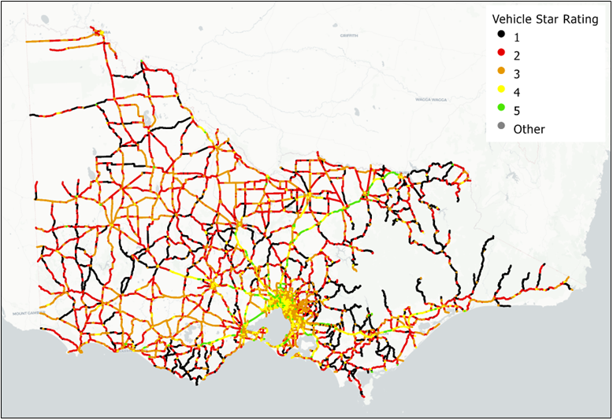
Figure 1: AusRAP Star Ratings Map – Statewide Road Network
  - 2023 Statewide Results
The distribution of star ratings for vehicle occupants across the network are shown in Table 1 and Figure 2. This table summarises the star rating results by road length, as well as vehicle kilometres travelled (VKT).
Table 1: AusRAP Star Ratings – Statewide Road Network
Star Ratings | By Length |  | By Travel
 | Length (km) | Per cent (%) | Million VKT (km) | Per cent (%)
5-star | 510.1 | 2.1 | 3,028 | 6.4
4-star | 2,175.2 | 8.9 | 10,573.8 | 22
3-star | 6,867.7 | 28 | 20,130.7 | 42
2-star | 8,695.3 | 35 | 10,843.9 | 23
1-star | 6,239 | 25 | 3,029.8 | 6.4
N/A | 25.5 | 0.1 | 36.9 | 0.08
Total | 24,512.8 | 100 | 47,643.1 | 100
3-star or better (vs target*) | 9,553.0 | 39 | 33,732.5 (38,114) | 71 (vs 80)
*Targets based on travel only
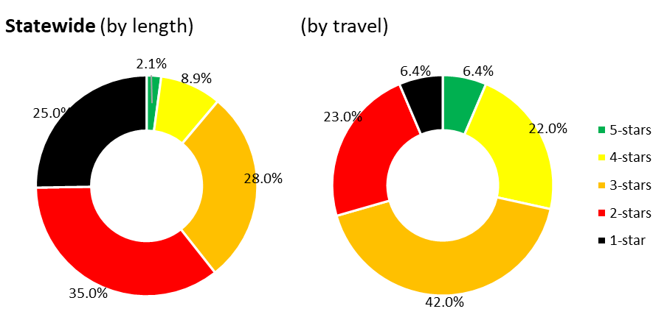
Figure 2: AusRAP Star Ratings – Statewide Road Network

Key results are shown below, in summary for the statewide network:
- 39% of road length (9,553 km) is rated 3-star or better.
- 71% of travel occurs on 3-star or better roads, compared to the AusRAP target of 80% by 2030.
- Rural Regions
  - Rural Regions Star Ratings Map
The star ratings map for vehicle occupants for all rural regions (Barwon South West, Gippsland, Grampians, Hume and Loddon Mallee) is shown in Figure 3.
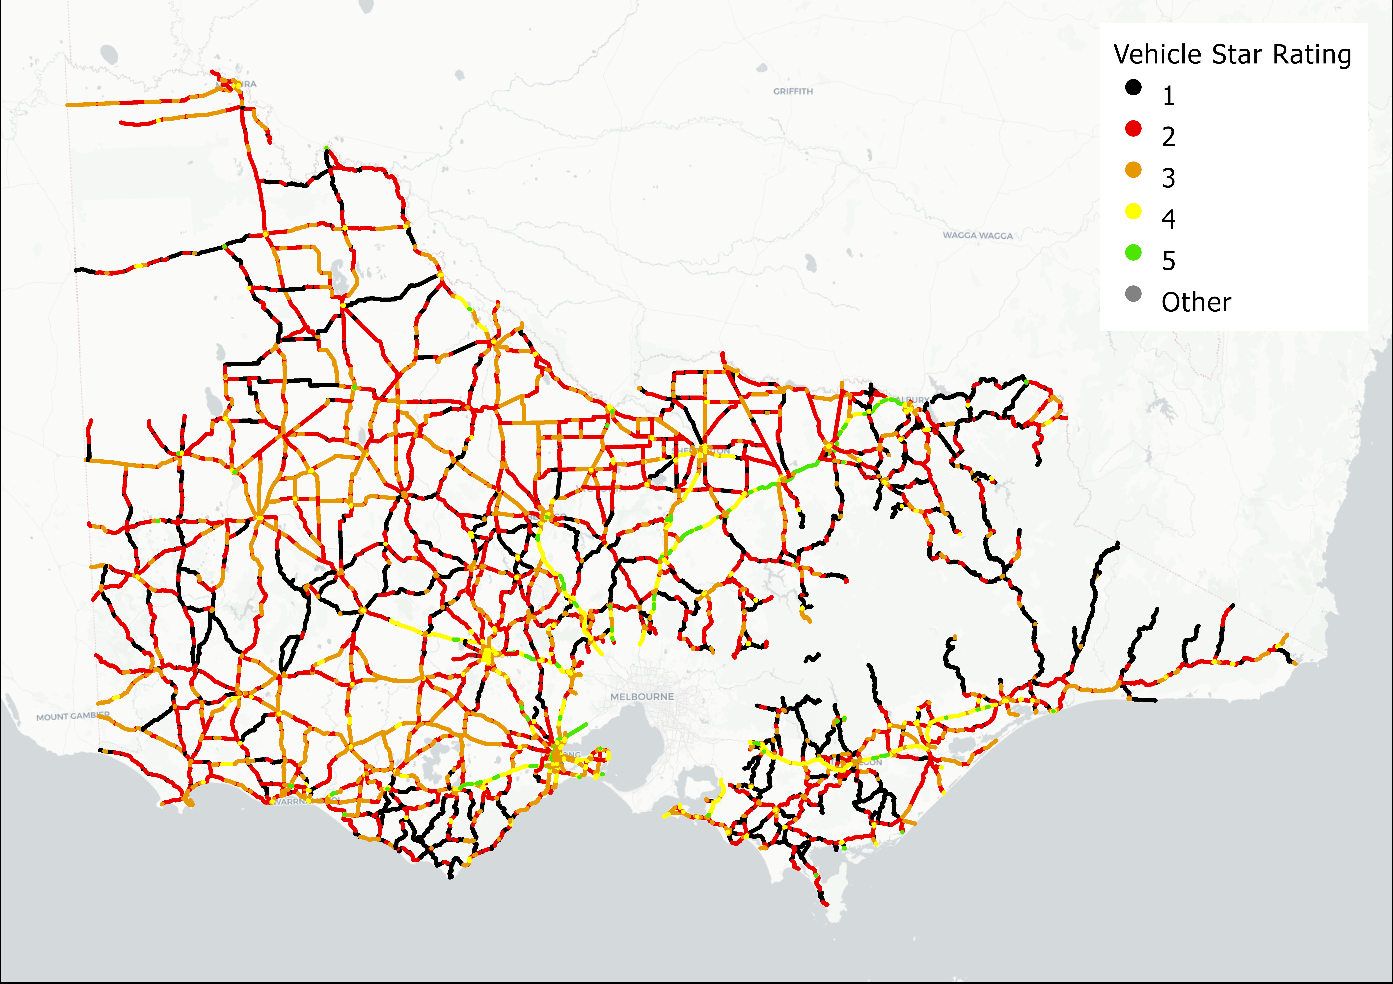
Figure 3: AusRAP Star Ratings Map – Rural Regions

  - Rural Regions Result Table
The distribution of star ratings for vehicle occupants across all rural regions (Barwon South West, Gippsland, Grampians, Hume and Loddon Mallee) are shown in Table 2 and Figure 4.
Table 2: AusRAP Star Ratings – Rural Regions
Star Ratings | By Length |  | By Travel
 | Length (km) | Per cent (%) | Million VKT (km) | Per cent (%)
5-star | 350.2 | 1.8 | 1,363.1 | 7.2
4-star | 1,495.3 | 7.5 | 3,960 | 21
3-star | 4,519 | 23 | 5,708.9 | 30
2-star | 7,619.4 | 38 | 5,438.2 | 29
1-star | 5,844.2 | 29 | 2,416. | 13
Total length | 19,853.6 | 100 | 18,923.1 | 100
3-star or better | 6,364.5 | 32.0 | 11,032.1 | 58

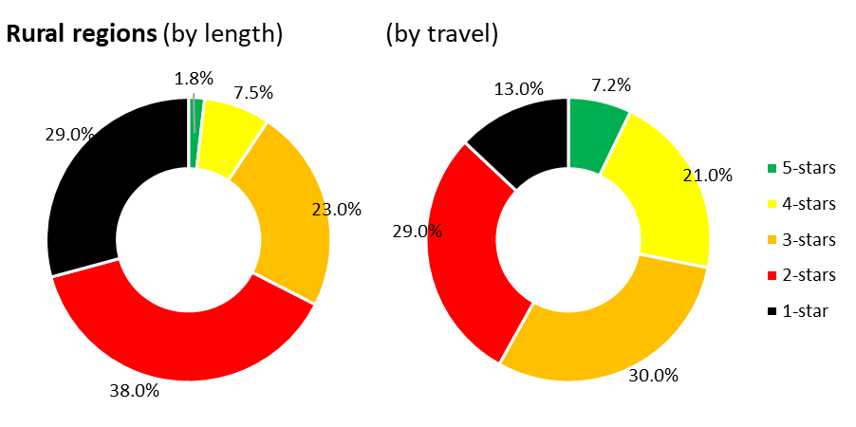
Figure 4: AusRAP Star Ratings – Rural Regions

Key results are shown below, in summary for rural regions:
- 32% of road length (6,365 km) is rated 3-star or better.
- 58% of travel occurs on 3-star or better roads.
- Metro Regions
  - Metro Regions Star Ratings Map
The star ratings map for vehicle occupants obtained from 2023 initiative for the Metro regions (Inner Metro and Greater Metro) is shown in Figure 5.
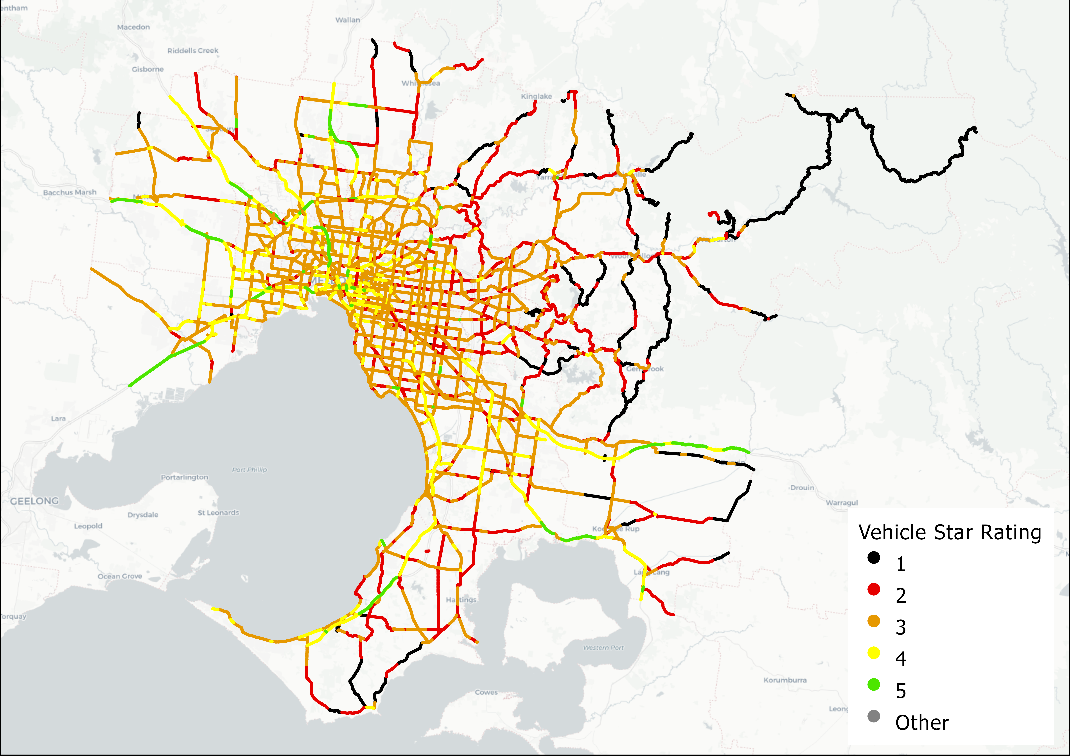
Figure 5: Star Ratings Map – Metro Regions

  - Metro Regions Result Table
The distribution of star ratings for vehicle occupants across the Metro regions (Inner Metro and Greater Metro) are shown in Table 3 and Figure 6.
Table 3: AusRAP Star Ratings – Metro Regions
Star Ratings | By Length |  | By Travel
 | Length (km) | Per cent (%) | Million VKT (km) | Per cent (%)
5-star | 159.9 | 3.4 | 1,664.9 | 5.8
4-star | 679.9 | 15 | 6,613.8 | 23
3-star | 2,348.7 | 50 | 14,421.7 | 50
2-star | 1,075.9 | 23 | 5,405.7 | 19
1-star | 394.8 | 8.5 | 613.8 | 2.1
Total length | 4,659.2 | 100 | 28,720 | 100
3-star or better | 3,188.5 | 68 | 22,700.4 | 79

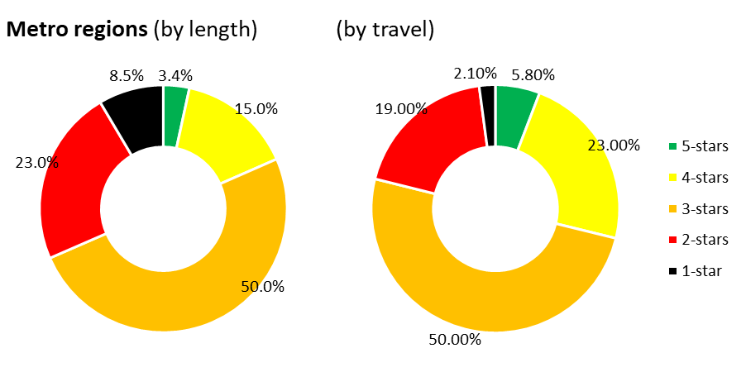
Figure 6: AusRAP Star Ratings – Metro Regions

Key results are shown below, in summary for metro regions:
- 68% of road length (3,189 km) is rated 3-star or better.
- 79% of travel occurs on 3-star or better roads.
- Star Rating Comparison – 2014 and 2023 Rural Regions
In 2014, road safety attribute data was collected along arterial roads in rural regions and selected arterial roads in the metro region. To ensure a direct comparison, the 2014 rural regions are compared with the 2023 rural regions, highlighting significant improvements in the safety performance of the Victorian road network since the previous assessment.
  - Rural Regions Result Table and Comparison
A comparison of the 2014 and 2023 star rating results for vehicle occupants across all rural regions are shown in Table 4 and Table 5 below.
Table 4: AusRAP Star Ratings by Length – 2014 and 2023 Rural Regions
Star Ratings | By Length
 | 2014 |  | 2023
 | Length (km) | Per cent (%) | Length (km) | Per cent (%) | % Change
5-star | 31.9 | 0.2 | 350.2 | 1.8 | +1.6
4-star | 510 | 2.5 | 1,495.3 | 7.5 | +5
3-star | 4,627.4 | 23 | 4,519 | 23 | 0
2-star | 8,190.8 | 40 | 7,619.4 | 38 | -2
1-star | 6,215.8 | 31 | 5,844.2 | 29 | -2
Total length | 20,242 | 100 | 19,853.6 | 100
3-star or better | 5,169.3 | 26 | 6,364.5 | 32 | +6

Table 5: AusRAP Star Ratings by Travel – 2014 and 2023 Rural Regions
Star Ratings | By Travel
 | 2014 |  | 2023
 | Million VKT (km) | Per cent (%) | Million VKT (km) | Per cent (%) | % Change
5-star | 105.1 | 0.6 | 1,363.1 | 7.2 | +6.6
4-star | 1,580.1 | 9.5 | 3,960 | 21 | +11.5
3-star | 6,602.3 | 40 | 5,708.9 | 30 | -10
2-star | 5,892 | 35 | 5,438.2 | 29 | -6
1-star | 2,130.9 | 13 | 2,416. | 13 | 0
Total length | 16,683.7 | 100 | 18,923.1 | 100
3-star or better | 8,287.5 | 50 | 11,032.1 | 58 | +8

The AusRAP star ratings of Victoria’s rural road network has improved since the 2014 assessment.
- By length: 3-star or better increased from 26% in 2014 to 32% in 2023.
- By travel: 3-star or better improved from 50% in 2014 to 58% in 2023.

