Summary of Investigation: Daylesford – Old Tom Track planned burn declared as a bushfire – April 2025
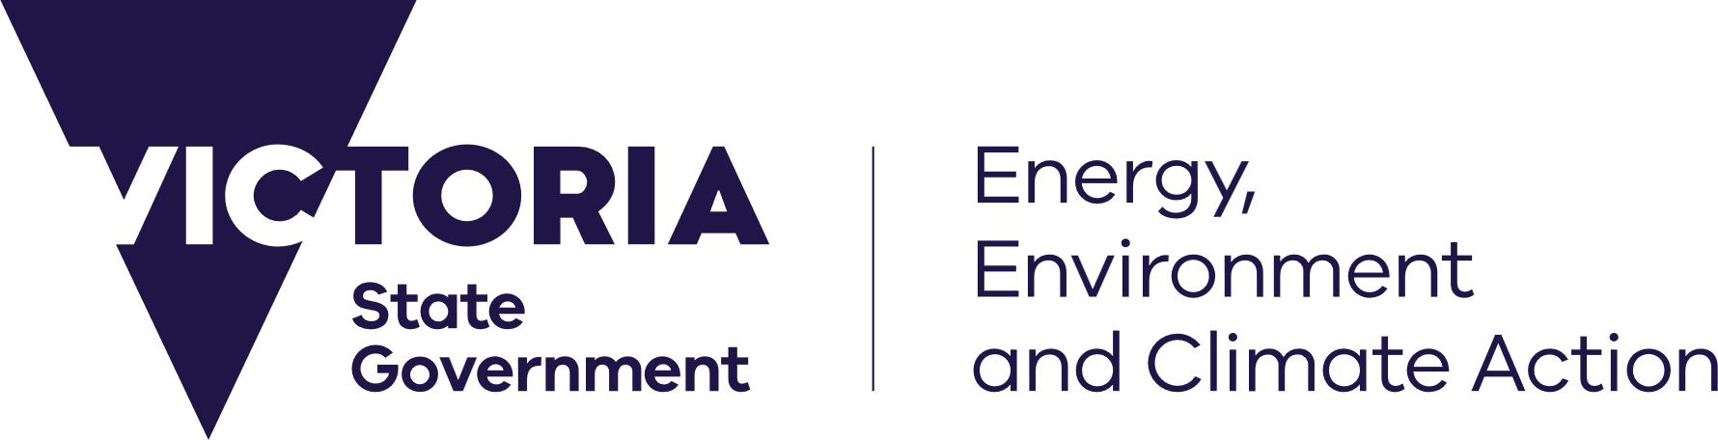








Published: October 2025
deeca.vic.gov.au

In April 2025, a planned burn in the Daylesford area escaped containment and was subsequently declared a bushfire. This page provides a summary of the incident, outlines the investigation findings, and details the response actions taken.

Incident summary
On 10 April 2025, the Department of Energy, Environment, and Climate Action’s (DEECA) Midlands District Forest Fire Management Victoria (FFMVic) ignited a 200.8 hectare (ha) planned burn (Daylesford – Old Tom Track Operation 1) in the Hepburn Regional Park, approximately four kilometres south-west of Daylesford.
The fuel hazard reduction burn was situated within the Bushfire Moderation Zone (BMZ) and was assessed as having extreme overall fuel hazard. The weather forecast indicated typical autumn weather for planned burning, and significant underlying dryness and a wind change forecast for the afternoon of the second day of planned operations.
Prior to ignition there was significant community engagement and communication in relation to the planned burn and its intent. The intent for the planned burn was to be fully ignited in two days, followed by an additional six days of patrolling.
Ignition of the burn continued on 11 April 2025. At 1500 hours fire within the burn progressed over the internal creek line and subsequently commenced an uphill run toward Black Jack Track on the northern boundary of the burn. Progress of the burn uphill across challenging terrain coincided with the forecast arrival of the unfavourable afternoon south-easterly wind change that further elevated the fire behaviour.
Despite attempts by ground crews to ignite the northern control line along Black Jack Track to prevent the burn from breaching, embers caused spot fires to ignite in the adjacent forest. At 1640 hours on 11 April 2025, the Midlands District Burns Controller declared that a breach of control lines had occurred and had progressed to a bushfire.
The fire impacted 94.5ha within Hepburn Regional Park, which was outside the planned area. A privately owned pine plantation was also damaged.
On 16 April 2025, the 96ha bushfire was classed as being under control.

Community impacts
The Daylesford – Old Tom Track bushfire caused disruption to the local community, threatening several homes and private properties, and prompting the closure of two residential roads. A ‘Watch and Act - Prepare to leave’ message was issued on the VicEmergency website and app, and a relief centre was established in the township of Newlyn to support affected residents.

Incident investigation
Under Victorian bushfire management arrangements, the Office of Bushfire Risk Management (OBRM) is responsible for overseeing the development and implementation of an end-to-end framework for bushfire risk management, with a primary focus on fuel management. As part of this role, OBRM is responsible for ensuring that FFMVic planned burns that breach control lines are appropriately investigated and opportunities for continuous improvement identified and implemented.
OBRM completed an independent investigation into the breach of planned burn control lines at the Daylesford – Old Tom Track.

Summary of investigation findings
The investigation recommended improvements to systems and processes, burn planning and risk assessments, burn approvals, and operational delivery. These findings are made in the context of planned burning being a safe practice with only about 1 per cent of planned burns breaching control lines. Further information about the investigation and its key findings will be made publicly available through OBRM’s Annual Assurance Report.
Key findings from the investigation included:
Systems, processes and procedures
- There are opportunities to improve some systems, processes and procedures to better support staff to effectively identify or complete administrative processes required for planned burning.
Planning and risk assessments
- There are opportunities to improve risk assessment systems, planning and procedures for planned burns, including more thorough risk mitigation planning to ensure that risks are appropriately identified, assessed and mitigated.
- The ignition method involved up-slope burn operations in complex terrain, which presented technical challenges. This was not documented with corresponding risk mitigations. Due to slower than anticipated ignition, this area was ignited under forecasted unfavourable wind conditions, which contributed to the breach of control lines.
Forest and weather conditions
- The risks associated with dryness and long-term rainfall deficiencies were underestimated and not mitigated prior to ignition.
- Key personnel involved in the delivery of the burn did not utilise the most current weather forecast information to inform their decision to proceed with the burn.
Approval processes and authorisation
- Approval processes for this planned burn were not correctly followed. The approval of the burn indicated that it would be delivered outside of prescribed conditions, which requires Regional Deputy Chief Fire Officer approval. However, this approval was not obtained.
Resourcing
- FFMVic have dedicated, highly trained and experienced staff committed to reducing bushfire risk to Victorian communities. An ambitious plan to deliver the fuel reduction program in limited autumn weather windows while delivering multiple high priority burns concurrently within the district may have inadvertently caused staff fatigue and a sense of delivery pressure. This also had an impact on resourcing the burn.
- The reassignment of key burn personnel shortly before the burn limited their involvement in the planning process, which affected continuity between planning and operational delivery.

