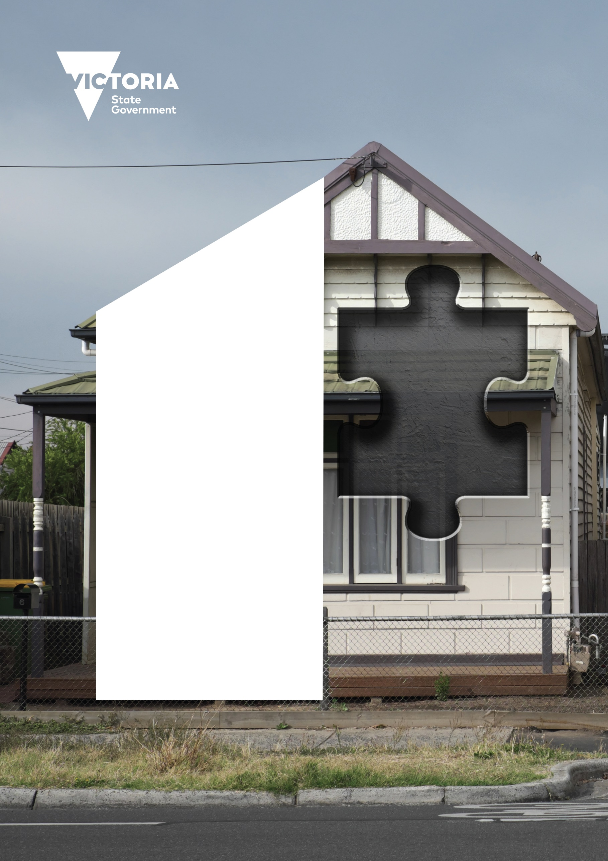
IS SOMETHING MISSING FROM YOUR HOME INSURANCE?
Does your insurance include temporary accommodation, clean-up costs or flood damage?
Find out what to look for
in your policy.
areyoucovered.vic.gov.au

Disclaimer: The information provided in this document is intended for general information purposes only and no reliance should be placed on its contents or accuracy. It is not a definitive guide and is not intended to constitute legal or financial advice and does not take into consideration your particular circumstances or needs. If you require assistance in respect to your personal circumstances, please seek independent advice. Every effort has been made to ensure the accuracy and completeness of this document and the references to the links included as at the date of publication.
Date of publication: 2025
For this information in other languages, go to areyoucovered.vic.gov.au
Contents
Why home insurance matters 2
How to speak insurance 3
Where to start 5
Wondering where to start when it comes to home insurance? 5
Step 1 Know your risk 6
Why you need to know your risk 6
Risks change over time 6
Step 2 Know your cost 7
What would it cost to rebuild your home? 7
Contents insurance 8
Step 3 Know your cover 9
Fire cover 9
Storm and flood cover 9
Two types of insurance 10
Questions to ask your insurer 11
What to check when renewing your policy 12
How to compare insurance policies 13
Step 4 Know how to claim 14
What to do after a disaster 14
What documents will you need? 15
What if my insurance information has been lost or destroyed? 15
What to expect during the claims process 16
If your claim is approved 18
If your claim is denied or you’re unhappy with the outcome 18
If you need help with an insurance dispute 18
Finding help 19
Help with your finances 19
Free legal advice 19
Wellbeing support 20

Why home insurance matters
In Victoria, rising temperatures and extreme weather events are damaging more homes.
Having the right home insurance can make life easier if something goes wrong. Most Victorians have home and contents insurance – but often, it’s not enough. Insurance gives you peace of mind and helps you bounce back financially if an emergency affects you.
 | Most people don’t have enough cover  Most Victorians believe they have enough insurance, but only half have enough cover to rebuild and refurnish their homes after a disaster.
Bushfire and flood risks are often underestimated
Bushfire and flood risks are often underestimated
Rebuilding costs are hard to guess
Rebuilding costs are hard to guess
You could save on insurance
Shopping around and comparing different providers could reduce
your home insurance policy costs by 20 per cent or more. However,
be warned that not all insurance policies provide the same level of coverage, and policies include specific caps on certain items.
 | Insurance can be confusing  Only 37 per cent of Victorians fully understand their insurance coverage, while 14 per cent say they don’t understand it well at all.

Take action today. Review your policy, know your risks and compare better options to better protect your home.

This data has been sourced from the Insurance Market Analysis and
Consumer Research – Final Report by Finity Consulting 2023.

How to speak insurance
Home insurance has a language of its own. Here are some terms you might come across.
- Bushfire prone area: An area that has been or is likely to be affected by bushfire.
- Flood prone area: An area that can be affected by flooding.
- Coverage: The property or people covered by your policy, the risk you are insured against and the amount of money or compensation you are insured for.
- Premium: The amount you pay your insurer each year to be insured.
- Renewal: Continuing your insurance policy for another year. You should read the renewal notice and check for changes you may need to make to your coverage.
- Excess: The amount you will pay if you make a claim. You may have to pay the excess before a claim is settled.
- Exclusions: Things not covered by an insurance policy.
- Insurance policy: The annual contract between you and your insurer detailing what you have insured. Each policy has a Product Disclosure Statement (PDS) which you should read so you know what you are covered for during the term of your policy.
- Product Disclosure Statement (PDS): A document that insurers must give you with the terms and conditions of your policy. This is an important document and you should read it.
- Market value: The amount your home would be worth if sold today. This is rarely the same as what it would cost to rebuild your home. This is different to the settlement amount.
- Sum insured: The maximum amount your insurer may pay if you make a claim. For home insurance, it’s the highest amount your insurer will cover to rebuild your home, while for contents insurance it’s the highest amount your belongings are insured for.
- Claim: When an incident such as property damage has occurred, and you seek payment from your insurance company.
- Scope of works report: If your claim is approved, you will receive a scope of works report. This report will outline all the repairs that are required. It’s important to check the report to make sure everything that is needed to be repaired or replaced is outlined in this report before you sign off.
- Settlement: What you get from your insurer if your claim is approved. Your insurer may organise the repair or rebuild of your home or give you the money to organise it yourself. Giving you money is sometimes referred to as a payout or cash settlement. Settlement value does not always reflect market value.
- Embargo: Insurers may place embargoes on the purchase of new insurance policies to prevent people buying insurance when a natural disaster is imminent, such as a bushfire, flood or cyclone.

Where to start

Wondering where to start when it comes
to home insurance?
This booklet will help you better understand home insurance, why it’s important, and how you can make sure you have the insurance policy that best meets your needs.
It will guide you through the four steps you can take to protect your home and make a claim if it is damaged. Taking time to learn about each step will help make managing your home insurance easier.

STEP 1 | Know your Risk
STEP 2 | Know your Costs
STEP 3 | Know your Cover
STEP 4 | Know your Claim

Step 1 know your risk

Why you need to know your risk
In home insurance, ‘risk’ means the chance that a disaster, such as a flood, storm or fire, could damage your home.
Your risk affects what your insurance should cover. If you live in a flood prone area, make sure your insurance has flood cover. And if you live in a bushfire prone area, make sure your insurance policy covers damage from bushfires, not just house fires.

Risks change over time
As the environment and weather change, so do your risks.
A home you bought 15 years ago may have had a low risk of bushfire or flood, but that risk may have increased over time. It’s your responsibility to know the risks that could affect your home today.

Learn about the risks near you:
www.areyoucovered.vic.gov.au
- Contact your council for information on zoning, land use
and historical data.
- Contact your catchment management authority for information on drainage systems, water levels and flood maps.

Step 2 know your cost

What would it cost to rebuild your home?
Your insurance needs to cover the amount it would cost to rebuild your home today. Rebuilding a home 10 years ago would have been much cheaper than rebuilding a home today.
Even if you have insurance, would it be enough to rebuild your home if disaster struck? Have you considered updated building codes, challenging sites and rising labour and material expenses? There may also be extra costs for demolition, clean-up, asbestos removal, council fees and architect and surveyor services. You might also need temporary accommodation during a rebuild.

Want to know how much it would
cost to rebuild your home?
Visit www.areyoucovered.vic.gov.au

Contents insurance
Contents insurance covers your household items if they’re damaged, lost or stolen. Make sure your contents insurance covers the cost of replacing everything you own.
Start by listing your belongings and their value – from kitchen items to tools in your shed. Remember to update your policy after any upgrades, such as renovations, new furniture or new appliances. Many people forget these changes, which can leave you underinsured if you need to make a claim.
Think about everything you own. Include your clothing as well as items like your lawnmower and devices. You need to be aware of any exclusions or cap limits for certain items such as tools. Damage to your car will usually need to be covered under a separate insurance policy to your home and contents insurance even if all your policies are with the same insurer.
The contents calculator at www.areyoucovered.vic.gov.au can help you estimate the replacement cost.

Tip for renters
Did you know you can get contents insurance to protect your belongings? Some insurance policies also help pay for a place to stay (temporary accommodation) if your rental property becomes unliveable. It’s a good idea to compare different policies.

 | HANDY TIP:  Take photos of your home and contents when you move in, when you take out home insurance and when you make any home improvements. Remember to store these photos in a secure place so you can reference them when making a claim.

Step 3 know your cover
Understanding your coverage means knowing exactly what your insurance includes and excludes, so you can be confident you’re properly protected.
Not all policies are the same or include the same amount of cover. It’s important that you review your policy and know what you’re covered for.

Fire cover
Many home insurance policies cover damage caused by fire, including bushfires, but may not include damage which doesn’t involve direct flames, such as damage from heat, smoke or ash. Some policies can have many different exclusions like:
- Fires less than 72 hours after buying your policy.
- Deliberately lit fires.
- Fires caused by carelessness or ignoring safety rules.
- Your insurance policy will say what is and isn’t covered for fire damage.

Storm and flood cover

Flood cover isn’t always included in an insurance policy – it’s a good idea to double-check.

Flooding can happen anywhere, anytime. Even if you don’t live near a waterway, floods may still happen in your area. When considering flood cover it is important to remember that:
- Flood cover is different from storm cover. Ask your insurer how each is defined. Many home insurance policies cover damage caused by storms. However, many policies do not cover water entering through open windows or doors, or damage caused by pre-existing issues in the home.
- It is important to regularly have general maintenance done on your home to avoid accidentally voiding your insurance policy.

Two types of insurance

1 | Sum insured cover
 | The maximum amount your insurer has agreed to pay if your home is damaged or destroyed. The amount is usually based on the value of your home and is the maximum amount you can receive from your insurer in the event of a claim.

2 | Total replacement cover
 | When your insurer agrees to cover the full cost of repairing or rebuilding your home to its original condition, reducing the risk of underinsurance. This coverage is not always offered and usually comes at a higher cost.

 | HANDY TIP:  Your insurance policy and Product Disclosure Statement (PDS) will tell you if you have sum insured cover or total replacement cover.

Questions to ask your insurer
Q: | What does my policy cover?  Does it include protection against floods, fires, storms or other disasters?
Q: | How are disasters defined?  Does it include protection against floods, fires, storms or other disasters?
Q: | Do I have sum insured cover or total replacement cover?  If it’s sum insured, does it cover the full cost of rebuilding my home?
Q: | Do I get temporary accommodation if my home is unliveable?  Does my policy cover a stay in a rental or hotel? Does it include pet boarding?
Q: | Are clean-up costs included?  Will the policy pay for removing debris after damage from a flood, fire or storm?
Q: | What are the exclusions?  What specific items or situations aren’t covered by the insurance policy?
Q: | Are there limits for payouts on certain claims?  Some policies set limits on claims, like covering up to $5,000 for storm damage, no matter the repair or replacement cost.
Q: | What is the excess?  How much will you need to pay out of your own pocket before the insurer covers the rest?
Q: | Does my policy cover extra rebuilding costs?  For example, demolition, asbestos removal, council fees and professional services, such as architects and surveyors.

HANDY TIP:
Part of an insurer’s job is to help policy holders. If you have questions about your policy, contact your insurer and ask
them to explain it.

What to check when renewing your policy

☐ | Does my policy cover the right risks?  Know your risk, such as flood or fire, and make sure it is covered by your policy.
☐ | Do I have enough cover?  If you have sum insured cover, check if rebuilding costs have changed. If they have, you should adjust your cover. Visit www.areyoucovered.vic.gov.au to find out how much it costs to rebuild your home or replace your personal belongings.
☐ | Have I made improvements to my home?  Tell your insurer about any changes you have made to your home so that your cover is based on your home’s new rebuild value. There is also a chance that by improving your home it will be better protected from natural disasters – meaning your premium may go down.
☐ | Have my policy terms changed?  Read your renewal notice carefully for any updates.
☐ | Is my excess amount still right for me?  Adjusting your excess can affect your premium, so make sure it fits your current needs and budget.

 | HANDY TIP:  Set a reminder to review your policy each year. Keeping your cover up-to-date helps ensure you’re protected if something goes wrong.

How to compare insurance policies
Switching insurers is one of the best ways to save money and get a better deal. Research shows that most Victorian households could save at least 20 per cent on their home insurance premium by shopping around.
Here are some tips to help you choose the right insurer and the right policy:
☐ | Check what the policy covers: Does it cover natural disasters like floods, fires and storms? Are you properly covered if you are in a high-risk area for one or more natural disasters?
☐ | Check inclusions and exclusions: Make sure you know what is and isn’t covered and what you do and don’t need.
☐ | Check the premiums: See what other insurers charge for the same cover.
☐ | Check claim limits: Look at the maximum amount insurers will pay for different claim types.
☐ | Consider your excess: Most insurers allow you to adjust your excess. Weigh up the benefit of having a low excess with a higher premium, or a high excess with a lower premium.
☐ | Consider combining policies: Some insurers let you combine your home and contents insurance. This could be cheaper than having two separate policies.

Step 4 know how to claim

What to do after a disaster
- Stay safe
If your home has been flooded, always take care. Do not enter your home or
turn on the power until an expert, such as an electrician, fire officer or a council building inspector, confirms it is safe to do so. Be aware of water damage to the structure of your house, the development of mould and even food spoilage well after a flood event has occurred. Do not drive a vehicle if it has suffered water damage.
Contact your insurer
Get advice on the claims process and how to access temporary accommodation and emergency repairs if you need them. Should you need an extension to your temporary accommodation, you should talk to your insurer at least three months before your accommodation period ends.
Take photos
Before cleaning up, take photos and list all the damage.
Make your home safe and secure your property from further damage
Take safe and reasonable steps to protect your home and belongings from more damage. This could include moving non-damaged items to a safe place (such as under cover or to higher ground) or putting a tarp over them.
Clean up your home, if you can do it safely
Remove any damaged items from your home that could be a health risk, such as fabric couches and carpet. Don’t throw away items that could be repaired, unless they pose a health risk. We recommend you do not go near damaged building material in case it contains asbestos or other hazards.

What documents will you need?
☐ | Contact details: Information for your insurer or your insurance broker.
☐ | Insurance policy numbers: Relevant policy numbers and documentation.
☐ | Identification: Your ID and any passwords or security questions associated with your account with your insurer.

What if my insurance information
has been lost or destroyed?
If you remember your insurer’s name, call them and give your details (your name, address and date of birth) and they will be able to help you and you can ask for a copy of your policy.
If you don’t know your insurer’s name, a good tip is to search your email history or bank transactions on your banking app.

 | HANDY TIP:  Make sure all your important documents are stored in a weatherproof and fireproof bag or safe. This is particularly important if you live in a fire or flood prone area.

What to expect during the claims process
- Contact your insurer
Get in touch with your insurer as soon as possible. You don’t need to know all the details of the damage yet. You can start your claim online, by phone or in person. You can find information about how long your insurer has to process your claim at financialrights.org.au/factsheet/insurance-claim-delay.
- Make your home safe
Before cleaning up, talk to your insurer. Take photos and videos of the damage for your claim. Your insurer may organise emergency repairs to prevent further damage, like removing debris, isolating electrical circuits or putting a tarp on the roof. You may need an electrician or inspector before re-entering your home.
- Damage assessment
Your insurer will send someone to check the damage and find out what caused it. Engineers or other experts may be needed for serious issues, such as structural damage.
- Claim decision
Your insurer will decide if they accept or reject your claim based on your policy and expert reports.
- If approved, they will provide a Scope of Works document outlining the repairs or rebuilding needed.
- Read this document carefully – it may change if more damage is found during repairs.
- Claim review
If you’re unhappy with your insurer’s decision, you can ask for your claim to be reviewed.

- Claim settlement
Your insurer will offer one of these options:
- Repair, replace, or rebuild: A builder will be assigned to manage the process, including contracts, timelines and approvals.
- Cash settlement: A cash settlement means that instead of the insurance company directly paying for repairs, you receive money to handle the repairs yourself. However, you must use a licensed builder and follow all regulations, or your home might not be insurable in the future. Before accepting a cash settlement, it’s important to check that the amount offered will cover all the repairs. It’s best to get quotes from different licensed builders. You might also want to seek independent financial advice to help you decide whether to accept the cash settlement.

Cash settlement
Remember:
It’s important to consider cash settlements carefully. You may wish to seek independent financial advice to help you decide whether to take a cash settlement. It is very important to check that the cash settlement amount will cover the required repairs.
It’s best to get a couple of quotes from different licensed builders.

 | HANDY TIP:  The General Insurance Code of Practice  (insurancecouncil.com. au/code-of-practice) sets out what insurers should do when handling your claim. This includes timeframes for decisions and updates of your claim status.

If your claim is approved
If your claim is approved, you will receive a report outlining the work to be done to your home. Read the report carefully to see what will be replaced or repaired, and what won’t. If you are not happy with the report, contact your insurer. If you are happy with the offer and agree to the terms, your insurer may offer to manage the work, offer you a cash settlement or offer both options.

If your claim is denied or you’re
unhappy with the outcome
Customers can lodge a complaint with the insurer at any point during the claims process.
If your claim is denied or you are not satisfied, the insurer must explain why and give you information on how to file a complaint. If you make a complaint to your insurer and you’re still unhappy, you can complain to the Australian Financial Complaints Authority (AFCA) by calling them on 1800 931 678 or by emailing info@afca.org.au

If you need help with an insurance dispute
Financial counselling is a free, confidential and judgement-free service for people experiencing or at risk of financial hardship. There are no access restrictions based on income source, visa status or residency status.
If you or someone you know has a debt or bill that they are worried about, they could benefit from a confidential appointment with a financial counsellor. Financial counsellors can also provide advice on insurance disputes.
- Financial Counselling Victoria: visit www.fcvic.org.au/get-help
or call 03 9663 2000.
- National Debt Helpline: visit www.ndh.org.au/financial-counselling
or call 1800 007 007.
Australian Financial Complaints Authority

www.afca.org.au
1800 931 678

info@afca.org.au

Finding help
Charities like Red Cross, St Vincent de Paul, The Salvation Army and Wesley Mission may be able to help with food, shelter and household items.

Help with your finances
- Contact your local council: They can connect you with local support services after an emergency. Find your local council at vic.gov.au/know-your-council/
- Banks and insurers: They have special teams that can help you if you have money worries. Call your financial institution or go to the ‘Financial Hardship’ section of their website.
- National Debt Helpline: visit www.ndh.org.au/financial-counselling
or call 1800 007 007.
- Financial Counselling Victoria: visit www.fcvic.org.au/get-help
or call 03 9663 2000.
- Anglicare Victoria: visit www.anglicarevic.org.au/our-services/financial-counselling/ or call 03 9412 6133.
- Good Shepherd No Interest Loan Scheme (NILS): No Interest Loans can be a safe and affordable way to pay for expenses. Borrow up to $2,000 for essentials like appliances, furniture, car repairs, tech, or health needs. Borrow up to $3,000 for housing expenses or natural disaster recovery. Visit: www.goodshep.org.au/services/nils/ for more information on these loans and eligibility.

Free legal advice
You may be eligible for free advice:
- The Financial Rights Legal Centre: visit www.financialrights.org.au or call 1300 663 464.
- Consumer Action Law Centre: visit www.consumeraction.org.au
- Disaster Legal Help Victoria: visit www.disasterlegalhelp.org.au or call 1800 113 432.

Wellbeing support
- Mental Health and Wellbeing: For free mental health support, visit www.partnersinwellbeing.org.au or call 1300 375 330. You don’t need a referral or a Medicare card.
- Family Domestic Violence: A national 24-hour support helpline for support with family and domestic violence or sexual abuse. Call 1800 RESPECT on 1800 737 732.
- Lifeline: A national 24-hour helpline for anyone in emotional distress. Call 13 11 14 or visit www.lifeline.org.au


areyoucovered.vic.gov.au



