Cladding Safety Victoria

Annual Report 2024–2025

Responsible body declaration
In accordance with the Financial Management Act 1994 (Vic), I am pleased to present the Cladding Safety Victoria (CSV) Annual Report for the year ending 30 June 2025.
Rodney Fehring
Board Chair
Cladding Safety Victoria
12 September 2025

Acknowledgement of country
CSV respectfully acknowledges the Traditional Owners and custodians of the land and water upon which we rely. We pay our respects to their Elders past, present and emerging. We recognise and value the ongoing contribution of Aboriginal people and communities to Victorian life. We embrace the spirit of reconciliation, working towards equality of outcomes and an equal voice.
ISSN 2653-2808
© State of Victoria
The 2024–25 CSV Annual Report is licensed under a Creative Commons Attribution 4.0 International licence. You may share and adapt the work under the terms of the licence on the condition that you attribute the State of Victoria as the creator. The licence does not apply to any images, photographs or branding, including the Victorian Coat of Arms, the Victorian Government logo and the Cladding Safety Victoria logo.
Copyright queries may be directed to IPpolicy@dtf.vic.gov.au.
Available online at vic.gov.au/cladding-safety.

24–25 Year at a glance

Risk reduction on residential buildings
1,346 Class 2 buildings in CSV’s program are now resolved
This means 81% of the program is now complete, benefitting more than 123,000 Victorians in 65,000 individual homes
Works are complete on 409 higher-risk residential buildings resulting in the removal of 275,000m² of combustible cladding, which equates to 13.5 times the playing surface of the Melbourne Cricket Ground*
Work is complete on the tallest building in the program, a 68-storey apartment building in Melbourne’s CBD
81% of buildings in the program are now free from cladding-related enforcement notices

Risk reduction on government-owned and public-use buildings
Combustible cladding has been removed on 130 government-owned buildings with a further 3 buildings added to the program in 2024–25
This equates to more than 50,000 m² of cladding removed
Protecting tens of thousands of Victorians in the community who use these facilities
Work commenced on the risk assessment of 1,038 Class 9 buildings where Victorians study, receive care and engage in leisure activities
*Based on an estimated MCG playing arena surface area of 20,370 square metres.

Table of Contents
24–25 Year at a glance 3
Board Chair’s statement 7
Chief Executive Officer’s statement 8
About Cladding Safety Victoria 10
Manner of establishment 10
Responsible Minister 10
Purpose and functions 11
Vision, mission and outcomes 11
Culture and values 12
Nature and range of services provided 13
Financial summary 14
Year in review 16
Materials testing program 17
Protocols for Mitigating Cladding Risk 18
Essential safety measures survey 19
Residential Cladding Rectification Program 19
Cladding Rectification Program 21
Cladding Remediation Partnership Program 25
Class 3 and 9 Buildings 28
Creating a lasting impact and legacy 29
2024–25 State Budget and service delivery 32
Organisation and people 34
Organisational structure 34
Minister 35
Department of Transport and Planning 35
Cladding Safety Victoria’s Board 35
CEO and senior executives 36
Our people 36
Public sector values, employment and conduct principles 37
Comparative workforce data 37
Senior employees 40
Workforce inclusion policy 41
Occupational health and safety 41
Financial statements 43
Disclosures 75
Financial Management Compliance Attestation Statement 75
Local jobs first 75
Social procurement framework 76
Emergency procurement 78
Disclosure of procurement complaints 78
Disclosure of major contracts 78
Consultancy expenditure 78
Reviews and studies expenditure 79
Freedom of information 80
Compliance with the Building Act 1993 (Vic) 82
Compliance with the Public Interest Disclosures Act 2012 (Vic) 82
Compliance with the Carers Recognition Act 2012 (Vic) 82
Compliance with the Disability Act 2006 (Vic) 83
Competitive Neutrality Policy 83
Compliance with the DataVic Access Policy 83
Environmental reporting 84
Additional information on request 84
Disclosure index 85
Acronyms and abbreviations 88

Board Chair’s statement
As Cladding Safety Victoria’s task moves past its peak phase, the true impact of the program across the State can now be more precisely measured.
While the major focus has been the safety of Victorians sleeping in their apartments – Class 2 buildings – CSV has also considered cladding risk on Class 3, Class 9 and government-owned buildings.
In total, more than 7,000 buildings have been looked at by a combination of the Statewide Cladding Audit, local councils and CSV itself. Any of these considered to be at risk have been subject to closer investigation and, where necessary, action.
At the end of this financial year, more than 1,300 Class 2 buildings – or 81 per cent of the total – have cladding issues resolved, including the majority of those considered to be at unacceptable risk. The remaining Class 2 buildings are in progress.
The government-owned building cladding rectification program’s original 130 buildings are complete and 3 more recent additions are underway. A small number of Class 3 buildings requiring advice are in the process of advice formulation and approximately 1,000 Class 9 buildings are being assessed and offered advice where required.
This means that we can now forecast, with considerable confidence, the risk and probability of Victorians being exposed to large and destructive cladding fuelled fires has fallen significantly. Unfortunately these types of fires continue to occur in other parts of the world.
Diligent completion of this core work remains our number one priority.
At the same time, the entire CSV team is determined to make the most of the opportunity to capture the learnings from this unprecedented program and pass them on wherever they are relevant and needed.
In addition to the findings of a significant series of live fire tests on a range of cladding products at varying conditions, CSV has this year published several research papers using the unique data gathered in the course of our work. This information can be viewed on our website and is helping policy makers in government respond to a range of challenges that arise from apartment living.
CSV is also partnering with Fire Safety Victoria to conduct a survey of essential safety measures in buildings where CSV has funded cladding rectification. The findings will provide an important indication of the true status of these vital features of apartment buildings.
These were the twin themes of the past 12 months, and in the months to come, CSV will continue to focus on:
- finishing the job; and
- making the most of what we have learned. We will continue to work with a range of stakeholders in Victoria, around Australia and internationally.
Genuine collaboration has been the key to CSV’s success. That success has made a material difference to tens of thousands of Victorians who own and live in apartments. Safer in their homes, free to buy and sell their property, assisted with public funding or having saved a fortune through the prevention of unnecessary works, these outcomes are a vindication of the Victorian Government’s decision to tackle the cladding problem head on.
I thank and congratulate CEO Dan O’Brien and the hard-working team at CSV for their skill, dedication and perseverance. I also wish to thank my fellow Board Members for their wise counsel and service.
Our thanks go to the Ministers who have held responsibility for CSV in the past 12 months – the Hon. Harriet Shing MP and the Hon. Sonya Kilkenny MP, our colleagues at the Department of Transport and Planning, at the Victorian Building Authority (VBA) (now the Building and Plumbing Commission (BPC)) and more than 30 local councils.
Thanks must also go to all the skilled professionals in the building industry who have carried out the physical rectification works effectively.
Finally, thank you to the thousands of apartment owners and tenants who have trusted CSV to help them through a difficult time. Together, we will see this through to completion.
Rod Fehring
Board Chair
Cladding Safety Victoria

Chief Executive Officer’s statement
After 6 years, thousands of assessments and hundreds of construction projects, Victoria is on the verge of becoming the first jurisdiction in the world to respond comprehensively to the threat of combustible cladding on private apartment and government buildings.
Working with a wide range of stakeholders including building owners, the VBA (now the BPC), Fire Rescue Victoria, the Department of Transport and Planning and more than 30 Victorian councils, CSV has assessed thousands of Class 2 and Class 3 buildings for cladding risk, as well as rectifying 130 government-owned buildings such as hospitals, schools and sporting venues.
More than 1,300 privately owned apartment buildings have been assisted, with another 350 in progress – a much larger task than originally anticipated. Work to close out actions on these buildings is expected to conclude in April 2026.
This progress has been possible because of the world leading methodology developed by CSV with RMIT University, the Data 61 team at CSIRO and a range of other experts. The impact of the new risk-based approach has been profound, saving many owners from outlaying large, unaffordable and unnecessary sums, allowing apartments to be bought and sold with confidence. CSV’s methodology, the Protocols for Mitigating Cladding Risk has been widely disseminated and published on our website. It is an important technical legacy from our program. Our approach has attracted considerable interest from other jurisdictions and countries, including the UK, Scottish, Irish and New Zealand governments.
Through our work, CSV has become an authority on cladding risk assessment and mitigation. The Victorian Government recognised this status by adopting CSV’s processes as official policy and providing Minister’s Guideline 15 to support building surveyors – both municipal and private – to make decisions based on CSV’s advice.
But as with any complex program, there have been significant difficulties to overcome.
It soon became clear that the way in which the sector and system operated – at least as they related to combustible cladding – placed all responsibility with apartment owners (most of whom were ill-equipped to manage it), but gave them few allies for dealing with the problem in a proportionate, affordable and timely manner.
It also became clear, as CSV assessed more and more buildings, that earlier risk assessments were in many cases based on incomplete information, a lack of understanding of how various cladding products actually behaved in fire scenarios or an overstatement of risk. These positions had significant consequences for owners corporations which faced rectification costs in the hundreds of thousands – and often millions – of dollars. CSV’s intervention has changed that in Victoria.
In addition to solving problems building by building, the breadth and depth of data gathered by CSV has informed a series of important research papers published during this financial year. The purpose of these research papers is to collect and share the insights made possible by a program that has had the opportunity to examine how complex buildings are performing post-construction. These reports are all available on our website.
Another critical initiative has been the work done by CSV to change regulatory views on the risk posed by expanded polystyrene concrete (also known as QT or Conpolcrete) and ACP-FR (the version of aluminium composite panel with fire retardant materials in the core). These changes demonstrate the importance of having access to reliable data before making judgements on cladding risk. Again, more detail, including videos of actual tests, is published on CSV’s website.
CSV continues to work with the insurance industry and others so that these findings are known and understood. In particular I would like to acknowledge CHU, the largest insurer in Victoria’s strata market, for their constructive approach in dealing with buildings impacted by combustible cladding.
CSV maintained a strong financial position throughout 2024–25, underpinned by sound governance, robust internal controls, and compliance with the Standing Directions under the Financial Management Act 1994 (Vic). The strategic draw down of reserves and prudent cash flow management ensures sustainability through to the agency’s expected closure in 2026. The application of the Protocols for Mitigating Cladding Risk has enabled CSV to deliver safer buildings at lower cost by tailoring rectification works to the actual fire risk posed by cladding. This year’s results reflect CSV’s commitment to delivering public value through prudent financial management, while fulfilling our mandate to make Victorians safer.
Our people remain the cornerstone of CSV’s success. In 2024–25, we continued to foster a high-performance, values-driven culture that empowers staff at every level. With a 97% participation rate in the People Matter Survey and an employee engagement index of 81% – well above the public sector average – our workforce has demonstrated deep alignment with CSV’s mission and values. As we move toward program close-out, we are investing in change management training, internal development opportunities, and career transition support to ensure our people are equipped for the future.
Based on the evidence of the past 6 years, the approach developed and applied by CSV has saved building owners and the government hundreds of millions of dollars and a great deal of time and inconvenience. This is because had CSV accepted the prevailing professional and regulatory approach towards cladding products and their associated risks, far more buildings would have required extensive rectification over a far longer timeline, leading to much greater misery and anxiety for their owners and occupants.
While there still work to do, the end of the program is just months away. At that point, CSV will have improved safety for the users of 133 government buildings, and funded remediation works and produced cladding risk information for more than 80,000 privately owned apartments.
As usual, I want to thank the Victorian Government and our Ministers, the Hon. Harriet Shing MP and the Hon. Sonya Kilkenny MP, for their support of this important community safety project. I also thank our Board Chair and Board Members for their guidance and support, my executive colleagues and every member of the CSV team for their professionalism, determination and dedication to helping the people of Victoria.
Dan O’Brien
Chief Executive Officer
Cladding Safety Victoria

About Cladding Safety Victoria

Manner of establishment
On 16 July 2019, the then Premier of Victoria and Minister for Planning announced the establishment of CSV, within the VBA (now the BPC). The Cladding Safety Victoria Act 2020 (Vic) (CSV Act) commenced on 1 December 2020 and established CSV as the world’s first stand-alone cladding rectification agency, formally separating CSV from the VBA. In March 2024, a legislated review concluded that CSV should continue to operate under the CSV Act to complete its existing cladding programs.

Responsible Minister
CSV is subject to the general direction and control of the Minister for Housing and Building and the Minister for Planning under a Supplement to the General Order issued on 27 March 2025 to ensure the administration of the CSV Act will be ‘jointly and severally administered’ by both Ministers. The Hon. Harriet Shing MP was appointed as Minister for Housing and Building on 19 December 2024 and is responsible for building policy, and the Hon. Sonya Kilkenny MP was appointed as Minister for Planning on 5 December 2022.

Purpose and functions
Section 6 of the CSV Act provides that the object of CSV is to support Victorians to rectify non-compliant or non-conforming external wall cladding products on buildings to improve the safety of those buildings.
CSV does this through administering the Cladding Rectification Program and Cladding Remediation Partnership Program.
To achieve this purpose, CSV has the following functions under the CSV Act:
- prioritising buildings for potential financial assistance for cladding rectification work
- deciding whether to grant or refuse to grant financial assistance to owners and owners corporations of buildings
- determining the amounts of financial assistance to owners and owners corporations of buildings for cladding rectification work
- monitoring cladding rectification work where financial assistance has been given
- supporting owners and owners corporations of buildings by procuring building practitioners and engaging technical design and project management services to undertake cladding rectification work
- facilitating cladding rectification work for government-owned buildings
- providing information, advice and support to owners and owners corporations of buildings and other persons and bodies in relation to cladding rectification work
- notifying the appropriate regulators, Municipal Building Surveyors, persons and bodies about matters relating to compliance and enforcement under the CSV Act, the Building Act 1993 (Vic) or any other Act
- advising the Minister on the performance of its functions
- performing any other function conferred on CSV, including under any agreement to which the state is a party.

Vision, mission and outcomes
CSV’s Strategic Plan 2021–25 outlines 2 core outcomes that provide the focus for performance monitoring and reporting. These are delivered within the context of CSV’s vision and mission.
Vision: Making the community safer by reducing combustible cladding risk.
Mission: We will improve the safety of buildings impacted by cladding issues by working in partnership with industry, government partners and the community.
Outcomes:
- Owners corporations and government bodies are supported by CSV to mitigate combustible cladding risk
- Program delivery and CSV close-out preparations are facilitated by robust resource management and planning
Each of these outcomes has outputs and measures attached to it that allow CSV to track progress against key activities during the year.

Culture and values
A positive workplace experience that attracts talent, drives engagement, enhances staff satisfaction and improves performance is critical to the successful delivery of CSV’s strategic objectives. To achieve CSV’s organisational outcomes, CSV’s values are brought to life in a way that is meaningful to all staff. CSV’s strong workplace culture is evidenced by the overwhelmingly positive responses from staff to the 2025 People Matter Survey, about which further information is provided on pages 38 and 42.
Developing and growing a values-based culture begins with understanding that all staff take responsibility for how they interact and work together. CSV is guided by the Code of Conduct for Victorian Public Sector Employees and in particular the values of leadership, respect, accountability and integrity. These values speak to the way staff work as individuals and team members. In addition, CSV holds safety, health and wellbeing at the forefront of all of its activities and processes.

We are all leaders
This means:
- We set the tone for workplace culture and have a huge influence over how our workplace is shaped.
- We are committed to building a positive and constructive workplace culture.
- We empower staff to show leadership at every level of the organisation.
- We promote and role model physically and psychologically safe work practices.

We are respectful
This means:
- We treat each other fairly, objectively and with civility.
- We recognise and value diversity, equality and human rights.
- We value each other’s contribution and are committed to listen and communicate honestly and clearly.
- We give and seek feedback and encourage reporting of behaviour outside of these values.

We are accountable
This means:
- We are comfortable with being held accountable and working to clear objectives in a transparent manner.
- We accept responsibility for our decisions and we take this seriously.
- We take ownership of the quality and demonstratable impact of our work.
- We are accountable for the responsible spending of public money.
- We ensure that our decisions and actions are evidence based and outcomes focused.

We have integrity
This means:
- We are honest, open and transparent with each other and in all of our dealings.
- We show a consistent and uncompromising adherence to compliance, decisions and our values.
- We strive to build and sustain community trust.
- Our interactions with people always demonstrate that we are concerned about how they experience the service we deliver.

Nature and range of services provided
CSV was established to reduce the risk posed by combustible cladding in Victoria’s built environment. Cladding is the outside skin of a building. It is used to provide thermal insulation, weather resistance, noise reduction, and to improve the appearance of buildings.
While there are numerous types and brands of cladding available, there are 2 types of combustible cladding that pose a particular risk for building occupants, as well as the community more broadly. This is because in the event of a fire, these materials may increase the rate at which a fire spreads. These cladding types are aluminium composite panels with a polyethylene core (ACP) and expanded polystyrene (EPS).
CSV’s program streams aim to reduce cladding risk across Victoria by targeting combustible ACP and EPS cladding. These streams include:
- addressing combustible cladding risk on government-owned buildings and facilities, which was completed in 2023–24
- funding rectification works for higher-risk privately-owned residential apartment buildings with combustible cladding and developing guidance for owners of lower-risk residential buildings
- providing advice on the cladding risk status and any relevant risk mitigation recommendations for Class 3 and Class 9 buildings referred to CSV.

Figure 1: A building with works underway in CSV’s Cladding Rectification Program
Through these programs, CSV delivers a number of community services where the primary customers are the owners, occupants and users of buildings with combustible cladding.
Cladding risk assessment and rectification funding services | The risk assessments performed by CSV help owners and Municipal Building Surveyors (MBSs) examine the level of fire spread risk that cladding adds to a building and what risk mitigation actions, if any, may need to be taken. Class 2 buildings assessed at a risk rating of ‘unacceptable’ are eligible to be considered for funding of cladding rectification works.
Case management services | Senior Customer Liaison Officers provide a dedicated one-to-one case management service for owners of funded buildings, to support them in navigating a complex range of issues that they need to contend with to make their buildings safer.
Due diligence inspection services | A multi-disciplinary expert team of building and fire safety practitioners is provided by CSV to inspect buildings, guide the development of Remediation Work Proposals and provide an initial appraisal of rectification costs.
Technical review and solutions services | CSV technical experts review building information – including the outcomes of any testing – to develop Remediation Work Proposals that outline the interventions to be implemented that will reduce cladding risk to an acceptable level, or to provide detailed advice about why no actions are required to mitigate cladding risk.
Project management services | CSV-appointed Independent Project Managers represent the mutual interests of building owners and CSV in cladding rectification work for funded buildings, overseeing all aspects of contract management and delivery progress for buildings in the funded program.
Quality control services | Clerks of Works and CSV staff undertake on-site inspections during the construction period for funded rectification works, to ensure work practices comply with quality standards and that building residents, visitors and workers are safe on-site.

Financial summary

Overview
CSV considers the net result from transactions to be the appropriate measure of financial management that can be directly attributed to the Cladding Rectification Program. In 2024–25, CSV achieved a net deficit result from transactions of $17.20 million, which is $11.07 million greater than the result in 2023–24. This increase is primarily due to a $41.48 million reduction in levy income and aligned with a planned strategy to utilise accumulated funds. This was partially offset by a $28.43 million decrease in grants paid to owners corporations.
Total net assets decreased from $113.02 million in 2023–24 to $95.82 million, primarily due to a decrease in the cash and receivables balance. CSV has a cash balance of $106.55 million, reflecting a decrease of $8.76 million from 2023–24 to 2024–25.
Five-year performance summary ($ thousand)
 | 2024–25 | 2023–24 | 2022–23 | 2021–22 | 2020–21¹
Total income from transactions | 67,697 | 108,557 | 156,311 | 145,312 | 98,002
Total expenses from transactions | (84,896) | (114,682) | (133,797) | (168,973) | (61,220)
Net result from transactions | (17,199) | (6,125) | 22,514 | (23,661) | 36,782
Net result for the period | (17,199) | (6,125) | 22,514 | (23,661) | 36,677
Net cash flows from operating activities | (8,759) | (2,251) | 17,895 | (21,138) | 34,332
Total assets | 107,997 | 127,003 | 132,494 | 111,429 | 134,753
Total liabilities | 12,181 | 13,988 | 13,354 | 14,803 | 14,466
Net assets | 95,816 | 113,015 | 119,140 | 96,626 | 120,287
¹ CSV was established as an entity on 1 December 2020 and therefore the figures for 2020–21 represent a period of 7 months.

Financial performance and business review
The main budgetary objectives of the organisation in 2024–25 were to oversee and coordinate the rectification of buildings while managing the financial resources efficiently, which included:
- timely reduction of cladding risk for referred buildings prioritised on a risk basis
- facilitation of timely rectification of government-owned building
- enhanced awareness of the Victorian community and participating owners corporations about cladding fire safety risk by providing information and guidance
- close-out preparations
- maintenance of the effectiveness of CSV’s financial, risk and resource planning and systems.
CSV’s funding was applied to achieve the main strategic outcomes as outlined in the 2024–25 Annual Work Program.
CSV achieved a net deficit result from transactions in 2024–25 of $17.20 million. Income decreased from 2023–24 due to a reduction of Cladding Rectification Levy received, as outlined above.
Expenses from transactions decreased by $29.79 million from the prior year. Grants payments to owners corporations for cladding rectification totalled $59.19 million, a decrease of $28.43 million. Payments to employees, consultants and professional services of $23.02 million represented a decrease of $0.86 million.
In 2024–25, 140 active grants were paid, a decrease from 171 in the previous year. This reduction in expenses from transactions and grant payments was largely due to the practical completion of 91 projects, compared to 140 completed in 2023–24. Following 2 years of peak activity, the cladding rectification program is now transitioning into its final stages, with fewer new projects entering the pipeline and many nearing completion.
CSV has been able to maintain fiscal responsibility in managing project budgets and commitments despite the challenges faced by the construction industry. The industry has experienced increased volatility in recent years, which can be attributed to factors such as economic fluctuations including the rising costs of building materials.

Financial position – balance sheet
Net assets decreased by $17.20 million over the year to $95.82 million, mainly due to a decrease in total assets of $19.01 million, comprising a $18.91 million reduction in financial assets and a reduction of $0.10 million in non-financial assets. The decrease in financial assets is mainly due to decreases in cash and deposits of $8.76 million and receivables of $10.15 million.
Total liabilities decreased by $1.81 million from the previous period to $12.18 million in 2024–25. Total liabilities are predominately made up of $9.73 million in grant payables to owners corporations and payables to suppliers.

Cash flows
The overall cash surplus of $106.55 million for 2024–25 was a decrease of $8.76 million compared to the previous year. The net cash outflows from operating activities was $8.23 million, an increase of $5.98 million from 2023–24. This movement was primarily driven by a reduction of in Cladding Rectification Levy receipts, partially offset by lower payments of grants to owners corporations and reduced expenditures to suppliers and employees.

Disclosure of grants and transfer payments
CSV has provided assistance to owners corporations to rectify the highest-risk privately-owned multi-storey residential buildings with combustible cladding. Financial assistance provided in 2024–25 was as follows.
Building
Cladding Rectification Program | ($ million)
Grant recipients | Payment
140 owners corporations | 59.19
CSV has entered into funding agreements with 486 owners corporations up to 30 June 2025.

Subsequent events
CSV had no material subsequent events that occurred after 30 June 2025. See Note 8.5 in the financial statements for further details.

Year in review
In July 2019, the State Government established a world-first program to address higher-risk cladding to improve building safety for Victorians. CSV was formed and $600 million was allocated to make Victorians safer by reducing the risk associated with combustible cladding on residential apartment buildings. Six years later, work on the program is rapidly reaching completion. Major milestones have been delivered to the end of 2024–25, including:
- completion of works on more than 90% of the highest-risk buildings in the Residential Cladding Rectification Program to an acceptable level of combustible cladding risk
- removal of cladding on 130 buildings identified as being eligible for funding under the Government-owned Buildings Cladding Rectification Program and commencement of work on 3 additional buildings
- the provision of advice and recommendations for 89% of lower-risk residential buildings with combustible cladding
- the development of risk assessment pathways for 1,038 Class 9 buildings.
Underpinning these achievements is the analysis of data gathered through the program, evidence-based research, product testing and the development of tailored risk-reduction approaches. CSV’s own research and analysis activities have been bolstered by partnerships with leading institutions such as CSIRO Data 61 and RMIT University. As CSV moves towards close-out, finalising and consolidating these insights will cement CSV’s long-term legacy beyond the mitigation of cladding risk in Victoria’s built environment.

Materials testing program
Critical to CSV’s understanding of combustible cladding risk and ability to generate evidence-based risk-reduction approaches has been its materials testing program. Buildings referred to CSV’s program are installed with a range of different cladding types. Scenario-based testing undertaken over the last 3 years has enabled CSV to examine the performance of these products and the degree of risk they pose in the event of fire.
CSV is committed to expanding sector knowledge and understanding of combustible cladding risk and to ensure broad distribution of testing data and results, all outcomes of testing are published on CSV’s website. During the year, CSV also posted a video that provides high-level insight into the program and how the tests are conducted.
In 2024–25, the program focused on larger-scale outdoor testing that involved the construction of cladded wall test specimens up to 12 metres high that replicate forms of cladding installation found on buildings in CSV’s program. During 2024–25, CSV tested 8 scenarios (across 12 tests) to further understand the behaviour of ACP and EPS cladding under particular ignition circumstances. This brings the total number of individual tests across the program to 105, covering 48 unique scenarios. Some testing was also undertaken in partnership with CSIRO to capture the gases released from cladding panels as they burn, to identify the types of gases that form when cladding panels ignite. Results from 2024–25 testing will be published on CSV’s website in the second half of 2025.
Testing outcomes support the development of evidence-based solutions for the buildings within CSV’s program and provide evidence that can be used in the consideration of similarly constructed buildings. In the interest of sharing knowledge generated through the testing program, CSV invites various building practitioners and council representatives to attend individual tests so they can observe the results. Tests conducted by CSV have clearly determined widely applicable insights, including proving:
- the inability of ACP-PE to spread fire vertically above a balcony projection, even a very small one
- that curtain wall systems with combustible stiffeners and back pans in the panel assembly are not themselves combustible, and therefore will not spread external cladding-based fires.
Further testing is currently underway on the ability of EPS material to sustain horizontal fire spread. The materials testing program will conclude in the latter half of 2025, with all results shared on CSV’s website via www.vic.gov.au/cladding-testing.
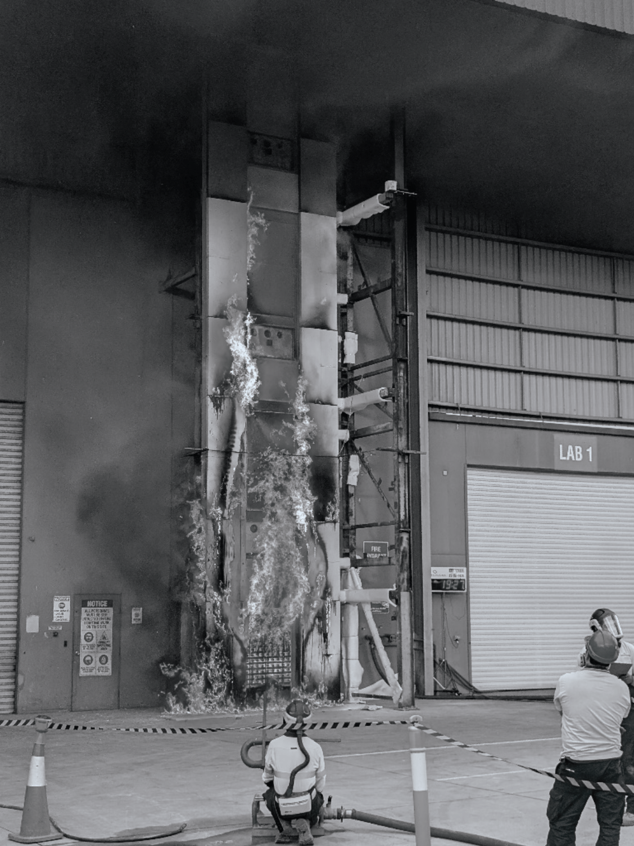
Figure 2: 12-metre ACP-PE test conducted to investigate a fire break solution, in which a 3-metre section of non-combustible cladding (solid aluminium) was used as the fire break
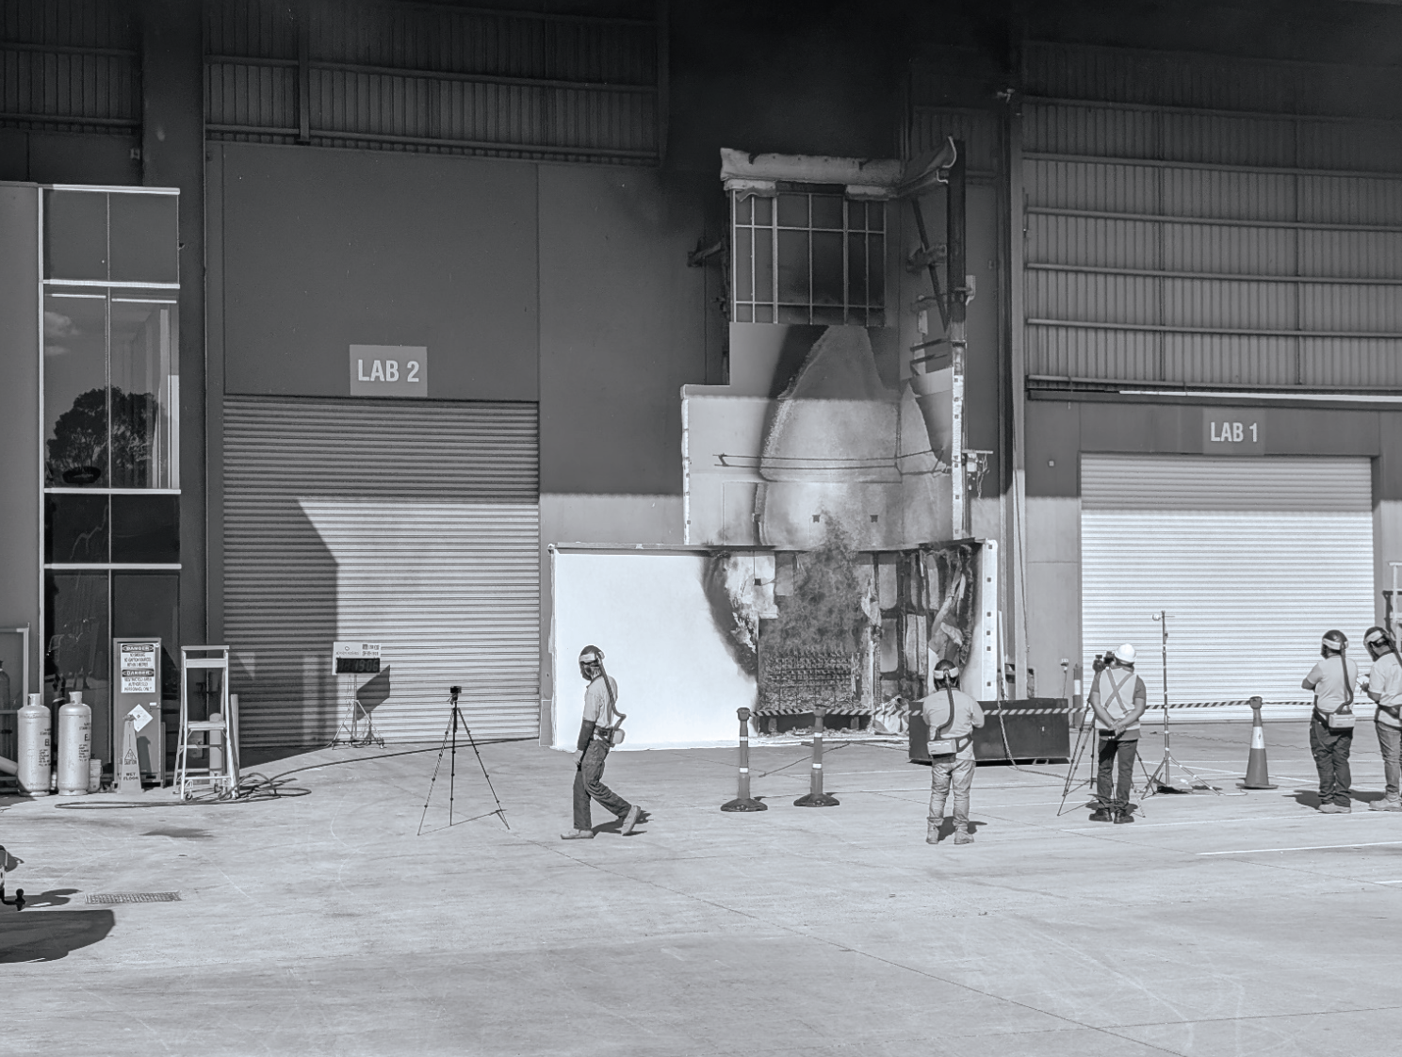
Figure 3: Large-scale rendered EPS test conducted using a main wall and a wing wall configuration to investigate horizontal fire spread

Protocols for Mitigating Cladding Risk
CSV’s ground-breaking approach to identifying, assessing, classifying and treating combustible cladding risk was formalised during the previous reporting period. Minister’s Guideline 15 mandates the consideration of CSV’s Cladding Risk Mitigation Framework (CRMF), advice and Remediation Work Proposals (RWPs) by building surveyors when they are undertaking their functions in relation to buildings with combustible cladding. The Protocols for Mitigating Cladding Risk (PMCR), which operates under the umbrella of Minister’s Guideline 15 and the CRMF, provides a comprehensive evidence-based methodology for identifying risk-proportionate responses for buildings of all risk levels.
Since the publication of the PMCR last year, CSV has undertaken further fire testing – as outlined above – as well as additional research with partner RMIT University to establish robust benchmarks, such as for the effectiveness of sprinklers in mitigating fire spread. CSV has also received feedback from MBSs about the application of the PMCR and identified areas where guidance can be refined to better support the consideration of risk-reduction solutions by building surveyors. An updated version of the PMCR will be published on CSV’s website in the second half of 2025.
During the year, some of the outcomes of this testing and research were published in international engineering resource Construction Materials and Their Properties for Fire Resistance and Insulation (Elsevier, October 2024) and in the international, peer-reviewed, open-access journal Fire: ‘A Risk-Based Approach to Assess the Effectiveness of Sprinklers in Buildings with Combustible Cladding’. Another paper on the impact of cladding and insulation materials on external fire spread is currently under peer review and CSV has been approached by other academic journals and publishers to contribute content arising from its findings. Work has also commenced with Standards Australia to develop a new technical standard based on the PMCR, which will involve collaboration with a number of other states and territories, as well as industry practitioners. CSV will continue to find different ways to share the research and approaches that underpin the world-leading PMCR methodology, which has transformed how cladding risk is considered and resolved.

Essential safety measures survey
During 2024–25, CSV commenced a joint project with Fire Rescue Victoria (FRV) to determine if essential safety measures (ESM) systems in residential buildings have been installed, are functioning correctly, and are being properly maintained and recorded. ESMs are building features that protect occupants in the event of a fire, including fire detection and alarm systems, sprinklers, fire doors, emergency lighting and hose reels. Failure to maintain ESMs presents a key risk to fire safety management and efficient building evacuation in an emergency.
The focus of the project has been unacceptable-risk and elevated-risk buildings where CSV has recommended that some cladding remain in place. The survey is intended to provide a basis for understanding the safety level provided by the ESMs in relation to the works CSV has recommended under the PMCR. ESMs are a critical component of the cladding risk assessment process, but responsibility for their implementation and maintenance lies with owners corporations and ESM maintenance contractors, and is outside of CSV’s purview.
CSV worked with FRV and an external fire safety auditor to develop an assessment methodology, including key systems for inclusion in the survey and testing approaches for each system. Data collected will be used to establish a maintenance score, which will support consistent data analysis across the buildings assessed.
During 2024–25, 60 buildings were surveyed. Further surveys will be undertaken in early 2025–26 to produce a comprehensive report that outlines trends and patterns across the building cohort. Each participating owners corporation will receive a copy of the survey result for their building, which will also be provided to the relevant council.

Residential Cladding Rectification Program
As at 30 June 2025, there are 1,653 Class 2 buildings within Victoria that have been identified for consideration under CSV’s residential program. This is an increase of 34 from 2023–24, which is a result of referrals of buildings from councils under Section 27 of the CSV Act and the assessment of some buildings from CSV’s database of referred buildings as being in-scope for the program.
More than 1,500 Class 2 buildings, or 91% of buildings in CSV’s program, have now either been resolved or have a pathway for resolution in place. This includes buildings that have been discharged and more than 440 buildings that have been approved for rectification funding.

Pathways for risk mitigation
Under the PMCR methodology, residential buildings in CSV’s program are categorised as either ‘unacceptable risk’, ‘elevated risk’ or ‘low risk’. These categories reflect the extent to which cladding would be expected to contribute to fire spread across a building facade.
Unacceptable risk | This means the amount, type and configuration of cladding on a building could lead to rapid acceleration of a fire. Most unacceptable-risk buildings require substantial cladding removal and replacement works to adequately mitigate combustible cladding risk.
Elevated risk | This means the extent of fire spread attributable to the presence of combustible cladding is limited. Minimal or no cladding removal is required for these buildings, as a range of other interventions are available to address cladding risk.
Low risk | This means well-maintained essential safety measures are sufficient to address any combustible cladding risk on a building and in most cases, no further intervention is required.
Buildings in the program may fall outside these risk categories if:
- they are subsequently deemed to be out-of-scope for a range of possible reasons, such as an ineligible ownership structure or the building being less than 3 storeys high
- the combustible cladding risk has already been resolved in another manner, for example by the owners corporation or by the MBS directly.
This chart illustrates the categorisation of residential buildings that have been identified for consideration under CSV’s residential program as at the end of 2024–25.
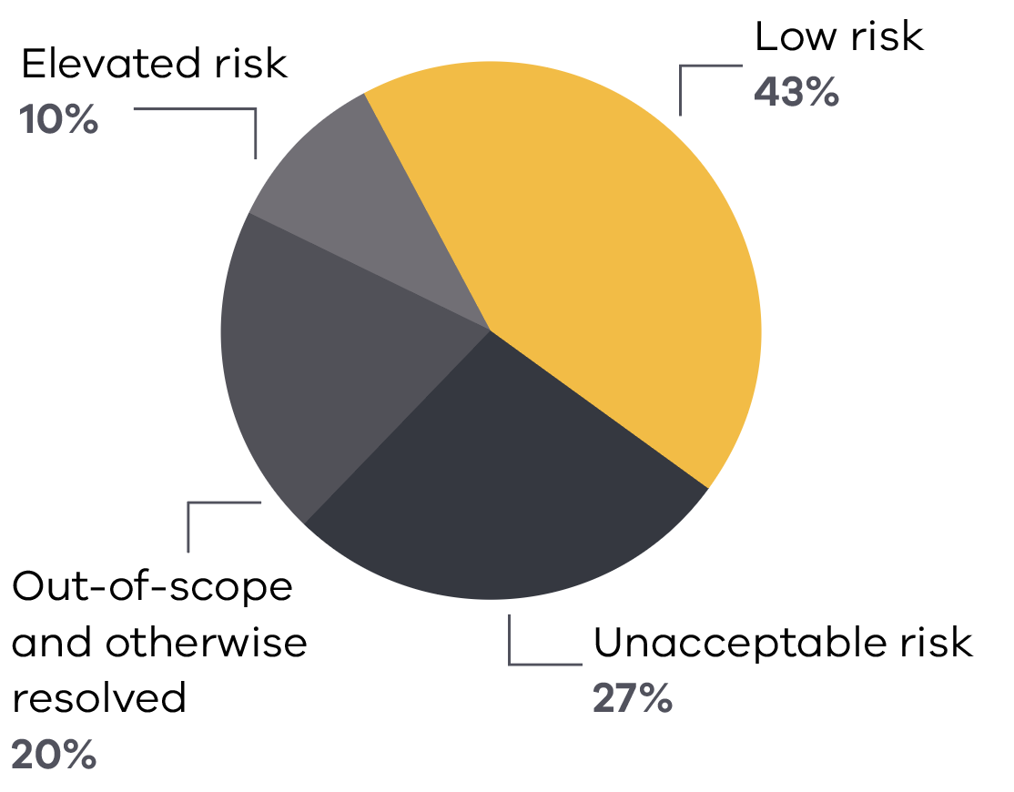
There are 2 main streams to CSV’s residential building program. The Cladding Rectification Program addresses unacceptable-risk buildings and the Cladding Remediation Partnership Program provides resolution pathways for lower-risk buildings. The following sections outline progress made during 2024–25 under these program streams.

Cladding Rectification Program
Residential buildings in the Cladding Rectification Program (CRP) represent approximately one-quarter of the total building cohort in CSV’s program, but by their very nature as higher-risk buildings, they represent 90% of the cladding risk across the state. Work to rectify these higher-risk buildings commenced in 2019 as a matter of priority. With the completion of works on 409 unacceptable-risk buildings to the end of 2024–25, 93% of cladding risk for this category of buildings has now been mitigated. This world-leading program is expected to conclude in early 2026 and is on track to make more than 42,000 Victorians safer in their homes.

Delivery achievements
The CRP funds rectification works to remediate unacceptable cladding fire risk on Class 2 residential buildings with 3 or more storeys. In 2024–25, 50 funding agreements with owners corporations were signed and works commenced on 62 buildings.
The completion of rectification works on 79 residential buildings during the year brings the total number of buildings rectified under the funded program to 409 to 30 June 2025. This equates to approximately 275,000 square metres of cladding removed and more than 20,000 individual homes made safer.
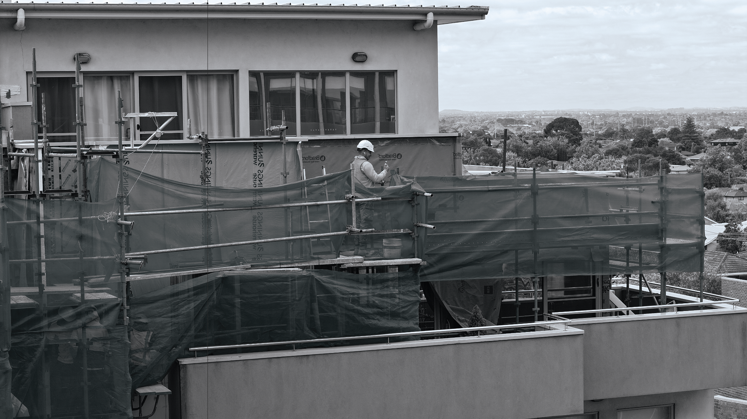
Figure 4. A building with works underway in CSV’s Cladding Rectification Program
The map on the following page details the number of buildings rectified during 2024–25 by local government area.
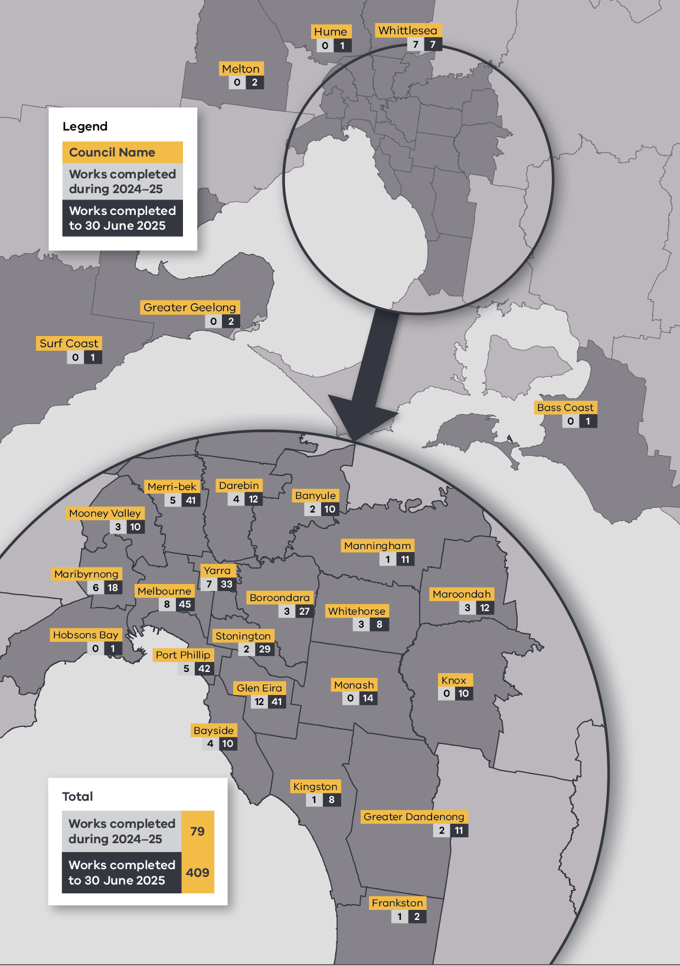

Support for building owners
Cladding rectification projects can be challenging for owners corporations to manage and steer through to successful conclusion. To address this risk, CSV has established project support mechanisms that facilitate the achievement of optimal outcomes for owners.

Engagement with owners corporations
A dedicated CSV staff member is assigned to every building that receives funding through the program. This staff member works with the owners corporation for that building from the beginning of the project through to the completion of works and acquittal of the building from the program. In 2024–25, CSV had a total of 10,636 engagements with owners corporations.
Type of engagement | Number
Meetings | 398
Phone calls | 1,657
Emails | 7,889
Enquiries via Cladding Support Line | 692
Total | 10,636
Each year, CSV surveys owners corporations to seek feedback about the level of support they are receiving for their rectification project. A consistently high level of satisfaction has been achieved year-on-year, with an 89% satisfaction rating being recorded for 2024.

Project management and assurance
Cladding rectification works are often complex, involving a range of building practitioners and extensive stakeholder management requirements. CSV does not directly undertake or project-manage rectification works, but has built safeguards into the design of the program to ensure that works meet relevant safety and quality standards.
The engagement of Independent Project Managers is a process that was established by CSV in 2020 to oversee the management of building contracts to ensure timely progress of works in line with contractual obligations and to act as a point of contact for the effective resolution of on-site matters.
An additional layer of control is the Clerk of Works program. In July 2019, the Victorian Cladding Taskforce recommended that the government consider the restoration of the Clerk of Works function as part of its longer-term reform of the building industry. CSV gave effect to the recommendation by providing this oversight across each building in construction. This program has been demonstrated to actively facilitate a high level of quality and safety outcomes for owners corporations and to deliver quantifiable savings for the Victorian Government through the early management of issues that would otherwise result in potentially significant financial and physical safety costs. Clerks of Works engaged by CSV for each project visit building sites regularly to undertake inspections, providing independent oversight for construction works that ensures adherence to quality and safety standards.
During 2024–25, Clerks of Works carried out 2,647 inspections and submitted 567 quality and safety observations to CSV for monitoring and resolution. CSV program staff also undertake regular site inspections, covering an average of 35 sites per week. In addition, CSV staff are involved in liaising with WorkSafe Victoria and ensuring the timely close-out of corrective actions, based on reported observations and incidents.
The following graphs outline the 3 most frequently reported categories of observations for quality and safety in 2024–25 across the 80 buildings that were under construction during the year.

Quality observations
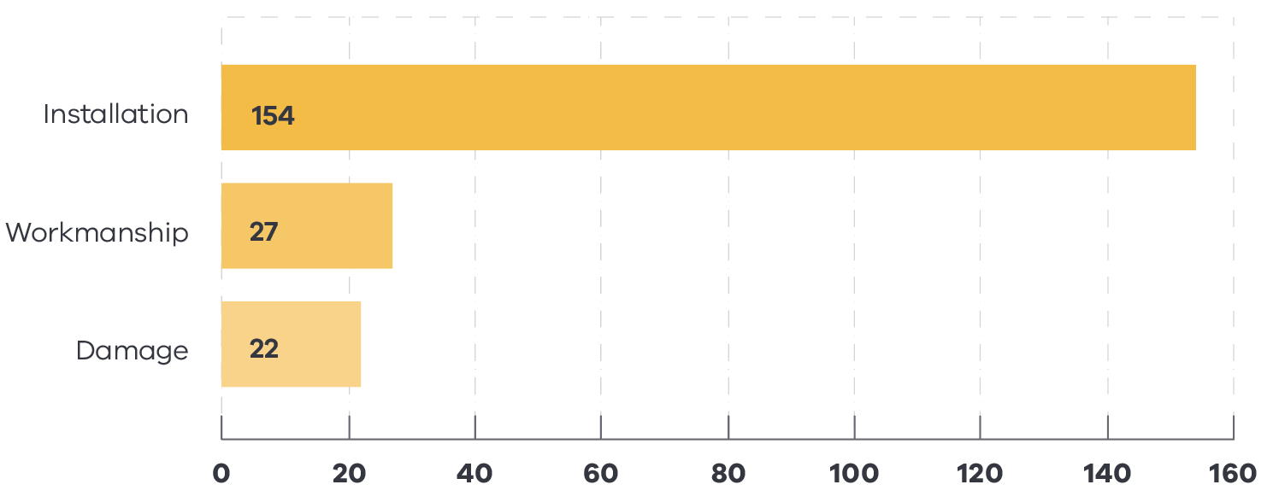

Safety observations
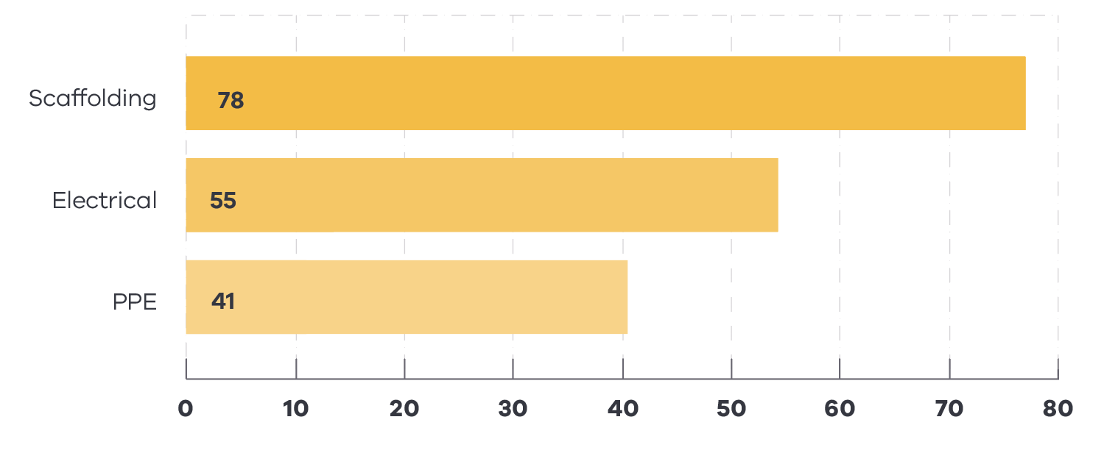

Challenges to delivery
In 2019, a group of 15 buildings was selected as representative of a range of complex issues that were expected to require resolution throughout the program. The types of issues covered within this group included significant non-cladding defects or poor overall construction, challenging owners corporation and MBS engagement, difficult ownership structures, poor-performing builders and buildings that incorporated a mix of different classes and uses. In addition, the regulatory system that governs remediation works was focused on construction compliance at the time and did not actively support the implementation of risk-reduction methodologies to address cladding risk. It was intended that prioritising these buildings would allow CSV to develop processes and delivery approaches that would provide a streamlined framework for progressing future cladding rectification projects.
CSV’s responses to the issues represented by these buildings shaped the methodologies that have been successfully employed to achieve effective stakeholder engagement and robust contractor management. They supported the case for greater on-site oversight delivered through the Clerk of Works Program and for an evidence-based approach to cladding risk identification and mitigation, which resulted in CSV’s risk-reduction approach and the PMCR model. The release of Minister’s Guideline 15 in September 2023 cemented risk reduction as a key consideration for building surveyors when fulfilling their functions in relation to Class 2 and 3 buildings with combustible cladding.
Nevertheless, these issues remain widespread across the sector, creating significant cost burdens and causing distress for owners. They are the subject of ongoing building and construction reform that is being implemented by the Victorian Government, along with other jurisdictions. Despite the early identification of issues associated with the initial prioritised group of buildings, completion of works on the final building in this cohort only concluded in 2025. This demonstrates how complex and intractable some of these issues can be, even when considerable resources and dedicated focus are applied to their resolution.
However, the primary challenge for CSV’s program remains the presence of non-cladding defects in a large number of buildings that has contributed to both project delays and substantial problems for owners and owners corporations. This is why CSV has prioritised the collation, analysis and publication of defects data, in order for the extent of this problem to be fully understood within government and the industry more widely.

Cladding Remediation Partnership Program
Under the Cladding Remediation Partnership Program (CRPP), CSV works with councils and building owners to mitigate cladding risk on lower-risk Class 2 buildings through the interventions outlined in the PMCR. Lower-risk buildings are those classified by CSV as being elevated-risk or low-risk, based on an assessment of identified aspects of a cladded building that could contribute to the risk of fire spread.
The PMCR operates in conjunction with Minister’s Guideline 15 and the CRMF to provide MBSs with a clear and evidence-based decision-making framework to address cladding risk for the residential buildings within their municipality. Councils are also able to apply for funding support through DTP to facilitate the application of appropriate resourcing for this process. In this way, the CRPP brings together different levels of government to identify an agreed pathway for the mitigation of cladding risk.
Buildings with an ‘elevated’ risk rating are provided with an RWP that identifies interventions to be undertaken by owners corporations to reduce cladding risk on their building to an acceptable level, that is, the level of risk for the building had the cladding not been installed in the first place. Low-risk buildings typically do not require any action by owners and reports are produced for these buildings to record the risk assessment process and outcome, provide data and images to illustrate the presence and type/s of cladding and incorporate any other relevant building information.
CSV works closely with MBSs to achieve agreement on the rating of low-risk buildings and on the actions to be recommended to owners for the mitigation of elevated-risk buildings. This is critical for owners being able to obtain the removal of any enforcement notices relating to combustible cladding risk. Although lower-risk buildings only account for approximately 10% of residential cladding risk across the state, providing certainty for owners about whether any actions are required to address cladding risk on their building is important for this reason.
Significant progress was made during 2024–25 towards the resolution of lower-risk buildings, with 89% now having an agreed pathway in place. The following table details progress made in reaching agreement on elevated-risk and low-risk buildings by municipality to 30 June 2025.

Figure 5: Work on the tallest building in the program, a 68-storey apartment building in Melbourne’s CBD, has been completed
Council | Number of RWPs and low-risk reports provided by CSV | Number of RWPs and low-risk reports endorsed by council | Percentage of RWPs and low-risk reports endorsed by council
Banyule | 8 | 8 | 100%
Bayside | 36 | 28 | 78%
Boroondara | 40 | 25 | 63%
Brimbank | 3 | 1 | 33%
Darebin | 32 | 28 | 88%
East Gippsland | 1 | 1 | 100%
Frankston | 1 | 1 | 100%
Glen Eira | 57 | 55 | 96%
Greater Dandenong | 5 | 5 | 100%
Greater Geelong | 5 | 4 | 80%
Hobsons Bay | 2 | 1 | 50%
Hume | 1 | 0 | 0%
Kingston | 10 | 10 | 100%
Knox | 4 | 4 | 100%
Manningham | 30 | 30 | 100%
Maribyrnong | 17 | 9 | 53%
Maroondah | 7 | 7 | 100%
Melbourne | 21 | 11 | 52%
Melton | 2 | 1 | 50%
Merri-bek | 57 | 55 | 96%
Monash | 12 | 10 | 83%
Moonee Valley | 33 | 31 | 94%
Mornington Peninsula | 3 | 2 | 67%
Nillumbik | 1 | 0 | 0%
Port Phillip | 60 | 45 | 75%
Stonnington | 35 | 34 | 97%
Whitehorse | 13 | 11 | 85%
Whittlesea | 2 | 2 | 100%
Yarra | 28 | 23 | 82%
In June 2025, data about the resolution of Class 2 buildings across all risk categories for every council was publicly published on the CSV website: www.vic.gov.au/project-completion-council-by-council.

Elevated-risk buildings
Elevated-risk buildings are not eligible for funding under CSV’s remediation program and any works required to mitigate cladding risk must be undertaken and funded by owners. The risk-reduction interventions outlined in the PMCR and included in RWPs represent an efficient way for owners to achieve an acceptable level of risk for their buildings that is also significantly more cost-effective than full cladding removal.
As an example, a 7-storey building outside of metropolitan Melbourne with ACP-PE and timber cladding was initially rated through the Statewide Cladding Audit at a ‘moderate’ level of risk. The owners corporation procured a fire engineering report that proposed significant cladding removal, which subsequent tenders indicated would cost approximately $900,000. CSV’s assessment under the PMCR deemed no cladding removal was required and concluded that the cladding risk could be mitigated through low-cost interventions such as the installation of smoke alarms and an audit of penetrations through the cladding. The RWP produced by CSV was approved by the MBS and provided to the owners corporation for implementation.
During 2024–25, 111 RWPs were developed by CSV and provided to the relevant MBS for review. Owners corporations received 102 RWPs that had been agreed with the MBS for their building. In April 2025, CSV contacted owners corporations who had received a finalised RWP and who’d had at least 8 weeks to consider the advice. This review confirmed 86% of owners corporations had either completed works to address the combustible cladding risk on their building, or had initiated works that were underway. CSV continues to support and provide advice to owners corporations who have experienced issues with the implementation of RWPs, to ensure cladding risk is mitigated in a timely manner.

Low-risk buildings
In parallel with the council engagement on elevated-risk buildings, CSV is also working with MBSs on reaching agreement on the rating for those buildings assessed by CSV as low-risk. This agreement was achieved for 160 low-risk reports in 2024–25. The next step for these buildings is to be discharged from the CSV program. Buildings may be discharged by CSV based on their low-risk rating or for other reasons, such as having an ineligible type of cladding or having been resolved in another manner (e.g. directly by the MBS or owners corporation). During the year, 280 low-risk buildings were discharged and as at 30 June 2025, a total of 947 buildings have been discharged from the program, representing 57% of the total building cohort.

Looking ahead
The CRPP will wrap-up in the first half of 2026, with all lower-risk Class 2 buildings to have a confirmed pathway for resolution. Not all buildings referred to CSV and considered under CSV’s program had a cladding-related enforcement notice on them, but many were under active enforcement notices, which has been the cause of ongoing and significant stress for owners. Although the removal of these notices is the responsibility of MBSs and outside of CSV’s remit, CSV has been undertaking monitoring activities to understand the extent to which the notices have been closed out. Data collected in late 2024–25 indicated that 81% of buildings in the program (in all risk categories) were no longer under active enforcement notices, which provides closure and certainty for the owners of residential apartment buildings across Victoria.

Class 3 and 9 Buildings
Since CSV’s establishment in 2019, the organisation’s focus has been on overseeing the rectification of government-owned buildings and supporting owners of Class 2 residential buildings to understand the risk posed by combustible cladding, allocating funding for rectification works and providing guidance about the measures that can be taken to mitigate cladding-related risk. In late 2023, the Minister for Planning requested that CSV’s services be extended to Class 3 and 9 buildings identified through the Statewide Cladding Audit. Significant work was undertaken in 2024–25 to analyse and sort the respective data sets for these classes of buildings and to define the path forward for addressing any combustible cladding risk.

Class 3 buildings
A small number of Class 3 buildings potentially affected by combustible cladding were referred by the VBA (now the BPC) and MBSs for assessment by CSV for eligibility under the Residential Cladding Rectification Program. Class 3 buildings include facilities that house multiple unrelated individuals – either long-term or temporarily – such as boarding houses, hostels, backpacker accommodation and the residential portions of hotels, motels, schools, and detention centres.
Some of the buildings identified for review by CSV have already had their cladding risk addressed or actions to mitigate the risk are underway. Buildings that require further assistance from CSV will be risk-assessed and have an RWP or low-risk report generated for them under the PMCR methodology. In this way, CSV will support owners and MBSs by providing clear advice about any actions required to reduce combustible cladding risk to an acceptable level for this class of buildings.
As at 30 June 2025, approximately 50 Class 3 buildings had been identified and of these, 26 had been resolved or discharged from CSV’s program due to other activity currently underway. The remaining Class 3 buildings will be assessed and provided with a risk-mitigation pathway by the end of 2025.

Class 9 buildings
A broad array of building types is included in the population of Class 9 buildings registered with CSV, including hospitals, aged-care facilities, childcare facilities, schools, universities, places of worship, gymnasiums, museums, cinemas, community clubs and sporting clubs. These buildings have very different user groups, and specifically with respect to fire safety, different degrees of vulnerability in relation to the ability of users to evacuate in the event of a cladding fire.
The aim of CSV’s Class 9 program is to ensure information and guidance about cladding risk and remediation is produced to facilitate the full transition of responsibility for cladding matters to council MBSs for all Class 9 buildings registered with CSV. Service levels to be provided by CSV for Class 9 buildings have been set, scaled in accordance with the risk profile of each category of buildings. For example, buildings that are used by able-bodied adults for finite periods (i.e. not for sleeping overnight) are allocated to a category with a lower level of priority.
During 2024–25, baseline information sets were prepared for the cohort of 1,038 Class 9 buildings referred to CSV from the VBA (now the BPC). CSV engaged with owners and the relevant MBSs about the status of buildings, undertook building desktop reviews and conducted site visits where further information about the presence of cladding was required.
Review and assessment of all Class 9 buildings will be completed by April 2026. Formal communication will be provided to all owners and/or MBSs about the cladding risk status of these buildings, including advice about possible risk mitigations where a building is identified as having an elevated or unacceptable level of risk.

Creating a lasting impact and legacy
All CSV program activities relating to the rectification of buildings and the provision of advice to building owners and councils are scheduled to be finalised in April 2026. While focus remains on ensuring the timely delivery of high-quality works and guidance, considerable energy is also being devoted to ensuring that CSV’s close-out as an entity occurs in an efficient and diligent manner, with all compliance and legal requirements being met.
CSV is developing a comprehensive report that details the roll-out of CSV’s program, approaches taken and benefits realised for the Victorian community from the significant investment of government funding and resources. CSV’s extensive data will also be prepared for sharing within government with entities that have responsibility for building and fire safety. Finally, a small number of trailing activities to finalise outstanding contracts as they move out of their defects liability period and to close-out stakeholder engagements will be transferred to the BPC to ensure all responsibilities are systematically concluded.

Unlocking data to build the case for change
The information collected, research undertaken and analysis performed by CSV through its program extends beyond purely technical data. CSV’s wide-ranging data sets have uncovered issues and provided insights that have the potential to make valuable contributions to future policy development and long-term strategies for sector reform.
To support this aim, CSV has initiated a series of research projects that will eventually be published in a compendium at the conclusion of the program to consolidate all research findings. This compendium will sit alongside the hundreds of buildings made safer across Victoria as the foundation of CSV’s legacy after its closure.
During 2024–25, 3 research reports were published on CSV’s website and a fourth was provided to relevant government stakeholders for consideration. Positive feedback on the reports has been received from the VBA (now the BPC), the Building Monitor, the Architects Registration Board of Victoria, Better Regulation Victoria, the NSW Building Commissioner and the joint Chairs of the Victorian Cladding Taskforce, among others.

Compliance in building design
This research project reviewed the documentation for more than 800 buildings in CSV’s program to understand which parties or entities were responsible for the use of combustible cladding on buildings in Victoria. Analysis of the data revealed widespread misapplication of Victoria’s regulatory requirements for external wall cladding by the key professionals accountable for the design and permitting of buildings, namely the architects, draftspersons, fire safety engineers and building surveyors. This report is available on CSV’s website: www.vic.gov.au/compliance-building-design

Non-cladding building defects
Another research project examined the performance of external wall systems of 359 buildings in CSV’s program that sits behind the external layer of cladding. This report expanded on research previously published by CSV about balcony defects to include other non-cladding defects that have resulted in moisture ingress and issues with structural integrity, which impacts occupant health and creates a significant cost burden for owners. Fifty percent of the buildings reviewed were identified as having defects unrelated to cladding. This report is available on CSV’s website: www.vic.gov.au/other-building-defects

Clerk of Works: Promoting quality and safety in construction
The Clerk of Works (COW) inspection program was established by CSV in 2021 to oversee the quality and safety of construction sites for the Cladding Rectification Program. More than 700 inspection observations from the COW program over a 3-year period were assessed and costed under this project. The analysis indicated that the COW program has driven improvements across CSV work sites and resulted in approximately $96 million in estimated cost savings. This report is available on CSV’s website: www.vic.gov.au/quality-and-safety-construction

The cost of doing business
This research project focused on the degree of consistency, level of transparency and processing timelines for building approvals across different Victorian councils. Lack of alignment between councils has the potential to create uncertainty for building contractors about requirements and possible unnecessary delays and costs for rectification works. The report has been circulated to key government stakeholders and will be incorporated into the research compendium, which will be published towards the end of CSV’s program.

Spreading the word
In 2024–25, CSV held meetings with government representatives engaged in sector oversight and reform, including:
- the Victorian Building Monitor to discuss CSV’s data, research program and the use of CSV information to provide an evidence base to drive building reform in government
- the NSW Building Commissioner to discuss issues across the building sector and CSV’s published research on non-cladding defects
- the Acting Commissioner of Better Regulation Victoria to discuss CSV’s findings on the impact of local government fees and lengthy processing timelines on contractors undertaking defect rectification works.
CSV continued regular engagement during the year with key bodies such as the Victorian Municipal Building Surveyors Group and Fire Rescue Victoria to provide updates about the PMCR and program progress. Insights from CSV’s program, such as installation practices, were also made available to manufacturers of non-combustible cladding products.
In 2024–25, CSV continued engagement with major building insurers to support the case for coverage for buildings with CSV remediation solutions. In addition, consultation commenced in 2025 with the Insurance Council of Australia’s Professional Indemnity Working Group about the role of the PMCR in supporting building consultants to consistently assess and treat cladding risks in a standardised way.
Following the visit of CSV representatives to the UK and Ireland in May 2024, ongoing discussions about CSV’s program progress, risk reduction approaches and quality assurance activities have been held with Britain’s Health and Safety Executive and Building Safety Regulator, as well as CSV’s counterparts in Scotland. In 2025, a representative from the UK Ministry of Housing, Communities and Local Government visited Victoria to learn more about CSV’s program and to undertake site visits to view rectification projects. Representatives from the City of Auckland in New Zealand also visited during the year to hear about CSV’s experience with construction defects and the building policy and delivery approaches of the Victorian Government.

Submissions
In September 2024, the Australian Building Codes Board (ABCB) issued a discussion paper on the development of a proposal to establish both a national building product register and a mandatory product labelling and traceability scheme to address problems caused by building products that do not conform or comply with the National Construction Code. A formal submission was made to the ABCB in October 2024 to provide it with CSV’s insights into building defects and to outline matters for the ABCB to consider in the development of the scheme.
In October 2024, CSV also made a formal submission to the Productivity Commission’s research project into housing construction productivity. CSV’s submission provided the commission with access to its published research to date, with a focus on building defects and compliance issues in building design.

Grenfell Tower Inquiry webinar
In October 2024, CSV hosted a webinar attended by more than 350 people to provide a summary of the findings arising from the inquiry into the Grenfell disaster in the UK. Registrants from the government and building sectors included the VBA (now the BPC), Department of Transport and Planning (DTP), FRV, the Housing Industry Association, the Master Builders Association of Victoria, the Victorian Managed Insurance Authority, dozens of industry practitioners and a number of local councils. There was active engagement from participants in discussing the lessons learned from the disaster and what it may mean for future building reform and the Victorian regulatory context.

2024–25 State Budget and service delivery
CSV is accountable for the delivery of one output performance measure that forms part of the government’s priorities for service delivery as outlined in the 2024–25 Department Performance Statement.
Performance measures | Unit of measure | 2024–25 target | 2024–25 actual | Performance variation (%) | Result
In-scope privately-owned residential buildings that have completed cladding rectification works | number | 75 | 79 | 5.3% | ü
The 2024–25 result is greater than the 2024–25 target due to favourable weather conditions and the completion of a larger number of smaller-scale projects.
ü Performance target achieved or exceeded
* Performance target not achieved – exceeds 5 per cent
# Performance target not achieved – within 5 per cent

Organisation and people

Organisational structure
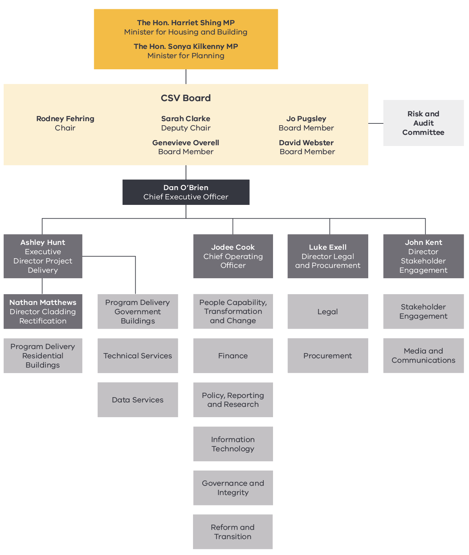
Note: The above chart represents CSV’s organisational structure as at 30 June 2025.

Minister
CSV is subject to the general direction and control of the Minister for Housing and Building and the Minister for Planning. From 5 December 2022, the Minister of Planning has been the Hon. Sonya Kilkenny MP, who was also the Minister for Suburbs until 19 December 2024 and is the Attorney-General (from 19 December 2024).
On 27 March 2025, a Supplement to the General Order was amended to ensure the administration of the CSV Act will be ‘jointly and severally administered’ by both the Minister for Planning and the Minister for Housing and Building. From 19 December 2024, the Minister of Housing and Building has been the Hon. Harriet Shing MP, who was the Minister for Housing, Minister for Water, and the Minister for Equality until 19 December 2024 and is also the Minister for the Suburban Rail Loop, and the Minister for Development Victoria and Precincts (since 19 December 2024).

Department of Transport and Planning
DTP is the portfolio department for CSV. The DTP-led Project Control Board (PCB) is responsible for strategic oversight of the cladding portfolio, including:
- implementation of the Cladding Rectification Program and Cladding Remediation Partnership Program for in-scope buildings overseen by CSV
- establishment and implementation of the rectification program for government-owned buildings, including authorising the release of funds
- cost recovery activity by DTP
- development and implementation of immediate reform priorities and scoping and development of longer-term policy reform options.
PCB comprises senior representation from CSV, DTP, the Department of Treasury and Finance, and the Department of Premier and Cabinet.

Cladding Safety Victoria’s Board
The role and responsibilities of the CSV Board are defined under the Cladding Safety Victoria Act 2020 (Vic). In addition to monitoring the performance of CSV against its duties under the CSV Act, the CSV Board is responsible for:
- setting the goals and overall strategy for CSV and monitoring deliverables
- establishing appropriate and effective financial governance and oversight arrangements, including the regular review of the effectiveness of those arrangements
- overseeing CSV’s systems for internal control, risk management, auditing and legal compliance
- selecting and appointing the CEO.
Details about Board Members can be found on the CSV website via www.vic.gov.au/our-ceo-and-governing-board.
Six Board meetings were held during 2024–25. The record of attendance for Board Members is shown in the following table.
Name | Position | Attended
Rod Fehring | Chair | 6
Sarah Clarke | Deputy Chair | 5
Genevieve Overell | Board Member | 6
Jo Pugsley | Board Member | 5
David Webster | Board Member | 4

Risk and Audit Committee
The Risk and Audit Committee provides assurance and advice to the Board on the effectiveness of the organisation’s financial and risk management systems and internal controls, including performance and sustainability, and compliance with laws and regulations.
Three Risk and Audit Committee meetings were held during 2024–25. The record of attendance for Committee Members is shown in the following table.
Name | Position | Attended
David Webster | Chair | 3
Rod Fehring | Member | 2
Genevieve Overell | Member | 3

CEO and senior executives
CSV is led by Dan O’Brien, Chief Executive Officer, who reports to the Chair of the CSV Board. CSV is managed by a senior executive group comprising the Chief Executive Officer, the heads of 3 of CSV’s divisions and the 2 executives who oversee delivery of the Cladding Rectification Program. Details about CSV’s Chief Executive Officer and senior executives can be found on the CSV website via www.vic.gov.au/our-ceo-and-governing-board.

Our people
CSV has firmly established itself as a people-powered organisation defined by purpose, excellence and impact. With the CRP and CRPP at the centre of its mission, CSV has created a workplace culture that is not only high-performing but genuinely inspirational, one where people feel proud, supported and empowered to deliver work that matters.
As an organisation with a defined program lifespan, CSV has navigated the inherent challenges of attracting and retaining skilled professionals by building a workplace where people are engaged, supported, and motivated to deliver with purpose and at the same time the workforce is agile, capable and future-ready. A strong emphasis on diversity, inclusion, wellbeing and leadership has create a culture of trust and belonging, one that attracts, motivates and retains exceptional talent.
CSV continues to elevate its delivery and technical capabilities across the organisation. Its people play a critical role in navigating this complexity, fostering collaborative relationships with owners corporations, government, the construction industry and communities to ensure outcomes that are both enduring and equitable.
The strength of CSV’s approach is clearly reflected in its 2025 People Matter Survey results:
- 97% participation, showing staff are highly engaged and invested in the organisation
- an employee engagement index of 81, outperforming the public sector average by 14 percentage points
- outstanding results in inclusion (91%), cultural safety (89%), collaboration and organisational integrity, showing a deeply supportive and aligned culture
CSV’s people bring energy, innovation and commitment to everything they do — and the results speak for themselves. CSV is an organisation that leads with purpose, invests in its people and is setting a powerful example for how great culture drives great outcomes.

Public sector values, employment and conduct principles
The Public Administration Act 2004 (Vic) established the Victorian Public Sector Commission (VPSC). The VPSC’s role is to strengthen public sector efficiency, effectiveness and capability, and advocate for public sector professionalism and integrity.
CSV continues to uphold the highest standards of integrity, fairness, and professionalism in line with the Public Administration Act 2004 (Vic). CSV’s commitment to the Victorian Public Sector values is reflected in robust, merit-based recruitment practices, early resolution of any workplace issues, and a culture grounded in inclusion and accountability. Through clear policies and regular staff engagement, conflicts of interest, gifts and hospitality, and conduct matters are actively managed, ensuring our workforce remains confident, capable, and aligned with community expectations.

Comparative workforce data
The following table details the head count and full-time staff equivalent (FTE) of all active public sector employees of CSV who were employed in the last full pay period in June of the current reporting period and in the last full pay period in June of the previous reporting period.

 | June 2025 |  |  |  |  |  |  | June 2024
 | All employees |  | Ongoing |  |  | Fixed Term & Casual |  | All employees |  | Ongoing |  |  | Fixed Term & Casual
 | No. HC* | FTE # | F/T ~ HC* | P/T ^ HC* | FTE # | No. HC* | FTE # | No. HC* | FTE # | F/T ~ HC* | P/T ^ HC* | FTE # | No. HC* | FTE #
Gender
Female | 32 | 31.8 | 30 | 1 | 30.8 | 1 | 1 | 36 | 36 | 20 | - | 20 | 16 | 16
Male | 34 | 34 | 29 | - | 29 | 5 | 5 | 39 | 38.6 | 17 | 1 | 17.6 | 21 | 21
Self-described | - | - | - | - | - | - | - | - | - | - | - | - | - | -
Age
20–24 | - | - | - | - | - | - | - | 2 | 2 | - | - | - | 2 | 2
25–34 | 13 | 13 | 13 | - | 13 | - | - | 17 | 17 | 7 | - | 7 | 10 | 10
35–44 | 24 | 23.8 | 21 | 1 | 21.8 | 2 | 2 | 25 | 25 | 14 | - | 14 | 11 | 11
45–54 | 16 | 16 | 15 | - | 15 | 1 | 1 | 17 | 17 | 10 | - | 10 | 7 | 7
55–64 | 11 | 11 | 8 | - | 8 | 3 | 3 | 12 | 12 | 6 | - | 6 | 6 | 6
65+ | 2 | 2 | 2 | - | 2 | - | - | 2 | 1.6 | - | 1 | 0.6 | 1 | 1
Band 1–6 | 56 | 56 | 56 | - | 56 | - | - | 65 | 64.6 | 33 | 1 | 33.6 | 31 | 31
3 | 1 | 1 | 1 | - | 1 | - | - | 2 | 2 | 1 | - | 1 | 1 | 1
4 | 15 | 15 | 15 | - | 15 | - | - | 19 | 19 | 4 | - | 4 | 15 | 15
5 | 21 | 21 | 21 | - | 21 | - | - | 24 | 24 | 13 | - | 1 | 11 | 11
6 | 19 | 19 | 19 | - | 19 | - | - | 20 | 19.6 | 15 | 1 | 15.6 | 4 | 4
Senior employees | 10 | 9.8 | 3 | 1 | 3.8 | 6 | 6 | 10 | 10 | 4 | - | 4 | 6 | 6
Senior Technical Specialist (STS) | 4 | 3.8 | 3 | 1 | 3.8 | - | - | 4 | 4 | 4 | - | 4 | - | -
Senior Executive Service (SES) | 6 | 6 | - | - | - | 6 | 6 | 6 | 6 |  | - |  | 6 | 6
Total employees | 66 | 65.8 | 59 | 1 | 59.8 | 6 | 6 | 75 | 74.6 | 37 | 1 | 37.6 | 37 | 37
* HC = headcount
# There may be some variation in totals due to rounding of FTE figures.
~ F/T = full-time
^ P/T = part-time

Senior employees
The following table discloses the annualised total remuneration for senior employees of CSV, categorised by classification. The remuneration amount is reported as the full-time equivalent.

Annualised total remunerations by $20,000 bands for executives and senior non-executive staff as at 30 June 2025
Income band | Executives | Senior Technical Specialist
$230,000–249,999 |  | 3
$250,000–269,999
$270,000–289,999 | 3 | 1
$290,000–309,999 | 1
$350,000–369,999 | 1
$500,000–519,999 | 1
Note: Salaries reported are for the full financial year and exclude superannuation.
The following table provides further information about the number of executive officers by classification and gender, including variations (‘Var.’) to the previous reporting period.

Number of executive officers by classification and gender as at 30 June 2025
Classification | Total |  | Female |  | Male
 | No. | Var. | No. | Var. | No. | Var.
SES 3 | 1 | 0 | 0 | 0 | 1 | 0
SES 2 | 1 | 0 | 0 | 0 | 1 | 0
SES 1 | 4 | 0 | 1 | 0 | 3 | 0
The following table provides a reconciliation of executive numbers presented in the report of operations and Note 8.2 in the financial statements.

Reconciliation of executive numbers
 |  | 2024–25 | 2023–24
 | Executives (Financial Statements Note 8.2) | 5 | 5
 | Accountable Officer | 1 | 1
Less | Separations | 0 | 0
 | Total executive numbers at 30 June | 6 | 6

Workforce inclusion policy
CSV has demonstrated sustained dedication to workforce inclusion through measured actions, cultural leadership and continued focus on embedding inclusive practices across the organisation. These efforts are central to CSV’s vision of creating a workplace where every employee feels valued, respected and empowered to thrive. Throughout the year, CSV has actively progressed initiatives that build a more inclusive and culturally safe workplace, including:
- CSV representatives attended the annual International Women’s Day High Tea hosted by the National Association of Women in Construction (NAWIC), highlighting support for women in the construction industry.
- Initiatives were rolled out that build inclusion through education and awareness:
  - ‘Building an Inclusive Workplace’ training was provided to all staff, covering core concepts of diversity, equity, and inclusion, along with practical actions to foster a more inclusive culture.
  - Cultural Diversity Week was celebrated with a vibrant cultural lunch showcasing a variety of international cuisines, encouraging connection and cultural exchange.
- The organisation regularly promotes events that support awareness of under-represented communities through internal forums and the weekly staff newsletter, including:
  - LGBTIQ+ observances such as IDAHOBIT Day, Wear It Purple Day, Pride Month, Transgender Awareness Week, and Intersex Awareness Day
  - other inclusion events such as International Day of People with Disability and International Day for the Elimination of Violence Against Women.
CSV’s inclusive culture is reflected in the positive results of the 2025 People Matter Survey:
- 90% of staff agreed that leave, flexibility and working arrangements are favourable.
- 89% of staff felt culturally safe at work.
- 87% of staff felt included at CSV, outperforming the comparator group average of 77.9%.
These outcomes reflect CSV’s sustained organisational capability and its ongoing commitment to fostering an inclusive workplace where every individual’s potential is supported. By continuing to uphold diversity, capability uplift and cultural safety, CSV maintains a strong workforce culture that is well-positioned to deliver on its mission to address the risks posed by combustible cladding on buildings across Victoria.

Occupational health and safety
CSV remains committed to maintaining a safe, healthy and inclusive workplace. Occupational health, safety and wellbeing continue to be prioritised across all activities and levels of the organisation. This commitment is strongly reflected in CSV’s 2025 People Matter Survey results, which showed:
- 97% of staff agree CSV provides a physically safe work environment.
- 84% agree senior leaders place equal importance on psychological health and productivity.
- 92% report their job stress is manageable, significantly above the public sector average.
These results demonstrate CSV’s continued investment in creating an environment where employees feel safe, supported and able to perform at their best even amid the organisation’s broader transition and demobilisation. In 2024–25, CSV implemented several key initiatives to further strengthen health, safety, and wellbeing, including:
- roll-out of the 2025 corporate skin check program, offered to all staff to support early detection of skin cancer and promote sun safety awareness
- annual flu vaccination program to reduce the impact of seasonal influenza
- ongoing access to the Employee Assistance Program (EAP), including a whole-of-organisation presentation on available supports
- mental health first aiders trained and available to provide immediate peer-level support
- mandatory training for fire wardens, health and safety representatives, first aiders and managers
- delivery of OH&S for People Leaders compliance training, conducted quarterly in 2024 and on a biannual basis in 2025
- targeted training sessions addressing psychosocial risks, including strategies for managing difficult conversations and interpersonal dynamics
- regular meetings of the Occupational Health, Safety and Wellness Committee, supporting continuous monitoring and proactive risk management.
CSV continues to uphold its responsibility to protect the wellbeing of its workforce, foster a strong safety culture and ensure staff feel supported during all phases of the organisation’s transition.

Performance against OH&S management measures
Measure | Performance indicator | 2022–23 | 2023–24 | 2024–25
Incidents | Number of incidents | 0 | 2 | 0
Incidents | Rate per 100 FTE | 0 | 1.78 | 0
Corrective actions | Percentage completed within agreed timeframes | N/A* | 100% | N/A*
Claims | Number of standard claims | 0 | 0 | 0
Claims | Rate per 100 FTE | 0 | 0 | 0
Claims | Number of lost time claims | 0 | 0 | 0
Claim costs | Average cost per standard claim | N/A** | N/A** | N/A**
Fatalities | Fatality claims | 0 | 0 | 0
* No incidents were reported during the period and therefore there were no corrective actions.
** No relevant claims were made during the period.

Incident management
CSV is committed to creating and maintaining a physically and psychologically safe environment for all its staff and communities. During the 2024–25 financial year, no workplace incidents were reported, compared with 2 for the previous financial year.

Financial statements

How this report is structured
Declaration in the Financial Statements 49
Independent Auditor’s Report 50
Comprehensive operating statement ^{(a)} 52
Balance sheet ^{(a)} 53
Cash flow statement ^{(a)} 54
Statement of changes in equity ^{(a)} 55
Note 1: About this report 55
1.1. Basis of preparation 56
1.2. Compliance information 57
Note 2: Funding delivery of our services 57
2.1. Levy income 57
2.2. Other income 58
Note 3: The cost of delivering services 58
3.1. Employee benefits expenses 59
3.2. Grant expenses 61
3.3. Other operating expenses 61
Note 4: Key assets to support service delivery 62
4.1. Property, plant and equipment 62
4.2. Depreciation and amortisation 64
Note 5: Other assets and liabilities 64
5.1. Receivables 65
5.2. Payables 66
5.3. Other non-financial assets 66
Note 6: How we financed our operations 67
6.1. Borrowings 67
6.2. Leases 68
6.3. Cash flow information and balances 70
6.4. Commitments for expenditure 70
Note 7: Financial instruments, contingencies and valuation judgements 71
7.1. Financial instruments specific disclosures 72
7.2. Contingent assets and contingent liabilities 74
7.3. Fair value determination 75
Note 8: Other disclosures 76
8.1. Responsible persons 77
8.2. Remuneration of executives 77
8.3. Related parties 78
8.4. Remuneration of auditors 80
8.5. Subsequent events 80

The Board of Directors of Cladding Safety Victoria (CSV) has the pleasure of presenting its audited general-purpose financial statements for the financial year ended 30 June 2025, providing users with information about the authority’s stewardship of resources entrusted to it.

Declaration in the Financial Statements
The attached financial statements for Cladding Safety Victoria have been prepared in accordance with Direction 5.2 of the Minister for Finance under the Financial Management Act 1994 (Vic), applicable Financial Reporting Directions, Australian Accounting Standards including interpretations, and other mandatory professional reporting requirements.
We further state that, in our opinion, the information set out in the comprehensive operating statement, balance sheet, statement of changes in equity, cash flow statement and accompanying notes, presents fairly the financial transactions during the year ended 30 June 2025 and the financial position of CSV at 30 June 2025.
At the time of signing, we are not aware of any circumstances which would render any particulars included in the financial statements to be misleading or inaccurate.
We authorise the attached financial statements for issue on 12 September 2025.
Rodney Fehring
Board Chair
Cladding Safety Victoria
12 September 2025
Dan O’Brien
Chief Executive Officer
Cladding Safety Victoria
12 September 2025
Rose Scasni
Chief Financial Officer
Cladding Safety Victoria
12 September 2025

Independent Auditor’s Report
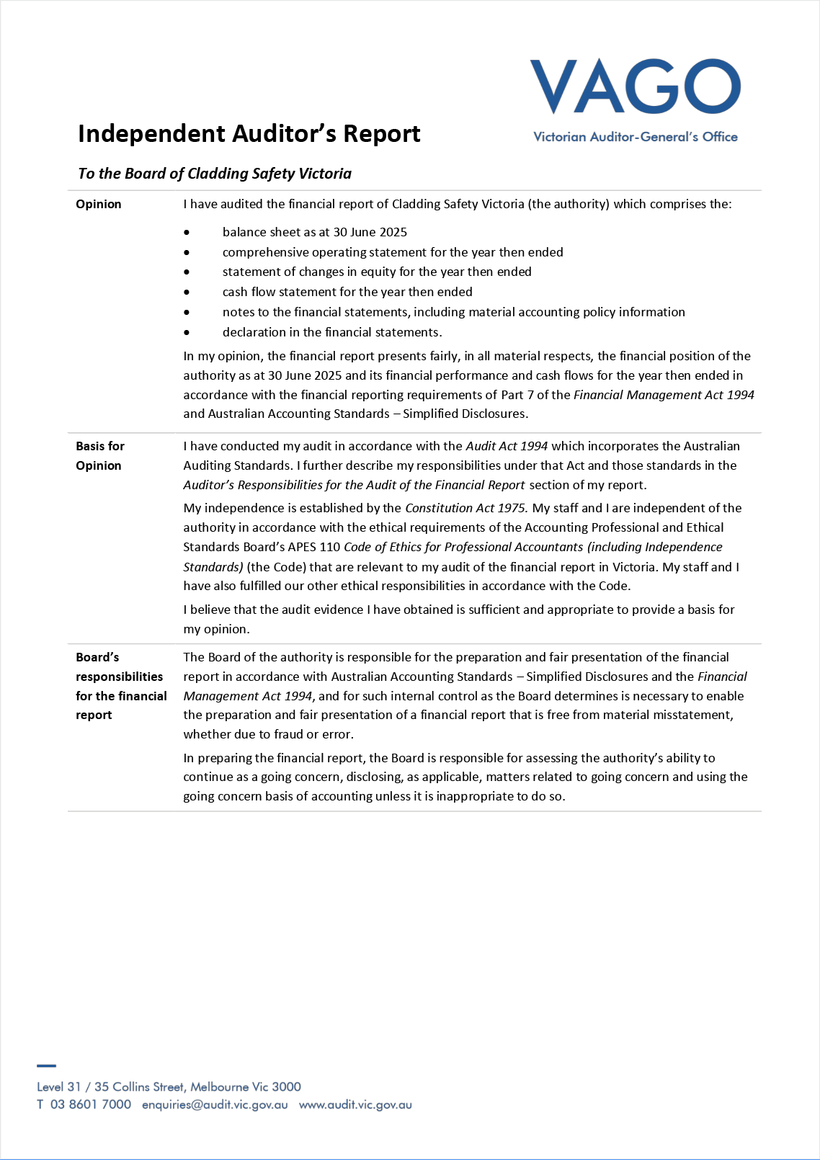
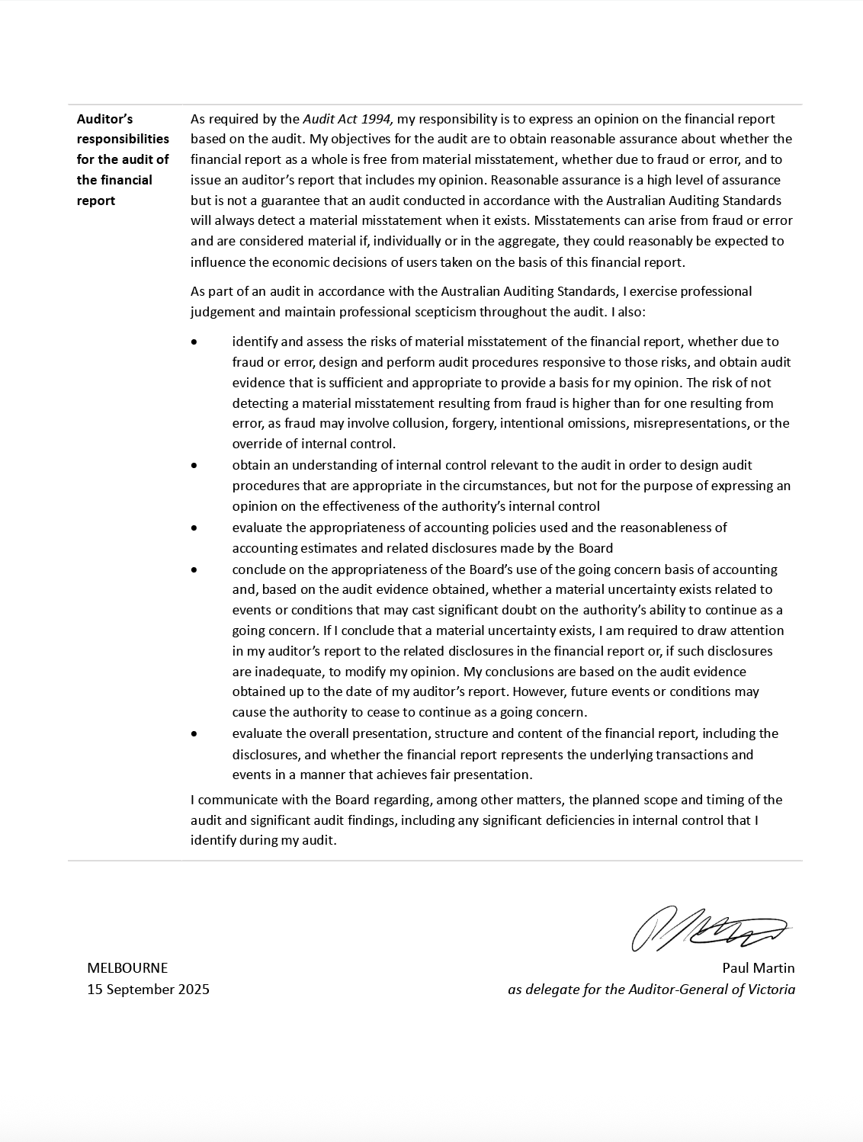

Comprehensive operating statement ^{(a)}

For the financial year ended 30 June 2025
 |  |  | ($ thousand)
 | Notes | June 2025 |  | June 2024
Continuing operations
Revenue and income from transactions
Levy income | 2.1 | 62,133 |  | 103,608
Other income | 2.2 | 5,564 |  | 4,949
Total revenue and income from transactions |  | 67,697 |  | 108,557
Expenses from transactions
Employee costs | 3.1 | (13,765) |  | (13,823)
Grant expenses | 3.2 | (59,187) |  | (87,618)
Other operating expenses | 3.3 | (11,397) |  | (12,671)
Depreciation and amortisation |  | (534) |  | (546)
Interest expense | 6.1.2 | (13) |  | (24)
Total expenses from transactions |  | (84,896) |  | (114,682)
Net result from transactions (Net operating balance) |  | (17,199) |  | (6,125)
Other economic flows included in net result
Total other economic flows included in net result |  | - |  | -
Comprehensive result |  | (17,199) |  | (6,125)
The accompanying notes form part of these financial statements.
Note:
- This format is aligned to AASB 1049 Whole of Government and General Government Sector Financial Reporting.

Balance sheet ^{(a)}

As at 30 June 2025
 |  | ($ thousand)
 | Notes | June 2025 | June 2024
Assets
Financial assets
Cash and deposits | 6.3 | 106,553 | 115,312
Receivables | 5.1 | 683 | 10,831
Total financial assets |  | 107,236 | 126,143
Non-financial assets
Property, plant and equipment | 4.1 | 364 | 378
Intangible assets |  | - | 4
Other non-financial assets | 5.3 | 397 | 478
Total non-financial assets |  | 761 | 860
Total assets |  | 107,997 | 127,003
Liabilities
Payables | 5.2 | 9,727 | 11,796
Borrowings | 6.1 | 339 | 343
Employee benefits provision | 3.1.2 | 2,115 | 1,849
Total liabilities |  | 12,181 | 13,988
Net assets |  | 95,816 | 113,015
Equity
Contributed capital |  | 83,610 | 83,610
Accumulated surplus/(deficit) |  | 12,206 | 29,405
Net worth |  | 95,816 | 113,015
The accompanying notes form part of these financial statements.
Note:
- This format is aligned to AASB 1049 Whole of Government and General Government Sector Financial Reporting.

Cash flow statement ^{(a)}

For the financial year ended 30 June 2025
 |  | ($ thousand)
 | Notes | June 2025 | June 2024
Cash flows from operating activities
Receipts
Receipts from customers |  | 71,760 | 105,338
Grants received from State Government |  | 39 | 38
Goods and services tax recovered from the ATO^{(b)} |  | 7,787 | 10,413
Interest received |  | 5,525 | 4,904
Total receipts |  | 85,111 | 120,693
Payments
Payments of grants |  | (67,735) | (95,957)
Payments to suppliers and employees |  | (25,590) | (26,963)
Payments of lease interest |  | (13) | (24)
Total payments |  | (93,338) | (122,944)
Net cash flows from/(used in) operating activities |  | (8,227) | (2,251)
Cash flows from investing activities  Payments for property, plant and equipment |  | (5) | (77)
Net cash flows from/(used in) investing activities |  | (5) | (77)
Cash flows from financing activities  Repayment of leases^{(c)} |  | (527) | (556)
Net cash flows from/(used in) financing activities |  | (527) | (556)
Net increase/(decrease) in cash and cash equivalents |  | (8,759) | (2,884)
Cash and cash equivalents at the beginning of the financial year |  | 115,312 | 118,196
Cash and cash equivalents at the end of the financial year | 6.3 | 106,553 | 115,312
The accompanying notes form part of these financial statements.
Notes:
- This format is aligned to AASB 1049 Whole of Government and General Government Sector Financial Reporting.
- GST paid to the Australian Taxation Office is presented on a net basis.
- CSV has recognised cash payments for the principal portion of lease payments as financing activities; cash payments for the interest portion as operating activities consistent with the presentation of interest payments and short-term lease payments for leases and low-value assets as operating activities.

Statement of changes in equity ^{(a)}

For the financial year ended 30 June 2025
 | ($ thousand)
 | Contributed capital | Accumulated surplus | Total
Balance at 30 June 2023 | 83,610 | 35,530 | 119,140
Net result for the year | - | (6,125) | (6,125)
Balance at 30 June 2024 | 83,610 | 29,405 | 113,015
Net result for the year | - | (17,199) | (17,199)
Balance at 30 June 2025 | 83,610 | 12,206 | 95,816
The accompanying notes form part of these financial statements.
Note:
- This format is aligned to AASB 1049 Whole of Government and General Government Sector Financial Reporting.

Note 1: About this report
CSV was established on 1 December 2020 as a statutory authority by the State of Victoria, under the Cladding Safety Victoria Act 2020 (Vic). CSV was established to deliver a program that is a world-first initiative, making Victorians safer by reducing the risk associated with combustible cladding on residential apartments and government-owned buildings.
Its principal address is:
Cladding Safety Victoria
Level 8
550 Bourke Street
Melbourne VIC 3000
A description of the nature of CSV’s operations and its principal activities is included in the Report of Operations, which does not form part of these financial statements.

Basis of preparation
These financial statements are Tier 2 general purpose financial statements prepared in accordance with AASB 1060 General Purpose Financial Statements – Simplified Disclosures for For-Profit and Not-for-Profit Tier 2 Entities (AASB 1060) and Financial Reporting Direction 101 Application of Tiers of Australian Accounting Standards (FRD 101).
CSV is a Tier 2 entity in accordance with FRD 101. These financial statements are the first general purpose financial statements prepared in accordance with Australian Accounting Standards – Simplified Disclosures. CSV’s prior year financial statements were general purpose financial statements prepared in accordance with Australian Accounting Standards (Tier 1). As CSV is not a ‘significant entity’ as defined in FRD 101, it was required to change from Tier 1 to Tier 2 reporting effective from 1 July 2024.
These financial statements are in Australian dollars and the historical cost convention is used unless a different measurement basis is specifically disclosed in the notes to the financial statements.
The accrual basis of accounting has been applied in the preparation of these financial statements whereby assets, liabilities, equity, income and expenses are recognised in the reporting period to which they relate, regardless of when cash is received or paid.
Consistent with the requirements of AASB 1004 Contributions, contributions by owners (that is, contributed capital and its repayment) are treated as equity transactions and, therefore, do not form part of the income and expenses of CSV.
Judgements, estimates and assumptions are required to be made about financial information being presented. The significant judgements made in the preparation of these financial statements are disclosed in the notes where amounts affected by those judgements are disclosed. Estimates and associated assumptions are based on professional judgements derived from historical experience and various other factors that are believed to be reasonable under the circumstances. Actual results may differ from these estimates.
Revisions to accounting estimates are recognised in the period in which the estimate is revised and also in future periods that are affected by the revision. Judgements and assumptions made by management in applying AAS that have significant effects on the financial statements and estimates are disclosed in the notes under the heading: ‘Significant judgement or estimates’.
These financial statements cover CSV as an individual reporting entity and include all the controlled activities of CSV. There is no entity consolidated into CSV.
These financial statements have been prepared on a non-going concern basis. This reflects management’s current expectation that CSV will not continue operations in the foreseeable future, due to the anticipated conclusion of its program activities.
While legislation to formally cease the entity has not been enacted, management has commenced wind-down planning in anticipation of a future legislative decision. Until such time, CSV remains a legal entity and continues to operate under the Cladding Safety Victoria Act 2020 (Vic).
Despite the expectation of closure, CSV has continued to apply the recognition and measurement requirements of Australian Accounting Standards in preparing these financial statements and amended the requirements to reflect the fact that the going concern assumption is not appropriate.
All amounts in the financial statements have been rounded to the nearest $1,000 unless otherwise stated. Figures in the financial statements may not equate due to rounding.

Compliance information
These general-purpose financial statements have been prepared in accordance with the Financial Management Act 1994 (Vic) (FMA) and applicable Australian Accounting Standards (AASs) which include Interpretations, issued by the Australian Accounting Standards Board (AASB).
Where appropriate, those AASs paragraphs applicable to not-for-profit entities have been applied. Accounting policies selected and applied in these financial statements ensure that the resulting financial information satisfies the concepts of relevance and reliability, thereby ensuring that the substance of the underlying transactions or other events is reported.

Note 2: Funding delivery of our services
CSV’s mission is to improve the safety of buildings impacted by cladding issues by working in partnership with industry, government partners and the community.
To enable CSV to fulfil its mission, it is funded predominantly through the distribution of the Cladding Rectification Levy (CRL) under the Building Act 1993 (Vic).
This section of the financial statements identifies the funding sources that enable CSV to achieve these objectives.

Structure
2.1. Levy income
2.2. Other income

2.1. Levy income
The CRL came into effect on 1 January 2020 and is calculated based on the rates and cost of building works for which a building permit number is sought. The CRL applies to Building Code of Australia classes 2 to 8 building works located in the metropolitan area that are $0.8 million or more. The CRL is brought to account upon issue of the building permit number and is recognised at a point in time. Building works on Commonwealth Crown Land retain the current exemption from any building permit levy, including the CRL. From 1 February 2025, CSV no longer receives the CRL.
 | ($ thousand)
 | June 2025 | June 2024
Cladding rectification levy | 62,133 | 103,608
Total levy income | 62,133 | 103,608

Income recognised under AASB 1058
AASB 1058 Income of not-for-profit entities clarifies the income recognition requirements that apply to not-for-profit entities. Under the AASB 1058 income recognition model, the entity first determines whether an enforceable agreement exists and whether the promises to transfer goods or services to the customer are “sufficiently specific”. This occurred where grants and contracts do not contain performance obligations that are sufficiently specific. As a result, income is recognised when CSV has an unconditional right to receive cash, in accordance with AASB 1058.
CSV has determined that the CRL is recognised as income of not-for-profit entities in accordance with AASB 1058, as there is no performance obligation that are sufficiently specific. CRL is recognised when the amounts become receivable.

2.2. Other income
 | ($ thousand)
 | June 2025 | June 2024
Interest income | 5,525 | 4,904
Grants | 39 | 38
Miscellaneous income | - | 7
Total other income | 5,564 | 4,949
Interest income includes interest received on bank deposits and Central Banking System deposits. Interest income is recognised using the effective interest method, which allocates the interest over the relevant period.

Note 3: The cost of delivering services
This section provides an account of the expenses incurred by CSV in delivering services. In Note 2, the funds that enable the provision of services were disclosed and in this note the costs associated with provision of services are disclosed.

Structure
3.1. Employee benefits expenses
3.2. Grant expenses
3.3. Other operating expenses

3.1. Employee benefits expenses

3.1.1. Employee expenses in the comprehensive operating statement
 | ($ thousand)
 | June 2025 | June 2024
Salaries and wages, annual leave, long service leave and on-costs | 12,493 | 12,560
Defined contribution superannuation expense | 1,229 | 1,180
Defined benefit superannuation expense | 17 | 17
Termination benefits | 26 | 66
Total employee benefits expense | 13,765 | 13,823
Employee expenses include all costs related to employment including wages and salaries, fringe benefits tax, leave entitlements, termination payments and WorkCover premiums.
The amount recognised in the comprehensive operating statement in relation to superannuation is employer contributions for members of both defined benefit and defined contribution superannuation plans that are paid or payable during the reporting period.
The defined benefit plan(s) provides benefits based on years of service and final average salary. The basis for determining the level of contributions is determined by the various actuaries of the defined benefit superannuation plans. CSV does not recognise any defined benefit liabilities because it has no legal or constructive obligation to pay future benefits relating to its employees. Instead, CSV accounts for contributions to these plans as if they were defined contribution plans under AASB 119 Employee Benefits. The Department of Treasury and Finance (DTF) discloses in its annual financial statements the net defined benefit cost related to the members of these plans as an administered liability (on behalf of the State as the sponsoring employer).
Termination benefits are payable when employment is terminated before normal retirement date, or when an employee accepts an offer of benefits in exchange for the termination of employment. Termination benefits are recognised when CSV is demonstrably committed to terminating the employment of current employees according to a detailed formal plan without possibility of withdrawal or providing termination benefits as a result of an offer made to encourage voluntary redundancy.

3.1.2. Employee-related provisions
Provision is made for benefits accruing to employees in respect of wages and salaries, annual leave and long service leave (LSL) for services rendered to the reporting date and recorded as an expense during the period the services are delivered.
 | ($ thousand)
 | June 2025 | June 2024
Current provisions
Annual leave | 1,004 | 837
Long service leave | 649 | 586
Provisions for on-costs | 345 | 279
Total current provisions | 1,998 | 1,702
Non-current provisions
Long service leave | 97 | 123
On-costs | 20 | 24
Total non-current provisions | 117 | 147
Total provisions for employee benefits | 2,115 | 1,849
Wages and salaries, annual leave and sick leave: Liabilities for wages and salaries (including non-monetary benefits, annual leave and on-costs) are recognised as part of the employee benefit provision as current liabilities, because CSV does not have an unconditional right to defer settlements of these liabilities.
The liability for salaries and wages are recognised in the balance sheet at remuneration rates which are current at the reporting date. As CSV expects the liabilities to be wholly settled within 12 months of the reporting date, they are measured at undiscounted amounts.
The annual leave liability is classified as a current liability and measured at the undiscounted amount expected to be paid, as CSV does not have an unconditional right to defer settlement of the liability for at least 12 months after the end of the reporting period.
No provision has been made for sick leave as all sick leave is non-vesting and it is not considered probable that the average sick leave taken in the future will be greater than the benefits accrued in the future. As sick leave is non-vesting, an expense is recognised in the Comprehensive Operating Statement as it is taken.
Employment on-costs such as payroll tax, workers compensation and superannuation are not employee benefits. They are disclosed separately as a component of the provision for employee benefits when the employment to which they relate has occurred.
Unconditional LSL is disclosed as a current liability; even where CSV does not expect to settle the liability within 12 months, it will not have the unconditional right to defer the settlement of the entitlement should an employee take leave within 12 months.
The components of this current LSL liability are measured at:
- undiscounted value – if CSV expects to wholly settle within 12 months
- present value – if CSV does not expect to wholly settle within 12 months.
Conditional LSL is disclosed as a non-current liability. There is a conditional right to defer the settlement of the entitlement until the employee has completed the requisite years of service. This non-current LSL is measured at present value.
Any gain or loss following revaluation of the present value of non-current LSL liability is recognised as a transaction, except to the extent that a gain or loss arises due to changes in bond interest rates for which it is then recognised as ‘other economic flow’ in the net result.

3.2. Grant expenses
 | ($ thousand)
 | June 2025 | June 2024
Payments for specific purposes to owners corporations | 59,187 | 87,618
Total grant expenses | 59,187 | 87,618
Grant expenses are contributions of CSV’s resources to another party for specific purposes where there is no expectation that the amount will be repaid in equal value (either by money, goods or services).
Grant expenses are paid for a particular purpose and have conditions attached regarding their use. CSV makes grant payments under funding agreements to rectify the highest risk privately owned buildings with combustible cladding.
Grant expenses are in the form of money and are recognised in the reporting period in which they are paid or payable.

3.3. Other operating expenses
 | ($ thousand)
 | June 2025 | June 2024
Consultants and professional services | 9,253 | 10,053
Computer services and equipment | 779 | 834
Insurance expense | 557 | 910
Administrative expenses | 515 | 687
Accommodation | 293 | 187
Total other operating expenses | 11,397 | 12,671
Other operating expenses generally represent the day-to-day running costs incurred in normal operations. Other operating expenses are recognised as an expense in the reporting period in which they are incurred.
Consultants and professional services relate to the expenses paid for operational services, specialist professional services, expert analysis and advice.
Insurance expense relate to the costs associated with insurance policies procured to safeguard against potential risks and liabilities.

Note 4: Key assets to support service delivery
CSV controls assets that are utilised in fulfilling its objectives and conducting its activities. They represent the resources that have been entrusted to CSV to be utilised for delivery of those services.

Structure
4.1. Property, plant and equipment
4.2. Depreciation and amortisation

4.1. Property, plant and equipment
 | ($ thousand)
 | Gross carrying amount |  | Accumulated depreciation |  | Net carrying amount
 | June 2025 | June 2024 | June 2025 | June 2024 | June 2025 | June 2024
Right-of-use buildings | 522 | 1,681 | (203) | (1,446) | 319 | 235
Plant, equipment and vehicles at fair value | 276 | 314 | (231) | (209) | 45 | 105
Leasehold improvements | - | 274 | - | (236) | - | 38
Net carrying amount | 798 | 2,269 | (434) | (1,891) | 364 | 378
Items of property, plant and equipment, including right-of-use (RoU) assets, are measured initially at cost and subsequently revalued at fair value less accumulated depreciation and impairment. Where an asset is acquired for no or nominal cost, the cost is its fair value at the date of acquisition.
The following tables are right-of-use assets included in the PPE balance.

4.1.1. Total right-of-use assets
 | ($ thousand)
 | Gross carrying amount |  | Accumulated depreciation |  | Net carrying amount
 | June 2025 | June 2024 | June 2025 | June 2024 | June 2025 | June 2024
Right-of-use buildings | 522 | 1,681 | (203) | (1,446) | 319 | 235
Net carrying amount | 522 | 1,681 | (203) | (1,446) | 319 | 235

 | ($ thousand)
 | Right-of-use buildings
Opening balance - 1 July 2024 | 235
Additions | 523
Depreciation expense | (439)
Closing balance - 30 June 2025 | 319

Right-of-use asset acquired by lessees – initial measurement
CSV recognises a right-of-use asset and a lease liability at the lease commencement date. The right-of-use asset is initially measured at cost which comprises the initial amount of the lease liability adjusted for:
- any lease payments made at or before the commencement date less any lease incentive received
- any initial direct costs incurred
- an estimate of costs to dismantle and remove the underlying asset or to restore the underlying asset or the site on which it is located.

Right-of-use asset - Subsequent measurement
CSV depreciates the right-of-use assets on a straight-line basis from the lease commencement date to the earlier of the end of the useful life of the right-of-use asset or the end of the lease term. The right-of-use assets are also subject to revaluation.
In addition, the right-of-use asset is periodically reduced by impairment losses, if any and adjusted for certain remeasurements of the lease liability.

Impairment of property, plant and equipment
The recoverable amount of primarily non-cash-generating assets of not-for-profit entities, which are typically specialised in nature and held for continuing use of their service capacity, is expected to be materially the same as fair value determined under AASB 13 Fair Value Measurement, with the consequence that AASB 136 does not apply to such assets that are regularly revalued.

4.1.2. Reconciliation of movements in carrying amount of property, plant and equipment
 | ($thousand)
 | Right-of-use buildings | Plant, equipment and vehicles at fair value | Leasehold improvements | Total
Opening balance - 1 July 2024 | 235 | 105 | 38 | 378
Additions | 523 | 5 | - | 528
Depreciation expense | (439) | (53) | (38) | (530)
Disposals | - | (12) | - | (12)
Closing balance – 30 June 2025 | 319 | 45 | - | 364

4.2. Depreciation and amortisation
All buildings, plant and equipment and other non-financial physical assets that have finite useful lives, are depreciated.
Depreciation is generally calculated on a straight-line basis, at rates that allocate the asset’s value, less any estimated residual value, over its estimated useful life. Typical estimated useful lives for the different asset classes for current and prior years are included in the table below:
 | (years)
Asset | Useful life
Right-of-use buildings | 1 to 5
Plant, equipment and vehicles at fair value | 3 to 10
Leasehold improvements | 1 to 5
The estimated useful lives, residual values and depreciation method are reviewed at the end of each annual reporting period, and adjustments made where appropriate.
Right-of-use assets are depreciated over the shorter of the asset’s useful life and the lease term. Where CSV obtains ownership of the underlying leased asset or if the cost of the right-of-use asset reflects that the entity will exercise a purchase option, the entity depreciates the right-of-use asset over its useful life.
Leasehold improvements are depreciated over the shorter of the lease term and their useful lives.

Note 5: Other assets and liabilities
This section sets out those assets and liabilities that arose from CSV’s controlled operations.

Structure
5.1. Receivables
5.2. Payables
5.3. Other non-financial assets

5.1. Receivables
 | ($ thousand)
Current receivables | June 2025 | June 2024
Contractual
Other sundry receivables | 1 | 4
Statutory
Cladding Rectification Levy receivables | - | 9,618
GST input tax credit recoverable | 682 | 1,209
Total current receivables | 683 | 10,831
Total receivables | 683 | 10,831
Receivables consist of:
- Contractual receivables are classified as financial instruments and categorised as financial assets at amortised costs. They are initially recognised at fair value plus any directly attributable transaction costs. CSV holds the contractual receivables with the objective to collect the contractual cash flows and therefore subsequently measured at amortised cost using the effective interest method less any impairment.
- Statutory receivables do not arise from contracts and are recognised and measured similarly to contractual receivables (except for impairment) but are not classified as financial instruments. The Cladding Rectification Levy is a component of the Building Permit Levy under the amendments to the Building Act 1993 (Vic) in the Building Amendment (Cladding Rectification) Act 2019 (Vic). CSV applies AASB 9 for initial measurement of the statutory receivables and, as a result, statutory receivables are initially recognised at fair value plus any directly attributable transaction cost.

Impairment of financial assets

Statutory receivables at amortised cost
The statutory receivables are considered to have low credit risk, taking into account the counterparty’s credit rating, risk of default and capacity to meet contractual cash flow obligations in the near term. As the result, the loss allowance recognised for these financial assets during the period was limited to 12 months of expected losses. No loss allowance has been recognised.

5.2. Payables
 | ($ thousand)
 | June 2025 | June 2024
Current payables
Contractual
Grants payables | 2,549 | 3,932
Supplies and services | 242 | 221
Accrued grants payables | 5,352 | 6,359
Accrued supplies and services | 1,475 | 1,224
Statutory
Other tax payables | 109 | 60
Total current payables | 9,727 | 11,796
Total payables | 9,727 | 11,796
Payables consist of:
- Contractual payables: Classified as financial instruments and measured at amortised cost. Accounts payable represent liabilities for goods and services provided to CSV prior to the end of the financial year that are unpaid.
- Statutory payables: Recognised and measured similarly to contractual payables, but are not classified as financial instruments and not included in the category of financial liabilities at amortised cost, because they do not arise from contracts.
Payables for supplies and services have an average credit period of 30 days, no interest is charged.
Payables for grants have an average credit period of 10 days, no interest is charged.

5.3. Other non-financial assets
 | ($ thousand)
 | June 2025 | June 2024
Current
Prepayments | 397 | 478
Total other non-financial assets | 397 | 478
Other non-financial assets include prepayments, which represent payments in advance of receipt of goods or services, or the payments made for services covering a term extending beyond the reporting period.

Note 6: How we financed our operations
This section provides information on the sources of finance utilised by CSV during its operations, along with interest expenses and other information related to financing activities of CSV.
This section includes disclosures of balances that are financial instruments (such as interest-bearing liabilities and cash balances).
Note 7.1 and Note 7.2 provide additional, specific financial instrument disclosures.

Structure
6.1. Borrowings
6.2. Leases
6.3. Cash flow information and balances
6.4. Commitments for expenditure

6.1. Borrowings
 | ($ thousand)
Current borrowings | June 2025 | June 2024
Lease liabilities^{(a)} | 339 | 343
Total current borrowings | 339 | 343
Total borrowings | 339 | 343
Note:
a) Secured by the assets leased. Leases liabilities are effectively secured as the rights to the leased assets revert to the lessor in the event of default.
Borrowings refer to interest bearing liabilities entirely made up of lease liabilities in CSV.
Borrowings are classified as financial instruments. Interest bearing liabilities are classified at amortised cost and recognised at the fair value of the consideration received less directly attributable transaction costs and subsequently measured at amortised cost using the effective interest method.

6.1.1. Terms and conditions of borrowings
 |  | ($ thousand)
 |  |  |  | Maturity dates
 | Weighted average interest rate (%) | Carrying amount | Nominal amount | Less than 1 month | 1–3 months | 3–12 months | 1–5 years | Over 5 years
June 2025
Lease liabilities | 3.89% | 339 | 345 | 28 | 55 | 262 | - | -
Total |  | 339 | 345 | 28 | 55 | 262 | - | -
June 2024
Lease liabilities | 4.00% | 343 | 346 | 49 | 99 | 198 | - | -
Total |  | 343 | 346 | 49 | 99 | 198 | - | -
CSV operates under the Government fair payments policy of settling financial obligations within 30 days and in the event of a dispute, making payments within 30 days from the date of resolution.

6.1.2. Interest expense
 | ($ thousand)
Current borrowings | June 2025 | June 2024
Interest on lease liabilities | 13 | 24
Total interest expense | 13 | 24
Interest expense represents costs incurred in connection with the interest component of lease repayments. Interest expense is recognised in the period in which it is incurred.
CSV recognises borrowing costs immediately as an expense, even where they are directly attributable to the acquisition, construction or production of a qualifying asset.

6.2. Leases
CSV leases a property, comprising of space for its head office. The lease contracts are typically made for fixed periods of 1–5 years with an option to renew the lease after that date. Lease payments for properties are renegotiated every 1–5 years to reflect market rentals.

6.2.1. Right-of-use assets
Right-of-use assets are presented in Note 4.1.1.

6.2.2. Recognition and measurement of leases as a lessee
For any new contracts entered into, CSV considers whether a contract is or contains a lease.
A lease is defined as ‘a contract, or part of a contract, that conveys the right to use an asset (the underlying asset) for a period of time in exchange for consideration’. To apply this definition CSV assesses whether the contract meets three key evaluations:
- whether the contract contains an identified asset, which is either explicitly identified in the contract or implicitly specified by being identified at the time the asset is made available to CSV and for which the supplier does not have substantive substitution rights
- whether CSV has the right to obtain substantially all of the economic benefits from use of the identified asset throughout the period of use, considering its rights within the defined scope of the contract and CSV has the right to direct the use of the identified asset throughout the period of use
- whether CSV has the right to take decisions in respect of ‘how and for what purpose’ the asset is used throughout the period of use.
Lease liability - Initial measurement: The lease liability is initially measured at the present value of the lease payments unpaid at the commencement date, discounted using the interest rate implicit in the lease if that rate is readily determinable; or CSV’s incremental borrowing rate.
Lease payments included in the measurement of the lease liability comprise the following:
- fixed payments (including in-substance fixed payments) less any lease incentive receivable
- variable payments based on an index or rate, initially measured using the index or rate as at the commencement date
- amounts expected to be payable under a residual value guarantee
- payments arising from purchase and termination options reasonably certain to be exercised.
Lease liability - subsequent measurement: Subsequent to initial measurement, the liability will be reduced for payments made and increased for interest. It is remeasured to reflect any reassessment or modification, or if there are changes in the substance of fixed payments. When the lease liability is remeasured, the corresponding adjustment is reflected in the right-of-use asset, or profit and loss if the right-of-use asset is already reduced to zero.

Presentation of right-of-use assets and lease liabilities
CSV presents right-of-use assets as ‘property, plant and equipment’ (refer to Note 4.1). Lease liabilities are presented as ‘borrowings’ in the balance sheet (refer to Note 6.1).

6.2.3. Future Lease Payments
 | ($ thousand)
 | Minimum future lease payments^{(a)}
 | June 2025 | June 2024
Not longer than 1 year | 345 | 346
Minimum future lease payments | 345 | 346
Less future finance charges | (6) | (3)
Present value of minimum lease payments | 339 | 343
Note:
a) Minimum future lease payments include the aggregate of all base payments and any guaranteed residual.

6.3. Cash flow information and balances
Cash and deposits, including cash equivalents, comprise cash on hand and cash at bank. CSV’s bank accounts are held in the Central Banking System (CBS) under the Standing Directions 2018. For cash flow statement presentation purposes, cash and cash equivalents include bank overdrafts, which are included as current borrowings on the balance sheet, as indicated in the reconciliation below.
 | ($ thousand)
 | June 2025 | June 2024
Total cash and deposits disclosed in balance sheet^{(a)} | 106,553 | 115,312
Balance as per cash flow statement | 106,553 | 115,312
Note:
a) Cash and deposits bear variable interest rate with a weighted-average interest rate of 4.47% during 2024–25 (2023–24: 4.37%)

6.4. Commitments for expenditure
Commitments for future expenditure include operating and capital commitments arising from contracts. These commitments are recorded below at their nominal value and inclusive of GST. Where it is considered appropriate and provides additional relevant information to users, the net present values of significant individual projects are stated. These future expenditures cease to be disclosed as commitments once the related liabilities are recognised in the balance sheet.
 | ($ thousand)
Nominal Amounts: as at 30 June 2025 | Less than 1 year | Between 1 and 5 years | Over 5 years | Total
Grants commitments | 36,363 | - | - | 36,363
Cladding Rectification Program commitments | 4,851 | - | - | 4,851
Total commitment (inclusive of GST) | 41,214 | - | - | 41,214
Less GST recoverable | (3,747) | - | - | (3,747)
Total commitment (exclusive of GST) | 37,467 | - | - | 37,467
Nominal Amounts: as at 30 June 2024
Grants commitments | 42,609 | - | - | 42,609
Cladding Rectification Program commitments | 8,102 | - | - | 8,102
Total commitment (inclusive of GST) | 50,711 | - | - | 50,711
Less GST recoverable | (4,610) | - | - | (4,610)
Total commitment (exclusive of GST) | 46,101 | - | - | 46,101
CSV has continued to fund projects for cladding rectification throughout financial year 2024-25.
Grant commitments include funding agreements executed for cladding rectification work.
Cladding Rectification Program commitments include contractors who work on the delivery of the Cladding Rectification Program including independent project managers, fire safety engineers, architects, and quantity surveyors, for which contracts have been executed.

Note 7: Financial instruments, contingencies and valuation judgements
It is often necessary for CSV to make judgements and estimates associated with recognition and measurement of items in the financial statements. This section sets out financial instrument specific information, as well as those items that are contingent in nature or require a higher level of judgement to be applied, which for CSV related mainly to fair value determination.

Structure
7.1. Financial instruments specific disclosures
7.2. Contingent assets and contingent liabilities
7.3. Fair value determination

7.1. Financial instruments specific disclosures
Financial instruments arise out of contractual agreements that give rise to a financial asset of one entity and a financial liability or equity instrument of another entity. Due to the nature of CSV’s activities, certain financial assets and financial liabilities arise under statute rather than a contract (for example taxes, fines and penalties). Such assets and liabilities do not meet the definition of financial instruments in AASB 132 Financial Instruments: Presentation.

Categories of financial assets

Financial assets at amortised cost
Financial assets are measured at amortised cost if both of the following criteria are met and the assets are not designated as fair value through net result:
- the assets are held by CSV to collect the contractual cash flows
- the assets’ contractual terms give rise to cash flows that are principal and interest payments.
These assets are initially recognised at fair value plus any directly attributable transaction costs and subsequently measured at amortised cost using the effective interest method less any impairment.
CSV recognises the following assets in this category:
- cash and deposits
- receivables (excluding statutory receivables).

Derecognition of financial assets
A financial asset (or, where applicable, a part of a financial asset or part of a group of similar financial assets) is derecognised when:
- the rights to receive cash flows from the asset have expired
- CSV retains the right to receive cash flows from the asset, but has assumed an obligation to pay them in full without material delay to a third party under a ‘pass through’ arrangement; or
- CSV has transferred its rights to receive cash flows from the asset and either:
  - has transferred substantially all the risks and rewards of the asset
  - has neither transferred nor retained substantially all the risks and rewards of the asset but has transferred control of the asset.
Where CSV has neither transferred nor retained substantially all the risks and rewards or transferred control, the asset is recognised to the extent of CSV’s continuing involvement in the asset.

Categories of financial liabilities
Financial liabilities at amortised cost
Financial liabilities measured at amortised cost are initially recognised on the date they are originated. They are initially recognised at fair value plus any directly attributable transaction costs. Subsequent to initial recognition, these financial instruments are measured at amortised cost with any difference between the initial recognised amount and the redemption value being recognised in profit and loss over the period of the interest-bearing liability, using the effective interest rate method.
Financial instrument liabilities measured at amortised cost include borrowings (including lease liabilities) and contractual payables.

Derecognition of financial liabilities
A financial liability is derecognised when the obligation under the liability is discharged, cancelled or expires. When an existing financial liability is replaced by another from the same lender on substantially different terms, or the terms of an existing liability are substantially modified, such an exchange or modification is treated as a derecognition of the original liability and the recognition of a new liability. The difference in the respective carrying amounts is recognised as an ‘other economic flow’ in the Comprehensive Operating Statement.

7.1.1. Financial instruments – Net gain/(loss) on financial instruments by category
 | ($ thousand)
 | Carrying amount | Net gain/(loss) | Total interest income/ (expense) | Fee income/ (expense)
June 2025
Financial assets
Cash and cash equivalents | 106,553 | - | 5,525 | -
Contractual receivables | 1 | - | - | -
Total financial assets | 106,554 | - | 5,525 | -
Financial liabilities
Payables | 9,727 | - | - | -
Borrowings | 339 | - | 13 | -
Total financial liabilities | 10,066 | - | 13 | -
June 2024
Financial assets
Cash and cash equivalents | 115,312 | - | 4,904 | -
Contractual receivables | 4 | - | - | -
Total financial assets | 115,316 | - | 4,904 | -
Financial liabilities
Payables | 11,736 | - | - | -
Borrowings | 343 | - | (24) | -
Total financial liabilities | 12,079 | - | (24) | -

7.2. Contingent assets and contingent liabilities
Contingent assets and contingent liabilities are not recognised in the balance sheet, but are disclosed by way of a note and, if quantifiable, are measured at nominal value. Contingent assets and liabilities are presented inclusive of GST receivable or payable respectively.

Contingent assets
Contingent assets are possible assets that arise from past events, whose existence will be confirmed only by the occurrence or non-occurrence of one or more uncertain future events not wholly within the control of the entity.
These are classified as either quantifiable, where the potential economic benefit is known, or non-quantifiable.
CSV does not have any contingent assets as at 30 June 2025.

Contingent liabilities
Contingent liabilities are:
- possible obligations that arise from past events, whose existence will be confirmed only by the occurrence or non-occurrence of one or more uncertain future events not wholly within the control of the entity
- present obligations that arise from past events but are not recognised because:
  - it is not probable that an outflow of resources embodying economic benefits will be required to settle the obligations; or
  - the amount of the obligations cannot be measured with sufficient reliability.
Contingent liabilities are also classified as either quantifiable or non-quantifiable.

Quantifiable contingent liabilities
For buildings that have yet to start construction, CSV has allocated a budget of $0.72 million, of which $0.13 million has been contractually committed. Out of the total budget allocation, $0.59 million has not been contractually committed. No present obligation exists for this uncommitted funding, until agreements are executed.

7.3. Fair value determination

Significant judgement: Fair value measurements of assets and liabilities
Fair value determination requires judgement and the use of assumptions. This section discloses the most significant assumptions used in determining fair values. Changes to assumptions could have a material impact on the results and financial position of CSV.
This section sets out information about how CSV determines fair value for financial reporting purposes. Fair value is the price that would be received to sell an asset or paid to transfer a liability in an orderly transaction between market participants at the measurement date.
Building, plant, equipment and vehicles are carried at fair value.

Fair value hierarchy
In determining fair values, a number of inputs are used. To increase consistency and comparability in the financial statements, these inputs are categorised into three levels, also known as the fair value hierarchy. The levels are as follows:
- Level 1 – quoted (unadjusted) market prices in active markets for identical assets or liabilities
- Level 2 – valuation techniques for which the lowest level input that is significant to the fair value measurement is directly or indirectly observable
- Level 3 – valuation techniques for which the lowest level input that is significant to the fair value measurement is unobservable.
CSV determines whether transfers have occurred between levels in the hierarchy by reassessing categorisation (based on the lowest level input that is significant to the fair value measurement as a whole) at the end of each reporting period.
The Valuer-General Victoria (VGV) is CSV’s independent valuation agency and CSV will engage them to monitor changes in the fair value of each asset and liability through relevant data sources to determine revaluations when it is required.

How this section is structured
For those assets and liabilities for which fair values are determined, the following disclosures are provided:
- valuation techniques
- details of significant assumptions used in the fair value determination.

7.3.1. Fair value determination: Non-financial physical assets

Valuation techniques and significant assumptions of non-financial physical assets measured at fair value
AASB 2022–10 Amendments to Australian Accounting Standards – Fair Value Measurement of Non-Financial Assets of Not-for-Profit Public Sector Entities amended AASB 13 Fair Value Measurement by adding Appendix F Australian implementation guidance for not-for-profit public sector entities. Appendix F explains and illustrates the application of the principles in AASB 13 on developing unobservable inputs and the application of the cost approach. These clarifications are mandatorily applicable annual reporting periods beginning on or after 1 January 2024. FRD 103 permits Victorian public sector entities to apply Appendix F of AASB 13 in their next scheduled formal asset revaluation or interim revaluation process (whichever is earlier). No revaluation was undertaken in 2024-25 as it was not a revaluation year.
For all assets measured at fair value, CSV considers the current use is the highest and best use.
Plant and equipment is held at fair value. When plant and equipment is specialised in use, such that it is rarely sold, fair value is determined using the current replacement cost method.
Vehicles are valued using the current replacement cost method. CSV acquires new vehicles and at times disposes of them before the end of their economic life. The process of acquisition, use and disposal in the market is managed by experienced fleet managers in CSV who set relevant depreciation rates during use to reflect the utilisation of the vehicles.
Buildings (including right-of-use assets) refer to Note 4.1.1.

Description of significant assumptions applied to fair value measurement
June 2025 and June 2024 | Valuation technique | Significant assumption | Range
Plant and equipment | Current replacement cost method | Cost per unit | $1,400-$17,000  ($2,700 per unit)
Plant and equipment | Current replacement cost method | Useful life of plant and equipment | 3-10 years
Vehicles | Current replacement cost method | Cost per unit | $26,000
Vehicles | Current replacement cost method | Useful life of vehicles | 3-5 years
Right-of use buildings | Current replacement cost method | Direct cost per square metre | $700-$900/m² ($800)
Right-of use buildings | Current replacement cost method | Useful life of buildings | 1-3 years

Note 8: Other disclosures
This section includes additional material disclosures required by accounting standards or otherwise, for the understanding of this financial report.

Structure
8.1. Responsible persons
8.2. Remuneration of executives
8.3. Related parties
8.4. Remuneration of auditors
8.5. Subsequent events

8.1. Responsible persons
In accordance with the Ministerial Directions issued by the Minister for Finance under the FMA, the following disclosures are made regarding responsible persons for the reporting period.
Ministers^{(a)}
Hon. Sonya Kilkenny MP, Minister for Planning  Hon. Harriet Shing MP, Minister for Housing and Building | 1/07/2024 – 30/06/2025  19/12/2024 – 30/06/2025
Governing Board
Rodney Fehring, Chair | 1/07/2024 – 30/06/2025
Sarah Clarke, Deputy Chair | 1/07/2024 – 30/06/2025
Genevieve Overell, Board Member | 1/07/2024 – 30/06/2025
Jo Pugsley, Board Member | 1/07/2024 – 30/06/2025
David Webster, Board Member | 1/07/2024 – 30/06/2025
Accountable Officer
Dan O’Brien, Chief Executive Officer | 1/07/2024 – 30/06/2025
Note:
a) On 27 March 2025, a Supplement to the General Order was amended to ensure that the administration of the Cladding Safety Victoria Act 2020 (Vic) will be ‘jointly and severally administered’ by both the Minister for Planning and the Minister for Housing and Building.

Remuneration of responsible persons
Remuneration received or receivable by the Accountable Officer in connection with the management of CSV during the reporting period was in the range of $560,000 – $569,999 (2024: $540,000 – $549,999).

8.2. Remuneration of executives
The number of senior executive service members, other than Ministers, governing board and accountable officers, and their total remuneration during the reporting period are shown in the table below. Total annualised employee equivalents provides a measure of full time equivalent executive officers over the reporting period.
Remuneration comprises employee benefits (as defined in AASB 119 Employee Benefits) in all forms of consideration paid, payable or provided by the entity, or on behalf of the entity, in exchange for services rendered. Accordingly, remuneration is determined on an accrual basis.

Remuneration of the senior executive service
(including Key Management Personnel disclosed in Note 8.3)
 | ($ thousand)
 | June 2025 | June 2024
Total remuneration ^{(a)} | 1,611 | 1,549
Total number of executives | 5 | 5
Total annualised employee equivalent (AEE) ^{(b)} | 5.0 | 5.0
Notes:
a) The total number of executive officers includes persons who meet the definition of Key Management Personnel (KMP) of the entity under AASB 124 Related Party Disclosures and are also reported within the related parties note disclosure (Note 8.3).
b) Annualised employee equivalent is based on the time fraction worked over the reporting period.

8.3. Related parties
CSV is a wholly owned and controlled entity of the State of Victoria.
Related parties of CSV include:
- all key management personnel and their close family members and personal business interests (controlled entities, joint ventures and entities they have significant influence over)
- the Minister and their close family members
- all departments and public sector entities that are controlled and consolidated into the whole of state consolidated financial statements.
All related party transactions have been entered into on an arm’s length basis.

Significant transactions with government-related entities
During the financial year, CSV had transactions with other government-controlled entities and these transactions were undertaken in the ordinary course of operations. Significant transactions are listed in the following table.
 | ($ thousand)
 | June 2025 | June 2024
Victorian Building Authority^{(a)} - receipt | 62,133 | 103,608
Department of Treasury and Finance^{(b)}- receipt | 5,525 | 4,904
State Revenue Office^{(c)} - payment | (828) | (857)
Total aggregate transactions | 66,830 | 107,655
Notes:
a) Cladding Rectification Levy income.
b) Interest on CBS bank account.
c) Payroll tax, mental health and wellbeing surcharge and COVID-19 debt temporary payroll tax surcharge.
Key management personnel (KMP) of CSV includes the Portfolio Ministers, the Hon. Sonya Kilkenny MP and the Hon. Harriet Shing MP, CSV Board, and members of the Senior Executive Team, which includes:
- Daniel O’Brien, Chief Executive Officer
- Ashley Hunt, Executive Director Program Delivery
- Nathan Matthews, Director, Cladding Rectification
- Luke Exell, Director, Legal and Procurement
- Jodee-Anne Cook, Chief Operating Officer
- John Kent, Director, Stakeholder Engagement
- Rose Scasni, Chief Financial Officer

Remuneration of key management personnel
The compensation detailed below excludes the salaries and benefits the Portfolio Minister receives. The Minister’s remuneration and allowances is set by the Parliamentary Salaries, Allowances and Superannuation Act 1968 (Vic) and is reported within the state’s Annual Financial Report.

Compensation of key management personnel
 | ($ thousand)
 | June 2025 | June 2024
Total compensation ^{(a)} | 2,584 | 2,476
Note:
a) Note that KMPs are also reported in the disclosure of remuneration of executive officers (Note 8.2)

Transactions and balance with key management personnel and other related parties
Given the breadth and depth of state government activities, related parties transact with the Victorian public sector in a manner consistent with other members of the public e.g. stamp duty and other government fees and charges. Further employment of processes within the Victorian public sector occurs on terms and conditions consistent with the Public Administration Act 2004 (Vic) and Codes of Conduct and Standards issued by the Victorian Public Sector Commission. Procurement processes occur on terms and conditions consistent with the Victorian Government Purchasing Board requirements.
Outside of normal citizen type transactions with the CSV, there were no related party transactions that involved key management personnel, their close family members and their personal business interests.
No provision has been required, nor any expense recognised, for impairment of receivables from related parties.

8.4. Remuneration of auditors
 | ($ thousand)
 | June 2025 | June 2024
Victorian Auditor-General’s Office
Audit of the financial statements | 44 | 43
Other non audit services^{(a)} | - | -
Total remuneration of auditors | 44 | 43
Note:
a.) The Victorian Auditor-General’s Office is prohibited from providing non-audit services.

8.5. Subsequent events
No matters or circumstances have arisen since the end of the financial year that significantly affected or may affect the operations of CSV, its operations or the state of affairs of CSV in future financial years.

Disclosures

Financial Management Compliance Attestation Statement
I, Rodney Fehring, on behalf of the Responsible Body, certify that Cladding Safety Victoria has no Material Compliance Deficiency with respect to the applicable Standing Directions under the Financial Management Act 1994 (Vic) and Instructions.
Rodney Fehring
Board Chair
Cladding Safety Victoria
12 September 2025

Local jobs first
The Local Jobs First Act 2003 (Vic) introduced in August 2018 brings together the Victorian Industry Participation Policy and Major Project Skills Guarantee (MPSG) policy, which were previously administered separately.
Departments and public sector bodies are required to apply the Local Jobs First policy in all projects valued at $3 million (exclusive of GST) or more in Metropolitan Melbourne or for state-wide projects, or $1 million (exclusive of GST) or more for projects in regional Victoria.
MPSG applies to all construction projects valued at $20 million (exclusive of GST) or more.

Projects commenced (standard)
During 2024–25, CSV funded the commencement of 3 Local Jobs First standard projects, which were for the rectification of residential buildings, totalling $11.59 million (exclusive of GST). Of those projects, all 3 were in metropolitan Melbourne, with an average commitment of 96.95 per cent of local content. The MPSG did not apply to any of these projects.

Projects completed (standard)
During 2024–25, 2 Local Jobs First standard projects funded by CSV for the rectification of residential buildings reached completion, totalling $6.98 million (exclusive of GST). Of those projects, all 2 were in metropolitan Melbourne, with an average commitment of 80 per cent of local content. MPSG did not apply to any these projects.
The outcomes expected from the implementation of the Local Jobs First policy to both commenced and completed projects where information was provided are as follows:
- An average of 96% per cent of local content commitment was made.
- A total of 115 positions were committed, including the creation of 29 new jobs and the retention of 86 existing jobs (AEE).
- A total of 24 positions for apprentices, trainees and cadets were committed – including the creation of 10 new apprenticeships, traineeships and cadets – and the retention of the remaining 14 existing apprenticeships, traineeships and cadets.
- 206 small-to-medium businesses were engaged through the supply chain on commenced standard projects.
- Of the projects that were completed in 2024–25, 7 reviews were submitted and 3 are yet to be submitted.

Projects commenced and completed (strategic)
Not relevant to CSV for 2024–25.

Reporting requirements – grants
Not relevant to CSV for 2024–25.

Social procurement framework
The Social Procurement Framework governs how the Victorian Government undertakes social procurement. The framework applies to the procurement of all goods, services and construction undertaken by, or on behalf of, entities subject to the Standing Directions 2018 under the Financial Management Act 1994 (Vic).
CSV leverages its buying power to deliver social, economic and environmental outcomes benefiting the Victorian community, the economy and the environment — above and beyond the goods, services and construction works procured.
CSV’s Social Procurement Strategy priorities the following social procurement objectives.
Social procurement objectives | Outcomes sought by CSV
Opportunities for Victorian Aboriginal people | - Purchasing from Victorian Aboriginal businesses  - Employment of Victorian Aboriginal people by suppliers to the Victorian Government
Opportunities for Victorians with disability | - Purchasing from Victorian social enterprises and Australian Disability Enterprises  - Employment of Victorians with disability by suppliers to the Victorian Government
Women’s equality and safety | - Gender-equitable employment practices, including leadership at senior levels and equal remuneration  - Support for female workers’ inclusion and safety in the construction sector  - Adoption of family violence leave by Victorian Government suppliers  - Gender equality within Victorian Government suppliers
Opportunities for Victorian priority jobseekers | - Purchasing from Victorian social enterprises  - Job readiness and employment for Victorian priority jobseekers by suppliers to the Victorian Government
Supporting safe and fair workplaces | - Purchasing from suppliers that comply with industrial relations laws and promote secure employment
Sustainable Victorian social enterprise and Aboriginal business sectors | - Purchasing from Victorian social enterprises and Aboriginal businesses
Sustainable Victorian regions | - Job readiness and employment for people in regions with entrenched disadvantage
Environmentally sustainable business practices | - Resource usage optimisation and sustainable waste management practices

Social procurement achievements
During 2024–25, CSV:
- engaged 2 social benefit suppliers with a total spend of $6,986 (exclusive of GST) with certified social enterprise
- established 8 contracts with external and Victorian Government suppliers that include social procurement commitments.

Emergency procurement
No emergency procurement arrangements were activated during 2024–25.

Disclosure of procurement complaints
CSV did not receive any formal complaints through its procurement complaints management system in 2024–25.

Disclosure of major contracts
CSV did not enter into any contracts greater than $10 million in value in 2024–25.

Consultancy expenditure

Details of consultancies (valued at $10,000 or greater)
In 2024–25, there were 3 contracts where the total fees payable to consultants were $10,000 or greater. The total expenditure incurred during 2024–25 in relation to these consultancies was $833,000 (excluding GST). Details of individual consultancies are outlined below. All amounts are exclusive of GST.
Consultant | Purpose of consultancy | Total approved project fee | Expenditure 2024–25 | ($ thousand)  Estimated future expenditure
Scyne Advisory | Internal audit services | 432 | 141 | 180
CSIRO | Risk modelling and measurement | 125 | 42 | 50
RMIT University | Research input into the PMCR | 1,212 | 650 | 200
Note:
CSV has partnered with RMIT University to undertake research, testing and analysis activities to verify PMCR methodologies and interventions

Details of consultancies less than $10,000
In 2024–25, no consultants were engaged by CSV for whom the total fees payable to individual firms was less than $10,000.

Government advertising expenditure
There is no government advertising expenditure to report for 2024–25.

Information and communication technology expenditure
For the 2024–25 reporting period, CSV had a total ICT expenditure of $0.89 million, with details outlined in the table below.
All operational ICT expenditure | ($ thousand)  ICT expenditure related to projects to create or enhance ICT capabilities
Business as Usual (BAU) ICT expenditure | Non-Business as Usual (non-BAU) ICT expenditure | Operational expenditure | Capital expenditure
(Total) | (Total = Operational expenditure and capital expenditure)
849 | 42 | 42 | nil
ICT expenditure refers to CSV’s costs in providing business enabling ICT services within the current reporting period. It comprises Business as Usual (BAU) ICT expenditure and non-Business as Usual (non-BAU) ICT expenditure. Non-BAU ICT expenditure relates to extending or enhancing CSV’s current ICT capabilities. BAU ICT expenditure is all remaining ICT expenditure that primarily relates to ongoing activities to operate and maintain current ICT capability.

Reviews and studies expenditure

Details of reviews and studies
During 2024–25, there were 3 reviews and studies undertaken with the total cost of $2.83 million.
Details of individual reviews and studies are outlined below. All amounts are exclusive of GST.
 |  |  |  |  | ($ thousand)
Name of the review | Reasons for review | Scope | Anticipated outcomes | Estimated cost 2024–25 | Final cost if completed | Public availability (Y/N) and URL
Material sample testing | To evaluate cladding fire spread under various scenarios | Determine how the products react, contribute to, and withstand fire exposure | More informed decision-making about the use of cladding products | 1,800 | N/A | Y  www.vic.gov.au/cladding-testing
Research services | To provide independent research input into the PMCR | Contribute to currency and completeness of evidence underpinning the PMCR | Effective and value-for-investment cladding risk reduction | 650 | N/A | N
ESM survey | To assess the status of ESMs across a cohort of CRP buildings | Understand the extent to which ESMs provide protection in the event of a fire | Information for owners and MBSs to support decision-making | 377 | N/A | N
Note: This table does not include reviews or studies that may be commercial-in-confidence or commercially sensitive, or where the release may be detrimental to government operations (e.g. by pre-empting the finalisation of policy decisions prior to their announcement by government).

Freedom of information
The Freedom of Information Act 1982 (Vic) (FOI Act) allows the public a right of access to documents held by CSV. The purpose of the FOI Act is to extend as far as possible the right of the community to access information held by government departments, local councils, Ministers and other bodies subject to the FOI Act.
An applicant has a right to apply for access to documents held by CSV. This comprises documents both created by CSV or supplied to CSV by an external organisation or individual, and may include maps, films, microfiche, photographs, computer printouts, computer discs, tape recordings and videotapes.
The FOI Act exempts the access to certain documents, which may be exempt in part or in full. Examples of documents that may be exempt from access include cabinet documents; some internal working documents; law enforcement documents; documents covered by legal professional privilege, such as legal advice; personal information about other people; and information provided in-confidence and information that is confidential under another Act.
Under the FOI Act, the processing time for requests received is 30 calendar days. However, when external consultation is required under ss29, 29A, 31, 31A, 33, 34 or 35, the processing time may be extended to 45 days. Processing time may also be extended by up to 30 days, by agreement with the applicant. With the applicant’s agreement this may occur any number of times. However, obtaining an applicant’s agreement for an extension cannot occur after the expiry of the timeframe for deciding a request.
If an applicant is not satisfied by a decision made by CSV, under section 49A of the FOI Act they have the right to seek a review by the Office of the Victorian Information Commissioner within 28 days of receiving a decision letter.

Making a request
Freedom of information requests can be made by filling out the form located on CSV’s website at www.vic.gov.au/freedom-information-and-cladding-safety-victoria and paying the application fee of $33.60. Access charges may also be payable if large amounts of documents are requested or the search for documents is time consuming.
A request for access to documents can also be by written request to CSV’s Freedom of Information team, as detailed in s17 of the FOI Act. When making a request, applicants should ensure requests are in writing, and clearly identify what types of documents are being sought.
Requests for documents held by CSV should be sent by email to foicsv@claddingsafety.vic.gov.au or posted to:
Freedom of Information Officer
Cladding Safety Victoria
PO Box 23392
Docklands VIC 8012

Freedom of information statistics
During 2024–25, CSV received 2 freedom of information requests. The requests were made by an apartment owner and a tenant. CSV also responded to another freedom of information request that was made in the 2023–24 reporting period.
Of the total decisions made, CSV granted access to 758 documents in full, 23 documents in part and denied access in full to 12 documents. Two decisions were made after mandatory extensions had been applied.

Further information
Further information regarding the operation and scope of freedom of information can be obtained from the FOI Act, regulations made under the FOI Act and www.ovic.vic.gov.au.

Compliance with the Building Act 1993 (Vic)
CSV does not own or control any government buildings and consequently is exempt from notifying its compliance with the building and maintenance provisions of the Building Act 1993 (Vic).

Compliance with the Public Interest Disclosures Act 2012 (Vic)
The Public Interest Disclosures Act 2012 (Vic) (PID Act) encourages and assists people in making disclosures of improper conduct by public officers and public bodies. The PID Act provides protection to people who make disclosures in accordance with the Act and establishes a system for the matters disclosed to be investigated and rectifying action to be taken.
CSV does not tolerate improper conduct by employees, nor the taking of reprisals against those who come forward to disclose such conduct. CSV is committed to ensuring transparency and accountability in its administrative and management practices and supports the making of disclosures that reveal corrupt conduct, conduct involving a substantial mismanagement of public resources, or conduct involving a substantial risk to public health and safety or the environment.
CSV will take all reasonable steps to protect people who make such disclosures from any detrimental action in reprisal for making the disclosure. It will also afford natural justice to the person who is the subject of the disclosure to the extent it is legally possible.

Reporting procedures
CSV is not an entity that can receive public interest disclosures. Disclosures of improper conduct or detrimental action by CSV or any of its employees may be made directly to the Independent Broad-based Anti-corruption Commission (IBAC):
Level 1, North Tower, 459 Collins Street
Melbourne VIC 3000
Phone: 1300 735 135
Internet: www.ibac.vic.gov.au

Compliance with the Carers Recognition Act 2012 (Vic)
CSV acknowledges that the Carers Recognition Act 2012 (Vic) establishes a guiding framework for the organisation. Accordingly, CSV offers a variety of flexible work arrangements and leave options to assist staff in balancing work responsibilities with personal and carer commitments. The organisation actively promotes flexibility in the workplace with the objective of reducing barriers to workforce participation for carers, empowering them to make informed decisions about their employment and care duties, and supporting their social, economic and personal wellbeing.
CSV is committed to continually developing policies, procedures, and work practices that are equitable, inclusive, and adaptable. Flexible work guidelines are designed to help all staff achieve a healthy work-life balance. Notably, CSV has observed a consistently high number of secondary caregiver parental leave requests from male employees, which have been supported by management. According to the 2025 People Matter Survey, 86% of CSV staff reported satisfaction with their work/life balance, compared to 78% within CSV’s comparator group.

Compliance with the Disability Act 2006 (Vic)
CSV is committed to provide an accessible and inclusive workplace so people with disability can fully participate in all aspects of employment. CSV also supports workplace adjustments to a work process/practice, job design, technology/equipment and work environment so that people with disability are able to have an equitable experience when they apply for a job, and they are equipped to do the inherent requirements of their job in an equitable, safe and productive way.
CSV also rolled out inclusive workplace training to all staff that covered key concepts of diversity, equity and inclusion, and provided examples of actions staff can take to support inclusion in the workplace.

Competitive Neutrality Policy
Competitive neutrality requires government businesses to ensure that where services compete, or potentially compete, with the private sector, any net advantage arising from government ownership is accounted for if it is not in the public interest. Government businesses are required to set a competitively neutral price, which accounts for any net advantage that comes from public ownership. Competitive neutrality policy supports fair competition between public and private businesses and provides government businesses with a tool to enhance decisions on resource allocation. This policy does not override other policy objectives of government and focuses on efficiency in the provision of service.
CSV complies with the National Competition Policy and with the requirements of the Competitive Neutrality Policy Victoria policy statement and any subsequent reforms. The Commissioner for Better Regulation is responsible for considering competitive neutrality complaints by individuals and businesses against government entities. No competitive neutrality complaints were lodged in 2024–25 relating to business activities operated by CSV.

Compliance with the DataVic Access Policy
The Victorian Government issued the DataVic Access Policy in 2012. Consistent with this policy, information included in this annual report will be available at www.data.vic.gov.au in electronic readable format. CSV was established as an independent entity in December 2020 and considers opportunities to publish other datasets as work progresses throughout its program.

Environmental reporting

Organisational boundary
CSV’s head office is located at Level 8, 550 Bourke Street, Melbourne. This premises was leased in December 2024. Prior to that, CSV was located at Level 4, 717 Bourke Street in Docklands.

Electricity production and consumption
CSV consumes energy predominantly through office facilities.
Total electricity consumption (MJ) | 2024–25 | 2023–24 | 2022–23
Purchased electricity – consolidated | 121,263 | 145,262 | 137,866.5
Not directly purchased but from outside the organisation | 0 | 0 | 0
Self-generated | 0 | 0 | 0

Total electricity offsets (MWh) | 2024–25 | 2023–24 | 2022–23
LGCs retired | 18.76 | 39.79 | 28.2
Greenpower or certified carbon neutral electricity purchased | 0 | 0 | 0

Transportation
CSV has a fleet of 3 hybrid vehicles, which are predominantly used for CSV building site visits.
Number and proportion of vehicles | 2024–25 |  | 2023–24 |  | 2022–23
Number and proportion of vehicles | No. | % | No. | % | No. | %
Passenger vehicles: Hybrid | 3 | 100 | 3 | 100 | 3 | 100

Sustainable buildings and infrastructure
No substantial office fit-outs were undertaken in 2024–25.

Additional information on request
In compliance with the requirements of the Standing Directions 2018 under the Financial Management Act 1994 (Vic), details in respect of the items listed below have been retained by CSV and are available on request, subject to the provisions of the Freedom of Information Act 1982 (Vic):
a) a statement that declarations of pecuniary interests have been duly completed by all relevant officers
b) details of shares held by senior officers as nominee or held beneficially in a statutory authority or subsidiary
c) details of publications produced by CSV about itself and how these can be obtained
d) details of any major external reviews carried out on CSV
e) details of major research and development activities undertaken by CSV
f) details of overseas visits undertaken, including a summary of the objectives and outcomes of each visit
g) details of major promotional, public relations and marketing activities undertaken by CSV to develop community awareness of CSV and its services
h) details of assessments and measures undertaken to improve the occupational health and safety of employees
i) a general statement on industrial relations within CSV and details of time lost through industrial accidents and disputes
j) a list of major committees sponsored by CSV, the purpose of each committee and the extent to which the purposes have been achieved
k) details of all consultancies and contractors, including:
− consultants/contractors engaged
− services provided
− expenditure committed to each engagement.
The information is available on request from the CSV telephone support line on 1300 456 542 or via email at support@claddingsafety.vic.gov.au.

Information that is not applicable to CSV
Details of changes in prices, fees, charges, rates and levies charged by CSV is not available because CSV does not charge for its services.

Disclosure index
CSV’s annual report is prepared in accordance with all relevant Victorian legislation and pronouncements. This index has been prepared to facilitate identification of CSV’s compliance with statutory disclosure requirements.
Click on a page reference number to refer to the relevant requirements for the corresponding disclosure requirements, or alternatively, refer to the corresponding page references.
Legislation | Requirement | Page reference
Standing Directions and Financial Reporting Directions
Report of Operations
Charter and purpose
FRD 22 | Manner of establishment and the relevant Ministers | page 9
FRD 22 | Purpose, functions, powers and duties | page 10–12
FRD 8 | Departmental objectives, indicators and outputs | page 10, 34
FRD 22 | Key initiatives and projects | page 16–34
FRD 22 | Nature and range of services provided | page 12–14
Management and structure
FRD 22 | Organisational structure | page 35
FRD 22 | Board committee membership | page 36–37
Financial and other information
FRD 8 | Performance against output performance measures | page 34
FRD 10 | Disclosure index | page 87–90
FRD 12 | Disclosure of major contracts | page 80
FRD 15 | Executive disclosures | page 73–75
FRD 22 | Employment and conduct principles | page 38
FRD 22 | Occupational health and safety policy | page 42–44
FRD 22 | Summary of the financial results for the year | page 14–16
FRD 22 | Significant changes in financial position during the year | page 15–16
FRD 22 | Major changes or factors affecting performance | page 15–16
FRD 22 | Subsequent events | page 16
FRD 22 | Application and operation of the Freedom of Information Act 1982 (Vic) | page 82–84
FRD 22 | Compliance with building and maintenance provisions of the Building Act 1993 (Vic) | page 84
FRD 22 | Statement on National Competition Policy | page 85
FRD 22 | Application and operation of the Public Interest Disclosures Act 2012 (Vic) | page 84
FRD 22 | Application and operation of the Carers Recognition Act 2012 (Vic) | page 85
FRD 22 | Details of consultancies more than $10,000 | page 80
FRD 22 | Details of consultancies less than $10,000 | page 81
FRD 22 | Disclosure of government advertising expenditure | page 81
FRD 22 | Disclosure of ICT expenditure | page 81
FRD 22 | Reviews and studies expenditure | page 81–82
FRD 22 | Statement of availability of other information | page 87
FRD 22 | Disclosure of emergency procurement | page 80
FRD 22 | Disclosure of social procurement activities under the Social Procurement Framework | page 78–80
FRD 22 | Disclosure of procurement complaints | page 80
FRD 24 | Reporting of environmental data | page 86
FRD 25 | Local jobs first | page 77–78
FRD 29 | Workforce data disclosures | page 38–42
SD 5.2 | Specific requirements under Standing Direction 5.2 | page 2, 77
Compliance attestation and declaration
SD 5.1.4 | Attestation for compliance with Ministerial Standing Direction | page 77
SD 5.2.3 | Declaration in report of operations | page 2
Financial Statements
Declaration
SD 5.2.2 | Declaration in financial statements | page 45–46
Other requirements under Standing Direction 5.2
SD 5.2.1(a) | Compliance with Australian accounting standards and other authoritative pronouncements | page 54
SD 5.2.1(a) | Compliance with Standing Directions | page 77
Other disclosures as required by FRDs in notes to financial statements ^{(a)}
FRD 21 | Disclosures of responsible persons, executive officers and other personnel (contractors with significant management responsibilities) in the financial report | page 73–74
FRD 103 | Non-financial physical assets | page 72–73
FRD 110 | Cash flow statements | page 51–52
FRD 112 | Defined benefit superannuation obligations | page 56
FRD 114 | Financial instruments – general government entities and public non-financial corporations | page 68–71
Note:
(a) References to FRDs have been removed from the Disclosure Index if the specific FRDs do not contain requirements that are in the nature of disclosure.
Legislation
Freedom of Information Act 1982 (Vic) |  | page 82–84
Building Act 1993 (Vic) |  | page 84
Public Interest Disclosures Act 2012 (Vic) |  | page 84
Carers Recognition Act 2012 (Vic) |  | page 85
Disability Act 2006 (Vic) |  | page 85
Local Jobs Act 2003 (Vic) |  | page 77–78
Financial Management Act 1994 (Vic) |  | page 2, 45 and 77

Acronyms and abbreviations
AAS | Australian Accounting Standards
AASB | Australian Accounting Standards Board
ACP | aluminium composite panels
ACP-FR | aluminium composite panels (fire retardant)
AEE | annualised employee equivalent
ATO | Australian Taxation Office
BAU | business as usual
BPC | Building and Plumbing Commission
CEO | Chief Executive Officer
CRL | Cladding Rectification Levy
CRP | Cladding Rectification Program
CRPP | Cladding Remediation Partnership Program
CSIRO | Commonwealth Scientific and Industrial Research Organisation
CSV | Cladding Safety Victoria
DTF | Department of Treasury and Finance
DTP | Department of Transport and Planning
EPS | expanded polystyrene
ESM | essential safety measures
FMA | Financial Management Act 1994 (Vic)
FOI | freedom of information
FRD | Financial Reporting Direction
FT | full-time
FTE | full-time equivalent
GST | Goods and Services Tax
HC | head count
IBAC | Independent Broad-based Anti-corruption Commission
ICT | information and communications technology
IDAHOBIT | International Day Against Homophobia, Biphobia and Transphobia
KMP | key management personnel
LGBTIQ+ | lesbian, gay, bisexual, transgender, intersex, queer+
LGC | large-scale generation certificate
LSL | long service leave
MBS | Municipal Building Surveyor
MCG | Melbourne Cricket Ground
MJ | megajoule
MPSG | Major Project Skills Guarantee
MWh | megawatt hour
OH&S | occupational health and safety
PCB | Project Control Board
PID | Public Interest Disclosures
PMCR | Protocols for Mitigating Cladding Risk
PT | part-time
RMIT | Royal Melbourne Institute of Technology
RoU | right-of-use
RWP | Remediation Work Proposal
SES | Senior Executive Service
STS | Senior Technical Specialist
VBA | Victorian Building Authority
VGV | Valuer-General Victoria
VPSC | Victorian Public Service Commission

Website
www.vic.gov.au/cladding-safety
Email
support@claddingsafety.vic.gov.au
Postal address
PO Box 23392, Docklands VIC 8012
Telephone
1300 456 542
For enquiries in languages other than English, contact the Translating and Interpreting Service on 131 450.
If you are deaf, or have a hearing or speech impairment, contact us through the National Relay Service.
For more information:
Voice Relay number 1300 555 727
TTY number 133 677
SMS relay number 0423 677 767

