Department of Transport and Planning

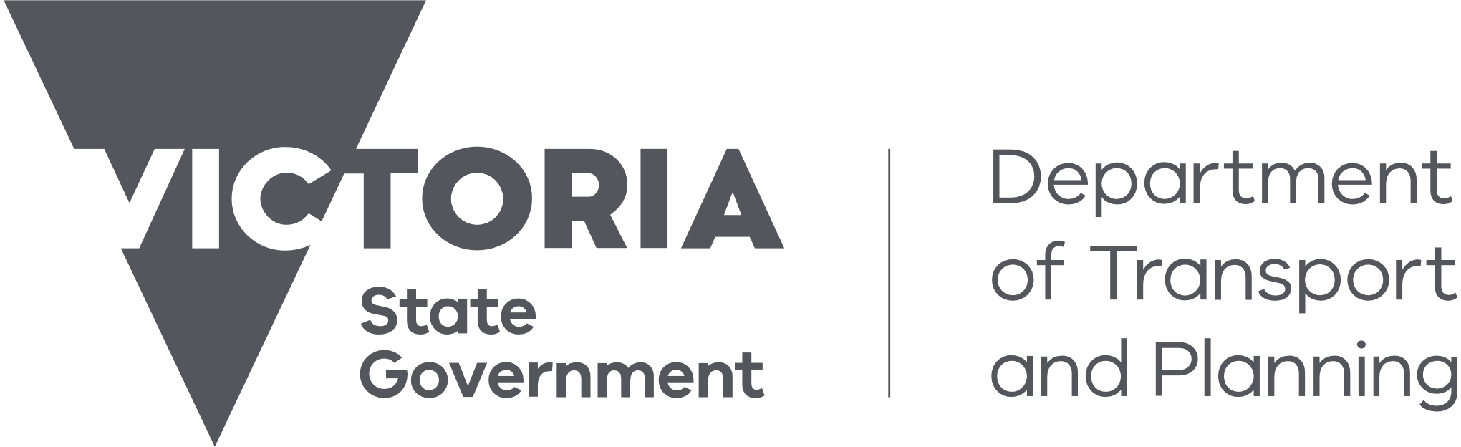
Accessibility Action Plan 2025-2029
Towards Equitable Journeys and Communities

Contents
Acknowledgement 3
Ministerial foreword 4
Secretary’s message 5
Message from the Chair, Accessible Transport Advisory Committee 6
Our language 7
Policy context for access and inclusion 7
Outcomes from the Accessible Public Transport in Victoria Action Plan 9
Transport Accessibility Strategic Framework 10
Introduction/about the plan 12
Who we spoke to 13
Action overview 14
Key Actions 15
Actions 17
Priority One: Assets 17
Priority Two: Journeys, Services and Systems 21
Priority Three: Organisation culture and public behaviour 26
Priority Four: Information and innovation 31
Chief Accessibility Advocate’s message 36
Implementing the action plan 37
Appendix 1 - Acronyms 39
Appendix 2 - Outcomes from the Accessible Public Transport in Victoria Action Plan 40
Priority One: Customer, community, and engagement 40
Priority Two: Access to public transport services 41
Priority Three: Accessible processes and systems 42
Priority Four: Access to facilities 43
Priority Five: Workplace accessibility 45

Acknowledgement
We proudly acknowledge the First Peoples of Victoria. We acknowledge their ongoing strength in practising the world’s oldest living culture. We acknowledge the Traditional Owners’ lands, waters, and skies on which we live and pay respects to their Elders past and present.
We recognise that there are long-lasting, far-reaching and intergenerational consequences of colonisation. Colonisation established Victoria with the intent of excluding First Peoples. This included their laws, cultures, customs and traditions. The development of Victorian laws, policies, systems and structures excluded First Peoples. This has resulted in entrenched systemic and structural racism. We acknowledge that the impact and structures of colonisation still exist today. We have a responsibility to transform our systems and services so that First Peoples can hold decision-making power over matters that affect their lives.
We acknowledge the distinct accessibility challenges experienced by First Peoples in Victoria.
As we integrate our transport and planning systems to create thriving places and connected communities, we acknowledge the use of songlines as an integral part of Aboriginal culture which allowed First Peoples to easily connect their journeys across the nation. We recognise the cultural significance of songlines as trade routes and ceremonial paths, and that some of the transport and planning networks and assets we use today are on those traditional songline routes.

Ministerial foreword
Improving accessibility benefits all Victorians. It makes it easier for people to take public transport when and where they choose, and access our planning, building and housing services and infrastructure.
The Victorian Government is committed to investing in accessible outcomes for our communities. We have delivered significant accessibility upgrades across the train, tram and bus networks that improve the safety and amenity for all.
However, we know that accessibility is not just about infrastructure, it extends to our systems, services, information and organisational culture. This includes ensuring our people and partners are disability confident, our websites and apps can be used by all, and our signage and wayfinding is intuitive.
This Action Plan reflects a range of initiatives to improve accessibility across all aspects of what we deliver. I would like to take this opportunity to highlight four key actions that will have a significant impact on accessibility – reviewing the scope of the Accessible Transport Advisory’s Committee’s (ATAC) advice, refreshing the Transport Accessibility Strategic Framework, addressing assistance animal handler refusals, and delivering more accessibility services through the Parkville Station pilot.
Early and ongoing engagement with all users is key to ensuring our investments meet the needs of all Victorians. The Victorian Government continues to amplify the voice of people with disability.
I would like to thank ATAC and the Chief Accessibility Advocate, Tricia Malowney OAM, for providing their ongoing expertise and advice to Government on how accessibility can be improved across our transport network.
I look forward to continuing to work with such strong advocates so that we can continue to deliver accessible outcomes.
This Plan’s vision and actions brings to life our commitment to advancing accessibility and improving the lives of all Victorians.
It will require collaboration by all working in the transport, planning, building and housing portfolios to deliver meaningful access to our infrastructure, systems, and services.
Gabrielle Williams
Minister for Transport Infrastructure
Minister for Public and Active Transport
Lead Minister, Department of Transport and Planning

Secretary’s message
Victoria is the fastest-growing state in Australia and is expected to reach a population of more than 10 million by 2050. Planning for this growth, while ensuring we retain our lifestyle, is a key reason that transport, planning, land, precinct, and policy functions have been united within our department.
The Department of Transport and Planning (DTP) is committed to creating an inclusive and accessible public transport and planning system for all Victorians.
Our built in, not bolted on approach builds accessibility into Victoria’s major infrastructure upgrade programs. This is done in close consultation with accessibility advocates, community groups, public transport operators, and government agencies. This approach ensures that the Government’s substantial investment in new and upgraded infrastructure makes it easier for all Victorians to get out and do the things they want to do, to travel to work, engage in social activities and go about their daily activities.
We have made significant progress to improve accessibility outcomes since the release of the former Department of Transport’s (DoT) Accessible Public Transport Action Plan 2020-2024. Here are a few key achievements, we have delivered throughout this four year period:
- 70 High Capacity Metro Trains that service the Pakenham/Cranbourne and Sunbury corridors, designed with accessibility groups, members of the public and technical stakeholders
- Accessibility improvements to 20 regional train stations, including at Warrnambool, Waurn Ponds and Traralgon stations
- 12 level access tram stops along LaTrobe Street, adding to those constructed in Parkville, and on St Kilda and Glen Huntly Roads
- 259 bus stop accessibility upgrades, and
- Upgrades to information provision to support whole of journey planning.
While not captured in the former DoT’s Accessible Public Transport Action Plan 2020-2024, our planning group collaborated with the building and construction industry, and disability advocates to transition to the new minimum accessible housing standards that came into effect through the National Construction Code.
This has set us up to continue improving accessibility across transport, planning, land, precinct, and policy functions through actions outlined in this Accessibility Action Plan 2025-2029: Thriving Places and Connected Communities.
Delivering this action plan requires ongoing coordination across DTP. Our aim is to build an accessibility culture across the transport and planning portfolio to integrate accessibility and respond proactively to the needs of people and communities.
I look forward to continuing our journey together with our people and partners to continue progressing accessibility outcomes in Victoria.
Jeroen Weimar, Secretary, DTP

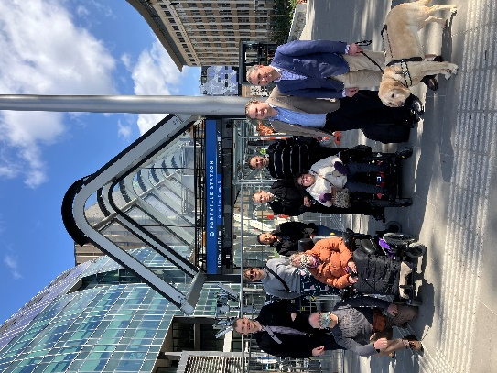
Message from the Chair, Accessible Transport Advisory Committee
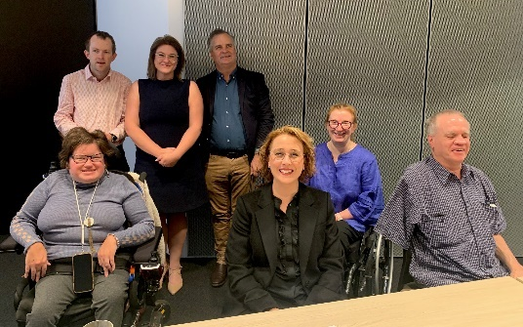

The Accessible Transport Advisory Committee (ATAC), previously known as the Public Transport Advisory Committee, was established in 2016 to provide independent advice to the Minister for Public and Active Transport and DTP on issues related to transport accessibility.
ATAC provides a direct, informed consumer and community voice for inclusive and accessible public transport, advocating for and advising on the needs of people with disability, the ageing population, and vulnerable groups.
Currently, ATAC is made up of myself as the Chair, and six individual members, Martin Stewart, Melissa Hale, Chris Edwards, Daniel Giles OAM, Julie Postma, and Karen Fankhauser. Former members of ATAC over the period of the previous action plan include Mark Tomkins, Sarah Barton, the late Kevin Murfitt AM, Mark Glascodine, Katherine Marshall, and Jeffrey McNeill.
Members reflect a diverse range of lived experiences of disability and have encountered various barriers across the transport network and built environment. Our experience enables us to provide advice on what helps us manage these barriers as we go about our day-to-day activities. Engaging people with disability early in projects, whether that be ATAC, disability organisations or members of the community with disability is key to delivering accessible outcomes that meet the needs of all people.
I am proud of the significant contributions ATAC has made across a breadth of public transport projects. We have collaborated with teams across DTP and consistently advocated to improve accessibility outcomes. We have participated in mock-up testing and provided advice on the Next Generation Tram, X’Trapolis 2.0 train, public transport ticketing project and the Metro Tunnel project. We have advocated and advanced accessibility outcomes through the tram refranchising process and at new station builds. ATAC completed a work reference on the impact of planned and unplanned public transport disruptions, focusing on accessibility for people with disability.
We have also commenced advising on transport components of broader planning and precincts work, such as Plan for Victoria, and have shared insights to Infrastructure Victoria’s 30-year Strategy refresh.
Leading into the development of this Action Plan, ATAC contributed to the Transport Accessibility Strategic Framework (the Framework). The vision, objectives and principles of the Framework sets out DTP’s approach to address accessibility gaps and improve transport experiences for all. While developed in a transport context, the Framework can be applied to all departmental work so that the biggest accessibility barriers are removed first. Importantly, as the Framework was co-designed with people with disability, we are confident that it reflects the perspectives and priorities of the whole disability community.
ATAC has worked with DTP to embed the voice of people with disability in this action plan and will play a key role in monitoring implementation. I look forward to continuing this work through ongoing and open dialogue so that the needs of all community members, including those with disability are reflected in the design and delivery of policies, services, conveyances and infrastructure.
Liz Ellis, Chair, ATAC

Our language
The Victorian Government has committed, through Inclusive Victoria: State Disability Plan 2022-26, to working with people with disability to understand community preferences and good practice in the language used to describe disability. Language continues to change and evolve over time and has different meaning for different people.
We recognise that people with disability have different preferences about how they describe their disability. People’s different preferences about how language is used reflects the variety of ways people perceive their identity, experience of disability, and views of the community.
In this Action Plan, we use person-first language to emphasise individuals beyond their disability, recognising diverse language preferences and committing to inclusive practices. This language puts the person before their disability, for example, ‘person with disability’. Person-first language emphasises a person’s right to an identity beyond their disability as a way of addressing ableism. This approach is an important part of reflecting many people’s identities, particularly those with cognitive disability and self-advocates.
While we have chosen to use person-first language in the Action Plan, we recognise that person-first language may not be the preferred language of the whole community and that many people with disability prefer to use ‘identity-first’ language. This approach puts a person’s disability identity before the person – for example, ‘disabled person.’ We recognise that identity-first language is important to many people with disability, including neurodiverse people and many in the Deaf community.
The Action Plan uses the United Nations Convention on the Rights of Persons with Disabilities definition of disability, which describes people with disability as people who have long-term physical, mental, intellectual, or sensory differences that, when interacting with inaccessible communities and environments, prevent full and equal community participation. This is often called the social model of disability. Under this approach, communities, services, and spaces that are not accessible or inclusive cause disability.
The Action Plan is inclusive of both visible and non-visible disabilities and acknowledges that non-visible disabilities may also impact a person’s full and equal community participation. Recognising both visible and non-visible disabilities in the Action Plan is essential for fostering inclusion, promoting accessibility, and ensuring equal rights and opportunities for all individuals.

Policy context for access and inclusion
This Action Plan is guided by State, Commonwealth and International laws and policies.
In Victoria, people with disability are protected against discrimination under the Equal Opportunity Act 2010 (Vic) and the Disability Discrimination Act 1992 (Cth) (DDA). These Acts set out that it is unlawful to discriminate on the basis of disability when providing goods and services and in relation to the access or use of public premises. Two sets of disability standards have been made under the DDA that are relevant to DTP:
- Disability Standards for Accessible Public Transport 2002 (DSAPT) – establishes minimum accessibility requirements that public transport operators and providers to make their services and infrastructure accessible.
- Disability (Access to Premises – Buildings) Standards 2010 (the Premises Standards) – specifies how public buildings must provide access for people with disability.
The Disability Act 2006 (Victoria) requires all public sector bodies to prepare a disability action plan and report on implementation through an annual report (s.38). The purpose of a disability action plan is to:
- Reduce barriers to persons with a disability accessing goods, services and facilities,
- Reduce barriers to persons with a disability obtaining and maintaining employment,
- Promote inclusion and participation in the community of persons with a disability, and
- Achieve tangible changes in attitudes and practices which discriminate against persons with a disability.
The DDA also provides for parties that are subject to the Act to prepare action plans. The DDA specifies that disability action plans should include programs, goals and targets, and evaluation mechanisms to achieve the objects of the Act (s.61).
Developing this Action Plan acquits DTP’s disability action plan obligations under both pieces of legislation and reflects a commitment to reducing and eliminating barriers for people with disability across the transport and planning portfolios. A copy of this Action Plan has been provided to the Australian Human Rights Commission.
Other relevant legislation that has been considered as part of this Action Plan includes the United Nations Convention on the Rights of Persons with Disabilities, the Charter of Human Rights and Responsibilities Act 2006 (Victoria), and the Transport Integration Act 2010 (Victoria).
The Action Plan supports Inclusive Victoria: State Disability Plan 2022-2026, the Victorian Government’s overarching framework to support all services and environments to improve the lives of Victorians with disability. It includes a commitment to work across government to embed universal design principles in all elements of the design and delivery of infrastructure. Actions developed by DTP sit within the following pillars of the State Disability Plan:
- Pillar One - Inclusive Communities: sets a range of outcomes to improve transport accessibility, and
- Pillar Two - Health, Housing and Wellbeing: considers affordable, stable and secure, and suitable housing.
DTP’s work also supports the six systemic reform commitments in the State Disability Plan, with many actions in this Plan supporting co-design with people with disability, and accessible communications and universal design.
The Action Plan is aligned with the strategic priorities and focus areas contained in DTP’s Strategic Plan 2024-2028, the internal facing Accessibility Action Plan 2020-2023 (separate to the Accessible Public Transport Action Plan 2020-2024), and other relevant DTP inclusion and diversity plans. These strategies outline DTP’s commitment to advancing an inclusive workplace culture where staff are safe, diverse, engaged, valued and high performing.
The Action Plan also sits alongside DTP’s commitment to self-determination and reform and to create a culturally safe and inclusive workplace for First Peoples staff, through the:
- Transport and Planning Portfolio First Peoples Self Determination and Reform Plan 2025 – 2029
- Yani Bangal Transport and Planning Portfolio First Peoples Careers Strategy 2023 - 2028
- Transport and Planning Portfolio First Peoples Cultural Safety Framework: DTP Action Plan 2024-2028
- Wurrek-al Transport and Planning Portfolio First Peoples Engagement Framework

Case Study: Next Generation PTV Mobile Application
The Next Generation PTV mobile application enables all Victorians to access their travel needs in one place easily.
The previous version of the PTV app lacked key accessibility functionality, particularly for people who are blind or have low vision when accessing information about public transport and journey planning.
The Next Generation PTV mobile app was re-designed to ensure it met the needs of people with disability. DTP worked with Vision Australia to test different components of the app so that it could be easily navigated by people who are blind or have low vision.
The app is completely accessible and provides an improved user experience. It is compatible with audible technology apps including VoiceOver and Talkback and has a large font option.
Navigation to the main menu is available on each page. Users can plan their journey and access route numbers through the journey plan summary and receive alerts relating to a specific stop or route. Other features include dynamic mapping, accessible alternate formats, and myki account integration.

Outcomes from the Accessible Public Transport in Victoria Action Plan
The former DoT’s Accessible Public Transport in Victoria Action Plan 2020 – 2024 set out opportunities to improve accessibility and the whole-of-journey experience across the public transport network. This report provides an update on the Action Plan by outlining progress on accessibility across the four-year period.
This did not include information related to actions from the planning portfolio, which joined the new Department of Transport and Planning on 1 January 2023.
Details on outcomes from the 2020-2024 Action Plan can be found at Appendix 2 of this document.

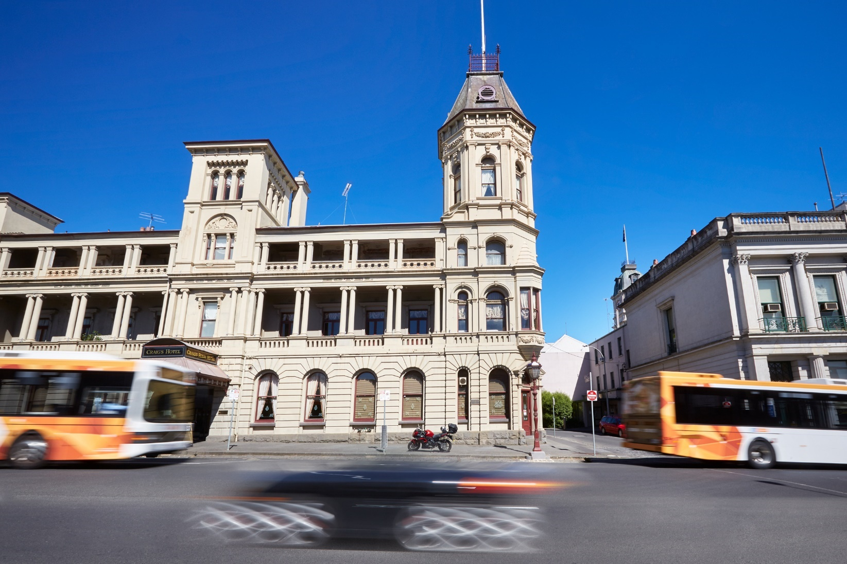

Transport Accessibility Strategic Framework
The Transport Accessibility Strategic Framework (Strategic Framework) has been used as a guide to shape this Action Plan. It identifies the approach DTP will take to address accessibility gaps and improve the end to end user experience for all by:
- Setting out a prioritisation framework to help identify and focus efforts on the biggest challenges to accessibility
- Providing an input to planning and investment decisions
- Helping inform Government on how to achieve better value for money, cost efficiencies and reduce community disruption, and
- Taking a whole-of-system view, centred on outcomes and drawing on innovative thinking.
Whilst it was developed in a transport context, it can be applied across all of DTP’s work, and is relevant to the planning, housing, building and land delivery systems.
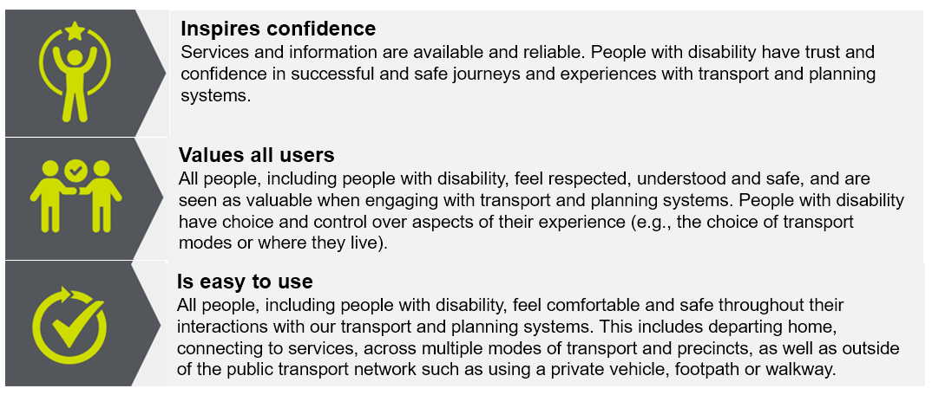
Image One: Objectives of an accessible transport and planning system

To support achieving these objectives, the Strategic Framework identified a series of strategic directions that outline key approaches that can be taken to improve accessibility. These are grouped into four categories and support how actions are structured in this document. These categories are:
- Assets: With our infrastructure and rolling stock, we aim to:
  - Ensure priorities for the most critical and beneficial improvements are considered as funding becomes available.
  - Make it easier for DTP, transport and planning agencies and local governments to embed and achieve accessibility outcomes.
  - Avoid the need for costly rethinking of approaches by considering accessibility at all stages of decision making rather than as an afterthought.
- Journeys, Systems and Services: Expanded to include systems and services, we can enhance accessibility and flexibility by integrating services, exploring diverse delivery models and improving infrastructure and support provisions to:
  - Explore opportunities to bridge the gaps between the limited options currently available so it is easier for a wider range of people to use transport and access our planning, housing, building and land delivery systems and services.
  - Better align available services through information coordination, tools and contractual arrangements.
  - Help provide greater flexibility for people to take journeys and access systems and services when and where they wish.
- Organisation culture and public behaviour: a good experience relies on more than accessible infrastructure, rolling stock, systems and services, it also relies on positive interactions along the way, including:
  - Staff training for frontline and other staff, drawing on lived experiences of disability.
  - Employing people with disability and diverse backgrounds.
  - Sharing stories and images or running campaigns that demonstrate equitable access for people with disability accessing transport and planning services.
- Information and innovation: Having accessible and reliable information is one of the most important requirements for inclusive transport and planning, we aim to:
  - Fill data gaps so that data is consistent and can be made into useful information for users and decision-makers.
  - Make information available so that people with disability can plan their journeys more easily and use our planning, housing, building and land delivery systems and services both when the system is operating normally and when it is disrupted.
  - Data, information and announcements should be readily available and provided in accessible formats including online digital and other forms to meet all users’ needs.
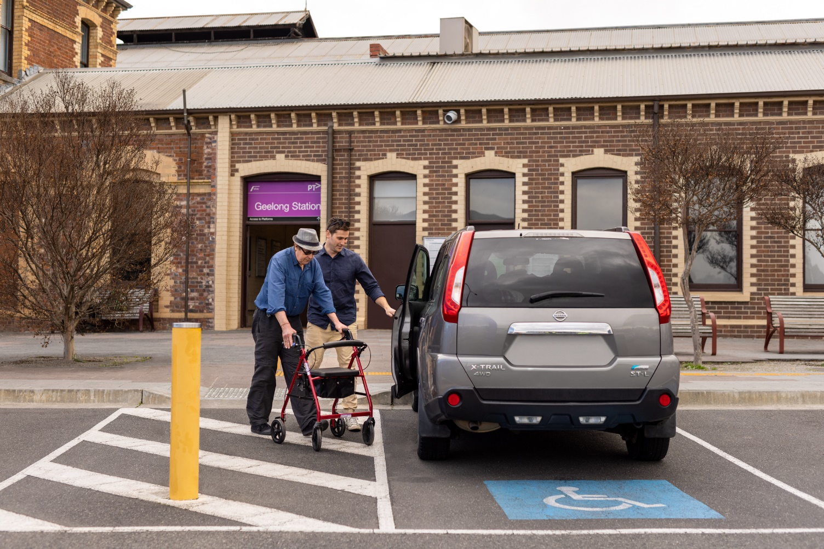

Introduction/about the plan
DTP brings together key transport, planning, land, precinct, and policy functions to create thriving places and connected communities for all Victorians. Together with our portfolio agencies, we are responsible for planning, building, operating, and maintaining Victoria’s transport, planning and land services for use by all.
While Victoria recognises the rights of all people to access all forms of transport, planning and land services and has invested heavily in new and upgraded rolling stock, infrastructure, systems and services, accessibility gaps remain. Key barriers include the age of legacy rolling stock, infrastructure and systems, the size of the network, and the high cost and complexity of upgrades or replacements.
Ensuring there is a consistent and coordinated approach when considering and prioritising accessibility improvements when undertaking transport, service and infrastructure planning is critical. By using the Strategic Framework to inform this Action Plan, DTP demonstrates a commitment to considering accessibility from the start, when planning, designing and delivering assets, services and policies.
The Action Plan identifies opportunities to improve accessibility so that people with accessibility needs are confident, respected and understood, and that our systems and infrastructure are comfortable, easy to use, and designed for everyone. User safety is also essential for a positive experience with our transport and planning systems. These priorities were identified in consultation with people with disability (see ‘who we spoke to’ section) as part of the development of the Strategic Framework.
By improving accessibility across our assets, journeys, systems and services, organisation culture and public behaviour, and information and innovation, we will acquit our action plan obligations under disability legislation. The table below links these priorities to the requirements in section 38 of the Disability Act 2006 (Victoria).
Table One: Action Plan priorities and disability legislative requirements
Priority | Legislative Requirements
Assets | - Reducing barriers to persons with a disability accessing goods, services and facilities, and  - Promoting inclusion and participation in the community of persons with a disability
Journeys, Systems and Services | - Reducing barriers to persons with a disability accessing goods, services and facilities, and  - Reducing barriers to persons with a disability obtaining and maintaining employment
Organisation culture and public behaviour | - Reducing barriers to persons with a disability obtaining and maintaining employment, and  - Achieving tangible changes in attitudes and practices which discriminate against persons with a disability
Information and Innovation | - Reducing barriers to persons with a disability accessing goods, services and facilities
The Action Plan takes a systems approach to accessibility. We recognise that people with disability who are women, Aboriginal and/or Torres Strait Islander Australians, Lesbian, Gay, Bisexual, Trans, Intersex, Queer, and Asexual + people, and/or from culturally and linguistically diverse backgrounds face additional barriers due to the intersection of multiple marginalisations. We also acknowledge that people with non-visible disability often experience additional barriers.
Experiences of people interacting with the transport and planning spheres differs between regional Victoria and metropolitan Melbourne. We understand the differences and impacts on regional areas and aim to further increase accessibility to benefit the whole community.
We have considered how initiatives captured in this Action Plan can reflect an intersectional approach to improving accessibility.

Who we spoke to
We developed the Action Plan by engaging extensively with a wide range of stakeholders both within and external to DTP.
We leveraged the priorities of people with disability captured through the Strategic Framework co-design process to shape initial discussions on where to target our efforts. This included extensive engagement with:
- People with disability, including people with low vision or blindness, people who are deaf or hard of hearing, people with reduced mobility, people with cognitive disability, people with complex communication needs, people with non-visible disabilities
- People with disability who have intersectional experiences, such as First Peoples, and/or people who are culturally and racially marginalised
- Members of various disability advisory committees
- Carers, and
- Older Victorians.
DTP’s Chief Accessibility Advocate and ATAC were involved in each stage of developing this Action Plan. They reviewed and provided feedback on draft actions, identified areas of uplift, and ensured that consultation with people with disability is embedded across the breadth of work represented in actions. Their work was critical to finalise this Action Plan and will form an important part of implementing and evaluating its success.
We met with our major public transport operators, including V/Line, Metro Trains Melbourne, Yarra Trams and Kinetic, as well as transport and planning partners, Travellers Aid, the Public Transport Ombudsman, Safe Transport Victoria, Municipal Association of Victoria and major infrastructure delivery authorities.
Through the major public transport operators, we also briefed their accessibility reference groups ahead of the Plan’s public release. This engagement has ensured that the Action Plan complements existing and emerging work on accessibility by DTP partners, including the following major public transport operator action plans:
- V/Line Accessibility Action Plan 2025-2028
- Metro Trains Melbourne Accessibility Action Plan 2025-27
- Yarra Trams Accessibility Action Plan 2024-2027
- Kinetic Accessibility Action Plan 2024-2026
We will continue to work with people with disability, our Chief Accessibility Advocate, ATAC, public transport operator accessibility reference groups and external accessibility stakeholders to implement actions in this Plan.


Action overview
This Action Plan contains 60 actions for DTP to ensure that we deliver accessible and safe integrated transport, planning, housing, building and land use outcomes. Each action is tied to a delivery timeframe, where:
- Year 1 reflects delivery to the middle of 2026,
- Year 2 to the middle of 2027,
- Year 3 to the middle of 2028,
- Year 4 to the middle of 2029 (end of this Action Plan), and
- Ongoing, which includes work that is delivered throughout the life of this Action Plan. For example, it may be a program that is run multiple times per year, or a plan for infrastructure works that is updated throughout this Plan.
We also intend to undertake a mid-way refresh of this Action Plan in late 2027, which will be informed by the new State Disability Plan that is due to commence in 2027.

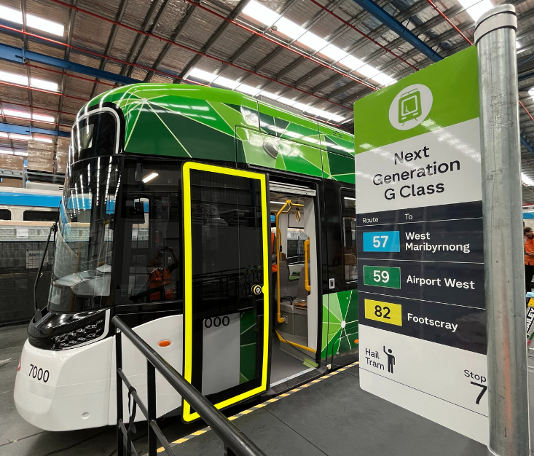

Key Actions
Four key actions have been highlighted below as focus areas for DTP to deliver in this Action Plan.


A. Scope of Accessible Transport Advisory Committee advice
The Accessible Transport Advisory Committee (ATAC) provides independent advice across transport policy and projects to create a more inclusive and accessible transport system in Victoria.

It is critical that what DTP delivers to the public is accessible and informed by the lived experience of people with disability to meet community expectations.

With the integration of transport and planning portfolios within DTP, there is an opportunity to consider whether ATAC could advise on planning, housing, building, precinct and land use issues, in addition to early and ongoing engagement with public transport matters.

Outcome: The Accessible Transport and Advisory Committee is sought out by project teams to provide expertise throughout the project lifecycle.
Measure: Earlier and increased consultation with people with disability.
Timeframe: Year 1, Ongoing.

Action: Support the Accessible Transport Advisory Committee to amplify the lived experience of people with disability by:
- Facilitating early engagement across a range of projects,
- Supporting identification of systemic issues, and
- Exploring opportunities to advise whole of departmental strategies and initiatives.


B. Transport Accessibility Strategic Framework review
Action: Explore options to refresh the Strategic Framework to consider how we approach accessibility for our planning, housing and building systems.
The Transport Accessibility Strategic Framework sets DTP’s approach to address accessibility gaps and improve the end to end user experience for all.
Ensuring there is a consistent and coordinated approach when considering and prioritising accessibility improvements when undertaking transport, service and infrastructure planning is critical.
The Strategic Framework was developed in the transport context. A consistent and coordinated approach to accessibility across transport, planning, housing, and building contexts will deliver more accessible outcomes for all Victorians.
Outcome: Consistent and coordinated approach to accessibility across our transport, planning, housing and building systems.
Measure: Strategic Framework updated to consider all DTP work.
Timeframe: Year 2.


C. Addressing assistance animal handler refusals
Assistance animals provide critical support to people with disabilities or health conditions. Victoria’s Transport Conduct Regulations permit guide dogs, hearing dogs and other assistance animals to travel on all public transport services. The Disability Discrimination Act 1992 (Cth) also makes it unlawful to discriminate against a person who needs the use of an assistance animal.
Complaint data collected by DTP reflects ongoing issues with assistance animal handlers being refused access to public transport services and commercial passenger vehicles. Refusals have persisted despite previous targeted interventions, suggesting that a suite of collaborative initiatives may be needed.

Outcome: Decrease in refusals of assistance animal handlers.
Measure: Number of refusals reported across different modes. Number of complaints made to bodies who accept complaints.
Timeframe: Year 3.

Action: Collaborate with relevant stakeholders and all industry partners to assess a range of legislative and policy options to reduce refusals of assistance animal handlers.


D. Accessibility service delivery and Parkville Station pilot
DTP supports Travellers Aid Australia to deliver a range of accessibility related services at Flinders Street and Southern Cross Stations, including mobility support, personal guidance, buggy services, toileting and showering facilities. These services are used frequently by a range of travellers with different support needs.
With the five Metro Tunnel Stations opening, there are additional locations where passengers are likely to require extra support to complete their journey. Parkville station is located in a unique precinct, with several state significant medical and educational facilities.

Outcome: Passengers provided with accessibility services in Parkville precinct.
Measure: Pilot program delivered.
Timeframe: Year 1.

Action: Deliver accessibility services for passengers travelling in the Parkville precinct through a pilot program with Travellers Aid Australia.

Actions

Priority One: Assets
With our infrastructure and rolling stock, we aim to:
- Ensure priorities for the most critical and beneficial improvements are considered as funding becomes available.
- Make it easier for DTP staff, transport and planning agencies and local governments to embed and achieve accessibility outcomes.
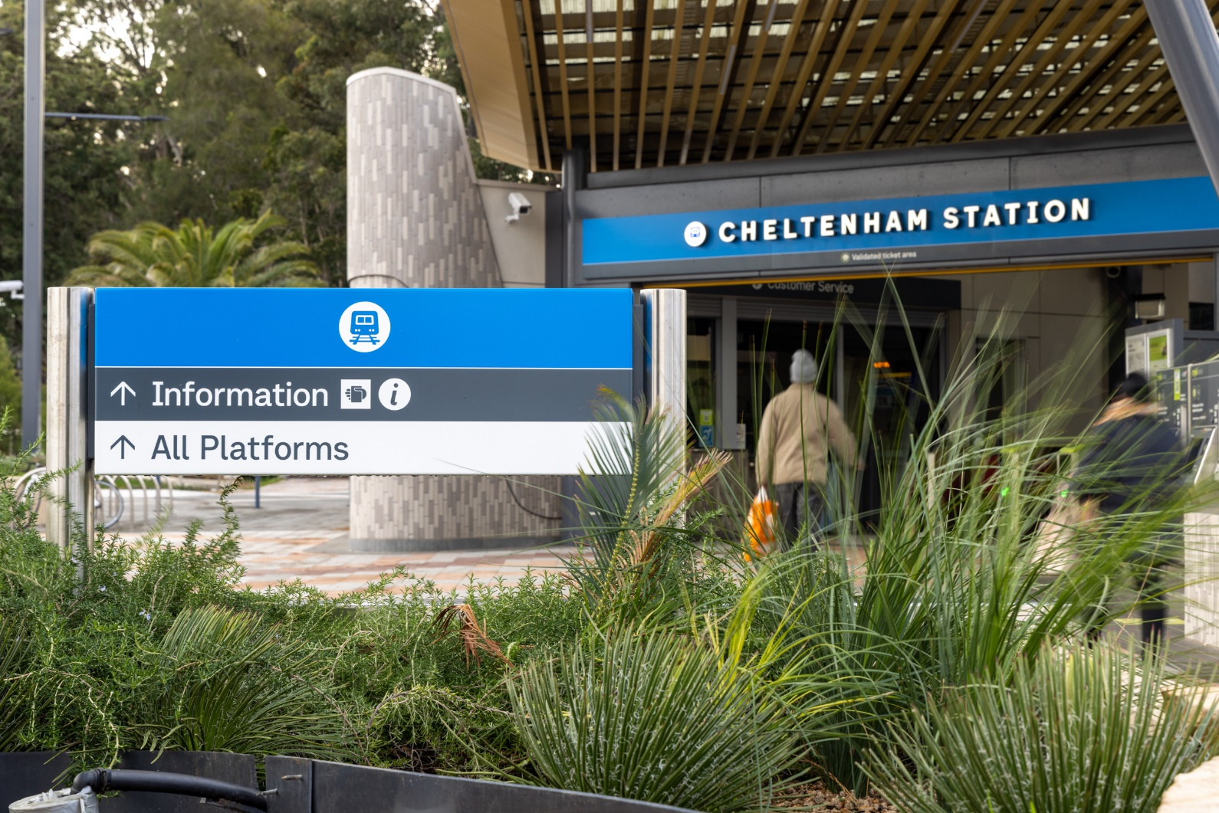
- Avoid the need for costly rethinking of approaches by considering accessibility at all stages of decision making rather than as an afterthought.

Action | Outcome/s | Measure | Timeframe
- Deliver Hearing Loops as a standard feature on all G Class trams. | Improved access to audible announcements and information updates for people who use hearing aids. | Improved travel confidence for people who are deaf or hard of hearing, and people who use hearing aids. | Year 1
- Progressively replace high floor trams with new low floor trams across the network. | Increased access to low floor trams on the network on priority routes. | Number of low floor trams operating on the network. | Year 4,  Ongoing
- Identify opportunities for level access tram stop and safety upgrades. | Improved accessibility and safety at tram stops. | An updated pipeline of prioritised level access tram stop and safety upgrades to inform future funding decisions. | Ongoing
- Identify opportunities for accessibility and safety upgrades at train stations. | Improved accessibility and safety at train stations. | Number of train stations upgraded with improved accessibility and increased safety. | Ongoing
- Deliver accessibility upgrades in partnership with Metro Trains Melbourne and V/Line. | Improved accessibility and safety at train stations. | Number of train stations upgraded to improve accessibility and safety. | Ongoing
- Leverage tender documents and contracts to deliver accessible bus stop infrastructure. | More accessible bus stops.  Bus stop design responds to legislative and policy change. | Accessibility requirements included in contracts to deliver bus stops. | Ongoing
- When designing and building new bus stops and shelters, validate the accessibility and manage site limitations before accepting the stop or shelter for ongoing maintenance. | More accessible bus stops and shelters.  Reduction in modification works post bus stop and shelter build. | Decisions about stop and shelter designs and limitations are recorded and accepted when built. | Ongoing
- Develop guidance for disability access to heritage listed railway stations and other transport infrastructure using best practice examples. | New works and approvals for transport infrastructure provide improved disability access and positive heritage outcomes. | Guidance for disability access to heritage listed railway stations and other transport infrastructure developed. | Year 4
- Engage expert accessibility advice early in the project design and development phases to ensure improved accessibility outcomes for the Sunshine and Albion stations. | Improved understanding of the accessibility challenges for Sunshine and Albion stations. | Accessibility outcomes form components of project scope.  Accessibility outcomes not built out or excluded from future complementary projects. | Ongoing
- Consider accessibility in the design of public realm spaces in the Arden precinct and include accessibility in the performance requirements for the request for proposal process for Activating Arden Central. | Planning for accessibility supports all members of the public benefiting from the use of government-owned land in the Arden precinct. | Public realm spaces in the Arden precinct are accessible. | Year 4

Case study: The new X’Trapolis 2.0 trains
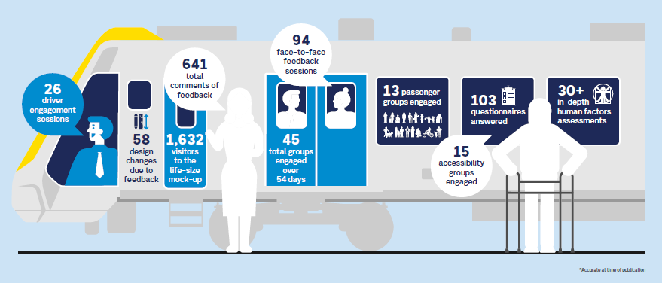
Graphic shows an illustration of people on a train and speech bubbles showcasing community engagement statistics.

Through a targeted engagement program, hundreds of Victorians were given the chance to influence the design of Melbourne’s new X’Trapolis 2.0 train.

The four-phased engagement program ran from April 2022 to July 2023, and involved consultation with train drivers, accessibility groups and user representatives on early concept designs, followed by virtual reality tours and a life-size mock-up, to help inform the final design of the train.

During the final engagement phase, 1,632 visitors experienced and provided feedback on a mock-up of one-and-a-half train carriages.

The mock-up featured life-like user features, allowing participants to experience passenger displays, seats, grab poles, accessibility spaces, and many other key elements of the design. We received 641 individual pieces of feedback, which resulted in 58 important design changes, including:

- improvements to the semi-automatic wheelchair ramp to make it easier for mobility aid users to get on and off the train, and make deployment of the ramp easier for drivers
- additional braille and tactile markings to priority seats
- lowered help point buttons to make calling for assistance easier
- increased space under companion seats to make it easier for guide dogs and support animals to fit
- installation of flashing lights on the doors and additional audio tones to signal doors opening and closing
- additional high-visibility markers on internal and external doors to improve accessibility.

Co-design is vital to ensuring our new trains and trams are being built for all Victorians right from the beginning. By actively involving key stakeholder groups in the design process, we gain valuable insights into accessibility challenges and have been able to identify issues and opportunities for improvements before our new trains and trams start taking users.
These changes improve user and driver experience, making journeys more comfortable and accessible.

“Seeing some of the feedback included in the final design is a testament to the way the teams at DTP and Alstom, along with our partners, are working together to listen to the community and come up with the best possible product.” – Tricia Malowney, DTP Chief Accessibility Advocate

Victorians will see the first X’Trapolis 2.0 trains testing on the network from 2025. These trains will be gradually introduced on the Craigieburn, Upfield and Frankston lines as we retire our long-serving Comeng Fleet.

More information: X'Trapolis 2.0 - modern trains for a modern Melbourne | vic.gov.au (www.vic.gov.au)

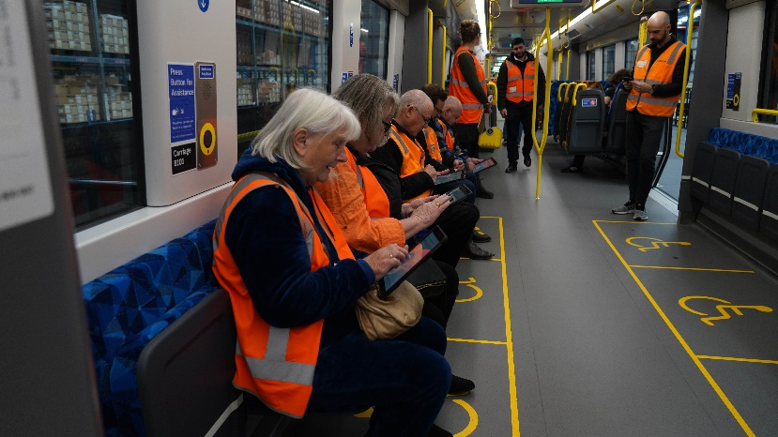

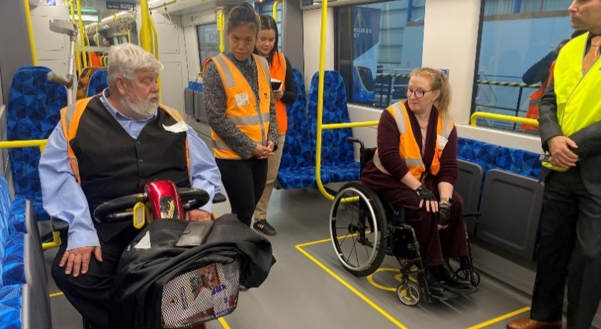

Priority Two: Journeys, Services and Systems
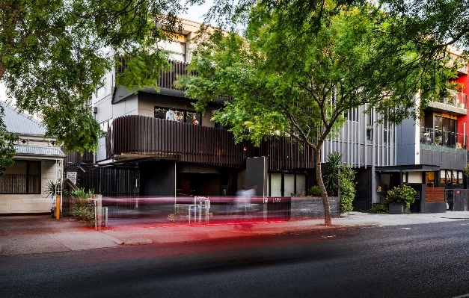
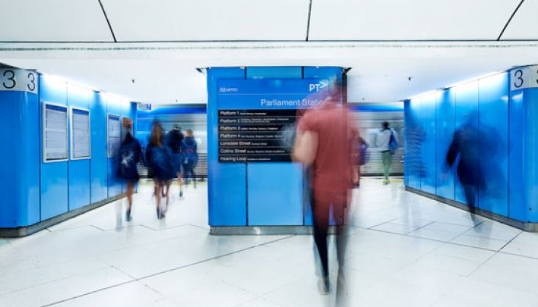

We can enhance accessibility and flexibility by integrating services, exploring diverse delivery models and improving infrastructure and support provisions and:
- Explore opportunities to bridge the gaps between the limited options currently available so it is easier for a wider range of people to use transport and access our planning, housing, building and land delivery services and systems.
- Better align available services through information coordination, tools and contractual arrangements.
- Help provide greater flexibility for people to take journeys and access systems and services when and where they wish.

Action | Outcome/s | Measure | Timeframe
- Include accessibility compliance when accepting new or updated products or services to the support team. | Accessibility compliance is understood when products are transitioned to support. | Accessibility compliance is continued throughout the life of the service. | Ongoing
- Consider accessibility when upgrading or managing a product or service. | Decisions to upgrade or replace products or services are informed by data on the compliance of legacy systems in the register of existing digital products. | Regular review of the register of existing digital products for compliance with accessibility requirements. | Ongoing
- Complete accessibility testing for all customer facing digital platforms and implement recommendations. | Accessibility requirements for customer facing digital platforms are met and assured through third-party testing. | Customer facing digital platforms pass accessibility testing, with recommendations implemented. | Ongoing
- Engage with people with disability through a corridor approach to tram planning to improve network accessibility. | People with disability have equitable and dignified access to trams. | People with disability are consulted when planning for tram stop corridor accessibility upgrades. | Ongoing
- Continue to improve connections and access between railway stations, bus and tram interchanges and stops where new services are introduced. | People with disability benefit from continual access to public transport with greater connectivity. | Audits of connections between modes of transport are completed and monitored. | Ongoing
- Support the consistent delivery of services to manage disruptions, including:  - Co-designing solutions with people with disability to manage significant disruptions,  - Assessing the implementation of disruption management processes, and  - Reviewing disruption management processes for future public transport contracts and ongoing service level agreements. | Improving the user experience of disruptions for people with disability. | Feedback from users with disability on disruption management experiences. | Year 2
- Continue to deliver simple, safe and connected journeys. | Increased user confidence through consistent departure and journey times.  Easier journey planning for all users. | Repeating train departure times, for example, trains always depart at 15 past, half past, and 15 minutes to the hour (clockface departures). | Ongoing
- Continue to coordinate bus services with rail timetable changes. | All users experience a more seamless and well connected journey, with less wait times when interchanging. | Bus services remain coordinated with train services after rail timetable changes, with consideration given to extra bus services added where needed. | Ongoing
- Continue to embed universal access principles in active transport planning. | People with disability have equitable and dignified access to walking and cycling infrastructure. | Universal access principles are embedded in an upcoming active transport strategy and applied when planning for and designing walking and cycling infrastructure. | Ongoing
- Support the implementation of mandatory liveable housing requirements into new residential dwellings. | More new dwellings with minimum accessibility features to meet the needs of people with mobility requirements. | Monitoring of building permit data.  Ongoing engagement with building industry practitioners and accessibility advocates to address barriers to implementation with communications and technical guidance. | Ongoing
- Work with jurisdictions to develop a best practice and human rights led approach to manage non-compliance with the Transport Standards so that greatest barriers on the transport network are removed sooner. | Consistent approach to prioritising removal of accessibility barriers on transport networks. | Approach to prioritising non-compliances is developed and implemented. | Year 2
- Investigate different options to reduce platform boarding gaps at complex stations in metropolitan Melbourne. | Agreed departmental policy position on preferred option/s to reduce platform boarding gaps at complex train stations in metropolitan Melbourne. | Report delivered on boarding gap solutions with recommendations on their suitability at different station types. | Year 1
- Monitor progress of accessibility deliverables in major public transport operator franchise agreements. | Drive continuous improvement in the way major public transport operators run the network that uplifts the user experience of accessibility. | Review all accessibility deliverables and report on progress, including identifying where deliverables have not been met. | Ongoing
- Work with the public transport ticketing system supplier to improve accessibility and usability. | Improved user experience with the ticketing system, including for people with disability. | User testing conducted with representative sample of Victorians, considering diversity in gender, age, accessibility needs, familiarity with the public transport network, and travel habits. | Ongoing
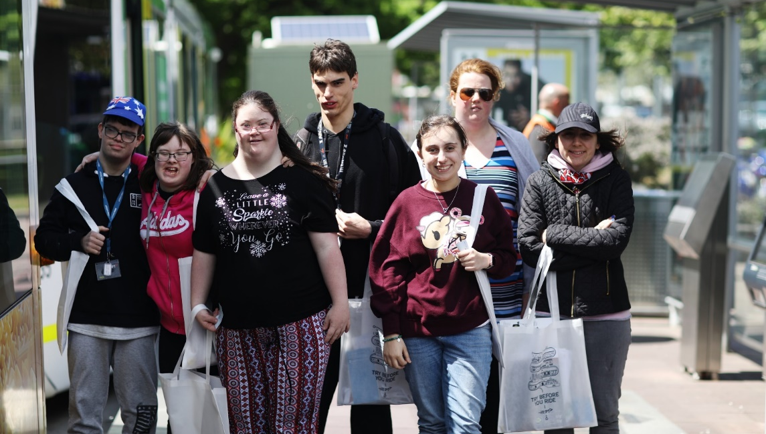

Case study: VicTraffic Website Accessibility

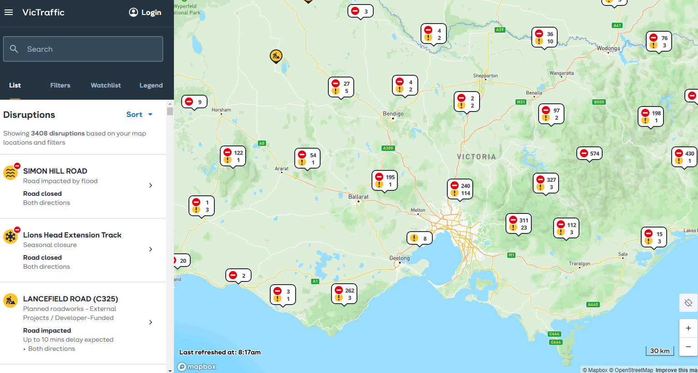
VicTraffic has been an essential tool in supporting transport users, emergency response units, and the public, ensuring safe and informed movement across Victoria's road network, particularly during emergencies. However, the platform lacked key accessibility features in line with standards in the World Wide Web Consortium’s latest Web Content Accessibility Guidelines (WCAG 2.1), which significantly limited its usability for people with disability, users who relied on assistive technologies or had difficulty navigating the website, especially during high-stress situations such as bushfires and floods.
Accessibility Improvements and Fixes
Recognising these shortcomings, we undertook a comprehensive programme of accessibility improvements as part of the VicTraffic re-platform project. We ensured a more user-centred approach was adopted, ensuring accessibility considerations were embedded from the outset.
Maps have always posed unique difficulties for users with visual impairments or colour deficiencies. To make them more accessible and ensure that all users, regardless of visual ability can engage effectively with the map content, we:
- Ensured that all information displayed on the map is also available in a text-based format, enabling screen readers to interpret the data easily.
- Introduced a toggle feature that allows users with colour vision deficiencies to distinguish between lines, routes, and disruptions using glyphs and patterns, rather than relying solely on colour.
- Enhanced the contrast of colours for better readability.
- Ensured all interactive elements were navigable via keyboard.
- Implemented clear, concise alt text for all images and buttons.
- Followed best practices for form labels, error handling, and dynamic content updates to ensure the site was fully compatible with screen readers.

Challenges Faced
Accessibility criteria had not been well-defined in past projects and basic principles of accessibility were not well understood by internal teams. As a result, we undertook an activity to deliver education resources on accessibility best practices, which helped uplift the overall skillset and improved our ability to deliver accessible solutions.
Another challenge encountered was the understanding that there is no single, uniform response from accessibility criteria. For example, when selecting a button, one screen reader might announce, "Button Name - Selected," while another might say, "Name - Button Selected." These discrepancies can cause issues during testing if the criteria are too prescriptive and testers do not receive the expected output, leading them to incorrectly mark the feature as a fail.
This issue was also addressed through further education, helping teams understand that while the actual output may differ between screen readers, if accessibility best practices and patterns are followed, the variance in output does not constitute a failure.
Outcomes of Testing and Fixes
As a result of these efforts, VicTraffic’s accessibility has significantly improved. Key accessibility metrics, including tab indexing, colour contrast ratios, and screen reader compatibility, all saw substantial enhancements. We reduced the number of blockers from four to zero, inhibitors from eight to zero, and WCAG 2.1 essential issues from 20 to just a few minor issues. This means that the platform is now accessible to a much wider audience, including those with visual, auditory, and cognitive impairments, ensuring that everyone can access real-time road information, particularly in emergencies.
Supporting the Community
These changes had a positive impact on the Victorian community, especially during emergencies when timely and accurate road disruption information is vital. By ensuring that VicTraffic is accessible, we are supporting vulnerable groups such as the elderly, people with disabilities, and those in remote or regional areas who may face additional challenges during emergencies like bushfires and floods. The accessibility improvements ensure that all users can confidently navigate road closures, incidents, and disruptions, thus improving safety and inclusivity across the entire community.

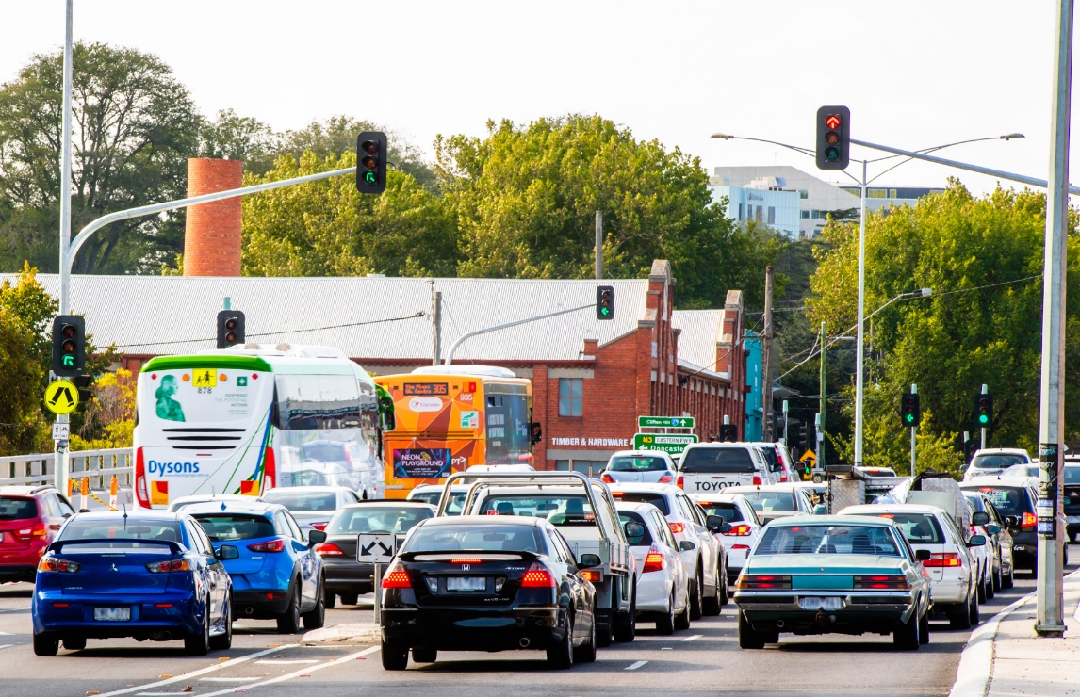

Priority Three: Organisation culture and public behaviour
A good experience relies on more than accessible infrastructure, rolling stock, systems and services, it also relies on positive interactions along the way. To do this, we need to:
- Staff training for frontline and other staff, drawing on lived experiences of disability.
- Employing people with disability and diverse backgrounds.
- Sharing stories and images or running campaigns that demonstrate equitable access for people with disability accessing transport and planning services.

Action | Outcome/s | Measure | Timeframe
- Support the Accessible Transport Advisory Committee to amplify the lived experience of people with disability by:  - Facilitating early engagement across a range of projects,  - Supporting identification of systemic issues, and  - Exploring opportunities to advise on transport components of broader planning strategies. | The Accessible Transport and Advisory Committee is sought out by project teams to provide expertise throughout the project lifecycle. | Earlier and increased consultation with people with disability. | Ongoing
- Continue the Chief Accessibility Advocate role for a further three years after the first term. Consider opportunities to provide advice on the intersection of accessibility with planning and precinct development, in addition to transport matters. | Uplift departmental capability to embed accessibility across all work, and value the expertise and lived experience of people with disability. | Earlier and increased consideration of accessibility requirements across departmental work programs. | Year 1
- Bring together existing information and processes for user testing and universal design to develop best practice guidance on co-design. | A consistent and meaningful approach to engaging with people with disability across departmental projects is developed. | Earlier and increased consultation with people with disability | Year 2
- Co-design guidance material with people with disability that sets out DTP’s approach to the disability standards, including:  - Establishing a position on how to apply the disability standards where current practice may result in inconsistencies.  - Developing a framework for stakeholder engagement.  - Ensuring user focused outcomes, which may exceed disability standard requirements. | Uplift major transport infrastructure project capability to deliver optimal accessible outcomes for people with disability. | Guidance materials with specific requirements on engaging with disability and accessibility auditors are developed and implemented. | Year 1
- Apply a Human-Centered Design approach to understand the needs of users with accessibility requirements to design the new public transport ticketing system. | The design of the new system takes user needs into account to ensure that the solution requirements are aligned with the department’s user experience objectives.​ | User research demonstrates that the ticketing system meets the needs of all people. | Ongoing
- Conduct analysis of the customer experience and key pain points throughout journeys for users with accessibility needs. | Drive improvements to the experience for users with accessibility needs. | Analysis completed with findings leveraged to drive improvements to the customer experience. | Ongoing
- Deliver inclusive and accessible communications materials and engagement activities for Plan for Victoria consultation. | All Victorians have an opportunity to contribute to Plan for Victoria. | Communication materials are provided in accessible formats.  All engagement activities held in accessible venues. | Year 1
- Support transport entities to increase their capacity to engage in co-design with people with disability to advise on whole of journey accessibility throughout project design and delivery. | Accessibility is embedded from the start when designing and delivering major transport infrastructure projects. | Increased consultation with people with disability. | Ongoing
- Increased employment of people with disability through requirements embedded in major public transport operator franchise agreements. | Increased employment of people with disability across major public transport operators. | Proportion of employees with disability. | Ongoing
- Advise department business areas during the procurement planning process on how to apply the Social Procurement Framework objective ‘Opportunities for Victorians with disability’. | DTP procurement outcomes provide opportunities for people with disability by purchasing from:  - social enterprises and/or disability enterprises, and/or  Suppliers that employ people with disability. | Department business areas are aware of the social procurement objective to provide opportunities for Victorians with disability. | Ongoing
- Support and facilitate the delivery of the Travelling in the Shoes of Others program to promote awareness and understanding of public transport accessibility for departmental staff. | Increased staff understanding of network barriers and links to accessibility in all roles. | Number of staff who have completed the program.  Feedback on impact of program. | Ongoing
- Support public transport operators to deliver the Try Before You Ride program to help people feel more confident when using the public transport system. | Increased confidence for members of the public to use the public transport network. | Number of attendees at the program.  Feedback on impact of the program. | Ongoing
- Digital accessibility training is provided to all staff working on customer facing digital platforms. | Project team members are aware of the accessibility requirements to be included in scope for customer facing digital platforms and the required testing for assurance. | All project managers are trained in accessibility testing requirements. | Year 1
- With input from people with disability, review the Law and Procedure Reference Notes and consider how interactions between Authorised Officers and people with disability are accommodated to improve the user experience. | Authorised officers are confident to positively and proactively engage with people with disability travelling on the public transport network. | Content in the Law and Procedure Reference Notes relating to Authorised Officer interactions with people with disability is updated, with input from people with disability. | Year 2

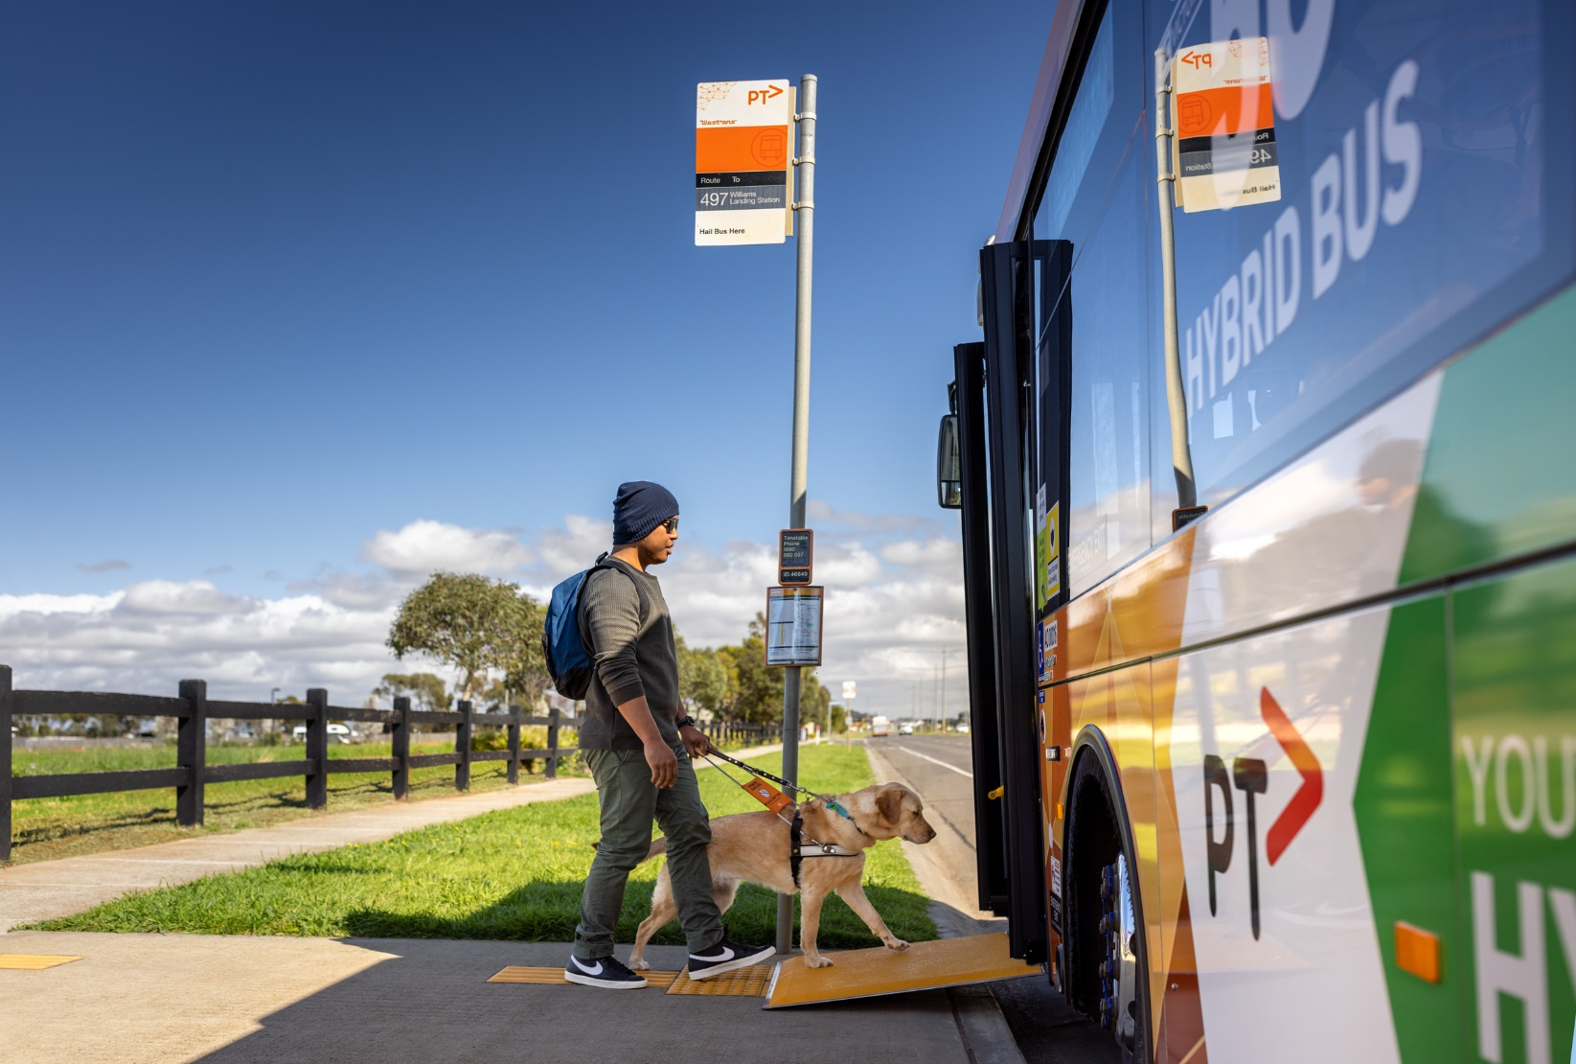
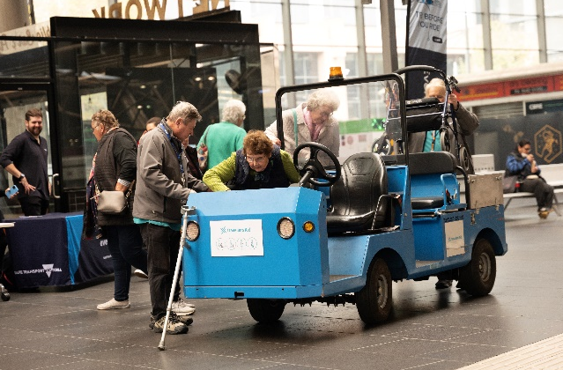
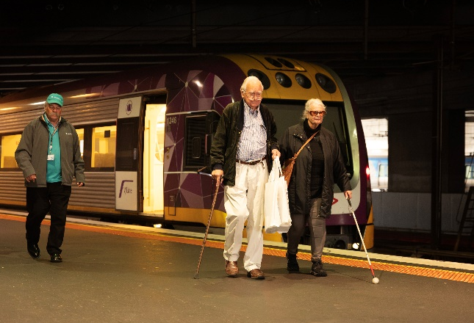
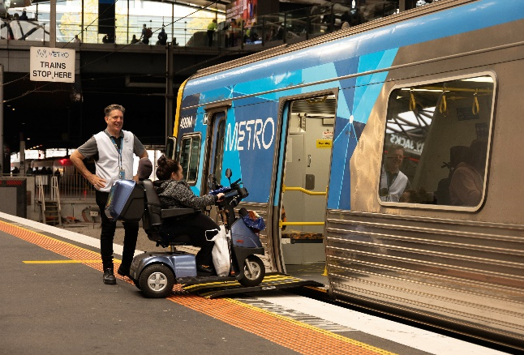
Participant Experience
The event enabled participants to:
- Board and disembark stationary Metro and V/Line buses, coaches, and taxis.
- Take guided tram trips to familiarise themselves with different transport modes.
- Engage directly with public transport staff to learn about accessibility features, safety protocols, and available support services.
Stakeholder Collaboration
The success of the Try Before You Ride event was a result of collaboration between many stakeholders and DTP, including:
- Public transport operators – Metro Trains, V/Line, Yarra Trams and Kinetic, and
- Transport and accessibility organisations – Travellers Aid, Safe Transport Victoria and the Hidden Disabilities Sunflower Network.
These organisations worked together to ensure the event catered to a diverse range of accessibility needs, such as people using wheelchairs, parents with young children and older Victorians.
Feedback and Impact
Participant feedback was crucial to understanding how accessibility features function and what improvements may be needed. Key takeaways included:
- Increased confidence to use the public transport system independently.
- Better understanding of accessibility features and how to access support if needed.
- Insights that will inform future accessibility improvements across the network.
Going Forward
Following the event’s success, Try Before You Ride has expanded further. In partnership with the City of Greater Bendigo, V/Line hosted additional events as part of the Victorian Seniors Festival in October 2024.

Case study: Try Before You Ride – Enhancing accessibility across Victoria’s public transport network
Try Before You Ride is an initiative designed to help individuals of all abilities gain confidence in using Victoria’s public transport system. Held in May 2024 at Southern Cross Station, the event was attended by over 130 participants to explore various modes of transport, providing hands-on experience with accessibility features in real-world settings.

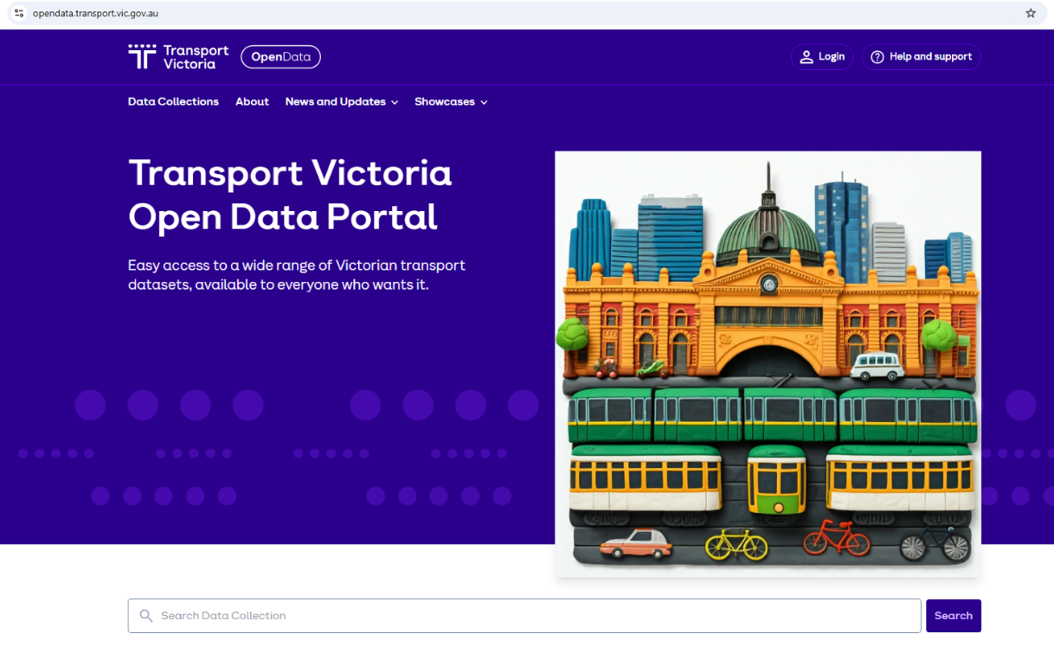
Case Study: Transport Victoria Open Data Portal

The new Transport Victoria Open Data Portal will give the open data community:
- The ability to access a wide range of accurate and consistent static and real-time public transport and road data on one platform.
- Access to transport open data in the global standards and formats widely used by the open data community.
- Use and download of all transport open datasets for free.

The data being updated and created with better accessibility information will be made available in the Transport Victoria Open Data Portal for anyone who wants to use it to develop or enhance current apps and journey planning tools with better accessibility information. The portal will help the development community to build inclusive tools with expanded accessibility attributes, for example, pathways, levels, lift status and tactile indicators, will be published as we continue to upgrade our source systems.

In addition, the Open Data Portal was built and tested to align with the Victorian Government standards for digital content accessibility. Web Accessibility Evaluation Tool (WAVE) and Google Lighthouse were used to help identify issues prior to third party audit.

Upgraded internal systems
Internal public transport data and information systems are being reconfigured or upgraded to provide better accessibility information including:
- The electronic timetable information system (EFA v.10.6) upgrade introduced the ability to provide more informative accessibility journey planning options. Settings were upgraded to allow the creation of customised user profiles to address more nuanced accessibility needs, such as transfer distances and times that reflect any need to use ramps and/or lifts. These settings will part of the Journey Planner application programming interface (API, which allows different software to communicate and exchange data) and can be consumed by the PTV channels and open data users.
- Reconfigurations were made to Chronos (a public transport data system) to improve tram accessibility information in PTV journey planning app, allow it to display accessible tram trips that were previously blocked.

Priority Four: Information and innovation
Having accessible and reliable information is one of the most important requirements for inclusive transport and planning. We aim to:
- Fill data gaps
- Make information available so that people with disability can plan their journeys more easily, and use our planning, housing, building and land delivery systems and services both when the system is operating normally and when it is disrupted.
- Ensure information is accessible.

Action | Outcome/s | Measure | Timeframe
- Deliver on trams:  - Simplified signage across all new and existing rolling stock, and  - Improved digital wayfinding information on all new rolling stock. | Increased user confidence when travelling on trams.  Support people with disability to understand route accessibility and progress arrival at key interchanges. | Positive feedback on signage and digital wayfinding information. | Year 1
- Review wayfinding and directional signage at new and existing train stations, and nearby transport interchanges. | Improved wayfinding, including for accessible pathways at train station precincts and nearby transport interchanges. | Wayfinding signage updated at fifteen train stations, informed by the departmental style guide that has, in part, been developed with users with accessibility requirements. | Year 4
- Review wayfinding at existing bus interchanges. | Improved wayfinding at existing bus interchanges to make finding the right bus easier. | Wayfinding signage updated at eight bus interchanges, informed by user testing, including users with accessibility requirements. | Year 4
- Develop a new suite of wayfinding standards and guidelines. | Stronger alignment of signage and information with the broader wayfinding strategy.  More consistent customer wayfinding experience.  Embedded user testing processes, including with people with disability. | Deliver a new suite of wayfinding standards and guidance for planning and delivering signage and information at stops, stations and precincts. | Year 2
- Develop a strategy to ensure consistency for accessible boarding points at shared regional and suburban train stations. | Users with accessibility requirements can self-serve with clearly marked boarding points steering them to accessible carriages on their service of choice. | Accessible boarding points for V/Line services identified at twelve Metro train stations.  Development of strategy to differentiate boarding points between modes including any relevant artwork updates to allow for delivery at stations when feasible. | Year 2
- Review passenger public address announcements for the public transport network. | An understanding of how to achieve consistent messaging delivered in a consistent tone across the entire metropolitan train network at stops, stations, and onboard vehicles for both live and automated announcements. | Review of passenger public address announcements for the public transport network is completed. | Year 2
- Develop a strategy and requirements for train service naming conventions for the next metropolitan train contract (MR5), informed by user testing. | Consistent information to identify metropolitan train services and improved user understanding. | User testing completed with different cohorts, including people with disability.  Requirements developed and adopted for the next metropolitan train contract (MR5). | Year 2
- Review signage for accessible evacuation refuge points at Metropolitan Underground Rail Loop (MURL) stations.  Note: MURL stations refer to Flagstaff, Melbourne Central and Parliament stations. | An understanding of how MURL stations can provide a visible and consistent experience, including identifying opportunities for updated communications that is informed by users with accessibility requirements. | Recommendations for improved consistency, visibility and communication to assist users with accessibility requirements during travel training and in the unlikely event of an evacuation at MURL stations. | Year 2
- Increase departmental use of the prioritisation tool to inform advice to Government on accessibility priorities. | Consistent and aligned approach to advising Government on accessibility that removes the most significant barriers first. | Completed staff engagement sessions.  Prioritisation tool made available to all staff. | Year 1  Ongoing
- Explore engagement opportunities between departmental accessibility subject matter experts and leads of infrastructure funding proposals. | Accessibility is built into the start of infrastructure projects. | Infrastructure planning considers accessibility impacts as part of developing funding proposals. | Ongoing
- Develop policy and guidance to improve understanding and drive more consistent interpretation of specific elements within the transport disability standards, with consideration of universal design. | Improved understanding and more consistent interpretation of the transport disability standards. | Publish policy and/or guidance materials.  Feedback on implementing materials demonstrates improved and more consistent application of the transport disability standards. | Ongoing
- Deliver public transport information to users in regional Victoria. | Information about public transport is provided flexibly and responds to the changing needs of users. | Volume (sessions) on DTP digital channels involving trips planned to/from locations in regional Victoria. | Year 1  Ongoing
- Deliver communications and engagement activities to support users with accessibility requirements in the lead up to and after the opening of the five Metro Tunnel stations to ensure:  - Station familiarisation and understanding of accessibility features, and  - Effective wayfinding and connections to other transport modes. | Improved user experience when transiting to and around Metro Tunnel stations. | Delivery of tailored activities and communications materials in partnership with accessibility stakeholders to support station familiarisation. | Year 1
- Review network technical standards and guidelines to align with project requirements for consistent interpretation of disability standards. | Improvements in the delivered accessibility outcomes across the network | Delivery of endorsed changes to accessibility requirements in the Network Technical Standard (NTS002) for Public Transport Precincts. | Year 2 / Ongoing
- Ensure digital platforms enabling Public Transport Ticketing to be compliant with web content accessibility guidelines (WCAG) 2.1AA and identify opportunities for continuous improvement. | Ensure all users, including people with disability, can navigate and use public transport ticketing digital platforms independently and effectively. | Project work includes user acceptance testing with people with a range of accessibility requirements to validate the project. | Ongoing
- Reduce barriers to accessing public transport ticketing services by ensuring corresponding digital products are available in multiple languages. | Ensure all users, including people with disability, can navigate and corresponding digital platforms independently and effectively. | Public transport ticketing digital platforms are available in multiple languages. | Ongoing
- Reduce barriers to understanding and using public transport ticketing services by developing information materials for corresponding digital products in multiple languages. | Ticketing system information is accessible to a greater range of users. | User information and marketing materials to support behaviour change when transitioning to the new ticketing system is produced in multiple languages. | Ongoing
- Add accessibility compliance to decision-making processes for technology project requirements and design. | Project teams plan for and implement accessibility requirements. | Accessibility compliance checklist included and completed to demonstrate consideration. Guidance provided to DTP and relevant initiatives. | Year 1
- Departmental digital content meets the web content accessibility guidelines level 2.0 AA | All users can access departmental digital content. | The vic.gov.au content management system includes templates to ensure compliance with accessibility standards. | Ongoing

Case study: Public Transport Data Program - Improved accessibility outcomes
The Public Transport Data Program is releasing better accessibility information to the open data community. This will help provide improved travel information and options for all users so they can confidently plan their journeys, regardless of ability level or journey planning tool they use. The open data community includes application providers but also allows for research and innovation.

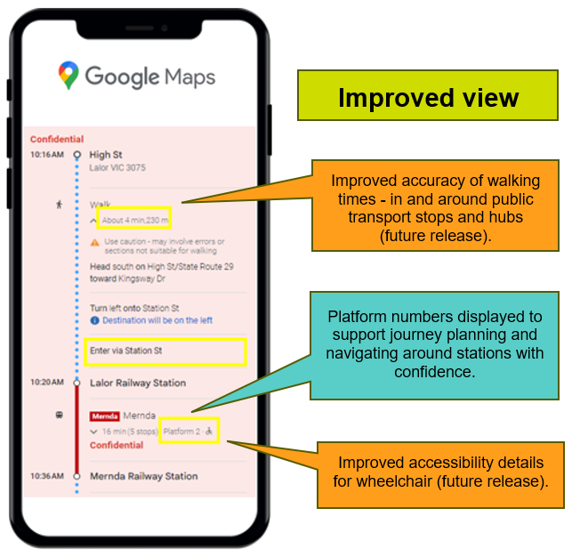
The improvements are being made through a range of projects:
Updated public transport network information for the open data community:
Public transport network information including vital accessibility features will be mapped and made available in the open data market:

Improved accessibility information and digital navigation:
- More detailed information about accessible features and facilities will be mapped, with locations of lifts and ramps, entrances and exits, and footpaths and walkways.

Improved accuracy of walking times: Walking times in and around public transport stops and hubs will be mapped to provide more accurate information that will help users with mobility needs to:
- Facilitate smoother interchanges between different transport modes.
- Support journey planning by considering the time required to walk between essential features such as platforms, entry/exit points, car parks and drop-off zones.

Improved timetable data and transfer information: Timetable trip data will be enriched to incorporate additional accessibility details, including:
- Improved accessibility details for wheelchair users.
- Improved tram accessibility information in PTV journey planning app.

Improved accessible trip information:
- Third-party journey planning tools will have more consistent and accurate accessibility information enabling users of all abilities to better plan and navigate their journeys seamlessly.

Improved real-time and disruptions information
The new systems, processes and data feeds needed to provide real-time public transport information for all modes will be set up and made available in the open data market. This will support better accessibility outcomes by setting the foundations to expand real-time data to include status updates on key accessibility features such as when a lift or escalator is out of order and when it is up-and-running again.

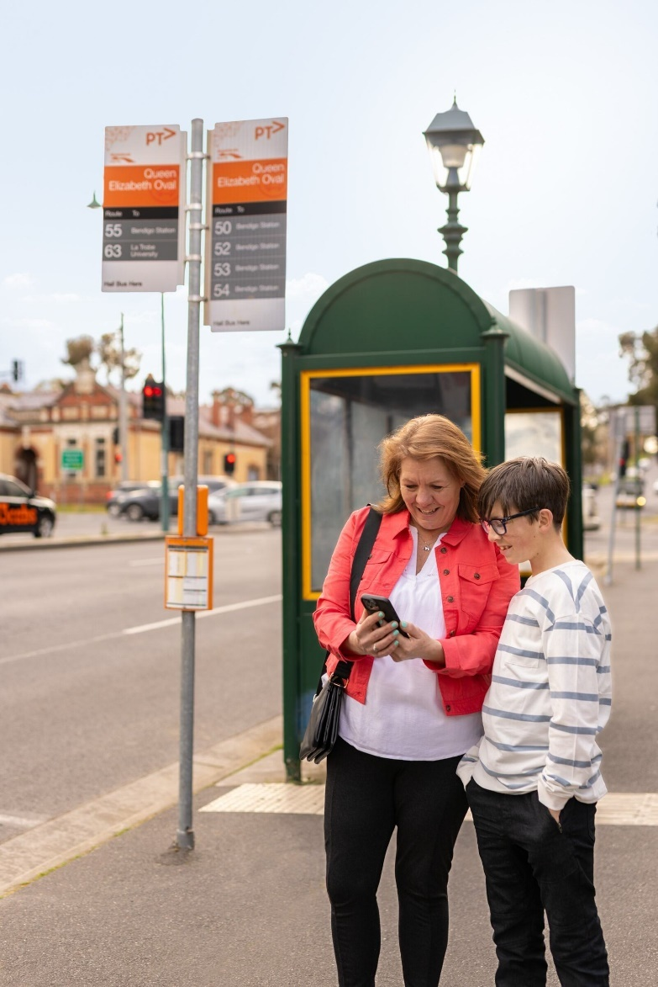
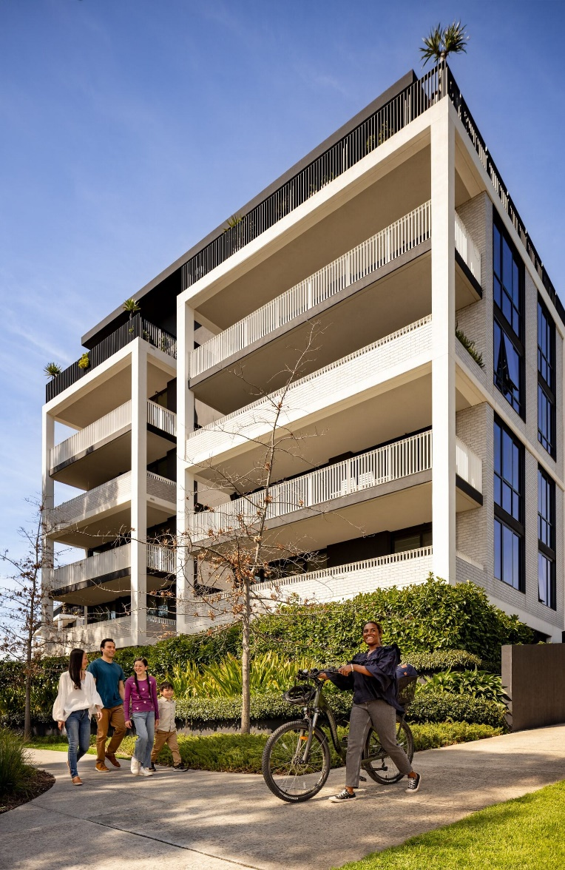

Chief Accessibility Advocate’s message
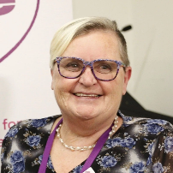
I commenced as the Chief Accessibility Advocate in November 2021 for the former DoT to amplify the voices of people with disability and improve public transport accessibility in Victoria. My role has since expanded with machinery of government changes to include planning to reflect the remit of DTP.
As an independent voice to DTP, my role drives accountability when delivering improved accessible outcomes. I also facilitate collaborative relationships between people with disabilities and DTP staff so that solutions meet the needs of all Victorians.
Victoria is leading the way on consultation and co-design with people with disability when building trains and trams. I’ve visited mock-ups of the X’Trapolis 2.0 and Next Generation Tram and facilitated conversations and learnings between the project delivery teams and people with disability. The design of these conveyances demonstrates an inclusive and iterative approach to delivering public transport. There is an opportunity to translate these practices to other work, such as our major infrastructure projects so that we can consistently deliver accessible outcomes for the community.
My work also involves providing strategic advice to the Secretary and senior leadership on the delivery of accessible and inclusive transport services, supporting transport and planning Ministers to highlight accessibility issues, and facilitating forums and toolbox talks with a range of stakeholders.
This action plan demonstrates DTP’s commitment to embedding accessibility and using all available levers to achieve inclusive outcomes. A critical part of this is accountability, ensuring that progress on all actions are tracked and reported on, and outcomes are evaluated. All areas of DTP are responsible for delivering their actions to improve accessibility.
It is essential that people with disability are engaged early in the planning process and throughout the lifecycle of a project so that solutions are inclusive and effective. Building accessibility into everything that we do reduces the need to retrofit solutions at the end. I will support business areas to realise their actions and look for opportunities to uplift knowledge and capabilities.
We know that barriers continue to exist for people with accessibility needs when traveling on our transport network, navigating the built environment, using government information and technology, and accessing appropriate housing.
We must do more to engage with people with accessibility needs to shape our strategies, plans, and major projects.
Accessibility is embedded in all aspects of our work, whether in policy, planning, design, construction, delivery, compliance, or any other area across DTP.
It is a shared responsibility, and by prioritising it in everything we do, we can create a more inclusive and accessible system for all.
I look forward to continuing my work over the next three years and consolidate key connections and the further expansion into the planning portfolio to provide for inclusive, accessible, and affordable housing and integrated land use.
Tricia Malowney, OAM, Chief Accessibility Advocate DTP

Implementing the action plan
We are creating change for people with disability to enable equitable and dignified access to public transport, planning, housing, building and land delivery areas across Victoria.
All areas of DTP are responsible for progressing this Action Plan. Each action has an implementation plan that includes further detail on how we will progress work, including how responsibilities are allocated and key milestones. This will help us to understand how actions will promote access and inclusion across our transport network and planning systems.
We will track progress of actions throughout the lifetime of this Action Plan. We will provide annual progress updates through DTP’s Annual Report, on our vic.gov.au website, and other reporting mechanisms, as appropriate.
Over the four year life of the plan, we will consult with people with disability, the Chief Accessibility Advocate, ATAC, public transport operator accessibility reference groups and external accessibility stakeholders. What we learn through consultation will be used to review and evaluate the policies and programs within the Action Plan. This will include a mid-way refresh of the Action Plan to respond to any changing priorities for DTP and people with disability.
The Action Plan has been communicated to departmental executives and staff through internal communication channels. It has been published on our website in a range of accessible formats for our external stakeholders and the broader community, including:
- HTML first, with all content available on our vic.gov.au website
- Accessible word document
- Summary accessible word document
- Easy English
Please contact us to request additional formats at transport.accessibility@ptv.vic.gov.au

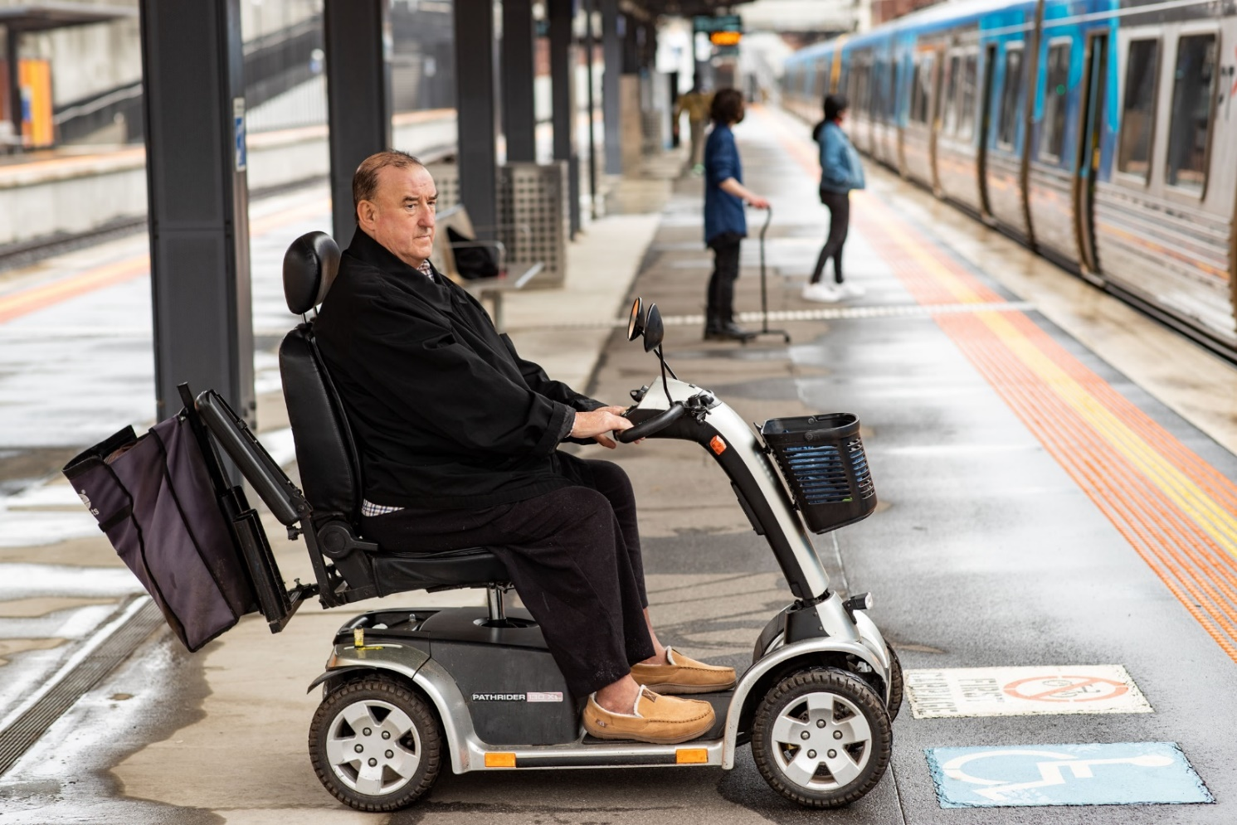

Case Study: Planning.vic.gov.au - The benefits of accessibility for our community

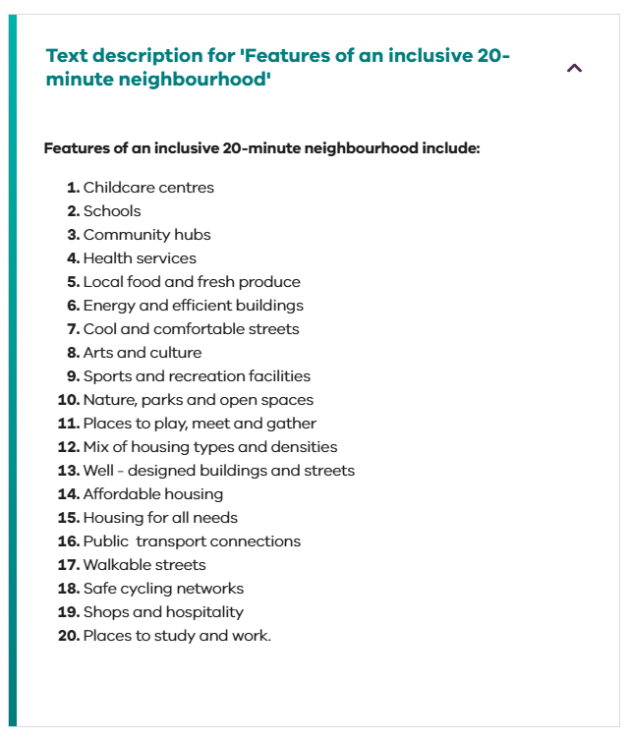

Designing with accessibility in mind is critical to ensuring that our websites can be used by all. When creating and publishing content, we have worked to ensure that:
- Stakeholders are educated so they understand the importance of consistently providing information in accessible formats.
- All content is converted to HTML to improve accessibility, particularly for mobile users.
- Developers create code for websites with key controls activated to improve navigation and support effective functionality of screen readers.
- All systems and data meet web accessibility and Victorian Government guidelines, with text descriptions, colour contrasts, video content supported by captions and transcripts.
- Where possible, external audits are undertaken to capture and address further accessibility improvements.

Example One: 20 Minute Neighbourhoods
Alongside infographics, information is also provided in text so that all users experience website content equally.
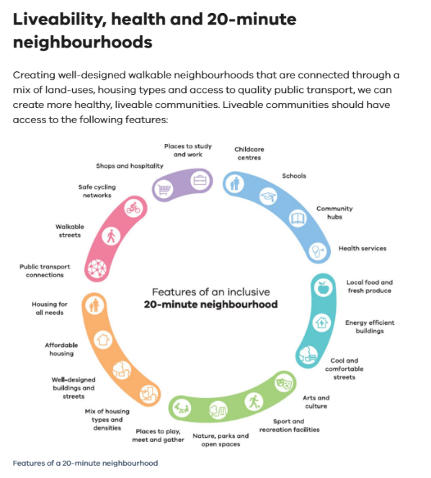

Appendix 1 - Acronyms
Acronym | Description
ATAC | Accessible Transport Advisory Committee
DoT | Department of Transport (previous iteration of DTP)
DSAPT | Disability Standards for Accessible Public Transport 2002 (Commonwealth)
DTP | Department of Transport and Planning
NDIS | National Disability Insurance Scheme
VIDA | Victorian Infrastructure Delivery Authority
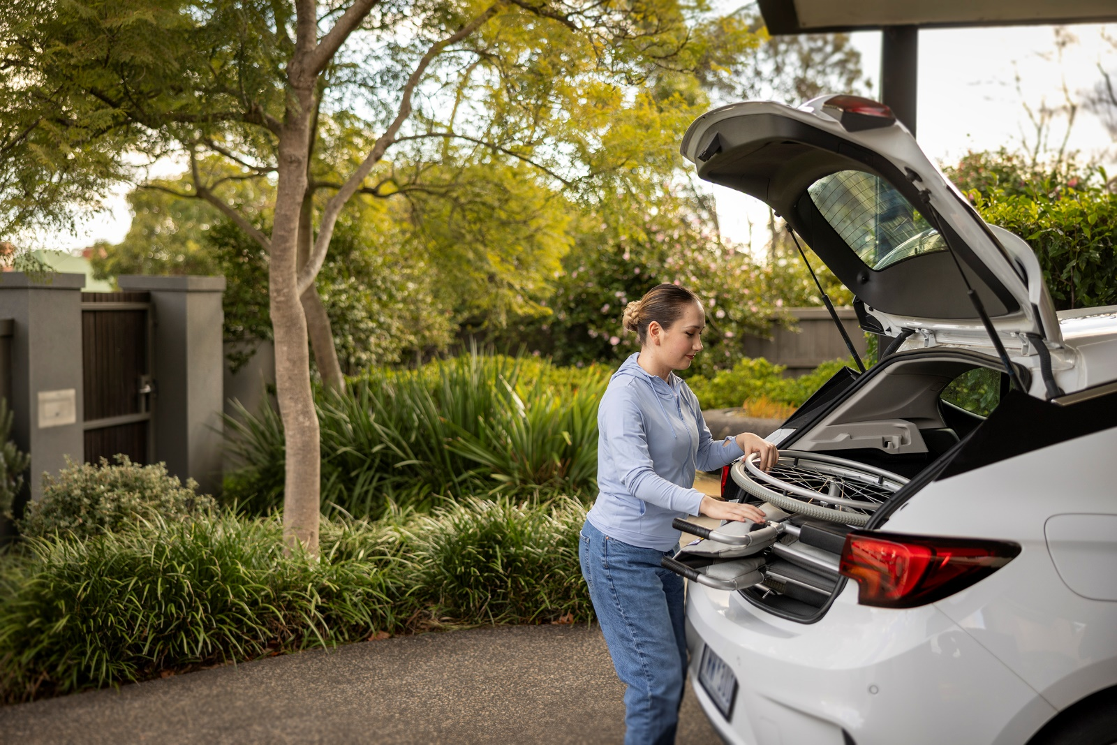

Appendix 2 - Outcomes from the Accessible Public Transport in Victoria Action Plan
The former DoT’s Accessible Public Transport in Victoria Action Plan 2020 – 2024 set out opportunities to improve accessibility and the whole-of-journey experience across the public transport network. This report provides an update on the Action Plan by outlining progress on across the four-year period. It does not include information related to actions from the planning portfolio, which joined the department on 1 January 2023.

Priority One: Customer, community, and engagement
People with disability have equitable, dignified, and responsive access to customer service and are provided the opportunity to interact and engage to identify continuous improvement.
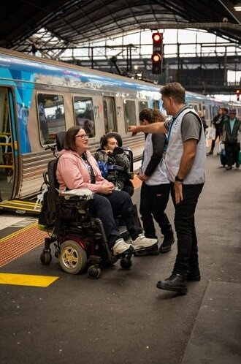
We have worked to ensure that DTP and operator staff are equipped with the tools and resources to assist users with disability. We require frontline staff for our major operators to undertake disability awareness training as a part of contractual arrangements.
Our major operators continue to work closely with their accessibility reference groups to embed inclusion across the transport network. Their customer service charters address the importance of access to transport for people with disability and highlight accessible information initiatives.
Several of our operators are accredited with the Communication Access Symbol, a key tool to communicate with users with communication difficulties, and support the Sunflower Initiative, so that staff can confidently deliver customer service that responds to the needs of all users.
Travellers Aid continues to provide vital services to users travelling on the transport network. In 2023, Travellers Aid commenced providing services at Ballarat Station, with thousands of users assisted to travel between platforms, coach and bus bays, taxi ranks, and car park drop off zones.
To ensure that accessible information and assistive technology continues to be available to all users, the PTV app has been redesigned to be fully accessible. VoiceOver and TalkBack capabilities assist blind and low vision users, alongside additional journey planning features. All departmental websites are compliant with web content accessibility guidelines. We are working towards aligning information about transport network accessibility features across operator websites.
We continue to increase opportunities for people with disability to provide feedback about their transport experiences. Tricia Malowney OAM was appointed as our Chief Accessibility Advocate in 2021 and has put accessibility at the forefront of departmental thinking.
ATAC, a Ministerially appointed committee made up of people with lived experience of disability continues to meet monthly and provides invaluable advice on accessibility requirements across a range of transport projects. This has included advising on the modernisation of DSAPT, the new public transport ticketing contract, and the design of the X’Trapolis 2.0 trains and the Next Generation Trams.
As part of the new tram franchise agreement, DTP included a new mystery shopper program that now includes people with disability employed on the network to evaluate the condition and accessibility of the tram network and the quality of customer service and staff interactions.

Priority Two: Access to public transport services
People with disability will have increased access to train, tram, bus, coach, ferry and commercial passenger vehicle services, including responsive and timely information on disruptions, cancellations and major events.
We have made significant improvements to the Public Transport Victoria website based on stakeholder feedback, such as improvements to keyboard navigation and screen reader functionality. To enable users with accessibility requirements to confidently plan their journey, information on accessible services, stops, stations and conveyances is available through the journey planner tool. Functionality has also been added to enable users to access real-time information on the accessibility of trams on different routes.
The department continues to provide accessible alternative transport options during disruptions, cancellations and major events. Customer service staff who assist people with disability to navigate disruptions are required to undertake disability awareness training. The department has also engaged Travellers Aid to support users at Flinders Street and Southern Cross Stations, while operators have engaged them to provide additional services during disruptions and major events as needed. Further work to improve the user experience of disruptions is captured in this Action Plan.
All metropolitan train platforms have information points that connect users to a customer service officer or to pre-recorded timetable information. Through the Better Stations Amenity Upgrades program, we have delivered accessibility upgrades at Glen Waverley, Jacana, Lalor, Merri, Thornbury, Victoria Park, Warrnambool, and Woodend. This has included installing new passenger information displays, tactile ground surface indicators, shelters and public address systems, as well as improving signage and wayfinding.
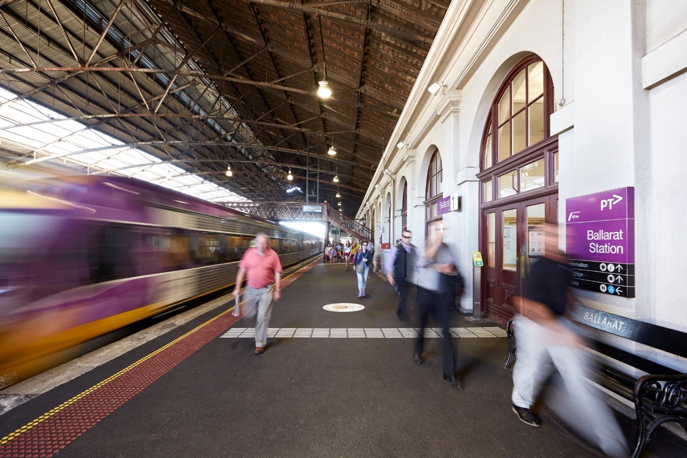
Several accessibility upgrades have been delivered through the Regional Rail Revival Program, with four new, three rebuilt, and 13 upgraded stations in growth areas across regional Victoria to continue to improve the accessibility of the network and to address compliance requirements under DSAPT. This has included improvements to accessible station infrastructure such as pathways, shelters, seating, and overpasses at Warrnambool, Waurn Ponds, Traralgon, South Geelong, and Marshall stations. We have also committed to installing lifts and building a connecting overpass at Ballarat Station.
We have delivered all 70 of the High Capacity Metro Trains and have commenced work on 25 new X’Trapolis 2.0 trains. The design of these trains has been informed by people with a range of accessibility needs and incorporates significant accessibility features, including:
- additional handholds,
- more allocated spaces at accessible boarding doors,
- real-time information through dynamic route maps and passenger information displays,
- semi-automated boarding ramps
- hearing loops, and
- continuous walkways throughout the trains.
VLocity trains are running on more lines, including to Bairnsdale and Albury. We are currently delivering 12 new VLocity trains to run on the Shepparton and Warrnambool lines and have committed funding to deliver a further 23 three-car trains that will run on the Melton and Geelong corridors.
Twelve level access tram stops have been built along La Trobe Street, servicing routes 30 and 35. Level access stops have also been delivered in Parkville and along St Kilda Road to connect to the new metro tunnel stations, and in Glen Huntly as part of level crossing removal works. All stops include a range of accessibility features to improve the safety and experience of users, including real time passenger information displays in accessible locations. There is a significant further pipeline of tram platform upgrades.
Since 2020, 259 bus stops have been upgraded to meet accessibility standards. This includes equivalent provision of information and messages for people with disability, whether through static or electronic visual information, or public address systems. Additional funding was provided for service, accessibility and amenity upgrades that aligned with Victoria’s Bus Plan, released in 2021. These upgrades have been delivered at 80 bus stops.
Safe Transport Victoria facilitates an industry that ensures that taxis, hire care and rideshare vehicles are accessible for all members of the community, including people with disability. The number of wheelchair accessible vehicles has increased by more than 300 following the Commercial Passenger Vehicle Industry Act 2017 coming into effect.
The Multi-Purpose Taxi Program (MPTP), which assists the travel needs of people with disability by offering discounted vehicle fares to program members has been expanded to include taxis, hire cars, and rideshare services. In addition, DTP advocates for better outcomes for people with disability travelling in commercial passenger vehicles through national committees, working groups and issue specific committees.
DTP has contributed to reforms to ferry accessibility as part of the Disability Standards for Accessible Public Transport 2002 reform project. In early 2023, the new Queenscliff Ferry Terminal opened. The terminal provides an accessible and safe route for users to board and disembark.

Priority Three: Accessible processes and systems
People with disability will benefit from inclusive and accessible processes and systems.
We have inclusive policies and processes that support and promote accessibility and will continue to build accessibility into our systems.
We have developed a set of Guidelines for Social Procurement that outlines how goods, works and services can be purchased to generate social value and benefit all Victorians. These guidelines have been applied to major projects to ensure that accessibility is a key consideration in procurement, including for the design of the X’Trapolis 2.0 trains and Next Generation Trams, as well as part of the new tram franchise agreement.
Since the introduction of DSAPT, Victoria has invested heavily in new and upgraded public transport infrastructure and rolling stock. However, significant challenges remain to make the network fully accessible and compliant with statutory obligations. Key barriers include the age of existing infrastructure and rolling stock, the size of the network, and the high cost of upgrades or replacements.
We have contributed to national work to review and reform DSAPT and advocate for better outcomes for Victorians with disability. Work to finalise this process is continuing through targeted working groups. We are also working on a network-wide monitoring and review process to support DSAPT compliance, to be completed following outcomes of the reform project being finalised.
To ensure a consistent approach to considering and prioritising accessibility as part of transport services and infrastructure planning, we have developed a Transport Accessibility Strategic Framework. Co-designed with people with disability, the Strategic Framework sets out our approach to assessing accessibility gaps. It proposes a prioritisation method to help guide future advice to Government on investment decisions and aims to embed thinking about accessibility so that it is considered from the start in planning, designing, and delivering assets, services, and policies. The key principles and strategic directions in the Strategic Framework have also provided a structure to develop this Action Plan.
Alongside transport operators, DTP has accessible feedback mechanisms. Users can provide feedback online, over the phone and via text telephone mode, in person or by post. Our customer service complaint systems generate reports where accessibility issues can be identified. Operators provide aggregated information on accessibility to the department as part of contractual requirements.
Operators of the metropolitan train, regional train, and tram network continue to update information on the available facilities at stations and stops across Victoria. This includes facilities such as accessible toilets, wheelchair accessible parking, hearing loops, lifts and other facilities that assist people to travel on the network. The new tram franchise agreement provides greater certainty that low floor trams will show up when expected through a ‘right tram, right trip’ key performance indicator.
The department also has an ongoing role in exploring different solutions to accessibility barriers. This has included:
- Design-based responses to platform and boarding ramps, as well as wheelchair containment systems,
- Technology and data-based responses, such as NaviLens real-time journey mapping, and
- Supporting start-ups through the CivVic Labs program at LaunchVic to develop technology-based solutions to public transport accessibility barriers.
Our accessible processes and systems are also reflected in our Master Style Guide, which is regularly updated with best practice accessibility messaging, such as consistent audio announcements and improved access features.
Through governance and reporting, we are accountable and transparent on progress of accessibility initiatives. Our executive-level committees review and provide input into accessibility initiatives, as well as accessibility components in major projects. This has included updates on progress of actions in the Accessible Public Transport Action Plan 2020-2024, which has also been reported on in the department’s Annual Report.
ATAC has played a key role in ensuring the department continues to build accessibility into all stages of projects and initiatives. For example, their involvement with the new ticketing system commenced with providing advice on the design of the tender, well prior to the engagement of a successful bidder. ATAC were also involved in user testing sessions with the three competing suppliers. Following the selection of the successful tender ATAC have been involved in testing new ticketing infrastructure, including readers, screens and gates. The early engagement has been important in identifying different accessibility needs to be considered in modernising the public transport ticketing system.

Priority Four: Access to facilities
Universal design principles and dignified access to buildings and public transport infrastructure will be included in network expansions and upgrades.
We continue to prioritise facilities for upgrade or redevelopment across the public transport network and build in accessibility outcomes.
The Transport Accessibility Strategic Framework’s prioritisation method seeks to identify the upgrades that will have the greatest impact for people with disability. The prioritisation method draws on data held by the department for public transport infrastructure, for example, from station and stop audits. Work to embed the prioritisation method in departmental processes is reflected in this Action Plan.
To improve connections across different transport modes, we have completed work on bus stop and interchange guidance and developed requirements for the design of new and upgraded infrastructure. This guidance was informed by user experience research, including with people with disability, and had a strong focus on improving journey accessibility.
We have improved access to our tram network by upgrading tram stops and increasing the number of low floor trams on the network. There are currently 200 low floor trams operating across metropolitan Melbourne, with another 100 to be rolled out from 2025. Since 2019, more than 25 tram stops have been upgraded to enable level access boarding, including on routes 19, 30, 35, 67, 70, 58, 86 and 96.
While there are minimal boarding gaps at new train stations, there are a complex set of variables that inform how access solutions for boarding gaps at existing train stations are developed. The height and width of platforms, as well as the size of trains across the network varies significantly. Raised boarding pads have been delivered at 14 stations along the Dandenong corridor, 8 stations along the Sunbury line as well as at Lalor, Merri, Thornbury, Warrnambool and Victoria Park stations. We continue to investigate options to reduce boarding gaps at existing stations, which is reflected in this Action Plan.
Accessible toilet facilities are available at 98 metropolitan stations and 44 regional stations. All new stations delivered as part of the Level Crossing Removal project have included accessible toilet facilities. On V/Line services, all Sprinter and VLocity trains have accessible toilets on board. Changing places facilities were installed at Bendigo Station in late 2020 and Pakenham in 2024. All five Metro Tunnel stations will also have Changing Places facilities.
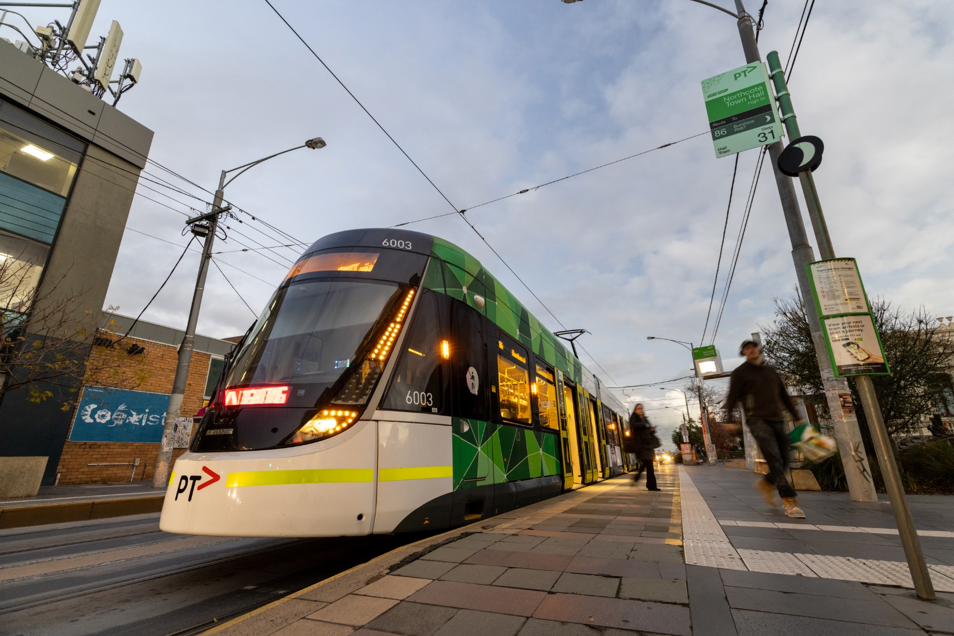

Priority Five: Workplace accessibility
Inclusive practices for employment of people with disability will create accessible work environments. The Action Plan aims to position accessibility and inclusion as fundamental values where our employees at every level embrace the inclusion of people with disability.
Through Public Transport Victoria, VicRoads, and the Department of Transport machinery of government changes, actions related to employment of people with disability are captured in DTP’s:
- Inclusion and Diversity Strategy 2019-2023
- Accessibility Action Plan 2020-2023 (internally facing), and the
- Transport and Planning Portfolio First Peoples Cultural Safety Framework: Action Plan 2024-2028
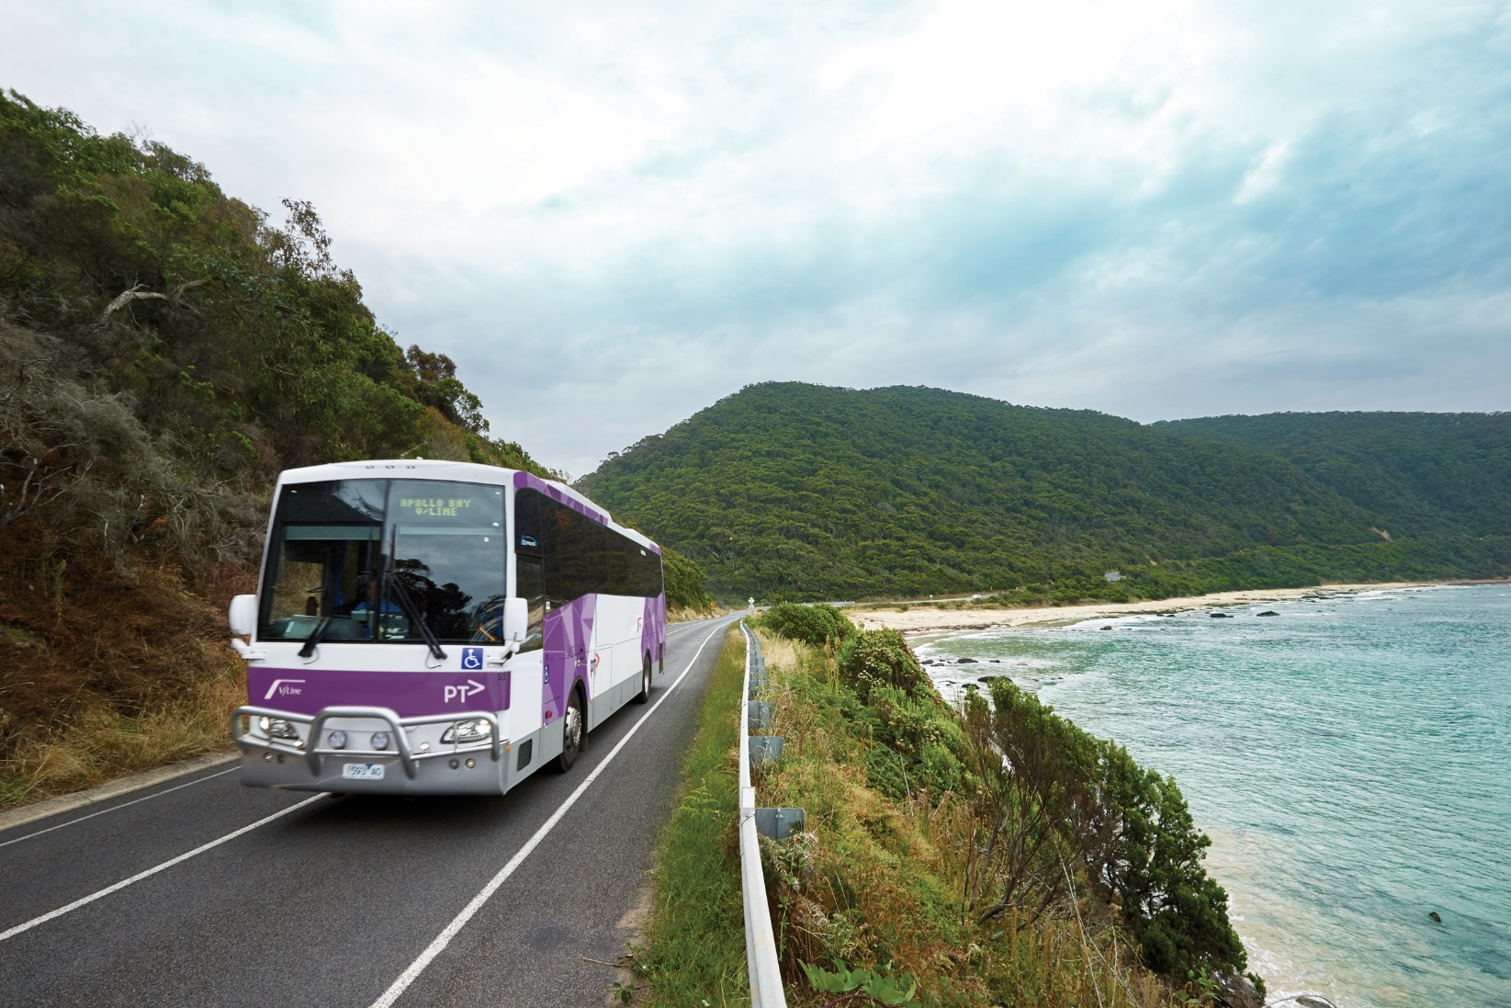
Progress on these strategies and action plans is reported back through relevant internal executive governance committees and in DTP’s Annual Report.

