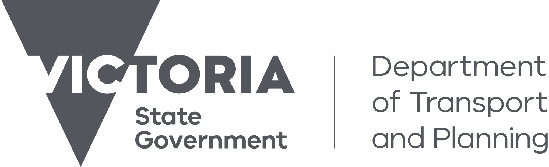
Accessibility Action Plan 2025-2029
Summary
[Meeting Name or Title]

Contents
Why we need the plan 2
What is in the plan 2
Vision 2
Actions from 2025 to 2029 3
Key Actions 4
Priority One: Assets 5
Priority Two: Journeys, Systems and Services 6
Priority Three: Organisation Culture and Public Behaviour 7
Priority Four: Information and Innovation 8
Implementation 9
More information 9

Why we need the plan
The Accessibility Action Plan 2025-2029: Towards Equitable Journeys and Communities (the Action Plan) is the Department of Transport and Planning’s (DTP) plan to make transport, planning, land, precinct and building inclusive and accessible for everyone.
The Disability Act 2006 (Victoria) says we must make a new disability action plan every four years. The DTP Accessibility Action Plan lists actions that help ensure we follow the United Nations Convention on the Rights of Persons with Disability.
This new action plan also helps us achieve what we want to under other national and state disability law and strategies.
We developed this plan with help from people with disability, including the Accessible Transport Advisory Committee and the Chief Accessibility Advocate. We also met with our major public transport operators, and transport and planning partners.

What is in the plan
The Action Plan includes activities that DTP will do to improve community inclusion.
The Action Plan is different to other DTP strategies and plans, such as DTP’s inclusion and diversity strategies, which sets out what we are doing to support our staff and create accessible work environments.

Vision
Our transport and planning system inspires confidence, values all users, and is easy to use. This means that all people, including people with disability:
- Have trust and confidence to use our services and information,
- Feel respected and understood and can choose how they engage with us, and
- Feel comfortable and safe from end to end of their journey or engagement with our services and information.
Our Transport Accessibility Strategic Framework has helped us develop this Action Plan. The Framework tells us how we can address accessibility gaps and improve the transport and planning experience for all users. The Framework was designed with people with disability.
We have organised the Action Plan around the four directions in the framework:

Assets
- We prioritise new and upgraded infrastructure and trains, trams and buses to address the biggest challenges to accessibility.

Journeys, Systems and Services
- We connect different services and explore different ways to improve accessibility.

Organisation Culture and Public Behaviour
- We create a positive experience for all people using our infrastructure, trains, trams and buses, systems and services.

Information and Innovation
- Our information is reliable and can be accessed by all people in a way that suits them.

Actions from 2025 to 2029
The Action Plan has many actions for DTP to deliver accessible, safe and connected transport, planning, housing, building and land use systems. Each action has an:
- Outcome, which tells us what we want to achieve
- Measure, which tells us how we know whether we have achieved something
- Timeframe, which provides a date to complete the action by.
A summary of these actions is provided below in table format. Not every individual action has been included. Some actions that are similar have been combined.
There are some words in this Plan that are used by people working in transport and planning that may not be familiar to the community. We have included some definitions below:
- Accessibility/Accessible: How easily a product, device, service or environment can be used by everyone.
- Assistance animal handler: A person who uses an animal to assist them to go about their day-to-day activities, such as travelling to work or meeting with friends. Assistance animals are often dogs but may be another type of animal.
- Authorised Officer: A person employed by a public transport operator to check tickets, provide passenger information, improve safety and help during special events.
- Precinct: A contained place or area, often where housing, transport, business and recreation are located.
- Wayfinding: How people find their way and move between different places.

Key Actions
Four key actions are highlighted as focus areas for DTP to deliver in this Action Plan:
- The scope of the Accessible Transport Advisory Committee’s (ATAC) advice.
- A review of the Strategic Framework.
- Developing options to address assistance animal handler refusals.
- Delivery of accessibility services, including the Parkville Station pilot.

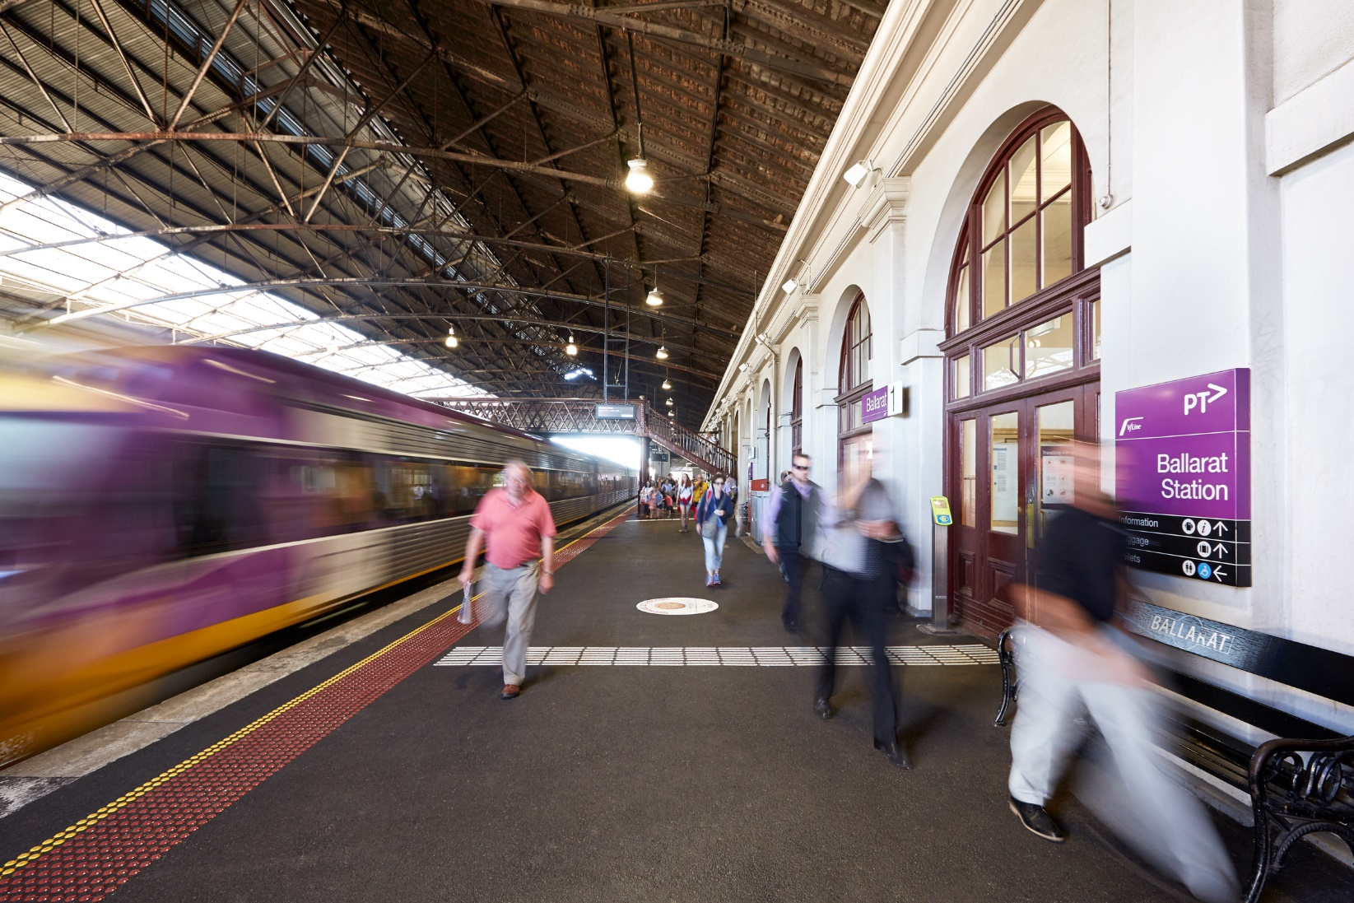

Priority One: Assets
Area | Summary of Actions
Trams and tram stops | Build new trams with improved accessibility features so that more people can access the tram network.  Plan for and deliver upgrades to tram stops to improve safety.
Train stations | Plan for and deliver upgrades to train stations to improve safety.
Bus stops | Design and build accessible bus stops.
Heritage infrastructure | Develop guidance for disability access to heritage listed stations and other transport infrastructure.
Precincts | Build accessibility into the design requirements to deliver precincts in Sunshine, Albion and Arden.
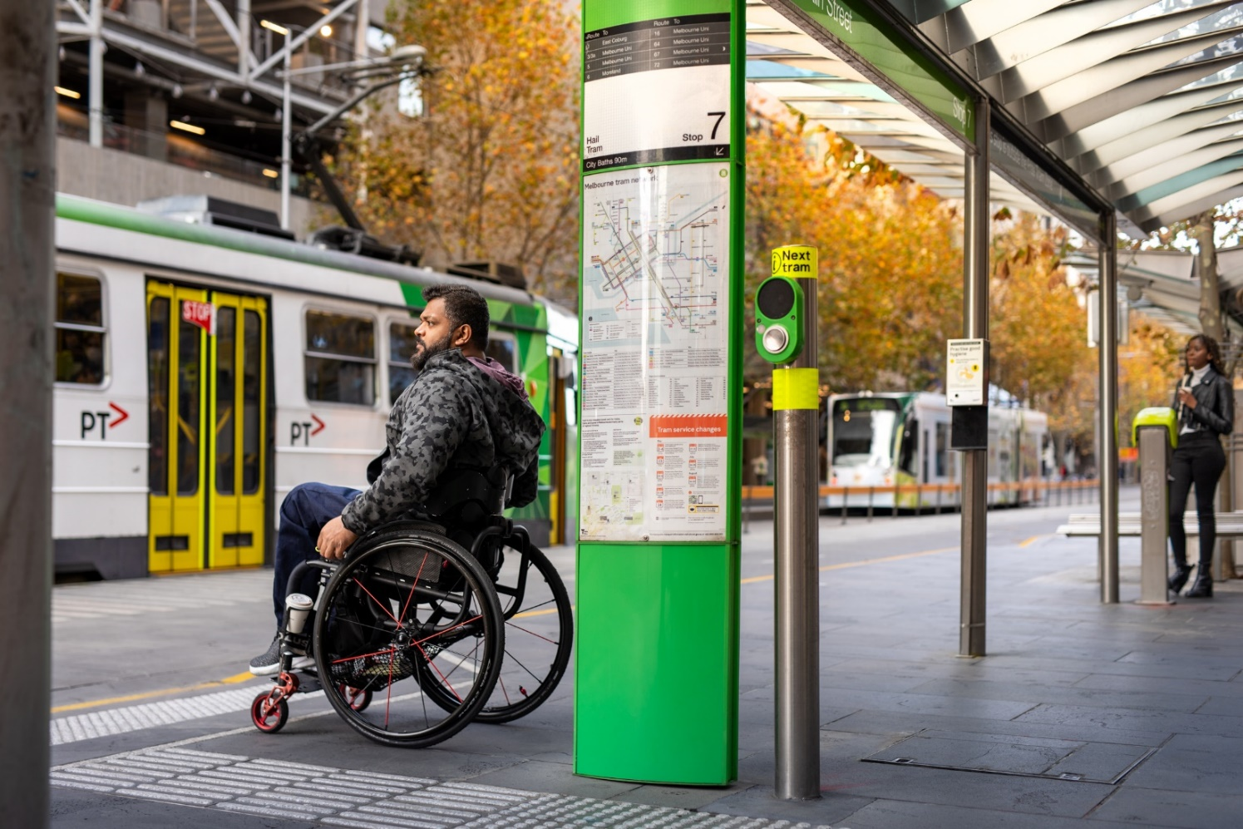

Priority Two: Journeys, Systems and Services
Area | Summary of Actions
Digital | - Ensure digital products are accessible. This includes:  - Completing accessibility testing,  - Reviewing the accessibility of digital products when they are upgraded or replaced, and  - Ensuring accessibility support is provided to DTP staff.
Transport planning and coordination | - Work with people with disability on our approach to tram planning.  - Better connect train stations, tram and bus stops, and service or timetable changes.  - Improve the experience of disruptions for people with disability.  - Continue to embed universal access principles in active transport planning.
Research, policy and implementation | - Make sure improvements are put in place so that people with disability can access more housing.  - Work with states and territories to agree on a way to remove barriers on the transport network for people with disability.  - Prepare a report on options to reduce platform boarding gaps at different train stations in Melbourne.  - Monitor progress of accessibility actions in major public transport operator contracts.
Public transport ticketing | - Work with the public transport ticketing system supplier to improve passenger accessibility and usability.

Priority Three: Organisation Culture and Public Behaviour
Area | Summary of Actions
Co-design, consultation and engagement | - Support the Accessible Transport Advisory Committee to amplify the lived experience of people with disability.  - Continue the Chief Accessibility Advocate role for a further three years.  - Develop resources to support DTP staff to use co-design and apply disability standards law.  - Through research and user testing with people with disability:  - Design the new public transport ticketing system, and  - Make improvements to the overall transport experience.  - Deliver inclusive information and engagement activities for Plan for Victoria consultation.  - Support all transport staff to consult with people with disability when designing and delivering major transport infrastructure projects.
Employment | - Use major public transport operator contracts to increase employment of people with disability.  - Advise DTP staff on applying the ‘opportunities for Victorians with disability’ social procurement objective when buying goods and services.
Disability awareness and confidence | - Work with our transport partners to deliver disability awareness training.  - Support public transport operators to run the Try Before you Ride program. This will help people feel more confident to use the public transport system.  - Provide digital accessibility training to departmental staff.  - Review resources for Authorised Officers to ensure that interactions with people with disability are accommodated to improve travel experiences.

Priority Four: Information and Innovation
Area | Summary of Actions
Wayfinding and Signage | - Deliver simplified signage and improved wayfinding information on trams.  - Review wayfinding and signage at train stations and nearby transport connections, such as bus stops.  - Develop new wayfinding standards and guidelines.  - Review signage for accessible meeting points at city underground train stations.  - Review passenger announcements on the public transport network.  - Develop strategies for:  - Accessible boarding points at train stations where there are both metropolitan and regional services to ensure consistency, and  - Train service naming rules for the next metropolitan train contract, informed by user testing.
Advice, guidance and engagement | - Increase departmental use of the prioritisation tool to inform advice on accessibility priorities.  - Explore engagement opportunities for infrastructure funding proposals.  - Develop policy and guidance to improve understanding of the transport disability standards.  - Deliver public transport information to passengers in regional Victoria.  - Deliver information and engagements to support people with disability in the lead up to and after the opening of the five Metro Tunnel stations.  - Review network technical standards and guidelines that support the transport disability standards.
Public transport ticketing | - Ensure digital platforms that support the public transport ticketing system meets web content accessibility guidelines.  - Develop resources for the new ticketing system in multiple languages.
Digital | - Ensure all digital products are accessible.

Implementation
We will measure the Action Plan’s success based on the impact it has on the lives of people with disability. We will track progress of actions. We will do this by reporting on work completed each year.
We will continue to consult with people with disability. What we learn will be used to review the Action Plan after two years.
We will also prepare information on work completed over all four years of this Action Plan.

More information
You can read a full copy of the Action Plan on our website: https://www.vic.gov.au/dtp-accessibility-action-plan-2025-2029
The full copy of the Plan also includes information on progress of actions in the previous Action Plan, called the Accessible Public Transport in Victoria Action Plan 2020-2024.
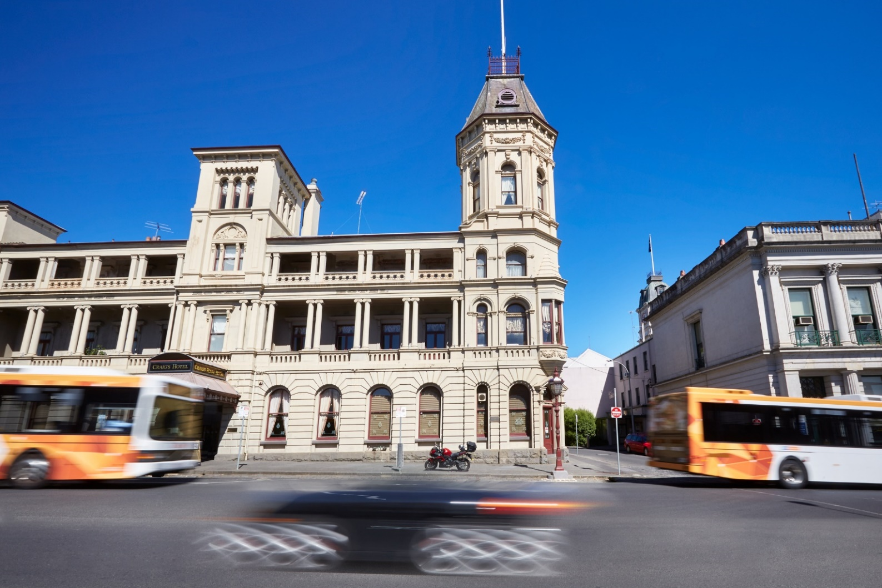
To find out more, email the Transport Accessibility and Inclusion team transport.accessibility@ptv.vic.gov.au

