Victoria’s Bushfire Management Snapshot
  - An overview of activities delivered in 2024-25
  - A broad range of actions that deliver on Victoria’s Bushfire Management Strategy
This Snapshot primarily provides information from Forest Fire Management Victoria (FFMVic), the Country Fire Authority (CFA) and Fire Rescue Victoria (FRV), however many other agencies also contribute to bushfire management across Victoria.
Table of Contents
People and community safety 3
Prevention and mitigation 3
Response 4
Fuel management 4
Aboriginal self-determination in cultural fire and bushfire management 6
Cultural burns 6
Ecosystem resilience and nature conservation 7
Ecosystem resilience 7
Seasonal Bushfire Outlook 8
Enhanced capability and capacity 8
How we’ve prepared for summer 2025-26 8
Five things you can do to reduce bushfire risk 9
Victoria’s Bushfire Management Snapshot 10
How we manage bushfire risk 12
We all have a role to play managing bushfire risk 14
Prevention and mitigation 14
Fuel management 14
Bushfire preparedness and response 15
Bushfire recovery 15
Integrating bushfire management into broader land management 15
Community action – five ways with fire 16
Publication information 18

People and community safety

Prevention and mitigation
- 425 unattended campfires detected
FFMVic responds to unattended campfires to help prevent accidental ignitions.
- 14 Total Fire Ban Days Declared
Total Fire Bans help prevent fires from starting by limiting the types of fires that can be lit and restrict or impose conditions on some high-risk activities. Total fire bans are declared by the CFA across fire districts.
- 1,945 community events and informal engagement by CFA (including CFA station Open Days)
Building community understanding and awareness of bushfire management is critical to keeping our communities safe. More information is available at: Plan & Prepare | CFA (Country Fire Authority)
- 150 children participated in a semester-long upper primary bushfire education program
Has your family discussed their bushfire survival plan? Try this template.
- 4.8% increase in online registration for private burn-offs
Victorians should be registering their burn-offs online through the Fire Permits Victoria website to help agencies manage fire risk effectively.
- 5,026 online modules completed (including Bushfire Safety for Workers)
If you are interested in learning more, and keeping you, colleagues and community safer, these resources will help you. E-learning | CFA (Country Fire Authority)
- 1,135 CFA Property Advice Visit Service assessments
Providing fire safety advice to communities which live in high fire-risk areas.

Response
- 1,371 bushfires attended by FFMVic
FFMVic attended bushfires impacting more than 251,730 ha. Information about bushfires attended by CFA and suppression performance is available in the CFA Annual Report 2024–25.
- 83% of bushfires contained on first attack by FFMVic
FFMVic also contained 92% of bushfires within 5 hectares, exceeding the suppression target of 80%.

Fuel management
- 66% modelled fuel-driven bushfire risk
Statewide modelled fuel-driven bushfire risk was 66% on 30 June 2025, with FFMVic achieving its target to maintain risk associated with bushfire fuels at or below 70% of maximum levels. (See page 9)
- 114,712 ha treated with fuel management by FFMVic and CFA
FFMVic delivered 270 planned burns treating 92,473 ha and 951 non-burn fuel treatments (mainly slashing and mowing), treating a further 17,465 ha. The total investment in FFMVic fuel management program was $159.8 M.
This year CFA completed 44 mechanical fuel management treatments and volunteers completed 202 planned burns. A total of 4,774 hectares were treated.
- 300+ CFA volunteers participated in the planned burn taskforce
The taskforce supports local crews in delivery of planned burns that reduce fuel loads and the intensity of bushfires.
- Fuel management on roadsides
The Department of Transport and Planning (DTP), councils and FFMVic with the support of CFA manage roadside vegetation on priority routes to reduce the likelihood of fires igniting and spreading, improve the safety of firefighters responding to bushfires and communities leaving the area.
- 1,072km of fuel breaks maintained
FFMVic maintained more than 1,072 km of existing fuel breaks to ensure they remained fit-for-purpose and constructed an additional 6.9 km to the network. Strengthening and expanding the fuel break network is a key strategy to make it easier, faster, and safer for firefighters to suppress bushfires and complements other fuel management works.
- 2,236km of strategic fire access roads improved by FFMVic
FFMVic also replaced or upgraded 10 bridges or crossing supporting firefighters to rapidly and safely access and suppress new bushfires.

Aboriginal self-determination in cultural fire and bushfire management

Cultural burns
- 31 Cultural Burns were delivered in partnership
FFMVic and CFA partner with Victorian Traditional Owners to deliver cultural burns. This includes a record number of cultural burns (104) nominated to year 1 of the Joint Fuel Management Plan (JFMP) bringing the total number of cultural burns planned to 211.

Ecosystem resilience and nature conservation

Ecosystem resilience
- 29% vegetation within Tolerable Fire Interval
- 38% vegetation in mature and old growth stages
Vegetation on public land within its Tolerable Fire Interval (TFI) has been maintained at 29% from the previous year. Vegetation in the mature and old growth stages decreased slightly in 2024–25 (39% in 2023–24).
- 27 ecological burns delivered by FFMVic
Ecological burns have a primary objective to improve the health of our ecosystems and reduce the intensity and potential destructive impacts of bushfires on our native flora and fauna.

Seasonal Bushfire Outlook
Victorian bushfire agencies monitor seasonal conditions and bushfire outlooks closely and take action accordingly. The Australasian Fire and Emergency Services Authorities Council (AFAC) has coordinated preparation of a seasonal Bushfire Outlook that identifies areas of increased risk in south west, western, central and north-central Victoria, as well as south-west Gippsland. The seasonal outlook is available at: AFAC Seasonal Bushfire Outlook

Enhanced capability and capacity

How we’ve prepared for summer 2025-26
- 28,000+ CFA volunteers (operational)
- 1,520 Frontline FFMVic staff, supported by hundreds more emergency & incident management staff
- 84 Incident Controllers (Level 3) across the sector
- 595 FFMVic water-carrying firefighting vehicles
FFMVic also has 444 transport vehicles for mobilising personnel and equipment. As of 1 December, some water-carrying vehicles are offline pending repairs. Fire agencies have assessed bushfire risk and the required firefighting strategies. Sufficient vehicles will be available across the season to manage required levels of emergency preparedness when combined with firefighting strategies.
FFMVic and CFA firefighting resources are part of Victoria’s broader bushfire response capabilities complementing resources from, Victoria State Emergency Service, Fire Rescue Victoria and Emergency Management Victoria.
- 54 Victorian contracted aircraft
Additionally, there are 5 National aircraft available on request and 100+ aircraft available via a call-when-needed panel of providers.
- 58 FFMVic bulldozers
940+ pieces of plant are available via a call-when-needed panel of providers.
- 147 new CFA emergency response vehicles delivered
For information on CFA appliances and resources, visit CFA at a Glance.
Figures as at 1 December 2025

Five things you can do to reduce bushfire risk
- Visit fireplanner.vic.gov.au to get started on a bushfire plan
- Download and get to know the VicEmergency app
- Get to know the Australian Fire Danger Ratings System
- Plan your travel – head to exploreoutdoors.vic.gov.au to help you stay safe when visiting state forests
- Never leave a campfire unattended – if they are cool to touch, they are safe to leave

Victoria’s Bushfire Management Snapshot
An overview of regional and state bushfire risk as at 30 June 2025, accounting for how bushfire and planned burning has reduced risk from maximum values
Figure 1: 2024-25 Fuel-driven Bushfire Risk
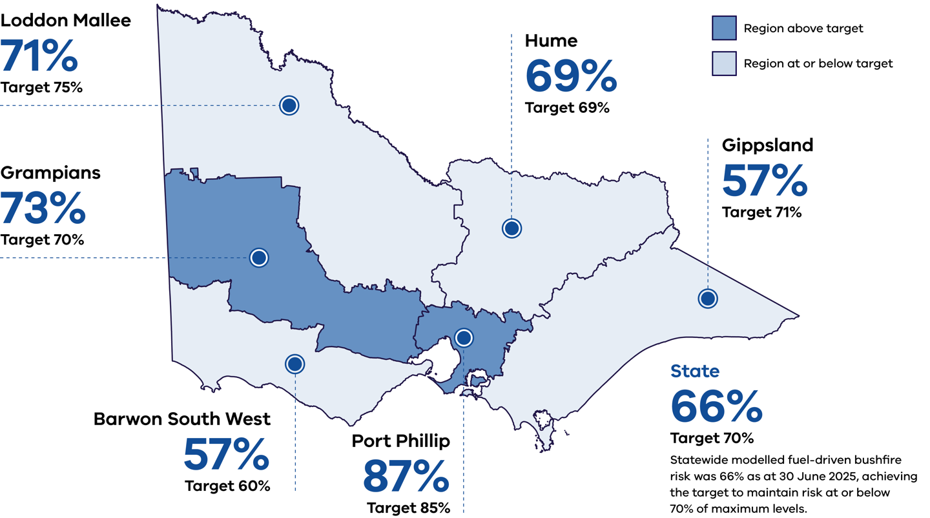
Table 1: Fuel-driven Bushfire Risk by Region (2024–25)
Region | Modelled Risk (%) | Target (%) | Status (Above / At or Below Target)
Loddon Mallee | 71% | 75% | At or below target
Grampians | 73% | 70% | Above target
Hume | 69% | 69% | At or below target
Gippsland | 57% | 71% | At or below target
Barwon South West | 57% | 60% | At or below target
Port Phillip | 87% | 85% | Above target
Statewide (Victoria) | 66% | 70% | At or below target  Statewide modelled fuel-driven bushfire risk was 66% as at 30 June 2025, achieving the target to maintain risk at or below 70% of maximum levels.

How we manage bushfire risk
Figure 2: Activities that reduce the risk of bushfires include:
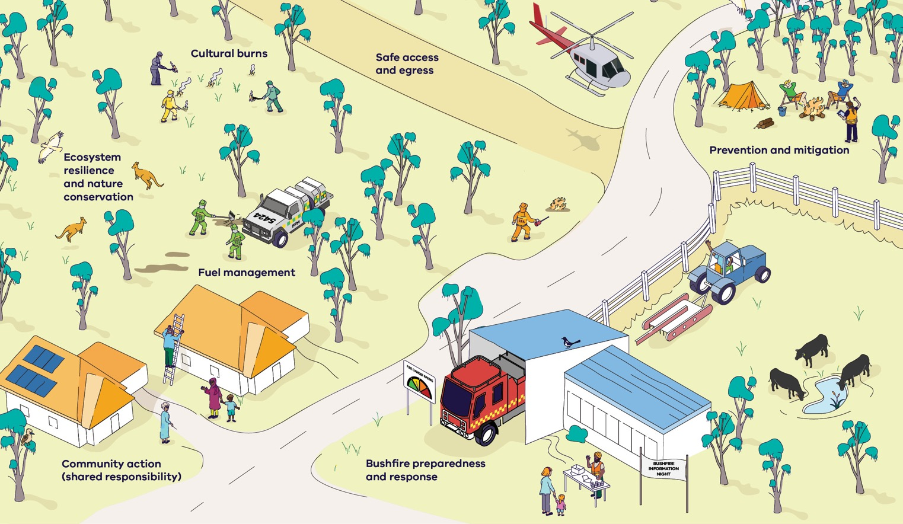
Table 2: How we manage bushfire risk – Activities that reduce the risk of bushfires
Activity / Theme | Description of Depicted Actions
Cultural burns | Indigenous fire practitioners conducting small, low-intensity cultural burns on forested land.
Ecosystem resilience and nature conservation | Wildlife such as kangaroos and birds present in a healthy forest environment; land appears managed for ecological health.
Fuel management | Fire agency staff assessing the landscape and undertaking controlled burning or fuel-reduction activities near trees and bushland.
Safe access and egress | A maintained access track through bushland and a helicopter landing area indicating support for safe entry and exit during bushfires.
Prevention and mitigation | Community members setting up a campsite and maintaining land; a tractor and farm equipment used for land preparation to reduce risk.
Community action (shared responsibility) | Residents preparing their homes — such as cleaning gutters and interacting with neighbours — showing community-based risk reduction.
Bushfire preparedness and response | A fire truck and fire station with a fire-danger rating sign; community members attending a “Bushfire Information Night” outside the station.

We all have a role to play managing bushfire risk
Many people know that in Victoria we use planned burning to manage bushfire risk. But this is not our only tool – and bushfire management is not just the responsibility of land and fire, and emergency service agencies. It is everyone’s responsibility and everyone can play a role in reducing their bushfire risk.
This infographic shows you some of the different ways Victoria manages bushfire risk.

Prevention and mitigation
- Declaring and enforcing Total Fire Ban Days, Fire Danger Periods and campfire compliance controls to prevent ignitions
- Closing forests and parks when conditions would make them dangerous to enter
- Setting and administering land use planning and building standards to reduce bushfire exposure
- Working with community, business and industry to help them understand bushfire and how they can take steps to reduce their own risk

Fuel management
Fuel management is an activity that reduces the vegetation available to 'fuel' a fire. As well as planned burning on public land, fuel management in Victoria includes:
- Planned burning on private and council-managed land, including burning along roadsides to allow firefighters access to bushfires when they do occur, and to help communities leave safely
- Non-burn fuel treatments, including slashing and mowing
- Removing storm debris
- Constructing and maintaining strategic fuel breaks

Bushfire preparedness and response
- Maintaining fire access roads and bridges to help crews respond quickly
- Training, maintaining equipment and pre-positioning aircraft and firefighters
- Watching out for new fires and responding rapidly and aggressively, including through use of rappel crews
- Keeping communities informed through advice and emergency warnings
- Having a well-trained workforce of volunteers and staff to respond to bushfires on the frontline and as part of incident management and support teams

Bushfire recovery
- Working to ensure infrastructure is safe, so evacuated communities can return quickly
- Working with communities and businesses to support recovery from bushfire. The aim is to minimise the social, economic and environmental consequences of bushfires

Integrating bushfire management into broader land management
In taking actions to prevent and suppress bushfires, Victoria’s bushfire sector considers broader land management objectives for different landscapes across the State.
In addition to the strategies above, complementary actions include:
- Delivering ecological burns to maintain healthy and resilient ecosystems
- Supporting Traditional Owners to reintroduce cultural fire for a range of land management objectives, which also reduces fuels and bushfire risk

Community action – five ways with fire

Get started on a Bushfire Plan
Use sites such as cfa.vic.gov.au/plan-prepare or http://fireplanner.vic.gov.au/ to learn some bushfire basics and to start building your Bushfire Plan. Start thinking about where and when you will go, who you will go with and what you will take.

Download and get to know the VicEmergency app – then set up ‘watch zones’ and turn on notifications to be kept up to date wherever you are
Emergency warnings can help you choose whether and when to leave and give you time to follow your bushfire plan. Agencies work year-round to maintain tracks and roads that will help access and egress in case of a fire, but it’s still always safest to leave early.

Get to know the Australian Fire Danger Ratings System
There are four ratings – Moderate, High, Extreme and Catastrophic.
Work out what fire danger rating will trigger your Bushfire Plan.
If the Fire Danger Rating is Catastrophic or Extreme you’re risking your life if you wait and see.

Plan your travel – head to exploreoutdoors.vic.gov.au to help you stay safe when visiting state forests
Government and agencies have a range of resources available online to help you navigate what you need to do if you are travelling or away from home. Sites such as Explore Outdoors and Parks Victoria have tips and advice for people visiting state forestsand national parks.

Never leave a campfire unattended – if they are cool to touch, they are safe to leave.
Under the Country Fire Authority Act 1958 It is an offence to leave a campfire unattended. The Office of the Conservation Regulator carries out compliance patrols to make sure people are acting safely in our forests and national parks. But you can help too: if a campfire is cool to touch, it is safe to leave.

Publication information

Acknowledgements
We acknowledge and respect Victorian Traditional Owners as the original custodians of Victoria’s land and waters, their unique ability to care for Country and deep spiritual connection to it.
We honour Elders past and present whose knowledge and wisdom has ensured the continuation of culture and traditional practices.
DEECA is committed to genuinely partnering with Victorian Traditional Owners and Victoria’s Aboriginal community to progress their aspirations.

Copyright
© The State of Victoria Department of Energy, Environment and Climate Action, December 2025.

Creative Commons
This work is licensed under a Creative Commons Attribution 4.0 International licence, visit the Creative Commons website (http://creativecommons.org/licenses/by/4.0/).
You are free to re-use the work under that licence, on the condition that you credit the State of Victoria as author. The licence does not apply to any images, photographs or branding, including the Victorian Coat of Arms, and the Victorian Government and Department logos.

Disclaimer
This publication may be of assistance to you but the State of Victoria and its employees do not guarantee that the publication is without flaw of any kind or is wholly appropriate for your particular purposes and therefore disclaims all liability for any error, loss or other consequence which may arise from you relying on any information in this publication.

Accessibility
To receive this document in an alternative format, phone the Customer Service Centre on 136 186, email customer.service@delwp.vic.gov.au, or contact National Relay Service on 133 677. Available at DEECA website (www.deeca.vic.gov.au).
End of document.

