Independent Review of the Victorian Public Service
Final Report

June 2025

Acknowledgement of Country
The Independent Review acknowledges that Aboriginal and Torres Strait Islander peoples are the First Peoples and Traditional Custodians of Australia, and the oldest continuing culture in human history. We proudly acknowledge Victoria’s Aboriginal communities and recognise the value and ongoing contribution of Aboriginal people and communities to Victorian life. We pay our respect to Elders past and present.

Letter of transmission
3 Treasury Place
East Melbourne VIC 3002

Jaclyn Symes MP
Treasurer
1 Treasury Place
East Melbourne VIC 3002

Dear Treasurer

I have pleasure in submitting to you the Final Report of the Independent Review of the Victorian Public Service.

Yours sincerely

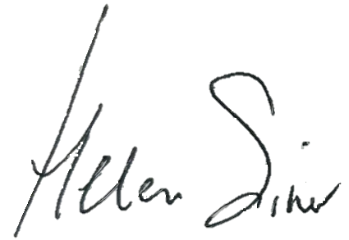

Helen Silver AO
Independent Reviewer

Independent Reviewer’s foreword

I was honoured to be asked by the Treasurer to undertake a broad ranging review of the Victorian public sector and its operating environment.
In undertaking the Review my focus was on improving the delivery of core services and finding opportunities to create more budget capacity.
My review provides advice to the government on how to set up the budget process for the future, including an ongoing cycle of review to improve service quality and sustainability. I also recommend ways to accelerate the uptake of digital platforms to provide contemporary, convenient and cost-effective services to the community.
Done well, spending reductions can lead to better outcomes. To find savings, there was a systematic examination of the objectives and outcomes of programs, the structure and size of the VPS, and the organisation of Victoria’s public entities.
In doing this important work, I was supported by a terrific team of talented and committed secondees from the Department of Premier and Cabinet and the Department of Treasury and Finance, as well as other crucial members.
I have always been a proud Victorian, and that pride has deepened over the past 4 months. It was a privilege to work with ministers and the Victorian Public Service again. I was reminded of how important the work of the Victorian public sector is, and I was impressed by the immense effort that individuals put in every day to make a complex system run as well as it can for the benefit of our community.
Helen Silver AO

Contents
Acknowledgement of Country ii
Letter of transmission iii
Independent Reviewer’s foreword v
Chapter 1: Executive summary 1
1.1 Summary of Review recommendations and savings 5
Chapter 2: The opportunity of this Review 15
2.1 Introduction 15
2.2 Context for the Review 17
2.3 Review approach 27
2.4 Methodology 28
Chapter 3: Fiscal management and strategy 31
3.1 Introduction 31
3.2 Principles for strong public sector financial management 32
3.3 The government’s fiscal strategy 33
3.4 Enhancing Victoria’s budget management processes 34
3.5 Recommendations 44
Chapter 4: Commonwealth-State relations 45
4.1 Introduction 45
4.2 Importance of Commonwealth funding to state revenue 46
4.3 Overlapping responsibilities and duplication 50
4.4 Reform of Commonwealth-State settings 51
4.5 Recommendations 56
Chapter 5: VPS size and structure 59
5.1 Introduction 59
5.2 VPS and public sector workforce growth 60
5.3 Spans and layers: good organisational design 64
5.4 Workforce reductions and rebalancing 66
5.5 Need for improved data 67
5.6 Executive government/VPS protocol 67
5.7 Capability reviews 68
5.8 Implementation 70
5.9 Recommendations 71
Chapter 6: Public entity reform 73
6.1 Introduction 73
6.2 Assessment framework for public entities 75
6.3 Reducing the number of public entities 76
6.4 Ongoing administration and oversight of public entities 87
6.5 Implementation 89
6.6 Recommendations 90
Chapter 7: Accelerating digital capability 91
7.1 Introduction 91
7.2 The role of the Department of Government Services 92
7.3 Conditions for successful reform 92
7.4 Digital reform priorities 93
7.5 Implementation 99
7.6 Recommendations 102
Chapter 8: Portfolio and other reforms 103
8.1 Introduction 103
8.2 Opportunities for portfolio reforms – case studies 104
8.3 Additional savings opportunities 110
Chapter 9: Implementation of the Review 117
9.1 Urgency for change 117
9.2 Need for a dedicated implementation approach 117
9.3 Implementation governance 118
9.4 Immediate priorities 119
9.5 Recommendations 120
Appendix A: Terms of Reference 123
Appendix B: Departmental summaries 125
Appendix C: Public entity reform 137
Abbreviations and glossary of key terms 151

Chapter 1: Executive summary

The Victorian community is well-served by its public service and public sector. Victoria’s economy is resilient, and Victorians generally enjoy high quality services.
In addressing its Terms of Reference, the Independent Review of the Victorian Public Service (VPS) has started from principles of strong public financial management and good public policy. The Review has taken a big picture view – the current context of the Victorian Government’s operating expenditure and its challenges, the government’s current fiscal strategy and financial management approach, the size and shape of the VPS and the public sector, and their systems, processes and culture. These are important considerations for the Review to be able to give advice about right-sizing program expenditure, consolidating public entities, and returning the VPS towards its pre-pandemic share of employment.
In total, the Review makes recommendations that amount to savings of around $5 billion over 4 years from
2025–26. This includes a reduction of more than 2,000 ongoing FTE in the VPS and public sector. These savings are a cumulative total from the Review’s interim recommendations supported by the government for inclusion in the 2025/26 Victorian State Budget, and in this Final Report.
More significantly, this report provides a map for a reset of the machinery of government – some of its systems, practices and processes, the role and number of public entities, and the size and structure of the public service. Doing fewer things and doing them better; making sure that public spending is invested well.
The intent is to assist the government, VPS and public sector to be for fit for purpose and equipped for the future, so that it can continue delivering high-quality core services for all Victorians, at the most efficient price.

Strong financial management
Strong financial management enables government to deliver on its objectives while supporting the community, business and the economy. The Victorian Government is committed to responsible financial management and has established a 5-step fiscal strategy. Recent budget papers show the government is on track to achieve all steps by the end of the forward estimates.
The government’s fiscal management and strategy are sound but should be enhanced to help create more operating budget capacity and opportunities to focus on base funding. Sustainable savings programs must be linked to overall fiscal management to create more ongoing operating budget capacity.
In Chapter 3 of this report, the Review proposes a set of financial management operating principles to help improve financial insights and management. The Review also recommends an enhanced annual budget process with tighter guardrails, such as a single window of annual budget decision-making and increased scrutiny of the existing base spend. This would support the government to achieve its fiscal strategy and improve the operational effectiveness, efficiency and quality of government service delivery.

A more strategic approach to Commonwealth-State relations
Strong Commonwealth-State relations are critically important to the state’s finances and ongoing operating budget capacity. Victoria’s share of Commonwealth government funding relative to its population share has been consistently below that of other large states, particularly for health and infrastructure. Victoria has also made decisions to fund services that are the responsibility of the Commonwealth, for example, in primary health care, to address Commonwealth service failures and gaps.
Chapter 4 discusses why strategic engagement with the Commonwealth government is essential to address the deep fiscal imbalance and address the inequities of distribution. As part of a more strategic approach, the Review recommends a new Commonwealth-State relations strategy, active pursuit of improved data sharing arrangements, and transitioning out of duplicative service provision. Better data will be key to the state being able to consider in the future how it can better target spending to address need in the community.

Rebalancing the size and structure of the VPS
The VPS is employed to deliver on the government’s commitments, and it is a capable and dedicated workforce. While overall VPS growth has stabilised in recent years, the VPS workforce has become top-heavy. This type of structure is costly, decisions are slower, staff are disempowered, and innovation is stifled. Better workforce data is needed for improved workforce planning and financial control.
Departments’ management structures need systematic streamlining to ensure resources are utilised in the most efficient and effective way. Chapter 5 discusses resetting the size and structure of the VPS. This starts with a disciplined model of increased spans of control and reduced layers of hierarchy, using the management ratios from 2019 and a model structure of spans and layers. The Review recommends removing 332 Senior Executive Service (SES) and Senior Technical Specialist (STS) roles from across departments and some large entities. The Review also recommends rebalancing VPS5 and 6 positions as a proportion of the VPS workforce towards more junior classifications, over a
4-year period.
The Review recommends a renewed approach to working between the VPS and the executive arm of government and establishment of forward-looking capability reviews so that departments are equipped to deliver on the government’s priorities. An enhanced Victorian Public Sector Commission (VPSC), supported by the Department of Premier and Cabinet (DPC), has an important role to play in this.
Executive and STS reductions and VPS rebalancing would save $484 million over 4 years from 2025–26 and reduce staffing by 332 full-time equivalent positions (FTE).

Major reform for public entities
Victoria’s more than 500 public entities and 3,400 boards and committees are costly and unwieldy. These arrangements come at a substantial, direct and indirect cost to government. Victorian public entities are estimated to have a total of around $35 billion in annual operating expenditure and there has been disproportionate growth in staffing in public sector entities and VPS non-departmental entities over the past 5 years. These arrangements also make government more difficult to deal with for citizens and business.
The Review finds there are substantial opportunities to reduce and streamline entities and their staff numbers through carefully targeted cessation, merging and streamlining. In Chapter 6, the Review recommends a major package of reform that would reduce the number of public entities by 78 and cease up to 90 advisory committees. This includes significant reforms to the regulatory system, water and land management, policy advice and research, and funds management.
Improved administration and oversight of entity establishment and governance are also needed, including default sunset dates for entities that have fulfilled their purpose, better data collection and regular reviews.
Entity reform would save $427 million over 4 years from 2025–26 and reduce 536 ongoing FTE in the VPS and public sector.

Accelerating digitisation and the adoption of Artificial Intelligence (AI)
Victorians expect government services to be easy to interact with. Too often though, they must repeat information, navigate complex systems, or wait for manual approvals. Public servants also lose time navigating bespoke and fragmented systems. More than 40 per cent of departments’ core systems and platforms are approaching their end of life.
Chapter 7 discusses the major opportunity for the government to modernise its delivery of services. This is system reform, not a technology project. The Review recommends a staged, platform-enabled shared service reform model, led by a refocused Department of Government Services (DGS), to digitise repeatable transactional services across customer services, regulatory functions, corporate services and enabling infrastructure. These changes could better meet service demand, save money, address public sector workload issues, and improve the quality of services to the community.
Safe and effective use of AI can lift public sector productivity by automating routine tasks, supporting better decisions, and freeing up time for higher-value work. The Review recommends establishing an AI Centre of Excellence in DGS, with a mandate to harness safely the benefits of AI for the VPS and public sector workforce, and the community.
These reforms would save $94 million over 4 years from 2025–26 and reduce 197 ongoing FTE.

Further opportunities for reform and savings
The Review provided interim recommendations to the government ahead of the 2025/26 Budget. These contributed $2.8 billion of savings over 4 years from 2025-26 and 619 ongoing FTE reductions to the government’s overall savings and efficiencies in the Budget.
In the time available, the Review considered some high expenditure program areas and has identified additional reforms and savings where functions are currently duplicated across government, the state has expanded its role into areas of others’ responsibility, or spending can be managed more efficiently. Chapter 8 describes opportunities for reforms to Early Learning and Childcare Centres, industry support, Technical and Further Education (TAFE) shared services and VPS accommodation, among others. These reforms result in a further $1.2 billion in savings over 4 years from 2025–26 and a reduction of 384 ongoing FTE.
The recommended reforms also demonstrate the importance and feasibility of regular review of recurrent expenditure, as part of enhanced financial management through the annual budget cycle.

Implementation must be focused and prioritised
The hard work of implementing recommended changes will need to begin immediately to realise the benefits of increased budget capacity and a more streamlined and effective public sector. Implementation will need to proceed thoughtfully and respectfully.
Chapter 9 outlines the importance of a dedicated approach to implementation to bring the required focus, clarity and priority to recommended changes. Dedicated resources will be needed in central agencies and in each department, and
unnecessary or lower-priority demands will need to be removed – or put on hold – for sufficient organisational bandwidth to focus on the reforms. The leadership of Secretaries and VPS leaders will be critical.
The Review recommends establishing a reform delivery unit in the Department of Treasury and Finance (DTF) to plan and monitor implementation, and to coordinate efforts across government. Strong oversight will be needed through the Victorian Secretaries’ Board (VSB) and the government’s budget committee. Transparent reporting of progress against milestones will be critical to maintain momentum and ongoing success. The Review also sets out some of its recommended early priorities for 2025–26, including the new Commonwealth-State relations strategy, first stage entity reform, and detailed planning for shared services reform.
Getting started on implementation and moving at pace will be important for early gains and to build momentum and confidence for reform.

1.1 Summary of Review recommendations and savings

The Review makes 52 recommendations in this Final Report to achieve improved operating budget outcomes through program savings, VPS restructuring, entity reform, enhanced budget processes, digitisation and service reform. In total, the Review’s recommendations would achieve around $5 billion in savings and a reduction of more than 2,000 ongoing FTE (Figure 1.1).
The Review’s Final Report recommendations are outlined, by chapter, in Figure 1.2. This includes recommended accountability of departments for implementation, following government decision-making.

Figure 1.1: Total recommended savings and FTE reductions
 | Savings  2025–26 to 2028–29  ($ millions) | Ongoing FTE  (VPS and public sector)
Supported in 2025/26 Budget | 2,762 | 619
VPS size and structure | 484 | 332
Public entity reform | 427 | 536
Accelerating digital capability | 94 | 197
Portfolio and other reforms | 1,214 | 384
Total | 4,981 | 2,068

Figure 1.2: Recommendations and implementation accountability, by chapter
Chapter 3: Fiscal management and strategy
Recommendation |  | Accountability
3.1 | Actively apply enhanced financial management operating principles to support strong fiscal management. | DTF
3.2 | Commit to consistently applying 10 enhanced financial management rules, across 4 distinct phases each year, to deliver on the fiscal strategy:  - Strengthen and embed an annual budget plan that aligns with longer-term planning at the start of the annual budget cycle.  - Limit all new resource allocation decisions to the annual budget decision window.  - Reinforce current practice that decisions on funding must be supported by robust information and business cases that meet DTF’s Investment Life Cycle guidelines.  - Embed a planning and review window in the annual budget cycle.  - Expand systematic expenditure evaluations in the annual budget cycle.  - Hold Secretaries and CEOs to account for their departmental and entity financial performance as part of the annual budget cycle.  - Replace the General Efficiency Dividend (GED) in the savings framework by embedding more systematic evaluation and discrete savings targets in each budget.  - Reduce the number of fixed-term funded programs.  - Mandate and deliver public sector financial training for executives.  - Embed systematic job rotation for financial officers between DTF and other departments. | DTF

Chapter 4: Commonwealth-State relations
Recommendation |  | Accountability
4.1 | Develop an overarching Commonwealth-State relations strategy for more effective strategic engagement, to unlock funding and savings, and to have a more proactive role in national reform. | DPC
4.2 | Continue to highlight the major consequences for Victoria and other states and territories of the Commonwealth’s Western Australia Goods and Services Tax (GST) agreement, and work with states and territories to maintain the Commonwealth no-worse-off guarantee. | DPC / DTF
4.3 | Strengthen strategic capacity in the central agencies for Commonwealth-State relations work. | DPC / DTF
4.4 | Identify current Victorian-funded activities that fall under Commonwealth responsibility and develop options to withdraw or divest from these programs. | DTF
4.5 | Advocate to the Commonwealth to fully fund Victoria’s 12 state-funded Urgent Care Clinics. | DPC
4.6 | Advocate strongly for better data sharing to improve the ability of states and territories to better target programs and tax expenditures that address disadvantage and cost of living pressures. | DPC / DTF
4.7 | Advocate for the Commonwealth to recommence state and territory funding from the DisabilityCare Australia Fund, which is funded by the Medicare levy increase to support the provision of disability services. | DPC / DTF
4.8 | Advocate for a renewed national approach and related incentives that can improve services and drive private and public sector productivity in Victoria and nationally. | DPC

Chapter 5: VPS size and structure
$484 million savings from 2025–26 to 2028–29; 332 ongoing FTE reduction
Recommendation |  | Accountability
5.1 | Reduce SES and STS roles by 332 FTE in departments and some large entities, capped at 15 per cent for departments, to return towards 2019 executive to staff ratios. | All Secretaries
5.2 | Rebalance the proportion of VPS5 and VPS6 positions, capped at 15 per cent, towards pre-pandemic profiles that included more staff at junior classifications, and create space for additional graduate positions. | All Secretaries
5.3 | Require Secretaries, in implementing staff and salary reductions, to:  - Restructure departments with a view to removing layers and widening spans of control, consistent with principles of good organisational design, including removal of any non-standard roles not aligned to a level in the classification structure.  - Adopt new ways of working and delegating that remove excessive layers of clearance. | All Secretaries
5.4 | Improve VPS employee data systems by introducing a workforce identifier. | DGS / VPSC
5.5 | Establish and implement a protocol between the executive government and the VPS that defines roles, recognises capacity constraints, and promotes shared stewardship of government effectiveness. | VPSC / DPC
5.6 | Establish and invest in a VPS capability review program, commencing with a review of DGS. | VPSC / DPC
5.7 | Task and equip the VPSC, supported by DPC, to play a stronger VPS workforce strategy development role, including:  - Designing and leading the implementation of a capability review program  - Issuing new guidance on organisational design  - Disseminating advice on work value and re-sizing roles  - Monitoring departments’ implementation (in partnership with DTF) of the structural changes recommended by the Review. | VPSC / DPC

Chapter 6: Public entity reform
$427 million savings from 2025–26 to 2028–29; 536 ongoing FTE reduction
Recommendation |  | Accountability
6.1 | Reduce the number of public sector entities by 78 through a process of consolidation and removal, including:  - Regulatory system reform  - Water and land management reform  - Policy advice and research  - Funds and investment management  - Abolishing some entities and ceasing their functions  - Absorbing the functions of entities into departments or other bodies  - Merging entities with overlapping functions. | DPC
6.2 | Confirm the need for 90 advisory committees, with the assumption that 90 per cent will cease and other mechanisms could be utilised if a need for external advice exists. | DPC
6.3 | Pursue a pragmatic approach to entity changes by taking early administrative actions to start realising reform and savings while developing appropriate executive actions and legislative change. | DPC
6.4 | Improve the ongoing oversight and administration of public entities, and embed best practice governance, by:  - Strengthening and publishing refreshed guidelines for the establishment of public sector entities to prevent further unnecessary proliferation  - Defaulting to a single executive governance model, and where boards are needed, streamline them over time to a smaller number of members  - Improving entity data collection and reporting, ensuring consistent data capture across all entities, and fit-for-purpose reporting requirements  - Enforcing public sector entity review and sunset by default after 5 years  - Extending reviews to other forms of public sector entities (including branded divisions within departments and statutory roles). | DPC

Chapter 7: Accelerating digital capability
$94 million savings from 2025–26 to 2028–29; 197 ongoing FTE reduction
Recommendation |  | Accountability
7.1 | Realign DGS to lead shared platforms and manage repeatable service delivery, return strategic corporate functions to DPC and DTF, and remove direct regulatory accountability from DGS. | DGS / DTF / DPC
7.2 | Develop a structured roadmap for digital reform: scale regulatory and customer platforms; standardise corporate processes; and onboard departments with complex corporate needs once core modules stabilise. | DGS
7.3 | Establish a DGS-led AI Centre of Excellence to support safe experimentation, capability uplift and adoption of AI. | DGS
7.4 | Invest in core digital infrastructure (identity, cloud, Application Programming Interface protocols and data standards) with workforce identifiers and common workflows prioritised in  years 1–2 of the roadmap. | DGS
7.5 | Establish strong central governance and accountability through a Digital Government Steering Committee, VSB and annual public scorecards. | DPC / DGS
7.6 | Create a fund to support transition, innovation, and capability uplift – with co-investment and return on investment expectations from departments. | DGS

Chapter 8: Portfolio and other reforms
$1,214 million savings from 2025–26 to 2028–29; 384 ongoing FTE reduction
Recommendation |  | Accountability
8.1 | Pause the commitment to Early Learning and Childcare Centres beyond the first 18 already operating and under construction. | DE
8.2 | Transition operation of the 18 Early Learning and Childcare Centre sites to non-government service providers over time. | DE
8.3 | Consolidate industry support activities currently delivered by the Department of Jobs, Skills, Industry and Regions (DJSIR), Department of Energy, Environment and Climate Action (DEECA) and their portfolio entities into Invest Victoria and reduce overall investment in this activity. | DJSIR / DTF
8.4 | Consolidate LaunchVic’s grant and facilitation and capacity uplift program activity into Invest Victoria and abolish LaunchVic as a standalone entity. | DJSIR
8.5 | As part of the government’s current Commercialisation and Innovation Review:  - consolidate the management of existing equity investments currently with LaunchVic and DTF into one entity – Breakthrough Victoria  - reduce overall investment and the level of risk exposure from equity funds investment by government. | DJSIR / DPC
8.6 | Mandate and accelerate shared service reforms across the TAFE sector over the next 3–4 years, focusing on common platforms, digital infrastructure and administrative functions, building on existing efforts. | DJSIR
8.7 | After 3-4 years, and based on progress and outcomes of shared services implementation, consider further TAFE consolidation opportunities, ranging from targeted mergers to a single TAFE entity. | DJSIR
8.8 | Immediately develop and implement a long-term asset strategy to sell under-utilised TAFE assets. | DJSIR
8.9 | Update and implement the VPS Flexible Work Policy and guidance to set clearer expectations about the default position of 3 days in the office, and provide practical guidance and tools for managers to support adherence. | VPSC / DPC
8.10 | Require DGS to provide Secretaries with attendance data for relevant offices on a quarterly basis. | DGS
8.11 | Reduce the current accommodation footprint and related expenses to support a 3 days per week office presence. | DGS
8.12 | Implement an immediate plan to reduce costs in current accommodation, including mothballing unused floors, consolidating weekend access of all buildings to only support existing demand, and adjusting building and maintenance services accordingly. | DGS
8.13 | Cease outdated Student Resource Package funding lines and redirect funding to support alternative, higher-priority school needs. | DE
8.14 | Cease Secondary Instrumental Music Program funding. | DE
8.15 | Cease the current funding model for Victoria’s 31 Local Learning and Employment Networks. | DE
8.16 | Change the funding model for the English as an Additional Language program from a proxy-based funding model to a student proficiency-based funding model. | DE
8.17 | Cease the Doctors in Secondary Schools program. | DE
8.18 | Cease the COVID-19 paid special leave for health workers. | DH
8.19 | Maintain Smile Squad activity and funding at 2024-25 levels and focus on core service delivery. | DH
8.20 | Cease grants to Melbourne City Council for transport initiatives. | DTP
8.21 | Improve contract management processes and recoup underspent funds from Community Service Organisations that have not delivered on service target deliverables in service agreements. | DFFH
8.22 | Reduce funding to the Better Boating Fund. | DJSIR

Chapter 9: Implementation
Recommendation |  | Accountability
9.1 | Establish a dedicated delivery unit within DTF to plan, implement, monitor and report to VSB and the budget committee on implementation of recommendations of this Review for at least the first two years. | DTF
9.2 | Empower and support departmental Secretaries to prioritise and implement reforms in their departments and associated entities. | DPC / DTF
9.3 | Recognise VSB as a key governance forum to help steward system-wide reform alignment and accountability, review reform performance and risks, and champion consistent reform expectations across portfolios. | DPC / DTF

Chapter 2: The opportunity of this Review
Key points
- The Victorian Government commissioned this Review to help support its commitment to responsible financial management and delivering high quality services to Victorians.
- As shown in the 2025/26 Victorian Budget, the government is making progress on delivering its fiscal strategy. However, the budget remains under significant pressure.
- Debt is creating inflexibility in the state’s budget and will constrain the government’s ability to deliver on its policy goals unless strong fiscal discipline is maintained. Economic growth and revenue opportunities are important but will not be sufficient to address the challenges.
- There has not been a systemic review of the Victorian budget practices, programs, staffing and entities for many years. Ways of working that were necessary during the pandemic are still having an impact. A reset is needed for contemporary and effective operations.
- Spending reductions and strategic, structural reform are the optimal way to enable a focus on the provision of excellent core services and a stronger, more confident economic environment.

2.1 Introduction

The Independent Review of the Victorian Public Service was commissioned by the Treasurer, Jaclyn Symes MP, and commenced formally on 20 February 2025.
The Review was led by Helen Silver AO, supported by a small team of analysts, over a 4-month period.
The formal task of the Review is set out in the Terms of Reference (Appendix A). In summary, the Review was asked to provide recommendations on how to right-size program expenditure, consolidate public entities, and return the VPS towards its pre-pandemic share of employment. The focus of the Review is on the operating expenditure of the Victorian budget.
In interpreting and addressing its Terms of Reference, the Review has started from principles of strong public financial management and good public policy. The Review has considered the government’s current budget position and its challenges over the coming years, and its current fiscal strategy and budget management processes. The Review has also considered the broader landscape of public entities, along with the current size and structure of the VPS and the increasingly outdated systems, processes and tools it is asked to use to undertake its work.
It is not possible to make recommendations to reduce inefficiencies and overlap,
remove programs, and reduce the size of the VPS without looking at the big picture. Operating expenditure does not occur in a vacuum and the VPS does not work in isolation to the government’s commitments.
It is also important to recognise the sheer scale of the VPS and the public sector in Victoria: the public sector represents around 10 per cent of Victoria’s workforce, comprising more than 380,000 employees, and the VPS employs more than 57,000 of these. This is an enormous enterprise and therefore change needs to be thoughtful and strategic, avoiding perverse outcomes and supporting continued quality service delivery for Victorians.
This starting point and considerations are important because they put into context the extent of spending reductions and structural reforms needed over the forward estimates and beyond.
There has not been a holistic, substantial review of Victorian budget practices, programs, staffing and entities for many years. Practices and institutions are now becoming outdated, and some ways of working that were necessary at the height of the COVID-19 pandemic are still having an impact.
This Review is a timely and real opportunity to consider the whole picture of government’s operating expenditure and more contemporary approaches to budget management and public service, to avoid current budget challenges becoming a budget crisis.
Recommendations made by this Review are not cuts for cuts’ sake. The Review is acutely aware of the dedicated VPS staff who work hard to deliver on the government’s commitments and priorities. The Review believes there are major opportunities to narrow the priorities to the delivery of excellent core services, and to create space for innovation.
Recommendations will mean change for all VPS departments, non-departmental entities and a number of public sector entities. A summary of all departments’ expenditure, workforce size and composition and demand pressures, along with the Review’s total recommended savings and FTE reductions, is at Appendix B.
Taken together, the recommendations seek to assist the government to create a more sustainable budget outlook and a streamlined and more effective public sector, through considered reforms. They will need to be implemented well to achieve their intent, and continued discipline and focus will be needed well beyond the forward estimates.

2.2 Context for the Review

Operating expenditure
Victorian Government output expenditure has grown significantly over the past 10 years, outpacing growth in revenue. Total expenditure increased by 44 per cent in real terms between 2014–15 and 2023–24, outpacing real growth in revenue of 35 per cent over the same period. Budget capacity is determined by government revenue and spending in excess of this amount must be financed through debt.
Operating expenditure has exceeded revenue and income from transactions on a per capita basis since 2019–20 (Figure 2.1). A similar trend has been evident in New South Wales (NSW), but not in Queensland, which benefited from high commodity prices that increased royalty revenue over the period.

Figure 2.1: Victorian General Government expenditure and revenue per capita, real terms
Source: 2025/26 Victorian Budget, Australian Bureau of Statistics (ABS)
Note: B&FE refers to the budget and forward estimate period, 2025-26 to 2028-29.

Real growth in expenditure averaged 4.2 per cent between 2014–15 and 2023–24, exceeding average annual growth of 3.4 per cent in the previous decade. Employee expenses accounted for around 42 per cent of expenditure in 2023–24, reflecting FTE growth and enterprise agreement outcomes. Other expenses such as service contracts and the purchase of supplies and consumables accounted for a further 30 per cent of spending. Grant expenditure was the third largest component, accounting for 17 per cent.
Health and education account for the majority of government spending (31 per cent and 23 per cent of operating expenditure respectively in 2023-24) and have increased strongly over time. Other areas of spending have also increased and growth in almost all major categories outpaced inflation over the past 5 years.
State government spending has outpaced economic growth over the same period, increasing from 13.8 per cent of Gross State Product (GSP) in 2014–15 to 16.1 per cent in 2023–24, having peaked at 18.5 per cent of GSP in 2021–22. In part, this is due to the government’s response to COVID-19, although Victorian spending as a share of the economy remains much higher than other jurisdictions (Figure 2.2). Spending as a share of GSP is forecast to decline over the forward estimates. Spending per capita was below other jurisdictions for most of the past 20 years, reflecting in part Victoria’s large and relatively concentrated population. This trend reversed during the pandemic but has since returned and spending per capita is now again below other jurisdictions again (also Figure 2.2).
COVID-19 was an unprecedented challenge, and the response included increased government spending in important areas to support the Victorian community. It may have further increased expectations of government service delivery and the provision of infrastructure.

Figure 2.2: General Government operating expenditure by jurisdiction, nominal
Vic
All states & territories excl. Vic
Vic
All states & territories
excl. Vic
Source: ABS, 2025/26 Victorian Budget, and various releases of state & territory budget papers

Expenditure continues to grow: the 2025/26 Budget included new funding for output initiatives worth $22.2 billion over 5 years. Even accounting for inflation and population growth, this is the largest outlay of new funds since the end of the pandemic. This spending coincided with the largest government savings program in over 10 years and a large above forecast increase in GST revenue. In Chapter 4, it is made clear that this increase in GST occurred as a result of the independent advice of the Commonwealth Grants Commission (CGC) (see Box 4.1).
Government Infrastructure Investment (GII) in Victoria is also at historically high levels. While the government capital program was not in scope for the Review, it is important to mention because it directly affects operating budget capacity. In addition to the interest expense, infrastructure investment comes with ongoing expenses, such as operational costs, maintenance and depreciation. The Review notes that GII is forecast to decline over the forward estimates. This trend is welcomed and needs to continue.
The Review has identified actions on the operating expenditure side of the budget that will assist the government over the medium to long term.

Interest expense – an operating expense
Debt plays an important role in allowing governments to make major investments for the long term, and assets provide benefits for successive generations. Melbourne’s City Loop, which opened in 1981, is a good example of this. Debt is an appropriate vehicle to fund infrastructure investment, with generations who benefit from these assets contributing to financing and maintaining them. However, there is a limit when debt levels and associated interest expense constrain ongoing budget expenditure.
The payment of interest on debt is now creating inflexibility in the available capacity of the state’s budget and will continue to impact output capacity over the medium term. Net debt has grown from $21 billion in 2013–14 to $133 billion in 2023–24 (529 per cent growth). Net debt is set to reach $194 billion by 2028–29.
Net debt as a share of GSP is forecast to peak at 25.2 per cent in 2026–27 before declining modestly (Figure 2.3). The decline in this ratio over the forward estimates is driven by projected strong GSP growth, with net debt increasing further in nominal terms, albeit more slowly than in recent years.
With regard to the operating side of the budget, Victoria’s interest expense increased from $2.1 billion in 2013–14 to $5.6 billion in 2023–24 – an increase of 164 per cent in nominal terms (102 per cent in real terms). Interest expenditure is forecast to reach $7.6 billion in 2025–26. By 2028–29, interest expense is expected to reach $10.6 billion, accounting for around 9.2 per cent of total operating expenditure (also Figure 2.3).

Figure 2.3: Nominal General Government net debt and interest expenditure
B&FE
Per cent
$, per capita

$m, nominal
Per cent
B&FE
Interest expense,
$m (RHS)
Interest expense as a per cent of total expenses
(LHS)
Source: 2025/26 Victorian Budget, ABS
Note: B&FE refers to the budget and forward estimate period, 2025-26 to 2028-29.

Strong financial management and strategy
Victoria has a long history of setting fiscal strategies to guide sustainable management of the state’s finances. The government is to be commended for its current fiscal strategy of 5 steps and progress towards achieving it. The 2025/26 Budget continues to commit to responsible financial management and the budget papers show that the government has achieved or is on track to achieve all 5 steps by the end of the forward estimates.
Confidence in Victoria’s economic performance is strongly connected to the state’s financial management and budget sustainability. The way the government manages its finances matters. It is an important lever for the Victorian Government, especially given the current turbulent economic situation around the world.
While the government’s progress towards achieving its fiscal strategy is positive, the fiscal aggregates in the 2025/26 Budget show how tightly the budget needs to be managed to achieve and maintain an operating surplus (Figure 2.4).
The improved operating balance in 2025–26 is somewhat fragile, and the outlook is subject to a number of pressures and risks in the near and medium term. There is currently little buffer for extenuating circumstances, unexpected shocks or emergencies. This is a risky situation noting the state is also still adding to net debt. The government’s commissioning of the Review highlights its commitment to finding further opportunities for building budget capacity in a systematic way.
The government’s current budget processes are sound but, as highlighted in Chapter 3, the Review finds they can be enhanced to support increased efficiency, effectiveness and accountability for operating expenditure.

Figure 2.4: Net operating balance
Source: Victorian Budget 2025/26
Note: B&FE refers to the budget and forward estimate period, 2025-26 to 2028-29.

Revenue and growth opportunities
There are limited new revenue options, and revenue and economic growth alone will not address the risk of ongoing structural deficits and high debt servicing costs.
Real growth in revenue and income from transactions averaged 3.4 per cent between 2014–15 and 2023–24. Around half of this revenue is sourced from the Commonwealth through GST distributions (~23 per cent over the past 10 years) and specific purpose payments (~24 per cent). Growth in Commonwealth-provided funding accounted for 44 per cent of the total increase in revenue over the past 10 years.
There are risks and opportunities related to Commonwealth funding to Victoria. The level of funding, the way it is delivered and the areas it covers all have crucial impacts on the State’s budget and therefore delivery capacity. The changes to the GST system in 2018 to assist Western Australia create significant future risks to Victoria given the time limited nature of the Commonwealth no-worse-off guarantee. The poor per capita share of infrastructure grants to Victoria since 2014–15 and the significance of the size and nature of Commonwealth co-investment in health, education and infrastructure requires a strong, strategic approach to Commonwealth-State relations. The importance of this and opportunities are discussed in Chapter 4.
State and territory taxation revenue is unlike the Commonwealth’s, which naturally rises with growth in the economy. This is a difficult mismatch for the state when providing services to a growing population.
Other jurisdictions have significant royalty revenue which Victoria does not. When these royalties are taken into account, the variance between Victoria and other states’ and territories’ revenue significantly reduces (Figure 2.5). Taxation accounts for the majority of Victoria’s revenue and grew by 57 per cent in real terms between
2014–15 and 2023–24.

Figure 2.5: State taxation and royalty revenue as a percentage of GSP
Vic
All states & territories
excl. Vic
Source: ABS
Note: Dotted lines refer to taxation as a percentage of GSP, solid lines represent taxation and royalty revenue as a percentage of GSP.

The Victorian Government has introduced a number of effective revenue measures to broaden its base, including the mental health and wellbeing payroll surcharge introduced in 2022 and land tax changes. However, opportunities to expand self-generated revenue are limited by the state’s tax revenue raising powers (further limited by Vanderstock v Victoria) and the ability of business to absorb higher costs. Victoria needs to be conscious of the impact of further tax imposts relative to other states.
The Review notes that Victorian business investment growth has outpaced the rest of the country since 2013–14 (Figure 2.6).

Figure 2.6: Real business investment
All states and territories excl. Vic
Vic
Source: ABS

Economic growth over the forward estimates assists in reducing net debt as a share of the economy, consistent with the government’s fiscal strategy. Nominal GSP is forecast to grow at an average of 5.4 per cent per year between 2025–26 and 2028–29 and net debt is forecast to grow at 5 per cent per year over the same period. Progress is good but more significant improvements to the state’s position will require sustainable expenditure reductions – the focus of this Review.

Growth in size, expense and complexity of government
With growth in expenditure on programs and infrastructure, government has become larger, much more expensive and complex to navigate – internally and for the community, stakeholders and business.
Victoria now has more than 500 public entities and 3,400 public boards – more than other jurisdictions. This is fuelling duplication, inefficiency and an increase in the indirect costs of oversight functions in departments. It also makes it more difficult for citizens and business to engage with the government. The opportunities for public entity reform are covered in Chapter 6.
The Victorian public sector grew by 45 per cent between 2013–14 and 2023–24, while the population grew at around 18 per cent. Government investment in services has largely driven this growth – in particular the growth in healthcare and government schools’ workforces. The VPS as a proportion of the broader public sector has fallen since 2021 and is now below pre-pandemic levels (Figure 2.7).

Figure 2.7: Growth in FTE across the VPS and public sector
VPS (department and agency) FTE
(LHS)
Total Victorian public sector FTE
(LHS)
VPS as a per cent of public sector (%)
(RHS)
Per cent
Employees – Full Time Equivalent (FTE)
Source: Victorian Public Sector Commission (VPSC)

While overall VPS growth has stabilised since the COVID-19 peak, there has been a disproportionate growth at the higher classifications. Chapter 5 discusses opportunities to reform the size and structure of the VPS.
There has also been disproportionate growth of FTE within VPS non-departmental entities. There are currently around 16,700 FTE employed in these entities, compared with approximately 7,800 in 2014 (114 per cent growth over the past 10 years).
The complexity of government is also compounded by the number of distinct systems and manual processes used for service delivery and internal to government corporate services. Victorians expect government to be easy to deal with, yet they must often repeat information, navigate complex systems, or wait for manual approvals. In 2023, more than 10 million rules-based transactions with Victorians were handled differently across agencies. Public servants also lose time navigating different human resources (HR), finance and procurement systems.
The Victorian Government has made some progress developing shared platforms to digitise, simplify and join up services, and the Review believes this needs to be accelerated. The advent of AI will also change the nature of government services and the way the public sector works. This needs greater focus. Accelerating digital capability in Victoria is discussed in Chapter 7.

2.3 Review approach

The Review provided interim recommendations to the government ahead of the 2025/26 Budget. These contributed $2.8 billion of savings over 4 years from 2025–26 and 619 ongoing FTE reductions to the government’s overall savings and efficiencies in the Budget.
This Final Report provides advice on how to achieve further programmatic spending reductions and entity changes across government, and a recommended annual process to find more over the coming years.
The hard work of systematic review on a regular, ongoing basis with strong central oversight is needed to achieve sustainable savings. ‘Set and forget’ approaches to spending allocations cannot be sustained.
More significantly, this report provides a map for a reset of government systems, practices and processes, the role and number of public entities, and the size and structure of the VPS.
Blanket FTE reduction targets, recruitment freezes, and vacancy management have been attempted previously and do not achieve sustainable reductions. Similarly, efficiency dividends may work for a period of time but are a blunt tool that, without regular review, can have perverse consequences. A GED has been in place in the Victorian budget since 2013. Despite
cumulative savings of more than $5.1 billion since its introduction and to the end of 2028–29, it is unclear how it has contributed to managing expenditure growth and improved effectiveness.
The Review scope does not include frontline staff, nor integrity agencies and the Parliament, given their independent functions. Notwithstanding, the government should expect that they be part of broader efforts to improve efficiency and effectiveness.
While not tasked with reviewing the government’s capital program, the Review does provide advice that is relevant to the delivery of infrastructure investment generally. It is not possible to provide strategic and comprehensive advice about government’s operating expenditure, entities and the VPS without some consideration of the impact of general government sector infrastructure investment. Infrastructure necessarily impacts operating expenditure – through operational costs, maintenance and depreciation, interest expense on debt, along with departments and entities that undertake infrastructure planning, advice and delivery.
VPS spending on consultants was not a focus of this Review. Spending has declined
from a 2021–22 peak ($167 million) to below pre-pandemic levels in 2023–24 ($130 million). This issue has been addressed in two recent Victorian Auditor-General’s Office (VAGO) reports. Oversight has also been strengthened through updated professional services and labour hire guidelines recently issued by DPC. It will be an important area of expenditure to continue to monitor.

2.4 Methodology

The Review has been undertaken in a rapid timeframe – approximately 4 months. This has meant that it was not possible to undertake detailed analysis of all government portfolios and programs. Therefore, the Review took a first principles approach and developed 5 criteria that it applied to its identification of reforms and savings.
- Duplication
The program overlaps with other government services, creating redundancy and inefficiency. This includes multiple agencies performing similar functions or funding streams supporting the same outcomes.
- Role expansion
The program delivers a service that is the primary responsibility of the Commonwealth or local government, and/or could be more effectively delivered by the private sector. This includes expenditure going beyond national partnership agreements, causing duplication and confusion, and reducing government’s flexibility to invest in other areas of demand.
- Effectiveness (including efficiency)
The program is not achieving its intended outcomes or lacks clear performance metrics to measure success or could be delivered more efficiently. Evidence from audits, evaluations, or benchmarking suggests it has low impact. This includes where demand for a service has declined but costs have not.
- Significant expenditure growth
The program's costs have grown significantly over time without corresponding efficiency gains or measurable improvements in service delivery outcomes.
- Alternative delivery models
There are opportunities to deliver the same outcomes more efficiently through innovative delivery methods.
The criteria were applied to develop specific program spending reductions and reforms, changes to right-size and reform public entities and the VPS, along with changes to systems, processes, culture and practice.
The reforms and savings are valuable and should be adopted; they also serve as case studies for regular and systematic reviews of programs. The Review has developed a model and process to undertake this as part of the annual budget cycle.
The Review’s Final Report draws on publicly available and internal to government sources. Publicly available data are current as of 20 May 2025. Data releases after this date include labour force and population estimates released by the Australian Bureau of Statistics (ABS) in June and various state budgets. Unless otherwise specified, references to budget aggregates are for the general government sector.
The Independent Reviewer met with senior officials and ministers through the Review to understand the operating context, systems and processes.
The Review’s findings and recommendations are underpinned by substantial analysis.
The Review found that significant work has been undertaken or is underway in the VPS to improve its effectiveness and efficiency. Many good ideas to improve services and reduce costs have already been implemented, and more are in train. There is a strong commitment to improving efficiency and effectiveness across the public service. The government needs to reinforce and encourage this work by implementing new and enhanced processes, systems and services to enable the VPS to do great work.

Chapter 3: Fiscal management and strategy
Key points
- Strong financial management enables government to deliver on its objectives while supporting the community, business and the economy.
- Savings programs to reduce operational expenditures do not occur in a vacuum and need to be intricately linked to the government’s overall fiscal management strategy. If not, they will lack sufficient support and will appear to be ‘add-ons’ rather than an important part of the budget and resource allocation process.
- The government’s fiscal management and strategy are sound but should be enhanced. Budget practices required during the pandemic are still having an impact.
- Good budget practices help create more budget capacity. They also build confidence in Victoria’s budget and financial position by providing a strong pathway to manage debt servicing over the medium to longer term.
- Adhering to enhanced budget rules would support the government to achieve its fiscal strategy and improve the operational effectiveness, efficiency and quality of government service delivery.

3.1 Introduction

The Review’s recommendations on programmatic and public entity savings are not made in isolation. They need to be considered as part of a strong financial management strategy – a fundamental element of public administration.
To provide enduring value, the Review has considered and makes recommendations that are embedded in good public financial principles and practices. They aim to strengthen Victoria’s financial management approach and assist the government’s ongoing consideration of its operating expenditure. Managed well, they will provide further opportunities to create budget sustainability and capacity, provide certainty and confidence to the economy, and support the government’s delivery of excellent core services to the community.
Strong financial management allows for:
- consistent and stable revenue through balanced taxation and spending, which enables government to fund key public services to benefit the community, enhance equity and grow the economy
- strategic and sustainable investments in public infrastructure and programs that create amenity, employment opportunities and economic development
- long-term financial health which creates financial sustainability and strong credit ratings that give government the ability to access the bond markets to raise capital to invest in public services and
infrastructure (and provides the bond markets with the high-quality bonds they need to meet prudential requirements)
- a buffer to absorb economic downturns or respond to emergencies quickly and effectively
- investor confidence, which attracts investment to the state and provides certainty for businesses to plan, invest and expand operations.
A strong financial management strategy provides the government with a pathway to manage the complex delivery of core services within a more constrained expenditure environment over the short to medium term.

3.2 Principles for strong public sector financial management

The Financial Management Act 1994 (the FMA) sets out high-level principles for sound financial management for Victorians. The government has recently introduced legislation to amend the FMA to strengthen its financial management approach. This includes adding an explicit expectation that each department and public body should operate within its budget.
To support the government’s implementation of the FMA, the Review believes it will assist all parties in the budget process to make explicit the currently somewhat implicit rules. This is particularly important as the government continues to be strongly focused on operational efficiency and effectiveness.
In this manner, the Review recommends the government highlight and actively apply enhanced operating principles in conjunction with the pending amendments to the FMA to improve financial management. They are:
- Financial sustainability – The budget position and decision-making should be aligned with long-term fiscal health and affordability. The budget needs to be managed for immediate and future needs.
- Efficiency and effectiveness – Resources should be allocated and utilised to maximise value and benefits.
- Evidence-based decision-making – Resource allocation decisions should be based on robust information and analysis that details and validates net benefits.
- Flexibility – While fiscal discipline is paramount, there should be a buffer in the state’s finances to allow government to respond to unexpected changes and meet its long-term liabilities.
- Annual budgets – Budgets should be prepared on an annual basis with all budget matters included for consideration and decision within a limited timeframe to allow for robust prioritisation and cohesive decision-making.
- Accountability – Responsible parties must be clarified and held accountable for complying with strong public sector governance requirements, budget execution and financial performance.
- Transparency – The state’s fiscal position and budget papers should continue to be clear, accessible and understandable to all stakeholders.
Full and consistent implementation of these operating principles is imperative at this time as it will provide the government with a stable pathway to manage the current complex budget position over the medium to long term as it deals with its debt servicing requirements.

3.3 The government’s fiscal strategy

Victoria has a long history of setting fiscal strategies to guide sustainable management of the state’s finances.
Nearly all Australian states and territories have developed strategies or have adjusted their fiscal plans and targets following the COVID-19 pandemic. The plans and targets across other jurisdictions include varying combinations of:
- returning to and/or maintaining cash and operating surpluses
- managing relative revenue and expenditure growth
- managing or stabilising government debt
- sustainable infrastructure investment.
In the 2020/21 Budget, at the height of the pandemic and its economic implications, the Victorian Government appropriately adopted a plan for the medium term to recover and stabilise Victoria’s general government sector fiscal position beyond the pandemic. This plan had four steps:
- Step 1: creating jobs, reducing unemployment and restoring economic growth
- Step 2: returning to an operating cash surplus
- Step 3: returning to operating surpluses
- Step 4: stabilising debt levels.
Over the course of the following four years, Victoria’s budget papers have demonstrated progress in delivering against these steps.
In the 2024/25 Budget, the government introduced a fifth step to recover and stabilise Victoria’s general government sector fiscal position over the medium term following the pandemic:
- Step 5: reducing net debt as a percentage of GSP.
The 2025/26 Budget shows that the government has achieved or is on track to achieve all 5 steps by the end of the forward estimates.
As outlined in Chapter 2, the budget outlook is fragile and there is little buffer for extenuating circumstances or unexpected shocks. Continued vigilance is required to ensure the existing steps are achieved. This will allow for strategic and considered decision-making, avoid the sudden need for drastic actions such as unplanned cuts to services – which can have broader macro-economic and social impacts – and provide a measured pathway to ongoing budget sustainability. Part of the work of the Review assists in this task.
In order to stabilise the future operating environment over time, a higher proportion of net cash flows should support the capital side of the budget. This will further assist the government’s fiscal strategy and provide further budget capacity.
In commissioning the Review, the government further signalled its
commitment to and appreciation of the need for fiscal sustainability. Well-crafted savings programs are an important part of good financial management. In this chapter, the Review recommends a process to embed this practice.

3.4 Enhancing Victoria’s budget management processes

To make enduring recommendations about operational efficiencies and process improvements, the Review has considered the current budget management processes and identified ways to strengthen and deepen insights and oversight, particularly of departments’ base budgets.
To put Victoria’s budget into context, it covers $107.7 billion in operating expenditure in 2025–26, more than 100 outputs and 380,000 public sector employees—it is large and complex. One of the major problems for governments is that the annual budget process makes decisions about a small proportion of total expenditure (around 5 per cent in Victoria’s case), leaving a very large part of the base unexamined on a regular basis. A structured and continuous approach to reviewing base spending will provide opportunities to identify new, sustainable savings, and to improve service delivery effectiveness and efficiency.
To enhance the annual budget cycle, the Review recommends the government undertake activities through 4 distinct phases over the year. The phases are:
- Enhanced upfront annual budget planning phase – December and January – establishes the plan for the forthcoming budget that is aligned with the longer-term fiscal strategy and sets a savings target for each department and non-departmental entity.
- A budget decision-making phase – February and March – drives stronger prioritisation across competing options and the allocation of public resources. Decisions would include assessment of departmental savings plans. Decisions would be consistently supported by robust information and business cases that meet DTF’s Investment Life Cycle guidelines.
- Budget production and public accountability phase (existing phase) – April to June – budget paper production and release, Public Accounts and Estimates Committee (PAEC) process and passage of the Appropriation Bill.
- New planning, review and evaluation phase – July to November – focuses the second half of the calendar year to learn more about departments, their costs and demand drivers, to evaluate deeply key programs and projects, and to hold departments and entities to account for their performance.
The Review further recommends explicit implementation and reinforcement of 10 financial management rules across the phases (noting that some of these are already in place). The 10 rules are described in the remainder of this chapter and include limiting new resource allocation decisions to an annual window, embedding new planning and review processes, expanding systematic evaluations, and retiring the GED.
Figure 3.1 depicts how the 10 rules apply at different times of the year or underpin the overall process.
The enhanced annual budget cycle will support government to more closely interrogate base spending, identify regular opportunities for savings and reform, and constructively assess the effectiveness of expenditure in advance of considering new resource allocation. The enhanced cycle will bring greater discipline and certainty around decision-making. It is also consistent with the enhanced operating principles discussed earlier in the chapter.

Figure 3.1: Enhanced annual budget cycle
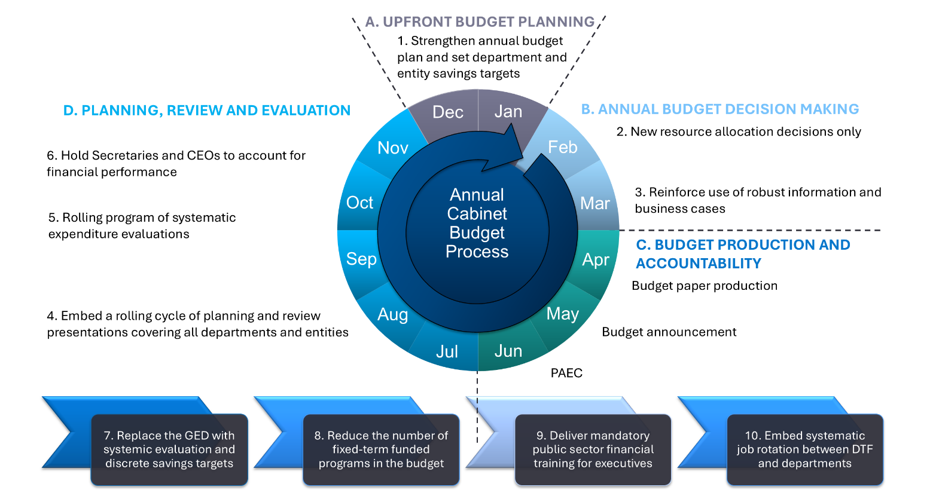
Source: Independent Review of the VPS, 2025

- Strengthen and embed annual budget planning that aligns with longer-term planning at the start of the annual budget cycle (December to January)
Developing an annual budget plan at the start of the cycle helps to set strong parameters and discipline for allocating resources. It should also support the government to achieve the steps in its overarching fiscal strategy.
As part of the annual budget plan, the government should consider and confirm its long-term planning priorities, future demand and service models coming out of a (new) planning and review process (rule 4), outcomes of new systematic evaluations (rule 5) and assessments of entity financial management performance (rule 6). All these factors should be used to agree and set the government’s spending capacity and savings targets for departments and non-departmental entities for the budget ahead.
- Limit all new resource allocation decisions to the annual budget decision window (February to March)
A tighter and more cohesive annual decision-making approach would drive stronger prioritisation across competing options and allocation of public resources. It would also reduce the likelihood of Victoria inadvertently spending more than it can afford relative to capacity. The annual budget decision window should be open in February and March only.
Departments and entities should submit their savings plan as part of the budget decision-making window, outlining how they will achieve the savings, including which functions, projects and programs can stop or change, and any anticipated service impacts.
Funding mechanisms (such as Treasurer’s Advances) already exist for government to provide new funds at other times during the financial year if it needs to respond to urgent and unforeseen events like natural disasters.
- Reinforce current practice that decisions on funding must be supported by robust information and business cases that meet DTF’s Investment Life Cycle guidelines
Consistent with Operating principle 3 – Evidence-based decision-making, the government should reinforce that it only funds major programs or projects supported by full business cases which comply with DTF’s Investment Life Cycle and high-value high-risk guidelines.
Business cases supported by robust information will help minimise the risk of poor investment decisions and maximise the efficient and effective allocation of resources, which increases value to the community and the economy. This also reduces the risk that projects are agreed without recognising their full operational costs.
- Embed a new planning and review window in the annual budget cycle (July to November)
Stronger planning and review – where trade-offs are confronted, and demand management and efficient pricing for outcomes are developed, implemented and assessed – is needed. It is also critical for government to understand in detail the base budget – where funding is allocated, for what purpose and what outcomes it is achieving.
The current central planning tool used by the Victorian Government is the Resource Management Framework (RMF), which is based on a sound Integrated Management Cycle. The Review finds that while the RMF is a good tool, it is applied in a way that directs the focus of most planning and review activity towards compliance activities, and its output has not been effectively utilised for budget decision-making.
A stronger, practical process of planning and review would provide departments and ministers with the opportunity to take a candid and strategic view of core roles, objectives and strategies and present this to the centre of government. It would provide the information needed to make decisions about trade-offs in the allocation of existing and new resources, how performance can be improved over time, and how to manage demand sustainably for services.
The Review considers that practical steps in this new process would include:
- A rolling cycle of planning and review presentations to and discussions with the government’s budget committee, outlining core services, performance data, proposed strategies for managing demand pressures and delivering more efficient and effective services within budget. This should any include election commitments, national partnership agreements and asset management plans. These should be led by the relevant departmental Secretary and lead portfolio minister. The work to develop the presentation should be led (and undertaken in-house, not by consultants) by the relevant department, in consultation with DTF and DPC.
- One large department (e.g. Department of Health, DH), one medium department (e.g. Department of Transport and Planning, DTP) and one relatively smaller department (e.g. DEECA) could be the subject of planning and review for the first year of a new process – in 2025–26. DTF could advise on priority non-departmental entities for the rolling cycle over the next 4 years.
- All departments and large non-departmental entities would present at least once in a 4-year cycle.
In the limited time available for the Review, deep base review analysis of all departments was not possible. The case study of DH in Box 3.1 demonstrates the rich opportunities that exist for a new planning and review approach. DH was chosen because it is a significant part of the overall Victorian operating budget.

Box 3.1: Case study – Department of Health
DH is responsible for developing and delivering policies, programs and services that support, protect and enhance the health, wellbeing and safety of all Victorians. It oversees the ministerial portfolios of Health, Mental Health, Health Infrastructure, Ambulance Services, Children and Ageing.
Victorian health spending has increased over the past 10 years, with real per capita state health expenditure increasing by 39 per cent in Victoria since 2014-15 (Figure 3.2). Victoria spends more on health than NSW per capita – with annual spend per capita at $4,200 versus NSW’s $3,600 in 2023–24. Victoria has spent more per capita on health than the Commonwealth Government over the past two years.
Health expenditure accounted for 31 per cent of Victorian government spending in 2023-24.
Figure 3.2: Total real health expenditure per capita
Commonwealth
NSW
Vic
Source: ABS, Victorian Annual Financial Reports, various years
Hospitals are a significant cost pressure for the state. For a number of years, hospitals have overspent allocated budgets and the government has been under considerable pressure to meet the gap. These top-ups have been provided after the budget allocation, with the gap between targeted and actual expenditure on admitted services growing considerably over recent years (Figure 3.3). These short-term budget top-ups generate uncertainty about future budget allocations and contribute to insufficient focus and investment in efficiency measures.
This cycle of ‘soft budgeting’ has been a challenge for a number of state and territory hospital systems over recent years, and international studies show that hospitals become more efficient when the top-ups stop. The Victorian Government’s recent tightening of hospital budget allocations and processes through the work of Hospitals Victoria and DH is positive.
Figure 3.3: Difference in actual and targeted expenditure on admitted services, $ millions

Source: 2025/26 Budget, Department performance measures
Note: Data indicate the difference between actual and targeted expenditure on administered services. Figures include Commonwealth and state revenue but exclude own source revenue.
Victoria is recognised as having a generally high-performing health system, but like in other parts of the world, it is a system under pressure. A range of factors are contributing to growing demand on the system, reflecting cost pressures, demographic changes, increased expectations and other community trends:
- An ageing population. Nearly 1.5 million Victorians (22 per cent) are aged 60 and above. The size of this cohort has grown by around 30 per cent over the past decade, twice the rate of growth of Victorians aged 59 and below, and this proportion is expected to continue rising.
- Complex and varied health needs. More than one in 5 Victorian adults live with 2 or more chronic conditions, such as type 2 diabetes, heart disease or cancer.
- One in 5 Victorians experience a mental health condition each year. Rates of high or very high psychological distress reached 22.8 per cent in 2022, up from 15 per cent 4 years prior.
- High numbers of people access hospital emergency departments as the ‘front door’ to the health system, which are not always the most appropriate point of contact for patient need. In 2022–23, 41 per cent of emergency department presentations were lower urgency cases that should have been dealt with through the primary care system.
There are significant opportunities for reform in health – with varying degrees of complexity and sensitivity. Government consideration of Victoria’s health system through an enhanced planning and review process in the July–November phase of the budget cycle would provide government with a greater opportunity to take a more strategic view of core roles, objectives, pressures and demand management strategies. This would support negotiations with the Commonwealth on key national partnerships (see Chapter 4). It would also facilitate engagement with reform opportunities, such as:
- An increased role for health and wellbeing promotion and preventive health measures.
- A greater role for digital service delivery and connected data systems.
- A greater role for community health to deliver care closer to home and at less cost.
- Improved statewide service and capital planning and a stronger DH stewardship role.
- Opportunities for more networked governance across health services – starting with accelerated Local Health Service Networks and opportunities for health service consolidation over time.
- Opportunities to transition out of areas of Commonwealth responsibilities – including in prevention, primary care, aged care and mental health – to allow a stronger focus on the government’s core responsibilities.

- Expand systematic expenditure evaluations in the annual budget cycle (July to November)
Expanding and embedding the systematic evaluation of the effectiveness and efficiency of operating expenditure would deepen understanding of base expenditure in the annual budget and enhance decision-making.
The process should consider a systematic rolling program of deep evaluations of major programs of work and projects. The evaluations would determine which programs, projects and expenditure should continue, stop, expand or be transformed to help generate savings, efficiencies and/or enable funds to be redirected to higher priority programs or to ongoing savings.
All major expenditure program areas should be evaluated at least once in a four-year cycle. A sample of potential programs for systematic evaluation include Vocational Education and Training (VET), industry support (the Review explores these program areas in Chapter 8), the Victorian Energy Upgrades program in DEECA, and crime prevention in the Department of Justice and Community Safety (DJCS).
- Hold Secretaries and Chief Executive Officers (CEOs) to account for their departmental and entity financial performance (information submitted twice yearly)
Service delivery and financial performance (actuals against budget) of departments and entities should be monitored and submitted to Cabinet for consideration at least twice a year. This will enable government to discuss significant emerging issues and use performance information to take corrective action and inform future resource allocation decisions during the year as well as part of the annual budget cycle.
The financial performance of departments and entities should be jointly assessed and rated by DTF, DPC and the relevant department or entity as part of an agreed financial management assessment, and the ratings reported to Cabinet at the start of the annual budget process.
Secretaries and CEOs of departments and entities with poor financial performance should be required to submit remedial plans for endorsement by government and have additional Treasurer oversight and approvals. This will directly assist in implementing amendments to the FMA.
- Replace the GED in the savings framework by embedding more systematic evaluation and discrete savings targets
The government should retire the GED beyond the existing forward estimates and replace it by embedding systematic evaluation (rule 5) and plans to achieve departmental annual savings targets and opportunities to re-prioritise base funding as part of the annual budget process (rule 1).

Box 3.2: General Efficiency Dividend – an outdated tool for budget savings
The GED has been in place since 2013, providing cumulative savings to government of more than $5.1 billion to the end of 2028–29. Distinct from programmatic savings, the GED reduces funding provided to departments for back-office resources that support the activities and administration of the department, anticipating that efficiency gains are possible without reducing service delivery.
Given the length of time the GED has been operating and the continued need for investment in new Information and Communication Technology (ICT) systems and processes, it is now affecting departments’ ability to operate effectively and maintain good management processes.

The savings process undertaken by the government in this year’s budget – to which the Review directly contributed – yielded significant long-term savings. The Review has continued this systematic approach to identify additional sustainable operating budget savings.
Removing reliance on the GED and replacing it with alternative processes should help give the government greater visibility and control over how resources are allocated. It should also drive more targeted and sustainable savings and better realisation of efficiencies.
- Reduce the number of fixed-term funded programs
Fixed-term funding is appropriate where time-limited government intervention is required (e.g. COVID-19 response), or where the accountable delivery of a program needs to be supported by more frequent government consideration (e.g. results of a pilot program). While providing some flexibility, it incurs additional costs and more complex program delivery.
Funding for fixed-term initiatives lapsing in the 2025/26 Budget accounted for around 30 per cent of new expenditure, up from around 20 per cent in the 2024/25 Budget.
Government has funded some important programs on a fixed-term basis over multiple budgets. For example, base road maintenance funding has been supplemented by additional time-limited funding in the past five budgets. Relying on these top-ups impedes long-term planning and prevents efficiencies that could be derived from multi-year service contracts. Fixed-term funding should not include programs that are highly likely to be re-funded.
Following implementation of a rolling program of periodic evaluation of programs (rule 5), government should be able to reduce the number of fixed-term funded programs in the budget. Nevertheless, all fixed-term programs should continue to submit an evaluation and associated business case to inform decisions on whether programs should be embedded in base funding, stopped or be transformed, as part of the annual budget process.
- Mandate and deliver public sector financial training for executives
Financial literacy and capability are needed for effective management of public sector programs and resources. The public sector tends to place responsibility for financial literacy and capability onto its Chief Finance Officers and finance teams, rather than considering it a core capability required of all public sector executives. The Review recommends mandatory public sector base financial management training for executives, to be completed every three years. This should be a core capability.
The VPS Accounting and Finance Graduate program can also be augmented through increasing numbers, boosting attraction and retention approaches, and offering further training in partnership with peak bodies. The importance of graduates being recruited to the VPS is discussed in Chapter 5.
- Embed systematic job rotation for financial officers between DTF and other departments
Periodic job rotations for financial officers between departments and DTF (e.g. the period of September to January) would lift financial management capability across the VPS. They would address any skill shortages during peak periods and foster better understanding of respective financial management issues, challenges and strategies to resolve them. It would also help build a more collaborative culture across departments and generate a greater shared ownership of problems and solutions.

3.5 Recommendations
- Actively apply enhanced financial management operating principles to support strong fiscal management.
- Commit to consistently applying 10 enhanced financial management rules, across 4 distinct phases each year, to deliver on the fiscal strategy:
  - Strengthen and embed an annual budget plan that aligns with
longer-term planning at the start of the annual budget cycle.
  - Limit all new resource allocation decisions to the annual budget decision window.
  - Reinforce current practice that decisions on funding must be supported by robust information and business cases that meet DTF’s Investment Life Cycle guidelines.
  - Embed a planning and review window in the annual budget cycle.
  - Expand systematic expenditure evaluations in the annual budget cycle.
  - Hold Secretaries and CEOs to account for their departmental and entity financial performance as part of the annual budget cycle.
  - Replace the GED in the savings framework by embedding more systematic evaluation and discrete savings targets in each budget.
  - Reduce the number of fixed-term funded programs.
  - Mandate and deliver public sector financial training for executives.
  - Embed systematic job rotation for financial officers between DTF and other departments.

Chapter 4: Commonwealth-State relations
Key points
- Roles and responsibilities of the Commonwealth and state and territory governments for funding services have become increasingly blurred.
- Victoria’s share of Commonwealth funding relative to its population share has been consistently below that of other large states. Victoria has received $9.4 billion less than its population share of infrastructure funding over the past 10 years.
- Victoria has increasingly stepped into funding areas outside its core responsibilities and is delivering beyond national partnership agreement commitments.
- Rebalancing state service delivery away from areas of primary Commonwealth responsibility is necessary. An immediate opportunity is Victoria’s Urgent Care Clinics.
- Strategic engagement in federal financial arrangements can unlock significant savings and produce more effective partnerships, leading to a stronger Victorian fiscal and economic outlook. It also supports national growth and reform.

4.1 Introduction

Strong Commonwealth-State relations are critically important to the state’s finances and operating budget capacity. Representing around half of all government revenue, the size of Commonwealth funding and how it is delivered impacts Victoria’s budget and its ability to deliver high quality services.
Commonwealth funding in key areas has been below Victoria’s population share over a number of years, and uncertainty around future funding arrangements, such as hospital funding and the no-worse-off GST guarantee, represent key fiscal risks to the state. Uncertainty directly impacts the state budget and the delivery of core services.
Roles and responsibilities between the Commonwealth and states and territories are also increasingly blurred, which is leading to duplication of effort. In some areas, Victoria has stepped in to fund areas outside its core responsibilities in order to address Commonwealth gaps. Victoria needs to rebalance state service delivery away from areas that are primarily Commonwealth responsibility.
The Review recommends a renewed focus on a strategic approach to Commonwealth-State relations, underpinned by strong central agency leadership.

4.2 Importance of Commonwealth funding to state revenue

Australia’s federation is marked by Vertical Fiscal Imbalance (VFI): the Commonwealth raises over 80 per cent of national tax revenue. States like Victoria rely on Commonwealth transfers to fund service delivery, with about half of Victoria’s revenue coming from the Commonwealth – primarily through the GST (22 per cent in 2023–24) and tied grants (23 per cent) that carry specific requirements.
Horizontal Fiscal Equalisation (HFE) seeks to address the other major imbalance present in federal financial relations – differences in revenue-raising capacities and expense requirements across states and territories. The principle of HFE seeks to enable each state and territory provide a similar standard of services and infrastructure to its residents, if each made a similar effort to raise revenue. In its current form, this objective is pursued through the distribution of GST across states and territories, informed by advice from the CGC. Some features of the current GST system see Victoria (and other states and territories) miss out on important untied revenue to deliver essential services that communities need (see Box 4.1).

Box 4.1: Goods and Services Tax
The introduction of the GST in 2000 was one of the most significant tax reforms since federation. Replacing various financial assistance grants and inefficient state taxes, the introduction of the GST provided greater autonomy to state governments to deliver services and supported economic growth. GST is divided between the states and territories by the Commonwealth based on advice provided by the CGC.
Victoria has received $281 billion in GST revenue since its inception to 2023–24, around a quarter of all government revenue over this period. This is $31 billion less than if Victoria had received its population share. While this is not inconsistent with the principle of HFE, it demonstrates Victoria has been a significant donor to other states and territories.
The growth in total GST revenue has not kept pace with economic growth as originally intended. Promoted as a growth tax, the GST was to provide states and territories a reliable source of revenue that grew with the size of the economy – like income and corporate tax revenue. This has not occurred, and GST revenue growth has lagged economic growth since its inception. This intensifies VFI in Australia.
Despite all GST revenue going to the states and territories, the Commonwealth has significant discretion over how the GST is distributed. Most recently, this has had large impacts on Victoria and NSW when the Commonwealth did not allow the CGC flexibility to recognise COVID-19 related spending by Victoria (and NSW) when determining GST allocations. This unavoidable expenditure was finally able to be recognised for the first time this year through the 2025 CGC’s 5-yearly method review, contributing to the CGC’s recommendation to increase Victoria’s GST revenue above its population share for the first time. This was almost too late. The previous exclusion of these costs in calculating GST shares lowered Victoria’s revenue by around $879 million in 2023–24 alone. The delay in recognising this spending means that COVID-19 expenditures from 2019–20 and 2020–21 will never be assessed accurately.
Significant Commonwealth changes to the GST system introduced in 2018, including a GST floor and a new standard of equalisation, which guarantees Western Australia a minimum share of GST, eroded the principle of HFE. In response to concerns from remaining states, a temporary no-worse-off guarantee was introduced to provide top-up payments to states and territories to ensure none are disadvantaged by the new GST arrangements. This effectively extends pre-2018 GST funding arrangements to all states and territories bar Western Australia, who now receive additional Commonwealth funding. The no-worse-off guarantee has been extended to 2029-30, however it remains a major fiscal risk for Victoria beyond that time. At the time of its introduction in 2018, the Commonwealth forecast all states and territories would benefit from the changes to the system, and no additional assistance would be required. This has not been the case and Victoria has received more than $9.2 billion in no-worse-off guarantee payments between 2021–22 and 2023–24. The Commonwealth estimates that Victoria will receive a further $9.7 billion in no-worse-off guarantee payments between 2024–25 and 2028–29.
The importance of GST to the state’s revenue base demonstrates the criticality of proactive and strategic engagement with the Commonwealth. It also reinforces the need for the Productivity Commission’s upcoming review to comprehensively examine the impact of the Commonwealth’s 2018 changes to the GST system.

In addition to GST revenue, the Commonwealth provides payments for specific purposes through more than 30 active partnerships, including six national partnership agreements. The Commonwealth has allocated more than $110 billion in funding between 2024–25 and 2028–29 to Victoria through these agreements at the most recent federal budget. The main partnerships are the Better and Fairer Schools Agreement ($42.1 billion over 5 years, expires in 2034), the National Health Reform Agreement ($41.5 billion over 5 years, being renegotiated now) and the National Skills Agreement ($3.1 billion over 5 years, expiring in 2028).
Funding provided through these partnerships is substantial, although there are areas where Victoria receives a disproportionately low share of Commonwealth funding relative to its population.
A notable example is health. Victoria is set to receive 23.9 per cent of Commonwealth health funding over the next five years according to the most recent Commonwealth budget, lower than its population share of 25.8 per cent. Funding equivalent to Victoria’s population share would see the state receive a further $3.4 billion over 5 years. Over time, this structural disadvantage means that Victoria
is not getting the level of Commonwealth support it needs to respond to growing public hospital demand. This places additional pressures on the state’s operating budget.
The National Health Reform Agreement (NHRA) is the largest component of Commonwealth health funding to the state. Under the NHRA, the Commonwealth funds 45 per cent of efficient hospital activity growth, capped at 6.5 per cent annually. When demand exceeds this cap or funding lags, states must cover the gap.
The Commonwealth provided $7.3 billion to Victoria through the NHRA in 2024–25 alongside a Victorian funding contribution of $11.9 billion. Renegotiation of the NHRA is critical given structural issues of the agreement have resulted in inequitable health funding and have restricted state and territories’ ability to plan accurately for long-term health needs due to the operation of the current funding model.
Funding for infrastructure is another critical area where Victoria receives less than its population share. Victoria received $11.1 billion in Commonwealth infrastructure funding over the past 10 years, contributing to important road and rail projects. However, this funding is around $9.4 billion less than Victoria’s population share (Figure 4.1). This shortfall is evident across current major, priority infrastructure projects in Victoria, namely:
- North East Link – $21 billion Victorian Government investment; $5 billion Commonwealth funding
- Level Crossing Removal Project – $15 billion Victorian Government investment; no Commonwealth funding
- Metro Tunnel – $13.5 billion Victorian Government investment; no Commonwealth funding
- West Gate Tunnel – $10 billion Victorian Government investment; no Commonwealth funding.
This shortfall is set to persist, with Victoria allocated 21.4 per cent of total Commonwealth infrastructure funding over the next 5 years in the most recent Commonwealth budget. Infrastructure funding commensurate with Victoria’s population share would see the state receive an additional $3.5 billion over 5 years. The sequence of future Commonwealth funding also does not necessarily align well with state priorities, for example, directing investment to the Beveridge Intermodal Freight Terminal ahead of the Western Interstate Freight Terminal.

Figure 4.1: Commonwealth infrastructure spending
Qld
NSW
Vic
National
Vic
Qld
NSW
Source: Commonwealth Treasury, DTF
Note: Consistent with DTF these estimates include estimated equity contributions for Western Sydney Airport and Melbourne Intermodal Terminal Package

4.3 Overlapping responsibilities and duplication

The Australian Constitution sets out the division of powers between the Commonwealth and states (Figure 4.2 – see end of chapter). In practice, service delivery responsibilities are increasingly shared – and blurred – across the Commonwealth and states. Layering and duplication have grown over time due to changing community expectations, overlapping program areas, and changes in governments’ priorities.
Victoria has increasingly expanded its role and invested in areas that fall within the Commonwealth’s responsibility, including in health, early childhood education, aged care, and energy, to fill gaps and protect community outcomes. At times, the duplication has been negotiated through national partnership agreements. Victoria has also elected to go beyond Commonwealth-State funding agreements to fund primarily Commonwealth responsibilities in Victoria.
Victoria has made these decisions to address short-term service gaps left by the Commonwealth and to respond to critical community needs. Victoria has also at times identified an opportunity to improve services in an area of Commonwealth responsibility. Such early mover actions have not routinely been recognised and supported through future funding arrangements. The pattern of taking on Commonwealth responsibilities has long-term implications for Victoria’s fiscal sustainability and governance clarity.
National partnerships help the Commonwealth and states to work effectively together. However, funding outside these partnerships contributes to confused responsibilities between governments. This undermines service delivery and stymies reform.
Again, health is a prime example. Public hospital funding is governed by the NHRA and there are important changes needed to be sure Victoria receives appropriate funding for its population size and to operate quality services.
In addition, funding and service gaps in areas of Commonwealth responsibility increase pressure on state hospital services. Hospital demand is linked to primary healthcare – a Commonwealth responsibility. Bulk billing rates have declined, and the share of Victorians avoiding general practitioner (GP) visits due to cost has risen from 2.2 per cent in 2020–21 to 7.3 per cent in 2023–24. This puts pressure on the state’s public hospital system. The Commonwealth recently announced measures to increase bulk billing rates, but these are yet to be implemented.
The other large area of joint responsibility is disability services. States are now spending far more in real terms on disability services than before the introduction of the National Disability Insurance Scheme (NDIS). Further reform is required, including an agreement around foundational supports which does not penalise states and territories by not recognising the additional investments they are already making in disability support.
Ongoing funding arrangements to meet increasing NDIS costs also need to be agreed. Commonwealth payments to the states and territories from the DisabilityCare Australia Fund (DCAF) ceased in 2024 with the expiry of the National Partnership on DisabilityCare Australia Fund Payments. Established in 2014 to reimburse all governments for NDIS expenditure, credits to the DCAF are funded from the ongoing Commonwealth Medicare Levy increase. A new National Partnership on DisabilityCare Australia should be established and states and territories should continue to receive funding from the DCAF.
In other policy areas, the Commonwealth Government has tied funding to detail in agreements which reach into service delivery and add to reporting and administrative burden. The National School Reform Agreement (2018-2024) is an example of this: areas such as teacher practice and professional development that are the responsibility of the states and territories are included in the agreement. These types of requirements not only add delivery costs to the agreements but are not focused on what really matters: outcomes. The key question should be whether schools and students are performing better. Commonwealth efforts to micromanage funding and reach into service delivery are antithetical to good Commonwealth-State policy.
Negotiations over these agreements and others are an opportunity to address duplication and administrative burden, improve coordination and pursue reform.

4.4 Reform of Commonwealth-State settings

Identifying and transitioning out of overlapping programs
It is prudent for Victoria to identify its current funded programs that overlap with Commonwealth responsibilities and develop options to withdraw or divest from these programs. This is timely as the Commonwealth Government has made recent commitments to increase investment in some areas for which it is responsible. Examples of Victoria expanding into Commonwealth responsibilities include:
- funding Urgent Care Clinics (UCCs) to alleviate pressure on hospital emergency departments and delivering a Doctors in Secondary Schools program in areas with high levels of disadvantage and low GP access
- building and operating early learning and childcare centres
- establishing VicGrid to take over transmission planning from the Australian Energy Market Operator for faster, locally focused development of Renewable Energy Zones
- funding aged care residential beds.
Box 4.2 provides an example of the opportunity to transition out of a primary care program.

Box 4.2: Transitioning out of primary health care – Urgent Care Clinics
The Victorian Government has established 29 UCCs across the state. UCCs are a primary health care service, providing GP-led care to people who need urgent care but not an emergency response. They are run through Priority Primary Care Centres and Medicare Urgent Care Clinics. The Victorian Government funds 12 UCCs and the Commonwealth funds 17. NSW also funds and operates urgent care services, with some Commonwealth funding.
The Victorian Government has been supporting Victoria’s UCCs since 2021–22. The 2025/26 Victorian Budget announced funding of $27.6 million to operate the 12 state-funded UCCs in 2025–26 (one year only).
Victoria introduced UCCs (initially as Priority Primary Care Centres) in 2022 in the wake of the pandemic, designed to reduce pressure on hospital emergency departments. Victoria’s UCCs receive an average of 7,000 patient visits per week, and patient surveys indicate around 50 per cent of patients would have attended an emergency department if the UCCs were not available.
Victoria should advocate to the Commonwealth to take over funding responsibility for its 12 UCCs. If the Commonwealth does not fully fund Victoria’s UCCs, the government should seek an additional Commonwealth contribution to Victoria’s health services via the NHRA.

Victoria’s approach to Commonwealth-State negotiations
Clarifying and committing to Victoria’s role within the federation is both a fiscal and strategic imperative. Reducing overlap, duplication and focusing on core responsibilities would improve service delivery and accountability. Rather than taking on risks and liabilities as a first mover, Victoria could position itself as a prudent partner in the federation – discharging its responsibilities and holding the Commonwealth to account.
A coordinated, whole-of-government strategy for Commonwealth–State relations – led by DPC – is essential to strengthen Victoria’s influence over national policy and funding settings. It would also maximise opportunities for Victoria to receive its fair share of funding for services and infrastructure and ensure the state does not fund things for which it is not responsible.
The Premier and Treasurer, as strong advocates for the state, need to be supported by the central agencies to be in the best position to manage the whole of government strategy. This would maximise revenue opportunities, minimise the risk of overlap, and enhance overall management of this key relationship.
Given the number and complexity of agreements, their interrelationship and the quantum of funding at stake, the state requires an overarching strategy to maximise financial outcomes, achieve reform outcomes and reduce duplication or unnecessary inputs. Further, to ensure equity and transparency, joint agreement to equitable cost-sharing for critical infrastructure ought to be negotiated upfront and ahead of commencing capital works.
Victoria should again lead the call for reform of federal financial arrangements. A renewed model – simplifying funding flows and reintroducing reform-linked incentive payments – could unlock public and private sector productivity and help drive national reform in partnership with the Commonwealth.
In the past where this has occurred, for example with the introduction of the GST and the National Reform Agenda in the 2000s, reform gains were made across all jurisdictions and there was appropriate sharing of risk and funding between the Commonwealth and states and territories. These gains were shown to improve economic and social outcomes and thereby strongly support the government’s fiscal and economic strategy.

Better data to improve needs-based targeting of programs
The Victorian Government provides substantial financial support to households and businesses through a range of concessions, tax expenditures and broad-based programs. These supports come at a significant cost to the budget, either through direct spending or by foregoing revenue (via tax expenditures). Over the decade to 2024–25, the state is estimated to have foregone $109.7 billion in revenue from tax expenditures and provided $19.3 billion in concessions. It is critical that government has appropriate data to be able to target its funding for supports to meet the community’s needs, and change supports where those needs change.
While the Commonwealth has responsibility for income support, the Victorian Government (and other state governments) has incrementally expanded its role and now duplicates the role of the Commonwealth by funding a number of concessions, tax relief and universal benefits.
These supports have been introduced at points in time to respond to national program gaps, to meet local priorities, or to provide a direct cash method to ease cost of living pressures. However, many of these supports have become ‘set and forget’ and are difficult to change or remove. For example, the Victorian Government expanded electricity and water concessions in the 2011/12 Victorian Budget. Expenditure on electricity concession alone has more than doubled in value over time, rising from $71 million in 2009–10 to $153 million in 2011–12. Since then, this expenditure has remained relatively stable at around that level.
Given the size of expenditure for these supports, it is critical that they are reviewed regularly to be sure they are effectively targeting need. Box 4.3 provides examples of current concessions, tax expenditures and relevant programs.

Box 4.3: Current Victorian-funded tax expenditures, concessions and programs
Concessions are direct budget outlays or reduced charges that lower the cost of services for holders of Pensioner Concession, Health Care, Seniors Health or Veterans’ Affairs Gold Cards. In 2025–26, the Victorian Government will provide around $2.6 billion in concessions, including free ambulance transport ($604 million), discounted public transport ($270 million), electricity and water concessions ($345 million), and subsidies for education, dental care and municipal (council) rates ($678 million).
Tax expenditures are deviations from standard tax treatment, such as exemptions, reduced rates or deductions, that benefit certain taxpayer groups, activities or assets. They are forecast to cost $19.1 billion in 2025–26, with land tax and payroll tax concessions forming the largest components with significant exemptions for principal place of residence and primary production (land tax only). As a share of total state tax revenue, tax expenditures have grown significantly over time, from 27 per cent in 2013–14 to 46 per cent in 2024–25, reflecting both the expansion of existing concessions and the introduction of new ones. As outlined in Chapter 2, the government has improved the equity and efficiency of the land and payroll tax revenue base.
Programs can be provided free of charge to all users or through concessions. For example, 4-year-old Kinder was previously available for free to a targeted cohort, with other users paying a fee. Other recent examples include free camping sites, and free public transport being introduced for all people under 18 years of age.

Currently, states and territories largely rely on the Commonwealth Health Care Card, Pensioner Concession Card or Veterans’ Affairs Gold Card for determining eligibility for concessions and other supports. States and territories are required to utilise these Commonwealth concession cards as they do not have access to more refined data about family and individuals’ incomes, held by the Commonwealth Government.
Access to more detailed data would give states and territories the flexibility to more accurately and efficiently target supports according to identified need, as the Commonwealth does (e.g. Family Tax Benefit A is a qualifier for the Extended Medicare Safety Net).
Victoria should, as a priority, lead work with other states and territories to advocate to the Commonwealth for improved data sharing arrangements so that concessions, tax expenditures and broad-based benefits can be better targeted to need. Action taken during the COVID-19 pandemic to allow state access to Australian Tax Office data for the purpose of COVID-19 business support payments shows this access is possible. However, previous attempts to embed greater data sharing on a sustained basis have not been given sufficiently high enough priority and have not progressed. Central agencies should pick up this task.
All governments’ objectives to provide supports to ease cost of living pressures
should drive the urgency for this data sharing work. Having more refined data is an important precursor for the Victorian Government being able to review and better target the supports it wishes to provide to individuals, families and businesses at particular points in time.
Box 4.4 shows how better data access would enable the government to review, and if desired, amend supports for the Municipal Rates Concession and Free Kinder.

Box 4.4: Opportunity to review and better target supports – Municipal Rates Concession and Free Kinder
Municipal Rates Concession
The Municipal Rates Concession (MRC) is a household concession established over 50 years ago. It is available to homeowners (ratepayers) who hold a Pensioner Concession Card or Veterans' Affairs Gold Card and provides a 50 per cent reduction on council rates, capped at $259.50 per year (2024–25).
This program is expected to cost the state $106 million in 2024-25 and $107 million in
2025–26. As MRC recipients are homeowners, there are people receiving the concession who are unlikely to be experiencing significant financial hardship. The Review understands that around 6,000 recipients of the MRC in Victoria live in homes worth over $2 million and almost 30 per cent (more than 130,000 people) in homes valued over $1 million.
The MRC was introduced at a time when home ownership was more common (even for those on low incomes) and when housing and rental affordability was a less challenging social and economic problem. Renters in the age group targeted by the MRC are now significantly more financially vulnerable than this group – as are younger, low-income renters.
The government could review the MRC if it had access to more refined data about need.
Free Kinder
The Victorian Government provides Free Kinder to 3 and 4-year-olds attending participating services. This includes long day care and sessional kinder services. Free Kinder was introduced in 2021 as a cost of living response to the impact of the pandemic.
Free Kinder for 3 and 4-year-olds cost around $375 million in 2024, with total costs projected to reach approximately $1.5 billion over the forward estimates. The current Preschool Reform Agreement 2022–2025 (national partnership agreement) provides all children an effective entitlement to 15 hours per week of a preschool program in the year before full time school. Victoria’s delivery of 15 hours of 3-year-old kinder and 30 hours of 4-year-old kinder delivers beyond the agreement.
Prior to the introduction of Free Kinder for 4-year-olds, Victoria had a high participation rate in the program (92 per cent in 2019), with targeted supports for concession card holders, Aboriginal and Torres Strait Islander families, families known to child protection, and refugees and asylum seekers. The participation rate of 4-year-old kinder increased to 96 per cent in 2024.
With more granular data about family incomes, the government would have more flexibility, like the Commonwealth does, to target supports to families more efficiently and effectively.

4.5 Recommendations
  - Develop an overarching Commonwealth-State relations strategy for more effective strategic engagement, to unlock funding and savings, and to have a more proactive role in national reform.
  - Continue to highlight the major consequences for Victoria and other states and territories of the Commonwealth’s Western Australia GST agreement, and work with states and territories to maintain the Commonwealth no-worse-off guarantee.
  - Strengthen strategic capacity in the central agencies for Commonwealth-State relations work.
  - Identify current Victorian-funded activities that fall under Commonwealth responsibility and develop options to withdraw or divest from these programs.
  - Advocate to the Commonwealth to fully fund Victoria’s 12 state-funded Urgent Care Clinics.
  - Advocate strongly for better data sharing to improve the ability of states and territories to better target programs and tax expenditures that address disadvantage and cost of living pressures.
  - Advocate for the Commonwealth to recommence state and territory funding from the DisabilityCare Australia Fund, which is funded by the Medicare levy increase to support the provision of disability services.
  - Advocate for a renewed national approach and related incentives that can improve services and drive private and public sector productivity in Victoria and nationally.

Figure 4.2: List of Commonwealth-State individual and shared responsibilities
 | Responsibility type | COMMONWEALTH GOVERNMENT | STATE/TERRITORY GOVERNMENT
HEALTH, AGED CARE & DISABILITY | Individual | - Primary health care (e.g. Medicare, Pharmaceutical Benefits Scheme)  - Aged care  - National Disability Insurance Scheme (NDIS) administration | - Emergency and acute care
HEALTH, AGED CARE & DISABILITY | Shared | - Public health (e.g. immunisations)  - Indigenous health  - Health regulation and safety  - Disability services
EDUCATION | Individual | - Curriculum development  - National framework oversight | - School infrastructure (e.g. public schools)  - Education regulation and curriculum development
EDUCATION | Shared | - Early childhood education and care  - Primary and secondary schooling  - Higher education  - VET
ENVIRONMENT AND NATURAL RESOURCES | Individual | - International environmental treaties and obligations | - Land use and planning
ENVIRONMENT AND NATURAL RESOURCES | Shared | - Environmental protection and conservation  - Natural resource management  - Climate change policy and action  - Energy policy and regulation  - Water resources and management
EMPLOYMENT | Individual | - National Employment Standards  - Skilled migration pathways | - State Migration Plans
EMPLOYMENT | Shared | - Employment support services  - Workplace regulation  - Apprenticeships and traineeships  - VET and TAFE regulation

 | Responsibility type | COMMONWEALTH GOVERNMENT | STATE/TERRITORY GOVERNMENT
INDUSTRY SUPPORT | Individual | - Federal tax incentives (e.g. specific industry tax offsets)  - International trade agreements  - National regulation (e.g. competition) | - Regional economic development programs  - Industrial zoning approvals
INDUSTRY SUPPORT | Shared | - Business grants and incentives  - Small business support  - Deliver industry development policy  - Manufacturing support  - Procurement rules
Note: These represent the majority of individual and shared responsibilities but is not exhaustive.
Source: Australian Government Department of Health and Aged Care, General Practice Supervision Australia, Australian Government Department of Education, Victorian Government Department of Education, Australian Government Department of Climate Change, Energy, the Environment and Water, Environment Protection Authority Victoria, Victorian Government Department of Energy, Environment and Climate Action, Fair Work Commission, Australian Government Australian Skills Quality Authority, Victorian Government Department of Jobs, Skills, Industry and Regions, Australian Government Department of Industry, Science and Resources, Disability Gateway

Chapter 5: VPS size and structure
Key points
- VPS growth has stabilised since the COVID-19 response, but the workforce has become top heavy. The number of executives and senior technical specialists (STS) has increased by 82 per cent since 2019, and they now comprise 7.2 per cent of the VPS workforce. Senior staff are overseeing fewer staff, and the layers of hierarchy have increased.
- The lack of strong and consistent VPS workforce data makes workforce analysis and planning very difficult.
- Increasing spans of control and reducing layers of hierarchy – based on management ratios from 2019 – will reduce the number of SES and STS by 332 FTE across all departments and some large entities. It will also deliver $359 million in savings over the forward estimates.
- Rebalancing the proportion of VPS5 and VPS6 positions towards pre-pandemic profiles that included more staff at junior classifications will result in a saving of $125 million over the forward estimates.
- A streamlined VPS will require a new approach to working with the executive arm of government and a focus on the capability of departments.

5.1 Introduction

This chapter addresses a key element in the Review’s Terms of Reference: reducing the VPS back towards its pre-pandemic share of employment, including an examination of the appropriate levels of executives.
The Victorian community is well-served by the VPS and it is important that it functions well for the benefit of the community. Best practice organisational design indicates that change is needed to maintain high quality, effective VPS organisations.
A focus on a return to the pre-pandemic employment share (2019) makes sense. The impact of COVID-19 has been significant in many ways, and therefore basing analysis on a date as close as possible to the outbreak is reasonable. In doing so, the Review does not suggest that 2019 necessarily represents best practice in organisational design or structure.
In looking at the VPS, the Review has sought to identify sustainable models and appropriate benchmarks to guide departmental Secretaries in the short and medium term. The focus is on management structures and systems that support excellent service delivery and more empowered public servants.
In this chapter, the Review refers to the organisational concepts of ‘spans’ and ‘layers’. A ‘span’ or ‘span of control' means the number of direct reports a manager oversees, and 'layers' means the number of levels between the top leadership and employees at the delivery level.
The Review encountered significant challenges in assessing data on reporting lines, spans of control and layers of hierarchy across departments and non-departmental entities. Existing data lack sufficient detail on reporting arrangements, particularly below executive level. This currently limits the ability to undertake good organisational design, resource allocation and workforce planning across the VPS.

5.2 VPS and public sector workforce growth

Since 2019, the public sector workforce in Victoria has grown by around 20 per cent, or more than 54,000 people. This growth has been concentrated outside of the VPS in frontline workforce roles, such as health care workers and teachers.
In the same period, the VPS grew by 16 per cent and executive numbers rose by 52 per cent. Growth has stabilised since the COVID-19 response, with only a marginal increase (0.1 per cent) since 2023. While overall growth has been largely in line with increased government expenditure and activity, FTE growth in non-departmental entities has outpaced growth in departments (Figure 5.1).

Figure 5.1: VPS growth (Department and non-departmental entities)
VPS non-department entities
VPS Departments
VPS non-department entities
Source: VPSC

While VPS growth has slowed, there has been a notable shift in the composition of the workforce: there are now proportionally more executives and senior staff (Figure 5.2). This directly impacts the cost of the VPS as well as culture and ways of working.
In 2019, the VPS (including departments and VPS non-departmental entities) had a total of 1,241 SES and 425 STS. There has been an increase of 641 SES and 727 STS FTE in five years, which is a combined 82 per cent increase. As a proportion of the VPS grade workforce, in 2024, SES and STS made up 7.2 per cent, compared to 5.5 per cent in 2019.
Even accounting for growth, there appears to be little basis for such a disproportionate increase since 2019. While the trend to greater executive numbers was already underway, the pandemic led to even more executive and specialist-level oversight in response to the urgency, increased complexity and volume of work. Risk, technical complexity and leadership requirements may have changed since the pandemic but not to the extent reflected in the increased numbers.
Similarly, there has been a disproportionate increase at the senior VPS levels. There are 2,910 more VPS6 staff today than in 2019, an increase of 54 per cent. The number of VPS5 staff has increased from 8,058 to 11,795, a 46 per cent increase from 2019.
Looking back to 2014, the level of growth is even more stark. VPS5 and 6 accounted for 47.9 per cent of the VPS grade workforce in 2024, up from 40.7 per cent in 2014. Similarly, the proportion of SES and STS has increased markedly over the decade: from 4.3 per cent to 7.2 per cent.

Figure 5.2: VPS composition 2014, 2019, 2024

Source: VPSC

Consistent data was not available to the Review below executive level for most departments to be able to assess spans and layers. However, observations based on a study of organisational charts identified narrow spans of control and many layers of hierarchy in some departments. Some departments were observed to have up to six layers between VPS staff and the Secretary.
The VPS Executive Classification Framework establishes three executive classification bands, and a consistent application of position titles connected to these bands. The framework is not being adhered to by all departments. The Review identified the use of non-standard executive roles sitting outside the framework such as Assistant Deputy Secretaries, Senior Executive Directors and Associate/Assistant Directors (Figure 5.3). Structures with additional layers increase cost and slow down decision-making.
The VPS classification structure is broadly in line with other jurisdictions. While improvements to the classification framework may be beneficial, it is not the source of hierarchy or expenditure pressures.

Figure 5.3: Current reporting layers in two large VPS departments
Secretary
Executive Director
Span: 6
Deputy Secretary
Span: 2
Analysts × 2
Director
Span: 3
Manager
Span: 2
Secretary
Assistant Deputy Secretary
Span: 7
Deputy Secretary
Span: 6
Policy and program staff
Executive Director
Span: 3
Director
Span: 6
Manager
Span: ?
Source: Independent Review of the VPS, 2025
Note: Data issues did not allow the Review to determine manager spans of control in some departments.

While there is no doubt the VPS is generally working hard, excessive hierarchy and layering create unnecessary distance between decision-makers and advisors. It slows decisions, reduces agility, blurs accountability and inhibits learning. It also limits career pathways and places a higher priority on risk avoidance, which ultimately weakens capability and culture. It also costs more.
The principle of subsidiarity holds that decision-making should be delegated to the lowest appropriate level, but the Review finds this principle has eroded somewhat over time, with decision-making being pushed up the hierarchy. The Review’s discussions with departmental officers and ministers confirm this change.

The Review has heard that, over time, staff at VPS5 and 6 levels have been disempowered by increased layers of hierarchy and oversight, resulting in a diminution of their professional agency and discretion. These are well paid, senior roles and should be recognised as such through appropriate delegation of responsibility.
Realigning departmental structures to reflect sound organisational design principles will not only support more efficient and effective service delivery, it will also help embed a purpose-driven, accountable culture that cultivates future public service leaders.

5.3 Spans and layers: good organisational design

Analysis of good organisational design research and practice undertaken by the Review confirms that it is essential to enable clear decision-making, accountability, efficiency and a high-performing public service culture. When done well, appropriate organisational design supports innovation, agility and effective service delivery.
There are standard models to assist good organisational design in the VPS but structures must be tailored to departmental function. The optimal span of control depends on work and context. The optimal number of layers is dependent on organisational complexity and size.
Departments and non-departmental entities vary in shape depending on their mix of service delivery, policy and oversight roles. Nevertheless, it is conceptually possible to define and test model spans and layers for different functional areas and progressively close the gap between current structures and best practice.
A more disciplined approach to spans and layers across the VPS would enable clearer career pathways, strengthen accountability, improve the effectiveness of leadership and deliver efficiencies. A more balanced structure would also mean that work is not unnecessarily escalated to higher levels. It would help restore the integrity of classification boundaries and reduce duplication of effort. It should speed up decision-making: moving from a watching culture to a doing culture.
Box 5.1 describes recommended guidelines as a starting point for future organisational design, depending on the functions undertaken by a department or entity. These are drawn primarily from the Review’s work and other jurisdictions, including the Australian Public Service (APS), which has strong evidence-based guidelines. They are not prescriptive but provide a guide for departments to evaluate their structures in light of the work being delivered. These guidelines have assisted departmental Secretaries in other jurisdictions to assess and clarify their organisational structures, especially at times of machinery of government or other changes.

Box 5.1: Indicative spans of control and organisational layers

The following guidelines should be a starting point for future organisational design:

Span of control – function-specific guidelines
Specialist Advisory | Policy and Strategy | Program development/case management | High volume service delivery
1 manager to up to 3 staff | 1 manager to 6–8 staff | 1 manager to 8–10 staff | 1 manager to 8–15+ staff

Layers
The total optimal number of organisational layers is between 5 and 7.

Methodology for determining efficiencies for SES and senior staff
All VPS departments and some large entities were in scope for this element of the Review’s work. Chapter 6 canvasses reform of public entities more generally and provides a plan for spending reductions through cessation, merging and streamlining.
Given the lack of adequate data, it was not possible to apply a pure ‘spans and layers’ methodology to the VPS at this time.
Instead, the Review analysed the ratios of executive staff to non-executive staff in 2024 and compared them to the ratios in 2019. STS positions were included alongside SES to guard against the practice of classifying SES roles as STS. The Review does not consider that the work of the VPS has increased in its technical specialisation since 2019 and therefore concludes that the ratios approach is appropriate for the STS classification level alongside SES.
The ratios approach accounts for workforce growth by focusing on the ratio of SES and STS roles to all other VPS staff. For example, if a department had one SES/STS for every 100 staff in 2019 and still has one for every 100 in 2024 (even if the total workforce has doubled), then no reduction is proposed. However, if the ratio has increased – for instance, from one SES/STS per 200 staff in 2019 to one per 100 staff in 2024 – a reduction is recommended to return to 2019 levels. Where a department’s executive-to-staff ratio has improved since 2019, no increase in SES/STS positions is proposed.
The results of applying this method to existing data delivers varied results across departments and in-scope entities. The Review set a cap on reductions of 15 per cent for departments, and 20 per cent for the large VPS entities to guard against any dramatic destabilising impact or unmanageable disruption.
Further future reductions may be possible through application of the spans and layers guidance over time, supported by high quality data that provides better visibility of reporting lines.

5.4 Workforce reductions and rebalancing

SES and STS
Based on the method described above, the Review recommends reducing the number of SES and STS positions by 332 FTE across all departments and some large entities, delivering $359 million in savings from 2025–26 and over the forward estimates. This reduction will return the ratios of these senior roles, as a proportion of the total organisation, closer to pre-pandemic levels.
The ratios methodology has allowed a reasonable analysis of the appropriate VPS organisational structure. However, it should not be locked in or become the new norm. In implementing revised structures, Secretaries and CEOs should also consider the Review’s indicative advice on spans of control and layers. Any further reductions – including mirroring earlier profiles – would require a more nuanced approach and access to data that is not currently available.
The Review also recommends removing any positions that sit outside of the VPS classification framework, to be pursued through the SES and STS reductions outlined above.

VPS reprofiling and reductions
To address top heaviness in the VPS grades, the Review recommends a reduction of VPS5 and VPS6 positions and replacement of these roles at more junior classifications.
Each department and some large entities would have an annual target of VPS5 and VPS6 reductions, capped at 15 per cent (like the methodology used for departmental SES/STS reductions) over 4 years.
Departments and some large entities will be required to review VPS5 and VPS6 positions, generally as they become vacant, and reclassify them to more junior grades wherever possible. This will produce a shift towards the pre-pandemic shape of the VPS.
The Review recommends that each department quarantines a proportion of the reclassified roles for graduates to support talent renewal and development across the VPS. The Review understands that applications for the VPS Graduate Program have declined in recent years, and that some departments may not be prioritising the program as an important source of new talent.
Reprofiling should be undertaken with reference to the VPS Enterprise Agreement and VPSC reference materials as guidance.
The gradual redistribution across the classifications will not ultimately result in any net FTE reductions but will deliver $125 million in employee expenditure savings over the next 4 years. The VPS rebalancing will also allow the remaining VPS5 and 6 roles to be reflective of their seniority, with leadership responsibilities commensurate to their classification and salary.

5.5 Need for improved data

The Review’s analysis was significantly constrained by the lack of position-level data. To support future reform, the Review recommends the development of a workforce identifier that would enable the VPS to identify its workforce at a position level and thereby have a clear picture of spans and layers. This information should be maintained sufficiently to enable whole-of-government planning and oversight, and the capacity to build whole of VPS shared corporate services over time (see also Chapter 7).
Once this data is established, a more rigorous spans and layers analysis can be
conducted to guide further improvements and respond to changing contexts. It will help Secretaries undertake good workforce planning and reporting for their departments, and enable appropriate monitoring by central agencies.
These data elements exist in the APS. It is also standard practice in the private sector to have an ongoing and current understanding of an organisation’s number of employees, the organisational structure and their costs.

5.6 Executive government/VPS protocol

The Review recommends the development of a new protocol to govern the relationship between the executive government (ministers and their staff) and the VPS.
The shift in the VPS structure to a top-heavier shape – and the related increased reliance on and growth in SES roles – has not happened in a vacuum. The Review has heard that, in recent years, the scale and pace of executive government’s ambition and demands for responsiveness have at times outstripped VPS capacity. This has seen growing delivery risks, rising staff burnout, and strategic functions being deprioritised to meet short-term demands. There is a misalignment of expectations and capacity.
A high-performing public service is a cornerstone of effective government. While the respective roles of the executive government and the public service are distinct, they are deeply interdependent. The executive government sets direction and policy priorities; the public service brings institutional memory, capability, and delivery expertise. When these roles are respected and aligned, outcomes improve. When they are misaligned – particularly under continuous pressure – delivery quality, workforce sustainability and trust are all at risk.
To help reset this relationship and support better long-term outcomes, there is a strong case for codifying the way of working between the executive government and the public service. An agreed protocol that clearly defines roles, recognises capability constraints and promotes shared stewardship of government effectiveness would benefit the executive government, the public service and ultimately the community.
The VPSC has developed a range of policies, protocols and codes that would form the basis for a new, standalone protocol. The Australian Public Service Commission (APSC) developed the Working with Ministers policy in 2021. This serves as an excellent blueprint for Victoria in combination with the VPSC’s existing work.
The new protocol needs to be the single, pre-eminent rule book or agreed way of
working – replacing existing guidelines or policies, and appropriate for a more streamlined VPS. It needs to be adopted by the executive government and the public service, referenced in all related guidance material, and embedded in induction and development material for both workforces.

5.7 Capability reviews

The delivery of high-quality core services and sound advice to government depends on the quality of the VPS. The Review recommends that the changes in structure and reduction in staff are supported by a refreshed approach to reviewing and building VPS capability.
Given the changing nature of demands and priorities, and the natural turnover seen in any workforce of this size, workforce capability needs to be a key feature of government’s ongoing approach to annual planning and review – where departmental Secretaries and senior executives, consulting with ministers, undertake a frank assessment of departmental workforce capability.
Currently, Victoria has the VPSC Capability Framework that defines the capabilities the VPS requires and the 2025 Capability Development Statement, which outlines a commitment to public service capability development. However, the absence of a process to actively assess each department’s capability is a gap in the existing framework.
The VPS would benefit from capability reviews that assess alignment between departmental objectives, government priorities and the capability of departments to deliver. This would inform decisions on staff development, organisational structure, policy change and resource utilisation (including base funding).
In the APS, capability reviews are forward-looking and assess an agency's ability to meet future objectives and challenges. They are led by an independent review team and conducted in line with a Capability Review Framework that identifies how the agency’s operating context may change over the next 4 years (the excellence horizon). It also assesses organisational capability across 18 elements to establish gaps and opportunities relative to the operating context.
The capability review process offers several benefits:
- Strategic alignment: Helps agencies align their capabilities with future objectives and government priorities.
- Continuous improvement: Encourages a culture of ongoing development and responsiveness to change.
- Transparency and accountability: Public reporting of reviews and action plans enhances trust and accountability.
- Resource optimisation: Identifies areas where investment in capability can reduce reliance on external consultants and improve service delivery.
The Review recommends that a similar approach is implemented in Victoria to support the government and VPS to adjust to streamlined structures and redefined responsibilities.
Establishing a capability review program in the VPS would provide a structured approach to assessing and enhancing agency capabilities, ensuring they are well-positioned to meet future challenges and deliver on the government’s priorities. It would also promote transparency, accountability and a culture of continuous improvement across the public service.
Given the important role the Review has identified for DGS (see Chapter 7), it is recommended that DGS be the subject of the first capability review, to commence during 2025–26.
When considering the significance of the Review’s recommendations for rebalancing the size and structure of the VPS, as well as entity changes and programmatic reform, the Review believes there is an opportunity for the government to equip the VPSC to be able to play a stronger workforce development role (Box 5.2).

Box 5.2: Role of the Victorian Public Service Commission
The VPSC is established under the Public Administration Act 2004 to strengthen efficiency, effectiveness and capability of the public sector, and maintain and advocate for public sector professionalism. Its powers include issuing binding standards on values and employment principles and monitoring compliance with those standards. The VPSC undertakes reviews into organisational culture and capability resulting in non-binding recommendations. It supports departments and public entities through guidance, workforce data and training tools. It also administers the VPS Graduate Program.
The VPSC has published several guidance documents that are relevant to the Review’s considerations:
- The VPSC Capability Framework defines the capabilities the VPS requires to achieve its objectives now and into the future.
- The 2025 Capability Development Statement outlines a commitment to a focused approach to public service capability development over the next 4 years.
- The VPS Executive Classification Framework aims to provide clarity on the expectations of executives at different levels.
- The Strategic Workforce Planning Toolkit has been developed to assist with strategic workforce planning, to align workforces to future business needs, and to determine what is required to create, access and mobilise the workforce.
- The Secretaries’ Guide for working with Ministers, the Officer and Executive Guide for informing and advising ministers, and the Model Protocol for Engaging with Ministerial Office provide guidance on working with executive government.
The Review recommends the VPSC develop a consolidated protocol on working with executive government, building on its existing work and drawing on the APSC Working with Ministers policy. The Review also recommends the VPSC establish and implement a VPS capability review program.
The Review proposes the VPSC develop new guidance on organisational design and update its guidance on work value and role re-sizing. It should also support DTF to monitor closely departments’ implementation of the Review’s recommended changes to the VPS, including identifying any deviations or perverse outcomes.
Given its current capacity, the VPSC will need initial support from DPC to be able to move quickly, while additional resourcing can be secured.

5.8 Implementation

Any changes to the workforce, including reductions, should be thoughtfully undertaken with a robust assessment of recommended spans and layers relevant to the organisation. The Review considers that targeted separation packages may be required to deliver these reforms effectively and to retain the most appropriate staff.
The Review appreciates this will be a challenging change management process. These changes are not arbitrary and are necessary for effective and efficient delivery of the government’s priorities.
In undertaking the restructuring and rebalancing in their departments, the Review recommends that Secretaries actively pursue wider spans of control and remove layers consistent with the Review’s indicative advice. In addition, the Review recommends that Secretaries drive the adoption of new ways of working, with fewer lines of clearance, and a higher tolerance for risk in lower complexity work.
To maintain a focus on cost effective and efficient organisational structures in the VPS, the VPSC should play a key role, including through enhanced guidance on a range of critical workforce and culture matters, and establishing the proposed capability review program.
The Review also considers that implementation of workforce changes must maintain government commitments to diversity and inclusion, including gender equality and targets for disability employment and employment of Aboriginal and Torres Strait Islander peoples. All statutory and industrial obligations must be followed diligently.
The changes will require strong and considerate leadership and expert change management. Implementation needs to consider the approach to delivering staff reductions and structural shifts; it must also consider the wellbeing and capability of remaining staff to ensure the workforce is supported to deliver on government priorities.

5.9 Recommendations
  - Reduce SES and STS roles by 332 FTE in departments and some large entities, capped at 15 per cent for departments, to return towards 2019 executive to staff ratios.
  - Rebalance the proportion of VPS5 and VPS6 positions, capped at 15 per cent, towards pre-pandemic profiles that included more staff at junior classifications, and create space for additional graduate positions.
  - Require Secretaries, in implementing staff and salary reductions, to:
  - Restructure departments with a view to removing layers and widening spans of control, consistent with principles of good organisational design, including removal of any non-standard roles not aligned to a level in the classification structure.
  - Adopt new ways of working and delegating that remove excessive layers of clearance.
  - Improve VPS employee data systems by introducing a workforce identifier.
  - Establish and implement a protocol between the executive government and the VPS that defines roles, recognises capacity constraints and promotes shared stewardship of government effectiveness.
  - Establish and invest in a VPS capability review program, commencing with a review of DGS.
  - Task and equip the VPSC, supported by DPC, to play a stronger VPS workforce strategy development role, including:
    - Designing and leading the implementation of a capability review program
    - Issuing new guidance on organisational design
    - Disseminating advice on work value and re-sizing roles
    - Monitoring departments’ implementation (in partnership with DTF) of the structural changes recommended by the Review.

Chapter 6: Public entity reform
Key points
- Victoria has more than 500 public entities and 3,400 boards and committees. More than 20 entities have been established since 2020. These are costly arrangements and make government more difficult for business and citizens to deal with.
- There has been disproportionate growth of FTE in public sector entities and VPS non-departmental entities over the past 5 years.
- There are substantial opportunities to streamline entities through carefully targeted cessation, merging and streamlining. The Review recommends a major package of reform that would reduce the number of public entities by 78 and cease up to 90 advisory committees, resulting in direct cost savings of $427 million over 4 years and FTE reductions of 536 VPS and public sector FTE.
- A smaller number of entities will enable clearer structures and oversight, and stronger accountability. It will make government less complex for citizens and business to navigate and streamline departments with less time spent managing and overseeing multiple bodies and stakeholders.
- Improved administration and oversight of entity establishment and governance are also required, including default entity sunset dates and regular reviews.

6.1 Introduction

This chapter helps address a key element in the Review’s Terms of Reference of identifying overlaps, inefficiencies, functions and programs that can be streamlined or eliminated, with a focus on entity consolidation.
Victoria has more than 500 public entities and 3,400 boards and committees – understood to be more than any other Australian state or territory. More than
20 entities have been created since 2020, for example, the Wage Inspectorate Victoria and the Portable Long Service Authority.
Victorian public entities are estimated to have a total of around $35 billion in annual operating expenditure. The largest 20 entities employ around 65 per cent of the total entity workforce. Many entities have less than $10 million in annual expenditure and around 45 per cent of
entities contribute to only 2 per cent of total entity expenditure (Figure 6.1). Growth in entity FTE (19 per cent) has outpaced growth in departments (13 per cent) over the past 5 years.

Figure 6.1: Total expenditure and share of total by public entities in 2025–26
Expenditure
Per cent
Per cent of total expenditure
(RHS)
Total expenditure
(LHS)
Per cent
Source: Independent Review of the VPS, 2025
Note: Not exhaustive; illustrative only.

There are good reasons for establishing entities to achieve a policy goal at a particular point in time, and they employ many talented and dedicated staff. However, the large and growing number of public entities and their complexity are creating duplication and confusion, and stifling public and private sector productivity.
Entities represent a substantial, direct cost to the government, including governance (e.g. a board), service delivery, corporate services (e.g. payroll, procurement and ICT) and reporting requirements (e.g. annual reports and auditing). They also create significant indirect costs to government, including through interaction and oversight by departments and ministers, which absorb executive and officer resources.
These costs and complexity risk undermining the government’s efforts to make organisations and services easier for business and citizens to interact with. It also undermines efforts to reduce spending.
Some entities can outlive their useful life, continuing to operate despite a shift in government or other priorities. There should not be a ‘set and forget’ stance when establishing entities. The Review is aware of some targeted reviews and changes to public entities – in recent years or underway now – but does not believe there has been any substantial review for more than 20 years.
The Review has identified major opportunities to reduce the number of
public entities currently operating in Victoria through ceasing, merging or streamlining operations. The Review has also found opportunities to improve the oversight and administration of remaining entities, and to embed best practice governance. Recommendations in this chapter build on entity changes supported by the Review and included in the 2025/26 Victorian Budget (see Appendix C).

6.2 Assessment framework for public entities

The Review applied a structured, first principles framework to assess entities (Figure 6.2). The approach aligns with Victorian Government guidelines for the creation and review of non-departmental entities, most recently published in 2013. The framework is consistent with the Review’s criteria applied to other areas of work.
Each entity in scope was assessed against the framework. This identified opportunities for change, ranging from an entity being abolished and functions ceasing altogether, to abolishing entities and absorbing relevant functions into departments, and to merging all or some functions of entities. Further consideration was given to the feasibility and viability of reform. Entities that passed all criteria are not recommended for change and are not discussed further in this chapter.
More detail about entities in scope and the assessment framework is at Appendix C.

Figure 6.2: Assessment Framework for public sector entities
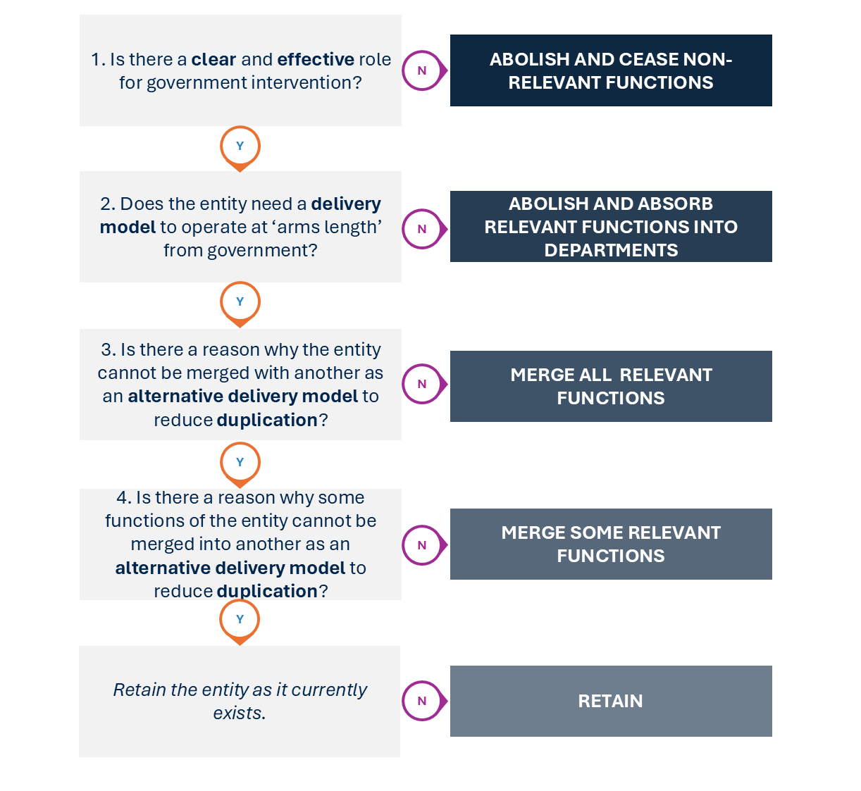
Source: Independent Review of the VPS, 2025

6.3 Reducing the number of public entities

The Review has found that the government can take immediate steps to reduce the number of public entities by 78, or around a third of those assessed, bringing Victoria closer to comparable jurisdictions. This reduction includes focused, phased consolidations of 60 current entities, and abolishing 18 entities, where there is no identified ongoing need or where their necessary functions can be absorbed into a department or another entity.
The entity reforms recommended by the Review are estimated to result in net savings of around $427 million over the forward estimates and reduce FTE (VPS and public sector) by 536. There will also be significant indirect savings. Recommended changes are discussed through this chapter. A summary of all recommended changes is at Appendix C.

Regulatory system reform
Victoria’s regulatory system is highly fragmented, with more than 30 standalone regulators and a number of regulators embedded in departments.
Using good regulatory principles and building on work committed in the government’s 2024 Economic Growth Statement, the Review recommends streamlining the regulatory system to a smaller number of larger, focused regulators that could address common issues and concentrate on core regulatory activities. For regulators assessed by the Review as showing opportunity for change, streamlining would reduce the current set of regulators to 12 (Figure 6.3).
Regulators should be big and broad enough to have operational and functional efficiencies, and to guard against the risk of industry capture that tends to occur with narrowly focused regulators. However, too big and regulators lose efficiency, subject matter expertise and focus on the sectors they regulate, and knowledge of the sector dynamics and the priority risks of harm.
This more streamlined regulatory system would remove duplication of effort, increase the use of shared services, and reduce red tape for business.
Along with a consolidation of regulators, there is greater opportunity for the use of shared platforms for the delivery of repeatable, straightforward regulatory services. Chapter 7 discusses this in more detail and the important role of DGS to build these platforms.
The estimated net direct savings for government through consolidating regulators is $40 million to $50 million over the forward estimates and around 80 FTE.
Recommended changes include:
- Create a Consumer Protection Regulator. This new, standalone entity would become the lead regulator for consumer protection, and a significant proportion of occupational and business licensing activities. This would reduce overlaps across regulatory bodies and strengthen the role of government in setting and enforcing clear rules for market conduct related to consumers or businesses. ​The entity would streamline processes for businesses by providing a single regulator for many licences and renewals. For consumers, a larger consumer protection focused regulator can help address unfair practices by connecting data and enforcement across sectors. ​
A new Consumer Protection Regulator entity will clarify accountabilities for regulatory activities. Moving regulatory responsibilities out of DGS will also allow it to focus on delivering shared service platforms across government (Chapter 7). The Review notes that policy responsibility for improving the Working with Children Check remains with DJCS.
- Merge Recycling Victoria functions into the Environment Protection Authority (EPA). The EPA’s functions would be expanded to cover environment protection,
waste, and recycling. This would consolidate environment-related functions into a single entity that can improve coordination, reduce fragmentation and enable greater data sharing and compliance activities. A single regulator may simplify approval processes for businesses and reduce the time spent interacting with multiple entities – such as through inspection activities. Integrated oversight may also have community benefits including improved environmental outcomes.
- Create a new Built Environment Regulator. This would consolidate regulators across building and construction, and energy. It would include the new Building and Plumbing Commission (that is bringing together the Victorian Building Authority, Domestic Building Disputes Resolution Victoria and the Domestic Building Insurance function of the Victorian Managed Insurance Authority) along with occupational licensing for architects and surveyors. Energy Safety Victoria’s oversight of electricity, gas and pipelines should also be included. This new entity would deliver more coherent oversight of activities involving the built environment and construction – an ‘engine room’ of Victoria’s economy.
- Absorb the Victorian Pharmacy Authority into the Health Regulator to oversee common issues across health settings. This would involve integrating the Pharmacy Authority’s pharmacy and non-pharmacy business licensing regulatory activities into the broader departmental regulatory framework. The consolidated regulator will simplify business interactions, streamline compliance, and strengthen Victoria’s ability to manage health safety risks.
- Create a Racing Integrity and Welfare Regulator and separate out commercial racing functions (see more below). The new regulator would oversee racing integrity, animal welfare, compliance, and licensing for all forms of horse and greyhound racing in Victoria. This change would lead to a clearer separation of activities and ensure that regulators are focused only on regulatory activities rather than providing commercial racing. This will lead to better practice governance as well as ensuring that oversight of the racing sector is consolidated in one place.
- Establish a new Food Safety Regulator to oversee common issues across food product safety settings, consolidating existing entities into a single focused body. This includes PrimeSafe (meat, poultry, and seafood), Dairy Food Safety Victoria (dairy), and DH (licensing, food safety). Consolidation will reduce duplication, improve coordination, and streamline regulatory interactions for food businesses, while strengthening oversight across the sector. The reform aligns with the phased consolidation outlined in the Economic Growth Statement, with consultation underway.
- Establish a new Workplace Regulator. This would consolidate the Wage Inspectorate Victoria, Portable Long Service Authority and Labour Hire Authority into a single body. These entities currently oversee overlapping aspects of workplace compliance, including portable entitlements, and labour hire licensing. Over time, a single regulator would streamline enforcement, reduce duplication and costs to government and business, and provide a clearer point of contact for employers and workers.
- Merge the Victorian Legal Services Board and the Legal Admissions Board. The existing bodies undertake duplicative functions – being the registration and regulation of legal practitioners. Consolidating these responsibilities under a Legal Practitioner Regulator will increase efficiency while maintaining professional standards and streamlining processes for law graduates and lawyers. Some other states have a single body that handles admissions and registration. Other professions do not have separate admissions and registration boards (e.g. doctors, architects, vets).
- Absorb Parks Victoria regulatory functions into the Conservation Regulator. Parks Victoria’s regulatory responsibilities – such as compliance, enforcement, and permits – overlap with the Conservation Regulator. Transferring these functions would consolidate environmental regulation under a single authority, improving clarity, consistency, and efficiency in managing Victoria’s natural assets. This reform would allow Parks Victoria to focus on its core service delivery role (e.g. park maintenance, visitor services), while the Conservation Regulator assumes responsibility for environmental compliance, enabling better coordination of enforcement and reducing duplication of effort.
- Create a new Outdoor Regulator. The Victorian Fisheries Authority and Game Management Authority both regulate the sustainable use of natural resources – fishing and hunting respectively – through licensing, compliance and education. Merging them would create a unified regulator body for wildlife management, improving coordination and reducing administrative duplication. Over time, a single entity would enhance data sharing, streamline enforcement, and provide a more consistent regulatory experience for recreational and commercial users, while supporting a holistic approach to ecosystem and species management.
- Merge Heritage Council of Victoria functions into Heritage Victoria. The Council and Heritage Victoria both operate within the heritage protection framework, with the Council providing independent advice and determinations, and Heritage Victoria managing day-to-day operations. Merging these functions would streamline governance and reduce duplication. It would also centralise heritage decision-making and policy implementation, improving efficiency and responsiveness while maintaining strong heritage protections through a single accountable body.
- Absorb the Housing Registrar into the Social Services Regulator (SSR). Victoria’s SSR is an independent statutory authority that was established in 2021 and replaced the Human Services Regulator. The SSR’s recently expanded regulatory framework establishes it as the single independent regulator for Victorian social service providers – overseeing safety and quality standards. An expanded SSR would incorporate the functions of the Housing Registrar. The Housing Registrar regulates Victoria’s community housing sector and providers oversight of registered community housing agencies for financial viability and tenant safety.

Figure 6.3: Regulators with substantive mergers or scope changes
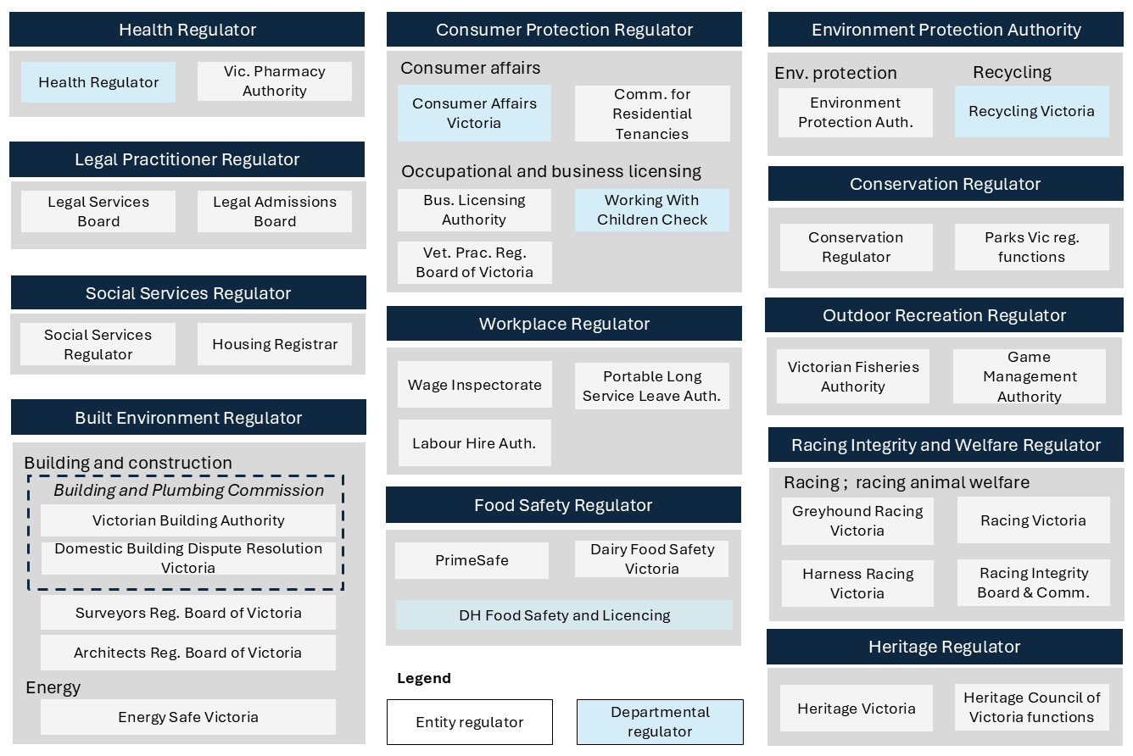
Source: Independent Review of the VPS, 2025

Water and land management reform
The Review recommends consolidating 17 water corporations (excluding Melbourne Water) into 6. Three metro corporations and 3 merged regional water corporations would form metro-regional partnerships, combining strategic coordination with local delivery expertise for efficient management of water resources across the state. Catchment Management Authorities (CMAs) would be merged into 3 regionally aligned bodies (Figure 6.4).
Metro water corporations would act as the central coordination hubs for their respective partnerships. They would be responsible for direct service delivery, infrastructure maintenance and emergency response within their defined areas (as they are now) and take leadership responsibility for the partnership for:
- Service delivery management – oversee and coordinate service delivery across urban and regional centres, guiding the service delivery operations of the regional corporation
- Network planning – undertake network planning for the partnership, including aligning plans with regional water corporations to ensure comprehensive coverage
- Procurement – leverage buying power and economies of scale for any contracts
- Corporate functions – manage finances, HR, communications, legal services and other functions for the partnership.
The regional water corporations would act as the service delivery arms for their respective partnerships. They would be responsible for:
- Direct service delivery – manage operations of water supply and sewage services within their areas, ensuring reliability and responsiveness to local customer needs
- Infrastructure maintenance – maintain and operate local infrastructure, including distribution networks and treatment facilities
- Emergency response – respond to localised service disruptions, implementing strategies coordinated with metro oversight for swift resolution.
The merged CMAs would remain responsible for planning and coordination of land, water and biodiversity management in all catchment and land protection regions. They would be distinct from water corporations but share aligned boundaries to support integrated planning across regions. A smaller number of CMAs across the state will support increased efficiency and strategic operations.
This partnership model would modernise and streamline administration and customer service, reduce duplication of corporate functions and allow for a more strategic water management approach across the state. It builds on some shared service arrangements already in place across the sector (e.g. via VicWater), so that current efficiencies are retained and scaled. Best of breed systems and processes could be adopted from existing corporations (metro or regional) as part of the partnership model.
Implementation planning will need to give careful consideration to resolving potential conflicts between storage management and retail, efficiencies to be passed on to customers, and any implications for government’s commitment to Traditional Owners’ self-determination. Consideration will also need to be given to the drought conditions and how regional communities will be supported, and how local knowledge and engagement can be sustained.
The estimated net savings for government through these reforms is $71 million over the forward estimates and 160 FTE.

Figure 6.4: Recommended land and water management reforms
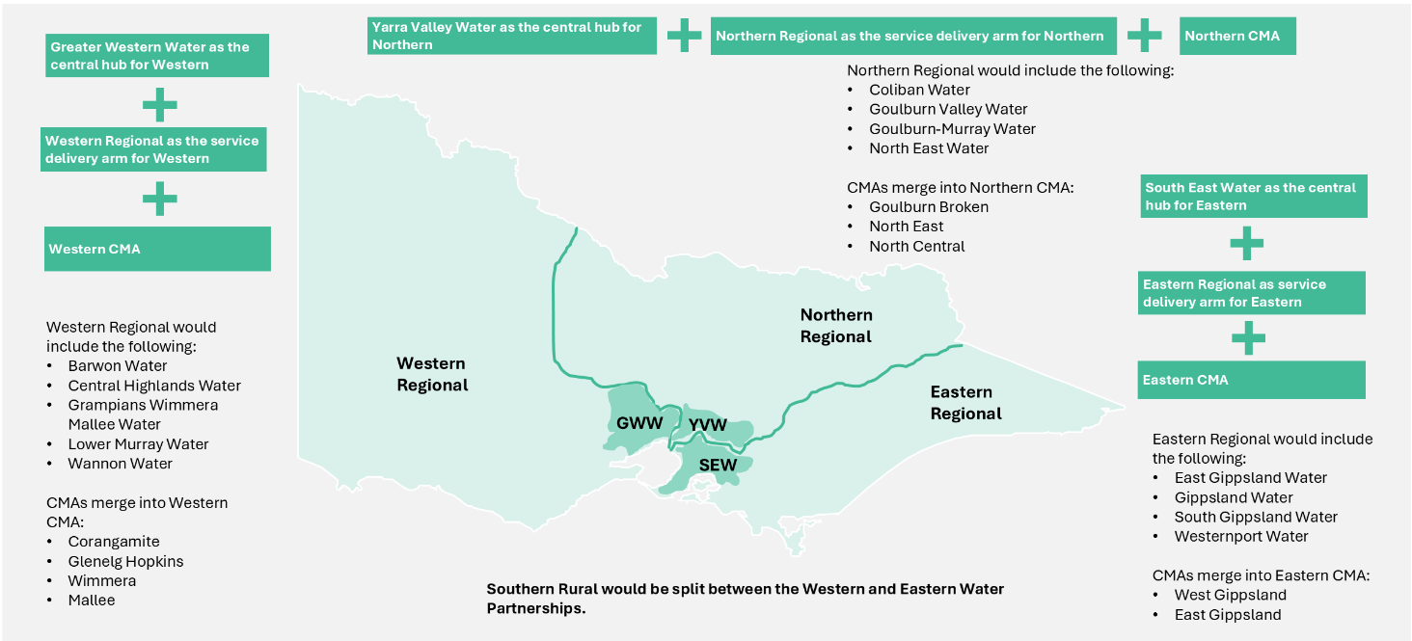
Source: Independent Review of the VPS, 2025

Policy advice and research
Victoria should bring policy advice and research work being conducted by entities back in-house to departments. Specifically, the Review recommends abolishing and ceasing the standalone functions of Better Regulation Victoria, Economic Growth Victoria and Infrastructure Victoria.
This change would bring core regulatory policy work back into DTF. Assessment of Regulatory Impact Statements and Legislative Impact Assessments, and supporting regulatory practice and supporting economic growth is core work of DTF and should be absorbed.
Infrastructure Victoria has undertaken good work but now is an appropriate time to absorb its operations into a department. Abolishing Infrastructure Victoria would mean long-term infrastructure planning and advice would be core work of DTF.
These changes reduce overlaps of policy advice and research functions.
The estimated net savings for government through these reforms is $31 million over the forward estimates and 36 FTE.

Funds and investment management
Victoria should consolidate its funds and investment management. By default, invested funds should be managed by the Victorian Funds Management Corporation (VFMC). The VFMC currently manages $92 billion of assets on behalf of more than 30 Victorian entities. The Review has identified other entities managing funds of least $2.6 billion (e.g. Victorian Legal Services Board, Residential Tenancies Bond Authority, Victorian Legal Practitioners Liability Committee), and recommends they be transferred to the VFMC. This is the same model that operates for the Transport Accident Commission and WorkSafe Victoria funds. Consolidating funds management into VFMC will leverage expertise, improve oversight and reduce financial and operational risk to government, and to participants ultimately utilising these funds.
The Review recommends that government consolidate and scale back its industry support activities. This includes abolishing LaunchVic as a standalone entity and absorbing necessary remaining functions into Invest Victoria. Management of LaunchVic’s equity investments should also be transferred to VFMC. Chapter 8 discusses recommended industry support changes in further detail.
The estimated net savings for government through these reforms is $13 million over the forward estimates and 14 FTE.

Abolishing entities and ceasing functions
The Review has found opportunities to abolish some entities where there is substantial duplication with the responsibilities of departments and there is not an identified ongoing need for the activity. These entities were established to achieve policy goals at a particular time, have done good work and achieved their objectives, and now arguably are no longer required.
The estimated net savings for government through these reforms is $18 million over the forward estimates and 14 FTE.
Recommended reforms include:
- Sustainability Victoria (SV) should be abolished as a standalone entity and its functions ceased. SV was established in 2005 to promote environmental sustainability, which is an important role for government. However, SV’s waste management, recycling, energy and climate change responsibilities overlap with DEECA and other non-departmental entities (i.e. Recycling Victoria and the EPA). Removing SV would streamline sustainability policy, simplify governance, reduce administrative overheads and clarify accountability across the relevant bodies.
- The Geelong Authority should be abolished as a standalone entity and its functions ceased. The Geelong Authority was established in 2015 to provide independent advice to the Minister for Planning on priority projects to attract investment and major planning decisions within the Geelong region. This duplicates DTP’s responsibilities and a separate entity is no longer required. Discontinuing this body will streamline planning processes and avoids duplicating administrative functions.
- The Office of the Local Jobs First Commissioner should be abolished as a standalone entity and its functions ceased. The Office was established in 2018 to promote Victorian jobs by promoting the Local Jobs First policy, and providing advocacy and leadership for local jobs and training. This was an important entity at the time but is no longer necessary as the Local Jobs First policy is now well established in Victorian Government procurement practices. The Office overlaps with the core functions of DJSIR and removing it will reduce duplication.

Absorbing functions into departments or other bodies
The Review has found there are some entities whose functions are not (or no longer) required to operate all or some of their functions at arm’s length from government, or functions overlap with the existing work of departments and other relevant bodies. In addition to achieving savings for direct and indirect costs to government, these reforms will enable clearer structures and oversight, and stronger accountability. It will also make government less complex to navigate for citizens, business and the VPS.
The estimated net savings for government through these reforms is $119 million over the forward estimates and 124 FTE.
Recommended reforms include:
- HealthShare Victoria (HSV) should be abolished as a standalone entity and its functions absorbed into DH as a branded division. HSV is currently an independent statutory authority with healthcare procurement logistics functions, monitors public health service compliance, ensures probity in purchasing, tendering and contracting activities, and provides advice and training related to procurement. This activity does not need to be conducted at arm’s length and can be absorbed into DH work without comprising service quality. HSV’s branding would be retained.
- VicHealth (Victorian Health Promotion Foundation) should be abolished as a standalone entity and its functions absorbed into DH. VicHealth was established to promote health and prevent chronic disease in Victoria through research, policy development, and community-based health initiatives – including Cancer Council Victoria programs and the QUIT helpline. This is important work but does not need to be conducted independently of a department; it can be absorbed into DH work without compromising service quality. This will also reduce current duplicative work across VicHealth and DH. The brand could be retained.

- The corporate functions of Court Services Victoria (CSV) should be absorbed into and delivered by DJCS. CSV was established to support judicial independence and to provide administrative services for courts and the Victorian Civil and Administrative Tribunal (VCAT). It is not essential that general corporate functions – such as finance, payroll, ICT and asset maintenance – be delivered at arm’s length from government. To improve the efficiency and effectiveness of corporate services within a more streamlined operational structure, CSV’s corporate functions can be delivered by DJCS. This integration will enable more cohesive management by DJCS and financial oversight while maintaining judicial independence. All courts and VCAT frontline service delivery, along with the Judicial College of Victoria and Judicial Commissioner of Victoria, would continue to be directly supported by CSV.
- Emergency Recovery Victoria (ERV) and Emergency Management Victoria (EMV) should be abolished as standalone entities and their functions absorbed into DJCS as a single branded division. ERV is responsible for leading Victoria’s recovery coordination and relief, while EMV is responsible for implementing emergency management reform. Both play an important role but do not need to operate separately and independently of government. They can be brought together and into DJCS. This will help clarify responsibilities and accountability within government for preparing for emergencies or supporting recovery following emergencies. It will also support Victoria to increasingly move towards a coordinated, all hazards approach. Emergency response will remain with existing organisations.
- The Victorian Small Business Commission (VSBC) should be abolished as a standalone entity and its functions absorbed into VCAT. The VSBC provides important dispute resolution services for small business but they do not need to be delivered by a separate body. They can be delivered by VCAT. This will reduce administrative duplication and simplify the experience for small businesses seeking to resolve disputes.

Merging entities with overlapping functions
The Review has found opportunities to reduce the number of entities by merging those with duplicative, overlapping or similar functions. This will consolidate expertise and increase efficiency and effectiveness through economies of scale and shared corporate functions.
The estimated net savings for government through these reforms is $61 million over the forward estimates and 64 FTE.
Recommended reforms include:
- Human rights offices and commissioners should be merged within the Victorian Equal Opportunity and Human Rights Commission (VEOHRC). This should be implemented in stages and include the Commission for Gender Equality in the Public Sector, the Commission for Children and Young People, the Commissioner for LGBTIQA+ Communities, the Victorian Multicultural Commission and the Office of the Public Advocate. This reform maintains the independence of the respective roles while leveraging expertise and increasing administrative inefficiencies through the consolidation of corporate functions. It also creates a more cohesive approach for the Victorian community with VEOHRC to be a centre of excellence and provide a one-door approach to human rights services.
- Racing Victoria should be refocused as a commercial entity by merging the commercial functions of Racing Victoria, Greyhound Racing Victoria and Harness Racing Victoria under the one entity. This should be done in combination with the regulatory system reforms for a new racing integrity and animal welfare body. This reform will create operational and corporate function efficiencies and will separate the commercial and regulatory aspects of racing. This would ensure that regulators are focused only on regulatory activities rather than also providing commercial racing.

Different approaches for advice and stakeholder engagement
It is important for the government to have mechanisms to seek policy advice and engage with stakeholders: government policy, programs and services benefit as a result. Over a number of years, establishing an advisory committee appears to have become the default mechanism for that advice and engagement.
The Review has identified 90 Victorian Government advisory committees. They vary in establishment formality (statutory and non-statutory), size, membership, tenure and operations. A list of the advisory committees is at Appendix C.
In a number of cases, advisory committees are in place for historical reasons, or because they are fixed in legislation, rather than because they represent the most appropriate or contemporary option for advice or engagement.
More modern, efficient and flexible methods for seeking policy advice are available to ministers and departments. When specialist advice or stakeholder perspectives are needed, departments can seek information on an as-needed basis (such as a round table meeting or forum) and fund it through their policy functions. General advice and advocacy are not core necessities, and industries can assume this role where appropriate. Other tools, such as online platforms (i.e. Engage Victoria) and data analysis, can obtain stakeholder and community input into the policy process.
This also has the benefit of allowing for a larger number and more diverse range of voices to be heard.
The Review recommends the government confirm the need for the 90 advisory committees and remove the vast majority of them. This reform would streamline governance and reduce the administrative burden associated with supporting legacy structures that are no longer fit-for-purpose.
DPC should lead a rapid process in 2025 to confirm the continued need for advisory committees. There should be a high threshold for retaining them (statutory and non-statutory), with the assumption that 90 per cent will be abolished and other mechanisms utilised should a continued need for external advice exist.
The estimated net savings for government through these reforms is $24 million over the forward estimates. This does not include indirect savings as executive and officer time is freed up from managing these groups.

6.4 Ongoing administration and oversight of public entities

The need to reduce the number of entities currently operating in Victoria has been driven in part by the lack of a current framework and a disciplined approach to establishing, monitoring and sunsetting entities over a number of years. While some guidance on entity formation does exist, it is not always followed.
The Review recommends stronger guidelines for entity establishment and improved entity governance. This includes best practice governance structures, enhancing visibility and monitoring through data collection, first-principles reviews, and sunsetting entities by default once their purpose is fulfilled.
Recommended reforms are outlined below (with more detail at Appendix C). Reforms include:
- Refresh guidelines for entity establishment. The government should update and publish guidance for assessing the need to establish
new entities and ensure they are fit-for-purpose. Clear guidelines, well implemented and adhered to, will help prevent unnecessary proliferation and reduce costs. Assessments should start from the position that an entity is not necessary.
- Default to a single executive governance model, and where boards are needed, streamline them over time. Boards in the general government sector are frequently adopted as the default governance structure without sufficient consideration of their appropriateness or effectiveness. ​When established, entity boards typically consist of 8 or more members. Best practice guidance recommends 6–12 members for public sector boards.​ The Review’s preference is for a maximum of 8 members.
The government should default to a single executive governance model for entities for efficient decision-making, except where accountability and integrity needs demand collective oversight. When boards are necessary, Victoria should move towards smaller, fit-for-purpose boards, sized according to operational complexity. Current board sizes could be reduced progressively as member tenures expire, and boards are refreshed.
- Improve entity data collection and reporting. Victoria lacks a comprehensive database of all government entities with operational and financial information. This makes monitoring and informed decisions about the efficacy of entities challenging. Despite mandatory reporting for most (if not all) entities, reports are often not consolidated and do not provide the data required to assess the relevance or necessity of the entity.
The government should improve data collection to have an accurate picture of all its entities. Reporting requirements should be reformed to make them fit-for-purpose for entities of different sizes and complexities. This will reduce their disproportionate administrative burden and redirect resources to service delivery for citizens, business and government.
- Enforce entity review and sunset by default. Regular reviews of entities are not undertaken to ensure entities remain relevant and necessary. Entity sunset dates are rarely set and adhered to, resulting in a large number of entities, not necessarily aligned with current government priorities.
The government should set default sunset dates for entities of no more than 5 years following establishment. Entities should wind up upon their sunset date unless there is a clear demonstration of continued relevance and effectiveness in fulfilling its mandate. A first-principles review of an entity should be undertaken in advance of the 5-year sunset date if it is considered necessary to retain it. This will help mean entities are aligned with current government priorities, and support resource allocation to high priority areas.
- Extend reviews to other forms of public sector entities. Certain types of entities – such as statutory roles and branded divisions within departments – do not fit neatly into existing VPSC categories and may be overlooked when considering the broader shape and size of the public entity landscape. The government should extend reviews of continued relevance and necessity to other forms of public entities to reduce the risk of continued proliferation.

6.5 Implementation

The need for entity reform is significant and the Review considers the government should take immediate action in this area. The Review also acknowledges that implementing entity reform will be complex. Stakeholder concerns, legislative amendments and administrative changes, along with industrial considerations, all require sensitive management.
The Review has identified efficient and pragmatic pathways to implement entity reform, including the use of legislative and administrative mechanisms. There is a legal basis to move with speed and pragmatism, and approach entity change in a way that delivers efficiencies and minimises disruption to service delivery.
The government has three broad pathways to implement the Review’s recommended entity changes as quickly and as efficiently as possible, including implementing entity change without reference to legislation, commencing entity change with executive actions, and implementing entity change through legislation. Necessary legislative change could be undertaken through an omnibus bill.
While the drafting and passing of legislation can take time, some of the reform and savings proposed should be materialised prior to enactment of that legislation, for example, combining office space or consolidating back-office functions of entities to be merged. Further detail about the pathways for implementation is at Appendix C. These early actions will help maintain momentum and opportunities for entity reform.
As part of implementing entity structural changes, the Review considers a best practice spans of control and layers approach should be applied to maximise efficiency and effectiveness (see model in Chapter 5).

6.6 Recommendations
  - Reduce the number of public sector entities by 78 through a process of consolidation and removal, including:
- Regulatory system reform
- Water and land management reform
- Policy advice and research
- Funds and investment management
- Abolishing some entities and ceasing their functions
- Absorbing the functions of entities into departments or other bodies
- Merging entities with overlapping functions.
  - Confirm the need for 90 advisory committees, with the assumption that 90 per cent will cease and other mechanisms could be utilised if a need for external advice exists.
  - Pursue a pragmatic approach to entity changes by taking early administrative actions to start realising reform and savings while developing appropriate executive actions and legislative change.
  - Improve the ongoing oversight and administration of public entities, and embed best practice governance, by:
  - Strengthening and publishing refreshed guidelines for the establishment of public sector entities to prevent further unnecessary proliferation
  - Defaulting to a single executive governance model, and where boards are needed, streamline them over time to a smaller number of members
  - Improving entity data collection and reporting, ensuring consistent data capture across all entities, and fit-for-purpose reporting requirements
  - Enforcing public sector entity review and sunset by default after 5 years
  - Extending reviews to other forms of public sector entities (including branded divisions within departments and statutory roles).

Chapter 7: Accelerating digital capability
Key points
- Victorians interact with state government services and systems millions of times every year. The core systems are fragmented and ageing, which is driving up cost, risk and inefficiency.
- There is a major opportunity for the government to modernise its delivery of services through digitisation. The Review recommends a staged, platform-enabled shared service reform model to digitise repeatable transactional services across customer services, regulatory functions, corporate services and enabling infrastructure.
- DGS should lead platform rollout and manage repeatable transactional services, while departments and regulators retain accountability for judgment-based decisions and enforcement actions, core service delivery and outcomes.
- AI has the potential to further improve services and reduce costs, if implemented safely and effectively.
- Digitisation will result in savings of $94 million over the forward estimates and VPS reductions of 197 FTE, with benefits increasing to around $800 million by year 10.

7.1 Introduction

Victorians expect government to be easy to deal with – fast, simple and connected – and expectations continue to rise. Yet too often, people must repeat information, navigate complex systems or wait for manual approvals. In 2023, more than 10 million rules-based transactions with Victorians were handled differently across VPS agencies. Public servants also lose time navigating more than 50 bespoke HR, finance and procurement platforms. Over 40 per cent of these core systems will reach end of life within 5 years.
The government must modernise the delivery of simple, repeatable services to improve user experience and reduce cost. Successful change will have a direct impact on the government’s current and future operating expenses.
These changes will require the government and the VPS to embrace an innovation culture – adopting a mindset of collaboration, experimentation, new partnerships and ways of working, and a willingness to do things differently. The Review finds there is much scope for change here.

7.2 The role of the Department of Government Services

DGS was formed in 2023. Its role is to improve the experience for people interacting with and within government by connecting and digitising government platforms and streamlining corporate and procurement services. DGS functions include digital transformation, consumer affairs, local government and other miscellaneous functions. As part of its role, DGS sets cloud hosting standards and delivers shared platforms for identity, contact centres and payments.
The Review has examined the delivery of shared services within government and provided to the community to date. It has found important lessons that inform its recommendations about accelerating digital capability in government. Digitising is essential and will result in significant savings and better customer service delivery, and better position government to take advantage of future technology advances.
The Review recommends reshaping and strengthening DGS to focus on leading and
being accountable for shared services platform rollout, managing repeatable transactional services, and driving the appropriate adoption of AI across government. It should have a role in any ICT-related decisions for platforms or core system replacement. CenITex would remain under DGS direction and deliver secure infrastructure.
Under this model, DGS would not be accountable for direct regulatory or service roles. This is consistent with entity reforms proposed in Chapter 6.
It should be reinforced to departments and regulators that they remain accountable for their overall outcomes and any decisions requiring discretion or judgement, to build support for partnerships with DGS. This would allow DGS to expand its platforms across more simple rules-based transactions – consistent with the Victorian Government Digital Strategy.

7.3 Conditions for successful reform

Other jurisdictions confirm Victoria’s experience: reforms struggle when platforms are rolled out before processes are aligned. Lessons learnt from Victoria and other jurisdictions have shaped the Review’s proposed approach to digitising services and shared services reform.
Reforms fail when centralisation comes before standardisation, when tools are bespoke, or when support is lacking. They also fail when savings are extracted too early – before processes are simplified and automated, and when governance and accountability are not clearly communicated and understood.
Earlier initiatives led by DGS – like the Common Corporate Platforms program – highlighted the risks of digitising services before simplifying them. Systems were configured differently for every department to accommodate variations in how common tasks were undertaken. This approach limited reuse, increased customisation and made improvements harder to scale.
Reform should start with generalisable tasks. In the case of VPS departments’ internal corporate services, reform should start with tasks like staff onboarding and leave approvals, where it is hard to argue that they should differ across departments. Platforms are modular, allowing progressive adoption and independent updates. Customisation should be limited to essential legal, operational or workforce needs, not historic practices. More complex needs, such as shift rostering, should be addressed later, once core systems are proven and stable. This sequencing builds trust, capability and early value, while avoiding the trap of digitising fragmented and bespoke practices.

7.4 Digital reform priorities

The Review considers the digital reform priorities for Victoria are:
- Regulatory and customer service platforms
- Corporate services for the VPS
- Enabling digital infrastructure
- Responsible and scalable use of AI across government.
Each of these is discussed in more detail below, including a description of how they should be progressed if adopted by government.

Regulatory and customer service platforms
Victorians interact with government more than 10 million times a year, applying for permits, registering businesses or seeking grants. Most of these follow repeatable rules and do not require bespoke systems, yet agencies deliver them separately, causing duplication and delays.
Government can digitise these repeatable transactions by scaling DGS’s existing platforms, like identity verification, grants and contact centres. DGS already manages more than 500,000 calls annually across multiple departments. These platforms should be integrated and expanded for whole-of-government use. Departments and DGS need to work closely together to implement quickly and monitor solutions.
DGS should expand the existing grants platform to cover application, assessment, payment, and reporting, while consolidating billing and data tools to reduce duplication and improve reliability.
Contact centres should be streamlined. Access to Victorian Government contact centres should be via a single number and shared digital front door to provide consistent access to routine queries. DGS should start with business-facing and regulatory contact centres, with departments retaining complex or sensitive cases. DGS should partner with relevant entities to develop the appropriate triage model.
A central entry point for complaints handling should triage and resolve simple issues, such as updating contact details, while referring complex matters to the appropriate department or regulator. Regular reports with themes synthesised need to be provided to the relevant agencies to inform service improvements.
DGS should manage regulatory transactions that involve no discretion, like verifying identity or issuing digital credentials after a regulator registers a professional. Clear rules governing these transactions should be developed by the regulator and agreed with and implemented by DGS. Judgment-based decisions, such as licensing assessments, investigations or enforcement actions, must remain with specialist regulators.
DGS’s role is to provide platforms and transactional support that enable regulators to focus on core responsibilities, while improving consistency, security, reporting and user experience.
These reforms could consolidate more than 50 services and avoid up to $250 million in annual costs by year 10. They would also improve the experience for businesses and citizens when interacting with government.
As capabilities grow, DGS should work with departments to close remaining gaps and deliver seamless, end-to-end digital journeys (Figure 7.1). These must combine platforms, business rules and user interfaces. DGS should also explore connections with Commonwealth systems, such as shared identity verification.

Figure 7.1: Customer journey case study – Parent & child
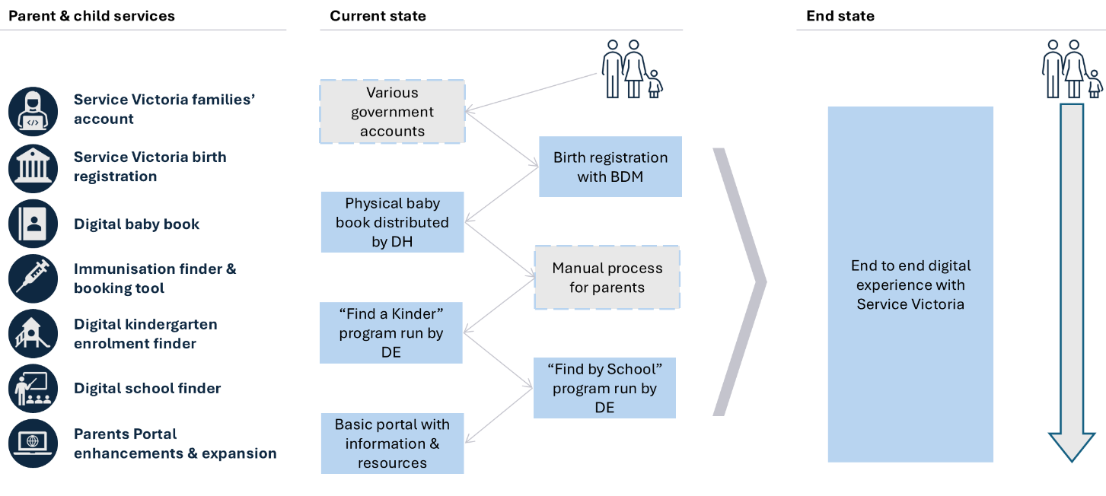
Source: Independent Review of the VPS, 2025

Corporate services for the VPS
The VPS uses more than 50 separate corporate systems. Transfers of staff between departments can take up to 4.5 months to complete, and routine processes are slow and inconsistent.
In a more digitised state, considerable efficiencies are possible:
- All VPS staff would use a single employee number and email so that access and credentials move with them between departments (Figure 7.2).
- Repeatable corporate tasks (onboarding, leave approvals, correspondence, and basic finance and procurement) would be standardised via shared platforms.
- Agencies would adopt a standard chart of accounts to support mobility, onboarding and reporting.
Figure 7.2: Case study – staff member moving between departments
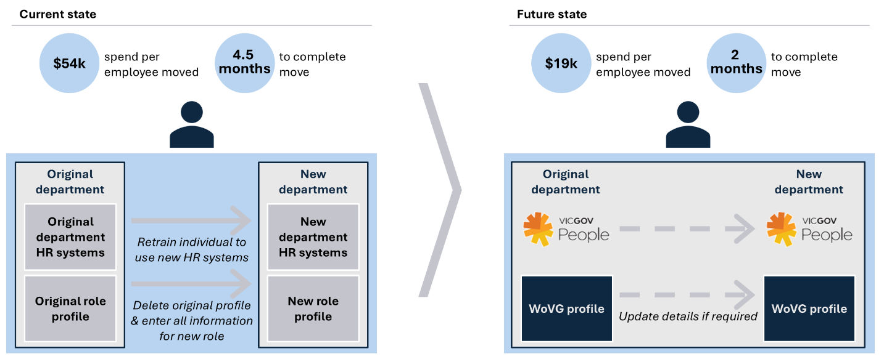
Source: Independent Review of the VPS, 2025

The Review heard mixed customer views in response to DGS’s implementation of Common Corporate Platforms. Some challenges related to recognising savings too early, too much customisation, taking all functions into DGS, and lack of genuine partnership between DGS and departments.
As part of the next strategic step, departments should retain strategic corporate functions that support Secretaries to fulfil legislative accountabilities (e.g. strategic HR, OH&S, financial administration). In line with this approach, the Review considers that strategic corporate functions currently performed by DGS should be transferred back to DPC and DTF.
The Review considers departments should transition to shared corporate systems over 8 years:
- Years 1–2: DGS, DTF, DPC
- Years 3–5: DJSIR, DTP, DEECA
- Years 5–8: DJCS, DFFH, DE, DH.
This phased rollout will build capability, reduce risk, and deliver early value. Departments with large frontline workforce networks (e.g. schools and hospitals) may retain internal delivery using shared tools. Others may transfer transactional services to DGS as platforms mature.
These reforms could avoid up to $150 million in annual costs by year 10.

Enabling digital infrastructure
Digital reform relies on modern infrastructure. VPS departments currently use more than 50 bespoke HR, finance and procurement platforms, driving up cost, cyber risk and delivery delays.
Over 40 per cent of these core systems will reach end of life within 5 years with a potential cost of up to $750 million to replace systems like for like. There is an opportunity for a more sophisticated and streamlined approach to invest in modern infrastructure.
The Review recommends the government invest in shared digital infrastructure. Victoria needs a whole-of-government identity framework, secure cloud hosting with reusable components, and standard data and API protocols. These will reduce duplication, improve cyber resilience, and accelerate service delivery (Figure 7.3).
Transitioning to an efficient, digitally enabled public service will require a targeted capability uplift – within DGS to govern and commission shared infrastructure, within CenITex to deliver and maintain it, and within departments to adopt and integrate it effectively.
The Review proposes three horizons for this transition:
- Horizon 1 (Years 1–2): Consolidate ICT services (identity, cloud, cyber). Establish shared security standards.
- Horizon 2 (Years 3–5): Migrate to shared platforms, retire legacy systems, and adopt common data standards.
- Horizon 3 (Years 6–10): Enable advanced digital capabilities – such as integration, automation and AI – on scalable, general-use platforms. Sector-specific systems (e.g. schools, hospitals) should remain department-led but supported by shared infrastructure where appropriate.

Figure 7.3: Future state enabling infrastructure model
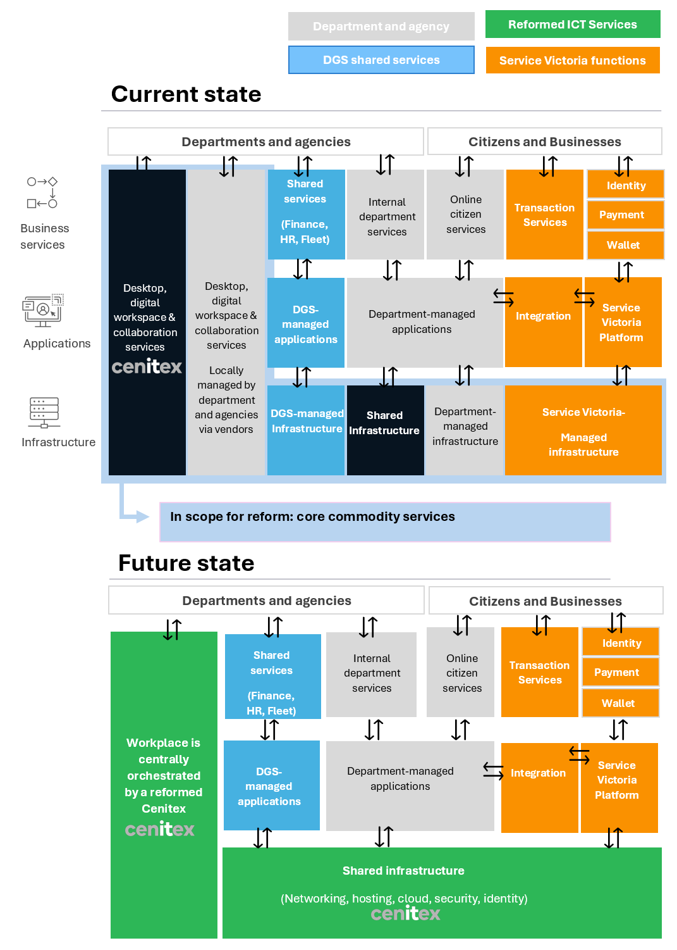
Source: Independent Review of the VPS, 2025

Safe and effective use of Artificial Intelligence
AI is already reshaping how people work. For governments, it offers a chance to boost productivity by automating routine tasks, supporting better decisions, and freeing up time for higher-value work. It does also pose some risks, including bias, poor transparency and loss of public trust. Notwithstanding, governments that act now can embed responsible AI use and gain an early advantage.
Other jurisdictions offer useful models that Victoria can draw on as it builds its approach. For example, the UK has introduced assurance frameworks and cross-government tools. Singapore and Canada have linked testbeds with talent pipelines and transparent risk assessments.
Victoria is already piloting tools like Microsoft Copilot, VicChat and offers a Service Victoria chatbot. These examples can be used to build confidence and support a structured, scalable approach. This requires trusted governance, practical tools and hands-on support.
To help with this, the Review recommends establishing a whole-of-government AI Centre of Excellence, led by DGS. The centre would:
- Provide expert advice, practical tools and training. Tools would include prompt libraries, testing dashboards and evaluation guides, and training to lift system-wide capability. Training must be tailored by role. General staff need to learn safe everyday use; legal and policy teams, ethical risk and governance; technical staff, model management; and executives, how to commission and oversee AI aligned with public values. All training should be applied and grounded in real use cases, with access to secure testing environments to build confidence and capability.
- Work with other bodies to help provide guidance. This would include working with the Victorian Information Commissioner. Victoria could also draw on work undertaken by the Commonwealth’s Digital Transformation Agency about the responsible use of AI in government.
- Support safe, structured experimentation through time-bound ‘sandpits’. The centre would run secure, short-term sandpits to give departments a place to test AI safely, focused on real-world use cases, such as summarising case files or triaging complaints. The sandpit model would manage risk and enable effective, scaled projects to be developed by using de-identified or synthetic data, involving cross-disciplinary teams (policy, legal, technical, frontline), testing tools in secure digital environments and concluding with a structured review and shared insights.
To succeed, the AI Centre of Excellence would need secure cloud environments, access to approved models and tools, governance dashboards and skilled staff. Departments must actively participate in pilots and share lessons. Initial funding would come from a proposed uplift fund, with a sustainable long-term model to be determined.

7.5 Implementation

A structured roadmap
Digital reform requires a structured, sequenced approach. The Review recommends DGS develops a clear roadmap to guide reform, and timing must reflect agency readiness. Central support must help departments plan, adapt and onboard in ways that build capability and momentum (Figure 7.4). Shared platforms should be mandatory where they meet common needs, with reuse designed in.
Key enablers, such as a single workforce identifier and common workflows should be prioritised in years 1-2. The single workforce identifier is a particularly important early step for better VPS workforce planning and re-sizing (see Chapter 5).
Implementation should focus on repeatable transactional services – prioritising high-volume areas or those that complete customer journeys. Common dashboards should track cost and user benefits, with annual public reporting through a performance scorecard.

Figure 7.4: High level roadmap
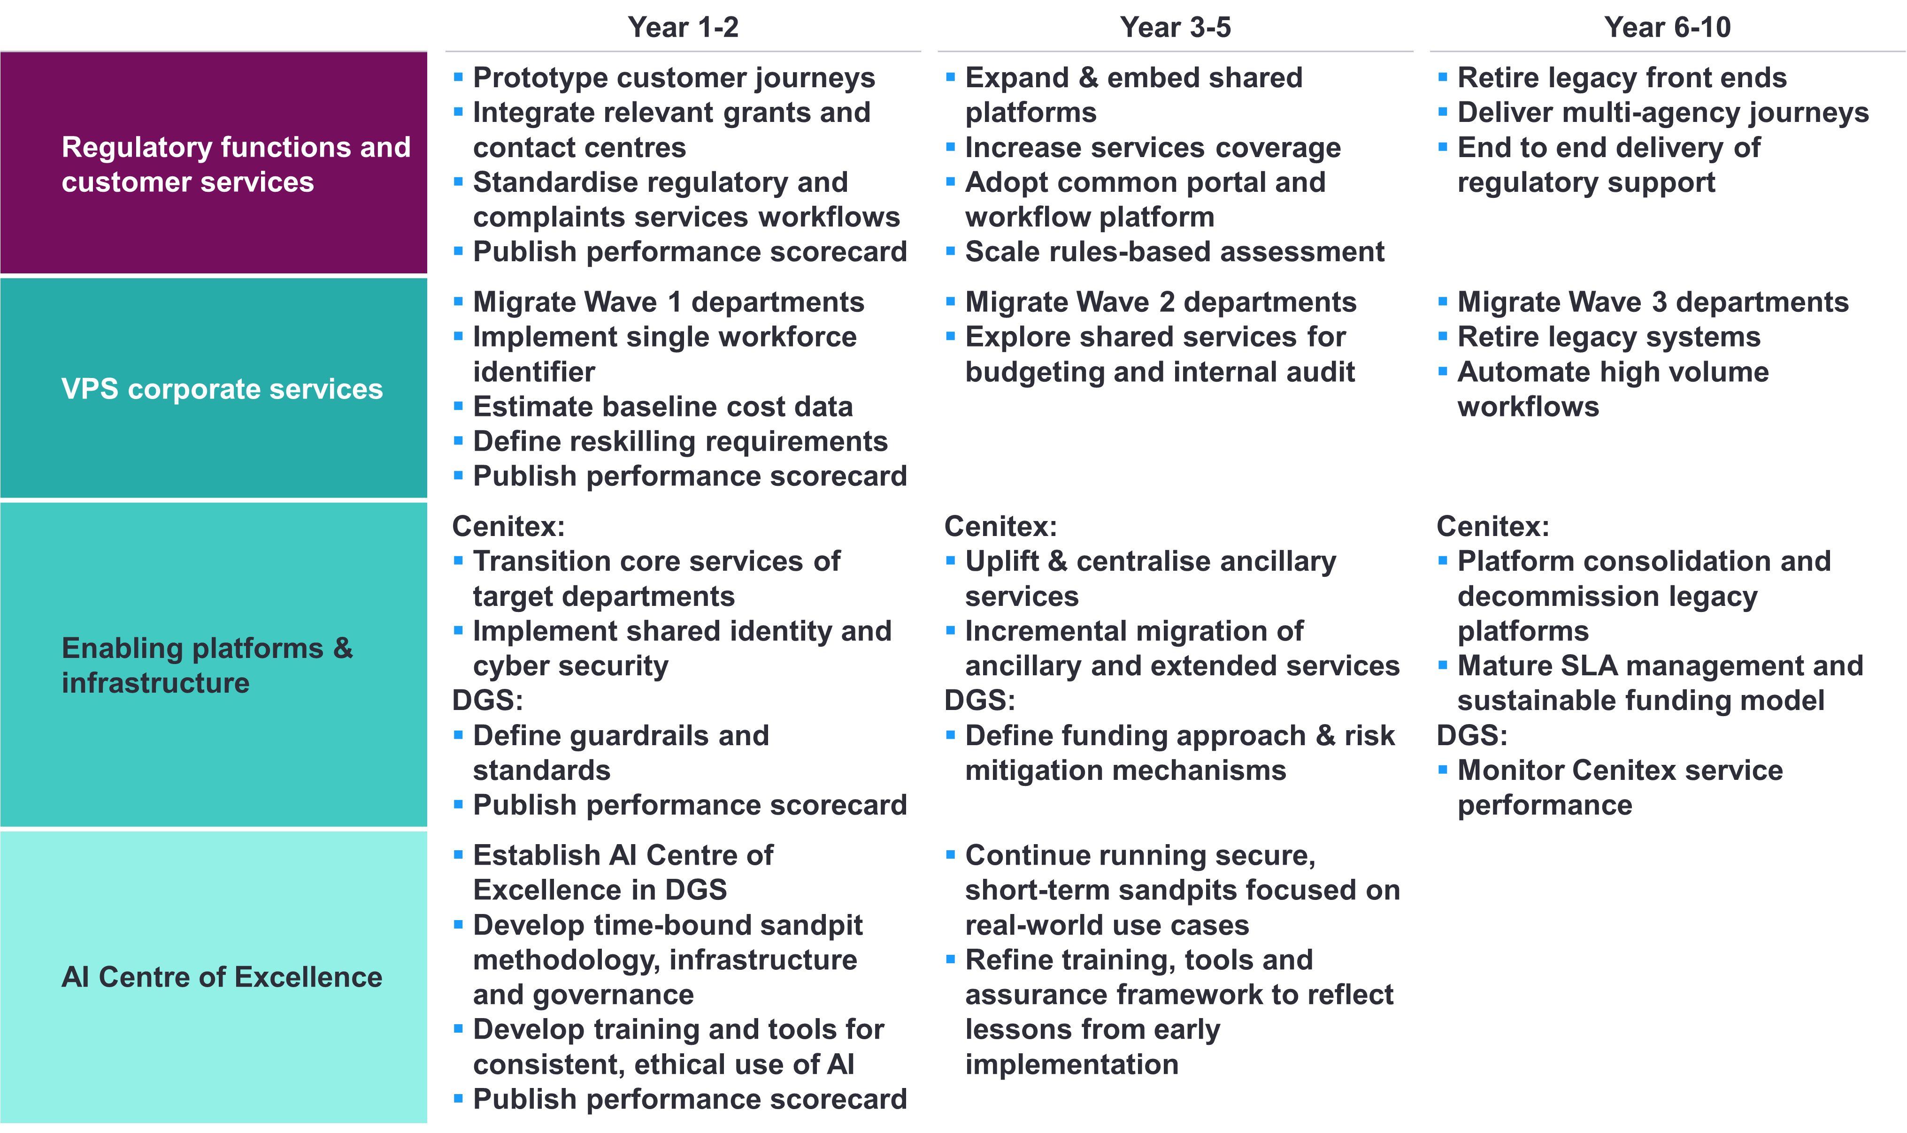
Source: Independent Review of the VPS, 2025

Governance and accountability
Strong central governance and delivery support will be essential to successful digital transformation. Decision rights, oversight and delivery plans will need to be clear.
Role clarity will be important for DGS, CenITex and departments. Each plays a critical, different and complementary role: DGS leads the strategy and planning; CenITex advises on platform viability and technical standards; and departments contribute to planning and governance, as well as ensuring local uptake. Departments need to be closely involved to help shape delivery but should not be able to opt out. All parties require a commitment to shared outcomes with clarity of their role in the reforms.
The Review recommends a new Digital Government Steering Committee be established, comprising DGS, DTF, DPC and independent experts, to guide investment and track progress. This steering committee should report to VSB to enable strong and shared Secretary oversight of reform. Regular reporting to government and published annual score cards will reinforce the importance of this work.
Within DGS, a Delivery Coordination Office should manage implementation, coordinate onboarding, and track milestones. A dedicated commercial function in DGS should support business case development and innovation, modelled on DTF’s Early Intervention Investment Framework. In addition, DGS should create relationship managers who sit in customer departments, and who can support departmental planning and transition.

Setting up for success – DGS capability review
To support DGS’s important role, the Review recommends that DGS is the first department to be reviewed under a new VPS capability review program (see Chapter 5). This forward-looking review would assess DGS’s ability to lead, coordinate and govern reform across departments, including performance and risk oversight (Box 7.1).

Box 7.1: DGS capability review
A capability review of DGS early in the whole of government digital transformation program could accelerate readiness.
Capability Area | Assessment objective | Example actions
Digital and customer operations platforms | Assess ability to deliver end-to-end digital services and manage high-volume transactions | Extend whole of government access by consolidating best in breed billing platform and data integration services within DGS, strengthen journey design
Regulatory operations capability | Test maturity to support regulatory consolidation (licensing, compliance, complaints) | Adopt workflows from departments with strong dispute resolution or audit tools; identify business-facing functions to be led by DGS
Corporate delivery and coordination functions | Confirm ability to scale shared HR, finance, and procurement processes with reporting and compliance | Accelerate development of core platforms (HRIS, finance), consolidate risks and governance processes
Technology enablement platform | Assess how well DGS is positioned to steward shared digital platforms, drive adoption of core enablers (e.g., identity, payments, data), and support Cenitex to coordinate re-platforming across Government | Strengthen API and data standard governance, finalise funding models and launch investment pathway to support progressive re-platforming
System stewardship and reform leadership | Assess DGS’s ability to lead, coordinate and govern reform across departments, including performance and risk oversight | Establish core operating model for delivery coordination, uplift engagement capability, improve transparency tools

Savings and service improvements
With the right delivery model, shared platforms can simplify services and lift productivity. An estimated $800 million in cumulative savings is possible over 10 years from retiring legacy systems, streamlining processes, and avoiding duplication. The Review estimates savings of $94 million over the forward estimates and a reduction of 197 FTE.
The identified savings exclude indirect benefits like better user experience, reduced delivery risk, and broader productivity gains. Advances in modular technology and AI could increase savings further.
Funding for shared services has challenges that can be overcome with good design. Perverse incentives – such as harvesting savings too soon – must be avoided.
Elements of an appropriate funding model for the Review’s proposed shared services reform comprise:
- upfront funding for the transformation stage
- sustainable steady-state funding with transparent funding
- benefits and savings flow back to consolidated revenue, freeing up departmental budgets to co-invest
- integrated governance and oversight
- incentives and accountability for transition and uptake
- funding matched to responsibility, funding flows and cost recovery mechanisms
- dedicated commercial capability within DGS to support business case development and innovation.
The Review recommends establishing a fund to incentivise, drive and support digital reform and change management. Upfront investment through the fund would help shift behaviour, driving process redesign, shared systems, and safe AI adoption. Departments would need to co-invest.
Over time, a sustainable funding model – centralised, fee-for-service, or hybrid – will be needed to scale innovation and maintain ‘steady state’ services. The government should expect departments to generate measurable efficiency improvements within 3 years of onboarding.
Realising this vision will take leadership, accountability, and sustained investment in people, tools and platforms.

7.6 Recommendations
  - Realign DGS to lead shared platforms and manage repeatable service delivery, return strategic corporate functions to DPC and DTF, and remove direct regulatory accountability from DGS.
  - Develop a structured roadmap for digital reform: scale regulatory and customer platforms; standardise corporate processes; and onboard departments with complex corporate needs once core modules stabilise.
  - Establish a DGS-led AI Centre of Excellence to support safe experimentation, capability uplift and adoption of AI.
  - Invest in core digital infrastructure (identity, cloud, APIs and data standards) with workforce identifiers and common workflows prioritised in years 1-2 of the roadmap.
  - Establish strong central governance and accountability through a Digital Government Steering Committee, VSB and annual public scorecards.
  - Create a fund to support transition, innovation, and capability uplift – with co-investment and return on investment expectations from departments.

Chapter 8: Portfolio and other reforms
Key points
- Significant opportunities exist for enduring change by carefully examining existing base funding to identify spending that is no longer required, can be better targeted, or can be managed more efficiently.
- The Review provided interim recommendations to the government for inclusion in the 2025/26 Budget, which resulted in $2.8 billion of savings and efficiencies.
- In the time available, the Review has applied its criteria and identified additional reforms totalling $1.2 billion in potential savings from 2025–26 to 2028–29.
- Opportunities identified by the Review are additional, sustainable, ongoing savings. They also underscore the importance of regular review of recurrent expenditure, including as part of an enhanced financial management approach through the annual budget cycle.

8.1 Introduction

The Terms of Reference ask the Review to identify overlaps, inefficiencies, functions and programs that can be streamlined or eliminated, with a focus on entity consolidation. Chapters 4 (Commonwealth-State relations), 6 (Public entity reform) and 7 (Accelerating digital capability) address this and make recommendations for significant savings and reforms. Chapter 5 (VPS size and structure) also results in ongoing savings. In total, the savings identified in this report so far total $1 billion from 2025–26 to 2028–29.
The Review provided interim recommendations about savings to the government ahead of the 2025/26 Budget, which resulted in $2.8 billion of savings and efficiencies over the forward estimates, and a reduction of 619 ongoing public sector FTE.
The Review continued that process, using the criteria outlined in Chapter 2, in some high expenditure portfolios and has identified additional savings and reform opportunities – set out in this chapter. The additional reforms will achieve an estimated $1.2 billion in savings from
2025–26 to 2028–29, which creates a cumulative total of around $5 billion in savings from the Review.
The government undertakes savings programs in annual budgets, but the focus can vary from top-down, generalised efficiencies to programmatic expenditure reductions. A GED has also been in place since 2013. In Chapter 3, the Review recommends replacing the GED at the end of the forward estimates with more systematic evaluation and discrete savings targets in each budget.
The 2025/26 Budget (supported by interim recommendations from the Review) included the largest savings program in over 10 years and – as set out in the budget papers – included initiatives to change service delivery models, reduce duplication, re-design or cease programs not achieving their intended outcomes and reduce expenditure growth where increased costs have not corresponded with improvements. This was a good exercise.
The recommended changes in this chapter serve as case studies for the types of opportunities for improvement, reform and
savings that government should continue to pursue on an annual basis to scrutinise base funding as part of stronger budget management processes (see Chapter 3).

8.2 Opportunities for portfolio reforms – case studies

In the time available and applying its criteria, the Review has identified further major programs and projects where there are significant opportunities for reform.
The following case studies identify and recommend specific improvements and savings.

Reducing role expansion – Early Learning and Childcare Centres
In 2022, the Victorian Government committed to develop and operate 50 Early Learning and Childcare Centres (ELCCs) in areas with low access to childcare. The first four centres opened in early 2025 and 14 more are under construction and will open in 2026. These centres offer integrated early childhood education and care (ECEC) services, including long daycare, 3-year-old kindergarten and 4-year-old kindergarten (Pre-Prep). The total estimated investment to construct the 50 ELCCs (along with additional kinder capital projects) is $1.3 billion.
Quality early childhood education (ECE) has many immediate and long-term benefits for health, wellbeing and economic outcomes. This has been increasingly recognised by governments and the provision of quality ECE is a shared responsibility of the Commonwealth and state. The Commonwealth is responsible for providing funding for ECE through various programs, including the Child Care Subsidy, which help families with the cost of ECE and care. ECEC services have traditionally been delivered by private, community or local government service providers. There are currently significant workforce shortages in the sector.
The government’s commitment to ELCCs – made with good intent and recognising the many benefits – is an example of role expansion. Victoria is now overlapping with a Commonwealth role and operating services that other sectors can deliver. This creates potential duplication and confusion, increases costs through unnecessary competition for resources and reduces government’s flexibility to invest in other areas of demand.
In 2024, the Productivity Commission presented a report to the Commonwealth including recommendations for improving ECEC affordability and access. This includes the creation of an ECEC Development Fund to support universal access in thin markets. The Commonwealth established a $1 billion Building Early Education Fund in December 2024 in response to the report’s recommendations.
Given the Commonwealth’s primary role, recent actions and resurgent policy interest, there is an opportunity to reconsider the state’s involvement in building ELCCs. Further, Victoria should transition the operation of ELCCs to non-state government service providers (including not
for profit providers and local government) over time. This will reduce risk and conflict of roles – with the Department of Education (DE) currently delivering ELCCs and regulating ECEC services delivered in Victoria.

Recommendation | Savings
- Pause the commitment to ELCCs beyond the first 18 already operating and under construction.  - Transition operation of the 18 ELCC sites to non-government service providers over time. | Output savings of up to  $9 –$13 million per annum relative to the full roll out.  Net capital savings of up to $350 million over the whole reform period.

Reducing duplication – Industry support
The Victorian Government provides industry support through a wide range of initiatives, delivered by different entities. In total, the Review has identified more than 25 separate industry support programs delivered across DJSIR, DEECA and their portfolio entities. Victoria’s industry support expenditure has grown considerably in recent years from at least $236 million in 2014–15 to over $660 million in 2024–25. The current spread of programs and entities is duplicative and makes government confusing and difficult for industry to deal with.
For example, there are currently different and duplicative entry points for industry to seek Victorian Government support. While Invest Victoria provides dedicated facilitation support to businesses looking to invest in Victoria, DEECA has an Innovation, Commercial and Investment group. This group undertakes policy development, stakeholder engagement and investment attraction, engaging with businesses and industries to encourage investment in Victoria’s energy sector and facilitate commercial transactions. This mirrors functions that sit with Invest Victoria.
There is also duplication of equity investment activities across government. The activities undertaken by Breakthrough Victoria overlap with activities undertaken by Invest Victoria, such as the $20 million Victorian Equity Investment Attraction Fund and the $25 million Victorian Venture Growth Fund, and DTF with the $250 million Victorian Business Growth Fund. This duplicative activity creates risk and is costly to deliver, as well as making it confusing for businesses and investors. While each program has a slightly different goal, they all interact with equity markets and make investment decisions.
Similarly, the activities undertaken by LaunchVic overlap with activities undertaken by Invest Victoria and other parts of government, such as offering grants and administering facilitation and capacity uplift programs.
The 2024 Economic Growth Statement announced a new initiative of a streamlined, single entry point for business on all investment-related engagements with the Victorian Government. This is a positive step, and the 2025/26 Budget funded some small steps towards this, including funding to establish a consolidated investment fund.
The Review considers the government should go further and consolidate department and entity industry support functions, expertise and activities. Invest Victoria should be the single entry point in government for all industry support provided by government, and the only area in government delivering this function. This includes LaunchVic being wound up as a standalone entity and necessary functions transferred to Invest Victoria (see also Chapter 6). In the context of fiscal capacity and consolidating activity and expertise, the Review recommends overall funding to industry support activity could be reduced by at least $350 million over the forward estimates.
The Review also considers that if the government continues to provide equity funding, it should be consolidated in one entity, the criteria for investment should reduce risk exposure to the state, and the overall level of equity funding should be reduced. The outcome should actively reduce risk to government from this type of industry investment and reflect budget capacity. The Review is aware that the government is currently considering these issues through a Commercialisation and Innovation Review, due to report later in 2025.
Consolidation of industry support and engagement will make working with government more straightforward. It will also free up the VPS workforce working in this area to focus on facilitation and strategic opportunities to attract investment and build priority sectors to contribute to economic growth. It could also be expected to streamline implementation of the government’s new Victorian Industry Policy, announced in early June 2025.

Recommendation | Savings
- Consolidate industry support activities currently delivered by DJSIR, DEECA and their portfolio entities into Invest Victoria and reduce overall investment in this activity.  - Consolidate LaunchVic’s grant and facilitation and capacity uplift program activity into Invest Victoria and abolish LaunchVic as a standalone entity.  - As part of the government’s current Commercialisation and Innovation Review:  - consolidate the management of existing equity investments currently with LaunchVic and DTF into one entity – Breakthrough Victoria  - reduce overall investment and the level of risk exposure from equity funds investment by government. | $350 million over 4 years from 2025–26.  See Chapter 6.

Improving effectiveness – TAFE reform
Since 2014–15, the Victorian Government has invested more than $29 billion in the VET system. The system is important for equipping individuals with skills for employment and contributes to economic growth. There are currently 12 TAFE institutes and 4 dual-sector universities, spread over more than 80 locations across the state.
Performance of the VET system is mixed, with continued skills shortages in priority industries, completion levels lower than the national average, and student satisfaction at or below national averages. The system also has financial challenges: the Review understands financial viability remains an issue for several TAFEs.
TAFEs are individual entities, largely with their own governance and systems. They vary in size and financial strength. They also operate as part of a market, competing with each other and other training organisations for students and funding. The creation of a VET market where TAFEs were incentivised to compete and innovate to meet industry and student need was a necessary reform several decades ago, however circumstances have changed. While TAFEs continue to play a crucial role for industry and students, the system is now too uncoordinated and diffuse, as TAFEs largely operate unilaterally.
The government established the Office of TAFE Coordination and Delivery (OTCD) in 2021 to work with TAFEs to drive collaboration and better financial performance. Some gains have been made to date but there is a real opportunity to do more and faster. Box 8.1 shows how a lack of collaboration leads to TAFEs delivering duplicative systems, creating cost and inefficiency.

Box 8.1: Student Management System adoption across the TAFE sector
Victorian TAFEs each have a Student Management System (SMS). All 12 developed an SMS in the past 7 years (10 were in the past 3 years). Today, more than half the TAFEs are in the process of developing, or have recently delivered, separate SMSs, many of them bespoke or heavily customised. This is a significant missed opportunity and resulted in:
- Lost economies of scale – Individual procurements pushed vendors to customise functionality, inflating licence and implementation costs compared with a sector-wide deal.
- Duplicated effort and cost – TAFEs have run their own business case, implementation, change management, data-migration and training programs.
- Inconsistent student experience – Divergent user interfaces, enrolment processes and data standards make it harder for students to move between providers, and for TAFEs to share insights.
- Delayed benefits – Several projects have exceeded timelines and budgets yet still fall short of the promised operational uplift.
The OTCD has taken steps to address this, designing and going to market for a unified SMS. Without a mandated approach to compel uptake, the risk remains that the sector ends up with another under-utilised system. The better approach would be to select a leading existing or in-flight SMS and invest in its delivery for the network. This would result in:
- lower overall costs through joint procurement and implementation
- improved system interoperability across providers, enhancing student mobility and data sharing
- greater consistency in service delivery and student experience across institutions.

The OTCD is now playing an important role in stronger coordination and building more shared services across TAFEs. The Review considers the government should build on existing efforts and mandate and accelerate shared service reform across TAFEs over the next 3–4 years, focusing on common platforms, digital infrastructure, administrative systems, joint procurement and a unified workforce strategy. This may require some investment but for the most part should be undertaken using existing, best of breed systems. Shared services are estimated to generate $36 million in savings over the forward estimates and boost productivity in the sector.
If progress on shared services is slow over the 3–4 year window, the government should consider a more deliberate approach to TAFE consolidation – with options ranging from TAFE mergers by geography or capability, through to all TAFEs merging into one single entity. Potential savings from these future opportunities range from $40 million to $200 million over a 4-year period.
The Review understands there is significant under-utilisation of assets across the TAFE network – with some buildings and land sitting vacant for many years. Selling under-utilised assets would realise significant savings or release capital for reinvestment. The precise current value of under-utilised assets across the TAFE network is unclear, but if 15 per cent of assets fit that definition, this would represent approximately $525 million of property available for sale.

Recommendations | Savings
- Mandate and accelerate shared service reforms across the TAFE sector over the next 3–4 years, focusing on common platforms, digital infrastructure and administrative functions, building on existing efforts.  - After 3–4 years, and based on progress and outcomes of shared services implementation, consider further TAFE consolidation opportunities, ranging from targeted mergers to a single TAFE entity.  - Immediately develop and implement a long-term asset strategy to sell under-utilised TAFE assets. | $36 million over 4 years from 2025–26.  $525 million

Improving effectiveness – VPS accommodation and flexible work
In March 2021, the Victorian Government announced the VPS Flexible Work Policy, with accompanying guidance setting a default assumption that full time VPS office workers work 3 days per week in their office. The policy and guidance were released as VPS staff were making the return to offices following almost a year of many working remotely during the pandemic.
Anecdotal and other evidence provided to the Review suggest adherence to the Flexible Work Policy guidance is low, with public servants working in the office, on average, closer to 2 days per week. Secretaries are currently unable to get clear data about how many days their staff are working in their offices to assist with managing the Flexible Work Policy.
Most government office buildings are still set up to accommodate a 5-day-per-week in-office presence. In addition, several government office buildings provide weekend access that is used sparingly by staff. This is leading to significant resource wastage, with the government spending around $500 million on accommodation services for the VPS every year.
The Flexible Work Policy and guidance acknowledge the social and economic benefits of flexible working, and the intrinsic value of engaging face to face with teams and colleagues within and across organisations. However, the guidance has not been updated to reflect post-pandemic conditions.
Given the low adherence to the policy and its outdated references, the Flexible Work Policy needs to be updated, with clearer
and stronger expectations about the 3-day default, and practical guidance and tools for managers to support adherence (including through Performance Development Plans). The government should also reduce the VPS accommodation footprint and related expenses accordingly – from a 5 to 3 days per week presence.
A reduction in the accommodation footprint is estimated to save $50 million per year.
There are also immediate actions that can be taken to reduce underutilised buildings costs – for example: mothballing unused floors, consolidating weekend access to only support existing demand, and adjusting building and maintenance services.

Recommendation | Savings
- Update and implement the VPS Flexible Work Policy and guidance to set clearer expectations about the default position of 3 days in the office, and provide practical guidance and tools for managers to support adherence.  - Require DGS to provide Secretaries with attendance data for relevant offices on a quarterly basis.  - Reduce the current accommodation footprint and related expenses to support a 3 days per week office presence.  - Implement an immediate plan to reduce costs in current accommodation, including mothballing unused floors, consolidating weekend access of all buildings to only support existing demand, and adjusting building and maintenance services accordingly. | $175 million over 4 years from 2025–26, and $50 million per annum ongoing.

8.3 Additional savings opportunities

The Review has applied its criteria to identify additional savings opportunities.
The following opportunities identify and recommend specific improvements and savings.
The savings identified here also serve as examples for the type of ideas and reforms that could be included in the recommended annual savings plan to be prepared by departments as an alternative to the GED (see Chapter 3, rule 7).

Improving effectiveness

Outdated budget lines – Student Resource Package
The Student Resource Package (SRP) is the main funding mechanism for Victorian government schools, distributing over $9.7 billion in 2024. Funding is provided for specific activities set out in a funding line. At least 12 SRP funding lines have been identified as outdated, misaligned with current policy or duplicative – for example, changes to bus coordination where this is now being managed centrally. These funding lines should cease, with funding redirected to support alternative, higher-priority school needs. This would reduce the call on the central budget.

Recommendation | Savings
- Cease outdated Student Resource Package funding lines and redirect funding to support alternative, higher-priority school needs. | $96.6 million over 4 years, and $29.7 million ongoing.

Outdated funding model – Secondary Instrumental Music Program
The Secondary Instrumental Music Program (SIMP) funds government secondary schools to assist with the additional cost of running an instrumental music program. The SRP provides funding for core music subjects. In 2024, the SIMP allocated $37.9 million to schools. Funding has not kept pace with enrolment growth and funding allocations are historically based, creating inequitable allocations. That is, around 10 per cent of schools receive 25 per cent of program funding. The Review recommends funding to the program be ceased, with funding redirected to support alternative, higher-priority school needs. Schools could consider alternative sources to fund an instrumental program.

Recommendation | Savings
- Cease Secondary Instrumental Music Program funding. | $125.7 million over 4 years, from 2026 calendar year, and $38.7 million ongoing.

Historical funding not achieving outcomes – Local Learning and Employment Networks
Local Learning and Employment Networks (LLENs) were established in around 2001 and act as an intermediary between schools and industry to connect students with work-based learning opportunities. The Victorian Government currently spends $15 million per annum on 31 networks. The current model appears to be inefficient and ineffective, with only a small proportion of all placements in work-based learning opportunities being the result of LLENs’ work. A new, cost-effective model should be considered to improve school-industry connections.

Recommendation | Savings
- Cease the current funding model for Victoria’s 31 Local Learning and Employment Networks. | $44.4 million over 3 years from 2026–27, and $15 million per annum ongoing.

Alternative service delivery models

Better targeting need – English as an Additional Language program for students
The English as an Additional Language (EAL) program supports schools to assist students developing English language skills. The program cost $192 million in 2024-25. The Review understands previous reviews have found that the current funding model does not target need as effectively as it could, and that transitioning to a proficiency-based funding model would improve efficiency and effectiveness.

Recommendation | Savings
- Change the funding model for the English as an Additional  Language program from a proxy-based funding model to a  student proficiency-based funding model. | $125.5 million over 4 years from 2025–26, and $44.5 million per annum ongoing.

Reducing duplication

Overlapping with a Commonwealth responsibility – Doctors in Secondary Schools
The Victorian Government established the Doctors in Secondary Schools (DiSS) program in 2017 to provide free primary health care services to students through GP consultation facilities in 100 government secondary schools. The DiSS program received ongoing funding of around $12 million per annum through the 2021/22 Budget.
This initiative was initiated in response to lack of access to primary care for young people in some areas of the state. Schools were identified as the platform to reach young people easily.
The Commonwealth has recently committed to additional investment in primary health care – providing access to free health advice and after-hours GP telehealth services and tripling the number of fully bulk billed GP practices to around 4,800 nationally. This will provide greater access to GP services, including for young people. This presents an opportunity for Victoria to transition out of funding this area of Commonwealth responsibility.

Recommendation | Savings
- Cease the Doctors in Secondary Schools program. | $42 million over four years from 2025–26, and $12 million per annum ongoing.

Efficiency and impact

No longer needed – COVID-19 special leave for health workers
COVID-19 paid special leave was introduced during the pandemic to support health workers required to isolate under public health directions or pandemic
orders. This special leave should cease, particularly in a COVID-19 endemic setting. Health workers continue to have access to alternative leave arrangements, including personal sick leave.

Recommendation | Savings
- Cease the COVID-19 paid special leave for health workers. | $28.5 million over 4 years from 2025–26, and $8.1 million per annum ongoing.

Refocus and cap funding to align with core responsibilities – Smile Squad
Smile Squad provides free dental care and oral health promotion to all students in government schools, with a planned future expansion to low-fee non-government schools. The program currently receives $75.5 million in annual funding. Like a number of other programs discussed in this report, Smile Squad could be reviewed and better targeted if the state had better data about family and child need (see Chapter 4). In the meantime, the Review recommends capping funding at 2024–25 levels and focusing on core service delivery.

Recommendation | Savings
- Maintain Smile Squad activity and funding at 2024-25 levels and focus on core service delivery. | $69.5 million over 4 years from 2025–26, and $20.6 million per annum ongoing.

Reconsider need – Grant to Melbourne City Council for transport Initiatives
The state provides an annual grant to the City of Melbourne for transport initiatives under a Memorandum of Understanding. This is funded from a portion of the Victorian Government’s Congestion Levy, which places an additional charge on off-street parking spaces in inner-city areas to discourage car travel into central Melbourne. Although the levy now applies to other local government areas, only the City of Melbourne receives this funding, with no clear policy justification. The Review recommends deferring any change until 2026–27 to avoid undermining investment decisions made through the City of Melbourne’s 2025–26 budget.

Recommendation | Savings
- Cease grants to Melbourne City Council for transport initiatives. | $21 million over 3 years from 2026–27, and $7 million per annum ongoing.

Improve efficiency and accountability – Contracting with community service organisations
The Department of Families, Fairness and Housing (DFFH) contracts with a large number of community service organisations (CSOs) to deliver services for Victorians. Strengthening contract management would improve transparency and ensure the funding provided aligns with actual service delivery and performance. While this saving is focused on CSOs contracting with DFFH, there are opportunities for other departments to equally strengthen their contract and performance management practices, which could generate additional savings. This should be pursued in the 2026–27 budget process.

Recommendation | Savings
- Improve contract management processes and recoup underspent funds from Community Service Organisations that have not delivered on service target deliverables in service agreements. | $57.8 million over 4 years from 2025–26, and $16.5 million per annum ongoing.

Improve efficiency – Better Boating Fund
The Better Boating Fund (BBF) is funded by marine licensing fees and vessel registrations. It supports the maintenance of public boating facilities and services, improves boating safety and education and promotes recreational boating. The BBF budget for 2024–25 was $36.4 million. The Review considers the BBF could achieve its purpose with a lower funding base, returning some of the revenue to the Consolidated Fund for other government priorities.

Recommendation | Savings
- Reduce funding to the Better Boating Fund. | $42 million over 4 years from 2025–26, and $12 million per annum ongoing.

Chapter 9: Implementation of the Review
Key points
- Good implementation is everything. Dedicated effort and resources will be needed over the medium term to implement changes successfully and appropriately while maintaining service delivery, with central leadership from DTF.
- Unnecessary or lower-priority demands will need to be removed – or put on hold – to ensure adequate organisational bandwidth to focus on reforms proposed.
- Actions need to be pursued immediately and thoughtfully, with high level leadership and authority. Proceeding with pace will be crucial to build momentum and confidence for reform.

9.1 Urgency for change

Change can be challenging. But – as this Review has shown – it is necessary.
The hard work of implementing recommended changes will need to begin immediately to realise the benefits of increased budget flexibility, and a more streamlined and effective public sector. Implementation of changes will need to proceed thoughtfully and respectfully to achieve their intent.
The program of savings and efficiencies supported by the Review and committed by the government in the 2025/26 Budget will see initial changes implemented and benefits beginning to be realised this financial year.
Reforms recommended by the Review in this report should also begin from now to start realising benefits from this year, over the forward estimates and beyond.

9.2 Need for a dedicated implementation approach

The Review has recommended significant savings and reform to reduce duplication, overlap and inefficiency in government spending. The Review has also set out a map for a major reset of the machinery of government – its systems, practices and processes, the role and number of public entities, and the size and structure of the public service.
The recommended changes are significant and will affect all VPS departments and many parts of the broader public sector. There will also be concurrent and intersecting reforms that departments will need to coordinate – for example, implementation of programmatic savings and entity changes, alongside changes to streamline departmental structures. Changes will need to be implemented with focus, clarity and priority.
To deliver this successfully, the VPS needs an implementation approach that takes account of the impact of change on staff and service delivery and can drive and support achievement of outcomes through good collaboration, planning and clear decision-making.
Dedicated resources in central agencies and in each department will be required. Unnecessary or lower-priority demands will need to be removed – or put on hold – to ensure adequate organisational bandwidth and resources to focus on reforms.

9.3 Implementation governance

Delivering reform at scale requires capability and leadership at both the centre of government and within departments. To that end, the Review proposes a distributed delivery model that includes strong central leadership and embeds accountability and support functions throughout the system.
At the centre of government, a reform delivery unit should be established within DTF to support and coordinate efforts across government. Central influence and support are essential to embedding new ways of working and delivering system-led reforms where the primary levers are funding, policy, governance, or structure.
DTF should develop an overarching implementation plan for the Review’s recommendations, including confirmation of allocated accountabilities. DTF should also provide quarterly updates of progress against milestones to VSB and the budget committee for at least the first two years following the Review, at which time the continued need should be formally assessed. The VPSC should work in partnership with DTF to monitor departments’ implementation of the structural changes recommended by the Review.
At the departmental level, Secretaries and nominated senior executives will need authorisation and support to lead internal reform delivery, change management and governance; identify capability gaps and seek support; participate in cross-agency learning forums; report on reform confidence, risks, and benefits via a whole-of-government dashboard; and track initiatives and update dashboard data.
This distributed approach ensures reform is owned and driven at multiple levels, while enabling central agencies to monitor progress, intervene early, and support peer learning across the VPS.
VSB would play a critical governance role in stewarding system-wide reform alignment and accountability; reviewing reform performance and risks escalated from the central delivery unit in DTF; championing consistent reform expectations across portfolios; and agreeing the delivery model and decision-rights for each major reform.
Executive government (via the budget committee and other relevant committees) would be the highest element of the implementation governance, including supporting recommendations, and making funding, machinery of government, legislation, policy or service decisions.
This model should reinforce shared ownership, avoid duplication or ambiguity in oversight, increase transparency of oversight, and means departments have confidence in where decisions sit – particularly for VPS-wide or cross-cutting reforms.
The Review notes that implementation of a number of its recommendations will engage existing legislative or other requirements. In particular, there is a range of obligations under the industrial framework for consultation in relation to the implementation of organisational change under the Victorian Public Service Enterprise Agreement 2024. In practice, this responsibility will sit with individual departmental Secretaries and entity heads. Central support from Industrial Relations Victoria may be required for consistent best practice. Consultation with the Community and Public Sector Union will also be required.

9.4 Immediate priorities

Getting started on implementation and moving at pace will be important for early gains and to build momentum and confidence for reform. Delay and uncertainty add to change fatigue and trepidation. Effective implementation requires clear decisions followed by detailed, staged plans to support momentum and change management, including supporting VPS staff. Box 9.1 outlines the Review’s recommended immediate priorities for 2025–26.

Box 9.1: Immediate implementation priorities for 2025–26

- DTF to develop an overarching implementation plan for the Review’s recommendations, including confirmation of allocated accountabilities and key milestones, and establish governance by the end of the first quarter of 2025–26.
- DTF to embed 10 enhanced financial management rules before the 2026–27 budget process (with guidance to departments by September 2025), and DH, DEECA and DTP to commence work to present to the budget committee later in 2025 for a first round of the new planning and review process (Chapter 3).
- DPC to develop an overarching Commonwealth-State relations strategy for more strategic engagement with the Commonwealth. Central agencies should also advocate strongly for better data sharing arrangements with the Commonwealth in the immediate term (Chapter 4).
- All departments and relevant non-departmental entities to commence necessary work to reduce SES / STS numbers and planning to rebalance the distribution of VPS6 and VPS5 positions to more junior classifications (Chapter 5).
- The VPSC (with DPC support) to undertake preparatory work to commence capability reviews with DGS as the first department to be reviewed (Chapters 5 and 7).
- DPC and all departments to undertake necessary work for public entity reform, including preparation of an omnibus bill and planning for the early adoption of reform and savings through administrative actions. DPC to lead a rapid process to confirm the need for the 90 advisory committees (Chapter 6).
- DGS, DTF and DPC to commence planning for shared services reform, including establishing recommended governance (Chapter 7).
- Relevant departments to prepare for and commence implementation of portfolio reforms and additional savings opportunities (Chapter 8).

9.5 Recommendations
  - Establish a dedicated delivery unit within DTF to plan, implement, monitor and report to VSB and the budget committee on implementation of recommendations of this Review for at least the first two years.
  - Empower and support departmental Secretaries to prioritise and implement reforms in their departments and associated entities.
  - Recognise VSB as a key governance forum to help steward system-wide reform alignment and accountability, review reform performance and risks, and champion consistent reform expectations across portfolios.

APPENDICES
Appendix A: Terms of Reference
Appendix B: Departmental summaries
Appendix C: Public entity reform

Appendix A: Terms of Reference
Independent Review of the VPS – Terms of Reference (20 February 2025)

Objective
The Victorian Government is focused on supporting Victorians with the cost of living and ensuring that families have access to the essential services they need in health, housing, education, transport and community safety.

Leadership and governance
The Review will operate independently of government and will be led by Helen Silver AO, who will report on and make recommendations to government for consideration.

Scope
The Independent Review will cover VPS departments and their entities. It will:
- identify overlaps, inefficiencies, functions and programs that can be streamlined or eliminated, with a focus on entity consolidation
- provide recommendations to increase operational efficiency and to deliver process improvements across all VPS departments and programs
- provide recommendations on how to reduce the VPS back towards its pre-pandemic share of employment, including an examination of the appropriate levels of executives.
The Review will cover recurrent and operational expenditure. Frontline workers will not be included in the scope of the Review.

Deliverables
Interim recommendations for inclusion in the 2025/26 Victorian Budget.
Final Report and recommendations by 30 June 2025.

Appendix B: Departmental summaries
This appendix provides summaries outlining key features of the 10 Victorian Government departments, alongside savings and FTE reductions recommended by the Review.
Identified savings and FTE reductions by department
Department | Net saving, $millions | FTE, ongoing
Department of Education | 1,405 | 524
Department of Energy, Environment and Climate Change | 325 | 333
Department of Families, Fairness and Housing | 160 | 98
Department of Government Services | 97 | 77
Department of Health | 1,135 | 47
Department of Jobs, Skills, Industry and Regions | 687 | 199
Department of Justice and Community Safety | 273 | 194
Department of Transport and Planning | 270 | 107
Department of Premier and Cabinet | 17 | 16
Department of Treasury and Finance | 133 | 86
Total | 4,502 | 1,681
Note: Total savings from 2025–26 to 2028–29, including those identified in the Review’s interim recommendations. Savings do not include those from proposals attributed to the whole of Victorian Government, such as accommodation consolidation and shared services reform.
Notes
* | 2023–24 Annual Financial Report provides details on actual expenditure by department. Can be sourced from the DTF website.
^ | VPSC VPS non-departmental entity and departmental annual report FTE data. The most recent data available to the Review is June 2024.
† | 2025/26 Victorian Budget, Departmental Performance Statement, details historical departmental expenditure by output group and is also the source for current departmental objectives. The most recent version of this document was published alongside the 2025/26 Budget and can be sourced from the DTF website.
Department specific references are listed at the bottom of each summary.

Department of Education (DE)
A great education for every child and young person so they can thrive now, and in the future, for a fairer, smarter and more prosperous state.

 | 
Objectives†  - Raise development outcomes for three and four-year-old children prior to attending school  - Raise learning, development, engagement and wellbeing outcomes for all Victorian students  - Provide equitable and inclusive schooling to all Victorian students | Ministerial portfolios  - Education  - Children  VPS non-departmental entities^  - See footnote 1
Share of VPS workforce^  VPS Classifications, June 2024  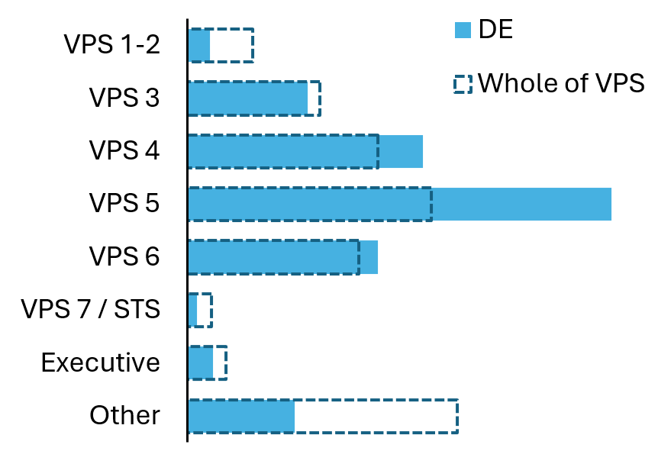 | Demand pressures  - Government school enrolments are growing by around 1 per cent per year.³  - $1.5 billion committed in 2025–26 to build, expand and upgrade school infrastructure.⁴  - Number of students with disabilities in government schools increased by 13 per cent from 2022 to 2024.³  - Teacher workforce pressures remain, with a projected shortfall of 5,000 teachers by 2028.⁵
Output expenditure†  $ millions, 2023/24  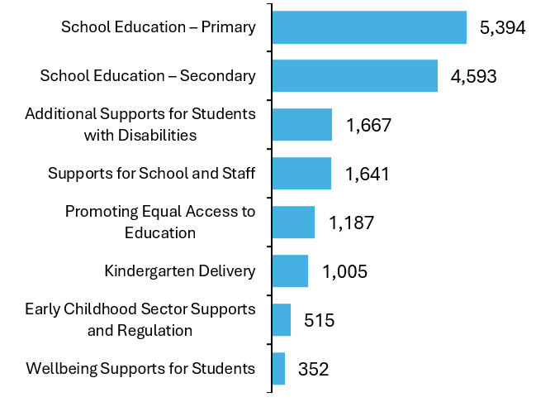 |     Review’s recommended savings  $1,405 million  2025–26 to 2028–29  524 staff  Ongoing FTE
- Total DE FTE figure includes Victorian Academy of Teaching & Leadership,
Victorian Curriculum & Assessment Authority, Victorian Registration & Qualifications Authority,
Merit Protection Boards and Disciplinary Appeals Boards.
- Victorian Public Sector Commission, State of the Sector, 2024.
- DE, Summary Statistics for Victorian Schools, 2025.
- Victorian School Building Authority, 2025.
- DE, Victorian Tracher Supply and Demand Report, 2022.

Department of Energy, Environment and Climate Action (DEECA)
A thriving, productive and sustainable communities, environments and industries across Victoria.

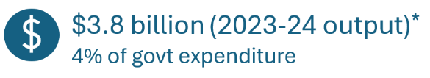 | 
Objectives†  - Productive and sustainably used natural resources  - Net zero emissions, climate ready economy and community  - Sustainable development of Victoria’s earth resources  - Reduced impact of major bushfires and other emergencies  - Reliable, sustainable and affordable energy services  - Healthy, resilient and biodiverse environment  - Productive and effective land management  - Safe, sustainable and productive water resources | Ministerial portfolios  - Agriculture  - Climate Action  - Energy and Resources  - Environment  - State Electricity Commission  - Water  VPS non-departmental entities^  - Environment Protection Authority  - VicGrid
Share of VPS workforce^  VPS Classifications, June 2024  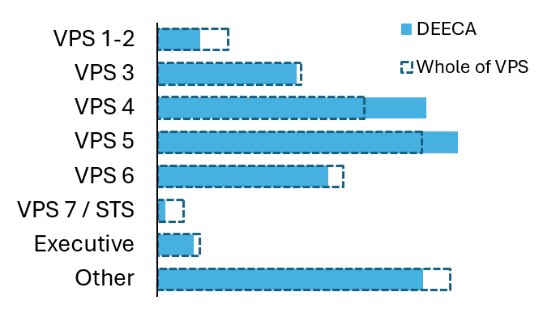 | Demand pressures  - Increasing severity and frequency of natural disasters necessitate improved risk management strategies.²  - Bringing forward the net zero emissions target from 2050 to 2045 is driving investment towards meeting emissions targets.³  - The Victorian Government’s 95 per cent renewable electricity target by 2035, alongside re-establishment of the State Electricity Commission, is accelerating demand for new renewable energy and storage projects.⁴
Output expenditure†  $ millions, 2023/24  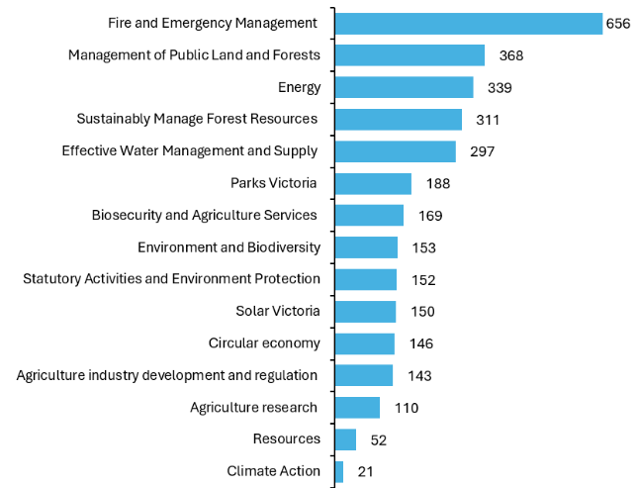 |     Review’s recommended savings  $325 million  2025–26 to 2028–29  333 staff  Ongoing FTE
- FTE figure includes Sustainability Victoria and Recycling Victoria.
- DEECA, Victoria’s Bushfire Management Strategy, 2024.
- DEECA, Annual Report 2023-24, 2023
- DEECA, Cheaper, Cleaner, Renewable: Our Plan for Victoria's Electricity Future, 2024.

Department of Families, Fairness and Housing (DFFH)
Safe and supported children and families, in stable homes and strong communities.
 | 
Objectives†  - Aboriginal voice, knowledge and cultural leadership drive Aboriginal policy, legislation and system reform  - Children, young people and families are safe, strong and supported  - Victorian communities are safe, fair, inclusive and resilient  - All Victorians have stable, affordable and appropriate housing  - Our social services system is integrated, effective, person-centred and sustainable | Ministerial portfolios  - Children  - Disability  - Ageing (with DH)  - Carers and Volunteers  - Equality  - Housing and Building (with DTP)  - Prevention of Family Violence  - Veterans  - Women  - Youth
Share of VPS workforce^  VPS Classifications, June 2024  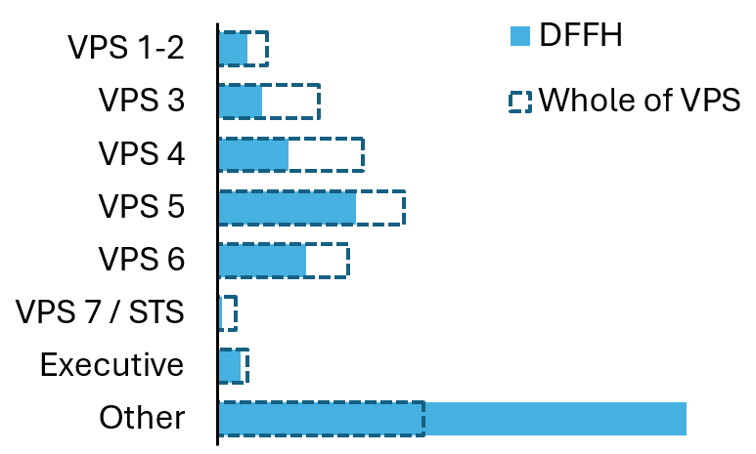  Output expenditure†  $ millions, 2023/24 | VPS non-departmental entities^  - Commission for Children and Young People  - Family Violence Prevention Agency (Respect Victoria)  - Office of the Social Services Regulator  - Victorian Disability Worker Commission  Demand pressures  - Victoria’s growing and ageing population is increasing demand for housing, disability and care services.²  - Rising cost-of-living pressures are driving increased demand for government services and financial assistance.³  - More frequent and severe natural disasters are placing added pressure on emergency, housing and social support systems.⁴  - Increasing complexity in client needs is placing greater pressure on integrated and specialist service responses.⁵
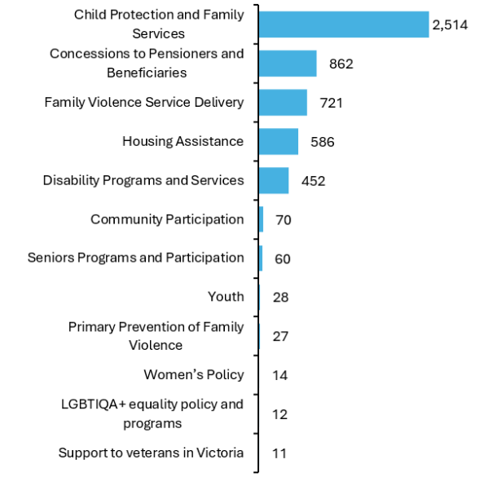 | Review’s recommended savings  $160 million  2025–26 to 2028–29  98 staff  Ongoing FTE
- FTE figure includes child protection workers.
- DFFH, Ageing well in Victoria 2022-2026, 2022.
- Consumer Affairs Victoria, Annual Report 2023-24, 2024.
- DFFH, 2028 Strategic Plan, 2024.
- DFFH, Service provision framework: Complex needs, 2020.

Department of Government Services (DGS)
Improve how Victorians and businesses engage with government, and to accelerate digital transformation and corporate services reform across the Victorian Public Service.

 | 
Objectives†  - Make it easier for individuals and businesses to engage with government  - Accelerate digital transformation for Government  - Deliver corporate services that enable efficiency, productivity and high-quality service delivery | Ministerial portfolios  - Consumer Affairs  - Government Services  - Local Government  VPS non-departmental entities^  - CenITex  - Service Victoria  - Public Record Office Victoria
Share of VPS workforce^  VPS Classifications, June 2024  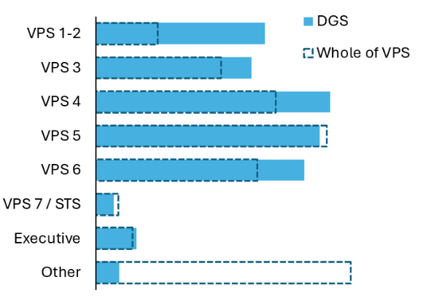 | Demand pressures  - Rapid advances in technology and growing cyber risks are increasing pressure to modernise digital service delivery while maintaining privacy, security, and service resilience.¹  - Cost of living pressures are driving higher demand for support services such as consumer rights enforcement and concessions.¹
Output expenditure†  $ millions, 2023/24  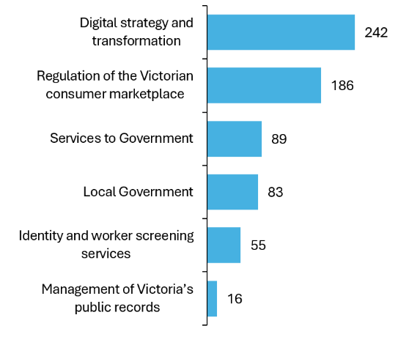 | Review’s recommended savings  $97 million  2025–26 to 2028–29  77 staff  Ongoing FTE
- DGS, Corporate Plan 2024-2028, 2024.

Department of Health (DH)
Developing and delivering policies, programs and services that support, protect and enhance the health, wellbeing and safety of all Victorians.
 | 
Objectives†  - Keep people healthy and safe in the community  - Care closer to home  - Keep improving care  - Improve Aboriginal health and wellbeing  - Move from competition to collaboration  - A stronger workforce  - A safe and sustainable health system  Share of VPS workforce^  VPS Classifications, June 2024 | Ministerial portfolios  - Health  - Mental Health  - Health Infrastructure  - Ambulance Services  - Children  - Ageing  VPS non-departmental entities^  - Mental Health and Wellbeing Commission  - Safer Care Victoria  - Victorian Collaborative Centre for Mental Health and Wellbeing
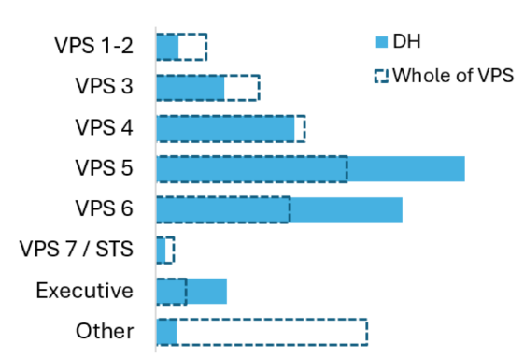  Output expenditure†  $ millions, 2023/24 | Demand pressures  - Nearly 1.5 million Victorians (22 per cent) are aged over 60, and this proportion is expected to continue rising.²  - In 2022-23, 41 per cent of emergency departments presentations were lower urgency cases that should have been dealt with through the primary care system.³  - More than one in five Victorian adults live with two or more chronic conditions, such as type 2 diabetes, heart disease or cancer.⁴  - One in 5 Victorians experience a mental health condition each year.⁵ Rates of high or very high psychological distress reached 22.8 per cent in 2022, up from 15 per cent 4 years prior.⁶
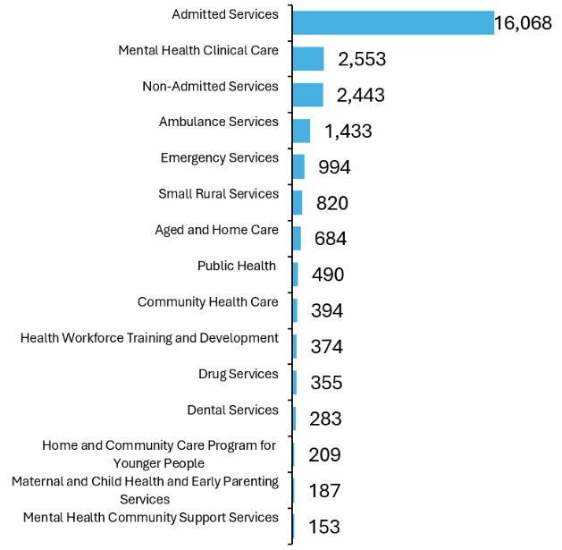 | Review’s recommended savings  $1,135 million  2025–26 to 2028–29  47 staff  Ongoing FTE
- Victorian Public Sector Commission, State of the Sector, 2024.
- DH, Ageing well in Victoria An action plan for strengthening wellbeing for senior Victorians 2022–2026, 2022.
- Productivity Commission, Report on Government Services, 2025.
- DH, Your health: Report of the Chief Health Officer Victoria, 2018.
- DH, Your Health: Report of the Chief Health Officer Victoria, 2020 and 2021.
- DH, Mental health and wellbeing annual report, 2022–23, 2023.

Department of Jobs, Skills, Industry and Regions (DJSIR)
Fostering economic development and creating opportunities for growth by supporting businesses and industries to invest and grow in Victoria.

 | 
Objectives†  - Growing prosperity by creating more opportunities for people through skills and jobs  - Building the productive capacity of our economy to help businesses and industries thrive  - Increasing participation and supporting vibrant communities and regions  Share of VPS workforce^  VPS Classifications, June 2024 | Ministerial portfolios  - Community Sport  - Creative Industries  - Economic Growth and Jobs  - Industry and Advanced Manufacturing  - Outdoor Recreation  - Regional Development  - Skills and TAFE  - Small Business and Employment  - Tourism, Sport and Major Events
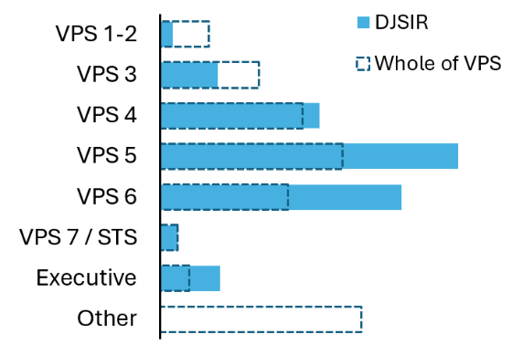  Output expenditure†  $ millions, 2023/24 | Demand pressures  - Victoria is forecast to require 352,000 additional workers between 2023 and 2026 to meet labour market needs, particularly in the care economy, clean economy, and construction sectors.²  - Workforce upskilling and reskilling is needed in key priority industries such as housing construction, the care economy and the clean economy transition to ensure the workforce has the necessary skills.³
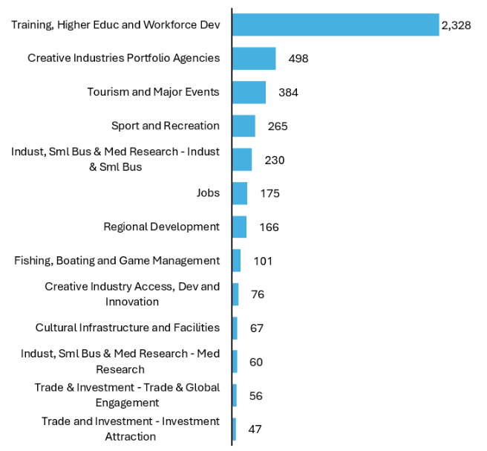 | Review’s recommended savings  $687 million  2025–26 to 2028–29  199 staff  Ongoing FTE
- FTE figure includes Invest Victoria.
- Victorian Skills Authority, State of the Labour Market Report, 2023.
- DJSIR, Strategic Plan 2023-2027, 2024.

Department of Justice and Community Safety (DJCS)
A trusted justice and community safety system that works together to build a just, safe, and resilient Victoria.
 | 
Objectives†  - Ensuring community safety through policing, law enforcement and crime prevention activities  - Reduce the impact of, and consequences from, natural disasters and other emergencies on people, infrastructure, the economy and the environment  - Effective management of prisoners and offenders and provision of opportunities for rehabilitation and reparation  - Effective supervision of children and young people through the provision of youth justice services promoting rehabilitation  - A fair and accessible justice system that supports confidence in the Victorian community  - Victorians are protected with equal opportunities, information freedoms and privacy rights  - Responsible and sustainable liquor, gambling and racing sectors  Share of VPS workforce^  VPS Classifications, June 2024 | Ministerial portfolios
 | - Attorney-General  - Casino, Gaming and Liquor Regulation  - Community Safety  - Corrections  - Emergency Services | - Natural Disaster Recovery  - Police  - Racing  - Victims  - Youth Justice
 | VPS non-departmental entities^
 | - Court Services Victoria  - Local Government Inspectorate  - Office of Public Prosecutions  - Office of the Legal Services Commissioner  - Office of the Road Safety Camera Commissioner  - Office of the Victorian Information Commissioner | - Victoria Police (Public Service)  - Victorian Equal Opportunity and Human Rights Commission  - Victorian Gambling and Casino Control Commission  - Victorian Government Solicitors Office  - Victorian Institute of Forensic Medicine (VIFM)
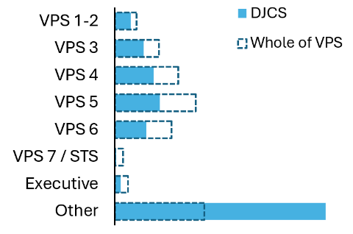  Output expenditure†  $ millions, 2023/24 | Demand pressures  - A growing complexity in the needs of children and young people in the youth justice system, including mental illness, cognitive impairment, and disability.³  - Rising demand for legal assistance services, particularly among vulnerable and regional communities.⁴  - Growing need for emergency management and disaster response capabilities.⁵
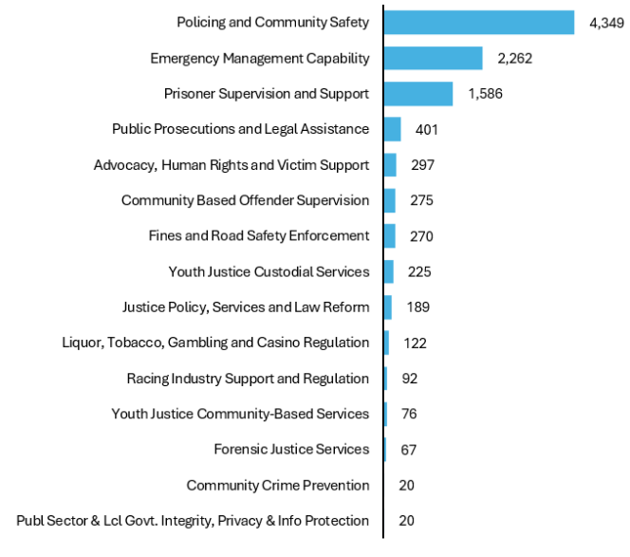 | Review’s recommended savings  $273 million  2025–26 to 2028–29  194 staff  Ongoing FTE
- FTE figure includes non-executive and non-forensic staff at VIFM,
community health practitioners, custodial officers, children youth and family workers, and youth justice workers.
- Victoria Police, Annual Report 2023-24, 2024.
- DJCS, Youth Justice Strategic Plan 2020-23, 2020.
- DJCS, Legal Assistance Strategy Victoria 2022-2025, 2022.
- DJCS, Strategic Direction: 2024-2028, 2024.

Department of Transport and Planning (DTP)
Integrating Victoria’s transport, land and planning system to create an inclusive, productive and sustainable state.

 | 
Objectives†  - Reliable and people-focused transport services  - Safe and well-regulated transport services  - A safe and quality-build environment  - Effective management of Victoria’s land assets  - Build prosperous and connected communities | Ministerial portfolios  - Transport Infrastructure  - Suburban Rail Loop  - Public and Active Transport  - Roads and Road Safety  - Ports and Freight  - Planning  - Development Victoria and Precincts  - Housing and Building (also DFFH)
Share of VPS workforce^  VPS Classifications, June 2024  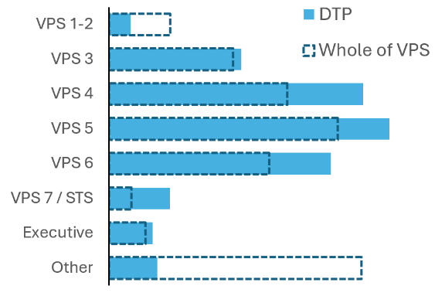  Output expenditure†  $ millions, 2023/24 | VPS non-departmental entities^  - Cladding Safety Victoria  - Safe Transport Victoria  - Suburban Rail Loop Authority  - Victorian Infrastructure Delivery Authority  Demand pressures  - Melbourne is projected to have a population of 8 million by 2051, driving demand for transport, housing and land-use reform.¹  - Public transport use is forecast to exceed pre-COVID levels by 2026–27, requiring network and service expansion.²  - Growth in heavy vehicle traffic is impacting the condition of Victoria’s road network, increasing demand for maintenance and renewal.³  - Increased frequency of extreme weather events is placing pressure on network resilience and maintenance needs.²
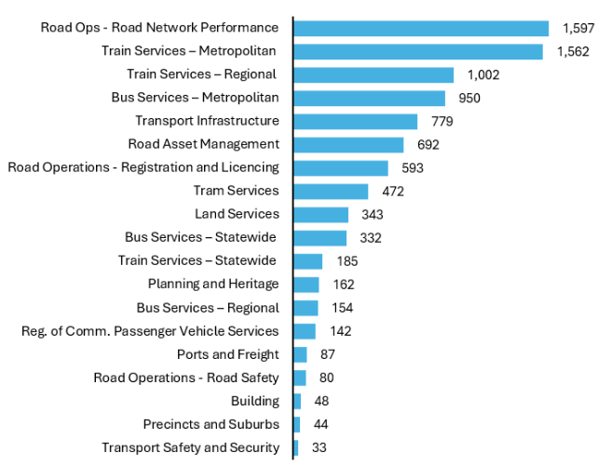 | Review’s recommended savings  $270 million  2025–26 to 2028–29  107 staff  Ongoing FTE
- DTP, Victoria in Future 2023, 2023.
- DTP, Strategic Plan 2024-28, 2024.
- DTP, 10-Year Victorian Road Maintenance Funding Conversation summary, 2024.

Department of Premier and Cabinet (DPC)
Support the people of Victoria by helping government achieve its strategic objectives, providing leadership to the public sector to improve its effectiveness and promoting collaboration across government to drive performance and improve outcomes.

 | 
Objectives†  - Stronger policy outcomes for Victoria  - First Peoples in Victoria are strong and self-determining  - Improved public administration and support for the Victorian Public Service | Ministerial portfolios  - Premier  - Deputy Premier  - Treaty and First Peoples  - Multicultural Affairs
Share of VPS workforce^  VPS Classifications, June 2024  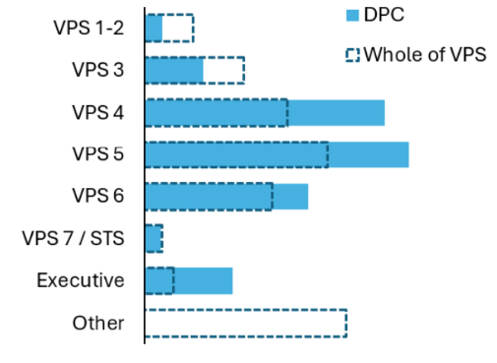  Output expenditure†  $ millions, 2023/24 | VPS non-departmental entities^  - Office of the Chief Parliamentary Counsel  - Office of the Governor  - Office of the Victorian Electoral Commission  - Victorian Public Sector Commission  Demand pressures  - Advancing treaty and truth-telling processes is a key priority, requiring sustained support and partnership with First Peoples.¹  - Challenging economic conditions and public debt are increasing demand for coordinated fiscal and policy advice.²  - Infrastructure and service delivery challenges require stronger oversight and whole-of-government coordination.²
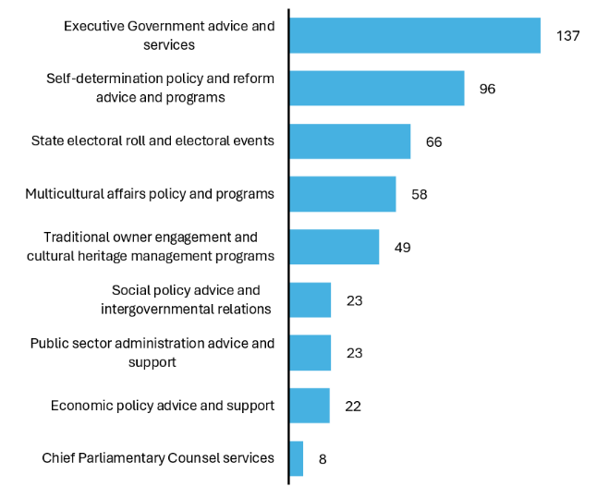 | Review’s recommended savings  $17 million  2025–26 to 2028–29  16 staff  Ongoing FTE
- DPC, Corporate Plan 2023-27, 2023
- DTF, 2025/26 State Budget - Strategy and Outlook, 2025.

Department of Treasury and Finance (DTF)
Provide economic, commercial, financial, infrastructure, industrial relations and resource management advice to help the Victorian Government deliver its policies.

 | 
Objectives†  - Optimise Victoria’s fiscal resources  - Strengthen Victoria’s economic performance  - Improve how Government manages its balance sheet, commercial activities and public sector infrastructure  - Strengthen Victoria’s economic performance through fair, equitable and productive workplaces | Ministerial portfolios  - Treasurer  - Finance  - Industrial Relations  - WorkSafe and the Transport Accident Commission (TAC)
Share of VPS workforce^  VPS Classifications, June 2024  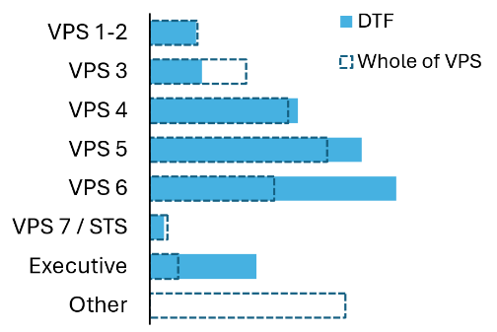  Output expenditure†  $ millions, 2023/24 | VPS non-departmental entities^  - Emergency Services Superannuation Board  - Essential Services Commission  - Infrastructure Victoria  - Labour Hire Licensing Authority  - Wage Inspectorate Victoria  - Portable Long Service Benefits Authority  Demand pressures  - Weaker economic conditions and elevated interest rates are placing pressure on revenue and debt management.²  - Rising infrastructure and service delivery costs are driving demand for tighter financial oversight.²  - Demographic change is driving long-term growth in demand for government services.²
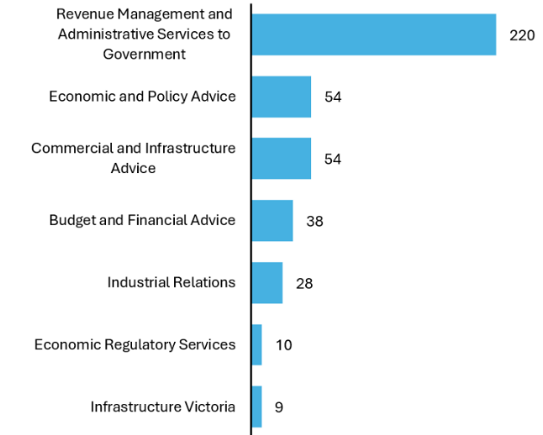 | Review’s recommended savings  $133 million  2025-26 to 2028-29  86 staff  Ongoing FTE
- FTE figure includes State Revenue Office Victoria.
- DTF, 2025/26 State Budget - Strategy and Outlook, 2025.

Appendix C: Public entity reform
C.1 Assessment framework for public entities
The Review identified and refined a list of public sector structures and entities.
- The Review identified a long list of Victorian public sector structures and entities through a range of sources, including VPSC data and departmental websites (Figure C.1).
- This process identified 500+ public sector entities which included statutory roles, special bodies and administrative offices in the VPS; statutory authorities; non-statutory advisory committees; public non-financial corporations and public financial corporations. An additional 90 advisory committees were also identified.
A number of entities were not included in the scope of the Review’s analysis.
- The Review’s Terms of Reference state that integrity bodies and Parliament are not in scope due to their independent functions. These entities were excluded from the analysis.
- Other entity groups were also not considered in the analysis. Frontline workers were considered outside the scope of the Review. Therefore, the Review did not consider schools, hospitals, health services and the police.
- Individual courts, local government and departments were also excluded from the analysis.
Figure C.1: Entity identification framework
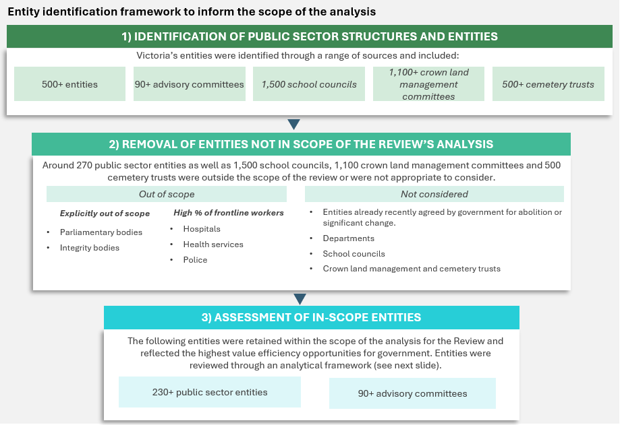
Source: Independent Review of the VPS, 2025
A structured assessment framework has guided entity recommendations.
- The Review developed a structured assessment framework, using sequential lines of enquiry to identify specific reform opportunities across Victorian public sector entities. This aligns with Victorian Government guidelines for entities and previous approaches to assess entities. It has been adapted to align with the criteria used across the Review. The framework is shown in Chapter 6.
- Each entity has an assessed opportunity for reform, aligned to defined criteria. The assessment framework was used to both identify individual opportunities from first principles for each public entity; and to identify cluster opportunities led by hypotheses across entities. This assessed opportunity was further refined to consider feasibility and viability of reform.
- Entities that passed all criteria are recommended for retention. They are not presented through the Review.
C.2 Recommended entity changes – interim recommendations
This list provides a summary of entity changes supported by the Review and included in the 2025/26 Victorian Budget. These were based on proposals developed by departments for the 2025–26 budget process.
Initiative summary and benefit
Abolish the Motor Car Traders Claims Committee
Creates operational efficiencies by transferring functions to DGS to deliver similar outcomes.
Abolish the Victorian Government Purchasing Board and transfer functions to DGS
Creates operational efficiencies by transferring functions to DGS to deliver similar outcomes.
Abolish the Victorian Marine and Coastal Council
Reduces duplicative functions and costs to government.
Absorb the Mine Land Rehabilitation Authority (MLRA) into the Resources Victoria Group (DEECA) and scale back MLRA functional activities
Reduces duplicative functions and costs to government.
Abolish the Victorian Public Sector Commission Advisory Board
Streamlines governance and reduce administrative burden in government.
Abolish Cladding Safety Victoria (at the end of its remit)
Reduces costs and administrative burden associated with legacy structures.

Initiative summary and benefit
Consolidate mRNA Vic and Medical Research, Innovation and Technology functions within DJSIR
Creates operational efficiencies and reduces administrative costs to government.
Abolish the Trade and Investment advisory board
Streamlines governance and reduces administrative burden in government.
Merge the Community Safety Building Authority into VIDA
Creates efficiencies and economies of scale in delivering justice-related infrastructure.
Abolish and transfer Firearms Appeal Committee functions to the Victorian Civil and Administrative Tribunal
Streamlines governance and reduce administrative burden by consolidating the public process appeals into a single body.
Abolish the Road Safety Camera Commissioner and Reference Group
Streamlines governance and reduce administrative burden in government.
Absorb the Victims of Crime Commissioner into DJCS
Retains functions and commissioner but creates operational efficiencies.
Abolish the Police Informants Royal Commission Implementation Monitor
Reduces costs and administrative burden associated with legacy structures.
Reduce the number of Victorian Mental Health and Wellbeing Commission commissioners
Creates operational efficiencies by delivering similar outcomes with fewer resources.
Cease Latrobe Health Assembly
Reduces duplication and reduces costs and administrative burden associated with legacy structures.
Absorb the Health Complaints Commissioner into Safer Care Victoria
Creates operational efficiencies and reduces administrative costs to government.

C.3 Recommended entity changes – Final Report
This list provides a summary of all entity changes recommended by the Review and presented in Chapter 6.
Initiative summary and benefit
Regulatory system reforms
Create a Consumer Protection Regulator
Brings together Consumer Affairs Victoria, Business Licensing Authority, Commissioner for Residential Tenancies, Veterinary Practitioners Registration Board and Working with Children Check into a new regulatory entity.
Lead regulator for consumer protection and a significant proportion of occupational and business licensing activities. Streamlines the process for businesses by providing a single regulator for a number of licences and renewals.
Merge recycling Victoria functions into the Environment Protection Authority (EPA)
Expands EPA’s functions to cover environment protection, waste and recycling.
Simplifies approval processes for businesses and reduces the time spent interacting with multiple entities. Integrated oversight may also support improved environmental outcomes.
Create a new Built Environment Regulator
Merges the new Building and Plumbing Commission (that is bringing together the Victorian Building Authority, Domestic Building Disputes Resolution Victoria and the Domestic Building Insurance function of the Victorian Managed Insurance Authority) with the Surveyors Registration Board and Architects Registration Board and Energy Safety Victoria.
Brings coherent oversight of construction and building activity and associated occupational or business licensing. Streamlines processes for businesses and reduce inefficiencies from duplicative back-office costs. Creates a one-stop shop for a key section of Victoria’s economy.
Absorb the Victorian Pharmacy Authority into the Health Regulator
Integrates pharmacy and non-pharmacy business licensing activities into a broader health regulatory framework.
Simplifies business interactions, streamlines compliance, and strengthens management of health safety risks.
Create a Racing Integrity and Welfare Regulator
Merges the regulatory and integrity responsibilities of Racing Victoria, Greyhound Racing Victoria, Harness Racing Victoria, the Office of the Racing Integrity Commissioner and Board to create a new regulatory entity. (Also separates out commercial racing functions – see below.)
Better practice governance with oversight of the racing sector integrity and animal welfare consolidated into one place.

Initiative summary and benefit
Regulatory system reforms
Establish a new Food Safety Regulator
Consolidates PrimeSafe (meat, poultry, and seafood), Dairy Food Safety Victoria (dairy), and the Department of Health (licensing, food safety).
Streamlines regulatory interactions for food businesses and strengths oversight across the sector. Aligns with work outlined in the government’s Economic Growth Statement 2024.
Establish a new Workplace Regulator
Consolidates Wage Inspectorate Victoria, Portable Long Service Authority and Labour Hire Authority into a single body.
Streamlines enforcement, reduces duplication and costs to government, and provides a clearer point of contact for employers and workers.
Merge Victorian Legal Services Board and Legal Admissions Board
Consolidates functions into a single body that handles admissions and registrations.
Increases efficiency while maintaining professional standards and streamlining processes for law graduates and lawyers.
Absorb the Parks Victoria regulatory functions into the Conservation Regulator
Consolidates environmental regulation under a single authority.
Improves clarity, consistency, and efficiency in managing Victoria’s natural assets. Allows Parks Victoria to focus on its core services.
Create a new Outdoor Regulator
Merges the Victorian Fisheries Authority and Game Management Authority to form a unified regulatory body for wildlife management.
Enhances data sharing, streamlines enforcement and provides a more consistent regulatory experience for recreational and commercial users. Supports a holistic approach to ecosystem and species management.
Merge Heritage Council of Victoria functions into Heritage Victoria
Merges functions to centralise heritage decision-making and policy implementation.
Improves efficiency and responsiveness while maintaining strong heritage protection through a single body.
Absorb the Housing Registrar into the Social Services Regulator
Brings the Housing Registrar into the Social Services Regulator’s recently expanded regulatory framework as the single independent regulator for Victorian social service providers.
Improves safety and quality standards for social services provided in Victoria.

Initiative summary and benefit
Water and land management reforms
Consolidate 14 water corporations into 3, forming metro-regional water partnerships
Western Water Partnership
- Greater Western Water (metro) as central hub, in partnership with
- Western Regional (regional): Barwon Water, Central Highlands Water, Grampians Wimmera Mallee Water, Lower Murray Water, Wannon Water
Northern Water Partnership
- Yarra Valley Water (metro) as central hub, in partnership with
- Northern Regional (regional): Coliban Water, Goulburn Valley Water, Goulburn-Murray Water, North East Water
Eastern Water Partnership
- South East Water (metro) as central hub, in partnership with
- Eastern Regional: East Gippsland Water, Gippsland Water, South Gippsland Water, Westernport Water.
Southern Rural would be split between the Western and Eastern Water Partnerships.
Metro water corporations act as the central coordination hubs for their respective partnerships. Regional water corporations act as the service delivery arms for their respective partnerships.
Proposal excludes Melbourne Water.
Merge Catchment Management Authorities (CMAs) into 3 regionally aligned bodies
- Western CMA: Corangamite, Glenelg Hopkins, Wimmera, Mallee
- Northern CMA: Goulburn Broken, North East, North Central
- Eastern CMA: West Gippsland. East Gippsland.
Merged CMAs remain responsible for planning and coordination of land, water and biodiversity management in all catchment and land protection regions. They are distinct from water corporations but share aligned boundaries to support integrated planning across regions.
Combines strategic coordination with local delivery expertise for efficient management of water resources across the state.
Retains and scale current efficiencies by building upon existing shared service arrangements already in place across the sector (e.g. through Vic Water).
Policy advice and research
Abolish Better Regulation Victoria and Economic Growth Victoria
Brings core regulatory policy work back into DTF. Reduces overlap of functions across entities.
Abolish Infrastructure Victoria and cease its strategic advisory functions
Returns long-term infrastructure planning and advice to be core work of DTF.

Initiative summary and benefit
Funds and investment management
Consolidate funds into the Victorian Fund Management Corporation
Funds being managed by Victorian Legal Services Board, Residential Tenancies Bond Authority, and Victorian Legal Practitioners Liability Committee to be consolidated into VFMC.
Improves oversight, reduces risk to government and improves financial returns.
Abolish Launch Vic and merge functions into Invest Victoria
Abolishes Launch Vic as a standalone entity. Absorbs necessary functions into Invest Victoria, including grant administration, facilitation, and capacity uplift programs.
Improves strategic oversight, and simplifies navigation for businesses seeking support, while enabling government to maximise investment outcomes. Also see Chapter 8.
Abolishing entities and ceasing functions
Abolish Sustainability Victoria and cease functions
Streamlines sustainability policy, simplifies governance, reduces administrative overheads and clarifies accountability across the relevant bodies.
Abolish Geelong Authority and cease functions
Original intent achieved. Streamlines planning processes and avoids duplicating functions.
Abolish Office of the Local Jobs First Commissioner and cease functions
Original intent achieved. Reduces duplication with the core functions of DJSIR.
Absorbing functions into departments or other bodies
Absorb HealthShare Victoria into DH as a branded division
Abolishes HealthShare Victoria as a standalone entity. Integrates activity and back-office functions into the department.
Absorb VicHealth into Department of Health (DH)
Abolishes VicHealth as a standalone entity. Reduces duplicative promotional and corporate functions.
Absorb corporate service functions of Court Services Victoria (CSV) into DJCS
Enables more cohesive management and financial oversight while maintaining judicial independence.
Absorb Emergency Recovery Victoria (ERV) and Emergency Management Victoria (EMV) into DJCS as a single branded division
Abolishes ERV and EMV as standalone entities. Supports move towards a coordinated, all hazards approach, clarifies responsibilities for preparing for emergencies or supporting recovery when emergencies occur.
Absorb the Victorian Small Business Commission into VCAT
Abolishes the Commission as a standalone entity. Reduces administrative duplication and simplifies the experience for small businesses seeking to resolve disputes.

Initiative summary and benefit
Merging entities with overlapping functions
Merge human rights offices and commissioners within the Victorian Equal Opportunity and Human Rights Commission (VEOHRC)
Brings together the Commissioner for LGBTIQA+ Communities, Commission for Gender Equality in the Public Sector, Commission for Children and Young People, the Victorian Multicultural Commission and the Office of the Public Advocate within VEOHRC.
To be implemented in stages. Maintains independence of respective roles but leverages expertise and increases administrative efficiencies. Provides a one-door approach to human rights services with VEOHRC to become a centre for excellence for human rights.
Merge the commercial functions of Racing Victoria, Greyhound Racing Victoria and Harness Racing Victoria under one entity
Creates focus for commercial functions, separate commercial and regulatory aspects of racing, creates operational and corporate efficiencies.
Different approaches for advice and stakeholder engagement
Confirm the need for 90 advisory committees
Enables different approaches for advice and stakeholder engagement. Streamlines governance and reduces the administrative burden associated with supporting legacy structures. There should be a high threshold for retaining committees (statutory and non-statutory), with the assumption that 90 per cent will be abolished and other mechanisms utilised should a continued need for external advice exist.

C.4 Victorian advisory committees
This is a list of the 90 advisory committees identified by the Review.
Advisory committees
Accessible Transport Advisory Committee | Radiation Advisory Committee
Animal Welfare Advisory Committee | Recreational Fishing License Trust Advisory Committee
Anti-Racism Taskforce | Reference Areas Advisory Committee
Apicultural Industry Advisory Committee | Regional Development Advisory Committee
Boards Ministerial Advisory Committee | Regional Policy Advisory Committee
Boronia Suburban Revitalisation Board | Reservoir Suburban Revitalisation Board
Broadmeadows Suburban Revitalisation Board | Responsible Pet Ownership Education Advisory Committee
Building Advisory Council | Return to Work Advisory Subcommittee
Building Industry Consultative Council | Scientific Advisory Committee
Building Regulations Advisory Committee | Senior Secondary Pathways Reform Taskforce
Cattle Compensation Advisory Committee | Senior Victorian Advisory Group
Council of Board Chairs | Sheep and Goat Compensation Advisory Committee
Defence Council Victoria | Sheep and Goat Identification Advisory Committee
Domestic Animal Management Implementation Committee | Shooting Sports Facilities Program Advisory Committee
Electric Line Clearance Consultative Committee | Small Business Ministerial Council
Equal Workplaces Advisory Council | South Sudanese Australian Youth Justice Expert Working Group
Equipment Advisory Committee | State Netball and Hockey Centre Advisory Committee
Fire District Review Panel | Swine Industry Projects Advisory Committee
Fire Rescue Victoria Strategic Advisory Committee | Tarneit Suburban Revitalisation Board
Fisheries Co-Management Council and Fishery Committees | Transport Industry Council
Food Relief Taskforce | Victim Survivors Advisory Council
Forestry Industry Council | Victims of Crime Consultative Committee
Frankston Suburban Revitalisation Board | Victorian Aboriginal Heritage Council
Gippsland Lakes Coordinating Committee | Victorian African Communities Committee
Gippsland Wild Dog Management Group | Victorian Agricultural Chemicals Advisory Committee
Health Complaints Commissioner Advisory Council | Victorian Agriculture and Climate Change Council
International Education Advisory Council | Victorian Broiler Industry Negotiation Committee
Invest Victoria Advisory Board | Victorian Catchment Management Council
Kardinia Park Advisory Committee | Victorian Electrolysis Committee
Lilydale Suburban Revitalisation Board | Victorian Forestry Industry Council
Melton Suburban Revitalisation Board | Victorian Forestry Plan Advisory Committee
Mental Health Ministerial Advisory Committee | Victorian Homelessness Advisory Committee
Metropolitan Development Advisory Panel | Victorian Multicultural Commission
Ministerial Community Advisory Committee (Custodial Community Permit Program) | Victorian Ovine Johne's Disease Advisory Committee
Motorcycling Community Engagement Panel | Victorian Railway Crossing Safety Steering Committee
Multicultural Business Ministerial Council | Victorian Skills Authority Advisory Board
Murray Valley Wine Grape Industry Development Committee | Victorian Strawberry Industry Development Committee
National Livestock Identification System Implementation Advisory Committee | Victorian Veterans Council
National Parks Advisory Council | Victorian Wild Dog Management Advisory Committee
North East Wild Dog Management Group | Women in Primary Industries Advisory Panel
Occupational Health and Safety Advisory Committee | Women's Correctional Services Advisory Committee
Office of Public Prosecutions Director's Committee | WorkCover Advisory Committee
Plumbing Advisory Council | Yarra Park Advisory Committee
Professional Boxing and Combat Sports Board | Young Farmers Advisory Council
Public Records Advisory Council | Yuma Yirramboi Council

C.5 Implementation
The government has three broad pathways to implement the Review’s recommended entity changes as quickly and as efficiently as possible. The pathway depends on the legal structure of each existing entity. The Review also notes that a lot can be achieved prior to legislation being enacted. For a number of years, entity changes have been stopped or substantially slowed because legislative change has been seen as too high a hurdle.
The three pathways include:
- Implement entity change without reference to legislation
There are numerous bodies established solely by executive powers without reference to any particular legislation. For example, various business units, non-statutory offices and unincorporated advisory boards and committees established by terms of reference fall under this category. Subject to further detailed analysis, restructuring of these bodies can, likely, be implemented without formal legislative changes.
For example, abolishing Better Regulation Victoria and Economic Growth Victoria and ceasing their functions can be given effect by instrument of the Governor in Council.
- Commence entity change without legislative changes
While many entities recommended for change were established by legislation or are expressly referenced in legislation, it is possible to substantially execute the Review’s recommendation to restructure or even abolish some of these entities by executive actions and without enactment of formal legislative changes. This is because:
- the enabling legislation simply confers a power on the minister or Governor in Council to establish these bodies but does not mandate their existence; and/or
- some of the enabling legislation for these bodies provides an express power and/or a road map for entity dissolution.
In these circumstances, the operational outcomes and savings that flow from the Review’s recommendations can be delivered first with executive actions. The legislative changes might ultimately be required to fully complete and regularise the relevant entity reform (e.g. removing or amending the references to the abolished body in legislation and/or other official instruments).
This pathway is relevant for the Review’s recommendation to merge water corporations and merge CMAs.
Water corporations are statutory corporations established under the Water Act 1989. Consolidation of the water corporations can be implemented by the responsible minister making the determinations by restructuring the relevant water corporations pursuant to the Water Act 1989. The minister’s discretion is guarded by a dual consent-or-scrutiny safeguard. The Water Act also contains provisions facilitating the transfer of assets and liabilities, staff, and governance arrangements once the determinations are made by the minister.
CMAs are established under the Catchment and Land Protection Act 1994 (CALP Act) which confers on the Governor in Council a broad power to make changes to catchment and land protection regions (CLP Regions) as well as the relevant CMAs established for the relevant CLP Regions. Merging the CMAs can be implemented by the responsible minister making orders published in the Gazette abolishing a region pursuant to the CALP Act.
- Implement entity change through legislation
There are entities for which their existence is mandated by express provisions in statute, and so legislative changes will be needed to implement the Review’s recommended changes for these entities. Various statutes may also confer certain powers on entities that are proposed to be abolished, which will require further legislative amendments beyond that entity’s establishing act. This could be undertaken through an omnibus bill.
For example, absorbing Parks Victoria’s regulatory functions into the Conservation Regulator requires amendments to the Parks Victoria Act 2018.
Further amendments (beyond the specific acts as referred to above) might be required as there are acts and/or other instruments which, while they do not establish the relevant bodies, confer additional powers and functions on them.
Early adoption of reform and savings through administrative actions
While the drafting and passing of legislation can take time, some of the reforms and savings proposed should be materialised prior to enactment of that legislation. The operational outcomes that flow from the Review’s recommendations could be undertaken prior to the changes necessary to the legal form and structure of the public bodies which require legislative changes. In many cases, it is available to the government to ‘frontload’ part of the efficiencies. These include the use of one or more of the administrative actions below:
- Combining office space of like-minded bodies, and exit redundant or unnecessary leased premises.
- Consolidating back-office functions of those public bodies, including consolidating administrative and support staff. For example, the consolidation of the administrative functions of various human rights commissioners into VEOHRC.
- For public bodies which are either no longer relevant or with the wrong scale, reducing funding, limiting scope of their activities and having part of their functions and/or services be delegated or contracted to other public bodies which are better resourced and managed. For example, the consolidation and transfer of functions from Launch Victoria to Invest Victoria.
C.6 Ongoing administration and oversight
Victoria should strengthen its approach to oversee and manage entities. It should implement best practice governance structures, enhance visibility and monitoring through data, conduct first-principles necessity reviews, and sunset entities by default once their purpose is fulfilled. Recommended reforms are outlined below.
- Refresh guidelines for entity establishment. The government should update and publish guidance, currently articulated through a Premier’s Circular, to assess the necessity of establishing new entities and ensure each entity is fit-for-purpose. Clear guidelines, well implemented and adhered to, will help prevent unnecessary proliferation and reduce administrative costs. This includes reviewing the appropriate governance for an entity and determining if corporate functions could be shared with existing departments or entities. It should start from the position that an entity is not necessary.​​
- Default to a single executive governance model, and where boards are needed, streamline them over time. Boards are frequently adopted as the default governance structure without sufficient consideration of their appropriateness or effectiveness as a governance method, resulting in increased administrative costs and slowed decision-making. When established, these boards typically consist of 8 or more members and many of them classified as Group B or C boards, despite best practice guidance recommending 6-12 members for public sector boards and 6-8 for mid-size ASX companies.​
Victoria should implement best-practice governance for its entities, by defaulting to a single executive governance model for efficient decision-making, except where robust public accountability and integrity needs demand collective oversight. ​
When boards are necessary, Victoria should move towards smaller, fit-for-purpose boards sized according to operational complexity to enhance collaboration, strengthen accountability, improve efficiency, and reduce costs. Reductions in board size should be implemented progressively as member tenures expire and boards are refreshed.
- Improve entity data collection and reporting. While the VPSC has a list of many entities and tracks FTE over time, Victoria lacks a comprehensive database of all government entities with operational and financial information. Without that key information, monitoring and informed decisions about the efficacy of those entities is challenging, affecting the overall efficiency of government.​
Despite mandatory reporting for most (if not all) entities, these reports are often not consolidated and do not provide the data required to assess the relevance or necessity of the entity. Reporting is not scaled to the size or complexity of the entity, disproportionately burdening smaller entities (estimated up to 15 per cent of operational time).​
Victoria should collect the right data better to have an accurate picture of all its entities. It should consider establishing a central database that captures all entities and extracts the most relevant metrics for evaluating performance and operational necessity. In addition, reporting requirements should be reformed to make them fit-for-purpose for entities across different sizes and complexities. Right-sizing reporting requirements will reduce their disproportionate administrative burden and redirect resources to service delivery for citizens, businesses and government.
- Enforce entity review and sunset by default. Victoria does not undertake regular reviews of entities to ensure they remain relevant and necessary for the effective operation of government. Where reviews are undertaken, they are not necessarily based on first-principles assessment of need and relevance. In addition, Victoria rarely sets and adheres to sunset dates for its entities, resulting in the large proliferation of entities and misaligned resource allocation with government priorities.​
Victoria should set sunset dates for entities of no more than 5 years following establishment. The default position should be that entities should be wound down upon their sunset date unless there is a clear demonstration of continued relevance and effectiveness in fulfilling its mandate.​
Victoria should undertake regular first-principles reviews on the continued need and relevance of entities. A review of an entity should be undertaken in advance of the 5-year sunset date if it is considered necessary to remain, and if it remains, at least every 3 years thereafter. This will prevent the ongoing proliferation of entities, ensuring that entities are aligned with current government priorities, and support optimised resource allocation to high priority areas.
- Extend reviews to other forms of public sector entities. Certain types of entities – such as statutory roles and branded divisions within departments which operate at varying degrees of distance and accountability – do not fit neatly into existing VPSC categories. By limiting the view of what an entity is, Victoria risks overlooking the opportunity to consider the broader system. This would not resolve the underlying issue of entities being created and imposing significant direct and indirect costs on government. Victoria should build upon the work in this Review and extend reviews of continued relevance and necessity to other forms of public sector entity proliferation.

Abbreviations and glossary of key terms
Abbreviations
ABS | Australian Bureau of Statistics
AI | Artificial intelligence
AO | Officer of the Order of Australia
API | Application Programming Interface
APS | Australian Public Service
APSC | Australian Public Service Commission
BBF | Better Boating Fund
BV | Breakthrough Victoria
CEO | Chief Executive Officer
CGC | Commonwealth Grants Commission
CMA | Catchment Management Authority
CSBA | Community Safety Building Authority
CSO | Community Service Organisation
CSV | Court Services Victoria
DCAF | DisabilityCare Australia Fund
DiSS | Doctors in Secondary Schools
 | Victorian Government Departments
DE | Department of Education
DEECA | Department of Energy, Environment and Climate Action
DFFH | Department of Families, Fairness and Housing
DGS | Department of Government Services
DH | Department of Health
DJCS | Department of Justice and Community Safety
DJSIR | Department of Jobs, Skills, Industry and Regions
DPC | Department of Premier and Cabinet
DTF | Department of Treasury and Finance
DTP | Department of Transport and Planning
EAL | English as an Additional Language
ECE | Early Childhood Education
ECEC | Early Childhood Education and Care
ELCC | Early Learning and Childcare Centres
EMV | Emergency Management Victoria
EPA | Environment Protection Authority
ERV | Emergency Recovery Victoria
FMA | Financial Management Act 1994
FTE | Full-time equivalent
GED | General Efficiency Dividend
GII | Government Infrastructure Investment
GSP | Gross State Product
GST | Goods and Services Tax
HFE | Horizontal Fiscal Equalisation
HR | Human Resources
HSV | HealthShare Victoria
ICT | Information and Communication Technology
LLEN | Local Learning and Employment Networks
LGBTIQA+ | Lesbian, Gay, Bisexual, Transgender, Intersex, Queer/Questioning, Asexual and other diverse sexualities and genders
MP | Member of Parliament
NDIS | National Disability Insurance Scheme
NHRA | National Health Reform Agreement
OH&S | Occupational Health and Safety
OTCD | Office of TAFE Coordination and Delivery
PAEC | Public Accounts and Estimates Committee
RMF | Resource Management Framework
SES | Senior Executive Service
SIMP | Secondary Instrumental Music Program
SMS | Student Management System
SRP | Student Resource Package
STS | Senior Technical Specialist
SSR | Social Services Regulator
SV | Sustainability Victoria
TAFE | Technical and Further Education institutes
UCC | Urgent Care Clinics
VAGO | Victorian Auditor-General’s Office
VCAT | Victorian Civil and Administrative Tribunal
VEOHRC | Victorian Equal Opportunity and Humans Rights Commission
VET | Vocational Education and Training
VFI | Vertical Fiscal Imbalance
VFMC | Victorian Funds Management Corporation
VIDA | Victorian Infrastructure Delivery Authority
VPS | Victorian Public Service
VPSC | Victorian Public Sector Commission
VSB | Victorian Secretaries’ Board
VSBC | Victorian Small Business Commission
Glossary
Key terms used in this report are defined below.
Base funding | Refers to ongoing funding for a department or entity; distinct from new initiatives that are considered during the budget process.
Budget committee | Refers to the Victorian Government cabinet committee responsible for Budget matters. Cabinet committees are established by a decision of the Premier or Cabinet.
Central agencies | Refers to the Department of Premier and Cabinet and Department of Treasury and Finance, who are responsible for whole of government policy and advice.
Consolidated Fund | The Consolidated Fund is the government’s primary financial account and receives all consolidated revenue under the Constitution Act 1975 from which payments, appropriated by Parliament, are made.
Executive government | Refers to ministers and cabinet.
General government sector | Includes all government departments, offices and other bodies engaged in providing services free of charge or at prices significantly below their cost of production. These entities are financed mainly through taxes, Commonwealth Government grants, and other compulsory levies and user charges. They typically provide products and services that are non-market in nature and/or are for the collective consumption of the community, and those which involve the transfer or redistribution of income.
Public entity | A public entity is an organisation that exercises a public function and is established outside the VPS. The entity performs its function with varied autonomy from ministers and public servants. Public entities are established through various instruments ranging from legislation to ministerial direction, and many have a governing board.  Broadly defined, public entities include regulators, service delivery bodies, independent advisory bodies, advisory committees and asset managers. Boards and committees include school councils, cemetery trusts and Crown land management committees.  This Review has used the terminology ‘public sector entity’ to cover both public entities (sitting outside the VPS) and VPS non-departmental entities in its analysis of entity reform.
Public financial corporations (PFC) sector | The PFC sector comprises bodies primarily engaged in the provision of financial intermediation services or auxiliary financial services. They are able to incur financial liabilities (e.g. taking deposits, issuing securities or providing insurance services) and acquire financial assets in the market on their own account.
Public non-financial corporations (PNFC) sector | The PNFC sector comprises bodies mainly engaged in the production of market goods and non-financial services (of a non-financial nature) for sale in the marketplace at prices that aim to recover most of the costs involved (e.g. water and port authorities). In general, PNFCs are legally distinguishable from the governments that own them.
Resource Management Framework (RMF) | The RMF outlines requirements for government and public sector planning, budgeting, service delivery, accountability and review. The RMF places major focus on the annual budget cycle with additional obligations applied on and guidance given to departments for medium-term (four years) and long-term (greater than five years) planning
Victorian Public Sector | The Victorian Public Sector includes the VPS alongside other public sector entities (e.g., Melbourne Water, V/Line). It includes teachers, nurses, paramedics, police officers and others.
Victorian Public Service (VPS) | The VPS comprises departments (Department of Health, Department of Government Services etc.) and non-departmental entities.  Examples of non-departmental entities are Victoria Police (non-sworn), Court Services Victoria, Victorian Infrastructure Delivery Authority, Suburban Rail Loop Authority, CenITex and the Environment Protection Authority.

As a matter of good practice, the Review presents data on actual expenditure and revenue wherever possible. Therefore 2023-24 is the latest year available in most cases.
The Victorian Public Service (VPS) comprises departments and non-departmental entities. Examples of VPS non-departmental entities include Court Services Victoria, the Environment Protection Authority and CenITex.
The public sector is broader and includes the VPS and other public entities (e.g. Melbourne Water, V/Line etc). It includes teachers, nurses, paramedics, police officers and others.
VAGO, Contractors and Consultants in the Victorian Public Service: Spending, Independent Assurance Report to Parliament, 2023.
Victorian Budget 2025/26, Budget Paper No. 2, page 4 sets out: “The fourth step – stabilising net debt as a percentage of GSP – involve progressively improving cash flow surpluses while growing the economy. These surpluses will fund a higher proportion of capital expenditure, reducing the reliance on borrowings. The 2025-26 Budget forecasts the achievement of this step from 2026-27.”
Base funding refers to ongoing funding for a department or entity; distinct from new initiatives that are considered during the budget process.
M Bordignon, S Coretti, M Piacenza and G Turati, ‘Hardening subnational budget constraints via administrative subordination: The Italian experience of recovery plans in regional health services’, Health Economics, 2020, 29(12):1378–1399
DTF, 2025/26 Victorian Budget, Budget Paper No. 5: Statement of Finances, Chapter 4, 2025.
DTF, 2025/26 Victorian Budget, Budget Paper No. 4: State Capital Program, Chapter 1, Box 2: Partnering with the Commonwealth to deliver priorities and provide certainty to industry, 2025.
Includes a third-party contribution.
Taxation Administration (Data Sharing – Relevant COVID‑19 Business Support Program) Declaration 2021.
Parliament of Victoria, Public Accounts and Estimates Committee, Inquiry into the 2025–26 Budget Estimates, Portfolio: Children, 10 June 2025.
This excludes other classifications such as child protection, youth justice, corrections and others.
Australian Public Service Commission, Optimal Management Structures Guidance 2023, 23 October 2023, https://www.apsc.gov.au/initiatives-and-programs/aps-workforce-strategy-2025/workforce-planning-resources/optimal-management-structures-guidance-2023.
Australian Public Service Commission, Working with Ministers: Strengthening Partnerships, 16 November 2021, https://www.apsc.gov.au/publication/working-ministers.
A public entity is an organisation that exercises a public function and is established outside of the VPS. Public entities include regulators, service delivery bodies, independent advisory bodies and asset managers. A non-departmental entity is an organisation that delivers public functions and is considered part of the VPS. In this chapter, the Review considers public entities and non-departmental entities and uses the general term of public entities. Boards and committees include school councils, cemetery trusts and Crown land management committees.
Many entities have alternative funding sources beyond government appropriation, which is included in this total annual expenditure figure.
Premier’s Circular No. 2013/2: Creation and review of non-departmental entities.
As set out in Chapter 2, the Review developed 5 criteria to apply to its work: duplication, role expansion, effectiveness (including efficiency), significant expenditure growth and alternative service delivery models.
The government has announced a merge of disability commissioner functions into the Social Services Regulator – it is not proposed this should change at this stage. The government may wish to consider this in the future.
Australian Institute of Company Directors, Director Tools: Board Size, 2020.
The Review notes that the Flexible Work Policy sets out individuals’ rights to seek specific arrangements to address their family, health or other personal requirements.
In the case of school-related programs, savings are generally required to be re-allocated to schools to fulfil Victoria’s obligations under the Better and Fairer Schools Agreement 2025–2034 (rather than being returned to the Consolidated Fund). Re-allocated funding should be applied to school programs and initiatives of a higher priority.
Note that 40 per cent of the entities referred to in the Review’s recommendations are either business units and administrative offices within departments or entities established by instruments issued by ministers and/or Governor in Council pursuant to statutory and/or executive powers.
Certain of the non-statutory bodies and departmental units and offices were established to support a statutory officer in performance of his or her statutory functions. Abolition of bodies of this kind should only be undertaken when there are arrangements in place to enable the relevant statutory officer during the transition period.
Australian Institute of Company Directors, Director Tools: Board Size, 2020.
Standard definitions of budget and financial terms can be found in the publicly available DTF glossary for budget and financial reports, available on the DTF State Budget page: https://www.dtf.vic.gov.au/state-budget.

