Existing Licence Holders:
Step 1) Log in to your Portal account
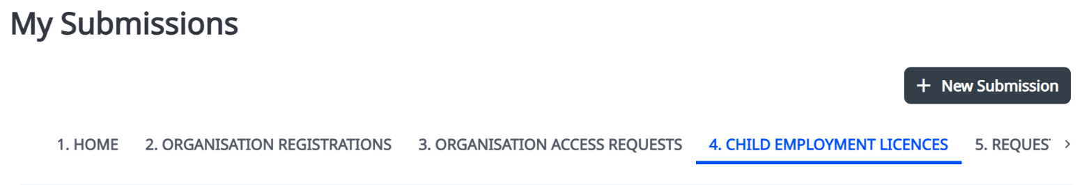
Step 2) From ‘My Submissions’, navigate to the ‘CHILD EMPLOYMENT LICENCES’ tab:
Step 3) Click on your valid child employment licence – this should start with ‘CELD’.
If you do not have an active licence, please follow the steps for ‘New Licence Holders’.
Step 4) Select ‘Create Organisation Profile’

You will now be the Group Administrator for your organisation. You can now add other users to your organisation, to manage licence applications, notifications and variations.
See User Guide: Add New Users or Request Access for more information.

New Licence Applicants:
To create an Organisation Profile, new Licence Applicants must first ‘Register an Organisation’.
Step 1) Create an account and log in to the Portal account
Step 2) Select ‘Register My Organisation’ from the Portal homepage
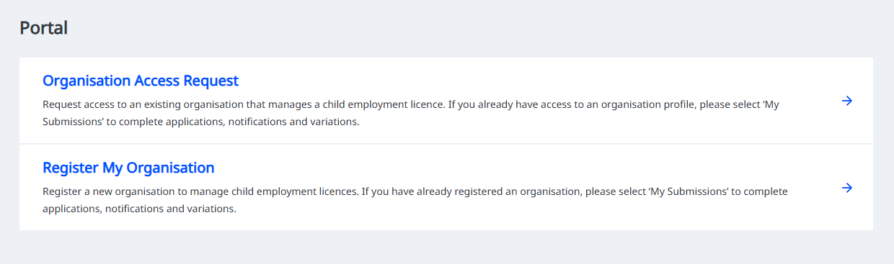

Step 3) Fill in the details for your organisation.

Make sure the email address entered for the organisation is the same email address you used to log into your Portal account. You will receive email updates regarding your organisation account.
Step 4) We will review your organisation registration details within 2 business days.
Step 5) You will receive an email when your organisation registration has been approved.
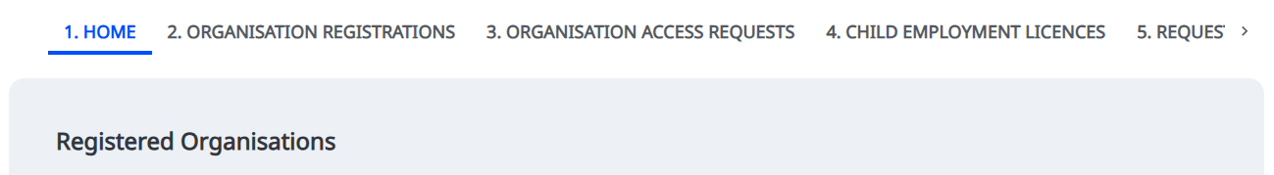
Step 6) From ‘My Submissions’, navigate to the ‘HOME’ tab to view your Registered Organisations.

You can now apply for a child employment licence.
See User Guide: Apply for a Child Employment Licence for more information.
As the Group Administrator for your organisation, you can now add other users to your organisation manage licence applications, notifications and variations.
See User Guide: Add New Users or Request Access for more information.

