Can I? Can’t I?
Campfires and Barbecues

Campfires can easily escape and start a bushfire
- Understand the campfire and barbecue rules before you visit forests and parks in Victoria.
- Think about using fuels other than wood for cooking while camping.
Your campfire is your responsibility. You are legally responsible for ensuring that it is safe, does not escape, and is completely put out before you leave.

Before you go
- Pack a bucket.
- Make sure you have access to water.
- Check the weather and Fire Danger Ratings.
Find out if there is a Total Fire Ban where you plan to visit.

Arriving at the campsite

Building your campfire
- Use a designated fireplace where available.
- Portable firepits may also be used, except in National Parks where campfires are only permitted in designated fireplaces.
- Make sure there is nothing that could catch fire within 3 metres of a campfire or designated fireplace (including above and around it).
Keep it small. Your fire (including the logs/branches within it) must be less than 1 square metre in size.

Using portable barbecues/stoves
- You can use barbecue/stove appliances that are designed and manufactured for that purpose.
- The barbecue/stove must be stable (not at risk of tipping over).
Make sure there is nothing that could catch fire within 1.5 metres of your barbecue (including above and around it).

While you are camping
- A responsible adult must watch the campfire or barbecue at all times.
- If it’s hot or windy, do not light a campfire or barbecue.
- If you leave the campsite for any reason, put out your campfire - even if you plan to come back.

Leaving the campsite
- Fill up your bucket with water and use it to put out your campfire.
- When the ashes are cool to touch it is safe to leave.
- Dirt is not enough – fires can keep burning underground for days in the right conditions.
Figure 1: Campfire safety at campsites: minimum distances, supervision, and safe extinguishing
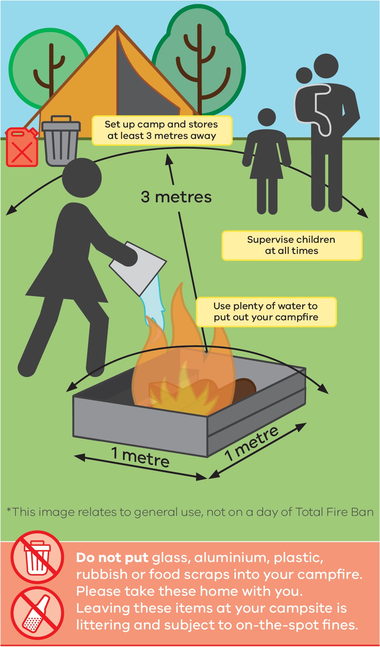

Total Fire Ban days
Total Fire Ban days = no campfires, including the use of wood, briquettes, heat beads.
- Find out if a Total Fire Ban is in place.
- Call the Vic Emergency Hotline on 1800 226 226
Download the Vic Emergency App or visit emergency.vic.gov.au

Barbecues on Total Fire Ban days
You can use a permanent gas or electric barbecue on a total fire ban day if it is:
- Built of stone, metal concrete, or another non-flammable material.
- Designed and manufactured only for meal preparation (including portable barbecues).
Always in a stable position when in use.
You must:
- Only use it to cook a meal.
- Make sure there is nothing that can catch fire within 1.5 metres of the barbecue.
- Supervise the barbecue at all times and make sure you can put it out if necessary.
- Have a hose connected to a water supply or at least 10L of water.
Ensure the barbecue is completely out before you leave.

It is important to remember:
- Unattended (unwatched) campfires are one of the biggest potential causes of bushfires.
- If we find an unattended campfire or barbecue, we will put it out.
- If we find a campfire or barbecue that is still alight or not completely extinguished, you could be fined or taken to court.
Every person has a legislative duty to prevent the spread of a fire.

Information sources
- Check the long range weather forecast before you leave via bom.gov.au
- Find out about Total Fire Bans and Fire Danger Ratings via:
- VicEmergency Hotline on 1800 226 226
- emergency.vic.gov.au
- Vic Emergency App

Contact Information
- To report suspicious or illegal activity call DEECA on 136 186
- To contact Parks Victoria, call 131 963
- Website: vic.gov.au/unattended-campfires

Publication information

Acknowledgements of Victorian Traditional Owners
We acknowledge and respect Victorian Traditional Owners as the original custodians of Victoria’s land and waters, their unique ability to care for Country and deep spiritual connection to it.
We honour Elders past and present whose knowledge and wisdom has ensured the continuation of culture and traditional practices.
DEECA is committed to genuinely partnering with Victorian Traditional Owners and Victoria’s Aboriginal community to progress their aspirations.

Copyright
© The State of Victoria Department of Energy, Environment and Climate Action, 2022. Updated 2026.

Creative Commons
This work is licensed under a Creative Commons Attribution 4.0 International licence, visit the Creative Commons website (http://creativecommons.org/licenses/by/4.0/).
You are free to re-use the work under that licence, on the condition that you credit the State of Victoria as author. The licence does not apply to any images, photographs or branding, including the Victorian Coat of Arms, and the Victorian Government and Department logos.
ISBN 978-1-76136-159-3 (Print)
ISBN 978-1-76136-160-9 (pdf/online/MS word)

Disclaimer
This publication may be of assistance to you but the State of Victoria and its employees do not guarantee that the publication is without flaw of any kind or is wholly appropriate for your particular purposes and therefore disclaims all liability for any error, loss or other consequence which may arise from you relying on any information in this publication.

Accessibility
To receive this document in an alternative format, phone the Customer Service Centre on 136 186, email customer.service@delwp.vic.gov.au, or contact National Relay Service on 133 677 or visit http://www.accesshub.gov.au/. This document is also available on the internet at www.conservationregulator.vic.gov.au.
End of document.

Allowed in some National Park areas – contact Parks Victoria to confirm.
This also applies to any generators you have running at your campsite.

