Evidence of participation

This fact sheet outlines how to meet our expectations for evidence of participation (EOP) under the Skills First program.

Why EOP is important
Your EOP enables us to reasonably judge whether a student has participated in training and assessment. You must maintain EOP at a subject level to substantiate your payment claims.

Only use approved EOP
We only accept these items of EOP:
- Evidence of work submitted  - Evidence of assessment | - Skills First teacher notes  - Login and engagement evidence | - Attendance roll  - Flexible and distance learning records
We may accept a statutory declaration in extreme circumstances.
You can refer to attachment 1 for examples of valid and invalid EOP. But you must read your contract for all specific requirements for each form of EOP.

Get the basics right
Make sure your EOP always includes:
- student name or client ID
- subject ID
- full date (dd/mm/yy).
Your EOP must occur and be dated between the activity start and activity end date of the claim you report.
This table shows the number of items of EOP you need to keep in different circumstances:
If the subject | Keep
is 30 days duration or fewer | 1 item of EOP
is more than 30 days | 2 items of EOP where:  - the first is no later than 30 days after the activity start date (and no earlier than it)  - the second is evidence of assessment for the subject
has an RPL outcome | 1 item of EOP which must be evidence of assessment for the subject
has a withdrawn outcome | 1 item of EOP, regardless of the duration
is delivered under the literacy and numeracy support program (TAFEs and dual sector providers only) | 1 item of EOP, regardless of the duration
When you transfer a student to a superseding subject, the superseded and superseding subjects are treated as a single subject for the purpose of EOP.

Retaining EOP records
Check your recordkeeping obligations before destroying any documents associated with your contract, including EOP.
You must keep records related to your contract for 3 years after a student has completed or withdrawn from the program. Check older contracts for previous requirements.

Electronic signatures
You can use electronic signatures for items of EOP that require a signature. Make sure they meet the principles of identity, consent, and reliability. For further information, please read our fact sheet: using electronic signatures.

Meeting expectations in different circumstances

Clustered delivery
Clustered delivery is where your training session or assessment activity covers more than one subject.
If you use an attendance roll as an item of EOP for clustered delivery, make sure it shows what subjects were delivered in each training session.
If this isn’t clear, we may ask you for additional evidence to show this, for example, a delivery schedule, timetable, lesson plan or equivalent document.

Student withdrawals
You only need to keep one item of EOP if a student withdraws from a subject.
You can use any accepted EOP item, except evidence of assessment, as this won’t apply for a subject that the student hasn’t finished.
When a student withdraws from a subject or discontinues without notice, you must amend their activity end date to when the student either:
- confirmed their intent to withdraw (official withdrawal)
- stopped participating or you decided they withdrew (apparent withdrawal).
If a student only attends the first class of a program, and they withdraw, an attendance roll for a subject delivered in that class is not sufficient EOP. You’ll also need to provide evidence to show the student engaged in training or assessment and that it wasn’t simply an induction or orientation.

Online and distance learning
You can use any item of EOP for online and distance learning and keep it electronically, provided you meet the requirements for the item of EOP you are using.

Electronic attendance rolls
If you use an electronic attendance roll for an online class as EOP, you must make sure:
- it’s a recognised tool for recording attendance as part of your normal processes
- your Skills First teachers record attendance consistently and accurately and can show how information is entered, updated, and interpreted on the roll
- the Skills First teacher signs the roll.
You can use automated methods of tracking attendance within your online learning platform. You’ll need to have evidence that each student logged into the platform at the time the subject was delivered.

Log-in and engagement evidence
You can’t use a login record that only shows a student received training materials as EOP. It needs to show their online engagement with the learning or assessment activity and that you’ve checked with them their continued engagement across the subject.
Examples include:
- a record of the student participating in an online discussion forum
- a record of the student completing a self-paced activity within an online learning platform
- emails or another record of communication between the student and their Skills First teacher.

Records of flexible or distance modes of learning
If you use this type of EOP, make sure that it demonstrates communication relating to engagement in learning and/or assessment activity. This could be emails, texts or messages from an online learning platform.
A Skills First teacher attempting to call a student and leaving a voicemail isn’t EOP. Evidence that the student has logged into an online platform to download learning materials is also not EOP.

Evidence of assessment
For subjects more than 30 days duration you must have 2 items of EOP.
The second item must be evidence showing the student completed all the assessment requirements for the subject.
Evidence of assessment must identify:
- the student | - the subject to which the assessment task (or tasks) relates
- the date | - the signature of the Skills First teacher who assessed it.
- a result for all assessment tasks in the subject, such as satisfactory or competent/not yet competent along with a key if you use abbreviations e.g., C=competent
As long as your evidence shows the student received results for each assessment task, you don’t have to include overall judgement of competency in the subject for the purpose of EOP.
You could use evidence such as a subject-level assessment summary from an online learning management system or an assessment summary cover sheet.
See attachment 2 for examples of assessment summaries that meet requirements.

Keep complete teacher notes
Your teacher notes must show 2-way communication between the teacher and student and be a subject-based interaction.
Notes that just say ‘student was contacted’ isn’t EOP. It must give enough detail about the interaction and expectations of the student. For example:
‘Contacted [student name or ID] on [full date] about their assignment for [subject ID] and clarified some requirements. Student feels confident to progress and will follow up with any further issues.’
This may include notes from personal interviews, phone calls or emails that show engagement between the student and teacher.

Workplace-based training
It can be challenging to collect EOP when apprentices are doing workplace training.
Keep in mind that the guidelines about apprenticeship/traineeship training delivery require you to make contact with both the apprentice/trainee and supervisor to monitor and document details of their progress.
This communication could qualify as EOP in the form of ‘Skills First teacher notes’.

Attachment 1
These examples are a limited guide to help you avoid common pitfalls when keeping EOP. You shouldn’t rely on them in isolation. Always refer to the contract for the requirements of each EOP type and remember all EOP must include student name or ID, subject ID and date.
 | Invalid EOP | Valid EOP
Skills First teacher notes | - A file note states ‘student was emailed’  - The teacher phoned a student and left a detailed voicemail about them falling behind in class  - The teacher emailed the student to ask them to complete an assignment  - The teacher posted due dates and details in the class forum | - Teacher notes state they shared text messages with the student about an assessment task for the subject and the student feels confident to progress  - Teacher notes show the student and teacher had a conversation in the class forum about how the best way to practice a skill  - The teacher replied to a student who emailed them to clarify an assessment requirement
Online student engagement | - The learning management system shows a student logged in to an online class and downloaded the presentation slides | The learning management system shows the student logged in and engaged, such as:  - doing an online quiz on the subject  - posting questions about the subject in the class online forum  - emailing the teacher questions about the subject
Evidence of work submitted | - A learning management system lists the enrolled subjects and the student’s progress | - A written assignment  - A completed practical placement workbook  - An observational checklist that clearly shows the teacher witnessed the student completing practical tasks
Attendance roll | - Students have signed a sheet of paper, but the teacher hasn’t endorsed and signed it  - An approved attendance roll that doesn’t list the subjects delivered during a clustered delivery session  - An attendance roll for student’s first class in the subject where they withdrew from the subject, with no.  supporting evidence to show you started training in that session (like a lesson plan) | - Your approved digital attendance record, used in your normal business processes, and electronically signed by the teacher  - An approved attendance roll that clearly lists every specific subject you delivered in a clustered delivery session, or one that’s supported by a lesson plan, timetable, or delivery schedule
Evidence of assessment | A summary screen, report or coversheet that shows:  - only the overall outcome of ‘competent’ or ‘not competent’ for the subject  - assessment tasks with a mark of ‘C’ but it doesn’t explain what ‘C’ means  - the student got a result of ‘satisfactory’ for 3 tasks but the subject required the student to do 4 tasks | - A summary screen (or screens) of all required assessment tasks with their results  It doesn’t matter whether it shows the overall judgement of ‘competent’ or ‘not competent’ for the subject  - An assessment cover sheet with a mark of ‘not competent’ for a task that is the only assessment for the subject

Attachment 2
These are fictional examples to show how all aspects of evidence of assessment could be met depending on how you record assessment. They show the information your evidence should include, but your evidence might look different to these. For example, you might extract a report from your learning management system rather than a summary screen view as seen below, or you might use two screen views to cover all the information.

Sample assessment summary – learning management system
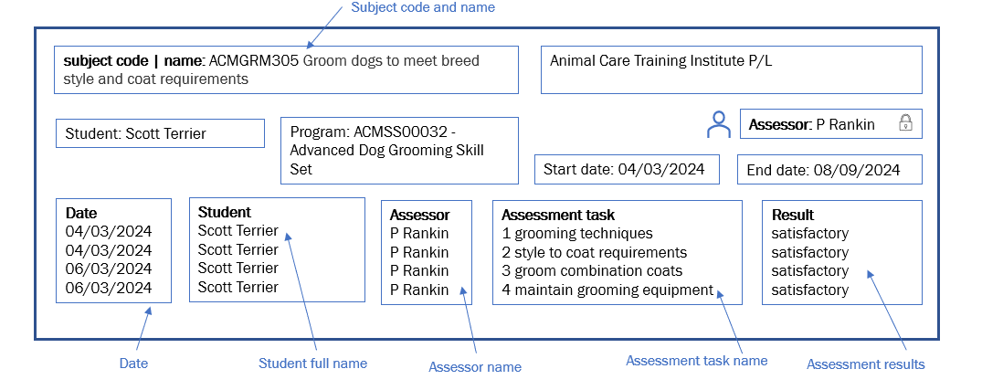
To meet the requirement for the assessor to sign the assessment, they complete an electronic action equivalent to a signature. The assessor must log in to the system using a unique username and password (identity), the system is set up so that only specific staff can enter assessment results in a specific workflow (consent) and the Animal Care Training Institute has a clear business process for how assessments are recorded in the system (reliability).
Sample assessment summary cover sheet - clustered subjects
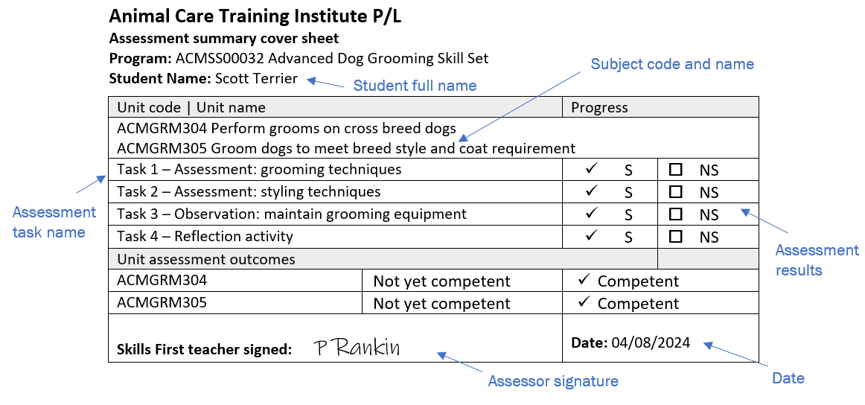
© Copyright State of Victoria, Department of Jobs, Skills, Industry and Regions 2025
Except for any logos, emblems, trademarks, artwork and photography this document is made available under the terms of the Creative Commons Attribution 3.0 Australia licence.

