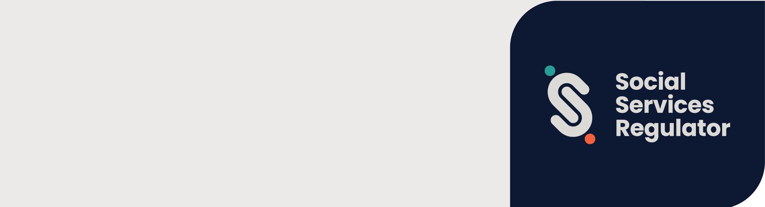

Declaration form
OFFICIAL

Declaration
I declare that:
- I am aware that my organisation has nominated me to be their head for the purposes of the Reportable Conduct Scheme.
- I accept the nomination as head for the purposes of the Reportable Conduct Scheme.
- I have read and considered the Social Services Regulator’s (SSR) Information about the responsibilities of the head of an organisation.
- If the SSR approves this nomination, I understand and accept that I will assume all of the responsibilities of a head for the purposes of the Reportable Conduct Scheme, including that I must:
- ensure that my organisation takes a preventative approach to keeping children safe
- ensure that my organisation has systems in place to enable anyone to notify me of reportable allegations made against a ‘worker or volunteer’ of the organisation
- ensure that my organisation has systems in place to allow other people to notify the SSR if a reportable allegation is made about my conduct
- ensure that my organisation has clearly defined and developed investigation processes
- ensure that the SSR is notified and updated on reportable allegations concerning my organisation’s ‘worker’s or volunteer’s’
- investigate reportable allegations made against ‘worker’s or volunteer’s’ of my organisation.
- I understand that I may be criminally liable in the event that the SSR is not notified of a reportable allegation made against a worker or volunteer of my organisation.
- I will notify the SSR if at any time my details change or I cease my current position in the organisation.
- That this nomination form and its contents are true and correct to the best of my knowledge, information and belief and that this nomination has been validly made.

Signature of the person making this declaration (the Nominee): |  | Signature of witness (aged 18 years or over):

Nominee’s name: |  | Witness’s name:

Date signed: |  | Date signed:

