Strengthening number sense at home:

One-to-one correspondence

Thank you for watching the one-to-one correspondence video with the Victorian Mathematics Ambassadors, Pat and Em, and Aintree Primary School: https://www.vic.gov.au/mathematics-and-numeracy-home.

The following tips and information will support you to practice the advice in the video to strengthen your child’s number sense at home.

What is one-to-one correspondence?
One-to-one correspondence is matching one number to one object when counting. For example, counting people in a picture by pointing at and counting each person one at a time; ‘1…2…3, there are 3 people’.
Practising this skill at home will help your child to understand that the last number spoken is the total number of objects in a group.

Tips
Here are some easy and fun ways to help your child develop their understanding of one-to-one correspondence.

At home

Dinner time
When setting the table for a meal, decide how many places need to be set. Touch and count each item together out as you are setting them out to make sure there are enough for everyone. Repeat the total.

Toys away
As you are tidying up toys, count each toy together as they are put away.

Counting from a page
Count objects on a page in a book, pointing to each object as your child counts.

At the supermarket

The big shop
Count like items one (for example, apples) at a time as they are put in the trolley. When you have finished counting ask, ‘how many do we have?’ If your child counts from the beginning again, let them finish and repeat the total; ‘that’s right, there are 5 apples’.

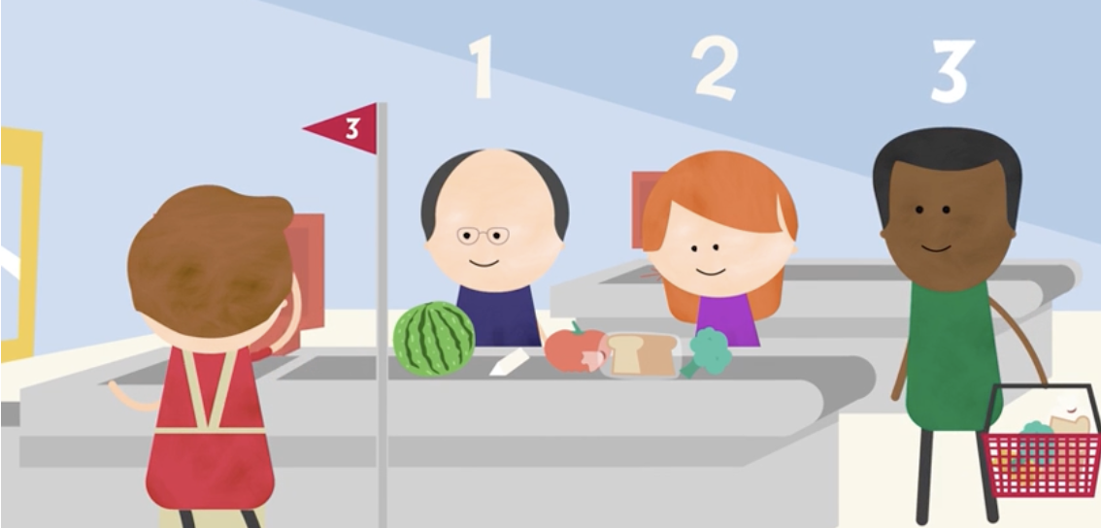
Everyday maths – shopping. CC BY: © State of Victoria (Department of Education).

Checkout games
Ask your child to count the number of people in each checkout queue to decide which checkout has the smallest queue.

How many in the bag?
As you unpack a shopping bag, have your child count each item are they are taken out to be put away.

At the park

Nature numbers
When sitting under a tree at the park, ask your child to count the leaves you can see on the ground. Pick up each leaf one at a time, counting to 10, and then restarting. Once your child can do this without skipping any numbers, practice counting all the way up to 20.

The playground counts
Count similar parts of playground equipment. For example, the number of steps to the top of the slide, or the number of rungs on the monkey bars.

Watch and experiment
Watch Mathscots – Puppy jump photos to see the Mathscots use markers to measure how far they jump.

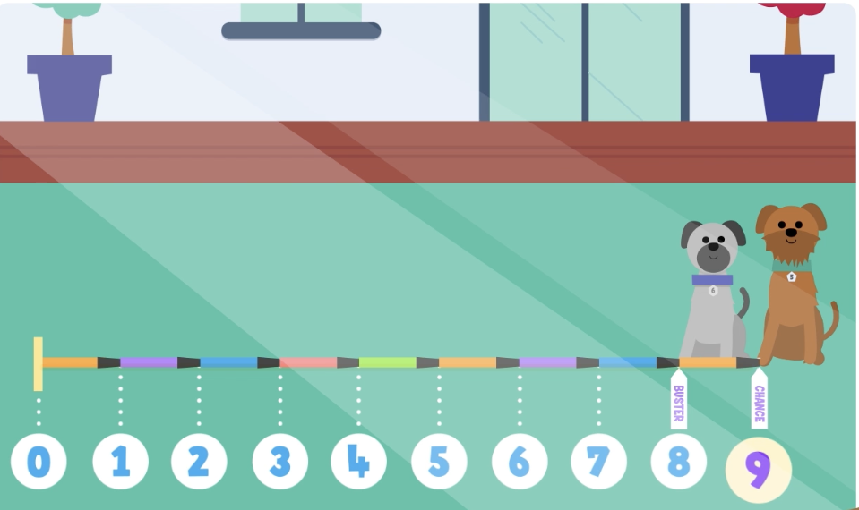

Mathscots – Puppy jump photos. CC BY: © State of Victoria (Department of Education).

You can then try marking out equal spaces using chalk on the pavement or even leaves at the park. Then count with your child how many spaces everyone in your family can jump.

Further information
To access other videos and tip sheets in this series as well as further tips, information and links for parents and carers, see: Mathematics and numeracy at home.
For further information about the Victorian Mathematics Ambassadors, see: Victorian Mathematics Ambassadors.
For further information on supporting your child’s education, see: Supporting your child's education | vic.gov.au.

Strengthening number sense at home:

Subitising

Thank you for watching the subitising video with the Victorian Mathematics Ambassadors, Pat and Em, and Tootgarook Primary School: https://www.vic.gov.au/mathematics-and-numeracy-home.

The following tips and information will support you to practice the advice in the video to strengthen your child’s number sense at home.

What is subitising?
Subitising is the ability to visually recognise how many objects are in a small group without counting. For example, knowing that someone is holding up 3 fingers without counting each finger.
Practising this skill at home will help your child to recognise small groups quickly without the need to count. Subitising usually works best with small numbers – up to 5, and sometimes up to 10.

Tips
Here are some easy and fun ways to help your child develop their understanding of subitising. Encourage your child to subitise first, then check by counting.

At home

Dice games
Roll a dice and have your child call out the number of dots as quickly as possible. Then count together to check. Roll again.

How many fingers?
When out walking, hold up 1-5 (or up to 10) fingers and thumbs for 1-2 seconds, and ask your child to tell you how many fingers they can see.

Snack peek
Place up to 5 pieces of snack food (for example, grapes, crackers) on a plate without your child seeing. Let your child look briefly, then cover it. Ask ‘how many did you see?’ Reveal the pieces and count together to check.

Plate patterns
Place up to 10 items on a plate, using familiar patterns. For example, 8 buttons could be arranged in 2 sets of 4 that use the pattern shown on standard dice. Let your child look for 3 seconds, then cover it. Ask ‘how many did you see’, or ‘how many altogether?’ Show the items again and count together to check.

Missing eggs
As you use eggs, show the egg carton to your child and give them 2 seconds to look at the number remaining without counting. Ask them, ‘how many eggs are left’ or how many have been used?’

At the supermarket

Bunches of bananas
Hold up a bunch of bananas for a few seconds and ask your child how many there were before counting. Count together afterwards to check if they were right.

Yoghurt tubs
Show your child a packet of yoghurt tubs quickly. Is it a pack of 2, 4, 6 or 12 yoghurts? Ask them, ‘would this be enough for everyone in our family?’

At the park

It’s a handful
Hide up to 5 small objects (for example, stones) in your hand. Open your hand briefly for 1-2 seconds then close it. Ask ‘how many did you see?’ Open your hand and count together to check.

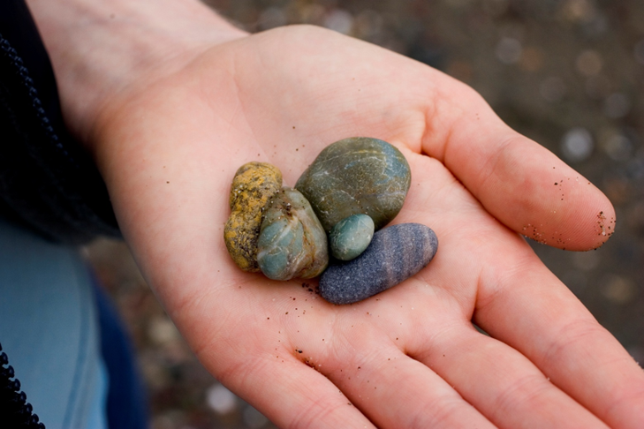
Licensed under CC BY: © iStock.com/Arjini

Knock them down skittles
Watch Everyday maths - around the house to see how to set up a game of skittles using empty plastic bottle. Play your own game of skittles and have your child call out how many bottles are left standing after round. They can show the number on their fingers too.

Further information
To access other videos and tip sheets in this series as well as further tips, information and links for parents and carers, see: Mathematics and numeracy at home.
For further information about the Victorian Mathematics Ambassadors, see: Victorian Mathematics Ambassadors.
For further information on supporting your child’s education, see: Supporting your child's education | vic.gov.au.

Strengthening number sense at home: Partitioning (part-part-whole)

Thank you for watching the partitioning video with the Victorian Mathematics Ambassadors, Pat and Em, and Warringa Park School: https://www.vic.gov.au/mathematics-and-numeracy-home.

The following tips and information will support you to practice the advice in the video to strengthen your child’s number sense at home.

What is partitioning?
Partitioning is breaking a whole number, for example 7, into different parts, for example 3 and 4. Breaking this ‘whole’ number into 2 ‘parts’ is called part-part-whole.
Another example would be taking the ‘whole’ number 9 and breaking into 2 ‘parts’ of 6 and 3. In this example the number 9 could also be broken into ‘parts’ of 4 and 5, or 2 and 7 or 1 and 8.
Practising this skill at home will help your child understand that any number can be broken into different parts, which supports later learning in addition and subtraction.

Tips
Here are some easy and fun ways to help your child develop their understanding of partitioning.

At home

Toy sort
Count a collection of your child’s favourite toys, such as construction blocks. This total is the whole.
Ask your child to rearrange them into 2 groups (parts) and tell you how many are in each part.
Bring both parts back into one group and then separate into 2 parts in a different way. Ask them, ‘how many ways can the toys be grouped into 2 parts?’

Petal parts
Draw a flower with 9 petals. Have your child count the petals (the whole).
Ask your child to colour in the petals of the flower using 2 different colours; for example, 4 red petals and 5 blue petals.
Draw a second flower with 9 petals. Ask your child to show you another way to colour the petals using the same 2 colours.
If you like, you can draw more flowers with 9 petals and see how many other ways your child can break 9 into 2 parts using the 2 colours.
You can also do this activity with flowers that have a different number of petals.
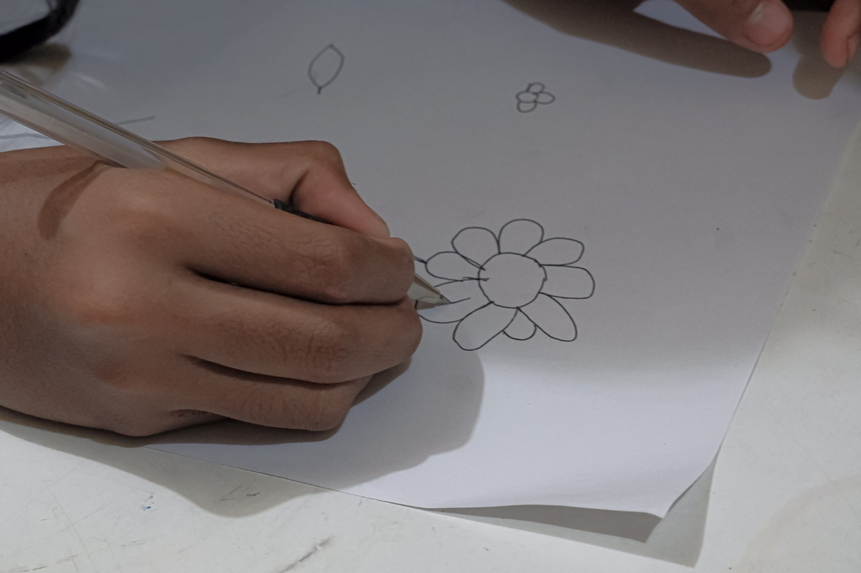
Licensed under CC BY: © iStock.com/Feri Ferdinan

At the supermarket

Oranges and apples
Pick 7 pieces of your child’s 2 favourite fruits (for example, apples and oranges).
Have your child tell you the total number of fruit (the whole), as well as how many of each type of fruit (the parts) there are; for example, 3 oranges and 4 apples. Talk about what other combinations of the 2 fruit types would make 7.

Two packets
Select 2 packets of bread rolls and ask your child to count the number of rolls (the whole). How many are in each packet (the parts)?

At the park

Chalk and talk
Use chalk to draw a number (the whole) on the pavement.
Have your child draw that number of a favourite shape below the number. Ask them to circle a number smaller than the whole to make 2 parts; for example, draw 6 shapes and circle 4 shapes, leaving 2 shapes as the second part.

Nature numbers
Collect a small group of sticks, leaves, or stones from the park. Count the whole with your child and then ask them to sort into 2 parts. Count and then bring back together to separate a different way.
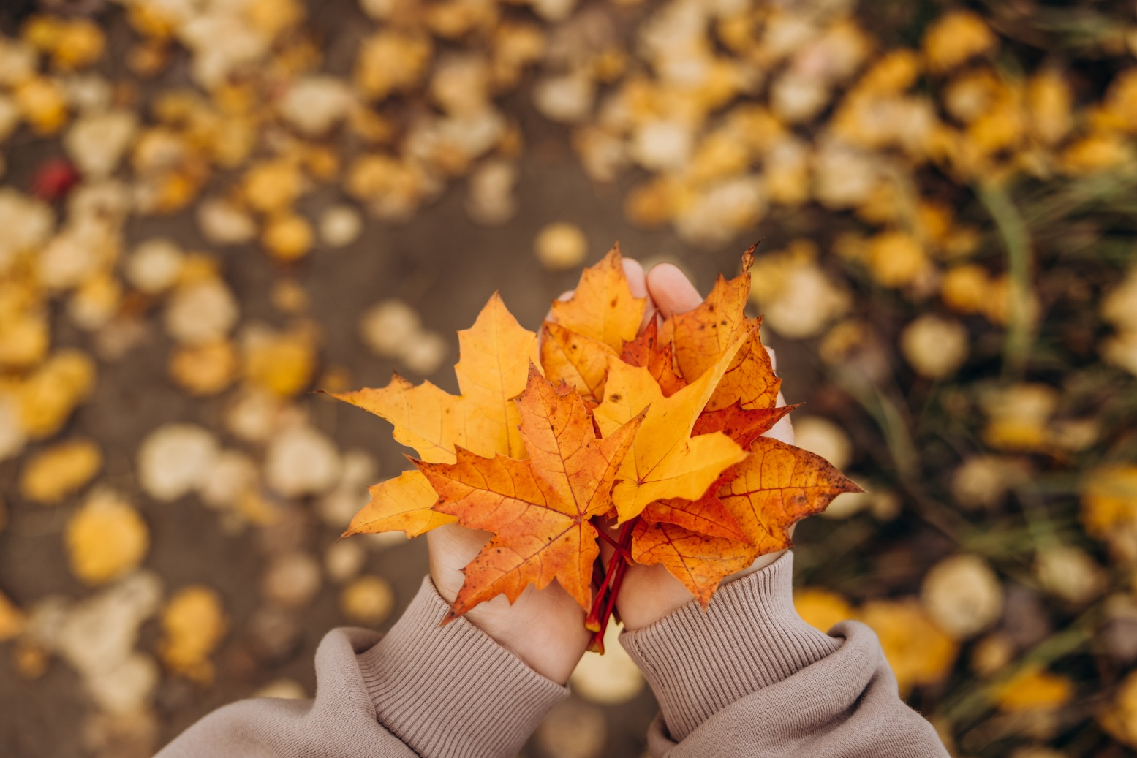
Licensed under CC BY: © iStock.com/Lyubov Smirnova

Jumping in parts
Ask your child to do 10 jumps in 2 parts. They might do 4 quick jumps for the first part, pause, and then do another 6 quick jumps for the second part. Ask, ‘how many jumps in each part’ or if there was another way they could jump in 2 parts.

Further information
To access other videos and tip sheets in this series as well as further tips, information and links for parents and carers, see: Mathematics and numeracy at home.
For further information about the Victorian Mathematics Ambassadors, see: Victorian Mathematics Ambassadors.
For further information on supporting your child’s education, see: Supporting your child's education | vic.gov.au.

Strengthening number sense at home

Teen numbers

Thank you for watching the teen numbers video with the Victorian Mathematics Ambassadors, Pat and Em, and St Thomas the Apostle Catholic Primary School: https://www.vic.gov.au/mathematics-and-numeracy-home.

The following tips and information will support you to practice the advice in the video to strengthen your child’s number sense at home.

What are teen numbers?
Teen numbers are numbers between 11-19. These numbers can be tricky to learn as they are different from 1-10 and do not follow the same naming patterns for 20 and above.
Learning the teen numbers and being able to count to 20 is an important skill for your child to learn. You can support your child to become confident with teen numbers by encouraging them to count to, and backwards from, 20.
Just like in the video, you and your child can use the prompt ‘10 and some more’ to describe the teen numbers.
Practising this skill at home will help your child feel confident counting to 20.

Tips
Here are some easy and fun ways to help your child develop their understanding of teen numbers:

At home

Count your eggs
When cooking eggs, take a carton of eggs and count the eggs together. Put 2 eggs on the bench and count the eggs remining in the carton, demonstrating that 12 is 10 and 2 more.

Block tower
Build block towers of different heights using 11-19 blocks. Build the first 10 blocks quickly and then add on some more. For more practice counting teen numbers, recount the number of blocks in each tower at the end.
Ask your child how many more than 10 the number is. For example, ‘15 is 10 and how many more?’
If your child is unsure of the answer, count together to 10, pause and then say ’15 is 10 and 1, 2, 3, 4, 5 more’, pointing to each block greater than 10 as you count.
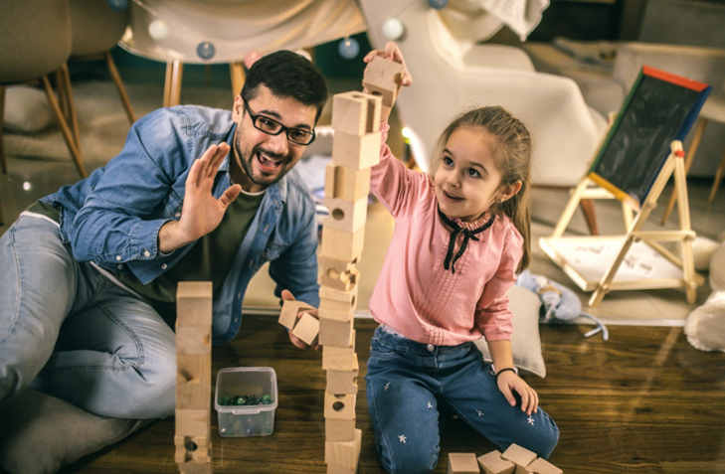
Licensed under CC BY: © iStock.com/Zeljkosantrac

Just a handful
Take a handful of a healthy snack such as sultanas. Count how many there are. Ask them, ‘is it a teen number?’ Add or take away sultanas to make the snack a teen number. Ask your child to tell how many more than 10 the total is; for example, 13 is 10 and 3 more.

What’s missing?
Write the numbers 11-19 on scraps of paper and place in order. When your child is not looking, remove one of the numbers and remove the gap created. Have them to tell you which number is missing. Return the number and then take it in turns to find the missing number. Ask your child to describe the missing number as ‘10 and how many more?’

At the supermarket

Aisle attention
Look at the aisles of larger supermarkets. Ask your child to show you which aisles have teen numbers. What will the next aisle be? Have your child lead you to a teen aisle or tell you what is in the aisle.

Number hunt
Encourage your child to look for teen numbers at the supermarket. They might find teen numbers written in price tags, barcodes or signs. Can they find 10 teen numbers?

Checkout games
Ask your child to count each item as they are taken out of the trolley or basket. When they reach a teen number, ask them to describe the next number as ‘10 and how many’ more; for example, ‘11 is 10 and 1 more’.

At the park

Teen number hopscotch
Play hopscotch with the numbers 11-20 instead of 1-10. Including 20 helps your child what comes after the teen numbers. Ask them to call out the number that the stone lands on before they hop through the course, counting each number.
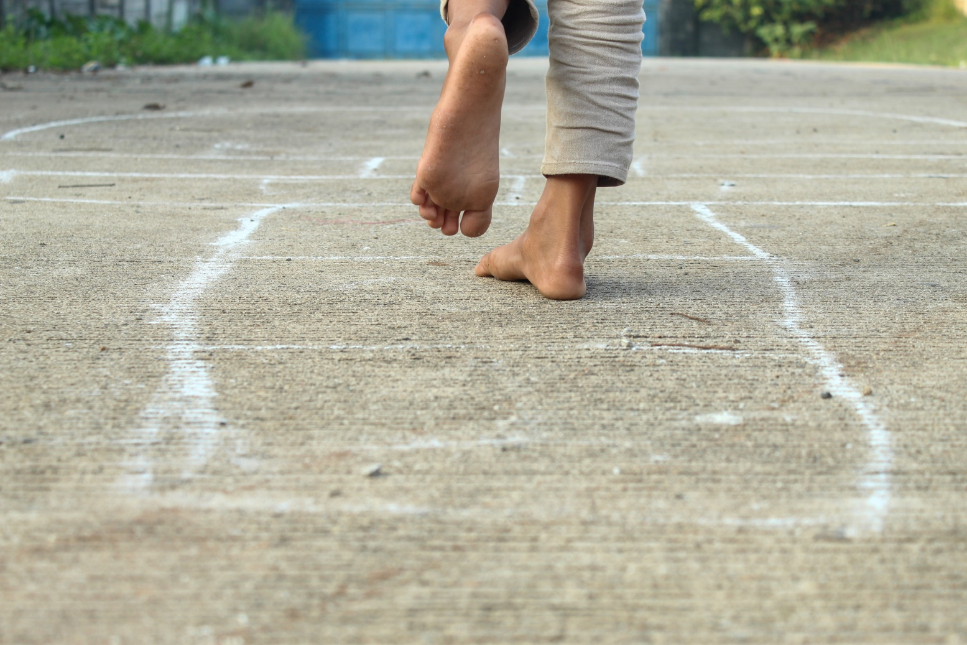
Licensed under CC BY: © iStock.com/Hendri

Outdoor counts
Have your child find things at the park that can be counted (fence rails, trees). Tell them the goal is to find something that has a teen number as a total.

Sticks and stones
Collect natural items like sticks and stones. Use them to represent a teen number; for example, make 14 from 10 sticks and 4 stones. Ask your child, ‘how many more than 10 is the total?’.
Collect more items to build another teen number.

Further information
To access other videos and tip sheets in this series as well as further tips, information and links for parents and carers, see: Mathematics and numeracy at home.
For further information about the Victorian Mathematics Ambassadors, see: Victorian Mathematics Ambassadors.

For further information on supporting your child’s education, see: Supporting your child's education | vic.gov.au.

