

Victorian Official Fare Compliance Series

October 2025 Report

Table of Contents
Table of Contents 1
Executive Summary 2
Background 3
Overview of the fare compliance survey 3
Definition and types of fare evasion 3
Data collection methodology 4
Survey scope 5
Calculation of fare compliance estimates 5
Results 6
Data collected 6
Fare compliance rates 6
Fare evasion behaviour 8
Fare compliance on metropolitan train 11
Fare compliance on metropolitan tram 12
Fare compliance on metropolitan bus 14
Fare compliance on regional train 15
Annual fare compliance rates 16
Revenue impact of fare evasion 17
Appendix A - Precision and disaggregation of survey results 18
Confidence levels for survey estimates 18
Fare compliance estimates by mode 18
Estimated rates of fare evasion behaviour 19
Fare evasion estimates by ticket type 20
Fare evasion estimates for metropolitan train 21
Fare evasion estimates for metropolitan tram 22
Fare evasion estimates for metropolitan bus 23
Fare evasion estimates for regional train 24
Appendix B - Revenue impact calculation 25

Executive Summary
As a part of the October 2025 fare compliance survey, the three metropolitan modes of transport of bus, tram and train were covered along with regional train services within the commuter belt. The impacts of COVID-19 have seen lower patronage across the transport network in Victoria since 2020. Despite this, sample sizes are in line with pre-COVID surveys.
- Compliance on the metropolitan network is in October 2025 was 93.5 percent. This is lower than the results obtained in May 2025, where the May 2025 fare compliance rate on the metropolitan network was 95.5 percent, and October 2024 fare compliance was 96.2 percent.
- Metropolitan train compliance rate of 96.2 percent in October 2025 is lower than May 2025, where a compliance rate of 96.4 percent was observed.
- Tram compliance rate of 91.3 percent in October 2025 is lower than compliance rates of 95.4 percent in May 2025.
- Bus compliance rate of 90.2 percent in October 2025 saw a decrease from the 93.6 percent observed in May 2025.
- Compliance levels on regional train services in October 2025 are lower than those seen on metropolitan network services. Regional train compliance rates in October 2025 of 96.3 percent are lower than results recorded in May 2025 of 97.2 percent.
- The results from the October 2025 survey have been used to estimate the revenue impact of fare evasion over the period July to December 2025. The revenue impact is estimated at $27.4 million for this period, comprising $26.0 million on the metropolitan network and $1.3 million on regional trains (difference in figures due to rounding).

Background

Overview of the fare compliance survey
Fare compliance surveys are conducted by the Department of Transport and Planning (formerly by Metlink) in May and October each year to measure the rate of fare compliance on the public transport network. It is also a requirement of the metropolitan train and tram Franchise Agreements that fare compliance surveys are conducted in each half year period.
Fare compliance surveys have been conducted on metropolitan trains, trams and buses since 2005 and on regional train services since October 2012. In 2020, the impact of COVID-19 necessitated that the fare compliance survey was not run in either May or October 2020. Results were obtained in May 2021, however the continued impact of COVID-19 prevented the survey from running in October 2021. October 2025 therefore represents the ninth set of results obtained since October 2019.
Methodology and analysis requirements for the fare compliance survey are detailed in the survey practice notes and outlined below. Results are reported to the public transport operators after each survey.

Definition and types of fare evasion
Fare evasion constitutes those who are travelling on public transport without a valid ticket. The fare evasion rate represents the percentage of all trips that are made without a valid ticket, including those taken on a concession ticket without a valid concession entitlement. The fare compliance rate is therefore the percentage of all trips that are made with valid tickets, and where appropriate, valid concessions. The fare compliance rate is equal to 100% minus the fare evasion rate.
Since May 2013, fare compliance on myki has been surveyed; prior to that both Metcard and myki fare compliance were surveyed. Regional train tickets are also included in the survey on regional trains.
The survey captures a range of fare evasion behaviours grouped into the following categories:
- No ticket – passengers travelling without a ticket or myki card
- Runner – passengers who when intercepted or believe they are about to be intercepted, get off the vehicle to avoid a ticket check
- Full fare breach – passengers travelling with an invalid full fare ticket (myki not touched on or with insufficient balance; validated but time expired or defaced/damaged or not validated; regional train ticket not valid for zone or off-peak ticket used at peak time)
- Concession breach – passengers travelling with an invalid concession ticket with a valid concession entitlement
- No entitlement – passengers travelling with a concession ticket (valid or invalid), without a valid concession entitlement
- Hoverer – passengers who remain close to a validator and validate or touch on only when there is a chance of interception; this behaviour is generally confined to trams and buses where validators are on board the vehicle
- Insufficient balance - passengers travelling multiple Zones with an insufficient myki money balance. The Victorian Fares and Ticketing Manual 2017 states that passengers are required to have a sufficient balance to cover all travel made.
Fare evasion using myki is also grouped into the following categories:
- myki with insufficient balance – where a myki has a zero or negative balance, due to the passenger not topping up the card before travel. A myki with insufficient balance cannot be touched on and therefore no fare is paid.
- myki not touched on (with balance) – where a myki card has funds but has not been touched on and therefore the passenger is not paying a fare for travel.
- Ineffective myki – where a myki card is defective such that it cannot be read by the Handheld Device or Fare Payment Device, and therefore no fare is paid.
While any of these behaviours may in fact be accidental or deliberate fare evasion, the survey does not attempt to determine passenger intent and does not distinguish between the two.

Data collection methodology
The fare compliance survey is conducted by teams of Authorised Officers accompanied by survey staff. Survey teams on tram and bus have three surveyors and two Authorised Officers, while teams on trains normally have four Authorised Officers and three surveyors. Authorised Officers are provided by the operator. Digital data capture technology was used in the survey, with a surveyor recording the data for each Authorised Officer where possible. A COVID-safe plan was developed in conjunction with, and agreed to by, DTP, all operators and EY Sweeney.
The teams are rostered to survey on specified routes or lines, on weekdays and weekends at set times. Survey methods vary by mode to accommodate differences in operating environments, for example, train passengers must touch on prior to boarding and prior to entering a platform, while tram and bus passengers may defer touching on until on-board. In general, the survey team boards a train, tram or bus and moves through the vehicle with Authorised Officers checking tickets and survey staff recording passenger counts and the types of tickets and fare evasion encountered. During peak times, surveying of train passengers may take place on platforms rather than on train carriages, due to crowding.
The survey of regional train is broadly similar to that conducted on metropolitan services. The survey was conducted by conductors travelling on regional trains, accompanied by survey staff. On boarding a regional train service, the conductor and survey staff move through the entire train with conductors checking all tickets and survey staff recording the data as presented by conductors.
All evasions are recorded regardless of whether or not they would have attracted a ‘Report of Non-Compliance’ in normal operation.

Survey scope
The metropolitan fare compliance survey is conducted on a representative sample of all train lines, tram routes and bus routes within the metropolitan area, with the exception of school bus routes. Surveys are conducted between 6:30am and 7pm on weekdays and between 10am and 5pm on weekends. There are no surveys on buses on Sundays. Note, since May 2024, no surveys have been conducted at Moonee Ponds Interchange, while a location review is still in progress.
The survey program is designed to run over a four week period in May and October each year. The number of surveys completed depends on multiple factors including frequency of services, passenger numbers, size of each sample and survey hours per shift. Minimum sample sizes are determined by a formula set down in the survey practice note.
The regional train fare compliance survey encompasses all lines within the ‘commuter belt’, which is defined as rail lines extending as far out as Bendigo, Ballarat, Geelong, Traralgon and Seymour. The survey covers combinations of inbound and outbound services by am, off-peak and pm time bands, and by day type (weekday, Saturdays and Sundays).

Calculation of fare compliance estimates
Fare compliance estimates are derived from appropriately weighted survey data using statistical estimation procedures.
The weightings ensure that the survey results are representative of the true population, and not just of the sample collected. This corrects for the effects of any disproportionate sampling that may occur as a result of the sampling and scheduling process. This practice has been employed since 2008.
Ticket touch-ons and validations data (after application of validation rates) are used to determine the total number of trips in each survey strata, against which the survey data is weighted. Weights are determined for each location (train line, tram depot, bus areas), day of week (weekday, weekend) and time of day (am peak, off peak, pm peak) combination.
The primary aim of the survey is to measure the modal level fare compliance rates across the metropolitan network and on the regional train commuter belt train services. Although tickets are checked at various locations and times it is not possible to accurately report fare compliance rates for each strata or disaggregation within the survey as there is not always an adequate sample within each strata to report a meaningful result. Fare compliance rates for particular strata, such as location or time of day, are only reported where a meaningful and comparable result can be derived from the survey data as presented by conductors.
Following a review in consultation with the University of Melbourne’s Statistical Consulting Centre, the statistical procedures for deriving the fare compliance estimates from the survey data were refined for the May 2010 survey. The new methods produce comparable estimates to previous surveys, but also provide a measure of precision for each estimate, including disaggregated estimates by location, time of day etc. The precision measures, or confidence intervals, indicate the extent to which the fare compliance estimates, particularly the disaggregated estimates, can be reasonably compared.
Details of the estimation procedures are included in technical reports provided by the University of Melbourne’s Statistical Consulting Centre. Please note: Figures are rounded to one decimal place throughout. This may mean that some combined results are impacted.

Results

Data collected
In the October 2025 survey, over 30 thousand passengers were surveyed on the metropolitan network and over 14 thousand on V/Line train services. The numbers of passengers and services surveyed on each mode are shown in Table 1.

TABLE 1: PASSENGERS SURVEYED, OCTOBER 2025 FARE COMPLIANCE SURVEY
 |  |  |  |  | 
Mode | Metropolitan Train | Tram | Metropolitan Bus | Metropolitan Network | Regional Train
Tickets checked | 12,987 | 8,656 | 9,655 | 31,298 | 14,435
Services surveyed | 1,188 | 1,255 | 2,586 | 5,029 | 510

Fare compliance rates
Estimated rates of fare compliance for all surveys from 2006 to date are set out in Figure 2 and the results of the past 7 years are shown in Table 2. Confidence levels for each estimate and disaggregated estimates by location, time of day and day type are set out in Appendix A - Precision and disaggregation of survey results.

FIGURE 1: ESTIMATED FARE COMPLIANCE RATE BY MODE (OCTOBER 2019 – OCTOBER 2025)

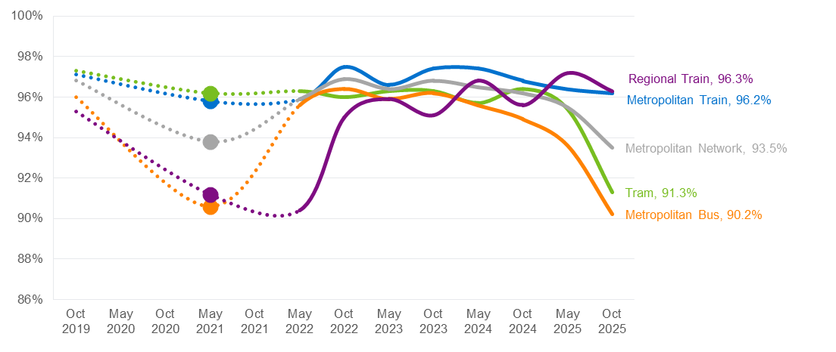

TABLE 2: ESTIMATED FARE COMPLIANCE RATE BY MODE (2006 – 2025) %
Survey Period | Metropolitan Train | Tram | Metropolitan Bus | Metropolitan Network | Regional Train
Oct 2006 | 90.4 | 88.9 | 91.9 | 90.1
May 2007 | 86.1 | 90.8 | 91.9 | 88.9
Oct 2007 | - | 90.6 | 92.9 | -
May 2008 | 93.7 | 90.2 | 92.6 | 92.2
Oct 2008 | 92.5 | 88.0 | 93.1 | 91.0
May 2009 | 92.3 | 85.9 | 94.4 | 90.4
Oct 2009 | 91.2 | 87.4 | 94.1 | 90.4
May 2010 | 90.6 | 83.7 | 93.4 | 88.7
Oct 2010 | 89.0 | 81.2 | 92.7 | 86.9
May 2011 | 90.2 | 79.7 | 90.8 | 86.5
Oct 2011 | 91.5 | 81.6 | 92.4 | 88.1
May 2012 | 88.3 | 86.7 | 91.7 | 88.5
Oct 2012 | 91.2 | 89.5 | 90.9 | 90.6
May 2013 | 90.1 | 88.1 | 84.0 | 88.1
Oct 2013 | 91.6 | 92.0 | 88.8 | 91.1
May 2014 | 93.7 | 91.2 | 87.3 | 91.3
Oct 2014 | 95.9 | 94.0 | 91.3 | 94.1 | 93.0
May 2015 | 97.3 | 95.2 | 91.3 | 95.0 | 93.9
Oct 2015 | 97.4 | 95.2 | 94.9 | 96.2 | 95.1
May 2016 | 97.7 | 95.3 | 92.7 | 95.9 | 95.7
Oct 2016 | 97.4 | 96.4 | 93.6 | 96.2 | 95.9
May 2017 | 97.6 | 95.1 | 89.2 | 94.8 | 94.2
Oct 2017 | 97.3 | 95.4 | 91.2 | 95.3 | 96.2
May 2018 | 97.0 | 96.1 | 91.0 | 95.3 | 93.6
Oct 2018 | 97.5 | 96.8 | 92.0 | 96.0 | 95.1
May 2019 | 96.9 | 97.1 | 95.1 | 96.5 | 93.9
Oct 2019 | 97.1 | 97.3 | 96.0 | 96.8 | 95.3
May 2020 | - | - | - | - | -
Oct 2020 | - | - | - | - | -
May 2021 | 95.8 | 96.2 | 90.6 | 93.8 | 91.2
Oct 2021 | - | - | - | - | -
May 2022 | 95.9 | 96.3 | 95.6 | 95.9 | 90.4
Oct 2022 | 97.5 | 96.0 | 96.4 | 96.9 | 95.0
May 2023 | 96.6 | 96.3 | 95.9 | 96.4 | 95.9
Oct 2023 | 97.4 | 96.3 | 96.2 | 96.8 | 95.1
May 2024 | 97.4 | 95.7 | 95.6 | 96.5 | 96.8
Oct 2024 | 96.8 | 96.4 | 94.9 | 96.2 | 95.6
May 2025 | 96.4 | 95.4 | 93.6 | 95.5 | 97.2
Oct 2025 | 96.2 | 91.3 | 90.2 | 93.5 | 96.3

Fare evasion behaviour
Table 3 and Figure 2 show fare evasion behaviour for the current survey by metropolitan mode and for regional trains. The most common forms of fare evasion in the October 2025 survey were no ticket and full fare breach.

TABLE 3: FARE EVASION BEHAVIOUR BY MODE (OCTOBER 2025 SURVEY) %
Fare evasion behaviour | Metropolitan Train | Tram |  |  | Metropolitan Bus | Metropolitan Network |  | Regional Train
No ticket | 1.7 | 2.5 |  |  | 5.1 | 2.7 |  | 1.5
Runner | 0.3 | 2.1 |  |  | 1.7 | 1.1 |  | -
Full fare breach | 0.8 | 2.8 |  |  | 1.6 | 1.4 |  | 1.7
Concession breach | 0.3 | 0.9 |  |  | 1.1 | 0.6 |  | 0.5
No entitlement | 0.6 | 0.4 |  |  | 0.1 | 0.4 |  | 0.0
Hoverer | 0.0 | 0.0 |  |  | 0.0 | 0.0 |  | -
Insufficient balance (V/Line only) |  |  |  |  |  |  |  | 0.0
Invalid other  (V/Line only) |  |  |  |  |  |  |  | 0.0
Total | 3.8 | 8.7 |  |  | 9.8 | 6.5 |  | 3.7

FIGURE 2: FARE EVASION BEHAVIOUR BY MODE (OCTOBER 2025 SURVEY) %
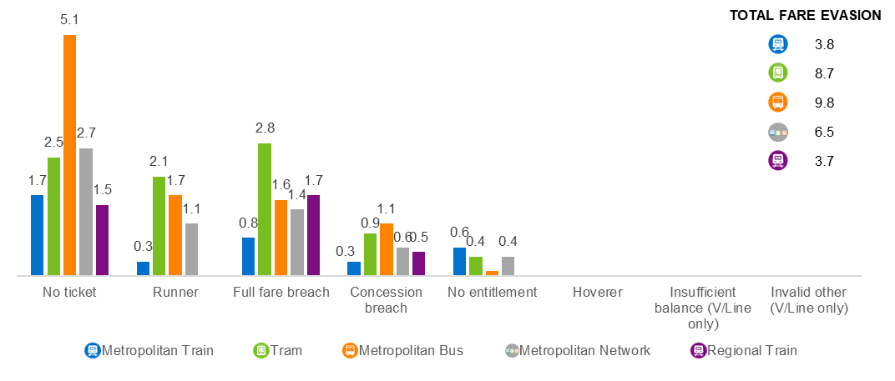

Figure 3 shows the incidence of different types of fare evasion behaviour on the metropolitan network since October 2019.

FIGURE 3: FARE EVASION BEHAVIOUR, METROPOLITAN NETWORK (OCTOBER 2019 - OCTOBER 2025)

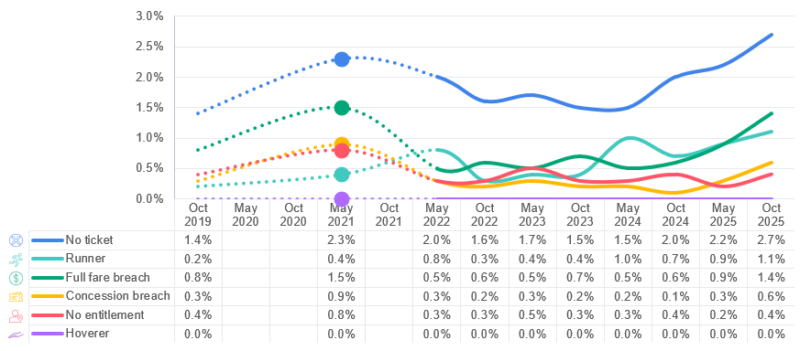

Table 4 and Figure 4 show myki fare evasion behaviour for the current survey for the metropolitan modes and regional train. The rates shown include both full fare and concession fare myki breaches

TABLE 4: MYKI FARE EVASION BEHAVIOUR BY MODE (OCTOBER 2025 SURVEY) %
myki Fare Evasion Behaviour | Metropolitan Train | Tram | Metropolitan Bus | Metropolitan Network | Regional Train
myki with insufficient balance | 0.7 | 1.2 | 1.6 | 1.0 | 0.8
myki not touched on (with balance) | 0.6 | 2.6 | 1.0 | 1.2 | 1.4
Ineffective myki | 0.0 | 0.0 | 0.0 | 0.0 | 0.0

FIGURE 4: MYKI FARE EVASION BEHAVIOUR BY MODE (OCTOBER 2025 SURVEY) %

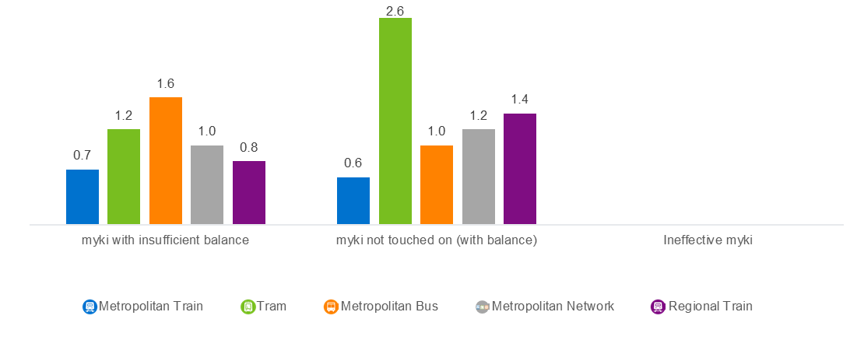

Fare compliance on metropolitan train
Figure 5 shows the incidence of fare evasion behaviour on metropolitan train since October 2019.

FIGURE 5: FARE EVASION BEHAVIOUR, METROPOLITAN TRAIN (OCTOBER 2019 - OCTOBER 2025)

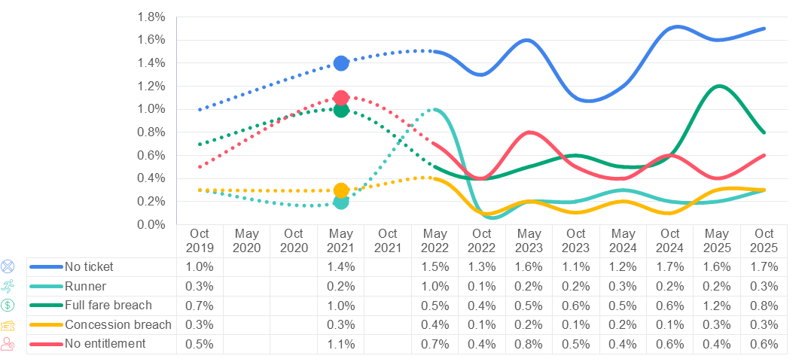

Figure 6 shows the incidence of v

FIGURE 6: MYKI FARE EVASION BEHAVIOUR, METROPOLITAN TRAIN (OCTOBER 2022 - OCTOBER 2025)

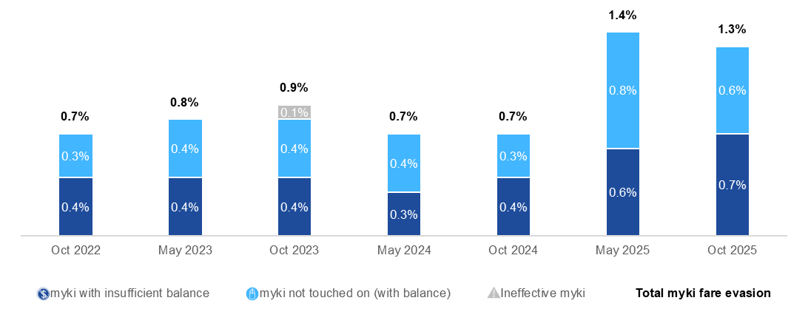

Fare compliance on metropolitan tram
Figure 7 shows the incidence of fare evasion behaviour on tram since October 2019.

FIGURE 7: FARE EVASION BEHAVIOUR, METROPOLITAN TRAM (OCTOBER 2019 - OCTOBER 2025)

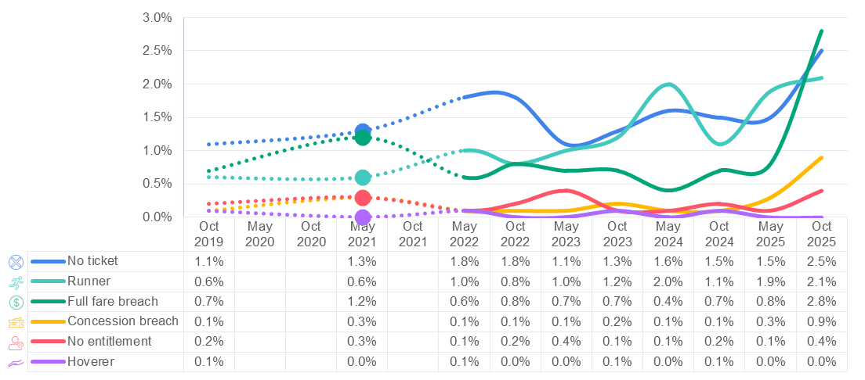

Figure 8 shows the incidence of myki fare evasion behaviour on metropolitan tram from October 2022 to October 2025.

FIGURE 8: MYKI FARE EVASION BEHAVIOUR, METROPOLITAN TRAM (OCTOBER 2022 - OCTOBER 2025)

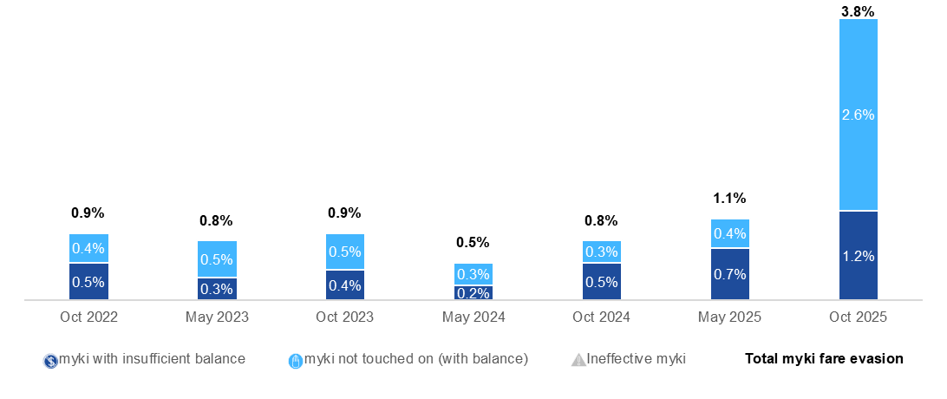

In the October 2014 fare compliance survey a new measure was added to monitor the difference between the fare compliance rate in the CBD, CBD fringe and Other Region.
Table 5 and Figure 9 show the incidence of fare evasion by area on tram. A statistically significant difference was observed between CBD fringe and Outer Region areas in the October 2025 survey.

TABLE 5: FARE EVASION RATE BY AREA, TRAM (OCTOBER 2025)

Tram Strata | Fare evasion estimate (%) | 95% confidence interval
CBD | No longer measured
CBD Fringe | 10.6 | 8.5, 12.7
Outer Region | 8.1 | 6.7, 9.5

FIGURE 9: FARE EVASION RATE BY AREA, TRAM (OCTOBER 2022 - OCTOBER 2025)

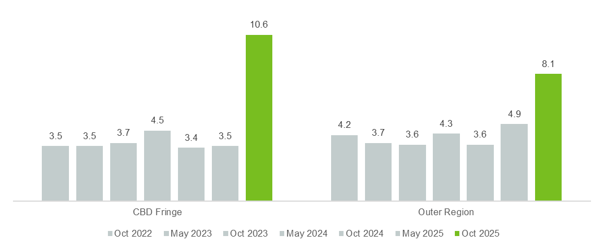

Fare compliance on metropolitan bus
Figure 10 shows the incidence of fare evasion behaviour on metropolitan bus since October 2019. Note, since October 2024, no surveys were conducted at Moonee Ponds Interchange, whilst a location review is still in progress.

FIGURE 10: FARE EVASION BEHAVIOUR, METROPOLITAN BUS (OCTOBER 2019 - OCTOBER 2025)

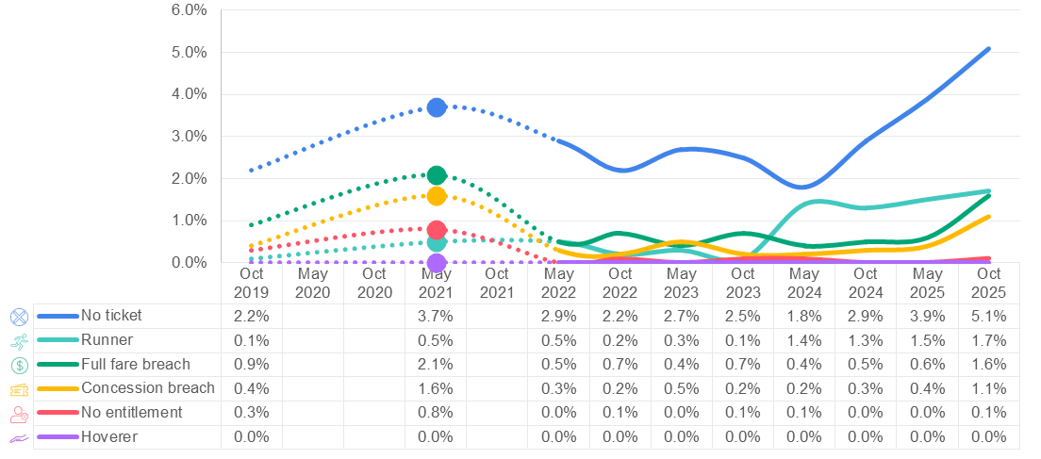

Figure 11 shows the incidence of myki fare evasion behaviour on metropolitan bus from October 2022 to October 2025.

FIGURE 11: MYKI FARE EVASION BEHAVIOUR, METROPOLITAN BUS (October 2022 - OCTOBER 2025)

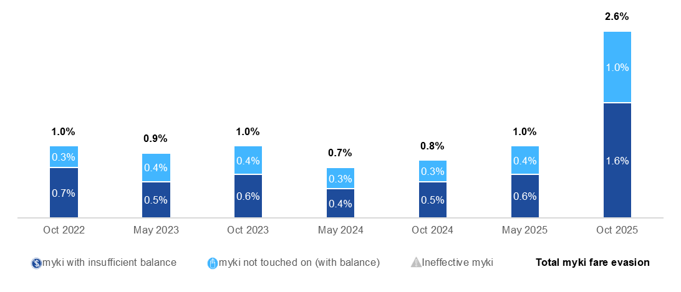

Fare compliance on regional train
Fare compliance surveys on regional train were introduced as part of the October 2012 survey.
Figure 12 shows the incidence of fare evasion behaviour on regional train from October 2019 to October 2025.

FIGURE 12: FARE EVASION BEHAVIOUR, REGIONAL TRAIN (OCTOBER 2019 - OCTOBER 2025)

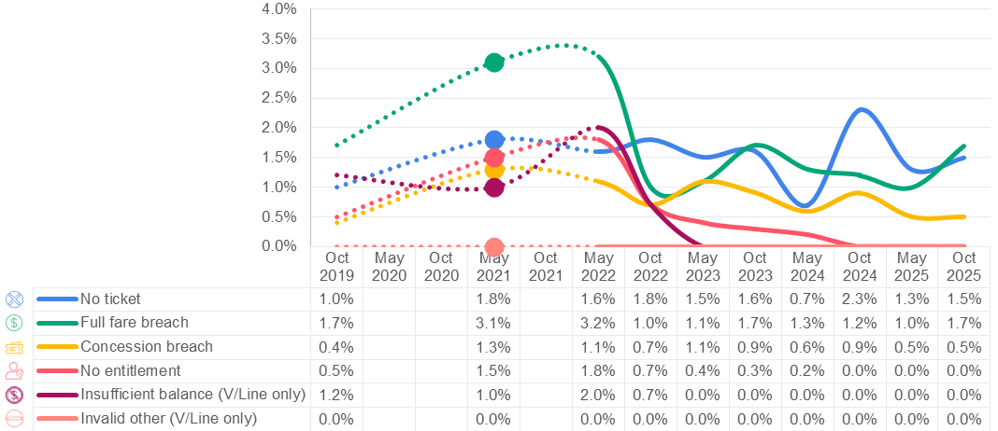

Figure 13 shows the incidence of myki fare evasion on regional train from October 2022 to October 2025.

FIGURE 13: MYKI FARE EVASION BEHAVIOUR, REGIONAL TRAIN (OCTOBER 2022 - OCTOBER 2025)

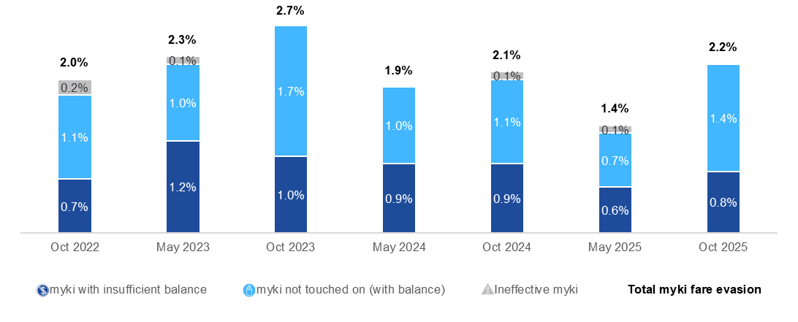

Annual fare compliance rates
Annual rates for fare compliance are provided for the calendar year by combining results of the two relevant surveys. Figure 14 and Table 6 show the estimated annual fare compliance rate for calendar years from 2015 to 2025.

FIGURE 14: ESTIMATED CALENDAR YEAR FARE COMPLIANCE RATE BY MODE (2015 - 2025)

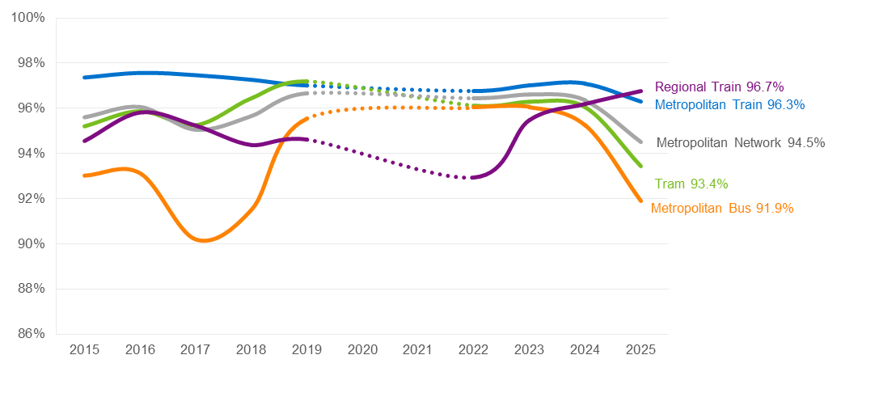

TABLE 6: ESTIMATED CALENDAR YEAR FARE COMPLIANCE RATE BY MODE (2015 - 2025)
 | Metropolitan Train | Tram |  | Metropolitan Bus |  | Metropolitan Network |  | Regional Train
2015 | 97.3% | 95.2% |  | 93.0% |  | 95.6% |  | 94.6%
2016 | 97.6% | 95.9% |  | 93.1% |  | 96.0% |  | 95.8%
2017 | 97.5% | 95.3% |  | 90.2% |  | 95.0% |  | 95.2%
2018 | 97.3% | 96.5% |  | 91.5% |  | 95.7% |  | 94.4%
2019 | 97.0% | 97.2% |  | 95.6% |  | 96.6% |  | 94.6%
2020 | - | - |  | - |  | - |  | -
2021 | - | - |  | - |  | - |  | -
2022 | 96.8% | 96.1% |  | 96.0% |  | 96.4% |  | 92.9%
2023 | 97.0% | 96.3% |  | 96.1% |  | 96.6% |  | 95.5%
2024 | 97.1% | 96.0% |  | 95.2% |  | 96.3% |  | 96.2%
2025 | 96.3% | 93.4% |  | 91.9% |  | 94.5% |  | 96.7%

Revenue impact of fare evasion
The revenue impact of fare evasion is an estimate of the value of fare revenue lost through fare evasion. Appendix B - Revenue impact calculation sets out the calculations applied to estimate the revenue impact.
The results of the October 2025 fare compliance survey are used to estimate the annual revenue impact of fare evasion. For the period July to December 2025, the revenue impact is estimated at $26.0 million on the metropolitan network and $1.3 million for regional trains; a total impact of $27.4 million (difference in figures due to rounding).
Table 7 shows the estimated revenue lost to fare evasion for this period. The estimated cost impact is exclusive of GST.

TABLE 7: ESTIMATED FARE COMPLIANCE REVENUE IMPACT (OCTOBER 2025) $

 | Metro Train | Tram | Metro Bus | Metro Network | Regional Train | Total
July – December 2025 | 5.3 | 11.0 | 9.8 | 26.0 | 1.3 | 27.4
2025 | 10.1 | 16.9 | 15.6 | 42.5 | 2.4 | 44.9

Appendix A - Precision and disaggregation of survey results

Confidence levels for survey estimates
The fare compliance survey is a sample survey, which means that a sample of public transport trips are surveyed in order to deduce the fare compliance rate across all trips on the public transport network. For this reason, the fare compliance rates produced by the survey are estimates and not exact measures of fare compliance.
Since 2010 the fare compliance survey and estimation procedures have enabled the calculation of a precision measure, in the form of a 95 per cent confidence interval, for each estimate. The 95 per cent confidence interval is interpreted as the range of values in which we are 95 per cent certain that the true measure occurs. For example, where a fare compliance estimate has a 95 per cent confidence interval of 96.9 to 98.5, we are 95 per cent certain that the true rate of fare compliance is within this range.
The confidence intervals provide an indication of the precision of each estimate, including the disaggregated estimates by location, day type and time of day. This measure of precision is used to indicate the validity of any comparison between estimates. For example, where the confidence intervals of two estimates overlap, it cannot be said with high confidence that either estimate is higher or lower than the other.

Fare compliance estimates by mode
Table 8 shows the estimated fare compliance rates and 95 per cent confidence intervals for each mode surveyed in the October 2025 survey. Estimates of the fare compliance rates exclusive of no entitlement fare evasion are also included, as these are used in the revenue impact calculations.

TABLE 8: ESTIMATED FARE COMPLIANCE RATES (OCTOBER 2025) %
Fare compliance estimate | Metropolitan Train | Tram | Metropolitan Bus | Regional Train
Fare compliance rate | 96.2 | 91.3 | 90.2 | 96.3
95% confidence interval | 95.5, 96.9 | 90.1, 92.5 | 89.2, 91.2 | 95.5, 97.1
Fare compliance rate, excl. no entitlement | 96.8 | 91.7 | 90.2 | 96.3
95% confidence interval | 96.2, 97.4 | 90.5, 92.9 | 89.2, 91.2 | 95.5, 97.1

Estimated rates of fare evasion behaviour
Table 9 shows the estimates and 95 per cent confidence intervals (95% CI) for rates of each type of fare evasion behaviour per mode.

TABLE 9: ESTIMATES OF TYPES OF FARE EVASION PER MODE (OCTOBER 2025) %
Types of fare evasion behaviour | Metro Train | Train  95% CI | Tram | Tram  95% CI | Metro Bus | Bus  95% CI | Regional Train | Regional Train  95% CI
No ticket | 1.7 | 1.3, 2.1 | 2.5 | 2.0, 3.0 | 5.1 | 4.4, 5.8 | 1.5 | 1.1, 1.9
Runner | 0.3 | 0.1, 0.5 | 2.1 | 1.6, 2.6 | 1.7 | 1.3, 2.1 | - | -
Full fare breach | 0.8 | 0.6, 1.0 | 2.8 | 2.2, 3.4 | 1.6 | 1.3, 1.9 | 1.7 | 1.2, 2.2
Concession fare breach | 0.3 | 0.1, 0.5 | 0.9 | 0.5, 1.3 | 1.1 | 0.8, 1.4 | 0.5 | 0.3, 0.7
No entitlement | 0.6 | 0.4, 0.8 | 0.4 | 0.2, 0.6 | 0.1 | 0.0, 0.2 | 0.0 | 0.0, 0.0
Hoverer | - | - | 0.0 | 0.0, 0.0 | 0.0 | 0.0, 0.0 | - | -
Insufficient balance |  |  |  |  |  |  | 0.0 | 0.0, 0.0
Invalid other |  |  |  |  |  |  | 0.0 | 0.0, 0.0
Total | 3.8 | 3.1, 4.5 | 8.7 | 7.5, 9.9 | 9.8 | 8.8, 10.8 | 3.7 | 2.9, 4.5
Table 10 shows the estimates and 95 per cent confidence intervals (95% CI) for rates of each type of myki fare evasion behaviour per mode.

TABLE 10: ESTIMATES OF TYPES OF MYKI FARE EVASION PER MODE (OCTOBER 2025) %
myki fare evasion behaviour | Metro Train | Train  95% CI | Tram | Tram  95% CI | Metro Bus | Bus  95% CI | Regional Train | Regional Train  95% CI
myki with insufficient balance | 0.7 | 0.5, 0.9 | 1.2 | 0.8, 1.6 | 1.6 | 1.2, 2.0 | 0.8 | 0.5, 1.1
myki not touched on (with balance) | 0.6 | 0.4, 0.8 | 2.6 | 2.0, 3.2 | 1.0 | 0.7, 1.3 | 1.4 | 1.0, 1.8
Ineffective myki | 0.0 | 0.0, 0.0 | 0.0 | 0.0, 0.0 | 0.0 | 0.0, 0.0 | 0.0 | 0.0, 0.0

Fare evasion estimates by ticket type
As of 29th December 2012, myki is the sole ticket system operational on the metropolitan network and Metcard fare compliance is no longer included in the fare compliance survey. The roll out of myki onto regional train commuter belt trains was completed in March 2014, however regional train tickets can still be used for journeys that continue beyond the commuter belt. Since May 2013 the improper use of myki and regional train tickets has been separately identified in the regional train fare compliance survey.
Table 11 reports three types of breach (full fare breach, concession fare breach and no entitlement) for myki and regional train tickets

TABLE 11: ESTIMATES FOR MYKI AND REGIONAL TRAIN TICKET FARE EVASION ON REGIONAL TRAIN (OCTOBER 2025)
Fare evasion behaviour | Regional ticket | Regional ticket 95% CI | myki | myki 95% CI
Full fare breach | 0.0 | 0.0, 0.0 | 1.7 | 1.2, 2.2
Concession fare breach | 0.0 | 0.0, 0.0 | 0.5 | 0.3, 0.7
No entitlement | 0.0 | 0.0, 0.0 | 0.0 | 0.0, 0.0

Table 12 shows the rates of myki and other ticket type usage.

TABLE 12: ESTIMATES FOR MYKI AND OTHER TICKET TYPE USAGE ON REGIONAL TRAIN (OCTOBER 2025)
myki behaviour | Estimate (%) | 95% CI
Valid myki | 87.0 | 84.4, 89.6
Invalid myki | 2.2 | 1.7, 2.7
Total myki | 89.2 | 86.6, 91.8
Valid regional ticket | 8.3 | 6.9, 9.7
Invalid regional ticket | 0.0 | 0.0, 0.0
Total regional ticket | 8.4 | 7.0, 9.8
Valid other ticket (inc. free entitlement) | 1.0 | 0.7, 1.3
No ticket | 1.5 | 1.1, 1.9

Fare evasion estimates for metropolitan train
Table 13 shows the estimates of fare evasion rates and 95 per cent confidence intervals on metropolitan train by day type, time of day, and train line.

TABLE 13: FARE EVASION ESTIMATES BY STRATA - METROPOLITAN TRAIN (MAY 2025 – OCTOBER 2025)
 | May 2025 |  | October 2025
Metropolitan Train Strata | Fare evasion estimate (%) | 95% confidence interval | Fare evasion estimate (%) | 95% confidence interval
Overall | 3.6 | 3.0, 4.2 | 3.8 | 3.1, 4.5
Day Type
Weekday | 3.5 | 2.8, 4.2 | 3.7 | 2.9, 4.5
Weekend | 4.0 | 2.5, 5.5 | 4.4 | 3.1, 5.7
Time of Day
Monday to Friday, am peak | 2.7 | 1.7, 3.7 | 3.5 | 2.2, 4.8
Monday to Friday, off peak | 3.6 | 2.5, 4.7 | 3.9 | 2.6, 5.2
Monday to Friday, pm peak | 4.2 | 2.8, 5.6 | 3.8 | 2.5, 5.1
Line Group
Alamein/Glen Waverley | 3.0 | 1.9, 4.1 | 3.9 | 1.9, 5.9
Cranbourne/Pakenham | 3.9 | 2.0, 5.8 | 4.4 | 2.3, 6.5
Frankston | 5.6 | 3.5, 7.7 | 4.2 | 2.3, 6.1
Lilydale/Belgrave | 2.3 | 1.1, 3.5 | 2.0 | 0.6, 3.4
Sandringham | 4.2 | 2.3, 6.1 | 4.1 | 2.4, 5.8
Mernda/Hurstbridge | 3.3 | 1.9, 4.7 | 3.5 | 1.9, 5.1
Sunbury | 3.2 | 1.0, 5.4 | 3.6 | 1.4, 5.8
Upfield/Craigieburn | 3.7 | 1.3, 6.1 | 3.8 | 1.5, 6.1
Werribee/Williamstown | 3.9 | 1.6, 6.2 | 5.5 | 2.8, 8.2

Fare evasion estimates for metropolitan tram
Table 14 shows the estimates of fare evasion rates and 95 per cent confidence intervals on tram by day type, time of day, and the tram depot from which the surveyed route originates.

TABLE 14: FARE EVASION ESTIMATES BY STRATA - TRAM (MAY 2025 – OCTOBER 2025)
 | May 2025 |  | October 2025
Tram Strata | Fare evasion estimate (%) | 95% confidence interval | Fare evasion estimate (%) | 95% confidence interval
Overall | 4.6 | 3.8, 5.4 | 8.7 | 7.5, 9.9
Day Type
Weekday | 4.7 | 3.8, 5.6 | 8.5 | 7.1, 9.9
Weekend | 4.3 | 2.8, 5.8 | 9.3 | 7.2, 11.4
Time of Day
Monday to Friday, am peak | 4.1 | 2.6, 5.6 | 4.9 | 3.2, 6.6
Monday to Friday, off peak | 4.8 | 3.4, 6.2 | 9.6 | 7.3, 11.9
Monday to Friday, pm peak | 4.8 | 3.4, 6.2 | 9.1 | 6.7, 11.5
Depot
Brunswick | 8.0 | 4.8, 11.2 | 7.9 | 4.9, 10.9
Camberwell | 4.4 | 2.2, 6.6 | 6.7 | 3.6, 9.8
Essendon | 3.8 | 2.0, 5.6 | 8.6 | 4.7, 12.5
Glenhuntly | 5.2 | 2.7, 7.7 | 6.5 | 3.5, 9.5
Kew | 3.4 | 1.4, 5.4 | 9.7 | 6.7, 12.7
Malvern | 4.1 | 2.0, 6.2 | 10.5 | 6.0, 15.0
Preston | 3.1 | 1.1, 5.1 | 14.9 | 11.2, 18.6
Southbank | 4.6 | 2.8, 6.4 | 5.5 | 2.5, 8.5
Area
CBD | No longer measured
CBD Fringe | 3.5 | 2.5, 4.5 | 10.6 | 8.5, 12.7
Outer Region | 4.9 | 4.0, 5.8 | 8.1 | 6.7, 9.5

Fare evasion estimates for metropolitan bus
Table 15 shows the estimates of fare evasion rates and 95 per cent confidence intervals on metropolitan bus by day type and location.

TABLE 15: FARE EVASION ESTIMATES BY STRATA - METROPOLITAN BUS (MAY 2025 – OCTOBER 2025)
 | May 2025 |  | October 2025
Metropolitan Bus Strata | Fare evasion estimate (%) | 95% confidence interval | Fare evasion estimate (%) | 95% confidence interval
Overall | 6.4 | 5.6, 7.2 | 9.8 | 8.8, 10.8
Day Type
Weekday | 6.5 | 5.7, 7.3 | 10.0 | 8.9, 11.1
Weekend | 5.6 | 4.3, 6.9 | 7.9 | 6.2, 9.6
Location
Altona Gate SC | 4.9 | 1.8, 8.0 | 9.4 | 5.0, 13.8
Box Hill RS | 6.3 | 3.8, 8.8 | 6.5 | 3.3, 9.7
Broadmeadows RS | 6.9 | 4.4, 9.4 | 9.6 | 6.0, 13.2
Chadstone SC | 6.8 | 3.8, 9.8 | 7.7 | 3.6, 11.8
Dandenong RS | 5.1 | 2.7, 7.5 | 7.4 | 4.4, 10.4
Doncaster SC | 6.4 | 3.4, 9.4 | 9.2 | 5.1, 13.3
Epping Plaza SC | 6.1 | 2.4, 9.8 | 10.1 | 5.2, 15.0
Footscray RS | 5.4 | 1.8, 9.0 | 4.6 | 0.0, 9.3
Fountain Gate SC | 7.8 | 1.5, 14.1 | 8.9 | 4.2, 13.6
Frankston RS | 6.9 | 2.5, 11.3 | 16.7 | 8.6, 24.8
Glen Waverley RS | 5.6 | 2.4, 8.8 | 6.9 | 1.3, 12.5
Greensborough SC | 4.5 | 1.1, 7.9 | 17.2 | 11.0, 23.4
Highpoint SC | 7.1 | 3.3, 10.9 | 9.9 | 4.7, 15.1
Knox City SC | 6.8 | 2.1, 11.5 | 13.5 | 7.8, 19.2
Lilydale RS | 4.3 | 1.9, 6.7 | 11.0 | 1.9, 20.1
Lonsdale St CBD | 8.5 | 5.2, 11.8 | 10.1 | 6.0, 14.2
Melton RS | 3.6 | 0.0, 7.2 | 20.5 | 10.9, 30.1
Monash University Clayton | 6.8 | 2.1, 11.5 | 7.8 | 2.4, 13.2
Moonee Ponds IC* | - | - | - | -
Northland SC | 6.5 | 3.6, 9.4 | 12.3 | 7.5, 17.1
Oakleigh RS | 7.2 | 2.7, 11.7 | 5.2 | 0.3, 10.1
Reservoir RS | 6.3 | 2.6, 10.0 | 5.7 | 0.0, 11.6
Ringwood RS | 6.4 | 3.1, 9.7 | 10.6 | 5.4, 15.8
Southland SC | 7.9 | 3.2, 12.6 | 9.5 | 4.2, 14.8
South Morang RS | 4.8 | 2.0, 7.6 | 13.4 | 7.3, 19.5
St Albans RS | 3.8 | 0.8, 6.8 | 11.2 | 4.8, 17.6
Sunshine RS | 8.4 | 4.7, 12.1 | 13.2 | 5.7, 20.7
Werribee Plaza SC | 9.0 | 1.0, 17.0 | 11.4 | 6.1, 16.7
*Note, since May 2024, no surveys were conducted at Moonee Ponds Interchange, whilst a location review is still in progress.

Fare evasion estimates for regional train
Table 16 shows the estimates of fare evasion rates and 95 per cent confidence intervals on regional train by time of day, day type, direction and line.

TABLE 16: FARE EVASION ESTIMATES BY STRATA, REGIONAL TRAIN (MAY 2025 – OCTOBER 2025)
 | May 2025 |  | October 2025
Regional Train Strata | Fare evasion estimate (%) | 95% confidence interval | Fare evasion estimate (%) | 95% confidence interval
Overall | 2.8 | 2.2, 3.4 | 3.7 | 2.9, 4.5
Time of day / day type
Peak | 0.9 | 0.3, 1.5 | 1.5 | 1.0, 2.0
Off peak | 3.7 | 2.6, 4.8 | 4.5 | 3.2, 5.8
Monday to Friday | 2.4 | 1.8, 3.0 | 3.5 | 2.6, 4.4
Saturday | 5.8 | 4.1, 7.5 | 4.1 | 3.2, 5.0
Sunday | 3.6 | 2.6, 4.6 | 6.5 | 3.8, 9.2
Direction
To City (up) | 2.6 | 1.8, 3.4 | 4.5 | 3.5, 5.5
From City (down) | 3.2 | 2.6, 3.8 | 3.1 | 2.0, 4.2
Line
Eastern | 1.0 | 0.4, 1.6 | 5.6 | 2.0, 9.2
North Eastern | 2.5 | 0.3, 4.7 | 2.0 | 1.2, 2.8
Northern | 1.6 | 1.1, 2.1 | 1.1 | 0.7, 1.5
Western | 7.9 | 6.2, 9.6 | 4.3 | 3.0, 5.6
South Western | 4.6 | 3.2, 6.0 | 3.9 | 2.6, 5.2

Appendix B - Revenue impact calculation
The level of fare compliance has an impact on fare revenue. The method used to estimate revenue lost uses the following inputs:

F_{mode} Fare evasion rate exclusive of ‘No entitlement’ – disaggregated by mode
C_{mode} ‘No entitlement’ – disaggregated by mode
T_{mode} Modal patronage as per cent of total patronage, for the period
R_{network} Revenue for half year (this is network-wide, not available disaggregated by mode)
N Nominal concession ticket discount.

Step 1: Revenue impact percent (I_{mode})

For each mode, I_{mode} = (1- N) × C_{mode} + F_{mode} ............. (1)

Step 2: Imputed half-year revenue by mode

With an integrated fare system there is no obvious way of disaggregating revenue generation by mode. The working definition, (employed here), is that revenue by mode is proportional to patronage by mode.

So, for each mode, R_{mode}= T_{mode} × R_{network} ................................................ (2)

Step 3: Estimated revenue impact in dollars ($)

For each mode, S_{mode}= I_{mode} × R_{mode}÷ (1-I_{mode}) ................................................ (3)

Table 17 shows each of the inputs for each mode and the subsequent estimates of the impact on revenue.

TABLE 17: CALCULATION OF THE REVENUE IMPACT OF FARE EVASION (JULY – DECEMBER 2025)
Category | Ref | Metro Train | Tram | Metro Bus | Metro Network | Regional Train
Fare Evasion (excl. ‘No entitlement’) | F | 3.2% | 8.3% | 9.8% |  | 3.7%
No entitlement | C | 0.6% | 0.4% | 0.1% |  | 0.0%
Proportion of metropolitan patronage (%) | T | 41.2% | 33.5% | 25.3%
Revenue* for half year ($m) | R |  |  |  | 353.0 | 34.7
Assume conc. discount on average is | N | 50.0% | 50.0% | 50.0% |  | 50.0%
Revenue impact (%) | Eqn 1** | 3.5% | 8.5% | 9.9% |  | 3.7%
Revenue* for the half year By Mode ($m) | Eqn 2** | 145.4 | 118.2 | 89.4
Revenue* impact by mode ($m) | Eqn 3** | 5.3 | 11.0 | 9.8 | 26.0 | 1.3

Metropolitan Fare Evasion survey, May 2016 Practice Note – TRIM reference DOC/16/153590, Regional Train Fare Evasion Survey – May 2016 Practice Note– TRIM reference DOC/16/153636
Estimation programs for PTV’s metropolitan fare compliance survey – TRIM reference DOC/14/139095.
³This is equivalent to the previously agreed formulation of I_{mode} = (1- N) × P_{mode} × (1-V_{mode})+ F_{mode}, where P is the percentage of trips made by concession users and V is the valid concession percentage

