
Water Efficient Fixtures
  - Regulatory Impact Statement
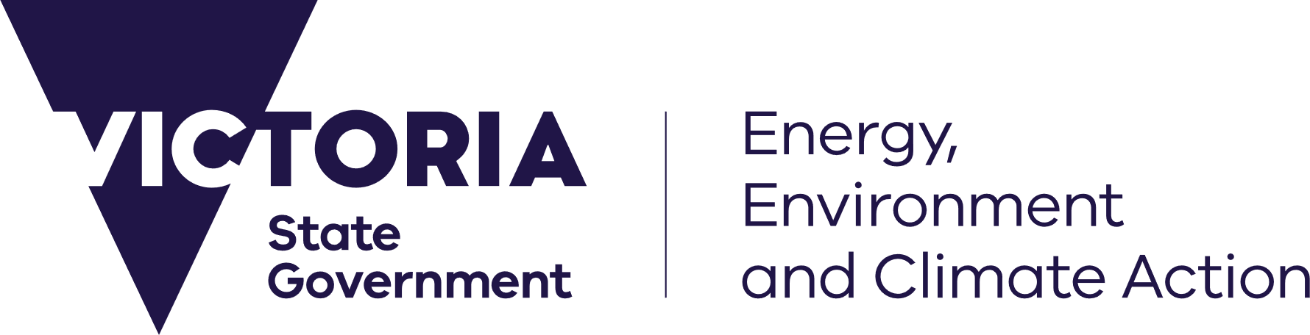






We acknowledge and respect Victorian Traditional Owners as the original custodians of Victoria’s land and waters, their unique ability to care for Country and deep spiritual connection to it.
We honour Elders past and present whose knowledge and wisdom
has ensured the continuation of culture and traditional practices.
DEECA is committed to genuinely partnering with Victorian Traditional Owners and Victoria’s Aboriginal community to progress their aspirations.
© The State of Victoria Department of Energy, Environment and Climate Action December 2025.
Creative Commons
This work is licensed under a Creative Commons Attribution 4.0 International licence, visit the Creative Commons website (http://creativecommons.org/licenses/by/4.0/).
You are free to re-use the work under that licence, on the condition that you credit the State of Victoria as author. The licence does not apply to any images, photographs or branding, including the Victorian Coat of Arms, and the Victorian Government and Department logos.
ISBN 978-1-76136-631-4 (PDF)
Disclaimer
This publication may be of assistance to you but the State of Victoria and its employees do not guarantee that the publication is without flaw of any kind or is wholly appropriate for your particular purposes and therefore disclaims all liability for any error, loss or other consequence which may arise from you relying on any information in this publication.
Accessibility
To receive this document in an alternative format, phone the Customer Service Centre on 136 186, email customer.service@deeca.vic.gov.au or contact National Relay Service on 133 677. Available at DEECA website (http://www.deeca.vic.gov.au).

Contents
Executive summary 3
What is being considered? 3
Why are these changes being considered? 3
What options were considered? 6
What are the costs and benefits of each option? 7
Implementation and evaluation 9
1. Purpose of this Regulatory Impact Statement 10
1.1 Purpose 10
1.2 How to provide feedback 10
2. The case for change 11
2.1 The problem 11
2.2 Key opportunities 15
2.3 Why water users aren’t investing in water efficient fixtures 19
3. Objectives 20
3.1 Relevant Victorian legislation and policy objectives 20
3.2 Objectives of proposed amendments to the Plumbing Regulations 21
4. Identification of options 22
4.1 Extended list of options considered 22
4.2 Options examined in this RIS 25
5. Assessment of options 30
5.1 Assessment of options 30
5.2 Summary of costs and benefits 36
6. Preferred option 37
6.1 Preferred option 37
6.2 Outcomes 38
6.3 Sensitivity analysis 39
6.4 Impact on competition 40
6.5 Impact on small business 40
6.6 Impacts on householders 41
7. Implementation and evaluation 41
7.1 Timing 41
7.2 Communication 42
7.3 Compliance and exemptions 42
7.4 Evaluation 42
7.5 Data collection 43
Glossary 44
Appendix A: Existing interventions to manage water demand 46
Appendix B: Long run marginal cost of water 48
Appendix C: Water efficient fixtures assessment 49
Appendix D: Competition impact assessment 51

Executive summary

What is being considered?
The Victorian Government is considering amendments to the Victorian Plumbing Regulations 2018 (the ‘Plumbing Regulations’) to update toilet, tap and showerheads (fixture) water efficiency requirements in all buildings. The changes are being proposed to conserve drinking water (potable water) and reduce household bills. They will also reduce greenhouse gas emissions by reducing use of hot water.
Victoria already has plumbing requirements that require a certain level of water efficiency for fixtures, which were set over 15 years ago, as it adopts the standards in the Plumbing Code of Australia (PCA). The proposed amendments would strengthen these requirements for Victoria. Both existing, and the potential new, fixture water efficiency requirements apply to all registered plumbing work in all buildings and are presented in Table 1.
Table 1. Comparison of existing and preferred fixture water efficiency requirements (maximum flow in brackets).
Existing requirements in the PCA | Preferred option
Requirements for plumbing work in all new and existing buildings (residential and non-residential):  - 3-star showerheads (further referred to as showers) (9.0 L/min)  - 3-star toilets (6.0 L/flush)  - 2-star urinals  Taps  - 3-star kitchen and laundry sink (9.0 L/min)  - 3-star basin taps (9.0 L/min) |  | Requirements for plumbing work in all new and existing buildings (residential and non-residential):  - 4-star showers (6.0-7.5 L/min)  - 4-star toilets (4.5 L/flush)  - 5-star urinals*  Taps**  - 4-star kitchen and laundry sink taps (6.0-7.5 L/min)  - 5-star bathroom basin taps for residential buildings (4.5-6.0 L/min)  - 6-star bathroom basin taps for non-residential buildings (4.5 L/min)
* While it is very uncommon for urinals to be installed in homes, the urinal standard applies to both residential and non-residential urinals in Victoria.
** Lower efficiency (higher flow) standards are proposed for the residential kitchen and laundry sink taps, than for bathroom basin taps, as these taps are often used to fill something (i.e. sink, pans or buckets) and therefore a lower flow tap may not result in lower water use (and may cause frustration as it will take longer to collect the water required). There is no change proposed for bath, appliance (i.e. washing machines and dishwashers) and outdoor tap flow rates, which are currently unregulated.
Note that all fixture star ratings referred to in this Regulatory Impact Statement (RIS) are Water Efficiency Labelling and Standards (WELS) scheme star ratings.
There might be rare instances where water efficient fixtures are not compatible with plumbing in existing buildings (assumed to occur in less than 3% of situations), for example in buildings with very old instantaneous hot water systems. For this reason, there is an option to revert to a less efficient fixture. The efficiency of this less efficient fixture must be equivalent to the highest WELS standard that can function in the building (with a 3-star minimum as per current requirements), thereby maximising water efficiency benefits that can operate effectively with the existing plumbing system.

Why are these changes being considered?

Conservation of potable water
Victoria remains one of Australia’s fastest growing states. At the same time, our climate is changing. Action is needed to ensure that Victorians continue to have access to safe and reliable water supplies as our population grows and we experience more frequent droughts and lower rainfall due to climate change.
To help manage the expected population growth, the Victorian Government has committed to an ambitious goal of delivering 800,000 new homes over the next decade – homes that will need water for gardens, drinking, showers and toilet flushing. Expected population growth will increase future demand on the greater Melbourne water supply system (also known as the South-Central Water Grid) by 60%.
The greater Melbourne water supply system services 80% of the state’s population. However, modelling for the Central and Gippsland Region Sustainable Water Strategy (CGRSWS) and more recently by Melbourne Water, show that, without further action, demand for water could exceed supply this decade. The supply shortfall could be as great as 95 gigalitres (GL) per year by 2030, under high climate change and demand.
Urban Water Strategies prepared for water supply systems in other areas of the state suggest that many of these systems are also vulnerable to the same challenges as Melbourne and would benefit from response options that reduce demand and help maintain resilience. For example, in Lorne under high demand and climate change, supply could fail to meet demand by as early as 2027, with increased probability of longer, harsher and more frequent water restrictions to manage drier periods.
As there are no new large-scale opportunities to take water sustainably from rivers or groundwater, we must develop a diverse portfolio of sources that includes water efficiency and use of desalinated water, recycled water, stormwater and rainwater to improve overall system resilience.
Water efficiency is more cost effective than major augmentations, such as desalinated water, recycled water and treated stormwater, and can provide significant water savings. However, it will not save enough water to address the entire supply demand deficit.
Augmentations therefore remain an important part of the solution but, with significant water efficiency measures in place, can be delayed, or built less frequently.
Water efficiency is also lower risk than major augmentations as it is incremental, more easily modified, spatially distributed (therefore more resilient to local network failures) and doesn’t involve significant upfront public investment.

Cost-of-living pressures
Victorians are facing high cost-of-living pressures, with 54% experiencing cost-of-living and personal debt distress beyond normal levels. The number of customers receiving payment assistance from energy retailers has increased, with 1-in-4 residents finding it hard to pay their gas and electricity bills. From July 2023, there was a 25% increase in electricity prices from the previous year — which is equivalent to a $352 increase to residential customers, and $752 increase for small business customers.
Most water supply options, such as large-scale water system augmentation (infrastructure) projects have historically been largely paid for through increased bills. Fortunately, water efficiency can help minimise bill increases because in general it is lower cost than other water security initiatives - as shown in Figure 1.
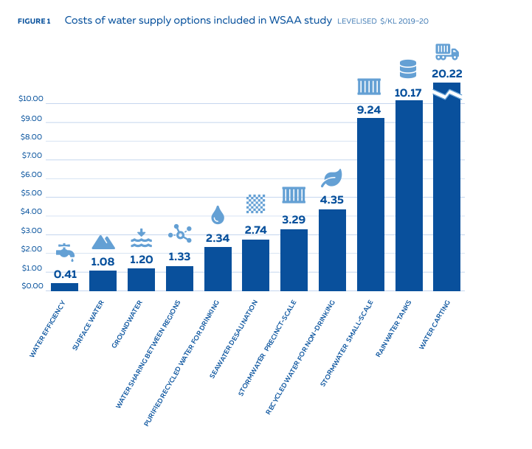
Figure 1. Costs of water supply options included in WSAA study (levelized $/ kilolitres (KL) 2019-20).
Source WSAA.

Why water efficient fixtures?
Currently the main building-scale interventions for increasing the water efficiency of buildings involve:
- installation of rainwater tanks (or recycled water third pipe)
- use of water efficient fixtures.
Until recently, Victoria required the installation of either a rainwater tank plumbed to all toilets (which could also be met with recycled water third pipe), or a solar hot water system for new Class 1 dwellings. By late 2023, this requirement in combination with state and council stormwater planning requirements (see Appendix A) was resulting in approximately 30% of new homes installing rainwater tanks.
This requirement, which commenced in 2005, ended in April 2024 due to changes to residential energy efficiency standards in the National Construction Code (NCC) 2022, which supersede the NCC 2019 solar hot water component.
These changes to the NCC offer an opportunity to consider all feasible water efficiency building and plumbing requirements for buildings, such as rainwater tank and efficient fixture requirements, to determine the most appropriate requirements going forward. Economic modelling undertaken by DEECA prior to preparing this RIS suggests that, of these, options that increase uptake of water efficient fixtures are the most cost effective and practical, providing significant water savings for relatively little cost (and in some instances no additional cost).
Water efficient fixtures can directly reduce both water and energy bills, thereby reducing financial pressure, particularly for lower income households.
They reduce water bills for homes and businesses by both:
- reducing potable water demand and thereby reducing the volumetric component of water bills
- reducing water supply system operating and augmentation costs, by reducing the need for major water supply augmentations, both of which impact water bills.
Water efficient fixtures reduce energy bills by reducing the amount of water that is heated for shower and basin use. They also reduce the amount of potable water distributed and supplied to customers and the amount of wastewater that requires treatment. This reduces overall water system costs, which are recovered through bills.
In the context of high cost-of-living pressures, this RIS therefore focuses on increasing uptake of water efficient fixtures as a first step towards capturing opportunities at the building scale.
While not the focus of this RIS, the Department of Energy, Environment and Climate Action (DEECA) remains committed to increasing uptake of rainwater tanks because they not only save large volumes of potable water but also reduce harmful urban stormwater impacts on downstream aquatic environments. DEECA works with key water stakeholders, through Integrated Water Management Forums, to identify local opportunities to increase the use of not only rainwater but also recycled water and treated stormwater. DEECA has also commissioned research and advice on options for improving rainwater tank maintenance and installation.

The need for regulation
Following a decade without water restrictions, there has been a gradual decline in water efficient behaviours. For example, the proportion of showers that are water efficient in Melbourne homes has, according to resident surveys, declined by 13% since 2012 (from 72% in 2012 to 59% in 2021), with only approximately 10% of people installing 4 star showers in 2018 (Institute of Sustainable Futures (ISF), 2018) and residents tending to take more frequent and longer showers (6.1 minutes in 2012 compared to 8.0 minutes in 2021).⁸ This suggests that relying on voluntary investment in water efficient fixtures, particularly outside of drought periods, is unlikely to be effective.
Current national plumbing and minimum WELS standards do not reflect advances in water efficient technologies for fixtures; with little change in the minimum plumbing standards for over 15 years.
Amendments to the Plumbing Regulations are cost-effective as they are triggered only when building or plumbing works are planned or underway rather than requiring property owners to replace fully functional water fixtures in existing buildings, which wouldn’t otherwise be replaced.

What options were considered?
A wide range of options for increasing the water efficiency of fixtures were considered in the development of this RIS.
This RIS examines three shortlisted options in more detail; two regulatory (plumbing requirement) options and a voluntary shower replacement program (see Table 2).
As per existing national fixture efficiency requirements, the two regulatory options (options 1 and 2) apply to all registered plumbing work. This includes plumbing work in all new buildings, major alterations and extensions and fixture replacements in existing buildings.
The non-residential standards are the same (4 to 6 stars) in both regulatory options.
Option 1 requires that all household fixtures meet the same minimum standard (4-star). Whereas Option 2 (preferred) introduces a higher standard (5-star) for residential basin taps to deliver the highest possible water savings, whilst still maintaining adequate customer experience.
In both Option 1 and Option 2, tap flow standards proposed for residential buildings are lower than non-residential buildings as efficient taps are already commonly in use in non-residential settings and those using basin taps in non-residential (i.e. office) bathrooms are less likely to need to wait for hot water to arrive.
The replacement program, Option 3, only includes showers because in the average home showers use more water (31%) than any other internal end use and efficient showers are extremely cost effective.
Table 2. Options assessed in RIS.
 | Option | Description
Water efficient fixtures | Option 1: 4-star residential and 4 to 6-star non-residential fixture requirements (referred to as 4-star RES) | Residential  4-star showers, toilets and all taps  Non-residential  4-star showers, toilets and kitchen and laundry sink taps  5-star urinals*  6-star bathroom basin taps
Water efficient fixtures | Preferred option:  Option 2: 4 to 5-star residential and 4 to 6-star non-residential fixture requirements (referred to as 4-5-star RES) | Residential  4-star showers, toilets and kitchen and laundry sink taps  5-star bathroom basin taps  Non-residential  4-star showers, toilets and kitchen and laundry sink taps  5-star urinals*  6-star bathroom basin taps
Water efficient fixtures | Option 3: Shower replacement program | Voluntary residential program to replace 1, 2 and 3-star showers with 4-star showers
* While it is very uncommon for water using urinals to be installed in homes in Victoria, the urinal standard applies to both residential and non-residential urinals.

What are the costs and benefits of each option?
The estimated whole of society costs and benefits (to the state of Victoria) of the RIS options were assessed as shown in Table 3 (for a more detailed breakdown of these costs and benefits see Table 12).

Water efficient fixtures
Table 3. Costs and benefits of water efficient fixtures, present values over a 20-year period.
Option | Total costs ($M) | Total benefits ($M) | Net benefit (NPV) ($M) | Benefit-cost ratio
Option 1: 4-star residential and 4 to 6-star non-residential fixture requirements (4-star RES) | $134 | $1,934 | $1,800 | 14.4
Preferred option:  Option 2: 4 to 5-star residential and 4 to 6-star non-residential fixture requirements (4-5-star RES) | $240 | $2,166 | $1,926 | 9.0
Option 3: Shower replacement program | $216 | $747 | $530 | 3.5
The costs of the options include the additional cost associated with purchasing more water efficient fixtures.
The shower replacement program (Option 3) also includes the cost to government (or water corporations, if funded by them) of offering the program, which is estimated to be $45 million per year.
The primary benefit of all three options is reduced use of potable water (reducing costs for both consumers and water supply systems, leading to lower water bills), reduced energy bills and reduced greenhouse gas emissions.
The costs and benefits associated with the two regulatory options (Options 1 and 2) are more certain than for the shower replacement program (Option 3) which may have low uptake and / or fail to incentivise significant uptake beyond those already planning to install efficient showers.
While Option 1 (4-star RES), is estimated to have a higher benefit-cost ratio and is simpler given the same efficiency requirements (4-star) apply to all fixtures in residential buildings, Option 2 (4-5-star RES) is preferred as it saves more water (saving 30 GL/year as opposed to 26 GL/year after 20 years) and has the greatest net benefits.

What are the impacts of the preferred option?
The preferred water efficient fixture option (Option 2, 4-5-star RES) is expected to have total benefit-cost ratio of 9.0 and save increasingly large volumes of water each year – reaching 18 GL per after 10 years and 30 GL per year of water after 20 years.
It has high quantifiable and unquantifiable benefit-cost outcomes, with a Net Present Value (NPV) of $1,926 million, and a net benefit of $2,166 million. It will also reduce energy use and, therefore, greenhouse gas emissions, while still maintaining customer experience (i.e. shower experience).
With the preferred option in place, Victoria would experience increased water supply resilience and reliability. As every litre of water saved through water efficiency results in one litre less needing to be produced from manufactured sources. The option would reduce the need for desalinated water (and associated water price increases), delaying and reducing the number of major augmentations in the longer term.
The benefits would be enjoyed by property owners and tenants through reduced water bills and energy bills.
Any cost uplift would fall mainly on impacted property owners, non-residential tenants paying for building refits and developers and is expected to reduce as more efficient products are sold and a bigger range of models enter the market. The estimated additional costs associated with more water efficient fixture ranges depending on model. Sometimes the cost of more efficient fixtures is less than the cost of less efficient fixtures, meaning it’s possible there is no additional cost. See Appendix C for more information.
If purchasing the least expensive fixture models (i.e. the lowest 10th percentile), it is estimated that the additional cost difference associated would, be $318 (for a two-bathroom home) in the first few years of implementation, reducing to $64 in 20 years’ time. $318 is less than 0.06% of the total cost of building an average new home and is recuperated in bill savings within two years from purchase (for reference solar panels are paid back between seven and nine years in Victoria).
The preferred option is estimated to provide the following (quantified) costs and benefits (Table 4), to which unquantified impacts (such as additional employment) are expected to add further community benefit.
Table 4. Preferred option, Option 2 (4-5-star RES), estimated costs and benefits, over 20 years.
Present values costs and benefits ($M NPV)
Total benefits |  | 2,166
Water savings | 726
Energy cost savings | 1,377
Reduced greenhouse gas emissions | 63
Total costs* | 240
- Additional costs of fixtures | 238
- Rebate program costs (Option 3 only) | -
Net benefit (NPV) |  | 1,926
Benefit-cost ratio |  | 9.0
Specific elements (included in above costs and benefits):
Water savings (GL/year after 20 years) |  |  |  | 30
Upfront costs to householders |  |  | up to $318  for a new two bathroom house
Bills savings / year |  | $193**  ($61 in water and $132 in energy bills)
* Includes $1m for implementing new building or plumbing requirements in options 1 and 2 (including administration, communications, as discussed under Section 5.1 costs).
** For houses with electric resistance tanks for hot water heating
The preferred option, Option 2 (4-5-star RES), is also estimated to provide:
- improved water efficiency of 2.9 million homes (or 74% of dwellings) over 20 years.
- reduced greenhouse gas emissions CO₂ by 1.8 mega tonnes (MT) over a 20 year period ($0.14 billion), which is equivalent to taking 22,500 cars off the road each year over the same period.
- reduced household water use by approximately 12% on average (new homes).
The sensitivity of these results to changes in key assumptions, such as changes in costs of water efficient fixtures has been tested. The analysis found that the viability of the preferred Option 2 is not sensitive to any of the changes in assumptions; with Benefit Cost Ratios (BCRs) between 5.7 and 22.1 for all scenarios (see Section 6.3).
If energy prices increase in the future, the net benefits and household energy bill savings will be even higher than those outlined in this RIS.

Implementation and evaluation
The proposed changes to the Plumbing Regulations under consideration are anticipated to come into effect in late 2026 or early 2027, pending timing of approvals.
The Building and Plumbing Commission will provide industry guidance to plumbers and building practitioners prior to the changes commencing, to assist them to comply. This may include webinars and online guidance, such as fact sheets, practice notes and other technical information.
DEECA will monitor the success of the new measures in the period up until 2028 when the Plumbing Regulations are due to sunset. This could include quantifying water and energy savings and reductions in utility bills, generated by the changes by comparing demand across new and existing developments before and after implementation to evaluate the impact of the proposed provisions.

Purpose of this Regulatory Impact Statement

Purpose
The Victorian Government is considering amendments to the Plumbing Regulations 2018 (Plumbing Regulations) to update water efficiency standards for showers, taps and toilets (fixtures) in all registered plumbing work in all buildings. Amendments to these regulations are being proposed to conserve drinking water (also referred to as potable water) and reduce household water and energy bills. They will also reduce greenhouse gas emissions.
The Regulatory Impact Statement (RIS) process aims to ensure that the estimated benefits of the proposed amendments to the Plumbing Regulations outweigh the estimated costs, and that the regulatory proposal is superior to other feasible alternatives that might also meet the same objective.
The Commissioner for Better Regulation provides an independent assessment on the adequacy of RIS’ which are assessed against the Victorian Guide to Regulation.
A key part of the RIS process is to seek views from the public on the impacts of the preferred option. This RIS and the proposed Plumbing Regulations have been publicly released for consultation to provide businesses, members of the public and other interested parties the opportunity to provide feedback through a formal feedback process.

How to provide feedback
Interested parties are invited to provide feedback on the preferred option for improving the water efficiency of fixtures in buildings across Victoria.
Feedback should be made via www.engage.vic.gov.au
The Minister for Water (as the Minister responsible for the water portfolio) and the Minister for Housing and Building (as the Minister responsible for the Plumbing Regulations) will consider the issues raised before making a final decision on the preferred option.
Feedback will be treated as public. If you do not wish your feedback to be published or to have content from it quoted in the DEECA response to consultation, please include this request as part of your feedback.

The case for change
At a glance
- Without further actions being taken, Greater Melbourne could experience water supply shortfalls this decade, and similar outcomes are forecast for many other Victorian water supply systems.
- There are significant opportunities to reduce potable water use in buildings by improving the water efficiency of fixtures. This will delay and reduce the number of large-scale supply system augmentations in the longer term, which are paid for through water bills.
- Existing regulations need updating because existing regulations do not reflect advances in water efficient technologies.

The problem

Future water shortfalls
Our demand for water is increasing as the population grows and as we change the way we use water. In 2022/23, Victoria’s population is estimated to have increased by 175,000 people, or 2.6%, representing the largest annual growth of any state or territory. The population is projected to continue grow from 6.8 million in 2023 to 10.3 million by 2051.
In the water supply system servicing Melbourne and connected towns, demand is already overtaking our current supply. Yet this system supplies areas like Wyndham, Melton and Sunbury, where the population is projected to almost quadruple during the next 50 years and Geelong, which is forecast to more than double over the next 50 years. This growth is expected to increase future demand on this supply system by 60%.
Significant population growth is also projected to occur in other regional areas. Moorabool shire is the fastest growing regional local government area and its population is forecast to increase by an average of 2.7% each year to 2036.
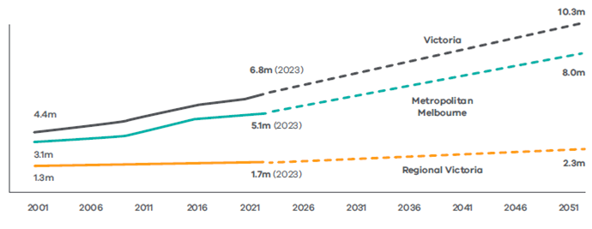
Figure 2. Past and projected population in major regions 2001 to 2051.
Source: Victoria in Future 2023.
To meet the needs of our growing population, an estimated 2.24 million more homes will be needed
across the state over the next 30 years. The Victorian Government is aiming to build 800,000 homes in Victoria over the next decade – homes that will need water for drinking, showers, gardens and toilet flushing etc. This presents an opportunity to influence how these homes are built to ensure that they are water and energy efficient.

Victorians have a strong track record of saving water, achieving large reductions in water use during the Millennium Drought and maintaining those savings in recent years. However, following a decade without water restrictions, there has been a gradual decline in water efficient behaviours. For example, the proportion of showers that are water efficient in Melbourne homes has declined by 13% since 2012 (from 72% in 2012 to 59% in 2021) and residents are taking more and longer showers (6.1 minutes in 2012 compared to 7.96 minutes in 2021). While this has been balanced by uptake of other more water efficient fixtures and appliances, it has meant that per capita water use has plateaued over the past decade and total use has increased.
At the same time, Victoria is becoming warmer and dryer with less water flowing into our water storages over the longer-term, and more frequent and extreme weather events. While the last few years have been wetter than average due to La Nina, this is not representative of the longer-term outlook. Inflows into Melbourne’s dams have decreased by 28% since 1997, and this trend is expected to worsen over time due to changes in Victoria’s climate. Declines in streamflow above 40% by 2065 are predicted for most regions in Victoria under a high impact climate change scenario. Victoria is also experiencing more climate extremes and variability, including droughts.
The result of increasing population and a drying climate is that our conventional water sources will be insufficient to meet future demand. Modelling shows that even with the Victorian Desalination Plant operating at full capacity, the supply shortfall for Greater Melbourne and the connected systems, under high climate change and demand, could be as great as 95 GL per year by 2030, increasing up to 220 GL by 2040 or sooner if there is an extended dry period² (see Figure 3).
It is important to take action now because storage levels can drop quickly in a severe drought. In 2006, Melbourne’s water storages dropped from around 60% to 40% in just one year. And, if a repeat of the Millennium Drought was to occur even with full use of the existing desalination plant, storages would decline rapidly and could trigger severe water restrictions in less than four years.
Modelling of other water supply systems across the state suggests that these systems are vulnerable to the same water security challenges as Melbourne and would benefit from changes that reduce demand and help maintain resilience. Regional water supply systems that have smaller storages and little access to rainfall-independent supplies, such as desalinated water, are more vulnerable to the effects of climate change. For example in Lorne, under high demand and climate change, supply could fail to meet demand by as early as 2027. Without other action, there would be increased probability of longer, harsher and more frequent water restrictions to manage drier periods.
Severe restrictions can have a significant and lasting impact on our everyday lives, economy and jobs, and the environment. Preliminary economic modelling from Melbourne Water shows that a very extreme water shortage event (for example if augmentation has not been completed by 2040) that required households and businesses to cut water use by 50%, could cost the Victorian economy tens of billions of dollars in just 12 months.
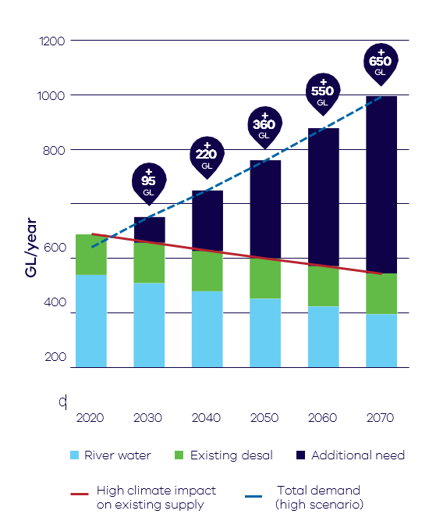
Figure 3. Forecast potential supply and demand gap (under a ‘high climate, high demand’ scenario) showing additional water security needs to avoid severe restrictions.
Data Source: Melbourne Water modelling 2024.

Water security options
There are no new large-scale opportunities to take water sustainably from rivers or groundwater.
In Greater Melbourne, expansion of the Victorian Desalination Plant can only provide another 50 GL and expanding the existing desalination plant, or constructing a new plant, would each take approximately ten years to complete. Therefore, other options that can be implemented more quickly, like water efficiency, also need to be considered.
Developing a diverse portfolio of sources that includes water efficiency and use of desalinated water, recycled water, stormwater and rainwater, can improve overall system resilience as different sources respond differently to different challenges such as climate change or societal changes.
Water efficiency is more cost effective than major augmentations and can provide significant water savings, however it will not save enough water to address the entire supply demand deficit. Augmentations therefore remain an important part of the solution but, with significant water efficiency measures in place, can be delayed, or built less frequently in the longer term.
Feedback from recent community consultation on the draft CGRSWS in 2021 suggests that the community strongly supports reducing demand for water and that people would rather reduce their water use than invest in more manufactured water sources (such as desalination).
Water efficiency is more cost effective than major augmentations and can provide significant water savings, however it will not save enough water to address the entire supply demand deficit. Augmentations therefore remain an important part of the solution but, with significant water efficiency measures in place, can be delayed, or built less frequently.
Water efficiency is also lower risk than major augmentations as it is incremental, more easily modified, spatially distributed (therefore more resilient to local network failures) and doesn’t involve significant upfront public investment.

Cost-of-living pressures
Victorians are facing high cost-of-living pressures, with 54% experiencing cost-of-living and personal debt distress beyond normal levels. The number of customers receiving payment assistance from energy retailers has increased, with 1-in-4 residents finding it hard to pay their gas and electricity bills. From July 2023, there was a 25% increase in electricity prices from the previous year — which is equivalent to a $352 increase to residential customers, and $752 increase for small business customers.
The community understands that making changes at home can reduce bills. In a recent survey asking Australians how they’re responding to increases in electricity and gas prices, a large portion (36%) have changed heating and/or cooling to lower costs and save money. Most young adults aged 18-34 and those earning below $50,000 annually reduced their consumption of hot water and 80% of those renovating or building believe that energy efficient homes will lead to lower energy bills.
Most water supply options, such as large-scale water system augmentation (infrastructure) projects have historically been largely paid for through increased bills. Fortunately, water efficiency can help minimise bill increases because, in general, water efficiency initiatives are lower cost than other water security initiatives - as shown in the following WSAA study of water supply option costs across Australia (Figure 4). While labour and infrastructure costs have increased since the study was undertaken in 2020, relative differences between the options are expected to remain similar, with water efficiency remaining the most cost-effective option.
Figure 4. Water supply option costs across Australia.
Source WSAA.

Key opportunities
Significant population growth and increased housing stock provide opportunity to build water efficiency into new buildings. Having more water efficient buildings increases future water security by conserving water and diversifying water supply management options.
It is much more cost-effective to build water efficiency into new buildings, and during upgrades and alterations, than to retrofit existing buildings. The opportunity cost of not realising water efficiency opportunities linked with the rapid pace of urban development over the next four years is therefore significant.
In 2019-20, residential use was 72% of total water use in Victoria. Around 85% of Melbourne’s residential water is used within the home and this proportion is expected to rise as the size of homes continues to increase in proportion to garden size.
Currently the main building scale interventions for increasing the water efficiency of buildings involve:
- installation of rainwater tanks
- use of water efficient fixtures and appliances.
Until recently, Victoria required the installation of either a rainwater tank plumbed to all toilets, or a solar hot water system for new Class 1 dwellings. By late 2023, this requirement in combination with State Government and council stormwater planning requirements (see Appendix A) was resulting in approximately 30% of new homes installing rainwater tanks.
This requirement, which commenced in 2005, ended in April 2024 due to changes to residential energy efficiency standards in the NCC 2022, which superseded the NCC 2019 solar hot water component.
These changes to the NCC offered an opportunity to consider all feasible water efficiency requirements for buildings to determine the most appropriate requirements going forward.
Our analysis indicates that options that increase uptake of water efficient fixtures are the most cost-effective and practical, providing significant water savings for relatively little (and in some instances no, additional cost).
Water efficient fixtures can directly reduce both water and energy bills, thereby reducing financial pressure, particularly for lower income households (explained in more detail in the following sections).
In the context of high cost-of-living pressures, this RIS therefore focuses on options for increasing uptake of water efficient fixtures as a first step towards capturing opportunities at the building scale.
While not the focus of this RIS, DEECA remains committed to increasing uptake of rainwater tanks because they not only save large volumes of potable water but also reduce harmful urban stormwater impacts on downstream aquatic environments. DEECA works with key water stakeholders, through Integrated Water Management Forums, to identify local opportunities to increase the use of not only rainwater but also recycled water and treated stormwater. DEECA has also commissioned research and advice on options for improving rainwater tank maintenance and installation.

Water efficient fixtures
An opportunity exists to improve Victoria’s water efficiency standards and performance of fixtures in all buildings because:
- current regulations do not reflect technological advancements
- water efficient fixtures save water and energy resulting in a reduction in household bills and greenhouse gas emissions
- it will reduce the volume of wastewater entering wastewater treatment plants.
It is also much more cost-effective to include water efficient fixtures in new buildings and during upgrades and alterations rather than replace functional fixtures, that wouldn’t otherwise be replaced. Given the rapid pace of urban development over the next four years, and the fact that a diverse portfolio of water security options increases resilience, the opportunity cost of not realising water efficient fixture opportunities now is significant.

Current regulations do not reflect technological advancements
The relevant existing regulatory settings that relate to water efficiency of fixtures in homes and non-residential buildings in Victoria include:
- The Plumbing Code Australia (PCA) has been adopted in Victoria to apply to all plumbing work (Table 5).
- The national WELS scheme regulates the water efficiency ratings and minimum standards of plumbing fixtures and appliances at point of sale.
- The Residential Tenancies Regulations 2021 includes a minimum 3-star WELS rating for any replacement of water fittings, fixtures or appliances and for showers at properties with a tenancy agreement made after 29 March 2021. Any replacement of water fittings, fixtures or appliances must also be 3-star WELS rated. See Changes to tenancy regulations for details on how rental minimum shower efficiency requirements might increase to 4-star in 2025.
The above regulations and minimum standards do not reflect advances in water efficient technologies for fixtures. There has been little change in the water efficient fixture regulations for new dwellings for over 15 years. For example, the PCA requirement to install WELS 3-star rated showers has been in place since 2006.
Table 5. National water efficient fixture regulations for all plumbing work under PCA.
Fixture / appliance | Current requirement
Showers (if installed by plumber), Taps (for basins, kitchen and laundry sinks) | 3-star WELS (Maximum flow of 9.0 L/min)
Toilets | 3-star WELS (Maximum 6.0 L/flush)
Urinals | 2-star WELS (Maximum 2.5 L/flush)
Many more water efficient products are now available in the Australian market and are widely used, such as WELS 4-star rated showers, 6-star rated taps and 5-star rated washing machines. WELS 4-star rated toilets (4.5/3 L per flush) now dominate toilet sales. 4-star showers are also now WELS-comfort tested to ensure an effective and comfortable user experience.
High efficiency fixtures typically require only a small additional initial cost and, in some cases, can be achieved with no cost or even some decrease in cost. For example, for those purchasing lower cost fixtures there is, on average, no cost increase associated with moving from 3 to 4-star taps.

Water efficient fixtures save water and energy, resulting in a reduction in household bills and greenhouse gas emissions
Heating water is the second largest household energy use, accounting for about 18% of household energy use in Victoria.³² Therefore, reducing use of hot water provides energy savings to both the individual premises and the water supply system (as less water needs to be pumped). Correspondingly, improving the water efficiency of fixtures used for hot water supplies, such as showering and kitchen uses, generates not just significant water bill savings but also energy bill savings.
Most water supply options, such as large-scale water system augmentation (infrastructure) projects have historically, been largely paid for through increased bills. Annual water bills rose on average by $50 in the regions and approximately $33 in and around Melbourne from July 1 2024. However, efficient fixtures improve water supply reliability while reducing both water and energy bills, for low additional upfront cost.
To summarise, efficient fixtures reduce water bills for homes and businesses by both:
- reducing potable water demand and thereby reducing the volumetric component of water bills
- reducing water supply (and, to a lesser extent, wastewater) system operating and augmentation costs, by reducing the need for major water supply augmentations, both of which impact water bills.
As mentioned, a reduction in water use can also result in a reduction in electricity and gas bills, as heating water uses energy. The energy bill savings associated with water efficiency are particularly important as, for most households, energy bills are higher than water bills and because energy bills have increased more than water bills over recent years.
Showers are particularly important for water efficiency – they use the most water within the home (31%) and are also the largest user of hot water. Despite this, approximately 40% of householders in a Melbourne survey report having inefficient showers in their homes.¹⁵

Replacing a 3-star shower (7.5 to 9.0 L/min flow rate) with a 4-star shower (6.0 to 7.5 L/min flow rate) could save a family of four annually around $37 on water bills, $119 on energy savings for gas-heated hot water, or almost $142 if using electric storage heating.
Water heating is the second largest use of fossil gas in Victorian homes (36%) and efficient water fixtures are a cost-effective way to reduce greenhouse gas emissions.
Water efficient fixtures also reduce the volume of wastewater that needs to be treated at wastewater treatment plants and are thereby expected to help minimise treatment costs. New York City Council spent $250M USD retrofitting toilets and other measures to defer the augmentation of wastewater treatment capacity. Similar examples exist in Australia, such as in Kalgoorlie-Boulder in Western Australia and on the north coast of NSW. Wastewater charge savings on bills have not been quantified as these charges differ significantly by water utility and can also differ by season.
Because more water efficient fixtures can reduce water and energy bills, they play an important role in reducing financial pressures, particularly for lower income households.

Other existing policies relating to the water efficiency of buildings

Victorian Energy Upgrades (VEU) Program
The VEU Program provides discounts for showers to save energy from heating water. The program helps households and businesses reduce energy use and save money by providing discounts on energy saving products, in-home energy assessments and solar power. This includes products that reduce hot water use, such as showers. The primary driver for inclusion of efficient (4 or 5 star) showers in the VEU program is the saving of energy for water heating.

NCC
The NCC sets the technical design and construction provisions for buildings. In Victoria, the NCC is given legal effect by the Building Act 1993, Building Regulations 2018 and Plumbing Regulations 2018. Collectively, volume one and two of the NCC are also titled the Building Codes of Australia (BCA). Volume Three is titled the Plumbing Code of Australia (PCA).
From 2005 to April 2024, a Victorian NCC 2019 variation required the inclusion of either a rainwater tank plumbed to all toilets or a solar hot water system for new Class 1 dwellings. In response to this variation, and State Government and Council stormwater planning requirements, around 30% of new Class 1 houses were installing a rainwater tank.
New national residential energy efficiency requirements were included in the NCC 2022, which supersede the solar hot water component of the current NCC 2019 variation. These changes include a new ‘whole of home’ approach to managing energy use. For this reason, the current NCC 2019 variation has, in NCC 2022, been replaced with a clause that refers practitioners to state regulations for any future tank requirements and does not include requirements relating to installing rainwater tanks.
The Australian Building Codes Board (ABCB), who produces and maintains the NCC, is also considering updating water efficiency requirements in the PCA. However, as these changes are yet to be assessed and consulted on via a national regulatory impact statement process, their approval and implementation remains uncertain.

Community support for more water efficient buildings
Victorian Government and agency policies and strategies, which have undergone stakeholder and community consultation, indicate strong support for water efficiency-related interventions at the building scale:
- The Central and Gippsland Region Sustainable Water Strategy (CGRSWS), released in 2022, is a comprehensive plan for the sustainable use of water resources across its region, which provides drinking water to 80% of Victorians. Community consultation on the draft CGRSWS included a proposal to undertake this RIS. Feedback included that the community wants to see more focus and investment in all aspects of water efficiency and participants were highly supportive of all water efficiency actions proposed (including the proposal to prepare this RIS). 100% of participants surveyed as part of the CGRSWS consultations supported assessing higher water efficiency and rainwater tank requirements.
- The Water Cycle Climate Change Adaptation Action Plan 2022 – 2026 was released in early 2022 and includes an action to review existing rainwater tank and water efficiency building and plumbing requirements. This action was supported by 75% of the submissions received during consultation on the draft Plan. Stakeholders considered that it represented ambitious but realistic progress over the next five years to address climate change risks and opportunities.
For more information on these strategies and actions relevant to this RIS see Section 3.1 – Relevant Victorian Government Policies.

Why water users aren’t investing in water efficient fixtures
As outlined above, more water efficient fixtures benefit consumers by reducing water and energy bills. However, consumers deciding whether to purchase water saving products might not understand or value the benefits, as individual benefits are not all easily calculated, and community benefits are not easily understood due to:
- Information asymmetries—The payoffs between the upfront cost margins of some more water efficient fixtures and the benefits of reduced water and energy bills might not be easy for an individual consumer to evaluate when planning a new building, alteration or replacing fixtures. New home buyers might not know the overall water efficiency of the building or likely water use costs. Most property purchasers are not involved in the design of their home and developers might not invest in water efficiency if demand for it is not apparent.
- Positive externalities—Externalities occur when an activity imposes costs (which are not compensated) or generates benefits (which are not paid for) on parties not directly involved in the activity. More water efficient fixtures benefit the water consumer, the wider community and the environment. Developers and individual building owners might not consider the wider external benefits when thinking about costs, with a likely underinvestment in water efficiency at the building scale. There are also split incentives in landlord/tenant situations, as landlords might underinvest in water efficiency when it is tenants who benefit from reduced water bills.
- Different consumer preferences—Low efficiency fixtures are often bought by consumers despite being the same price (or sometimes more expensive) than more efficient alternatives. This suggests that price and water efficiency are not the dominant factors in consumer decisions. Products might be preferred because of their aesthetics or other attributes.

Objectives
At a glance
- Victoria’s legislation and policies support more sustainable management of water and the construction of environmentally efficient buildings.
- The objectives of the options examined in this RIS are to conserve potable water and reduce bills while reducing energy consumption and greenhouse gas emissions.

Relevant Victorian legislation and policy objectives

Victorian Legislation
Victorian legislation most relevant to this RIS is the Water Act 1989 and the Building Act 1993 (Building Act).
The Water Act 1989 requires conservation of water resources, ensuring their sustainable use for the benefit of both present and future generations, while considering customer affordability.
It provides for the integrated management of all elements of the terrestrial phase of the water cycle and promotes orderly, equitable and efficient use of water resources. Its objectives include:
- that water resources are conserved and properly managed for sustainable use for the benefit of present and future Victorians
- to foster the provision of responsible and efficient water services
- to maximise community involvement in the making and implementation of arrangements relating to the use, conservation or management of water resources.
If implemented, the preferred option would become requirements in the Plumbing Regulations that licenced or registered plumbers must comply with when carrying out plumbing work, per section 221FA of the Building Act. The Building Act facilitates among other things:
- the adoption and efficient application of national building and plumbing standards through regulations
- the construction of environmentally and energy efficient buildings.

Victorian Government policies
Relevant Victorian Government and agency policies consistently provide for and promote increased water efficiency. The most relevant of these are described below.
A broader list of interventions in place to manage water demand is included in Appendix A.

Water for Victoria (2016)
Water for Victoria is the Victorian Government’s strategic plan for management of our water resources now and into the future. The analysis and consultation undertaken for Water for Victoria indicated that, to meet the challenges of climate change and population growth, the Victorian Government must take action to ensure that our water system is efficient and innovative. The objectives of Water for Victoria are to achieve:
- a resilient water cycle
- security of supply and water quality
- lower costs in meeting our water needs
- greater environmental and amenity benefits
- increased innovation across the water sector.
Of relevance to this RIS, Water for Victoria commits to: “reinvigorate water efficiency programs for Melbourne and regional Victoria”.
The plan also recognises the obligation to achieve net-zero greenhouse gas emissions by 2050. The plan commits water corporations to (1) be leaders in both climate change mitigation and adaptation, (2) to demonstrate a pathway to net-zero emissions, and (3) to pledge an interim emission reduction target to be achieved by 2025, while being cognisant of vulnerable customers.

Central and Gippsland Region Sustainable Water Strategy (CGRSWS) 2022
The CGRSWS is a comprehensive plan for the sustainable use of water resources in the Central and Gippsland region of Victoria, which includes the greater Melbourne Region.
In 2021, during the development of the draft CGRSWS, Victorian water corporations modelled the demand supply balance for the Central and Gippsland region. They examined a range of possible supply and demand options for addressing the anticipated supply shortfalls expected to occur this decade, under medium climate change and population growth.
The work undertaken to develop the CGRSWS suggests that an incremental and diversified approach makes us more adaptive and resilient to future challenges, and that water efficiency is a critical component of this approach. Through analysing the issues and opportunities and high-level costs and benefits, a CGRSWS working group developed a shortlist of water efficiency priorities. This included proposals to reduce potable water use at the building scale through efficient fixtures.
The final CGRSWS, released in 2022, proposes, under Action 2.2, to implement new variations to the National Construction Code, and stronger state building and plumbing regulations for water efficiency, to improve the water efficiency of all buildings, subject to a regulatory impact statement and stakeholder and community consultation. This RIS delivers on this proposal.
Urban water strategies for other water supply systems across the state indicate that most other supply systems are vulnerable to the same future uncertainties as Melbourne, such as climate change and climate variability, and would also benefit from response options that reduce demand and help maintain resilience.

Water Cycle Climate Change Adaptation Action Plan 2022–2026
The Water Cycle Climate Change Adaptation Action Plan is a plan for climate change adaptation across Victoria’s water cycle system. It also contains a commitment to Review existing rainwater tank and water efficiency building and plumbing requirements (Action 20). This RIS delivers on this commitment.
The Plan also commits to progress measures aimed at reducing energy and associated greenhouse gas emissions related to water use within households and businesses (Action 19).

Victoria's Climate Action Act 2017
The Victorian Government has committed, under Victoria's Climate Action Act 2017, to legislating a long-term target of net-zero greenhouse gas emissions from Victoria by 2045. The Act also requires 5-yearly interim emissions reduction targets to be set to keep Victoria on track to meet the state's long-term target of net-zero.

Objectives of proposed amendments to the Plumbing Regulations
In the context of these policy objectives and the identified problems, the objectives of the proposed amendments to the Plumbing Regulations are to:
- achieve cost-effective reductions in water demand which conserve drinking water
- reduce household water bills (through both water use and wastewater reduction) and energy and natural gas bills
- reduce energy and greenhouse gas emissions.

Identification of options
At a glance
- A wide range of options for improving water efficiency has been considered prior to the preparation of this RIS.
- These have been shortlisted down to three options for increasing uptake of water efficient fixtures.
- The options identified will increase use of water efficient fixtures in new buildings, alterations, renovations and fixture replacements in existing buildings.

Extended list of options considered
There is a wide range of options, regulatory and non-regulatory, that could be used to increase water efficiency at the building scale and address the problems described in Section 2.1.
As described in Section 2.2, the main building scale interventions for increasing the water efficiency of buildings involve installation of rainwater tanks and use of water efficient fixtures and appliances. As options for increasing uptake of water efficient fixtures were found to be the most cost effective and reduce both water and energy bills, this section examines only water efficient fixture options.
The main water efficient fixture options examined prior to, but not included in, this RIS are described below.

Behaviour Change
Victorians have embraced voluntary water savings campaigns to date such as metropolitan Melbourne’s Target 155, and the accompanying regional campaign, Target Your Water Use. Their efforts resulted in significant water savings of 163 GL/year, equivalent to the annual capacity of the Victorian Desalination Project every year since 2001. Water efficiency behaviour-change campaigns will be rolled out over the coming years to further reduce water use. In 2022, the average water use target for Melbourne was reduced to 150 litres per person per day and regional water corporations are, where possible, setting equivalent per capita targets that reflect local conditions.
Water efficiency behaviour change programs are insufficient in isolation. In periods of higher water availability, it is difficult to generate water-related behaviour change. In addition, the impact of behaviour change is limited by the effect of ‘demand hardening’, a term used to describe that, with each additional unit of water saved, additional reductions in water consumption become progressively harder to achieve. In other words, the ability to save large volumes of water through behaviour change has, to some extent, diminished over time. It is therefore critical to include water efficiency initiatives that do not rely on behaviour change.

Water Efficiency Labelling and Standards (WELS) scheme
Water efficiency rating labels and minimum standards of sale for fixtures and appliances are set nationally, through the WELS scheme, which helps consumers make decisions about water-using products at home and at work. WELS minimum standards ensure that less efficient products are not able to be sold or installed.
Recent amendments made to the Australian Standard for WELS, AS/NZS 6400, include minimum water efficiency standards of 3-star for toilets, showers and taps, and 2-star for urinals, in alignment with the NCC. The amendment also added a 3-star minimum standard for dishwashers along with the current minimum 3-star standard for washing machines. The new minimum standards commenced on 17 June 2022 and from 21 July 2023 products with ratings below the minimum standard can no longer be sold.
The Victorian Government is advocating for stronger minimum ratings for appliances and fixtures and will also work to increase awareness of the WELS ratings and minimum standards in Victoria.
Increasing the minimum standard for products rated under the WELS scheme (to the ones being considered by Victoria) was found by the Institute for Sustainable Futures (ISF), University of Technology Sydney in its Cost Benefit Analysis of Increasing Water Efficiency Standards for Fixtures and Appliances to have a high benefit-cost ratio compared to the other options examined. However, Victoria’s ability to influence WELS is limited as it is a national scheme and requires consensus from all States and Territories to change WELS standards.
If Victoria were to move beyond the national WELS minimum standards, data could be provided to inform future decisions about the national WELS standards. If WELS minimum water efficiency standards for fixtures increase in the future to the same standards proposed by the preferred RIS option, the Plumbing Regulations could be further amended as required.

Leakage detection and auditing private properties
Many Victorian urban water corporations are currently delivering, or planning to deliver, digital metering for both residential and non-residential properties. This will assist with leakage detection and providing instantaneous, fine-grained information about water use which can also result in small increases in water efficient behaviours. The Victorian Government and urban water corporations are therefore working together to expedite the current pace of digital metering installations including, potentially, through rebates for digital metering for large water using customers.
The Schools Water Efficiency Program, funded by the Victorian Government and delivered by Yarra Valley Water on behalf of all water corporations, helps students to learn about water efficiency and track the school’s water use online, including detecting leaks. An ongoing review of the program (at the end of each school term) shows that about 28% of water used by schools is due to leaks and unnecessary usage. Since 2012, more than 1,450 Victorian schools (more than 50% of all Victorian schools) have signed up to the program, saving a total of 10.6 GL that would have cost more than $35.9 million in water and wastewater charges up to December 2021. Expansion of the program to all public schools by 2030 is committed to in the CGRSWS.
The CGRSWS also commits to implement a targeted non-residential water efficiency program. This includes investigating the merits of water use audits and rebates for digital water meters for large non-residential water users not captured by other programs.
Victorian urban water corporations, in partnership with the Victorian Government, offer rebates for customers who are vulnerable or experiencing hardship to upgrade and fix water-using fixtures and appliances, and fix leaks, to increase water efficiency via the Community Rebate Program and the Community Housing Retrofit Program (see Appendix A).

Improving building plumbing configurations
There is scope to save both water and energy by improving building plumbing configurations.
A key improvement involves minimising the distance between hot water systems and their end uses (i.e. taps and showers). This reduces the amount of cooled water from the supply pipe needing to be drawn off prior to delivery of heated water, thereby reducing water and energy use and costs.
As it may be possible to address these types of issues by increasing plumbing and building industry awareness and education, plumbing configuration regulations are not examined in this RIS.

Changes to tenancy regulations
Improving the water efficiency of rental properties, through changes to tenancy regulations, is not being considered through this RIS. In June-July 2024, the government consulted with the community on a range of new energy efficiency requirements, from insulation to heating, for rental properties and rooming houses. The proposed requirements included increasing the minimum efficiency of showers from 3 to 4-star at point of lease, agreement conversion or shower replacement. Pending the results of this consultation, a new 4-star shower requirement for rental properties could come into effect from October 2025 via an amendment to the Victorian Residential Tenancies Regulations 2021.

Mandatory disclosure on property sale
Mandatory disclosure of water efficiency on property sale was considered as those selling homes in Victoria are not required to disclose energy or water efficiency performance at point of sale. The introduction of water efficiency mandatory disclosure requirements would however add a cost burden to home sellers for the cost of water efficiency auditing. Given most homeowners are not currently investing in water efficiency, mandating disclosure of water efficiency is not expected to generate significant increases in investment in water efficiency (relative to auditing costs).
The water efficient fixture RIS preferred option applies to all plumbing work whereas mandatory disclosure would impact fewer homes as it would only apply to new dwellings and dwellings at point of lease or sale.

Increased water prices
Demand for water could theoretically be reduced by increasing water prices. Water corporations are required to charge prices that recover the cost of delivering water services to end users. They use a mixture of fixed charges (broadly for service availability) as well as variable charges based on actual water usage that reflect the cost of delivering water supply and sanitation services, including to meet the needs of customers over the long-term. Because demand for water is relatively price inelastic, any additional charges on water use would need to be substantial to have a meaningful impact on water demand. Price signals to encourage water saving must be balanced with Victorian Government policy and community expectation to keep water affordable and provide reliable water supply to support social, environmental and economic objectives given that water is an essential service. Water prices in Victoria are regulated by the independent Essential Services Commission (ESC) that approves water and sewage prices, ensuring they reflect efficient costs and consider customer interests.

Restricting supply via severe restrictions
Commercial, industrial and residential outdoor water demands could also be managed via water restrictions. This however has substantial impacts, including financial impacts on affected businesses (such as carwashes and nurseries) and impacts on liveability. Irrigated parks and gardens can minimise the urban heat island effect and reduce local temperatures. For example, watered grass can be up to 5.2 degrees cooler than non-irrigated grass, which is important for managing more frequent and severe heatwaves anticipated under future climate change.
During the Millennium Drought, severe water restrictions left many sports grounds unusable, leading to the reduced quality of public open spaces and impacting on mental and physical health. The cost of the Millennium Drought water restrictions in Melbourne alone are estimated to be at least $83 million. For these reasons, water corporations only use water restrictions as a last resort and a temporary measure in times of severe water shortages and other emergencies (such as bushfires). Restrictions are applied in addition to the Permanent Water Saving Rules, which ensure common-sense actions for using water around the home are ongoing.
While 85% of residential use in Melbourne is indoor use, this use is not subject to water restrictions. Indoor use is essential to human health and hygiene however, being invisible to those outside the home, is not subject to the same social pressures as outdoor water use. As water corporations do not know how many people live in each home or how water is being used (other than total use), ‘per person’ or ‘use specific’ (i.e. shower use) caps or water limits are not feasible. As such, there is limited scope to expand the application of water restrictions as a means of managing demand.

Options examined in this RIS
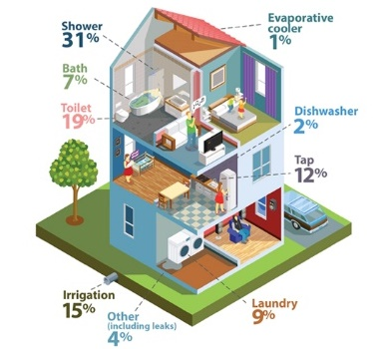
The options examined in this RIS include a base case (do nothing scenario), and three options aimed at increasing uptake of water efficient fixtures.
Figure 5. Typical water use within homes.
Source: Greater Western Water.

RIS options
A range of options were considered to improve the water efficiency of fixtures in areas of the home with high water use and high hot water use: showers, taps and toilets, as shown in Figure 5. These products exist in most homes and many non-residential buildings, need replacement from time to time and are all rated for water efficiency under the national WELS scheme. About 60% of water used in the home is used in the bathroom.
Regulation is the most cost-effective way to increase uptake of water efficient fixtures and, 100% of participants in a recent community survey supported increasing water efficiency requirements for homes.⁵¹ For these reasons, two of the three options examined in this RIS involve updating existing regulatory requirements.
The options, detailed in Table 6, provide opportunities to install more water efficient fixtures or appliances when:
- buildings are constructed (or altered) and when fixtures no longer work or are replaced for other reasons (Options 1 and 2), or
- when a customer is incentivised to replace a functional but inefficient fixture (through rebates or replacement programs) (Option 3).
The rationale for the flow rating requirements is outlined under Rationale for specific WELS ratings and the fixtures targeted, and the rationale for the preferred option is explained in Section 6.1.
Table 6. RIS options.
Option | Description | Requirement
1 | 4-star residential and 4 to 6-star non-residential fixture requirements | Residential  4-star showers, toilets and all taps  Non-residential  4-star showers, toilets and kitchen and laundry sink taps  5-star urinals  6-star bathroom basin taps
2 | 4 to 5-star residential and 4 to 6-star non-residential fixture requirements | Residential  4-star showers, toilets and kitchen and laundry sink taps  5-star bathroom basin taps  Non-residential  4-star showers, toilets and kitchen and laundry sink taps  5-star urinals  6-star bathroom basin taps
3 | Shower replacement program | Voluntary residential program to replace 1, 2 and 3-star showers with 4-star showers.
These options were assessed in two preliminary cost-benefit analysis commissioned by DEECA from ISF. The options drew on available information about opportunities, and consideration of measures being taken in other Australian states and territories (where relevant). This preliminary work allowed DEECA to refine the feasible options down to the three options for analysis in this RIS.

Enhanced water efficient fixture requirements (Options 1 and 2)
Given the advances in water efficient technologies over the past 15 years, there are a range of opportunities associated with enhancing fixture requirements in existing Plumbing Regulations.
As the water efficiency regulatory requirements were primarily designed to optimise water savings without negatively impacting on customer experience, an option that included 4 to 5-star requirements for all residential developments and 4 to 6-star for non-residential developments was examined (Option 2).
A simpler option (Option 1) with the same star ratings for all home fixtures (4-star) was also examined, for which a greater range of taps would be compliant.
Exceptions would be made for existing buildings where the plumbing system is unlikely to function with very low flow devices (see Section 7.3).
These options apply to new buildings, alterations, renovations and where water using fixtures are being replaced in existing buildings because it is much cheaper to build water efficiency into new developments (or when fixtures need replacing or as part of building or product upgrades), than to retrospectively improve water efficiency in fully functional, existing buildings. This approach provides a reasonable and practical intervention, ensuring the large number of new buildings expected to be constructed or upgraded in Victoria in the coming decades are significantly more water efficient.
The impacts of higher fixture efficiency requirements were analysed separately for residential and non-residential buildings prior to preparing this RIS. The results indicated that, while higher net benefits could be expected for residential buildings, both categories of building demonstrated very high net benefits and bill savings. Given these results, coupled with the fact that current efficiency standards apply to all plumbing work in all buildings, both regulatory options apply to all types of buildings.

Shower replacements
Replacing an inefficient shower is a cost-effective and simple way to reduce water and energy use and save money on household bills. Assuming a 10-year life for showers, many of the showers provided through earlier replacement or exchange programs would now be needing replacement or upgrade.
Discounts on water efficient showers are available through the Victorian Energy Upgrades (VEU) program (see Appendix A). Further expansion of the program to include water efficiency audits and offering rebates for washing machines, toilets, taps and showers was considered in the ISF reports prepared for this RIS. Voluntary shower replacements were found to be the most cost effective, therefore rebates to encourage people to replace ineffective showers by expanding state-wide incentives for water-efficient showers are included in this RIS (Option 3).
This option builds on the VEU program, but instead of offering a discount, 4-star showers would be offered and installed at no cost, to replace low efficiency (1, 2 or 3-star) showers in residential buildings, supported by significant funding and promotion.
This option could be extended to non-residential buildings as economic modelling suggests that doing so would deliver similar cost-benefit results. However, this additional scenario was not modelled as part of this project, as the results for the voluntary residential replacements were found to be less favourable than regulatory change, in terms of net benefits to the community.
The Victorian Government has committed to developing a business case to expand state-wide incentives for water-efficient showers under the CGRSWS Action 2.4, which would complement the preferred RIS option. This could include incentives for even more efficient showers (than those examined in this RIS) given that rebates are voluntary.
Yarra Valley Water (YVW) is trialling a replacement program for ultra-efficient 5-star showers (4.5 to 6.0 L/min) which demonstrates significant water savings per household and overall net benefits to the community.

Rationale for specific WELS ratings and the fixtures targeted
Several water authorities across the major capital cities (including Melbourne and Sydney) have deployed four-star products as part of their water efficiency programs and follow up surveys with consumers indicate high customer satisfaction.²⁹

Showers
4-star (6.0 to 7.5 L/min) showers have been selected for the RIS options, as they provide an ideal balance between comfort and water savings (based on findings from other jurisdictions - see Approaches in other jurisdictions). While most showers currently on the Australian market are 3-star, there are 515 4-star and 184 5-star showers currently registered in WELS and 4-star showers are sold by most of Victoria’s larger shower retailers.
An investigation commissioned by DEECA suggests that spray force and distribution are the main factors determining perceived comfort for users of low flow shower roses.³⁰ The Australian Standard test procedures for spray force and distribution for low-flow shower roses are world-leading.
4-star and 5-star showers are tested for spray force and coverage, and customer feedback, while limited, is currently positive. The above mentioned YVW shower replacement program trial showed positive responses about the shower comfort levels, for both 4 and 5-star showers.
4-star showers have been installed in households for over a year via the Victorian Government’s Community Rebates and Community Housing Retrofit Programs and for over five years via the Victorian Government’s VEU program (see Appendix A), with no reported issues associated with plumbers sourcing 4-star showers.

Taps
Results of preliminary industry consultation and the cost-benefit analysis indicate that 5-star bathroom basin taps are the most feasible higher efficiency standard for residential settings (the current requirement is equivalent to 3-star). There is only a small cost margin (increase) associated with moving to 5-star taps from current requirements and there are 5-star taps available that are cheaper than 3-star. There are many 5-star taps available, and many tap sets with 5-star basin and 4-star kitchen and laundry sink tap options.
Lower efficiency (higher flow) standards are proposed for residential kitchen and laundry sink taps (4-star) than for bathroom basin taps (5-star for residential and 6-star for non-residential) in the preferred option (Option 2). These taps are often used to fill something (i.e. the sink, pans or buckets) and a lower flow tap may not result in lower water use and may cause frustration as it will take longer to collect the water required.
There is no change proposed for bath, appliance (i.e. washing machines and dishwashers) and outdoor taps, as here, in most situations, lower flowrates will not save water.
6-star taps are considered suitable for non-residential settings, where many highly efficient taps are already in use and people are less likely to need to wait for hot water at basin sinks because:
- people in an office usually just use cold water at bathroom sinks to wash their hands (rather than, for example, washing faces with warm water)
- non-residential buildings often have hot water recirculation systems (which avoid the need to run cold water through long lengths of pipe prior to receiving hot water).

Toilets
4-star toilets are about $80 more than the lower cost 3-star models and very few issues with their use have been reported to Victorian water corporations. As most people already install 4-star toilets, making it a requirement is likely to help phase lower efficiency toilets out of the market. It is also expected to benefit residents most likely to have cheap, low efficiency product replacements without the power to select the appliance, i.e. renters.
Melbourne’s water corporations and Sydney Water (which installs 4-star toilets and other efficient fixtures in existing homes as part of its Water Fix program) have anecdotally indicated there are very few blockage issues with 4-star toilets, and most blockages are caused by tree roots disturbing or breaking pipes rather than low flows.

Appliances not included
Dishwashers were not included in the RIS options as they were found not to contribute substantial water savings, partly because there is already high use of dishwashers with 4-star rating or higher (90%).
Washing machines were also not included in the RIS options because they are often installed after building inspection, do not need to be installed by a licenced plumber, and are not subject to plumbing or building controls.

Approaches in other jurisdictions

Approaches taken to encourage the use of water efficient fixtures in other Australian jurisdictions were examined in preparation for this RIS. The preferred water efficient fixture option is largely consistent with and has been informed by lessons learnt in other jurisdictions.
Western Australia (WA) has had a water efficiency addition in NCC (Volume 2) since 2008. This requires new Class 1 homes to have 4-star toilets and taps (basin, kitchen and laundry) and a 3-star shower. WA’s Water Corporation has advised that it is not aware of any complaints or issues, such as wastewater pipe blockages, resulting from this policy, even in older suburbs.
Queensland (QLD) also requires 4-star toilets in new houses, townhouses and sole-occupancy units in multi-unit residential buildings.
Sydney Water has been successfully installing 6-star taps for basins, and 4-star (6.0 to 7.5 L/min) showers, in existing homes through its Water Fix program. The only issue reported (anecdotally and in rare cases) is that some customers are concerned about the longer time for hot water to arrive (as it takes longer to discharge the stagnant cold water sitting in the pipe with more water efficient fixtures). However, Sydney Water has advised that most customers, once informed that they were not wasting water, were satisfied with the replacement.
A recent review of the New South Wales (NSW) BASIX (Building Sustainability Index) planning requirements recommended expanding BASIX options to enhance water efficiency outcomes by introducing minimum water efficiency standards for fixtures and appliances. The review found that most people were fulfilling the BASIX water use (% reduction) target by installing a rainwater tank without installing efficient fixtures. However, during prolonged dry periods (such as drought), rainwater tanks may be empty for extended periods.

Eight states in the United States of America have water efficiency requirements for showers, equivalent to or beyond 4-star. Several of these states have had high water efficiency standards in place for many years. Water experts from these locations reported they had no issues regarding 4-star equivalent showers in terms of consumer comfort but that going to lower flow showers (around or below 6 L/min, which is beyond 4-star) does create user comfort issues.

Base case
The base case is the expected future state if no further regulatory or policy changes are made to affect water demand or supply trends. It is against this base case that the estimated costs and benefits of potential options are analysed in this RIS – i.e. this RIS considers the impacts that are incremental to what is likely to happen anyway.
The base case for this study assumes that all existing policy and regulatory settings remain constant into the future and that the policies and programs promoting water efficiency continue at current levels. There are no other programs that will significantly affect water efficient fixture uptake across Victoria.
Under the base case, major augmentation (i.e. new water supplies, such as desalinated water) will be required to meet the growing demands in cities and towns as no new actions are taken to conserve water supplies. The analysis compares the differences in costs associated with the RIS options compared to the costs of major augmentations. This difference is reflected using the Long Run Marginal Cost Value (LRMC) of water savings. The LRMC is an estimate of the saving in long run costs associated with reducing demand for potable water supply (through for example water efficiency). It is an estimate of the value of deferring future supply augmentations on a per megalitre (ML) basis (further detail in Appendix B).

Assessment of options
At a glance
- The analysis of costs and benefits indicate that Option 2: 4 to 5-star residential and 4 to 6-star non-residential fixture requirements has the highest estimated benefit-cost outcomes, water savings (and consequential deferrals and reductions in augmentation investment) as well as being practical to implement.
- The option is expected to have total benefit-cost ratio of 9.0, with a NPV of $926 million over 20 years and save 30 GL per year of water after 20 years.

Assessment of options
The costs and benefits of water efficient fixture options considered in the assessment are shown in Figure 6. There are also some expected costs and benefits which are not quantified, such as additional employment and some environmental benefits from a reduction in environmental costs associated with water supply.
Increase in use of more efficient fixtures
Less potable water used by premises
Less energy used to heat water
Lower water bill for premises
Lower overall water demand, delays need for system augmentation
Reduced energy costs across energy system
Improved environmental outcomes
Increase in up-front costs associated with more efficient fixtures
OR
Cost of providing shower replacements
Costs
Benefits

Figure 6. Expected impacts of more water efficient fixtures.

Premises impacted
The estimated number of residential properties that would install more water efficient fixtures under each of the three options (over and above what would occur in the base case) is shown in Table 7 below.
Table 7. Estimated number of residential premises impacted after 20 years.
Option | Number of dwellings* that improve their water efficiency by option (million) | As a % of total dwellings in Victoria after 20 years
Option 1: 4-star residential and 4 to 6-star non-residential fixture requirements | 2.9 | 74%
Option 2: 4 to 5-star residential and 4 to 6-star non-residential fixture requirements | 2.9 | 74%
Option 3: Shower replacement program | 1.1 | 29%
*Includes premises that are impacted due to alterations.
The premises impacted in Option 1 and 2 includes all new residential and non-residential buildings, plus all buildings that undertake any works that involve replacements (i.e. alterations and retrofits), or merely licenced plumber replacements, of the fixtures targeted.
Non-residential premises weren’t included in Table 7 as only Option 2 affects non-residential buildings and the water demands used in the cost-benefit analysis were based on the number of people in each industry rather than number of buildings (as more information was available on number of people working in a sector than number and size of buildings).
The premises impacted by Option 3 include all the homes that contain showers of efficiency less than 4-stars.
The impacts of these options are expected to begin relatively small, accumulating as the number of building and major alteration projects increase over time.
There is more uncertainty in the number of dwellings affected by the shower replacement program (Option 3) as uptake is uncertain and this may be lower than modelled. Many householders are currently unaware or not prioritising water efficiency as recent years have been wetter than average across most of the state, and other factors such as aesthetics may take priority.
Further, shower replacement programs have been shown to attract participants who would otherwise purchase an efficient shower regardless of the program. DEECA’s evaluation of previous shower rebates, offered during the Millennium Drought, found that half of the recipients would have installed efficient showers regardless of the program.

Costs

Additional costs of more water efficient fixtures
The main estimated cost of changing to a more water efficient fixture in a new development, or upgrade of an existing fixture, is the price margin associated with more efficient products.
Where replacing fixtures in older existing buildings, a plumber will need to assess if the plumbing is incompatible with the efficient fixtures. For example, if the building has a very old instantaneous hot water heater or if the customer commonly experiences very low pressure due to having a gravity fed hot water system. This would typically take less than 5 minutes by asking the householder and/or undertaking an assessment, and additional costs would therefore be minimal. This is expected to occur in less than 3% of situations. For the remainder of situations, the installation cost by plumbers or installers is the same regardless of the efficiency rating.
It is anticipated the Building and Plumbing Commission (BPC), which enforces plumbing regulations in Victoria, will incur small implementation costs to prepare additional guidance for practitioners and industry alerts (via email newsletters) and new practice notes. BPC may also incur additional costs to change the compliance certificate platform, training of BPC staff on new requirements and updates to compliance and enforcement procedures.

Program costs for a shower replacement program
The estimated shower replacement program costs are set out in Table 8 below, which assumes 1.66 showers per household and 1.15 million participating households (after 20 years). These estimated costs are based on data from Yarra Valley Water’s (YVW) current pilot.
Given the assumed life of a shower is ten years and previous programs suggest that uptake wanes after the first few years, this RIS proposes a shower program for 4 years, followed by a 6-year break, then recommence for a further 4-year program.
A shower replacement program is estimated to total approximately $45 million per year for the first 4 years, assuming 953,000 showers are replaced over 4 years, and the program is funded by the Victorian Government or water corporations.
Table 8. Estimated shower program cost (Option 3).
Cost Element | Costs
Shower | $100 / shower  (953,000 showers over 4 years)
Installation | $139.60 / household  (574,000 households over 4 years)
Program management | $1.0M over 4 years
Engagement and marketing | $1.0M per year
Research and monitoring / evaluation | $100k for evaluation every 4 years
Program cost per shower | $189 / shower

Benefits

Water savings
Projected estimated annual water savings at 5 to 30 years are shown in Table 9. The estimated economic benefits of water savings for all options are quantified using the LRMC, explained in Appendix B.
Table 9. Estimated water savings (GL per year).
 | 1: 4-star residential and 4 to 6-star non-residential fixture requirements | 2: 4 to 5-star residential and 4 to 6-star non-residential fixture requirements | 3:Shower replacement program
After 5 years | 8.0 | 9.2 | 4.3
After 10 years | 15.9 | 18.3 | 3.9
After 20 years | 26.2 | 30.1 | 5.4
After 30 years | 31.0 | 35.6 | 6.0
The cumulative water savings across this period are shown in Figure 7.

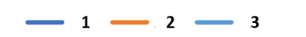
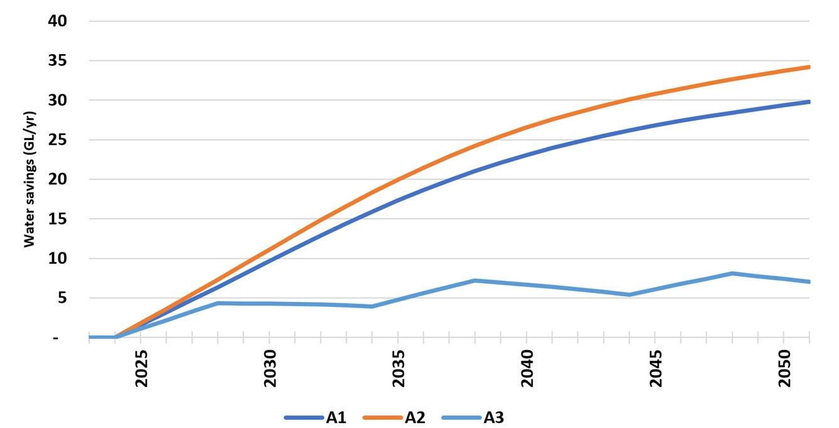
Figure 7. Estimated water savings (GL/year) for each of the options analysed relative to the base case.
For the higher efficiency fixture-based options (Options 1 and 2), total savings generally trend upwards as additional properties are impacted. The water savings for the shower replacement program (Option 3) fluctuate. This reflects the assumption the program will be re-run every 10 years for 4 years, with less water efficient fixtures lost from the overall stock over time as they reach end of life and / or are replaced.
The projected annual water savings per impacted household are in Table 10 below, noting the savings do not change over time.
Table 10. Estimated per household residential water savings (kilolitres (KL) per year and % reduction in use*, per impacted household).
 | 1: 4-star residential and 4 to 6-star non-residential fixture requirements | 2: 4 to 5-star residential and 4 to 6-star non-residential fixture requirements | 3: Shower replacement program
Yearly water savings | 12.9 (~10%) | 14.5 (~11%) | 7 (~5%)
*Based on the assumption that householders in Melbourne use approximately 135 KL/yr (161 Litres per person per day and 2.3 people / household).

Energy savings
Table 11 compares the projected total energy savings for each option. Most energy savings are from avoided water heating, with approximately three quarters of the estimated energy savings coming from reduced natural gas use.
The energy savings incorporate the costs of energy system augmentations, as these costs are reflected in price increases.
The estimated energy savings are conservative because, while less natural gas will be used for heating water as energy systems become electrified into the future, the following benefits have not been quantified:
- energy savings associated with using less manufactured (i.e. desalinated) water
- energy savings associated with moving less potable water around the network.
Furthermore, if energy costs increase as much as forecast in Infrastructure Victoria’s recently released draft 30-year Infrastructure Strategy, which predicts that wholesale energy costs will more than double by 2030, the net benefits and household energy bill savings will much higher than those calculated and outlined in this RIS.

Table 11. Projected energy savings (Terajoules per year, $ million per year in brackets).
 | 1: 4-star residential and 4 to 6-star non-residential fixture requirements | 2: 4 to 5-star residential and 4 to 6-star non-residential fixture requirements | 3: Shower replacement program
after 5 years | 985 ($70 M/yr) | 1,088 ($78 M/yr) | 636 ($45 M/yr)
after 10 years | 1,823 ($161 M/yr) | 2,015 ($177 M/yr) | 539 ($47 M/yr)
after 20 years | 2,571 ($285 M/yr) | 2,842 ($316 M/yr) | 648 ($72 M/yr)

Environmental benefits
Figure 8 shows the cumulative estimated greenhouse gas emission savings resulting from reduced energy use for each option assessed.
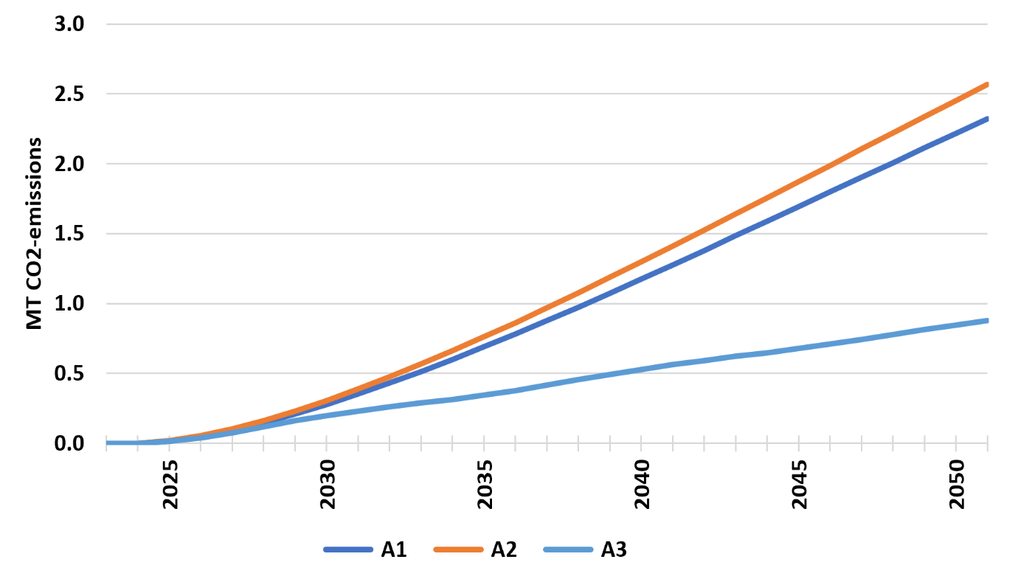
Figure 8. Estimated cumulative greenhouse gas emissions savings (Mega tonnes (MT) CO₂-emissions).

Cost-benefit analysis
The results of the cost-benefit analysis are summarised in Table 12, under a real discount rate of 7%. The ‘Net Present Value’ (NPV) benefit shows the Victoria-wide net present value benefit of each option. The Benefit Cost Ratio (BCR) is the ratio of estimated benefits to costs for the three options. The results show that each of the three RIS options are expected provide net benefits (i.e. the benefits are greater than the costs).
Table 12. Estimated costs and benefits to the State of Victoria for water efficient fixture options ($M, present values over 20 years).
 | 1: 4-star residential and 4 to 6-star non-residential fixture requirements |  | 2: 4 to 5-star residential and 4 to 6-star non-residential fixture requirements | 3: Shower replacement program
Total benefits | 1,934 | 2,166 |  | 747
Water savings | 631 | 726 |  | 218
Energy cost savings | 1,246 | 1,377 |  | 503
Reduced greenhouse gas emissions | 57 | 63 |  | 26
Total costs* | 134 | 240 |  | 216
- Additional costs of fixtures | 132 | 238 |  | -
- Rebate program costs (Option 3 only) | - | - |  | 209
Net benefit (NPV) | 1,800 | 1,926 |  | 530
Benefit-cost ratio | 14.4 | 9.0 |  | 3.5
*Includes $1M for implementing new building or plumbing requirements in options 1 and 2 (including administration, communications, as discussed under Section 5.1 - costs).
The estimated benefit cost ratios for the regulatory options (Options 1 and 2) are significantly higher than the shower replacement program (Option 3). The costs and benefits are also more certain than those estimated for the shower replacement program, which risks low uptake and failing to incentivise enough additional people to install efficient showers beyond those who already do.
Of the two regulatory options, Option 1 is estimated to have a higher benefit cost ratio and is simpler to comply with, as the same water efficiency requirements (4-star) apply to all fixtures in residential buildings. However, Option 2 is the preferred option as it saves more water (30 GL compared to 26 GL after twenty years) and has the greatest net benefits. It also has a very high cost-benefit ratio (9.0).
Appendix C provides a breakdown of net benefits by fixture type which confirms that all components of each option contribute positively to the overall net benefits.
There are also some expected costs and benefits which are not quantified. As previously mentioned, reducing water use through water efficient fixtures reduces the amount of wastewater generated thereby reducing the amount of wastewater needing to be treated and managed, however, this cost saving has not been quantified.
Unquantified costs include the costs incurred on householders or tenants due to using lower flow fixtures, for example, if any sewers become blocked. These costs are expected to be relatively small given that these issues are expected to arise less than 3% of the time. Other unquantified costs include any costs incurred if plumbing product suppliers need to move less efficient products into other states for sale.

Summary of costs and benefits
The costs and benefits of the three options in this RIS are estimated in Table 13 to which unquantified impacts (such as additional employment) are expected to provide further community benefits.
Table 13. Estimated costs and benefits to the state of Victoria, over 20 years (present values).
Option - Water efficient fixtures | Total costs ($M) | Total benefits ($M) | Net benefit (NPV) ($M) | Benefit-cost ratio
Option 1: 4-star residential and 4 to 6-star non-residential fixture requirements | $134 | $1,934 | $1,800 | 14.4
Preferred option:  Option 2: 4 to 5-star residential and 4 to 6-star non-residential fixture requirements | $240 | $2,166 | $1,926 | 9.0
Option 3: Shower replacement program | $216 | $747 | $530 | 3.5
The quantifiable and unquantifiable costs and benefits indicate that Option 2: ‘4 to 5-star residential and 4 to 6-star non-residential fixture requirements’ provides the greatest water savings and net benefits to Victoria. The option is therefore examined in more detail in the following section.

Preferred option
At a glance
The anticipated outcomes from implementing the preferred option, Option 2: ‘4 to 5-star residential and 4 to 6-star non-residential fixture requirements’, include:
- Increased water supply resilience and reliability and reduced need for major augmentations (and associated water price increases).
- Reductions in water and energy bills for both businesses and householders ($136 for a two-bathroom house).
- Water savings (18 GL after 10 years and 30 GL per year after 20 years) and energy savings.
- Significant greenhouse gas emission reductions associated with reducing hot water use (1.8 mega tonnes (MT) over a 20 year period ($0.14 billion), which is equivalent to taking 22,500 cars off the road each year over the same period).
- Costs on property owners and developers due to the cost margins associated with purchasing more water efficient fixtures. For those purchasing the lowest cost fixtures, the additional estimated cost of the fixtures, for a new two-bathroom Class 1 home is $318, less than 0.06% of the total average cost of building the home (excluding the land).

Preferred option
This section provides a more in-depth analysis of the estimated impacts associated with implementing the preferred option (Option 2: 4 to 5-star residential and 4 to 6-star non-residential fixture requirements), including information on distributional impacts. To recap, the preferred option is shown alongside existing requirements in Table 14.
Table 14. Proposed changes to water efficient fixture requirements (maximum flow in brackets).
Existing requirements (in PCA) | Preferred option (Option 2)
Requirements for all plumbing work in all new and existing buildings (residential and non-residential):  - 3-star showers (9.0 L/min)  - 3-star toilets (6.0 L/flush)  - 2-star urinals  Taps  - 3-star kitchen and laundry sinks (9.0 L/min)  - 3-star basin taps (9.0 L/min)  (2019 and 2022 National Construction Code (NCC) | Requirements for all plumbing work in new and existing buildings (residential and non-residential):  - 4-star showers (6.0-7.5 L/min)  - 4-star toilets (4.5 L/flush)  - 5-star urinals*  Taps**  - 4-star kitchen and laundry sink taps (6.0-7.5 L/min)  - 5-star bathroom basin taps for residential buildings (4.5-6.0 L/min)  - 6-star bathroom basin taps for non-residential buildings (4.5 L/min)
* While it is very uncommon for urinals to be installed in homes, the urinal standard applies to both residential and non-residential urinals in Victoria.
**Lower efficiency (higher flow) standards are proposed for the residential kitchen and laundry sink taps, than for bathroom basin taps, as these taps are often used to fill something (i.e. the sink, pans or buckets) and therefore a lower flow tap may not result in lower water use (and may cause frustration as it will take longer to collect the water required). There is no change proposed for bath, appliance (i.e. washing machines and dishwashers) and outdoor tap flow rates, which are currently unregulated.
There might be rare instances where plumbers determine that the water efficient fixtures will not be compatible with plumbing in existing buildings, for example in buildings with very old instantaneous hot water systems. For this reason, there is an option to revert to a less efficient fixture. The efficiency of this less efficient fixture must be equivalent to the highest WELS standard that can function in the building (with the minimum at 3-star as per current requirements), thereby maximising water efficiency benefits that can operate effectively with the existing plumbing system.

Outcomes
The preferred option is expected to have the following (quantifiable) costs and benefits (Table 15), when implemented in isolation, to which unquantified impacts are expected to add further community benefit:
Table 15. Preferred option (2: 4 to 5-star residential and 4 to 6-star non-residential fixture requirements) - estimated costs and benefits, present values over 20 years.
Overall costs and benefits:
Total costs ($M) | $240
Total benefits ($M) | $2,166
NPV ($M) | $1,926
Benefit-cost ratio | 9.0
Water savings (GL/year after 20 years) (included in above costs and benefits) | 30
The preferred option has greater water savings and overall benefits than the other options. By saving 30 GL/year after 20 years across the state, Victoria would experience increased water supply resilience and reliability. The option would reduce the need for desalinated water (and associated water price increases), delaying and reducing the number of major augmentations in the longer term.
The preferred option is practical to implement and has other high quantifiable and unquantifiable benefit-cost outcomes.
The benefits would be enjoyed by property owners and tenants through reduced water bills and energy bills ($132 per year, for a new two-bathroom home). Other benefits of the preferred option include that it would:
    - improve the water efficiency of 2.9 million homes (or 74% of dwellings) over 20 years, reducing impacted household water use by approximately 12% on average (new homes)
    - reduced greenhouse gas emissions CO2 by 1.8 mega tonnes (MT) over a 20 year period ($0.14 billion), which is equivalent to taking 22,500 cars off the road each year over the same period.
Any cost uplift associated with more efficient fixtures would fall mainly on impacted property owners, non-residential tenants paying for building refits and developers and is expected to reduce as more efficient products enter the market. The estimated additional costs associated with more water efficient fixtures ranges depending on model (selected under existing versus proposed regulations), with sometimes no additional cost. See Appendix C for more information.
If purchasing the least expensive fixture models (i.e. the lowest 10th percentile), it is estimated that the additional cost difference associated would be $318 (for a two-bathroom home and separate laundry) initially, reducing to $64 in 20 years’ time. $318 is less than 0.06% of the total cost of building an average new home and is recuperated in bill savings within two years (for reference solar panels are paid back between seven and nine years in Victoria).
However, for larger new ‘volume build’ multi-dwelling developments, most of the costs associated with the proposed water efficiency requirements are expected to be borne by property developers, particularly in the short term. This assumes that in most of these developments, the market rather than the developer would determine the price of the home. Home prices are unlikely to change due to these costs as they are very small in the scale of a home purchase.
For non-residential sectors, the analysis indicates that there is also significant potential for water, energy and greenhouse gas emissions savings in this sector, especially accommodation, office and commercial / retail properties, including food and restaurant facilities.
More detail on the costs and benefits to householders is shown in Section ‎6.6.

Sensitivity analysis
Analysis was undertaken to test the sensitivity of the preferred option to key assumptions.
The assumptions used for sensitivity testing were selected based on the level of uncertainty for these values and the relatively large impacts that are expected on the outcomes.
In summary, the overall costs and benefits of the water efficient fixture options were not highly sensitive to the assumptions used in the economic modelling.
The ranking of the options remains the same under all scenarios as there are similar impacts across the options. Therefore, the following section focuses on sensitivity testing results for the preferred option only.
The preferred option’s CBR remains between 5.7 and 22.1 for all scenarios tested.

Sensitivity analysis results
The sensitivity of the preferred option (Option 2: 4 to 5-star residential and 4 to 6-star non-residential fixture requirements) to the following parameters was analysed (ISF, 2021 and 2022):
    - Alternative discount rates of 4% and 10% (compared to 7%).
    - Alternative water and electricity prices of plus and minus 40% of current values (long run marginal cost of water of $5,083 per ML, electricity at $83.99 per GJ and gas as $54.78 per GJ, carbon value at $71.90 per T CO₂-e).
    - Alternative emissions value of zero and 200% of current prices (greenhouse gas value at $40 per T CO₂-e).
    - Changing the carbon intensity rate (time) to carbon neutrality in the energy sector (28% reduction by 2030 vs 2005) compared to (28% reduction by 2030 and net zero by 2050).
    - Changing fixture price margins (additional cost), and timing of price changes, from margins reducing over time to zero within the first 10 years to remaining at full (current or 100%) price margins for the full CBA period.
Changes to the LRMC (water saving benefit) were not tested because the LRMC has since increased (from $5,083 in 2022 to $5,764 in 2024) and is expected to continue increasing into the future as the costs of augmentations increase.
The results suggest that the preferred option remains extremely economically viable under all scenarios tested, as shown in Table 16.
Table 16. Sensitivity analysis results – Option 2: 4 to 5-star residential and 4 to 6-star non-residential fixture requirements.
Assumption varied | BCR
No sensitivity testing (for comparison) | 9.0
Discount rate of 4% | 10.4
Discount rate of 10% | 7.9
Water prices plus 40% | 10.2
Water prices minus 40% | 7.8
Energy prices plus 40% | 11.3
Energy prices minus 40% | 6.7
Emissions value zero | 8.8
Emissions value 200% of current | 9.3
Price margins (decrease to zero in 10 years) | 22.1
Price margins (remain at 100% full period) | 5.7
The size and longevity of price margins has the largest, and most negative, impact on the BCR. This is because the price margins are the largest cost. However, even if current price margins are maintained at current levels for the entire 20-year period (which is unlikely as the market is expected to adjust to the increased demand for more water efficient fixtures), the BCR for the preferred option remains high, at 5.7.

Impact on competition
The preferred option does not impose a material restriction on competition in any sector. The assessment of the impact on competition considers barriers to entry and exit, conduct restrictions, increases to business costs and possible advantages for some firms over others and is included in Appendix D.

Impact on small business
The preferred option is not expected to have a disproportionately negative impact on small business.
Cost impacts on business would largely be borne by property developers and those responsible for fit-outs of non-residential buildings in the form of minor price margins for more efficient products, mostly:
    - taps in non-residential settings (borne by those funding upgrades and passed on to future purchasers), and those upgrading fixtures in existing buildings
    - taps and showers in new home developments, which are likely to be passed on to house purchasers. The estimated total combined price margins per dwelling is $318.
The loss of sales for less water efficient fixtures might affect specific suppliers, distributors or manufacturers in Victoria. However, most toilets currently installed are already 4-star and most tap manufacturers and retailers sell both efficient and less efficient products (3, 4, 5 and 6-star products) , and could continue to sell less efficient rated products (i.e. 3-star) in other states or overseas.
The biggest impact will be on shower manufacturers as most showers sold in the Australian market are 3-stars, there are however no shower manufacturers in Australia.⁵⁹ While distributors and retailers would need to source 4-star in place of 3-star showers in Victoria, the financial impact of this adjustment is expected to be minimal as 3-star products could still be sold in other states and the plumbing industry advises that there are no shower distributers that operate solely in Victoria.
Across the sector the reduced sale of inefficient products will be offset with increased sales of efficient products, with the same total number of products sold and installed overall, compared to the base case. The overall impact on the market is expected to be minor as other jurisdictions continue to require products with the lower water efficiency standards (higher flow) currently specified in the NCC.

Impacts on householders
Most of the benefits of the preferred option would flow to residential customers in the form of energy and water bill savings. The water efficient fixtures will save affected householders $61 per year in water bills and $132 per year in energy bills.
The key costs are the potential costs to property owners (except in some larger developments when developers may incur the costs) due to the potential cost margin associated with some more efficient fixtures. A breakdown of the estimated impacts on householders is summarised below in Table 17, noting that not everyone will experience a cost difference, those purchasing higher-end products may not experience any cost difference and may in fact benefit from a cost saving (as shown in Figure 7 and explained in Appendix C.
If additional costs are incurred, the maximum difference in costs for householders is expected to be approximately $318, which represents less than 0.06% of the total cost of building an average new home (excluding the land).
Table 17. Estimated householder impacts (2.5 persons) from the preferred water efficient fixture option (costs for fixtures in two bathrooms and toilets plus kitchen and laundry taps, for householders heating water with electricity*)
Option | Upfront costs | Decrease in energy bills  (per year) | Decrease in water bills  (per year) | Total decrease in bills
2: 4 to 5-star residential and 4 to 6-star non-residential fixture requirements | $318  (new two bathroom house)** | $132*** | $61 | $193
*The savings for using gas to heat hot water is $111/year.
**The additional cost is the marginal cost of two showers, two basin taps, a kitchen and a laundry tap.
***Annual costs do not include end-of-life fixture replacements. However, these costs are included in the overall economic analysis, with the assumption that they will occur after the first 10 years but within the 20 year period for analysis.

Implementation and evaluation

Timing
If implemented, the preferred option and associated proposed changes to the Plumbing Regulations are planned to come into effect late 2026 or early 2027, pending timing of approvals.
The requirements would not be retrospective, they would only apply to registered plumbing work undertaken after the new efficiency requirements commence.

Communication
Communications to prepare the industry for these changes would include a dedicated communications plan prepared and implemented by the BPC, in collaboration with DEECA, to support practitioners to understand and implement the new requirements. The BPC currently disseminates information to large numbers of practitioners on changes in requirements via webinars and online guidance, such as fact sheets, practice notes and other technical information.
Industry education on the changes would likely include seminars and/or webinars, and associated guidance material.

Compliance and exemptions

Water Efficient Fixtures
Given that the PCA (Plumbing Code of Australia), already includes minimum standards for taps, toilets and showers, in most situations there would not be any change in compliance requirements and assessments.
A new element is the introduction of an exception to the proposed minimum requirements for plumbing work on existing buildings if:
- the requirement cannot be complied with because of the age, nature or structure of the plumbing system
- or complying with the requirement would impair the effective operation of the plumbing system, water service or rainwater service.
It is assumed that this exception will apply to plumbing systems that are unlikely to function with very low flow devices, in less than 3% of situations. In these situations, a less efficient standard, equivalent to the highest WELS rating that can be used while still enabling the plumbing system to operate effectively and, at a minimum 3-star as per current requirements, would be acceptable. The licenced plumbers installing the fixtures would be responsible for deciding whether the exception applies.
The BPC is responsible for enforcing the Plumbing Regulations. The BPC will, in collaboration with DEECA, provide guidance to plumbers explaining the exceptional and specific situations under which the exception may have application. These are likely to include where fixtures are supplied by:
- Old (made before 2016) instantaneous (continuous) hot water heaters.
- Gravity fed hot-water heaters.

Evaluation
DEECA would be responsible for monitoring the success of the new measures.
The Regulations will be evaluated in 2028 as that is when the Plumbing Regulations are due to sunset.
It is proposed that the impacts of the Regulations be evaluated by analysing data regarding how the regulations operate in practice (see Section 7.5 Data collection below).
The evaluations will:
    - assess whether the Regulations are meeting the objectives to increase water efficiency
    - gather evidence to understand any compliance issues discovered through BPC audits
    - review whether Compliance Certificates are effective in gathering the data needed to monitor the plumbing work that is being undertaken to implement the Regulations
    - assess how these interventions are impacting on water use rates and potable water demand management.

Data collection
Monitoring the functionality and community acceptance of water efficient fixtures will be critical for understanding associated customer experience and improving their contribution to water security. DEECA will work with the water industry and the BPC to monitor the success of the changes. This could include quantifying the water and energy savings, and utility bills reductions, generated by the changes by comparing demand across new and existing developments before and after implementation to help validate and evaluate the impact of the proposed provisions.

Building and Plumbing Commission data
The BPC undertakes audits of a representative percentage of all completed plumbing installations and proactive inspections of active building permits, which involve site visits to active building sites to check compliance. BPC audits provide data on WELS-rated fixtures.
If exemptions to water efficient fixtures are triggered due to technical issues, this would be indicated in the compliance certificate (i.e. the plumber would declare that the higher efficiency product is not suitable for that installation, and that a lower efficiency product was substituted). This provides BPC with visibility of issues, enabling BPC to target audits to validate compliance.
DEECA will continue to work with BPC to understand the outcomes of the audits and inspections and respond appropriately.

Water corporation data
As digital monitoring of water use is rolled out to homes affected by the regulations (expected to occur over the next 10 years in Melbourne) there is potential for water corporations to analyse household water use data to determine the effectiveness of efficient fixtures and / or to determine the ongoing water supply benefits associated.
The impacts of replacing inefficient fixtures in existing homes could be evaluated through water corporation end-use studies, which are surveys of sample households to better understand how water is used and what levels of water efficient fixtures currently exist in homes, undertaken approximately every five years.

Glossary
Term | Meaning
Alteration | A change to an existing building. Includes an addition or extension to a building.
Augmentation | Increasing potable water supplies through infrastructure-related actions.
BCA | Building Code of Australia.
BPE | Best Practice Environmental Management Guidelines for Urban Stormwater.
Class 1 Buildings | Domestic or residential buildings – single, standalone single houses and horizontally attached houses, such as terrace houses, row houses or townhouses and small hostels of less than 300 square metres (as defined in National Construction Code - NCC). For the purposes of this Regulatory Impact Statement, Class 1 Buildings also include any attached garages that share a roof. Enclosed garages are considered as Class 10a buildings in the National Construction Code.
Desalination | The removal of salt and impurities from seawater to produce potable water.
Extension | When rooms are added to an existing building to make it larger.
Carbon | Greenhouse gas.
Gigalitre (GL) | One billion (1,000,000,000) litres.
Industrial and commercial buildings | NCC Class 5,6,7 and 8 buildings including office buildings used for professional and commercial purposes, shops or places for sale of retail goods and the supply of services direct to the public, storage type buildings such as carparks, and warehouses and factories where a process is carried out for trade or gain.
Impervious surface | An ‘impervious surface’ is a surface that does not allow rainfall or stormwater to pass through. Examples include roofs, roads and pavements. Instead of infiltrating into the soil, the stormwater washes off the impervious surface into drains and into waterways, causing pollution and potential flooding.
Integrated Water Management (IWM) | Water management that considers the urban water cycle as a single integrated system, in which all urban water flows are recognised as potential resources. IWM is practised through a collaborative and jointly planned management of all water systems — where all waters are valued and put to use.
Kilolitre (KL) | One thousand (1,000) litres.
Megalitre (ML) | One million (1,000,000) litres.
Millennium Drought | The drought in Victoria that began with low rainfalls in late 1996 and ended in 2010, resulting in the lowest inflows on record into many of Victoria’s catchments.
NPV | Net Present Value.
NCC | National Construction Code.
PCA | Plumbing Code of Australia.
Plumbing Regulations | Regulations for plumbing works made under the Building Act 1993 (Vic).
Potable water | Water of suitable quality for drinking (sometimes referred to as drinking water).
Rainwater | Water that has fallen as rain or has been collected from a roof and stored in a rainwater tank.
RIS | Regulatory Impact Statement.
Renovation | Renovations are performed on existing buildings and usually update, repair or restore the building.
Recycled water | Treated wastewater.
Stormwater | Water run-off from urban areas. Urban development increases run-off because development increases surface areas that are impervious to water, such as roofs and roads.
Surface water | Water found on the surface of the land, in waterways (such as rivers, wetlands and estuaries) and in bodies of water (such as lakes, dams and reservoirs).
BPC | The Building and Plumbing Commission.
Variation | A requirement in the NCC that applies only to Victoria, which deviates from national requirements.
State stormwater planning requirements | A range of developments are required to meet the 1999 Best Practice Environmental Management Guidelines (BPEM) for stormwater in the Victoria Planning Provisions. The BPEM seeks to protect to the health of waterways, estuaries and bays by requiring a reduction in levels of suspended solids, nutrients and litter in stormwater compared to the typical urban annual load. This is usually achieved through the retention and treatment of stormwater at the neighbourhood scale, for example through a constructed wetland and / or through a tank, which captures and uses rainwater before it enters the stormwater system from the site.
Water corporation | A government-owned entity that provides a range of water services to customers in its service area, including water supply; sewage and trade waste disposal and treatment; water delivery for irrigation, domestic and stock purposes; drainage; and salinity mitigation. Some water corporations have regulatory functions for diverting water from waterways and extracting groundwater.
Waterway | A river, its associated estuaries and floodplains (including floodplain wetlands) and non-riverine wetlands.
Waterway health | The overall state of the main features and processes underpinning a functioning waterway ecosystem (such as species and communities, habitat, connectivity, water quality, riparian vegetation, physical form, and ecosystem processes such as nutrient cycling and carbon storage)
WELS star ratings | The national Water Efficiency Labelling and Standards scheme rating, which ranks the water efficiency of fixtures and appliances from 0 to 6 stars. The more stars, the more water efficient the product is.
Wetland | An area, whether natural, modified or artificial, that is subject to permanent or temporary inundation and holds static or very slow-moving water and develops — or has the potential to develop — biota adapted to the aquatic environment. A wetland may be fresh or saline.

Appendix A: Existing interventions to manage water demand
To ease the demand on drinking water supplies, the Victorian Government and water corporations are promoting and investing in water efficiency and greater use of fit-for-purpose recycled water and treated stormwater.
Actions taken by the Victorian Government and initiatives the government is involved in to support water saving include:
    - Victorian Energy Upgrades (VEU) Program. The VEU Program provides discounts for showers to save energy from heating water. The program helps households and businesses reduce energy use and save money by providing discounts on energy saving products, in-home energy assessments and solar power.
    - The Schools Water Efficiency Program (SWEP). The SWEP, which the government funds to provide continuous monitoring of water at schools, reduces water losses from leaks and educates students about efficient water use in schools and at home.
    - The Community Rebates and Community Housing Retrofit Programs. Victorian urban water corporations offer rebates for customers who are vulnerable or experiencing hardship to upgrade and fix water-using fixtures and appliances, and fix leaks, to increase water efficiency. The Community Rebate Program targets low-income and vulnerable water customers by improving the water efficiency of their homes, leading to lower water bills and increased wellbeing. The Community Housing Retrofit Program assists not-for-profit organisations providing housing for individuals or families in a vulnerable or hardship situation.
    - Permanent Water Saving Plans / Rules to ensure common-sense actions for using water around the home are ongoing.
    - Public campaigns in collaboration with water corporations, including Target 155 in Melbourne and Target Your Water Use in regional Victoria.
    - WELS Scheme membership. The WELS scheme was established in 2005 as a national instrument for encouraging more efficient domestic water use and reducing demand for potable water by informing consumers about water efficiency at the point of sale. The WELS scheme requires specified products to be registered and labelled with their water efficiency in accordance with the standard set under the Water Efficiency Labelling and Standards Act 2005 (Commonwealth).
Actions taken by the Victorian Government and initiatives the government is involved in to support greater use of fit-for-purpose recycled water and treated stormwater, that also reduce demand from drinking water supplies, include:
    - Integrated Water Management (IWM) Forums. These IWM forums involve planning to use all available water sources efficiently and manage sewage and stormwater to create more sustainable living urban spaces for communities. Council, land and water management agencies and Traditional Owner groups have been meeting in IWM forums to identify local challenges, and to plan, package and action important projects for their communities.
    - Guidelines for using recycled water. The revised guidelines look to increase community expectations for more sustainable development and has meant an increased interest in treating and recycling sewage or wastewater.
The Victorian Government also has existing policies, in addition to the NCC 2019 variation, that support the installation of rainwater tanks.
Water corporations promote water efficiency through:
    - offering showers and dual flush toilet assistance and trialling shower exchanges
    - delivering behaviour change programs (including behaviour change program trials)
    - rolling out digital metering to both residential and non-residential customers, to help them (and water corporations) identify leaks and better manage their water use
    - working with developers to demonstrate the benefits of water saving technologies. A stand-out example is the Aquarevo development, where new homes will be plumbed with three types of water — drinking, recycled, and rainwater
    - Yarra Valley Water delivers the SWEP program and many water corporations sponsor schools in their areas to participate.
Councils have also demonstrated a strong commitment to water efficiency including initiatives requiring higher levels of water efficiency and uptake of rainwater tanks through use of the planning system and through the Council Alliance for a Sustainable Built Environment.

Appendix B: Long run marginal cost of water
A long run marginal cost (LRMC) is an estimate of the saving in long run costs of the water supply system associated with reducing demand for potable water supply. A benefit of options that rely on water efficiency or alternative water sources (i.e. rainwater tanks, fit-for-purpose recycled water and treated stormwater) is that they lead to a reduction in demand from the existing potable water supply system. This enables future supply augmentations to be delayed, and occur less often, as illustrated in the Figure 9 below.
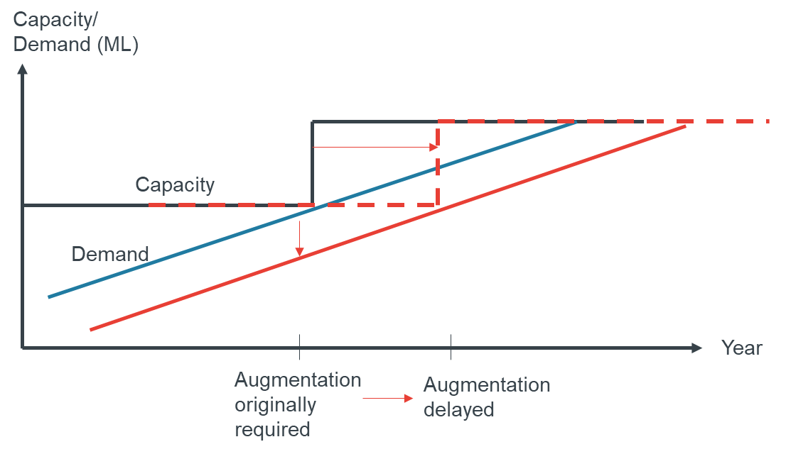
Figure 9. Estimating the long run marginal cost (LRMC).
Source: Frontier Economics 2023.
A LRMC is an estimate of the value of deferring future supply augmentations on a per megalitre (ML) basis. It is calculated as the difference between the NPV of bulk water costs under a reference case and under a scenario where potable water demand is reduced by a fixed amount. This is then divided by the NPV of the demand reduction assumed. The result of this calculation is an average estimate of the long run avoided costs on a per ML basis.
The LRMC estimates $5,083 per ML water saved under the options considered. This value was calculated in 2022 using Melbourne Water’s Bulk Water Cost Calculator (BWCC), assuming a medium demand and medium climate scenario. The BWCC provides an estimate of future water resources costs under different demand and climate scenarios. The BWCC assumes new supply to Melbourne will come from desalination and it progressively adds supply capacity based on demand information and specified augmentation sizes. While this estimate is specific to Melbourne rather than Victoria-wide, this is the best estimate available.
The LRMC has increased since then ($5,734 in 2024) and will likely continue to increase as water augmentation costs rise.

Appendix C: Water efficient fixtures assessment
Fixture requirements assessment
The water efficiency fixture requirements in the preferred option have been selected to provide the greatest water savings benefits to households.
Each of the fixtures were also assessed individually as shown below, for the preferred option, in Table 18. All the individual components of the preferred water efficiency requirements for new or existing developments for the options examined in this RIS have a strong BCR to the whole of society.
Table 18. Individual assessment of tap, toilets, showers and urinals, whole of society costs for Option 2.
 | Fixtures in preferred option  Residential |  |  |  | Additional fixtures  Non-residential
 | Toilets  (4-star) | Showers  (4-star) | Basin Taps  (5-star) | Kitchen & Laundry Sink Taps  (4-star) | Urinals  (5-star) | Basin Taps  (6-star)
PV Benefits ($M) | 26.1 | 1,282.1 | 253.4 | 140.5 | 40.4 | 116.0
PV Costs ($M) | 5.9 | 90.1 | 112.6 | 0.2 | 0.2 | 6.2
NPV benefits ($M) | 20.2 | 1,192.0 | 140.8 | 140.2 | 40.2 | 109.9
Benefit / Cost ratio | 4.4 | 14.2 | 2.3 | 654.5 | 188.4 | 18.8
Price Premium / Margin (lowest 10%) | $108* | $64 | $52 to $95 | $0** | $0*** | $17 to $112
*95% of toilets installed are 4-star WELS rated, thus in most cases price margin for toilets will not apply.
**99.7% of sink taps installed are 4-star WELS rated or higher, thus the price premium for 4-star is not applicable.
***No price premium found across WELS star ratings for urinals.
Cost distribution of fixtures
The following graphs of fixture prices in Figures 10, 11 & 12 show that the cost of the fixtures depends on which model is selected. Toilets are not shown as most toilets on the market are already 4-star.
The red dotted line shows the 10th percentile prices.
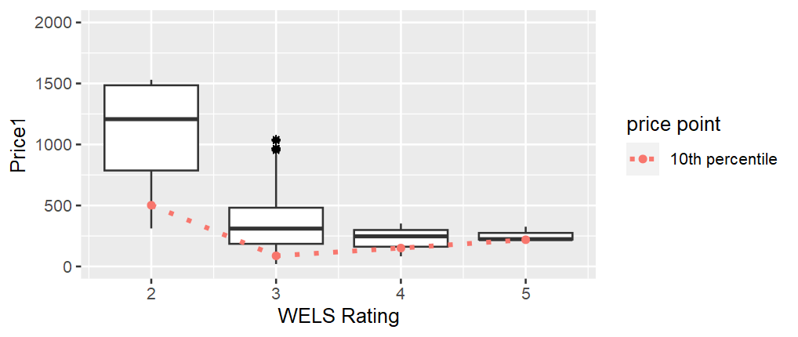
Figure 10. Price distribution of available showers.

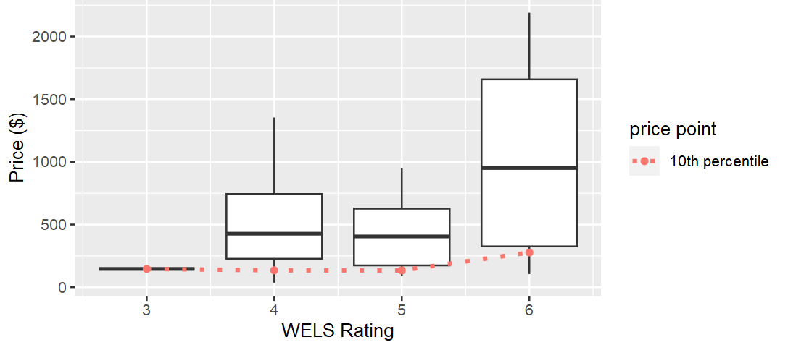
Figure 11. Price distribution of available sink taps.

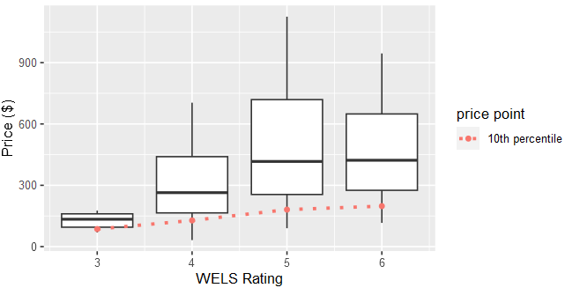
Figure 12. Price distribution of available basin taps.

Appendix D: Competition impact assessment
This Appendix considers whether the preferred option is likely to lead to a material decline in competition in any market. Victoria is party to the Competition Principles Agreement, which requires that any new primary or subordinate legislation should not restrict competition unless it can be demonstrated that the Victorian Government’s objectives can only be achieved by restricting competition and that the benefits of the restriction outweigh the costs. This is the ‘competition test’ to be applied to regulations. The competition assessment does not preclude any option being preferred but requires that any decrease in competition should ensure that the benefits outweigh the costs and that the desired outcomes can only be achieved by affecting competition.
In some cases, regulation can affect competition by preventing or limiting the ability of businesses and individuals to enter and compete within particular markets. The primary cost of a restriction on competition is that it can reduce the incentives for businesses to act in ways that benefit consumers, that can result in lower innovation and productivity, reduced choice of products and / or higher prices.
The types of regulations that may be regarded as affecting competition either directly or indirectly are set out in Table 19.
Table 19. Potential restrictions on competition.
Category of restriction | Examples
Barriers to entry or exit | Governs the entry and exit of firms or individuals into or out of markets  Creates or protects a single buyer or seller  Limits the number of firms that can carry out a particular activity  Restricts who can own or operate a business  Gives existing firms access to information that is not available to new market participants
Conduct restrictions | Controls prices or production levels  Restricts certain activities, for example, advertising  Imposes requirements on product quality  Restricts the quality, quantity or location of goods and services available  Restricts access to inputs used in the production process, for example, infrastructure and employment standards; restricts the price of or type of inputs used in the production process  Limits consumer access to particular goods or services  Restricts advertising and promotional activities
Increase in business costs | Imposes specific levies and / or imposts on a particular industry  Imposes high administrative or compliance costs
Advantage for some firms over others | Imposes requirements on certain firms, but not on competing firms  Sheltering some activities from the pressures of competition  Advantages government businesses over the private sector  Gives one firm access to infrastructure, but not others
Source: Based on Assessment against the Competition Test, guidelines published by the New South Wales Department of Finance, Services and Innovation, 2017, with additional examples from Legislation Impact Assessment Guidelines published by Tasmanian Department of Treasury and Finance December 2016.
Some regulatory arrangements may impose more than one restriction, and some restrictions may fall into more than one category.

Table 20. Does the preferred option restrict competition?
Test question | Assessment
Is the proposed measure likely to affect the market structure of the affected sector(s) – i.e. will it reduce the number of participants in the market, or increase the size of incumbent firms? | No
Will it be more difficult for new firms or individuals to enter the industry after the imposition of the proposed measure? | No
Will the costs / benefits associated with the proposed measure affect some firms or individuals substantially more than others (e.g. small firms, part-time participants in occupations, etc.)? | No
Will the proposed measure restrict the ability of businesses to choose the price, quality, range or location of their products? | Yes
Will the proposed measure lead to higher ongoing costs for new entrants that existing firms do not have to meet? | No
Is the ability or incentive to innovate or develop new products or services likely to be affected by the proposed measure? | No
The preferred option limits choice by mandating minimum efficiency standards on fixtures above what otherwise might be installed in premises. However, this is not expected to have a material reduction in competition in the market for products, as the same overall number of products are expected to be required, although of a higher water efficiency standard.


deeca.vic.gov.au

The WELS Scheme regulates the water efficiency ratings and minimum standards for plumbing fixtures and appliances at point of sale.
High climate change, high water demand growth scenario from 2024 Melbourne Water modelling to DEECA.
Barwon Water Urban Water Strategy 2022.
DELWP (2022), Central and Gippsland Region Sustainable Water Strategy.
Suicide Prevention Australia’s quarterly survey March 2024.
Essential Services Commission (2023), Victorian Energy Market Report: March 2023, p.13.
https://www.rmit.edu.au/news/all-news/2023/may/hidden-energy-poverty
WSAA, 2020, All Options on the Table, https://www.wsaa.asn.au/sites/default/files/publication/download/FINAL%20Urban%20water%20supply%20options%20for%20Australia.pdf
NCC 2019 Volume 2, Building Code of Australia, Solar Heated Water – 6 Star Requirements.
The Victorian Government supported the establishment of 18 IWM forums across the state to enable partnerships with Traditional Owners, water corporations, local government and catchment management authorities. Each IWM forum has a shared vision and identifies local opportunities to increase the use of recycled water, treated stormwater and rainwater to match suitable water supply with the water needs in the forum area. For more information see www.water.vic.gov.au
Melbourne Metropolitan, Appliance Stock and Usage Patterns Survey (ASUPS), 2021 Survey Findings Report.
ISF (2018b), Evaluation of the Environmental and Economic Impacts of the WELS Scheme. Report prepared for: Australian Government Department of Agriculture and Water Resources.
Assumes householder would have installed 4-star toilets regardless (as over 90% of market and WELS registered toilets are 4-star), if not cost increases to $426.
ABS April 2022 data suggests cost of new home (excl. land) is $450,000. HIA has indicated that these costs are now 20% higher (i.e. $540,000).
www.solar.vic.gov.au
For gas storage heating (most common). Three years for heat pumps.
Victoria in Future, 2023
Plan for Victoria 2025, pg. 12.
Based on the target set in https://www.vic.gov.au/housing-statement 2023
Melbourne Metropolitan, Appliance Stock and Usage Patterns Survey (ASUPS), 2021 Survey Findings Report.
Comparing 1913-1996 inflows data with 1997-2020 inflows data, Greater Melbourne Urban Water System Strategy, Figure 12.
Potter NJ, Chiew FHS, Zheng H, Ekström M and Zhang L (2016). Hydroclimate projections for Victoria at 2040 and 2065, CSIRO, Australia.
Barwon Water Urban Water Strategy 2022.
²⁴ DELWP (2022), Central and Gippsland Region Sustainable Water Strategy.
Central and Gippsland Region Sustainable Water Strategy What we heard Report Consultation on the discussion draft Strategy, March 2022.
Suicide Prevention Australia’s quarterly survey March 2024..
Essential Services Commission (2023), Victorian Energy Market Report: March 2023, p.13.
www.rmit.edu.au/news/all-news/2023/may/hidden-energy-poverty
Taking the Pulse of the Nation, Informing Australian economic & social policy. A Melbourne Institute & Roy Morgan partnership, survey media release 2 Feb 2023.
Sustainability Victoria Annual Report 2024.
WSAA, 2020, All Options on the Table, https://www.wsaa.asn.au/sites/default/files/publication/download/FINAL%20Urban%20water%20supply%20options%20for%20Australia.pdf
Greater Western Water data, see Figure 4 Typical water use within homes (source Greater Western Water).
NCC 2019 Volume 2, Building Code of Australia, Solar Heated Water – 6 Star Requirements.
The Victorian Government supported the establishment of 18 IWM forums across the state to enable partnerships with Traditional Owners, water corporations, local government and catchment management authorities. Each IWM forum has a shared vision and identifies local opportunities to increase the use of recycled water, treated stormwater and rainwater to match suitable water supply with the water needs in the forum area. For more information see www.water.vic.gov.au.
The requirements set out in the PCA apply to all plumbing works which includes new and existing residential and non-residential properties and applies across Australia.
A plumber cannot legally install a shower with a flow rate above 9.0 L/min (3-star) but 1 & 2-star showers can no longer be sold.
ESC website, June 2024, article Regulator approves 2024–25 water prices for Victorian water businesses.
Average annual water bills in 2021-22 were $973 in Melbourne and $1,131 in regional Victoria (https://www.esc.vic.gov.au/water/water-prices-tariffs-and-special-drainage/average-household-water-bills-victoria). Electricity bills for a 2-3 person household are approximately $1,290 in Victoria (https://www.momentumenergy.com.au/blog/average-electricity-bill).
Victorian Default Offer 2023-24: Draft Decision – indicates an increase of 31% in 2023.
Northmore Gordon and Energeia (2021), Gas Infrastructure Advice – Cost benefit analysis of energy efficiency activities in the gas sector assets.infrastructurevictoria.com.au/assets/Resources/Cost-Benefit-Analysis-of-Energy-Efficiency-Activities-in-the-Gas-Sector.pdf
S.B White, Institute of Sustainable Futures, C. Howe, Sydney Water Corporation, Water Efficiency and Reuse: A Least Cost Planning Approach.
Botica, R and White, S (1996) 'Kalgoorlie-Boulder: the Water Efficient City', Water, 23, 5,14-17.
Victorian Energy Upgrades Specification Updates for Water Heaters, Prepared for: Department of Environment, Land, Water and Planning. Report by: Sustainable Energy Transformation Pty Ltd With David Ferrari, TPG and EnergyConsult 11 February 2022.
BPC data.
Australian Building Codes Board, Energy Efficiency, https://www.abcb.gov.au/initiatives/energy-efficiency Last accessed 23 November 2021.
2022 Central and Gippsland Sustainable Water Strategy, What We Heard report.
Consultation summary report: Draft Water Cycle Climate Change Adaptation Action Plan 2022.
Department of Treasury and Finance (2011) Victorian Guide to Regulation – Edition 2.1, August, 2011, pp. 8 – 9.
Publication Number: AS/NZS 6400:2016 and 1:2022. Link to Australia Standards site for standard is at: AS/NZS 6400:2016 Amd 2:2022 | Standards Australia
ISF (2021) Cost Benefit Analysis of Increasing Water Efficiency Standards for Fixtures and Appliances, prepared for Department of Environment, Land, Water and Planning, Victoria, June 2021.
Coutts A, Harris R (2013). Urban Heat Island Report: ‘A multi-scale assessment of urban heating in Melbourne during an extreme heat event: policy approaches for adaptation’. Victorian Centre for Climate Change Adaption Research.
Marsden Jacob Associates (2017) Dimensions and costs of urban water demand, shortages and restrictions – Final Draft Report August 2017. Internal document prepared for DELWP.
Data provided by Greater Western Water 2022.
ISF (2021) Cost Benefit Analysis of Increasing Water Efficiency Standards for Fixtures and Appliances, prepared for Department of Environment, Land, Water and Planning, Victoria, June 2021. ISF (2022) Impact of Increased Water Efficiency Standards and Rebates for Fixtures and Appliances for Residential and Non-residential Buildings prepared for Department of Environment, Land, Water and Planning, Victoria, January 2022. Updated by ISF in October 2023: Updated Analysis of the Impact of Increased Water Efficiency Standards and Rebates for Fixtures and Appliances for Residential and Non-residential Buildings in Victoria.
REECE personal communication 2024.
Personal communication November 2021 Simon Frazer, SAI Global.
The sale of inefficient washing machines and dishwashers could be addressed through minimum WELS standards. There are currently 3-star minimum WELS standards for both washing machines (except for small capacity machines) and dishwashers.
BASIX Water Review - Stage 1 Prepared for NSW Department of Planning and Environment by UTS Institute for Sustainable Futures April 2023.
YVW Shower Business Case Model 2021.
Nov 2024, Victoria’s draft 30-year infrastructure strategy 2025-2055, Energy Transition Analysis technical document https://assets.infrastructurevictoria.com.au/assets/Energy-transition-analysis.pdf
In the modelling it is assumed that the additional costs of lower end 5-star (compared to 3-star) taps will decrease with time, and that by 2050 they are no longer higher cost. As the tap price difference decreases over time, the BCR increases.
Assumption based on discussed with Melbourne’s water corporations and Sydney Water (which installs 4-star toilets, taps and showers in existing homes as part of its Water Fix program).
Assumes householder would have installed 4-star toilets regardless (as over 90% of market and WELS registered toilets are 4 star), if not cost increases to $426.
ABS April 2022 data suggests cost of new home (excl. land) is $450,000. HIA has indicated that these costs are now 20% higher (i.e. $540,000).
https://www.solar.vic.gov.au/solar-panel-pv/print-all
For gas storage heating (most common). Three years for heat pumps.
Plumbing Products Industry Group (PPIG) pers. comm. November 2021
ABS April 2022 data suggests cost of new home (excl. land) is $450,000. HIA has indicated that these costs are now 20% higher (i.e. $540,000).
https://www.epa.vic.gov.au/for-community/environmental-information/water/alternative-water-supplies-and-their-use/review-on-the-use-of-recycled-water
Frontier Economics Cost Benefit Analysis of options for onsite rainwater harvesting, Final Report, January 2023.

