Facilities Services BGIS Connect

How to raise a service request
- Open https://apps.bgis.com/BGISConnect.
- Access to this link is available after registration. Please check the BGIS Connect-new user guide and follow the steps to register. Once you have logged in using your VicGov account credentials you will see the landing page below.
- Click Log a Service Request
Note: At any time while using the portal, you can navigate to the Service Request option from the menu on the left side of the page.
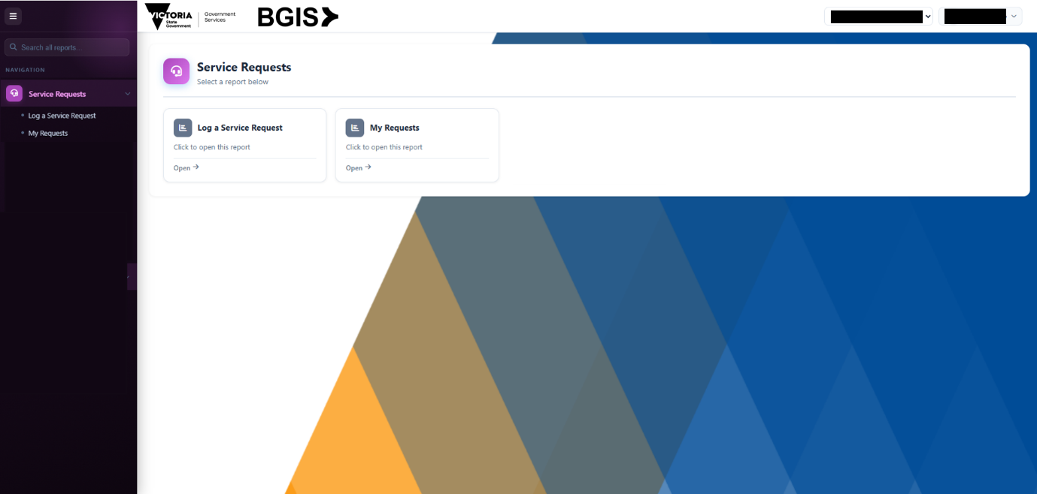

- When the pop-up menu appears, select the appropriate option - Emergency or non-Emergency.

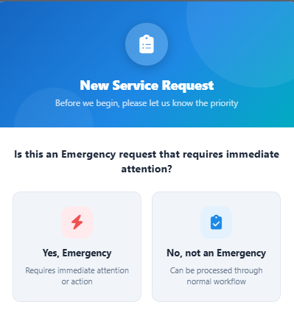
- If you select Emergency, you will see the instructions below

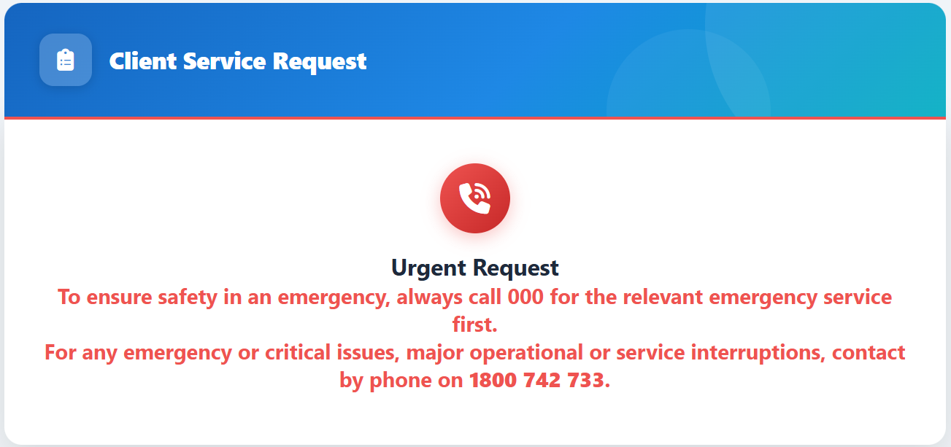
Note – Only non-emergency jobs to be logged via BGIS Connect. Emergency or critical issues should be logged by phone on 1800 742 733.

- If you select non-emergency, the Client service request form will open.
- Complete all mandatory fields marked with an asterisk (*).
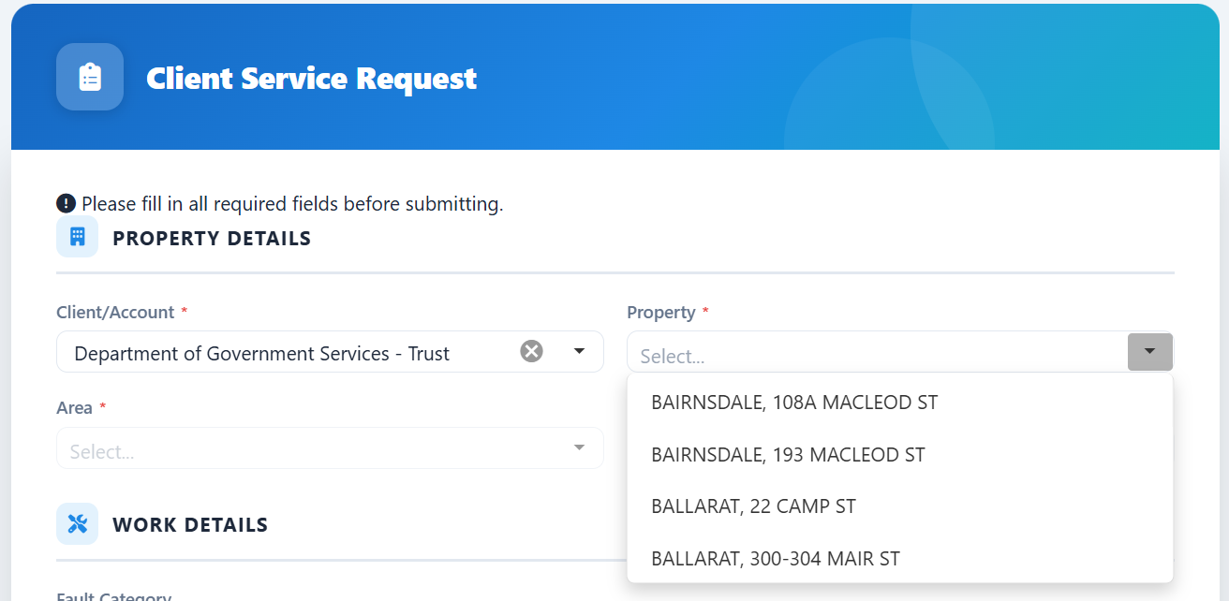
- You can select an option from drop-down menus or type keywords and numbers to filter the list and then select from the results.
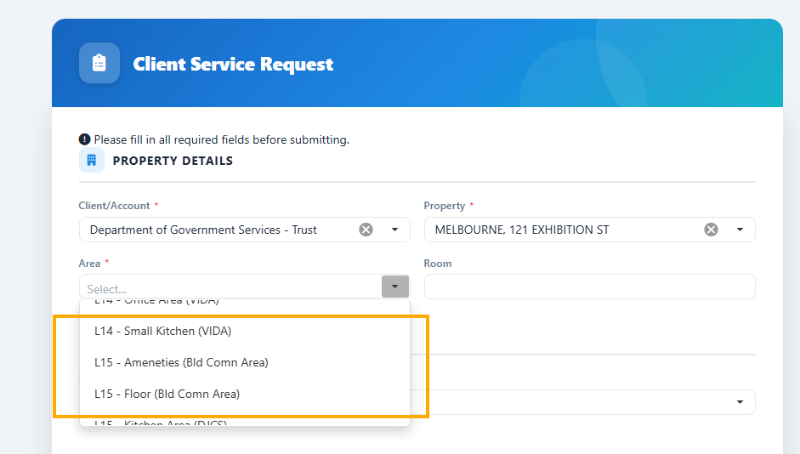
- Select the property and area from the drop-down lists.
- Note: Refer note below Area selection image for guidance on selecting the correct area.
Note: “Comm Area” means common areas that are NOT within the tenancy/premises area such as lift lobby areas, ground floor lobbies, toilets, and end of trip facilities. For example, shared meeting rooms, kitchen areas and collaboration spaces should NOT be selected as “Comm Area”. For these areas, please select the relevant level provide as much detail as possible in the “Room” field to assist with identification of the location.
- Select the most suitable category for the service request from the Fault category drop down menu.
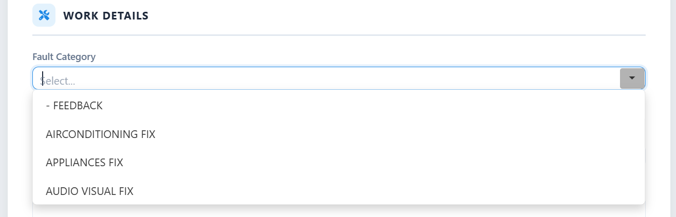
Note: Vertical Transport relates to Lifts.

If your agency requires a reference for invoicing purposes, enter your agency reference into the Reference field. (Optional)
- Enter details of the service request in the Detailed description field. Include as much information as required.
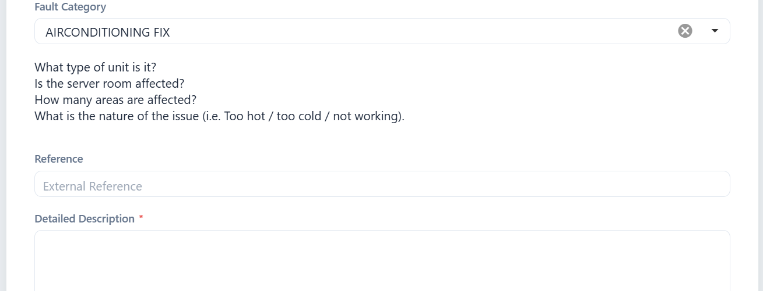
Note: Once a fault category is selected the system will provide you with sample questions to answer (if possible) to include in the Detailed Description field.
- Enter any information needed to arrange site access or provide a site contact into the Site contact / Site access information field.
- Review your contact details as the Service requestor, update if necessary.
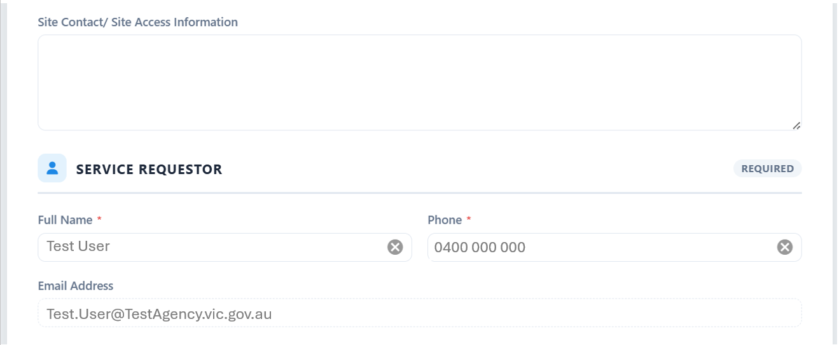

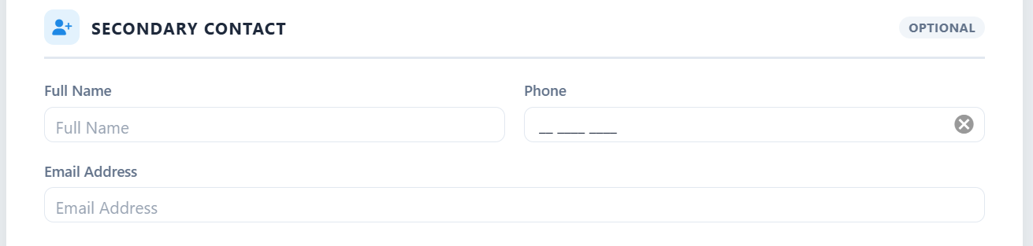
- Enter details of any additional contact for the service request to the Secondary contact fields. Secondary contacts will receive email notifications with the service requestor. (e.g. shared mailboxes)

- You can add a photo relating to the Service Request into the Attachment field. Any images loaded must be JPG or PNG file type and up to 5MB max file size.
- Submit the service request.

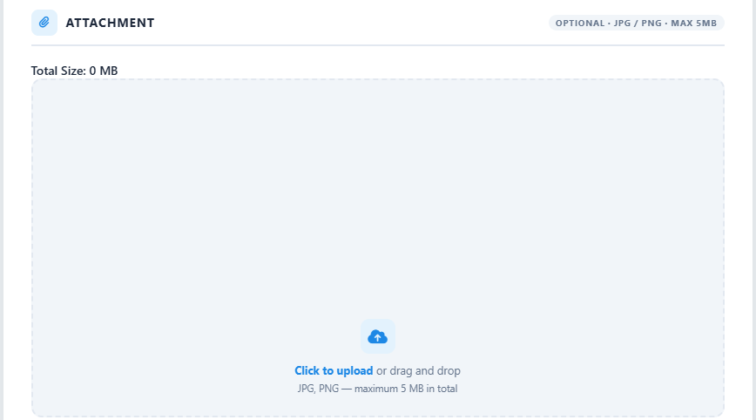

- You will receive a notification that the request has been submitted successfully.
The service requestor and any secondary contacts will receive an email confirming the request has been logged, including a unique service request (SR) number. Further email notifications will be sent as the service request status changes.
Notifications will be received when the request progresses to logged, issued and completed status.
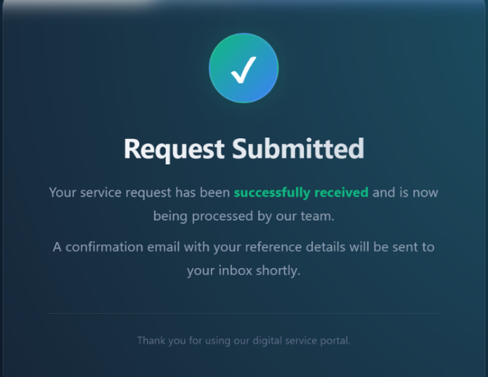

How to check status of service requests logged
After logging one or multiple service requests, you can view your requests and their status in My requests.
All service requests you submit through BGIS Connect or by phone will appear in My requests.
- Select My requests from the left-hand menu or the tile on the landing page.

- The My service requests page will open.
At the top of the page a summary shows the total number of service requests and their status.
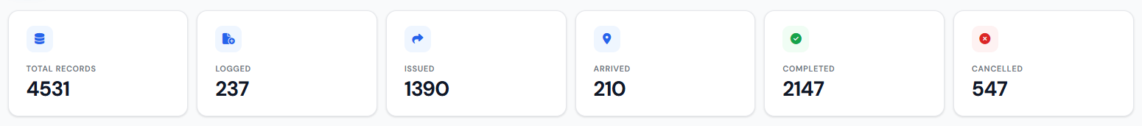

The categories are:
Title | Description
Total Records | the total number of service requests and feedback logged
Logged | service requests and feedback that have been logged but not yet issued
Issued | service requests and feedback that have been issued to a service provider or BGIS team member to action
Arrived | service requests and feedback that have registered arrival on site
Completed | service requests and feedback that have had works completed
Cancelled | service requests and feedback that have been cancelled
- Below the summary is a grid with the details of each service request logged.
You can expand any column to view more detail by hovering over the line between columns and dragging or changing the order of columns by clicking and dragging a column to a different location.
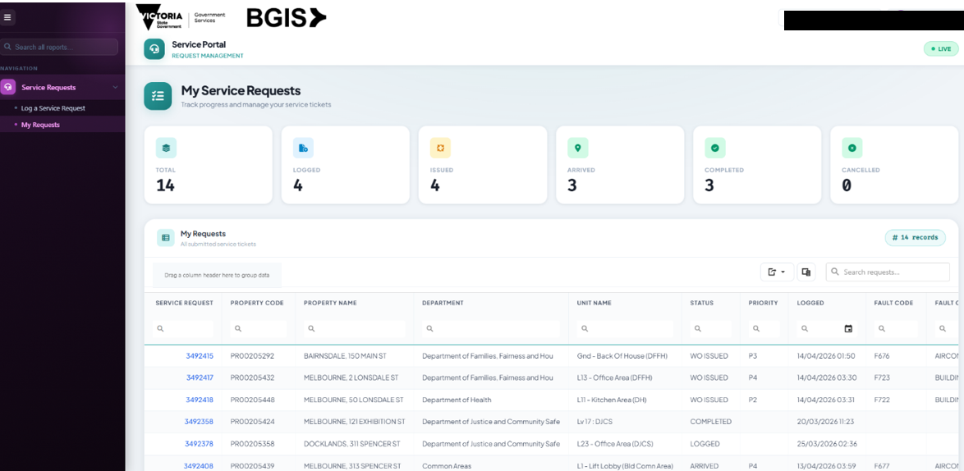

You can search each column by typing keywords or numbers into the field next to the search field at the top of the column or using the calendar icon to search by date.
From clicking on the magnifying glass icon next to the search field, the search criteria can be set using any of the below listed conditions. Different criteria are available for text fields and date fields.

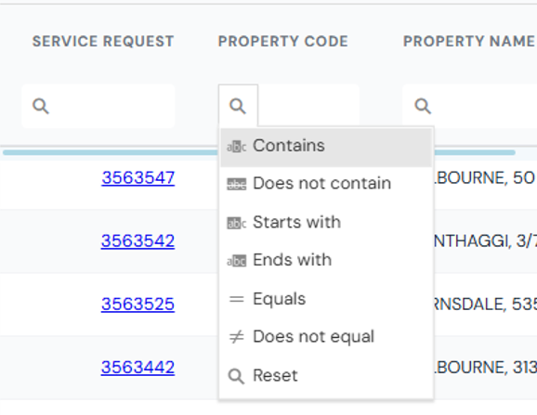
Text fields

Title | Description
Contains | Finds results where the value includes the specified text anywhere within it.
Does not contain | Excludes results where the value includes the specified text.
Starts with | Matches results where the value begins with the specified text.
Ends with | Matches results where the value finishes with the specified text.
Equals | Finds results that exactly match the specified value.
Does not equal | Excludes results that exactly match the specified value.
Reset | Clears all selected search/filter criteria.

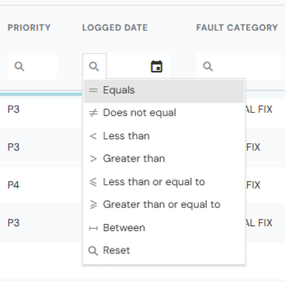
Date fields

Title | Description
Equals | Finds results that exactly match the specified value.
Does not equal | Excludes results that exactly match the specified value.
Less than | Finds values that are smaller than the specified number or value.
Greater than | Finds values that are larger than the specified number or value.
Less than or equal to | Includes values that are either smaller than or exactly equal to the specified value.
Greater than or equal to | Includes values that are either larger than or exactly equal to the specified value.
Reset | Clears all selected search/filter criteria.

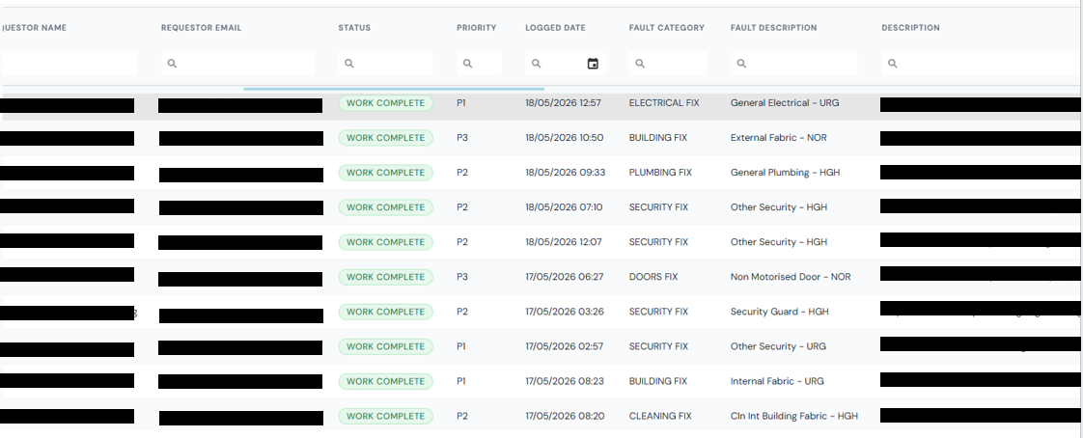

The Service Request grid includes the following information:
Title | Description
Service request | unique reference number for the request
Property code | unique reference code of property the service request was raised for
Property name | name of property the service request was raised for
Department name | name of department/ agency that is occupant of the space that the request relates to
Unit name | name of the area within the property that the request relates to
Requestor name | name of person that logged the service request
Requestor email | email address of person that logged the service request
Status | status of the service request is currently (refer to step 2 for definition of statuses).
Priority | priority level assigned to the service request
Logged date | date and time the service request was logged
Fault category | trade/ service category of the service request
Fault description | trade/ service sub-category of the service request
Description | detail of the service request as entered into the portal or provided by phone
Supplier name | Name of supplier (or landlord/ landlord managing agent) that has been assigned to action the request
Response due date | date and time response is due for the service request
Eta date | planned date/ time for contractor to arrive to commence works
Response date | date and time the contractor arrived to commence work
Completion due date | date and time completion is due for the service request
Work completed | date and time the service request has been completed
Work order cancelled date | date and time the service request was cancelled (if applicable)
Sla response status | status of service request against response service level agreement (SLA) (achieved, not achieved, overdue, not yet due, no SLA)
Sla completion status | status of service request against completion service level agreement (SLA) (achieved, not achieved, overdue, not yet due, no SLA)
Completion code | category of completion of service request (COMP – completed CNCL – cancelled, DECL – declined, DUPL – duplicate, XRSN – reassigned, SRNA – Service request not approved, XCAN – request cancelled, R007 – adjusted, R006 – no action required)

How to view detail of a service request
You can view detail of a specific service request by clicking on the service request number, displayed in blue with underline.
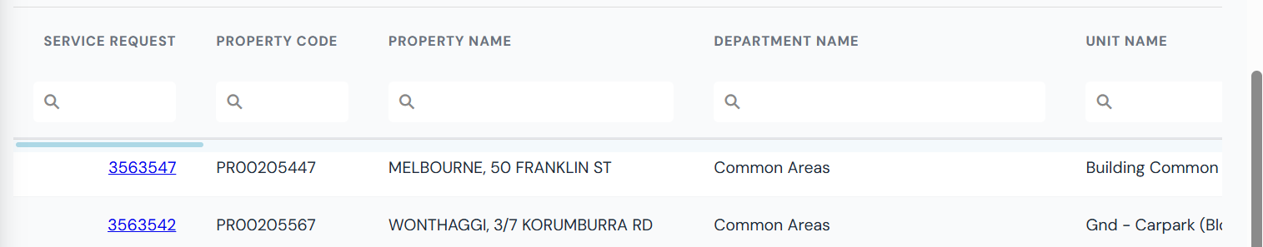

The request detail will load on a new page, allow approximately 15 seconds for the detailed Service Request (SR) page to load.
You can return to the grid of Service Requests at any time by selecting RETURN TO GRID at top left of the page.
- The bar at the top of screen displays the key information about the service request, including:
- Service Request number
- Property Code
- Property Name
- Priority
- Requestor Name
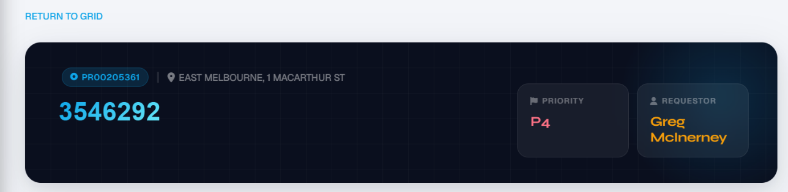

- Request Progress displays the key milestones in the lifecycle of the service request. Except for requests which have been cancelled, the progress milestones presented will be: Logged, Issued, Arrived, Completed. Each milestone that has been achieved to date is displayed with a green tick.
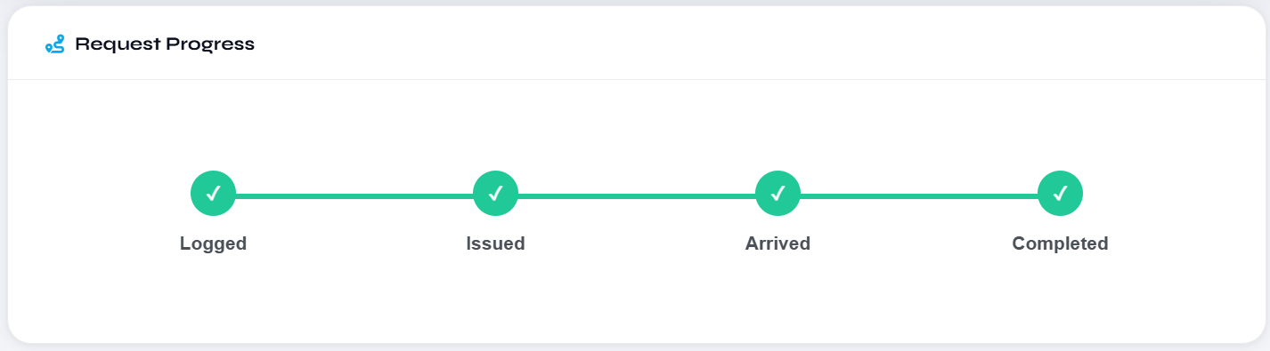

- Property, Department and Area Information displays the location information regarding the service request.
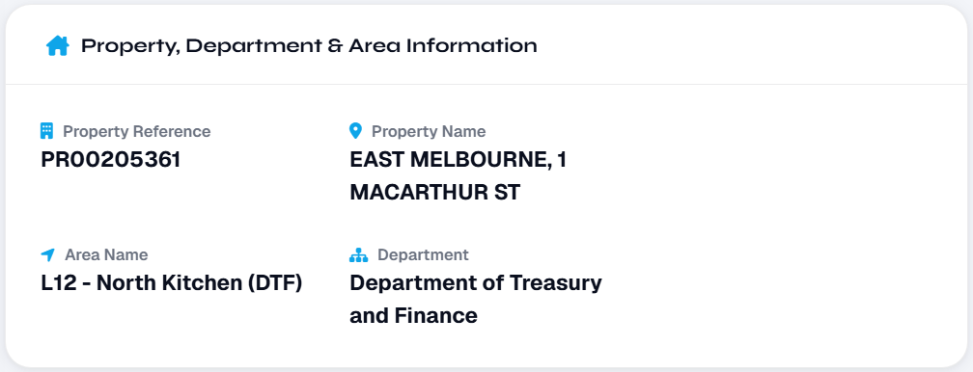

- Service Request Description & Categorisation displays the description and categorisation of the service request.
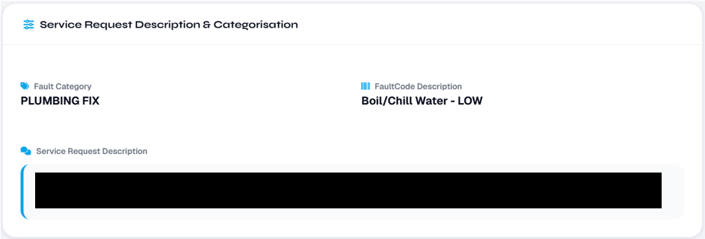

- SLA and Delivery Dates displays the due dates and times for response and completion, per the SLA timeframe associated with the priority level assigned to the request.

Any estimated arrival date and time (ETA) that has been provided for attendance by the contractor will be presented in the Vendor ETA field.
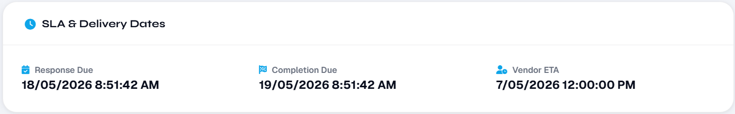

- Activity Log displays the historical progress of the service request, in chronological order, including the requestor that logged the request, the contractor the request has been issued to and the date and time each milestone has been met.

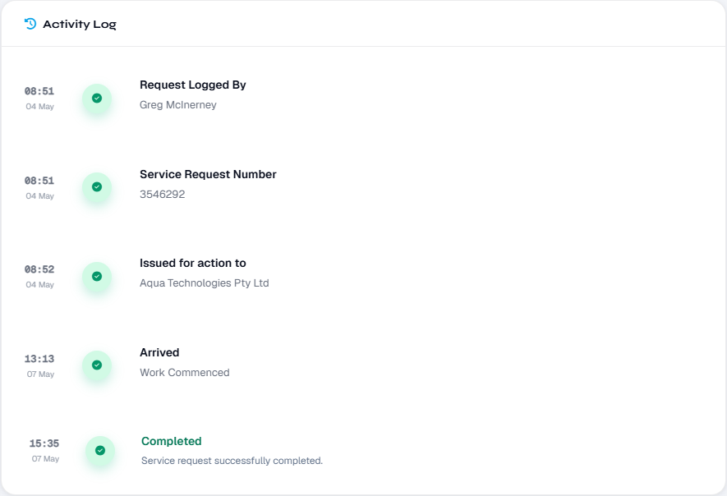

- Service Request Activity Notes displays the notes that have been entered relating to the service request throughout the lifecycle of the request. The notes presented include the date and time of the note and the user that inputted the note.
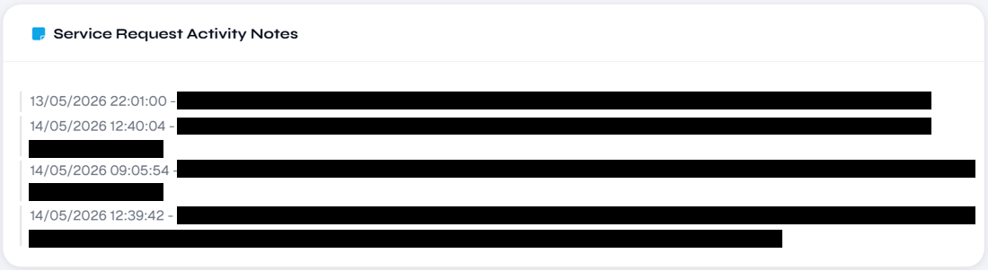

- Completion Notes presents the detail regarding the action performed to complete the request, or other note regarding the closure of the service request. The completion notes are inputted by the contractor or BGIS team member.
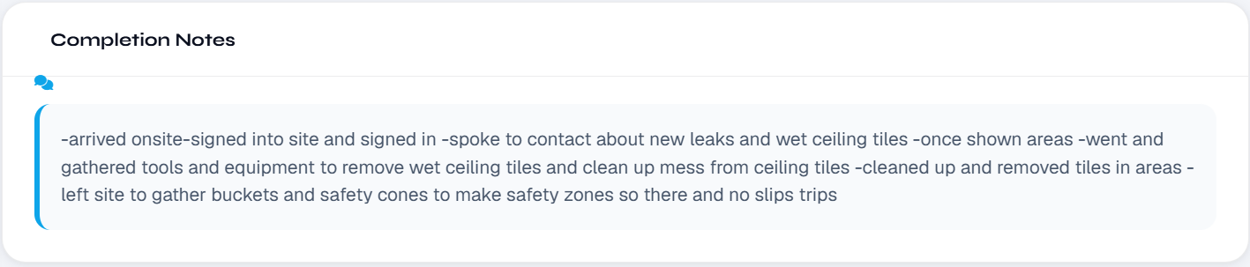

How to request cancellation of a service request
In the Service Request detail page, to the right of the Property, Department & Area Information, is a Quick Actions section. Within Quick Actions is a function to request for cancellation of a service request.
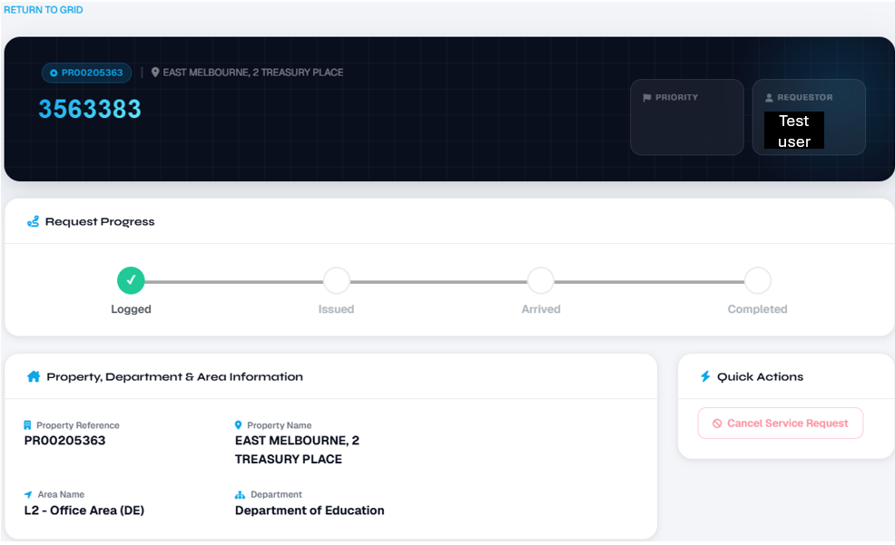

Quick Actions – Cancel Service Request allows for the requestor or other user with access to this function to request for cancellation of the request. Cancellation requests submitted here will be added to the Service Request Activity Notes and trigger a notification to the Helpdesk to action/ respond accordingly.
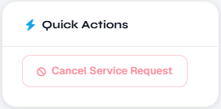

A request to cancel the service request can be logged using this function when the request is still in Logged status. If the request has progressed beyond Logged status (I.e. Issued, Arrived, Completed, Cancelled), please call the Helpdesk to discuss the request for cancellation.

How to add a note to a service request
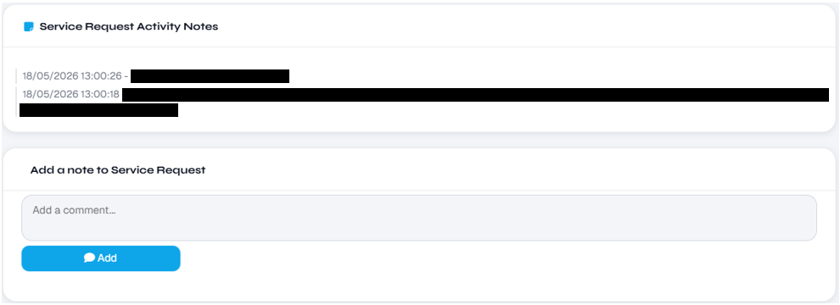
In the Service Request detail page, below the Service Request Activity Notes, is a function to add a note to Service Request.

Add a note to Service Request allows for adding of notes to the service request by the requestor or other user with access to this function. Notes inputted and submitted here will be added to the Service Request Activity Notes and trigger a notification to the Helpdesk to action/ respond accordingly.
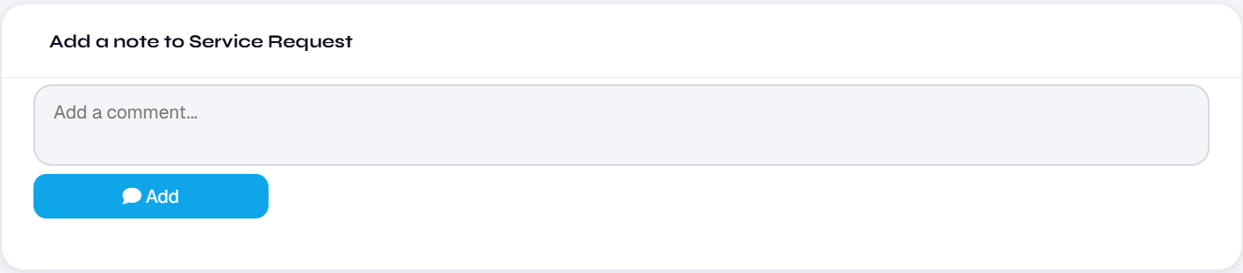

Troubleshooting
If you have any issues with logging a service request or finding the information you need about service requests previously logged, please refer to the BGIS Connect Facilities Services– troubleshooting guide.
You can additionally call the 24/7 Accommodation Services helpdesk on 1800 742 733 (option 1 – facilities requests) instead of using the portal if:
- the issue is of an emergency or critical nature
- BGIS Connect is unavailable
- you need to urgently follow up a request.

