Annual Assurance Review – Breaches of FFMVic planned burn control line 2024-25
Table of Contents

Executive summary 3
Planned burning 3
Introduction 5
Planned burning 5
Planned burn breaches 5
How are planned burn incidents classified? 6
OBRM’s role in planned burn breach assurance 6
Purpose and scope 9
Purpose 9
Scope 9
Planned burn breach investigations 11
Planned burn breach investigations 2024-25 11
Dargo – Wonnangatta Valley Block 2 12
Big River SF – Enoch’s Creek 14
Daylesford – Old Tom Track 15
Tandarra – Thunder Swamp 17
Assurance reviews 20
2024-25 assurance review outcomes 20
Key themes from 2024-25 planned burn breaches 21
Key themes 21
Planning and documentation 21
Policy and communication 22
Resources and equipment 22
Human factors 22
Multi-year trends and insights (2020-25) 24
Planned burning activity over time 25
Multi-year key themes 27
Management Action Plans (MAPs) 30
2024-25 Management Action Plans 30
2022-24 Management Action Plans 31
Case study: Improving risk assessment during burn operation 32
Concluding remarks 33
Publication information 34
Acknowledgement of Victorian Traditional Owners 34
Copyright 34
Creative Commons 34
Disclaimer 34
Accessibility 35

Executive summary

Planned burning
Victoria’s forests, parks and public reserves cover approximately one third of the state. These landscapes hold significant environmental, cultural and community value, but also present a substantial bushfire risk. Victoria is one of the most bushfire‑prone regions in the world, with weather, terrain and vegetation that can result in fast‑moving and destructive bushfires. Effective fuel management, including planned burning, is essential to reducing the likelihood and impact of major bushfires on communities, infrastructure and the natural environment.
Forest Fire Management Victoria (FFMVic) delivers Victoria’s fuel management program on public land. Fuel management, including planned burning is one of the most effective ways to reduce the size and intensity of bushfires, helping to keep communities and environment safer. Planned burning is also used to support land management objectives, enable Traditional Owner cultural burning, improve biodiversity and threatened species outcomes, and help ecosystems adapt to climate change. The risk of not burning is far greater than the risks associated with carrying out burns. Most planned burns are
conducted safely and successfully, with approximately 1 percent of planned burns breaching control lines over the past decade. However, when breaches do occur, they can have consequences on communities, the environment, and public confidence.
Although planned burn breaches are uncommon, it is important they are appropriately investigated to support continuous improvement of Victoria’s planned burning program. The Office of Bushfire Risk Management (OBRM) provides independent oversight of planned burn breaches, a function previously undertaken by the Inspector-General for Emergency Management (IGEM).

This Annual Assurance Review summarises OBRM’s assurance activities relating to
four FFMVic planned burns that breached control lines during the 2024–25 financial year. It outlines what occurred, highlights key themes and lessons identified, and the improvements that are underway to strengthen how planned burning is carried out
in Victoria.

Around 1% of planned burns breach control lines
Planned burn breaches are rare. When they do occur, each incident is investigated and lessons identified. This provides confidence to the community that incidents are reviewed transparently and that improvements support safer planned burning into the future.

Introduction

Planned burning
Planned burning is the controlled use of fire, carried out under specific conditions to a predetermined area, to reduce bushfire risk or support land and resource management objectives.
In Victoria, planned burning is carried out within a legal and policy framework1 that guides how fuel management activities are planned, authorised and delivered on public land. This includes the Code of Practice for Bushfire Management on Public Land 2025, which supports the Secretary to the Department of Energy, Environment and Climate Change (DEECA) to meet its legislative responsibilities relating to the management of fire
on relevant public land in Victoria (being State forests, national parks, and protected public land). Under this framework, and under carefully controlled and monitored conditions, FFMVic delivers planned burns as part of the state’s fuel management program.

Planned burn breaches
While planned burning is one of the most effective ways to reduce the likelihood and intensity of bushfires, it carries some level of risk. If fire moves beyond the planned burn area, or there is concern that it may do so, the incident is assessed and classified as one of three breach categories: minor breakaway or spot over, breach, or bushfire. The category depends on factors such as the potential impacts on people, property or the environment, and the resources needed to control it.

¹ Key legislation includes the Forest Act 1958, Emergency Management Act 2013, Conservation, Forests and Lands Act 1987 and Country Fire Authority Act 1958

How are planned burn incidents classified?
Planned burn incidents are classified into three categories:

- Minor breakaway or spot over: a small fire outside the planned burn area that can be controlled quickly with the resources already on hand
- Breach: fire outside the planned burn area that cannot be readily controlled with the planned resources
- Bushfire: fire outside the planned burn area that presents a higher level of risk, such as a threat to public safety, more serious impacts, or the need for additional firefighting resources

OBRM’s role in planned burn breach assurance
OBRM is responsible for providing independent assurance for planned burns that breach control lines. This role was transferred from IGEM to OBRM to strengthen oversight and support ongoing improvements in how planned burning is carried out in Victoria.

What is assurance?
Assurance means providing confidence to the government and community that systems and processes are working as intended.

OBRM is responsible for ensuring that FFMVic planned burn breaches are appropriately investigated, lessons are identified, and improvements are implemented to reduce future risk. Through this work, OBRM gives confidence to the government and the Victorian community that planned burning remains safe, effective and is continuously improving.
Importantly, assurance is not focused on assessing the actions of individuals, but rather the systems and processes in place to support them.

While OBRM is located within DEECA, it is a separate function to FFMVic. Its assurance function is designed to operate independently to ensure reviews are objective, transparent and focused on learning and improvement.
OBRM’s assurance role includes:

- Leading or overseeing investigations of planned burn breaches, assessing the adequacy of investigation findings and recommendations, and making additional recommendations where needed
- Identifying key themes and system risks, and identifying improvements to processes and systems
- Monitoring progress on improvement actions and reporting publicly on outcomes

- Identifying systemic issues and recommending strategic assurance where patterns or systemic risks are evident, to drive continuous improvement across planned burning
- Supporting FFMVic to continuously improve investigation processes and outputs to ensure efficient delivery and robust reports.

Figure 1 provides an overview of the key stages in OBRM’s assurance process for FFMVic-led investigations, from breach declaration to public reporting.

Figure 1: Overview of OBRM’s assurance process for FFMVic-led investigations
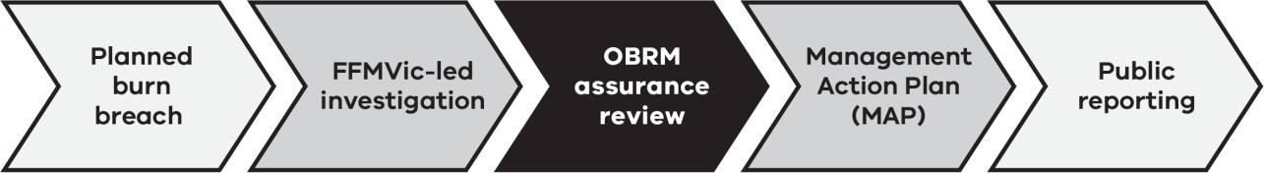

The list below provides an overview of the five key stages in OBRM’s assurance process for FFMVic-led investigations, from breach declaration to public reporting as shown in Figure 1.
- Stage 1: Planned burn breach

- Stage 2: FFMVic-led investigation

- Stage 3: OBRM assurance review

- Stage 4: Management Action Plan (MAP)

- Stage 5: Public reporting

Learn more about the Office of Bushfire Risk Management.

Purpose and scope

Purpose
This review examines planned burn breaches that occurred between 1 July 2024 and 30 June 2025. It outlines what occurred, the key lessons identified, and how those
lessons are implemented to reduce the likelihood and consequences of future breaches.

The review also provides an overview of the assurance function performed by OBRM through independently assessing each investigation, identifying broader contributing
factors and themes, and monitoring whether improvement actions are being implemented.

Through this report, OBRM gives confidence to government and the Victorian community that lessons from breaches are being identified, acted on and monitored, strengthening the safe delivery of the planned burning program. Public reporting supports transparency, builds confidence, and reinforces accountability for how bushfire risk is managed.

Scope
This review provides a summary of FFMVic planned burn breaches that occurred in Victoria during the 2024-25 financial year. It includes:
- FFMVic planned burns that breached control lines during the reporting period

- A summary of planned burn breach investigations, including community impacts and key themes
- OBRM’s independent assurance assessment of each investigation

- A summary of recurring themes in systems and processes that contributed to breaches

- An update on FFMVic’s progress in addressing recommendations from previous years

- If necessary, recommended improvements to support safer and more effective planned burning.
- This review does not assess individual staff performance, firefighting activities following a breach, broader bushfire risk management policy or planned burn breaches from other fire agencies or land managers.

Planned burn breach investigations
For planned burn breaches that are categorised as either a breach or a bushfire, OBRM determines the appropriate investigation approach based on an initial assessment of the incident’s impacts, complexity and risk. For incidents with lower impacts, FFMVic generally leads the investigation, with OBRM providing independent oversight and assurance. For incidents with more significant impacts or complexity, OBRM leads the investigation directly.
Regardless of who leads the investigation, OBRM is responsible for ensuring that each incident is appropriately investigated, that key themes are identified, and that improvement actions support safer planned burning in the future. This risk-based approach ensures the level of investigation is proportionate to the incident while maintaining transparency, independence and a focus on continuous improvement.

Planned burn breach investigations 2024-25
Between 1 July 2024 to 30 June 2025, FFMVic delivered 270 planned burns, treating 92,473 hectares across Victoria. Four burns breached control lines and were declared bushfires, representing 1.5 percent of all planned burns for the financial year. Each
incident varied in scale, context and consequence. Three investigations were led by FFMVic, with OBRM providing oversight and assurance, while one incident was led by OBRM due to its significance and impacts. Table 1 summarises these incidents. The following section summarises each incident, its community impacts and the key themes identified through the investigation.

Table 1: Summary of planned burn breaches in 2024-25

Incident name | Region | Planned burn area (ha) | Breach date | Breach classification | Breach area (ha) | Investigation lead
Dargo – Wonnangatta Valley Block 2 | Gippsland region | 210 | 5 March  2025 | Bushfire | 3,079 | FFMVic
Big River SF – Enoch’s Creek | Hume region | 2,199 | 9 April  2025 | Bushfire | 90 | FFMVic
Daylesford –  Old Tom Track | Grampians region | 200.8 | 11 April  2025 | Bushfire | 96 | OBRM
Tandarra –  Thunder Swamp | Loddon Mallee region | 90.73 | 13 May  2025 | Bushfire | 36 | FFMVic

Dargo – Wonnangatta Valley Block 2

Incident summary
A planned ecological burn was conducted on public land in Alpine National Park as part of Victoria’s fuel management program, with the aim of supporting environmental outcomes through vegetation management in a remote area.
During the burn, changing weather conditions contributed to fire moving beyond the planned area and crossing control lines. Fire crews responded and worked to manage the situation, however due to the remote location, steep terrain and dry conditions, the fire continued to spread beyond the intended perimeter. The incident was subsequently declared a bushfire and was later brought under control and declared safe.

Community impacts
Public warnings were issued through VicEmergency, and temporary road closures were put in place to support community and responder safety. The incident affected areas of public land within the Alpine National Park and required sustained firefighting efforts over an extended period.

Key themes from the investigation

Policy and communication
There are opportunities to improve consistency in how weather information is interpreted and communicated to better support operational decision-making during the burn.
Differences between weather forecast products used during planning and conditions observed on the day influenced operational decision-making, showing the importance of using consistent weather information to support timely and well-informed decisions.

Planning and documentation
Planning and risk documentation did not fully reflect the complexity of the burn. The burn was classified as lower complexity despite factors such as remoteness, difficult access, localised weather influences and a history of previous breaches at the same location.
Contingency planning also underestimated the potential consequences of a breach and did not fully account for the steep terrain, access constraint and available resources.

Resources and equipment
The scale, remoteness and complexity of the location presented challenges in the availability and coordination of resources during the incident. Ground and aerial resources were limited for the level of complexity involved, including delayed aerial support and long turnaround times for water. Planned preparation works were not fully completed, increasing reliance on alternative containment measures that were difficult to support with the available resources.

Crew management and tasking
Concurrent management of another bushfire in the same district created communication and coordination challenges. This affected clarity around roles and information flow, contributing to delays in key decision‑making and escalation.

Environmental and weather conditions
Dry underlying conditions identified during test ignitions were not fully factored into operational decisions or resource deployment. Combined with changing weather, this increased the likelihood of fire spreading beyond the planned area and made suppression more challenging.

Big River SF – Enoch’s Creek

Incident summary
A planned burn was conducted within Big River State Forest as part of Victoria’s fuel management program, with the objective of reducing fuel hazard across a largely remote and steep landscape.
During the days following ignition, fire activity continued within the planned area. Burning material fell down steep terrain and caused a breach. Fire crews monitored and responded to the incident, however challenging terrain and limited access made containment more difficult. The incident was declared a bushfire and was later contained and declared safe.

Community impacts
Community information messages were issued through VicEmergency, and temporary closures of public land were put in place to support safety. The incident affected areas of public land and required ongoing firefighting efforts over an extended period. No private assets were impacted.

Key themes from the investigation

Policy and communication
There were opportunities to improve consistency in the application of procedures during burn delivery, including patrol scheduling, documentation and escalation. Differences

between weather information sources were not fully reconciled, creating uncertainty around conditions and influencing operational decision‑making as the burn progressed.

Planning and documentation
Planning assumptions relied on natural features such as gullies to act as effective barriers to fire spread, without sufficient on-ground verification or fuel moisture testing. Risk and contingency planning did not fully consider the potential for fire to spread into steep terrain or adjacent exclusion areas, and patrol and monitoring requirements were not fully integrated into operations once fire moved beyond initial control points.

Environmental and weather conditions
Dry conditions and increasing fire danger in the days following ignition increased the likelihood of continued fire activity and spread outside the planned boundaries. The level of risk associated with these conditions was underestimated following rainfall, despite broader indicators of ongoing dryness, contributing to fire persisting and gradually moving beyond the planned area.

Resources and equipment
The steep and remote environment limited access for crews and equipment, placing greater reliance on aerial resources for patrol and suppression. Competing operational demands and reduced aircraft availability, including equipment failures, constrained suppression effectiveness once fire spread beyond the planned area.

Daylesford – Old Tom Track

Incident summary
A planned fuel reduction burn was conducted in Hepburn Regional Park as part of Victoria’s fuel management program, with the aim of reducing bushfire risk near local communities.

During the burn, fire behaviour intensified as conditions changed, and fire moved beyond the planned area and crossed control lines. Fire crews responded to manage the situation, however the combination of terrain, vegetation and weather contributed to the fire spreading into adjacent areas. The incident was subsequently declared a bushfire and was later brought under control and declared safe.

Community impacts
The incident caused disruption within the local area, including temporary road closures and community warnings. Emergency information was provided through VicEmergency, and a relief centre was established to support affected residents. A private pine plantation was impacted.

Key themes from the investigation

Policy and communication
There were opportunities to strengthen how systems, processes and guidance supported staff to consistently identify, document and respond to emerging risks during burn delivery. In particular, the most current weather information was not consistently used to inform decisions to proceed, contributing to uncertainty as conditions changed.

Planning and documentation
Risk assessment and mitigation planning could have more fully accounted for the complexity of the terrain, the ignition method used and forecast changes in conditions. The ignition approach involved upslope burning in challenging terrain, which presented additional risk but was not documented with corresponding mitigations. As ignition progressed more slowly than anticipated, sections of the burn were ignited under less favourable forecast conditions, increasing the likelihood of fire escaping the planned area.

Environmental and weather conditions
Dry underlying conditions and longer‑term rainfall deficiencies increased the potential for more intense fire behaviour. A forecast wind change, combined with these dry conditions, contributed to fire behaviour that was more active than anticipated during delivery and increased the likelihood of control lines being breached.

Human factors
Operational pressure associated with delivering multiple burns within limited weather windows influenced decision making and affected the ability to respond to changing conditions. Resourcing pressures, including staff fatigue and changes to key personnel shortly before the burn, reduced continuity between planning and operational delivery and affected the ability to respond as risks increased.
Further information about this incident is available on the OBRM website.

Tandarra – Thunder Swamp

Incident summary
A planned burn was conducted at Thunder Swamp Wildlife Reserve in partnership with a Traditional Owner Corporation, with a primary objective of Traditional Owner land management and a secondary objective of reducing surface fuel hazard.
During ignition, changes in wind conditions and vegetation characteristics influenced fire behaviour. Fire crews attempted to contain the fire, however limitations in on site suppression capacity contributed to fire crossing control lines and entering adjacent private land. The incident was subsequently declared a bushfire and was brought under control later the same day.

Community impacts
The incident affected a small area of adjacent private farmland, resulting in damage to fencing and farm infrastructure. Impacts were contained to the adjoining property, although the incident generated some local community concern and media interest.

Key themes from the investigation

Policy and communication
There were opportunities to improve consistency in the application of systems, processes and administrative requirements during burn delivery. Gaps in documentation and notification processes reduced clarity around roles, responsibilities and escalation,
particularly as conditions changed during ignition and initial response.

Planning and documentation
Contingency planning could be strengthened to better reflect the potential behaviour of grassland fuels and the resource requirements needed for rapid suppression under changing conditions. Planning documentation did not fully account for the additional complexity associated with the vegetation type and collaborative delivery arrangements, nor clearly document escalation triggers or decision‑making responsibilities.

Resources and equipment
Limited onsite suppression capability, including water availability and refilling capacity, reduced the ability to contain the fire quickly once conditions changed. Concurrent burn activity and late changes in key personnel affected the availability of experienced staff and continuity between planning and delivery, which constrained initial response capability in a fast‑moving grassfire environment.

Environmental and weather conditions
Grassland fuels, underlying dryness and elevated drought indicators increased the potential for faster fire spread. Wind conditions further influenced fire behaviour, reducing the effectiveness of initial containment efforts and contributing to the rapid development of the incident.

Assurance reviews
OBRM conducts assurance reviews where FFMVic has led the planned burn breach
investigation. Assurance reviews focus on confirming that investigations have been robust, that key lessons have been identified, and that improvement actions are likely to reduce the risk of future incidents occurring. This helps ensure that learning from planned burn breaches contributes to ongoing improvements in how planned burning is delivered across Victoria.
Insights from individual assurance reviews also inform broader, statewide monitoring and trend analysis, helping OBRM identify common themes and emerging issues over time.

2024-25 assurance review outcomes
During the 2024-25 financial year, OBRM completed assurance reviews for the three
FFMVic-led investigations. OBRM’s assurance reviews found that these investigations had been robust and that the lessons identified supported system-level improvements. For the Daylesford – Old Tom Track incident, OBRM led the investigation, and therefore no assurance review was required. Findings and lessons from that investigation were included in the broader themes identified across all assurance activities in this report (see Section 5).

Table 2: OBRM assurance reviews for 2024-25 planned burn breach investigations

Incident | OBRM Assurance Review
Dargo – Wonnangatta Valley Block 2 | Assurance review completed
Big River SF – Enoch’s Creek | Assurance review completed
Daylesford – Old Tom Track | No assurance review required (OBRM-led investigation)
Tandarra – Thunder Swamp | Assurance review completed

Key themes from 2024-25 planned burn breaches
To better understand why planned burn breaches occur and how future risk can be reduced, OBRM groups findings from each incident into a set of broad themes. These themes help identify patterns across incidents and support consistent learning and improvement over time. Findings from individual investigations are grouped into eight broad themes.
Some themes group together multiple related contributing factors, while other themes are more specific. As a result, themes that appear more often do not necessarily indicate more frequent or more serious issues; rather, they may simply capture a broader range of contributing factors identified across incidents.
Across the four breaches in 2024-25, common themes were identified, highlighting similar contributing factors across incidents, despite the burns varying in size, location and operating conditions. These patterns show that breaches typically result from a combination of factors, rather than a single cause or individual action.

Key themes
While eight themes are used to group findings, a smaller number appeared consistently across incidents. The most common themes identified across the four incidents were:

Planning and documentation
Figure 2 shows that planning and documentation was the most common issue across incidents. In several cases, planning information did not fully reflect local conditions, terrain, or how a fire might behave if conditions changed. This reduced the ability to anticipate and respond quickly when fire behaviour differed from expectations.

Policy and communication
Incidents highlighted opportunities to improve clarity and consistency in how guidance and other documentation was interpreted and used during planning and delivery. For example, ensuring weather information is used and interpreted consistently.

Resources and equipment
Access to resources, equipment reliability and the availability of experienced personnel influenced how effectively fire spread was managed at some incidents, particularly in remote areas or challenging terrain.

Human factors
Workload, delivery pressure, limited weather windows and changes in personnel affected decision-making in some incidents. These factors influenced how contributing factors were identified and managed during planned burn activities.

Figure 2: Key themes triggered across 2024-25 planned burn breaches

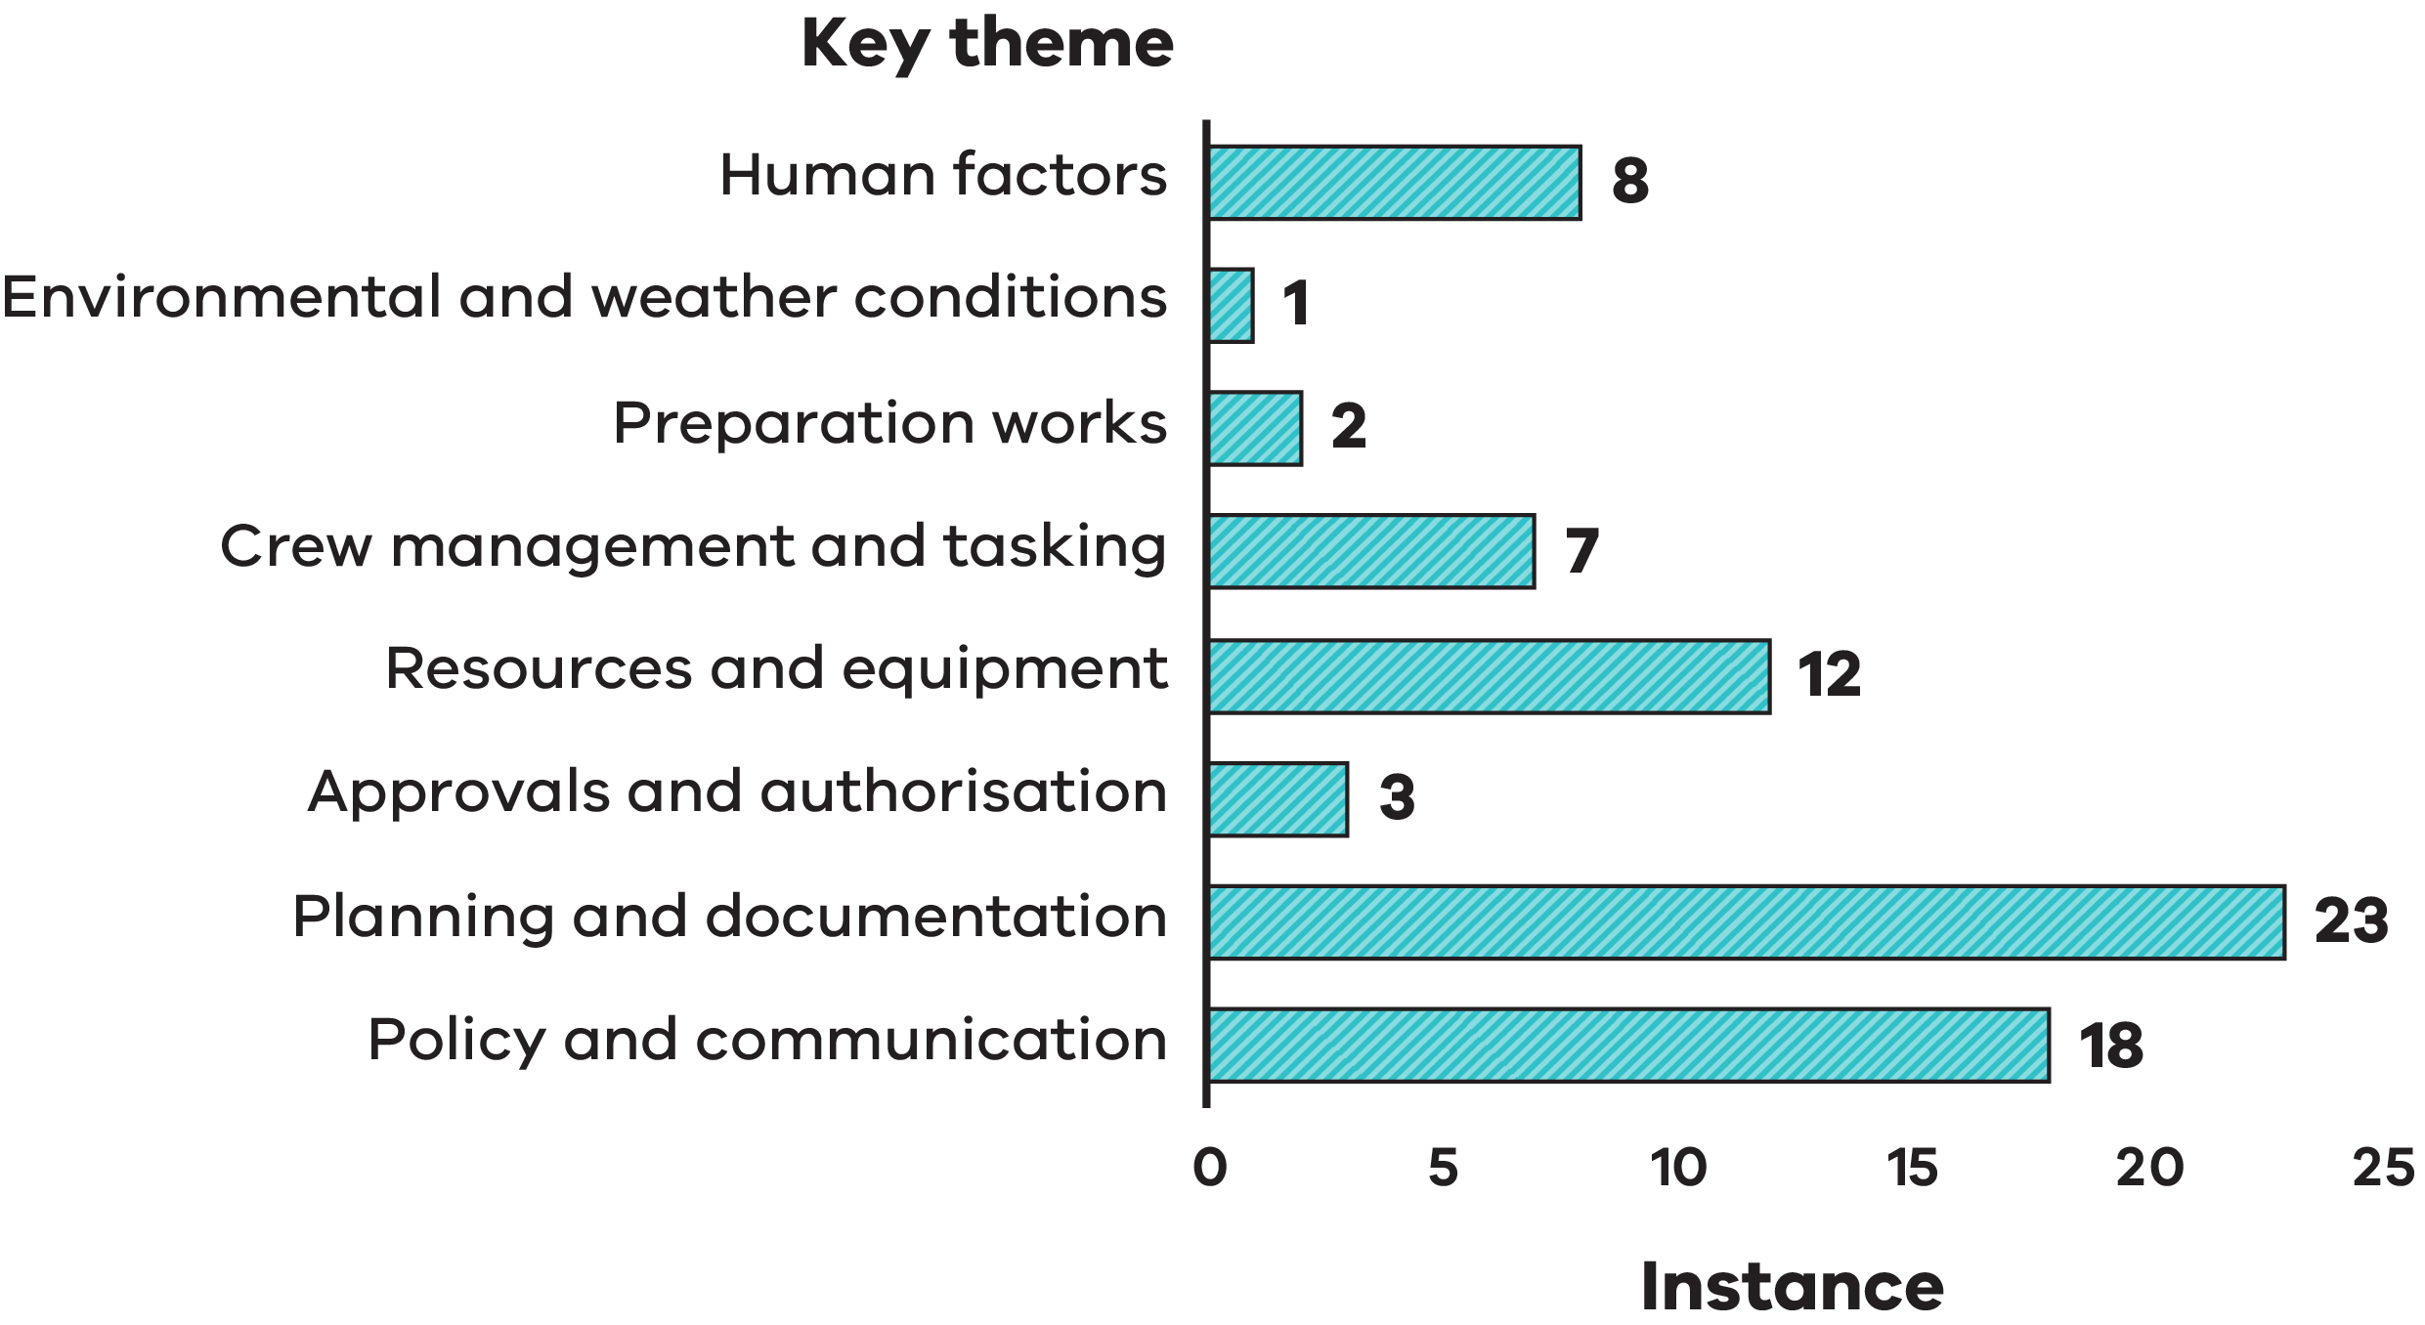

The 8 key themes triggered across 2024-25 planned burn breaches as shown in Figure 2 are listed in the table below:
Key theme | Instance
Human factors | 8
Environmental and weather conditions | 1
Preparation works | 2
Crew management and tasking | 7
Resources and equipment | 12
Approvals and authorisation | 3
Planning and documentation | 23
Policy and communication | 18

Key insight

Breaches typically occur when multiple contributing factors combine, rather than because of a single issue. Environmental and weather conditions such as underlying dryness, wind changes or complex terrain tended to amplify existing challenges rather than act as direct causes on their own. This is consistent with trends observed in previous years (see Section 6) and highlights the importance of a system-wide approach to continuous improvement across the planned burning program.

Multi-year trends and insights (2020-25)
Looking at planned burning outcomes over several years provides important insights into how Victoria’s planned burning program is performing over time and where improvements can have the greatest impact. While the number and size of breaches varies from year to year, the broader trend shows that planned burning has continued to be delivered safely and effectively overall, with breaches representing a small proportion of total planned burns. Figure 3 shows that across five years from 2020 to 2025, on average breaches remain below 1 percent of the total number of burns carried out, indicating that planned burning is generally carried out as intended. This longer-term data also provides useful information on recurring key themes and which improvement areas to focus on.

Figure 3: Planned burn breaches as a percentage of total planned burns from 2020-25
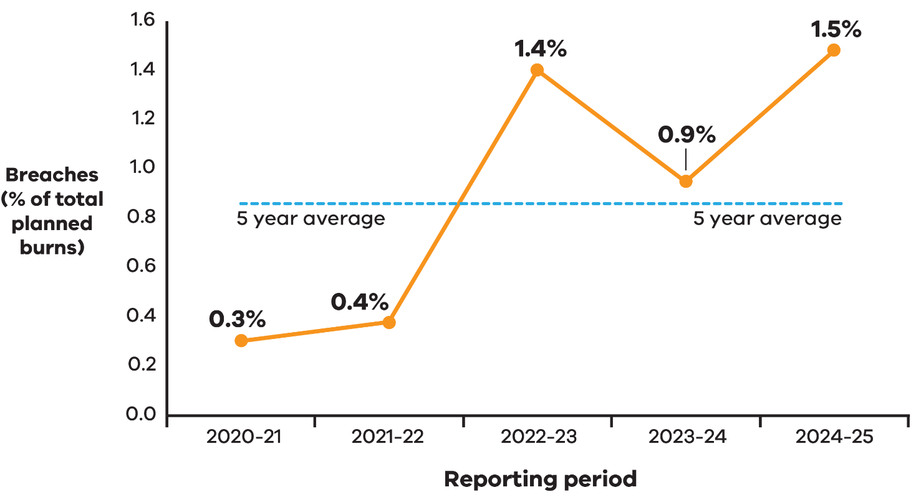

Data shown in Figure 3: Planned burn breaches as a percentage of total planned burns from 2020-25

Reporting period | Planned burn breaches as a percentage of total planned burns
2020 – 2021 | 0.3%
2021 – 2022 | 0.4%
2022 – 2023 | 1.4%
2023 – 2024 | 0.9%
2024 – 2025 | 1.5%

Planned burning activity over time
Over the past five years, Victoria has continued to deliver planned burning across large areas of public land each year. Table 3 summarises five years of planned burn delivery and breach outcomes. Annual planned burning programs have treated approximately 62,000 to 152,000 hectares, while the number of planned burn breaches has remained low, with only one to four incidents per year. While the number of breaches in any given year is small, the size of individual breaches can vary. In 2024-25, one incident in a remote location accounted for most of the total area affected by breaches that year. This highlights that while breaches are uncommon, the environmental consequences and community impacts from individual breaches can differ significantly (see Figure 4). The size of an area affected by a breach does not necessarily reflect the level of impact.

Table 3: Summary of planned burn activity and breaches from 2020-25

Reporting period | Total number of planned burns | Total area of planned burning (ha) | Total number of planned burn breaches/bushfires | Total area of planned burn breaches (ha)
1 July 2020 to  30 June 2021 | 331 | 152,083 | 1 bushfire | 716
1 July 2021 to  30 June 2022 | 264 | 62,260 | 1 bushfire | 82
1 July 2022 to  30 June 2023 | 214 | 75,500 | 3 bushfires | 0*
1 July 2023 to  30 June 2024 | 316 | 122,291 | 2 breaches  1 bushfire | 516
1 July 2024 to  30 June 2025 | 270 | 92,473 | 4 bushfires | 3301

*Note: In 2022-2023, three planned burns were classified as bushfires due to elevated risk, despite no breach of control lines.

Figure 4: Total FFMVic planned burn program area versus total breach area, with breach area shown as a percentage of total burn area from 2020-25.
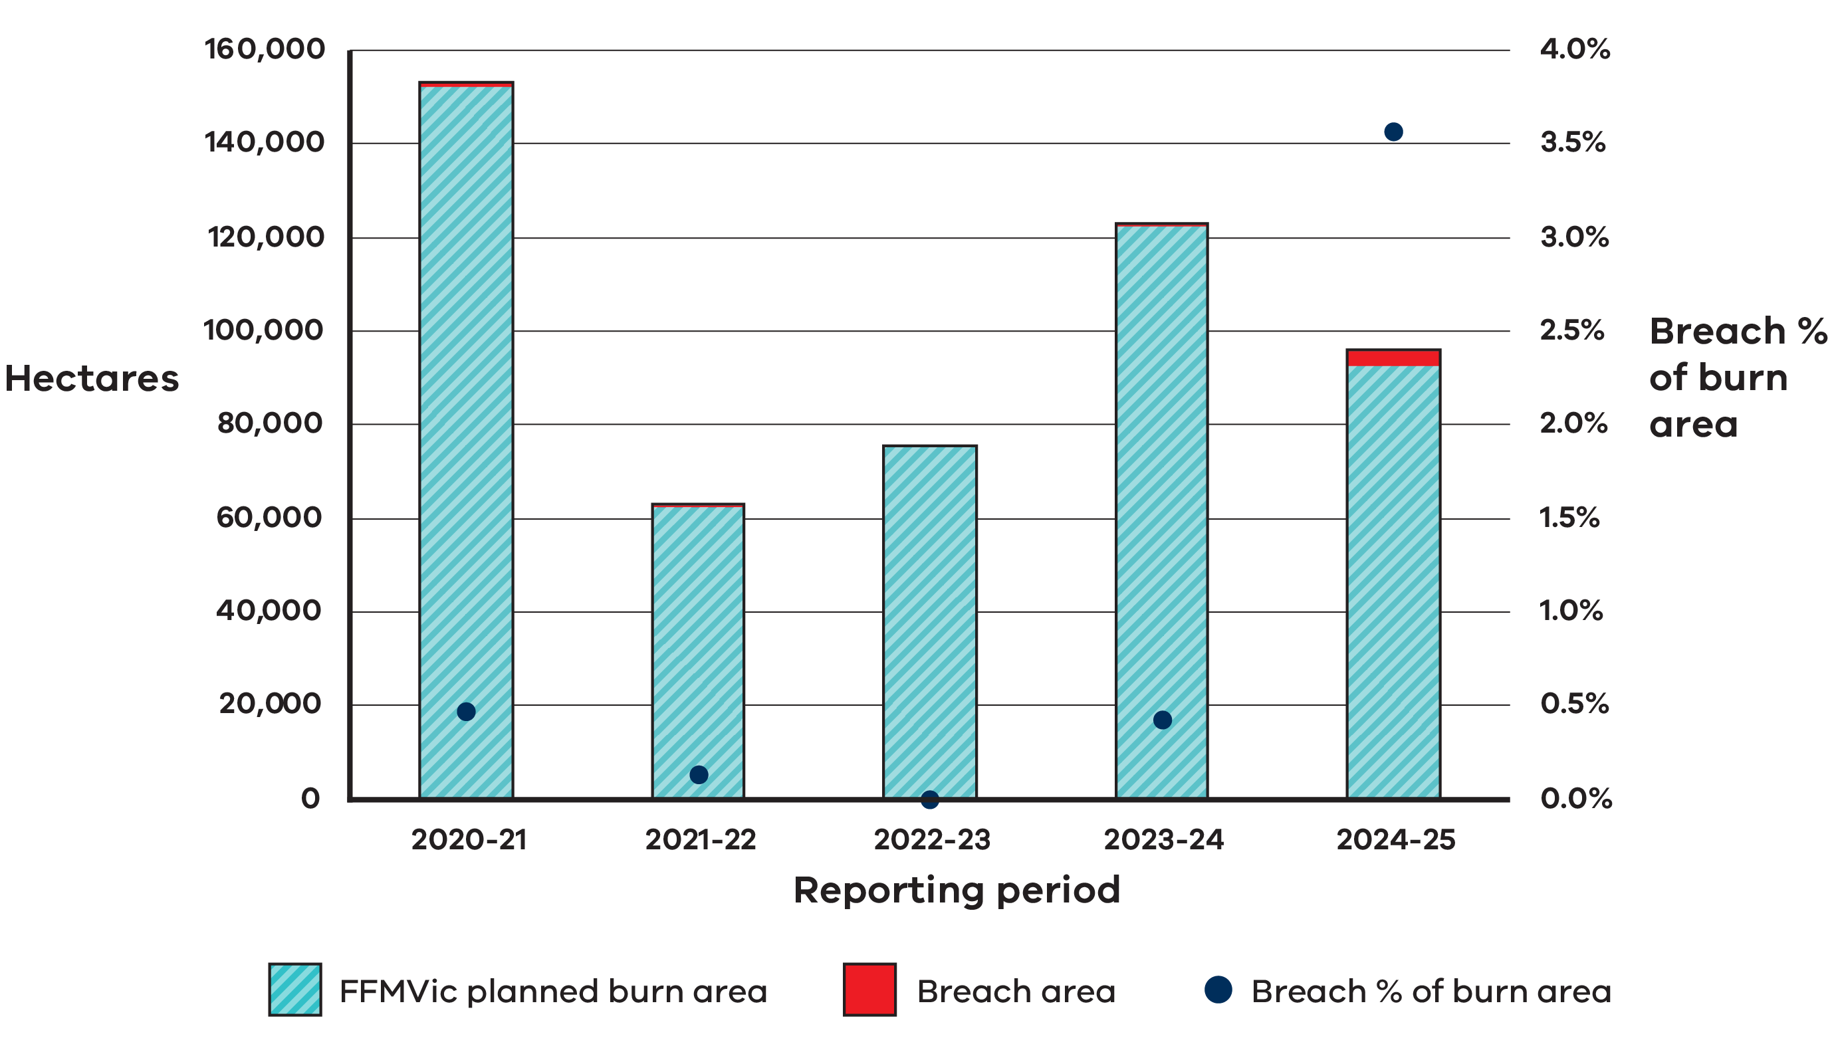

Multi-year key themes
Analysis of investigation findings over time shows that common issues and contributing factors continue to emerge across incidents. Figure 5 shows consistent patterns in the factors that contribute to planned burn breaches across 2020 to 2025. Like the 2024-25 findings, this data indicates that breaches typically occur when several factors combine,
and that no single factor causes a breach. Over the past five years, three themes occurred most frequently across incidents:

Planning and documentation
Ensuring contributing factors, local conditions and contingencies are thoroughly identified and considered during planning remains important.

Policy and communication
Clear guidance and consistent use of information is essential to support decision-making during burn delivery.

Resources and equipment
Ensuring appropriate equipment and resources are available and matched to the level of complexity of a planned burn remains important.

These themes highlight the importance of ongoing improvements that strengthen identification and assessment of contributing factors, improve guidance material, and reduce resourcing pressures across planned burning. Like the 2024-25 patterns in Figure 2, other factors such as environmental conditions, preparation works, and approval and authorisation processes, appear less frequently on their own and tend to amplify existing challenges rather than directly cause breaches.

Figure 5: Key themes identified across 2020-25 planned burn breaches Insights
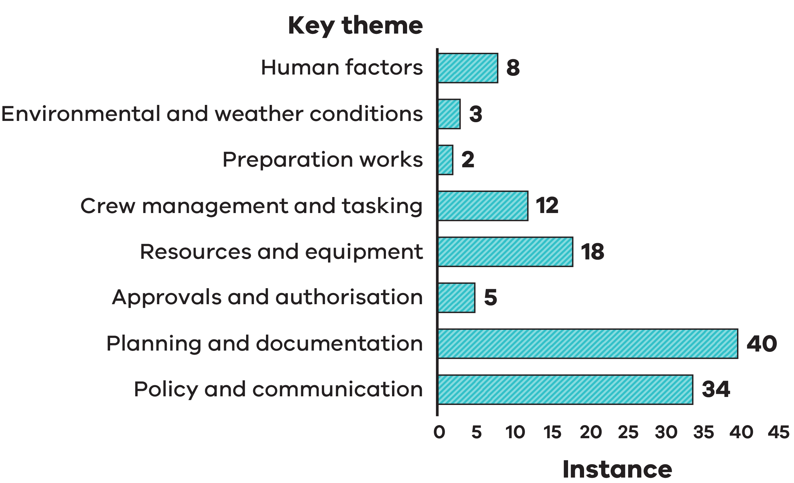

The 8 key themes Key themes identified across 2020-25 planned burn breaches Insights as shown in Figure 5 are listed in the table below:
Key theme | Instance
Human factors | 8
Environmental and weather conditions | 3
Preparation works | 2
Crew management and tasking | 12
Resources and equipment | 18
Approvals and authorisation | 5
Planning and documentation | 40
Policy and communication | 34

The multi-year trends provide confidence that Victoria’s planned burning program is operating safely and effectively overall, whilst also highlighting areas where continued attention can further strengthen outcomes.
Reviewing trends over time helps ensure lessons from individual incidents are not viewed in isolation but instead contribute to broader improvements across planning and delivery. These insights help guide future priorities, ensuring improvement efforts focus on areas where they will make the greatest impact.
While long-term trends provide important context, it is the findings from individual incidents that directly inform specific improvement actions to support a safe and effective planned burn program.

Key insight
Five-year trends show that planned burn breaches remain uncommon, providing confidence in the overall safety and effectiveness of Victoria’s planned burn program. Reviewing outcomes over time helps confirm what is working well and where improvements will have the greatest impact.

Management Action Plans (MAPs)
Following each planned burn breach investigation, FFMVic develops a Management Action Plan (MAP). A MAP documents improvement actions that address the lessons identified and focuses on practical changes that can strengthen how planned burning is planned and delivered. OBRM independently assesses each MAP to confirm it addresses the key issues identified and then monitors progress over time. Actions are only considered complete once there is evidence that the intended change has been put in place. This approach provides transparency about how improvement actions are tracked and delivered, and provides confidence that lessons from incidents lead to meaningful and measurable improvements in planned burning.

2024-25 Management Action Plans
For the four 2024-25 planned burn breaches, OBRM reviewed each MAP and confirmed that the actions appropriately responded to the issues identified in the respective
investigations (Table 4).

The MAPs for these incidents focus on areas such as improving contingency planning,

strengthening the use of weather information, ensuring appropriate resources and capabilities are available, and improving approval and escalation processes. Because these incidents occurred recently, all actions are at an early stage of implementation. OBRM will report publicly on progress in future reviews once actions have had time to be put into practice.
Table 4: OBRM assurance assessment of 2024-25 MAPs

Incident | OBRM MAP Assurance Assessment
Dargo – Wonnangatta Valley Block 2 | Actions deemed adequate
Big River SF – Enoch’s Creek | Actions deemed adequate
Daylesford – Old Tom Track | Actions deemed adequate
Tandarra – Thunder Swamp | Actions deemed adequate

2022-24 Management Action Plans
OBRM also monitors MAPs from previous years planned burn breaches, where improvement actions continue to be progressed and influence how planned burning is carried out. Progress on the implementation of these actions varies depending on the scale and complexity of change required, as well as competing operational demands during busy fire seasons. Implementation monitoring focuses on Management Action Plans from 2022 onwards, as this is the earliest year in which actions remain open and continue to influence current system-level improvements to planned burning. For 2022-23 breaches, most actions have been completed, with only a small number of more complex, system-level changes still in progress or yet to commence. These include upgrading risk assessment processes and improving reporting systems, which require longer timeframes to deliver.
For 2023-24 breaches several actions have been completed, including key procedural updates, clearer guidance on escalation and decision-making, and additional briefings on operational requirements. Several actions remain in progress or are yet to commence, primarily where they involve system upgrades, contingency planning reforms or statewide doctrine updates.
Overall, across the 2022-24 period, OBRM notes that 31 management actions have been completed, 17 remain in progress, and 8 are yet to commence. The number of actions still in progress reflects the scale, complexity and interdependencies required to implement longer-term system improvements. OBRM will continue to monitor all remaining actions and report on progress.

Case study: Improving risk assessment during burn operation
Identified issue: Planned burn breach investigations identified that when planned burn approaches changed during operations, the associated changes in risk were not always reassessed or documented. This has the potential of creating gaps in identifying and managing emerging risks.
Associated management action: To address this issue, guidance for conducting planned burns was updated, so that when an ignition plan or delivery approach changes, the risks and mitigations must be reassessed and documented, and the changes from the initial approved delivery plan clearly recorded.
This helps ensure that emerging risks are identified and managed consistently during operations

Concluding remarks
Planned burning remains an important tool for reducing bushfire risk across Victoria. While breaches represent a small proportion of all planned burns conducted each year, the four breaches that occurred in 2024-25 provide valuable insights into how the program can continue to improve.
OBRM’s independent assurance role provides confidence that planned burn breach investigations are appropriately reviewed and that the improvement actions identified
address the key themes seen this year and in previous years. Strengthening planning and documentation, clarifying guidance and approval processes, improving the use of weather information, and ensuring appropriate resourcing will support safer, more consistent and effective planned burning.
These findings help ensure that planned burning continues to reduce bushfire risk while minimising impacts on communities and the environment. OBRM will continue to report publicly on progress so Victorians can see how lessons are being learned and embedded across the planned burning program.

Publication information

Acknowledgement of Victorian Traditional Owners
We acknowledge and respect Victorian Traditional Owners as the original custodians of Victoria’s land and waters, their unique ability to care for Country and deep spiritual connection to it.
We honour Elders past and present whose knowledge and wisdom has ensured the continuation of culture and traditional practices.
DEECA is committed to genuinely partnering with Victorian Traditional Owners and Victoria’s Aboriginal community to progress their aspirations.

Copyright
© The State of Victoria Department of Energy, Environment and Climate Action, June 2026.

Creative Commons
This work is licensed under a Creative Commons Attribution 4.0 International licence, visit the Creative Commons website (http://creativecommons.org/licenses/by/4.0/).
You are free to re-use the work under that licence, on the condition that you credit the State of Victoria as author. The licence does not apply to any images, photographs or branding, including the Victorian Coat of Arms, and the Victorian Government and Department logos.
ISBN 978-1-76176-900-9 (pdf/online/MS word)

Disclaimer
This publication may be of assistance to you but the State of Victoria and its employees do not guarantee that the publication is without flaw of any kind or is wholly appropriate for your particular purposes and therefore disclaims all liability for any error, loss or other consequence which may arise from you relying on any information in this publication.

Accessibility
To receive this document in an alternative format, phone the Customer Service Centre on 136 186, email customer.service@delwp.vic.gov.au, or contact National Relay Service on
133 677 or visit http://www.accesshub.gov.au/. Available at DEECA website
(www.deeca.vic.gov.au).

End of document.

