Primary prevention of family and gender-based violence capability framework
Accessible
OFFICIAL


Contact us to receive this document in another format. Please email freefromviolence@dffh.vic.gov.au
Authorised and published by the Victorian Government, 1 Treasury Place, Melbourne.
© State of Victoria, Australia, Department of Families, Fairness and Housing, June 2026.

With the exception of any images, photographs or branding (including, but not limited to the Victorian Coat of Arms, the Victorian Government logo or the Department of Families, Fairness and Housing logo), this work, Primary prevention of family and gender-based violence capability framework, is licensed under a Creative Commons Attribution 4.0 licence.
The terms and conditions of this licence, including disclaimer of warranties and limitation of liability are available at Creative Commons Attribution 4.0 International Public License https://creativecommons.org/licenses/by/4.0/.
You are free to re-use the work under that licence, on the condition that you credit the State of Victoria, Australia (Department of Families, Fairness and Housing) as the author, indicate if any changes have been made to the work and comply with the other licence terms.
In this document, we may use the terms ‘First Peoples’, ‘First Nations’ or ‘Aboriginal people’. This includes all Aboriginal and Torres Strait Islander peoples living in Victoria. We retain ‘Indigenous’ or ‘Koori/Koorie’ when part of a title, program or quote.
Unless otherwise noted, images in this document show models and illustrative settings only. The images may not depict actual services, facilities or recipients of services. Some images may be of deceased Aboriginal or Torres Strait Islander people.
ISBN 978-1-76171-068-1 (pdf/online/MS word)
Available at VIC.GOV.AU – Primary prevention of family and gender-based violence capability framework
https://www.vic.gov.au/primary-prevention-family-violence-and-gender-based-violence-capability-framework (2603548)

Acknowledgements
The Department of Families, Fairness and Housing (DFFH) acknowledges and thanks those working in the primary prevention sector who contributed to the development of this capability framework. We also acknowledge the support and commitment of stakeholders working across family and sexual violence, women’s health, gender equity and a range of additional sectors who offered their collaboration and expertise.
Safe and Equal worked in partnership with the DFFH Centre for Workforce Excellence on the development of this framework. They consulted with a range of practitioners and organisations, as well as a sector advisory group.

Aboriginal acknowledgement
The Victorian Government acknowledges Victorian Aboriginal people as the First Peoples and Traditional Custodians of the land and water on which we rely. We acknowledge and respect that Aboriginal communities are steeped in traditions and customs built on a disciplined social and cultural order that has sustained 60,000 years of existence. We acknowledge the significant disruptions to the social and cultural order and the ongoing hurt caused by colonisation. We acknowledge the ongoing leadership role of Aboriginal communities, particularly Aboriginal women, in addressing and preventing family violence and will continue to work in collaboration with First Peoples to eliminate family violence from all communities.

Acknowledgment of victim survivors of family violence
We pay our respects to victims and victim survivors of family and gender-based violence. We acknowledge their resilience and courage. They remain at the forefront of our work.

Family and sexual violence services and support
If you have experienced family violence or sexual assault, contact 1800RESPECT (1800 737 732). You can get immediate help. You can also get ongoing help. When you call, you will talk to a counsellor from the National Sexual Assault and Domestic Violence hotline.
For confidential support and information, contact Safe Steps’ 24/7 family violence response line on 1800 015 188.
If you are concerned for your safety or that of someone else, contact the police in your state or territory, or call Triple Zero (000) for emergency help.
Contents
Acknowledgements 3
Aboriginal acknowledgement 3
Acknowledgment of victim survivors of family violence 3
Family and sexual violence services and support 3
Introduction 6
What is the primary prevention of family and gender-based violence capability framework? 6
Focus and scope 6
Why have a capability framework? 10
Capability frameworks and workforce development 11
How different roles can use this framework 11
Language and terminology 12
A coordinated approach to capability building 13
Capabilities for the primary prevention of family and gender-based violence 14
Key concepts 14
Guiding principles 14
How to use this framework 16
Figure 1: Structure of the Primary prevention of family and gender-based violence capability framework 17
Figure 2: Capabilities and skill indicators for workers across the primary prevention workforce 18
Figure 2: Capabilities and skill indicators for workers across the primary prevention workforce (continued 2) 19
Figure 2: Capabilities and skill indicators for workers across the primary prevention workforce (continued 3) 20
Plain figure text 21
Figure 1 text: Structure of the Primary prevention of family and gender-based violence capability framework 21
Figure 2 text: Capabilities and skill indicators for workers across the primary prevention workforce 22
Supporting 22
Delivering and leading 24

Introduction

What is the primary prevention of family and gender-based violence capability framework?
This framework describes the knowledge, skills and capabilities needed to work in the primary prevention sector. It is for all workers whose roles intersect with primary prevention.
The framework was developed in collaboration with Victoria’s primary prevention sector to:
- support and align with contemporary primary prevention practice
- ensure the skills and strengths of this workforce are visible and valued.
This framework is part of the Victorian Government’s Building from strength: 10-Year Industry Plan for Family Violence Prevention and Response and expands on Victoria’s first Preventing family violence and violence against women capability framework (2017).
This framework draws on findings from Safe and Equal’s report, Foundations for Action: Understanding the primary prevention workforce in Victoria (2024). This report describes the existing primary prevention workforce and explores ways of strengthening workforce development.

Focus and scope
The focus of the framework is the primary prevention of family and gender-based violence. The framework aligns with current family and sexual violence policy in Victoria. It also complies with national approaches outlined in 2 key documents:
- Change the story: A shared framework for the prevention of violence against women and children in Australia
- National Plan to End Violence Against Women and Children 2022–2032.
Family and gender-based violence can take many forms, including physical, emotional, psychological and sexual violence. It includes coercive control, intimate partner violence, elder abuse, or limitations to autonomy and independence. It can occur outside of family or relationships, such as:
- sexual assault and harassment perpetrated by someone other than a partner or family member
- violence perpetrated by paid or unpaid carers.
Primary prevention of family and gender-based violence addresses the deep underlying social conditions that produce and perpetuate violence. These ‘drivers’ of violence include:
- gendered drivers outlined in Change the story
- the influence of systems of inequality and discrimination, as experienced by for example (but not limited to):
  - Aboriginal and Torres Strait Islander people
  - people from migrant and refugee communities
  - people of colour
  - LGBTIQA+ communities
  - people living with disabilities.
A number of complementary evidence-based frameworks and resources address primary prevention with and for these communities. These include:
- Changing the Picture
- Changing the Landscape
- Pride in Prevention
- Intersectionality Matters.
Primary prevention activity takes place within a context of dedicated work. It supports early intervention, response and recovery, both separately and in integrated ways. It includes activities with individuals, communities, organisations and across society in settings where people live, learn, work, socialise and play. Settings designed to stop violence from happening in the first place.
Primary prevention has a significant focus on engaging men and boys, seeking to shift dominant forms of masculinity that are associated with violence. Key research and practice guidance includes:
- Our Watch’s Men in Focus resources
- The Man Box study
- Respect Victoria’s Willing, capable and confident: men, masculinities and the prevention of violence against women report.

The primary prevention workforce

Describing the work
Over the last 10 years the specialist primary prevention workforce has grown significantly. While the history of prevention goes back to the early days of the family violence response and gender equity movements, a specific and funded focus on primary prevention is new in Australia. Based on the work initiated by VicHealth in the mid-2000s and the reform process initiated by Victoria’s 2016 Royal Commission into Family Violence, this focus has developed substantially.
Primary prevention of family and gender-based violence is based on approaches drawn from:
- public health
- community development
- international development theory and practice.
Primary prevention work has a specific focus on addressing social determinants through evidence-based action. It is informed by decades of evidence showing that systemic and structural inequalities – particularly gender inequality – create the conditions for family and gender-based violence.
Primary prevention in Victoria is not a discrete sector. It is comprised of a system of diverse, highly skilled and dedicated practitioners working across a range of overlapping sectors and settings. These include gender equity, women’s health, local government, sport, education, and family and sexual violence services, and many others. The range of organisations involved, and the variety of roles, creates some challenges in supporting and developing this workforce.
Practitioners come from a wide range of professional backgrounds and specialisations. These include health promotion, community services, social work, academia, education, messaging and communications, human resources, equity and inclusion, policy advocacy, community leadership and direct service work. Other practitioners draw on their lived experience of family or gender-based violence, or their background as community members and leaders.
Practitioners use a range of universal and tailored approaches across societal, community, organisational and individual levels. This ensures that key messages and activities reach everyone and are consistently reinforced in all settings.

Describing the workforce
The Foundations for Action report describes 3 broad categories of practitioners involved in primary prevention in Victoria.
The first category is for those who are:
- contributing to prevention through participation, support and promotion of initiatives across all workforces.
This category includes anyone who contributes to prevention within their role. While the capability framework targets those who ‘formally’ have prevention responsibilities within their role and function, this category recognises that prevention is ‘everyone’s business’ and that many people across all parts of the system play an important role.
The second and third categories (and focus of this framework) are:
- supporting prevention initiatives through advocacy, leadership, management and active participation
- delivering and leading prevention initiatives in specialist organisations, as well as those in key settings, related sectors and communities.
These categories are not separate or fixed, and movement between categories will help the workforce grow and develop. Also, the categories do not represent a hierarchical picture, as each category includes practitioners working at different levels of seniority.
While we consider the ‘supporting’ and ‘delivery and leading’ categories to broadly make up the prevention workforce, the ‘contributing’ category includes anyone involved with prevention within the scope of their role, commitment and capability.
The intention is for each category to expand and evolve. There should be opportunities for all professionals across workforces and the wider community to contribute to primary prevention. But to be most effective, workforce and capability development must target the ‘supporting’ and ‘delivering and leading’ categories.
By using the framework to suit their unique needs, organisations and practitioners can make sure that capabilities are consistently developed and work together across sectors and systems. This shared approach helps build a capable and prepared workforce.

Prevention is ‘everyone’s business’ – contributing to prevention
Primary prevention cannot succeed if it relies only on a small (and gendered) specialist workforce. To successfully address the drivers of violence a wide audience needs to be convinced to support and contribute to primary prevention. Increasingly, primary prevention requires capabilities that are firmly grounded in specialist practice but can also be translated to wider audiences.
To communicate and convince others effectively relies on being able to describe a vision for the future, outline barriers to overcome and set out the actions to get there. Primary prevention should take a strengths-based approach and reach people ‘where they are at’, while motivating and challenging people to change.
This framework starts with the understanding that prevention is ‘everyone’s business’. It then breaks down the capabilities required across a range of roles to make this a reality.
The practitioners referred to above as ‘contributing to prevention’ require baseline knowledge about family and gender-based violence, and the need for action to address it. This means understanding:
- family and gender-based violence is a significant social problem, related to gender and overlapping forms of inequality
- violence is preventable
- broader workforces across the system, including health, education, justice, social and community services, have a role in contributing to prevention through informed engagement.
Practitioners contributing to prevention should be expected to undertake a range of activities including:
- engage in conversations and learning opportunities to increase awareness of evidence-based prevention approaches
- recognise and reflect on their attitudes and values in relation to family and gender-based violence
- contribute to advocacy efforts by sharing information and resources that amplify key messages
- contribute to prevention projects and programs in their workplace, sector or community
- engage in relevant professional networks that focus on gender equality, violence prevention, Aboriginal self-determination, and diversity and inclusion.
Everyone should be encouraged to understand when it is appropriate to take action and challenge violence-supportive attitudes, when safe to do so (being an active bystander).
All workers must also meet other relevant obligations. These include:
- managing disclosures of family and gender-based violence
- mandatory reporting
- any prescribed obligations under the family violence Multi-Agency Risk and Assessment and Management Framework.
Practitioners and organisations should also be aware of their obligations according to other regulatory frameworks that may be applicable, such as Victoria’s Child Safe Standards.

Connecting across the continuum
Preventing and responding to family and gender-based violence happens across a continuum – from primary prevention and early intervention through to response and recovery.
This framework has been developed in line with Victoria’s Multi-Agency Risk Assessment and Management Framework (MARAM Framework). MARAM ensures services and practitioners across a range of sectors have a shared understanding of family violence, to effectively identify, assess and manage family violence risk with the aim to increase the safety and wellbeing of Victorians.
The Report on the implementation of the Family Violence Risk Assessment and Management Framework 2021-22 – Appendix 1: Prescribed organisations lists organisational types that are prescribed under legislation to align with MARAM. Primary prevention practitioners who are part of prescribed organisations and have contact with the public have responsibilities under MARAM. The MARAM practice guides contain resources for understanding these responsibilities. However, the MARAM Framework is not just for those working in formally prescribed organisations. It can (and should) be used by all services that come into contact with individuals and families experiencing and/or using family violence.
Primary prevention activities increase community awareness and commonly elicit disclosures from staff, program participants, online forums and a range of other places. This should be considered and planned for in advance. Practitioners must be able to identify and assess risk, and have the capability to respond effectively in the moment. The MARAM Framework provides the best practices to do this.
While family violence response practitioners and primary prevention practitioners each have a unique and necessary practice specialisation, their work often overlaps and is connected through shared responsibilities and goals. Common threads include efforts to change minds and ideas through to experiences of backlash and resistance to change. Ending family and gender-based violence is long-term work that occurs across a continuum of interconnected and concurrent activities. These are often grouped into 3 broad categories:
- prevention (or primary prevention)
- early intervention (or secondary prevention)
- response and recovery (or tertiary prevention).
Initiatives focused on each of these areas are important and reinforce each other.

Why have a capability framework?
A capability framework identifies the critical factors or capabilities required now and in the future for effective performance in a particular field. It offers a structured approach to identifying the skills that people need across a range of roles, and supports both the workforce and organisations.

Capability building
Capability frameworks outline the critical skills and knowledge required at varying levels of practice. This can be from entry-level to more advanced roles. Capability frameworks enable:
- targeted training
- professional development
- role-specific development.

Organisational planning
Capability frameworks offer a consistent language and structure to inform workforce strategies. This includes for:
- recruitment
- performance management
- succession planning.

Performance and development
Capability frameworks providing a structured basis for evaluating individual and organisational performance. This helps staff understand their roles and the value they contribute.

A system that works together
Capability frameworks improve cross-sector collaboration. This framework helps align workforce capabilities with critical system features, such as the MARAM Framework. This can help coordinate responses to family violence.

Capability frameworks and workforce development
A capability framework is often used alongside other workforce development documents. Each have a different purpose.

Capability framework
This outlines the skills, knowledge and behaviours expected across the organisation/sector. It offers a foundation for role-specific requirements and development.

Practice guidance
These detail guidelines, best practice and/or procedures for specific professional activities and in organisations.

Position descriptions
These outline tasks, responsibilities and skills needed for a role. They help workers understand what is expected of them and how they can grow in their role.

How different roles can use this framework

Workers
- Identify current capabilities.
- Assess any skills gaps for professional development.
- Organise professional development and training plans.
- Guide professional development conversations.
- Develop goals to support career pathway planning and development.

Managers
- Guide skills and gaps analysis to inform:
  - team training plans
  - professional development opportunities.
- Use as a foundation for performance reviews.
- Support reflective supervision conversations.
- Help provide clear feedback and guidance.

Organisations
- Guide recruitment processes such as writing position descriptions and assessing candidates’ competencies.
- Inform strategic workforce planning including:
  - succession planning
  - resource allocation
  - training investment.
- Build organisational capacity by integrating the skills into:
  - staff induction programs
  - ongoing professional development.

Human resources staff
- Based on the capabilities, develop:
  - position descriptions
  - job advertisements
  - interview questions.
- Design professional development pathways and learning opportunities aligned with the framework. This will help in meeting organisational and sector goals.
- Assess and enhance performance management systems. This helps ensure they reflect the framework’s capabilities.

Trainers and training providers
- Design education and training programs that align with the framework.
- Design education and training programs around the capabilities outlined in the framework.
- Identify any gaps in existing training content and develop new content to address them.
- Integrate capabilities into qualification pathways.
- Align training with professional expectations and needs.

Language and terminology
Language around identities is always evolving. This is especially the case for diverse groups of people. The terms used in this framework reflect the accepted language at the time of writing. But we understand that one term or description may not capture the full breadth of individual identity. It may not be the language that individuals or groups identify with.
Language is a social construct. Our intent is to be inclusive and respectful of everyone. We commit to evolve our language as it changes to create inclusive practice.
‘Language is empowering and having a strengths-based approach to language [means that] workers fully advocate for people experiencing family violence when [they are] not in the room.’

A coordinated approach to capability building
This framework is 1 of 3 interconnected capability frameworks, developed with recognition of the intersecting and overlapping nature of family and sexual violence. The suite of frameworks recognise the similarities and differences in the knowledge and skills required for safe and effective prevention and response of family and sexual violence. The 2 other frameworks are:
- Responding to family violence capability framework. This framework outlines the knowledge and skills workers need to safely and effectively respond to family violence in the context of their professional role, as prescribed and outlined in the MARAM Framework. The framework supports all workers whose roles intersect with family violence. This includes those who work in specialist family violence, as well as the broader health, justice and social services.
- Responding to sexual violence and harmful sexual behaviour capability framework. This framework describes the knowledge, skills and capabilities needed to work in the specialist sexual assault sector. It is for workers who support victims and survivors of sexual violence and children and young people who display harmful sexual behaviours. This includes diverse communities and their families, children and young people, and First Nations communities. It focuses on the knowledge and skills needed to support victim survivors across all stages of engagement, including:
  - initial responses
  - therapeutic support
  - navigating the legal system.
Depending on their role, individuals may find their responsibilities reflected across more than one framework. An organisation may employ practitioners across all 3 frameworks. Together, these resources will support workforce planning and development across Victoria’s services and systems engaged in preventing and responding to family violence and sexual assault. They will outline the unique skills needed in these areas. They will also reinforce the shared skills needed across different sectors. This will help workforces to collaborate more effectively.

Capabilities for the primary prevention of family and gender-based violence

Key concepts
The fundamentals of a shared national approach to the primary prevention of violence against women are outlined in Change the story. Building on this, practice is continually evolving and developing as the implementation of primary prevention activity progresses on the ground.
The summary of capabilities contained in this framework relies on key concepts and principles outlined in a number of evidence-based frameworks and resources. In particular, Change the story describes the prevalence, nature, impacts and ‘drivers’ of violence against women. It also outlines the ‘reinforcing factors’ that contribute to the severity and/or frequency of violence, but do not on their own drive violence. Change the story provides a comprehensive set of ‘essential actions’ that are required to end men’s violence against women, along with a set of principles to guide the work.
A number of complementary evidence-based frameworks and resources address the key components of a primary prevention approach to violence experienced by priority communities. These include:
- Changing the Picture
- Changing the Landscape
- Pride in Prevention
- Intersectionality Matters.
In addition, Our Watch’s Men in Focus resources outline key principles and approaches to address masculinities and work with men to prevent violence against women.

Guiding principles
Throughout the consultation process for this framework, some guiding commitments were highlighted and identified by workforce stakeholders in Victoria. These principles are informed by and align with Change the story, and Victorian and national policy frameworks for family and gender-based violence.
- Gender equity and social justice – primary prevention of family and gender-based violence is based on a commitment to change social systems of inequality and discrimination.
- Aboriginal self-determination – all primary prevention practice must address racism and the ongoing impacts of colonisation. Aboriginal communities must be supported to lead and determine solutions.
- Intersectionality – primary prevention must address systems of inequality. This includes sexism, racism, homophobia, transphobia, ableism, cultural myths and ageism. Workforce diversity is one way to enact change. It enhances the relevance, reach and impact of primary prevention. As part of a broader primary prevention system, it is essential to support community-led organisations and initiatives.
- Partnership – primary prevention requires collaboration and the ongoing expansion of alliances and collective work. Partnerships between organisations and sectors are key to current and future practice. The only way to ensure that primary prevention activity is responsive, equitable and effective is to building partnerships with community-led organisations.
- Working with men and masculinities – primary prevention is a whole-of-population approach. To address the drivers of violence it must involve working with men and boys to change attitudes and behaviours. Primary prevention should be gender-transformative. Working with men and boys must be done in ways that maintain accountability to women and elevate women’s leadership.
It is also worth noting that primary prevention as an approach and practice must continue to evolve and change over time in response to political and social context, and emerging discussions, feedback and new evidence.
One example of an important consideration relates to lived experience of family and sexual violence and how this informs primary prevention activities and approaches. An essential starting point is to actively acknowledge, value and support the lived experience that exists within the primary prevention workforce, regardless of whether this is openly declared. Also, a focus on engaging survivor advocates in ethical ways to share their stories and contribute to program design and delivery is increasingly a feature of primary prevention. This discussion will undoubtedly develop further into the future.

How to use this framework
The capabilities outlined in this framework map to 2 of the 3 categories identified in Foundations for Action. These are separated into the essential skills and knowledge and additional skills and knowledge required for specialisation in a range of roles.
The framework outlines 4 capabilities required for primary prevention practice. All 4 capabilities are required across the primary prevention workforce with increased specialisation depending on workforce category, role and context. Additional capabilities are also described; these may be applicable depending on seniority and the context of the work.
The capabilities are cumulative across the 2 categories. Those who work in the ‘supporting’ category should refer to the indicators at that level. Those involved in ‘delivering and leading’ work should refer to the capabilities across the whole framework.
This approach does not assume a hierarchy across the categories, nor a linear trajectory for practitioners. For example, a CEO may be ‘supporting’ or could be part of a broader workforce contributing to primary prevention activity; a gender equality officer is likely to be leading and developing this work. Individuals in these roles can be encouraged to develop and specialise further in primary prevention.
Each workforce category is colour-coded:
Supporting
Delivering and Leading
Practitioners working in different contexts require different degrees of specialisation. Specialisation is required for those working with:
- Aboriginal and Torres Strait Islander communities
- migrant and refugee communities
- LGBTIQA+ communities
- women living with disabilities.
Specialisation is also needed when working with particular cohorts such as:
- working with children and young people in prevention
- working with men and boys to shift dominant forms and expressions of masculinity.
Practitioners may specialise in working in particular locations or settings, such as education settings, councils and sports settings. It is not expected for a single practitioner to hold all the skills and knowledge listed under Additional capabilities.
All capabilities must be considered in the context of the guiding principles outlined above.

Readable figure text
The following figures provide a visual overview of the workforce capabilities for responding to family violence. The figures are also available as plain figure text at the back of this document.
All figures are available as printable PDFs: www.vic.gov.au/primary-prevention-family-violence-and-gender-based-violence-capability-framework

Figure 1: Structure of the Primary prevention of family and gender-based violence capability framework
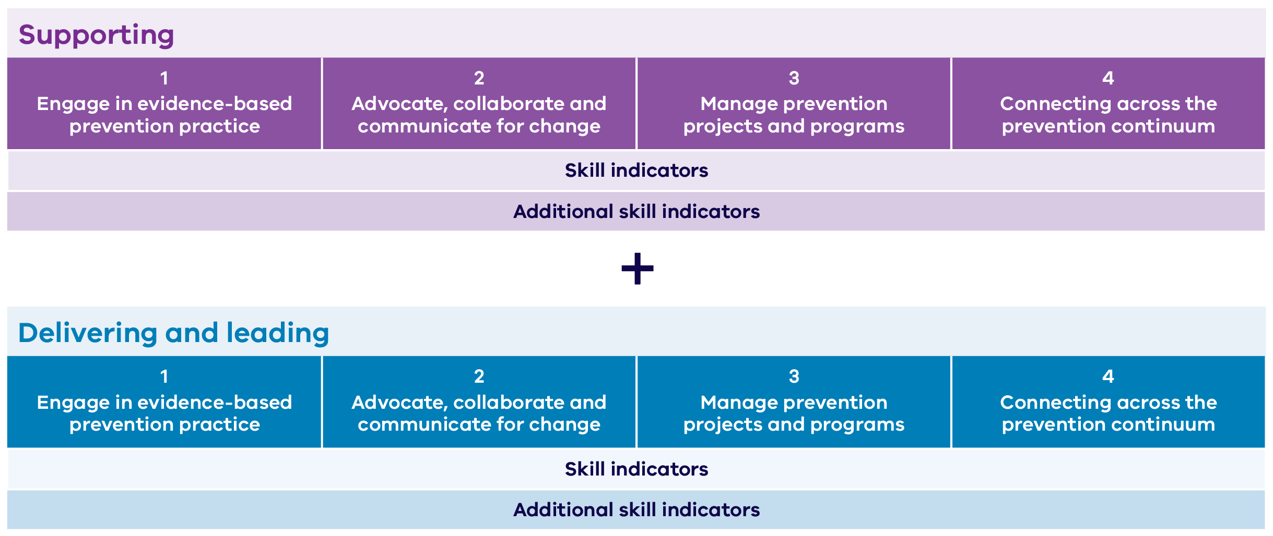

View plain figure text for Figure 1: Structure of the Primary prevention of family and gender-based violence capability framework

Figure 2: Capabilities and skill indicators for workers across the primary prevention workforce
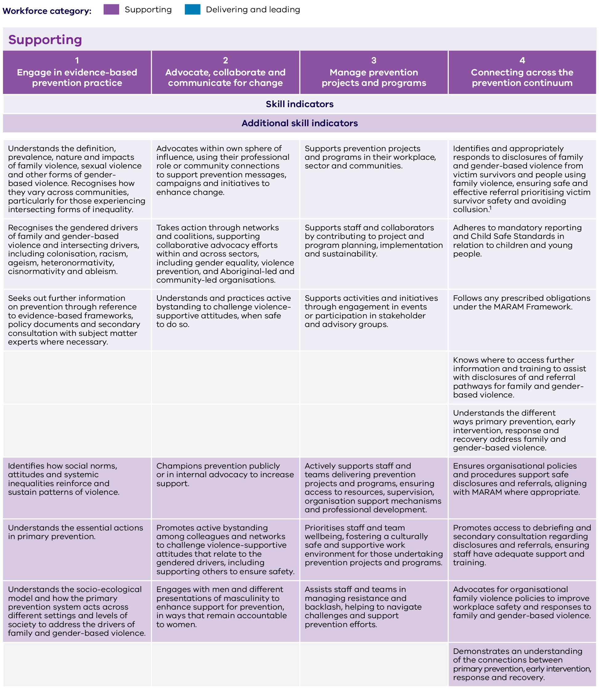

Figure 2: Capabilities and skill indicators for workers across the primary prevention workforce (continued 2)
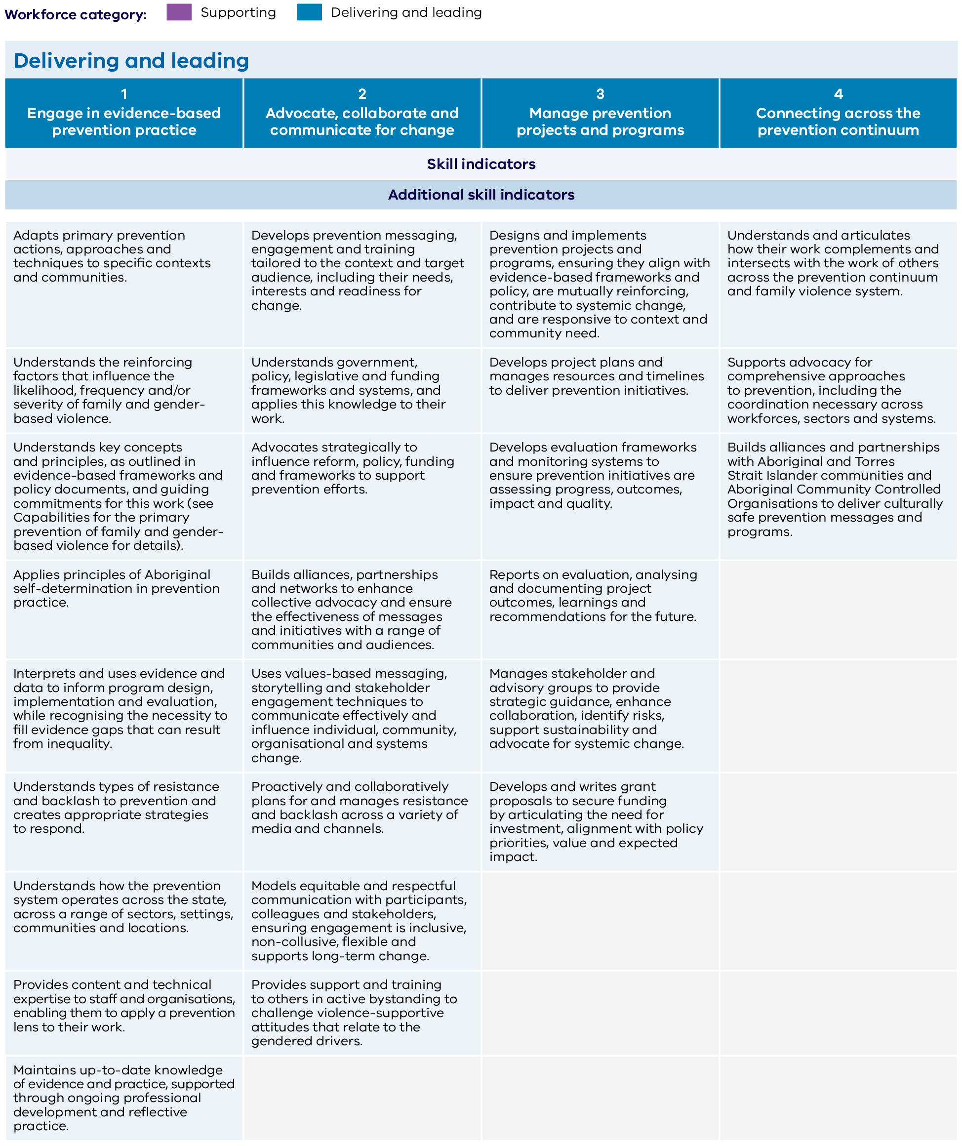

Figure 2: Capabilities and skill indicators for workers across the primary prevention workforce (continued 3)
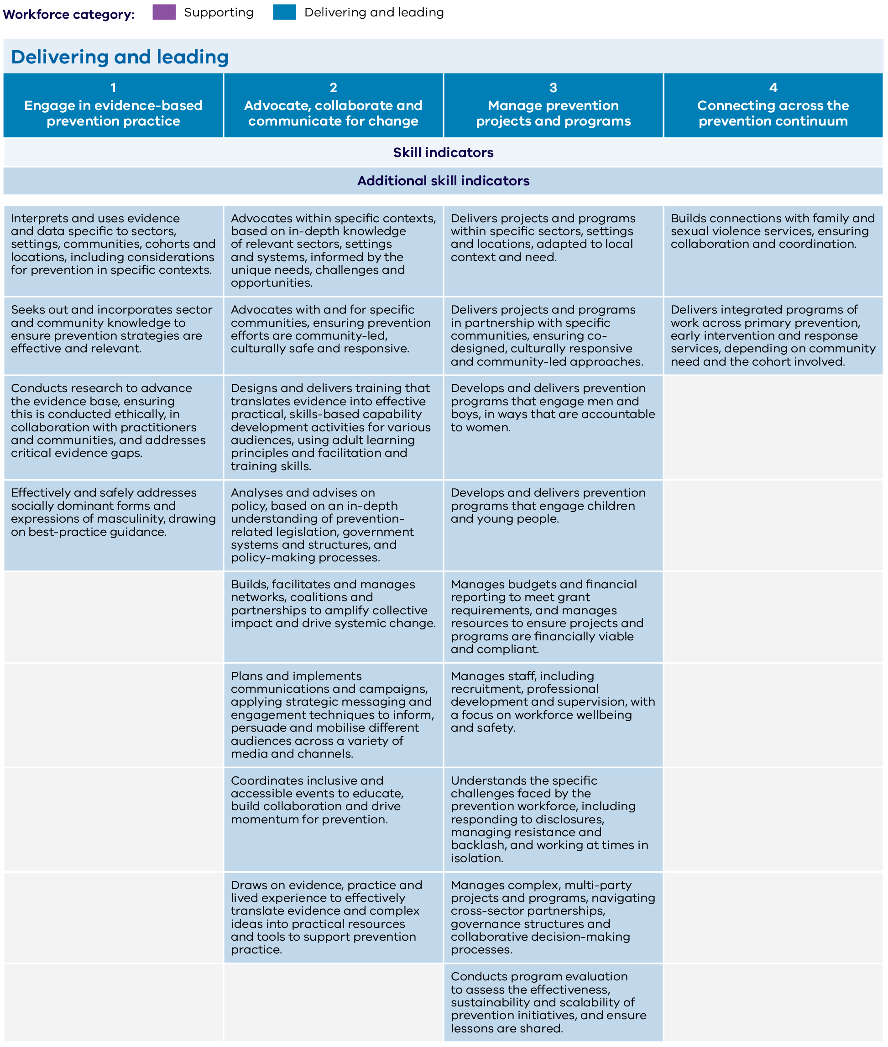
View plain figure text for Figure 2: Capabilities and skill indicators for workers across the primary prevention workforce

Plain figure text

Figure 1 text: Structure of the Primary prevention of family and gender-based violence capability framework

Supporting

Capability 1: Engage in evidence-based prevention practice
- Skill indicators
- Additional skill indicators

Capability 2: Advocate, collaborate and communicate for change
- Skill indicators
- Additional skill indicators

Capability 3: Manage prevention projects and programs
- Skill indicators
- Additional skill indicators

Capability 4: Connecting across the prevention continuum
- Skill indicators
- Additional skill indicators

Delivering and leading

Capability 1: Engage in evidence-based prevention practice
- Skill indicators
- Additional skill indicators

Capability 2: Advocate, collaborate and communicate for change
- Skill indicators
- Additional skill indicators

Capability 3: Manage prevention projects and programs
- Skill indicators
- Additional skill indicators

Capability 4: Connecting across the prevention continuum
- Skill indicators
- Additional skill indicators
Return to Figure 1: Structure of the Primary prevention of family and gender-based violence capability framework

Figure 2 text: Capabilities and skill indicators for workers across the primary prevention workforce

Supporting

Capability 1: Engage in evidence-based prevention practice

Skill indicators for engage in evidence-based prevention practice
- Understands the definition, prevalence, nature and impacts of family violence, sexual violence and other forms of gender-based violence. Recognises how they vary across communities, particularly for those experiencing intersecting forms of inequality.
- Recognises the gendered drivers of family and gender-based violence and intersecting drivers, including colonisation, racism, ageism, heteronormativity, cisnormativity and ableism.
- Seeks out further information on prevention through reference to evidence-based frameworks, policy documents and secondary consultation with subject matter experts where necessary.

Additional skill indicators for engage in evidence-based prevention practice
- Identifies how social norms, attitudes and systemic inequalities reinforce and sustain patterns of violence.
- Understands the essential actions in primary prevention.
- Understands the socio-ecological model and how the primary prevention system acts across different settings and levels of society to address the drivers of family and gender-based violence.

Capability 2: Advocate, collaborate and communicate for change

Skill indicators for advocate, collaborate and communicate for change
- Advocates within own sphere of influence, using their professional role or community connections to support prevention messages, campaigns and initiatives to enhance change.
- Takes action through networks and coalitions, supporting collaborative advocacy efforts within and across sectors, including gender equality, violence prevention, and Aboriginal-led and community-led organisations.
- Understands and practices active bystanding to challenge violence-supportive attitudes, when safe to do so.

Additional skill indicators for advocate, collaborate and communicate for change
- Champions prevention publicly or in internal advocacy to increase support.
- Promotes active bystanding among colleagues and networks to challenge violence-supportive attitudes that relate to the gendered drivers, including supporting others to ensure safety.
- Engages with men and different presentations of masculinity to enhance support for prevention, in ways that remain accountable to women.

Capability 3: Manage prevention projects and programs

Skill indicators for manage prevention projects and programs
- Supports prevention projects and programs in their workplace, sector and communities.
- Supports staff and collaborators by contributing to project and program planning, implementation and sustainability.
- Supports activities and initiatives through engagement in events or participation in stakeholder and advisory groups.

Additional skill indicators for manage prevention projects and programs
- Actively supports staff and teams delivering prevention projects and programs, ensuring access to resources, supervision, organisation support mechanisms and professional development.
- Prioritises staff and team wellbeing, fostering a culturally safe and supportive work environment for those undertaking prevention projects and programs.
- Assists staff and teams in managing resistance and backlash, helping to navigate challenges and support prevention efforts.

Capability 4: Connecting across the prevention continuum

Skill indicators for connecting across the prevention continuum
- Identifies and appropriately responds to disclosures of family and gender-based violence from victim survivors and people using family violence, ensuring safe and effective referral prioritising victim survivor safety and avoiding collusion.
- Adheres to mandatory reporting and Child Safe Standards in relation to children and young people.
- Follows any prescribed obligations under the MARAM Framework.
- Knows where to access further information and training to assist with disclosures of and referral pathways for family and gender-based violence.
- Understands the different ways primary prevention, early intervention, response and recovery address family and gender-based violence.

Additional skill indicators for connecting across the prevention continuum
- Ensures organisational policies and procedures support safe disclosures and referrals, aligning with MARAM where appropriate.
- Promotes access to debriefing and secondary consultation regarding disclosures and referrals, ensuring staff have adequate support and training.
- Advocates for organisational family violence policies to improve workplace safety and responses to family and gender-based violence.
- Demonstrates an understanding of the connections between primary prevention, early intervention, response and recovery.

Delivering and leading

Capability 1: Engage in evidence-based prevention practice

Skill indicators for engage in evidence-based prevention practice
- Adapts primary prevention actions, approaches and techniques to specific contexts and communities.
- Understands the reinforcing factors that influence the likelihood, frequency and/or severity of family and gender-based violence.
- Understands key concepts and principles, as outlined in evidence-based frameworks and policy documents, and guiding commitments for this work (see Capabilities for the primary prevention of family and gender-based violence for details).
- Applies principles of Aboriginal self-determination in prevention practice.
- Interprets and uses evidence and data to inform program design, implementation and evaluation, while recognising the necessity to fill evidence gaps that can result from inequality.
- Understands types of resistance and backlash to prevention and creates appropriate strategies to respond.
- Understands how the prevention system operates across the state, across a range of sectors, settings, communities and locations.
- Provides content and technical expertise to staff and organisations, enabling them to apply a prevention lens to their work.
- Maintains up-to-date knowledge of evidence and practice, supported through ongoing professional development and reflective practice.

Additional skill indicators for engage in evidence-based prevention practice
- Interprets and uses evidence and data specific to sectors, settings, communities, cohorts and locations, including considerations for prevention in specific contexts.
- Seeks out and incorporates sector and community knowledge to ensure prevention strategies are effective and relevant.
- Conducts research to advance the evidence base, ensuring this is conducted ethically, in collaboration with practitioners and communities, and addresses critical evidence gaps.
- Effectively and safely addresses socially dominant forms and expressions of masculinity, drawing on best-practice guidance.

Capability 2: Advocate, collaborate and communicate for change

Skill indicators for advocate, collaborate and communicate for change
- Develops prevention messaging, engagement and training tailored to the context and target audience, including their needs, interests and readiness for change.
- Understands government, policy, legislative and funding frameworks and systems, and applies this knowledge to their work.
- Advocates strategically to influence reform, policy, funding and frameworks to support prevention efforts.
- Builds alliances, partnerships and networks to enhance collective advocacy and ensure the effectiveness of messages and initiatives with a range of communities and audiences.
- Uses values-based messaging, storytelling and stakeholder engagement techniques to communicate effectively and influence individual, community, organisational and systems change.
- Proactively and collaboratively plans for and manages resistance and backlash across a variety of media and channels.
- Models equitable and respectful communication with participants, colleagues and stakeholders, ensuring engagement is inclusive, non-collusive, flexible and supports long-term change.
- Provides support and training to others in active bystanding to challenge violence-supportive attitudes that relate to the gendered drivers.

Additional skill indicators for advocate, collaborate and communicate for change
- Advocates within specific contexts, based on in-depth knowledge of relevant sectors, settings and systems, informed by the unique needs, challenges and opportunities.
- Advocates with and for specific communities, ensuring prevention efforts are community-led, culturally safe and responsive.
- Designs and delivers training that translates evidence into effective practical, skills-based capability development activities for various audiences, using adult learning principles and facilitation and training skills.
- Analyses and advises on policy, based on an in-depth understanding of prevention-related legislation, government systems and structures, and policy-making processes.
- Builds, facilitates and manages networks, coalitions and partnerships to amplify collective impact and drive systemic change.
- Plans and implements communications and campaigns, applying strategic messaging and engagement techniques to inform, persuade and mobilise different audiences across a variety of media and channels.
- Coordinates inclusive and accessible events to educate, build collaboration and drive momentum for prevention.
- Draws on evidence, practice and lived experience to effectively translate evidence and complex ideas into practical resources and tools to support prevention practice.

Capability 3: Manage prevention projects and programs

Skill indicators for manage prevention projects and programs
- Designs and implements prevention projects and programs, ensuring they align with evidence-based frameworks and policy, are mutually reinforcing, contribute to systemic change, and are responsive to context and community need.
- Develops project plans and manages resources and timelines to deliver prevention initiatives.
- Develops evaluation frameworks and monitoring systems to ensure prevention initiatives are assessing progress, outcomes, impact and quality.
- Reports on evaluation, analysing and documenting project outcomes, learnings and recommendations for the future.
- Manages stakeholder and advisory groups to provide strategic guidance, enhance collaboration, identify risks, support sustainability and advocate for systemic change.
- Develops and writes grant proposals to secure funding by articulating the need for investment, alignment with policy priorities, value and expected impact.

Additional skill indicators for manage prevention projects and programs
- Delivers projects and programs within specific sectors, settings and locations, adapted to local context and need.
- Delivers projects and programs in partnership with specific communities, ensuring co-designed, culturally responsive and community-led approaches.
- Develops and delivers prevention programs that engage men and boys, in ways that are accountable to women.
- Develops and delivers prevention programs that engage children and young people.
- Manages budgets and financial reporting to meet grant requirements, and manages resources to ensure projects and programs are financially viable and compliant.
- Manages staff, including recruitment, professional development and supervision, with a focus on workforce wellbeing and safety.
- Understands the specific challenges faced by the prevention workforce, including responding to disclosures, managing resistance and backlash, and working at times in isolation.
- Manages complex, multi-party projects and programs, navigating cross-sector partnerships, governance structures and collaborative decision-making processes.
- Conducts program evaluation to assess the effectiveness, sustainability and scalability of prevention initiatives, and ensure lessons are shared.

Capability 4: Connecting across the prevention continuum

Skill indicators for connecting across the prevention continuum
- Understands and articulates how their work complements and intersects with the work of others across the prevention continuum and family violence system.
- Supports advocacy for comprehensive approaches to prevention, including the coordination necessary across workforces, sectors and systems.
- Builds alliances and partnerships with Aboriginal and Torres Strait Islander communities and Aboriginal Community Controlled Organisations to deliver culturally safe prevention messages and programs.

Additional skill indicators for connecting across the prevention continuum
- Builds connections with family and sexual violence services, ensuring collaboration and coordination.
- Delivers integrated programs of work across primary prevention, early intervention and response services, depending on community need and the cohort involved.
Return to Figure 2: Capabilities and skill indicators for workers across the primary prevention workforce

https://www.vic.gov.au/building-strength-10-year-industry-plan
https://safeandequal.org.au/resources/foundations-for-action-understanding-the-primary-prevention-workforce-in-victoria/
https://www.ourwatch.org.au/change-the-story/change-the-story-framework
https://www.dss.gov.au/national-plan-end-gender-based-violence
https://www.ourwatch.org.au/change-the-story
https://www.ourwatch.org.au/resource/changing-the-picture/
https://www.ourwatch.org.au/resource/changing-the-landscape/
https://rainbowhealthaustralia.org.au/news/launch-pride-in-prevention-evidence-guide
https://www.mcwh.com.au/intersectionality-matters-a-new-resource-for-preventing-violence-against-women/
https://www.ourwatch.org.au/change-the-story/men-in-focus
https://jss.org.au/programs/research/the-man-box/
https://www.respectvictoria.vic.gov.au/willing-capable-and-confident-men-masculinities-and-prevention-violence-against-women
https://safeandequal.org.au/resources/foundations-for-action-understanding-the-primary-prevention-workforce-in-victoria/
https://www.vic.gov.au/family-violence-multi-agency-risk-assessment-and-management
https://www.vic.gov.au/report-implementation-family-violence-risk-assessment-and-management-framework-2021-22/appendix-1
https://www.vic.gov.au/maram-practice-guides-and-resources
https://www.ourwatch.org.au/change-the-story
https://www.ourwatch.org.au/change-the-story/changing-the-picture
https://www.ourwatch.org.au/resource/changing-the-landscape/
https://rainbowhealthaustralia.org.au/news/launch-pride-in-prevention-evidence-guide
https://www.mcwh.com.au/intersectionality-matters-a-new-resource-for-preventing-violence-against-women/
https://www.ourwatch.org.au/change-the-story/men-in-focus
https://safeandequal.org.au/resources/foundations-for-action-understanding-the-primary-prevention-workforce-in-victoria/
Further detail on the capabilities required to safely and effectively identify family violence risk and respond to disclosures is outlined in the Responding to family violence capability framework.

