Know the rules. Play your part. Protect nature.
Here are some rules that help to protect our wildlife.
There are lots more you can learn about too!
When you are around wildlife, look but don't touch, and make sure you give them plenty of space. In Victoria, the law protects all wildlife so you must not pick up or disturb any wildlife in any way.

Wildlife live in many different types of habitats.
Some live in trees in a forest, others live in the sand on a beach, and others might live in your backyard or local park. When you're out in nature, enjoy watching wildlife, but don't disturb them or their homes.
Some rules to remember when you’re out in nature:
- To keep wildlife safe and protect their habitat, put your dog on a leash at the beach or forest.
- If you see an animal in the wild, you shouldn’t touch or pick it up. You are much bigger than they are, and they get very scared and can accidentally get injured. You might be able to get an awesome photo, though!
- If you want a pet lizard or turtle, you may need a licence, and only captive-bred wildlife can be kept as pets.
- Leave tadpoles where they are. Never take an animal into captivity.
- It’s fun to build a campfire when you go camping, but you need to make sure your campfire is safe. Always keep an eye on it and keep the area around it clear. When you leave, make sure to put your fire out with water, and take all rubbish with you. Rubbish can harm the wildlife that lives there.
If you spot whales, dolphins or seals, enjoy them from a distance and never approach them.
These are just some of the rules you need to know.
Figure 1: Examples of wildlife that are included in the Focus Species Program.
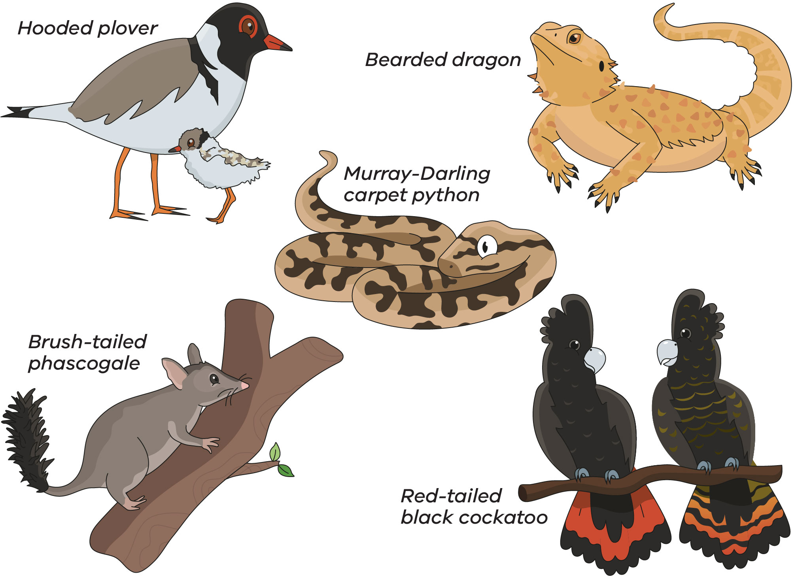
Start by looking here to discover more rules: vic.gov.au/conservation-regulator
You might come across one of our Focus Species while out looking for wildlife. Find more information on Conservation Regulator Focus Species at: vic.gov.au/focus-species-program

Class wildlife record
Explore the natural environment and record the wildlife that you see
Class name:
Time period:
Start date: |  | End date:
Table 1: Class wildlife record details
Wildlife sighted  What species did you see? | Where did you see it?  Was it in your backyard?  Was it in your schoolyard?  Was it in a park? | Rules that protect it  What are the rules that keep this wildlife safe?  Hint: you’ll find some of these rules on our Focus Species website | Threatened status  (e.g. Not threatened, vulnerable, endangered, critically endangered)
E.g. Hooded plover | In the wild!  At Lorne beach in a nesting area | Keep a safe distance  Keep your dog on a lead in bird nesting areas | Vulnerable
E.g. Brush-tailed phascogale | In a big gum tree in the forest in the Grampians | Don’t illegally take firewood from the forest, it might be the home of a Brush-tailed Phascogale | Vulnerable

