Digital Procurement Guide
July 2026

The Secretary
Department of Treasury and Finance
1 Treasury Place
Melbourne Victoria 3002
Australia
Telephone: +61 3 9651 5111
dtf.vic.gov.au

Authorised by the Victorian Government
1 Treasury Place, Melbourne, 3002
Printed by XXXXXXXXXXX
Printers address XXXXXXXXXXXXX
Printed on recycled paper.

© State of Victoria 2026

You are free to re-use this work under a Creative Commons Attribution 4.0 licence, provided you credit the State of Victoria (Department of Treasury and Finance) as author, indicate if changes were made and comply with the other licence terms. The licence does not apply to any branding, including Government logos.

If you have copyright queries or would like to receive this publication in an accessible format email information@dtf.vic.gov.au

ISBN 000-0-000000-00-0 [check with the Victorian Government Library Service for requirements]
Published June 2026

This document is available in Word and PDF format at dtf.vic.gov.au
Contents
1 Introduction 1
1.1 Communities of support 2
1.2 Applicability of the Victorian goods and services procurement policies 2
2 Defining your business need 2
2.1 The Digital Regulation Capability Model 2
2.1.1 An example from the Digital Regulation Capability Model 3
2.2 ‘Reuse before Rent before Buy before Build’ – Victorian Government Digital Strategy 2021-2026 4
3 Becoming digitally ready 4
3.1 Using the Common Data Taxonomy and Digitally Ready Regulators Playbooks 4
3.2 The Common Data Taxonomy 4
3.3 The Better Regulation Victoria Playbooks 5
3.3.1 The Permissions Playbook 5
3.3.2 The Better Practice Inspections Playbook 6
4 The buying process 7
4.1 Getting Started 7
4.2 Plan the procurement 7
4.3 Prepare invitation documents 8
4.4 Invite and evaluate offers 8
4.5 Manage the contract 9
4.6 Complete the contract 9
5 Navigating digital change 9
5.1 Procurement management 9
5.2 Change management 10
6 Resources 11
6.1 Victorian goods and services procurement policies 11
6.2 The buying process 11
6.3 Other supporting resources 11

Introduction
Procurement is the process of acquiring goods and services. This Digital Procurement Guide defines the steps for regulators seeking to procure information technology products and associated services. Each step outlined below includes high-level guidance and links to supporting materials from across government so that regulators can make confident procurement decisions regardless of their size or digital maturity.
This document will focus on best-practice digital procurement processes for agencies governed by the Victorian goods and services procurement policies guidelines. This guide will not describe specific procurement procedures, which vary between departments and agencies.
The Resources section at the end of the document provides links to supporting materials referred to throughout this document.

Communities of support
The Innovation Network can link you to groups such as the Victorian Buyer’s Community of Practice, which provide places to ask questions and connect with other VPS employees with experience in procurement.

Applicability of the Victorian goods and services procurement policies
The Financial Management Act 1994 governs goods and services procurement in Victoria. Goods and services mandated agencies must follow the goods and services procurement policies when procuring goods or services.
The resources section contains links to:
- The four core principles underpinning goods and services procurement
- The five goods and services policies
- The list of mandated agencies covered by Victorian goods and services procurement policies

Defining your business need

The Digital Regulation Capability Model
The first step in digital procurement is defining your business need. The Digital Regulation Capability Model will help you understand if and how your target capabilities can be achieved through digital uplift. The model has 5 steps, described in the table below.

Table 1: Steps of the Digital Regulation Capability Model
Step | Description | In other words, | What to ask
1. | Understand better practice digital capabilities for common regulatory functions. | Find out what digital tools and practices other regulators use for their core work. | How have other regulators gone about digitisation? What has worked for them?
2. | Conduct a current-state self-assessment of digital capabilities across relevant regulatory functions. | Which of your functions are already digitised? | Do you still have manual or paper-based processes? Do you have useful and robust digital systems in place, or is there room for improvement?
3. | Define your future state ambition for digital capabilities relevant to your needs and stakeholder expectations. | Which functions will you prioritise digitising? How advanced will you make them? | Are your digital goals appropriate for your needs and resourcing? Where will digitisation best improve the experience people and business have when interacting with your organisation?
4. | Analyse current digital capabilities to identify key focus areas for change. | Do your current digital tools and practices work well? Which need to be improved? | Are your most important functions digitised? Where could digitisation make the biggest difference for the cost?
5. | Use identified focus areas and digital capabilities as a starting point for the definition of technology initiatives that may be needed and incorporate these into your planning for technology uplift. | You know your organisation’s digital strengths and gaps, and you can use this to plan how to improve. | What work is needed to achieve your digital goals? How can you incorporate these goals into your organisation’s planning?

An example from the Digital Regulation Capability Model
The Digital Regulation Capability Model describes common regulatory functions as well as examples of digital enablers to improve your organisation’s ability to carry out these functions. An example of a common regulatory function is application management. The level of digital capability required for a regulator to effectively carry out this function will vary, but could include:
- Foundational: applicants can submit applications online
- Intermediate: duty holder portal – applicants can submit applications, view progress and set preferences for how they would like to receive notifications and alerts in relation to their application
- Future focus: AI support assistant – applicants can receive assistance in real time in response to their queries including links and references to supporting information or guidance
An example from a regulator: using the Digital Regulation Capability Model
A small regulator with a limited budget is seeking to reduce their application processing times. The regulator still has several forms that are submitted as PDFs. An effective, foundational digital uplift for this regulator may be to move these remaining manual application forms online as smart forms, starting with those with the highest volume of submissions. This may reduce processing times even without a complex digital integration by increasing application accuracy and completeness.

‘Reuse before Rent before Buy before Build’ – Victorian Government Digital Strategy 2021-2026
After defining your business need and determining a digital capability to uplift, follow the 4-step approach from the Victorian Digital Strategy:

- If the Victorian Government has it and it is fit for purpose, reuse it.
  - Be clear about the value of innovating before you invest in new technology.
  - Some digital capabilities are available within Vic Gov, such as: DGS' application programming interfaces (API) which allow two pieces of software to interact even if they weren’t originally designed to do so; or Service Victoria’s reusable digital capabilities which include national police checks, identity verification, and payment capabilities.
- If we do not have it, subscribe to it (software as a service – SaaS).
- If you cannot subscribe to it, buy it off the shelf.
- If all options are closed, only then consider building it yourself.

Becoming digitally ready
Effective digital uplift requires effective processes – don’t digitise a bad process. DTF has developed multiple guidance documents to support process improvement, including:
- a common data taxonomy, which provides a standard approach for Victorian regulators to structure data related to business licensing
- two complementary playbooks from Better Regulation Victoria that support regulators preparing for digital reform to become ‘digitally ready’:
  - the Better Practice Permissions Playbook, which provides guidance on how to implement better practice permissions
  - the Better Practice Inspections Playbook, which provides guidance on how to improve compliance monitoring processes in a standardised way.

Using the Common Data Taxonomy and Digitally Ready Regulators Playbooks
There are benefits in aligning to other regulators. This does not mean losing agency over your capabilities; it means refining your digital uplift and following established better practice where possible. Relying on the experience of other organisations and using defined strategies facilitates efficient digital uplift, saving your organisation resources that can be used operationally or invested to effectively build bespoke digital capabilities where necessary.

The Common Data Taxonomy
The Taxonomy is a structured way for regulators to organise information based on shared characteristics. It serves as a foundational tool to help regulators manage their data.
The Taxonomy can help regulators identify which businesses are subject to oversight by which regulators and interpret data provided by other regulators with greater ease and consistency. This shared framework strengthens collaboration, reduces duplication, and supports a more coordinated regulatory environment. Refer to the materials section for the full model and examples.
Figure 1: Common Data Taxonomy Model
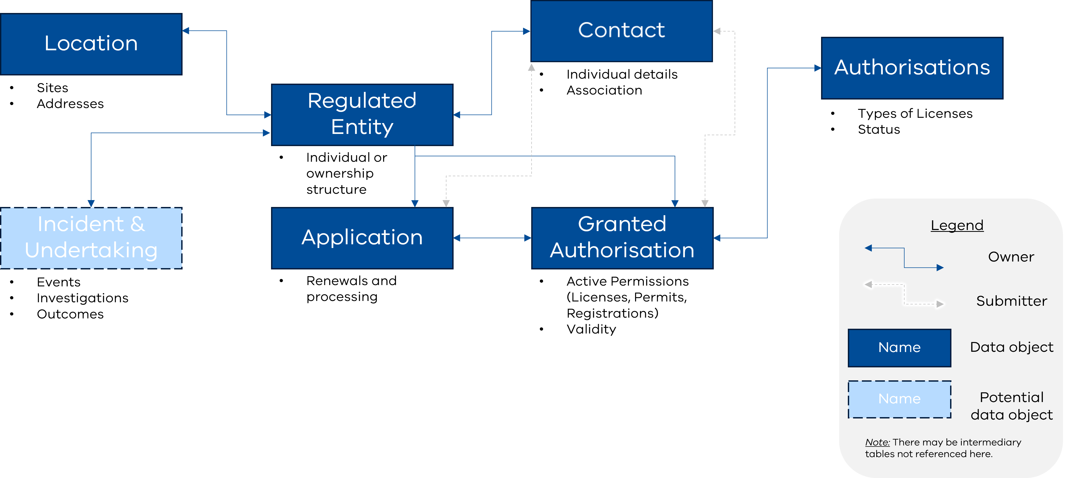

The Better Regulation Victoria Playbooks

The Permissions Playbook
The Permissions Playbook outlines an approach to improving regulatory practice and processes to be more consistent, streamlined and digital. The Permissions Playbook includes companion resources to help regulators implement improvements.
Figure 2: The Permissions Playbook
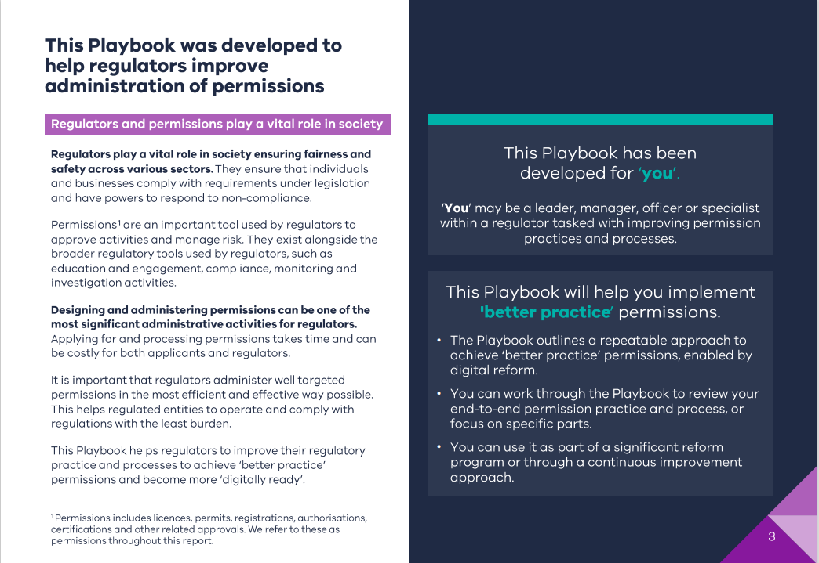

The Better Practice Inspections Playbook
The Better Practice Inspections Playbook provides guidance on preparing for digitisation and improving compliance monitoring processes (with a focus on inspections) in a standardised way. The inspections playbook includes specialised tools to help regulators make practical reforms to compliance monitoring processes.
Figure 3: The Better Practice Inspections Playbook
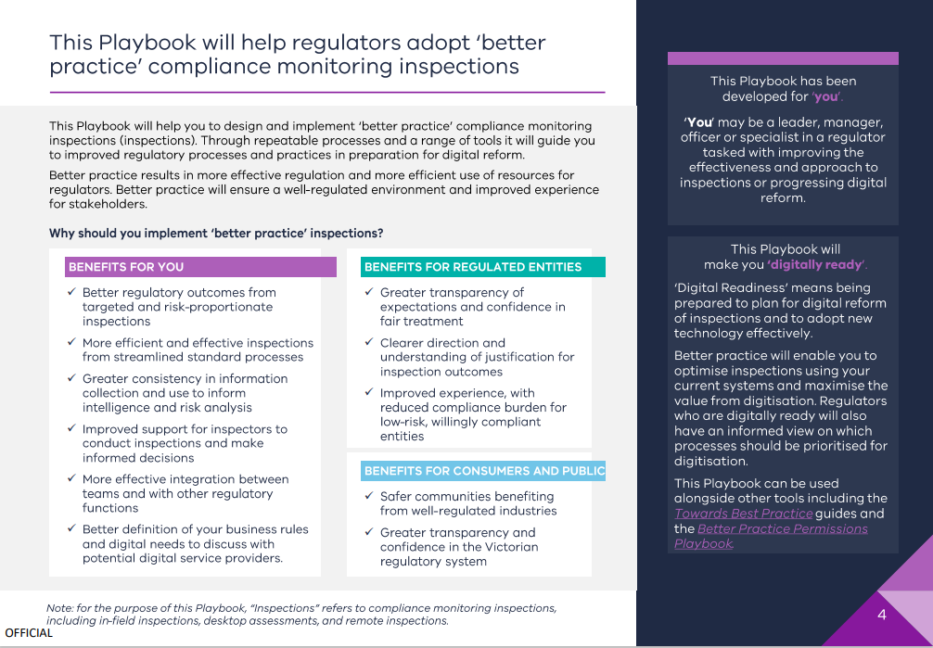

The buying process
Have you defined your business need? Are you digitally ready? Then it’s time to start the buying process. This process is divided into six sections.

Getting Started
Getting started covers your obligations under the Victorian goods and services procurement policies. Regardless of whether your organisation must follow these policies, the procurement process described below will be broadly applicable.

Plan the procurement
Once you’ve defined your business need and become digitally ready, the next step is to plan the procurement. Consider your options and compare in-house solutions with external procurement options.
Once you’ve decided from your procurement options, the rest of this stage covers planning for the chosen option: Plan the procurement | buyingfor.vic.gov.au

Table 2: Planning your procurement
Option | Description | Example | Benefits | Drawbacks
Process Amendment | Amending processes to more effectively use existing digital resources may also present opportunities for uplift without procurement. | A regulator accepts permit applications via email. They set up a shared inbox so all staff can see incoming applications. | Low cost, low risk. | Not appropriate where digital capabilities don’t exist or are not fit for purpose.
Internal Uplift | Agencies with sufficient resourcing may consider internally driven uplift, with no procurement necessary. | Larger regulators may have in-house staff who can support digitisation. | More control and accountability may reduce risk. | Not available for all regulators. May still need to engage vendors to procure digital systems.
Internal Vendor | You may have access to internal resources to fulfil all or part of your procurement through your responsible department or elsewhere within the Victorian Government. | The Department of Government Services Digital and Analytics Service can provide standardised digital products across agencies. | Standardisation within organisation. | Not widely available. Limited products and supplier options.

Prepare invitation documents
The Digital Marketplace and Supplier Hub bring Victoria’s state purchasing contracts together in one central location and lets government buyers research suppliers and manage their procurement. Before you can approach the Digital Marketplace, you will need to prepare the required documents and develop an evaluation plan to set out how offers from suppliers will be assessed.
The Digital Marketplace includes state purchase contracts, which have been set up to streamline the procurement of commonly used goods and services, including digital. All agencies covered by the Victorian goods and services procurement policies must use state purchase contracts where available.
Aside from state purchase contracts, the Digital Marketplace can be searched for registered and prequalified suppliers, including for digital services under the eServices register and change management services.

Invite and evaluate offers
Regulators will need to complete an invitation to supply to contract with a supplier. A strong evaluation plan will ensure that submissions to the invitation to supply are given a fair and objective evaluation. Your assessment should focus on which supplier will best meet your business need. You may also negotiate with potential suppliers to improve value-for-money, including best-and-final offers, or to address concerns or issues with their offers to supply.
Regardless of whether you advertise your invitation to supply or issue tender documents directly to selected participants, aim to use clear and standardised language to convey your business need with the market. Regulators can refer to capability terminology as outlined in the Better Regulation Victoria playbooks, the Digital Regulation Capability Model, or the common data model and taxonomy. These materials have been developed in conjunction with experts in digital uplift and will help bridge the understanding gap between different levels of digital expertise.
As the procurer, you may still face information asymmetry about how your requirements translate into a tangible business need. Anticipate potential design and implementation issues by communicating your required outcomes and deliverables clearly to your supplier. Your supplier should then be able to identify potential issues before the project starts, avoiding incompatibilities or scope creep during the delivery process.
Contract variations to scope after the initial negotiation can be difficult. A robust procurement plan and invitation to supply process will reduce the risk renegotiation is needed.

Manage the contract
Contract management begins the moment the buying process begins. A contract manager is responsible for negotiating and drafting your contract with the vendor and ensuring both your organisation and the vendor meet their obligations throughout the delivery of your procurement. Different departments may have their own contract management requirements and materials.

Complete the contract
Supplier performance should be monitored and reviewed throughout the delivery of the contract. A formal evaluation should be made at the completion of your procurement of:
- supplier performance
- opportunities to improve processes
- incorporation of process improvement
Save your evaluations and keep them up to date. This will let you learn from previous procurements.

Navigating digital change
Procurement success is not guaranteed by defining your business need and following the buying process. Success requires procurement management throughout the purchasing process and change management as you roll out and implement your new or uplifted digital capabilities.

Procurement management
Though the role of project manager may overlap with contract manager, both responsibilities are distinct and critical to the success of your digital procurement.
Your project manager is responsible for:
- identifying and then translating your business needs into cohesive and actionable instructions for vendors (requirements gathering)
- providing a contact point so your vendor can obtain the information and resources they need
- resolving issues
A project manager may need to manage differing perspectives and expectations from across your organisation to develop a unified position. By providing a clear contact point during your procurement, you will be best placed to meet your contractual obligations and support successful project delivery.
An example from a regulator: procurement management
A regulator has engaged a vendor to replace a bespoke, end of life regulatory system. Senior leadership relies on internal business subject matter experts to advise on the needs of the new system.
The project sets out to create an updated system without understanding where improvements and efficiencies can be made. A lack of alignment between the subject matter experts and the vendor means the vendor struggles to understand the regulator’s requirements. The regulator cannot provide a clear picture of its needs to the vendor. This results in two years of requirements gathering. Ultimately, costs and timeframes blow out and no system is delivered.
The regulator starts again, this time employing a dedicated business analyst to work with its subject matter experts and advocate for its business needs. The analyst interprets the needs of the regulator in a way the vendor can understand and action, creating a strong basis for successful digital delivery.

Change management
Effective change management ensures that staff are brought along and supported to adopt the improved capabilities. Reflect on whether your organisation has the skills and knowledge required to support change management internally and consider engaging expertise externally through the procurement process.
Change management is particularly relevant for digital transformations with significant process changes. Failing to support staff through digital uplift can:
- slow uptake and reduce productivity
- lower staff morale
- increase cost and timeframes
- lead to project failure, wasting your investment
Change management services may be offered by digital capability vendors or can be procured separately, e.g., as fixed-term staff.

Resources

Victorian goods and services procurement policies
Goods and services mandated agencies:
Goods and services mandated agencies | buyingfor.vic.gov.au

Understand the core principles underpinning goods and services procurement:
Principles underpin procurement | buyingfor.vic.gov.au

Understand the five goods and services policies:
Goods and services policies & guides | buyingfor.vic.gov.au

The buying process
Buying for Victoria home:
Making it easier to do business with government | buyingfor.vic.gov.au

Buyer’s Guide:
Buyers guide | buyingfor.vic.gov.au

The Digital Marketplace:
Digital Marketplace | buyingfor.vic.gov.au

Invitation to supply templates:
Goods and services Invitation to Supply templates | buyingfor.vic.gov.au

Other supporting resources
Victorian Government Buyers' Community of Practice:
Victorian Government Buyers' Community of Practice | Innovation Network

Council and Regulator Toolkit (CART):
Council and Regulator Toolkit | vic.gov.au

Digitally Regulation Capability Model:
https://www.vic.gov.au/digital-regulation-capability-model

Better Regulation Victoria playbooks:
Support for regulators preparing for digital reform | vic.gov.au

Common Data Model and Taxonomy:
https://www.vic.gov.au/victorian-common-data-taxonomy

Victorian Government Digital Strategy 2021-2026:
A Future-ready Victoria: Victorian Government Digital Strategy 2021–2026

Document version control
Version | Date | Description of changes
1 | July 2026 | Initial publication

