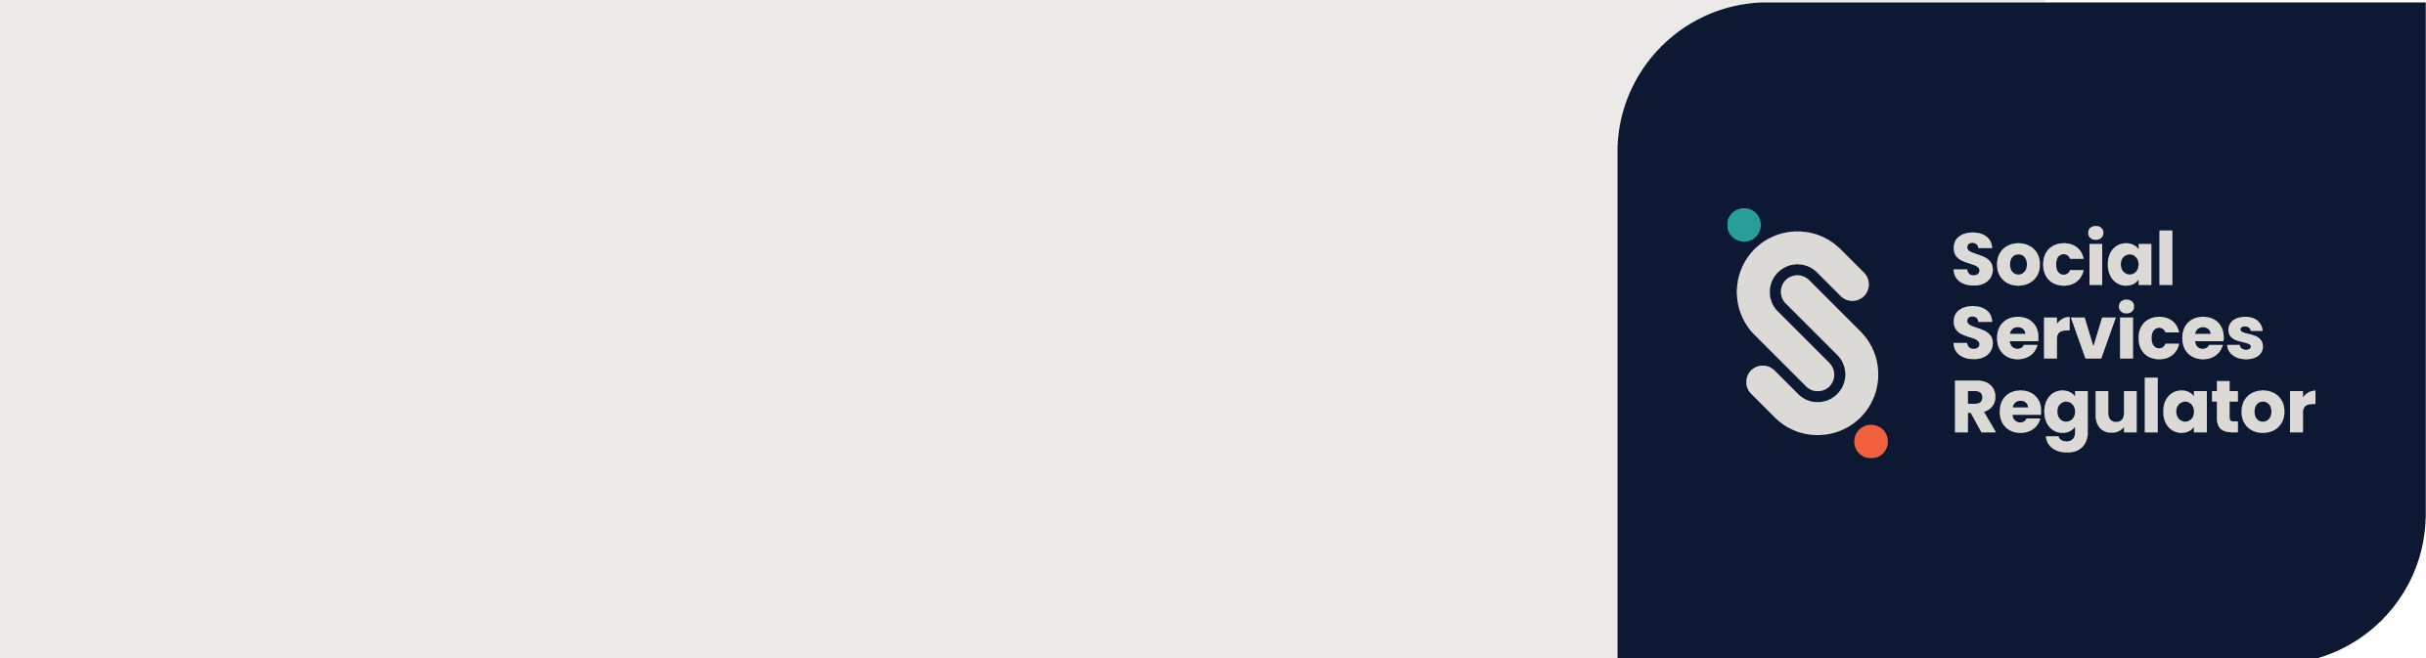

Changes to the Working with Children Check effective from 28 July 2026
Learn about the key changes to the WWC Check and how they strengthen child safety in Victoria
OFFICIAL

Working with Children Check: Key Changes
Victoria’s Working with Children (WWC) Check has been strengthened to better protect children by improving how child safety risks are identified and assessed.
The changes commenced on 28 July 2026. They are part of a suite of reforms to Victoria’s child safeguarding system and respond to recommendations from the Rapid Child Safety Review.
The Social Services Regulator (SSR) now has stronger powers to act earlier where there are concerns about a person’s suitability to work or volunteer with children.
These new powers:
- enable more effective sharing of information between the WWC Check scheme and other regulators and agencies
- allow the SSR to consider a greater range of child safety risk information that may be relevant to a WWC Check applicant or clearance holder’s suitability to work with children
- enable the SSR to immediately prohibit people from working with children where it receives or becomes aware of child safety risk information
- establish a new internal review process for anyone seeking to review an adverse WWC Check decision by the SSR, which will ensure that child safety is at the centre of decision-making while preserving procedural fairness for applicants.

What’s changed?

More information can be considered
The WWC Check can consider a broader range of information when assessing whether a person is eligible to hold a WWC Clearance.
This information (called ‘child safety risk information’ under the legislation) can be considered when a person first applies for a WWC Clearance and while they continue to hold one.
The Rapid Child Safety Review identified that child safety risk information can provide valuable insight into a person’s conduct, regardless of whether it results in a criminal charge or substantiated report.
Child safety risk information can include allegations, intelligence and other information, that could, when considered together, help identify a concerning pattern of behaviour.

Stronger information sharing
The reforms improve information sharing between the WWC Check and other child safety agencies and regulators. This helps ensure decisions are informed by relevant child safety information.
This includes sharing information with:
- Victoria Police
- the Reportable Conduct Scheme
- Worker and Carer Exclusion Scheme
- the Victorian Institute of Teaching (VIT)
- the Victorian Early Childhood Regulatory Authority (VECRA).
Better information sharing helps identify risks sooner and supports coordinated action to protect children.
It also allows the WWC Check to reassess a person’s eligibility to continue to work with children if new child safety risk information becomes available.

New Interim Bar and Suspension powers
New powers mean the SSR may issue an Interim Bar to an applicant or suspend a person’s WWC Clearance while it assesses or reassesses their eligibility for a WWC Clearance. A person who has been issued with an Interim Bar or Suspension will not be able to work with children while the assessment is underway as a precautionary measure to protect children.
An Interim Bar or Suspension may be imposed if the SSR:
- receives or becomes aware of child safety risk information relevant to an applicant or current card holder
- is satisfied that taking immediate action is in the interests of child safety.

Reportable Conduct Scheme
In some cases, the SSR may suspend a person’s WWC Clearance while it reassesses their eligibility during Reportable Conduct Scheme investigation.
The Reportable Conduct Scheme requires some organisations to notify the SSR about allegations of child abuse and child-related misconduct involving their workers and volunteers.
Information shared through the Reportable Conduct Scheme, including allegations, all findings and supporting evidence, can be considered by the WWC Check when assessing or reassessing a person’s eligibility. Where the law allows, the SSR can also share relevant information with other regulators, and agencies to help protect children.

A new internal review process
If a person disagrees with an adverse WWC Check decision, they may be able to ask the SSR to conduct an internal review.
An internal review:
- allows the SSR to reconsider certain WWC Check decisions
- is available for most Exclusion notices issued on or after 28 July 2026
- replaces applications to VCAT for eligible new decisions
- is conducted by a different decision-maker.
Most people who receive a WWC Check Exclusion can apply for an internal review of the decision instead of applying to VCAT. If a person’s exclusion notice is dated 27 July 2026 or earlier, the previous VCAT review arrangements continue to apply.
Some decisions involving the most serious offences have limited review rights.

What hasn’t changed?
The WWC Check scheme still screens workers and volunteers using intelligence- and risk-based assessments to determine whether a person is suitable for child-related work.
People who hold a WWC Check Clearance do not need to reapply because of these reforms.
Existing obligations for workers volunteers and organisations continue to apply.

Why these changes matter
The reforms strengthen Victoria’s WWC Check by:
- Improving child safety
- Enabling earlier action where risks are identified
- Strengthening information sharing to assess and manage risks
- Supporting more informed and consistent decision-making.

Find out more
Visit www.vic.gov.au/working-with-children-check on the SSR’s website for detailed information about the reforms, eligibility assessments and review rights.
For queries about the changes to Working with Children Check email contact@ssr.vic.gov.au. If you are unable to email us, you can call us on 1300 310 778.

Contact us to receive this document in another format. Please email the Social Services Regulator at contact@ssr.vic.gov.au
Authorised and published by the Victorian Government, 1 Treasury Place, Melbourne.
© State of Victoria, Australia, Social Services Regulator, July 2026.

Attribution CC. By attribution as required by licensor.
This work is licensed under a Creative Commons Attribution 4.0 licence https://creativecommons.org/licenses/by/4.0/deed.en. You are free to re-use the work under that licence, on the condition that you credit the State of Victoria (Social Services Regulator) as author, indicate if changes were made and comply with the other licence terms.
ISBN 978-1-76171-210-4 online/MS word). The licence does not apply to any branding (including Government logos), any images or photographs.
Available at Social Services Regulator https://www.vic.gov.au/social-services-regulator

